BEFORE THE FLORIDA PUBLIC SERVICE COMMISSION

In re: Petition for approval of modification to and extension of the approved economic development and re-development rider experimental pilot tariffs, by Duke Energy Florida, LLC. | DOCKET NO. 160173-EI  ORDER NO. PSC-16-0423-TRF-EI  ISSUED: October 3, 2016

The following Commissioners participated in the disposition of this matter:

JULIE I. BROWN, Chairman
LISA POLAK EDGAR
ART GRAHAM
RONALD A. BRISÉ
JIMMY PATRONIS

ORDER APPROVING ECONOMIC DEVELOPMENT AND RE-DEVELOPMENT RIDERS

BY THE COMMISSION:

Background
On July 19, 2016, Duke Energy Florida, LLC (DEF or company) filed a petition requesting approval of modifications to and an extension of the approved pilot Economic Development (ED-1) and Economic Re-Development (EDR-1) riders (economic development riders). Modifications to these tariffs (Sheet Nos. 6.380 and 6.385) are needed to continue the pilot program for an additional three years, along with clarifications to the accompanying standard service agreement forms (Sheet Nos. 7.500 and 7.510). The tariffs and forms in this petition were initially approved by this Commission in Order No. PSC-13-0598-FOF-EI as part of DEFs’ Revised and Restated Stipulation and Settlement Agreement (RRSSA). Paragraph 17 and Exhibit 15 of the RRSSA provided that DEF introduce these tariffs on a pilot basis for three years (from October 2013 to October 2016). The riders, which require a five-year electric service contract, provide base rate credits/reduction for new businesses that meet certain requirements such as minimum load, job creation, and verification that the availability of the riders are a significant factor in the customer’s location or expansion decision.
Commission staff issued one data request to DEF on August 4, 2016, for which responses were received on August 12, 2016. The tariff pages and service agreement forms with proposed changes are contained in Attachment A to this Order. We have jurisdiction over this matter pursuant to Sections 288.035 and 366.06, Florida Statutes.

Decision
The economic development riders are designed to attract new commercial and industrial customers to DEF’s service territory and foster economic growth. The riders offer base rate electric price incentives over a five-year period for new or expanding businesses that meet certain electric load, capital investment, and job creation requirements. As shown in Table 1, the two riders require that the rider customers hire and maintain the following number of full-time employees.
Table 1
Required Full Time Employees & Capital Investments
Rider | Minimum kW Load | Number of FTEs | Capital Investment
ED-1 | 500 | 25 | $500,000 or greater
EDR-1 | 350 | 15 | $200,000 or greater
Source: Tariff Sheet Nos. 6.380 & 6.385
To take service under the subject riders, the customers must agree to a minimum five-year service agreement and the company will request verification from the rider customers of the number of jobs created as a direct result of the riders. DEF states that the first ED-1 customer enrolled in April 2014, and since then DEF has attracted five more customers for a total of six (one EDR-1 customer and five ED-1 customers) that have the potential to create 968 FTE jobs. DEF is also working on attracting additional customers for whom the economic development rider is a significant factor in their location/expansion decisions. DEF proposes to extend the pilot program for an additional three years, until October 17, 2019.
Table 2 illustrates the credits that will be applied to base demand and energy charges.

Table 2
Percentage Reduction in Base Demand & Energy Charges
Year | ED-1 | EDR-1
1 | 50% | 50%
2 | 40% | 35%
3 | 30% | 15%
4 | 20% | 0%
5 | 10% | 0%
Source: Tariff Sheet Nos. 6.380 & 6.385
The company, in its responses to Commission staff’s data request and follow-up, stated that the enrolled customers are currently not taking service under the economic development riders because they are not yet ready to commence their respective discounts. The single EDR-1 applicant who is in the process of ramping up the operation expects to meet the minimum service threshold by September 2016. Of the five ED-1 applicants, four are ramping up their new operations by installing new equipment, increasing product output and/or adding more shifts/increasing hours of operation. However, these four customers have not yet met the minimum ED-1 kW demand and/or load factor threshold. The company estimates these customers might receive their discounts in September 2017. The fifth ED-1 applicant has yet to construct its building.

DEF’s petition states that the company is not requesting the pilot tariffs be made permanent at this time, because the company wants additional time to market the tariff and determine customers’ interest in the program. In its responses to a Commission staff’s data request and follow-up question as to whether the company would make the riders permanent after October 17, 2019, DEF stated that if this petition is approved it would make a request to this Commission on or before October 17, 2019 to either continue the riders as is, continue the riders with modifications based on the experienced gained from the current customers, or discontinue the riders.

The riders appear to be successful in attracting new load and incremental base revenues to DEF’s service territory, which benefits the general body of ratepayers. Therefore, we hereby approve DEF’s petition for an extension of its economic development riders until October 17, 2019 and approve the revised service agreement forms as shown in Attachment A.

Based on the foregoing, it is

ORDERED by the Florida Public Service Commission that Duke Energy Florida, LLC’s petition for extension of its economic development and re-development riders is hereby approved as set forth herein. It is further

ORDERED that if protest is filed within 21 days of the issuance of the order, the tariff should remain in effect pending resolution of the protest. If no timely protest is filed, this docket shall be closed upon the issuance of a Consummating Order.

By ORDER of the Florida Public Service Commission this 3rd day of October, 2016.

/s/ Carlotta S. Stauffer
CARLOTTA S. STAUFFER
Commission Clerk
Florida Public Service Commission
2540 Shumard Oak Boulevard
Tallahassee, Florida 32399
(850) 413-6770
www.floridapsc.com

Copies furnished: A copy of this document is provided to the parties of record at the time of issuance and, if applicable, interested persons.

KRM

NOTICE OF FURTHER PROCEEDINGS

The Florida Public Service Commission is required by Section 120.569(1), Florida Statutes, to notify parties of any administrative hearing or judicial review of Commission orders that is available under Sections 120.57 or 120.68, Florida Statutes, as well as the procedures and time limits that apply. This notice should not be construed to mean all requests for an administrative hearing or judicial review will be granted or result in the relief sought.

Mediation may be available on a case-by-case basis. If mediation is conducted, it does not affect a substantially interested person's right to a hearing.

The Commission's decision on this tariff is interim in nature and will become final, unless a person whose substantial interests are affected by the proposed action files a petition for a formal proceeding, in the form provided by Rule 28-106.201, Florida Administrative Code. This petition must be received by the Office of Commission Clerk, 2540 Shumard Oak Boulevard, Tallahassee, Florida 32399-0850, by the close of business on October 24, 2016.

In the absence of such a petition, this Order shall become final and effective upon the issuance of a Consummating Order.

Any objection or protest filed in this docket before the issuance date of this order is considered abandoned unless it satisfies the foregoing conditions and is renewed within the specified protest period.

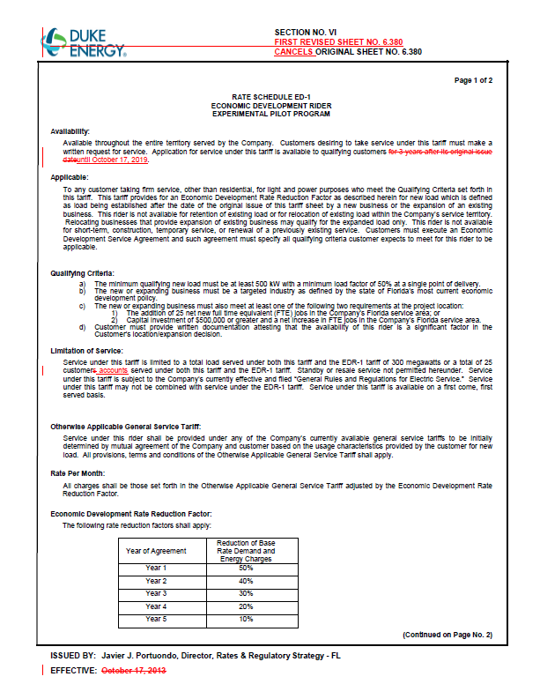
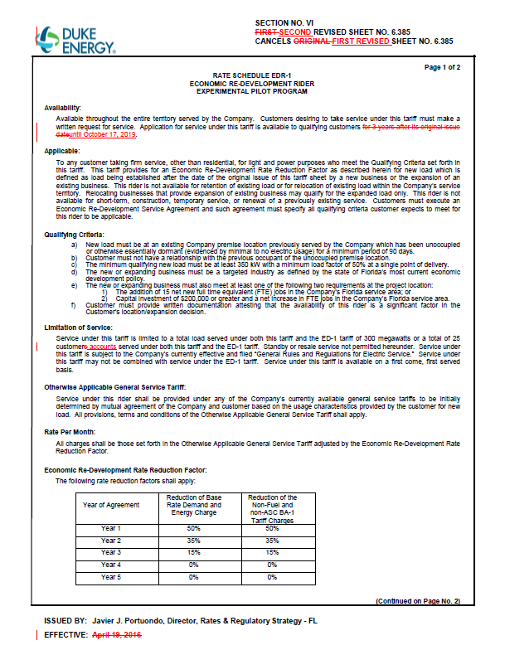
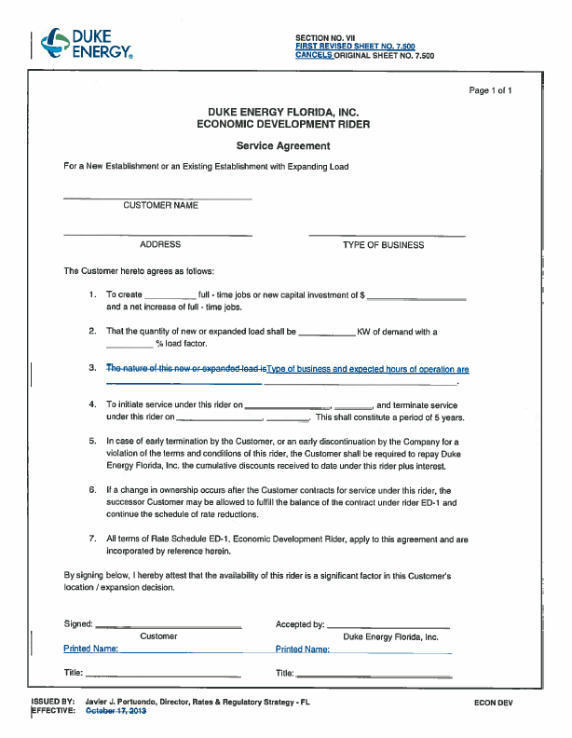
- 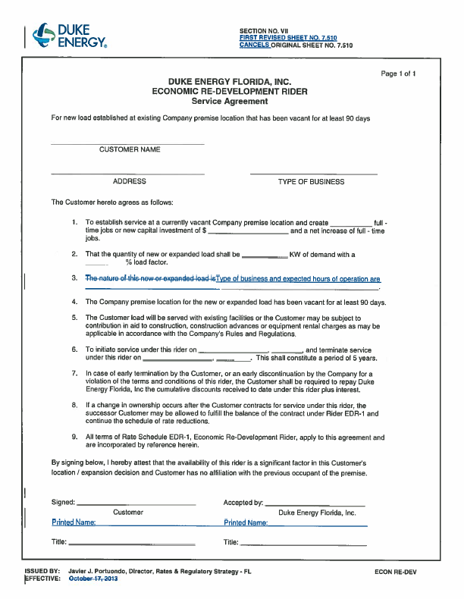

Order No. PSC-13-0598-FOF-EI, issued November 12, 2013, in Docket No. 130208-EI, In re: Petition for limited proceeding to approve revised and restated stipulation and settlement agreement by Duke Energy Florida, Inc. d/b/a Duke Energy.
The EDR-1 rider also provides a reduction of the non-fuel and non-asset securitization charge factors.

