BEFORE THE FLORIDA PUBLIC SERVICE COMMISSION

In re: Joint petition for approval of revised swing service rider rates for the period January through December 2018, by Florida Public Utilities Company, Florida Public Utilities Company-Indiantown Division, Florida Public Utilities Company-Fort Meade and Florida Division of Chesapeake Utilities Corporation. | DOCKET NO. 20170191-GU  ORDER NO. PSC-2017-0442-TRF-GU  ISSUED: November 17, 2017

The following Commissioners participated in the disposition of this matter:

JULIE I. BROWN, Chairman
ART GRAHAM
RONALD A. BRISÉ
DONALD J. POLMANN
GARY F. CLARK

ORDER APPROVING REVISED SWING SERVICE RIDER TARIFF

BY THE COMMISSION:

Background
On September 1, 2017, Florida Public Utilities Company, Florida Public Utilities Company – Indiantown Division, and Florida Public Utilities Company – Fort Meade (jointly, FPUC), as well as the Florida Division of Chesapeake Utilities Corporation (Chesapeake) (jointly, Companies), filed a petition for approval of a revised swing service rider tariff for the period January through December 2018. FPUC is a local distribution company (LDC) subject to the regulatory jurisdiction of the Commission pursuant to Chapter 366, Florida Statues (F.S.). It is a wholly-owned subsidiary of Chesapeake Utilities Corporation which is headquartered in Dover, Delaware. Chesapeake is also an LDC subject to the Commission’s jurisdiction under Chapter 366, F.S. It is an operating division of Chesapeake Utilities Corporation.
We first approved the Companies’ swing service rider tariff in Order No. PSC-16-0422-TRF-GU (swing service order) and the initial swing service rider rates were in effect for the period March 2017 through December 2017. As required in the swing service order, the Companies submitted the instant petition with revised 2018 swing service rider rates for our approval by September 1, 2017. The swing service rider is a cents-per-therm charge that is included in the monthly gas bill of transportation customers. This Order addresses the 2018 swing service rider rates.
The Companies waived the 60-day file and suspend provision of Section 366.06(3), F.S., on September 18, 2017. During its evaluation of the petition, Commission staff issued a data request to the Companies for which a response was received on September 29, 2017. On October 23, 2017, the Companies filed a revised petition and associated tariff sheets to correct certain spreadsheet formulas used to compute the rates. The correction filed resulted in a minimal change to the calculations and the proposed rates. The proposed revised tariff sheets are shown in Attachment A, pages 1-4, to the Order. We have jurisdiction over this matter pursuant to Sections 366.06, 366.04, 366.05, and 366.06, F.S.
Decision
The Companies incur intrastate capacity costs when they transport gas on intrastate pipelines (i.e., pipelines operating within Florida only). The swing service rider allows the Companies to recover the intrastate capacity costs from their transportation customers as intrastate pipeline projects benefit all customers. The Companies have two types of natural gas customers: sales and transportation customers.
Sales customers are primarily residential and small commercial customers that purchase gas from an LDC and receive allocations of intrastate capacity costs through the Purchased Gas Adjustment (PGA) charge. Only Florida Public Utilities Company and Florida Public Utilities Company – Fort Meade have sales customers.
Transportation customers receive gas from third party marketers or shippers and, therefore, do not pay the PGA charge to the LDC. The Companies’ transportation customers can be categorized as TTS (Transitional Transportation Service) or non-TTS. TTS program shippers purchase gas for residential and small commercial customers, in aggregated customer pools, who do not contract directly with a shipper for their gas supply. Only Florida Public Utilities Company – Indiantown Division and Chesapeake have TTS customers.
TTS customers receive allocations of intrastate capacity costs through the swing service rider. Prior to the approval of the swing service rider, TTS customers received allocations of intrastate capacity cost through the Operational Balancing Account (OBA) mechanism. The OBA mechanism allowed Indiantown and Chesapeake to assign intrastate capacity costs to TTS shippers, who then passed the costs on to the TTS customers for whom they purchase gas. With the approval of the swing service rider, TTS customers are now charged directly their allocated portion of the intrastate capacity costs (rather than Indiantown and Chesapeake charging the shippers who then passed the costs on to the TTS customers).
Non-TTS customers are primarily large commercial or industrial customers who contract directly with a shipper for their gas supply. Prior to the approval of the swing service rider, non-TTS customers were not paying a share of the intrastate capacity costs. We approved a stepped implementation process for the swing service rider for non-TTS customers because the implementation of the swing service rider could have a significant financial impact on those customers who previously had not been allocated any portion of the intrastate capacity costs.
Specifically, the swing service order approved a five-year implementation period for non-TTS customers with a 20 percent per year stepped allocation. Accordingly, the 2017 swing service charges included a 20 percent allocation of intrastate capacity costs to the non-TTS customers; the instant petition includes a 40 percent allocation of intrastate capacity costs to the non-TTS customers.
Proposed Swing Service Rider Rates
The proposed 2018 swing service rider rates, as revised on October 23, 2017, were calculated based on the same methodology approved in the swing service order. As shown in the Companies’ revised petition, the total intrastate capacity costs for the period July 2016 through June 2017 are $5,166,583. Some of these costs ($313,726) will be billed directly to certain large special contract customers. The remaining costs, $4,852,857 ($5,166,583 - $313,726), are allocated between sales and transportation customers.
The Companies used actual therm usage data for the period July 2016 through June 2017 to allocate the intrastate capacity costs. Based on the usage data, the appropriate split for allocating the cost is 70.12 percent ($3,402,998) to transportation customers and 29.88 percent ($1,449,859) to sales customers. The sales customers’ share of the cost is embedded in the PGA.
The transportation customers’ share is allocated to the various transportation rate schedules in proportion with each rate schedule’s share of the Companies’ total throughput. The cost allocated to each rate schedule is then divided by the rate schedule’s number of therms to calculate the swing service rider rates.
As stated earlier, TTS customers are charged their allocated portion of the intrastate capacity costs, while non-TTS customers are subject to a phased implementation. Since non-TTS customers are only allocated 40 percent of the total intrastate capacity costs, the 2018 swing service revenues the Companies will receive will total $1,550,837; the remaining $1,852,161 ($3,402,998 - $1,550,837) of intrastate capacity costs allocated to transportation customers will be recovered through the PGA from sales customers.
Credit to the PGA
The total intrastate capacity costs are embedded in the PGA with the projected 2018 swing service rider revenues incorporated as a credit in the calculation of the 2018 PGA. The amount credited to the 2018 PGA is $1,550,837, plus $313,726 received from special contract customers, for a total of $1,864,563. At the end of the stepped implementation period in year five, non-TTS customers will no longer receive a reduced allocation of the intrastate capacity cost, the credit to the PGA will increase accordingly, and sales customers will no longer absorb a portion of the non-TTS intrastate capacity costs.
Conclusion
Based on our review of the information provided in the petition and in response to Commission staff’s data request, we find that the Companies’ proposed swing service rider is reasonable. We hereby approve the proposed swing service rider tariff, as revised on October 23, 2017, for the period January through December 2018.
Based on the foregoing, it is

ORDERED by the Florida Public Service Commission that the proposed swing service rider rates for Florida Public Utilities Company, Florida Public Utilities Company – Indiantown Division, Florida Public Utilities Company – Fort Meade and the Florida Division of Chesapeake Utilities Corporation, as revised on October 23, 2017, for the period January through December 2018, are approved. It is further

ORDERED that if a protest is filed within 21 days of issuance of the Order, the tariff shall remain in effect with any charges held subject to refund pending resolution of the protest. It is further

ORDERED that if no timely protest is filed, this docket shall be closed upon the issuance of a Consummating Order.

By ORDER of the Florida Public Service Commission this 17th day of November, 2017.

/s/ Hong Wang
HONG WANG
Chief Deputy Commission Clerk
Florida Public Service Commission
2540 Shumard Oak Boulevard
Tallahassee, Florida 32399
(850) 413-6770
www.floridapsc.com

Copies furnished: A copy of this document is provided to the parties of record at the time of issuance and, if applicable, interested persons.

WDT

NOTICE OF FURTHER PROCEEDINGS

The Florida Public Service Commission is required by Section 120.569(1), Florida Statutes, to notify parties of any administrative hearing or judicial review of Commission orders that is available under Sections 120.57 or 120.68, Florida Statutes, as well as the procedures and time limits that apply. This notice should not be construed to mean all requests for an administrative hearing or judicial review will be granted or result in the relief sought.

Mediation may be available on a case-by-case basis. If mediation is conducted, it does not affect a substantially interested person's right to a hearing.

The Commission's decision on this tariff is interim in nature and will become final, unless a person whose substantial interests are affected by the proposed action files a petition for a formal proceeding, in the form provided by Rule 28-106.201, Florida Administrative Code. This petition must be received by the Office of Commission Clerk, 2540 Shumard Oak Boulevard, Tallahassee, Florida 32399-0850, by the close of business on December 8, 2017.

In the absence of such a petition, this Order shall become final and effective upon the issuance of a Consummating Order.

Any objection or protest filed in this docket before the issuance date of this order is considered abandoned unless it satisfies the foregoing conditions and is renewed within the specified protest period.

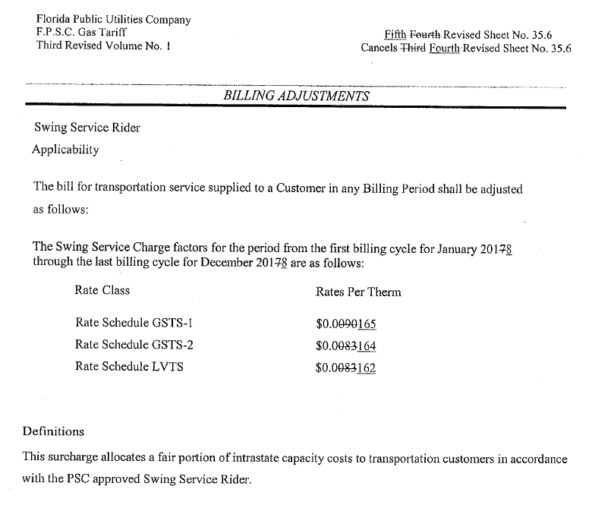

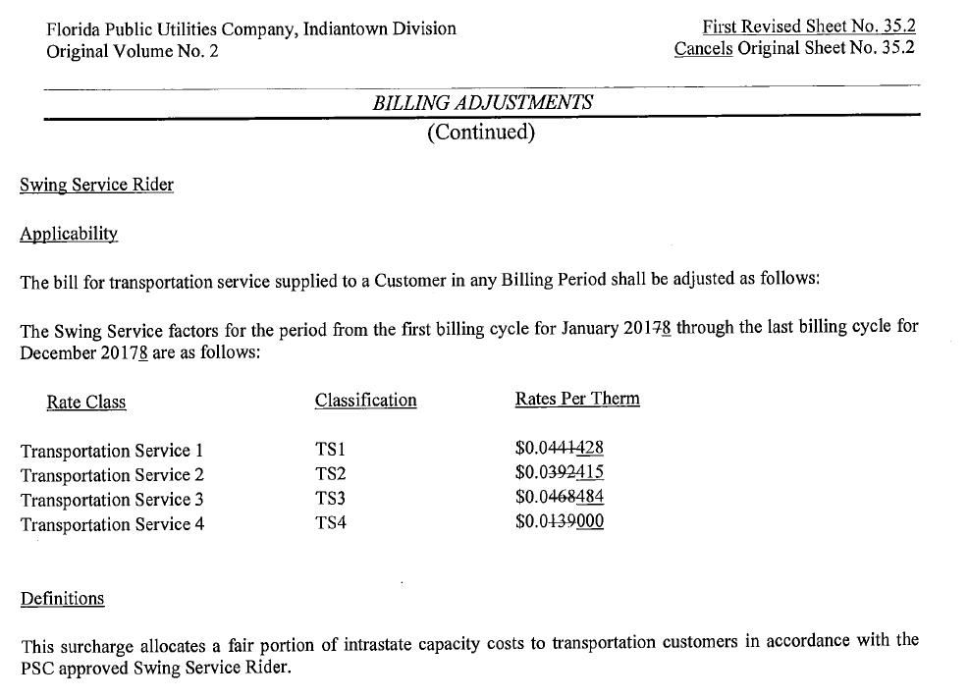

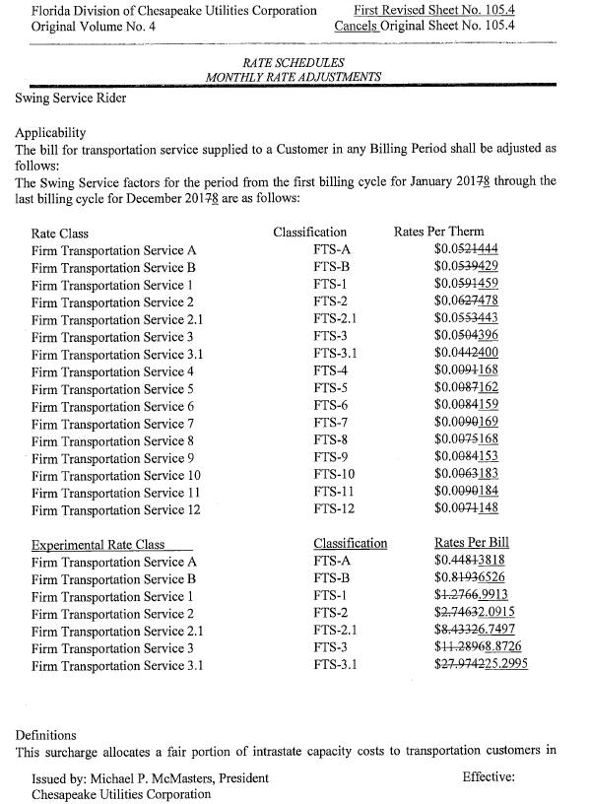
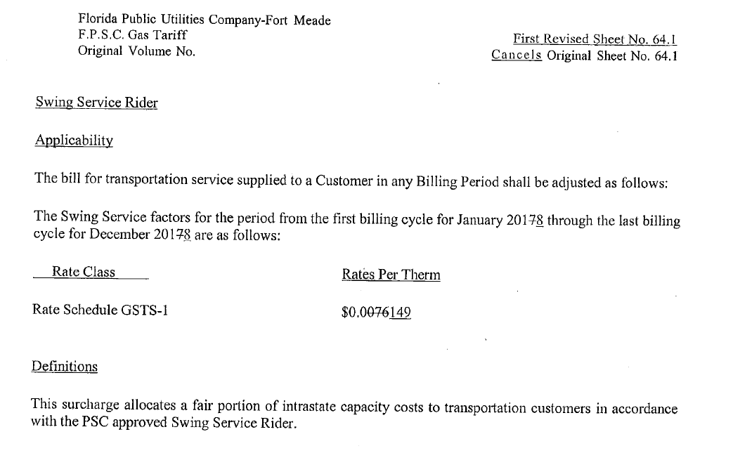

Order No. PSC-16-0422-TRF-GU, issued October 3, 2016, Docket No. 160085-GU, In re: Joint petition for approval of swing service rider, by Florida Public Utilities Company, Florida Public Utilities Company-Indiantown Division, Florida Public Utilities Company-Fort Meade, and Florida Division of Chesapeake Utilities Corporation.
The PGA charge is set by this Commission in the annual PGA proceeding.
This Commission does not regulate the shippers and their charges for the gas commodity.
See Document No. 07559-2017, Revised Petition by Florida Public Utilities Company for Approval of PGA Factor filed on September 6, 2017, in Docket No. 20170003-GU. We note that the PGA reflects a credit of $1,864,388 based on the calculation contained in the original petition filed on September 1, 2017, in the instant docket.

