State of Florida |  | Public Service Commission  Capital Circle Office Center ● 2540 Shumard Oak Boulevard  Tallahassee, Florida 32399-0850  -M-E-M-O-R-A-N-D-U-M-
DATE: | January 25, 2018
TO: | Office of Commission Clerk (Stauffer)
FROM: | Division of Engineering (Thompson, Ellis, King)  Office of the General Counsel (Dziechciarz, Cuello)
RE: | Docket No. 20170226-EQ – Petition for approval of renewable energy tariff and standard offer contract, by Florida Power & Light Company.
AGENDA: | 02/06/18 – Regular Agenda – Proposed Agency Action – Interested Persons May Participate
COMMISSIONERS ASSIGNED: |  |  | All Commissioners
PREHEARING OFFICER: |  |  | Administrative
CRITICAL DATES: |  |  | None
SPECIAL INSTRUCTIONS: |  |  | None

Case Background
Section 366.91(3), Florida Statutes (F.S.), requires that each investor-owned utility (IOU) continuously offers to purchase capacity and energy from renewable generating facilities and small qualifying facilities. The Florida Public Service Commission (Commission) Rules 25-17.200 through 25-17.310, Florida Administrative Code (F.A.C.), implement the statute and requires each IOU to file with the Commission, by April 1 of each year, a revised standard offer contract based on the next avoidable fossil fueled generating unit of each technology type identified in the utility’s current Ten-Year Site Plan. On July 18, 2017, a final Commission Order was filed approving Florida Power & Light Company’s (FPL’s) standard offer contract with the Dania Beach Clean Energy Center denoted as its avoided unit.
Pursuant to Rule 25-17.250(2)(a)2, F.A.C., a standard offer contract should remain open until the utility files a petition for a need determination for the avoided unit. On October 20, 2017, FPL filed a petition for a determination of need for the Dania Beach Clean Energy Center, the 2022 avoidable unit identified in FPL’s current Ten-Year Site Plan and the basis for the standard offer contract approved in Docket No. 20170077-EQ, as well as a petition for approval of its revised standard offer contract and rate schedule. On December 22, 2017, FPL filed an amended petition correcting the expected in-service date of the specified avoided unit. The Commission has jurisdiction over this standard offer contract pursuant to Sections 366.04 through 366.06, and 366.91, F.S.

Discussion of Issues

Issue 1:
Should the Commission approve the amended renewable energy tariff and standard offer contract filed by Florida Power & Light Company?

Recommendation:
Yes. The provisions of FPL’s revised renewable energy tariff and standard offer contract conform to the requirements of Rules 25-17.200 through 25-17.310, F.A.C. FPL does not have any avoidable fossil fueled generating units or avoidable power purchases in the upcoming 10-year planning period. However, FPL has identified its next avoidable unit rather than offer only energy payments in its standard offer contract. FPL’s revised standard offer contract provides flexibility in the arrangement for payments so that a developer of renewable generation may select the payment stream best suited to its financial needs. Staff recommends that FPL’s revised renewable energy tariff and standard offer contract be approved as filed. (Thompson)

Staff Analysis:
Rule 25-17.250, F.A.C., requires that FPL, an IOU, continuously make available a standard offer contract for the purchase of firm capacity and energy from renewable generating facilities (RF) and small qualifying facilities (QF) with design capacities of 100 kilowatts (kW) or less. Pursuant to Rules 25-17.250(1) and (3), F.A.C., the standard offer contract must provide a term of at least 10 years, and the payment terms must be based on the utility’s next avoidable fossil-fueled generating unit identified in its most recent Ten-Year Site Plan or, if no avoided unit is identified, its next avoidable planned purchase.
Due to FPL’s recent need determination filing, its 2017 Ten-Year Site Plan no longer includes any avoidable fossil fueled generating units. In addition, there are not any long term planned purchases to be avoided or deferred during the 2017-2026 planning period. As a result, FPL could opt to offer only a standard contract for energy payments based on its as-available energy cost. However, in an effort to encourage renewable generation, FPL has identified its next avoidable unit which is a 1,752 megawatt (MW) natural gas-fired combined cycle (CC) unit at a greenfield site with an expected in-service date of June 1, 2028. To reflect the new avoidable unit, cost data has been revised in FPL’s standard offer contract. The Commission has approved using a unit outside of the Ten-Year Site Plan planning period previously.
The RF/QF operator may elect to make no commitment as to the quantity or timing of its deliveries to FPL, and to have a committed capacity of zero (0) MW. Under such a scenario, the energy is delivered on an as-available basis and the operator receives only an energy payment. Alternatively, the RF/QF operator may elect to commit to certain minimum performance requirements based on the identified avoided unit, such as being operational and delivering an agreed upon amount of capacity by the in-service date of the avoided unit, and thereby becomes eligible for capacity payments in addition to payments received for energy. The standard offer contract may also serve as a starting point for negotiation of contract terms by providing payment information to an RF/QF operator, in a situation where one or both parties desire particular contract terms other than those established in the standard offer.
In order to promote renewable generation, the Commission requires the IOU to offer multiple options for capacity payments, including the options to receive early or levelized payments. If the RF/QF operator elects to receive capacity payments under the normal or levelized contract options, it will receive as-available energy payments only until the in-service date of the avoided unit (in this case June 1, 2028), and thereafter, begin receiving capacity payments in addition to the energy payments. If either the early or early levelized option is selected, then the operator will begin receiving capacity payments earlier than the in-service date of the avoided unit. However, payments made under the early capacity payment options tend to be lower in the later years of the contract term because the net present value (NPV) of the total payments must remain equal for all contract payment options.
Table 1 below contains FPL’s estimates of the annual payments for each payment option available under the revised standard offer contract. It assumes an operator with a 50 MW facility, operating at a capacity factor of 94 percent, which is the minimum capacity factor required under the contract to qualify for full capacity payments. Normal and levelized capacity payments begin in 2028, reflecting the projected in-service date of the avoided CC unit (June 1, 2028).

Table 1 - Estimated Annual Payments to a 50 MW Renewable Facility
(94% Capacity Factor)
Year | Energy Payment | Capacity Payment (By Type)
 |  | Normal | Levelized | Early | Early Levelized
 | $(000) | $(000) | $(000) | $(000) | $(000)
2018 | 11,440 | - | - | - | -
2019 | 13,394 | - | - | - | -
2020 | 10,973 | - | - | - | -
2021 | 11,645 | - | - | - | -
2022 | 10,885 | - | - | - | -
2023 | 11,133 | - | - | - | -
2024 | 12,500 | - | - | 2,534 | 2,905
2025 | 12,420 | - | - | 2,598 | 2,905
2026 | 13,715 | - | - | 2,663 | 2,905
2027 | 14,649 | - | - | 2,729 | 2,905
2028 | 13,941 | 4,354 | 4,806 | 2,797 | 2,905
2029 | 15,373 | 4,463 | 4,806 | 2,867 | 2,905
2030 | 14,989 | 4,574 | 4,806 | 2,939 | 2,905
2031 | 15,169 | 4,689 | 4,806 | 3,013 | 2,905
2032 | 15,902 | 4,806 | 4,806 | 3,088 | 2,905
2033 | 16,620 | 4,926 | 4,806 | 3,165 | 2,905
2034 | 15,600 | 5,049 | 4,806 | 3,244 | 2,905
2035 | 16,001 | 5,175 | 4,806 | 3,325 | 2,905
2036 | 16,495 | 5,605 | 4,806 | 3,408 | 2,905
2037 | 16,657 | 5,437 | 4,806 | 4,494 | 2,905
Total | 279,501 | 48,777 | 48,061 | 41,864 | 40,668
NPV (2018$) | 134,265 | 15,847 | 15,847 | 15,847 | 15,847

Source: FPL’s Response to Staff’s Second Data Request

FPL’s revised renewable energy tariff and standard offer contract, in type-and-strike format, are included as Attachment A to this recommendation. Revisions include updates to the avoided unit, dates, and payment information which reflect the current economic and financial assumptions for the avoided unit costs.

Conclusion
The provisions of FPL’s revised renewable energy tariff and standard offer contract conform to the requirements of Rules 25-17.200 through 25-17.310, F.A.C. FPL does not have any avoidable fossil fueled generating units or avoidable power purchases in the upcoming 10-year planning period. However, FPL has identified its next avoidable unit rather than offer only energy payments in its standard offer contract. FPL’s revised standard offer contract provides flexibility in the arrangement for payments so that a developer of renewable generation may select the payment stream best suited to its financial needs. Staff recommends that FPL’s revised renewable energy tariff and standard offer contract be approved as filed.

Issue 2:
Should this docket be closed?

Recommendation:
Yes. This docket should be closed upon issuance of a consummating order, unless a person whose substantial interests are affected by the Commission’s decision files a protest within 21 days of the issuance of the Commission’s Proposed Agency Action Order. Potential signatories should be aware that, if a timely protest is filed, FPL’s standard offer contract may subsequently be revised. (Dziechciarz, Cuello)

Staff Analysis:
This docket should be closed upon the issuance of a consummating order, unless a person whose substantial interests are affected by the Commission’s decision files a protest within 21 days of the issuance of the Commission’s Proposed Agency Action Order. Potential signatories should be aware that, if a timely protest is filed, FPL’s standard offer contract may subsequently be revised.

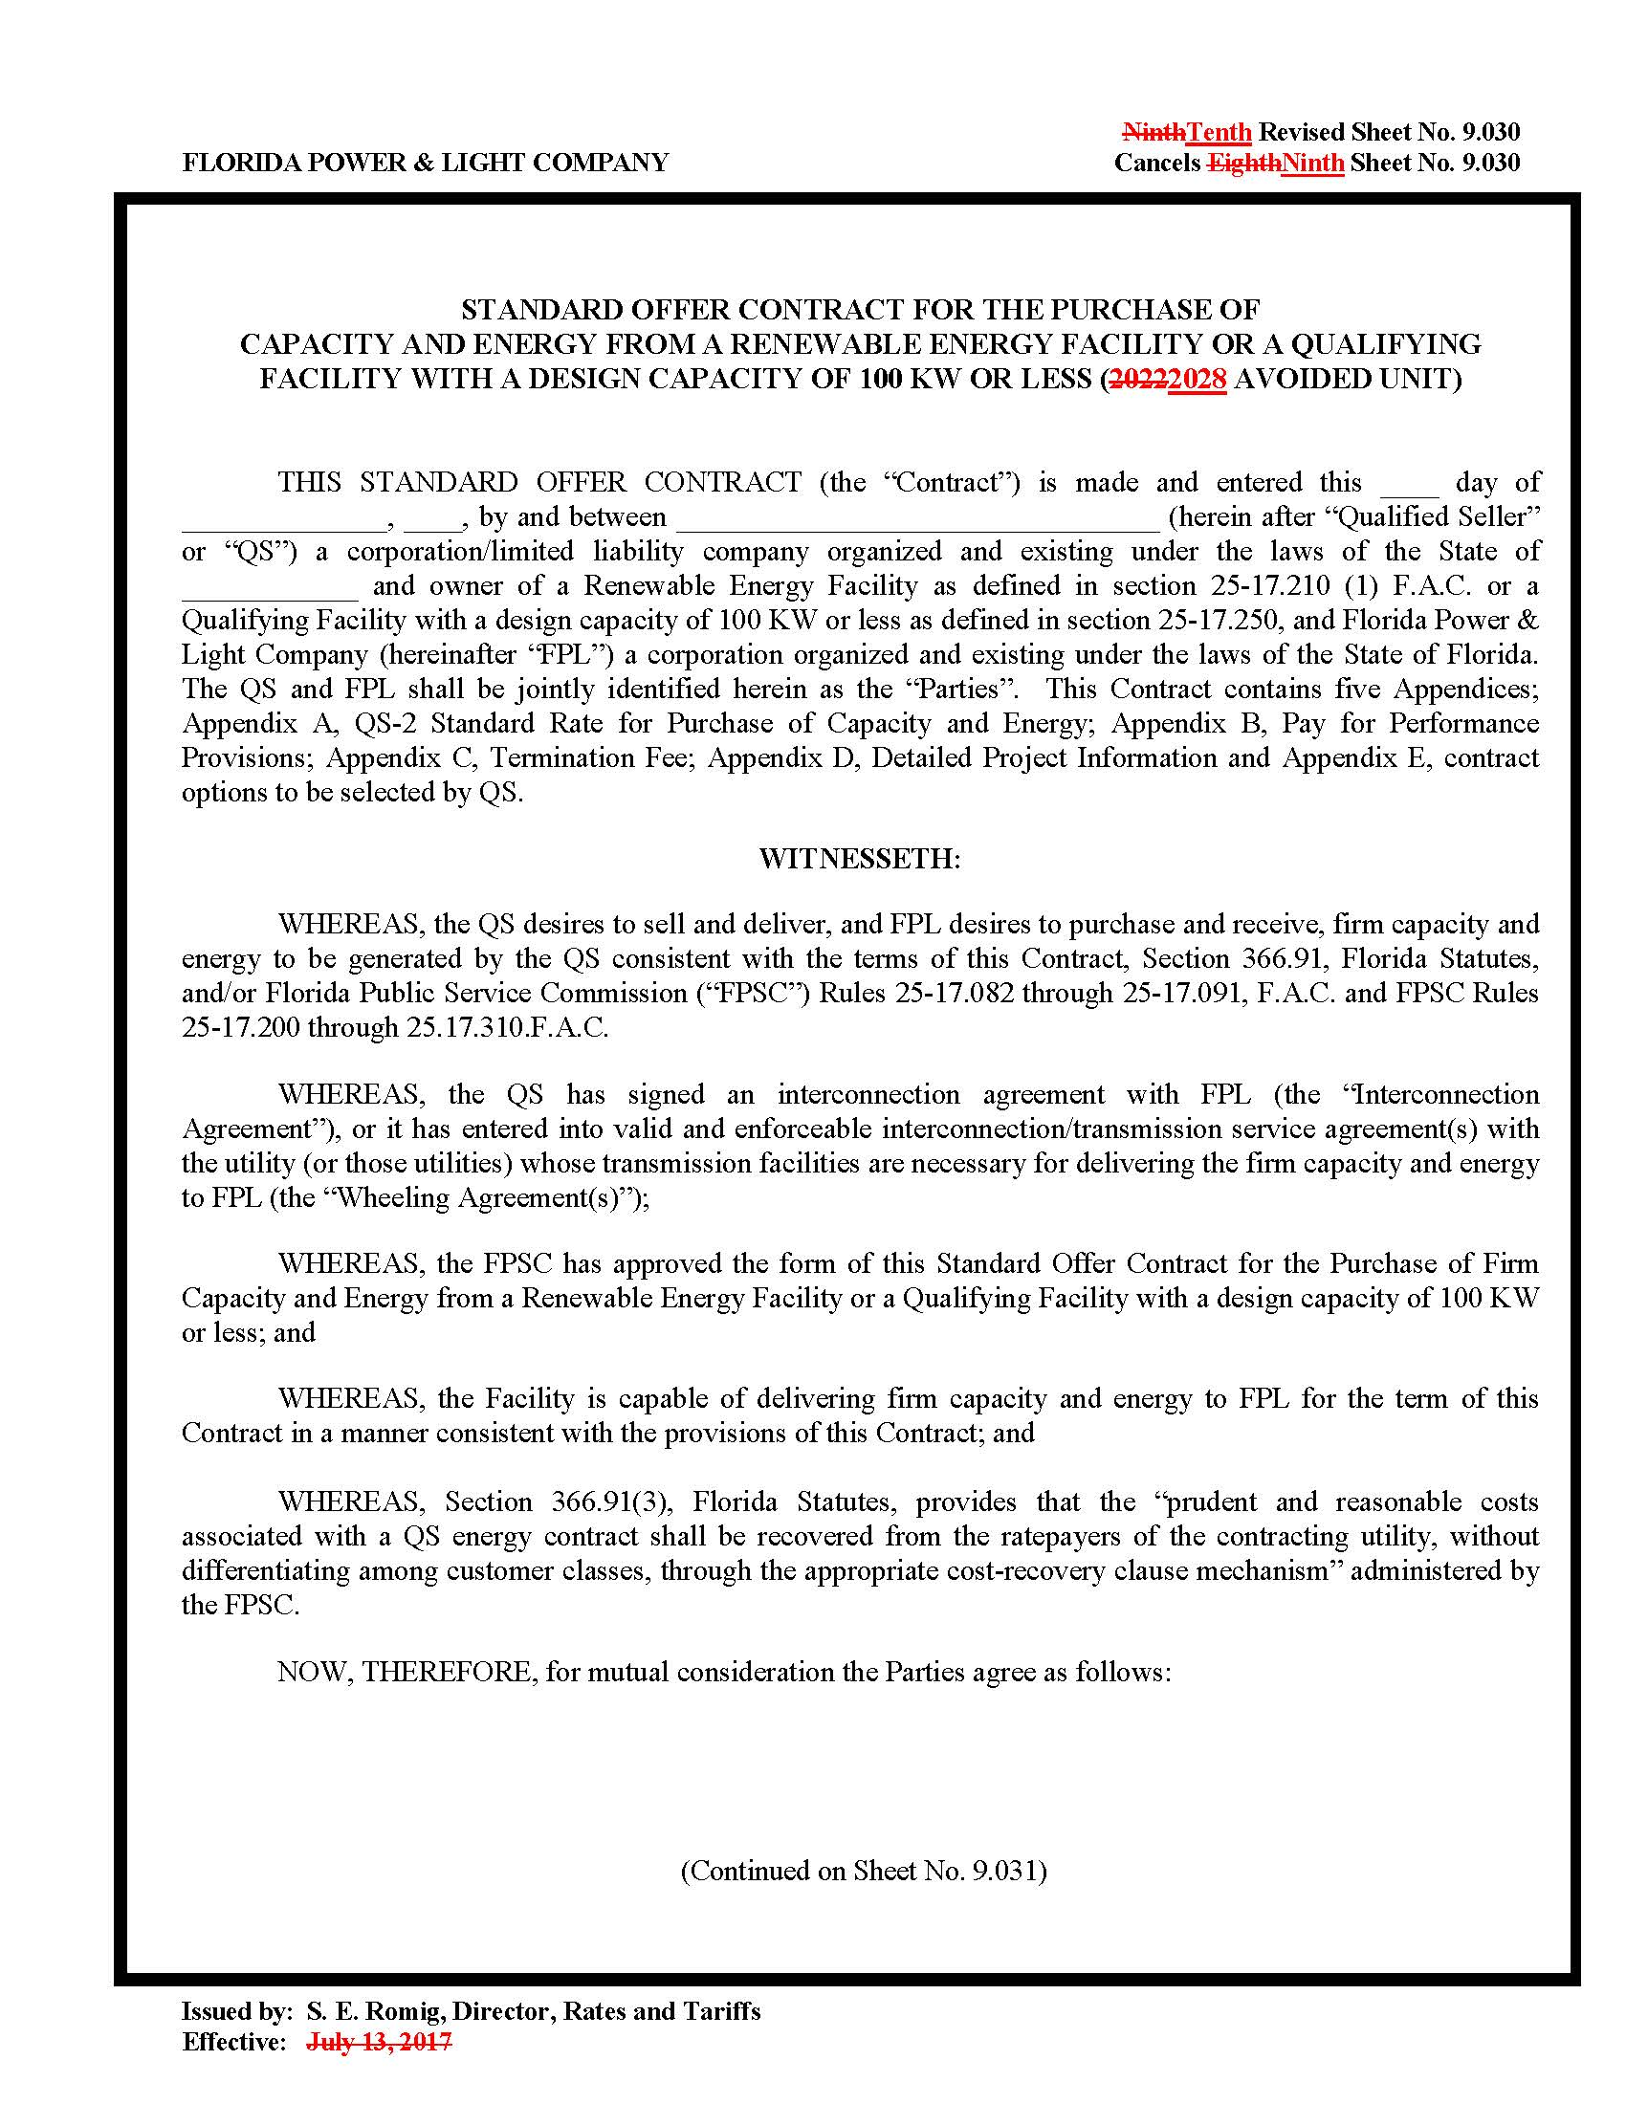
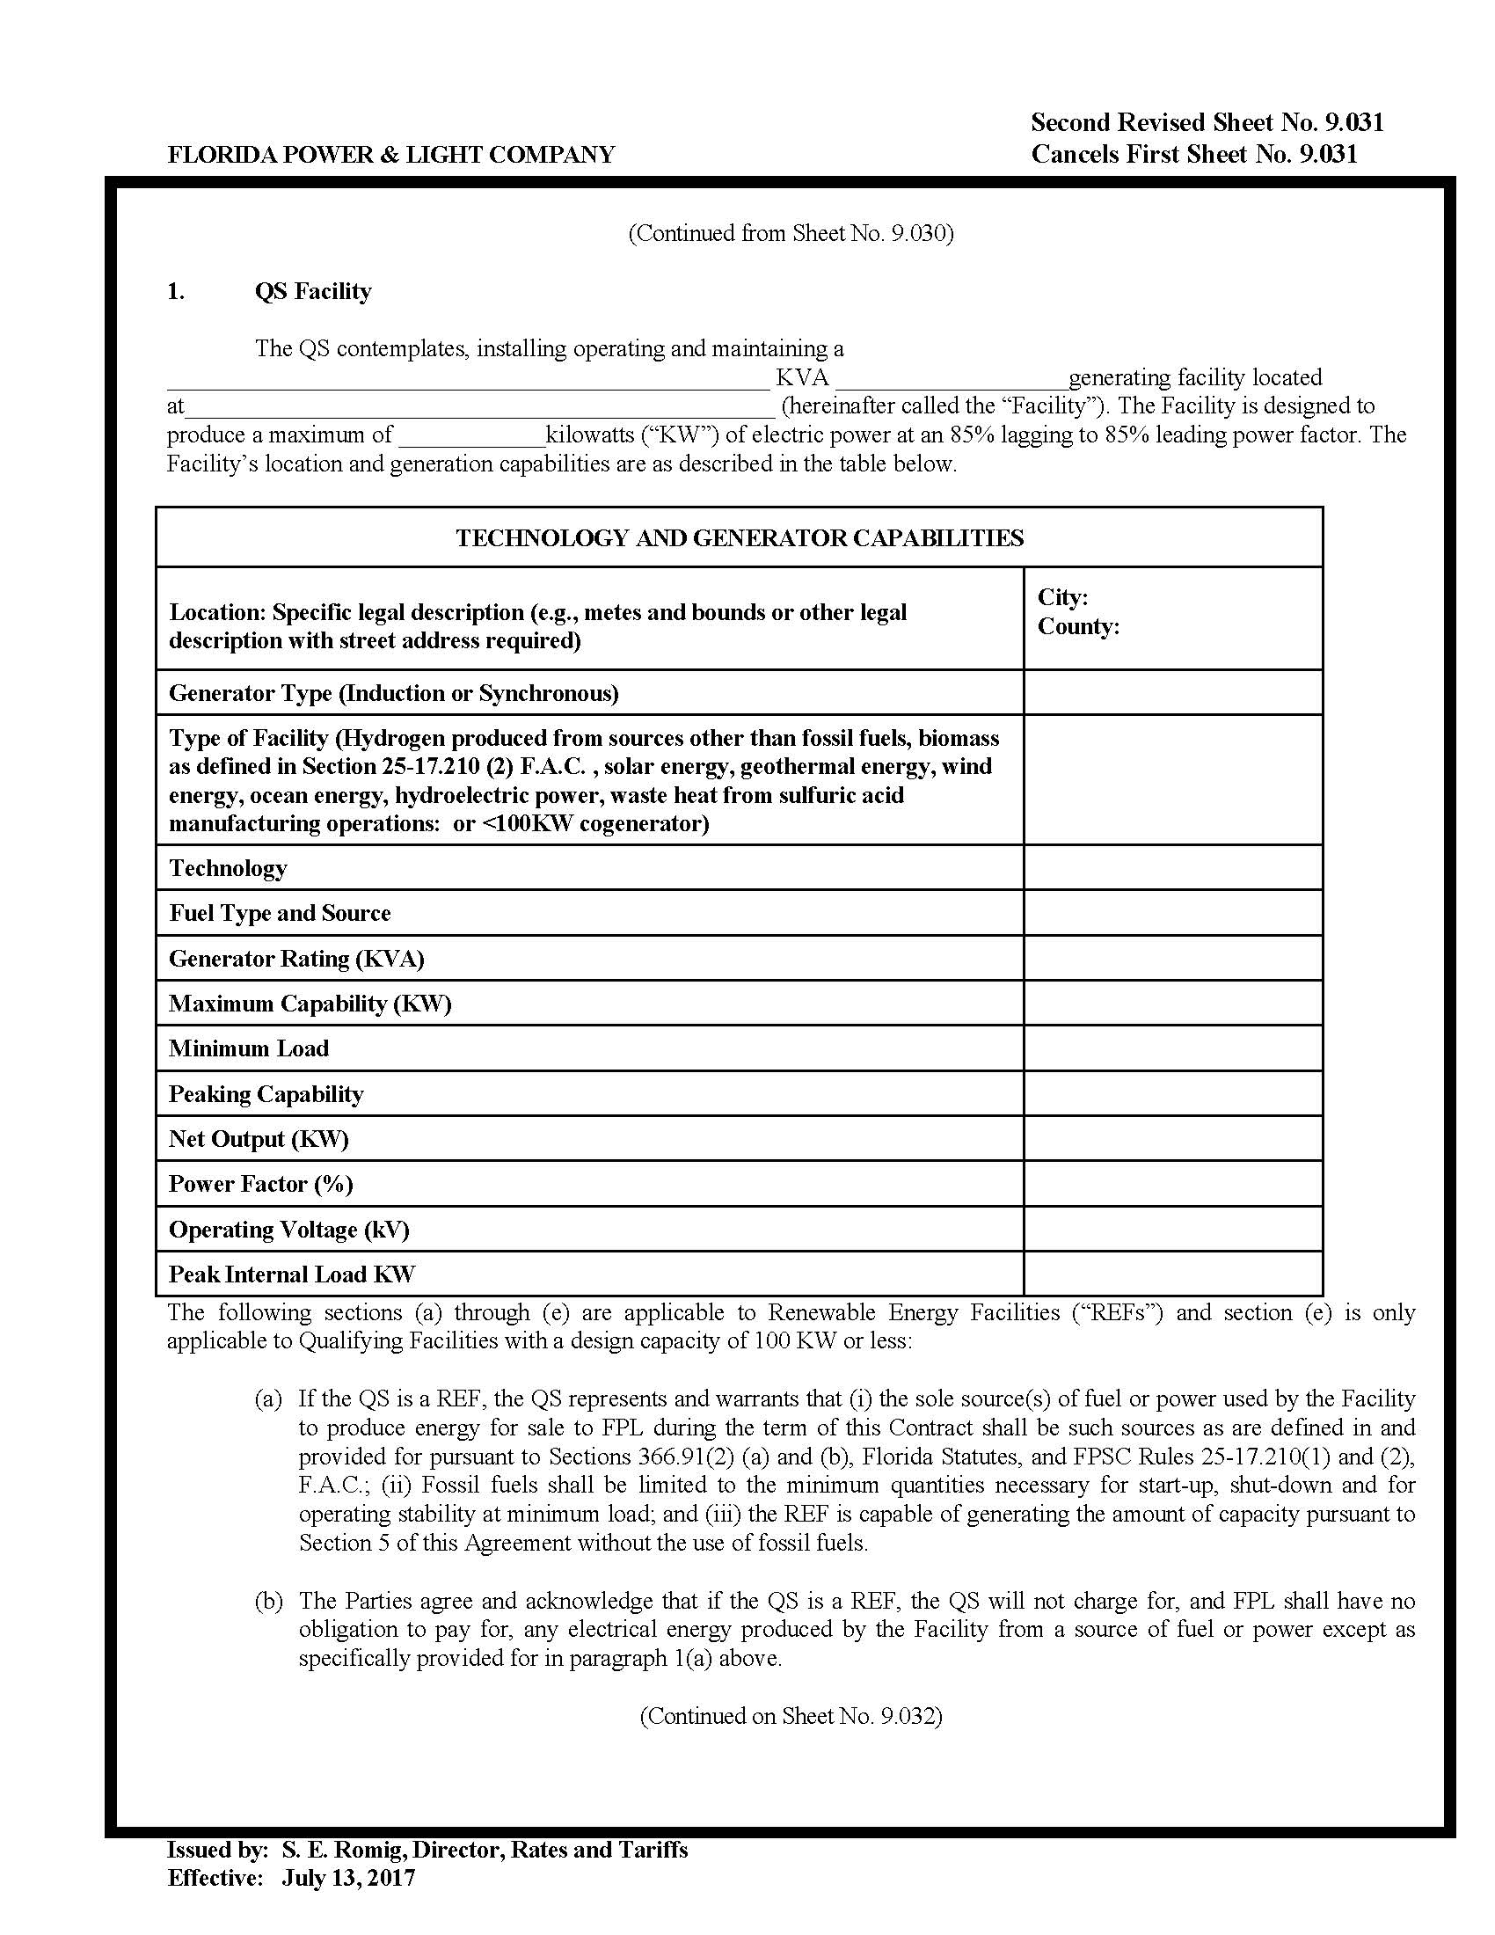

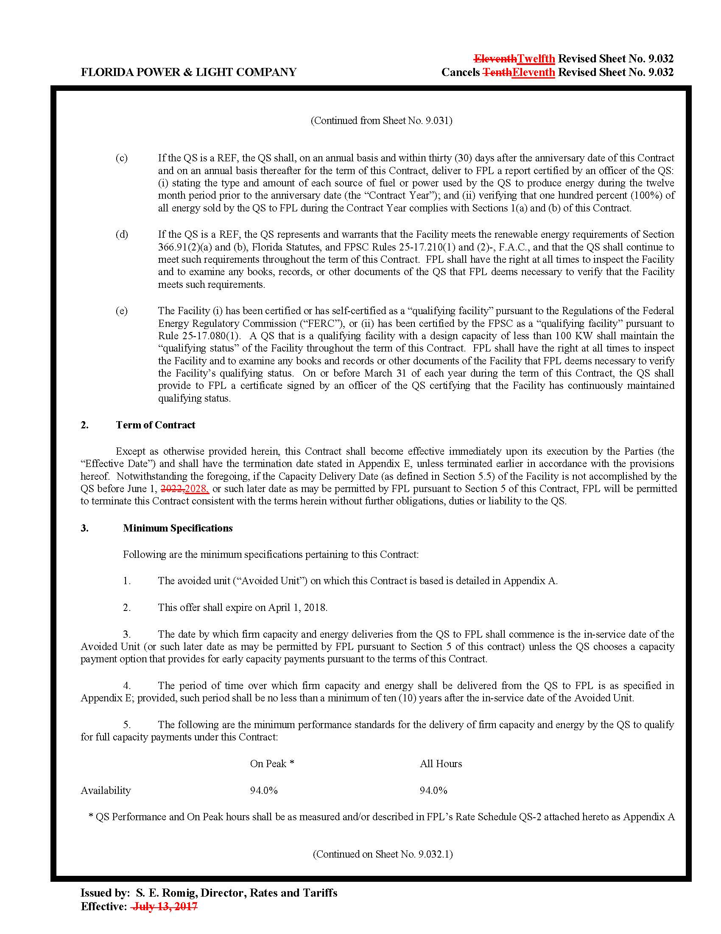

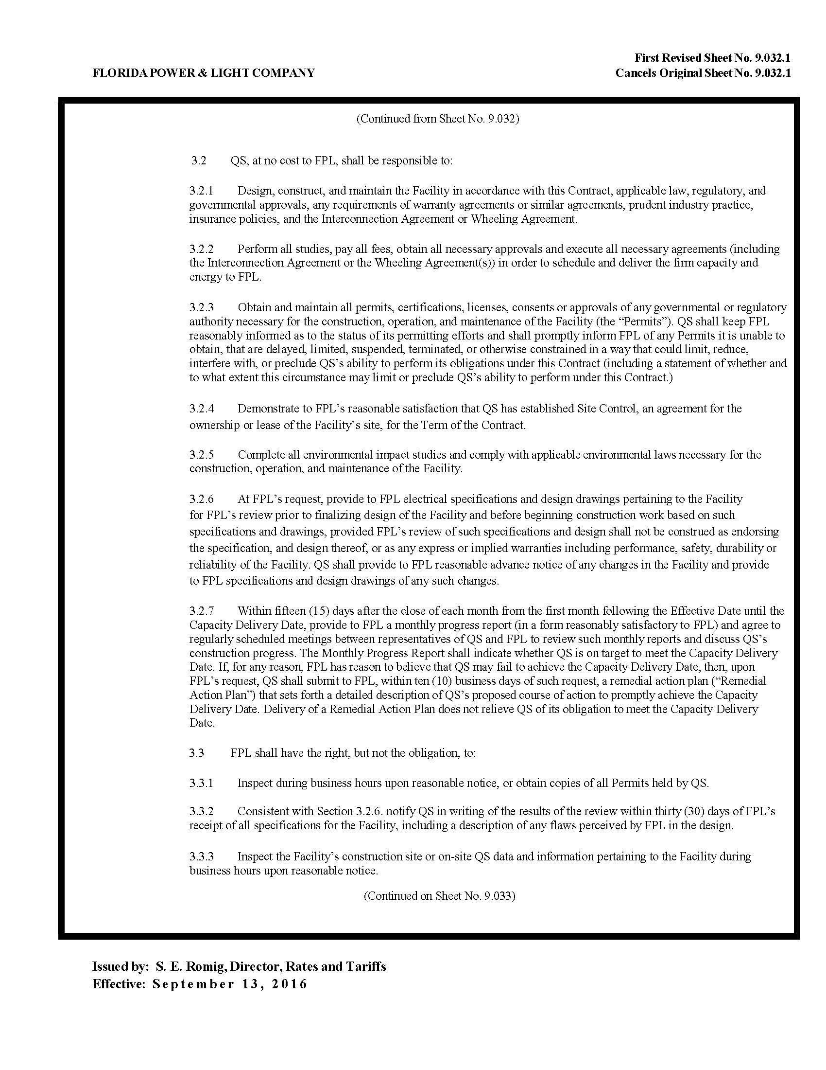

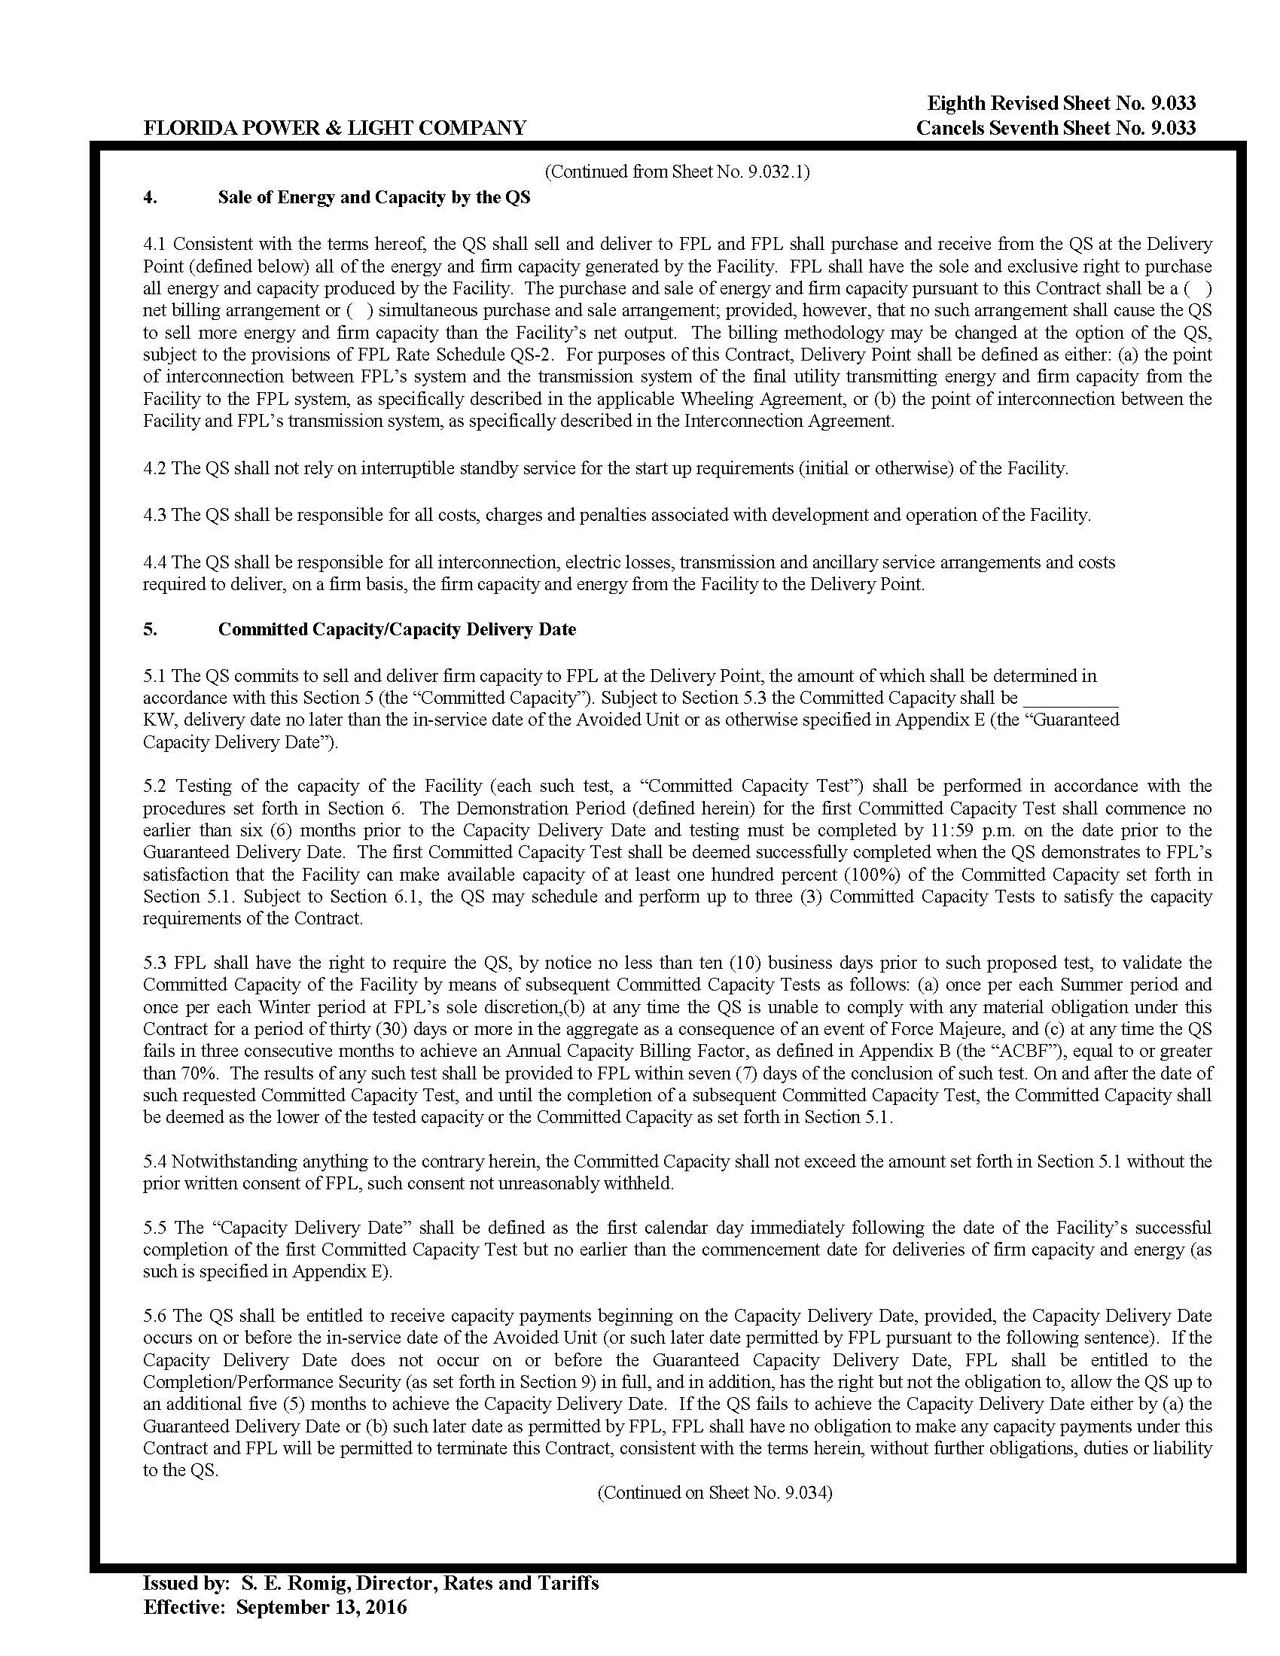

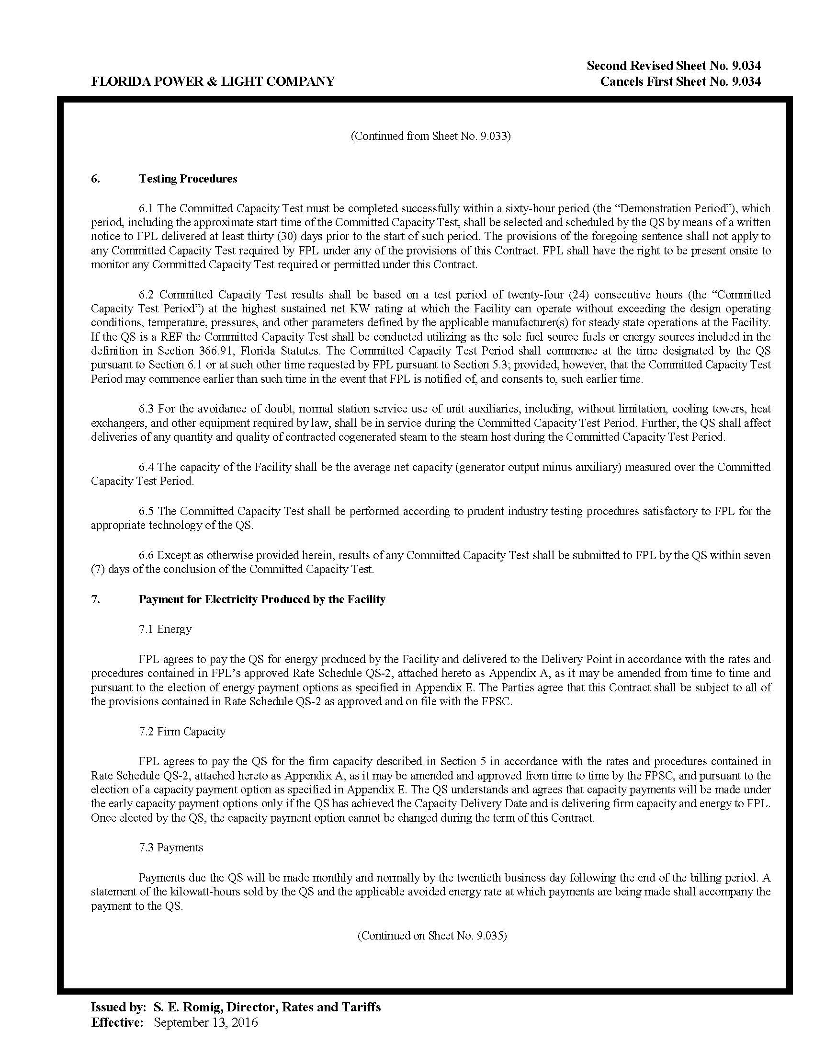

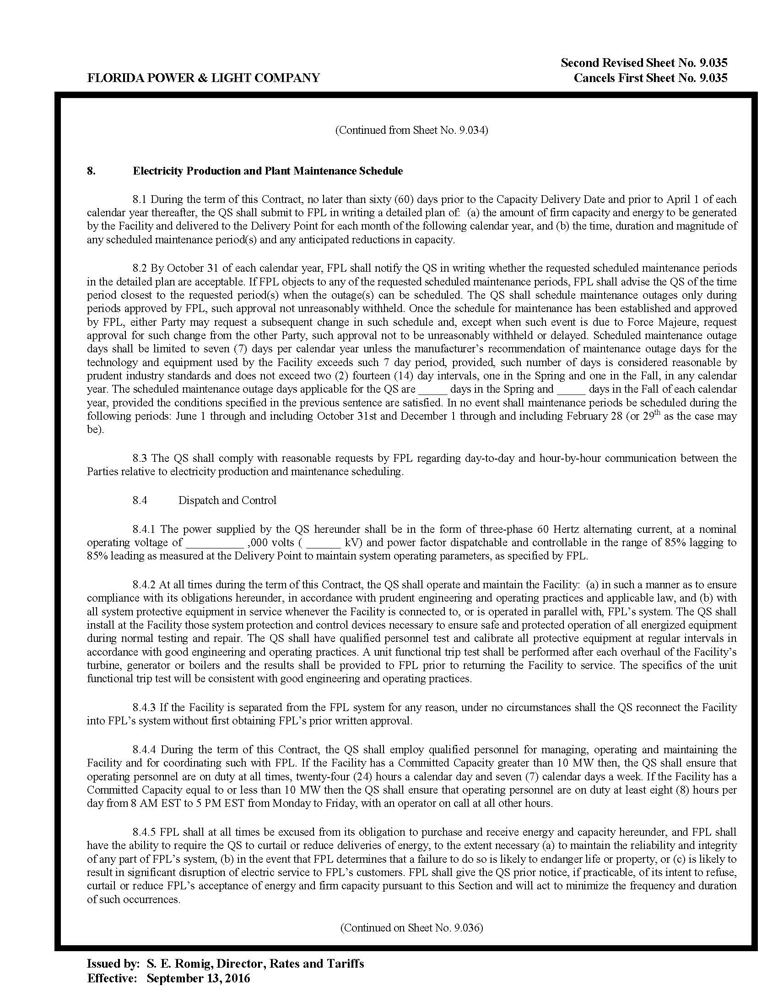

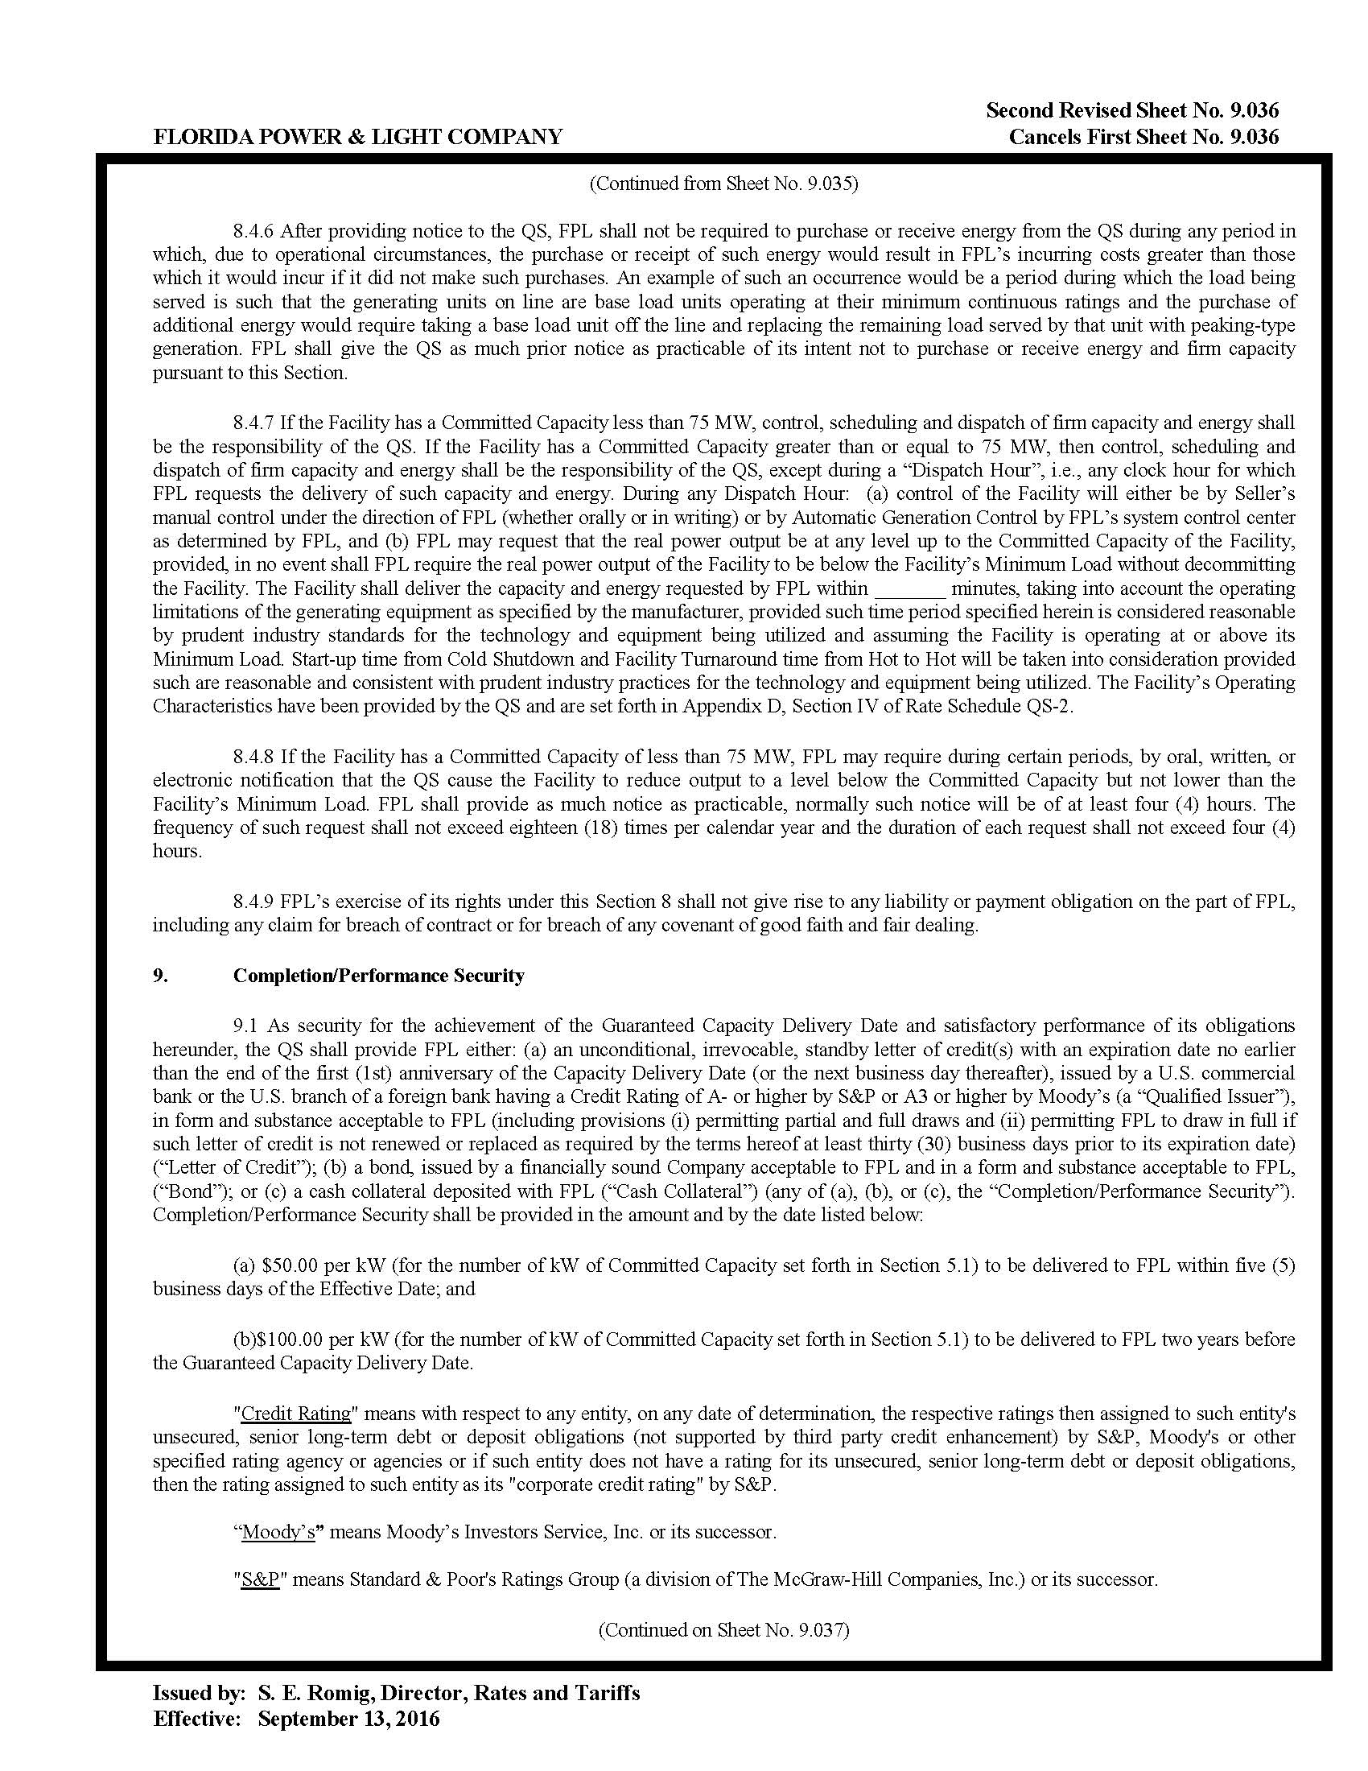

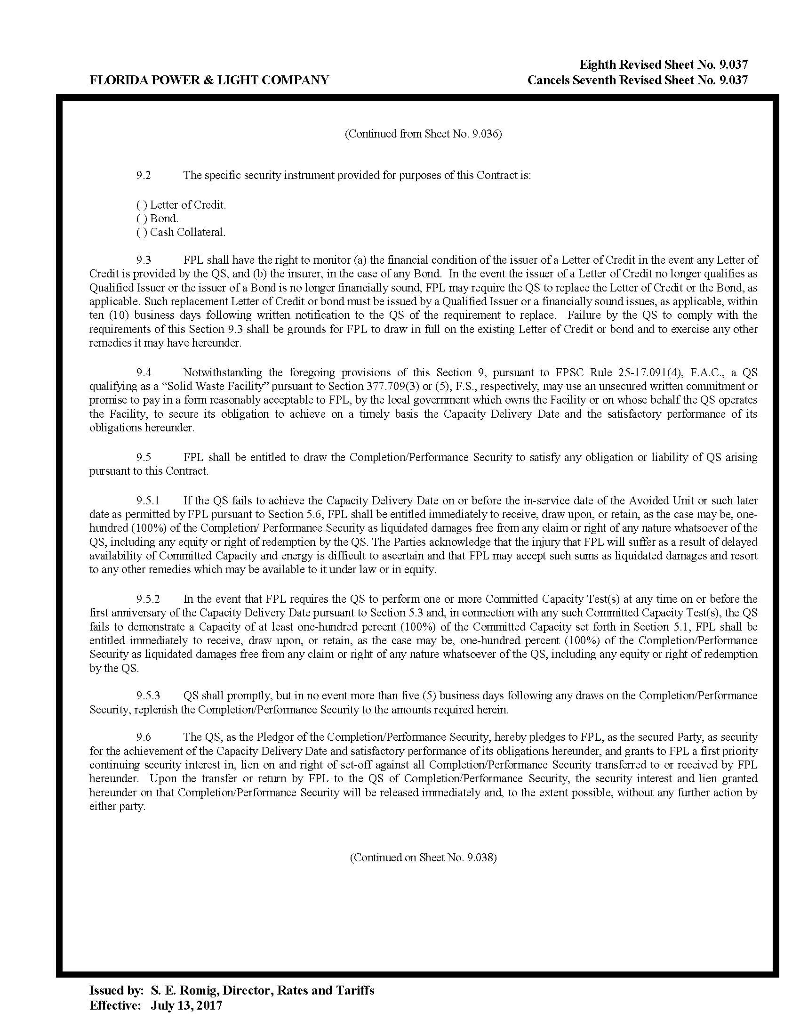

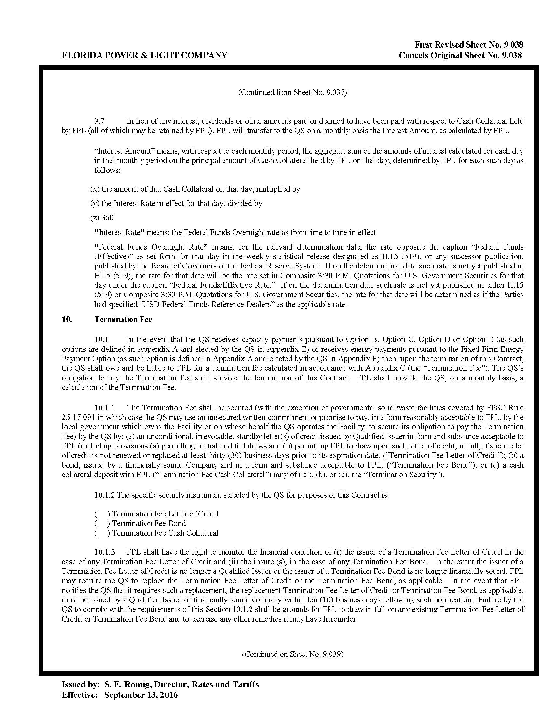

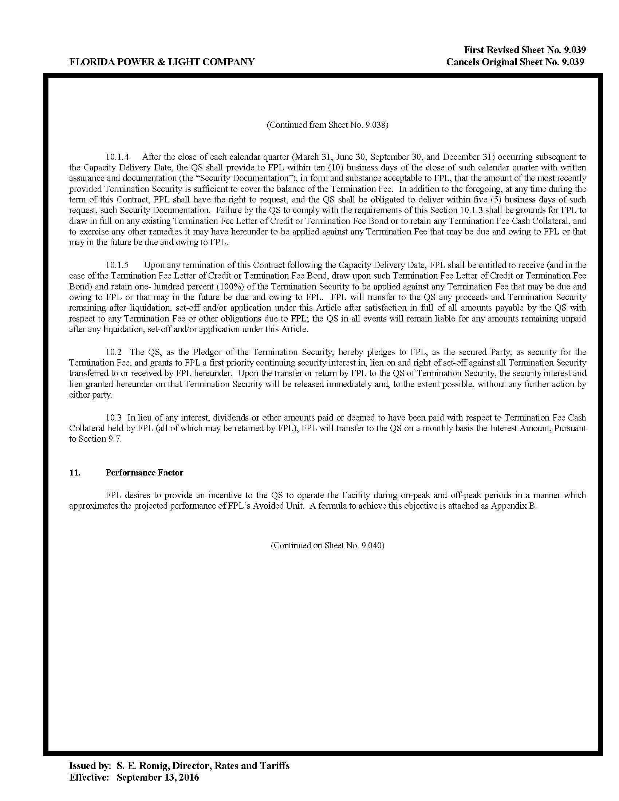

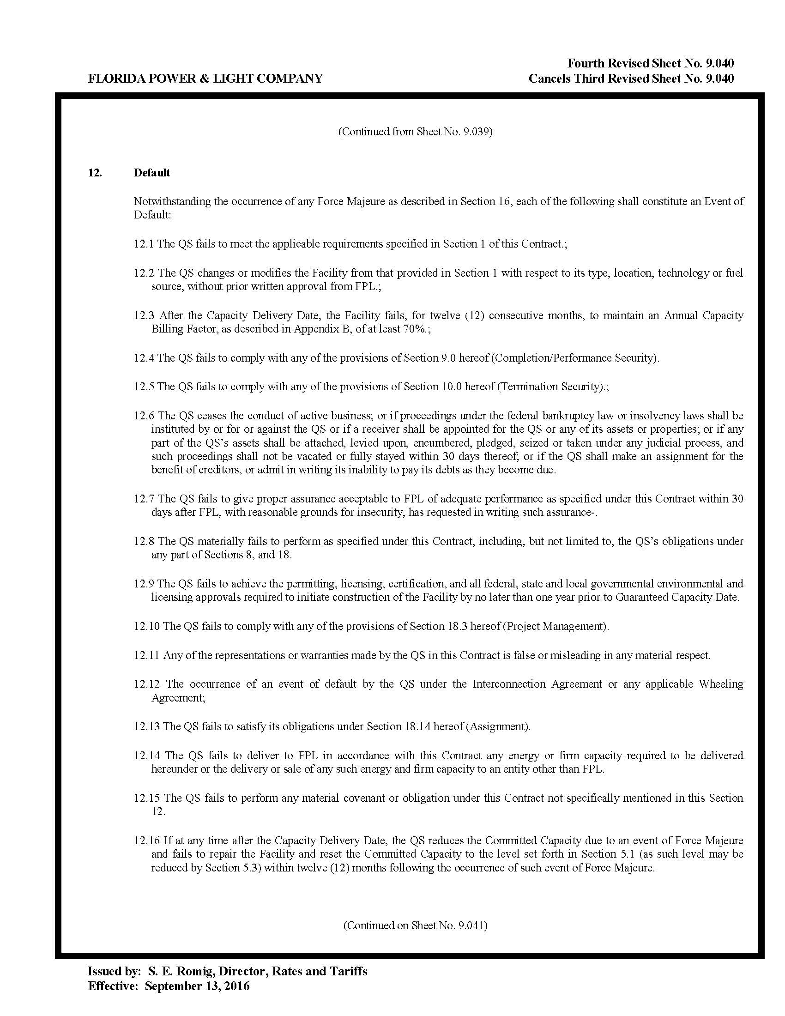

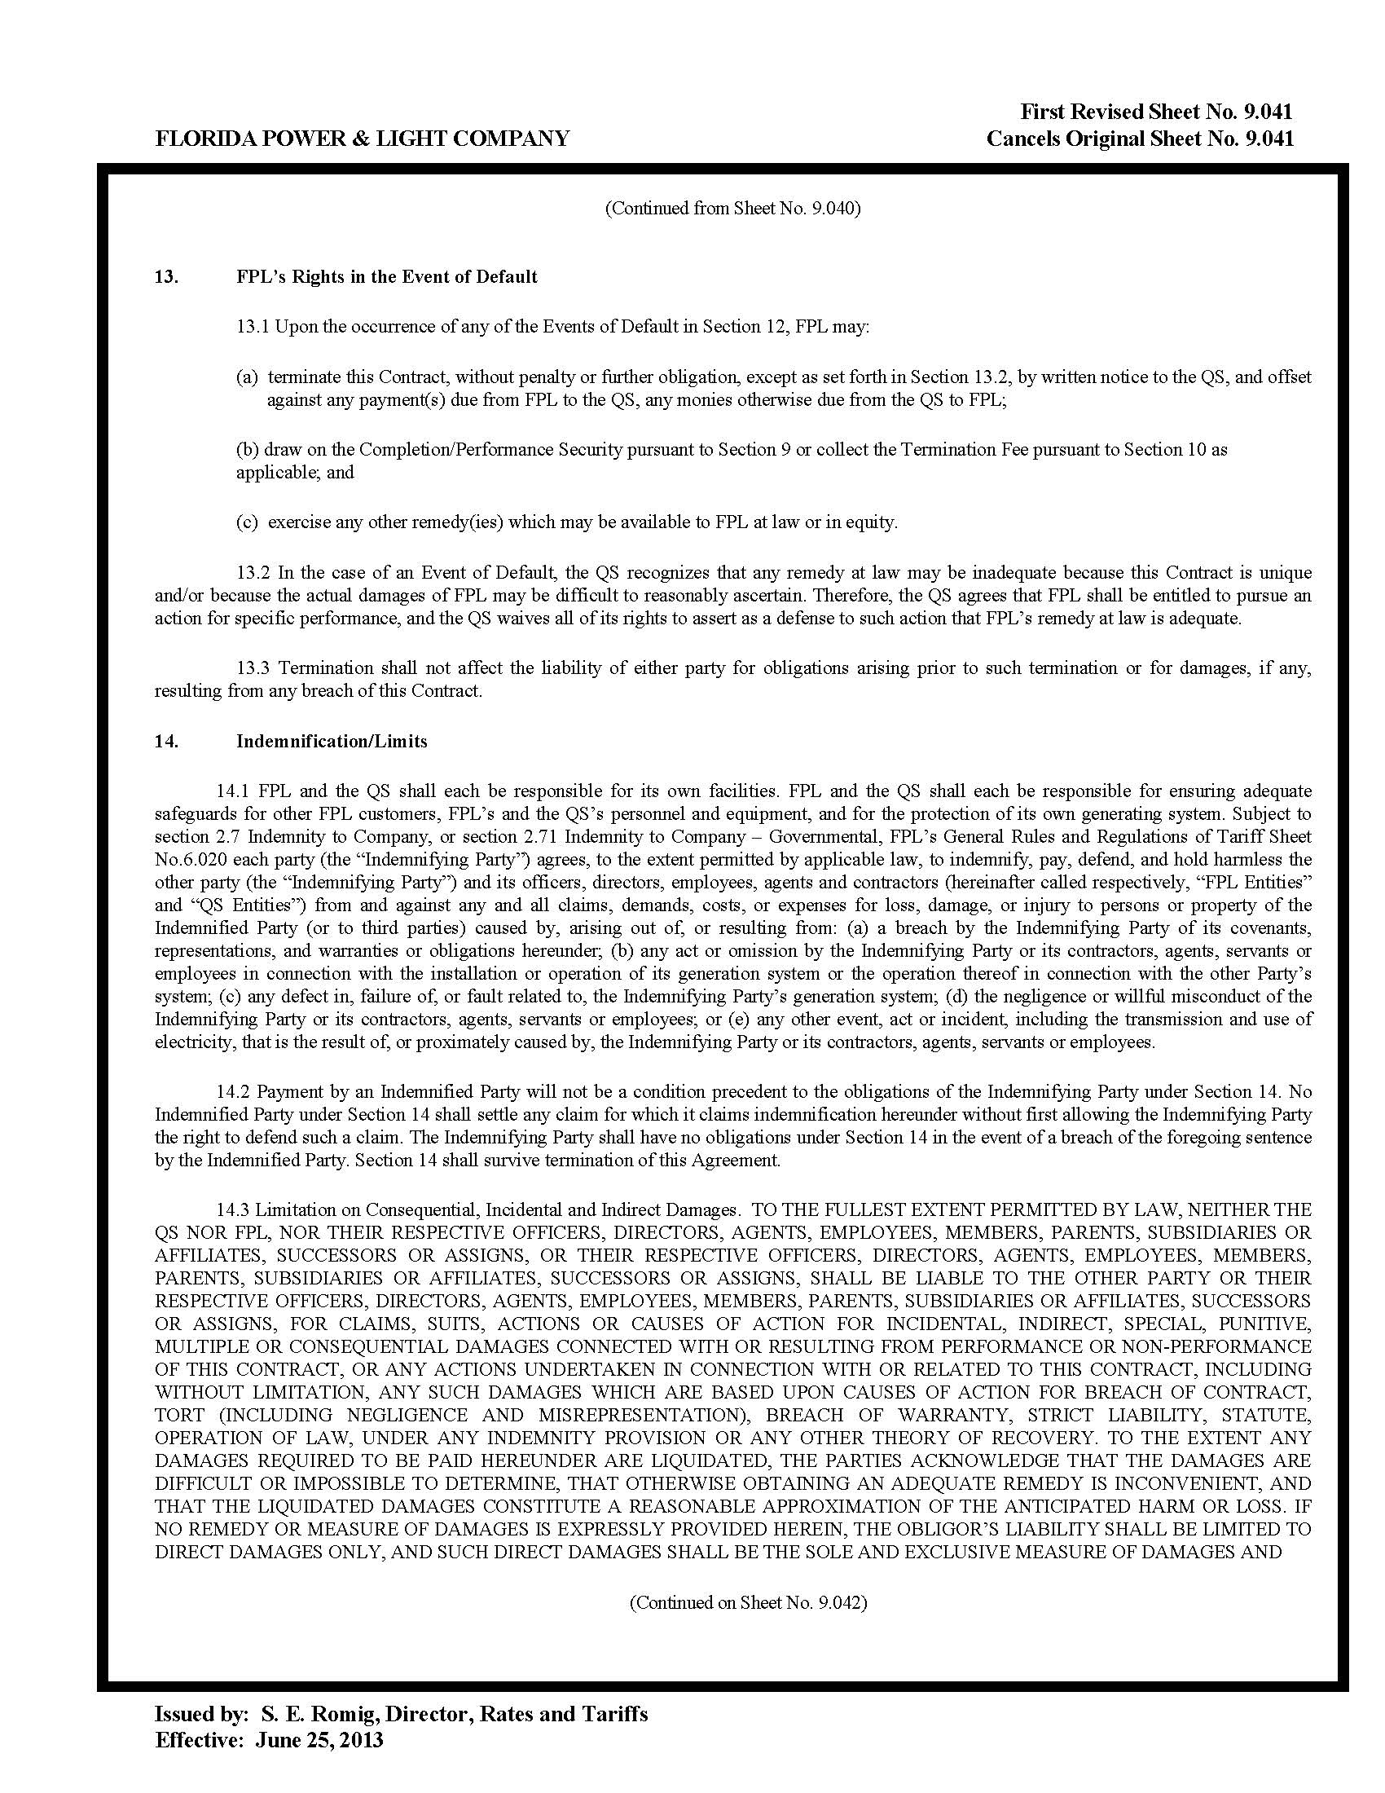

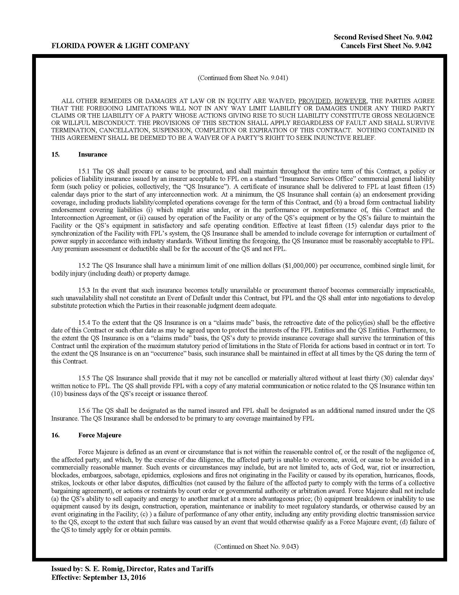

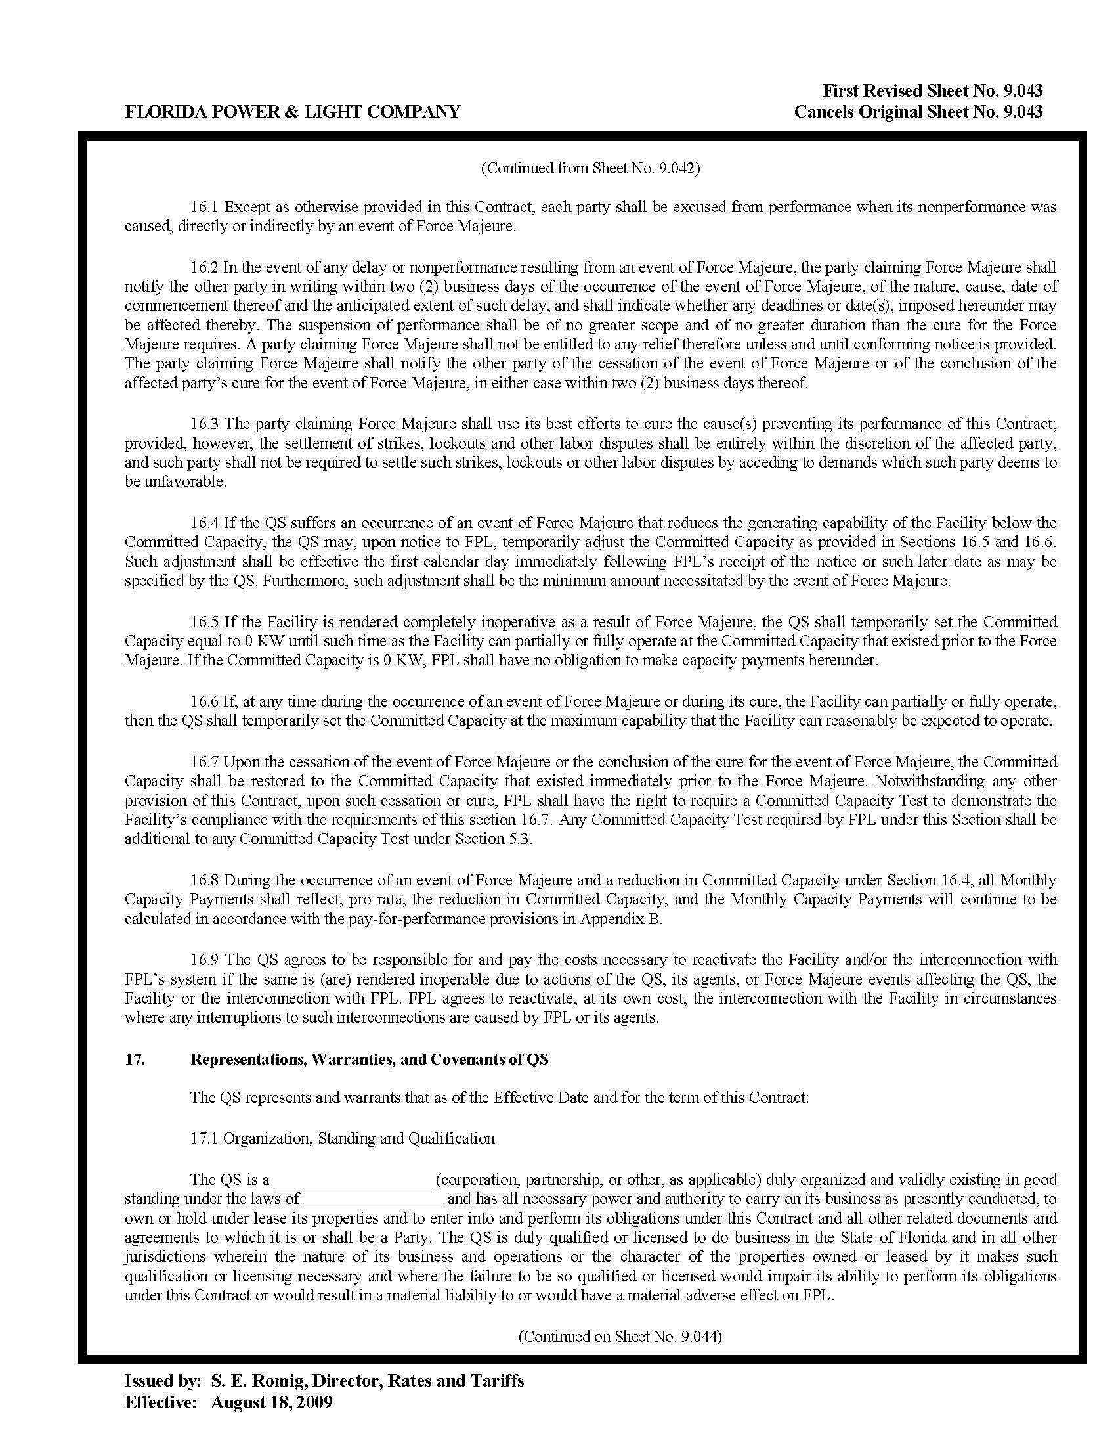

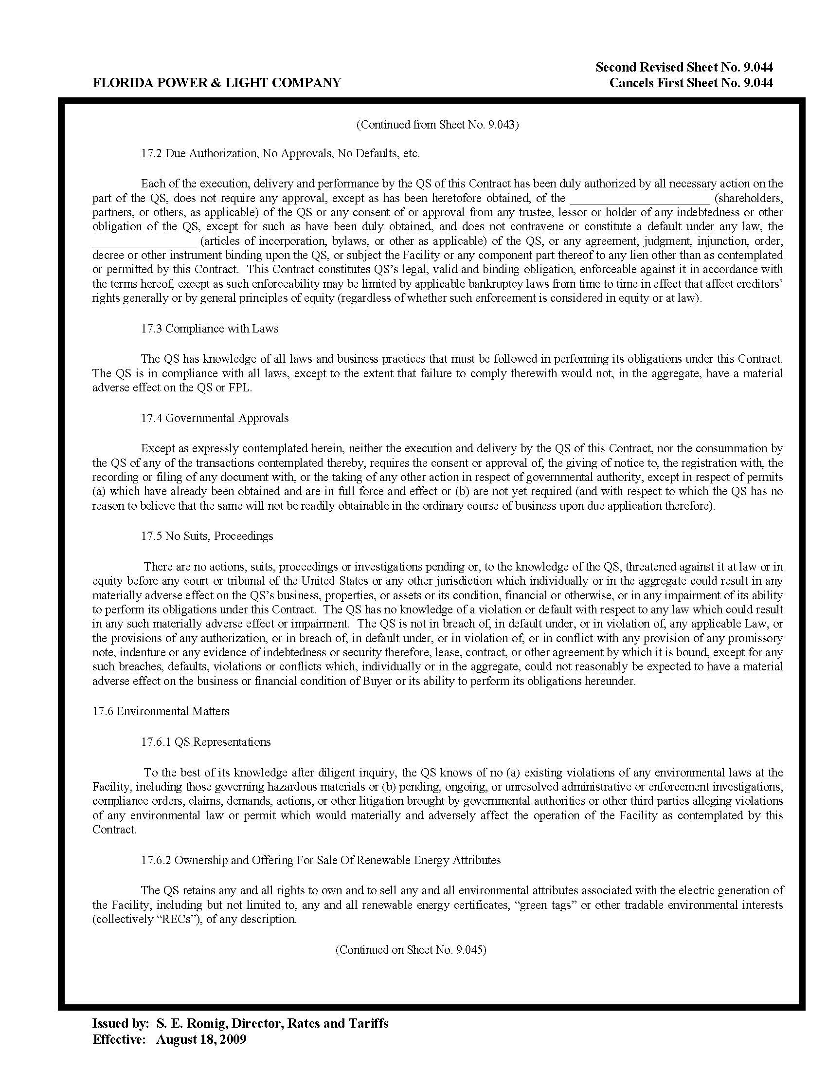

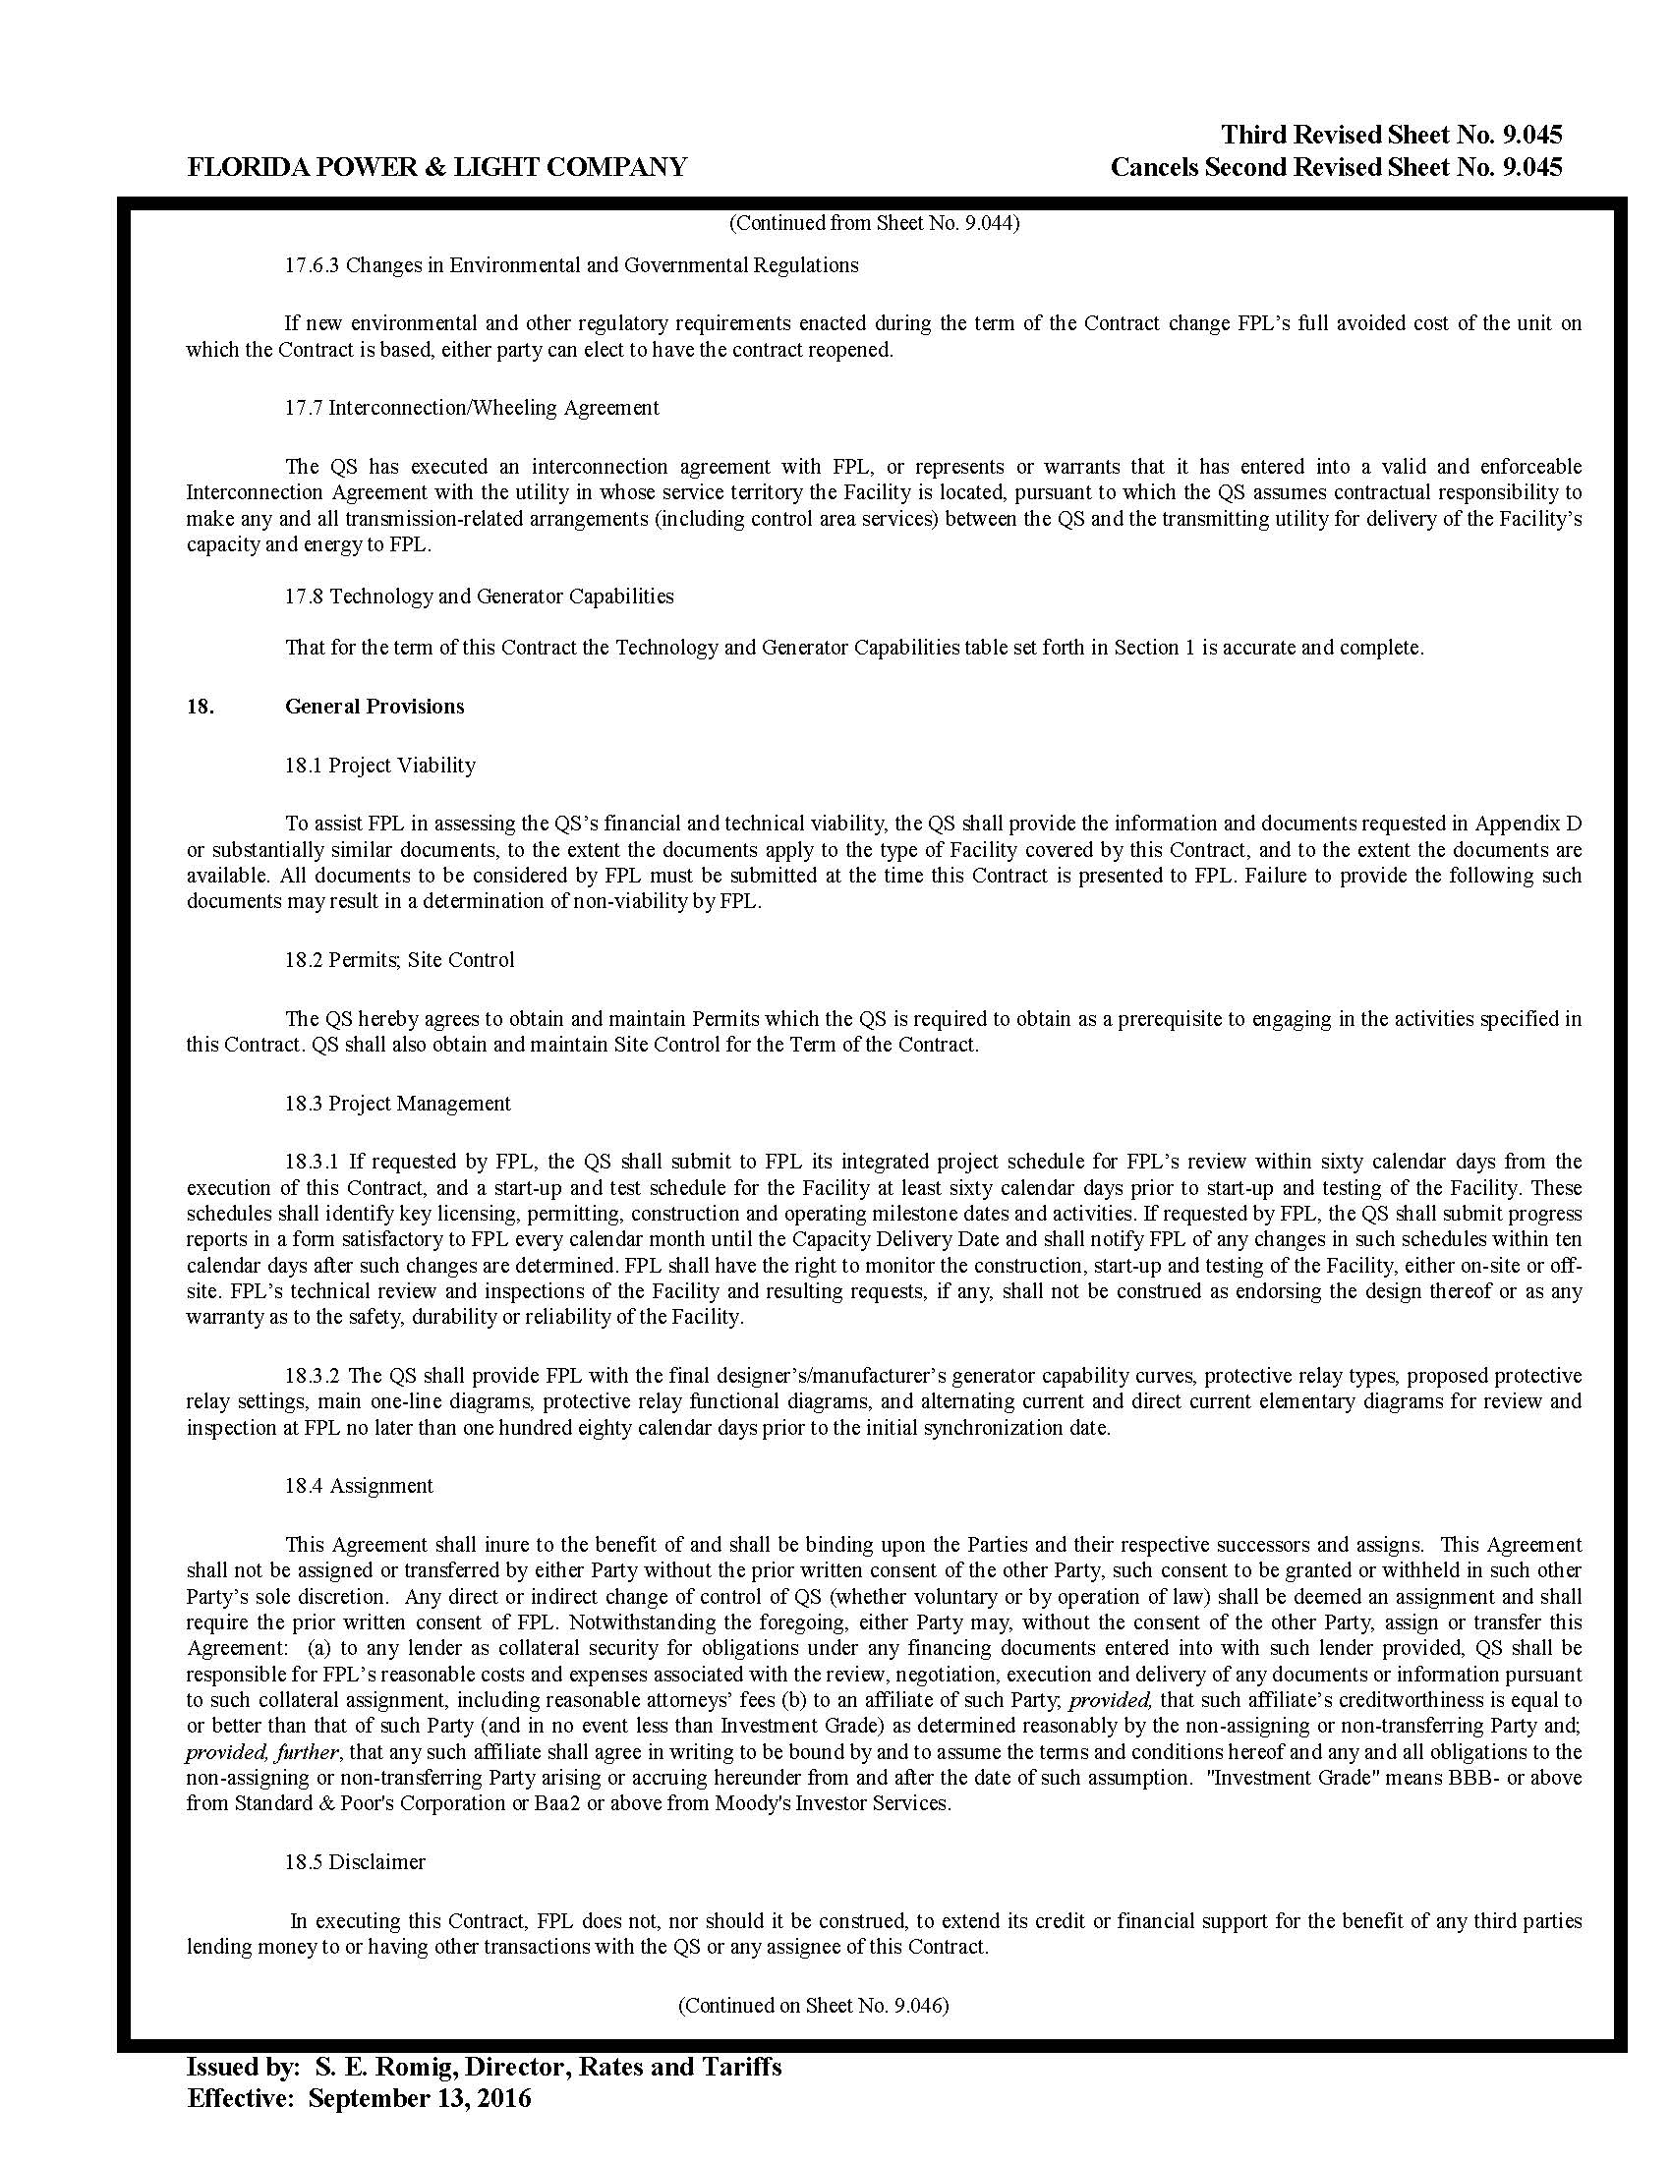

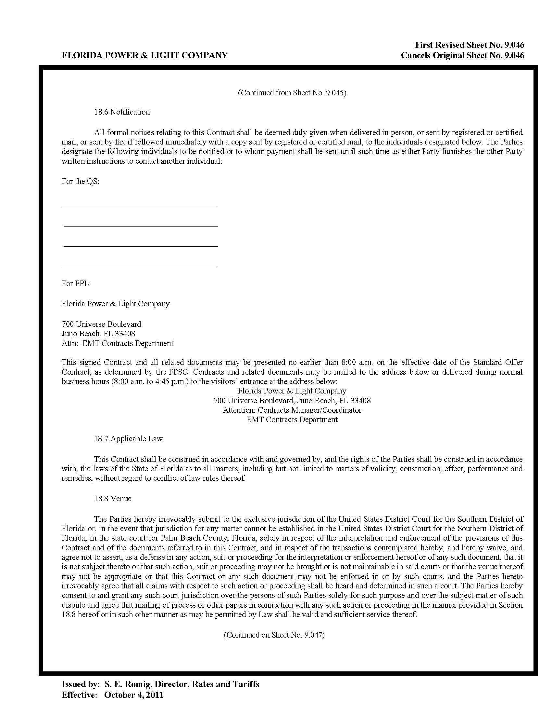

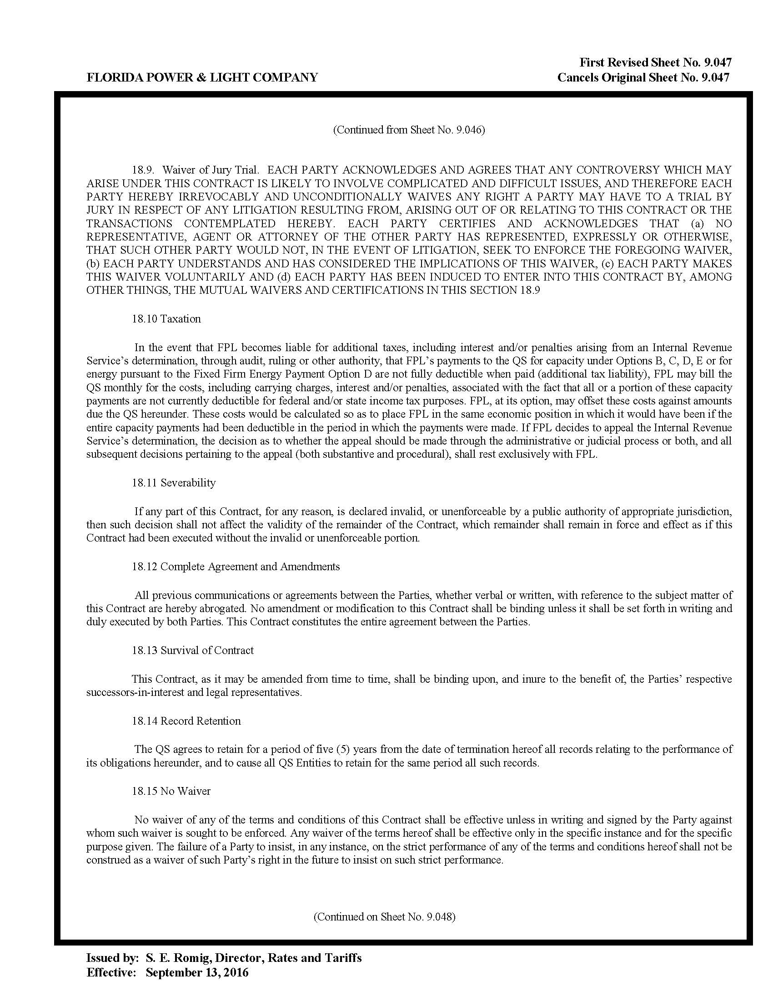

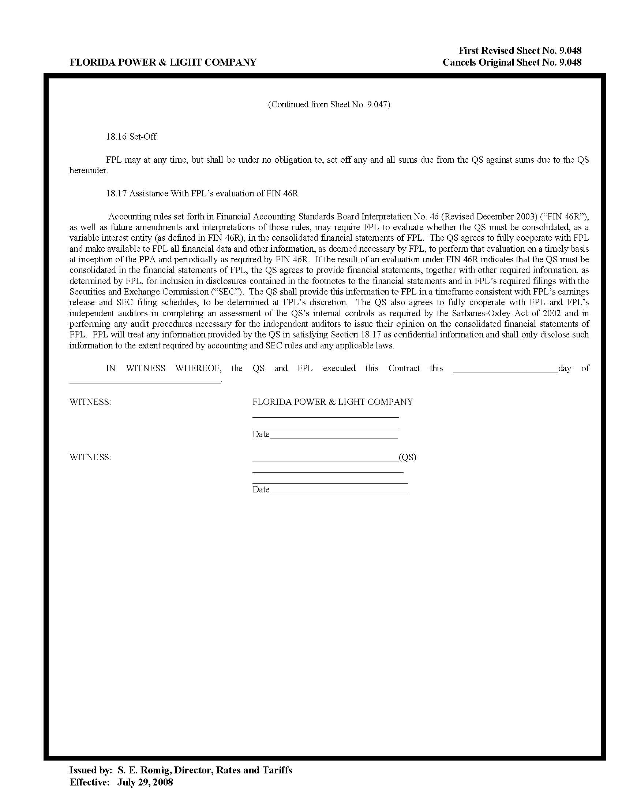

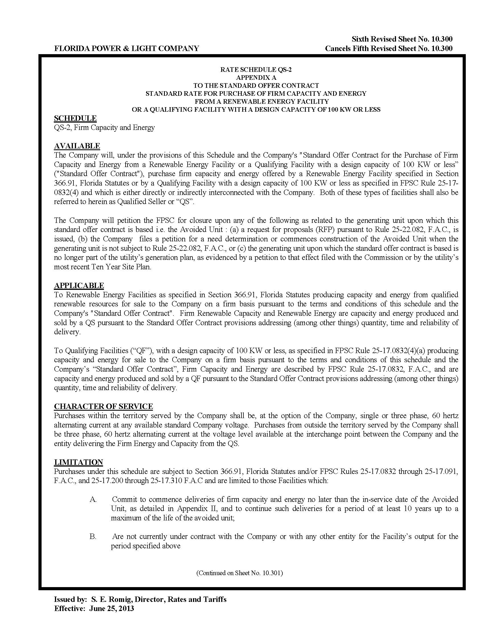

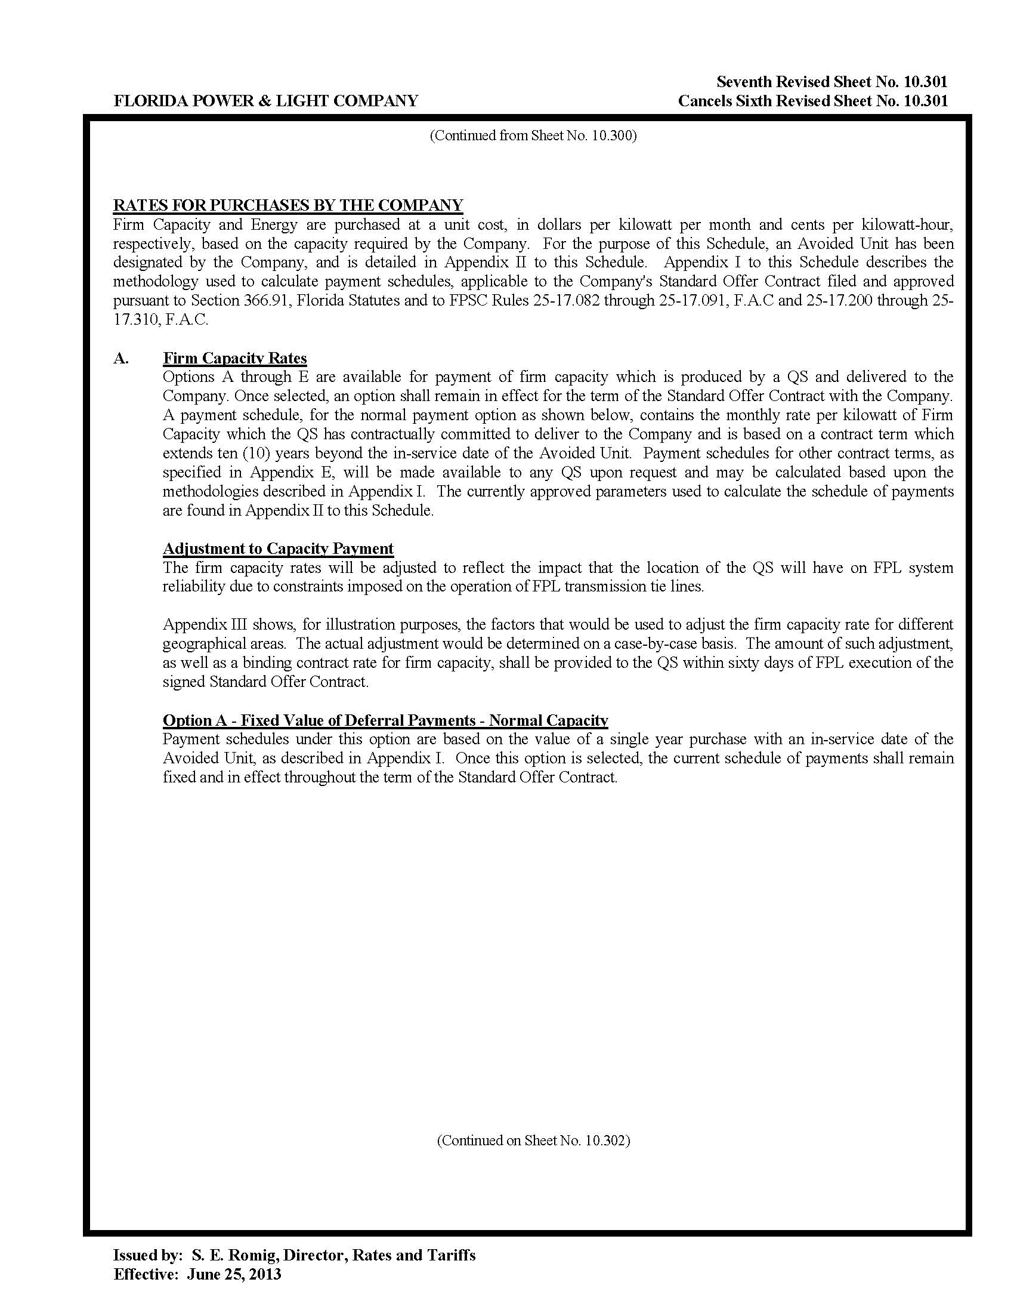

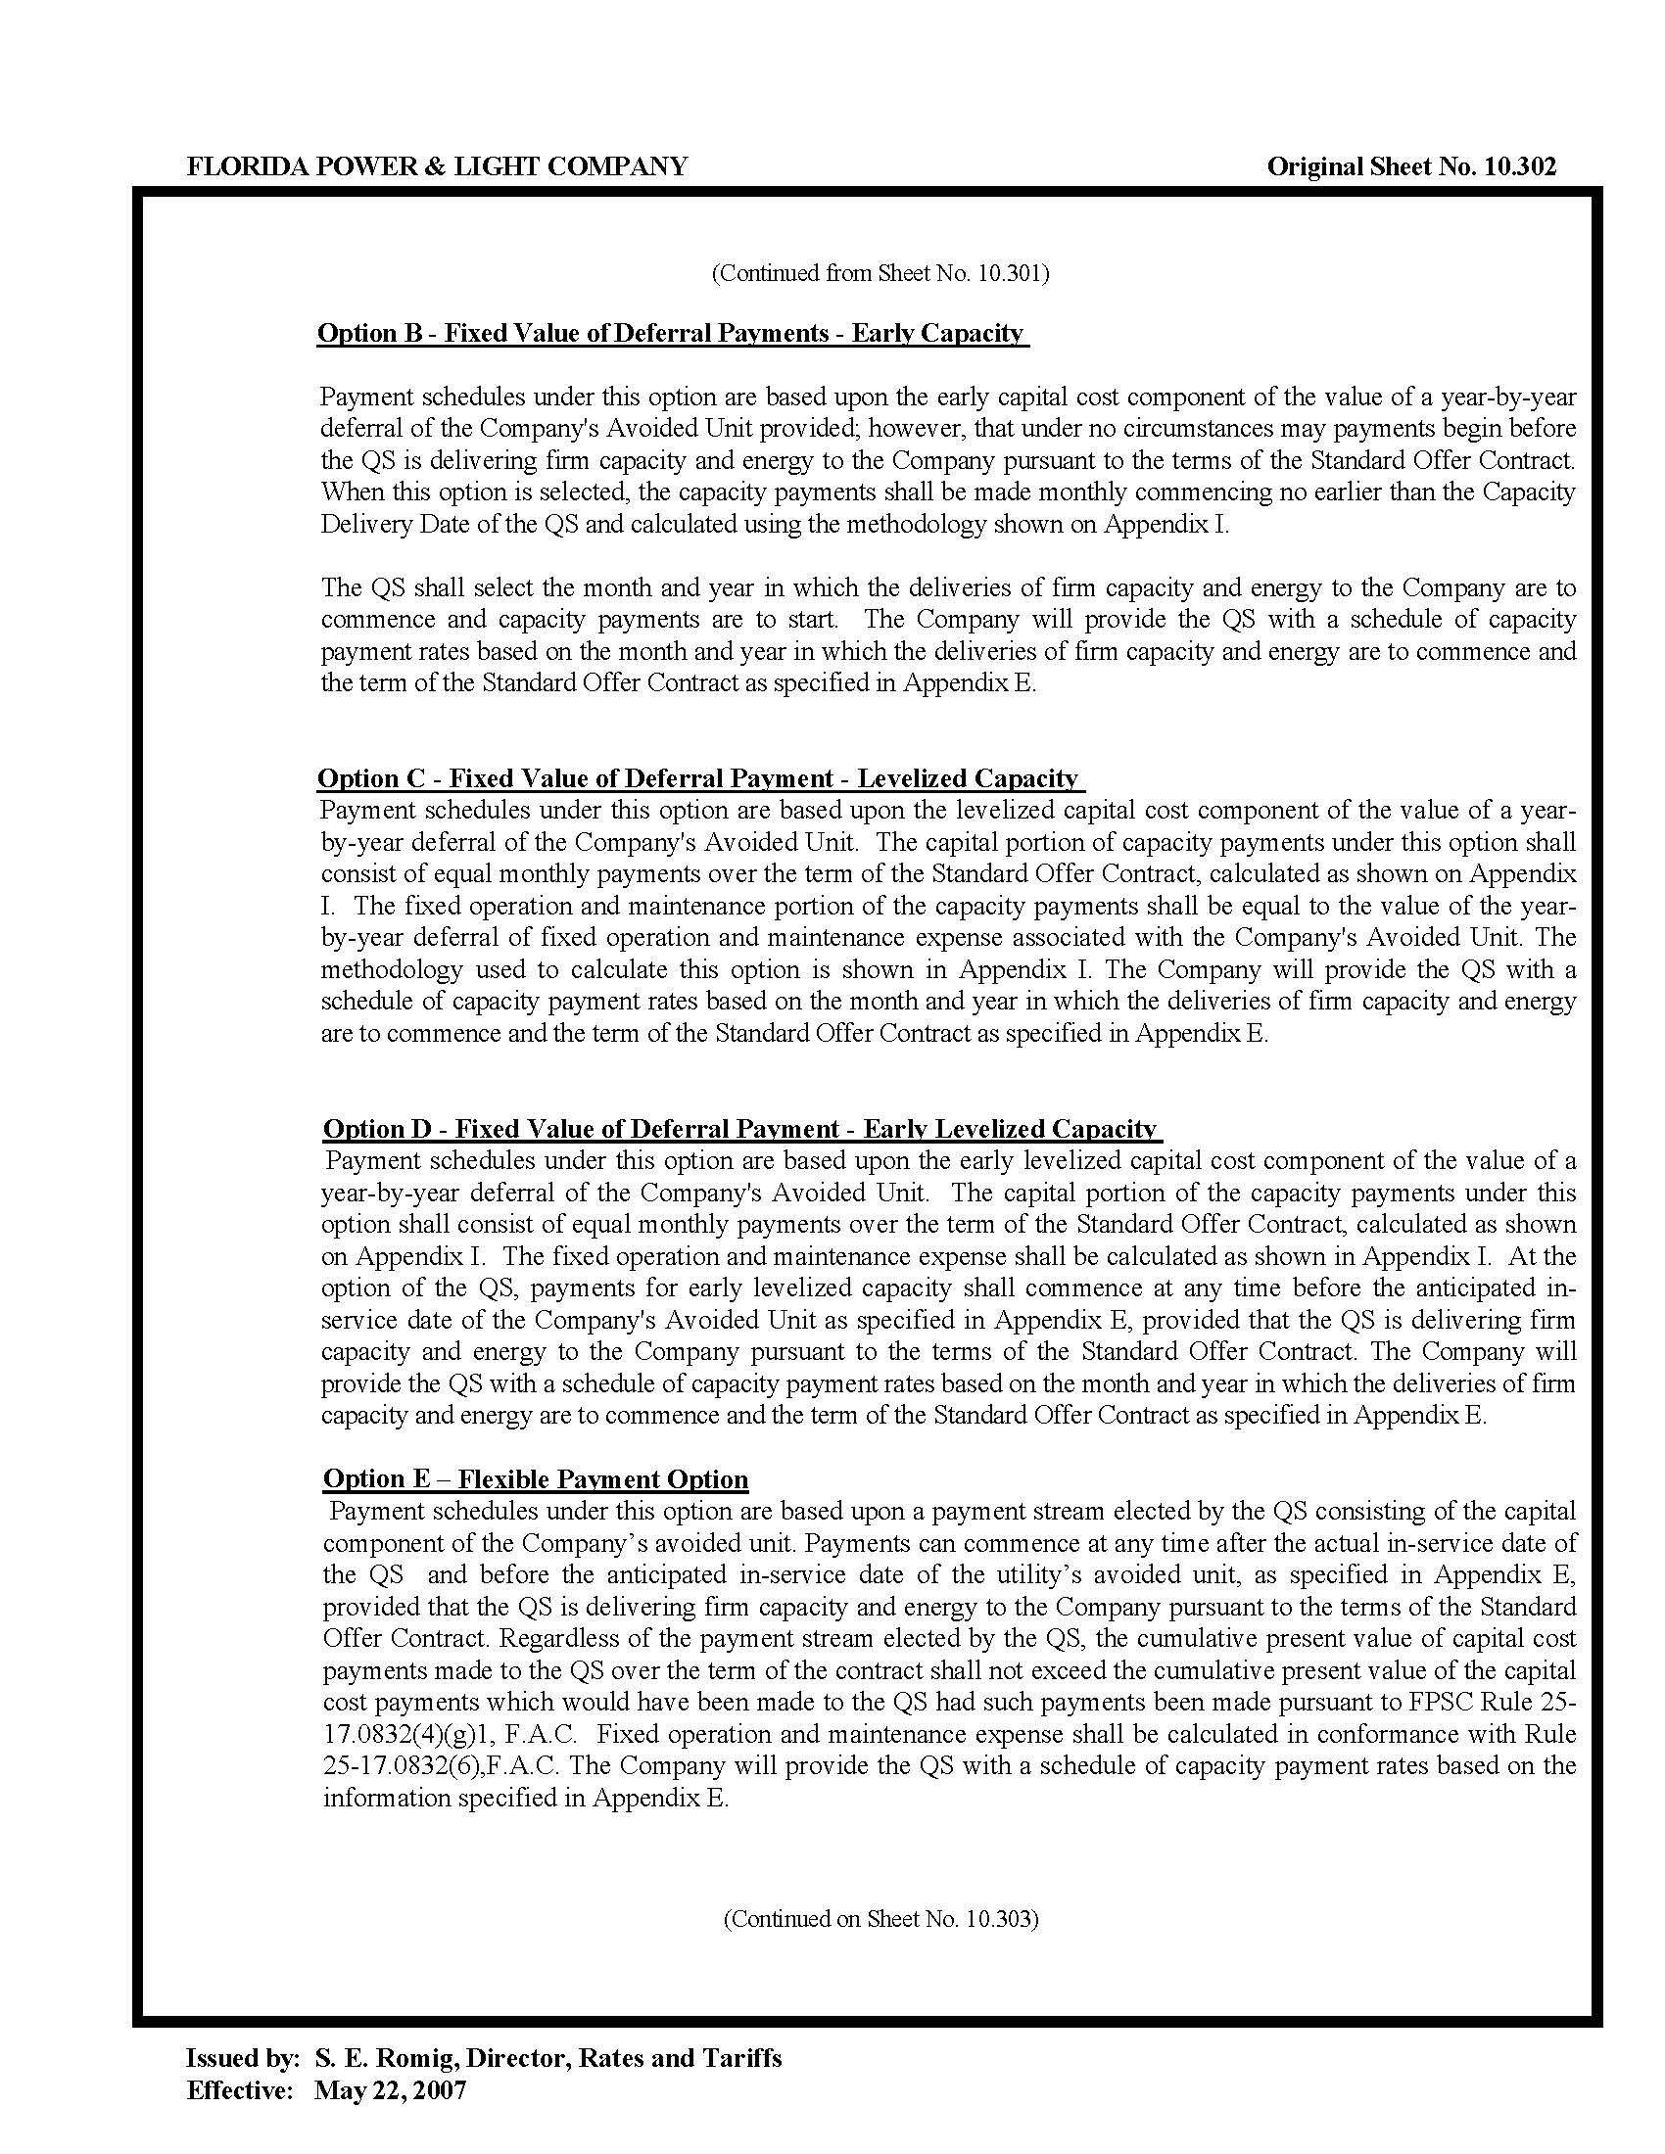

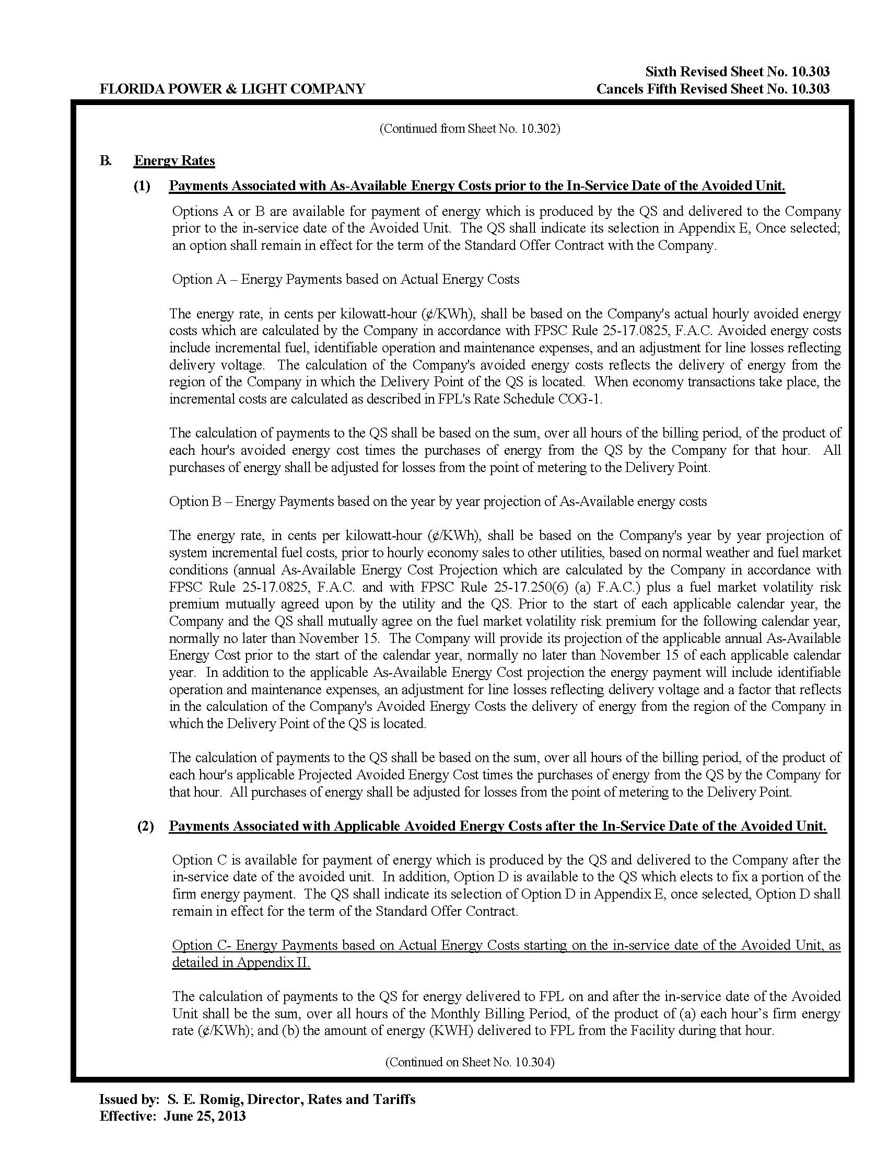

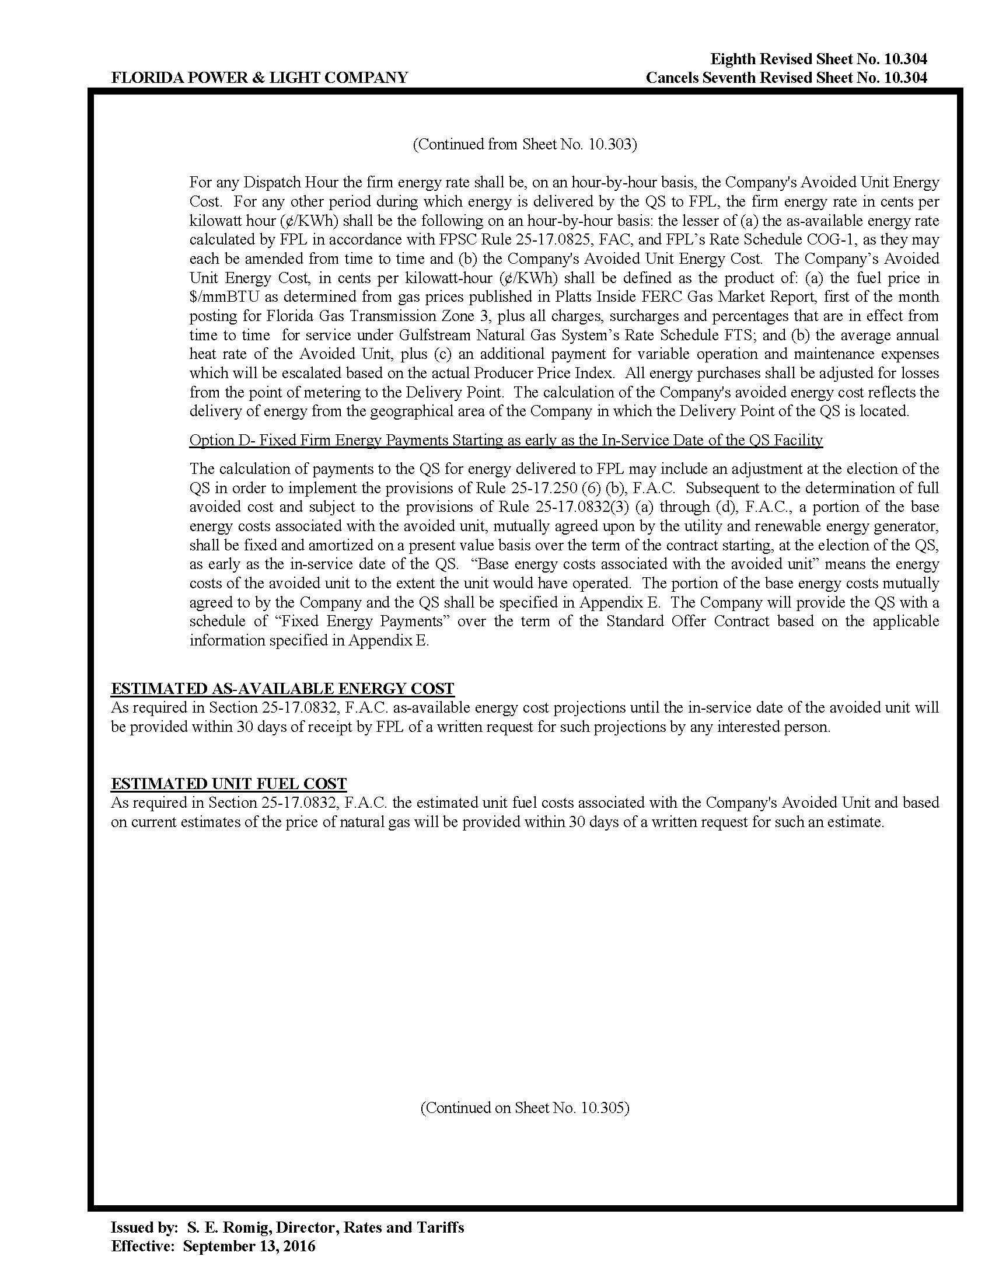

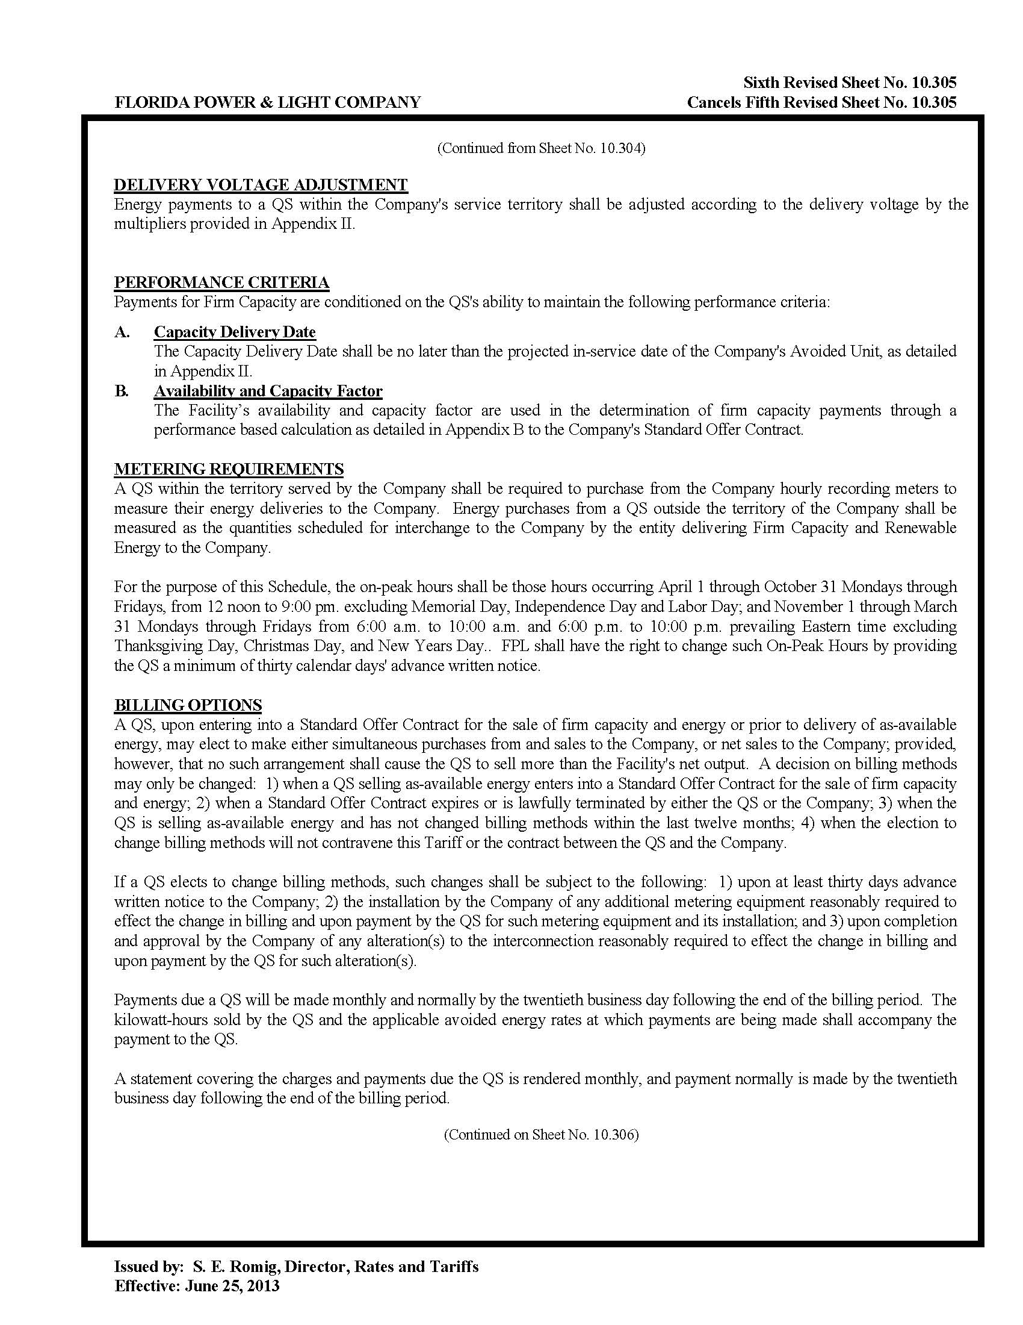

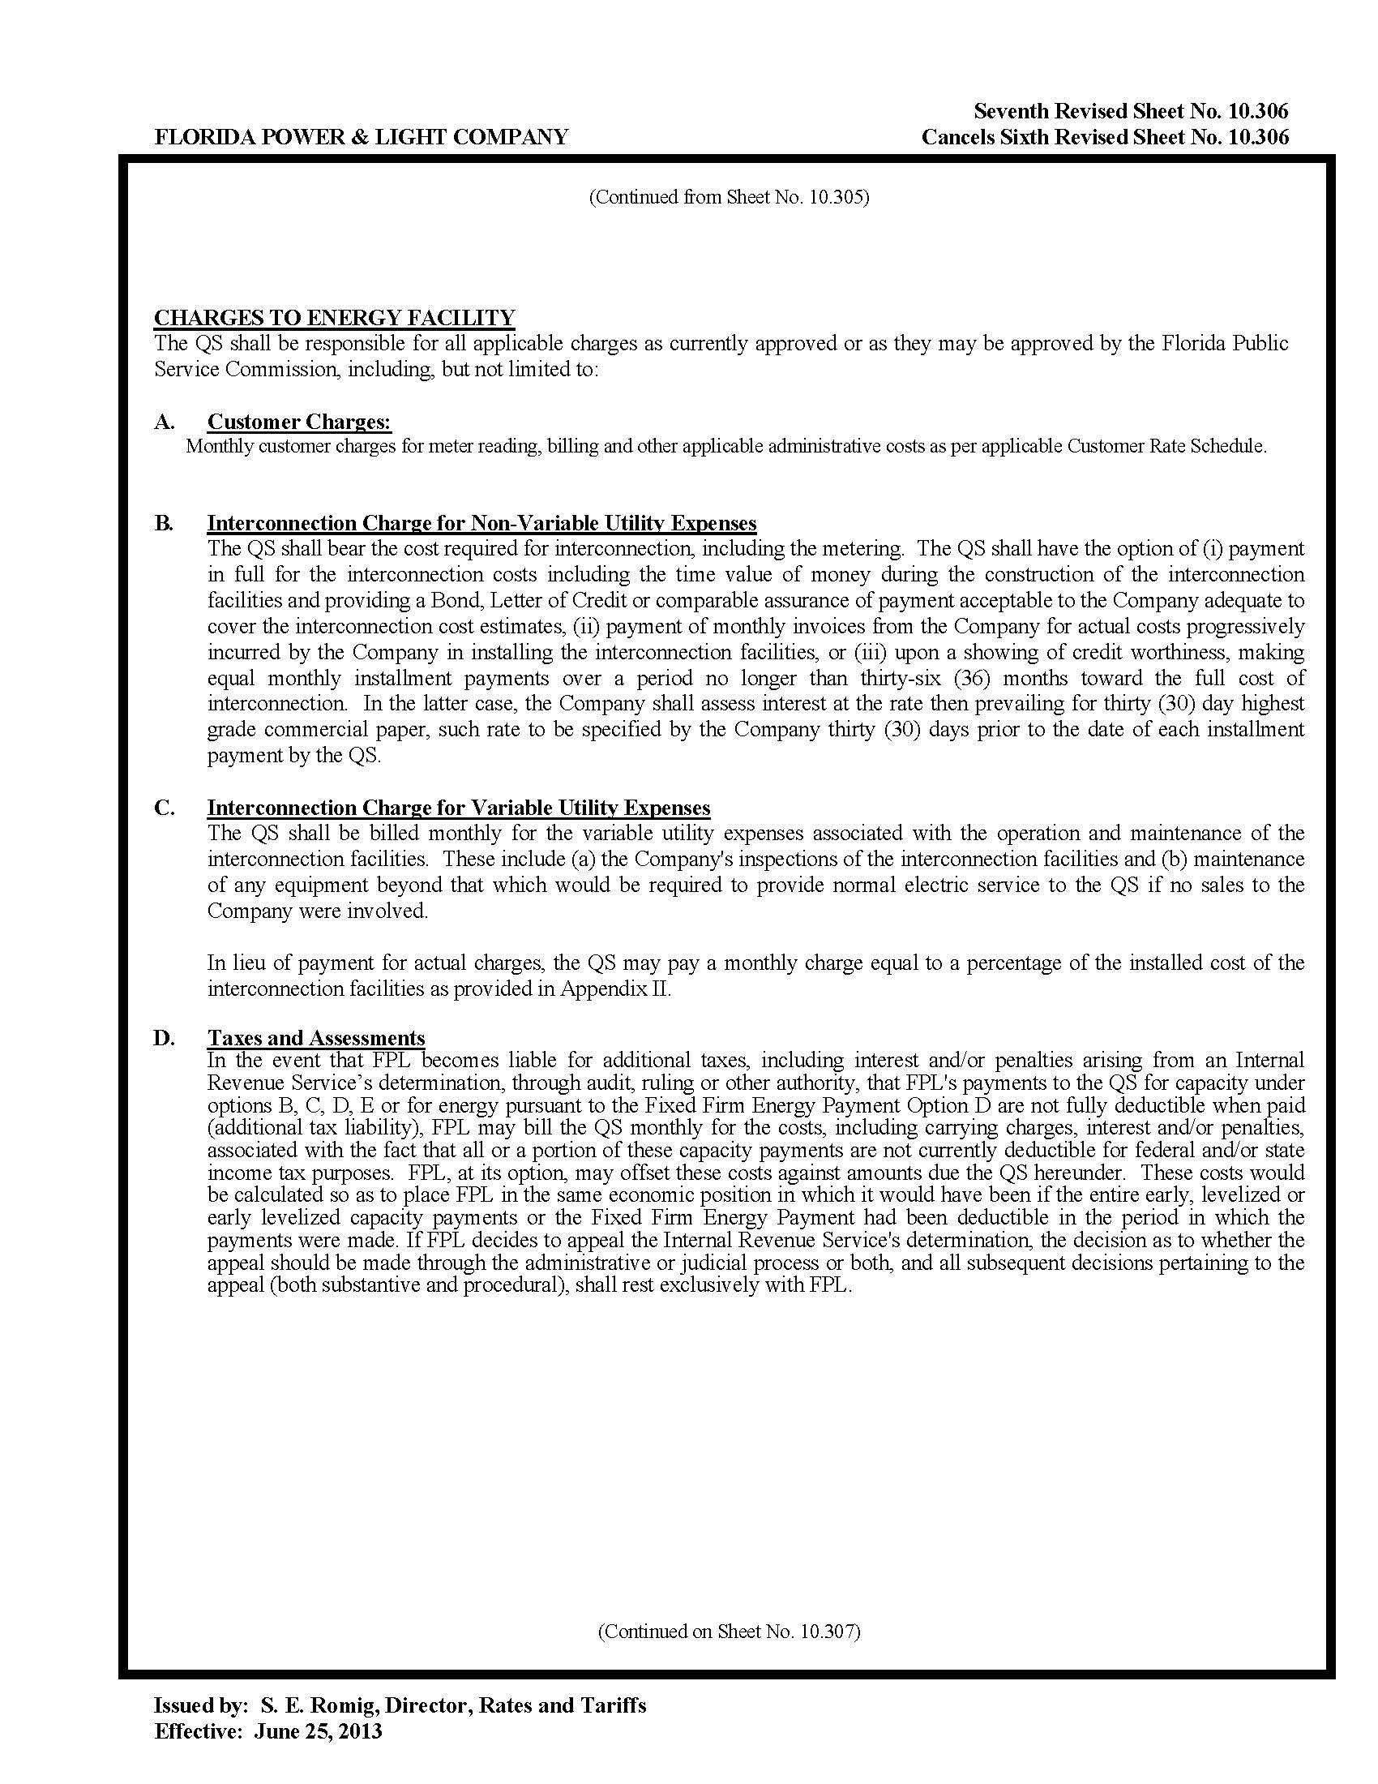

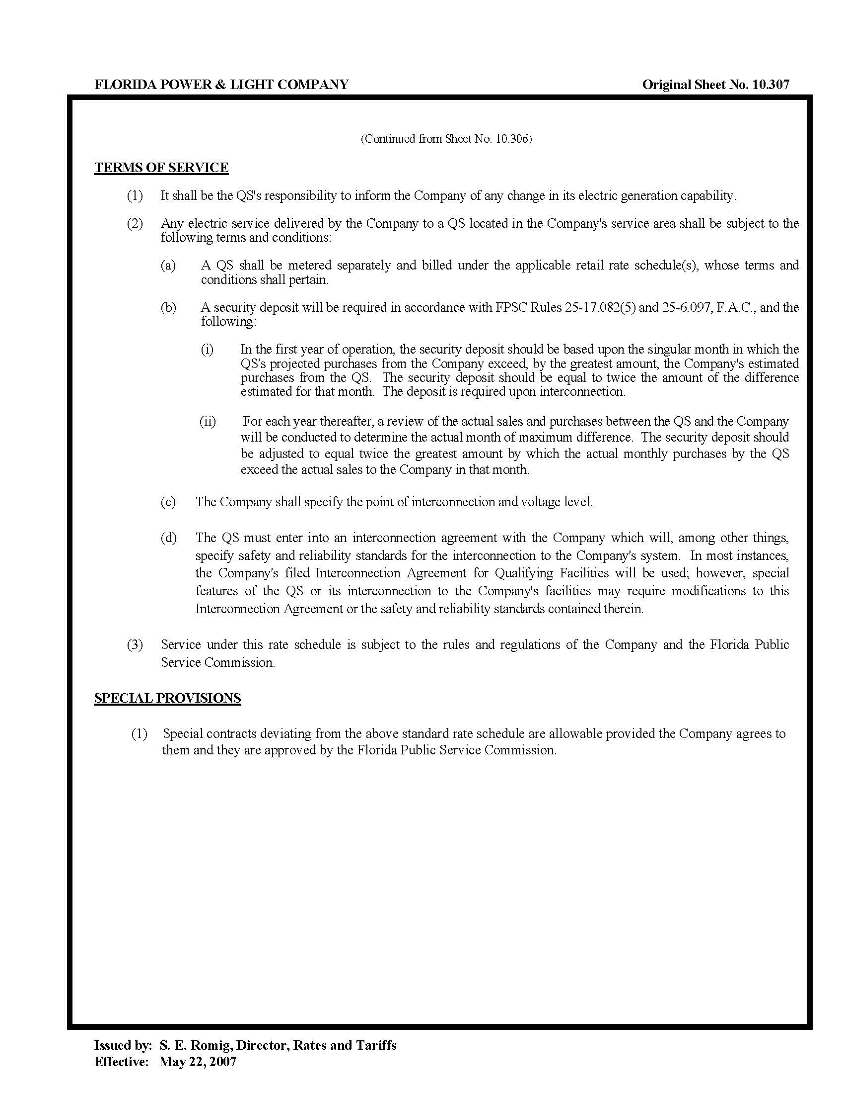

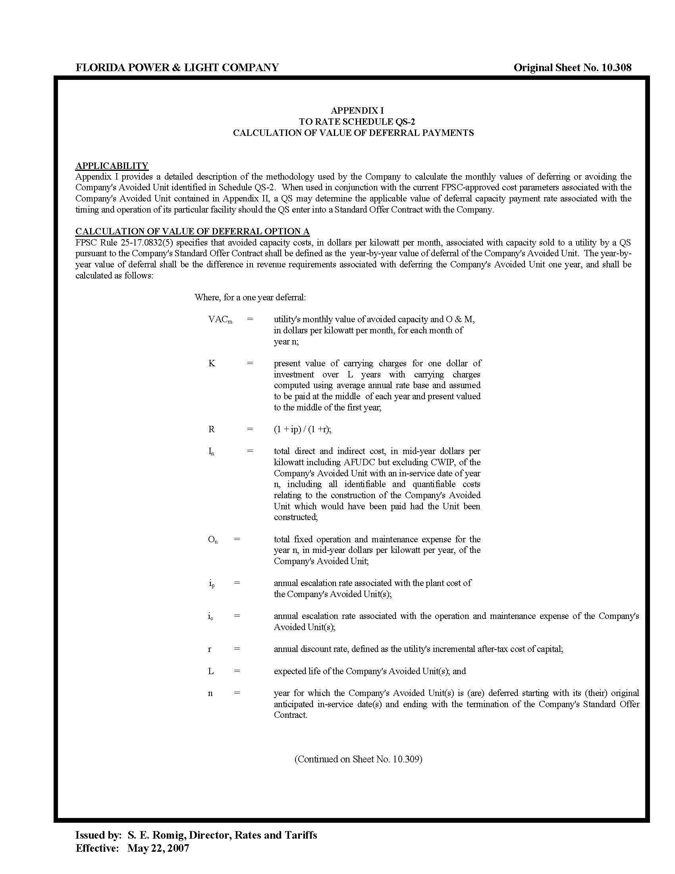

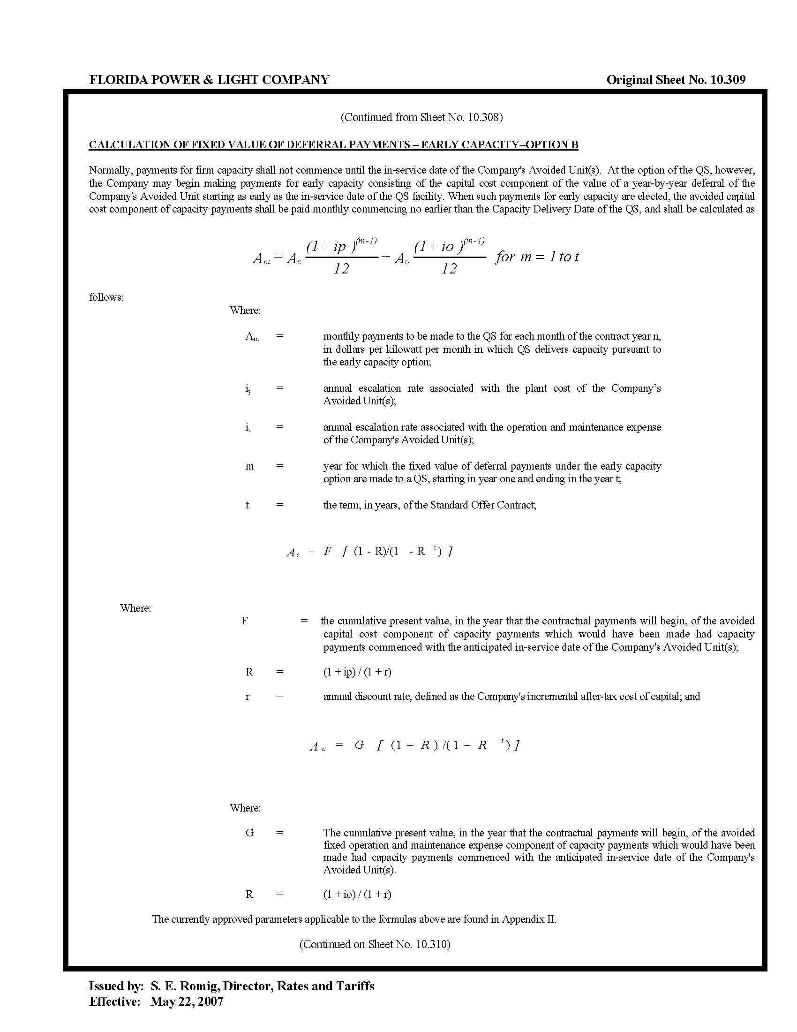

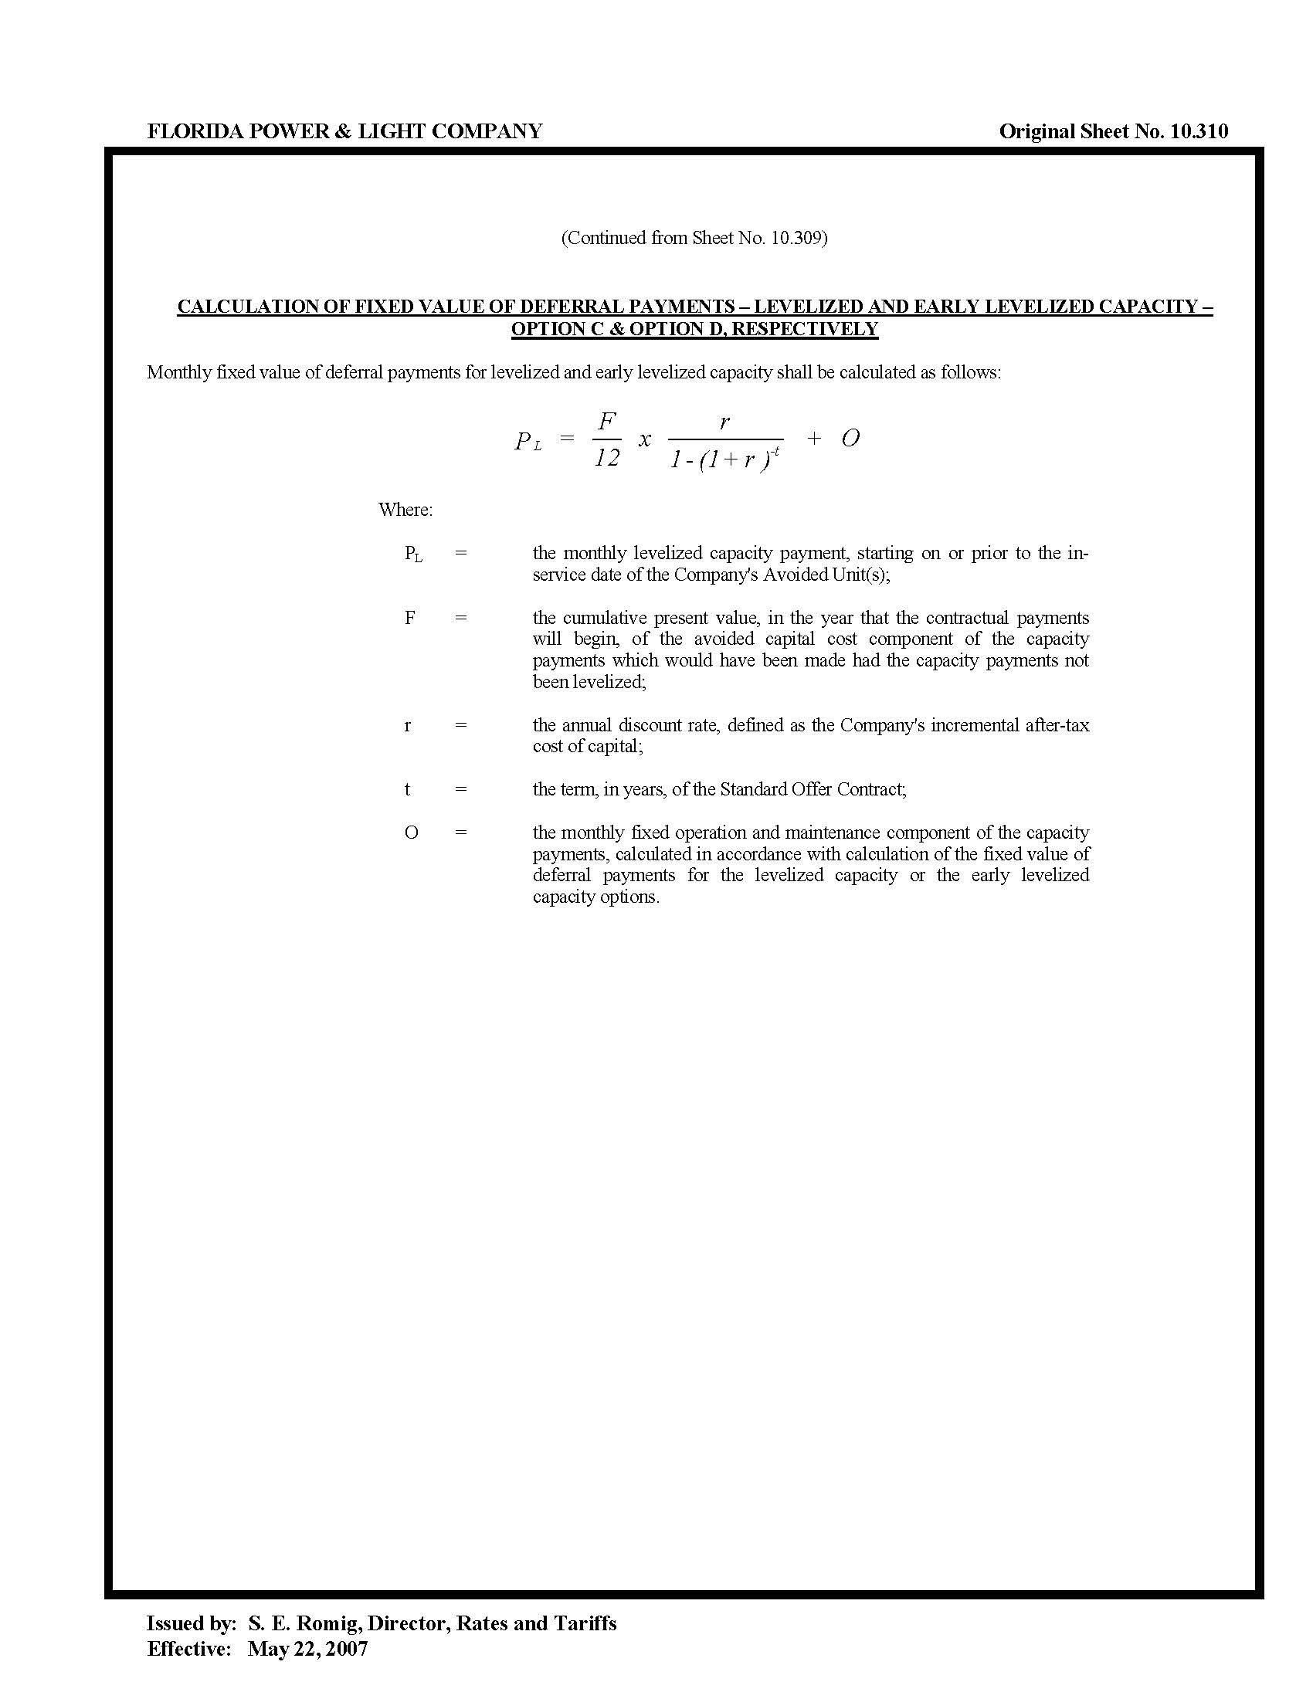

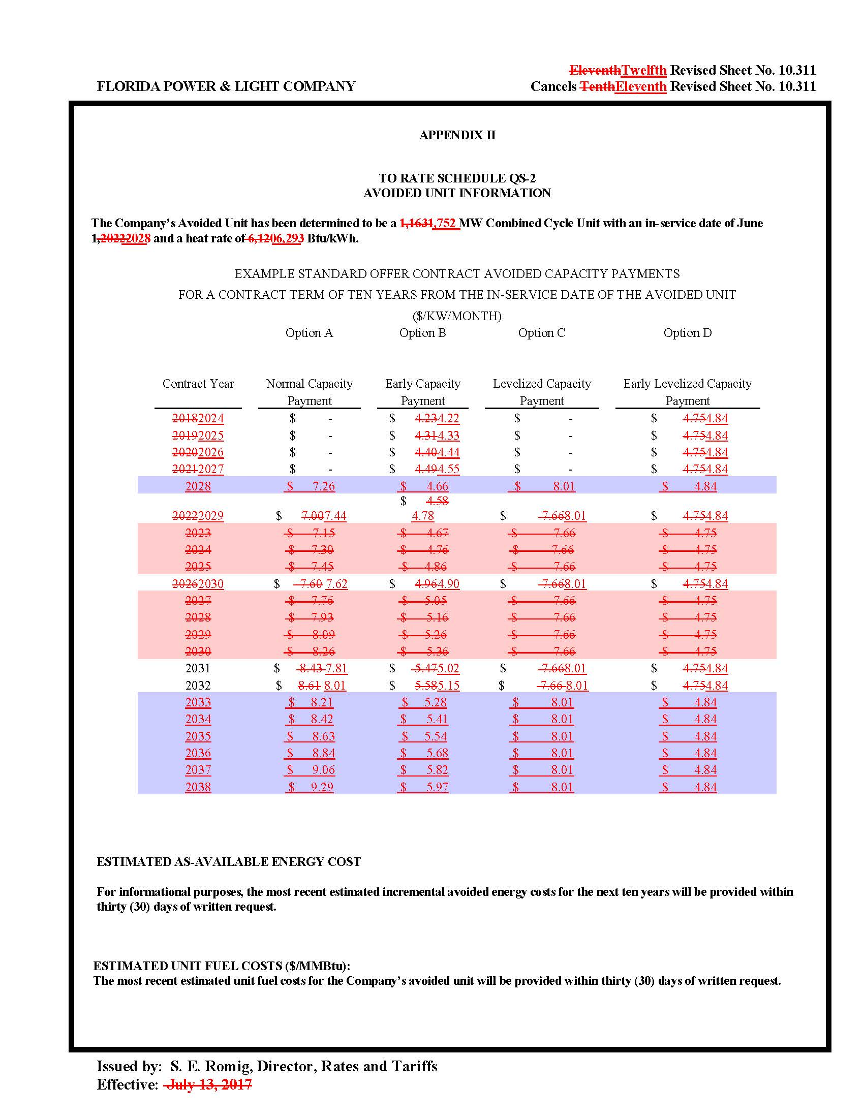

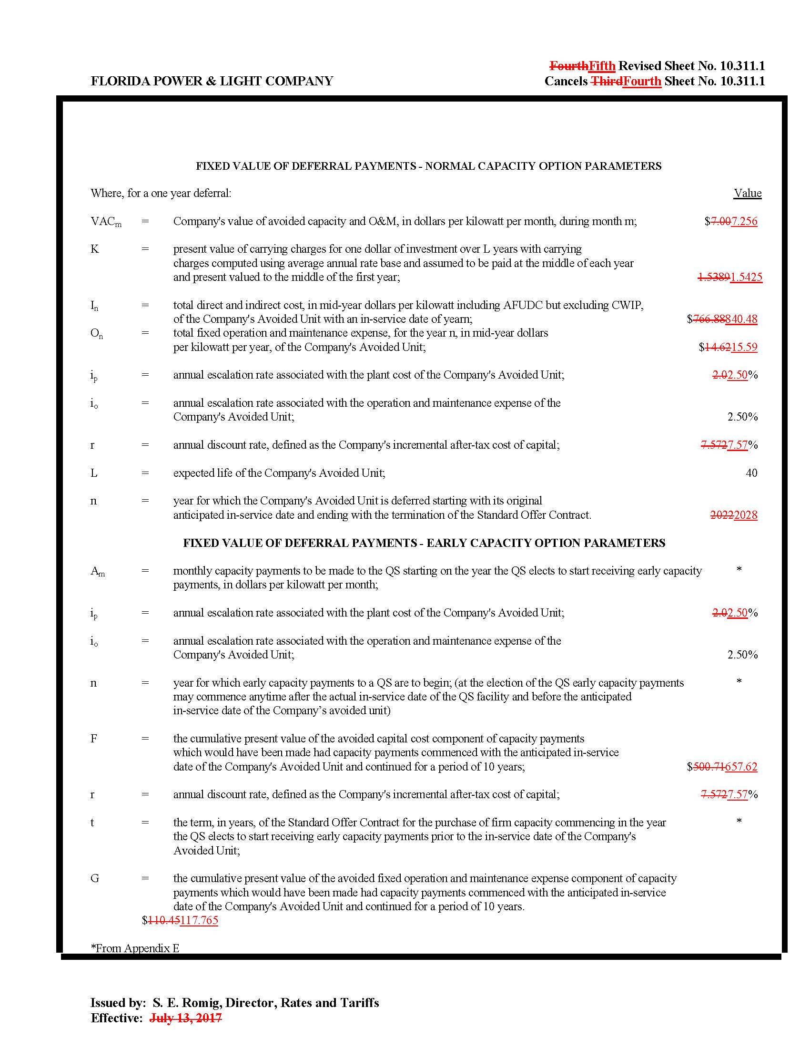

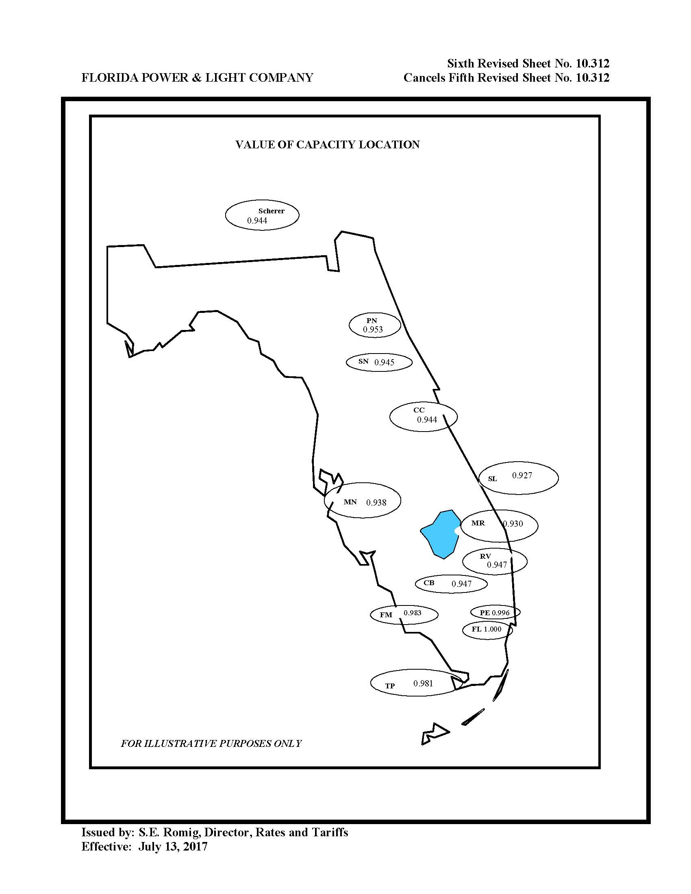

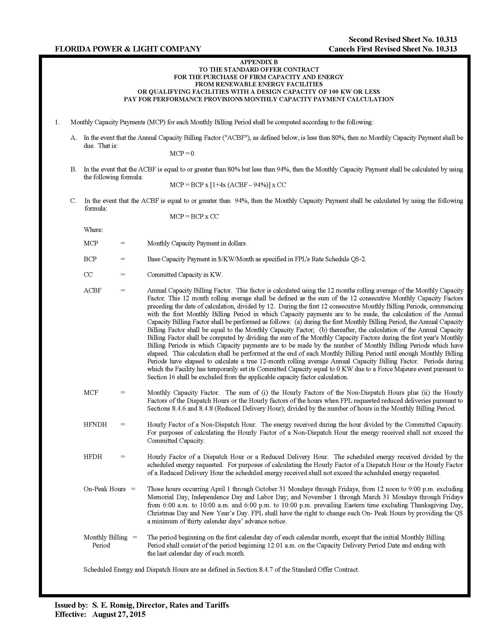

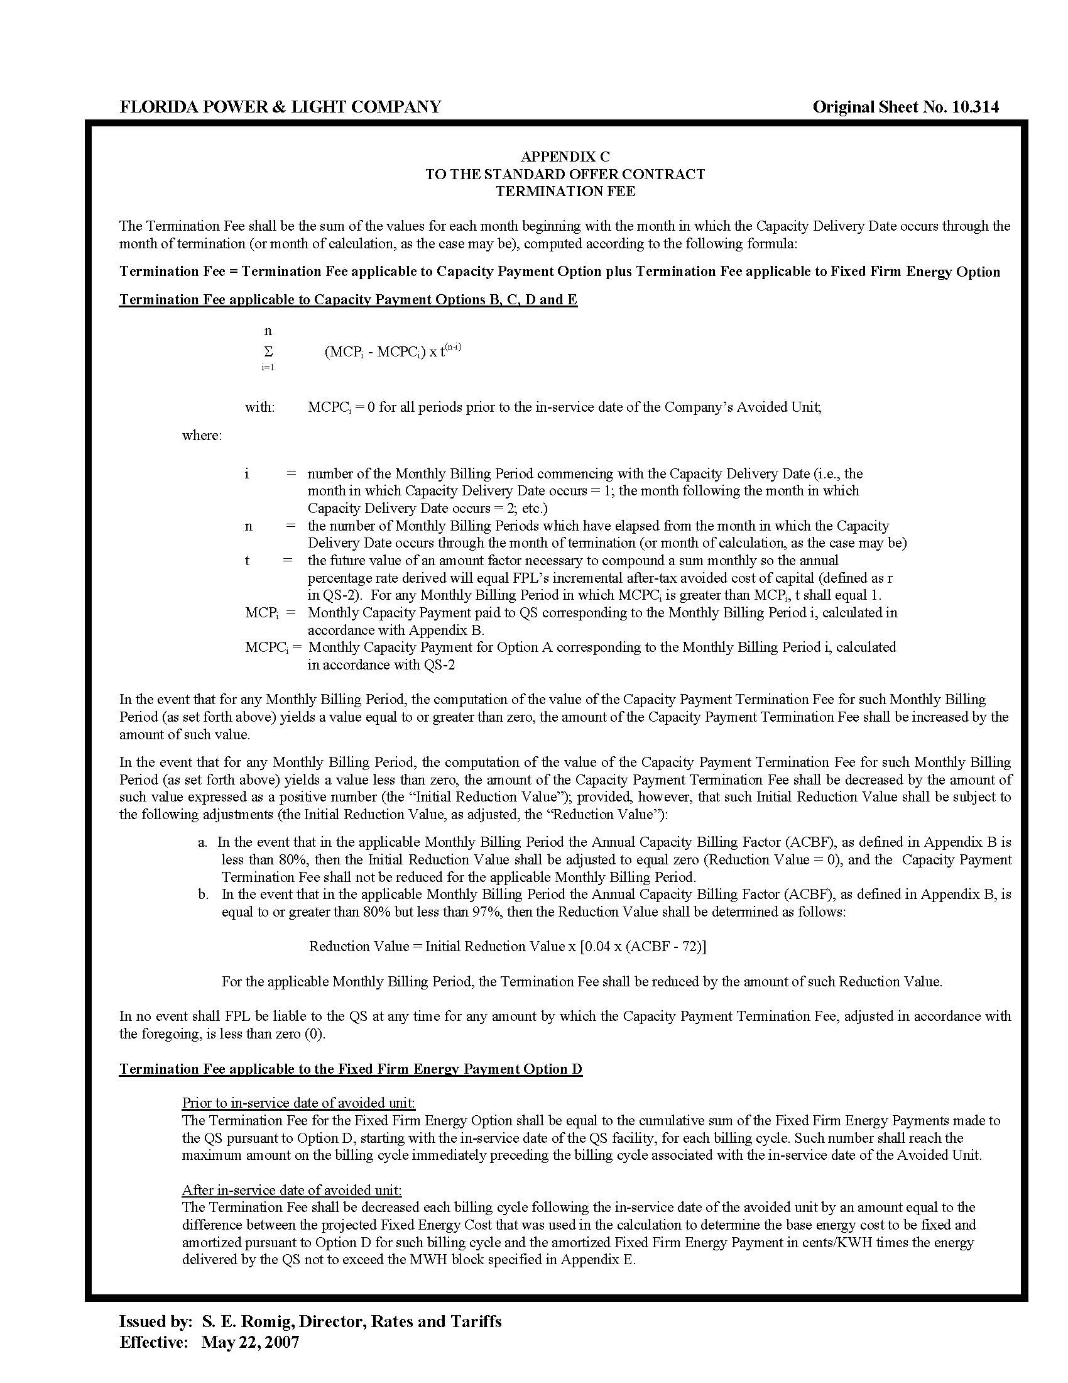

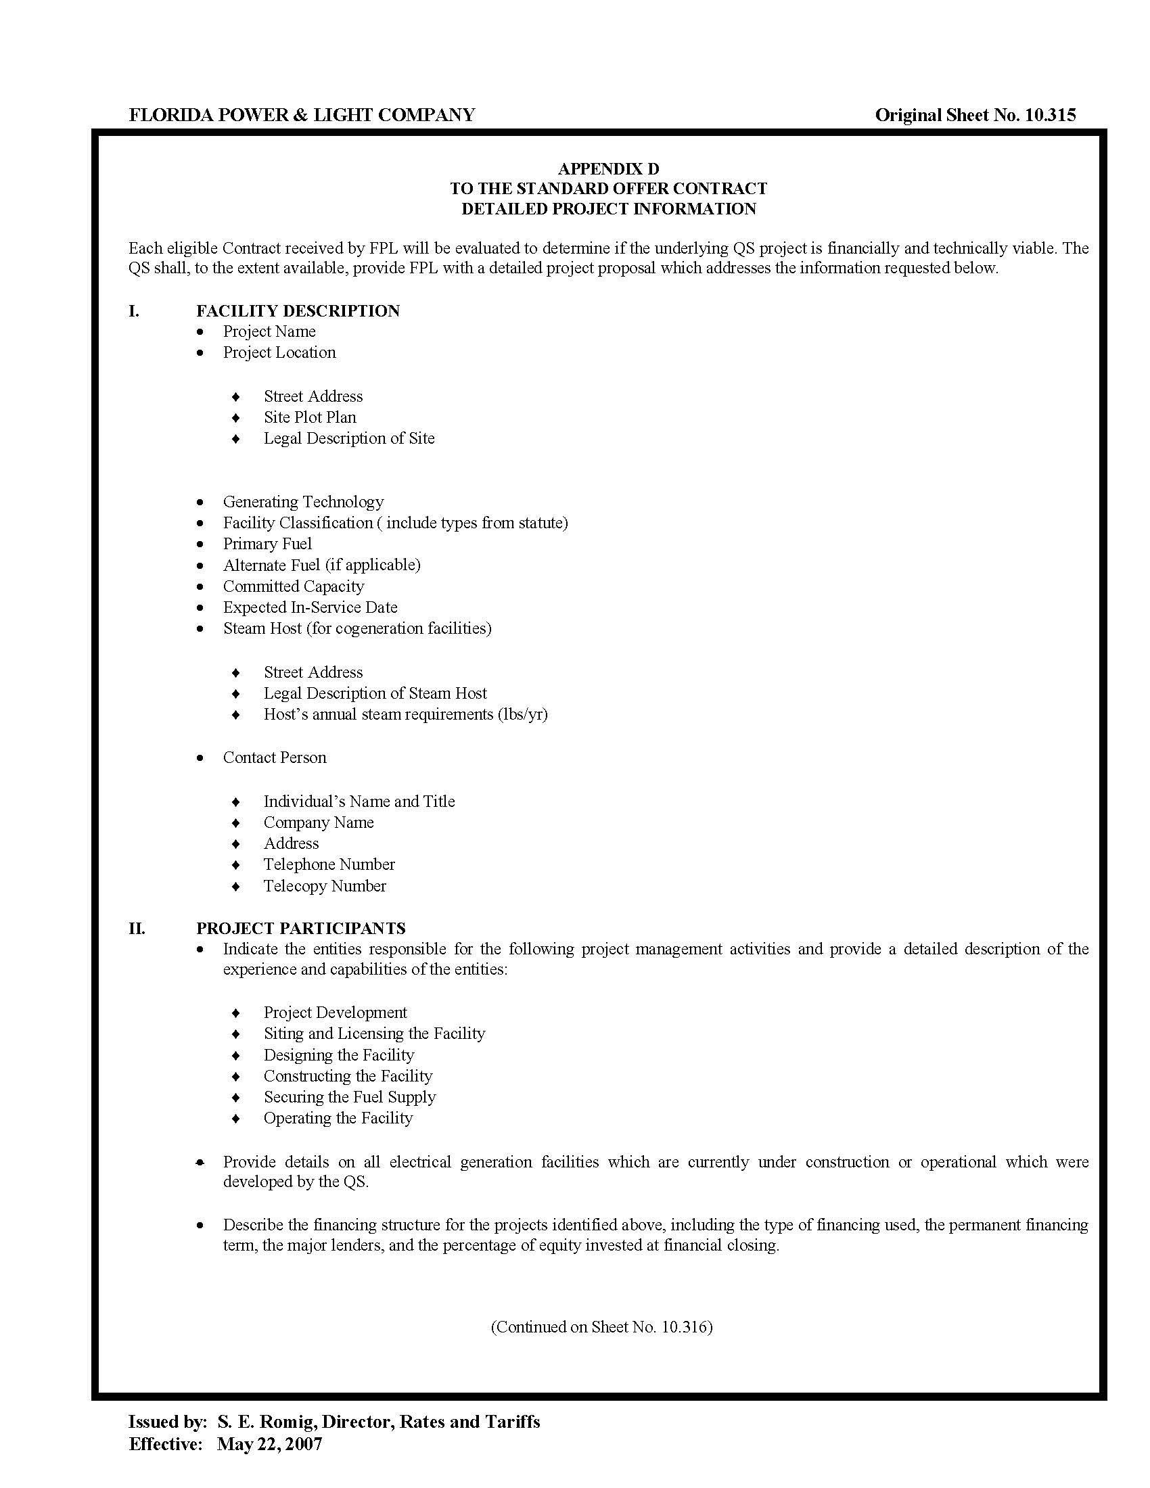

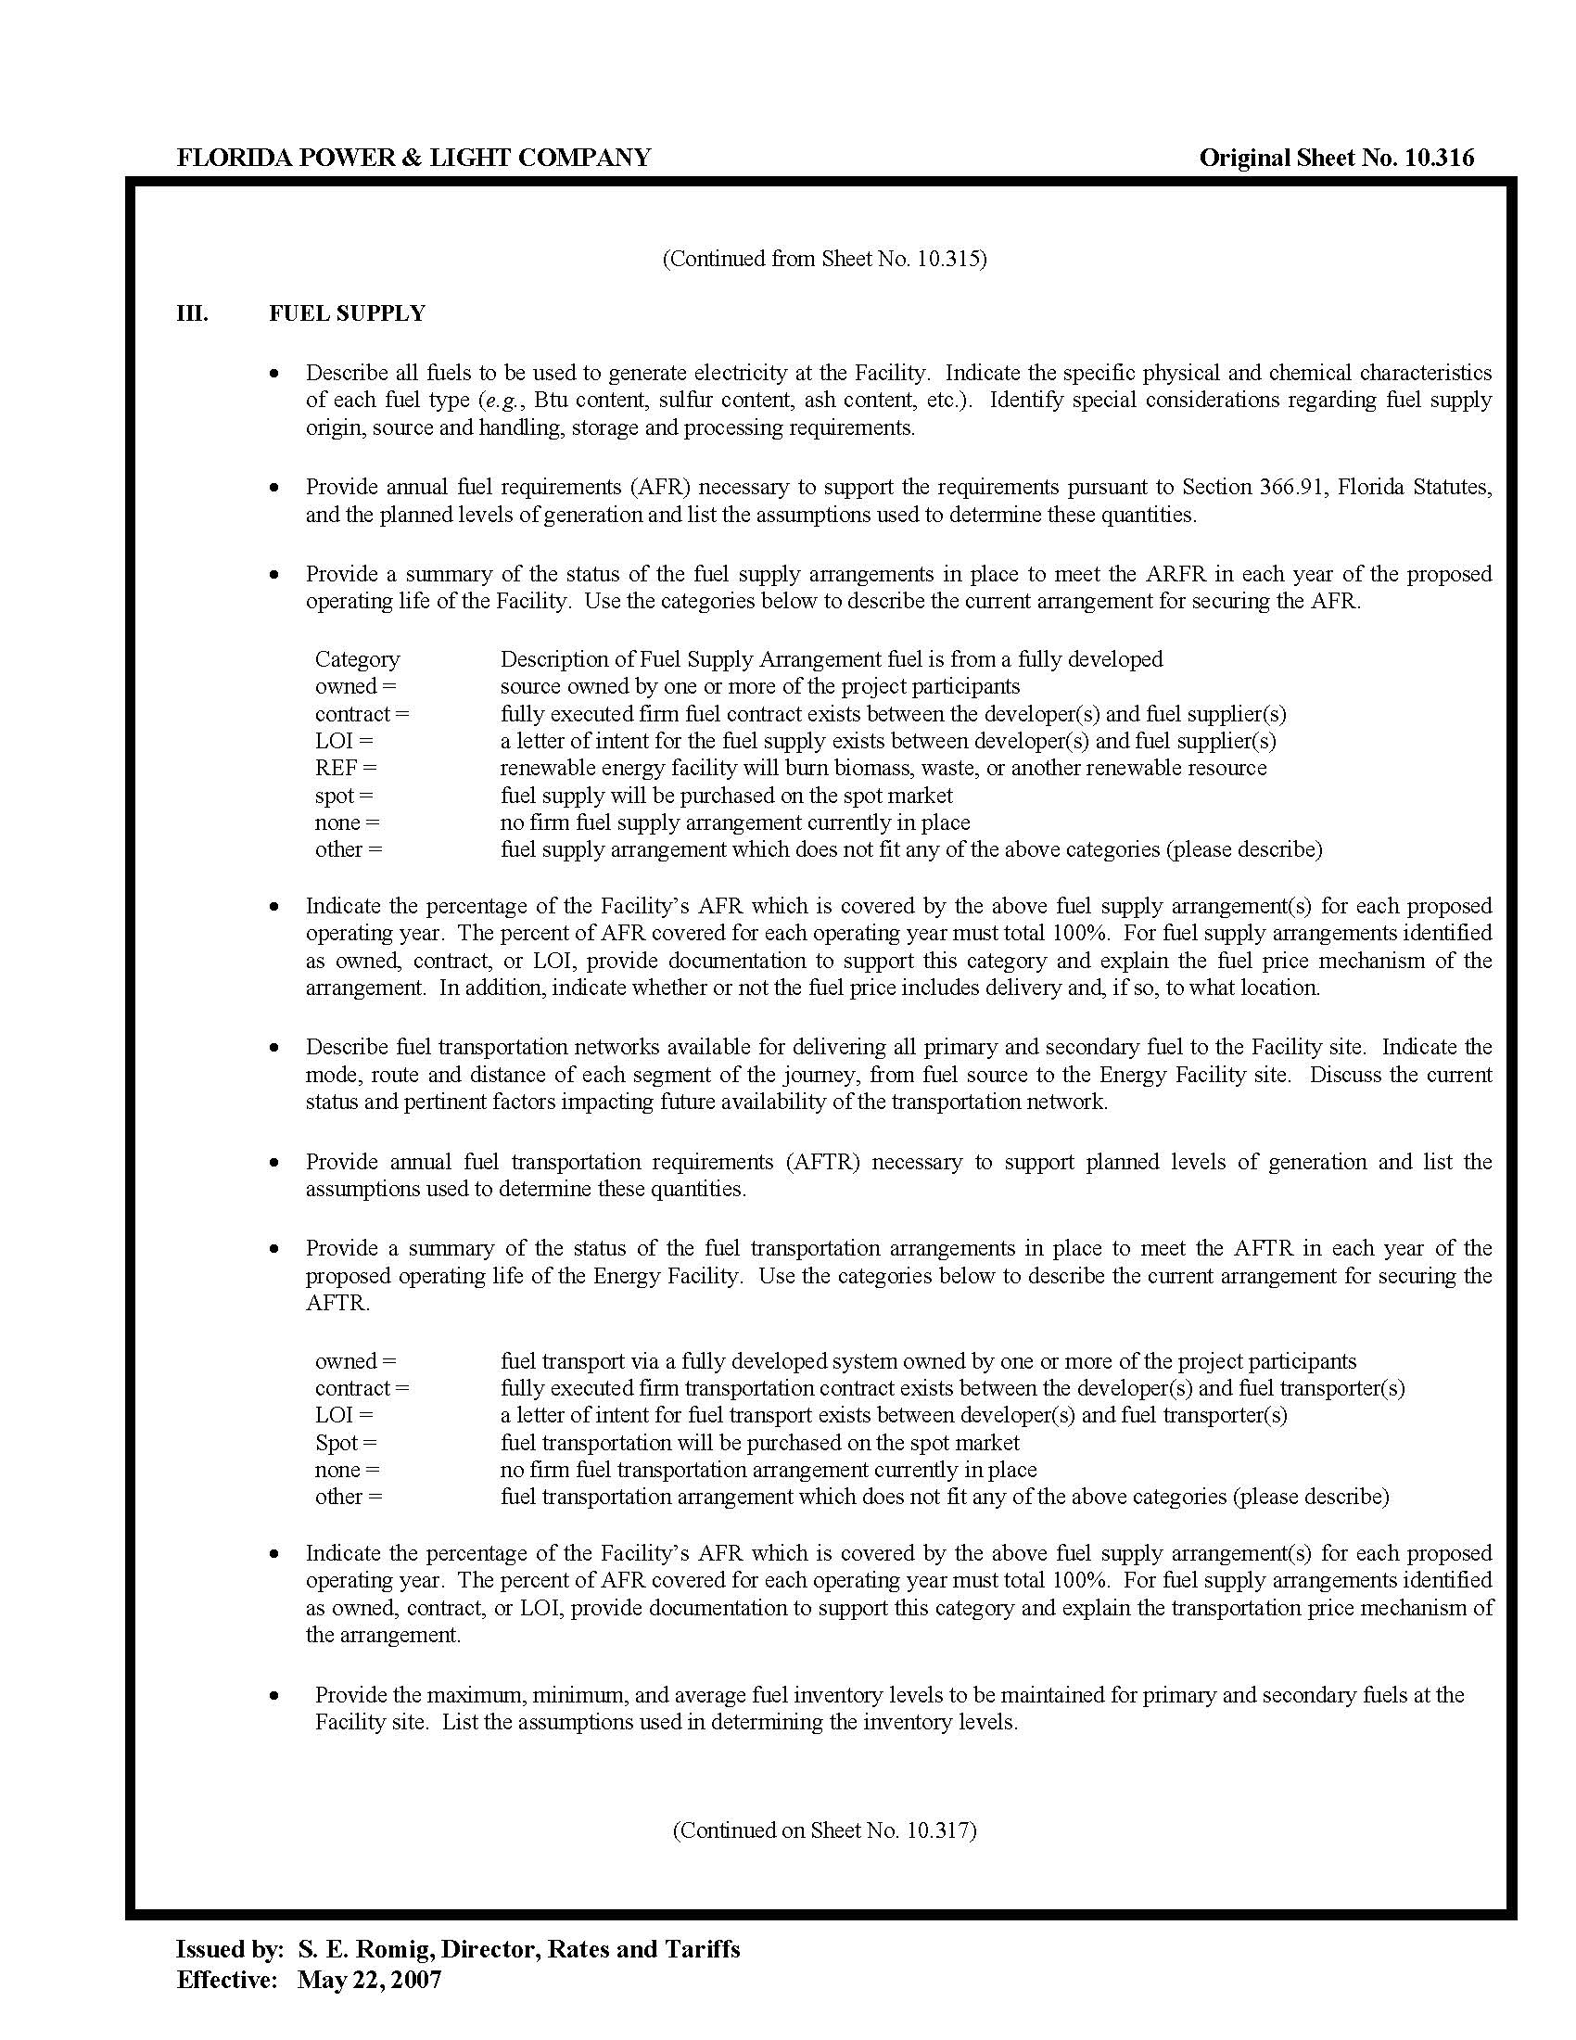

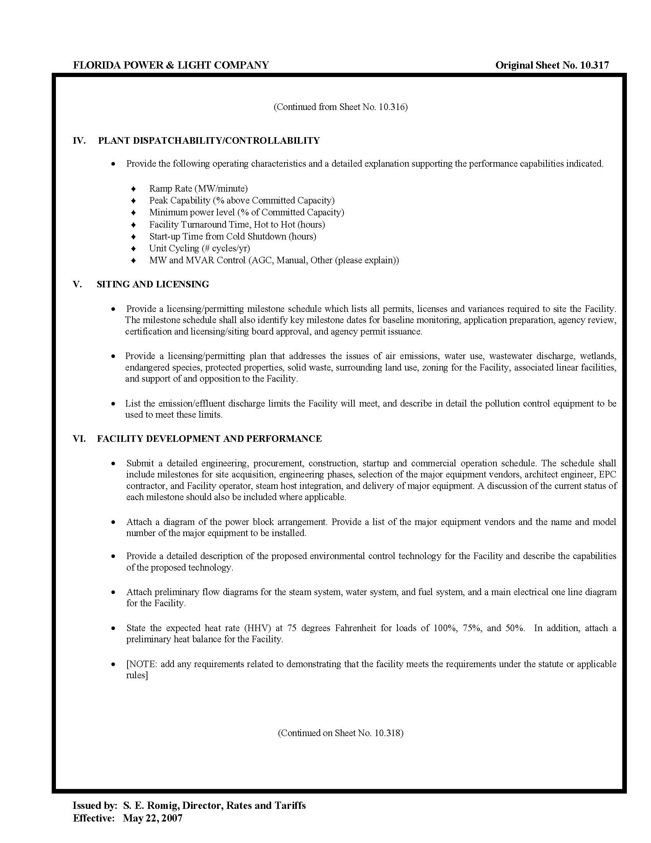

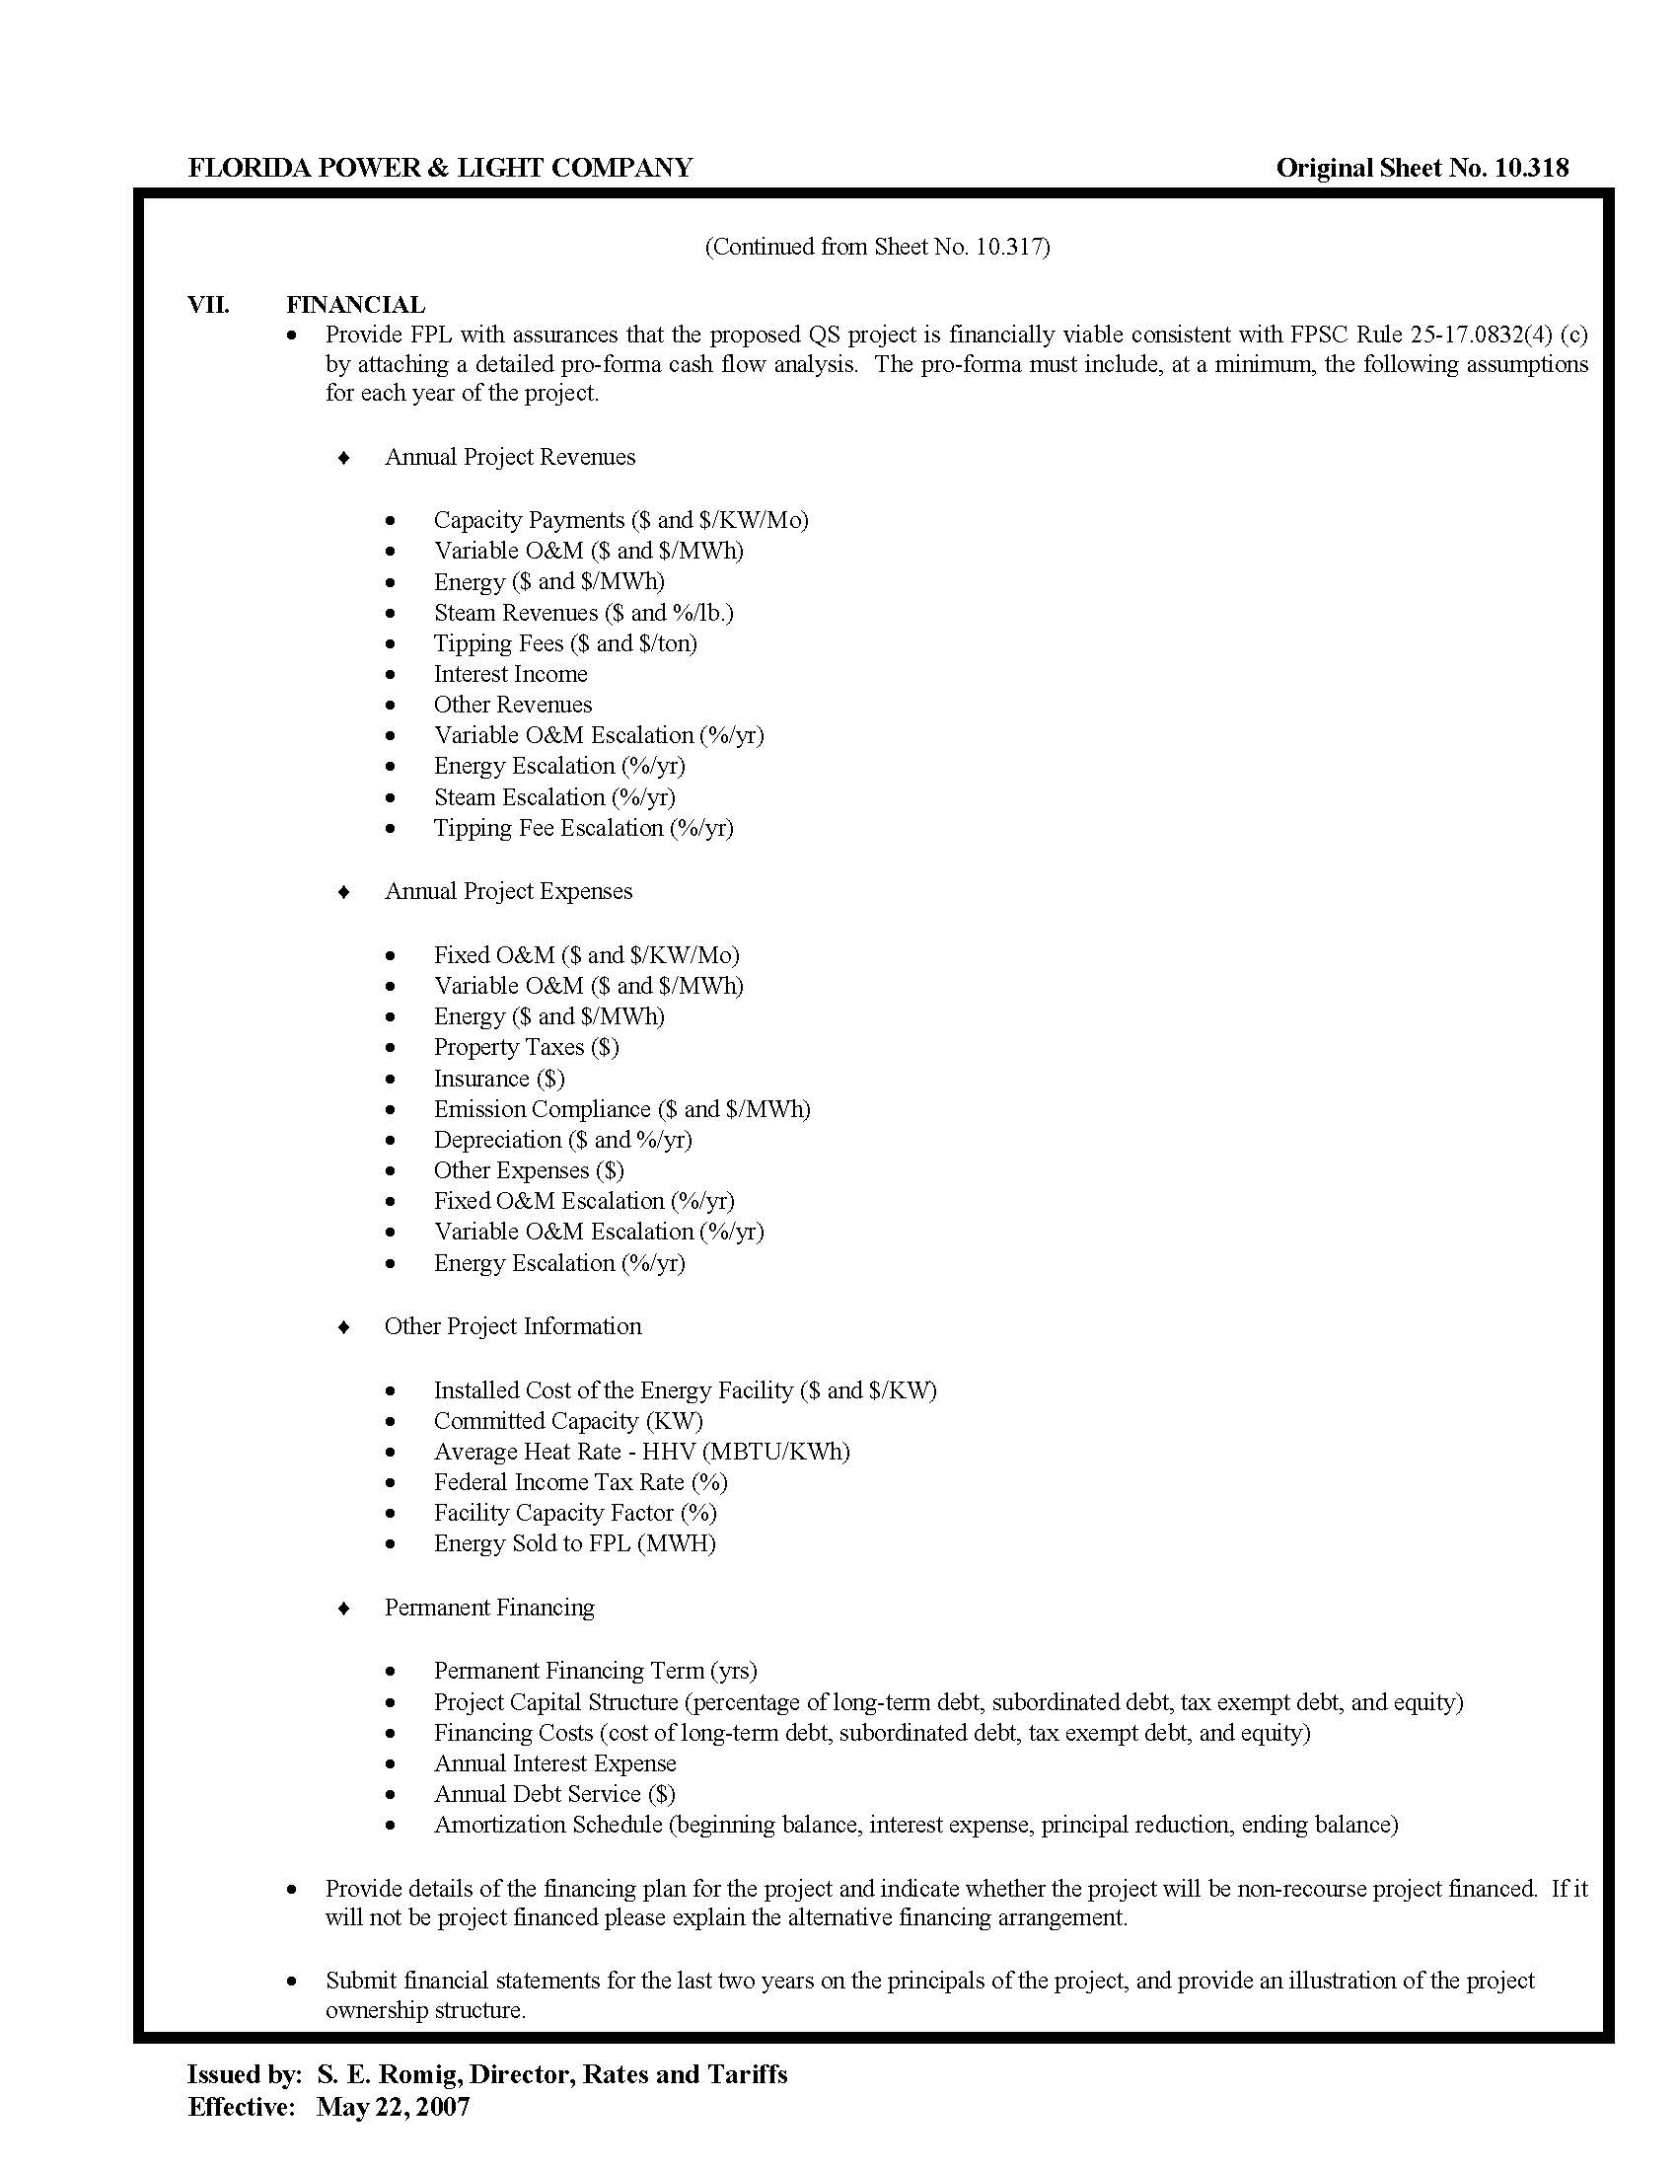

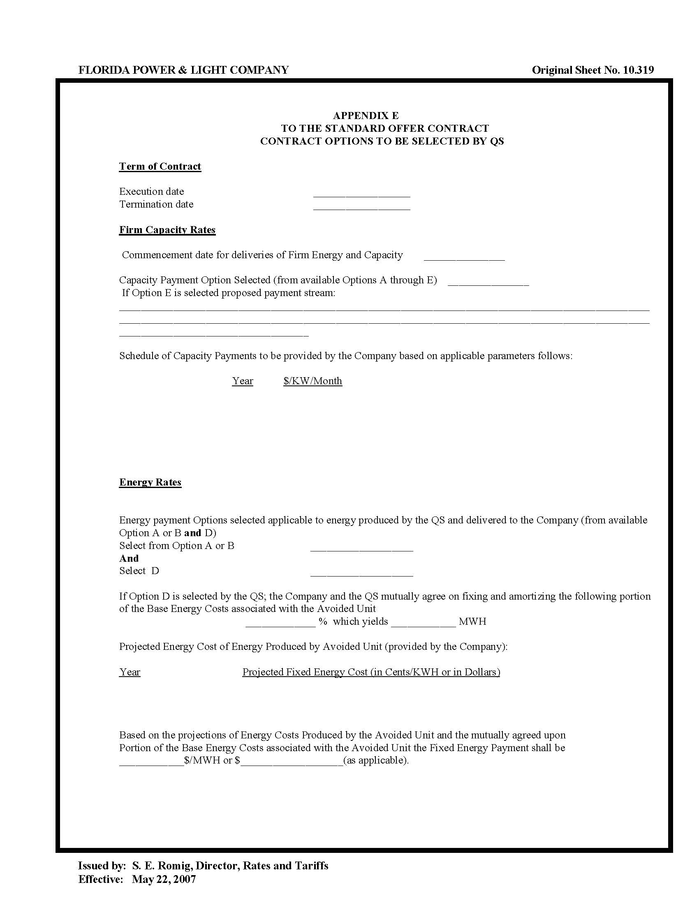

Order No. PSC-2017-0278-PAA-EQ, issued July 18, 2017, in Docket No. 20170077-EQ, In re: Petition for approval of renewable energy tariff and standard offer contract, by Florida Power & Light Company.
Order No. PSC-13-0322-PAA-EQ, issued July 12, 2013, in Docket No. 130072-EQ, In re: Petition for approval of renewable energy tariff and standard offer contract, by Florida Power & Light Company.
Document No. 00228-2018, filed January 10, 2018, in Docket No. 20170226-EQ.

