State of Florida |  | Public Service Commission  Capital Circle Office Center ● 2540 Shumard Oak Boulevard  Tallahassee, Florida 32399-0850  -M-E-M-O-R-A-N-D-U-M-
DATE: | January 25, 2018
TO: | Office of Commission Clerk (Stauffer)
FROM: | Office of the General Counsel (Cowdery)  Office of Consumer Assistance and Outreach (Hicks)  Division of Economics (Guffey)  Division of Engineering (Graves, King)
RE: | Docket No. 20170222-WS – Proposed amendment of Rules 25-30.130, Record of Complaints, and 25-30.355, Complaints, F.A.C.
AGENDA: | 02/06/18 – Regular Agenda – Interested Persons May Participate
COMMISSIONERS ASSIGNED: |  |  | All Commissioners
PREHEARING OFFICER: |  |  | Brown
RULE STATUS: |  |  | Proposal May Be Deferred
SPECIAL INSTRUCTIONS: |  |  | None

Case Background
Rule 25-30.130, Record of Complaints, Florida Administrative Code (F.A.C.), requires each water and wastewater utility to keep a record of each signed, written customer complaint and identifies the information that must be kept in the record. Rule 25-30.355, Complaints, F.A.C., requires a utility to make a full and prompt acknowledgement and investigation of all customer complaints, and defines the word “complaint.” Staff initiated this rulemaking to update language, delete obsolete requirements, edit to improve readability, and clarify the rules.

The Commission also has a rule addressing customer complaints that applies to all of the Commission’s regulated utilities, Rule 25-22.032, F.A.C., Customer Complaints. Under this rule, if a customer complaint is not resolved informally between a customer and the utility, the customer may file a complaint with the Commission. Staff is not recommending any amendments to this rule because the process set out in the rule works well. However, staff examined Rules 25-30.130 and 25-30.355, F.A.C., in light of the process described in Rule 25-22.032, F.A.C., to determine whether there was any duplication between the rules.

The notice of rule development for Rules 25-30.130, Record of Complaints, and 25-30.355, Complaints, F.A.C., appeared in the February 8, 2017, edition of the Florida Administrative Register, volume 43, number 26. Staff rule development workshops were held on February 28, 2017, and on June 27, 2017. Although no water or wastewater utility representatives attended the workshops, Mr. Mike Smallridge provided comments that were considered in this rulemaking. The Office of Public Counsel participated in both workshops and provided comments that were incorporated into the draft rule amendments.
The Record of Complaints and Complaints rules were considered by the Commission at the December 12, 2017, Agenda Conference. The Commission deferred this docket to the February 6, 2018 Agenda Conference so that staff could make two changes to the draft Complaints rule, Rule 25-30.355, F.A.C.. The Commission directed staff to amend the Complaints rule to require a utility to acknowledge receipt of a complaint no later than three days after receipt of the complaint. The Commission also directed staff to amend the Complaints rule to require a utility to investigate the complaint and give the customer a verbal or written response within 15 days of receipt, instead of within 15 working days of receipt as had been recommended by staff. Staff sent out a second data request and invited water and wastewater utilities and interested persons to provide comments on these draft changes. Staff received one utility response from Mr. Mike Smallridge. Staff prepared a Statement of Estimated Regulatory Costs that included consideration of this data request response.
This recommendation addresses whether the Commission should propose the amendment of Rules 25-30.130 and 25-30.355, F.A.C. The Commission has jurisdiction pursuant to Sections 120.54, 350.127(2), 367.0812, 367.111, and 367.121(1), Florida Statutes (F.S.).

Discussion of Issues

Issue 1:
Should the Commission propose the amendment of Rules 25-30.130, Record of Complaints, and 25-30.355, Complaints, F.A.C.?

Recommendation:
Yes, the Commission should propose the amendment of Rules 25-30.130 and 25-30.355, F.A.C., as set forth in Attachment A. Staff recommends that the Commission certify proposed amended Rules 25-30.130 and 25-30.355, F.A.C., as minor violation rules. (Cowdery, King, Graves, Hicks, Guffey)

Staff Analysis:
Staff recommends that the Commission propose the amendment of Rules 25-30.130 and 25-30.355, F.A.C., as set forth in Attachment A.

Rule 25-30.130, F.A.C., Record of Complaints
Staff’s suggested changes to Rule 25-30.130, F.A.C., are the same as were recommended in the previous staff recommendation heard by the Commission at the December 12, 2017, Agenda Conference. Staff’s analysis of the recommended amendments is explained below.

Requirement to maintain a record of all complaints
Under subsection (1) of Rule 25-30.130, F.A.C., water and wastewater utilities must maintain a record of all signed, written complaints. The requirement for a signed, written complaint pre-dates electronic communication and is technically obsolete. For this reason, staff recommends that the Commission propose the amendment of subsection (1) of Rule 25-30.130, F.A.C., to require water and wastewater utilities to maintain a record of all complaints received.
Staff is further recommending that Rule 25-30.130(1), F.A.C., be amended to state that the word “complaint” is defined in Rule 25-30.355(2), F.A.C., as discussed below. Staff believes that this will assure that water and wastewater utilities are made aware of what customer contacts constitute complaints that are subject to the record keeping requirements of Rule 25-30.130, F.A.C.

Requirement to maintain a record of each complaint for five years
Staff is recommending that Rule 25-30.130, F.A.C., be amended to require water and wastewater utilities to keep a record of all customer complaints for five years from the date of receipt. Currently, water and wastewater utilities are required to keep records and reports of customers’ service complaints for three years pursuant to Rule 25-30.110(1)(a), F.A.C., Records and Reports. However, staff believes that this three year retention period is obsolete because of recent changes to Section 367.0812(1)(c), F.S. These statutory changes require the Commission, in considering quality of service in rate cases, to consider complaints regarding applicable secondary water quality standards filed by customers with the Commission during the past five years. Because the Commission in practice reviews five years of customer complaints concerning secondary water treatment standards in compliance with current law, staff believes it is reasonable to update the rule to require that water and wastewater utilities keep a record of all customer complaints for five years.

As mentioned in the Case Background, the Commission has a rule applicable to all industries with a procedure to resolve customer complaints that are not resolved informally between a customer and the utility, Rule 25-22.032, F.A.C., Customer Complaints. This Customer Complaints rule requires a utility to keep copies of documentation relating to each Commission complaint for two years after the date the complaint was closed by the Commission. This is a different recordkeeping requirement than the requirement that water and wastewater utilities retain a record of each complaint received by the utility for five years under Rule 25-30.130, F.A.C., addressed in this docket. Staff recommends that for clarity, the Commission should add language to Rule 25-30.130, F.A.C., specifying that documentation relating to customer complaints processed under the Commission’s Customer Complaints rule, Rule 25-22.032, F.A.C., shall be retained as set forth in Rule 25-22.032(10)(a), F.A.C.

Requirement for utilities to provide records of complaints to Commission staff upon request
Staff is recommending that Rule 25-30.130, F.A.C., be amended to include a requirement in subsection (2) that utilities provide records of complaints to Commission staff upon request. Staff believes that this is the intent of Rule 25-30.130, F.A.C. Water and wastewater utilities are required by Rule 25-30.110(1)(b), F.A.C., to maintain their records at their offices in Florida, unless otherwise authorized by the Commission, and they must keep those records open for inspection by Commission staff during business hours. However, there is no specific Commission rule requiring utilities to provide records of complaints to the Commission upon Commission staff’s request. Amending Rule 25-30.130, F.S., to specifically include this requirement will give clarity to assure that utilities keep their records of complaints in such a format or manner that the records are readily available to Commission staff when requested.

Rule 25-30.355, F.A.C., Complaints
Staff’s recommended amendments to this rule incorporate the modifications requested by the Commission at the December 12, 2017 Agenda Conference. Staff’s analysis of the recommended amendments is explained below.
Subsection (1) of Rule 25-30.355, F.A.C., requires water and wastewater utilities to make a full and prompt acknowledgement and investigation of all customer complaints. Specific time periods should be added to the rule to clarify how much time is considered prompt in acknowledging and responding to customer complaints. Staff believes that it is reasonable to expect a utility to acknowledge a customer’s complaint within three days. Further, staff believes that 15 days is an appropriate and sufficient time for a utility to investigate a complaint and give the customer a verbal or written response. It is staff’s opinion that under the current rule, it would be expected that utilities would acknowledge customer complaints within three days and would investigate and provide a response to complaints within 15 days. In essence, clarifying the rule to include these specific timeframes is meant to codify the time frames the Commission would expect utilities to already be meeting in acknowledging and responding to customer complaints.
As explained in the Case Background, following the December 12, 2017 Agenda Conference, staff sent out a second data request and request for comments on the draft amendments to Rule 25-30.355, F.A.C., to all water and wastewater utilities and interested persons in this docket. Staff received one written response from Mr. Mike Smallridge. Mr. Smallridge requested that the time for acknowledging a customer complaint be change from 3 days to 3 business days to compensate for holidays and weekends. Water and wastewater utilities provide an essential public service. Staff believes that a utility should be required to acknowledge its receipt of a customer complaint within 3 days, whether or not some of those days fall on a weekend or holiday.
Subsection (1) of Rule 25-30.355, F.A.C., also requires water and wastewater utilities to “respond fully and promptly to all customer requests.” Staff is recommending that this requirement be deleted from Rule 25-30.355, F.A.C., because it is duplicative of other rule requirements that better explain the utilities’ responsibilities to promptly address customer service requests. In this regard, Rule 25-30.310(2), F.A.C., requires water and wastewater utilities to initiate service to a customer “without unreasonable delay;” Rule 25-30.250(1), F.A.C., requires water and wastewater utilities to re-establish service with the shortest possible delay consistent with the safety of its consumers and the general public; and Rule 25-30.320, F.A.C., addressing refusal or discontinuance of service, contains customer notification requirements. Additionally, Rule 25-30.266, F.A.C., contains provisions that apply when a customer requests the utility to test for meter error. Further, the requirement that customer service requests be promptly addressed is appropriately addressed in the rules described above instead of in the customer complaint rule because customer service requests are not complaints.

Subsection (2) of Rule 25-30.355, F.A.C., defines a complaint, in part, as an objection made to the utility by the customer as to the utility’s charges, facilities, or service that requires action on the part of the utility. Staff believes that the rule should be amended to make clear that the customer may inform the utility of his or her complaint by telephone call, e-mail, letter, or utility’s web-site form. This specificity will mean that all such customer complaints will be recorded and retained as required in Rule 25-30.130, F.A.C., and will be responded to within 15 days as required by subsection (1) of Rule 25-30.355, F.A.C.
Subsection (3) of Rule 25-30.355, F.A.C., requires water and wastewater utilities to reply in writing to Commission staff inquiries within 15 days from the date of the inquiry. Staff recommends that this requirement should be deleted because this same requirement is already properly included in Commission Rule 25-22.032, F.A.C., Customer Complaints, and does not belong in Rule 25-30.355, F.A.C. The focus of Rule 25-30.355, F.A.C., Complaints, is on the utility’s responsibility to promptly investigate and respond to customer complaints and attempt to resolve those complaints without Commission staff’s involvement. If Commission staff has become involved and is requesting information from the utility, it means the complaint has not been resolved by the utility and customer, and the customer has filed a complaint with the Office of Consumer Assistance and Outreach for resolution under Rule 25-22.032, F.A.C.
Staff recommends that Rule 25-30.355, F.A.C., be amended to require each water and wastewater utility to have a procedure for receiving and promptly responding to emergency calls 24 hours a day. Staff believes this amendment is necessary because although another Commission rule, Rule 25-30.330(1), F.A.C., Information to Customers, requires water and wastewater utilities to provide their customers, at least annually, their telephone numbers for regular and after hours, the rule does not address emergency calls. Commission rules require electric and gas public utilities to have a procedure for receiving and promptly responding to emergency calls 24 hours a day. Staff believes it is appropriate for water and wastewater utilities to also be required to have a procedure for receiving and responding to emergency calls 24 hours a day. Staff is recommending that the rule be amended to define emergencies as reports of water or wastewater main breaks or conditions caused by utility-owned facilities wherein property damage or personal injury is reasonably foreseeable. This language is similar to the electric utility definition of emergency in Rule 25-6.094, F.A.C.

Statement of Estimated Regulatory Costs
Pursuant to Section 120.54(3)(b)1., F.S., agencies are encouraged to prepare a statement of estimated regulatory costs (SERC) before the adoption, amendment, or repeal of any rule. A SERC was prepared for this rulemaking and is appended as Attachment B. As required by Section 120.541(2)(a)1., F.S., the SERC analysis includes whether the rule amendments are likely to have an adverse impact on economic growth, private sector job creation or employment, or private sector investment in excess of $1 million in the aggregate within 5 years after implementation. Section 120.541(2)(a)1., F.S. None of the impact/cost criteria will be exceeded as a result of the recommended revisions.

The SERC concludes that the rule amendments will likely not directly or indirectly increase regulatory costs in excess of $200,000 in the aggregate in Florida within 1 year after implementation. Further, the SERC concludes that the rule amendments will not likely increase regulatory costs, including any transactional costs or have an adverse impact on business competitiveness, productivity, or innovation in excess of $1 million in the aggregate within 5 years of implementation. Thus, the rule amendments do not require legislative ratification, pursuant to Section 120.541(3), F.S. In addition, the SERC states that the rule amendments would have minimal impact on small businesses, would have no implementation or enforcement cost on the Commission or any other state and local government entity, and would have no impact on small cities or small counties. The SERC states that transactional costs likely to be incurred by individuals and entities required to comply with the requirements of the rule are expected to be minimal.

Minor Violation Rules Certification
Pursuant to Section 120.695, F.S., beginning July 1, 2017, for each rule filed for adoption, the Commission is required to certify whether any part of the rule is designated as a rule the violation of which would be a minor violation. A list of the Commission rules designated as minor violation rules is published on the Commission’s website, as required by Section 120.695(2), F.S. Currently, Rules 25-30.130 and 25-30.355, F.A.C., are on the Commission’s list of rules designated as minor violations. If the Commission proposes the amendment of Rules 25-30.130 and 25-30.355, F.A.C., the rules would continue to be considered minor violation rules. Therefore, for purposes of filing the amended rules for adoption with the Department of State, staff recommends that the Commission certify proposed amended Rules 25-30.130 and 25-30.355, F.A.C., as minor violation rules.

Conclusion

For the reasons described above, staff recommends that the Commission should propose the amendment of Rules 25-30.130 and 25-30.355, F.A.C., as set forth in Attachment A. Staff recommends that the Commission certify the proposed amended Rules 25-30.130 and 25-30.355, F.A.C., as minor violation rules.
Issue 2:
Should this docket be closed?

Recommendation:
Yes. If no requests for hearing or comments are filed, the rules should be filed with the Department of State, and the docket should be closed. (Cowdery)

Staff Analysis:
If no requests for hearing or comments are filed, the rules should be filed with the Department of State, and the docket should be closed.

25-30.130 Record of Complaints.
(1) Each utility shall maintain a record of all complaints each signed, written complaint received by the utility from any of that utility’s customers.
(2) Each The record shall show include the name and address of the complainant;, the nature of the complaint;, the date received;, the result of any the investigation;, the disposition of the complaint; and the date of the disposition of the complaint. The word “complaint” as used in this rule is defined in subsection 25-30.355(2), F.A.C.
(2) Notwithstanding the requirements of paragraph 25-30.110(1)(a), F.A.C., utilities shall maintain a record of each complaint for a minimum of five years from the date of receipt and shall provide a copy of records of complaints to the Commission upon Commission staff’s request. Documentation relating to customer complaints processed under Rule 25-22.032, F.A.C., shall be retained as set forth in paragraph 25-22.032(10)(a), F.A.C.
Rulemaking Authority 350.127(2), 367.0812(5), 367.121(1) FS. Law Implemented 367.0812(1), 367.111, 367.121(1) FS. History–New 9-12-74, Formerly 25-10.30, 25-10.030, Amended 11-10-86, ____________.

25-30.355 Complaints.
(1) A utility shall give a customer verbal or written acknowledgment of the utility’s receipt of the customer’s complaint no later than three days after it receives the complaint. A utility shall investigate a complaint and give the customer a verbal or written response no later than 15 days after it receives the complaint. make a full and prompt acknowledgement and investigation of all customer complaints and shall respond fully and promptly to all customer requests.
(2) For the purpose of this rule Tthe word “complaint” as used in this rule means shall mean an objection made to the utility by a the customer by telephone call, e-mail, letter, or the utility’s website form as to the utility’s charges, facilities, or service, that where the disposal of the complaint requires action by on the part of the utility.
(3) Each utility shall have a procedure for receiving and promptly responding to emergency calls 24 hours a day. Reports of water or wastewater main breaks or conditions caused by utility-owned facilities where property damage or personal injury is reasonably foreseeable shall be considered an emergency. Replies to inquiries by the Commission’s staff shall be furnished within fifteen (15) days from the date of the inquiry and shall be in writing, if requested.
Rulemaking Authority 350.127(2), 367.0812(5), 367.121(1) FS. Law Implemented 367.0812(1), 367.111, 367.121(1) FS. History–New 9-12-74, Formerly 25-10.70, 25-10.070, Amended 11-10-86, _________.

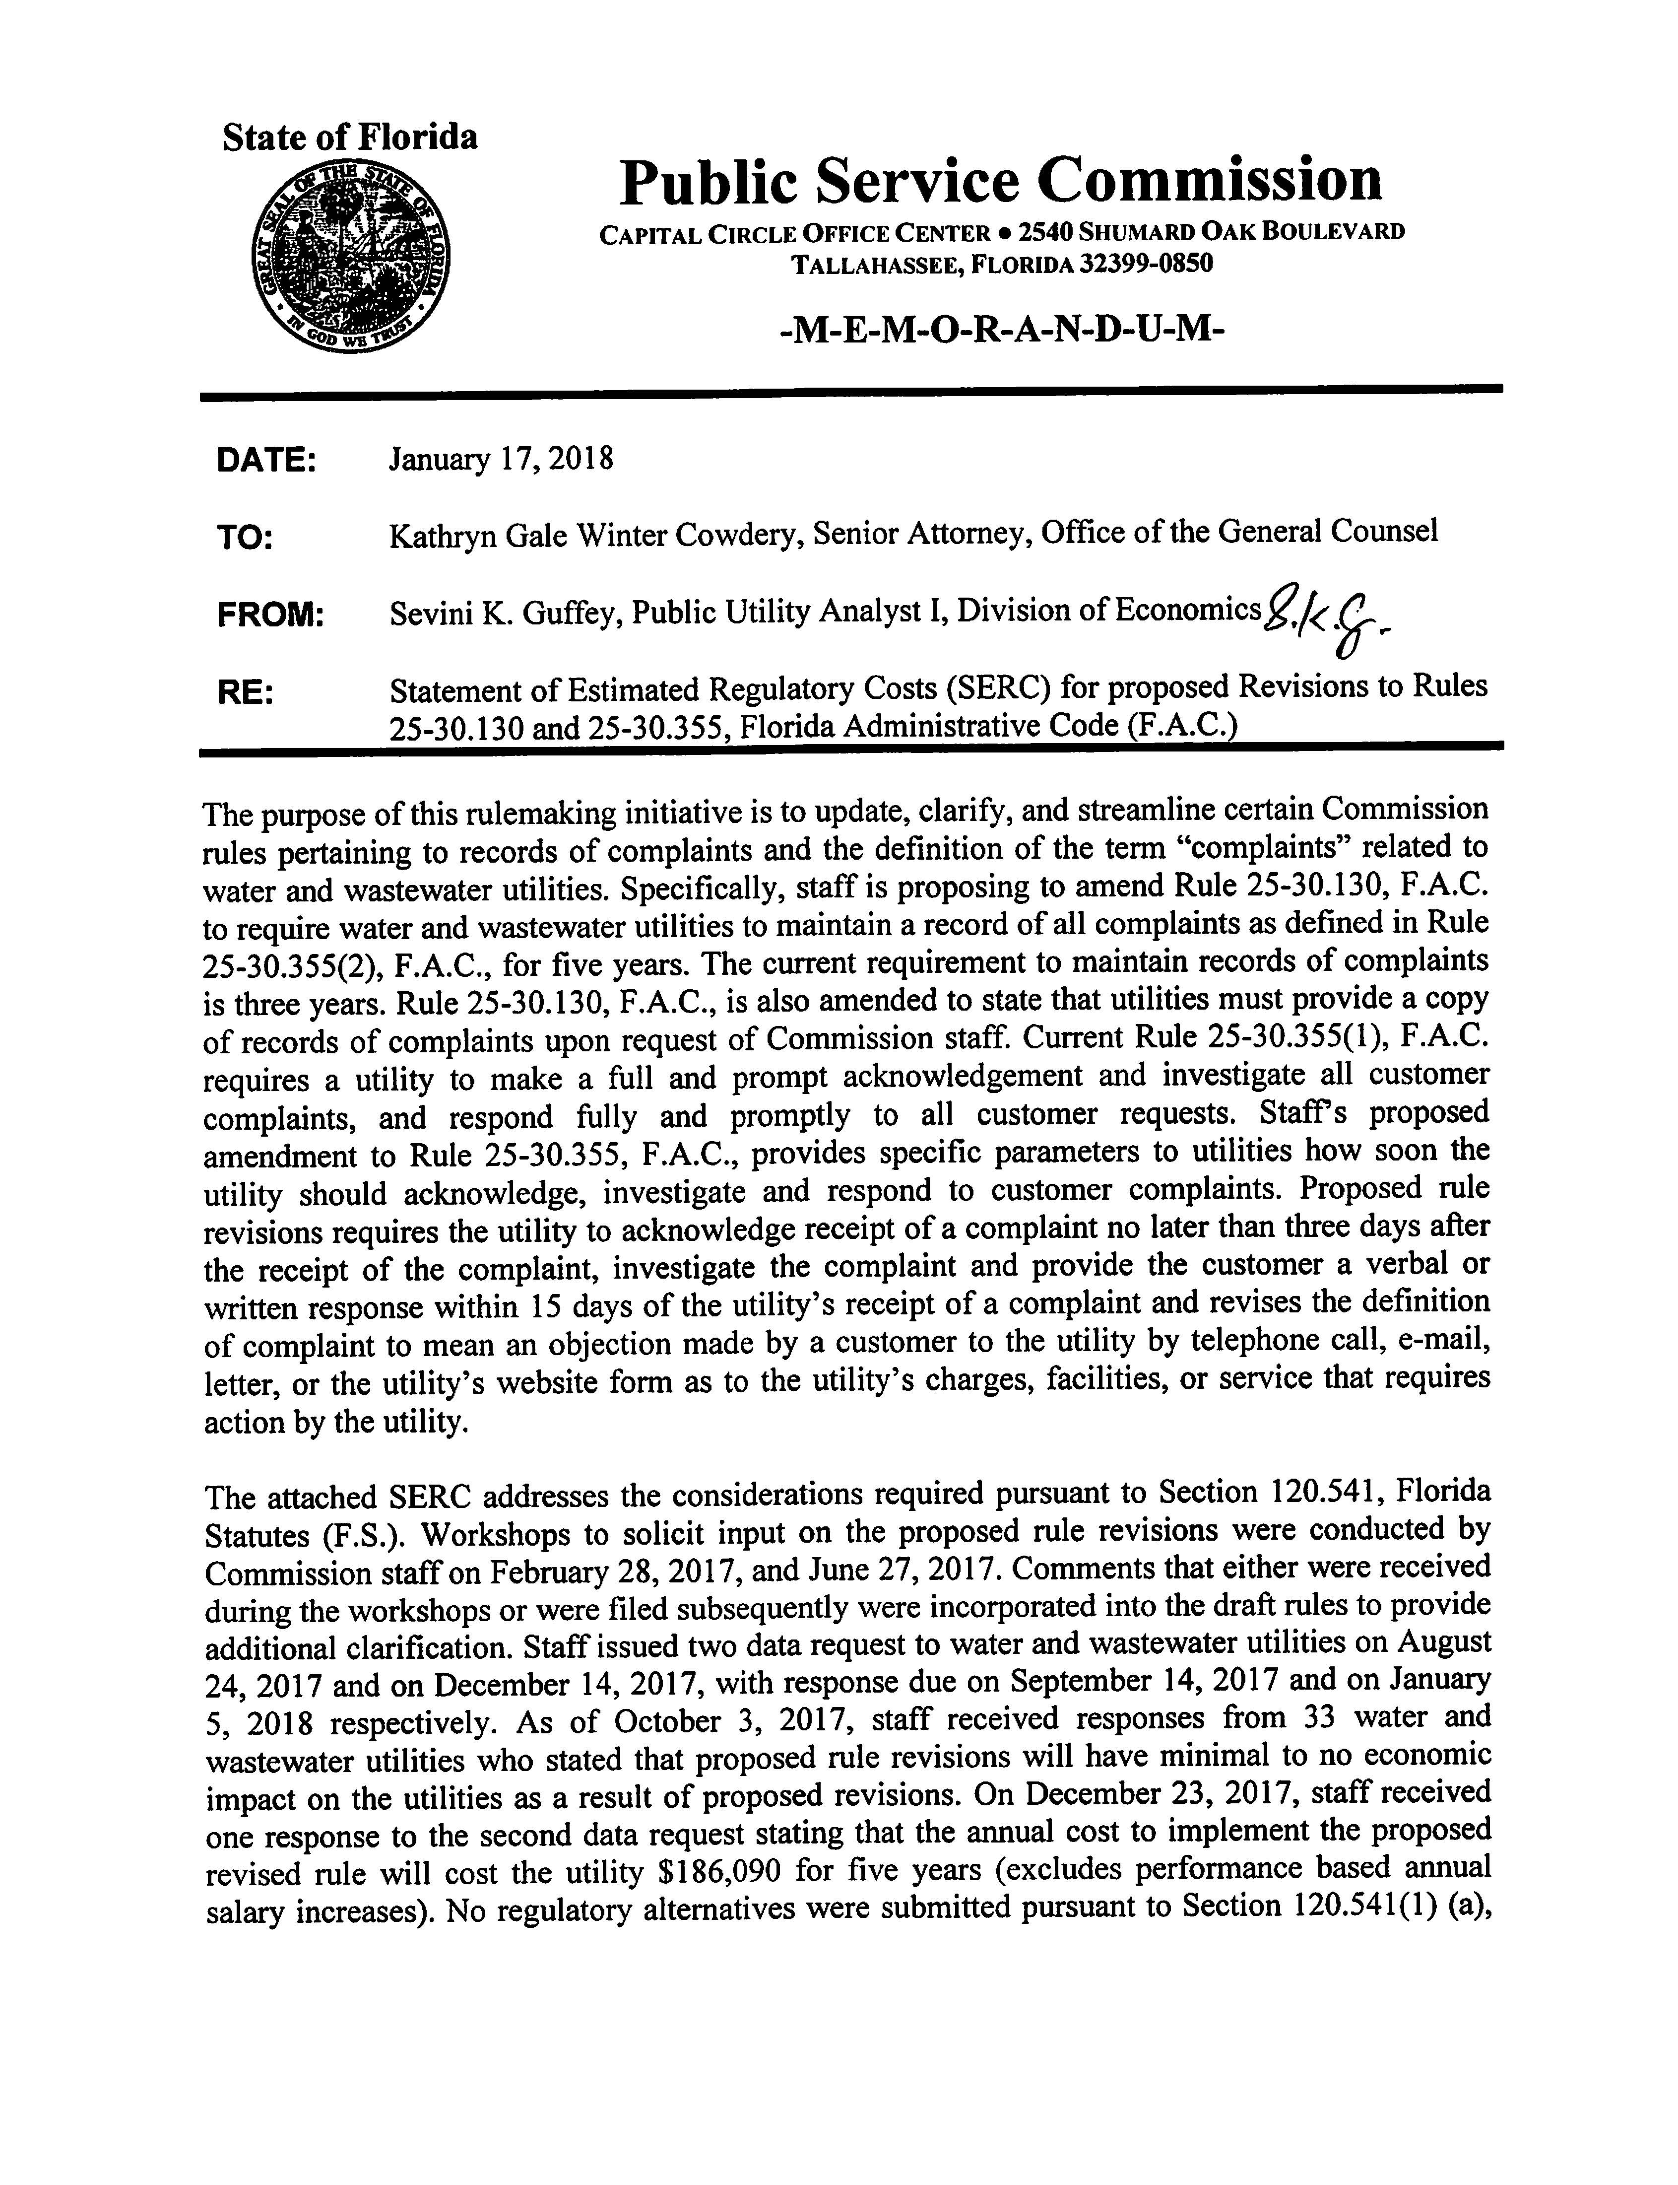

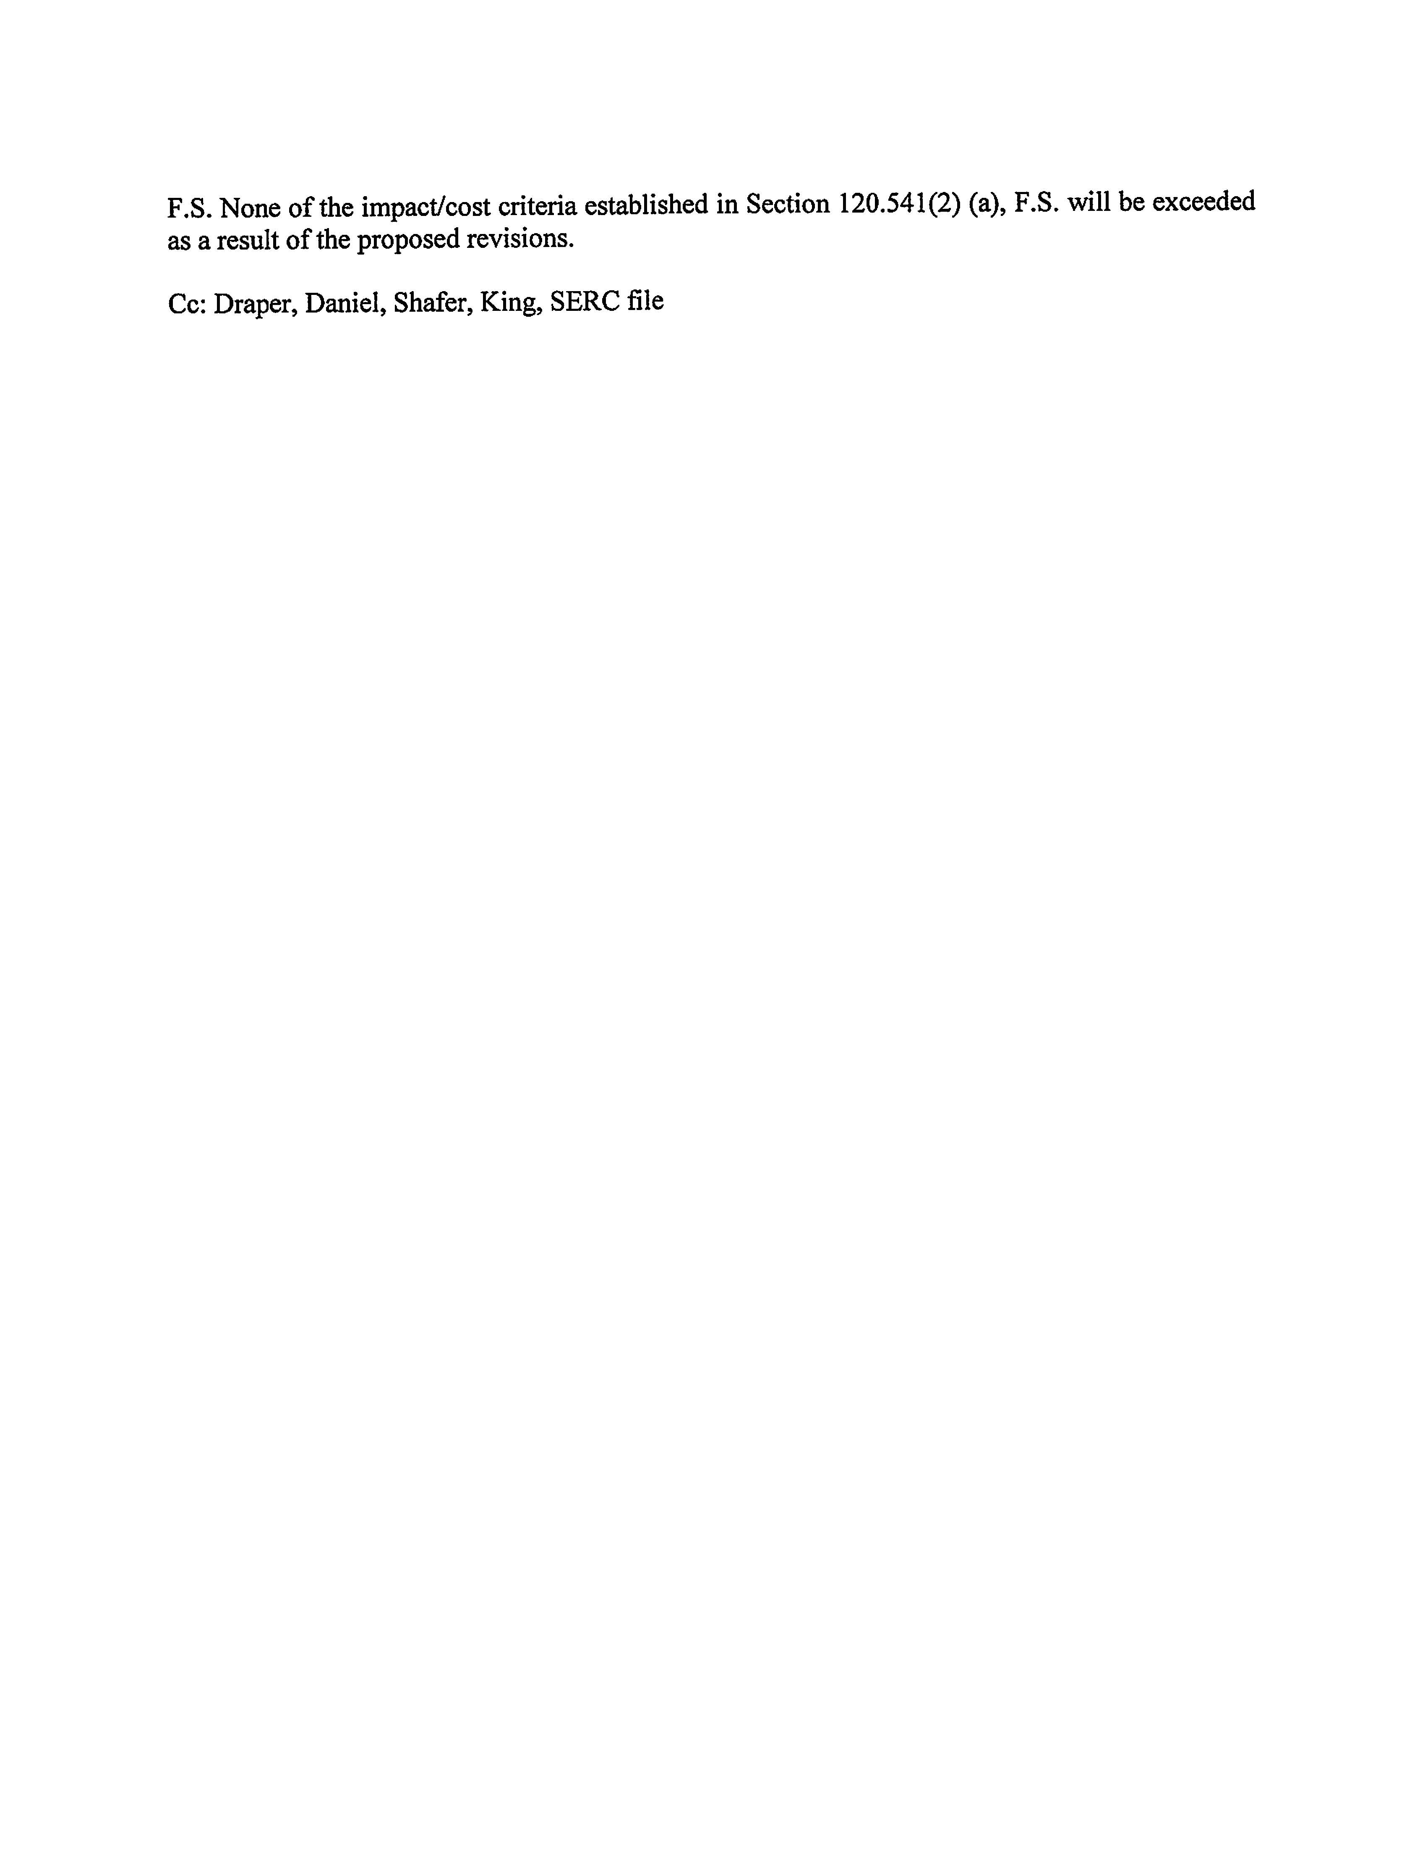

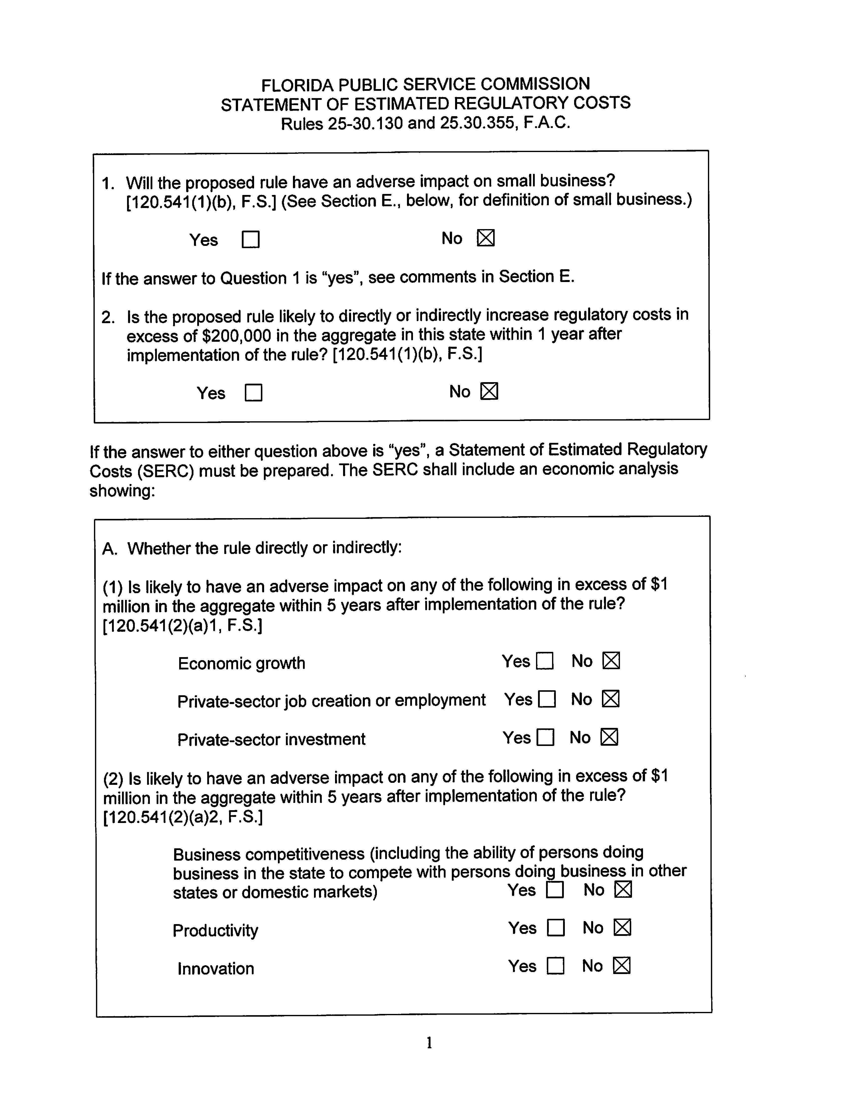

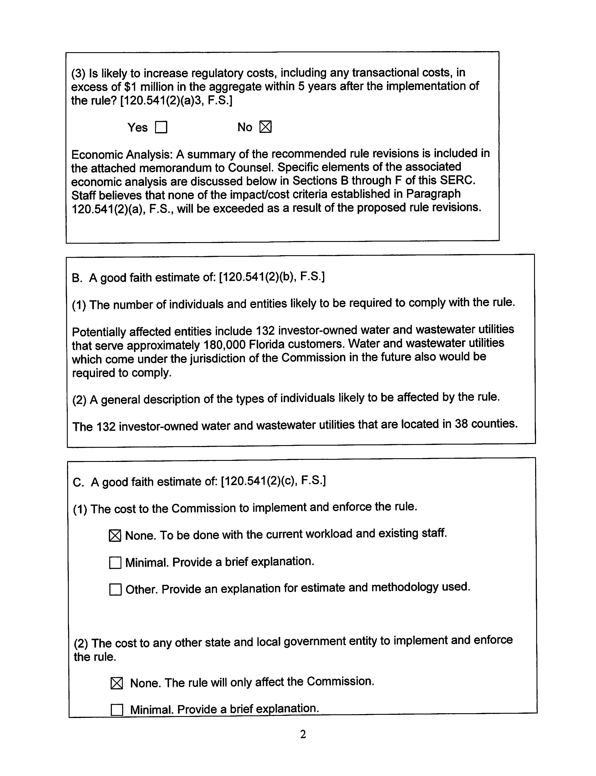

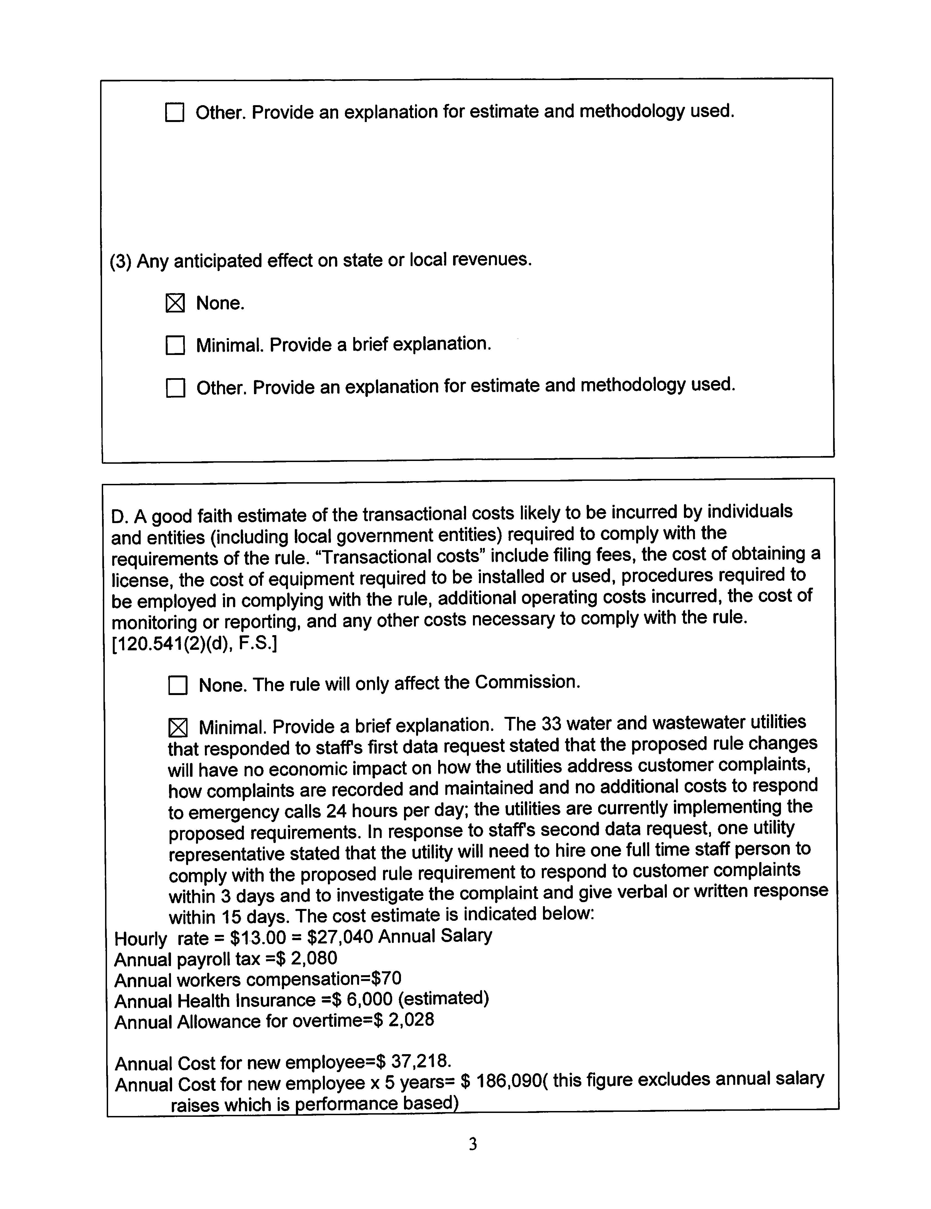

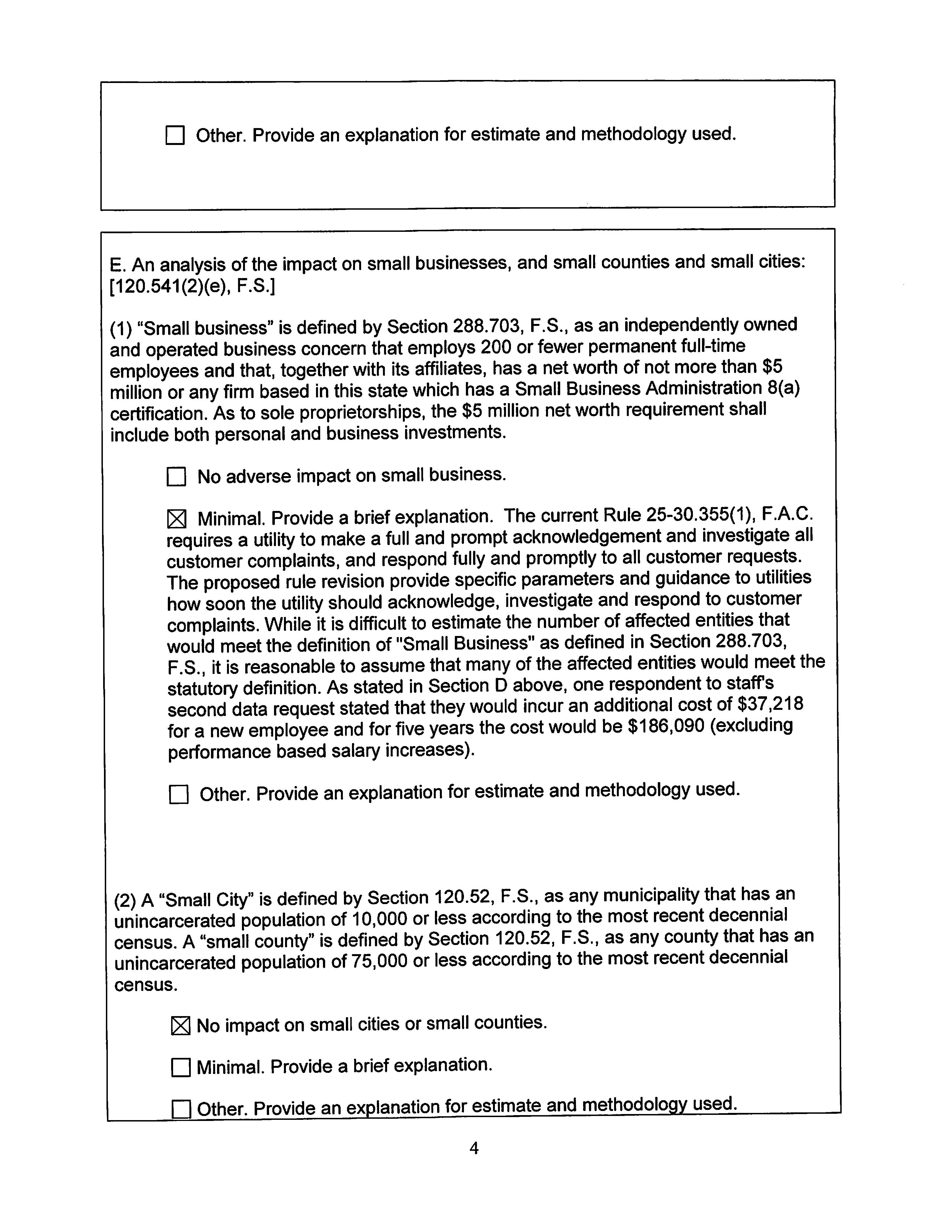

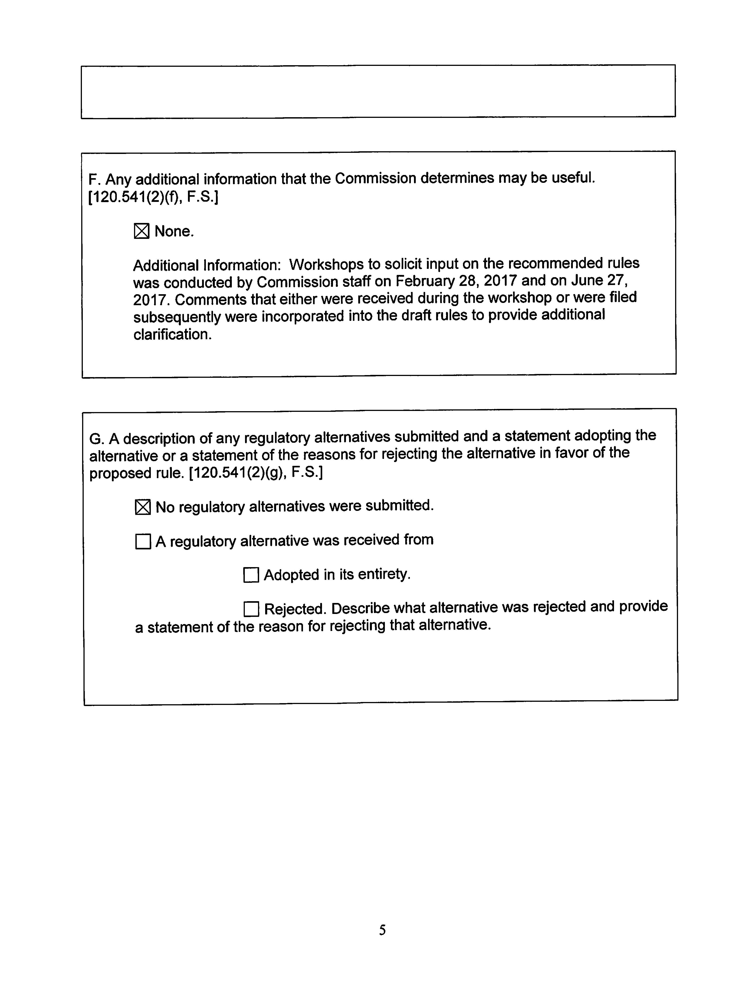

Because of these changes to Section 367.0812(1)(c), F.S., the Commission amended Rules 25-30.440 (11) and 25-30.037(1)(r)4, F.A.C., to require water and wastewater utilities’ rate case applications and applications for authority to transfer an existing water utility to include a copy of all customer complaints that the utility has received regarding DEP secondary water quality standards during the past five years. Order No. PSC-15-0567-FOF-WS, issued December 16, 2015, in Docket No. 150198-WS, In re: Proposed Adoption of Rules; Order No. PSC-15-0055-FOF-WS, issued January 21, 2015, in Docket No. 140205-WS, In re: Proposed Adoption of Rule.
The Commission has rules that specifically require utilities to provide other types of records upon staff’s request. For example, Rule 25-30.245(2), F.A.C., requires each water and wastewater utility to furnish its accident reports to the Commission upon request of Commission staff. Rule 25-22.032(6)(e), F.A.C., addressing unresolved customer complaints filed with Commission, states that Commission staff may request and the utility is required to provide copies of information necessary to resolve a dispute between the utility and the customer.
If a customer believes that his or her service request has not been addressed promptly as required by the Commission rules discussed above for service requests, the customer may make a complaint to the utility.
Rules 25-6.094, 25-7.080(2), 25-12.041 and 25-12.042, F.A.C.

