State of Florida |  | Public Service Commission  Capital Circle Office Center ● 2540 Shumard Oak Boulevard  Tallahassee, Florida 32399-0850  -M-E-M-O-R-A-N-D-U-M-
DATE: | January 25, 2018
TO: | Office of Commission Clerk (Stauffer)
FROM: | Division of Engineering (Mtenga)  Office of the General Counsel (Murphy, Cuello)
RE: | Docket No. 20180007-EI – Environmental cost recovery clause.
AGENDA: | 02/06/18 – Regular Agenda – Interested Persons May Participate
COMMISSIONERS ASSIGNED: |  |  | All Commissioners
PREHEARING OFFICER: |  |  | Clark
CRITICAL DATES: |  |  | None
SPECIAL INSTRUCTIONS: |  |  | None

Case Background
On November 17, 2017, Florida Power & Light Company (FPL) filed a petition for mid-course correction to its 2018 Environmental Cost Recovery Clause (ECRC) factors approved in Order No. PSC-2018-0014-FOF-EI. FPL has requested that the revised factors become effective March 1, 2018. The mid-course correction is a result of stipulation 10G entered by FPL and other parties and approved by the Florida Public Service Commission (Commission) on October 25, 2017.
Mid-course corrections are rare in the ECRC docket and are more typical in the fuel docket. Mid-course corrections are considered preliminary procedural decisions, and any over-recoveries or under-recoveries caused by, or resulting from, the Commission-approved adjusted cost recovery factors may be included in the following year’s cost recovery factors. If approved by the Commission, this mid-course correction will result in lower cost recovery factors for FPL’s customers.
This mid-course correction was filed by FPL with the intention of the proposed decrease in rates becoming effective March 1, 2018. Typically, effective dates are set a minimum of 30 days after a Commission vote modifying the charges as the result of a mid-course correction. However, the Commission has also implemented charges in less than 30 days when circumstances warrant. In this instance, the interval between the Commission’s vote on this matter (February 6, 2018) and the proposed implementation date (expected to be March 1, 2018) is 22 days. Since this filing, if approved, results in a decrease to rates, staff believes the 22 day interval is sufficient.
The Commission has jurisdiction over this matter pursuant to Section 366.05 and 366.8255, Florida Statutes.

Discussion of Issues

Issue 1:
Should the Commission approve FPL’s petition for a mid-course revision to its 2018 ECRC factors and associated tariff sheets?

Recommendation:
Yes. FPL’s petition for mid-course correction to its 2018 ECRC factors and associated tariff sheets reflect the results of the prior stipulation that was approved by the Commission. The revised factors and associated tariffs should become effective March 1, 2018. (Mtenga)

Staff Analysis:
The St. John River Power Plant (SJRPP) transaction was resolved by settlement between the Office of Public Counsel and FPL through a joint stipulation approved by the Commission on September 25, 2017. At the time FPL had already filed its 2018 ECRC projection filings on August 11, 2017. A consensus was reached between the parties involved in the ECRC proceedings that FPL would be required to file a mid-course correction instead of modifying the August 11, 2017 filing. The parties presented a stipulation to the Commission which noted that FPL would file a mid-course correction on November 17, 2017, and the Commission will rule on the petition at the February 6, 2018 Commission Conference. If approved, the revised ECRC factors will go into effect on March 1, 2018.
The impact of the SJRPP transaction is a reduction in ECRC revenue requirements by $1,123,318 for the projected year of 2018. This reduction in revenue requirement results in the 2018 ECRC factor for the RS-1 rate decreasing from 0.159 cents per kilowatt/hour(kWh) to 0.158 cents per kWh, included as Attachment A. At an informal meeting held January 4, 2018, between staff and interested parties, FPL stated that it will provide customers notice of the reduction in their March billing inserts in conjunction with the mid-course correction that is occurring in Docket No. 20170001-EI.

Staff recommends that the Commission approve FPL’s petition for mid-course correction to its 2018 ECRC factors and associated tariff sheets. The revised factors and associated tariffs should become effective March 1, 2018.
Issue 2:
Should this docket be closed?

Recommendation:
No. The ECRC docket is on-going and should remain open.(Murphy)

Staff Analysis:
The ECRC docket is on-going and should remain open.

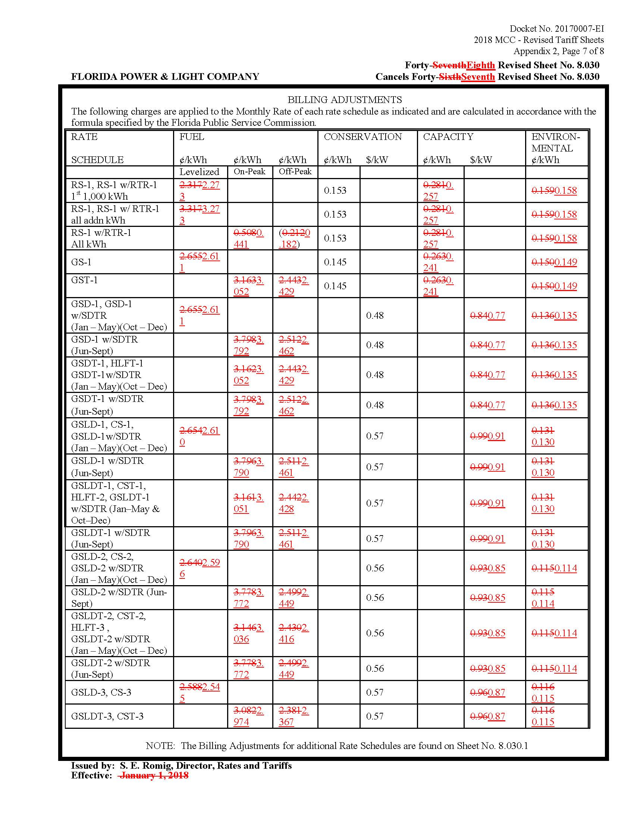

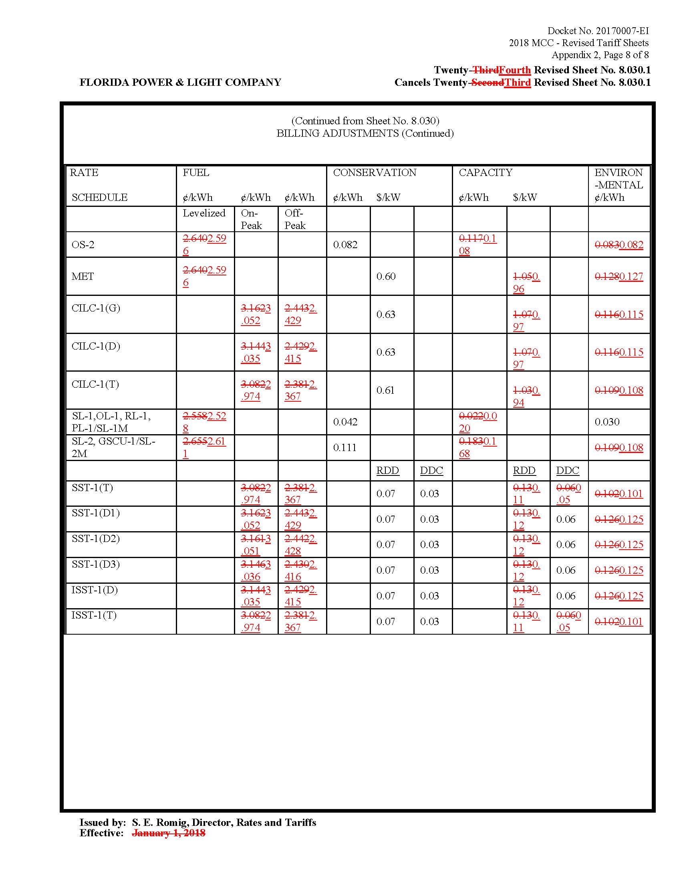

Document No. 09919-2017, filed November 17, 2017, in Docket No. 20170007-EI, In re: Environmental cost recovery clause.
Order No. PSC-2018-0014-FOF-EI issued January 4, 2018, in Docket No. 20180007-EI, In re: Environmental Cost Recovery Clause.
See e.g., Gulf Power Co. v. Cresse, 410 So.2d 492 (Fla. 1982); Order No. PSC-96-0907-FOF-EI, issued on July 15, 1996, in Docket No. Docket No. 19960001-EI, In re: Fuel and purchased power cost recovery clause and generating performance incentive factor; Order No. PSC-1996-0908-FOF-EI, issued July 15, 1996, in Docket No. 19960001-EI, In re: Fuel and purchased power cost recovery clause and generating performance incentive factor; Order No. PSC-97-0021-FOF-EI, issued on January 6, 1997, in Docket No. 19970001-EI, In re: Fuel and purchased power cost recovery clause and generating performance incentive factor.
See e.g., Order No. PSC-01-0963-PCO-EI, issued April 18, 2001, in Docket No. 20010001-EI, In re: Fuel and purchased power cost recovery clause and generating performance incentive factor, (allowing recovery of increase in fuel factor in order to decrease the carrying costs and therefore the total amount ratepayers were ultimately required to repay.); Order No. PSC-00-2383-FOF-GU, issued December 12, 2000, in Docket No. 20000003-GU, In re: Purchased gas adjustment (PGA) true-up (allowing recovery of an increased gas fuel factor due to drastic increases in natural gas prices in winter of 2000-2001.); Order No. PSC-15-0161-PCO-EI, issued April 30, 2015, in Docket No. 20150001-EI, In re: Fuel and Purchased Power Cost Recovery Clause with Generating Performance Incentive Factor. (approving FPL’s petition for a mid-course correction, thereby reducing fuel factors with less than 30 days notice).
Order No. PSC-2017-0415-AS-EI issued October 24, 2017, in Docket No. 20170123-EI, In re: Petition for approval of arrangement to mitigate unfavorable impact of St. Johns River Power Park, by Florida Power & Light Company.

