State of Florida |  | Public Service Commission  Capital Circle Office Center ● 2540 Shumard Oak Boulevard  Tallahassee, Florida 32399-0850  -M-E-M-O-R-A-N-D-U-M-
DATE: | February 16, 2018
TO: | Office of Commission Clerk (Stauffer)
FROM: | Division of Economics (Bruce, Hudson)  Office of the General Counsel (Crawford)  Division of Accounting and Finance (Cicchetti)
RE: | Docket No. 20180025-WS – Application for approval of tariff for the gross-up of CIAC in Charlotte, Highlands, Lake, Lee, Marion, Orange, Pasco, Pinellas, Polk, and Seminole Counties, by Utilities, Inc. of Florida.
AGENDA: | 03/01/18 – Regular Agenda – Tariff Filing – Interested Persons May Participate
COMMISSIONERS ASSIGNED: |  |  | All Commissioners
PREHEARING OFFICER: |  |  | Administrative
CRITICAL DATES: |  |  | 03/30/18 (60-Day Suspension Date)
SPECIAL INSTRUCTIONS: |  |  | None

Case Background
Utilities, Inc. of Florida (UIF or utility) is a Class A utility providing water and wastewater services to 27 systems in the following counties: Charlotte, Highlands, Lake, Lee, Marion, Orange, Pasco, Pinellas, Polk, and Seminole. The utility reported in its 2016 annual report, water operating revenues in the amount of $2,498,891 and $1,440,710 for wastewater.
On January 29, 2018, UIF filed an application for approval of a tariff to allow for gross-up of contributions in aid of construction (CIAC) in Charlotte, Highlands, Lake, Lee, Marion, Orange, Pasco, Pinellas, Polk and Seminole Counties. As discussed in Issue 1, the utility indicated that a change in tax law may cause it to be at risk of the opportunity to earn a reasonable return on its used and useful property if it is not allowed to collect the impact on receipt of CIAC.
This recommendation addresses the utility’s request for approval of a gross-up tariff. ; The Commission has jurisdiction pursuant to Sections 367.081 and 367.091, Florida Statutes (F.S.).

Discussion of Issues

Issue 1:
Should UIF’s request for approval of a tariff to allow the gross-up of CIAC be approved?

Recommendation:
Yes, the proposed tariff should be approved. The gross-up amounts should be collected subject to refund pending resolution of Docket No. 20180013-PU and guaranteed by a corporate undertaking. UIF should provide notice to property owners who have requested service during the 12 months prior to the month the request for gross-up of CIAC was filed. The approved gross-up charges should be effective for connections made on or after the stamped approval date on the tariff sheets. The utility should provide proof of noticing within 10 days of rendering its approved notice. In addition, UIF should be required to file with its Annual Report, a calculation detailing: (1) the amounts of cash and property contributions received during the reporting year; (2) the calculation of the utility’s tax liability for the reporting year; and (3) the amount of taxes actually collected on CIAC for the reporting year. The reporting requirement should begin with the 2018 Annual Report and continue each year thereafter. (Bruce, Hudson, Cicchetti)

Staff Analysis:
Effective January 1, 2018, the Federal Tax Cuts and Jobs Act amended Section 118 of the Internal Revenue Code. Prior to the amendments, CIAC was exempt from taxable gross income for water and wastewater utilities. As a result of the amendments, both cash and property CIAC are now taxable gross income for water and wastewater utilities. In recognition of this change in the tax law, the Commission has opened Docket No. 02180013-PU, In re: Petition to establish a generic docket to investigate and adjust rates for 2018 tax savings by Office of Public Counsel, to address the potential rate impacts on regulated electric, gas, water, and wastewater utilities.
A similar law, the Tax Reform Act of 1986, became effective in 1987. In Docket No. 860184-PU, the Commission found that it was appropriate to allow water and wastewater utilities to recover the tax on CIAC from the contributor, including the tax associated with the additional tax that would also become taxable income. For those utilities that were approved to collect the gross-up on CIAC, the gross-up amounts collected were held subject to refund and were evaluated on a case-by-case basis as to whether any refunds were subsequently required.
In its petition, the utility included a proposed tariff (Attachment A) to gross-up cash service availability charges and property contributions to recover the federal and state corporate income taxes associated with those contributions. According to the utility, UIF could risk loss of its opportunity to earn a reasonable return on its property used and useful in the public service if it is not allowed to collect the tax impact on receipt of CIAC.

The gross-up amounts collected by UIF should be subject to refund pending resolution of Docket No. 20180013-PU and guaranteed by a corporate undertaking. In addition, UIF should be required to file with its Annual Report, a calculation detailing: (1) the amounts of cash and property contributions received during the reporting year; (2) the calculation of the utility’s tax liability for the reporting year; and (3) the amount of taxes actually collected on CIAC for the reporting year. The reporting requirement should begin with the 2018 Annual Report and continue each year thereafter.

Based on the above, the proposed tariff should be approved. The gross-up amounts should be collected subject to refund pending resolution of Docket No. 20180013-PU and guaranteed by a corporate undertaking. UIF should provide notice to property owners who have requested service during the 12 months prior to the month the request for gross-up of CIAC was filed. The approved gross-up charges should be effective for connections made on or after the stamped approval date on the tariff sheets. The utility should provide proof of noticing within 10 days of rendering its approved notice. In addition, UIF should be required to file with its Annual Report, a calculation detailing: (1) the amounts of cash and property contributions received during the reporting year; (2) the calculation of the utility’s tax liability for the reporting year; and (3) the amount of taxes actually collected on CIAC for the reporting year. The reporting requirement should begin with the 2018 Annual Report and continue each year thereafter.

Issue 2:
Should this docket be closed?

Recommendation:
If the Commission approves staff’s recommendation in Issue 1, the docket should remain open pending resolution of Docket No. 20180013-PU. (Crawford)

Staff Analysis:
If the Commission approves staff’s recommendation in Issue 1, the docket should remain open pending resolution of Docket No. 20180013-PU.

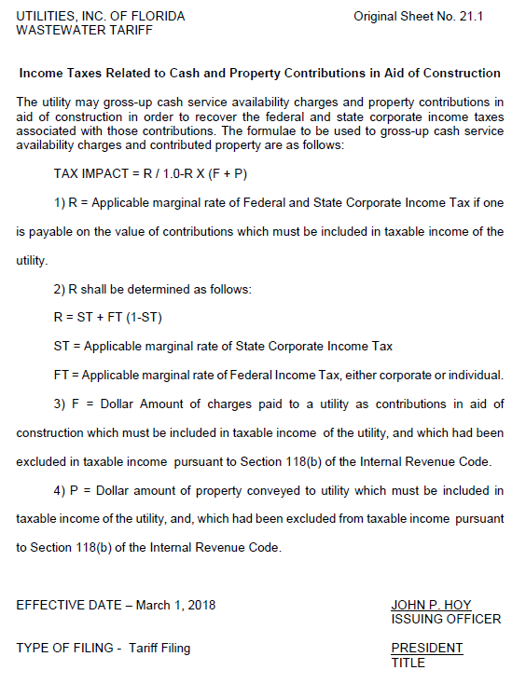

The amendment was repealed in 1996.
According to the 2016 Annual Report, UIF collected approximately $835,000 in cash and property CIAC.

