State of Florida |  | Public Service Commission  Capital Circle Office Center ● 2540 Shumard Oak Boulevard  Tallahassee, Florida 32399-0850  -M-E-M-O-R-A-N-D-U-M-
DATE: | February 16, 2018
TO: | Office of Commission Clerk (Stauffer)
FROM: | Division of Economics (Bruce)  Office of the General Counsel (Trierweiler)
RE: | Docket No. 20170223-SU – Application for establishment of wastewater allowance for funds prudently invested (AFPI) charges in Highlands, Lake, Marion, Pasco and Pinellas Counties, by Utilities, Inc. of Florida.
AGENDA: | 03/01/18 – Regular Agenda – Tariff Filing – Interested Persons May Participate
COMMISSIONERS ASSIGNED: |  |  | All Commissioners
PREHEARING OFFICER: |  |  | Administrative
CRITICAL DATES: |  |  | 06/16/18 (8-Month Effective Date)
SPECIAL INSTRUCTIONS: |  |  | None

Case Background
Utilities, Inc. of Florida (UIF or utility) is a Class A utility providing water and wastewater services to 27 systems in the following counties: Charlotte, Highlands, Lake, Lee, Marion, Orange, Pasco, Pinellas, Polk, and Seminole. The utility reported in its 2016 annual report, water operating revenues in the amount of $2,498,891 and $1,440,710 for wastewater.
On October 16, 2017, the utility filed an application to establish allowance for funds prudently invested (AFPI) charges for the LUSI, Labrador, Lake Placid, Mid-County, and UIF-Marion wastewater systems, including tariff sheets reflecting the proposed charges. Subsequently, on February 8, 12, and 15, 2018, the utility filed revised tariffs to reflect the change to the corporate income tax rate which became effective on January 1, 2018, and to correct calculation errors in the proposed tariffs. The utility is requesting AFPI charges because the above-mentioned wastewater systems were considered less than 100 percent used and useful (U&U) by Order No. PSC-2017-0361-FOF-WS, issued September 25, 2017. The utility’s proposed AFPI tariffs were suspended by Order No. PSC-2017-0477-PCO-SU, issued December 21, 2017, in the instant docket, pending further investigation.

This recommendation addresses UIF’s request to establish AFPI charges for its LUSI, Labrador, Lake Placid, Mid-County, and UIF-Marion wastewater systems. The Commission has jurisdiction pursuant to Sections 367.081 and 367.091, Florida Statutes (F.S.).

Discussion of Issues

Issue 1:
Should UIF be authorized to collect the proposed AFPI charges for its Labrador, Lake Placid, Mid-County, and UIF-Marion wastewater systems?

Recommendation:

Yes. UIF should be authorized to collect the proposed AFPI charges, shown on Attachment A, from future wastewater customers in its Labrador, Lake Placid, Mid-County, and UIF-Marion systems. After December 31, 2020, the utility should be allowed to collect the constant charge until the projected ERCs included in the calculation of the charge have been added, upon which the charges should be discontinued. The AFPI charges should apply to future connections of 155 ERCs for Labrador, 226 ERCs for Lake Placid, 203 ERCs for Mid-County, and 45 ERCs for the UIF-Marion system.
UIF should provide notice to property owners who have requested service during the 12 months prior to the month the request for AFPI charges was filed. The approved charges should be effective for connections made on or after the stamped approval date on the tariff sheets. The Utility should provide proof of noticing within 10 days of providing its approved notice. (Bruce)

Staff Analysis:
Pursuant to Rule 25-30.434, Florida Administrative Code (F.A.C.), an AFPI charge is a mechanism designed to allow a utility the opportunity to earn a fair rate of return on prudently constructed plant held for future use from the customers that will be served by that plant. This one-time charge is assessed based on the date the future customer connects to the utility’s system.
The utility’s proposed AFPI charges for the Labrador, Lake Placid, Mid-County, and UIF-Marion wastewater systems (Attachment A) are based on the non-U&U adjustments associated with those wastewater treatment plants (WWTP) in Order No. PSC-2017-0361-FOF-WS. The Labrador WWTP was determined to be 79.94 percent U&U, the Lake Placid WWTP was 29.79 percent U&U, the Mid-County WWTP was 93.67 percent U&U, and the UIF-Marion WWTP was 68.65 percent U&U. The U&U adjustments in that rate case excluded a return on the non U&U portion of the investments and the associated depreciation, property taxes, and regulatory assessment fees from the approved revenue requirement. The proposed tariffs filed on February 8, 12, and 15, 2018, reflect the new corporate federal tax rate that became effective on January 1, 2018.
Pursuant to Rule 25-30.434(4), F.A.C., the beginning date for accruing the AFPI charges should agree with the month following the end of the test year that was used to establish the amount of non-U&U plant. The test year used in Docket No. 201610101-WS for establishing the amount of non-U&U plant was the year ended December 31, 2015; therefore, the beginning date for accruing the AFPI in this case is January 1, 2016. The proposed AFPI charges were calculated for a five-year period consistent with Rule 25-30.434(5), F.A.C. After December 31, 2020, the utility should be allowed to collect the constant charge (reflecting the costs accrued through the fifth year) until the projected equivalent residential connections (ERCs) included in the calculation of the charge have been added, upon which the charges should be discontinued. The AFPI charges should apply to future connections of 155 ERCs for Labrador, 226 ERCs for Lake Placid, 203 ERCs for Mid-County, and 45 ERCs for the UIF-Marion system.
UIF should provide notice to property owners who have requested service during the 12 months prior to the month the request for AFPI charges was filed. The approved charges should be effective for connections made on or after the stamped approval date on the tariff sheets. In accordance with Rule 25-30.434(4), F.A.C., no charge may be collected for connections made prior to the effective date of the AFPI charges. The Utility should provide proof of noticing within 10 days of providing its approved notice. The charges reflect the costs associated with one ERC based on 280 gallons per day (gpd) per ERC. If a future customer is expected to place more demand on the system than one ERC, the charge should be multiplied by the number of ERCs of demand which are needed to provide service to the customer.

Conclusion

Based on the above, UIF should be authorized to collect the proposed AFPI charges from future wastewater customers in its Labrador, Lake Placid, Mid-County, and UIF-Marion systems. After December 31, 2020, the utility should be allowed to collect the constant charge until the projected ERCs included in the calculation of the charge have been added, upon which the charges should be discontinued. The AFPI charges should apply to future connections of 155 ERCs for Labrador, 226 ERCs for Lake Placid, 203 ERCs for Mid-County, and 45 ERCs for the UIF-Marion system.

UIF should provide notice to property owners who have requested service during the 12 months prior to the month the request for AFPI charges was filed. The approved charges should be effective for connections made on or after the stamped approval date on the tariff sheets. The Utility should provide proof of noticing within 10 days of providing its approved notice.
Issue 2:
Should UIF be authorized to collect the proposed AFPI charges for its LUSI wastewater system?

Recommendation:
No. UIF’s proposed tariff as filed should be denied. UIF should be given the option to file a revised tariff within 10 days of the Commission’s vote, for administrative approval by staff, that reflects the non U&U costs associated with the LUSI WWTP, pursuant to Order No. PSC-2017-0361-FOF-WS, and accrued beginning January 1, 2016.
Upon staff’s administrative approval, UIF should be authorized to collect the proposed AFPI charges from future wastewater customers in its LUSI system. After December 31, 2020, the utility should be allowed to collect the constant charge until the projected ERCs included in the calculation of the charge have been added, upon which the charges should be discontinued. The AFPI charges should apply to 1,471 future ERCs.
UIF should provide notice to property owners who have requested service during the 12 months prior to the month the request for AFPI charges was filed. The approved charges should be effective for connections made on or after the stamped approval date on the tariff sheets. The Utility should provide proof of noticing within 10 days of providing its approved notice. (Bruce)

Staff Analysis:
The utility’s proposed AFPI charges for the LUSI WWTP (Attachment B) are based on the non-U&U adjustments determined in Order No. PSC-2017-0361-FOF-WS. The proposed tariff filed on February 8, 2018, reflects the new corporate federal tax rate that became effective on January 1, 2018. However, staff believes that, because the utility’s proposed tariff reflects costs accrued beginning in 2010, the proposed tariff is inconsistent with Rule 25-30.434(4), F.A.C. As discussed in Issue 1, the rule provides that the beginning date for accruing the AFPI charges should agree with the month following the end of the test year that was used to establish the amount of non-U&U plant which, in this case, is January 1, 2016. The utility contends that the AFPI charges should not be reset (accrued beginning January 1, 2016), but should continue from the prior U&U adjustments.
AFPI charges applicable to the LUSI WWTP (formerly known as Lake Groves) were previously approved in 1991 in the utility’s original certificate case. At that time, the capacity of the system was 160,000 gpd and the AFPI charges were based on the 545 ERCs which the system was originally designed to serve. UIF purchased the Lake Groves system in 1998 and increased the capacity to 500,000 gpd in 2000. In 2007, the treatment capacity was expanded to 1,000,000 gpd and in a subsequent rate case, Docket No. 20070693-WS, the Commission found the wastewater treatment plant to be approximately 53 percent U&U. The utility was serving approximately 2,860 wastewater customers at that time. In the utility’s next rate case, Docket No. 20100426-WS, the Commission again found the 1,000,000 gpd WWTP to be 53 percent U&U based on the U&U percentage from the prior order.
Pursuant to Order No. PSC-2017-0361-FOF-WS, the utility’s most recent rate case, the Commission found the LUSI WWTP to be 58.78 percent U&U (including prepaid commitments). However, because the LUSI WWTP was serving in excess of the original 545 ERCs the system was designed to serve, the LUSI WWTP AFPI charges were discontinued and an investigation was opened to determine whether there was an over collection of AFPI charges. The investigation addresses AFPI collections prior to 2018, while the proposed charges in this docket will be collected from future connections.
Although it was determined that the utility had non-U&U plant in prior dockets, the AFPI charges were not re-evaluated by staff and the utility did not request that the LUSI AFPI charges be revised following the addition of the original 545 ERCs and the plant expansion that occurred in 2007. Because it is incumbent upon the utility to request consideration of AFPI charges for non-U&U capacity, staff does not believe it is appropriate to accrue AFPI charges prior to January 1, 2016. However, the utility should be given the option to file a revised tariff within 10 days of the Commission’s vote, for administrative approval by staff, that reflects the non U&U costs associated with the LUSI WWTP, pursuant to Order No. PSC-2017-0361-FOF-WS, and accrued beginning January 1, 2016.
Upon staff’s administrative approval, UIF should be authorized to collect the proposed AFPI charges from future wastewater customers in its LUSI system. After December 31, 2020, the utility should be allowed to collect the constant charge until the projected ERCs included in the calculation of the charge have been added, upon which the charges should be discontinued. The AFPI charges should apply to 1,471 future ERCs.
UIF should provide notice to property owners who have requested service during the 12 months prior to the month the request for AFPI charges was filed. The approved charges should be effective for connections made on or after the stamped approval date on the tariff sheets. The Utility should provide proof of noticing within 10 days of providing its approved notice.

Issue 3:
Should this docket be closed?

Recommendation:
If the Commission approves staff’s recommendation in Issue 1, the docket should remain open pending staff’s verification that the revised tariff sheets and notice have been filed by the utility and approved by staff. If a protest is filed within 21 days of the issuance date of the Order, the approved tariff should remain in effect with the charge held subject to refund pending resolution of the protest. If no timely protest is filed, a consummating order should be issued.

If the Commission approves staff’s recommendation in Issue 2, UIF timely files a revised AFPI tariff for its LUSI wastewater system, and a protest is filed within 21 days of the issuance of the order, the revised tariffs should remain in effect, with any revenues held subject to refund, pending staff’s verification that the revised tariff sheets and notice have been filed by the utility and approved by staff; the docket should remain open pending resolution of the protest. If UIF timely files a revised AFPI tariff for its LUSI wastewater system and no timely protest is filed with respect to that issue, the docket should remain open pending staff’s verification that the revised tariff sheets and notice have been filed by the utility and approved by staff, a consummating order should be issued, and the docket should be closed administratively.

If the Commission approves staff’s recommendation in Issue 2, UIF does not timely file a revised AFPI tariff meeting the conditions of the order, and a protest is filed within 21 days of the issuance of the order, the tariffed charges originally requested by UIF could be placed into effect, with any revenues held subject to refund, pending staff’s verification that the revised tariff sheets and notice have been filed by the utility and approved by staff; the docket should remain open pending resolution of the protest. If UIF does not timely file a revised AFPI tariff with respect to its LUSI wastewater system and no timely protest is filed, a consummating order should be issued, and the docket closed administratively. (Crawford)

Staff Analysis:
If the Commission approves staff’s recommendation in Issue 1, the docket should remain open pending staff’s verification that the revised tariff sheets and notice have been filed by the utility and approved by staff. If a protest is filed within 21 days of the issuance date of the Order, the approved tariff should remain in effect with the charge held subject to refund pending resolution of the protest. If no timely protest is filed, a consummating order should be issued.

If the Commission approves staff’s recommendation in Issue 2, UIF timely files a revised AFPI tariff for its LUSI wastewater system, and a protest is filed within 21 days of the issuance of the order, the revised tariffs should remain in effect, with any revenues held subject to refund, pending staff’s verification that the revised tariff sheets and notice have been filed by the utility and approved by staff; the docket should remain open pending resolution of the protest. If UIF timely files a revised AFPI tariff for its LUSI wastewater system and no timely protest is filed with respect to that issue, the docket should remain open pending staff’s verification that the revised tariff sheets and notice have been filed by the utility and approved by staff, a consummating order should be issued, and the docket should be closed administratively.

If the Commission approves staff’s recommendation in Issue 2, UIF does not timely file a revised AFPI tariff meeting the conditions of the order, and a protest is filed within 21 days of the issuance of the order, the tariffed charges originally requested by UIF could be placed into effect, with any revenues held subject to refund, pending staff’s verification that the revised tariff sheets and notice have been filed by the utility and approved by staff; the docket should remain open pending resolution of the protest. If UIF does not timely file a revised AFPI tariff with respect to its LUSI wastewater system and no timely protest is filed, a consummating order should be issued, and the docket closed administratively.

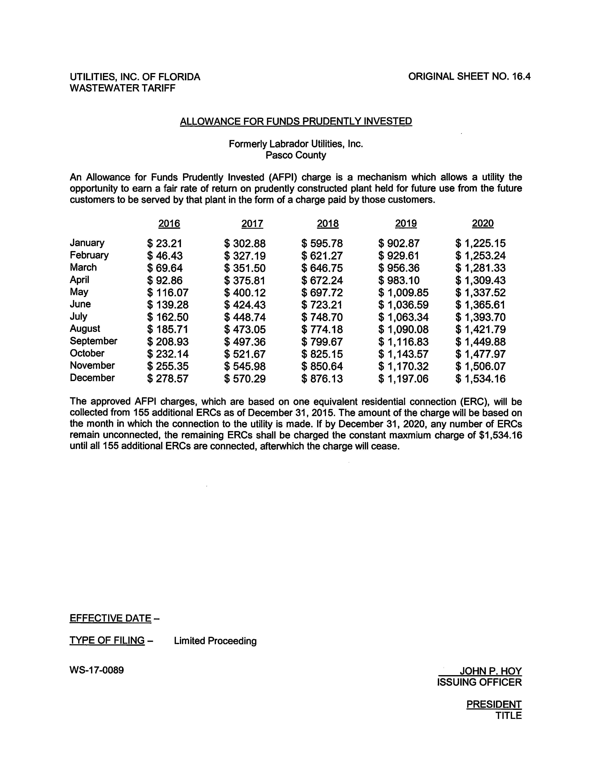

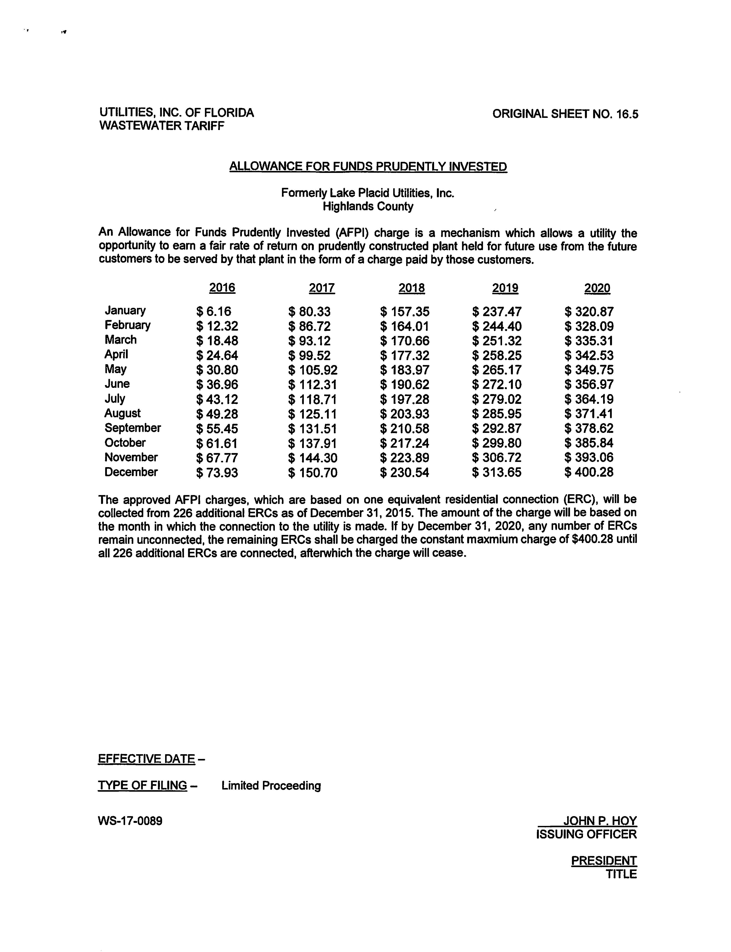
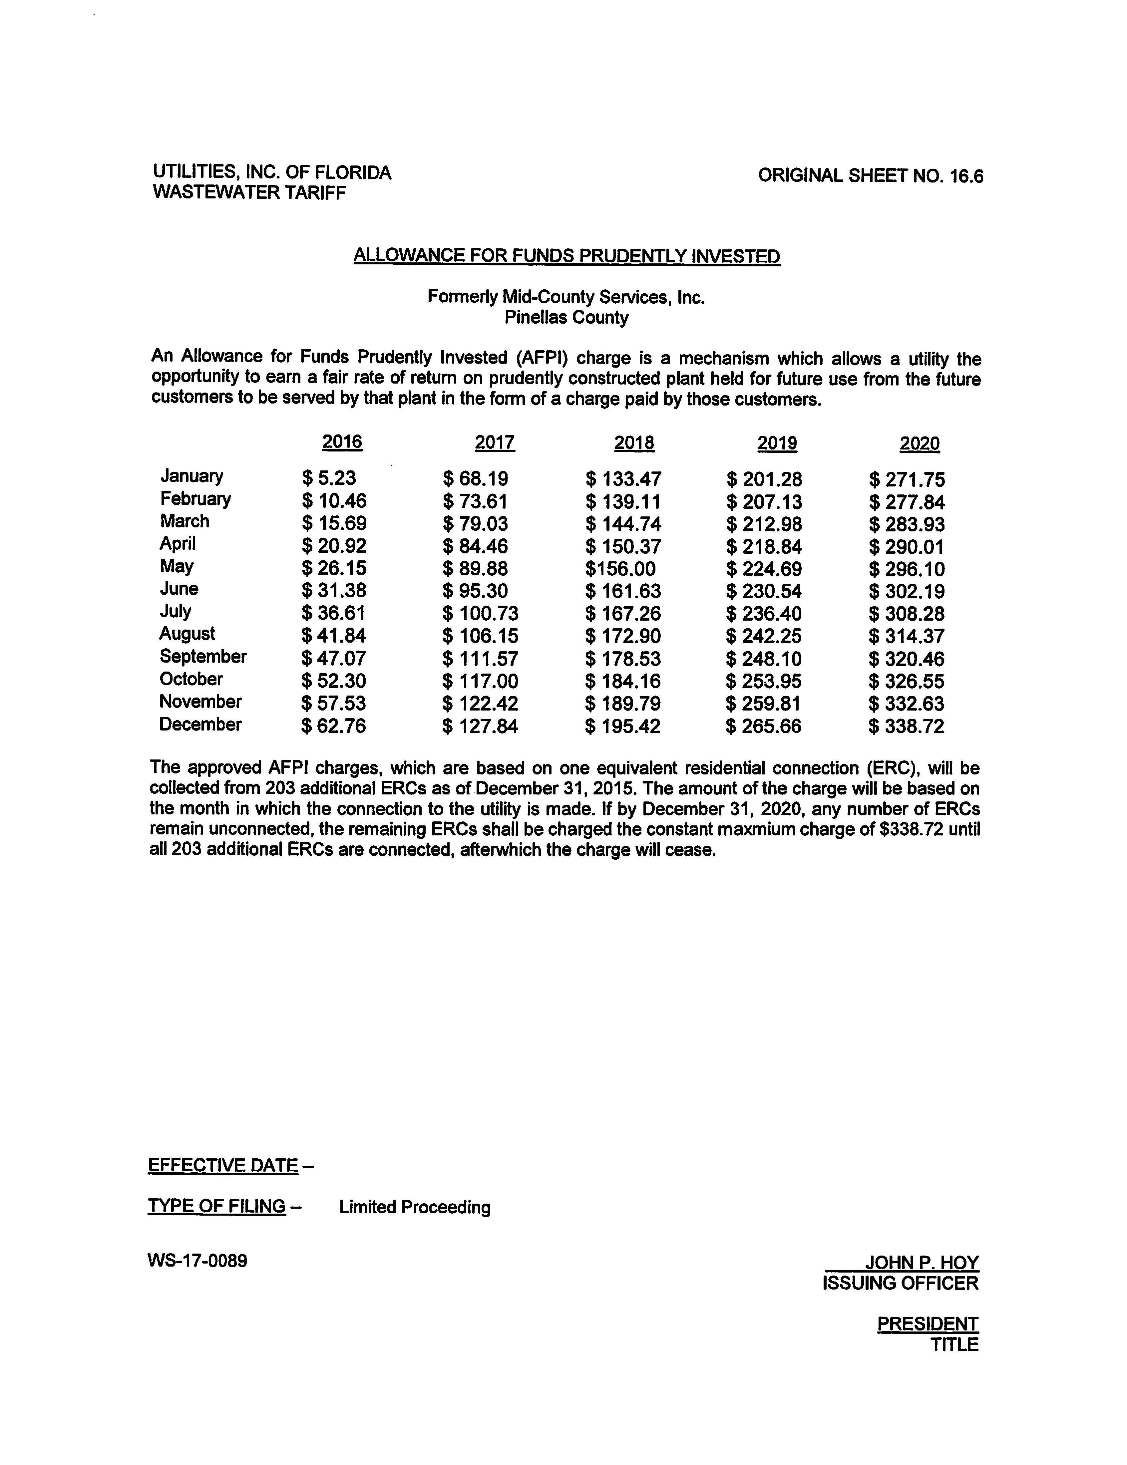

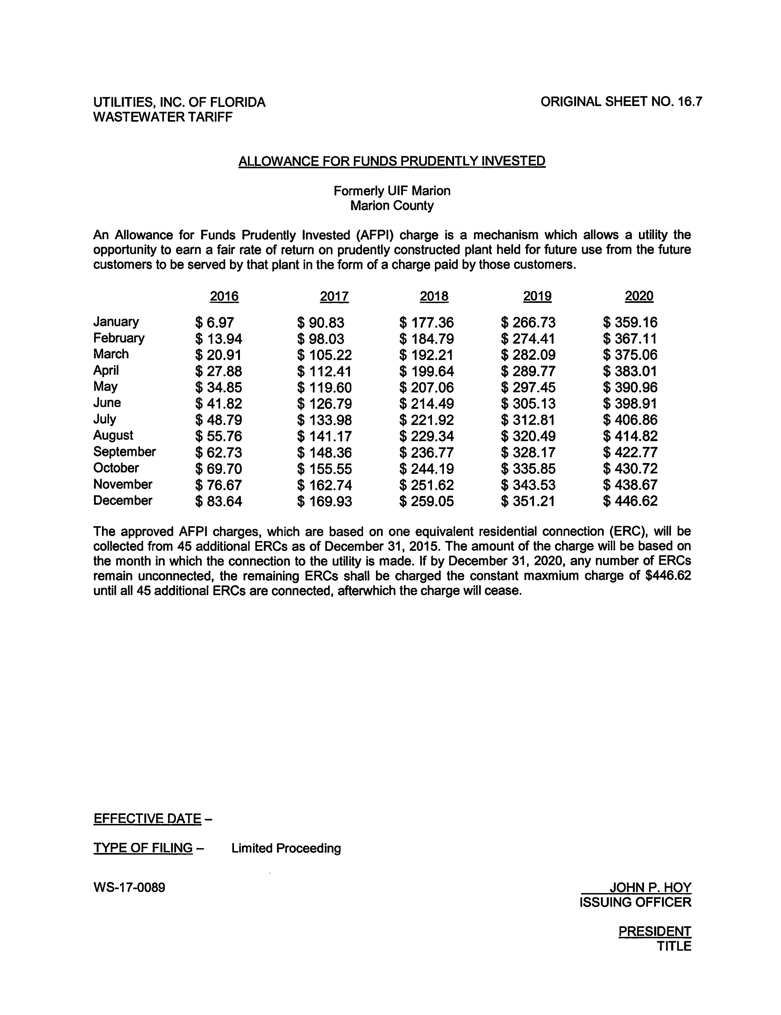
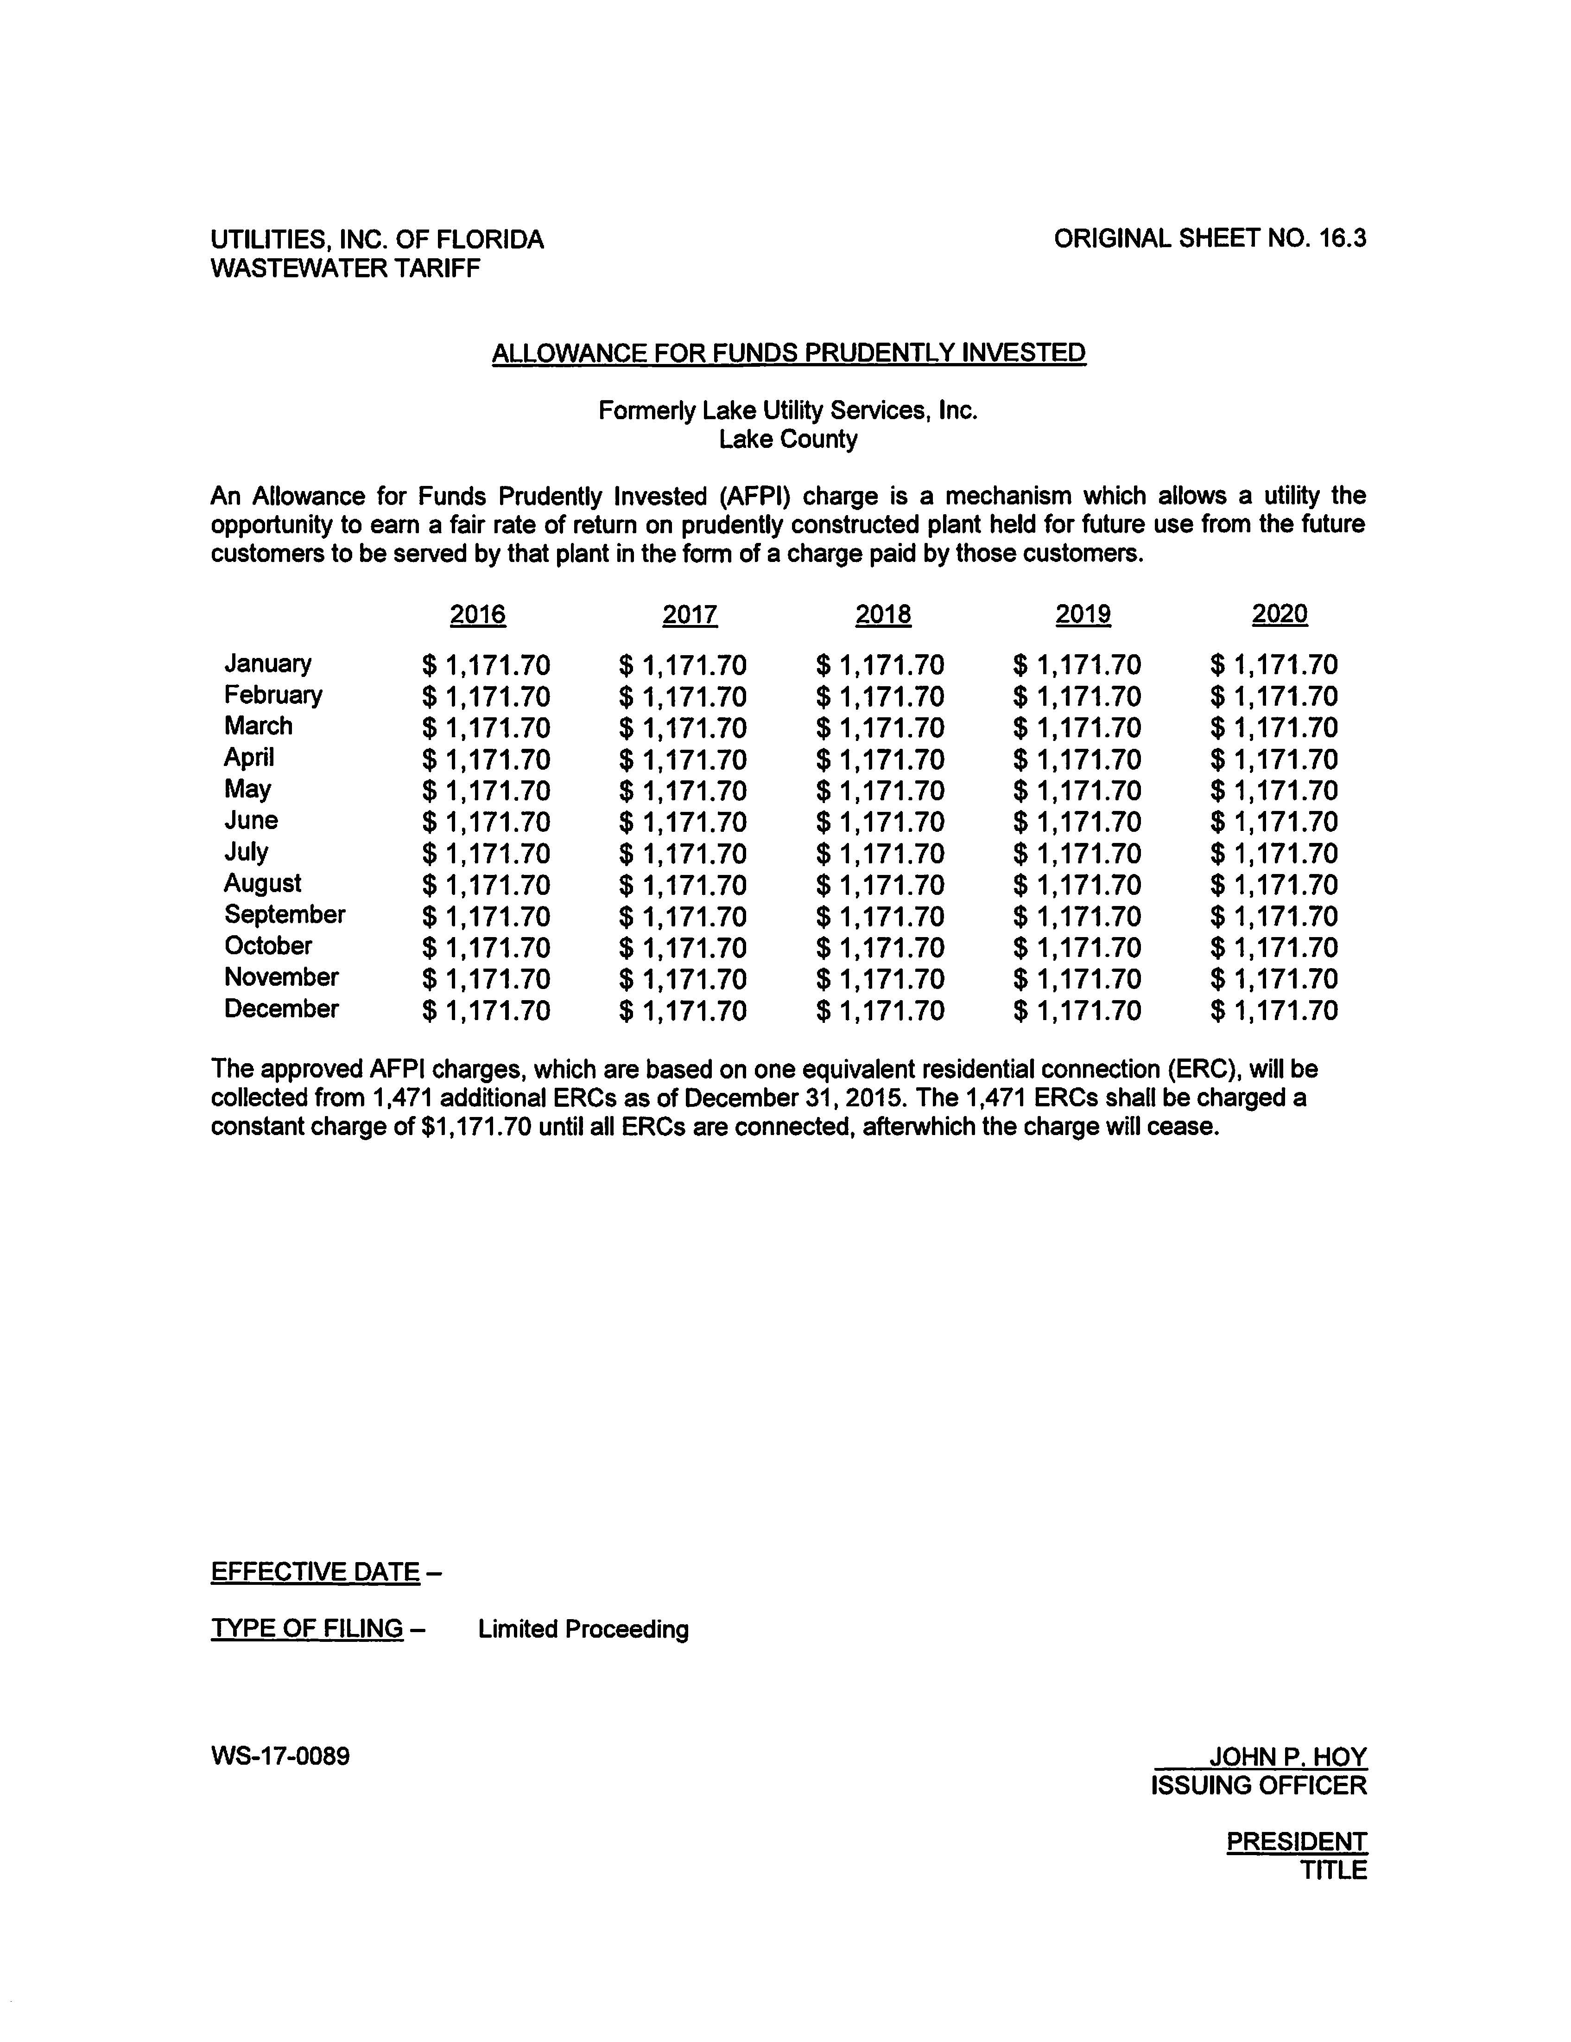

Order No. PSC-2017-0361-FOF-WS, issued September 25, 2017, in Docket No. 20160101-WS, In re: Application for increase in water and wastewater rates in Charlotte, Highlands, Lake, Lee, Marion, Orange, Pasco, Pinellas, Polk, and Seminole Counties by Utilities, Inc. of Florida.
Order No. 24283, issued March 25, 1991, in Docket No. 900957-WU, In re: Application of Lake Groves Utilities, Inc. for water and sewer certificates in Lake County.
Order No. PSC-00-1657-PAA-WS, issued September 18, 2000, in Docket No. 000430-WS, In re: Application for amendment of Certificates Nos. 534-W and 465-S to add territory in Lake County by Lake Groves Utilities, Inc.
Order No. PSC-09-0101-PAA-WS, issued February 16, 2009, in Docket No. 070693-WS, In re: Application for increase in water and wastewater rates in Lake County by Lake Utility Services, Inc.
Order No. PSC-11-0514-PAA-WS, issued November 3, 2011, in Docket No. 20100426-WS, In re: Application for increase in water and wastewater rates in Lake County by Lake Utility Services, Inc.
Order No. PSC-2017-0361-FOF-WS, issued September 25, 2017, in Docket No. 20160101-WS, In re: Application in water and wastewater rates in Charlotte, Highlands, Lake, Lee, Marion, Orange, Pasco, Pinellas, Polk, and Seminole Counties by Utilities, Inc. of Florida.
Pending Docket No. 20180014-WS, In re: Investigation of Allowance For Funds Prudently Invested in Lake County

