BEFORE THE FLORIDA PUBLIC SERVICE COMMISSION

In re: Environmental cost recovery clause. | DOCKET NO. 20180007-EI  ORDER NO. PSC-2018-0100-FOF-EI  ISSUED: February 22, 2018

The following Commissioners participated in the disposition of this matter:

ART GRAHAM, Chairman
JULIE I. BROWN
DONALD J. POLMANN
GARY F. CLARK

ORDER APPROVING
FLORIDA POWER & LIGHT COMPANY’S
MID-COURSE CORRECTION TO ITS ENVIRONMENTAL COST RECOVERY
FACTORS AND ASSOCIATED TARIFFS

BY THE COMMISSION:

Background
On November 17, 2017, Florida Power & Light Company (FPL) filed a petition for mid-course correction to its 2018 Environmental Cost Recovery Clause (ECRC) factors approved by Order No. PSC-2018-0014-FOF-EI. FPL has requested that the revised factors become effective March 1, 2018. The mid-course correction is a result of stipulation 10G entered into by FPL and other parties and approved by the Florida Public Service Commission (Commission) on October 25, 2017.
Mid-course corrections are rare in the ECRC docket and are more typical in the fuel docket. Mid-course corrections are considered preliminary procedural decisions, and any over-recoveries or under-recoveries caused by, or resulting from, our approved adjusted cost recovery factors may be included in the following year’s cost recovery factors. In this case, the requested mid-course correction will result in lower cost recovery factors for FPL’s customers.
This mid-course correction was filed by FPL with the intention that the proposed decrease in rates will become effective March 1, 2018. Typically, effective dates are set a minimum of 30 days after our vote approving a mid-course correction. However, we have also implemented charges in less than 30 days when circumstances warrant. In this instance, the interval between our vote on this matter and the proposed implementation date of March 1, 2018, is 22 days. Since this filing results in a decrease to rates, we find the 22 day interval to be sufficient. We have jurisdiction over this matter pursuant to Sections 366.05 and 366.8255, Florida Statutes.
Analysis and Decision
The St. John River Power Plant (SJRPP) transaction was resolved by settlement between the Office of Public Counsel and FPL through a joint stipulation approved by this Commission on September 25, 2017. At that time, FPL had already filed its 2018 ECRC projection filing. Thus, we approved a stipulation requiring FPL to file a mid-course correction in this docket on November 17, 2017, for us to address at our February 6, 2018 Commission Conference. The approved revised ECRC factors will go into effect on March 1, 2018.
The impact of the SJRPP transaction is a reduction in ECRC revenue requirements by $1,123,318 for the projected year of 2018. This reduction in revenue requirement results in the 2018 ECRC factor for the RS-1 rate decreasing from 0.159 cents per kilowatt/hour(kWh) to 0.158 cents per kWh. FPL will provide customers notice of this reduction and the associated reduction in Docket No. 20170001-EI via a March billing insert.
Upon review, we approve FPL’s petition for mid-course correction to its 2018 ECRC factors and associated tariff sheets. The revised factors and associated tariffs shall become effective March 1, 2018.
Based on the foregoing, it is

ORDERED by the Florida Public Service Commission that Florida Power & Light Company’s petition for a mid-course revision to its 2018 environmental cost recovery clause factors and associated tariff sheets is hereby approved. It is further,
ORDERED that the environmental cost recovery clause docket is on-going and shall remain open.

By ORDER of the Florida Public Service Commission this 22nd day of February, 2018.

/s/ Carlotta S. Stauffer
CARLOTTA S. STAUFFER
Commission Clerk
Florida Public Service Commission
2540 Shumard Oak Boulevard
Tallahassee, Florida 32399
(850) 413-6770
www.floridapsc.com

Copies furnished: A copy of this document is provided to the parties of record at the time of issuance and, if applicable, interested persons.

CWM

NOTICE OF FURTHER PROCEEDINGS OR JUDICIAL REVIEW

The Florida Public Service Commission is required by Section 120.569(1), Florida Statutes, to notify parties of any administrative hearing or judicial review of Commission orders that is available under Sections 120.57 or 120.68, Florida Statutes, as well as the procedures and time limits that apply. This notice should not be construed to mean all requests for an administrative hearing or judicial review will be granted or result in the relief sought.

Any party adversely affected by the Commission's final action in this matter may request: 1) reconsideration of the decision by filing a motion for reconsideration with the Office of Commission Clerk, 2540 Shumard Oak Boulevard, Tallahassee, Florida 32399-0850, within fifteen (15) days of the issuance of this order in the form prescribed by Rule 25-22.060, Florida Administrative Code; or 2) judicial review by the Florida Supreme Court in the case of an electric, gas or telephone utility or the First District Court of Appeal in the case of a water and/or wastewater utility by filing a notice of appeal with the Office of Commission Clerk, and filing a copy of the notice of appeal and the filing fee with the appropriate court. This filing must be completed within thirty (30) days after the issuance of this order, pursuant to Rule 9.110, Florida Rules of Appellate Procedure. The notice of appeal must be in the form specified in Rule 9.900(a), Florida Rules of Appellate Procedure.

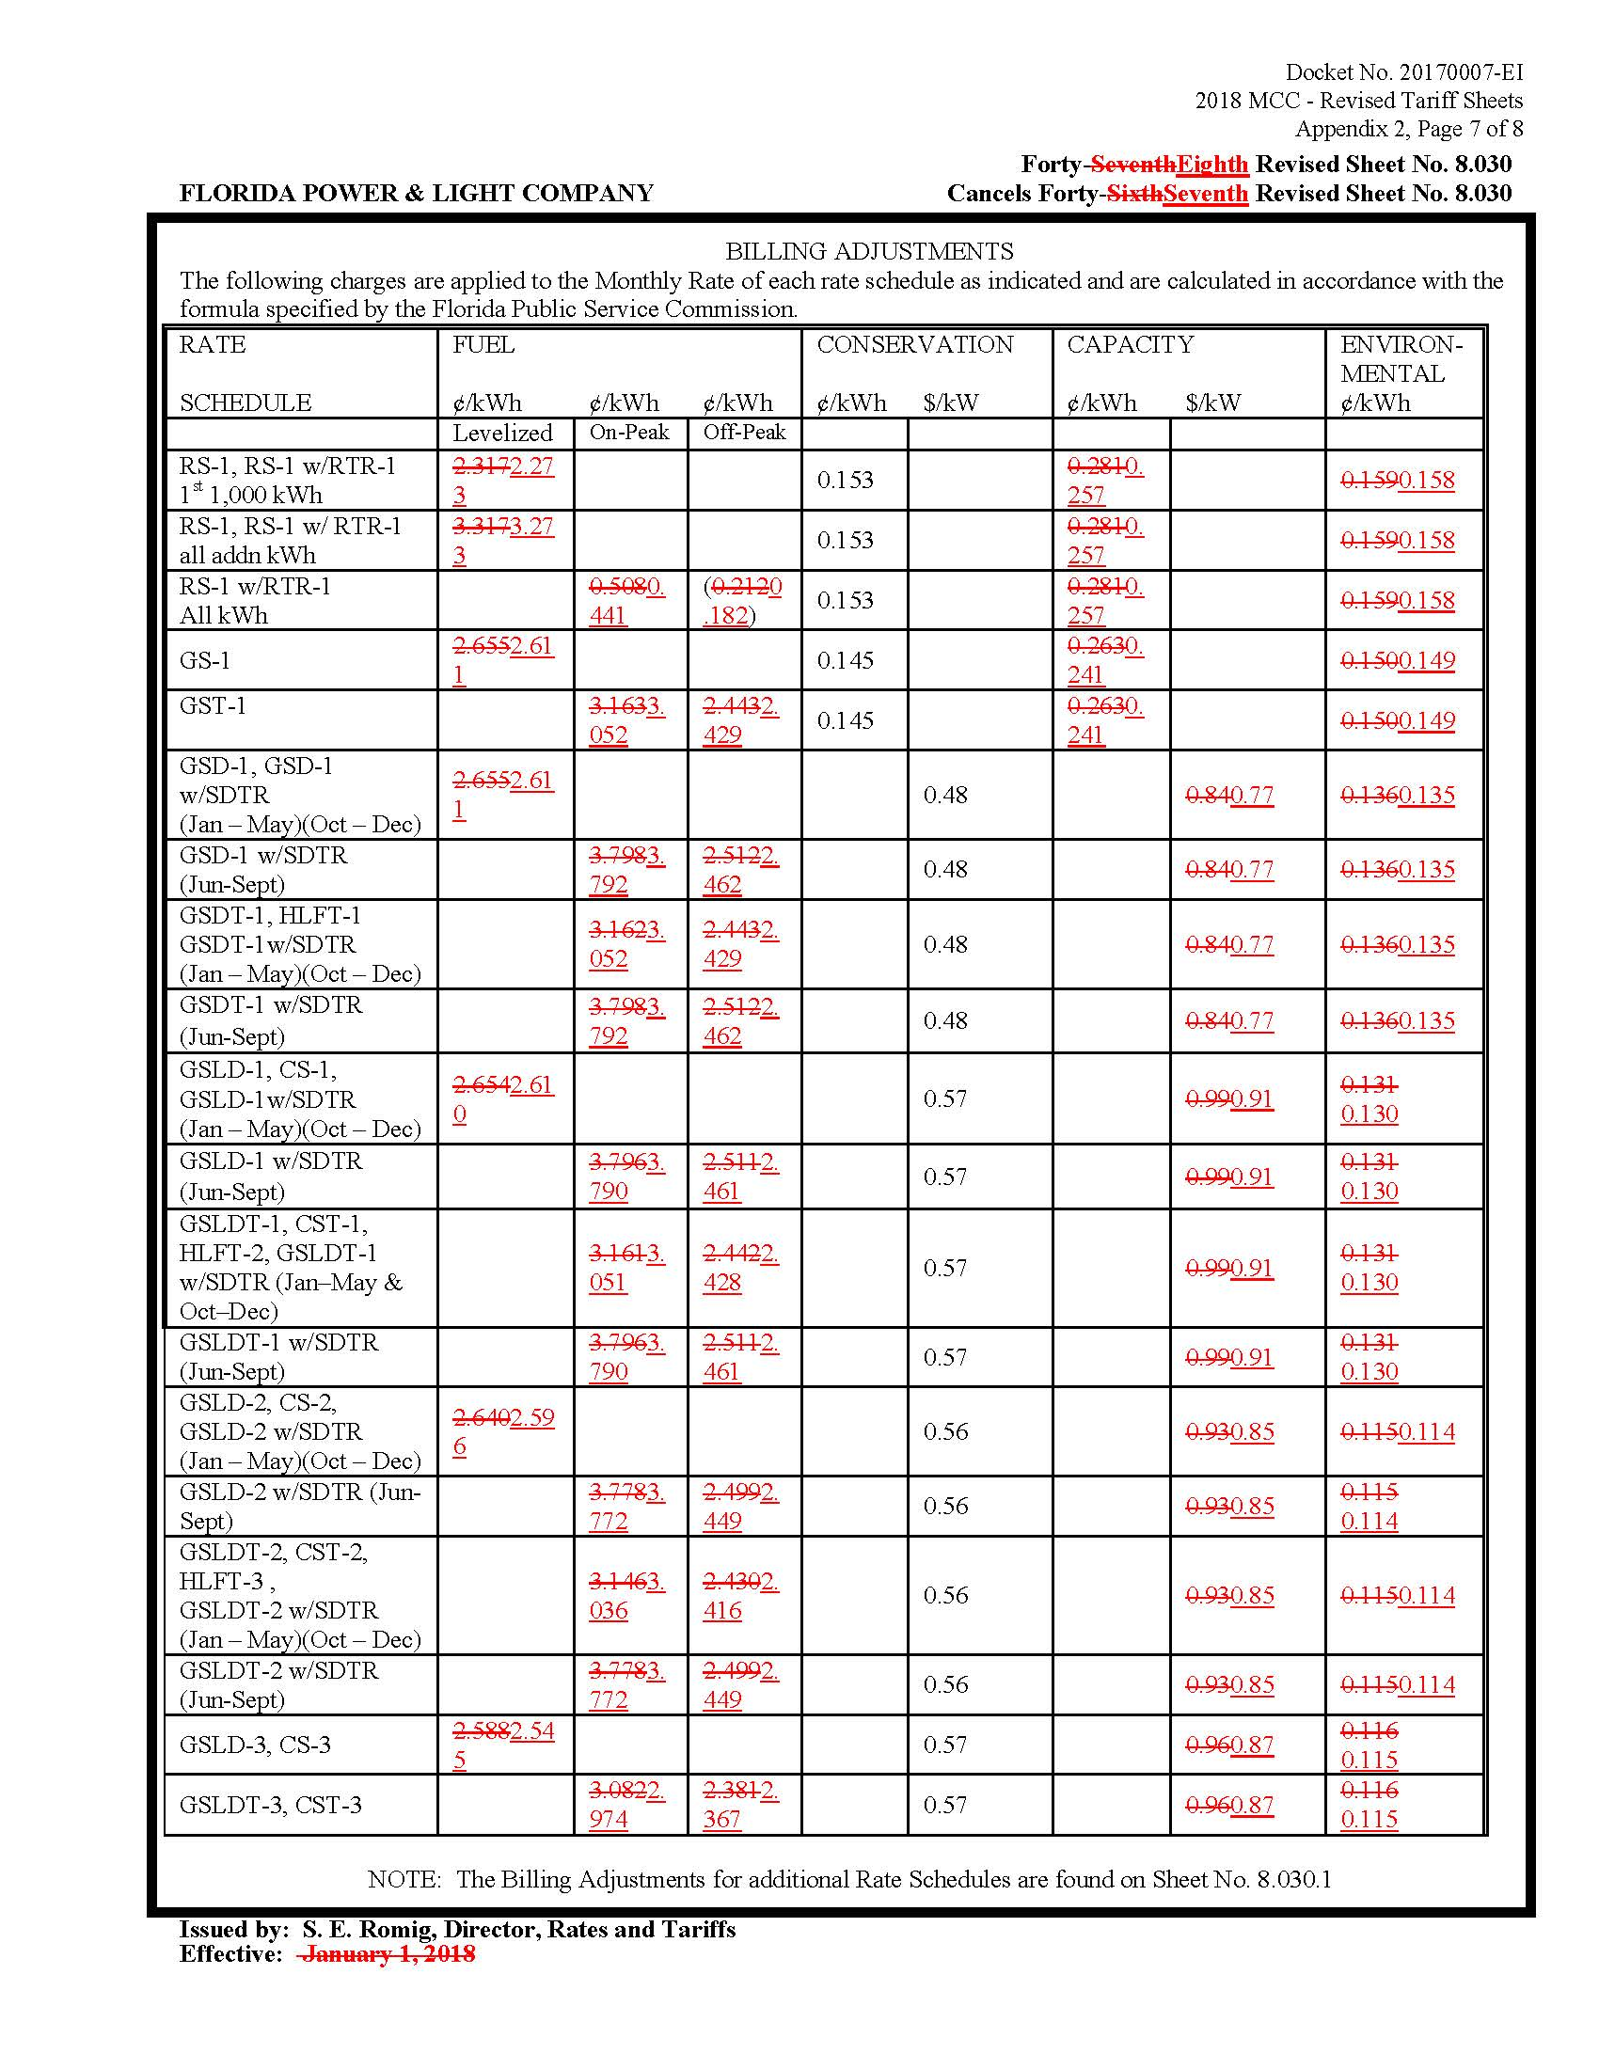

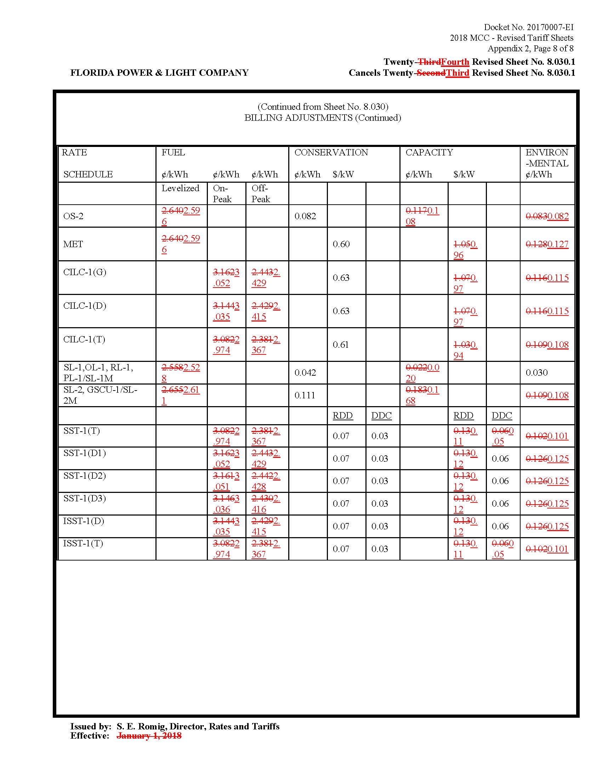

Order No. PSC-2018-0014-FOF-EI issued January 4, 2018, in Docket No. 20180007-EI, In re: Environmental Cost Recovery Clause.

