BEFORE THE FLORIDA PUBLIC SERVICE COMMISSION

In re: Petition for approval of experimental curtailable demand-side management program, by Gulf Power Company. | DOCKET NO. 20170252-EI  ORDER NO. PSC-2018-0159-PAA-EI  ISSUED: March 21, 2018

The following Commissioners participated in the disposition of this matter:

ART GRAHAM, Chairman
JULIE I. BROWN
DONALD J. POLMANN
GARY F. CLARK
ANDREW GILES FAY

NOTICE OF PROPOSED AGENCY ACTION ORDER
APPROVING GULF POWER COMPANY’S
EXPERIMENTAL CURTAILABLE LOAD PROGRAM
AND ASSOCIATED TARIFFS

BY THE COMMISSION:

NOTICE is hereby given by the Florida Public Service Commission (Commission) that the action discussed herein is preliminary in nature and will become final unless a person whose interests are substantially affected files a petition for a formal proceeding, pursuant to Rule 25-22.029, Florida Administrative Code (F.A.C.).

I. Background
On May 16, 2017, we approved a Stipulation and Settlement Agreement (Settlement) which resolved all outstanding issues in the Gulf Power Company (Gulf or Company) 2016 base rate proceeding. On November 28, 2017, in accordance with Section 19 of the Settlement, Gulf filed a petition for approval of its experimental Curtailable Load program as part of its Demand-Side Management (DSM) plan. The rate rider and associated tariffs for the proposed Curtailable Load program are shown in Attachment A.
This Commission has jurisdiction over this matter pursuant to Sections 366.80 through 366.83 and 403.519, Florida Statutes.

II. Review
The criteria used to review the appropriateness of DSM programs are: (1) whether the program advances the policy objectives of the Florida Energy Efficiency and Conservation Act (FEECA) and its implementing rules; (2) whether the program is directly monitorable and yields measurable results; and (3) whether the program is cost-effective. As discussed below, Gulf’s petition for its experimental Curtailable Load program is consistent with these criteria.
A. Program Description

The proposed Curtailable Load program is available to industrial and commercial customers who take service under rates LP, LPT, PX, or PXT. The proposed program provides qualifying customers capacity payments for load which can be curtailed during certain conditions. Customers who qualify for the program must commit to a minimum non-firm demand reduction of 4,000 kilowatts (kW). A customer must execute a Curtailable Load Service Agreement (CL Service Agreement) for a term of 10 years beyond the anticipated in-service date of Gulf’s next generation capacity need in 2023. Multiple accounts may be combined to meet the demand and load factor requirements provided that the demand response is coordinated from a single location and a single point of contact is provided to Gulf for notification. The program is only applicable to locations at which the interruption of electric service will primarily affect only the customer and will not significantly affect members of the general public, or interfere with functions performed for the protection of public health or safety unless adequate on-site backup generation is available. The program will be closed to additional customers when the total non-firm demand subject to CL Service Agreements reaches 50 megawatts.

A curtailment period may be designated by Gulf when non-firm demand curtailment is necessary to alleviate any conditions that could lead to the interruption of power supply in the local area or region. Gulf expects to provide at least 30 minutes advance notice of the curtailment period. Gulf may terminate service under the program at any time based on the customer’s failure to comply with the terms and conditions of the CL Service Agreement. An incident of non-compliance will be considered to have occurred if the customer’s maximum integrated 15 minute demand to the nearest kW during a curtailment period is greater than the firm demand. Customers may terminate their CL Service Agreement without penalty or liability by providing the Company with at least a five year advanced written notice, which we find to be sufficient for planning purposes to acquire or build firm capacity. The program, as described, meets the Settlement requirement that Gulf offer a curtailable rate program. Gulf represents that the signatories to the Settlement do not have any material concerns with the Company’s petition for our approval of the experimental Curtailable Load program.

B. FEECA Policy Objectives/Program Monitoring and Evaluation

FEECA emphasizes reducing the growth rate of peak demand and reducing and controlling growth rates of electricity consumption. The proposed Curtailable Load program will provide qualified customers with an incentive to decrease their firm peak demand. Customers taking service under the program will initially receive a monthly bill credit of $3.35 per kW that will be subject to curtailment. This initial monthly credit was determined by Gulf to be the maximum recurring monthly credit that will not cause the program’s costs to be higher than the benefits realized from the avoided capacity. The bill credit amount will be subject to review and adjustment in the Company’s Energy Conservation Cost Recovery (ECCR) Clause proceeding. The program is experimental in nature with a December 31, 2021, termination date unless Gulf asks this Commission for an extension. Gulf will use several criteria in evaluating this program. These include: customers’ interest in the program; customers’ responses to curtailment periods; program implementation and management costs; and, the Company’s capacity needs.
C. Cost-Effectiveness

Pursuant to Rule 25-17.008, F.A.C., Gulf provided a cost-effectiveness analysis of the program using the Participant test, the Rate Impact Measure (RIM) test, and the Total Resource Cost (TRC) test. The Participant test analyzes the costs and benefits from a program participants’ point of view. The RIM test ensures that all ratepayers will benefit from a proposed DSM program, not just the program participants. The TRC test measures the overall economic efficiency of a DSM program from a system perspective. Each test estimates the benefits and costs, and the program is determined to be cost-effective if the ratio of benefits to costs is greater than one. We have reviewed the assumptions associated with Gulf’s program savings and find them to be reasonable. The table below shows the results for cost-effectiveness for the program.

Cost-Effectiveness Test Results
Participant Test | RIM Test | TRC Test
∞ | 1.00 | 17.11

Gulf anticipates that current customers receiving service under the Critical Peak Option for Rate LPT will be likely participants in the program, which will result in an increase of approximately $134,000 to the ECCR clause in 2018. The estimated monthly rate impact to the ECCR factor for this scenario is $0.02/1,000 kWh for a residential customer. The impact to the ECCR clause for 1000 kWh if all 50 MW are subscribed is $0.15 per customer.

III. Decision

The Curtailable Load program meets a requirement of the Settlement reached in Gulf’s 2016 base rate proceeding. It fulfills the policy objectives of FEECA. It is directly monitorable, yields measurable results, and it is cost effective. Therefore, we shall approve Gulf’s proposed experimental Curtailable Load program and associated rate rider and tariffs.
Based on the foregoing, it is

ORDERED by the Florida Public Service Commission that Gulf Power Company’s experimental Curtailable Load program and associated rate rider and tariffs are hereby approved. It is further

ORDERED that this docket shall be closed unless a person whose substantial interests are affected by this Commission’s decision files a protest within 21 days of the issuance of this Order. The tariffs shall become effective and the docket closed upon the issuance of a consummating order. If a timely protest of this is filed, the tariffs shall not go into effect, pending resolution of the protest.

By ORDER of the Florida Public Service Commission this 21st day of March, 2018.

/s/ Carlotta S. Stauffer
CARLOTTA S. STAUFFER
Commission Clerk
Florida Public Service Commission
2540 Shumard Oak Boulevard
Tallahassee, Florida 32399
(850) 413-6770
www.floridapsc.com

Copies furnished: A copy of this document is provided to the parties of record at the time of issuance and, if applicable, interested persons.

RD

NOTICE OF FURTHER PROCEEDINGS OR JUDICIAL REVIEW

The Florida Public Service Commission is required by Section 120.569(1), Florida Statutes, to notify parties of any administrative hearing that is available under Section 120.57, Florida Statutes, as well as the procedures and time limits that apply. This notice should not be construed to mean all requests for an administrative hearing will be granted or result in the relief sought.

Mediation may be available on a case-by-case basis. If mediation is conducted, it does not affect a substantially interested person's right to a hearing.

The action proposed herein is preliminary in nature. Any person whose substantial interests are affected by the action proposed by this order may file a petition for a formal proceeding, in the form provided by Rule 28-106.201, Florida Administrative Code. This petition must be received by the Office of Commission Clerk, 2540 Shumard Oak Boulevard, Tallahassee, Florida 32399-0850, by the close of business on April 11, 2018.

In the absence of such a petition, this order shall become final and effective upon the issuance of a Consummating Order.

Any objection or protest filed in this/these docket(s) before the issuance date of this order is considered abandoned unless it satisfies the foregoing conditions and is renewed within the specified protest period.

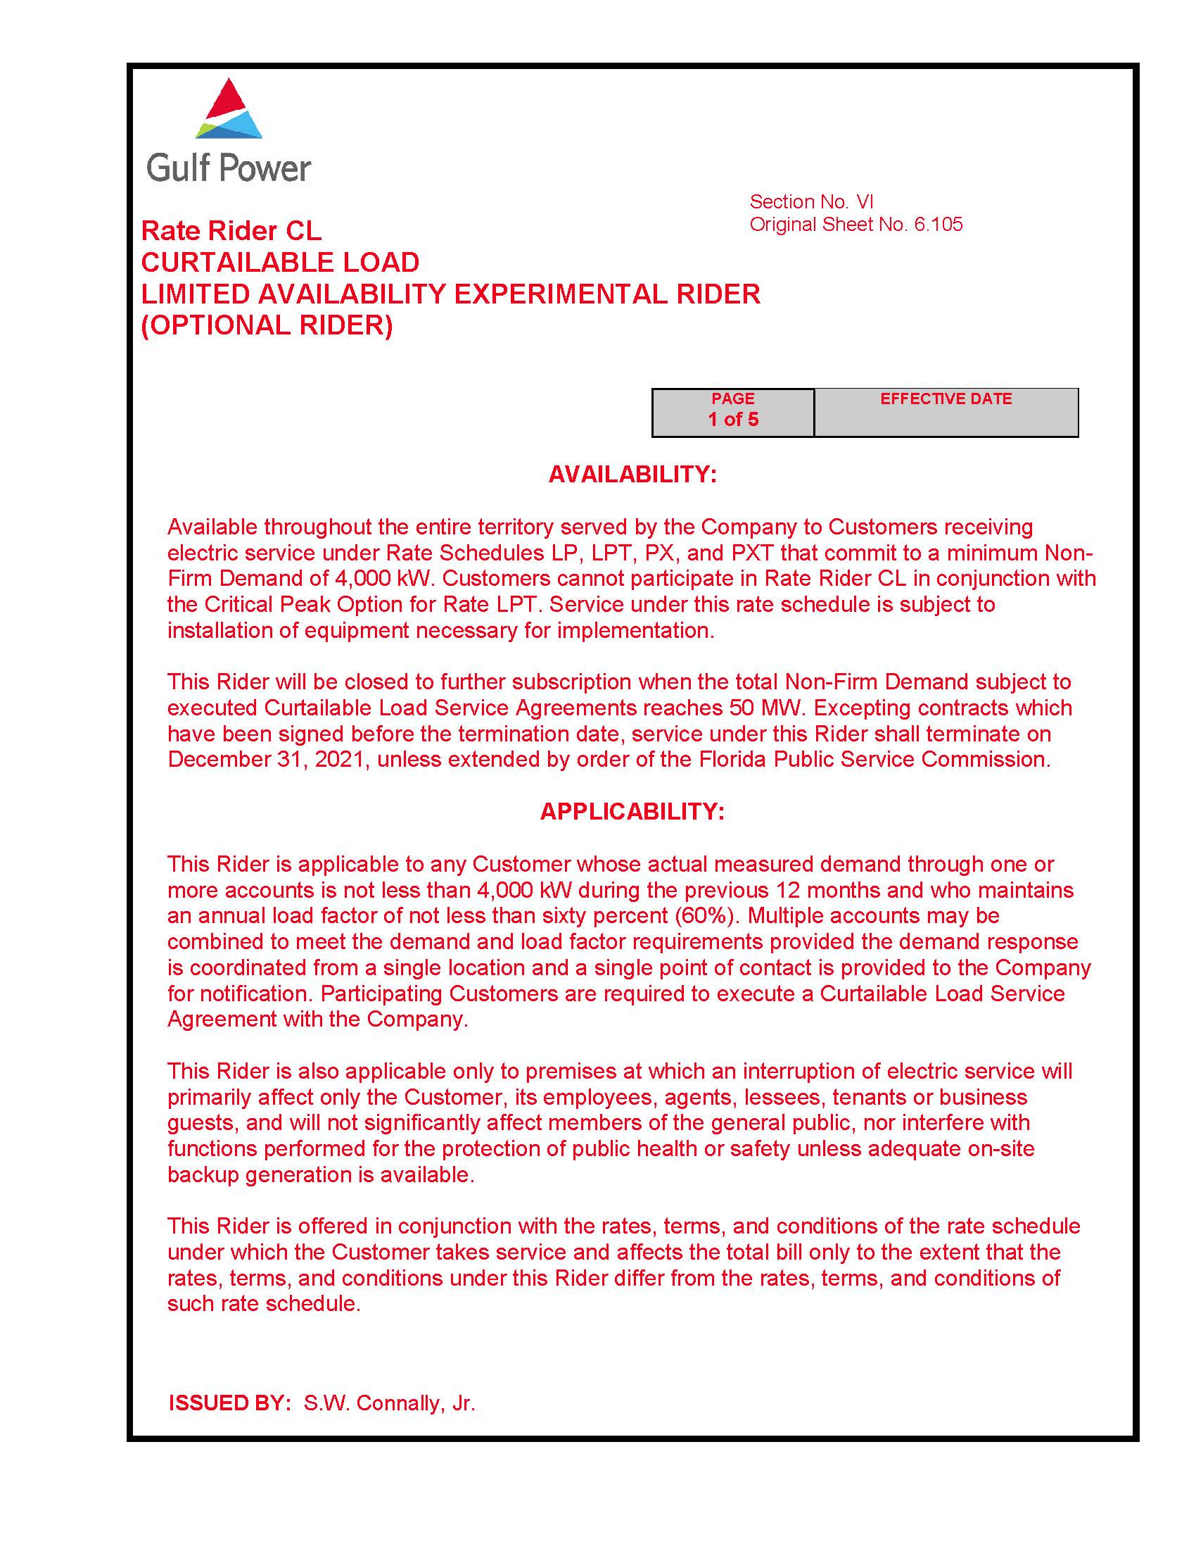

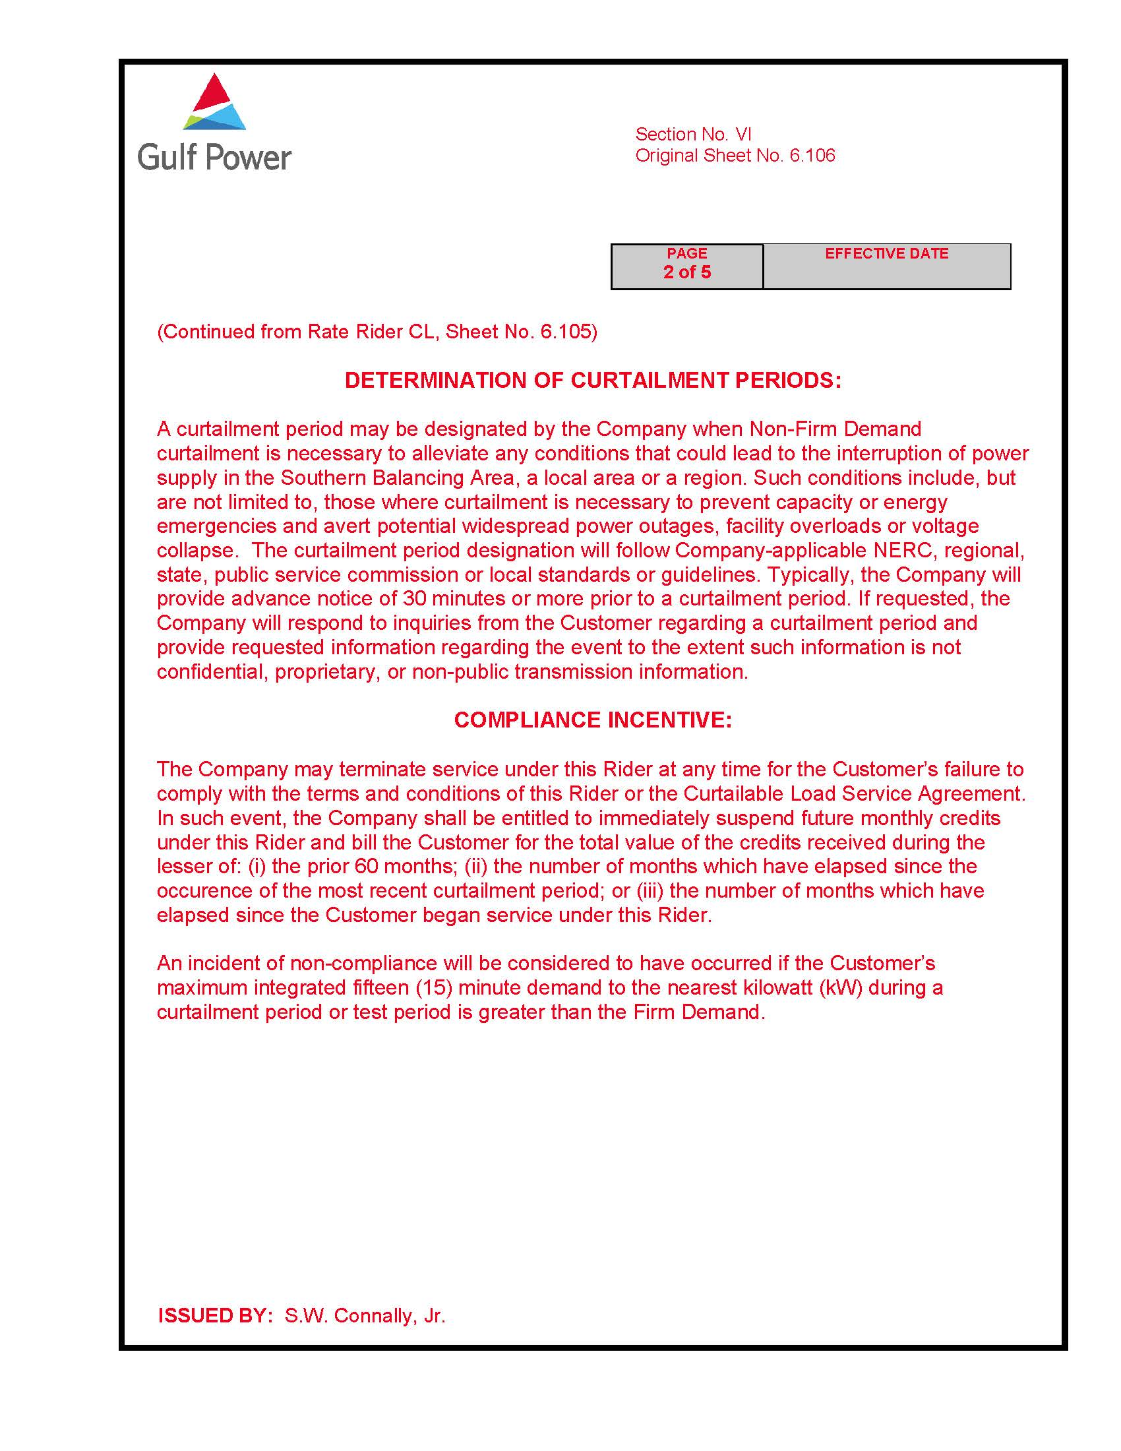

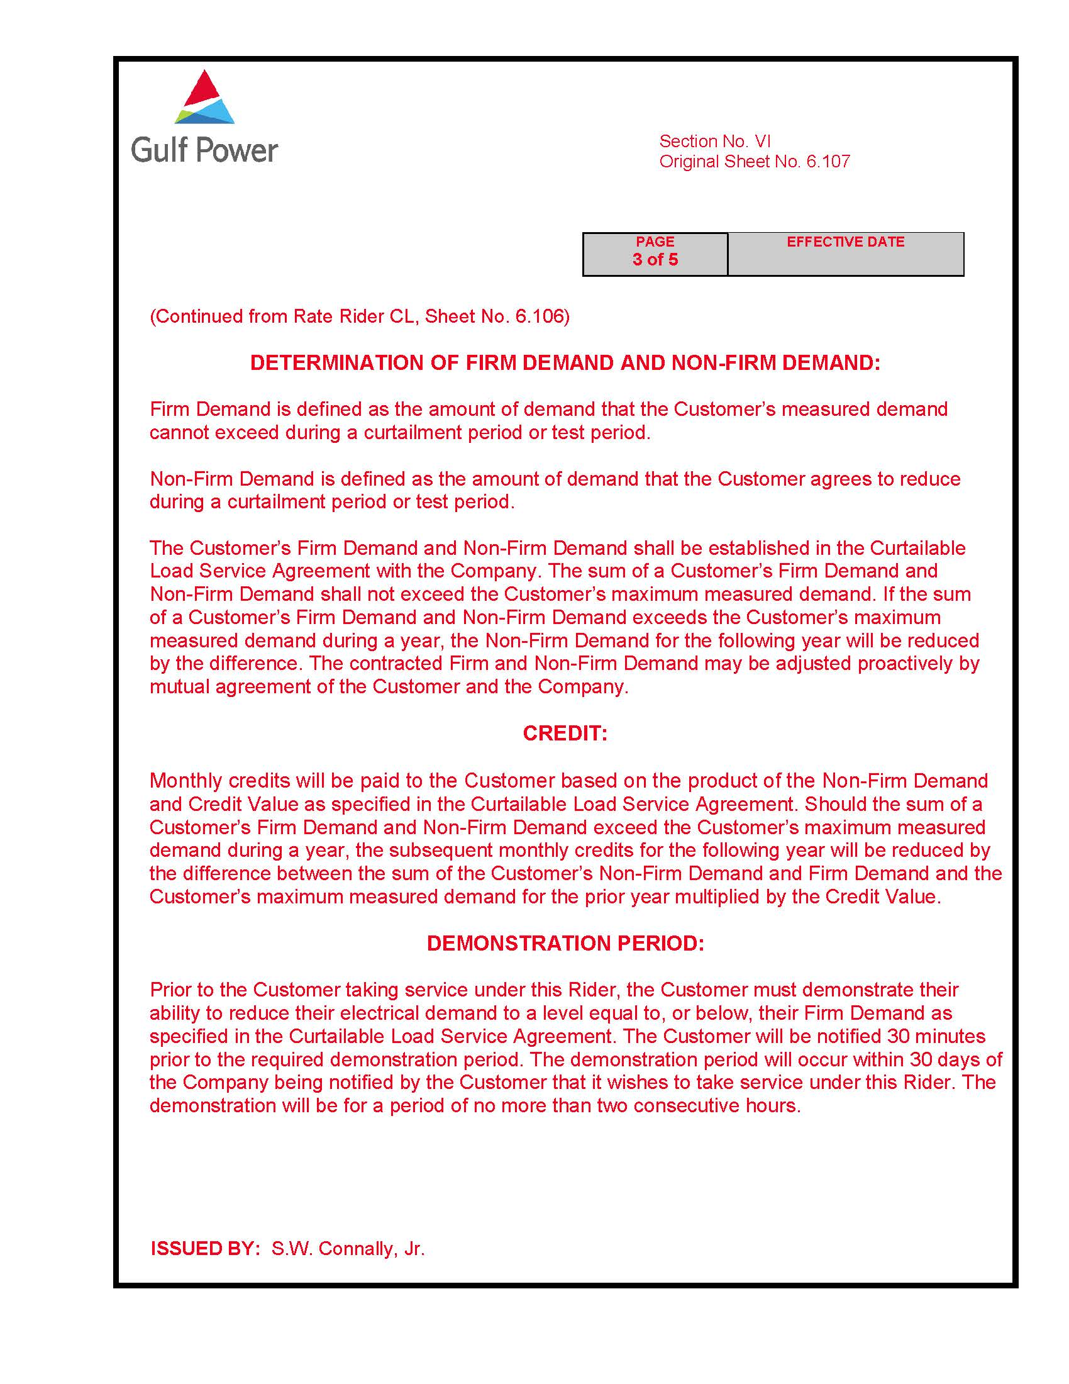

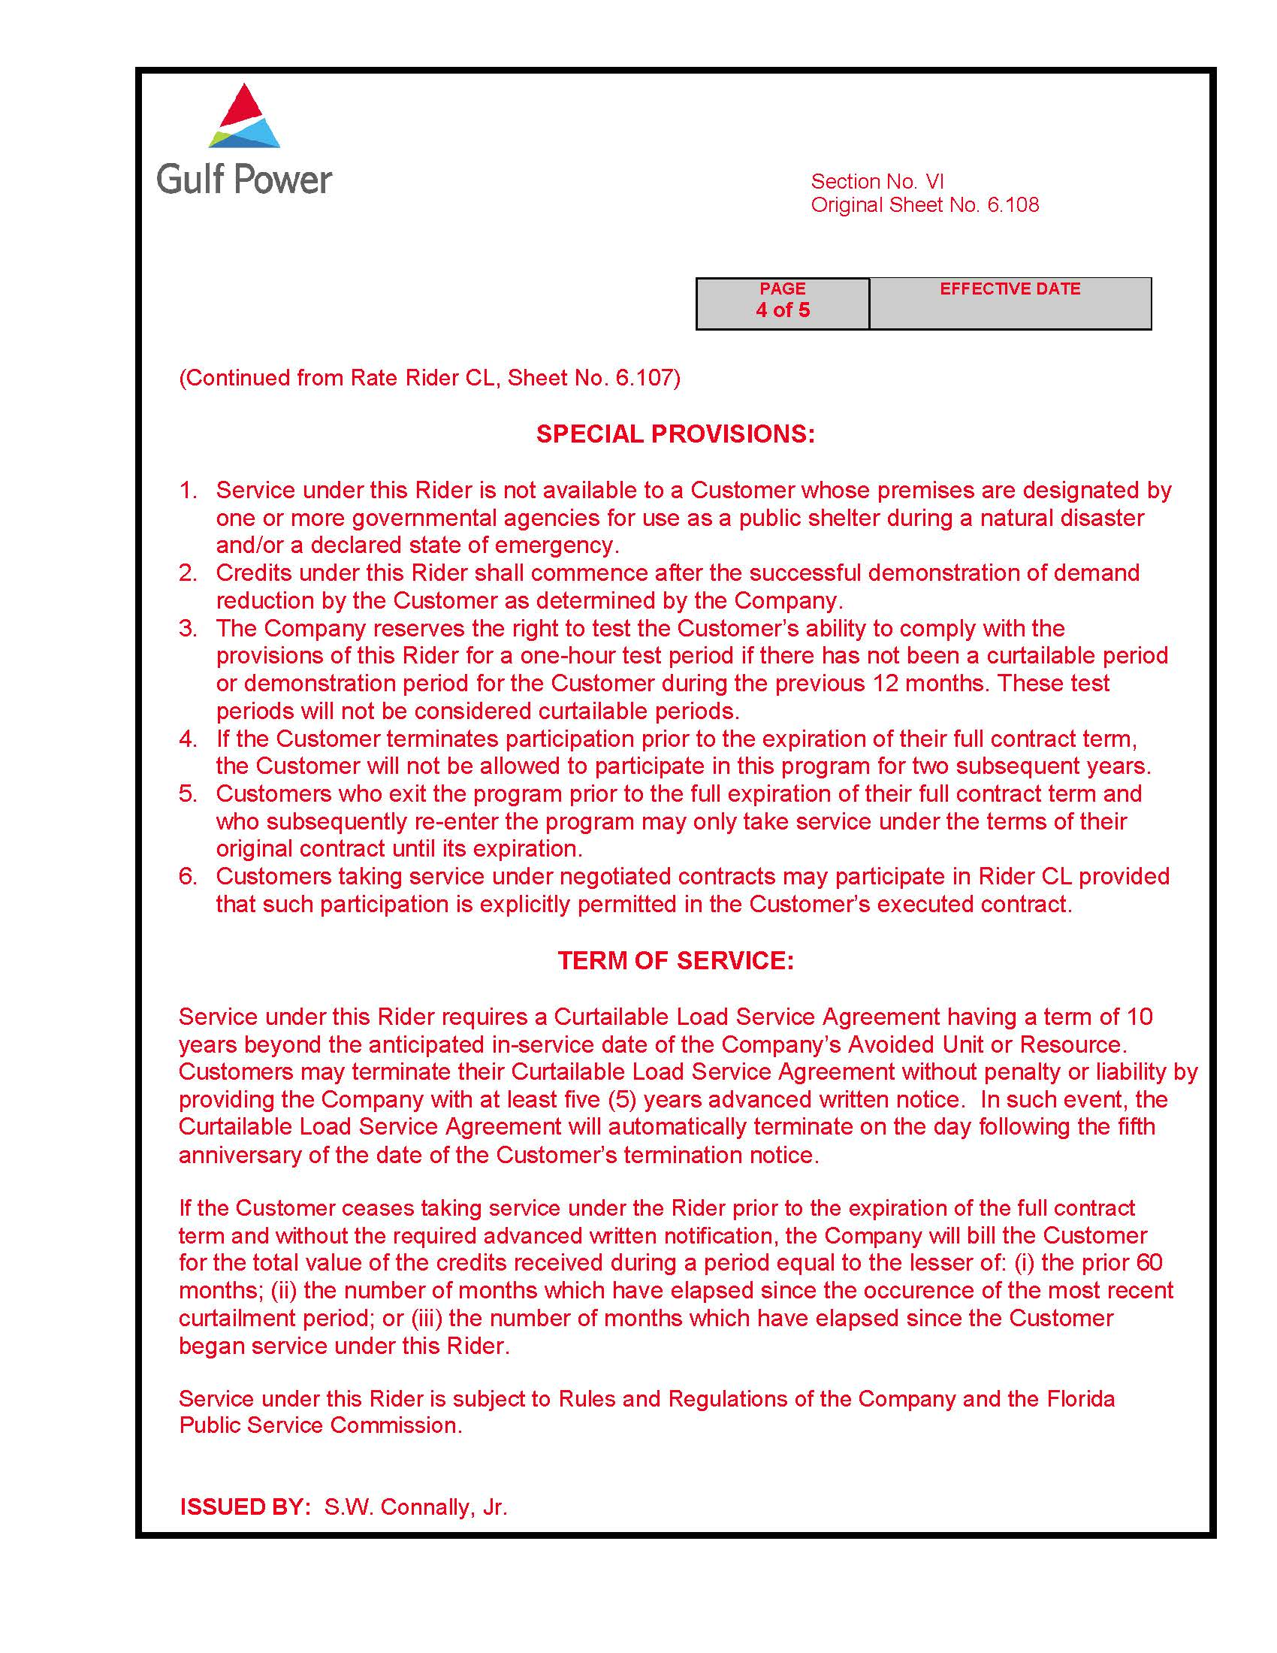

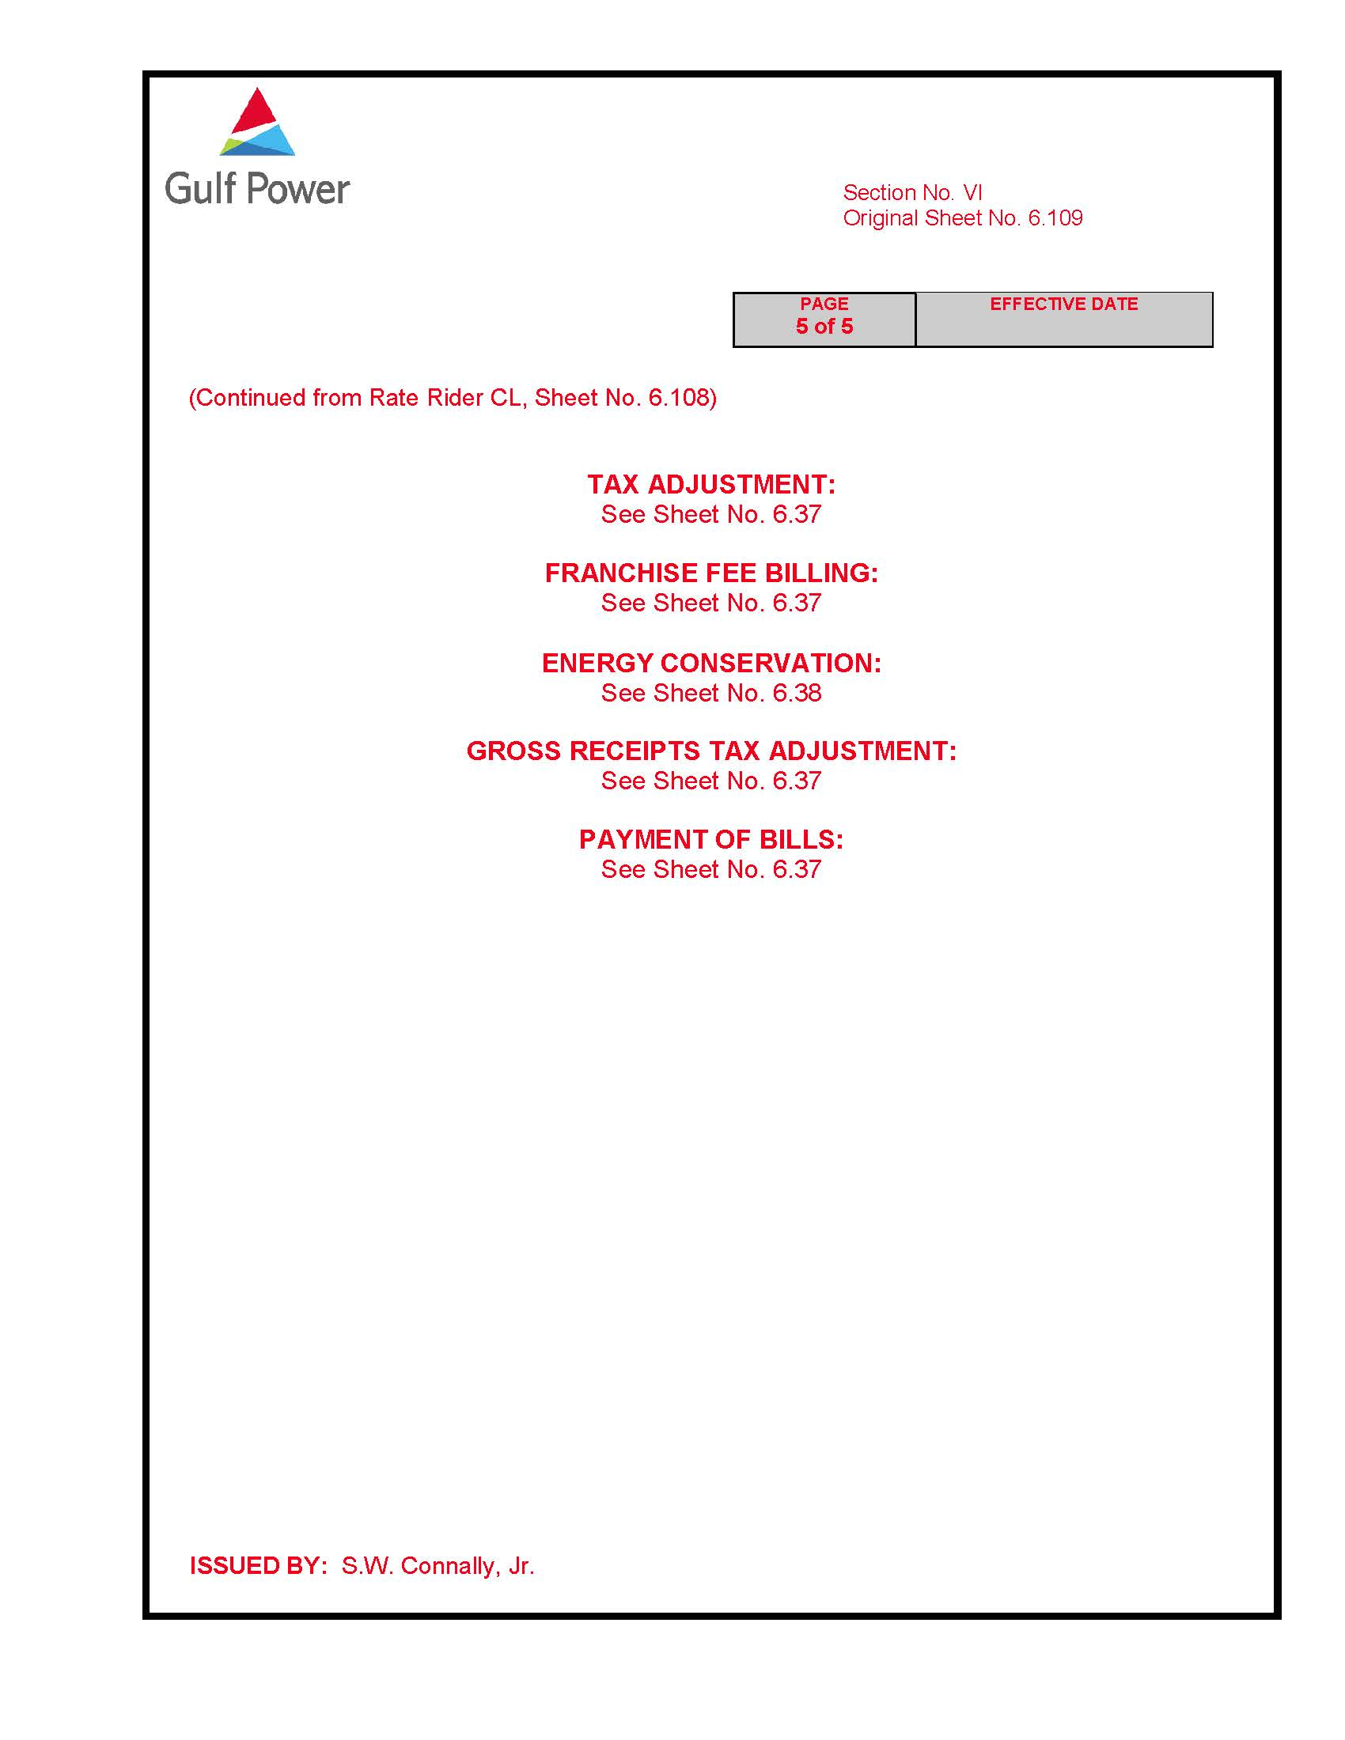

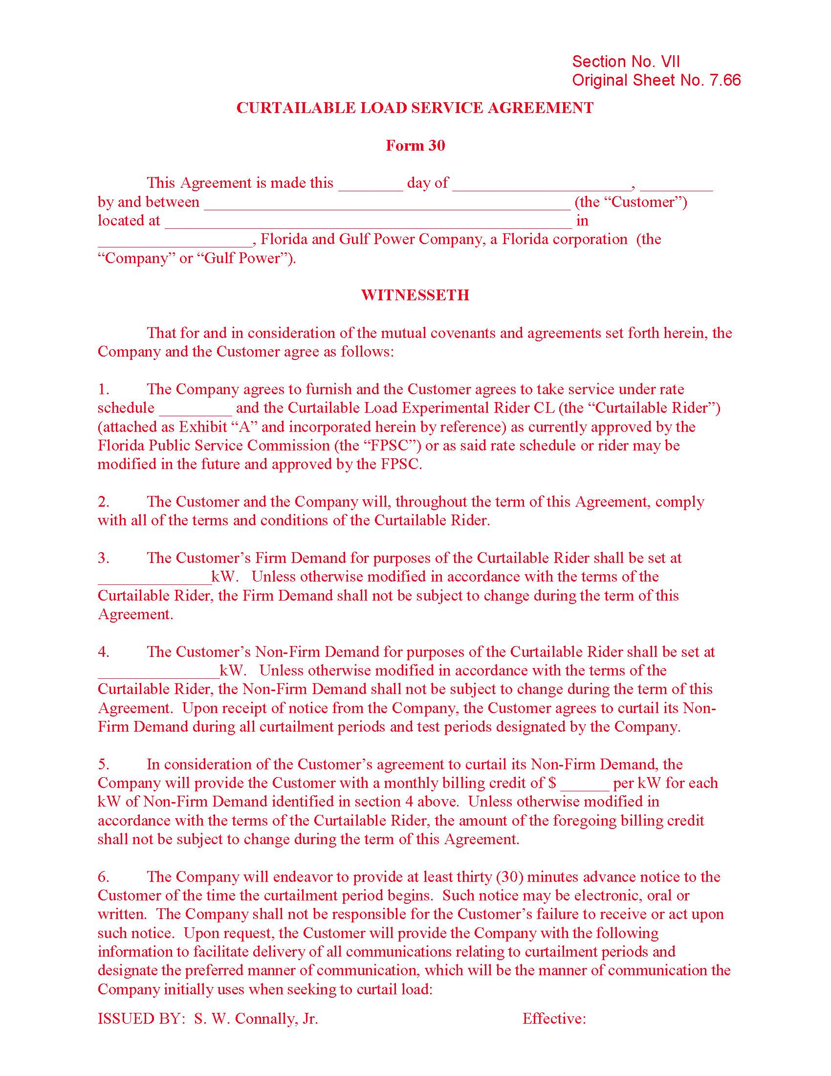

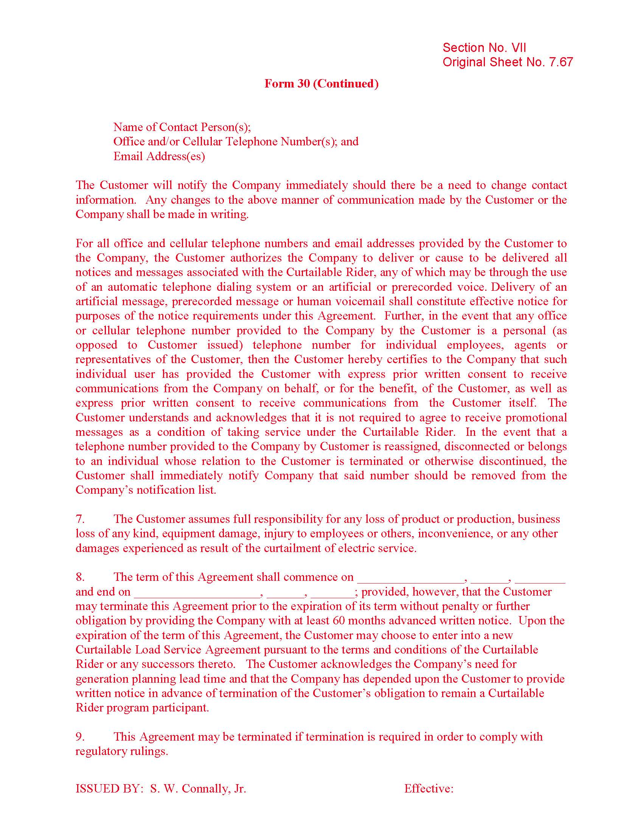

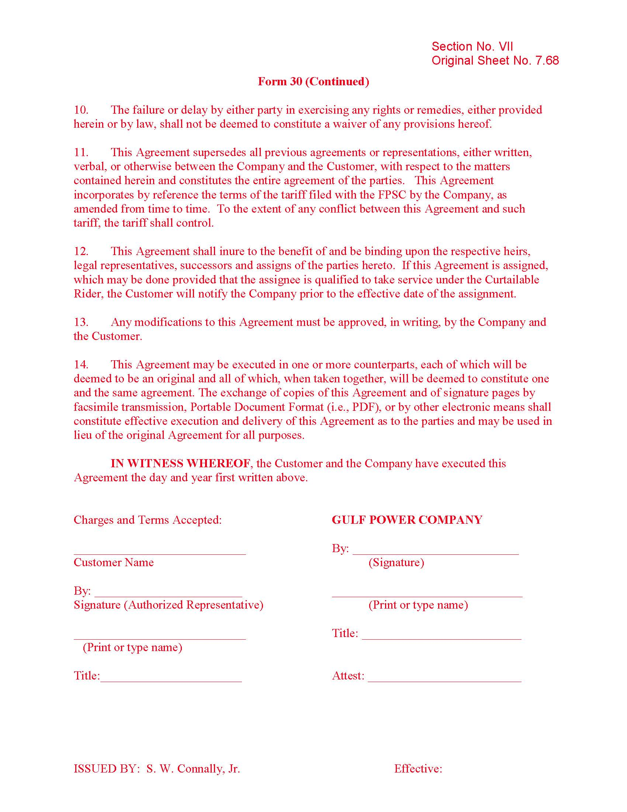

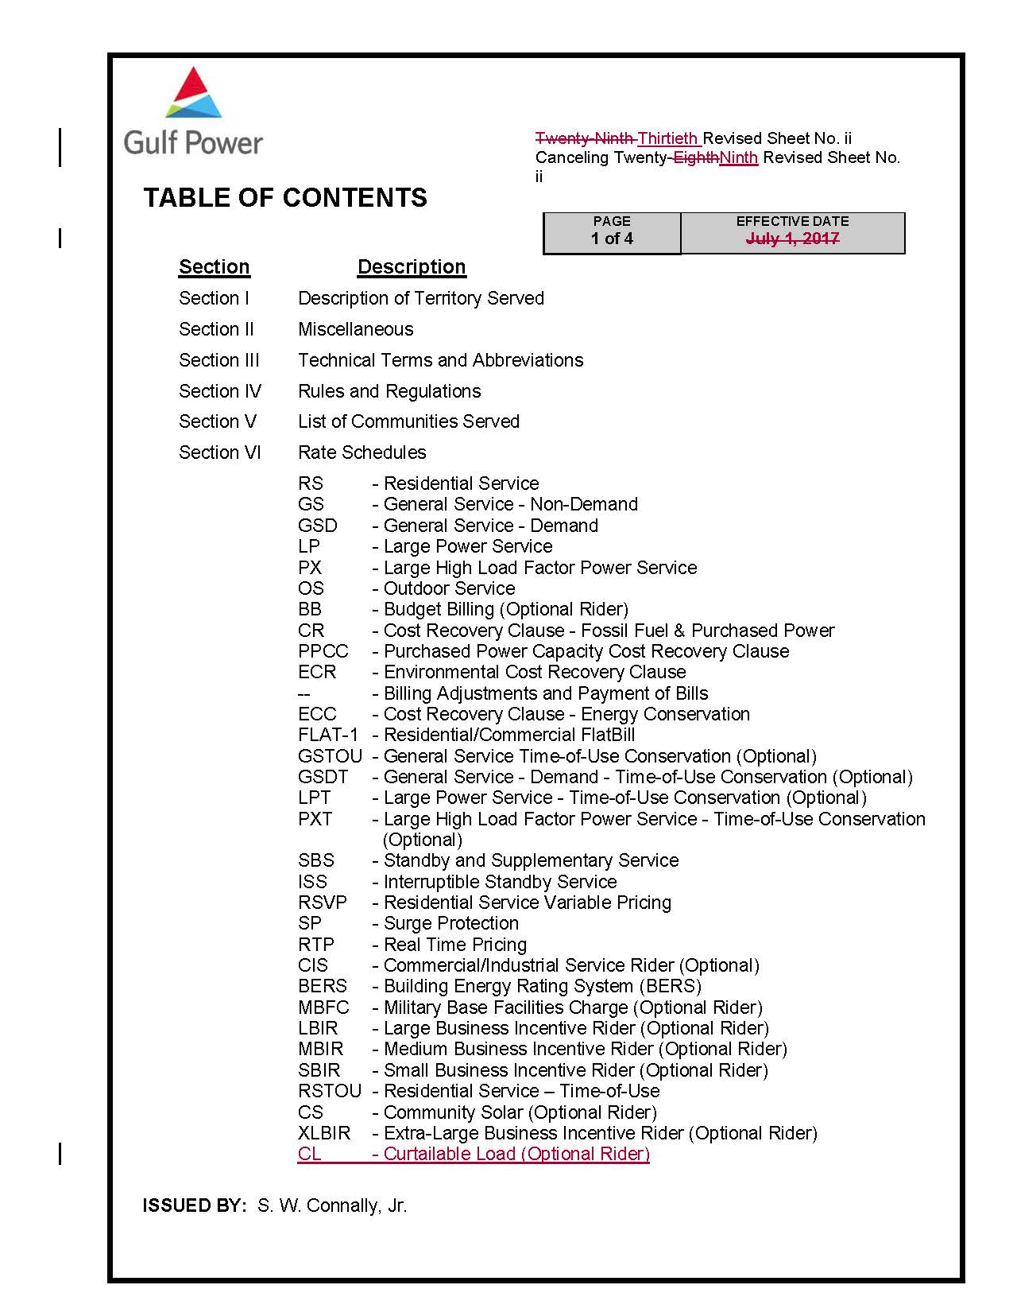

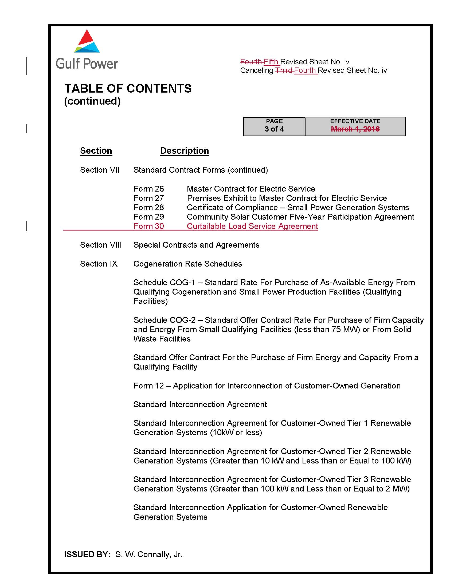

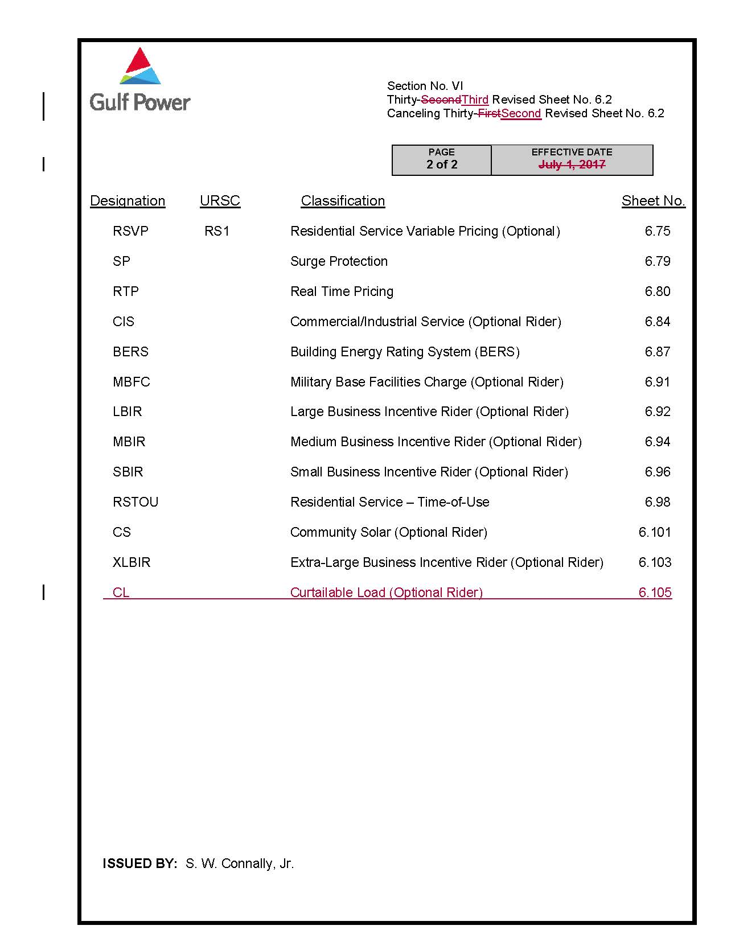

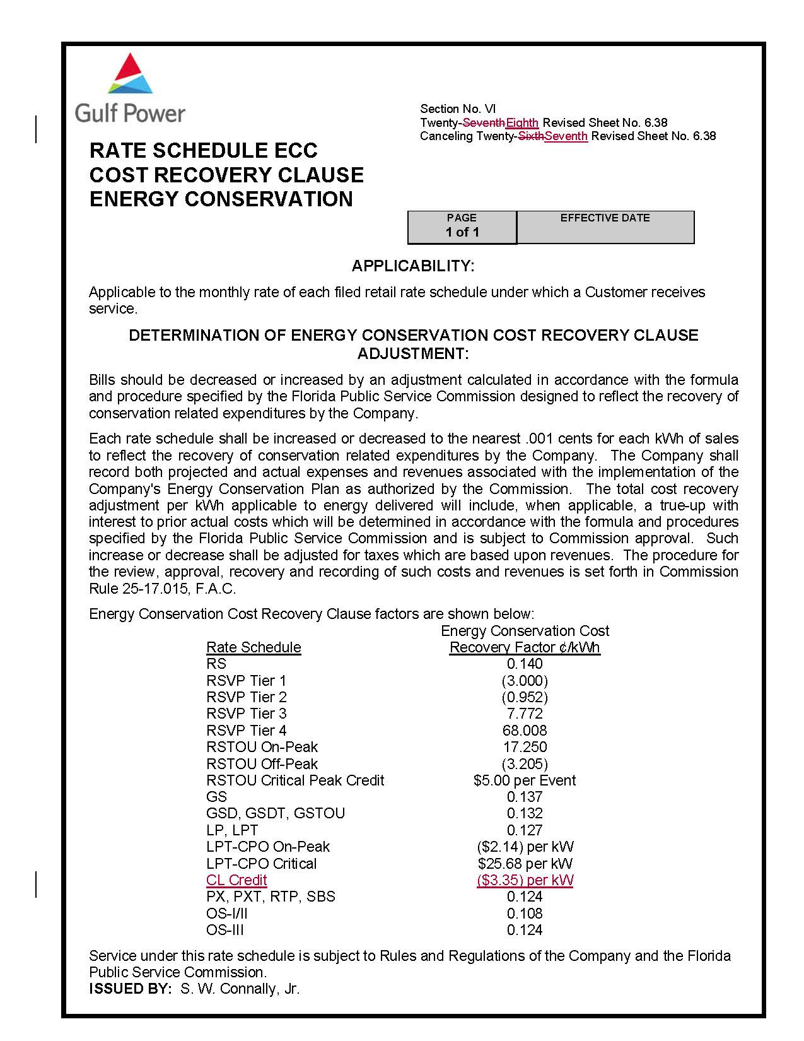

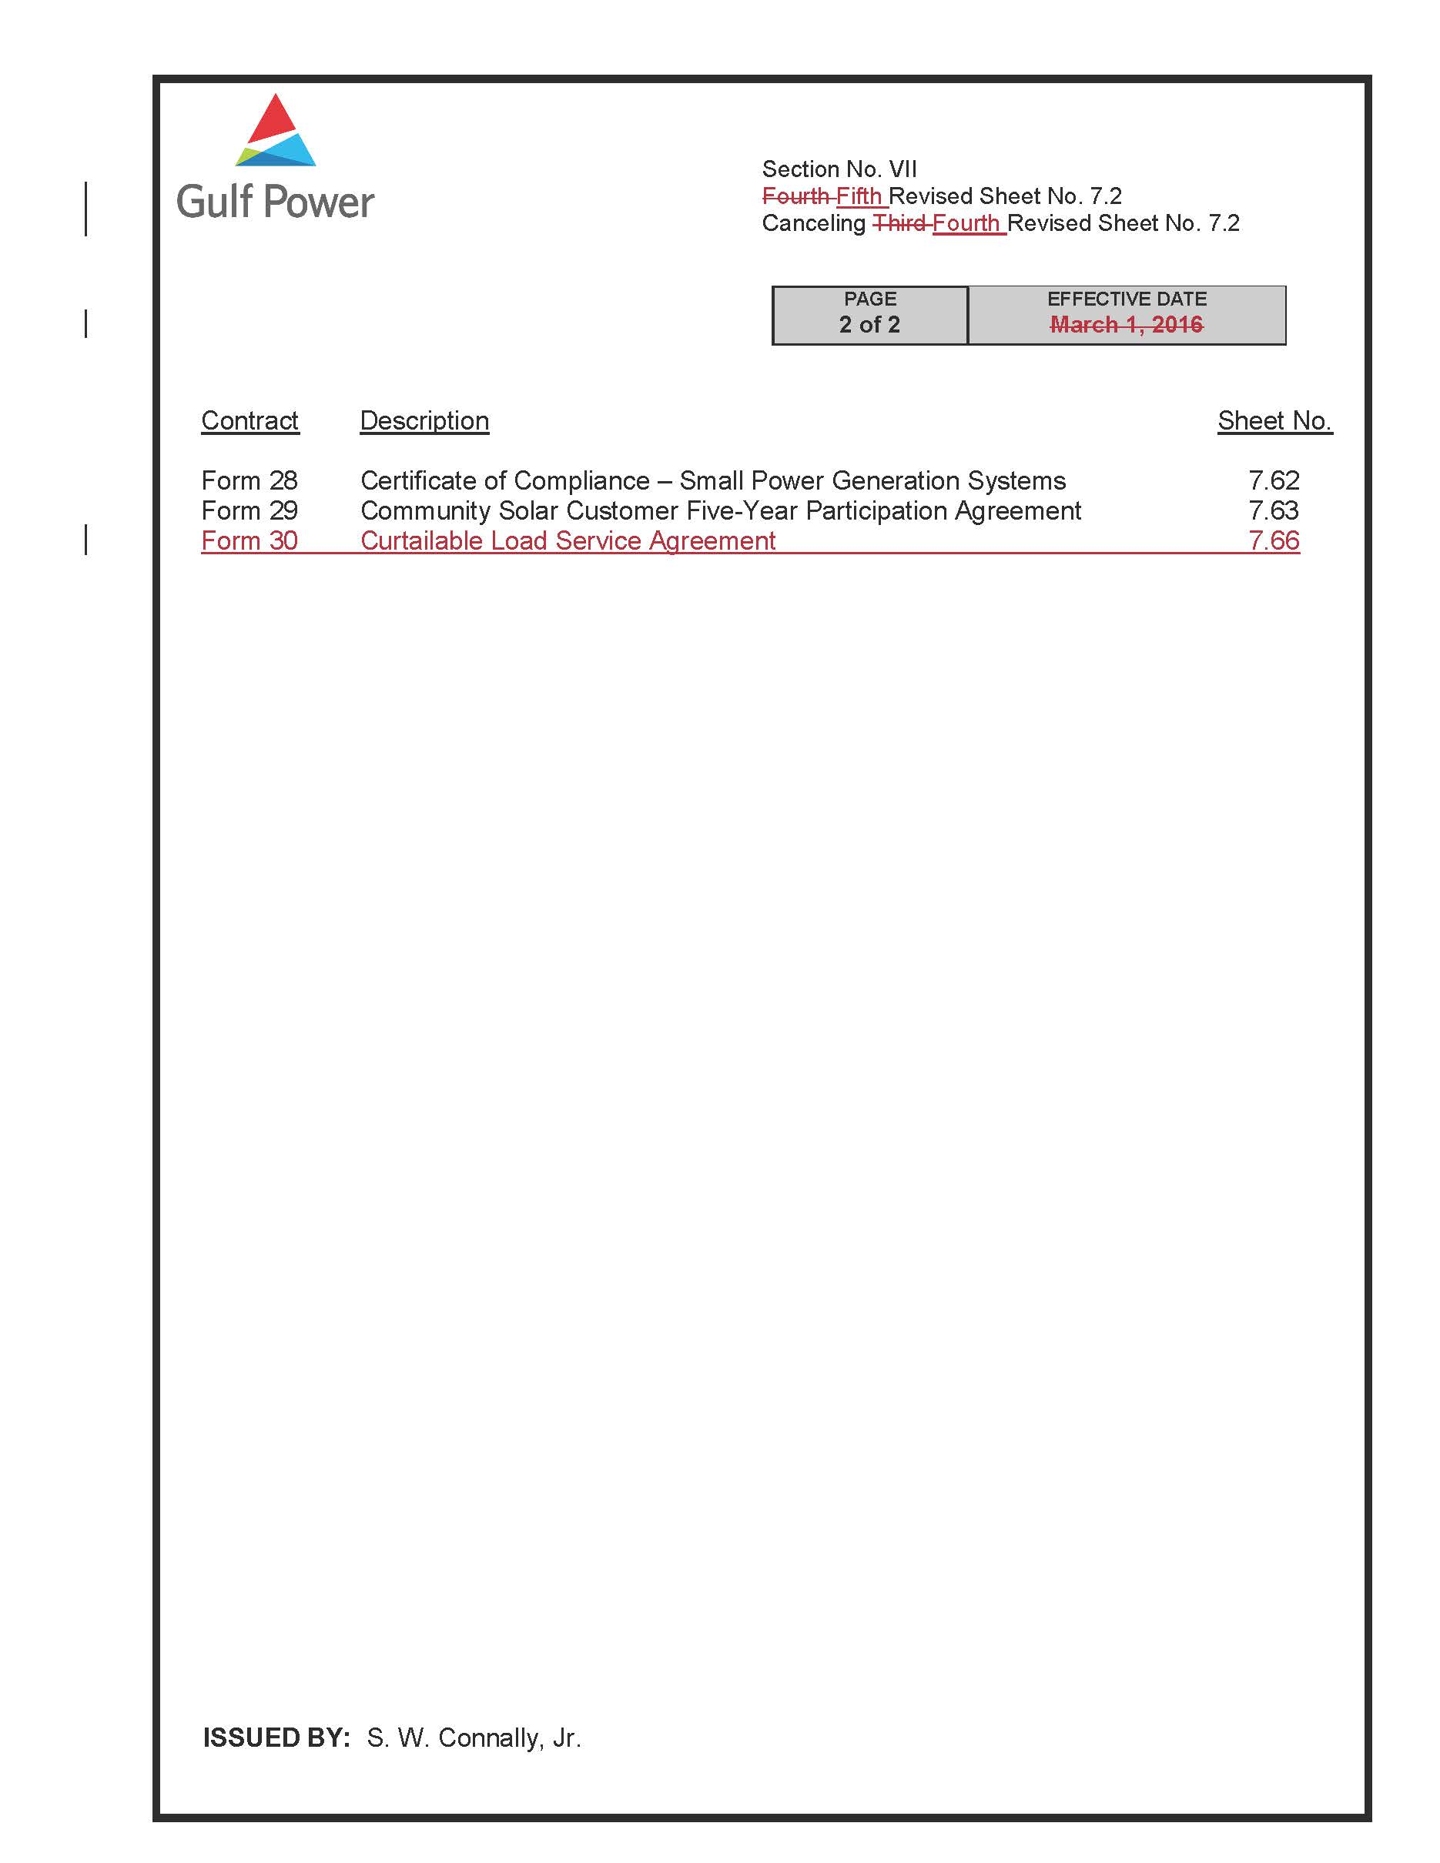

Order No. PSC-2017-0178-S-EI, issued May 16, 2017, in Docket No. 20160186-EI, In re: Petition for Rate Increase by Gulf Power Company.
We note that an Updated Settlement Agreement was filed on February 14, 2018, in Docket Nos. 20160186-EI and 20160170-EI, and will be reviewed in a later Commission proceeding. The Updated Settlement Agreement only addresses changes to the tax code and does not affect the Curtailable Load program proposed by Gulf in the instant docket.
See Order No. 22176, issued November 14, 1989, in Docket No. 890737-PU, In re: Implementation of section 366.80-85 Florida Statutes, Conservation Activities of Electric and Natural Gas Utilities.

