BEFORE THE FLORIDA PUBLIC SERVICE COMMISSION

In re: Consideration of the stipulation and settlement agreement between Gulf Power Company, the Office of Public Counsel, Florida Industrial Power Users Group, and Southern Alliance for Clean Energy regarding the Tax Cuts and Jobs Act of 2017. | DOCKET NO. 20180039-EI  ORDER NO. PSC-2018-0180-FOF-EI  ISSUED: April 12, 2018

The following Commissioners participated in the disposition of this matter:

ART GRAHAM, Chairman
JULIE I. BROWN
DONALD J. POLMANN
GARY F. CLARK
ANDREW GILES FAY

APPEARANCES:

JEFFREY A. STONE and RUSSELL A. BADDERS, ESQUIRES, One Energy Place, Pensacola, Florida 32520-0100; Beggs & Lane, P. O. Box 12950, Pensacola, Florida 32576-2950
On behalf of Gulf Power Company (Gulf).

J.R. KELLY and CHARLES REHWINKEL, ESQUIRES, Office of Public Counsel, c/o The Florida Legislature, 111 West Madison Street, Room 812, Tallahassee, Florida 32399-1400
On behalf of the Citizens of the State of Florida (OPC).

JON MOYLE and KAREN PUTNAL, ESQUIRES, Moyle Law Firm, PA, The Perkins House, 118 North Gadsden Street, Tallahassee, Florida 32301
On behalf of the Florida Industrial Power Users Group (FIPUG).

SUZANNE BROWNLESS, ESQUIRE, Florida Public Service Commission, 2540 Shumard Oak Boulevard, Tallahassee, Florida 32399-0850
On behalf of the Florida Public Service Commission (Staff).

MARY ANNE HELTON, ESQUIRE, Deputy General Counsel, Florida Public Service Commission, 2540 Shumard Oak Boulevard, Tallahassee, Florida 32399-0850
Advisor to the Florida Public Service Commission.

Keith hetrick, ESQUIRE, General Counsel, Florida Public Service Commission, 2540 Shumard Oak Boulevard, Tallahassee, Florida 32399-0850
Florida Public Service Commission General Counsel.
FINAL ORDER APPROVING JOINT MOTION TO APPROVE
STIPULATION AND SETTLEMENT AGREEMENT

BY THE COMMISSION:
BACKGROUND

On February 14, 2018, Gulf Power Company (Gulf) filed a Stipulation and Settlement Agreement (SSA) between Gulf and the Office of Public Counsel (OPC), the Florida Industrial Power Users Group (FIPUG), and the Southern Alliance for Clean Energy (SACE) regarding the Tax Cuts and Jobs Act of 2017 in Docket Nos. 20180013-PU, the generic tax docket, and 20160186-EI, Gulf’s last base rate case proceeding. The SSA addresses the effects of the passage of the Tax Cuts and Jobs Act of 2017 (Act), signed into law by President Trump on December 22, 2017. The signatories to the SSA are OPC, FIPUG and SACE, all of whom were signatories to Gulf’s last rate case stipulation.

The SSA implements paragraph 6 of Gulf’s 2017 Stipulation and Settlement Agreement (2017 Settlement) approved by Order No. PSC-17-0178-S-EI. There are six basic parts to the SSA: 1) base rate reduction of $18.2 million per year commencing on April 1, 2018; 2) establishment of a regulatory liability to account for the tax rate reduction from January 1, 2018 until the effective date of the base rate reduction; 3) refund of $69.4 million by the end of 2018 through the fuel cost recovery clause for the unprotected excess deferred tax regulatory liability as of December 31, 2017; 4) reduction of $15.6 million to Environmental Cost Recovery Clause (ECRC) recovered by the end of 2018; 5) establishment of a 53.5% equity ratio cap for all retail regulatory purposes, e.g., earnings surveillance reporting, interim rate determinations, cost recovery clauses; and 6) initiation of a limited scope proceeding by May 1, 2018, for the purpose of determining the amount and flow back period for protected excess deferred taxes through a prospective reduction in base rates, should one be warranted. The SSA is intended to resolve all of Gulf’s outstanding tax issues associated with the Act.

On February 19, 2018, pursuant to Section 366.076(1), Florida Statutes, this docket was opened to expedite consideration of the SSA as requested by the signatories so that the base rate reduction agreed to by the parties, if appropriate, can be implemented in April 2018. On February 26, 2018, Gulf filed a Joint Motion to Approve Stipulation and Settlement Agreement (Motion) requesting that the SSA be approved in its entirety and that this Commission take final action no later than March 26, 2018, which would allow the tariffs filed with the Motion to become effective in April 2018. Gulf states that the SSA is in the best interest of Gulf’s ratepayers as it allows for a reduction in base rates shortly after the Act’s passage as well as reducing the Environmental Cost Recovery Clause factors, and returning unprotected excess deferred income taxes to customers more rapidly than normally done. All parties to this docket - OPC, FIPUG and SACE - as joint movants to Gulf’s Motion support the Motion.

On March 20, 2018, Gulf filed amended tariffs correcting scrivener’s errors in the tariffs filed on February 26, 2018. On March 26, 2018, we held an administrative hearing on this matter in which Gulf’s customers and interested persons were provided with an opportunity to present public testimony and voice any concerns with the SSA. Gulf sponsored witnesses Robin Boren, Rhonda Alexander, and Lee Evans, who answered questions under oath about the SSA, and four exhibits were admitted into evidence.

DECISION

The standard for approval of a settlement agreement is whether it is in the public interest. A determination of public interest requires a case-specific analysis based on consideration of the proposed settlement taken as a whole.

As testified to by Gulf’s witnesses, effective the first billing cycle of April 2018, this SSA greatly benefits ratepayers by implementing a base rate decrease of $18.2 million per year associated with the reduction of the corporate income tax rate from 35 to 21 percent. This reduction will remain in effect until Gulf’s next base rate case. Further, Gulf’s customers will also receive $69.4 million through the Fuel Clause in 2018 associated with unprotected accumulated deferred income taxes that would normally be amortized over a 5 to 10 year period. Finally, Gulf’s ratepayers will immediately see a $15.6 million reduction in the Environmental Cost Recovery Clause factor which would normally not be implemented until January of 2019. Combined, Gulf’s ratepayers will see a $103.2 million reduction in charges in 2018. Although Gulf’s equity ratio cap will increase from 52.5% to 53.5% to allow the refund of $103.2 million in one year, the equity ratio is well within the normal, accepted equity range and will maintain Gulf’s financial stability. The issue of excess protected deferred income taxes, which total approximately $386.1 million per year, has not been resolved by this SSA. The parties will continue to work on a mutually acceptable resolution to this issue and, if none can be reached by May 1, 2018, Gulf will file a petition for a limited proceeding in this docket to resolve the issue.

Based on our review of the SSA, the exhibits entered into the record, the support of the Parties, the testimony provided by Gulf witnesses, and the benefits to Gulf customers discussed above, we find that the SSA, taken as a whole, is in the public interest. Therefore, the SSA is hereby approved.

Based on the foregoing, it is

ORDERED by the Florida Public Service Commission that the Joint Motion to Approve Stipulation and Settlement Agreement between Gulf Power Company, the Office of Public Counsel, the Florida Industrial Power Users Group, and the Southern Alliance for Clean Energy, dated February 14, 2018, is hereby granted and the Stipulation and Settlement Agreement, Attachment A hereto, approved. It is further

ORDERED that the revised tariff sheets implementing the Stipulation and Settlement Agreement between Gulf Power Company, the Office of Public Counsel, the Florida Industrial Power Users Group, and the Southern Alliance for Clean Energy, dated February 14, 2018, reflecting the approved final rates and charges, as filed on February 26, 2018, and amended on March 20, 2018, are hereby approved effective the first billing cycle of April 2018. It is further

ORDERED that this docket shall remain open for disposition by this Commission of the issue of protected excess deferred income taxes.

By ORDER of the Florida Public Service Commission this 12th day of April, 2018.

/s/ Carlotta S. Stauffer
CARLOTTA S. STAUFFER
Commission Clerk
Florida Public Service Commission
2540 Shumard Oak Boulevard
Tallahassee, Florida 32399
(850) 413-6770
www.floridapsc.com

Copies furnished: A copy of this document is provided to the parties of record at the time of issuance and, if applicable, interested persons.
SBr

NOTICE OF FURTHER PROCEEDINGS OR JUDICIAL REVIEW

The Florida Public Service Commission is required by Section 120.569(1), Florida Statutes, to notify parties of any administrative hearing or judicial review of Commission orders that is available under Sections 120.57 or 120.68, Florida Statutes, as well as the procedures and time limits that apply. This notice should not be construed to mean all requests for an administrative hearing or judicial review will be granted or result in the relief sought.

Any party adversely affected by the Commission's final action in this matter may request: 1) reconsideration of the decision by filing a motion for reconsideration with the Office of Commission Clerk, 2540 Shumard Oak Boulevard, Tallahassee, Florida 32399-0850, within fifteen (15) days of the issuance of this order in the form prescribed by Rule 25-22.060, Florida Administrative Code; or 2) judicial review by the Florida Supreme Court in the case of an electric, gas or telephone utility or the First District Court of Appeal in the case of a water and/or wastewater utility by filing a notice of appeal with the Office of Commission Clerk, and filing a copy of the notice of appeal and the filing fee with the appropriate court. This filing must be completed within thirty (30) days after the issuance of this order, pursuant to Rule 9.110, Florida Rules of Appellate Procedure. The notice of appeal must be in the form specified in Rule 9.900(a), Florida Rules of Appellate Procedure.

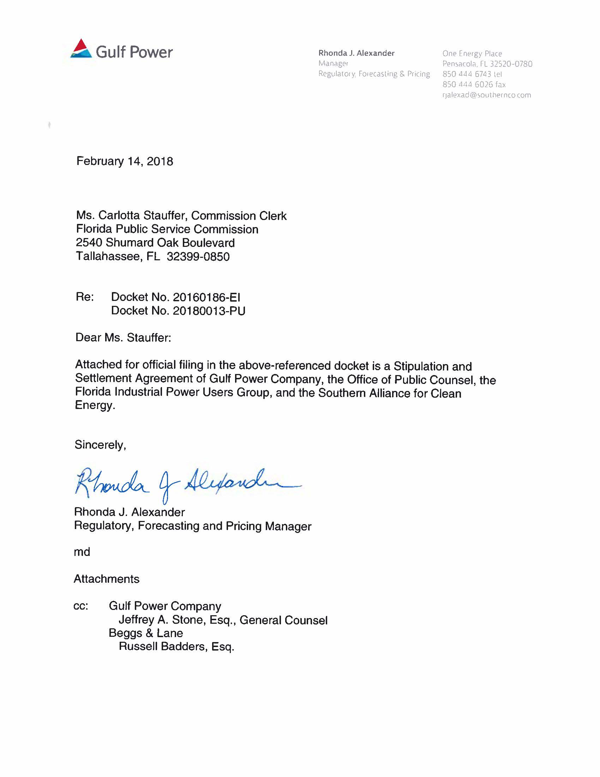
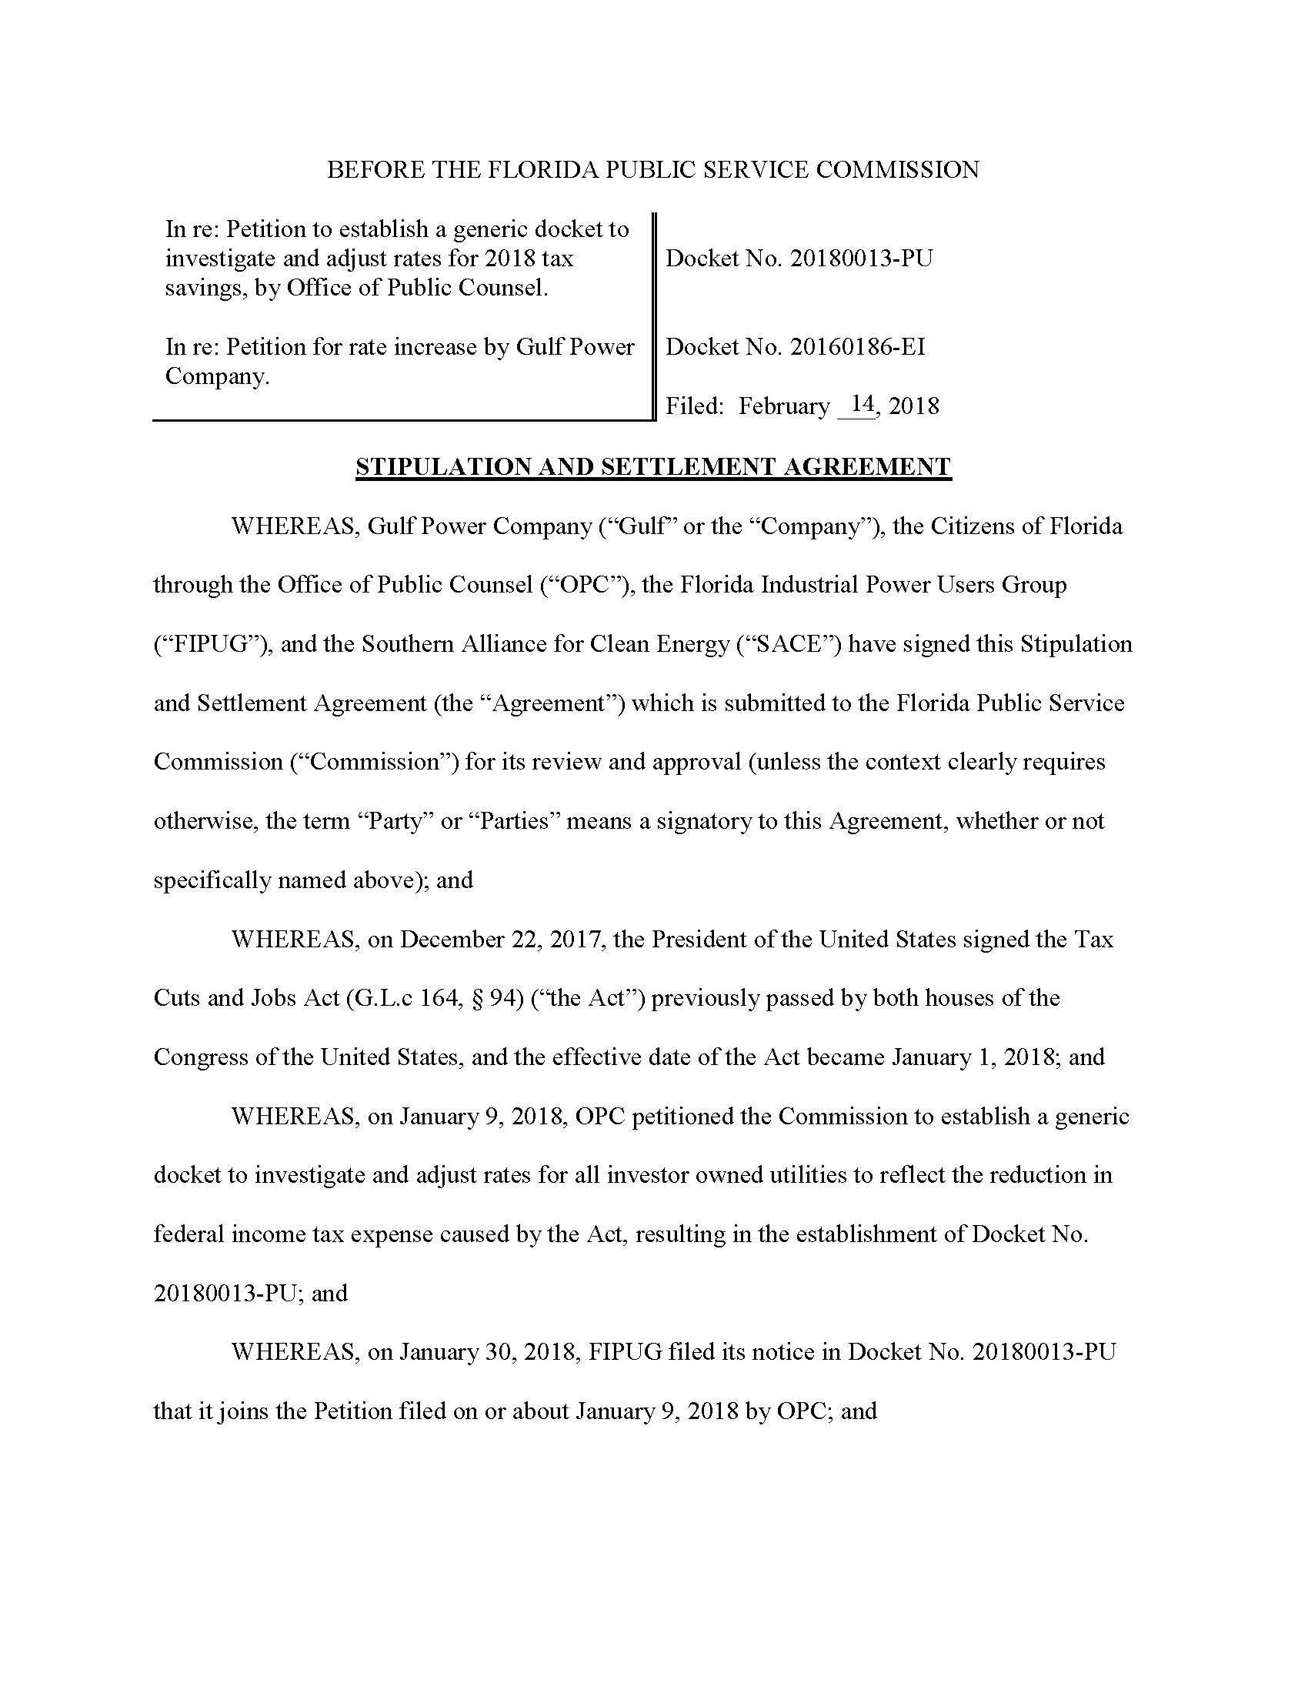

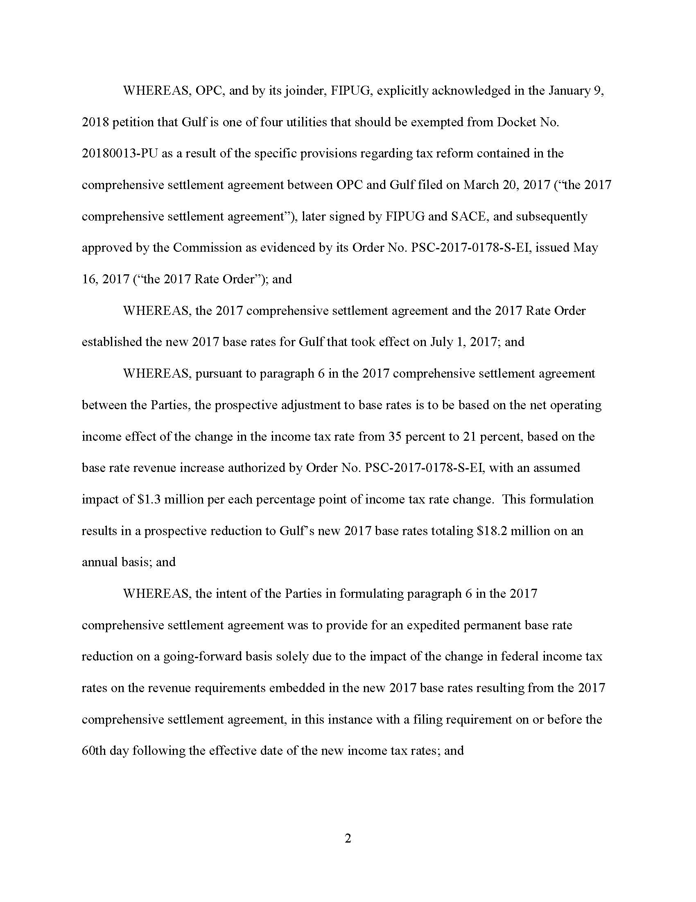

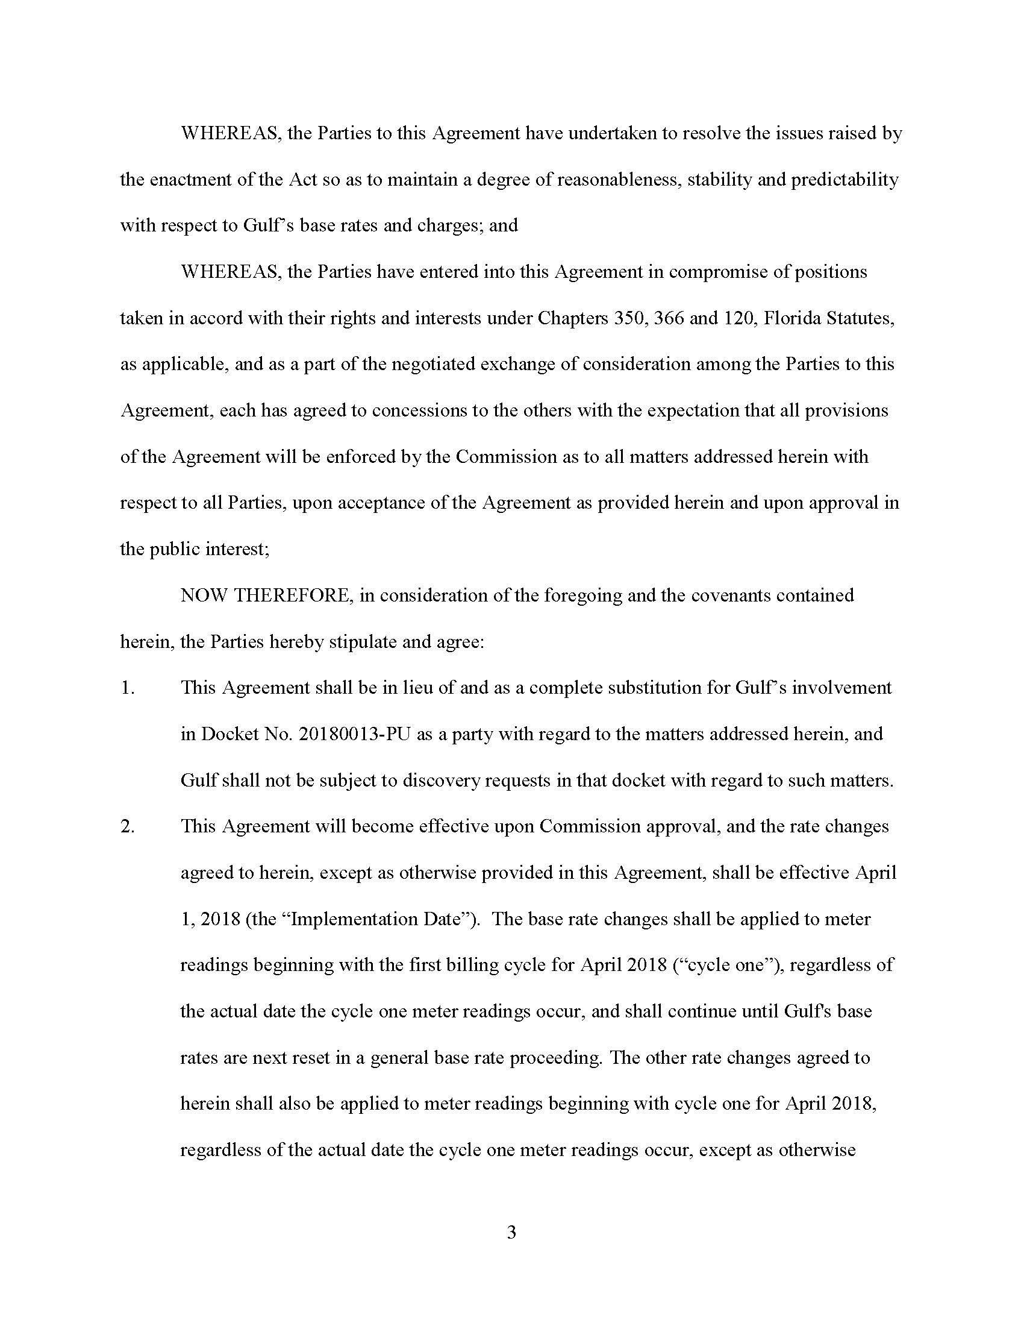

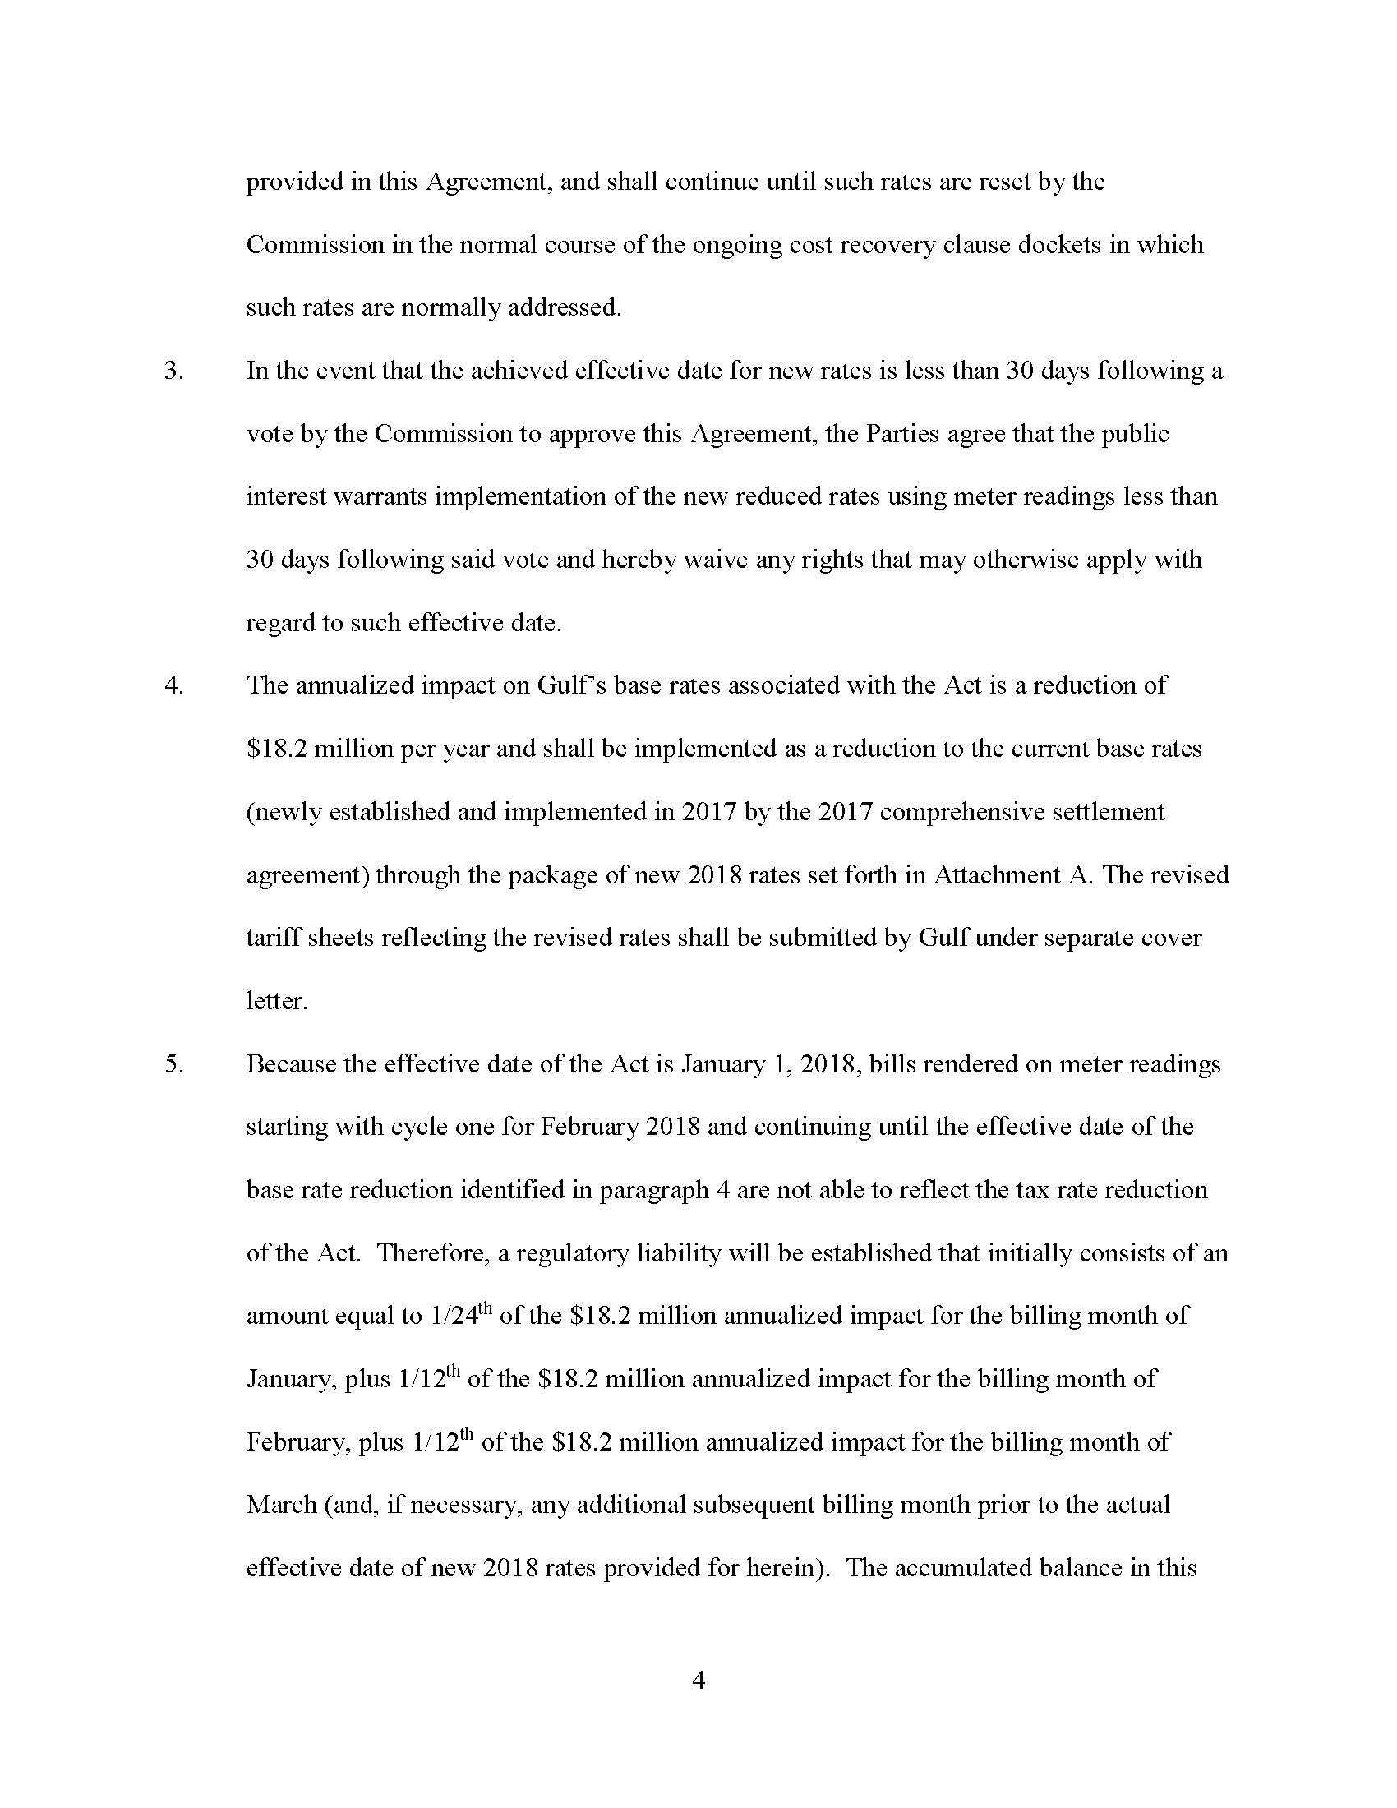

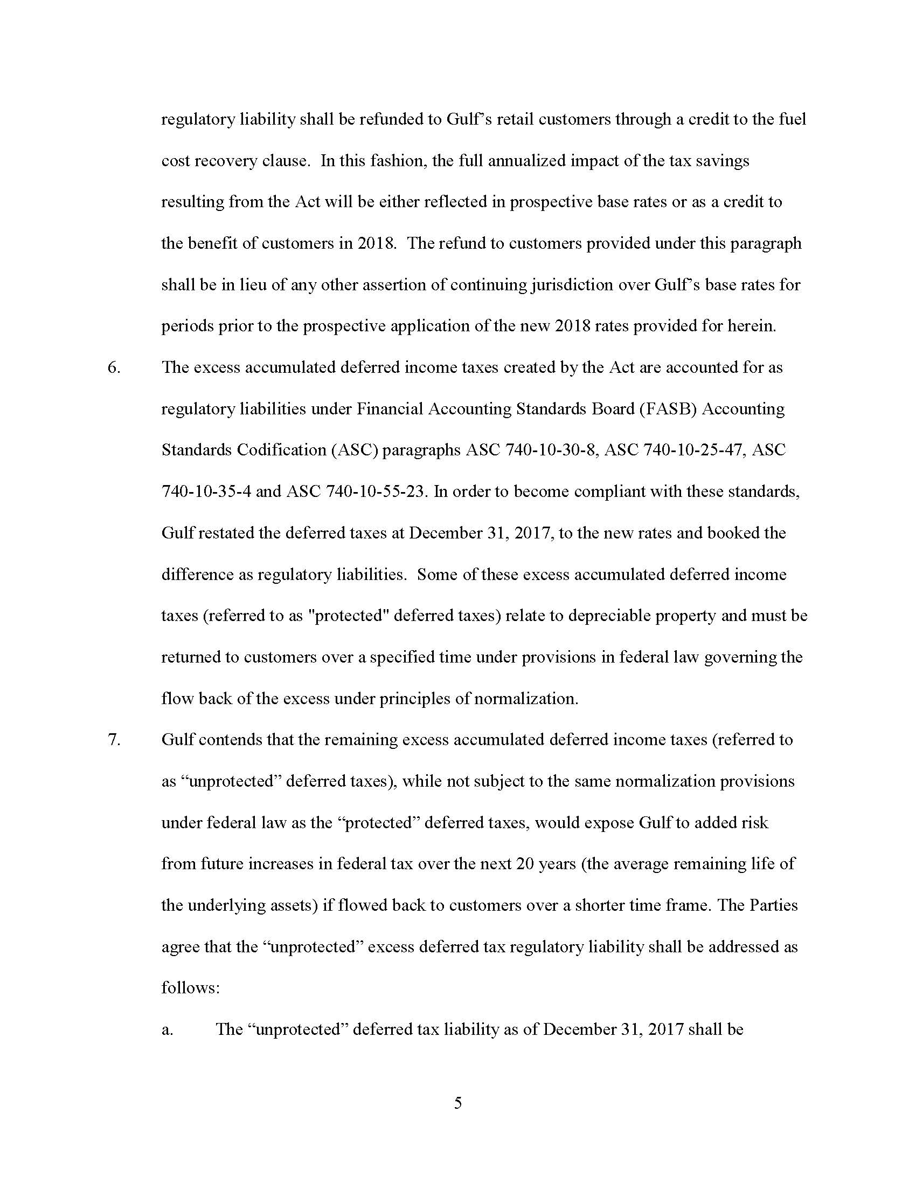

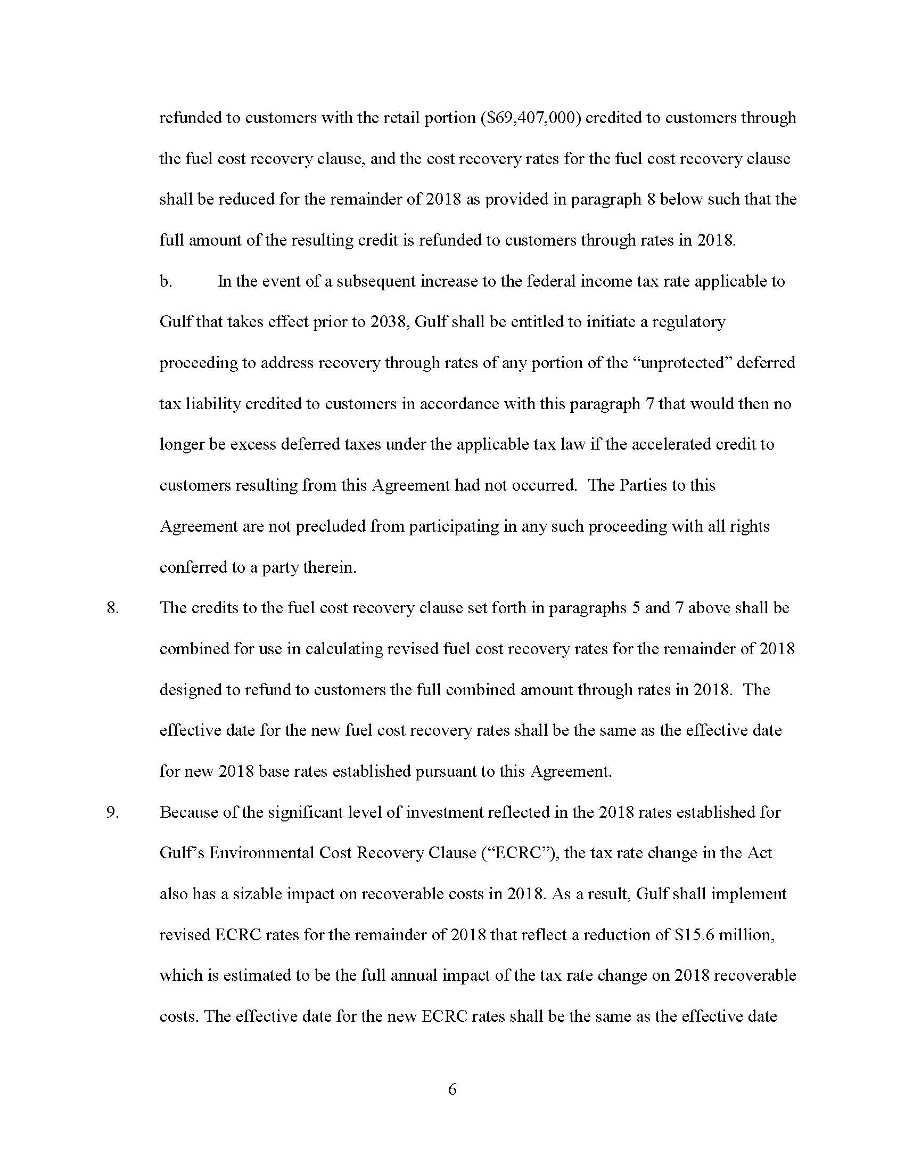

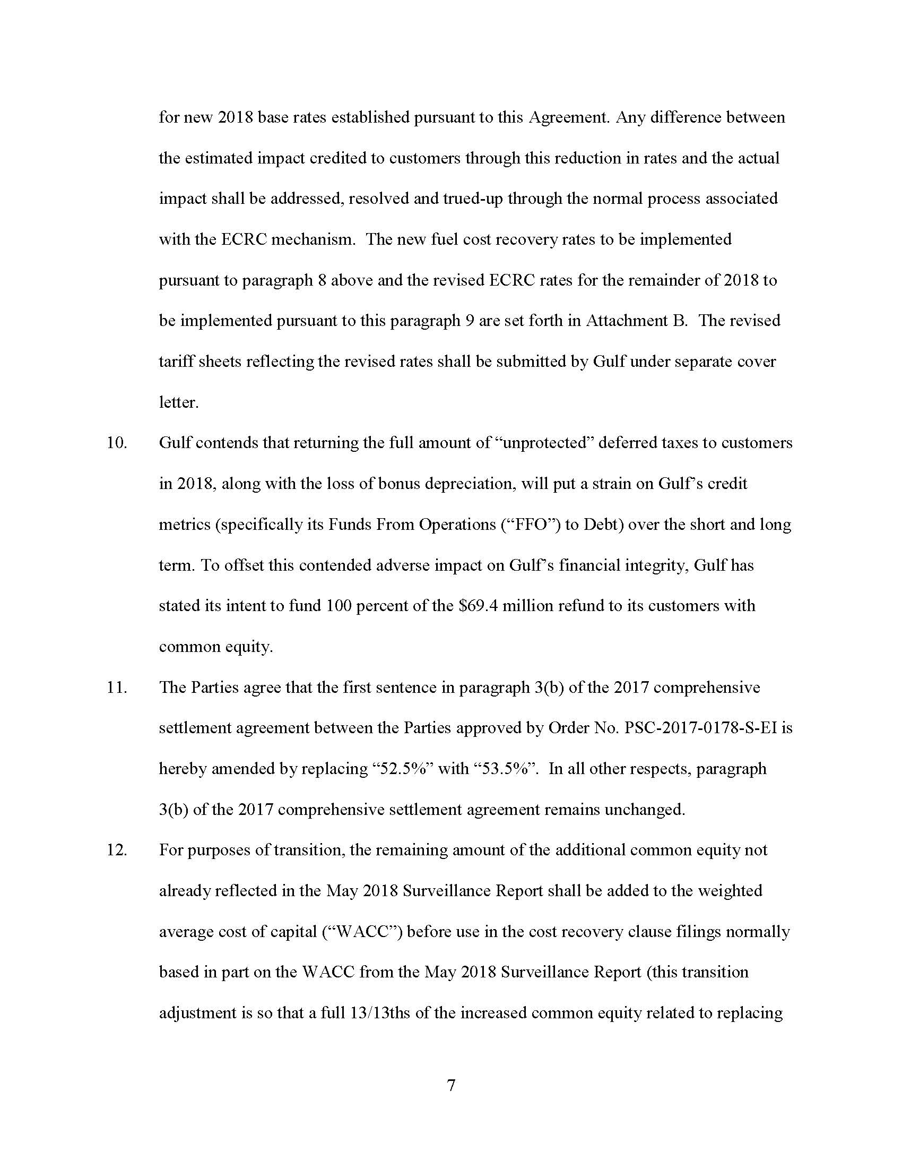

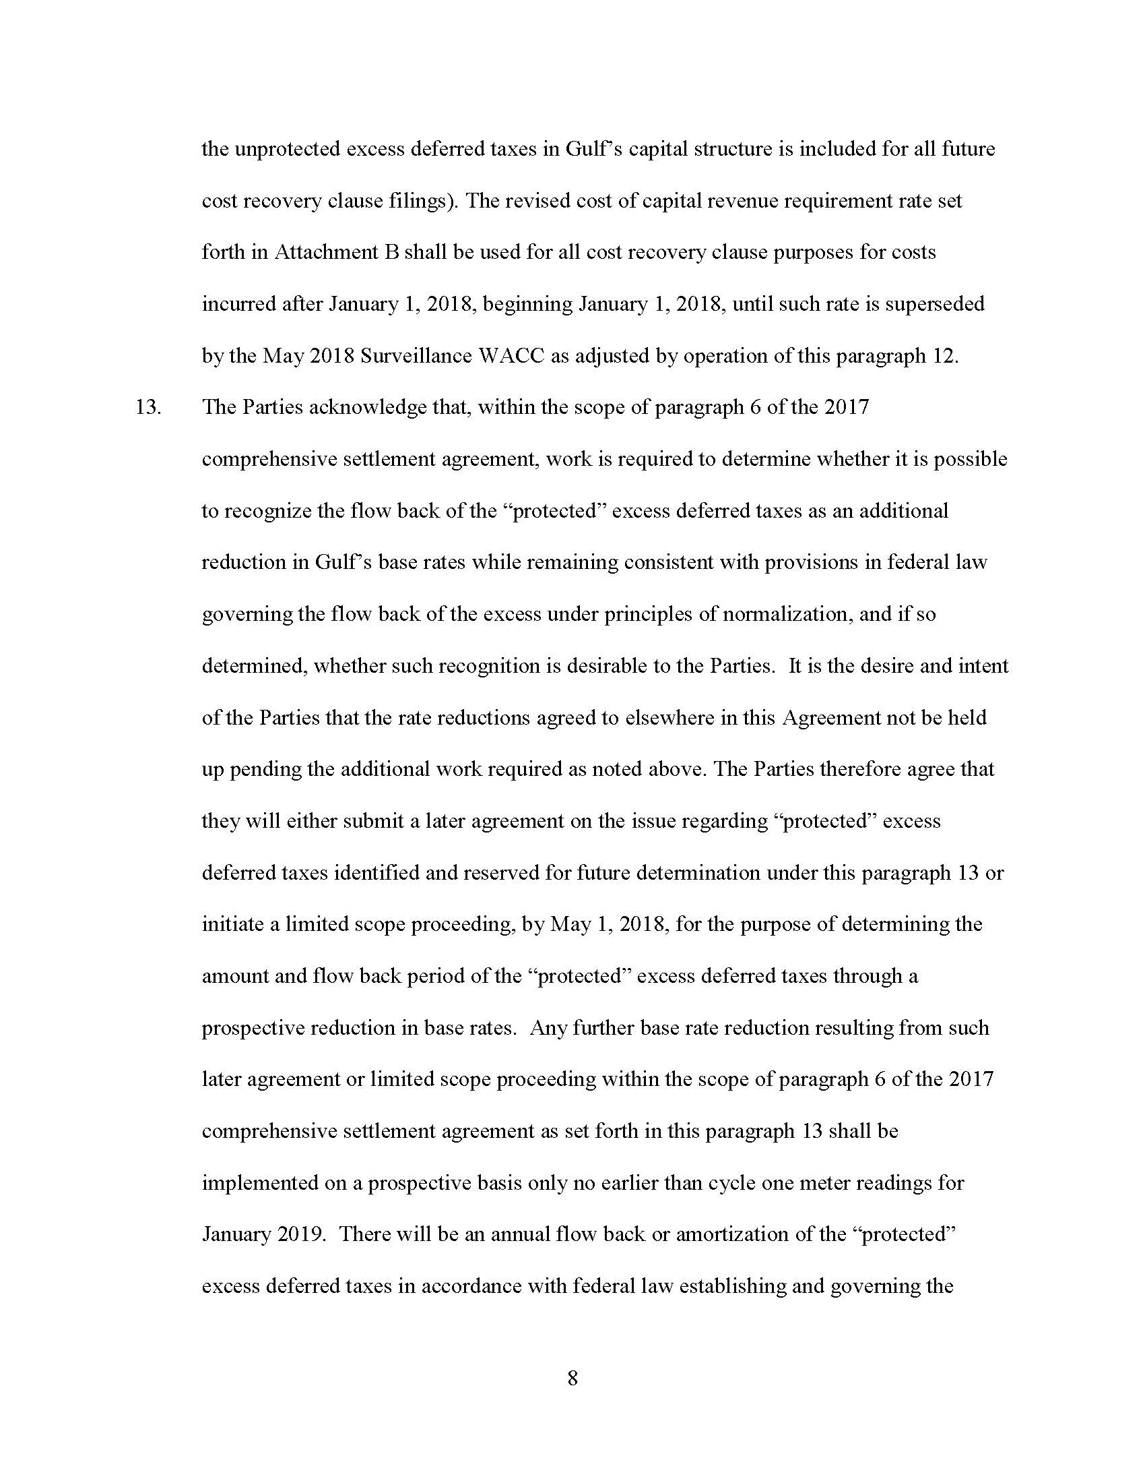

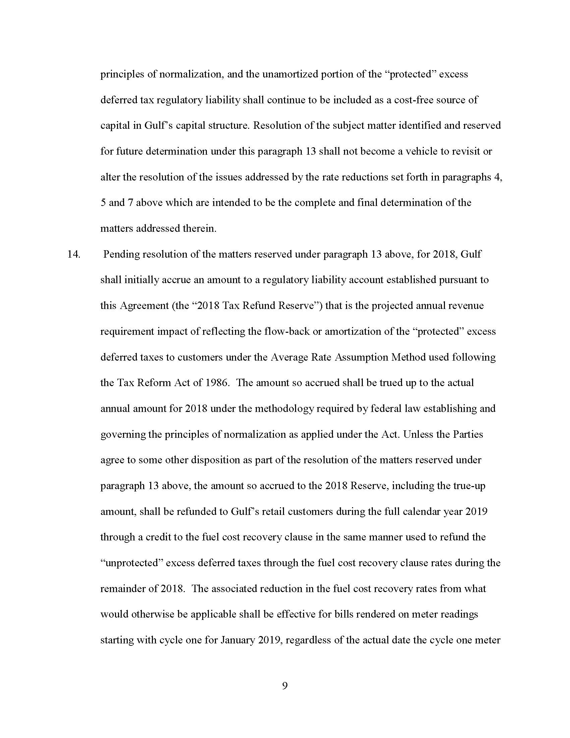

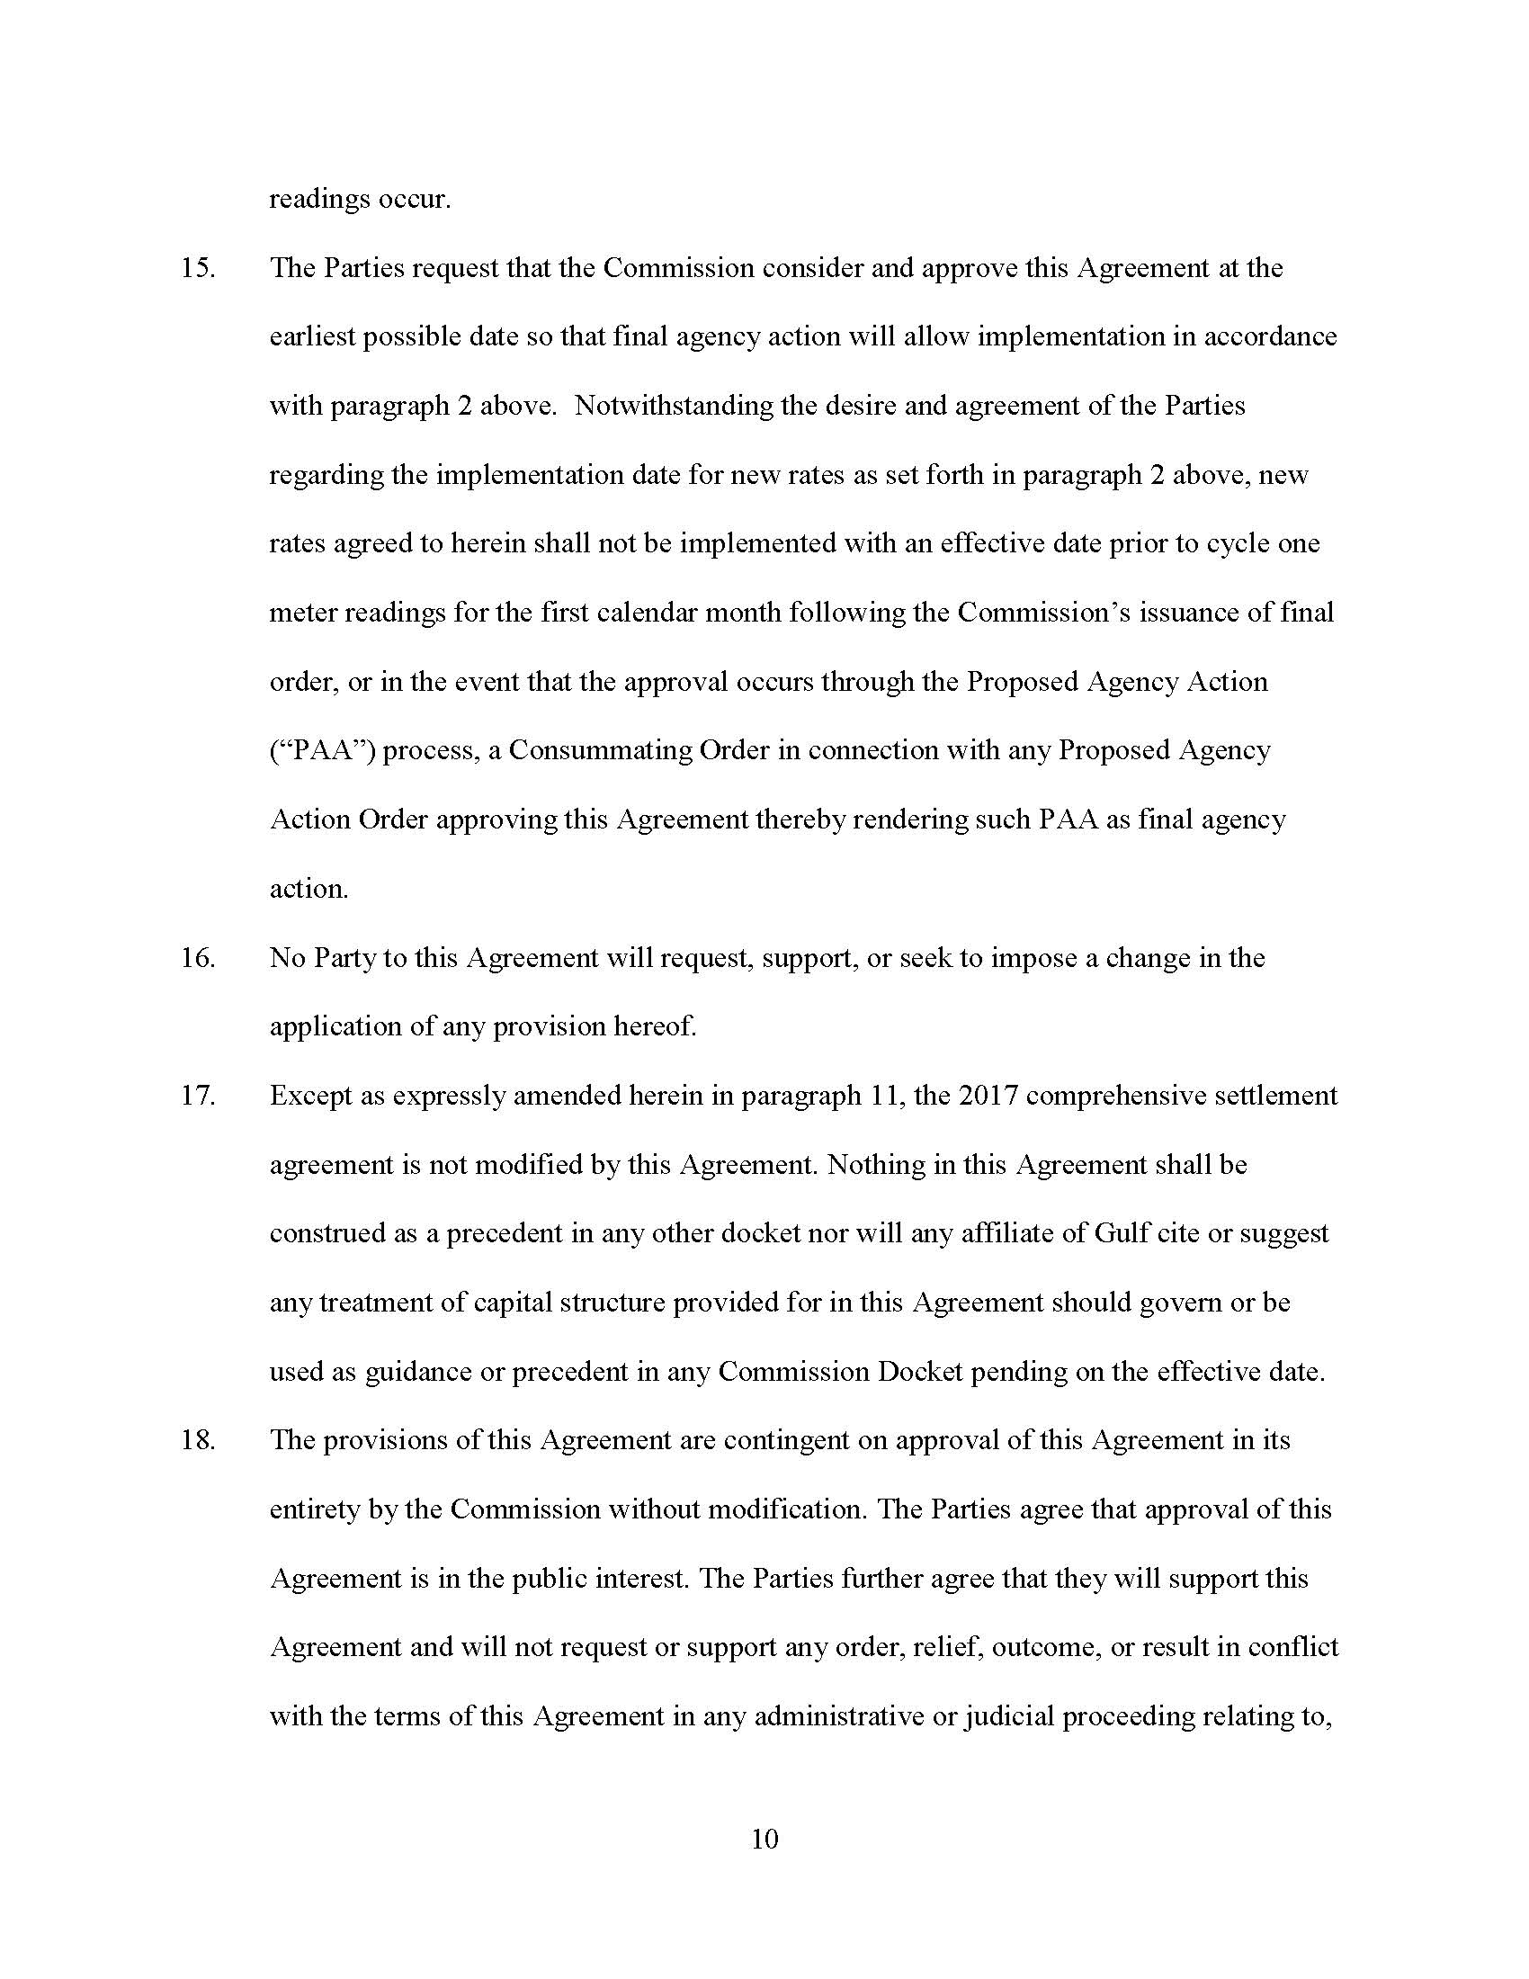

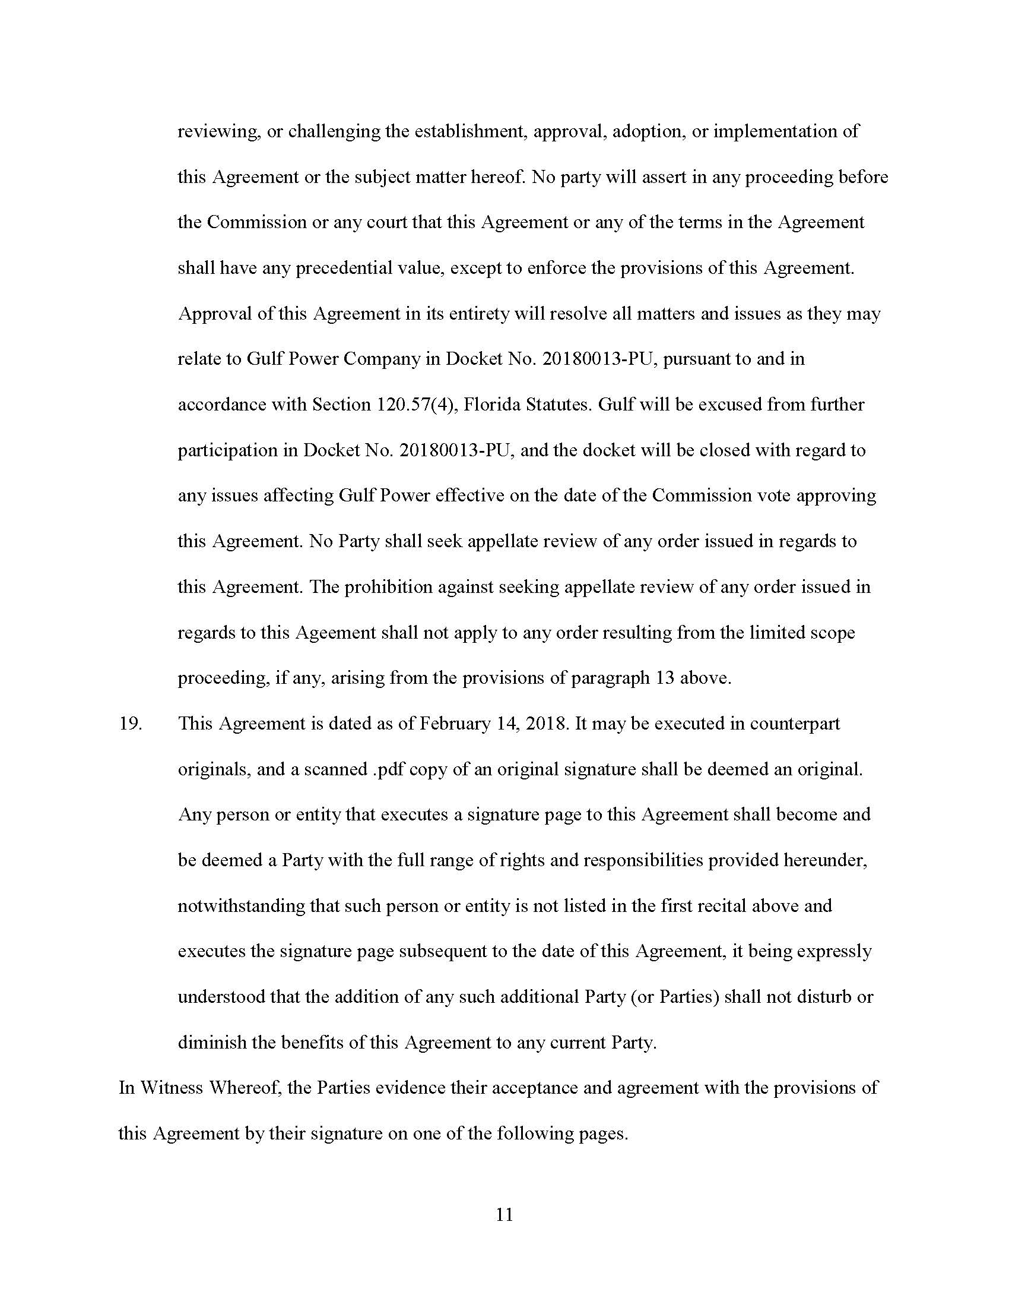

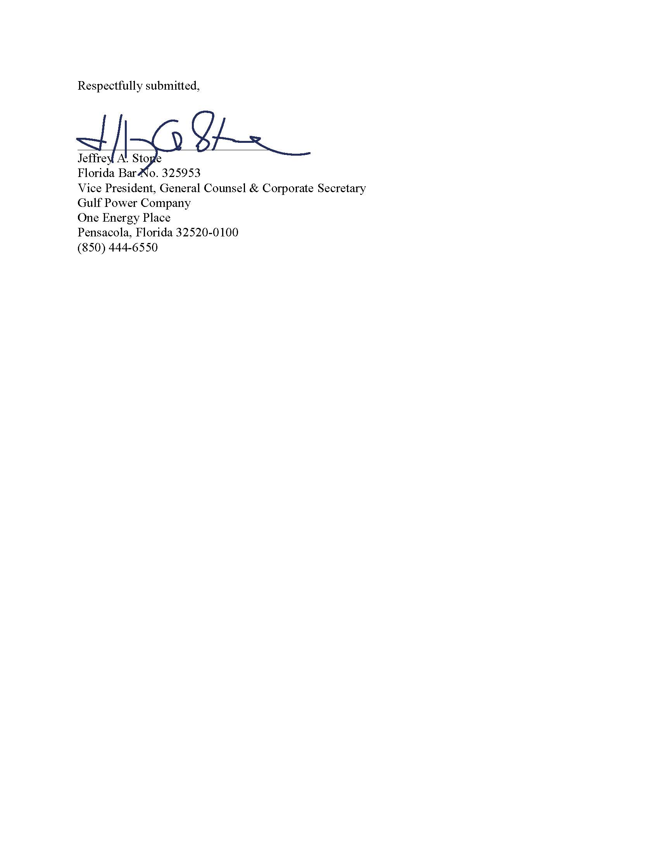

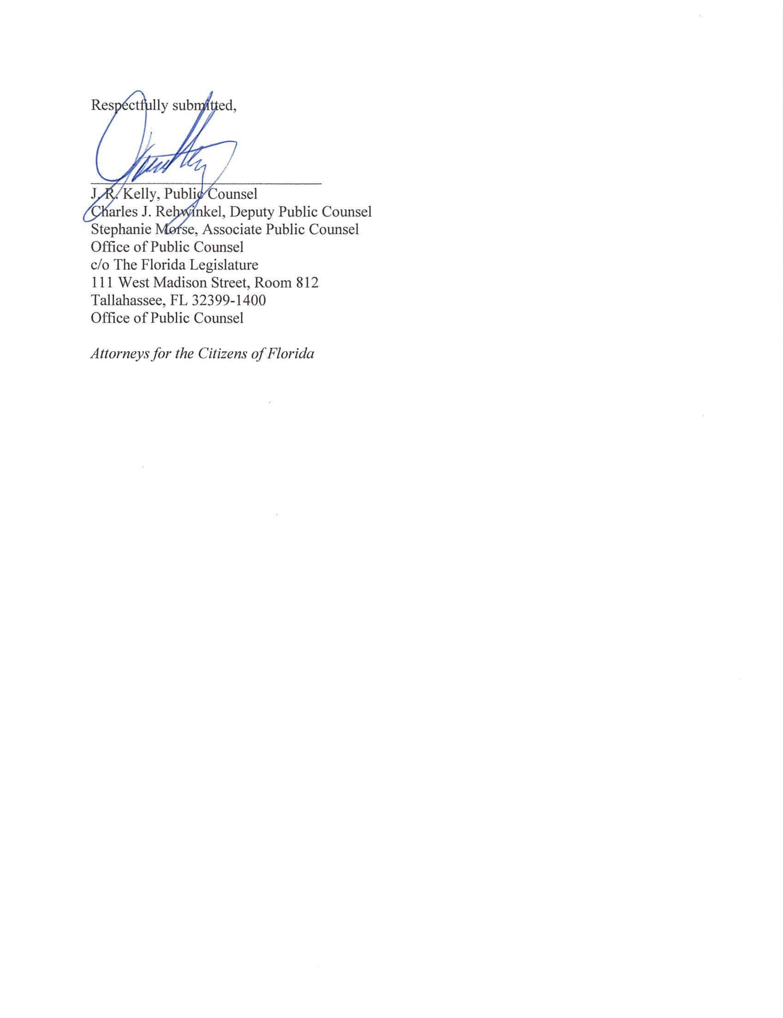

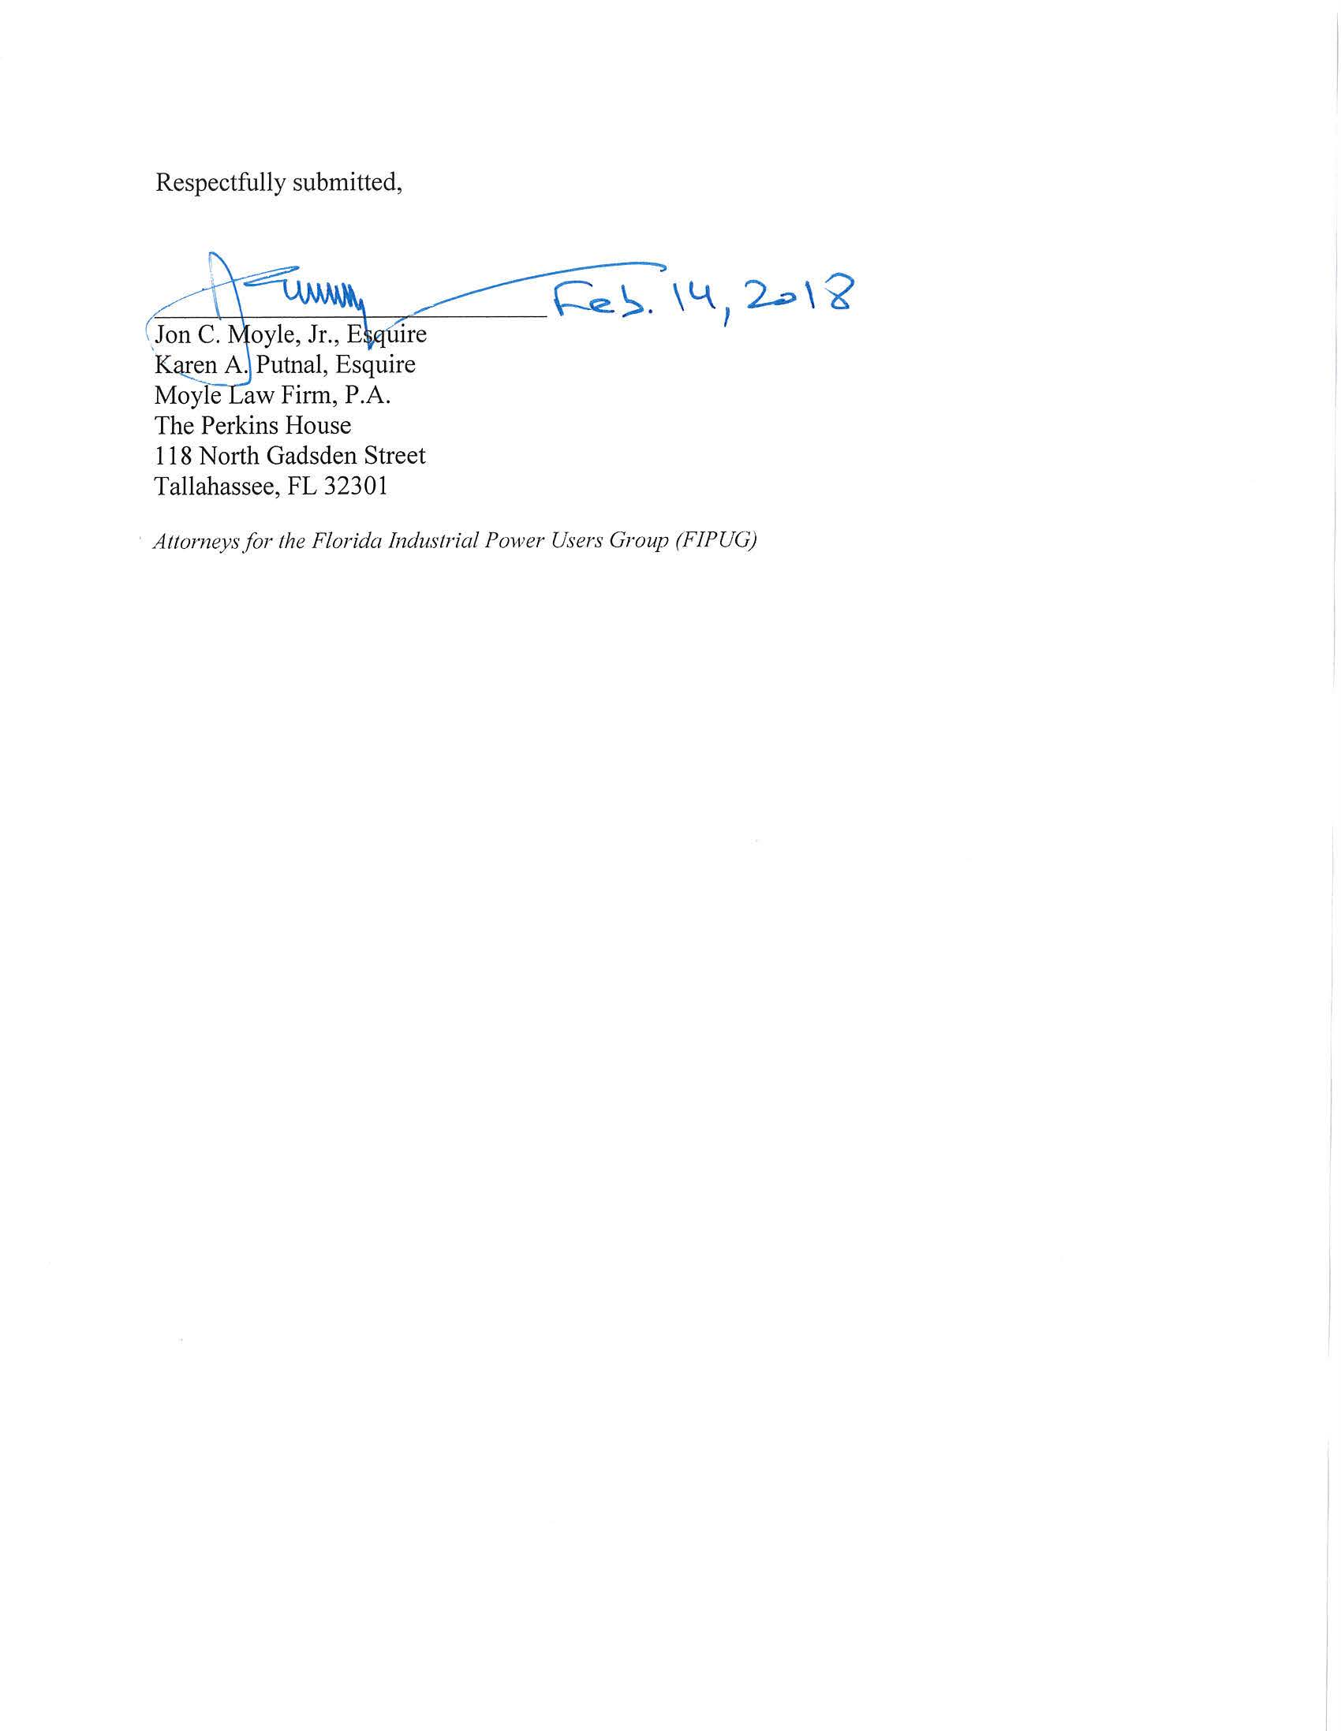

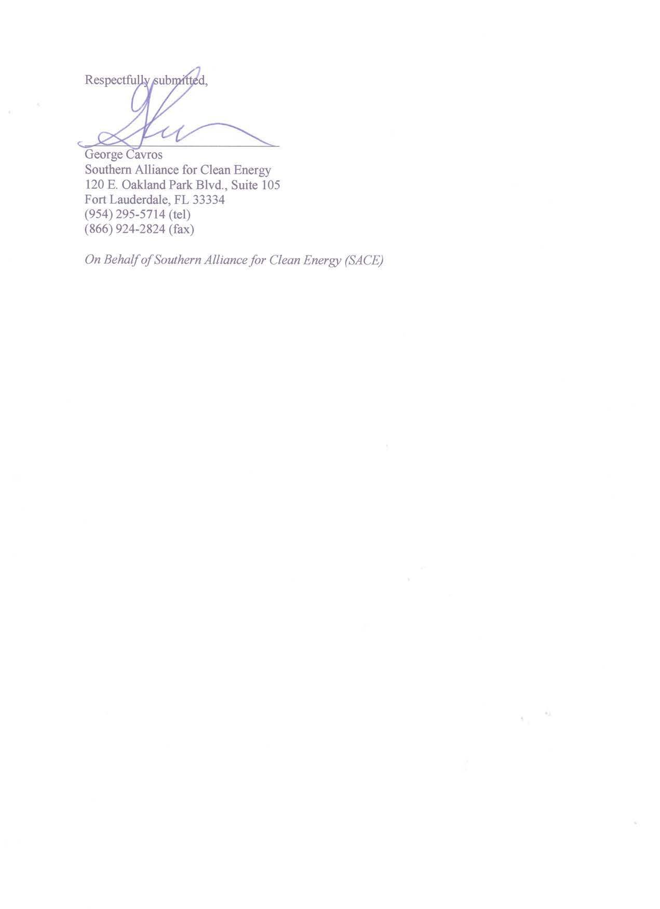

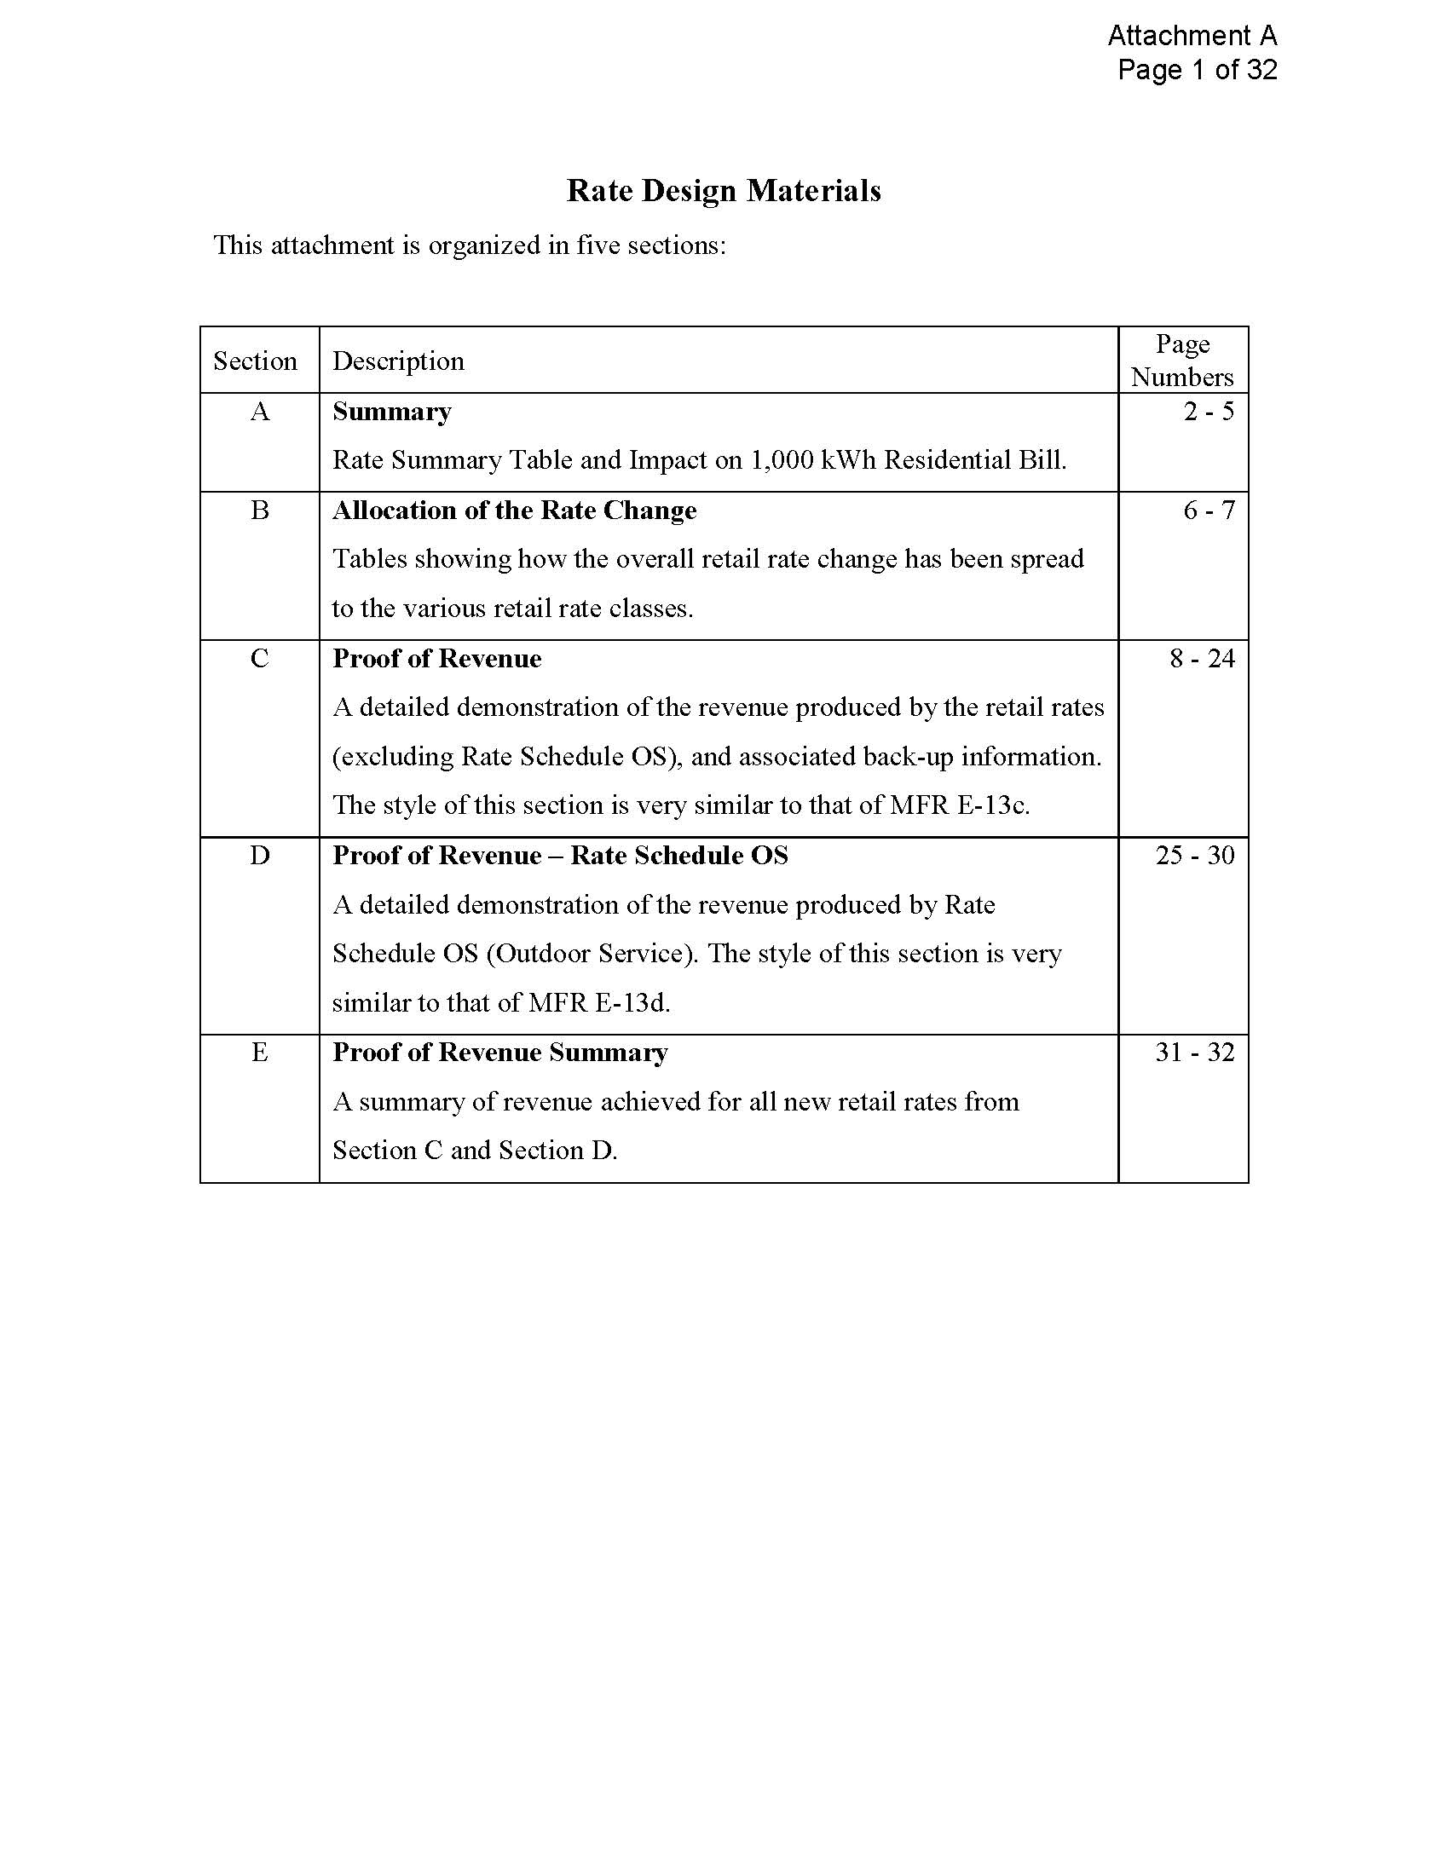

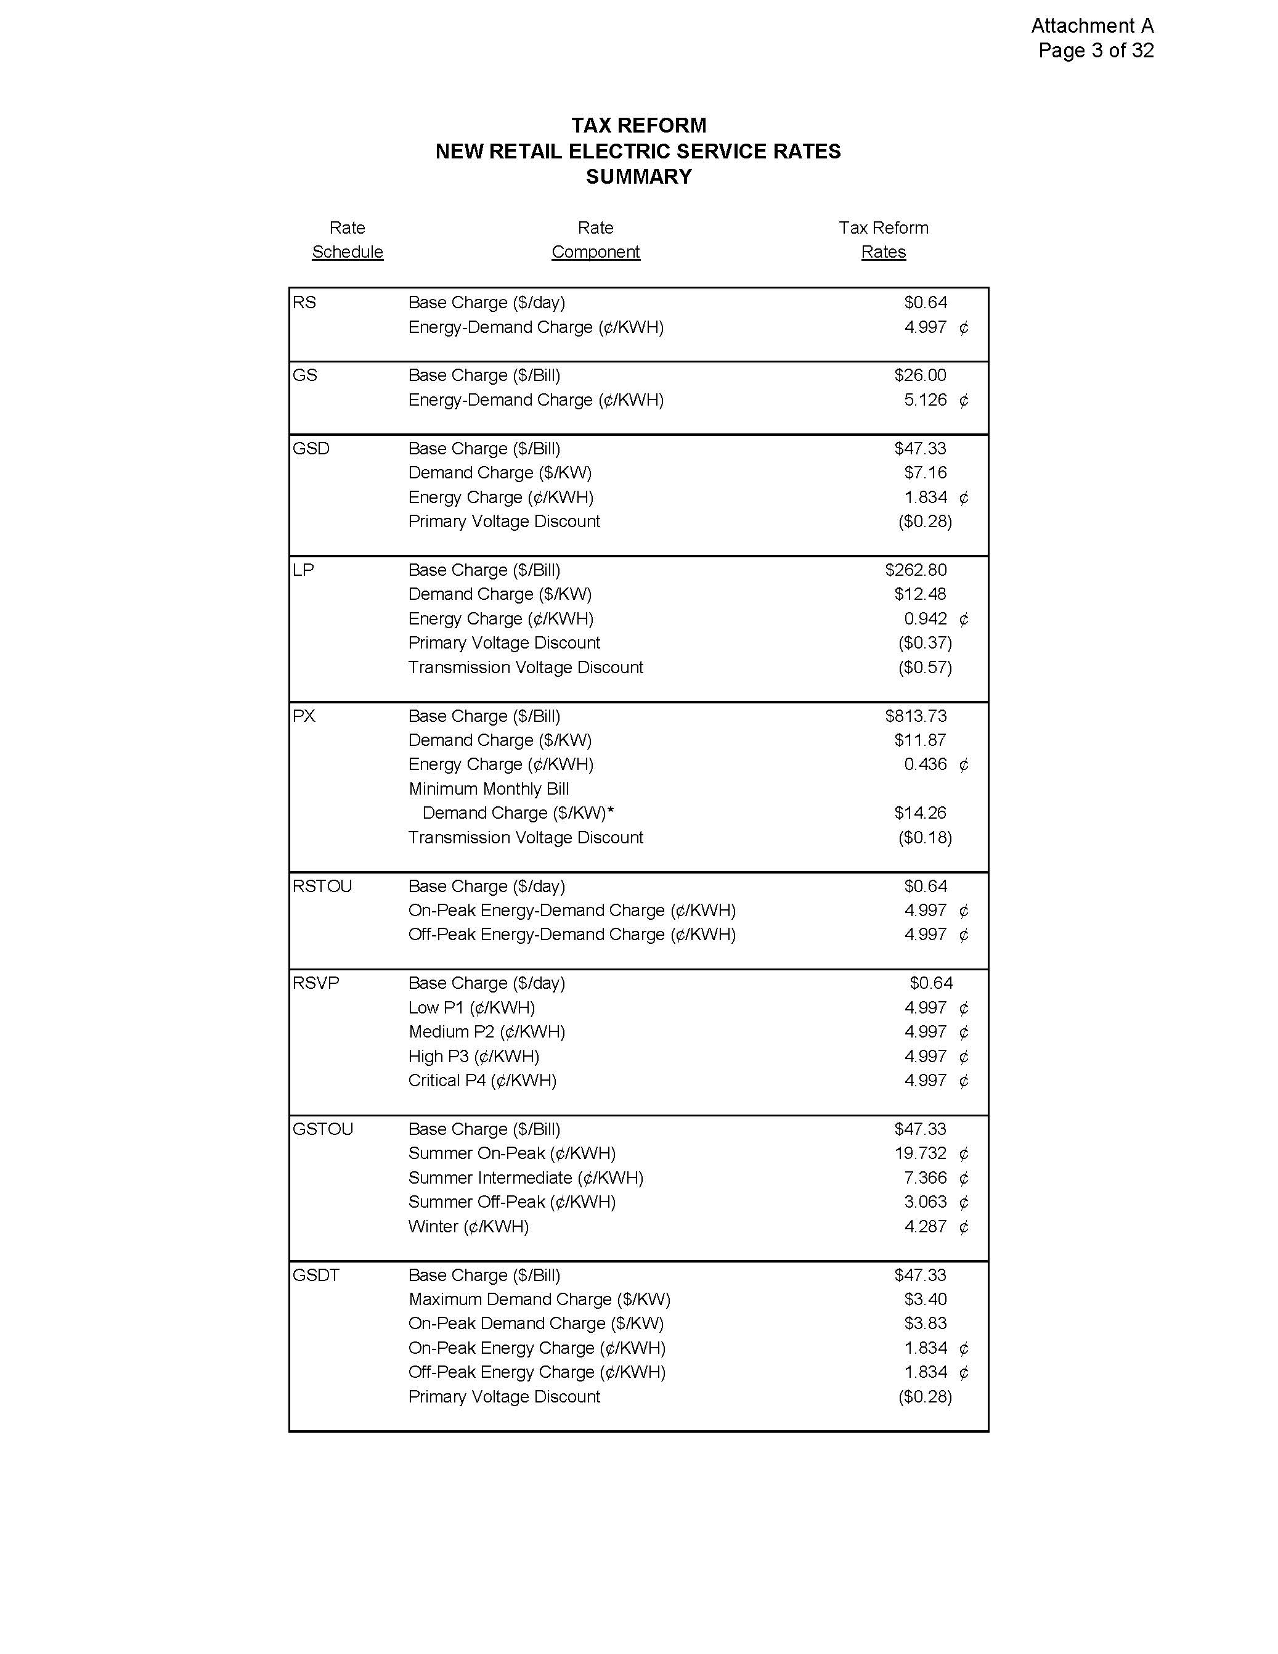

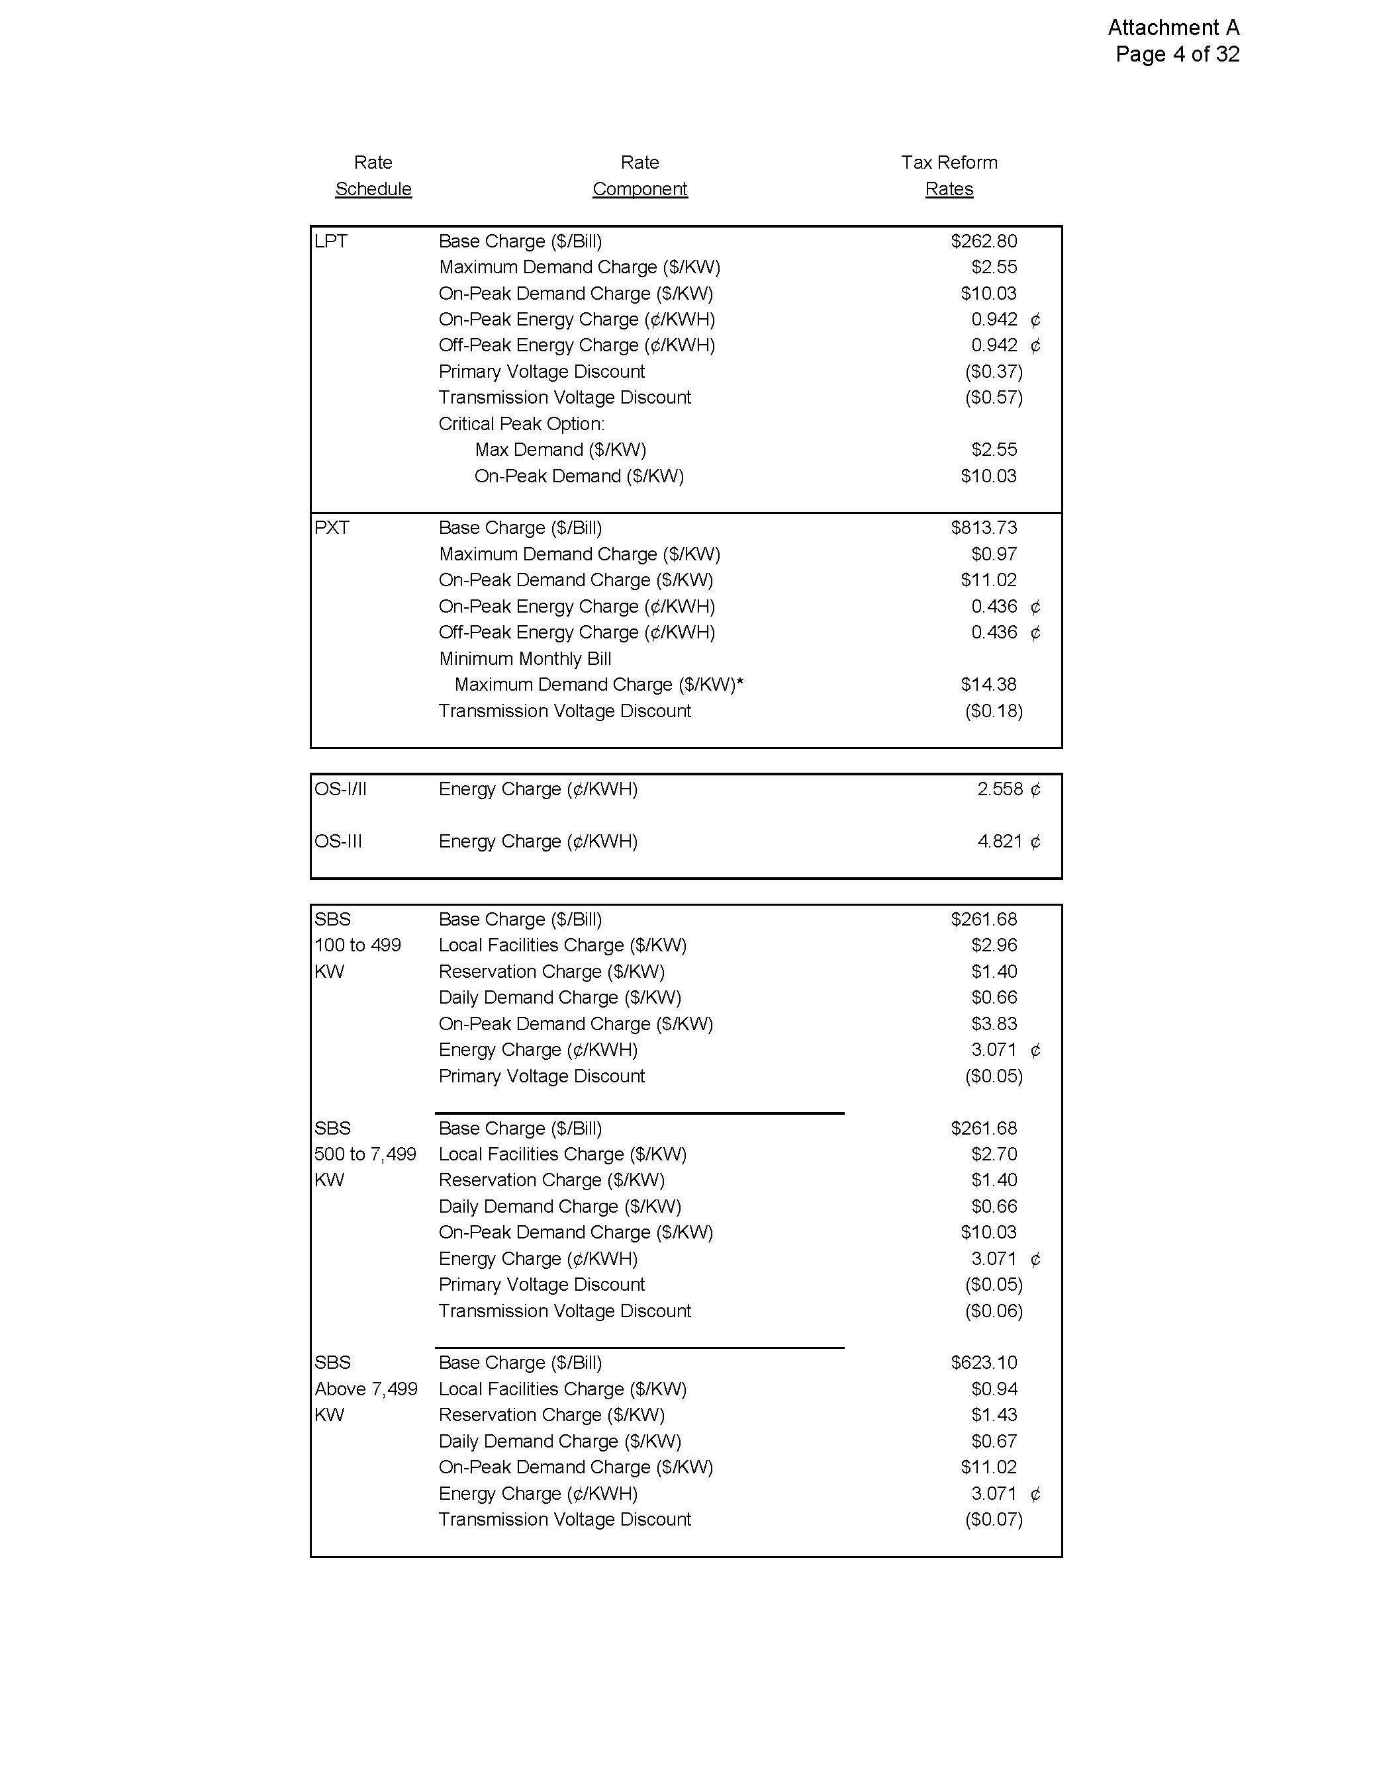

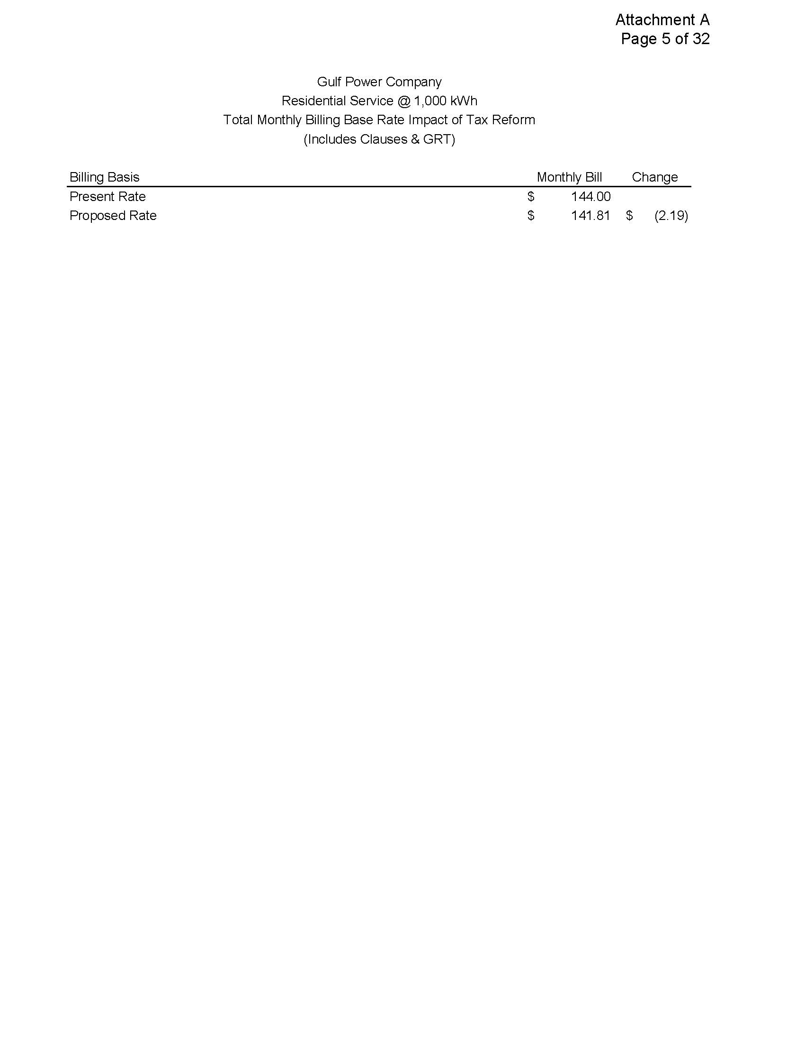

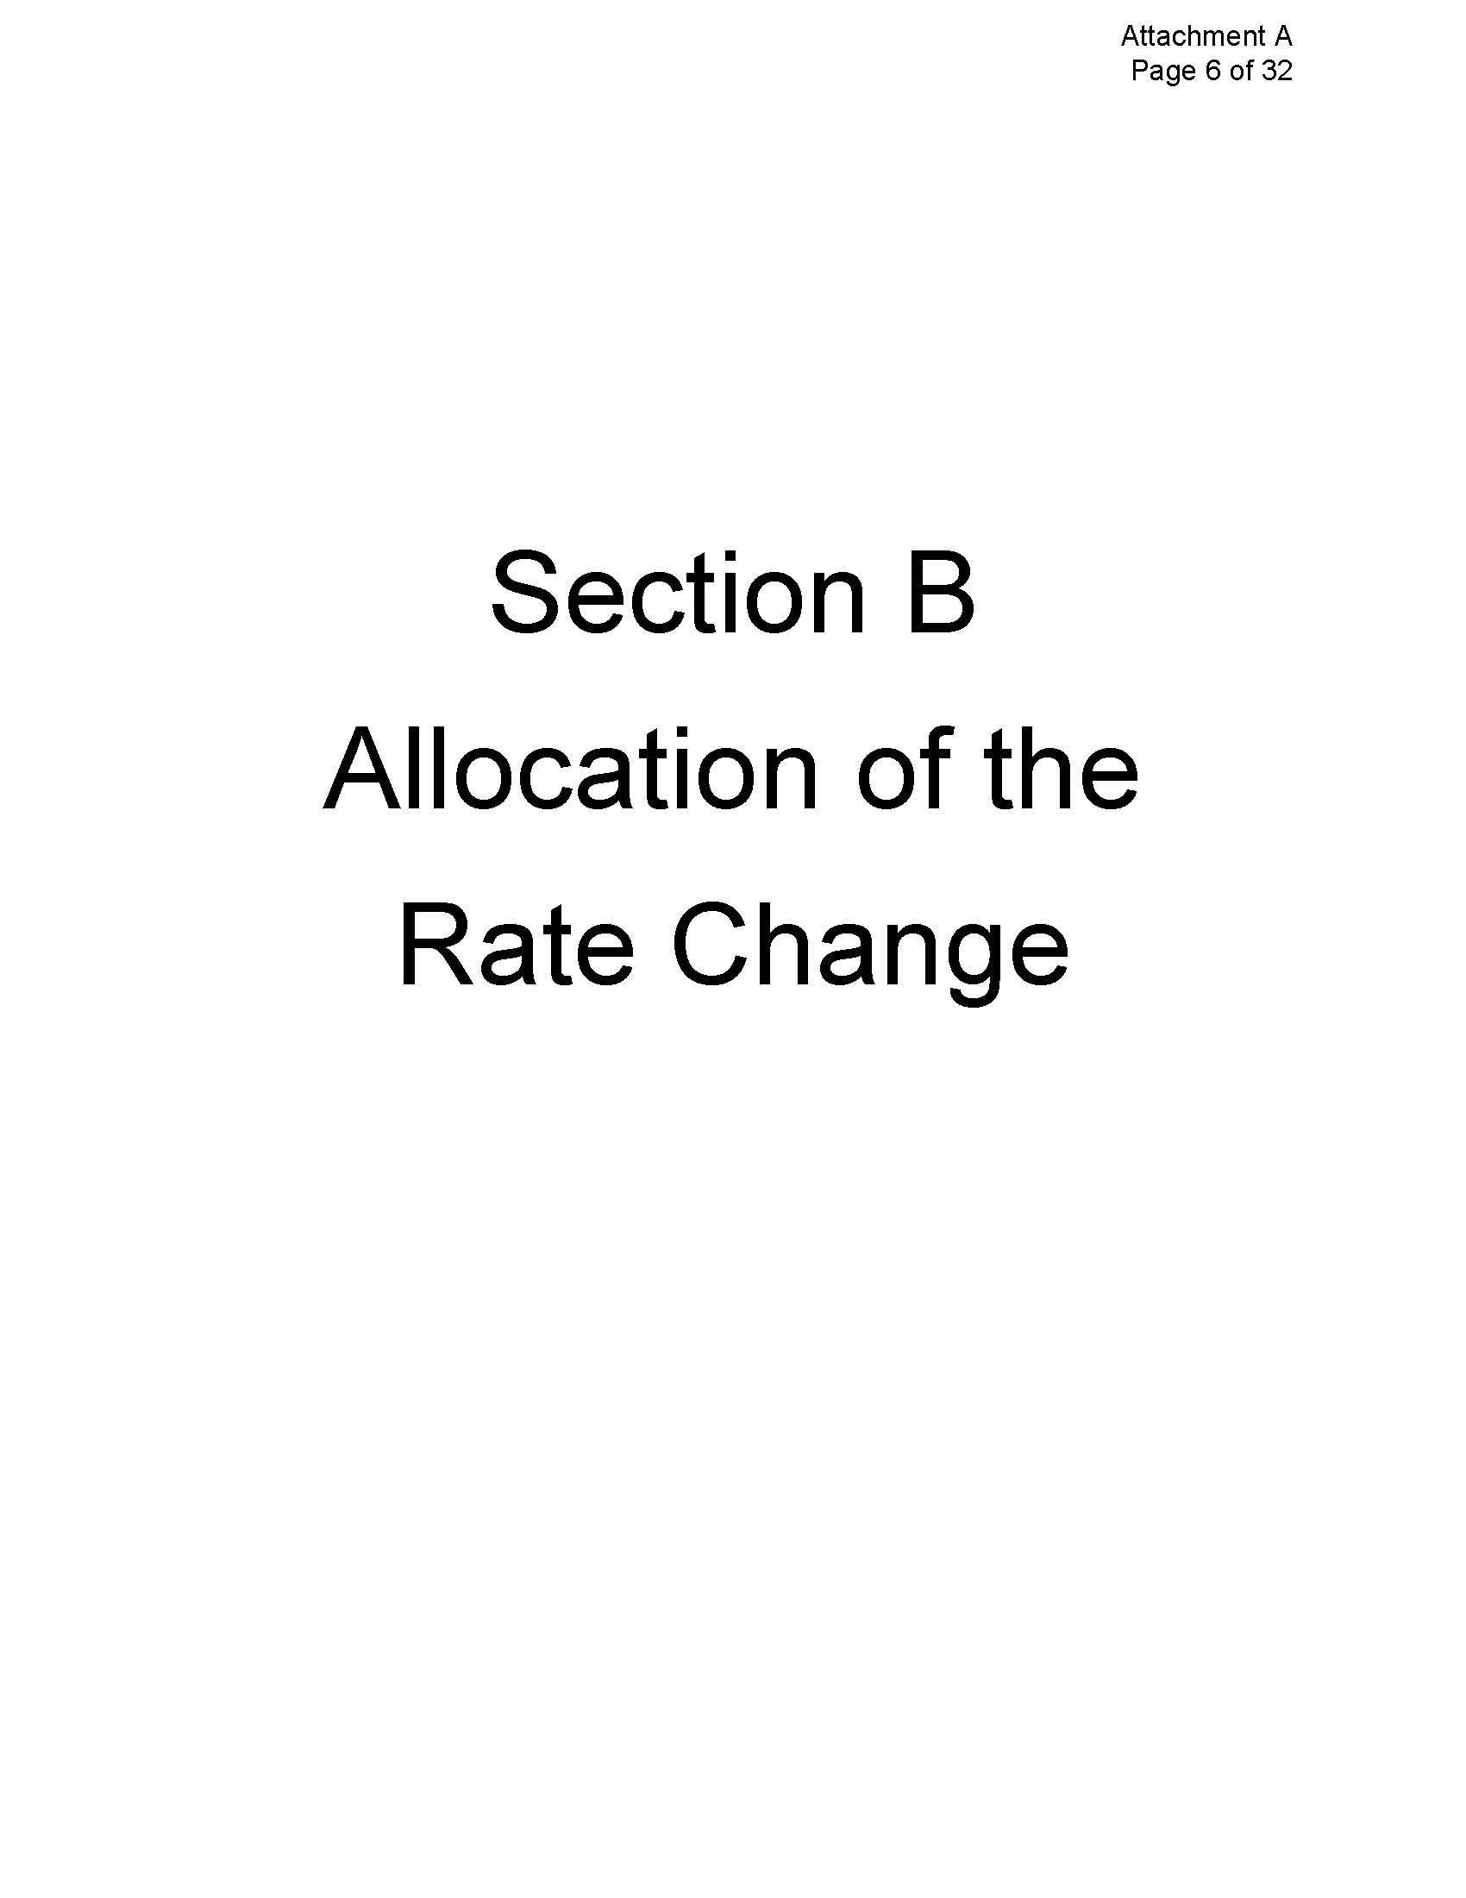

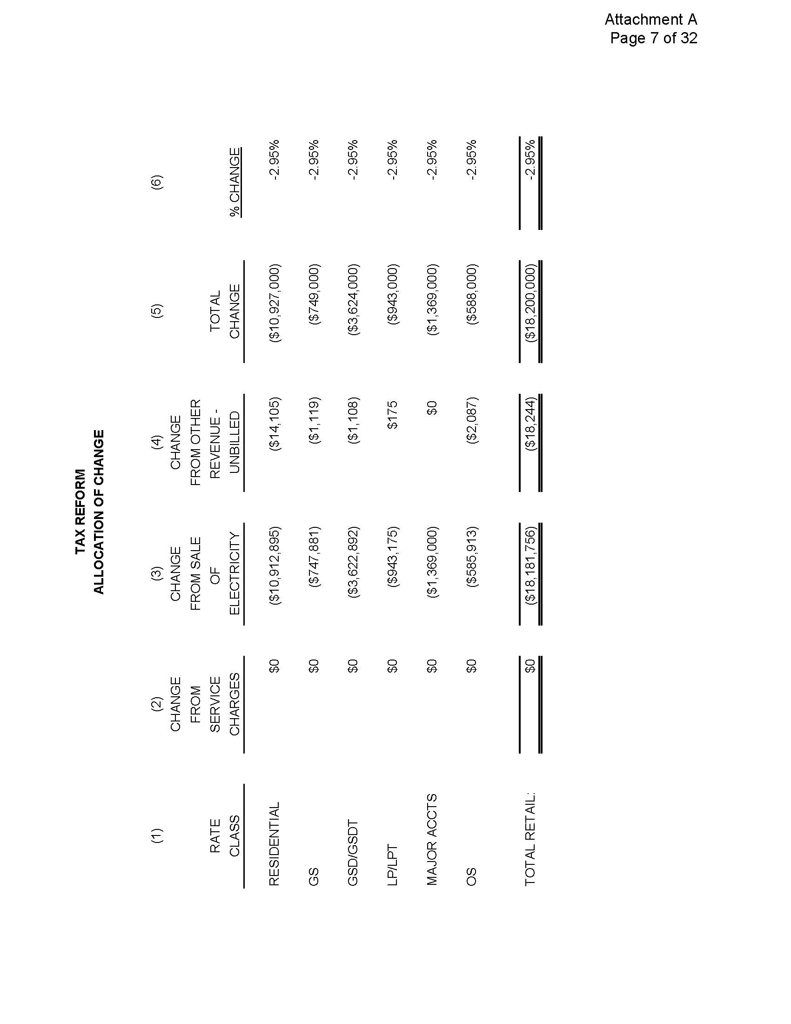

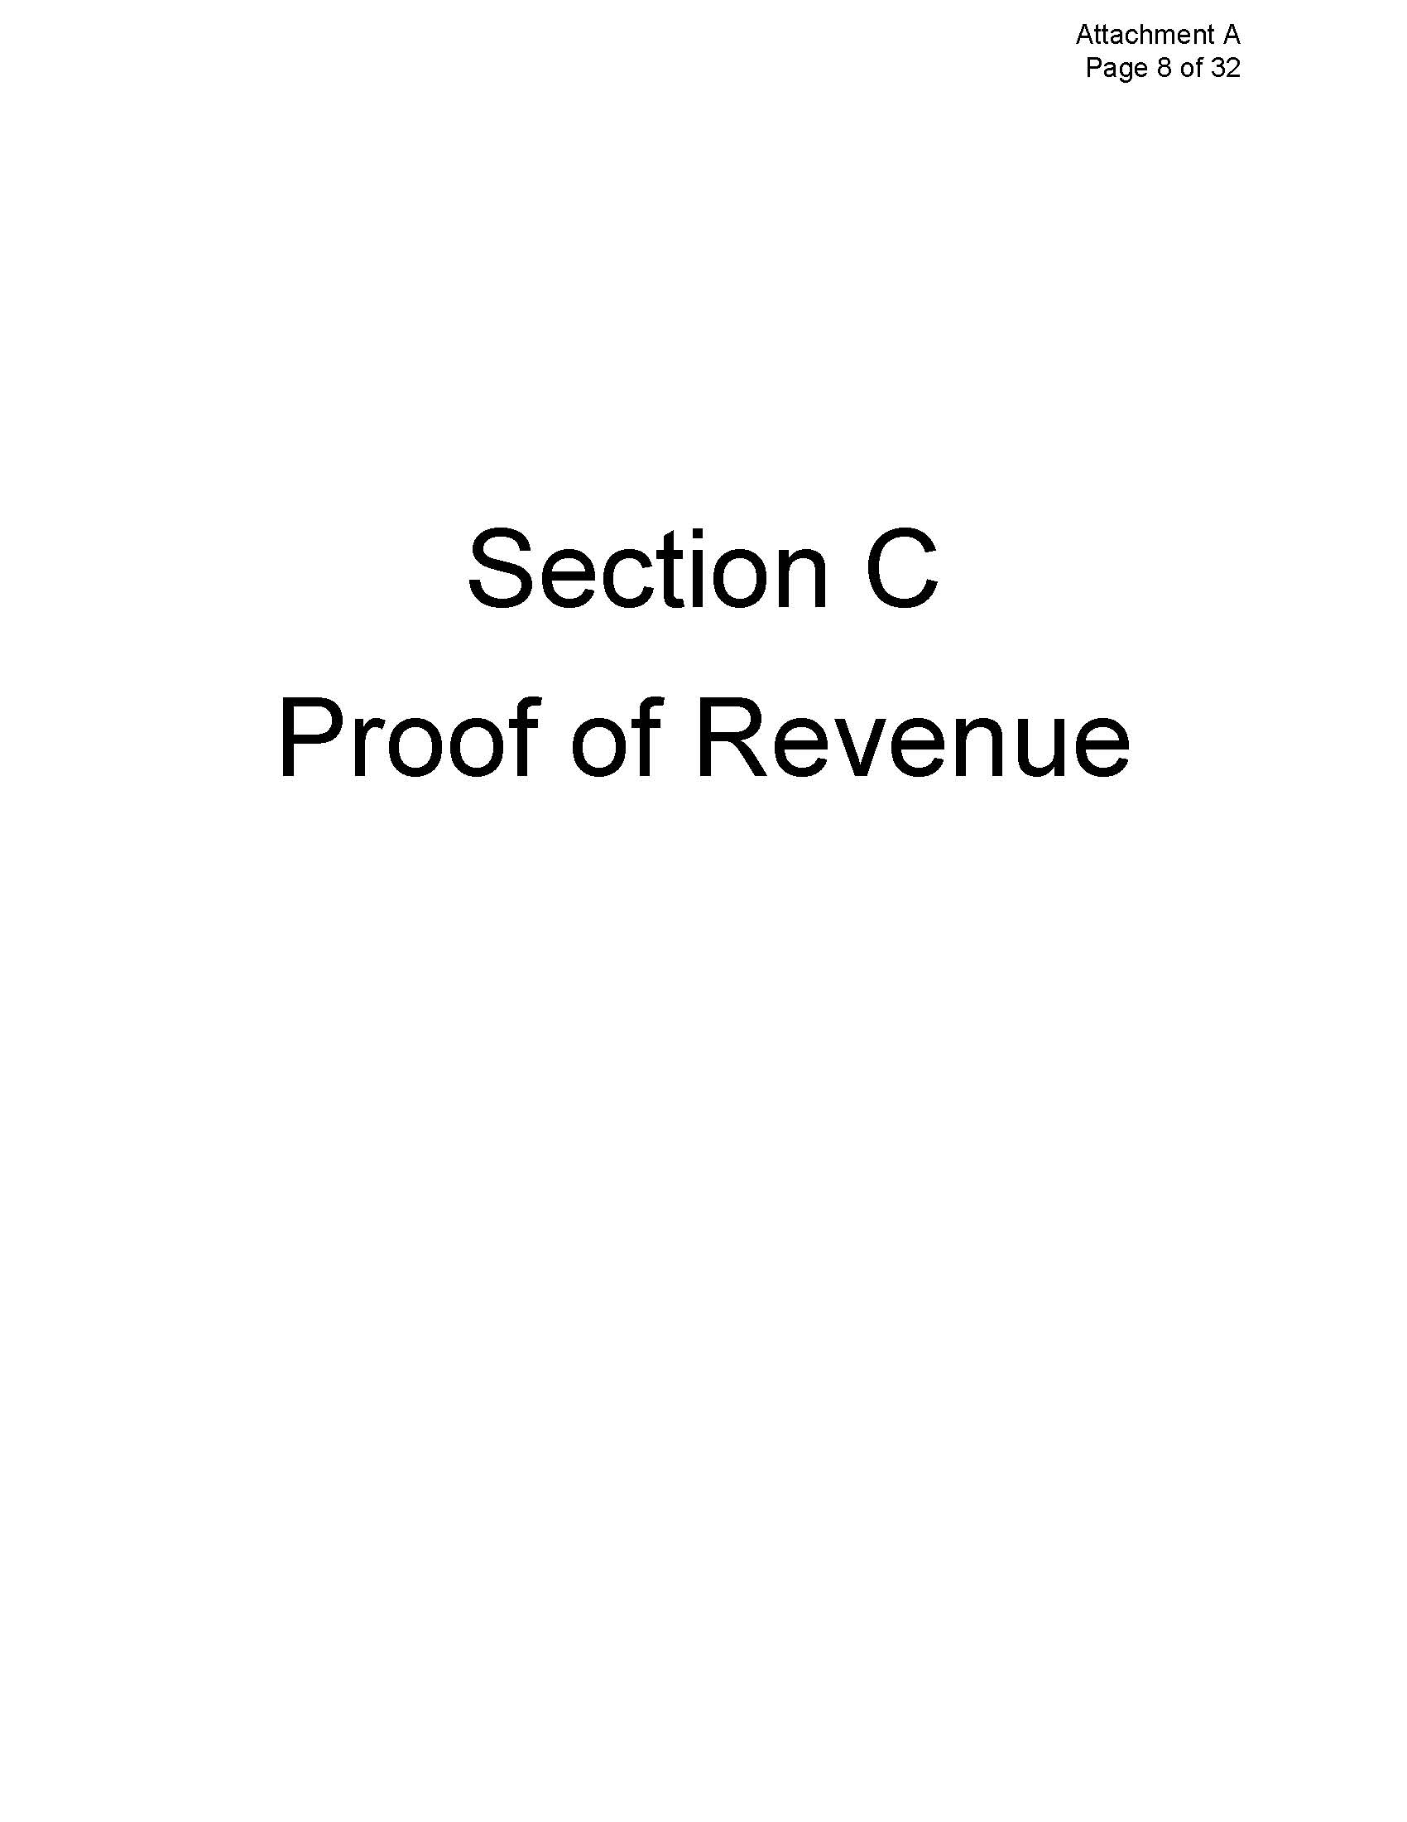

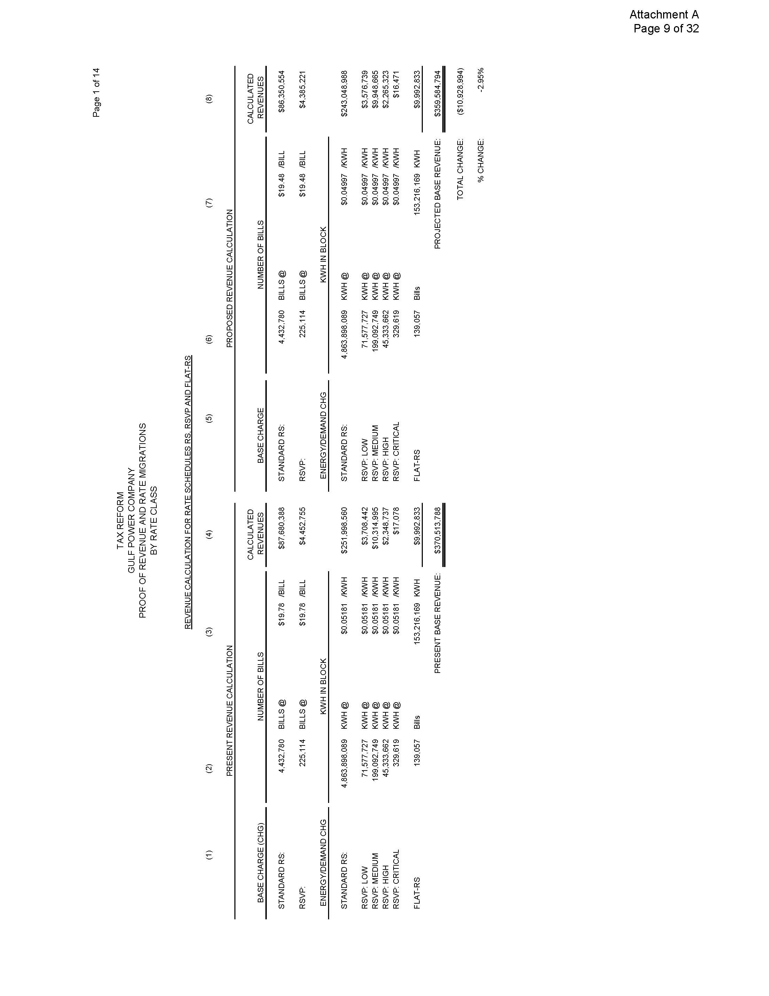

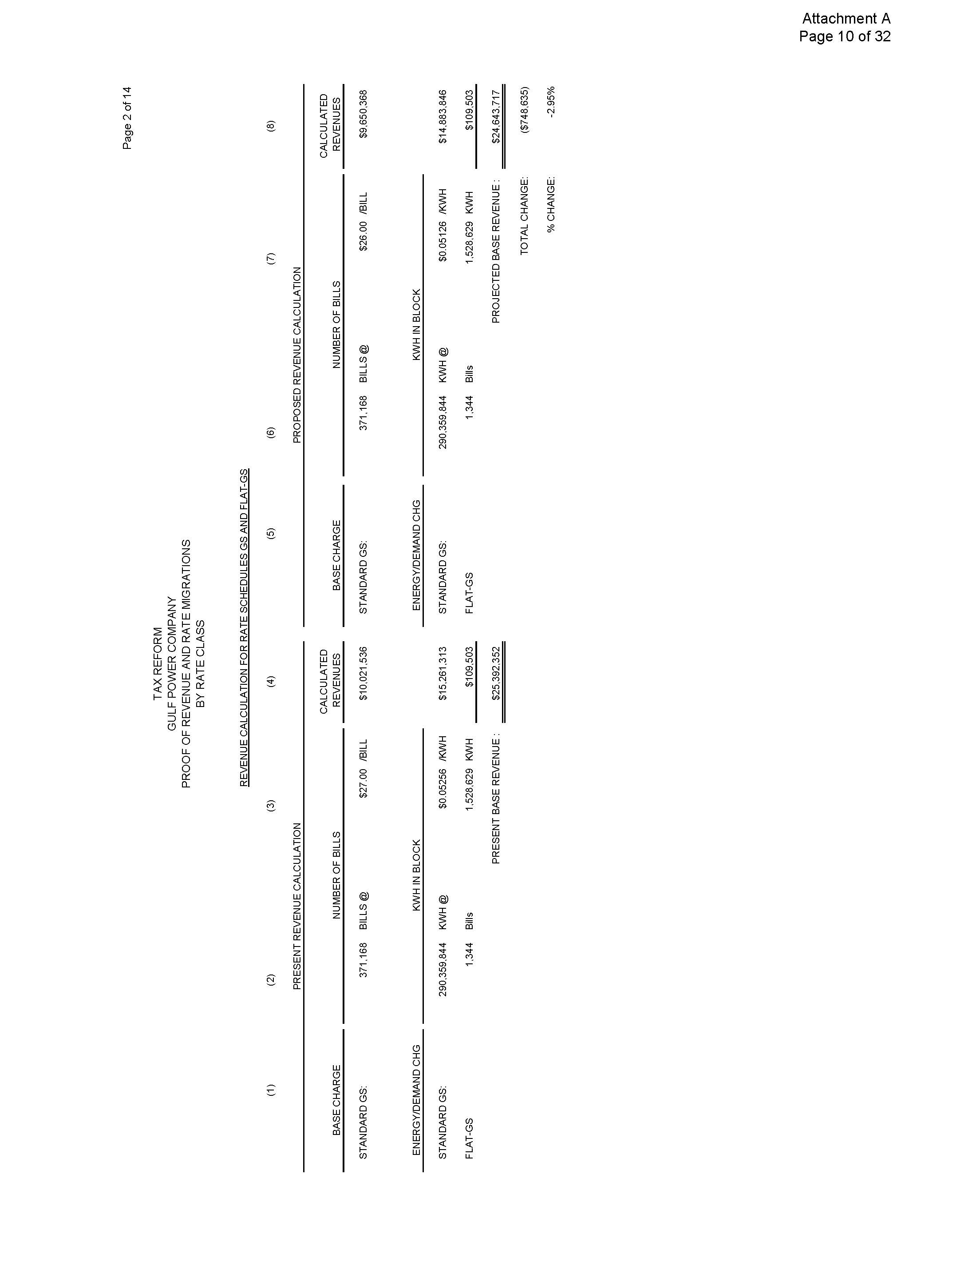

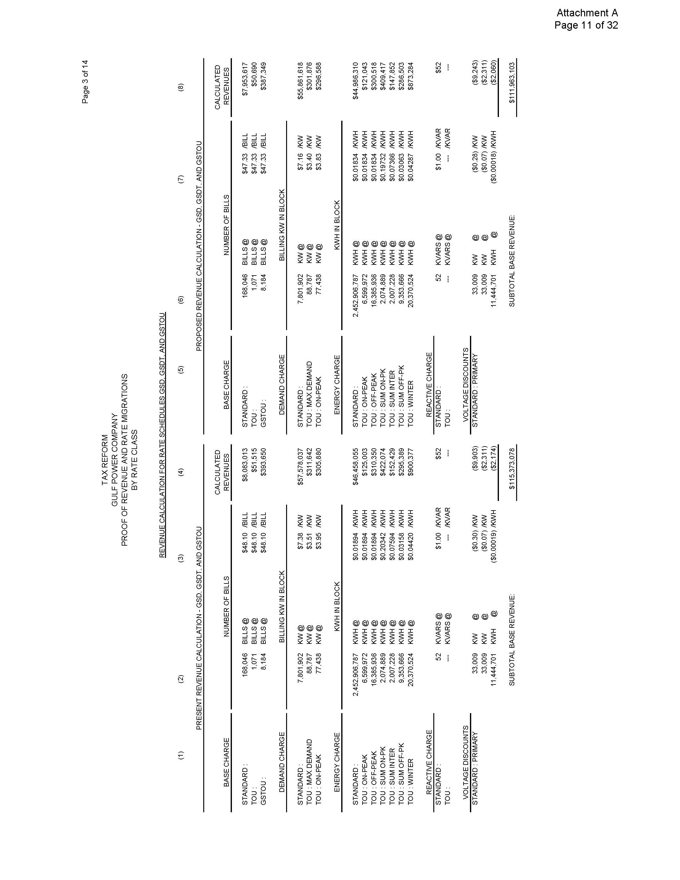

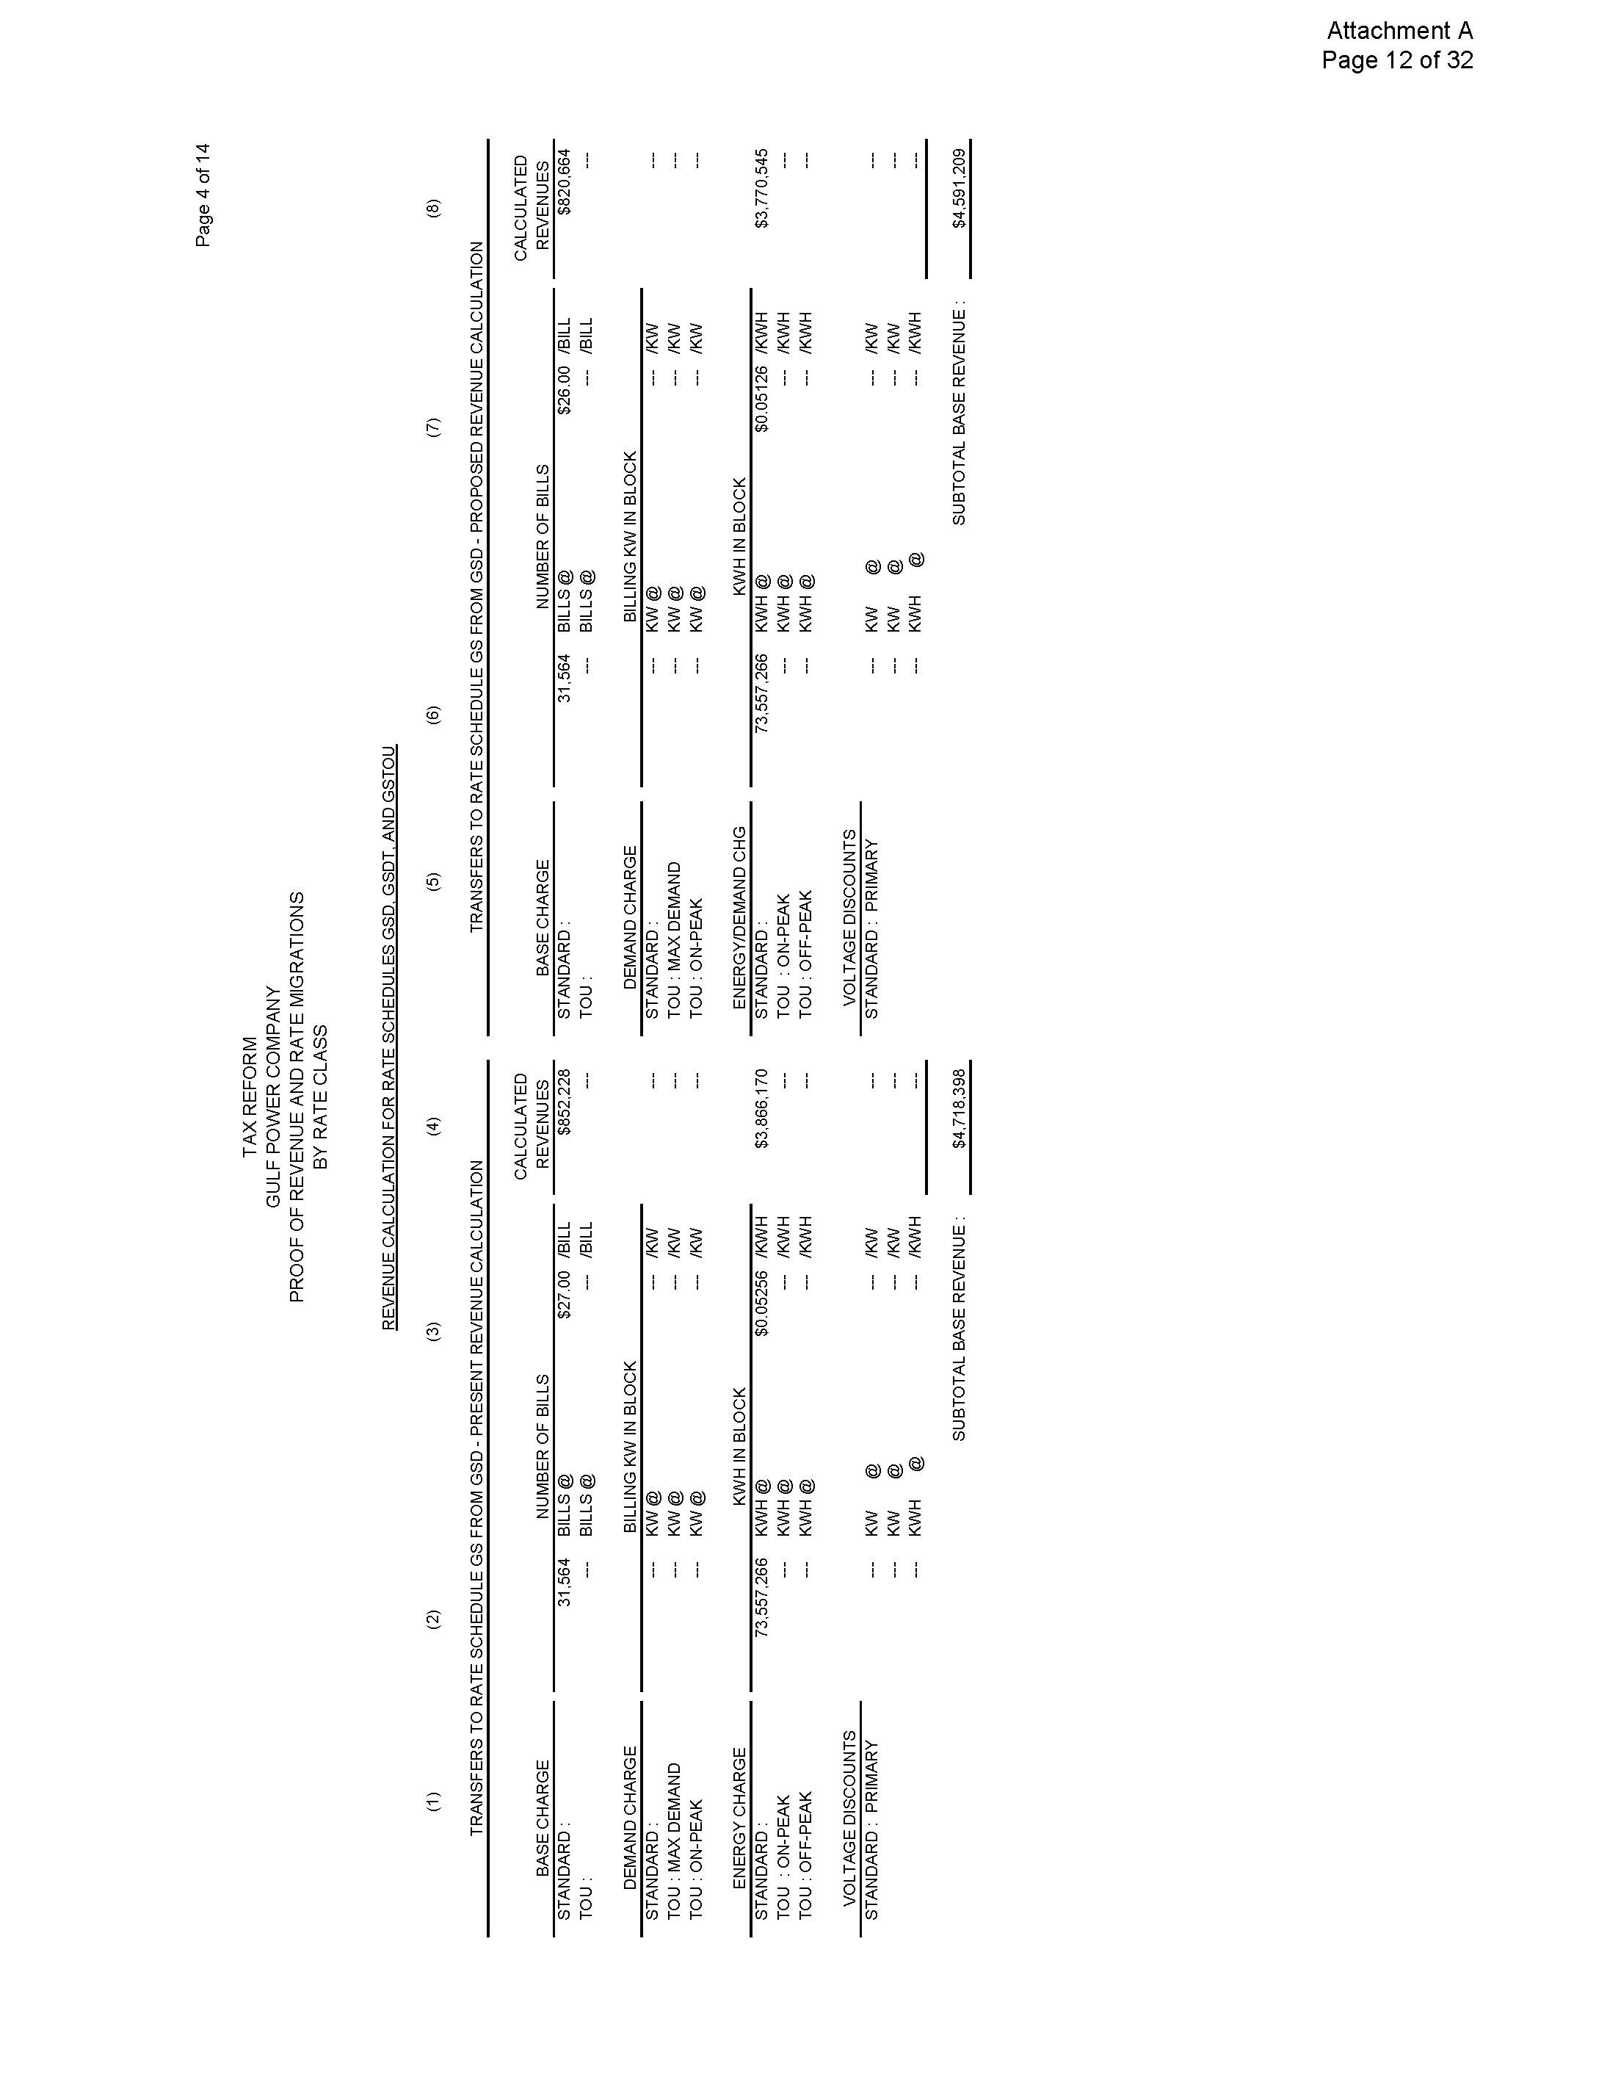

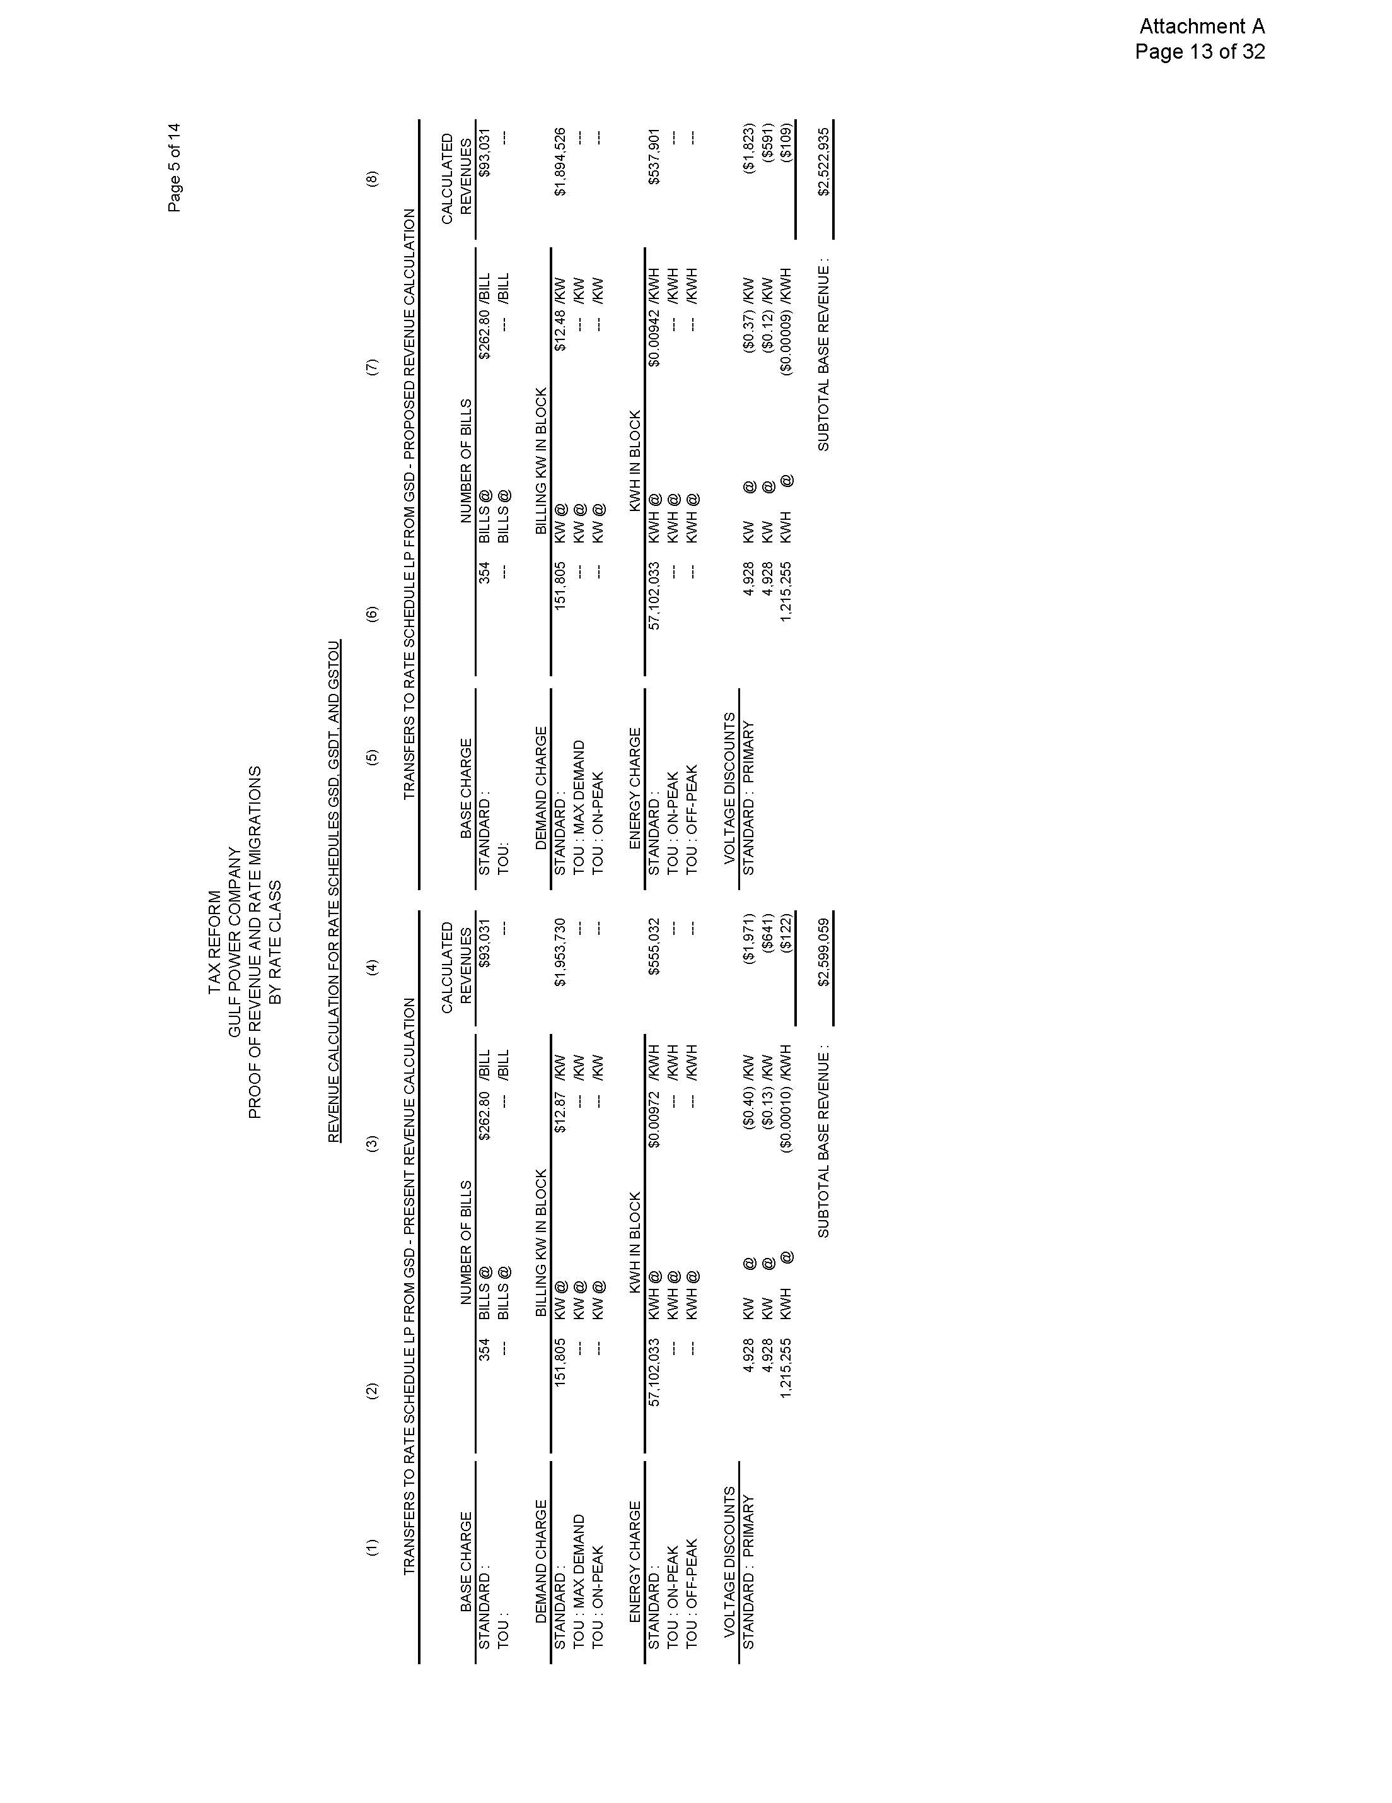

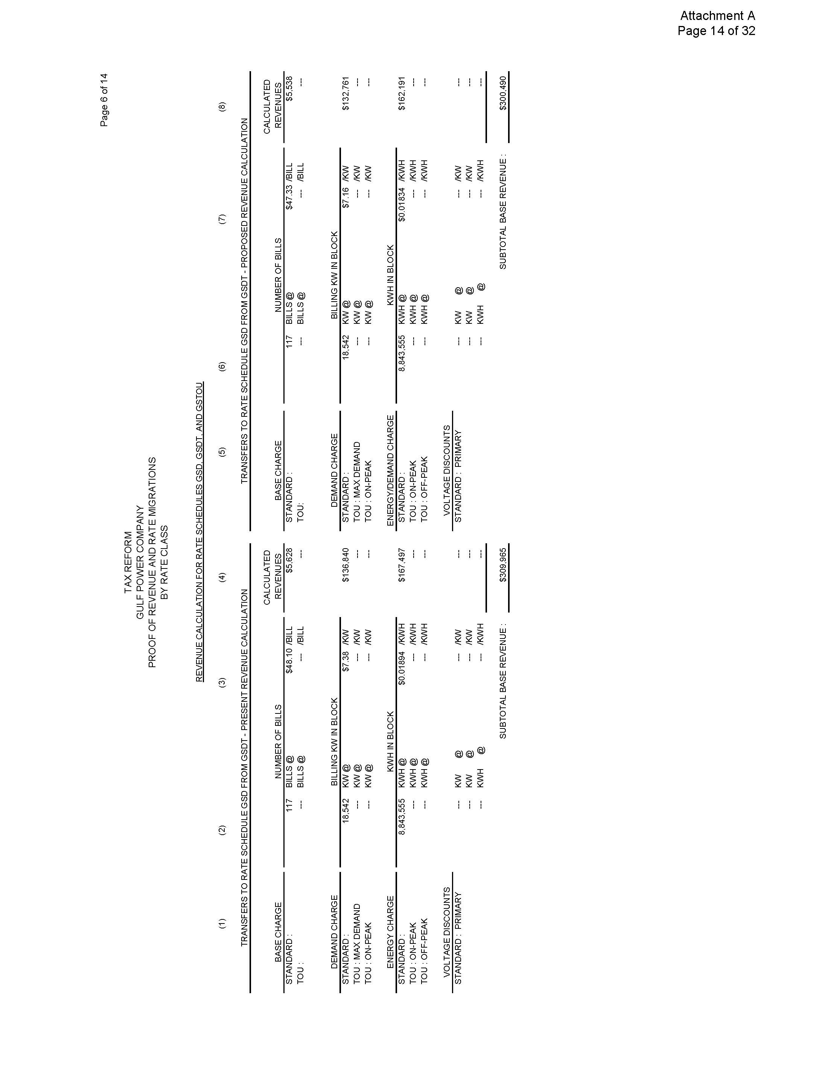

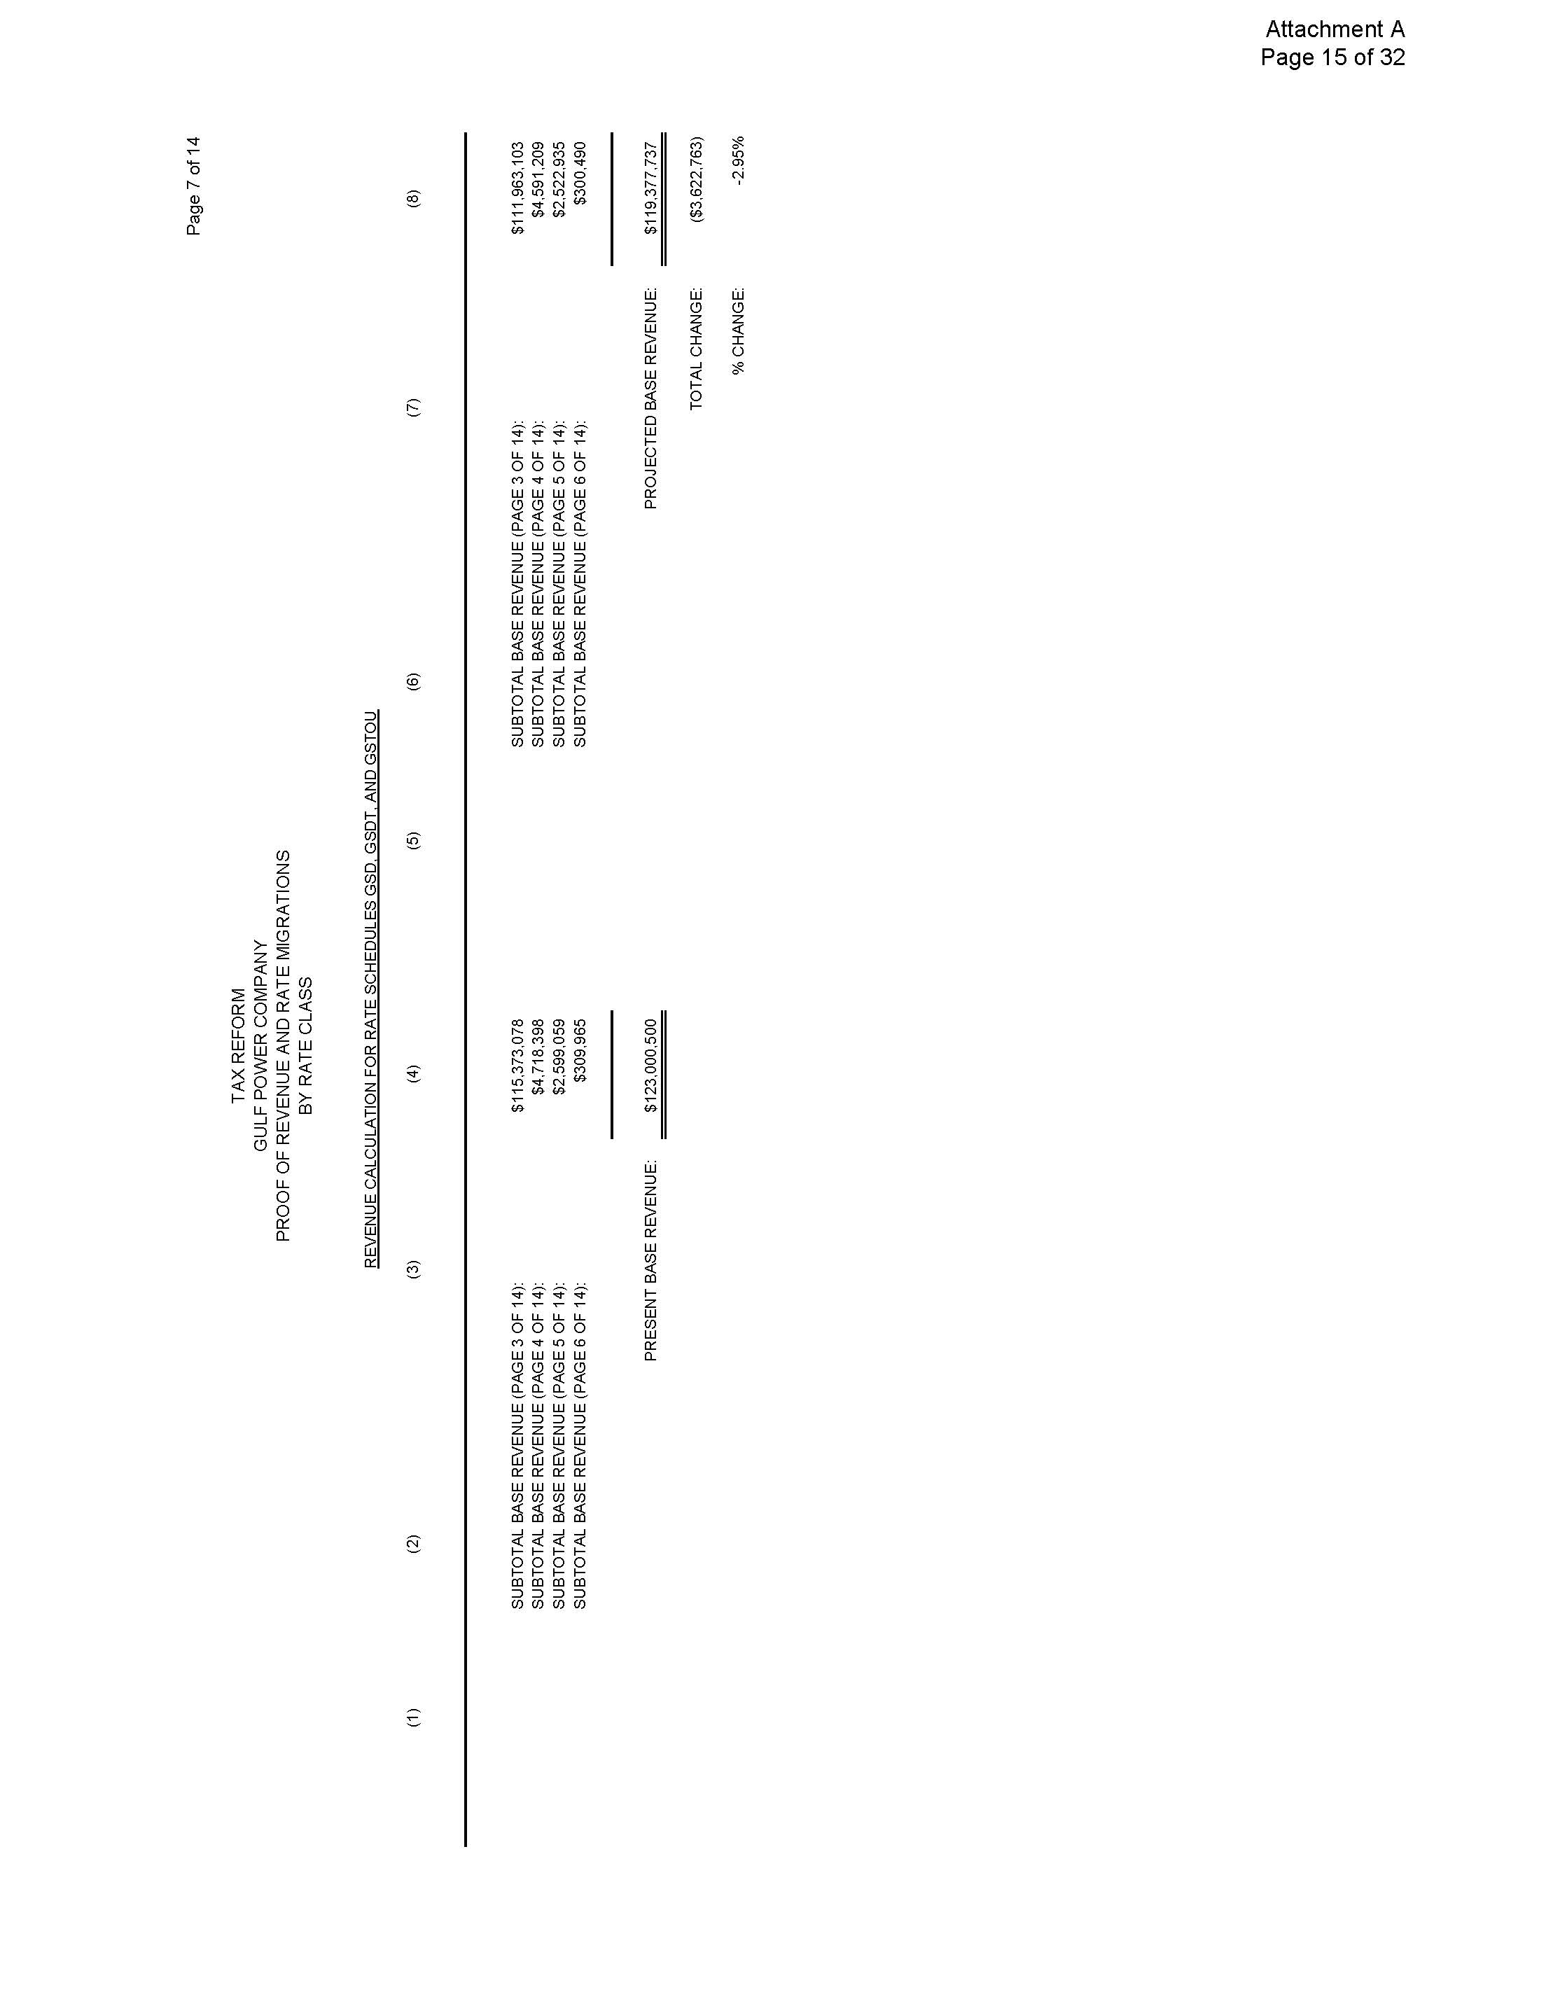

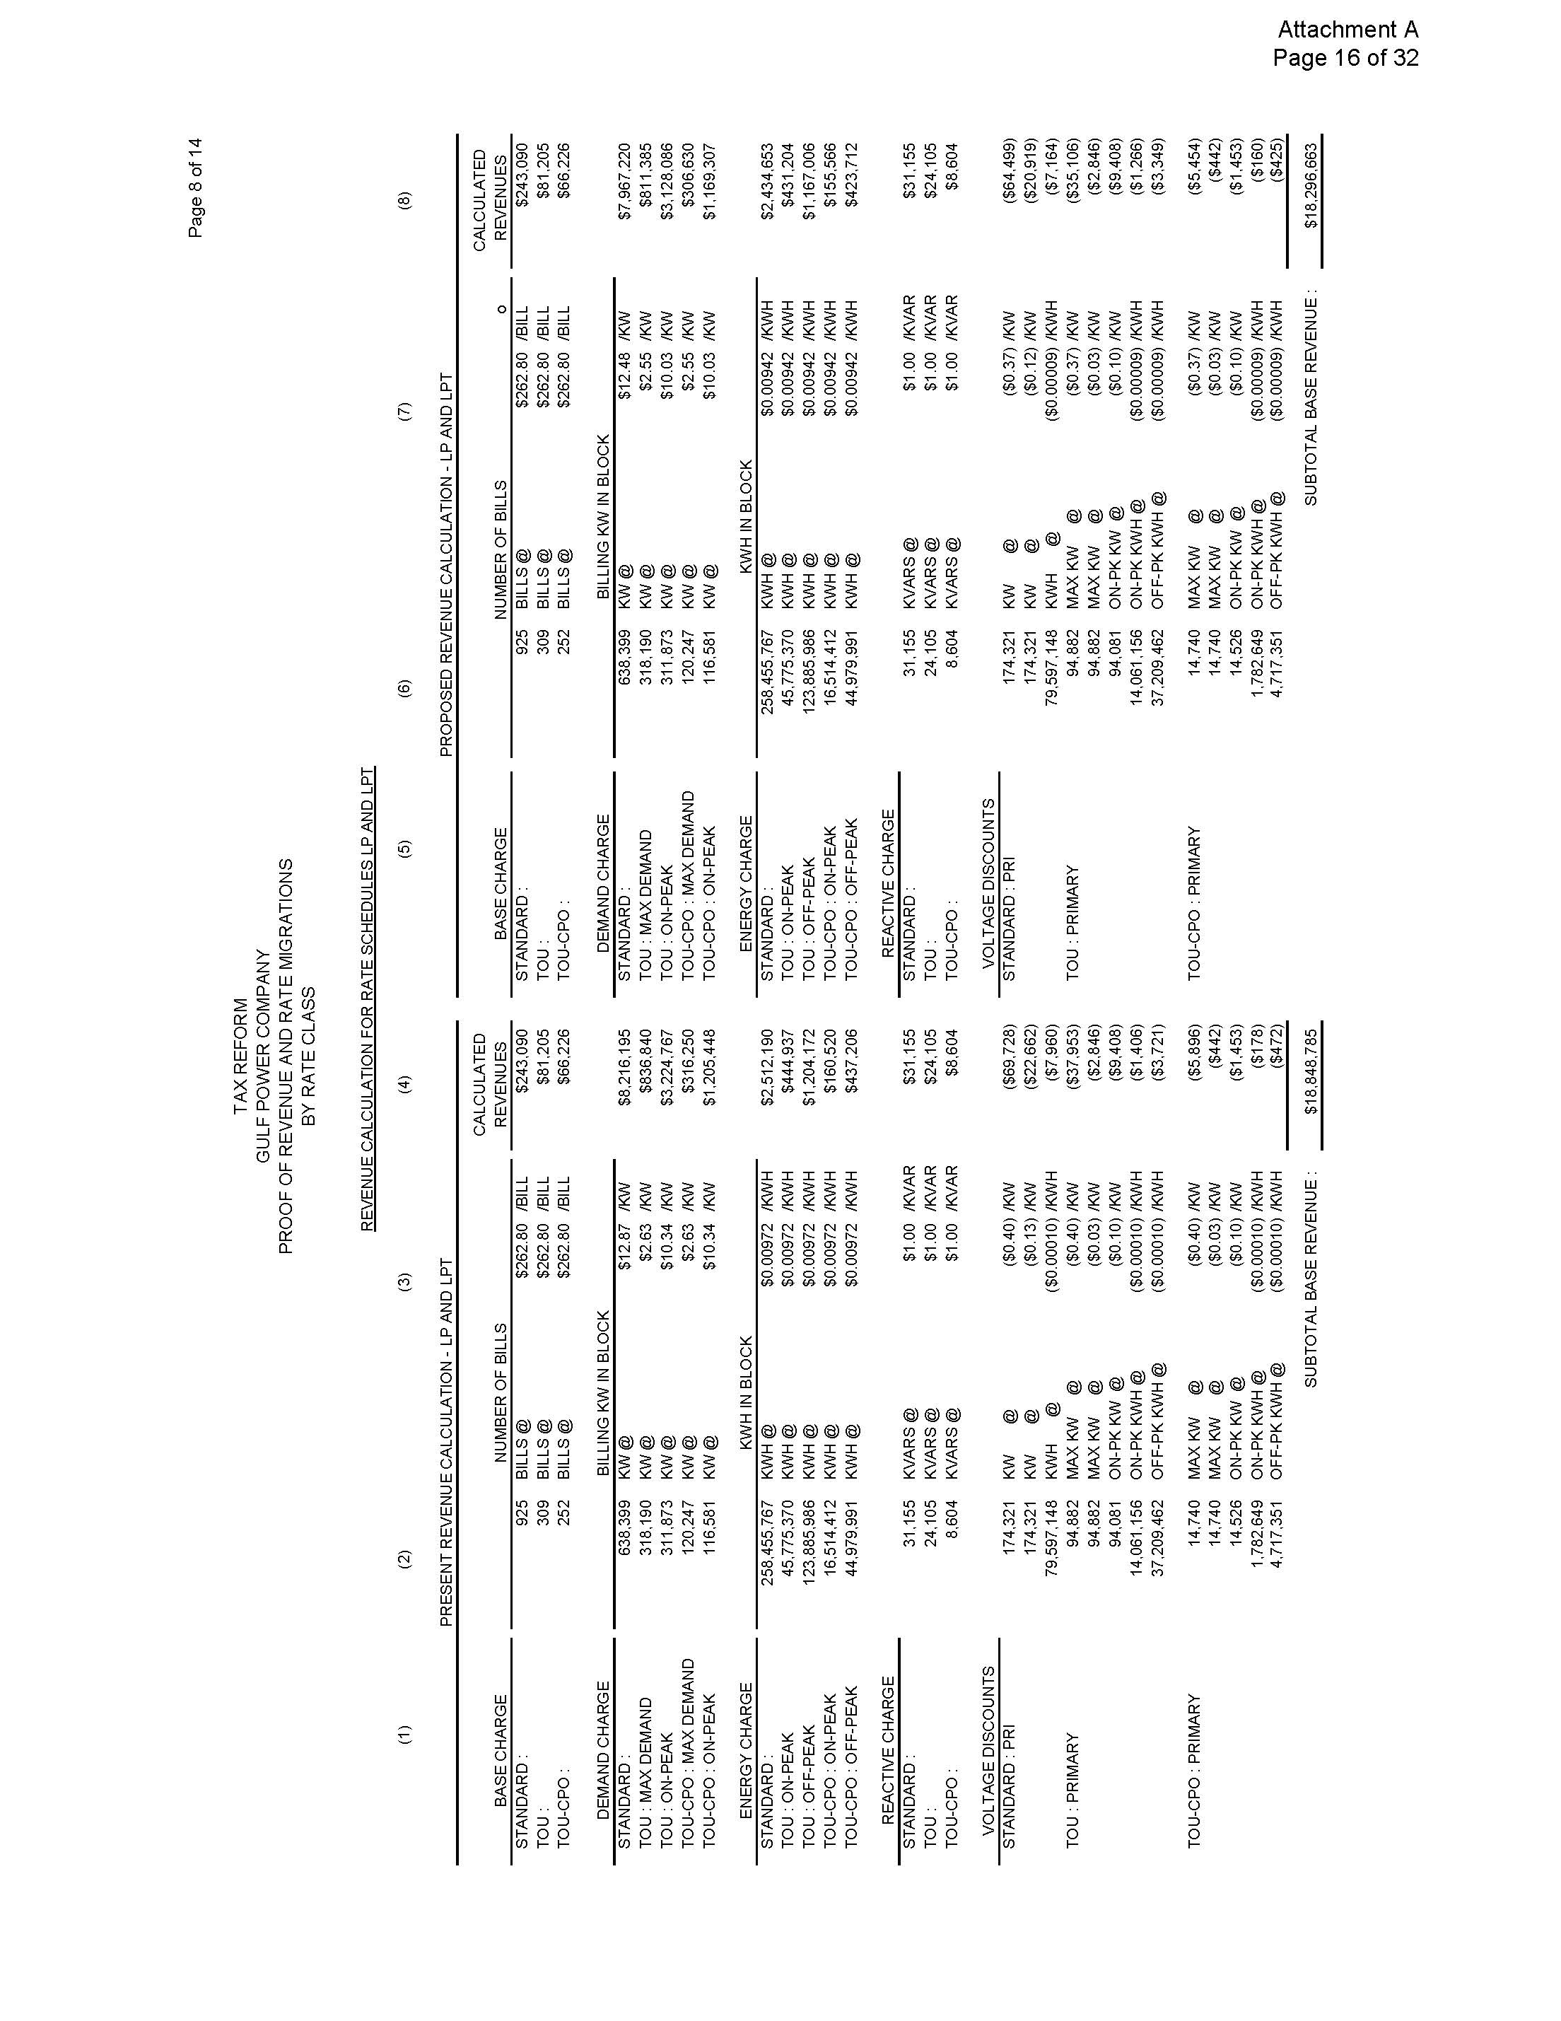

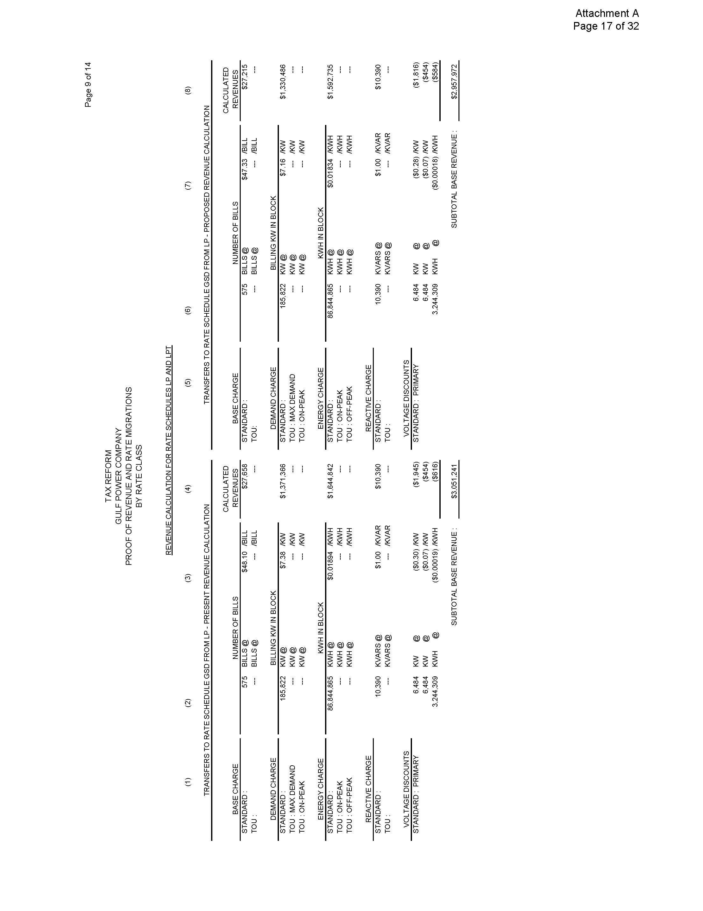

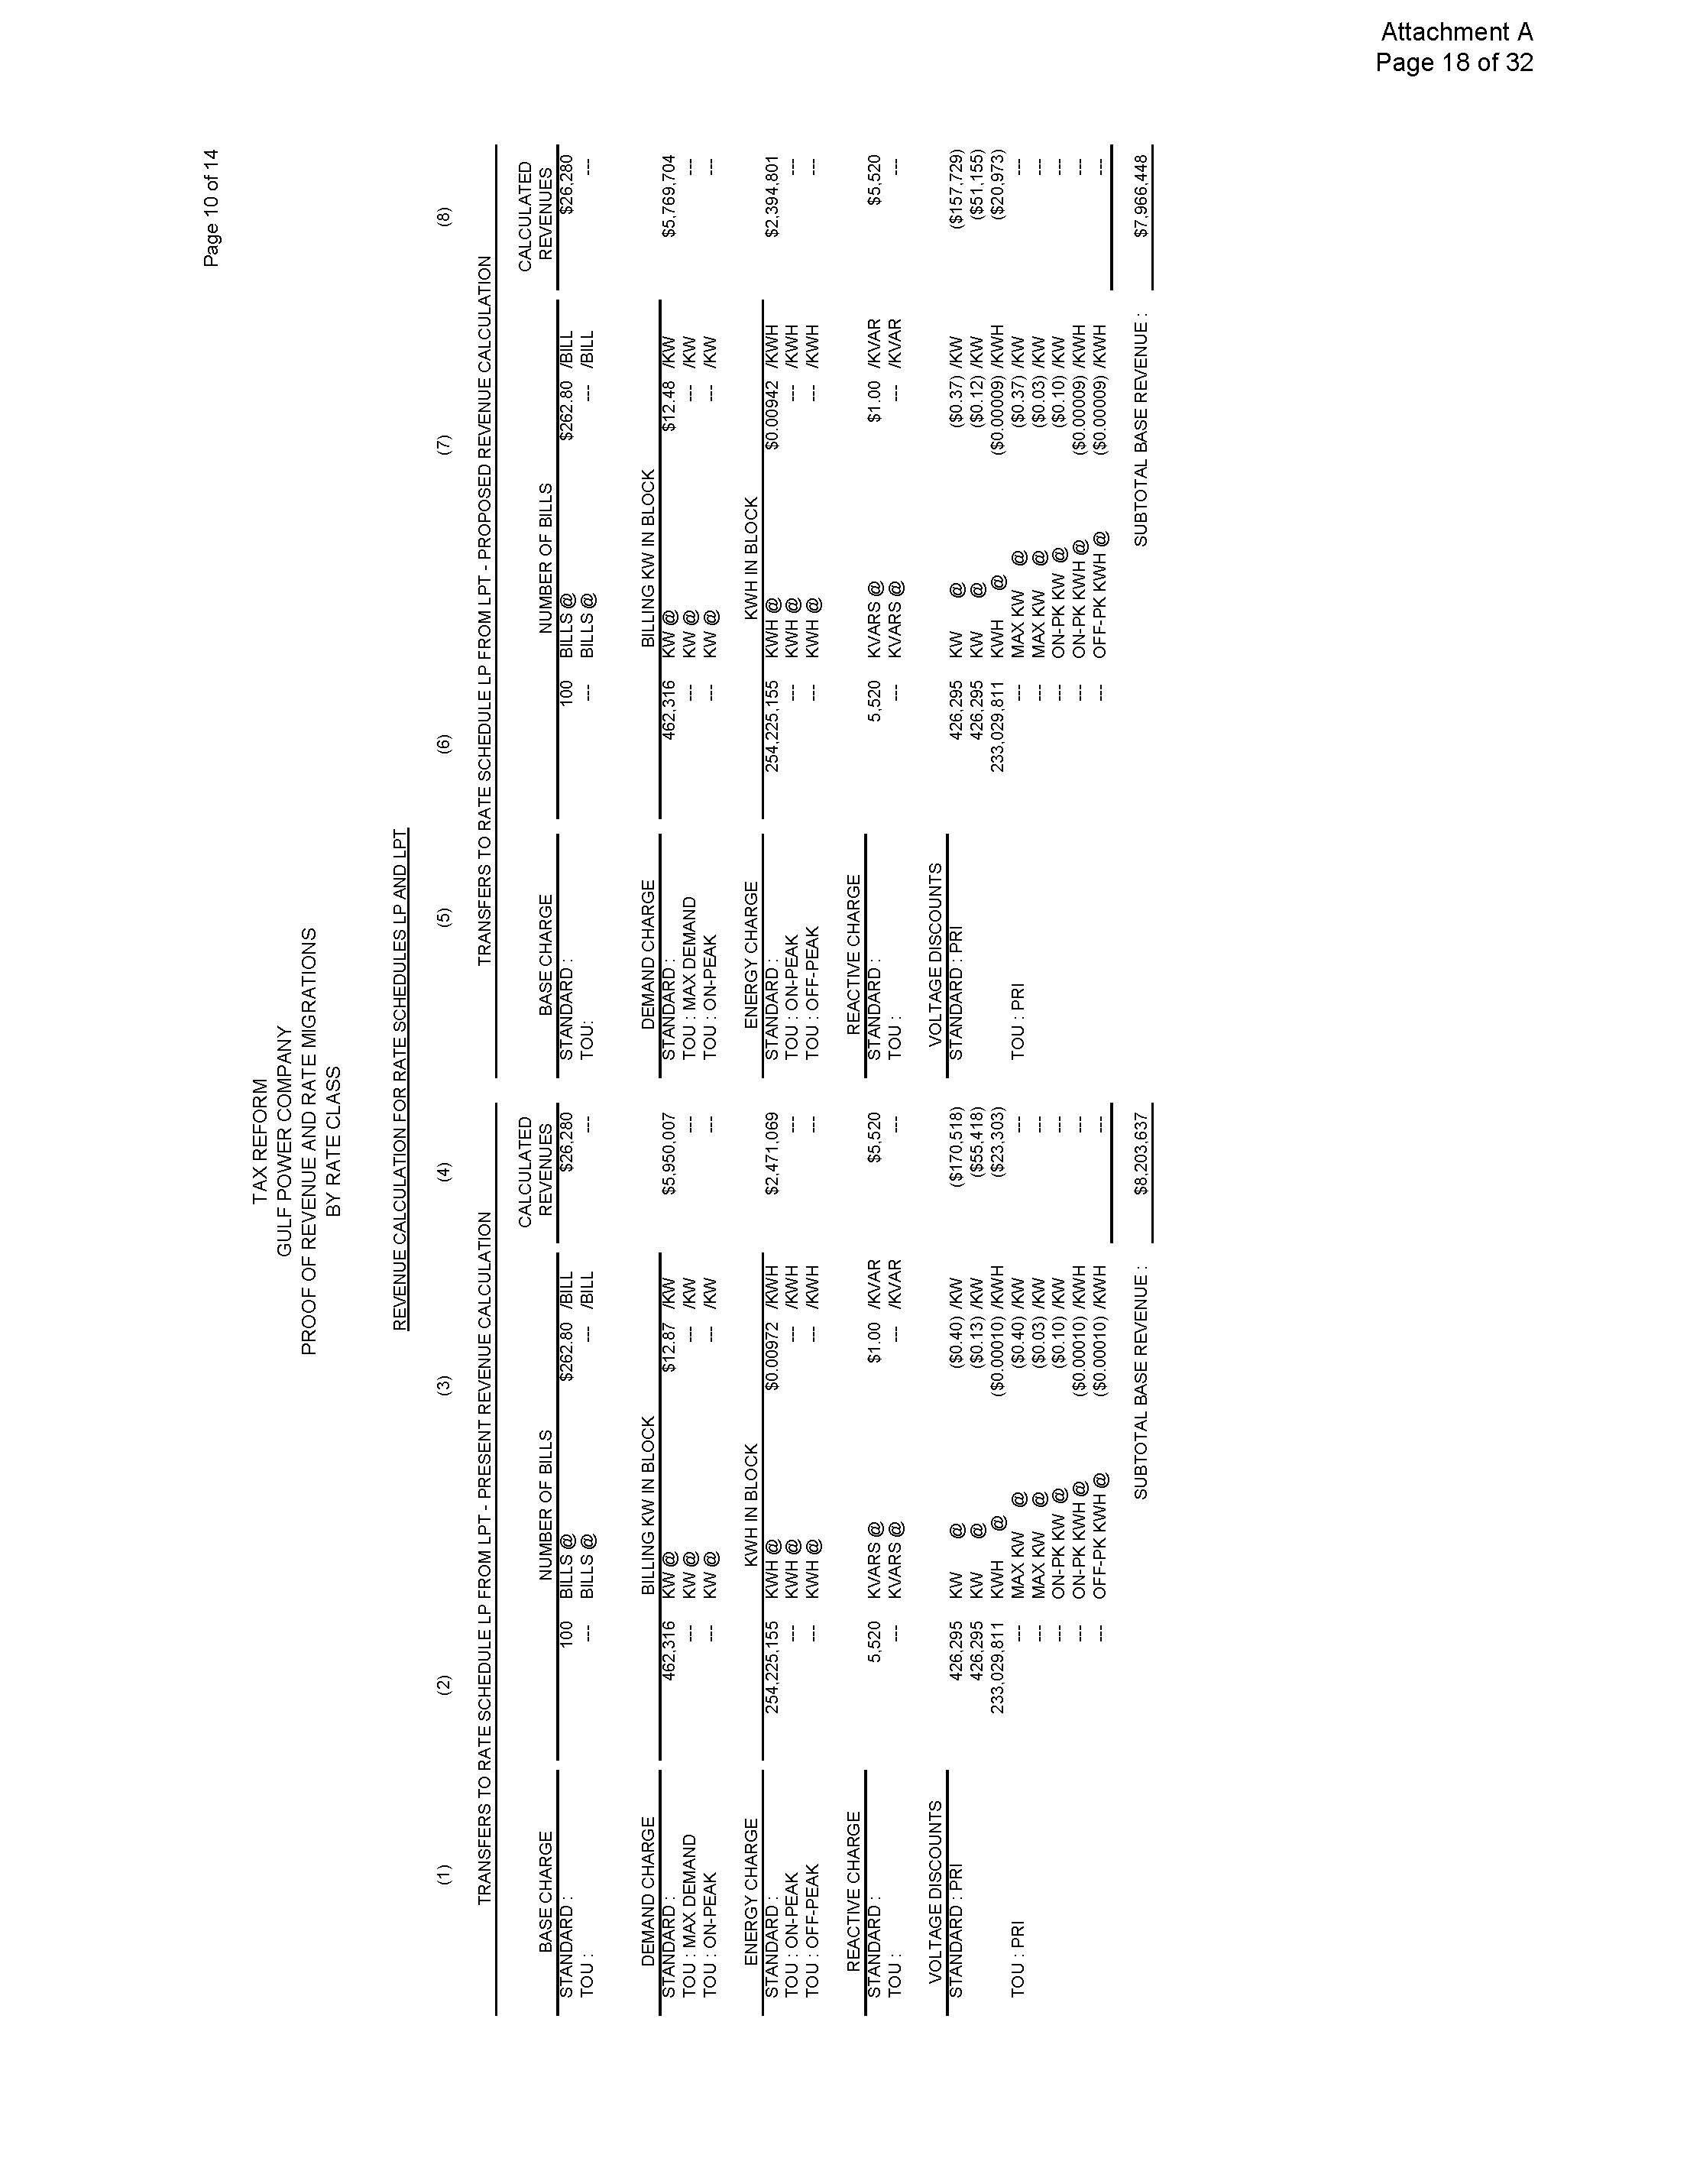

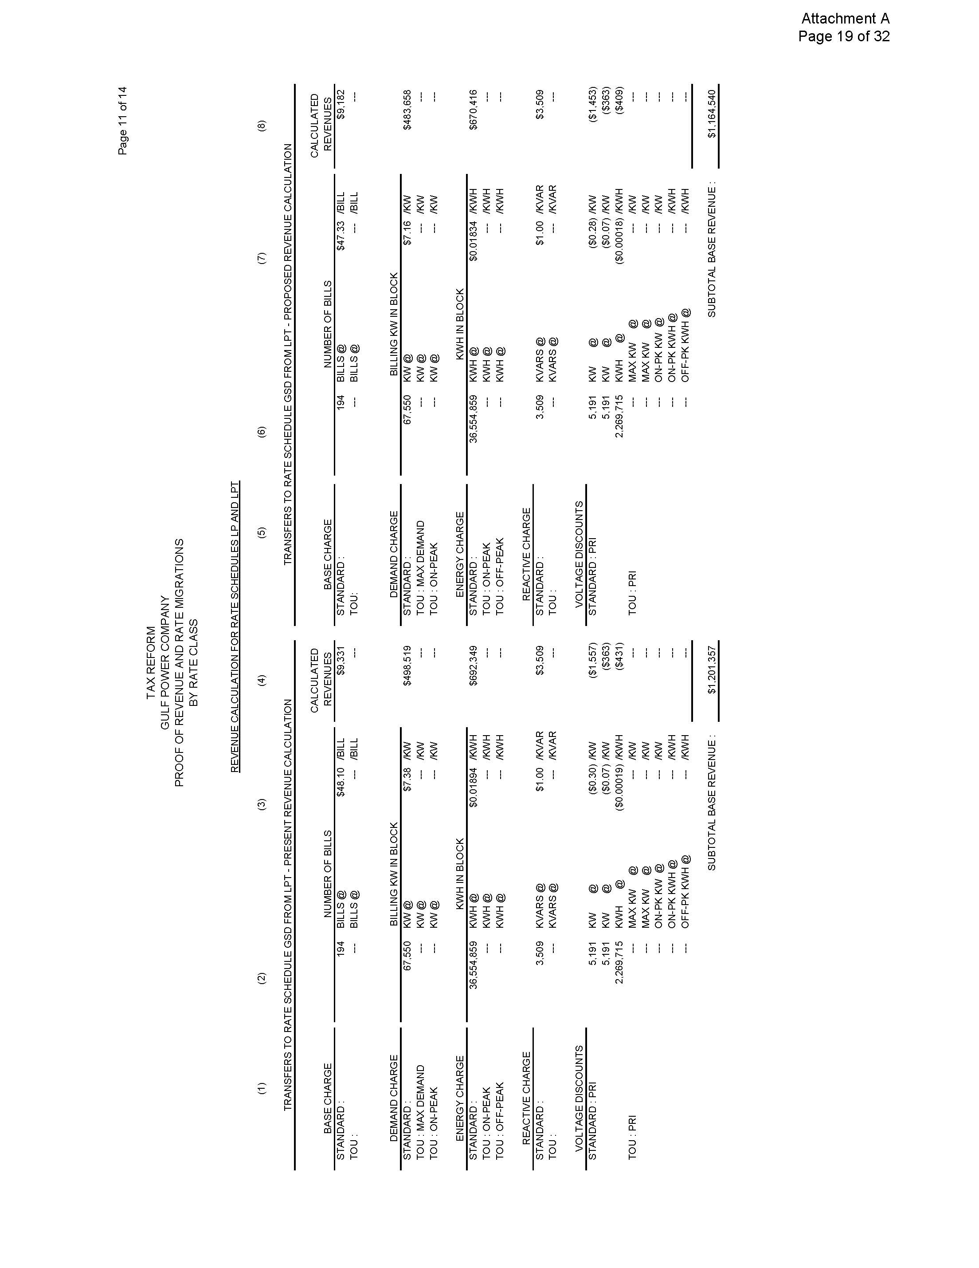

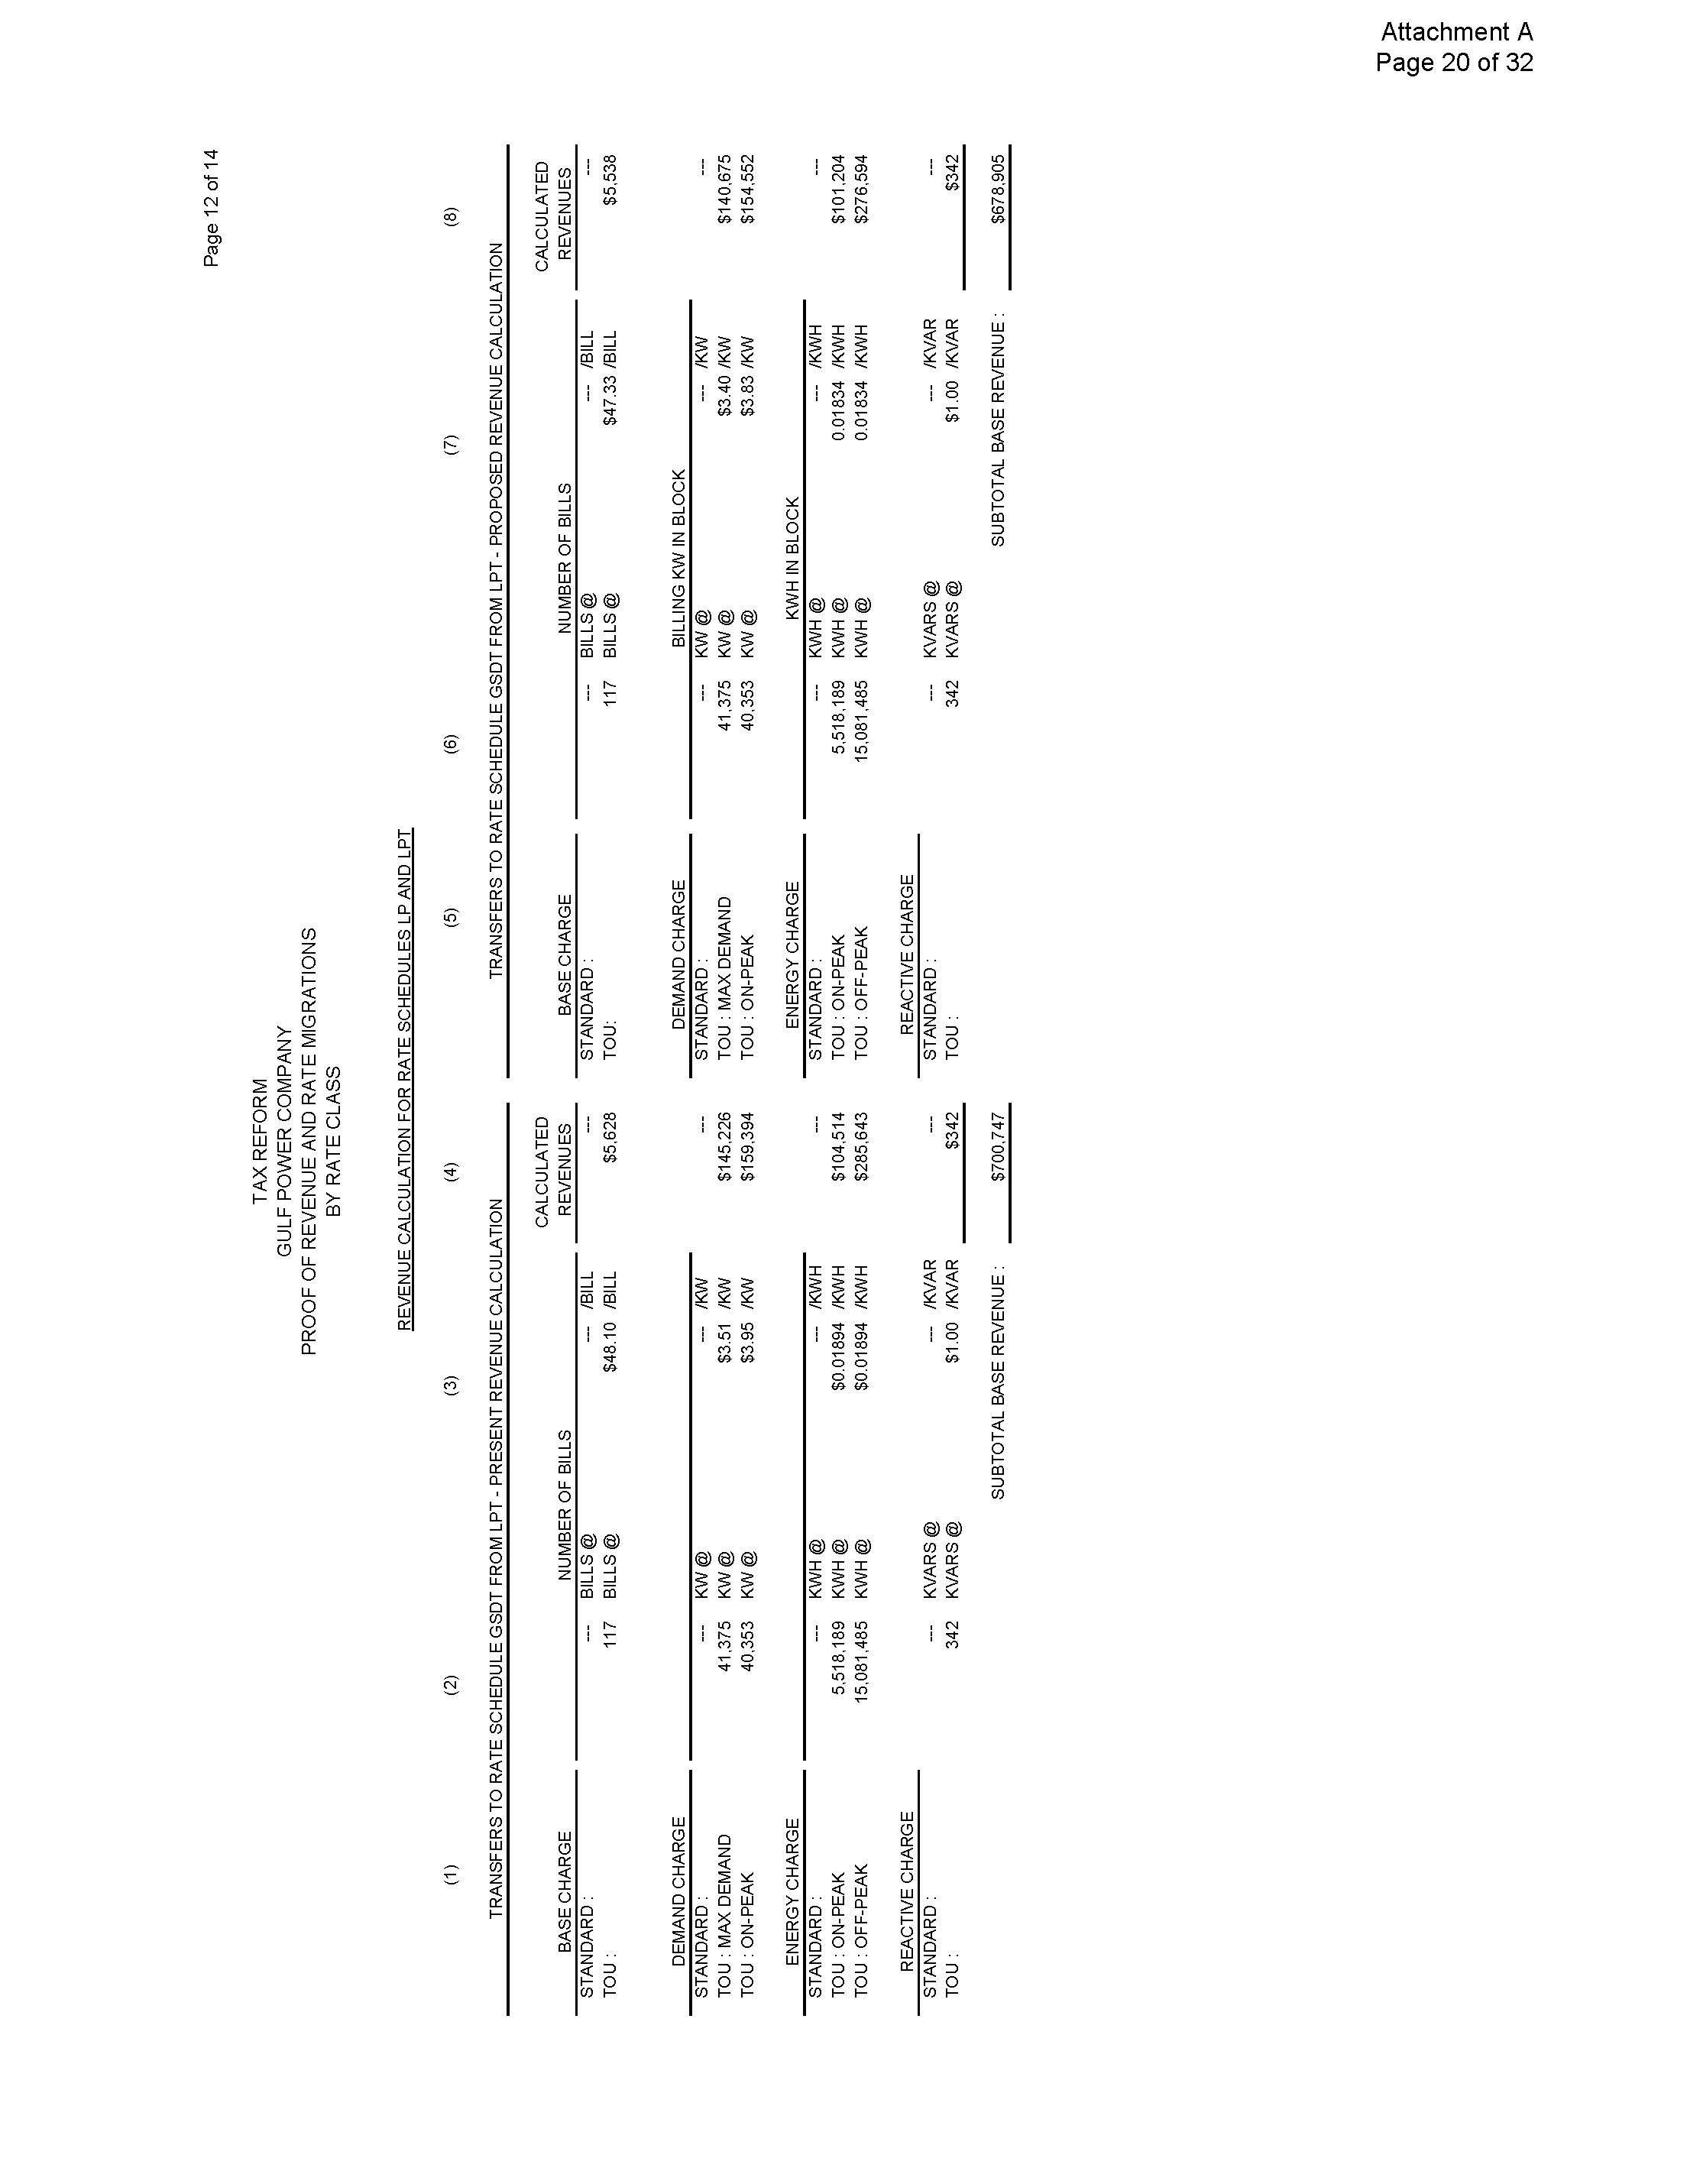

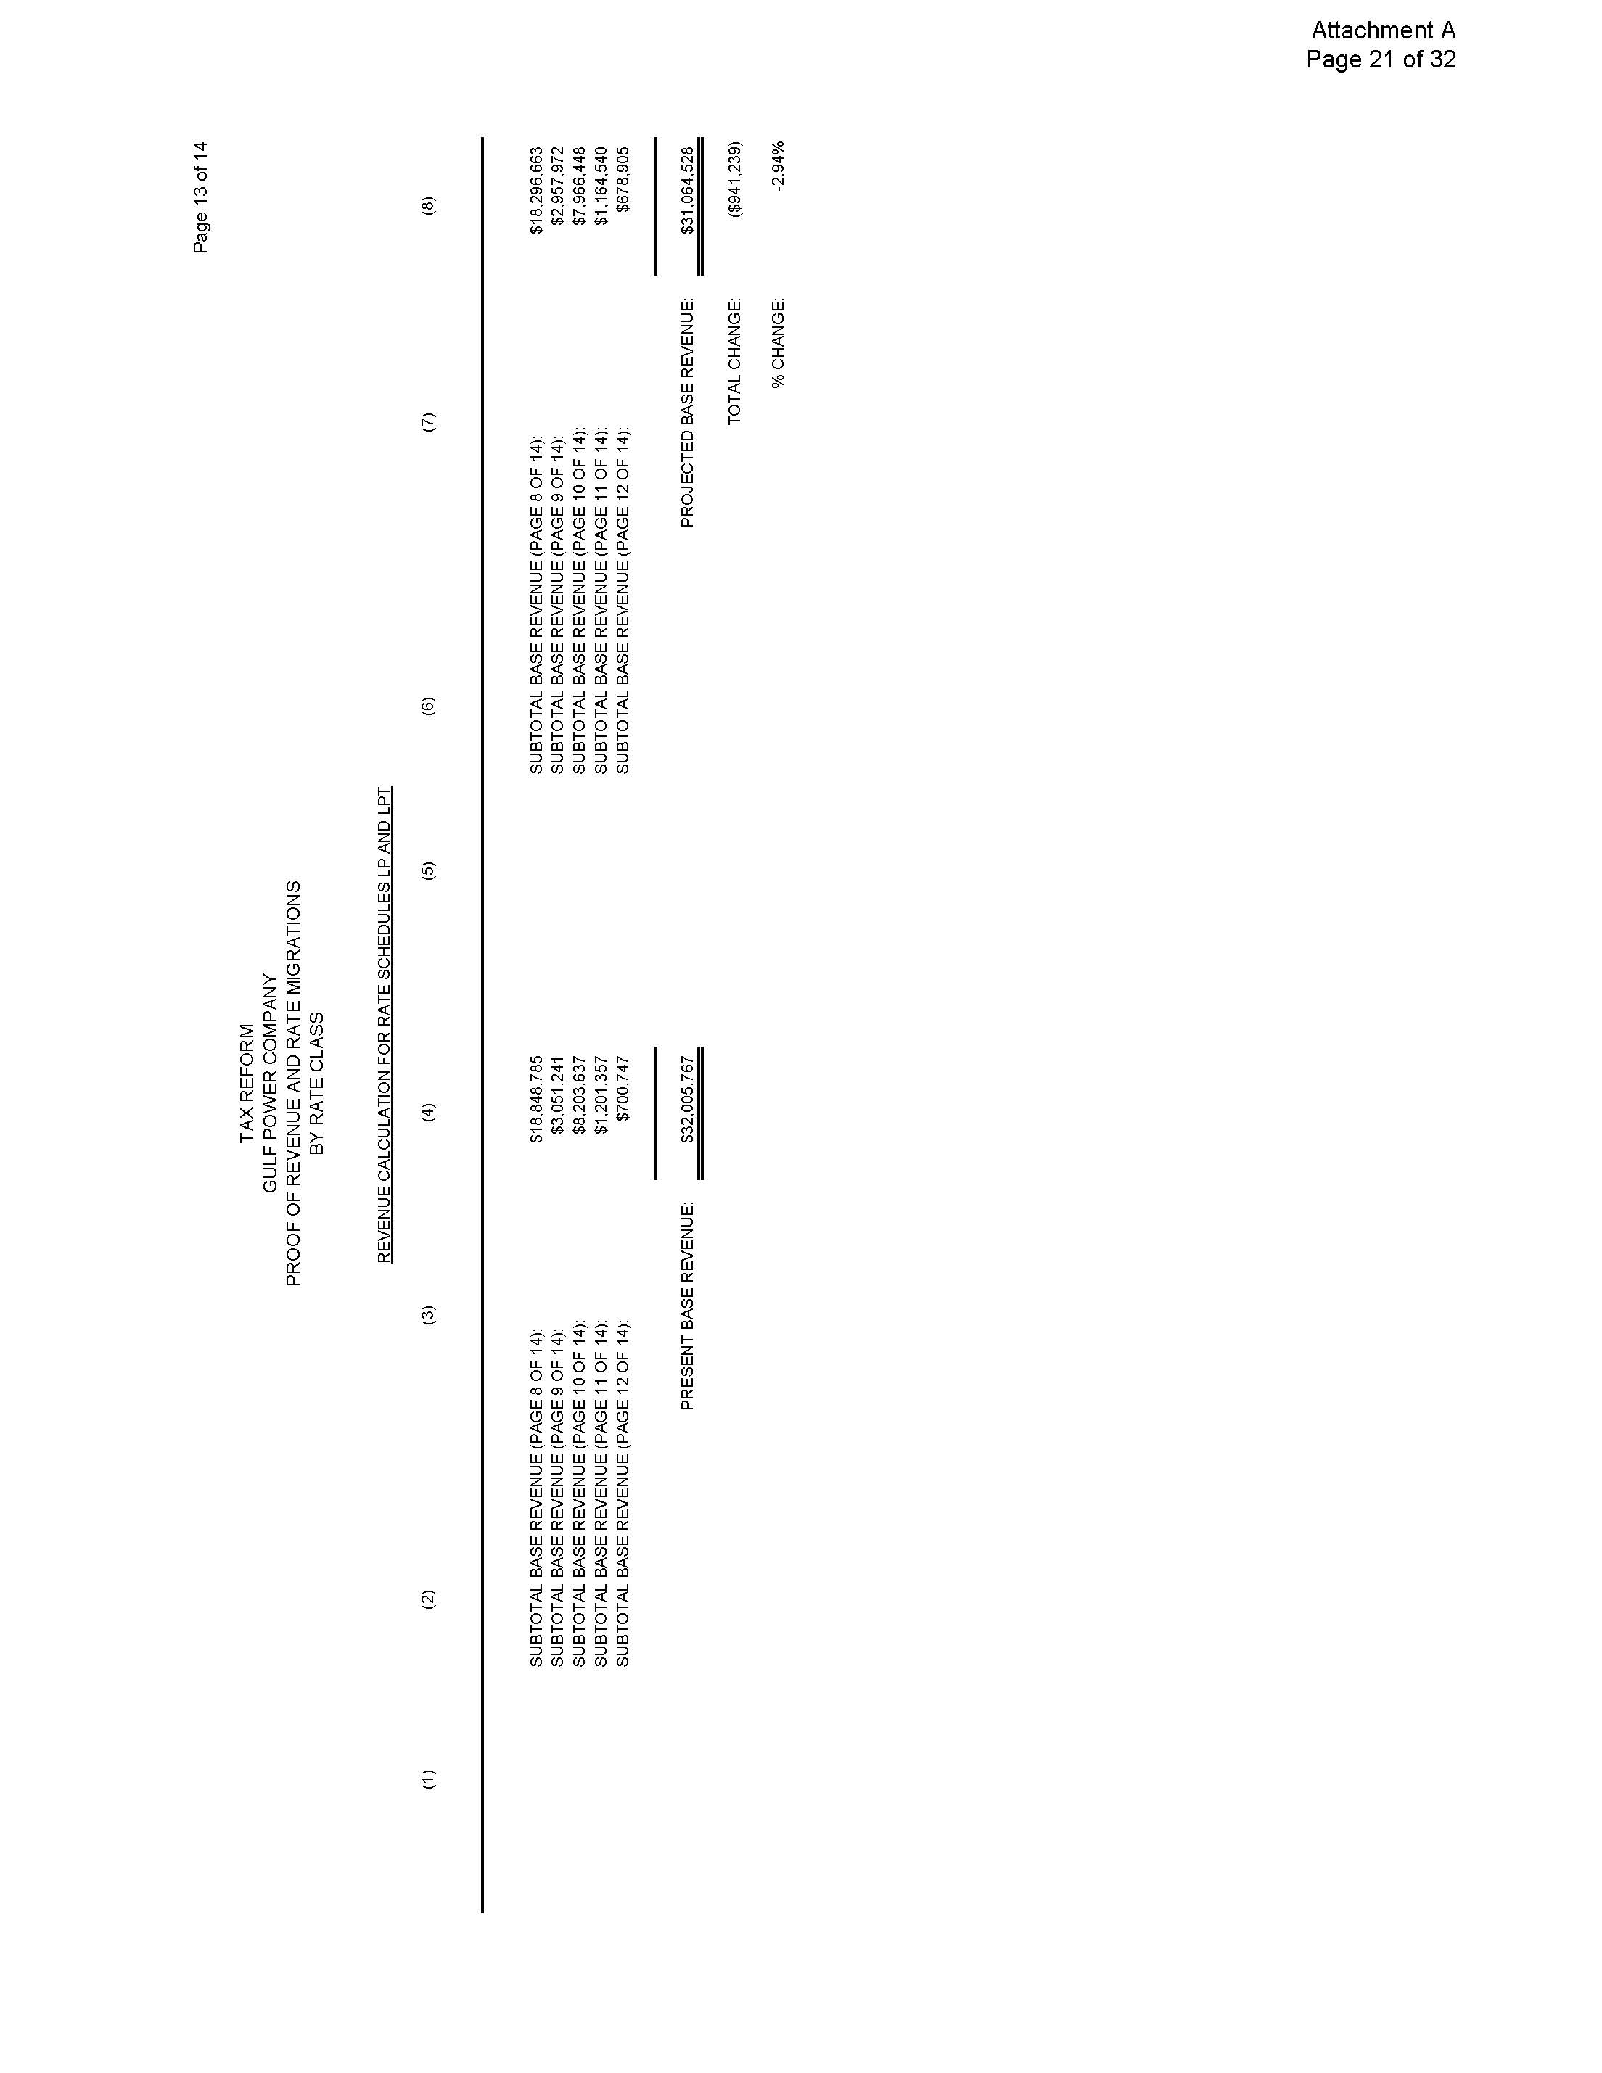

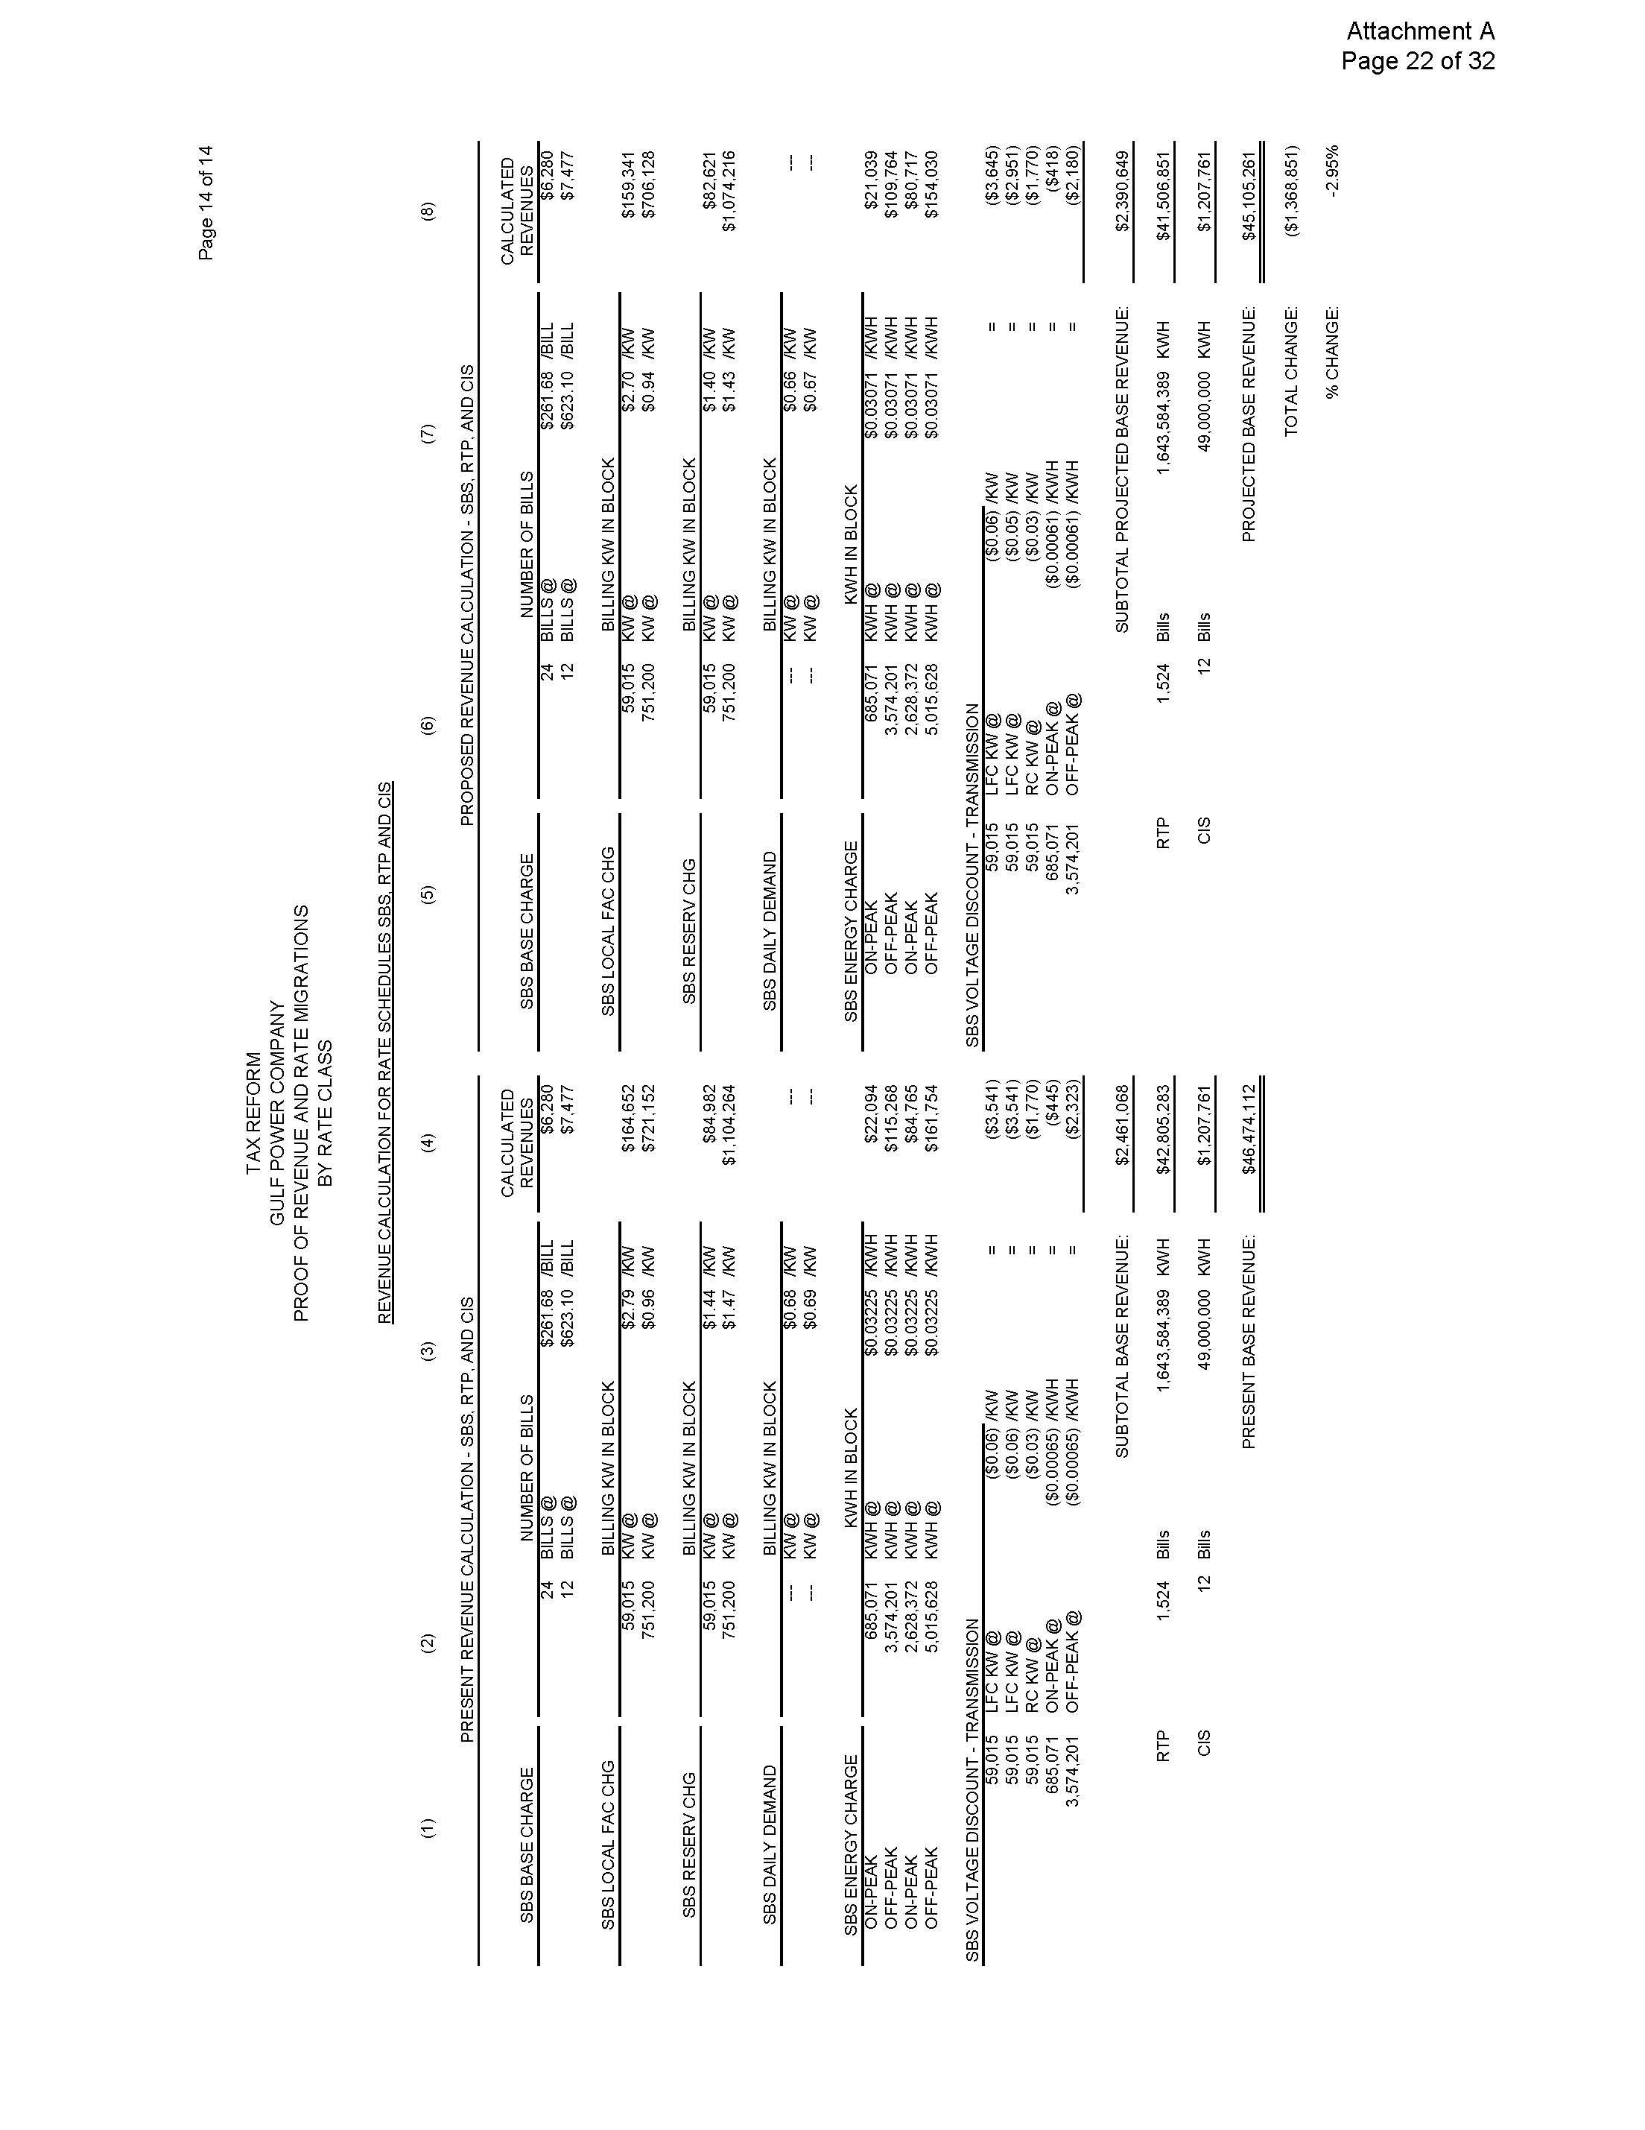

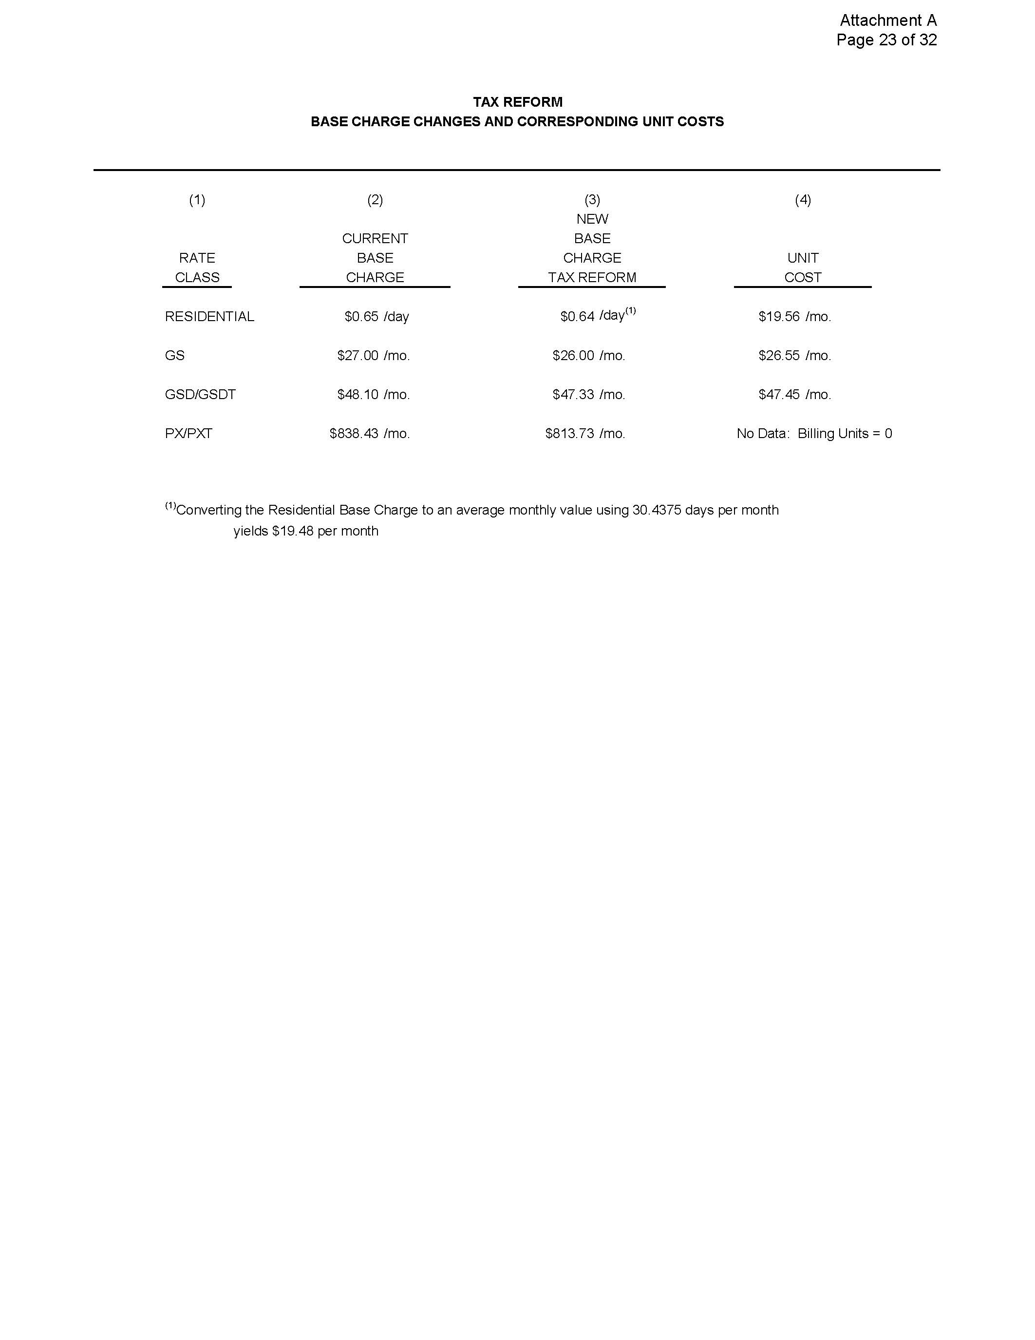

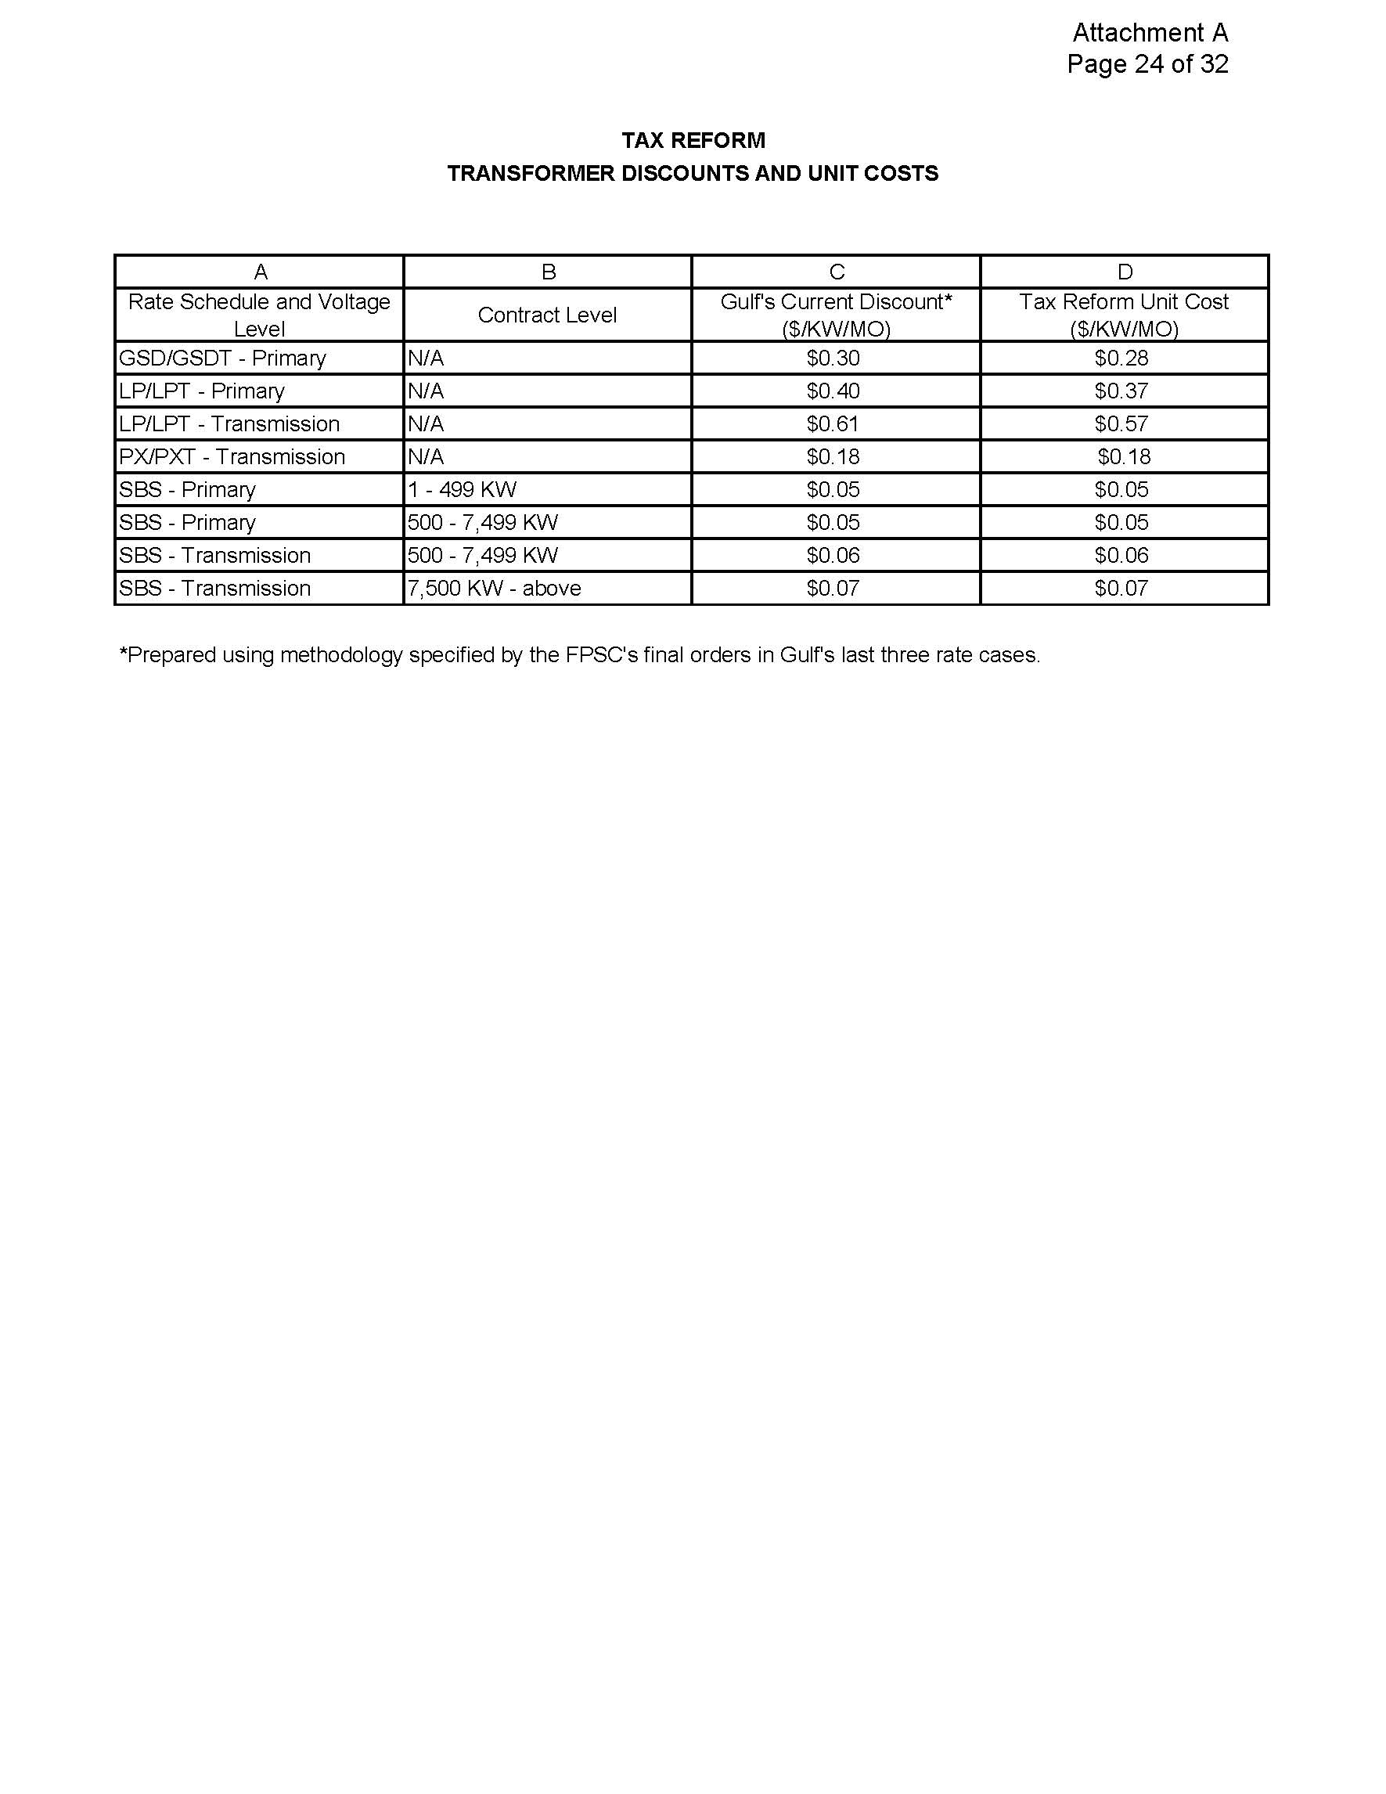

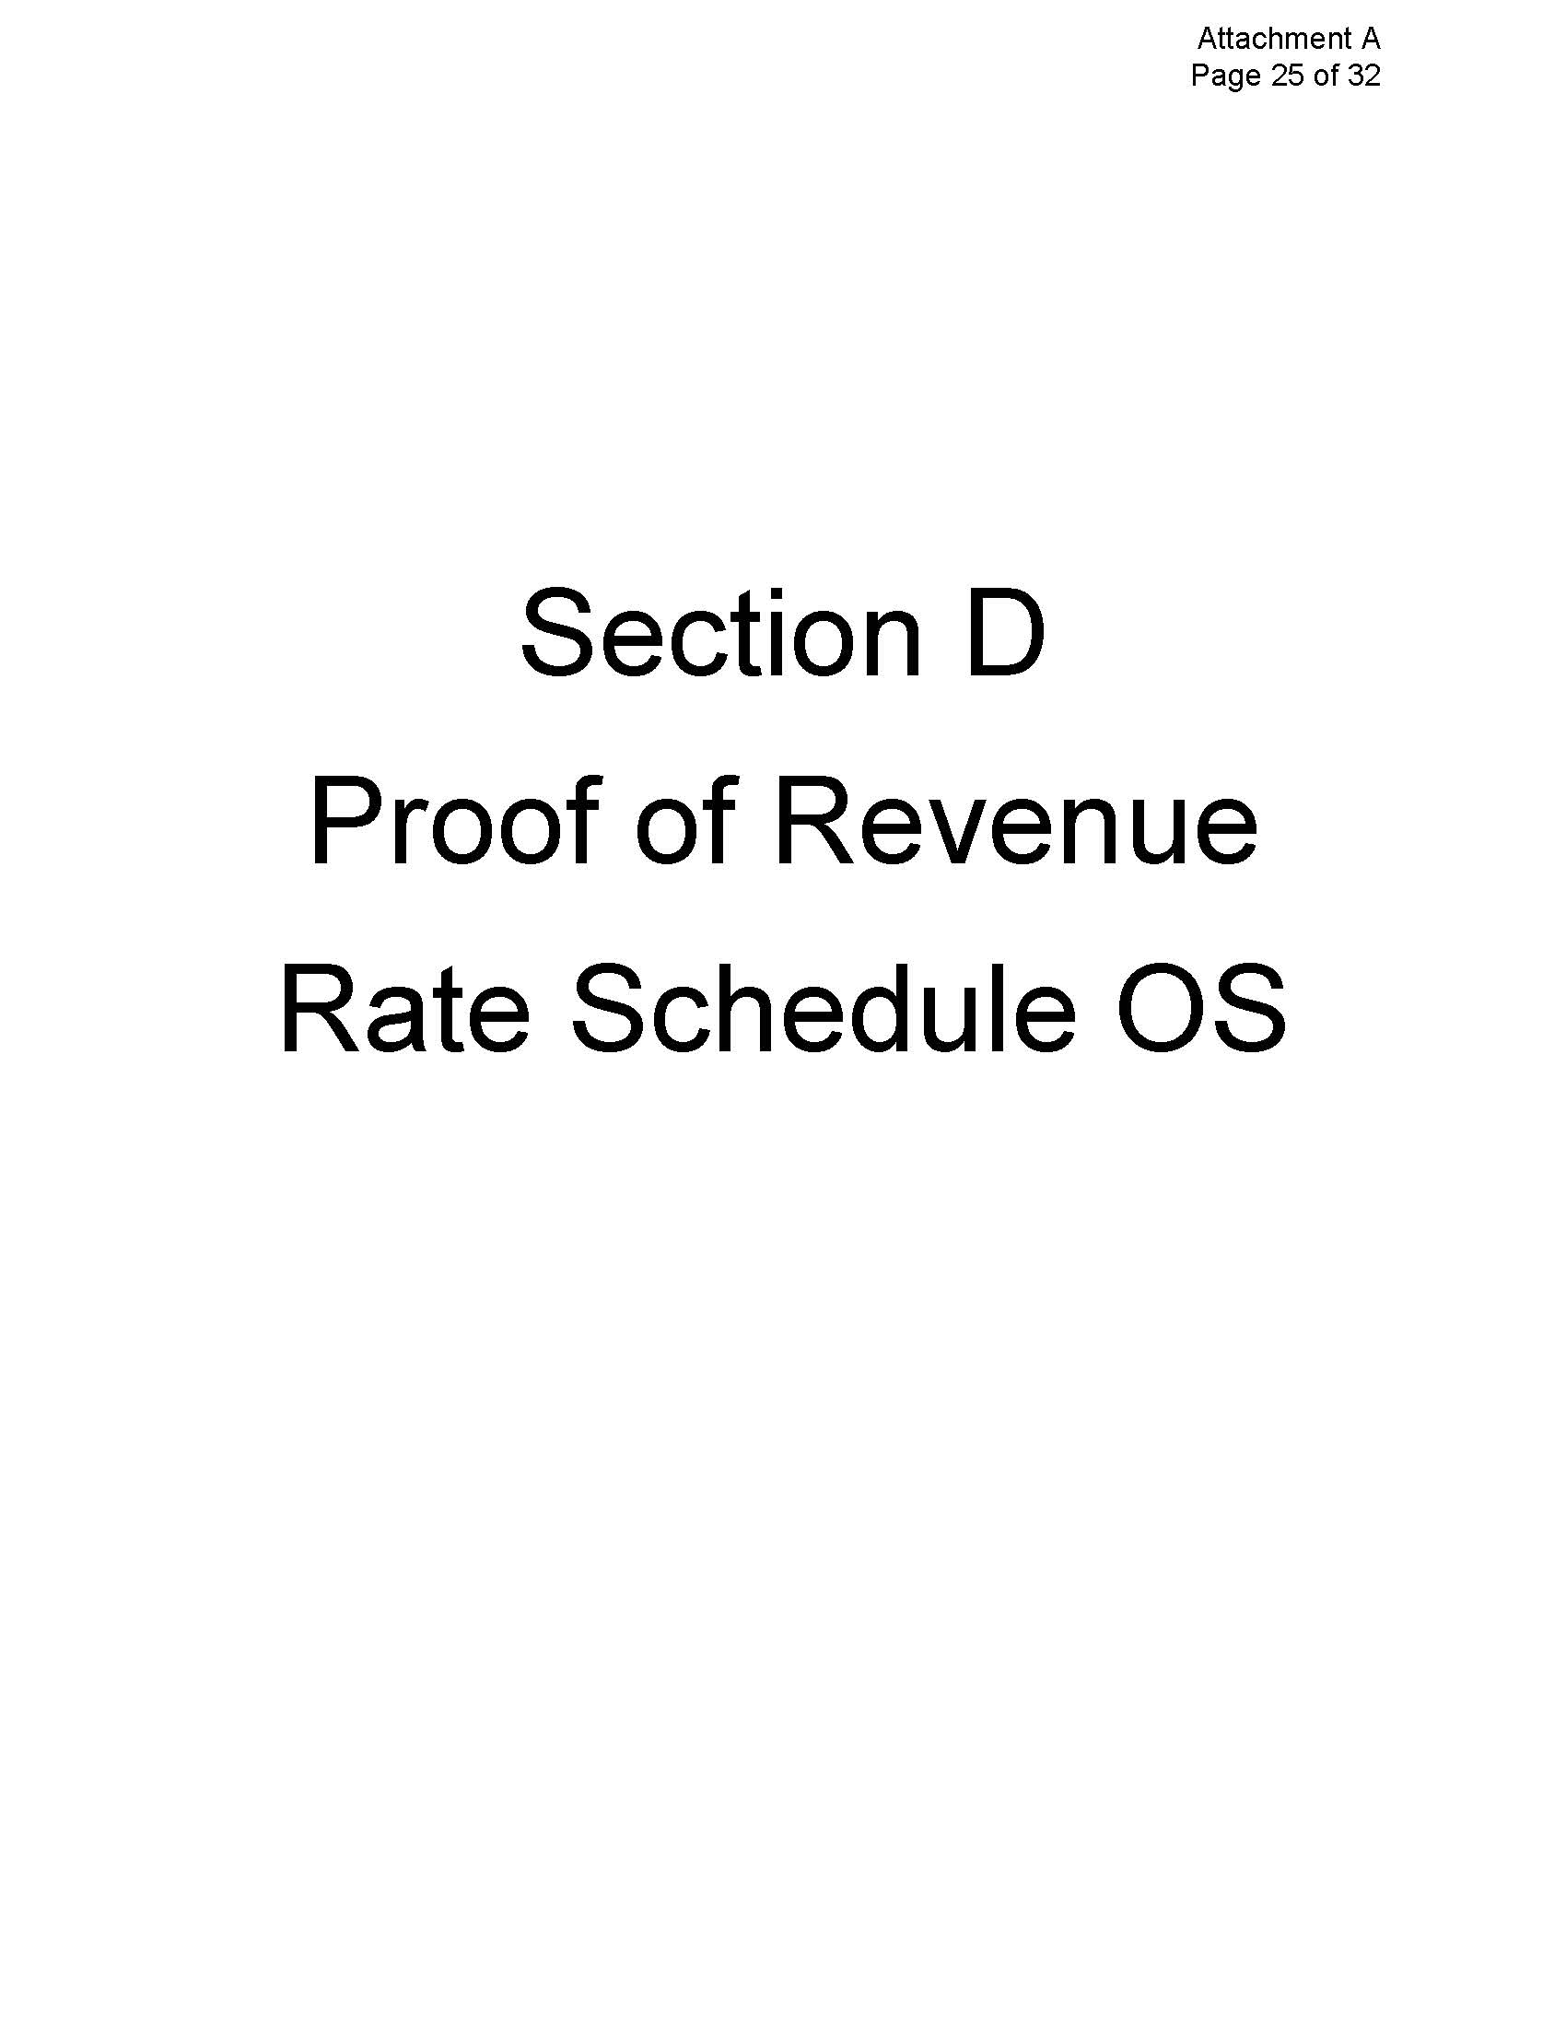

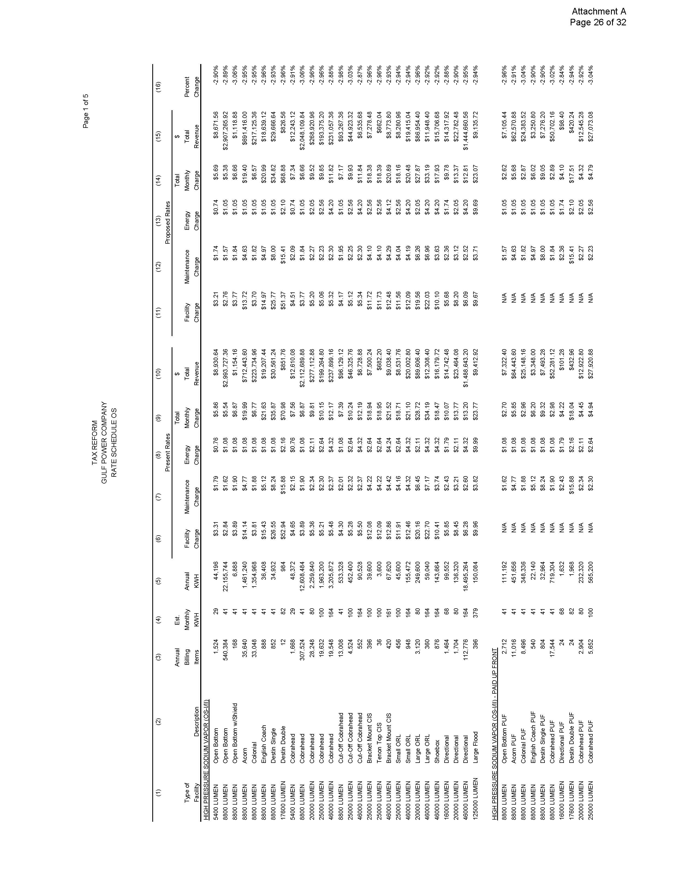

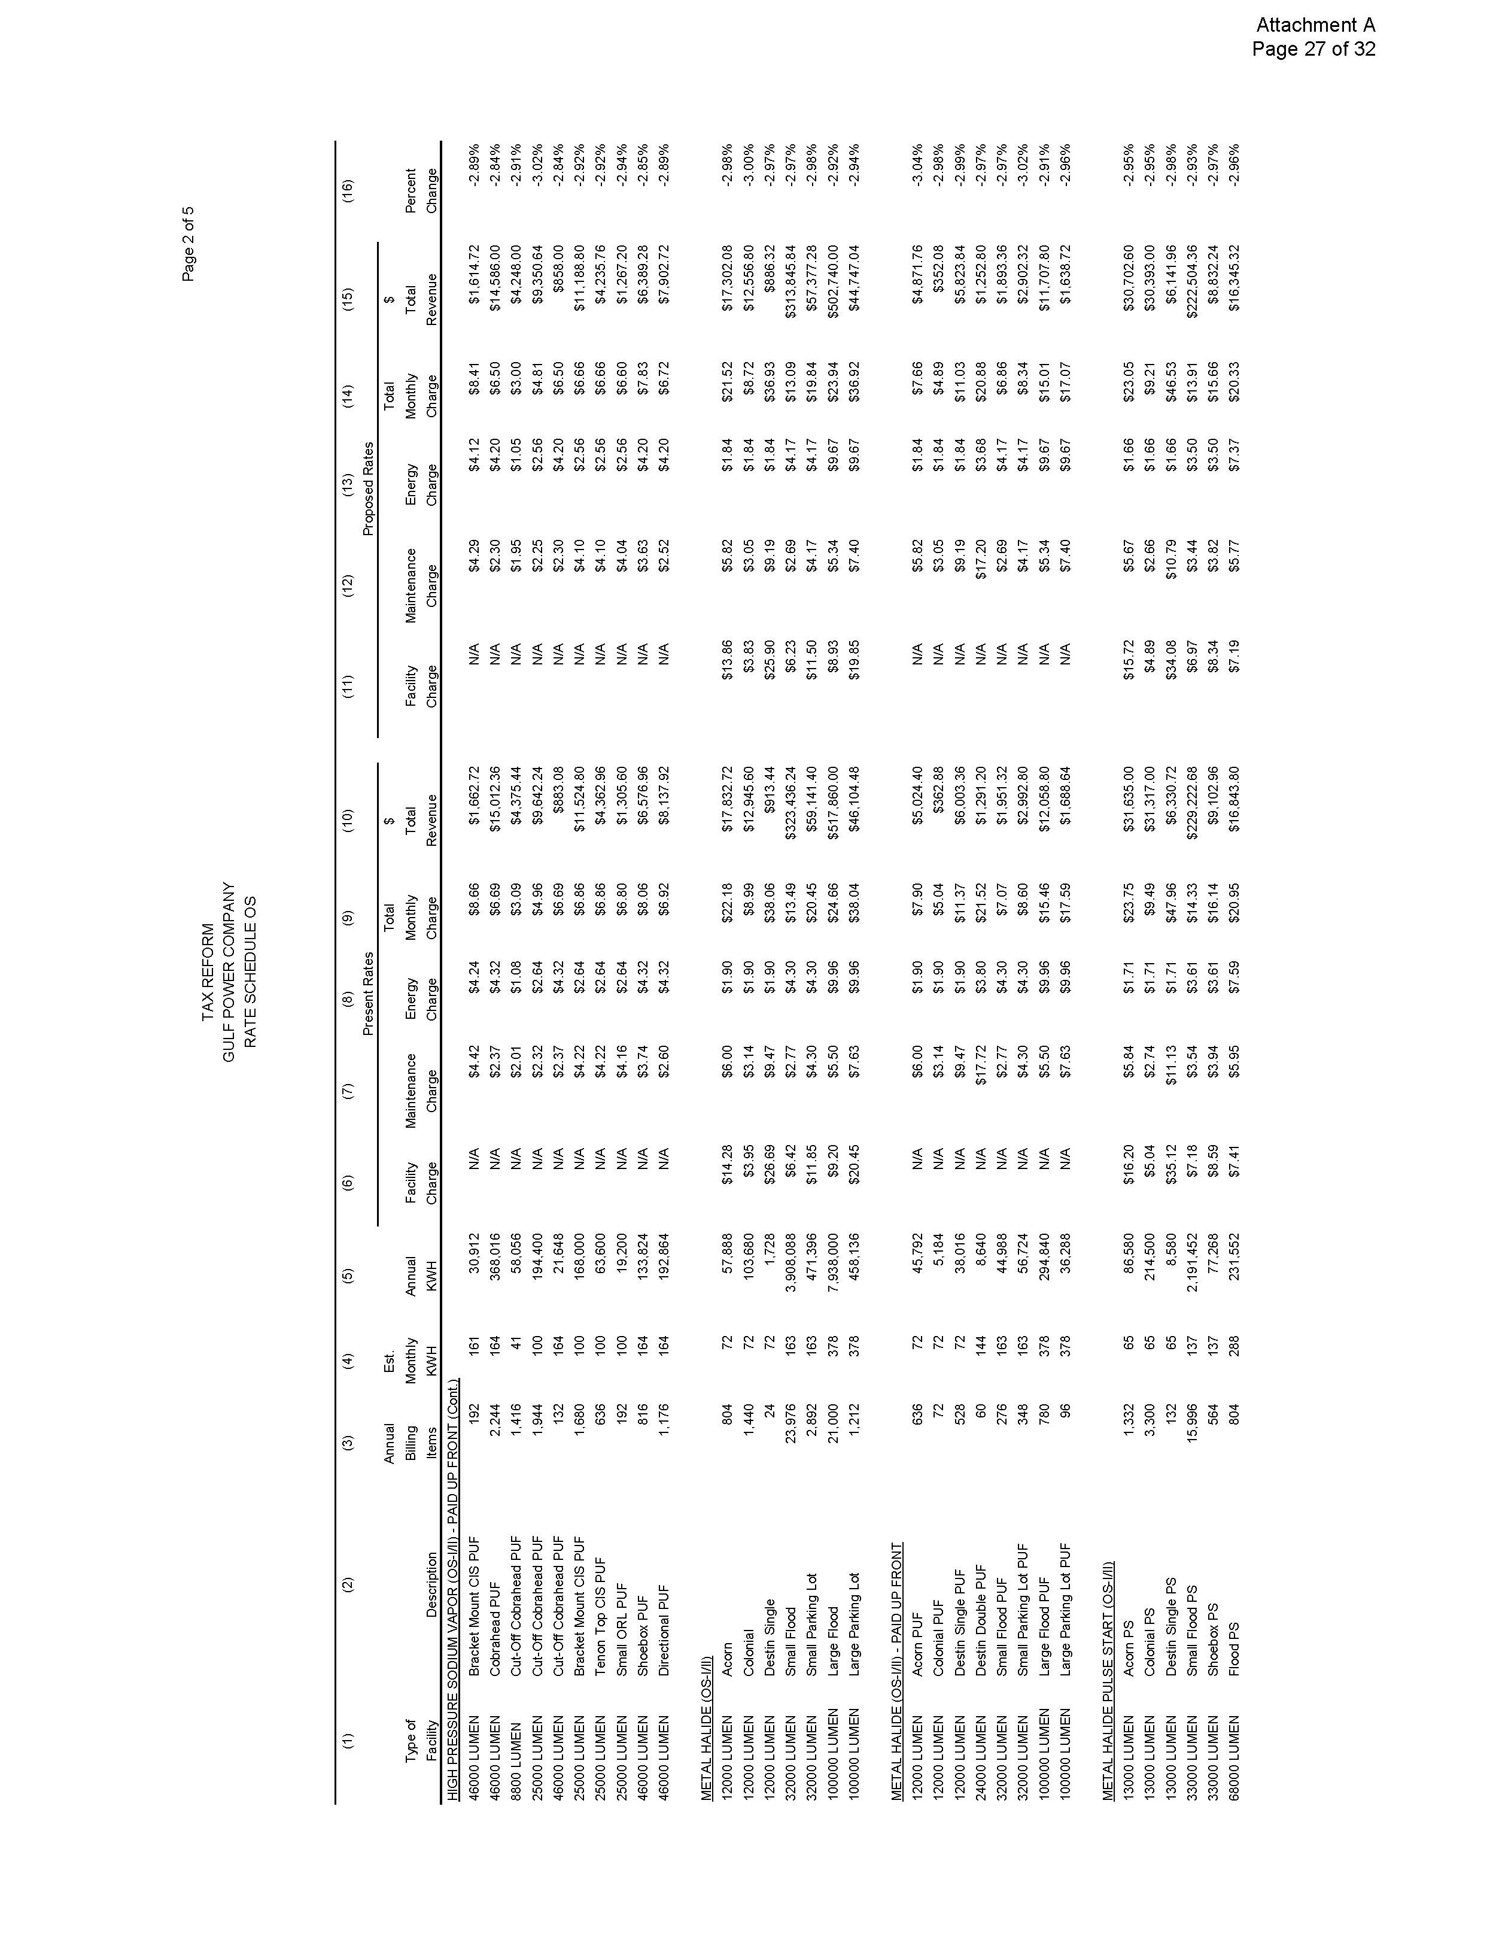

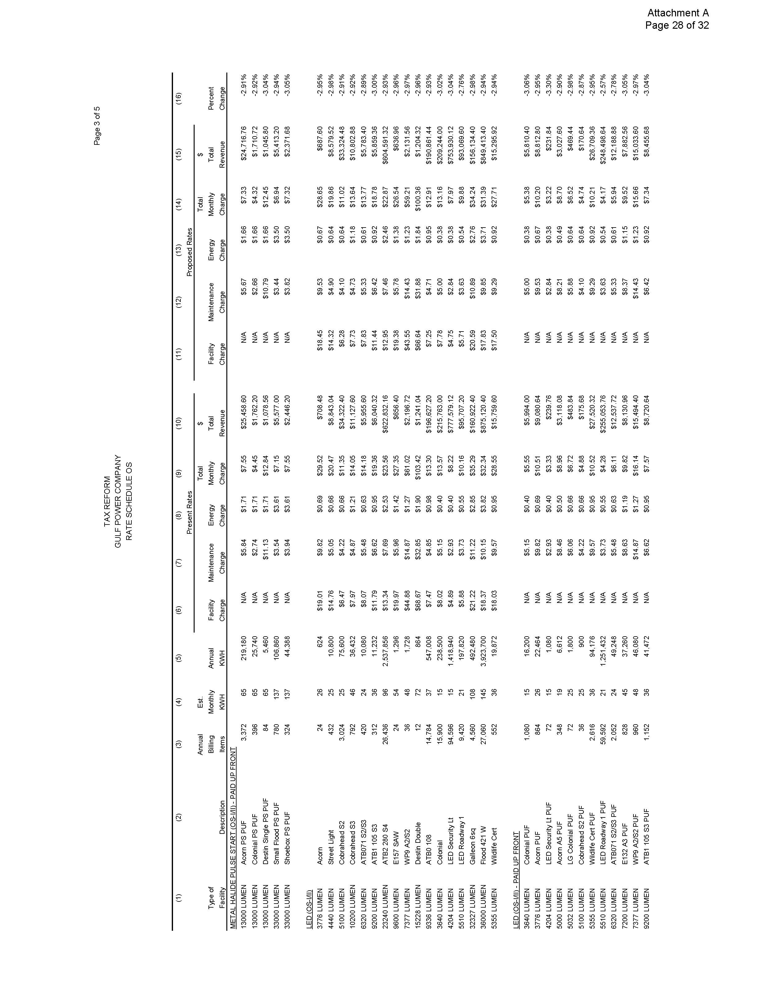

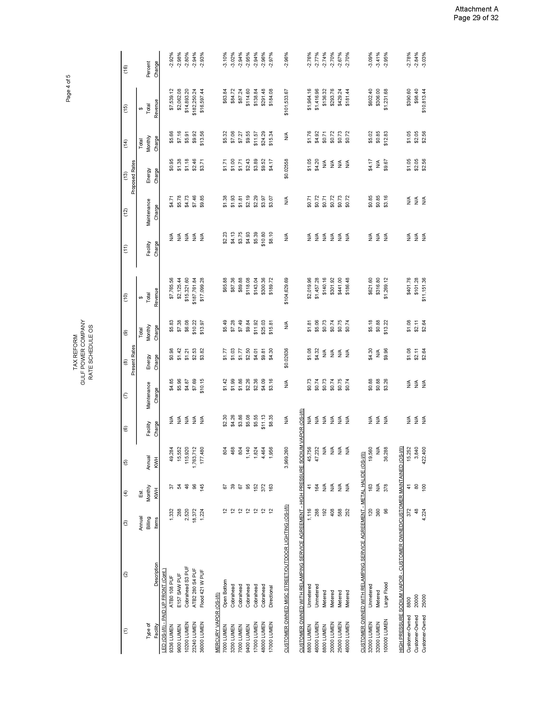

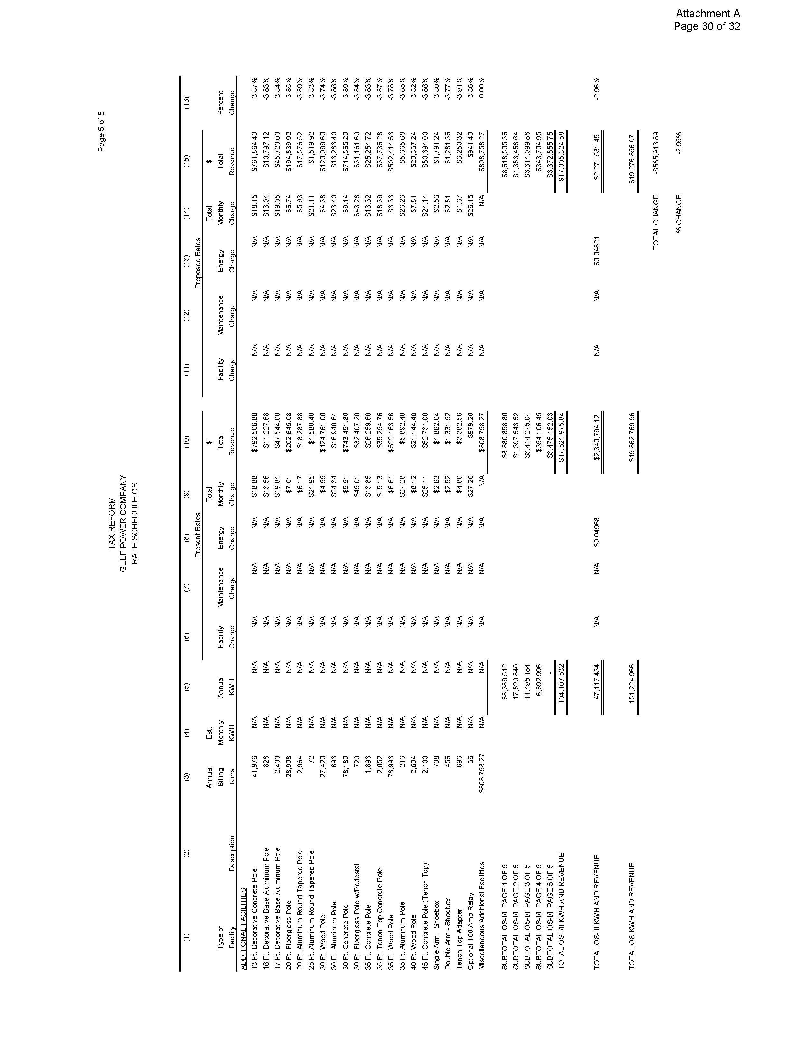

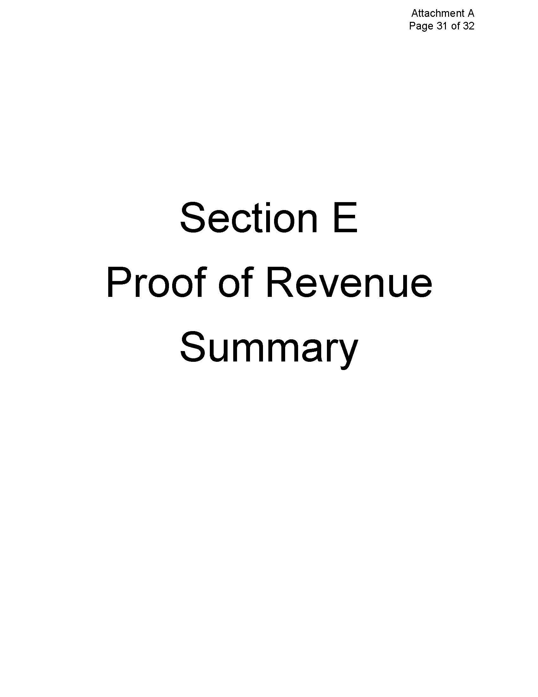

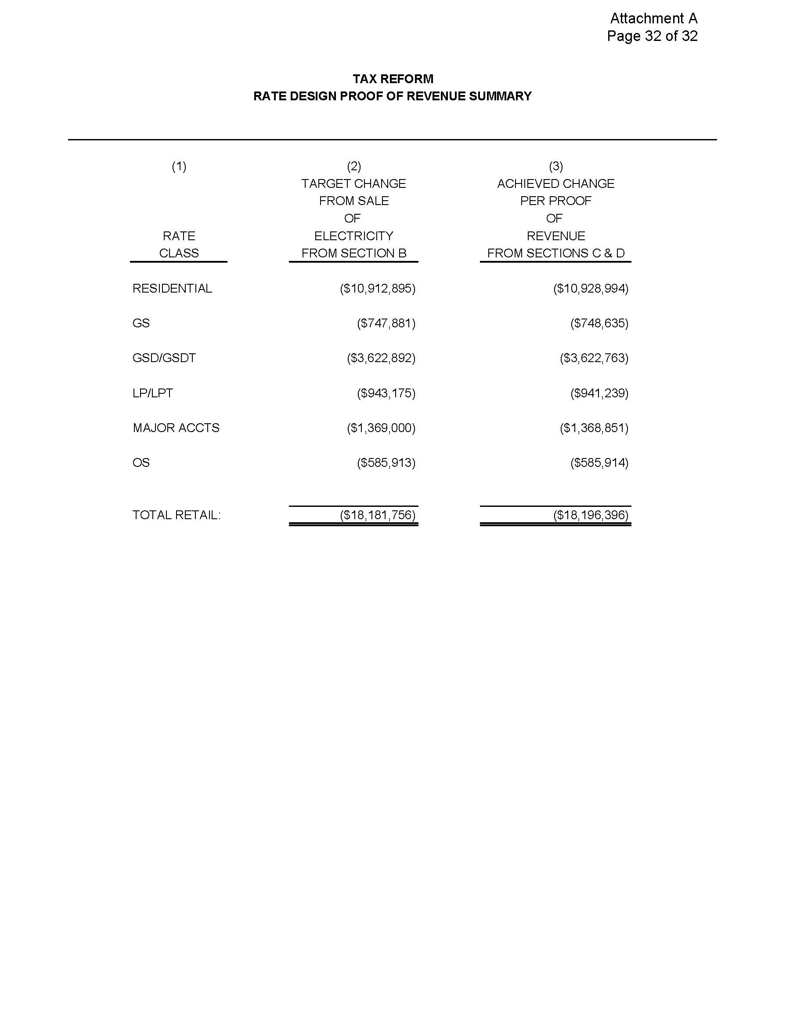

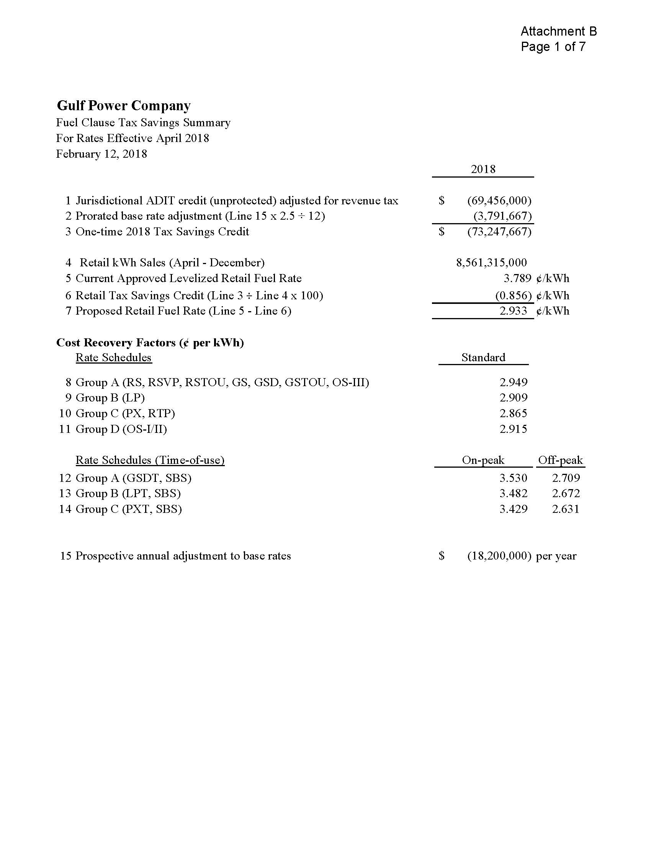

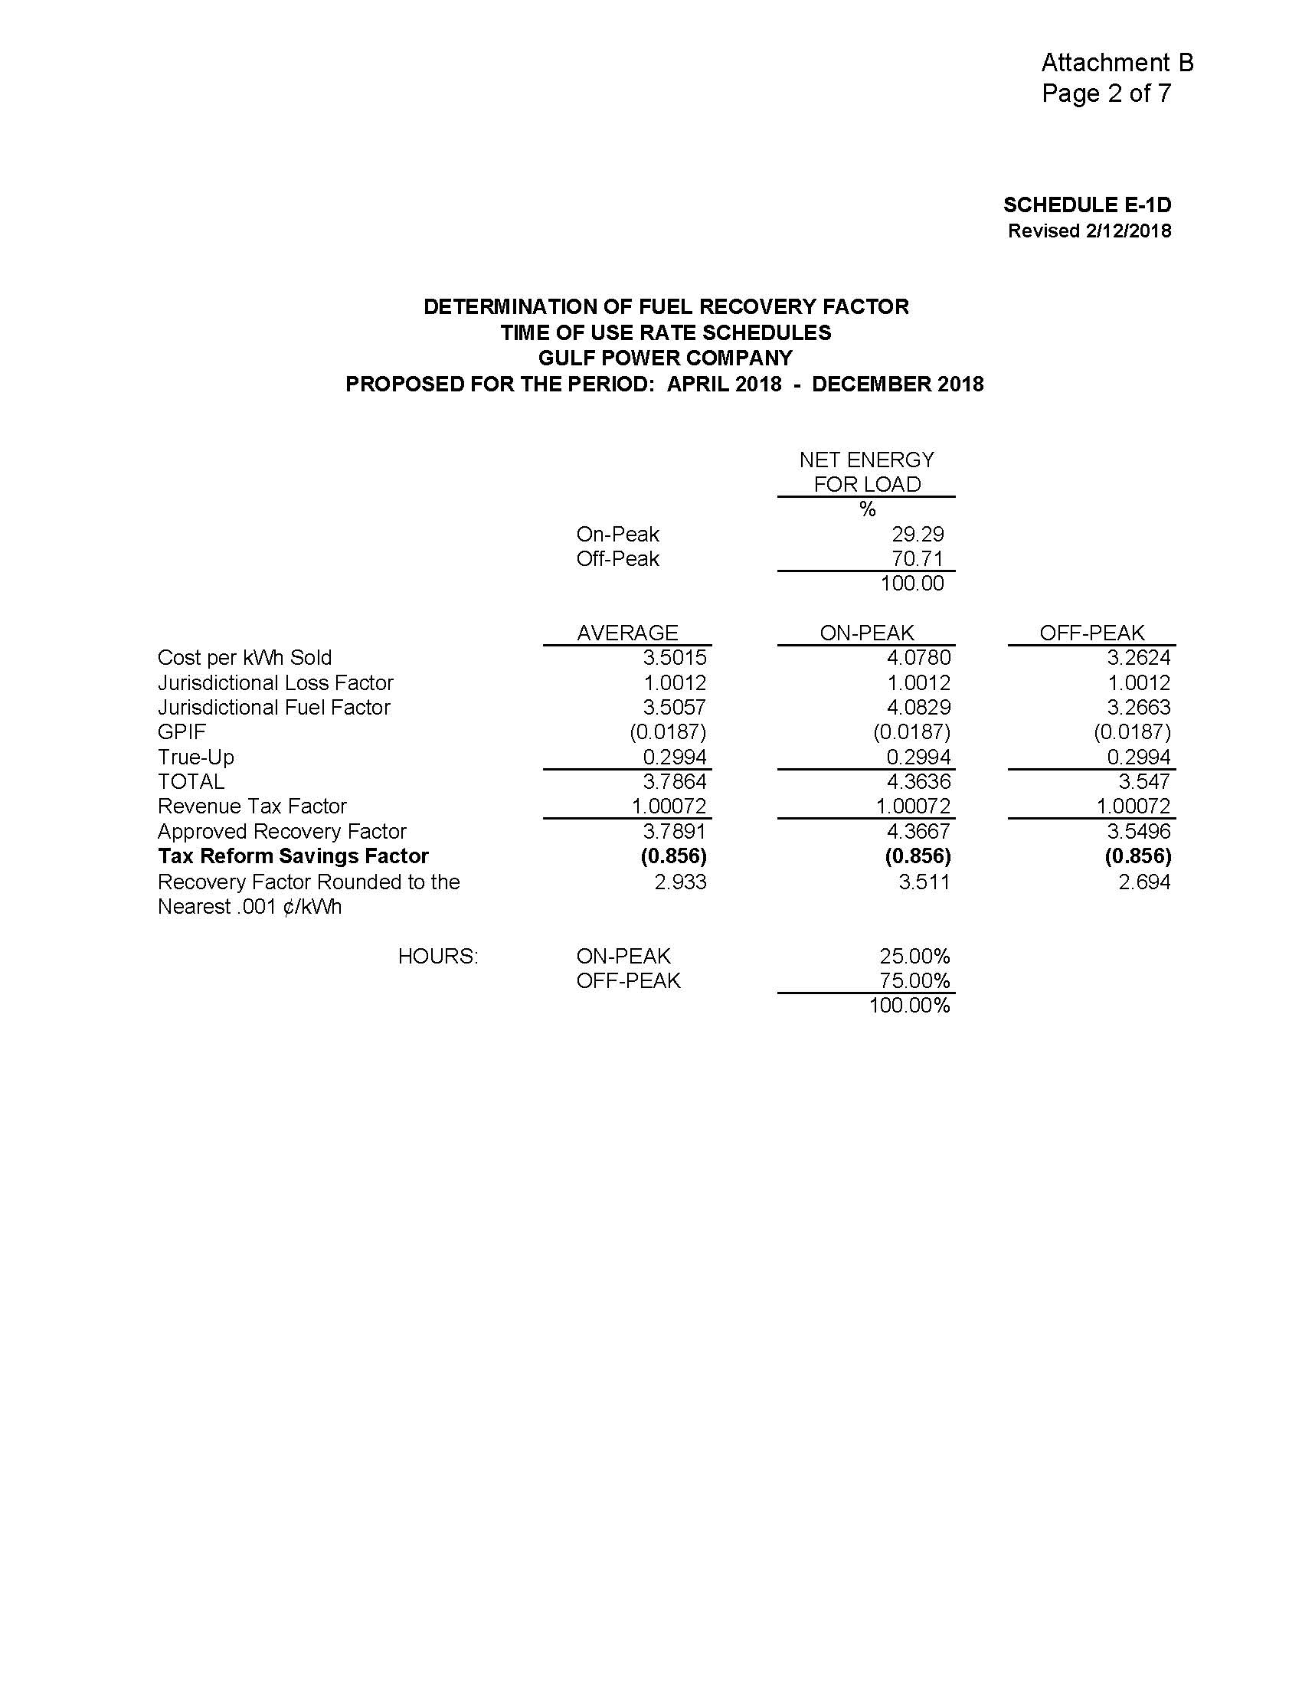

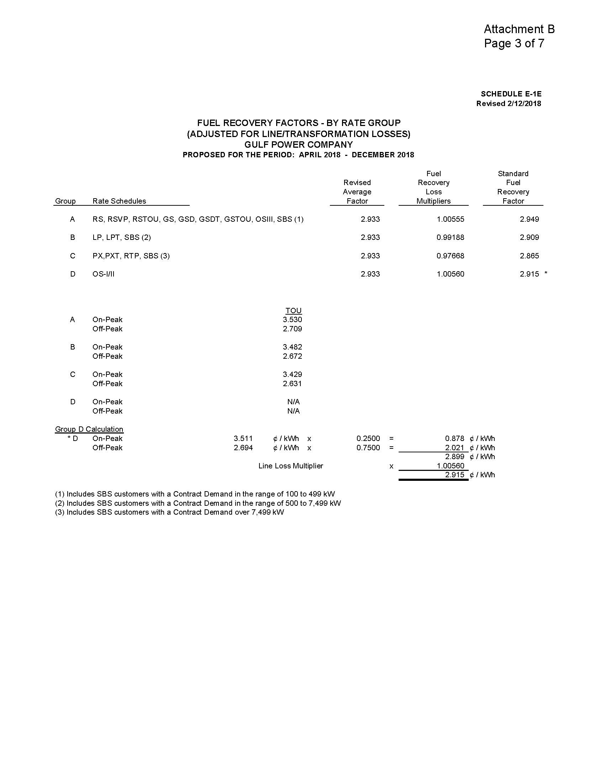

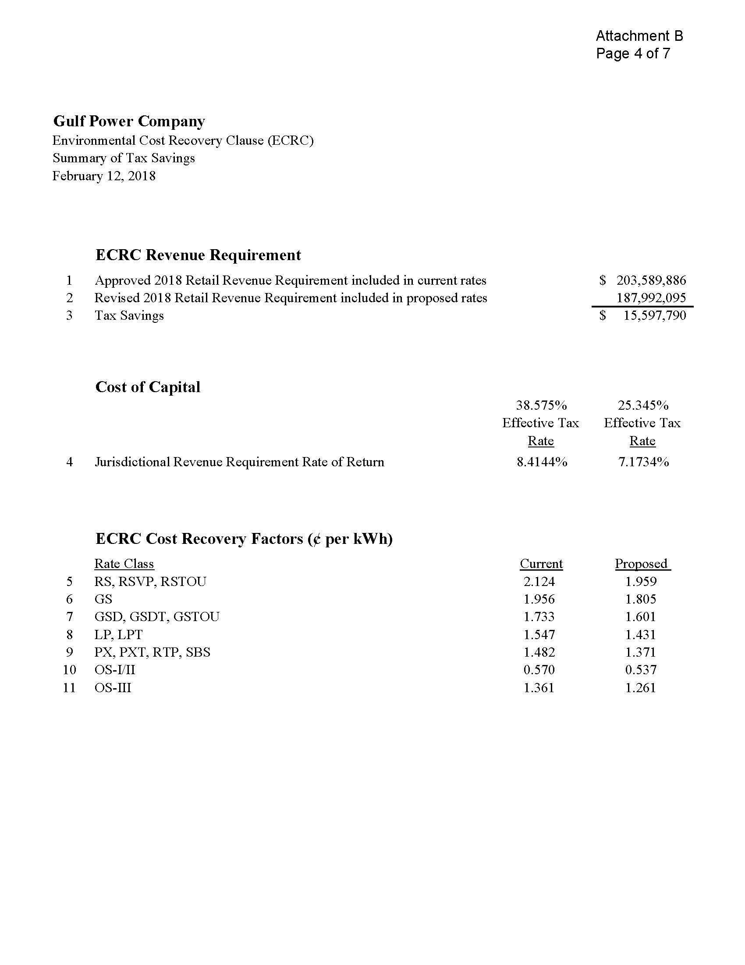

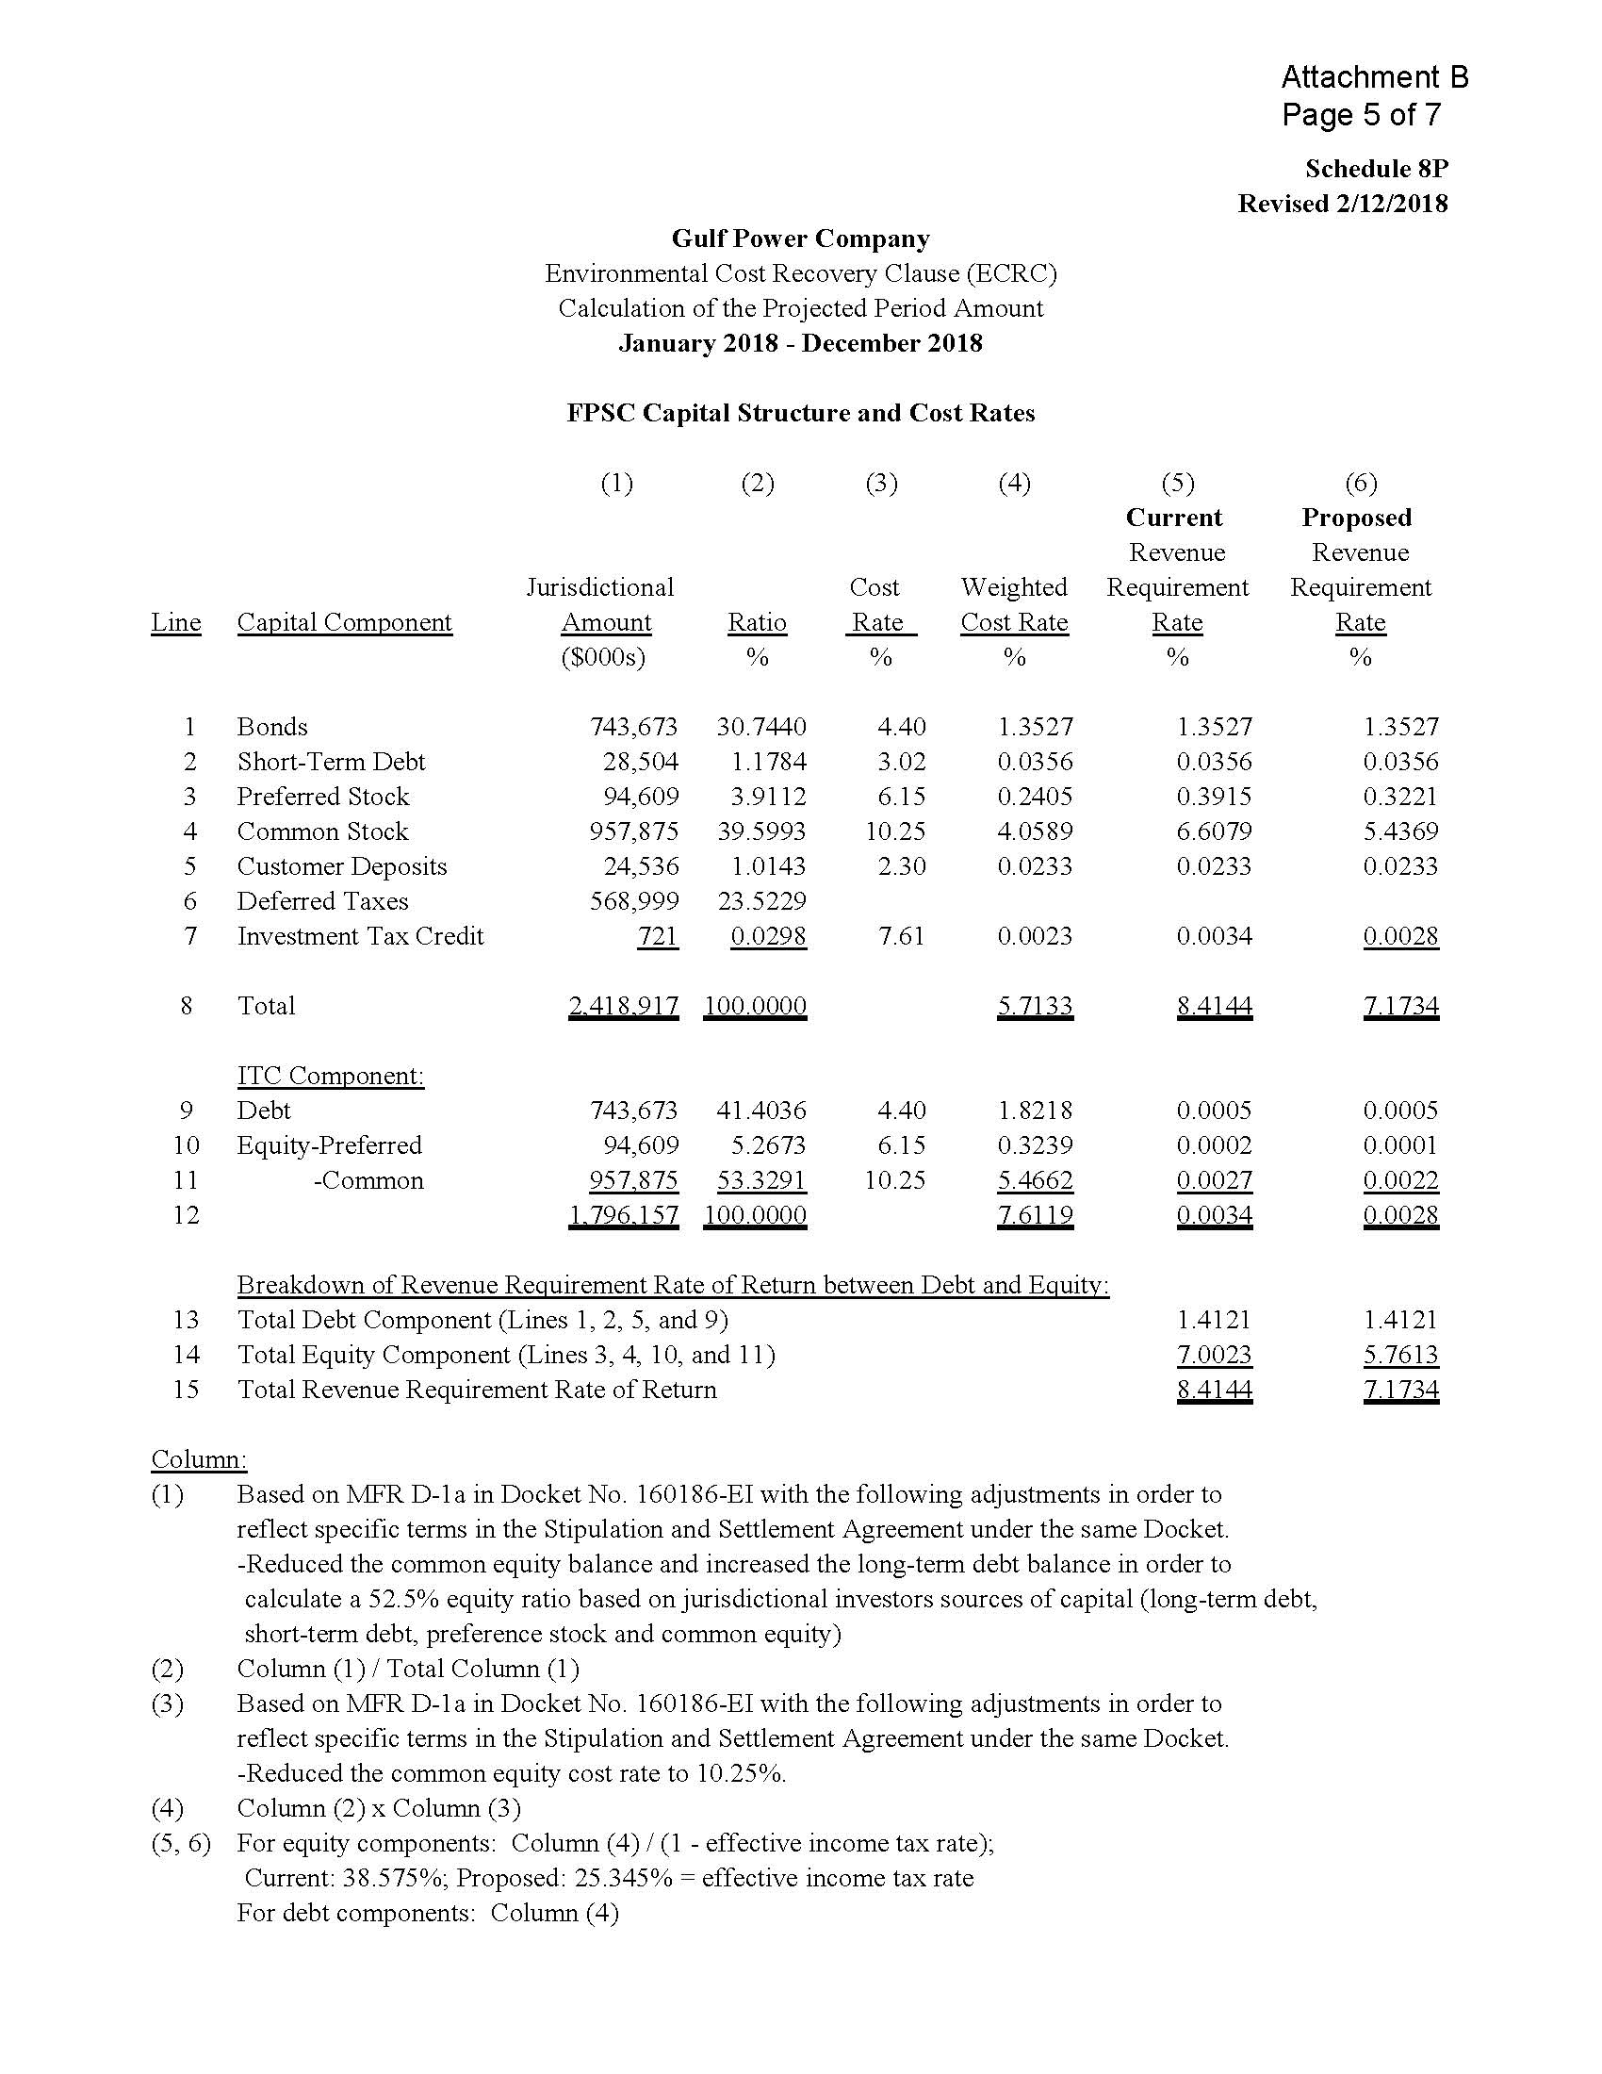

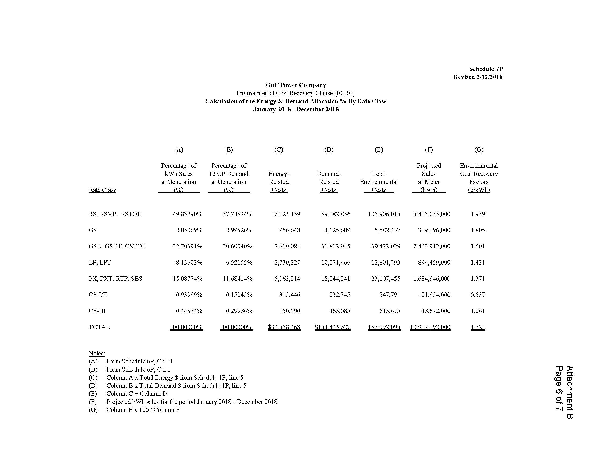

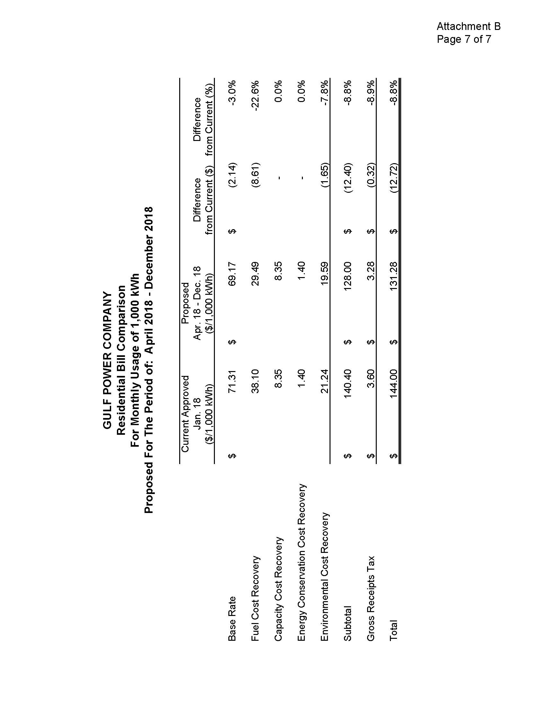

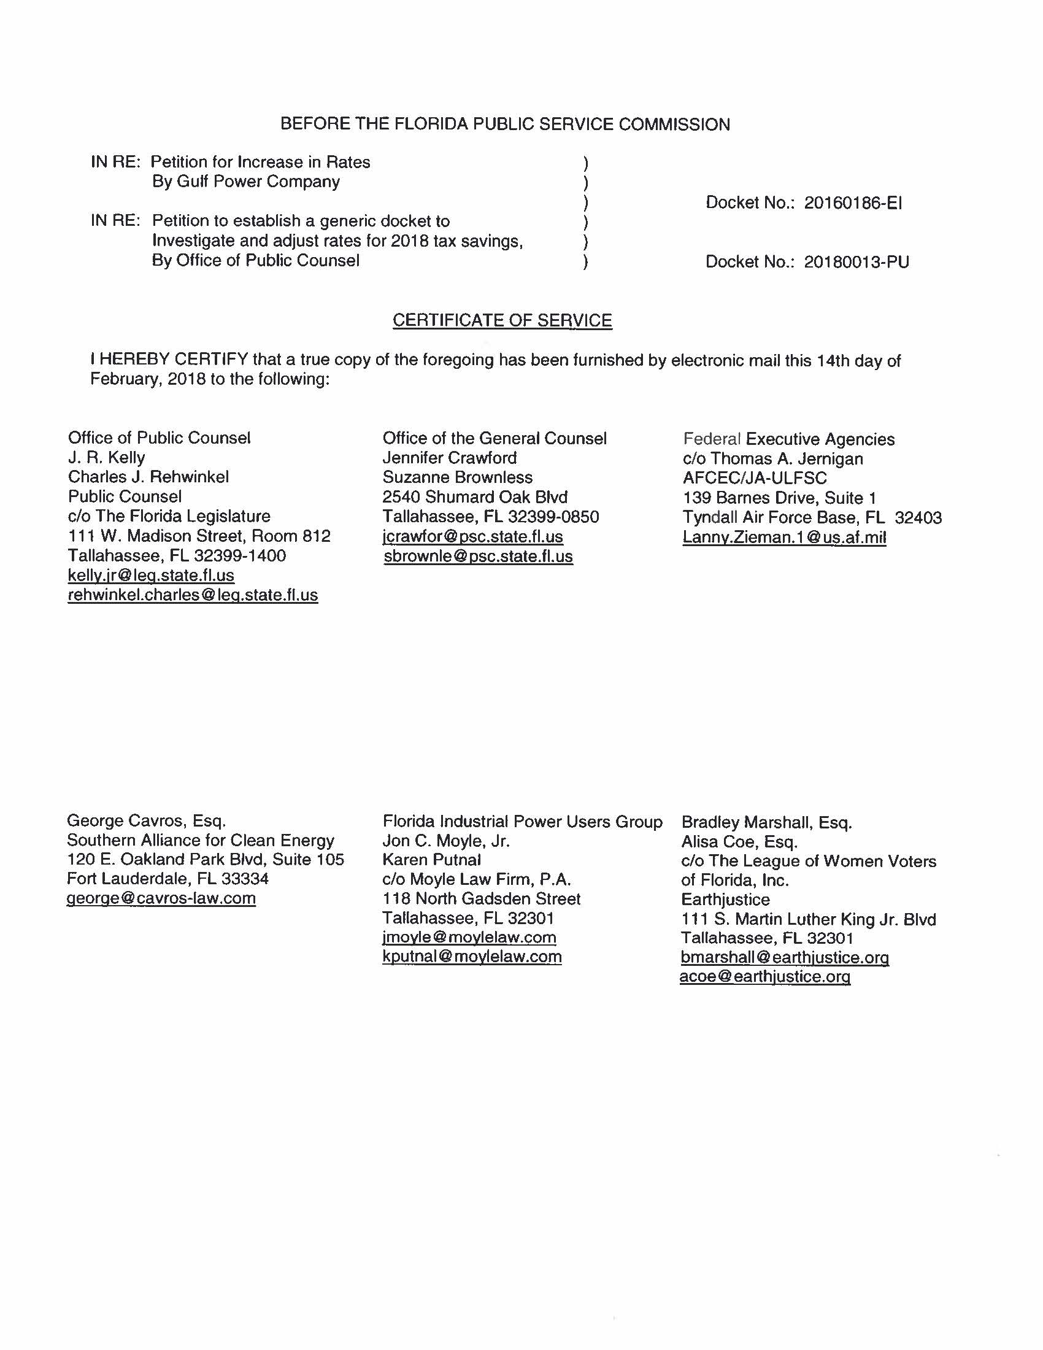

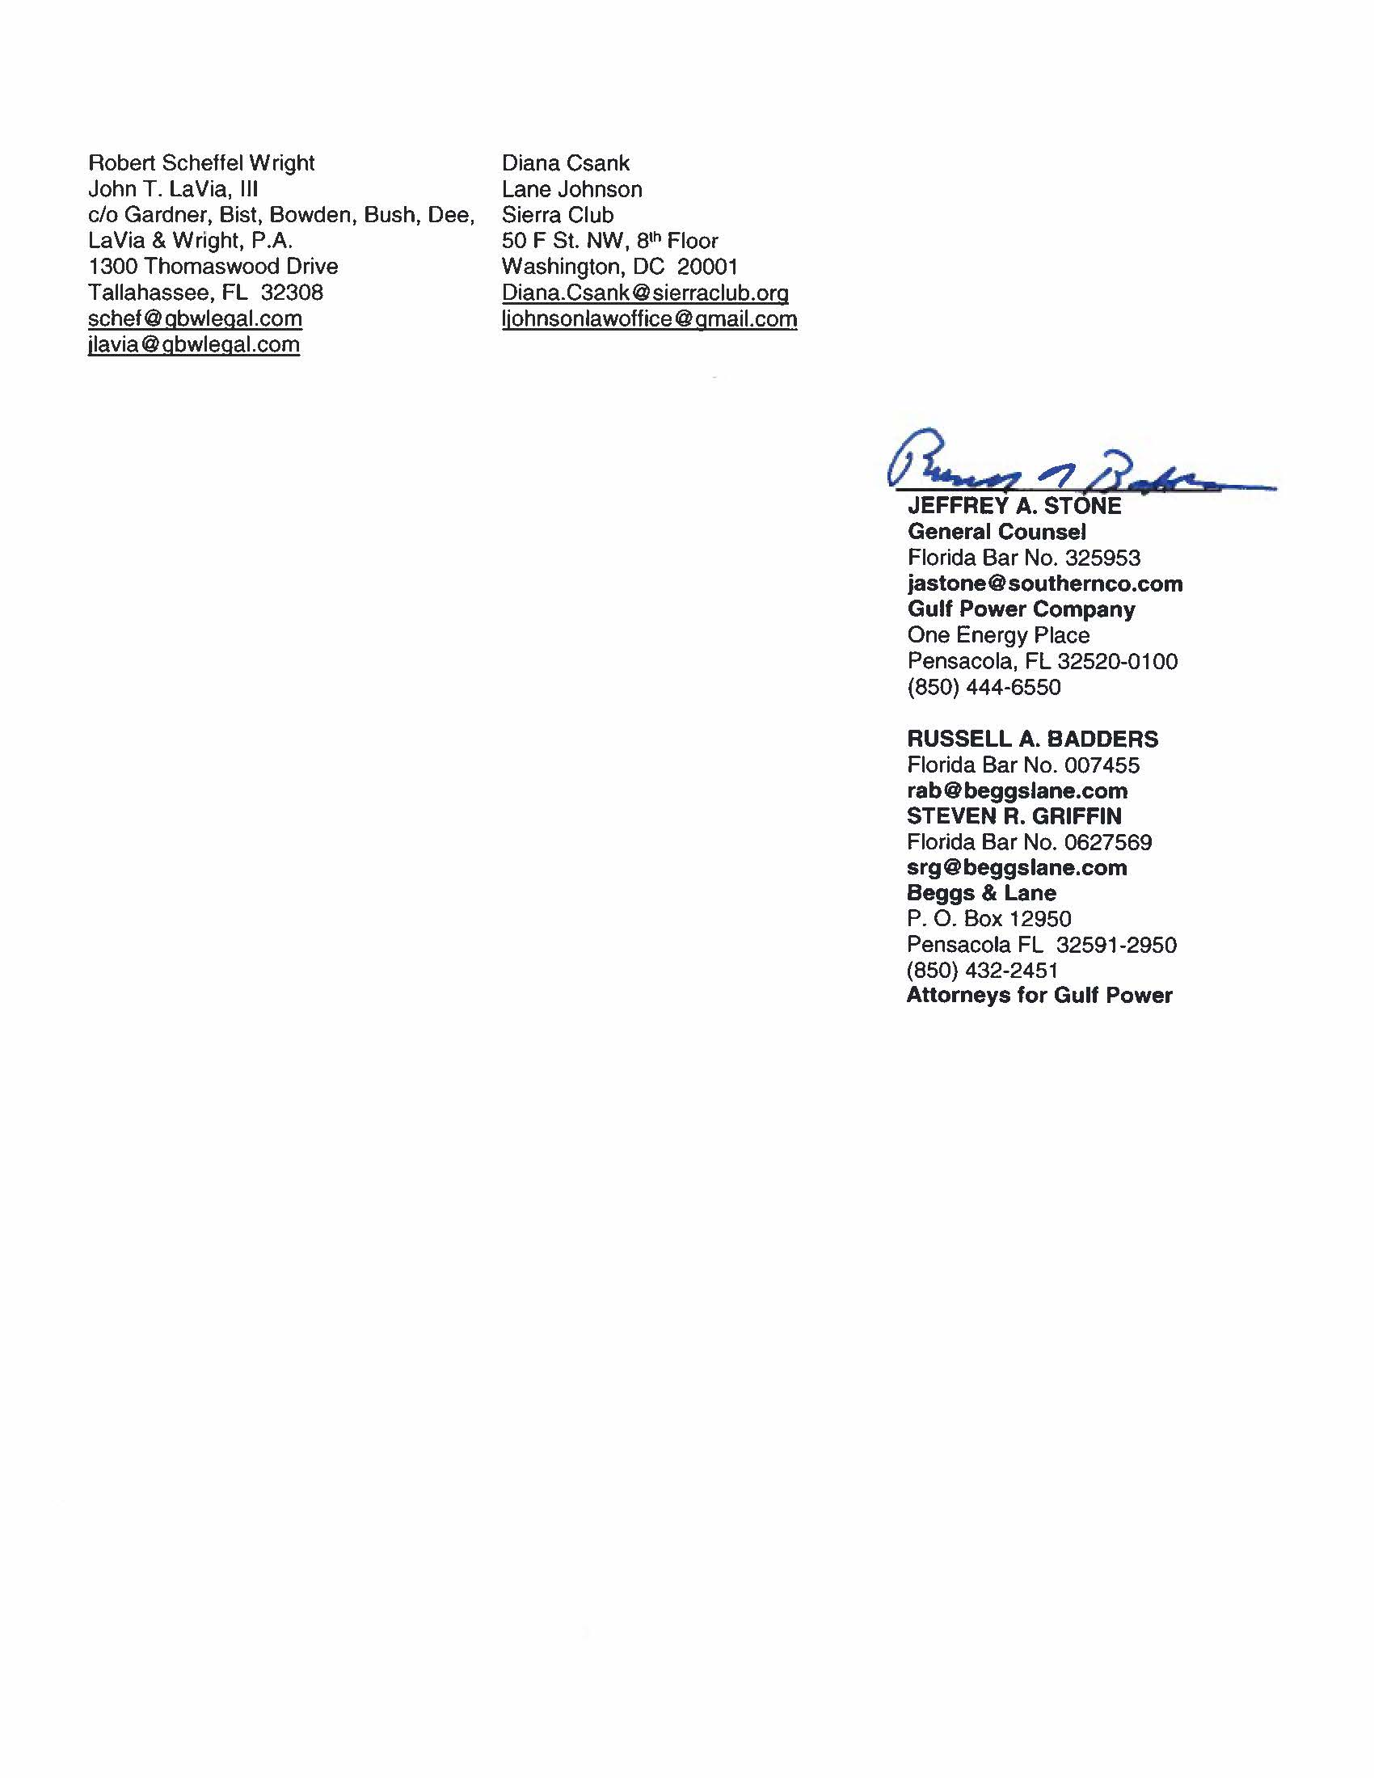

Docket No. 20180013-PU, In re: Petition to establish a generic docket to investigate and adjust rates for 2018 tax savings, by Office of Public Counsel.
Docket No. 20160186-EI, In re: Petition for rate increase by Gulf Power Company.
Order No. PSC-17-0178-S-EI, issued on May 16, 2017, in Docket No. 160186-EI, In re: Petition for rate increase by Gulf Power Company.
Id.
Paragraphs 2, 4.
Paragraphs 5, 8.
Paragraph 7.
Paragraph 9.
Paragraph 11.
Paragraph 13.
Order No. PSC-13-0023-S-EI, issued January 14, 2013, in Docket No. 120015-EI, In re: Petition for increase in rates by Florida Power & Light Company; Order No. PSC-11-0089-S-EI, issued February 1, 2011, in Docket Nos. 080677 and 090130, In re: Petition for increase in rates by Florida Power & Light Company and In re: 2009 depreciation and dismantlement study by Florida Power & Light Company; Order No. PSC-13-0023-S-EI, issued January 14, 2013, in Docket No. 120015-EI, In re: Petition for increase in rates by Florida Power & Light Company; PSC-10-0398-S-EI, issued June 18, 2010, in Docket Nos. 090079-EI, 090144-EI, 090145-EI, 100136-EI, In re: Petition for increase in rates by Progress Energy Florida, Inc., In re: Petition for limited proceeding to include Bartow repowering project in base rates, by Progress Energy Florida, Inc., In re: Petition for expedited approval of the deferral of pension expenses, authorization to charge storm hardening expenses to the storm damage reserve, and variance from or waiver of Rule 25-6.0143(1)(c), (d), and (f), F.A.C., by Progress Energy Florida, Inc., and In re: Petition for approval of an accounting order to record a depreciation expense credit, by Progress Energy Florida, Inc.; Order No. PSC-05-0945-S-EI, issued September 28, 2005, in Docket No. 050078-EI, In re: Petition for rate increase by Progress Energy Florida, Inc.
Order No. PSC-13-0023-S-EI, at p. 7.

