BEFORE THE FLORIDA PUBLIC SERVICE COMMISSION

In re: Petition for approval of transportation service agreement with Florida Public Utilities Company, by Peninsula Pipeline Company, Inc. | DOCKET NO. 20180016-GU  ORDER NO. PSC-2018-0232-PAA-GU  ISSUED: May 8, 2018

The following Commissioners participated in the disposition of this matter:

ART GRAHAM, Chairman
JULIE I. BROWN
DONALD J. POLMANN
GARY F. CLARK
ANDREW GILES FAY

NOTICE OF PROPOSED AGENCY ACTION
ORDER APPROVING FIRM TRANSPORTATION SERVICE AGREEMENT

BY THE COMMISSION:

NOTICE is hereby given by the Florida Public Service Commission that the action discussed herein is preliminary in nature and will become final unless a person whose interests are substantially affected files a petition for a formal proceeding, pursuant to Rule 25-22.029, Florida Administrative Code (F.A.C.).

BACKGROUND
On January 12, 2018, Peninsula Pipeline Company, Inc. (Peninsula) filed a petition seeking approval of a firm transportation service agreement (Agreement) between Peninsula and Florida Public Utilities Company (FPUC), collectively the parties. Peninsula operates as a natural gas transmission company as defined by Section 368.103(4), Florida Statutes (F.S.). FPUC is a local distribution company (LDC) subject to the regulatory jurisdiction of the Commission pursuant to Chapter 366, F.S.
By Order No. PSC-07-1012-TRF-GP, Peninsula received approval of an intrastate gas pipeline tariff that allows it to construct and operate intrastate pipeline facilities and to actively pursue agreements with natural gas customers. Peninsula provides transportation service only; it does not engage in the sale of natural gas. Pursuant to Order No. PSC-07-1012-TRF-GP, Peninsula is allowed to enter into certain gas transmission agreements without prior Commission approval. However, Peninsula is requesting Commission approval of this Agreement as it does not fit any of the criteria enumerated in the tariff for which Commission approval would not be required. Both Peninsula and FPUC are subsidiaries of Chesapeake Utility Corporation (Chesapeake), and agreements between affiliated companies must be approved by the Commission pursuant to Section 368.105, F.S., and Order No. PSC-07-1012-TRF-GP.
Pursuant to the proposed Agreement (Attachment B), Peninsula will construct and operate a natural gas pipeline in the West Palm Beach area. During its evaluation of the petition, a data request was issued to both Peninsula and FPUC to which responses were received on February 27, 2018. We have jurisdiction over this matter pursuant to Sections 366.05(1), 366.06, and 368.105. F.S.

DECISION

FPUC provides natural gas service to residential and commercial/industrial customers in the West Palm Beach area. Currently, FPUC receives deliveries of natural gas to serve its customers in the area over a transmission pipeline owned by Florida City Gas. This arrangement is referred to as an LDC to LDC interconnection. City Gas’ pipeline is directly interconnected with the interstate Florida Gas Transmission (FGT) line. FPUC’s distribution system interconnects to City Gas’ transmission line at the Benoit Farm gate station. However, FPUC is restricted to 300 dekatherms (dts) per day at this delivery point and FPUC stated that the amount of capacity at the Benoit Farm gate station cannot be increased.
FPUC explained that, in the past, the 300 dts per day capacity amount was adequate to serve FPUC’s customers; however, in recent years FPUC has experienced growth in West Palm Beach which has caused FPUC to exceed the allowed capacity. If an LDC exceeds its allowable capacity from the interstate pipeline, FGT assesses the LDC penalties. To address the capacity issues and avoid imbalance penalties, FPUC and Peninsula have entered into the proposed Agreement.
Pursuant to the proposed Agreement, Peninsula will construct and own a new pipeline referred to in the Agreement as the Belvedere Pipeline. The Belvedere Pipeline will interconnect with FGT at the compressor station located at the Florida Turnpike near Belvedere Road. From this interconnection, Peninsula will construct two miles of eight inch steel pipeline going west where it will interconnect with FPUC’s existing distribution system at Belvedere Road and Sonsbury Way. The Belvedere Pipeline is shown on the map in Attachment A to this order as the solid red line. This Agreement will be in effect for an initial period of 20 years and shall be extended for additional 10-year increments, unless either party gives written notice of termination.
The parties assert that the negotiated monthly reservation charge contained in the Agreement is consistent with a market rate since they are within the ranges of rates set forth in similar agreements as required by Section 368.105(3)(b), F.S. FPUC did not obtain a Request for Proposals (RFP) from other entities to construct the pipeline. Peninsula, however, engaged in discussions with FGT about possibly building the pipeline. FGT declined to bid on the construction of the project stating that owning and operating laterals such as the one proposed in this petition are not a focus of their expansion activities.
FPUC is proposing to recover the payments to Peninsula from its customers under the proposed Agreement through its Purchased Gas Adjustment (PGA) and Swing Service Rider mechanisms consistent with other gas transmission pipeline costs incurred by FPUC. FPUC provided information showing that the impact on the PGA will be minor ($0.00579 per therm for 2019). While FPUC will incur costs associated with this service expansion, any new load will help spread the costs over a larger customer base.
The benefit of Peninsula, as opposed to FPUC, constructing the new pipeline, is primarily that Peninsula’s construction and ownership of the pipeline will avoid FPUC undertaking the costs and risks for this project, which in turn protects FPUC’s ratepayers.
Based on our review of the petition and data request responses from Peninsula, we find that the proposed Agreement between Peninsula and FPUC dated January 12, 2018, is cost effective, reasonable, meets the requirements of Section 368.105, F.S., and benefits FPUC’s customers. For these reasons, we hereby approve the proposed Agreement between Peninsula and FPUC dated January 12, 2018.
Based on the foregoing, it is
ORDERED by the Florida Public Service Commission that Peninsula Pipeline Company’s request to approve a firm transportation service agreement dated January 12, 2018, between Peninsula and Florida Public Utilities Company is hereby approved. It is further

ORDERED that the provisions of this Order, issued as proposed agency action, shall become final and effective upon the issuance of a Consummating Order unless an appropriate petition, in the form provided by Rule 28-106.201, F.A.C., is received by the Office of the Commission Clerk, 2540 Shumard Oak Boulevard, Tallahassee, Florida 32399-0850, by the close of business on the date set forth in the “Notice of Further Proceedings” attached hereto. It is further

ORDERED that, if a protest is filed within 21 days of the issuance of the order, this docket shall remain open pending resolution of the protest. If no protest is timely filed, this docket shall be closed upon the issuance of a Consummating Order.

By ORDER of the Florida Public Service Commission this 8th day of May, 2018.

/s/ Carlotta S. Stauffer
CARLOTTA S. STAUFFER
Commission Clerk
Florida Public Service Commission
2540 Shumard Oak Boulevard
Tallahassee, Florida 32399
(850) 413-6770
www.floridapsc.com

Copies furnished: A copy of this document is provided to the parties of record at the time of issuance and, if applicable, interested persons.

SBr

NOTICE OF FURTHER PROCEEDINGS OR JUDICIAL REVIEW

The Florida Public Service Commission is required by Section 120.569(1), Florida Statutes, to notify parties of any administrative hearing that is available under Section 120.57, Florida Statutes, as well as the procedures and time limits that apply. This notice should not be construed to mean all requests for an administrative hearing will be granted or result in the relief sought.

Mediation may be available on a case-by-case basis. If mediation is conducted, it does not affect a substantially interested person's right to a hearing.

The action proposed herein is preliminary in nature. Any person whose substantial interests are affected by the action proposed by this order may file a petition for a formal proceeding, in the form provided by Rule 28-106.201, Florida Administrative Code. This petition must be received by the Office of Commission Clerk, 2540 Shumard Oak Boulevard, Tallahassee, Florida 32399-0850, by the close of business on May 29, 2018.

In the absence of such a petition, this order shall become final and effective upon the issuance of a Consummating Order.

Any objection or protest filed in this/these docket(s) before the issuance date of this order is considered abandoned unless it satisfies the foregoing conditions and is renewed within the specified protest period.

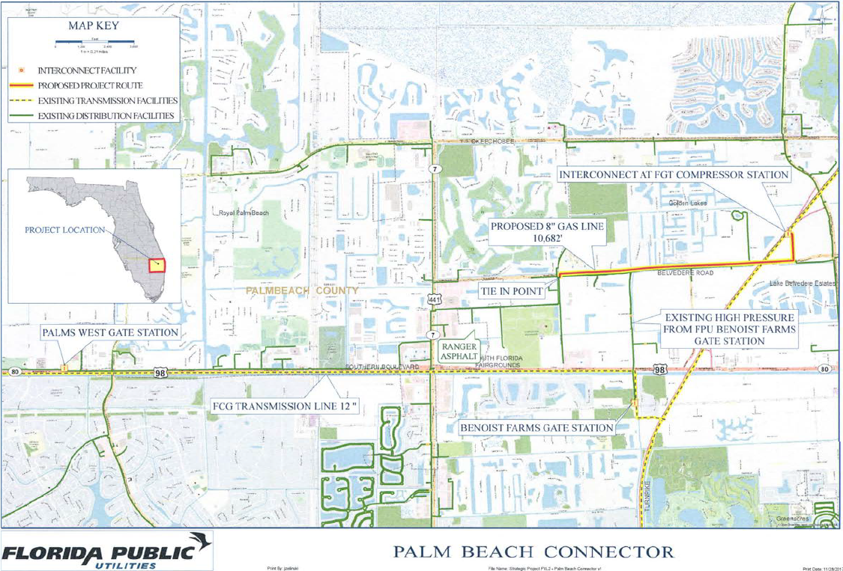

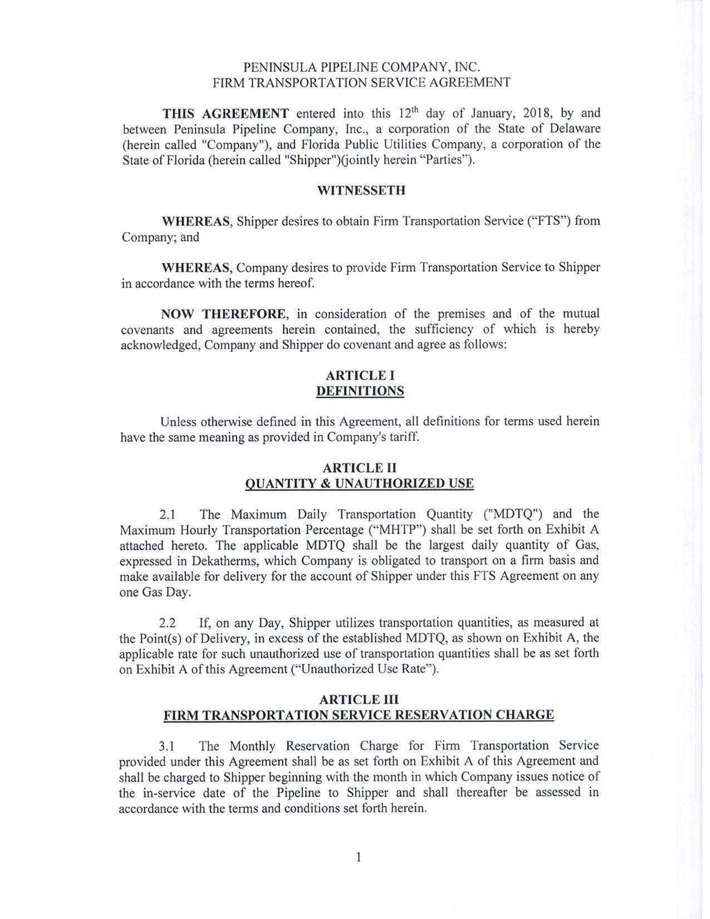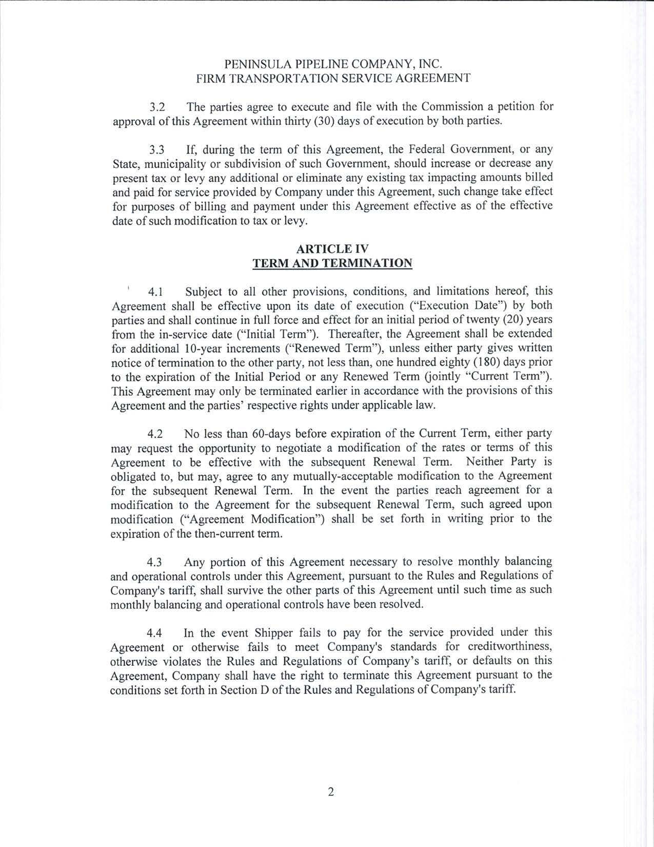

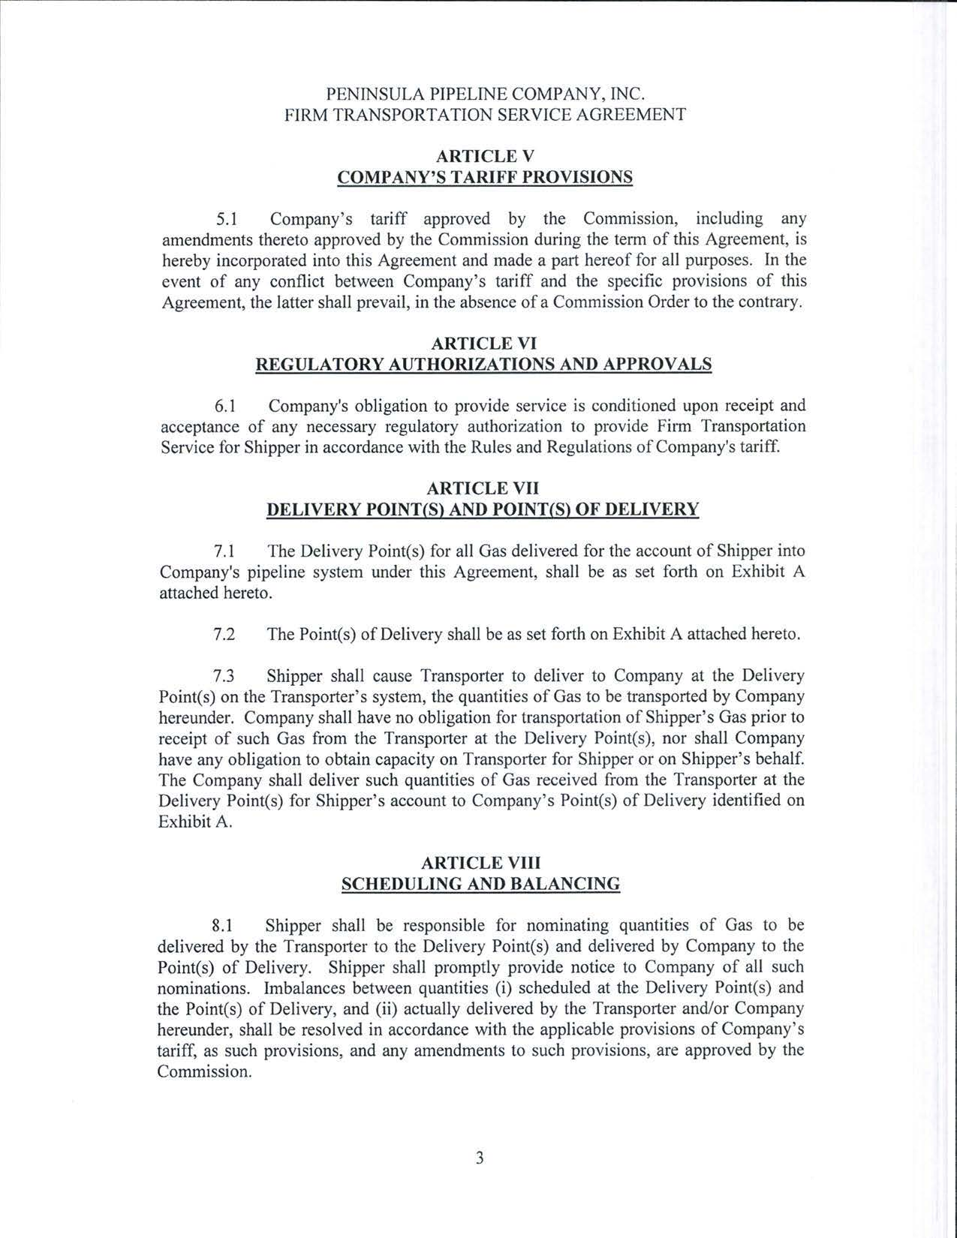

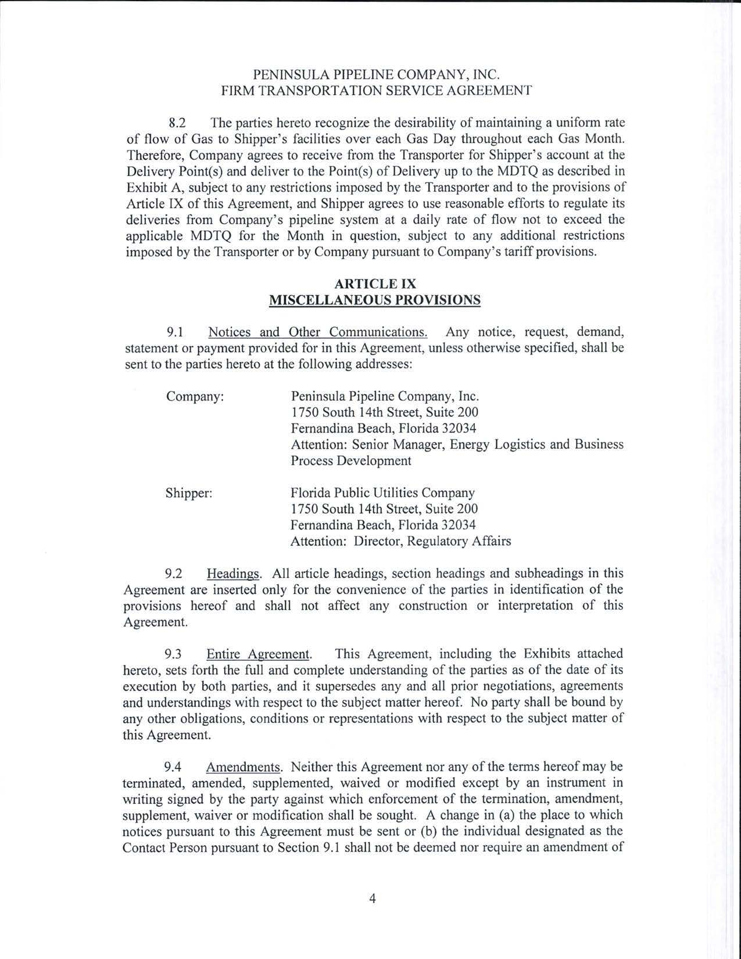

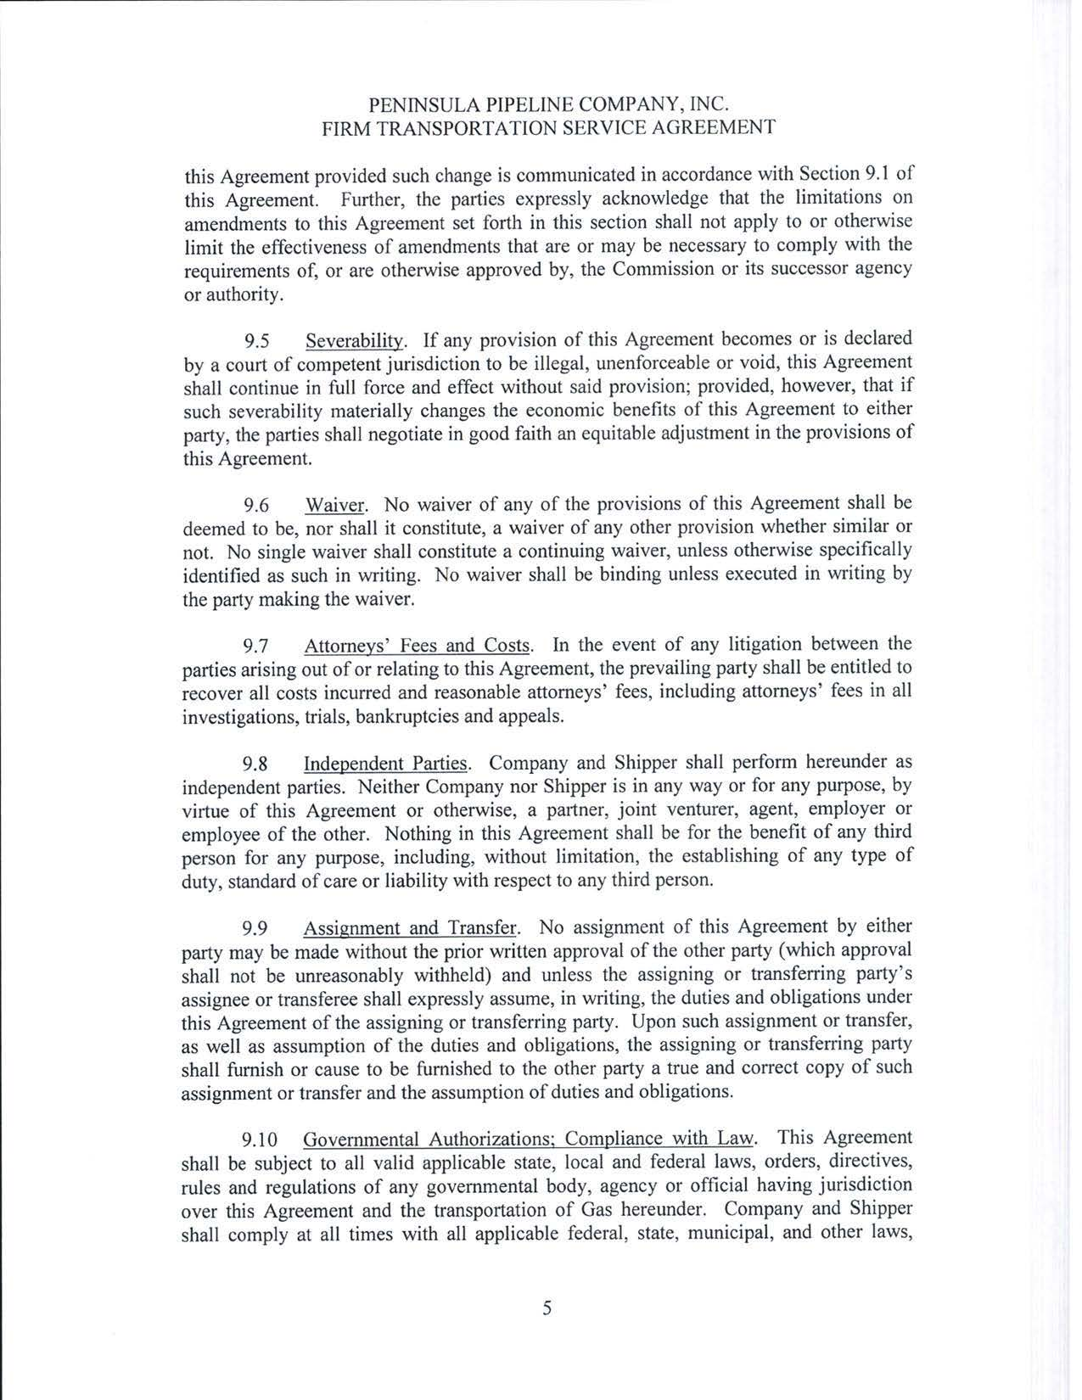

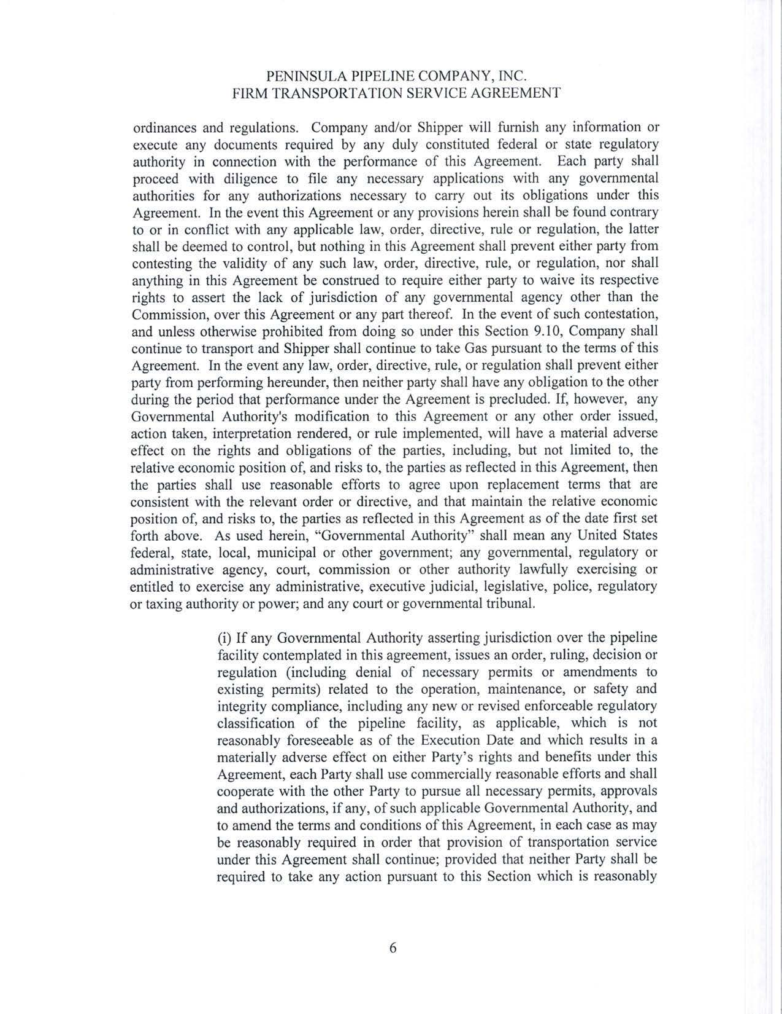

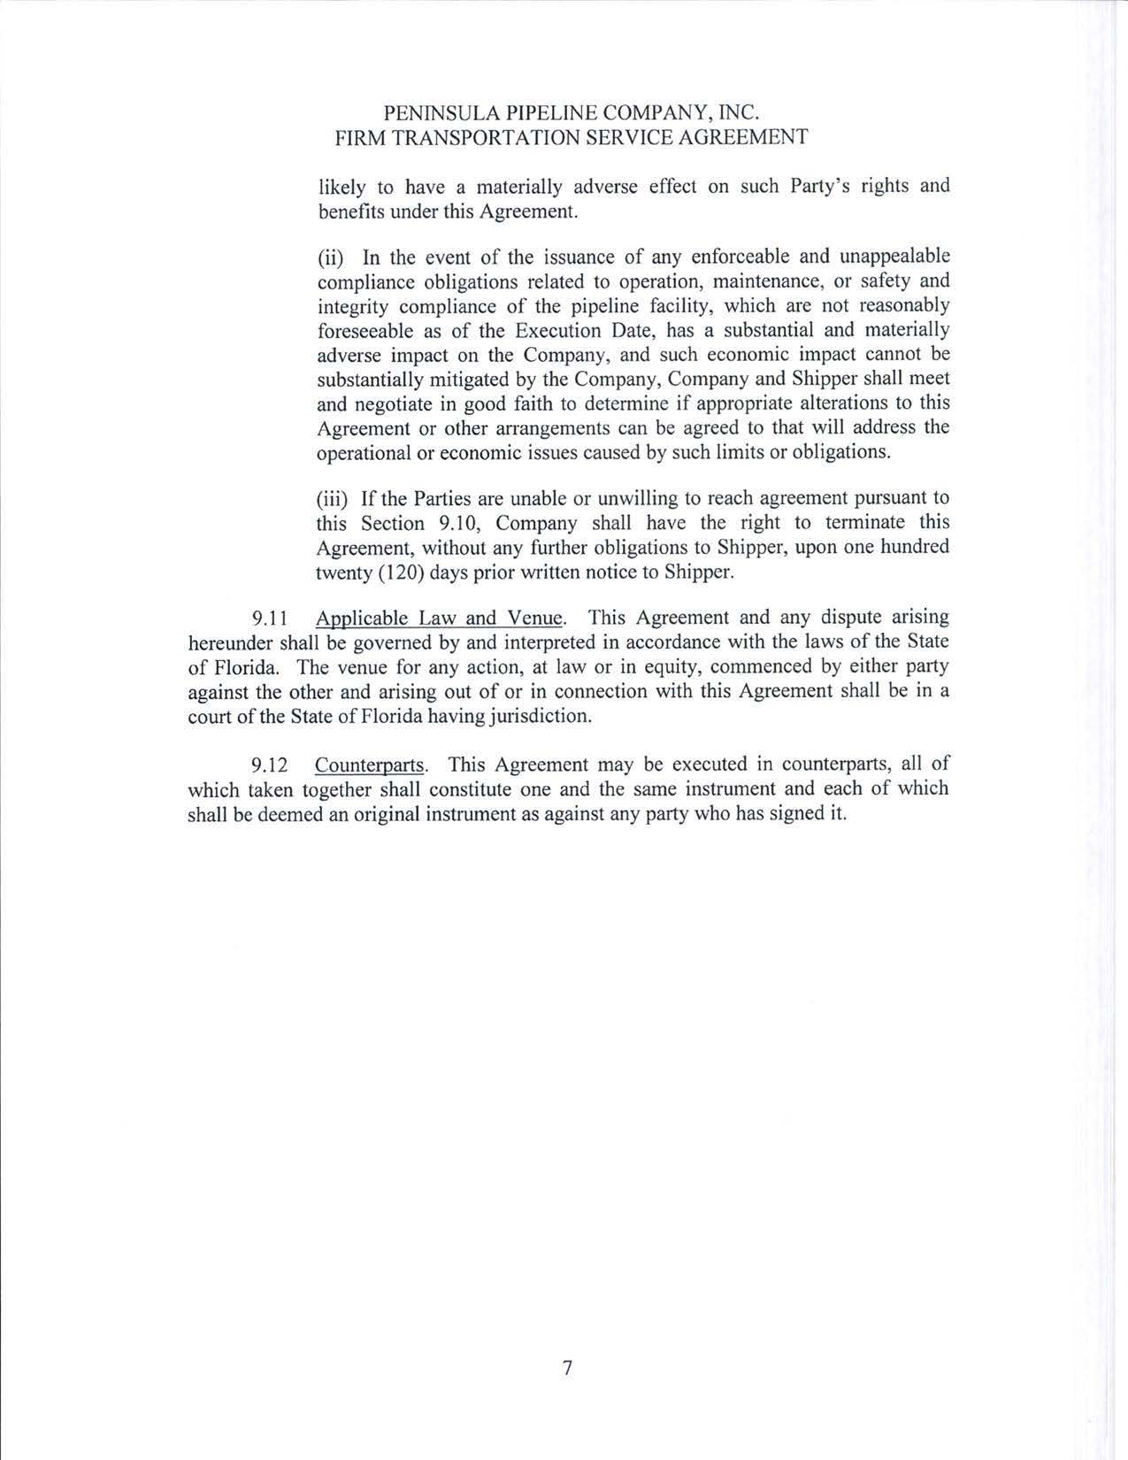

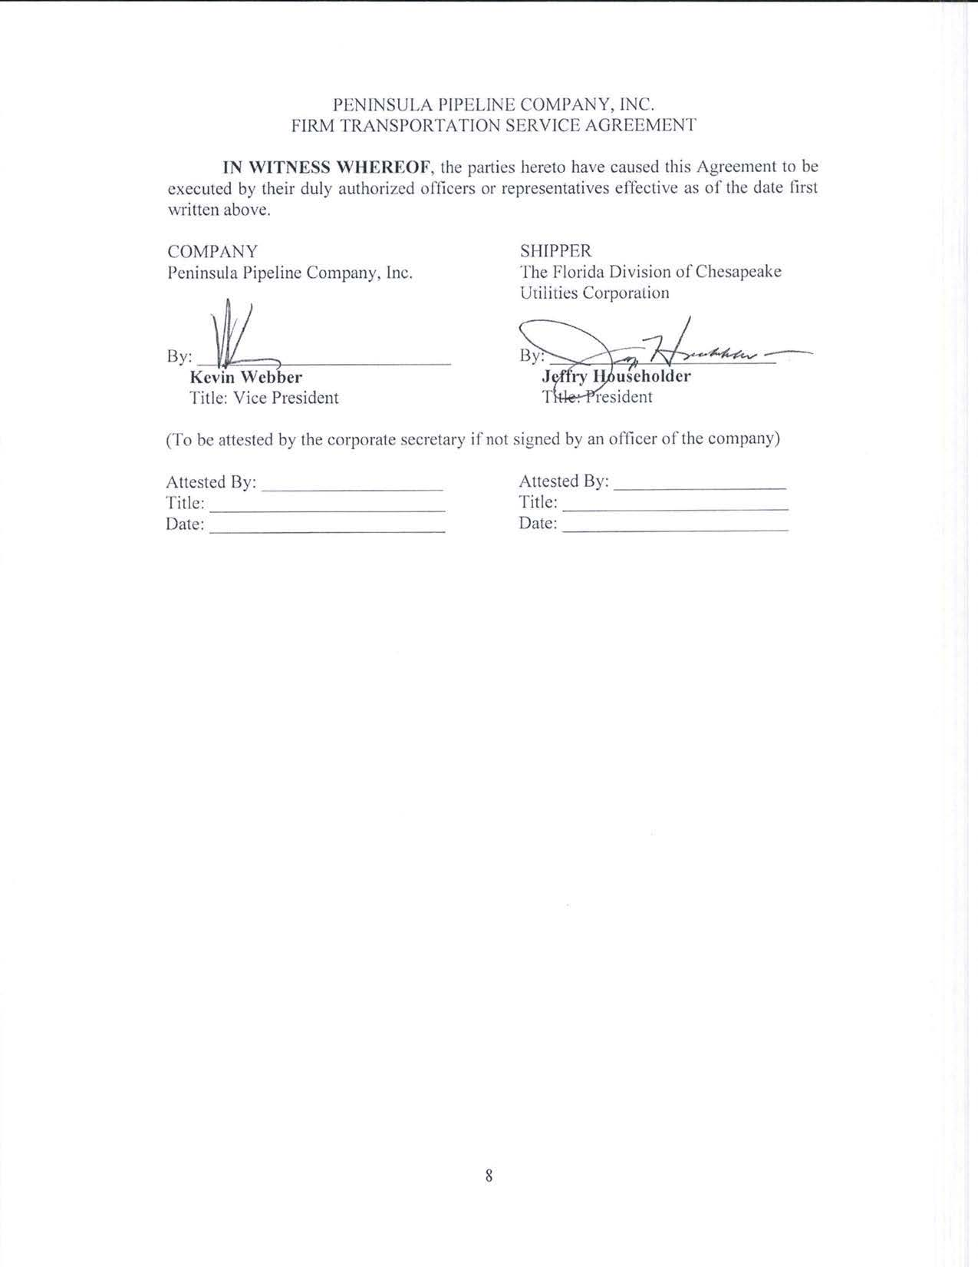

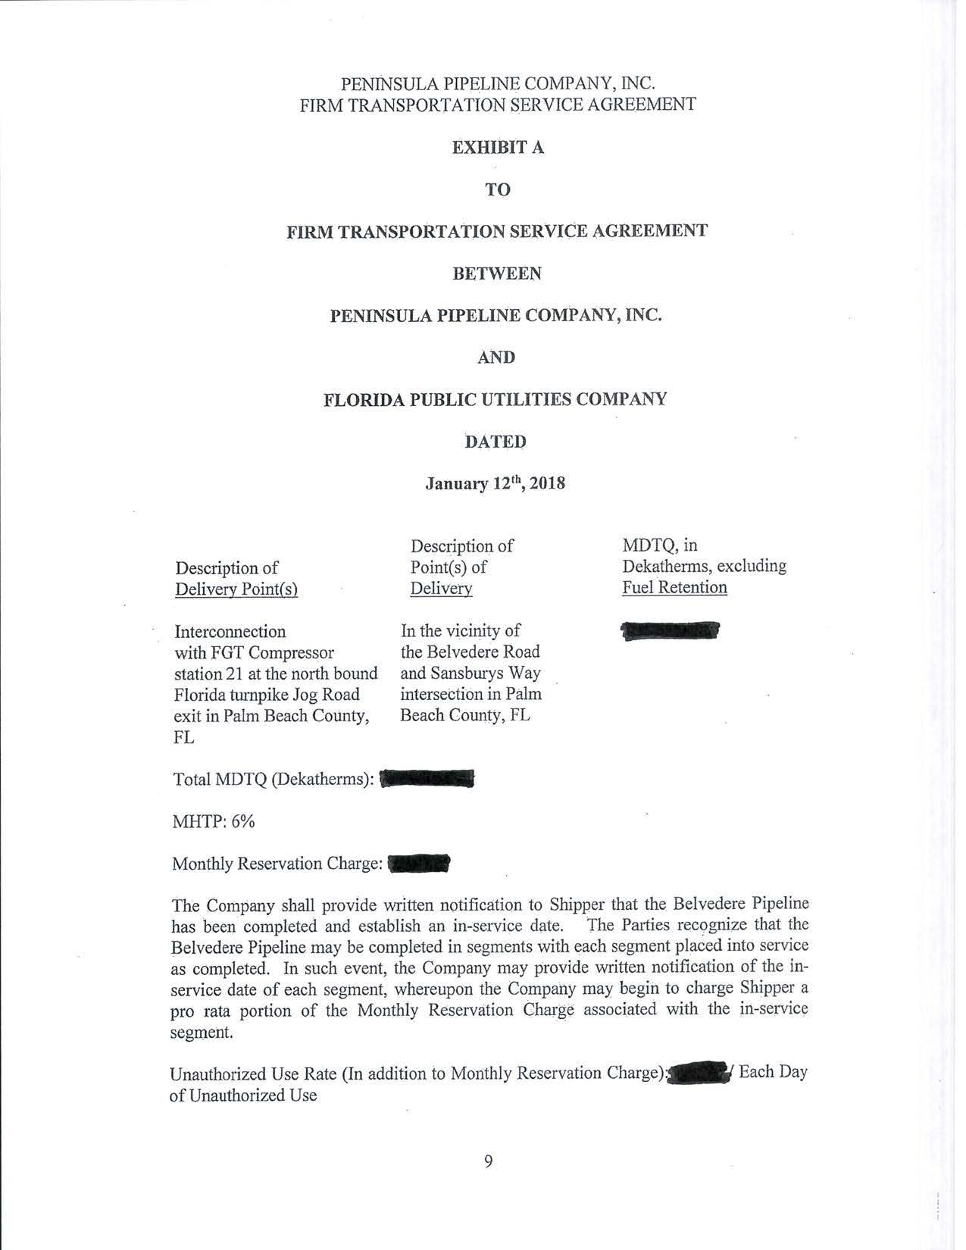

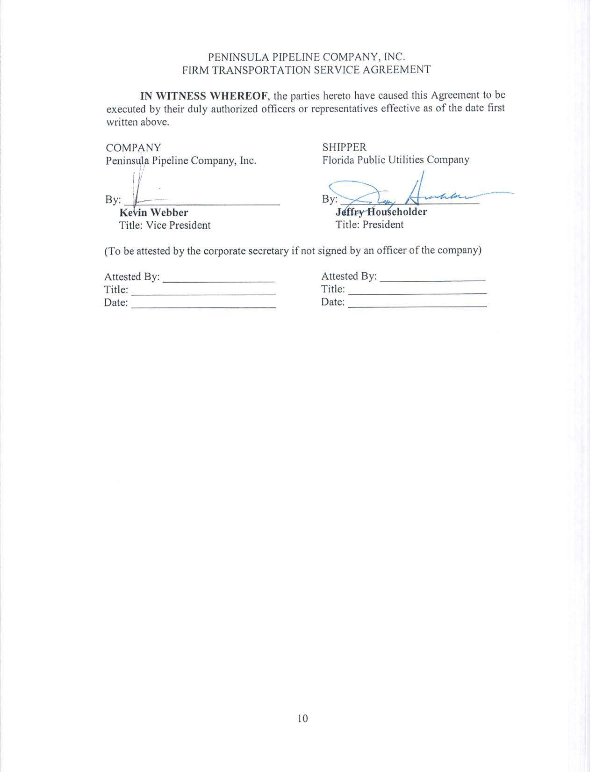

Order No. PSC-06-0023-DS-GP, issued January 9, 2006, in Docket No. 050584-GP, In re: Petition for declaratory statement by Peninsula Pipeline Company, Inc. concerning recognition as a natural gas transmission company under Section 368.101, F.S., et seq.
Order No. PSC-07-1012-TRF-GP, issued December 21, 2007, in Docket No. 070570-GP, In re: Petition for approval of natural gas transmission pipeline tariff by Peninsula Pipeline Company, Inc.
Peninsula Pipeline Company, Inc., Intrastate Pipeline Tariff, Original Vol. 1, Sheet No. 12, Section 4.
Order No. PSC-2017-0467-CO-GU, issued December 12, 2017, in Docket No. 170191-GU, In re: Joint petition for approval of revised swing service rider rates for the period January through December 2018, by Florida Public Utilities Company, Florida Public Utilities Company-Indiantown Division, Florida Public Utilities Company-Fort Meade and Florida Division of Chesapeake Utilities Corporation.

