State of Florida |  | Public Service Commission  Capital Circle Office Center ● 2540 Shumard Oak Boulevard  Tallahassee, Florida 32399-0850  -M-E-M-O-R-A-N-D-U-M-
DATE: | May 23, 2018
TO: | Office of Commission Clerk (Stauffer)
FROM: | Division of Engineering (Mtenga, King)  Office of the General Counsel (Murphy)
RE: | Docket No. 20180007-EI – Environmental cost recovery clause.
AGENDA: | 06/05/18 – Regular Agenda – Interested Persons May Participate
COMMISSIONERS ASSIGNED: |  |  | All Commissioners
PREHEARING OFFICER: |  |  | Clark
CRITICAL DATES: |  |  | None
SPECIAL INSTRUCTIONS: |  |  | Please take up this item following the recommendation for Docket No. 20180001-EI.

Case Background
On April 16, 2018, Florida Power & Light Company (FPL or Company) filed a Petition for Mid-Course Corrections to its 2018 Environmental Cost Recovery Clause (ECRC) factors that reflect the impact of the Tax Cuts and Jobs Act of 2017 (Mid-Course Petition). By its Mid-Course Petition, FPL seeks to reduce the 2018 ECRC factors that were approved in Order No. PSC-2018-0100-FOF-EI.
Mid-course corrections are rare in the ECRC docket and are more typical in the fuel docket. Mid-course corrections are considered preliminary procedural decisions, and any over-recoveries or under-recoveries resulting from the approval by the Florida Public Service Commission (Commission) may be adjusted in the following year proceeding.
The Tax Cuts and Jobs Act of 2017 (Tax Act) was signed into law on December 22, 2017, about four months after FPL filed its projection testimony and cost recovery schedules for 2018. In addition to filing its Mid-Course Petition in Docket No. 20180007-EI, FPL filed similar petitions in Docket No. 20180001-EI, the Fuel and Capacity Cost Recovery Clause docket, and in Docket No. 20180046-EI, Consideration of the tax impacts associated with Tax Cuts and Jobs Act of 2017 for FPL.
The Commission has jurisdiction over this matter pursuant to Section 366.05 and 366.8255, Florida Statutes. (F.S.)

Discussion of Issues

Issue 1:
Should the Commission approve FPL’s Mid-Course Petition to correct its 2018 ECRC factors and associated tariff sheets?

Recommendation:
Yes. Staff recommends approval of FPL’s Mid-Course Petition which was filed to address a federal tax reduction. Approval will allow for a reduction in the ECRC factors and will decrease customer bills. The revised factors and associated tariffs should become effective July 1, 2018. (Mtenga)

Staff Analysis:
The projected ECRC costs for 2018 were developed before the Tax Act was signed into law. The Tax Act will have the effect of lowering the federal income tax rate for corporations from 35 percent to 21 percent; therefore, some of the costs embedded into the total projected ECRC costs for 2018 are overstated. Federal income tax amounts are included in the calculation of the costs that have a capital component. Adjustments for tax impacts on revenue requirements recovered through the ECRC will change the currently approved factors. The impact of the Tax Act on FPL’s ECRC cost projections result in an over-recovery of approximately $19.1 million or 9.2 percent. Approval of FPL’s Mid-Course Petition will result in a reduction to the typical 1,000 kWh monthly residential customer bill of $0.36. The revised tariffs are included as Attachment A. In its May 10, 2018, response to staff’s second set of interrogatories No. 19, FPL indicated that the Company will include a short bill insert on all customer bills 30 days in advance of the rates taking effect, and will provide updated rate schedules on its website.
FPL’s Mid-Course Petition was filed with the intention of the proposed decrease in rates becoming effective July 1, 2018. Typically, effective dates are set at a minimum of 30 days after a Commission vote modifying the charges as the result of a mid-course correction. This time limit is imposed in order to not have new rates applied to energy consumed before the effective date of the Commission’s action. However, the Commission has also implemented charges in less than 30 days when circumstances warrant. In this instance, the interval between the Commission’s vote on this matter (June 5, 2018), and the proposed implementation date (expected to be July 1, 2018) is 25 days. Since this filing, if approved, results in a decrease to cost recovery factors, staff recommends that the 25 day interval is sufficient.

Staff recommends approval of FPL’s Mid-Course Petition which was filed to address a federal tax reduction. Approval will allow for a reduction in the ECRC factors and will decrease customer bills. The revised factors and associated tariffs should become effective July 1, 2018.
Issue 2:
Should this docket be closed?

Recommendation:
No. The ECRC docket is on-going and should remain open. (Murphy)

Staff Analysis:
The ECRC docket is on-going and should remain open.
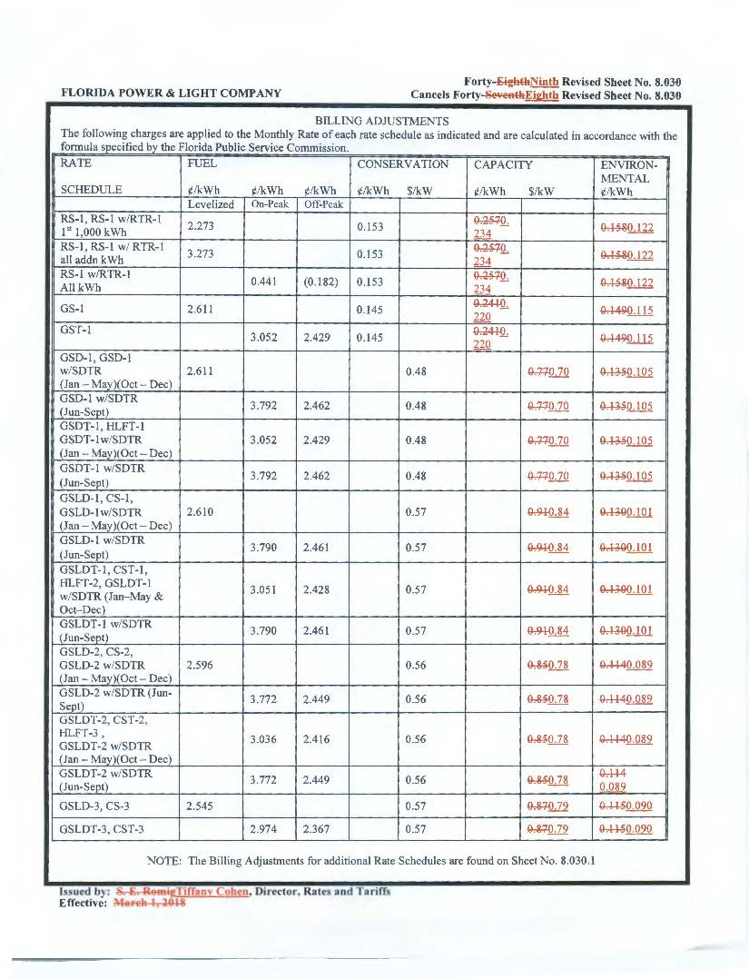

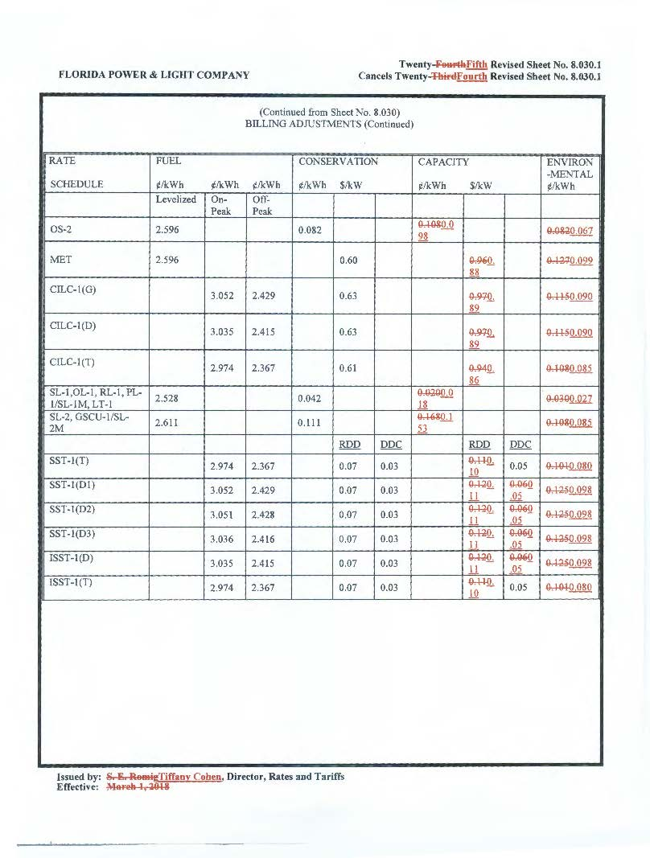

The capacity cost recovery portion of FPL’s Mid-Course Petition will be addressed in Docket No. 20180001-EI.
Order No. PSC-2018-0100-FOF-EI, issued February 22, 2018, in Docket No. 20180007-EI, In re: Environmental Cost Recovery Clause.
Gulf Power Co. v. Cresse, 410 So. 2d 492 (Fla. 1982); Order No. PSC-96-0907-FOF-EI, issued July 15, 1996, in Docket No. 19960001-EI, In re: Fuel and purchased power cost recovery clause and generating performance incentive factor; Order No. PSC-96-0908-FOF-EI, issued July 15, 1996, in Docket No. 19960001-EI, In re: Fuel and purchased power cost recovery clause and generating performance incentive factor; Order No. PSC-97-0021-FOF-EI, issued January 6, 1997, in Docket No. 19970001-EI, In re: Fuel and purchased power cost recovery clause and generating performance incentive factor.
Order No. PSC-01-0963-PCO-EI, issued April 18, 2001, in Docket No. 20010001-EI, In re: Fuel and purchased power cost recovery clause and generating performance incentive factor (allowing recovery of increase in fuel factor in order to decrease the carrying costs and therefore the total amount ratepayers were ultimately required to repay.); Order No. PSC-00-2383-FOF-GU, issued December 12, 2000, in Docket No. 20000003-GU, In re: Purchased gas adjustment (PGA) true-up (allowing recovery of an increased gas fuel factor due to drastic increases in natural gas prices in winter of 2000-2001.); Order No. PSC-15-0161-PCO-EI, issued April 30, 2015, in Docket No. 20150001-EI, In re: Fuel and Purchased Power Cost Recovery Clause with Generating Performance Incentive Factor (approving FPL’s petition for a mid-course correction, thereby reducing fuel factors with less than 30 days notice).

