State of Florida |  | Public Service Commission  Capital Circle Office Center ● 2540 Shumard Oak Boulevard  Tallahassee, Florida 32399-0850  -M-E-M-O-R-A-N-D-U-M-
DATE: | May 23, 2018
TO: | Office of Commission Clerk (Stauffer)
FROM: | Division of Accounting and Finance (Barrett, Galloway)  Division of Economics (Draper, Guffey)  Office of the General Counsel (Brownless)
RE: | Docket No. 20180001-EI – Fuel and purchased power cost recovery clause with generating performance incentive factor.
AGENDA: | 06/05/18 – Regular Agenda – Interested Persons May Participate
COMMISSIONERS ASSIGNED: |  |  | All Commissioners
PREHEARING OFFICER: |  |  | Clark
CRITICAL DATES: |  |  | None
SPECIAL INSTRUCTIONS: |  |  | Please take up this item and the recommendation for Docket No. 20180007-EI consecutively.

Case Background
On April 16, 2018, Florida Power & Light Company (FPL) filed a Petition for Mid-Course Corrections to its 2018 Capacity and Environmental Cost Recovery Factors that reflect the impact of the Tax Cuts and Jobs Act of 2017 (FPL Mid-Course Petition). The FPL Mid-Course Petition seeks to reduce the respective 2018 capacity cost recovery factors that were approved in Order No. PSC-2018-0105-PCO-EI, and the environmental cost recovery factors that were approved in Order No. PSC-2018-0100-FOF-EI. Staff notes that the capacity cost recovery portion of FPL’s Mid-Course Petition will be addressed in Docket No. 20180001-EI, and environmental cost recovery clause reduction will be addressed in Docket No. 20180007-EI.
Mid-course corrections are part of the fuel and purchased power cost recovery clause (fuel clause) proceeding, and such corrections are used by the Commission between fuel clause hearings whenever costs deviate from revenues by a significant margin. Petitions for mid-course corrections to fuel factors are addressed in Rule 25-6.0424, Florida Administrative Code (F.A.C.). Under this rule, a utility must notify the Commission whenever it expects to experience an under-recovery or over-recovery greater than 10 percent. Pursuant to Rule 25-6.0424, F.A.C., the mid-course percentage is the estimated end-of-period total net true-up amount divided by the current period’s total actual and estimated jurisdictional fuel revenue applicable to period amount.
Mid-course corrections are considered preliminary procedural decisions, and any over-recoveries or under-recoveries caused by or resulting from the Commission-approved adjusted fuel or capacity factors may be included in the following year’s fuel or capacity factors.
The Commission’s jurisdiction to consider fuel clause proceedings derives from the Commission’s authority to set fair and reasonable rates, found in Section 366.05, Florida Statutes.

Discussion of Issues

Issue 1:
Should the Commission approve FPL's Mid-Course Petition to correct its capacity cost recover factors and the associated tariff sheets?

Recommendation:
Yes. FPL’s request for mid-course correction to its 2018 capacity cost recovery factors and the associated tariff sheets should be approved. The recommended capacity cost recovery factors are presented in Attachment A and the associated tariff sheets are presented in Attachment B. The revised capacity cost recovery factors and the associated tariff sheets should become effective with the July 2018 billing cycle, which begins on July 1, 2018. The Commission should give staff administrative authority to approve the tariff sheets implementing the approved rate adjustments. (Barrett, Galloway, Draper, Guffey)

Staff Analysis:
The Tax Cut and Jobs Act of 2017 was signed into law on December 22, 2017, about 4 months after FPL filed its projection testimony and cost recovery schedules for 2018. FPL’s Mid-Course Petition is the second similar filing made in this docket in 2018, the first occurring when the impact of the St. Johns River Power Park Transaction was addressed by Commission in the First Mid-Course Order. As noted in the instant petition, this proposed correction is primarily applicable to capacity and environmental cost recovery factors, and only minimally applicable to the Conservation Cost Recovery Clause. In addition to filing its Mid-Course Petition in Docket No. 20180001-EI (the Fuel and Capacity Cost Recovery Clause docket), FPL filed it in Docket Nos. 20180007-EI (the Environmental Cost Recovery Clause), and in 20180046-EI (Consideration of the tax impacts associated with Tax Cuts and Jobs Act of 2017 for Florida Power & Light Company).

Midcourse Adjustment for Capacity Cost Recovery (CCR) Factors
FPL’s currently authorized 2018 fuel and capacity amounts and factors are codified in the First Mid-Course Order, which projected total capacity costs of $282,109,414 for 2018. Because this projection of total capacity-related costs was developed before the Tax Cuts and Jobs Act of 2017 lowered the federal income tax rate for corporations from 35 percent to 21 percent, many of the costs embedded in that total are now overstated. Federal income tax rate amounts are included in the calculation of the capacity costs that have a capital component, such as the Cedar Bay, Indiantown, and St. John River Power Park Transactions, or the capital-related costs for Incremental Power Plant Security, as shown in Schedule E12A/B of FPL’s Mid-Course Petition. When the lower federal income tax amount is incorporated into the projected costs, the revised total capacity costs for 2018 are $261,614,030. When the true-up provision amounts are applied and final calculations are performed, the total end-of-period balance reflects that FPL would over-recover its capacity costs for 2018 by $12,071,089, or 4.61 percent.
If FPL’s Mid-Course Petition is granted, this amount would be recovered through reduced capacity cost recovery factors for July–December 2018. For a residential customer using 1,000 kilowatt hours (kWh) of electricity, the capacity portion of their bill will be reduced by $0.23. The revised capacity cost recovery factors are reflected on Attachment A.
As noted previously, the FPL Mid-Course Petition also seeks to reduce the respective 2018 environmental cost recovery factors, as addressed in a recommendation filed in Docket No. 20180007-EI. A typical bill comparison for a residential customer using 1,000 kWh of electricity is presented in Attachment C showing all of the changes that would be implemented in the July billing cycle, pending Commission approval.
Bill Impact and Customer Notifications
Consistent with the First Mid-Course Order, the current bill for a residential customer using 1,000 kWh of electricity for the period March-December, 2018, is $99.37 per month, with a capacity cost recovery component of $2.57 per month. As proposed, the capacity cost recovery component will be reduced by $0.23 per month, to $2.34 per month. In addition, an environmental cost recovery clause reduction of $0.36 per month is being addressed in Docket No. 20180007-EI, and a small change is proposed for the storm bond charge. The sum of those three changes results in a slight reduction to the Gross Receipts Tax, as well. Pending the Commission’s approval in this matter and the similar consideration in Docket No. 20180007-EI, the proposed bill for a residential customer using 1,000 kWh of electricity for July-August, 2018, is projected to be $98.87 per month, as shown and presented in Column 3 from Table 1 of Attachment C.

Staff believes implementing reduced capacity cost recovery factors is in the best interests of FPL’s customers because the factors would be decreasing, and customers would receive the benefit of reduced rates as quickly as administratively possible.

In its May 30 2018, response to Commission staff’s Second Data Request, Question No. 5, FPL stated that it will notify customers with bill inserts 30 days in advance of the rates taking effect. In addition, FPL stated the billing changes identified in the instant petition will be addressed in the Company’s next quarterly newsletter (to be published in July 2018). FPL’s website will include links to show the proposed rate schedules for residential and business rate classes that are proposed to become effective July 1, 2018. The Company stated that physical restrictions on bill inserts limit the amount of detail that can be included in such notifications, but noted its customers can access detailed billing information from links on the Company’s website.

If approved by the Commission, this mid-course correction will result in lower capacity cost recovery factors for FPL’s customers. This mid-course correction was filed by FPL with the intention of the proposed decrease in rates becoming effective July 1, 2018. Typically, effective dates are set a minimum of 30 days after a Commission vote modifying the charges as the result of a mid-course correction. This time limit is imposed in order to not have new rates applied to energy consumed before the effective date of the Commission’s action, i.e., the date of the vote. However, the Commission has also implemented charges in less than 30 days when circumstances warrant. In this instance, the interval between the Commission’s vote on this matter (June 5, 2018) and the proposed implementation date (expected to be July 1, 2018) is 25 days. Because this filing, if approved, results in a decrease to cost recovery factors, staff believes the 25 day interval is sufficient.

Conclusion
Staff recommends the Commission approve FPL’s request for mid-course correction to its 2018 capacity cost recovery factors and the associated tariff sheets. The recommended capacity cost recovery factors are presented in Attachment A and the associated tariff sheets are presented in Attachment B. The revised capacity cost recovery factors and the associated tariff sheets should become effective with the July 2018 billing cycle, which begins on July 1, 2018. The Commission should give staff administrative authority to approve the tariff sheets implementing the approved rate adjustments.

Issue 2:
Should this docket be closed?

Recommendation:
The fuel docket is on-going and should remain open. (Brownless)

Staff Analysis:
The fuel docket is on-going and should remain open.

Table 1
FPL Revised Capacity Cost Recovery Factors
for the Period July-December, 2018
Rate Schedule | $/kW | $/kWh | Reservation Demand Charge (RDC) $/kW | Sum of Daily Demand Charge (SDD) $/kW
RS1/RTR1 | - | 0.00234 | - | -
GS1/GST1 | - | 0.00220 | - | -
GSD1/GSDT1/HLFT1 | 0.70 | - | - | -
OS2 | - | 0.00098 | - | -
GSLD1/GSLDT1/CS1/CST1/HLFT2 | 0.84 | - | - | -
GSLD2/GSLDT2/CS2/CST2/HLFT3 | 0.78 | - | - | -
GSLD3/GSLDT3/CS3/CST3 | 0.79 | - | - | -
SST1T | - | - | $0.10 | $0.05
SST1D1/SST1D2/SST1D3 | - | - | $0.11 | $0.05
CILC D/CILC G | 0.89 | - | - | -
CILC T | 0.86 | - | - | -
MET | 0.88 | - | - | -
OL1/SL1/SL1M/PL1 | - | 0.00018 | - | -
SL2/SL2M/GSCU1 | - | 0.00153 | - | -
Source: Schedule E1-E, Appendix 1, Page 5 of 20 from Mid-Course Petition

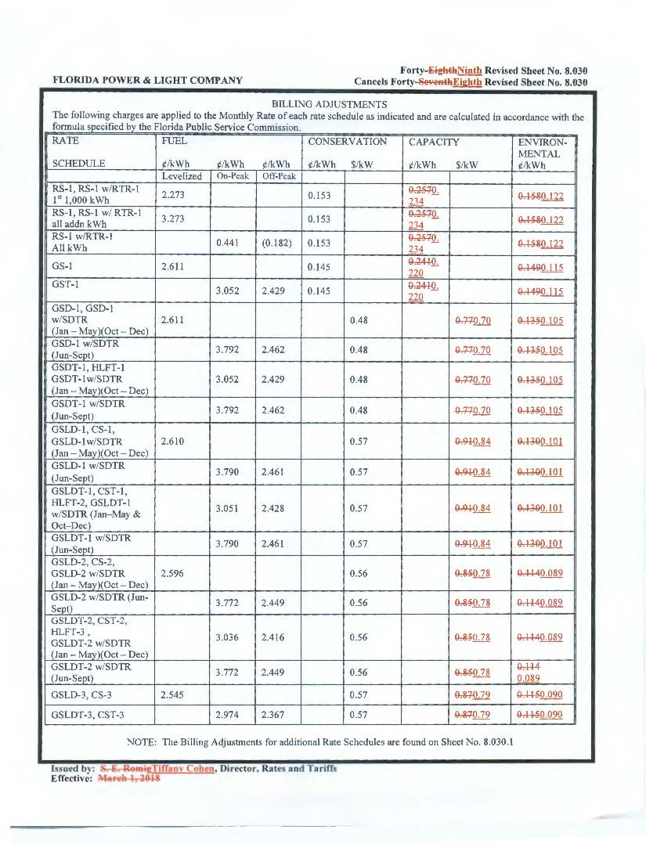

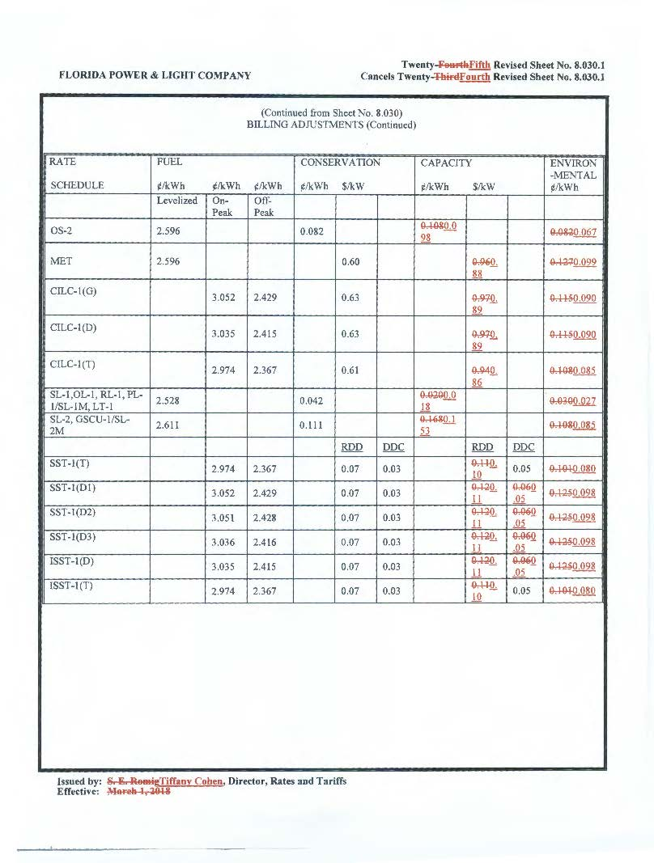
Table 1
FPL Typical 1,000-kWh Residential Customer Bill Comparison
for the period July-December, 2018
(1) | (2) | (3) | (4) | (5) | (6)
Component | Current  March 2018 | Proposed  July-August  2018 | Net Difference | Proposed  September-December  2018 | Net Difference
Base Charge | $67.10 | $67.10 | $0.00 | $66.88 | ($0.22)
Fuel Cost Recovery | $22.73 | $22.73 | $0.00 | $22.93 | $0.20
Energy Conservation Cost Recovery | $1.53 | $1.53 | $0.00 | $1.53 | $0.00
Capacity Cost Recovery | $2.57 | $2.34 | ($0.23) | $2.34 | $0.00
Environmental Cost Recovery | $1.58 | $1.22 | ($0.36) | $1.22 | $0.00
Storm Bond Charge | $1.38 | $1.48 | $0.10 | $1.48 | $0.00
Interim Storm Restoration Surcharge | $0.00 | $0.00 | $0.00 | $0.00 | $0.00
Subtotal | $96.89 | $96.40 | ($0.49) | $96.38 | ($0.02)
Gross Receipts Tax | $2.48 | $2.47 | (0.01) | $2.47 | $0.00
Totals | $99.37 | $98.87 | ($0.50) | $98.85 | ($0.02)
Source: Schedule E-10, attached to FPL’s Mid-Course Petition, dated April 16, 2018.

By Order No. PSC-2018-0105-PCO-EI, issued February 26, 2018, in Docket No. 20180001-EI (First Mid-Course Order), In re: Fuel and Purchased Power Cost Recovery Clause with Generating Performance Incentive Factor, the Commission approved a prior mid-course correction from FPL. The instant pleading is the second petition for a mid-course correction FPL has filed in this docket in 2018.
Order No. PSC-2018-0100-FOF-EI, issued February 22, 2018, in Docket No. 20180007-EI, In re: Environmental Cost Recovery Clause.
Order No. PSC-2018-0105-PCO-EI, issued February 26, 2018, in Docket No. 20180001-EI, In re: Fuel and Purchased Power Cost Recovery Clause with Generating Performance Incentive Factor.
In its Mid-Course Petition, FPL stated that the Conservation Cost Recovery Clause adjustment attributable to the Tax Cut and Jobs Act of 2017 was too small to warrant a mid-course correction; instead, the Company believes the adjustment can be recovered in the ordinary true-up process for that clause.
These amounts do not reflect any storm-related charges attributable to named storms that impacted FPL’s service territory in the 2017 hurricane season, nor do they reflect a true-up adjustment to the storm restoration surcharge FPL addressed in its May 30, 2018, response to Commission staff’s Second Data Request, Question No. 7. In addition, these amounts do not reflect any changes that may be approved by the Commission in other docketed matters.
The storm bond charge will become effective on June 1, 2018, whereas the clause-adjustment changes are scheduled to become effective July 1, 2018. In its May 30 2018, response to Commission staff’s Second Data Request, Question No. 7, FPL stated that it included the billing change for storm bond charge in Schedule E-10 for informational purposes only, in order to provide the full impact on the typical 1,000 kWh residential bill from current rates to the proposed rates that would go into effect on July 1, 2018. On April 2, 2018, in Docket No. 20060038-EI, FPL filed its routine storm charge quarterly true-up adjustment to the storm recovery bond repayment charges and the storm recovery bond tax charges. Based on this true-up adjustment, the residential storm bond charge will increase from $1.38 to $1.48 for the typical residential 1,000 kWh customer bill.
As of May 30, 2018, the date FPL filed its response to Commission staff’s Second Data Request, draft copies of the newsletter article were not yet available for staff to review. However, FPL committed to provide advance copies before the publication date.
Gulf Power Co. v. Cresse, 410 So. 2d 492 (Fla. 1982); Order No. PSC-96-0907-FOF-EI, issued on July 15, 1996, in Docket No. Docket No. 19960001-EI, In re: Fuel and purchased power cost recovery clause and generating performance incentive factor; Order No. PSC-1996-0908-FOF-EI, issued July 15, 1996, in Docket No. 19960001-EI, In re: Fuel and purchased power cost recovery clause and generating performance incentive factor; Order No. PSC-97-0021-FOF-EI, issued on January 6, 1997, in Docket No. 19970001-EI, In re: Fuel and purchased power cost recovery clause and generating performance incentive factor.
Order No. PSC-01-0963-PCO-EI, issued April 18, 2001, in Docket No. 20010001-EI, In re: Fuel and purchased power cost recovery clause and generating performance incentive factor (allowing recovery of increase in fuel factor in order to decrease the carrying costs and therefore the total amount ratepayers were ultimately required to repay.); Order No. PSC-00-2383-FOF-GU, issued December 12, 2000, in Docket No. 20000003-GU, In re: Purchased gas adjustment (PGA) true-up (allowing recovery of an increased gas fuel factor due to drastic increases in natural gas prices in winter of 2000-2001.); Order No. PSC-15-0161-PCO-EI, issued April 30, 2015, in Docket No. 20150001-EI, In re: Fuel and Purchased Power Cost Recovery Clause with Generating Performance Incentive Factor (approving FPL’s petition for a mid-course correction, thereby reducing fuel factors with less than 30 days notice).
RDC=((Total Capacity Costs )/(Projected Avg. 12CP @gen)(.10)(demand loss expansion factor)/12 months
SDD=((Total Capacity Costs )/(Projected Avg. 12CP @gen)(21 on peak days)(demand loss expn. factor)/12 months
Reflects approval of the Mid-Course corrections to Capacity and Environmental Cost Recovery Clause amounts, and a true-up adjustment in storm charges, as filed in Docket No. 20180001-EI.
The Net Difference shown in Column 4 of Table 1 reflects the true-up adjustment in storm charges effective June 1, 2018, and the Mid-Course Corrections to Capacity and Environmental Cost Recovery Clause amounts, effective July 1, 2018. It does not reflect the Martin-Riviera Natural Gas Pipeline transfer petition in Docket No. 20170231-EI, which, if approved, would change Base and Fuel Cost Recovery amounts, effective September 1, 2018.
Reflects approval of the proposed Martin-Riviera pipeline lateral transfer, pending in Docket No. 20170231-EI.
The Net Difference shown in Column 6 of Table 1 reflects the true-up adjustment in storm charges effective June 1, 2018, the Mid-Course Corrections to Capacity and Environmental Cost Recovery Clause amounts effective July 1, 2018, and the Martin-Riviera Natural Gas Pipeline transfer petition that is pending in Docket No. 20170231-EI, which, if approved, would change Base and Fuel Cost Recovery amounts, effective September 1, 2018.

