State of Florida |  | Public Service Commission  Capital Circle Office Center ● 2540 Shumard Oak Boulevard  Tallahassee, Florida 32399-0850  -M-E-M-O-R-A-N-D-U-M-
DATE: | May 23, 2018
TO: | Office of Commission Clerk (Stauffer)
FROM: | Division of Economics (Doherty)  Office of the General Counsel (Mapp)
RE: | Docket No. 20180086-EI – Petition for approval of revised underground residential distribution tariffs, by Tampa Electric Company.
AGENDA: | 06/05/18 – Regular Agenda – Tariff Filing – Interested Persons May Participate
COMMISSIONERS ASSIGNED: |  |  | All Commissioners
PREHEARING OFFICER: |  |  | Administrative
CRITICAL DATES: |  |  | 06/12/18 (60-Day Suspension Date)
SPECIAL INSTRUCTIONS: |  |  | None

Case Background
On April 2, 2018, Tampa Electric Company (TECO or utility) filed a petition for approval of its revised underground residential distribution (URD) tariffs. The proposed tariffs and associated charges are shown in legislative format in Attachment A of the recommendation. TECO’s current URD tariffs were approved in Order No. PSC-2017-0293-TRF-EI.
Rule 25-6.078, Florida Administrative Code (F.A.C.), defines investor-owned utilities’ (IOU) responsibilities for filing updated URD tariffs. TECO has filed the instant petition pursuant to subsection (3) of the rule, which requires IOUs to seek Commission approval of updated URD tariff charges if the utility’s per-lot cost differentials between overhead and underground service based on current material and labor costs vary by more than 10 percent from the existing Commission-approved differentials. All IOUs are required to file supporting data and analyses for URD tariffs at least once every three years.
The URD tariffs provide standard charges for underground service in new residential subdivisions and represent the additional costs, if any, the utility incurs to provide underground service in place of overhead service. The cost of standard overhead construction is recovered through base rates from all ratepayers. In lieu of overhead construction, customers have the option of requesting underground facilities. Typically, the URD customer is the developer of the subdivision.
Staff issued one data request and in its response TECO provided certain corrections to the cost support. The Commission has jurisdiction over this matter pursuant to Sections 366.03, 366.04, 366.05, and 366.06, Florida Statutes.

Discussion of Issues

Issue 1:
Should the Commission approve TECO's proposed URD tariffs and associated charges?

Recommendation:
Yes, the Commission should approve TECO’s proposed URD tariffs and associated charges as shown in Attachment A, effective June 5, 2018. (Doherty)

Staff Analysis:
TECO’s URD charges are based on two standard model subdivisions: (1) a 210-lot low density (LD) subdivision, and (2) a 176-lot high density (HD) subdivision. While actual construction may differ from the model subdivisions, the model subdivisions are designed to reflect average overhead and underground subdivisions.
Costs for underground construction have historically been higher than for standard overhead construction and the additional cost is paid by the customer as a contribution-in-aid-of-construction (CIAC). However, as shown on proposed tariff sheet No. 5.510, TECO’s proposed URD differential charges are $0 for both model subdivisions. Therefore, the URD customer will not be assessed a CIAC charge for underground service in a new residential subdivision.
Table 1-1 presents a comparison between the currently approved and proposed URD differentials for the LD and HD subdivision. The charges shown are per-lot charges.
Table 1-1
Comparison of URD Differential per Lot
 | Current Differential | Proposed Differential
Low Density | $247.69 | $0.00
High Density | $0.00 | $0.00
Source: Petition page 2; paragraphs 6 and 7
As shown in Table 1-1 above, the proposed differential for the LD subdivision decreases to $0 per lot and the proposed differential for the HD subdivision remains at $0. The decrease in the LD differential is primarily attributable to the overhead operational costs increasing at a higher rate than the underground operational costs. The calculations of the proposed URD charges include updated labor and material costs and updated operational costs. The costs are discussed below.

Updated Labor and Material Cost
The installation costs of underground and overhead facilities include the labor and material costs to provide primary, secondary, and service distribution lines as well as transformers. The costs of poles are specific to overhead service while the costs of trenching and backfilling are specific to underground service. TECO’s current URD charges are based on 2016 labor and material costs and the proposed charges are based on 2017 costs. Table 1-2 compares the per-lot 2016 and 2017 underground and overhead labor and material costs (rounded to whole dollars) for the two subdivisions.
Table 1-2
Labor and Material Costs per Lot
 | 2016 Costs | 2017 Costs | Difference from 2016 – 2017
Low Density
Underground labor/material costs | $2,156 | $2,082 | ($74)
Overhead labor/material costs | $1,379 | $1,289 | ($90)
Per lot differential | $777 | $793 | $16
High Density
Underground labor/material costs | $1,640 | $1,596 | ($44)
Overhead labor/material costs | $1,001 | $1,001 | $0
Per lot differential | $639 | $595 | ($44)
Source: Petition Exhibit pages LD 1 and HD 1 and revised LD 1 filed on May 4, 2018.
As indicated in Table 1-2 above, the overhead labor and material cost for the LD model subdivision decreased at a higher rate than the underground labor and material cost, resulting in a minor increase in the differential ($16). For the HD model subdivision, underground labor and material costs decreased, while overhead labor and material cost remained the same, resulting in a decrease in the differential ($44).
Documentation provided by TECO shows that material costs for both underground and overhead construction increased. Specifically, for the LD subdivision model, underground material cost increased by 3.63 percent and overhead material cost increased by one percent. TECO explained that the utility has seen more volatility in material costs as a result of hurricane restoration work in recent years. However, labor costs decreased by 8.55 percent for underground construction and by 12.61 percent for overhead construction resulting in the overall decrease in total labor/material costs shown in Table 1-2. TECO explained that labor costs mainly decreased because of a decrease in contract labor rates. The HD subdivision model has similar changes in material and labor costs.

Updated Operational Costs
Rule 25-6.078(4), F.A.C., provides that the differences in Net Present Value (NPV) of actual operational costs between overhead and underground systems, including average historical storm restoration costs over the life of the facilities, be included in the URD charge. Operational costs include operations and maintenance (O&M) costs and capital costs. The inclusion of the operational costs is intended to capture the longer term costs and benefits of undergrounding.
TECO used its actual historical O&M and capital expenses to calculate the operational cost difference for overhead and underground facilities. Table 1-3 below compares 2016 and 2017 NPV calculations of operational cost differentials (rounded to whole dollars) between overhead and underground systems on a per-lot basis.

Table 1-3
NPV of Operational Costs Differential per Lot
 | 2016 Calculation | 2017 Calculation | Difference
Low Density
Underground NPV – Operational Costs | $1,025 | $1,247 | $222
Overhead NPV – Operational Costs | $1,554 | $2,531 | $977
Per lot Differential | ($529) | ($1,284) | ($755)
High Density
Underground NPV – Operational Costs | $484 | $590 | $106
Overhead NPV – Operational Costs | $1,157 | $1,871 | $714
Per lot Differential | ($673) | ($1,281) | ($608)

Table 1-3 shows that the NPV of operational costs for overhead service increased at a significantly higher rate than the NPV of operational costs for underground service. This has the effect of reducing the URD differentials shown on Table 1-1 to $0. TECO explained that the inclusion of the 2017 overhead storm restoration costs as a result of Hurricane Irma contributed to the significant increase in the overhead operational costs. The operational costs are based on the three-year average of TECO’s operational costs for the years 2015 through 2017.
The methodology used by TECO in its 2017 filing for calculating the NPV of operational costs was approved in Order No. PSC-09-0784-TRF-EI. In response to a staff data request, TECO stated that it used the same approved methodology in the instant docket. TECO’s NPV calculation uses a 35-year life for the facilities and a 6.81 percent discount rate. Staff notes that operational costs may vary among IOUs as a result of differences in size of service territory, miles of coastline, regions subject to extreme winds, age of the distribution system, or construction standards.

Other Proposed Tariff Changes
In addition to the proposed tariff changes discussed above, TECO proposed to revise its non-refundable deposits for estimates of CIAC for conversion of existing overhead distribution facilities to underground facilities. To develop the proposed deposits, TECO adjusted its current deposit amounts by the Consumer Price Index (CPI) of 2.1 percent. TECO also proposed modifications to the charges and credits for customers requesting new underground service laterals from overhead distribution systems and for the conversion of existing service laterals from overhead to underground based on current material and labor costs.

Conclusion
Staff has reviewed TECO’s proposed changes to its URD tariffs and associated charges, the accompanying work papers, and responses to staff’s data requests. Documentation provided by TECO supports the utility’s assertion that the per-lot cost differentials for the model LD and HD subdivisions is $0. Staff believes TECO’s proposed URD tariffs and associated charges are reasonable and recommends approval of the tariffs shown in Attachment A, effective June 5, 2018.
Issue 2:
Should this docket be closed?

Recommendation:
If Issue 1 is approved and a protest is filed within 21 days of the issuance of the order, the tariffs should remain in effect, with any revenues held subject to refund, pending resolution of the protest. If no timely protest is filed, this docket should be closed upon the issuance of a consummating order. (Mapp)

Staff Analysis:
If Issue 1 is approved and a protest is filed within 21 days of the issuance of the order, the tariffs should remain in effect, with any revenues held subject to refund, pending resolution of the protest. If no timely protest is filed, this docket should be closed upon the issuance of a consummating order.

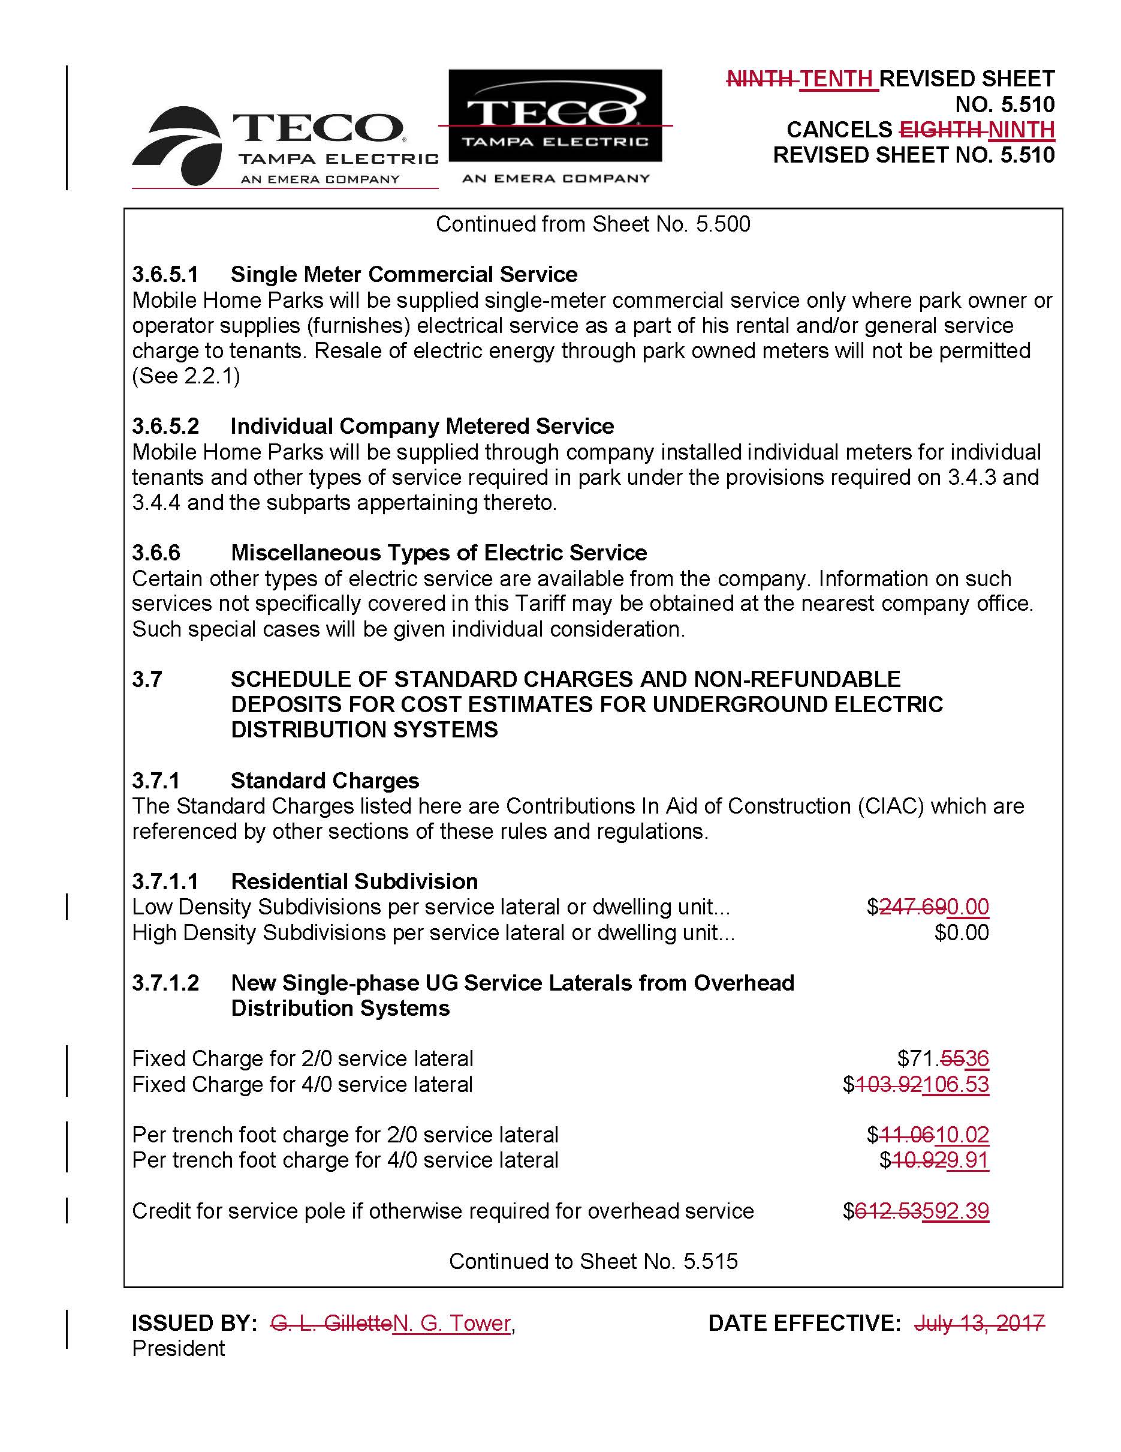

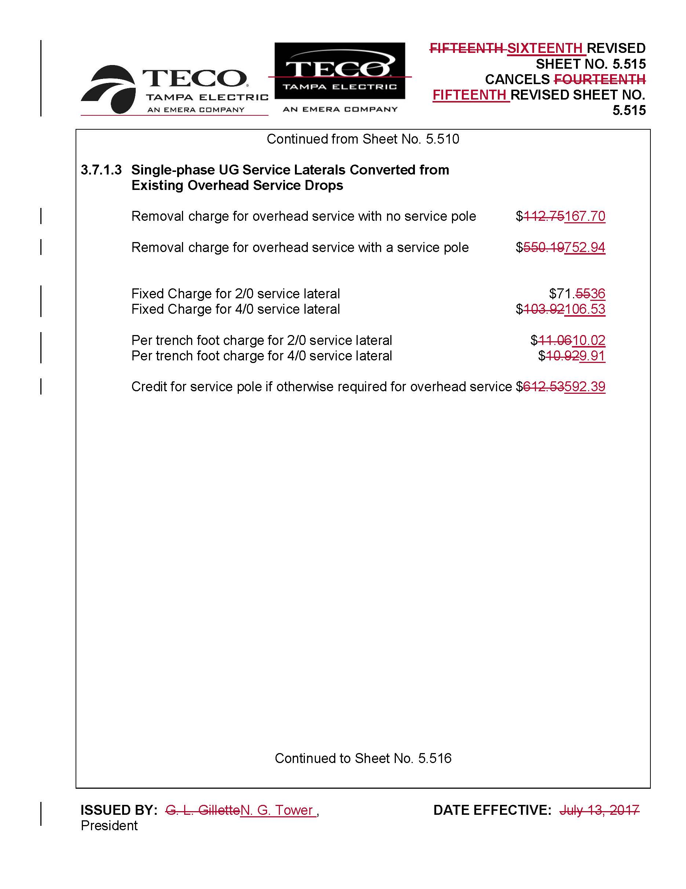

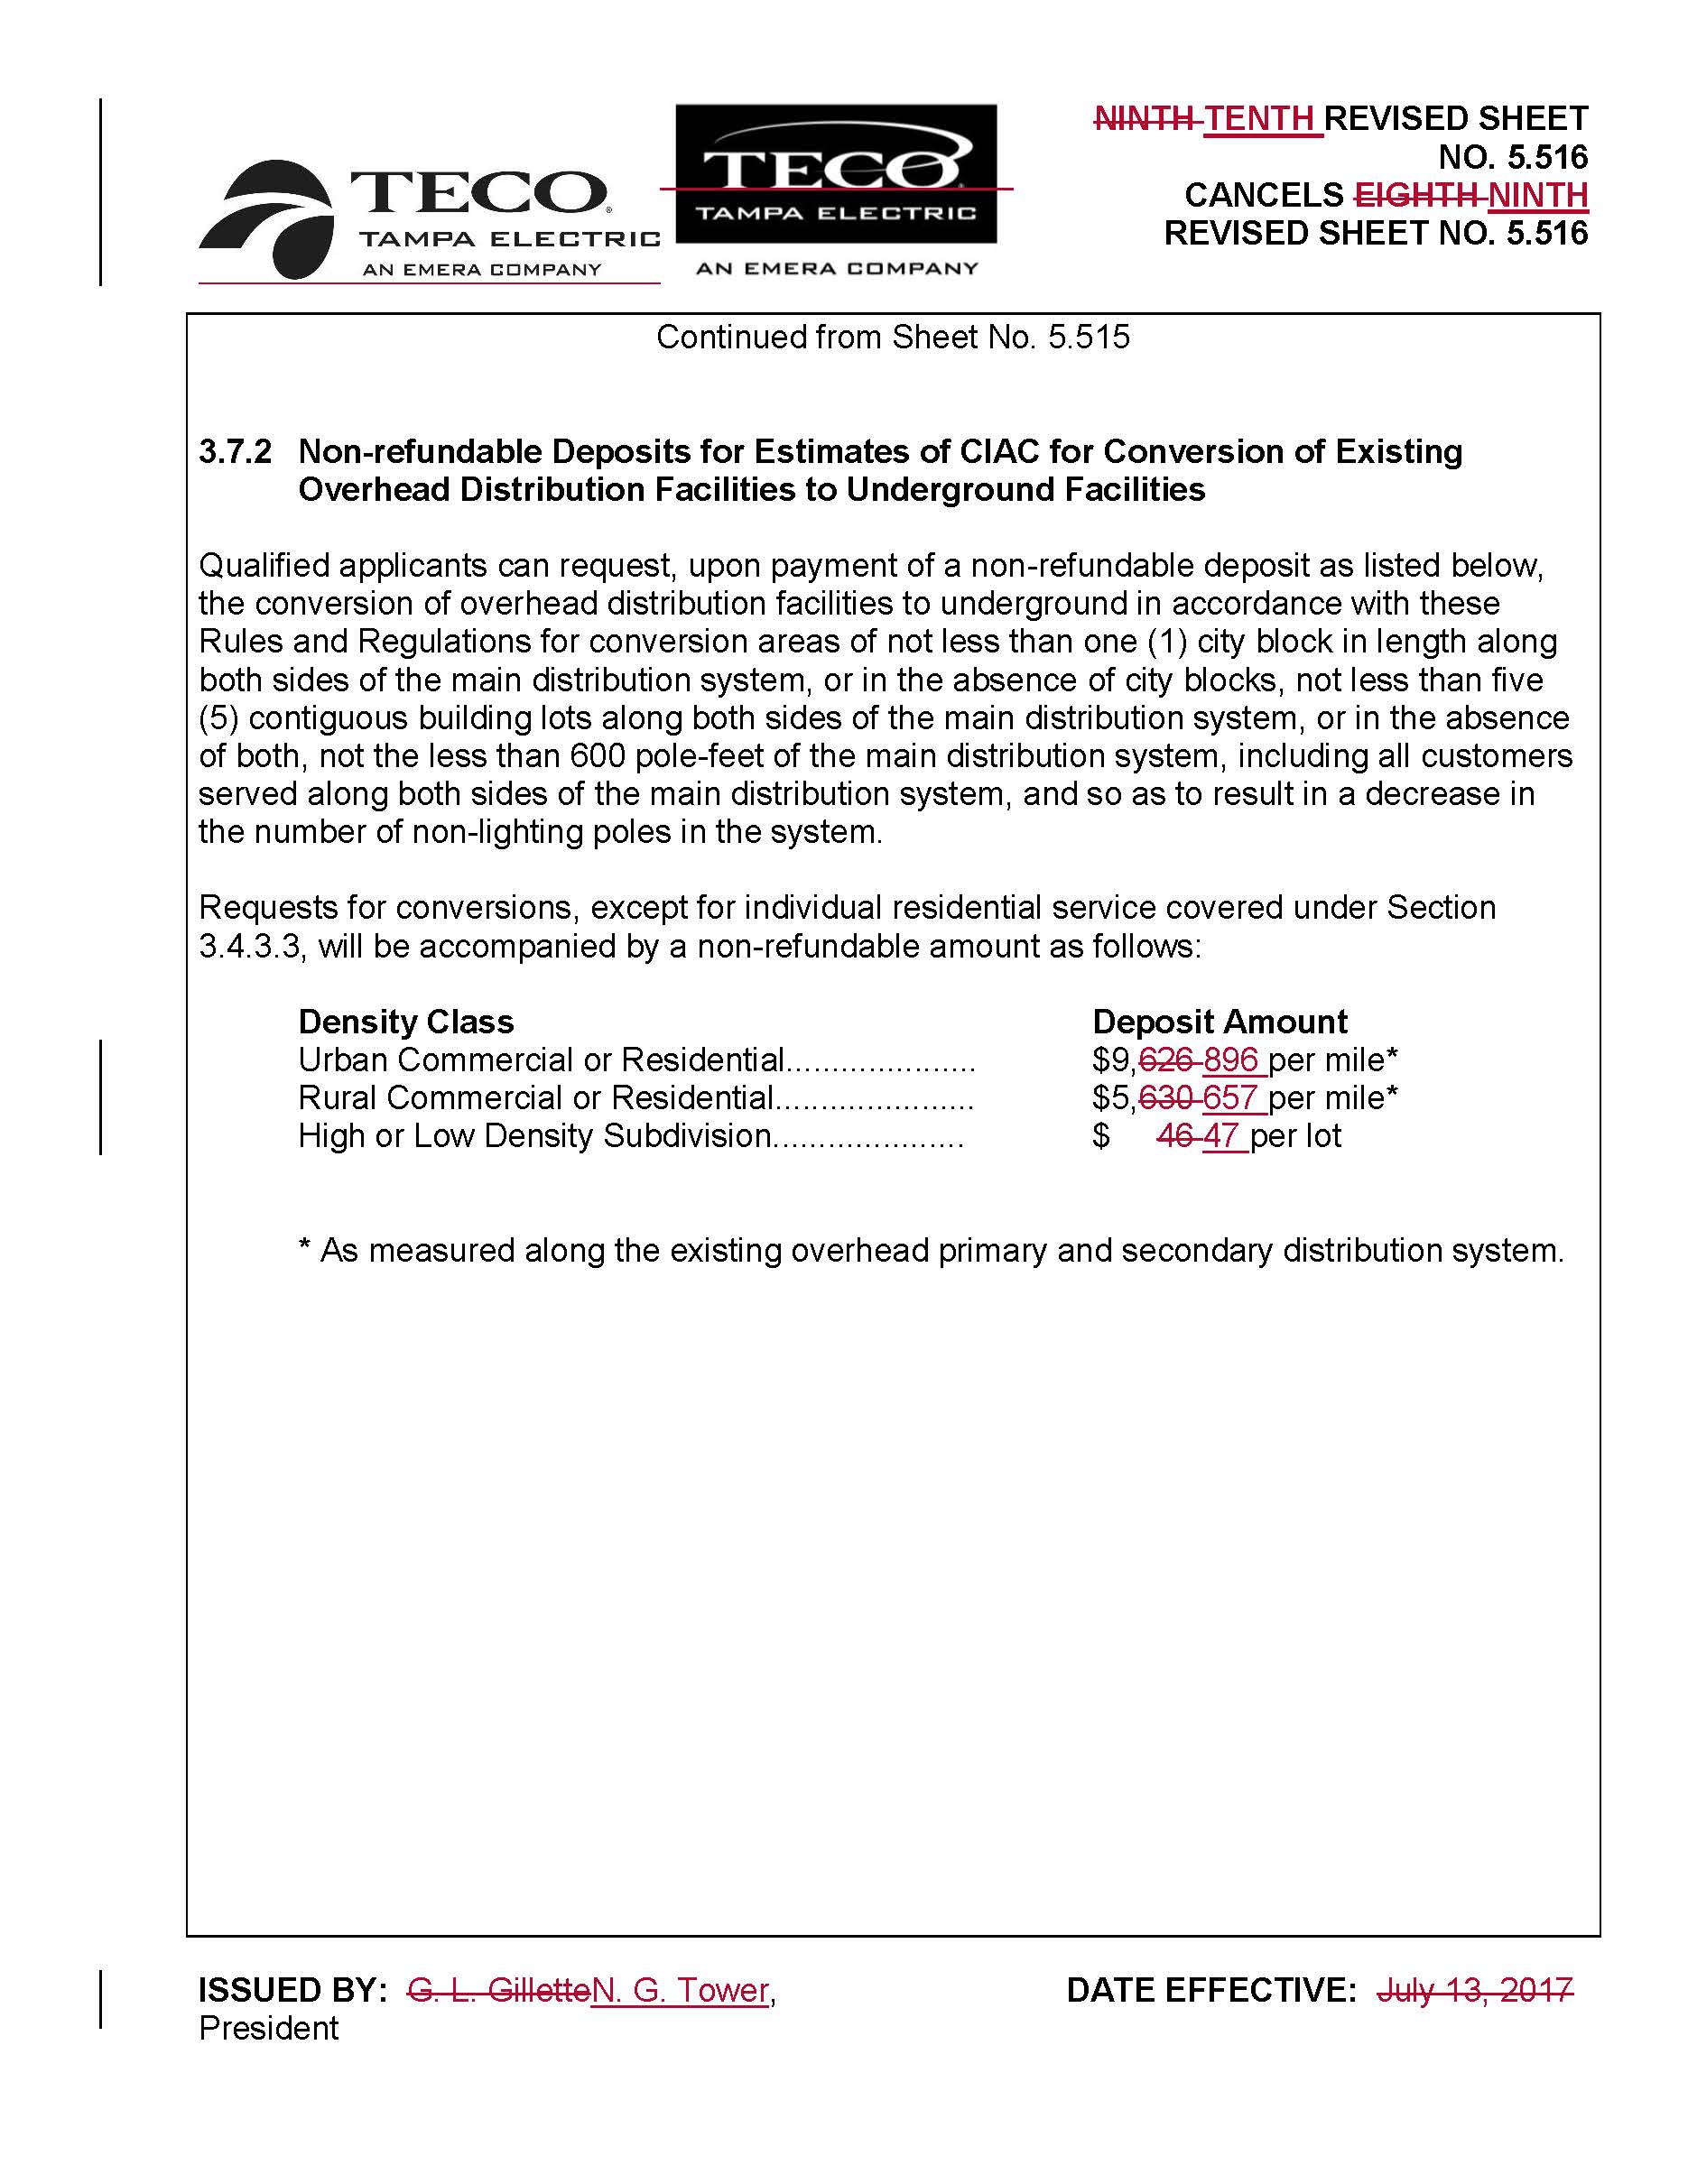

Order No PSC-2017-0293-TRF-EI, issued August 1, 2017, in Docket N0. 20170073-EI, In re: Petition for approval of revised residential distribution tariffs, by Tampa Electric Company.
The calculation is as follows: $793 (rounded Table 1-2) - $1,284 (Table 1-3) = -$491; the proposed URD differential per lot is $0 as the URD differential can not be less than zero.
TECO provided similar comments in its slide presentation (page 16) at the workshop held on May 2-3, 2018, and in its responses to Staff’s First Data Request No. 36, and to Staff’s Third Data Request No. 4. in Docket No. 20170215-EU, In re: Review of electric utility hurricane preparedness and restoration actions.
Order No. PSC-09-0784-TRF-EI, issued November 19, 2009, in Docket No. 090164-EI, In re: Petition for approval of revised tariff sheets for underground residential distribution service, by Tampa Electric Company.
Table 24 of the CPI Detailed Report published by the United States Department of Labor Bureau of Labor Statistics.

