State of Florida |  | Public Service Commission  Capital Circle Office Center ● 2540 Shumard Oak Boulevard  Tallahassee, Florida 32399-0850  -M-E-M-O-R-A-N-D-U-M-
DATE: | May 23, 2018
TO: | Office of Commission Clerk (Stauffer)
FROM: | Division of Engineering (Wooten, Ellis, Wright)  Office of the General Counsel (Dziechciarz)
RE: | Docket No. 20180091-EQ – Petition for approval of revisions to standard offer for energy purchased from cogenerators and renewable generating facilities and standard offer contract for purchases of firm capacity and energy, by Florida Public Utilities Company.
AGENDA: | 06/05/18 – Regular Agenda – Proposed Agency Action – Interested Persons May Participate
COMMISSIONERS ASSIGNED: |  |  | All Commissioners
PREHEARING OFFICER: |  |  | Administrative
CRITICAL DATES: |  |  | None
SPECIAL INSTRUCTIONS: |  |  | Staff recommends the Commission simultaneously consider Docket Nos. 20180073-EQ, 20180081-EQ, 20180082-EQ, 20180083-EQ, and 20180091-EQ.

Case Background
Section 366.91(3), Florida Statutes (F.S.), requires that each investor-owned utility (IOU) continuously offer to purchase capacity and energy from renewable energy generators and small qualifying facilities. Florida Public Service Commission (Commission) Rules 25-17.200 through 25-17.310, Florida Administrative Code (F.A.C.), implement the statute and require each IOU to file with the Commission, by April 1 of each year, a standard offer contract based on the next avoidable fossil fueled generating unit of each technology type identified in the Utility’s current Ten-Year Site Plan. On March 29, 2018, Florida Public Utilities Company (FPUC) submitted a petition for approval of its revised standard offer contract, pursuant to the rules cited above and Rules 25-9.003, 25-17.0825, and 25-17.0832, F.A.C. However, the petition was erroneously submitted to the Commission’s Division of Economics. On April 5, 2018, FPUC filed its petition with the Office of Commission Clerk, requesting that the Commission accept its late-filed petition.
Because FPUC, an IOU, does not own or operate any electric generating units, it does not have any avoidable units on which to base its standard offer contract. Rule 25-17.250(1), F.A.C., requires that, under these circumstances, the standard offer contract be based on avoiding or deferring a planned purchase. In its Northwest Division, FPUC currently purchases all of its electric power through purchased power agreements with Gulf Power Company (Gulf). FPUC has recently changed its full requirements purchased power supplier for the Northeast Division from JEA, formerly known as the Jacksonville Electric Authority, to Florida Power & Light (FPL). Revisions to FPUC’s standard offer contract and rate schedule are limited to changes reflecting FPL replacing JEA.
The Commission has jurisdiction over this standard offer contract pursuant to Sections 366.04 through 366.06, and 366.91, F.S.

Discussion of Issues

Issue 1:
Should the Commission approve the revisions to the standard offer rate schedule and standard offer contract filed by Florida Public Utilities Company?

Recommendation:
Yes. FPUC’s revised standard offer rate schedule and standard offer contract conform to all the requirements of Rules 25-17.200 through 25-17.310, F.A.C., and reflect the avoidable costs associated with FPUC’s power purchase agreements. (Wright)

Staff Analysis:
Pursuant to Rule 25-17.250, F.A.C., an IOU must continuously make available a standard offer contract for the purchase of firm capacity and energy from renewable generating facilities (RF) and small qualifying facilities (QF) with a design capacity of 100 kilowatts (kW) or less. FPUC does not own or operate any of its own electric generating facilities, and thus does not file a Ten-Year Site Plan. Instead, FPUC purchases its electric energy under long-term, full requirements contracts with wholesale providers.
The standard offer rate schedule consists of three components: (1) the Standard Offer – As Available Schedule (SOA); (2) the Standard Offer – Firm Schedule (SOF); and (3) the Standard Offer Contract. Current revisions to FPUC’s standard offer contract and rate schedule are limited to changes reflecting FPL replacing JEA as FPUC’s full requirements supplier for FPUC’s Northeast Division. The revised standard offer rate schedule and standard offer contract, in type-and-strike format, are included as Attachment A to this recommendation. The capacity and energy payments under the proposed rate schedule depend on the terms of FPUC’s wholesale contracts with its suppliers for FPUC's Northeast Division and Northwest Division.

Northeast Division
At present, FPL is the full requirements supplier for FPUC’s Northeast Division, which consists of Fernandina Beach and Amelia Island. In response to Staff’s First Data Request, FPUC provided estimates of the annual payments to an operator of a 10 megawatt (MW) facility, operating at a capacity factor of 70 percent, under a 20 year contract for (1) RF/QF operators located inside the service territory and (2) for operators delivering power to interconnection with the territory. Under both of these scenarios, FPUC estimated that its annual energy payments would be approximately $1.9 million starting in 2019 and would increase annually, based on the full reduction in FPL billing to FPUC. FPUC’s estimated annual capacity payments are confidential.

Northwest Division
At present, Gulf is the full requirements supplier for FPUC’s Northwest Division, which consists of portions of Jackson, Calhoun, and Liberty counties. In response to Staff’s First Data Request, FPUC provided estimates of the annual payments to an operator of a 10 MW facility, operating at a capacity factor of 70 percent, under a 20 year contract for (1) RF/QF operators located inside the service territory and (2) for operators delivering power to interconnection with the territory. Under both of these scenarios, FPUC estimated that its annual energy payments would be approximately $2.1 million starting in 2019 and would increase annually, based on the full reduction in Gulf billing to FPUC. FPUC’s estimated annual capacity payments are confidential.

Conclusion
FPUC’s revised standard offer rate schedule and standard offer contract conform to all the requirements of Rules 25-17.200 through 25-17.310, F.A.C., and reflect the avoidable costs associated with FPUC’s power purchase agreements. Staff recommends that the revisions to the rate schedule and standard offer contract filed by FPUC be approved as filed.

Issue 2:
Should this docket be closed?

Recommendation:
Yes. This docket should be closed upon issuance of a consummating order, unless a person whose substantial interests are affected by the Commission’s decision files a protest within 21 days of the issuance of the Commission’s Proposed Agency Action Order. Potential signatories should be aware that, if a timely protest is filed, FPUC’s standard offer contract may subsequently be revised. (Dziechciarz)

Staff Analysis:
This docket should be closed upon the issuance of a consummating order, unless a person whose substantial interests are affected by the Commission’s decision files a protest within 21 days of the issuance of the Commission’s Proposed Agency Action Order. Potential signatories should be aware that, if a timely protest is filed, FPUC’s standard offer contract may subsequently be revised.
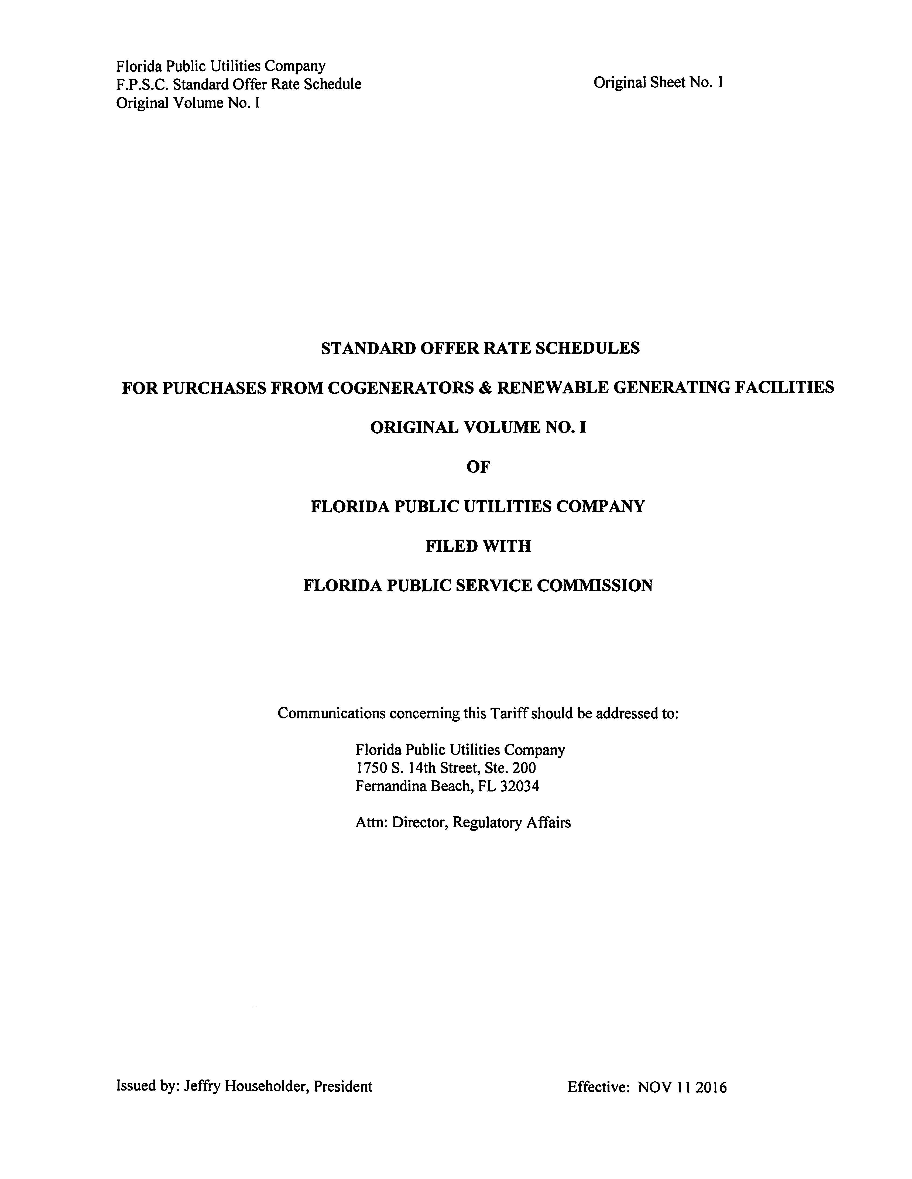
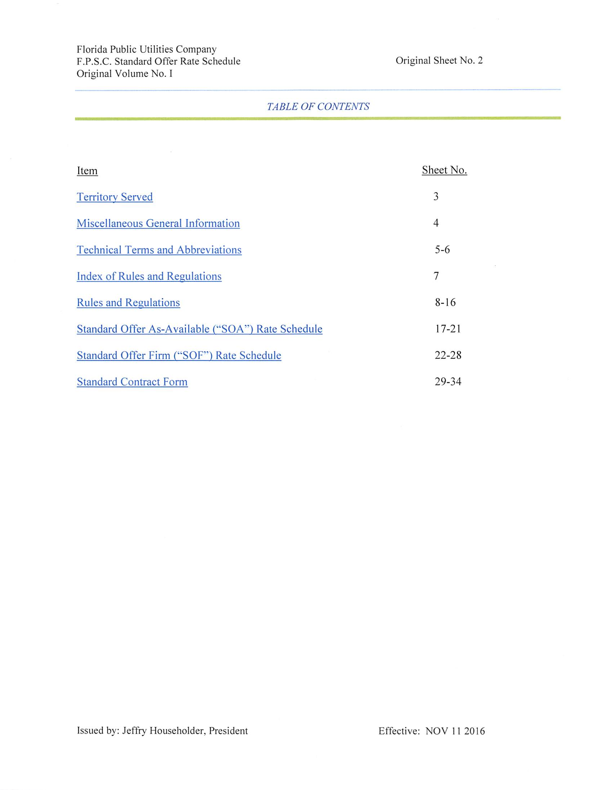

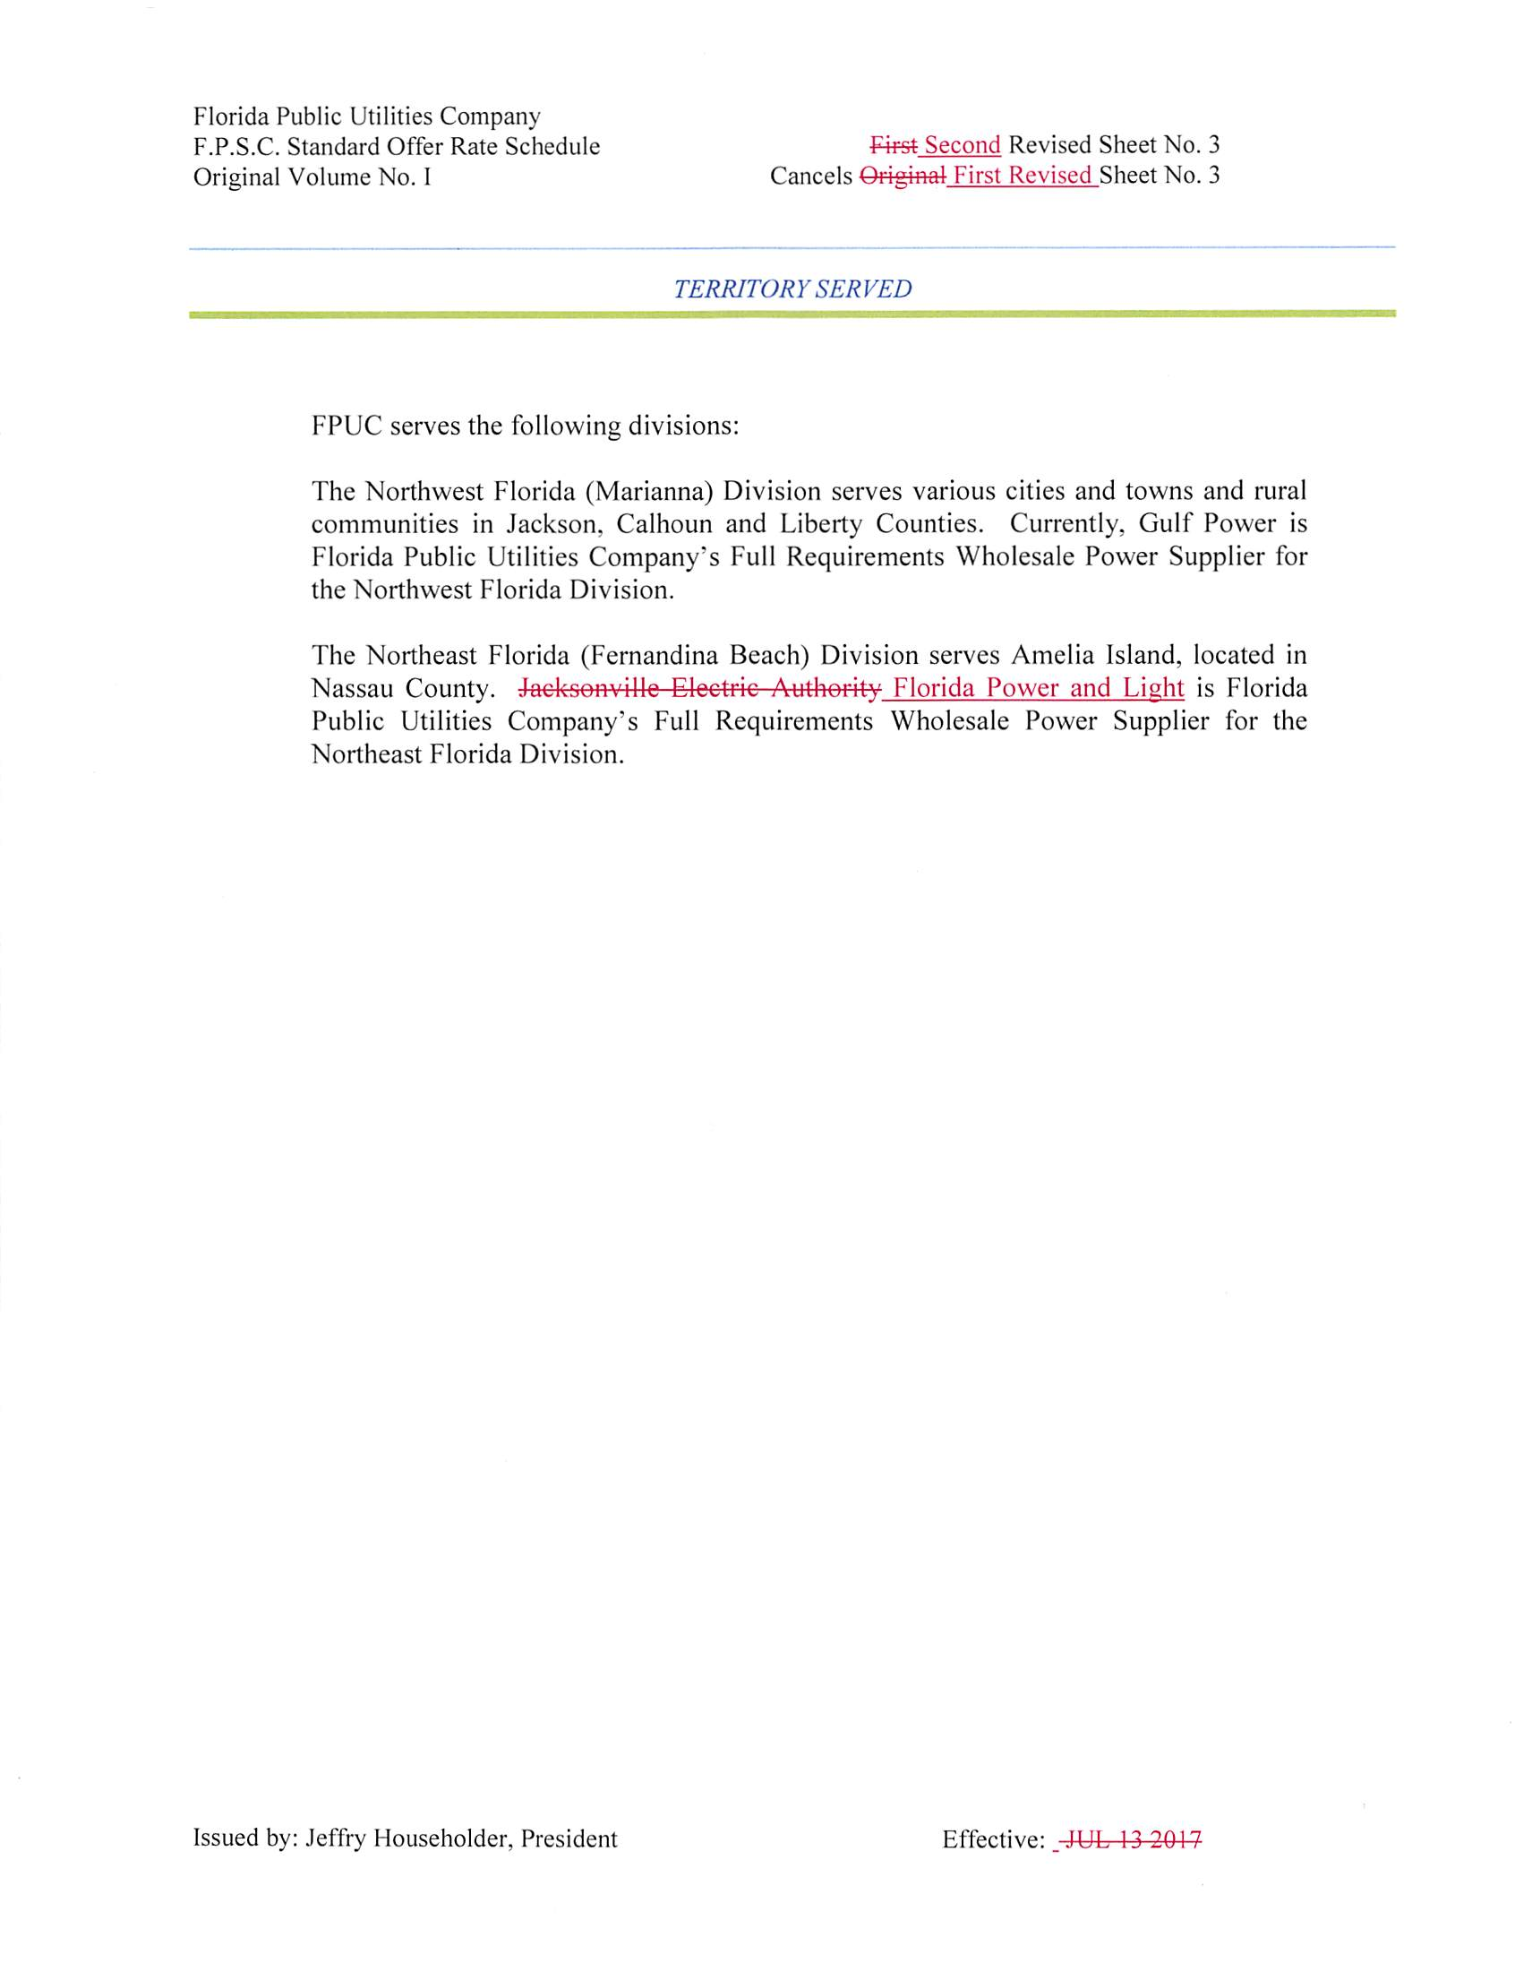
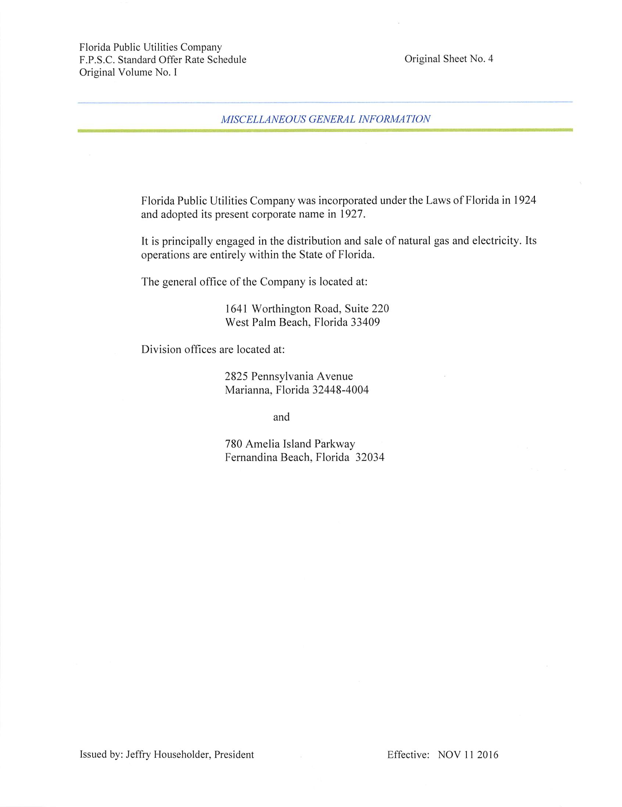

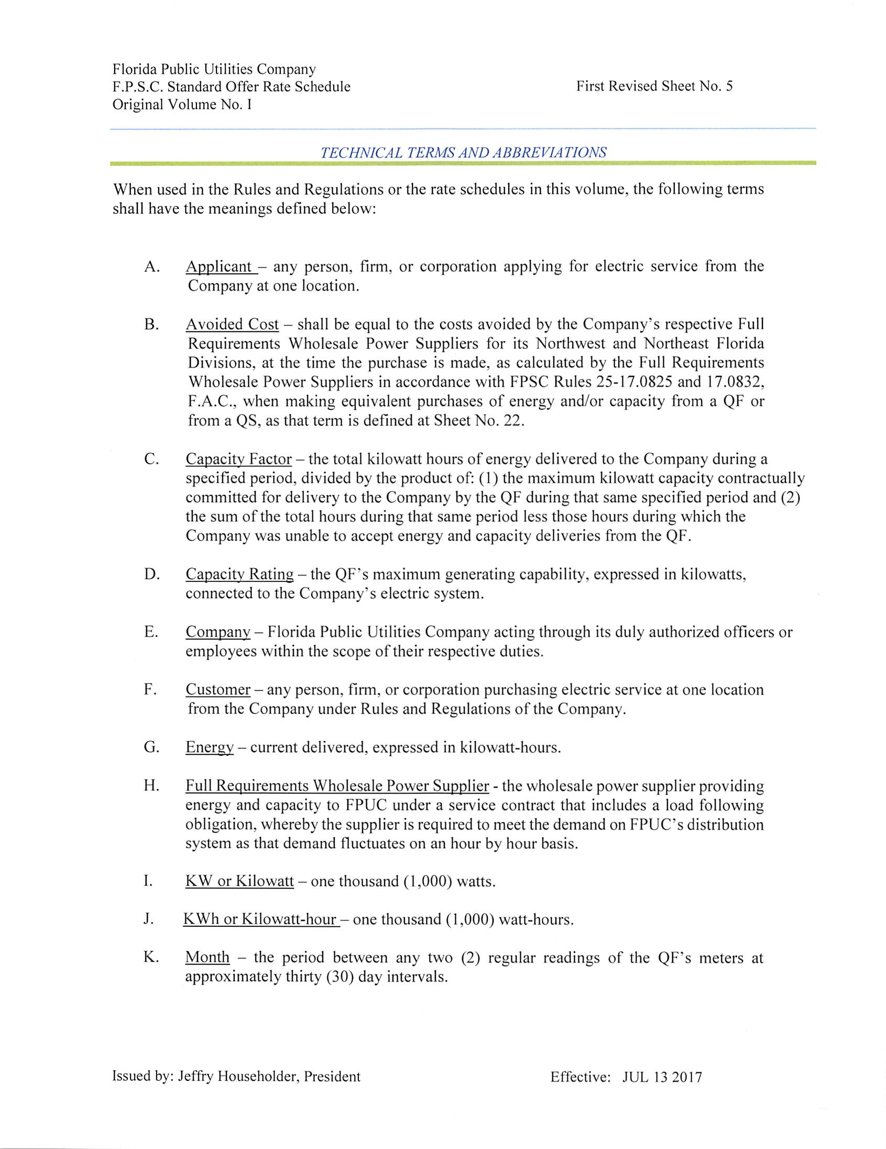

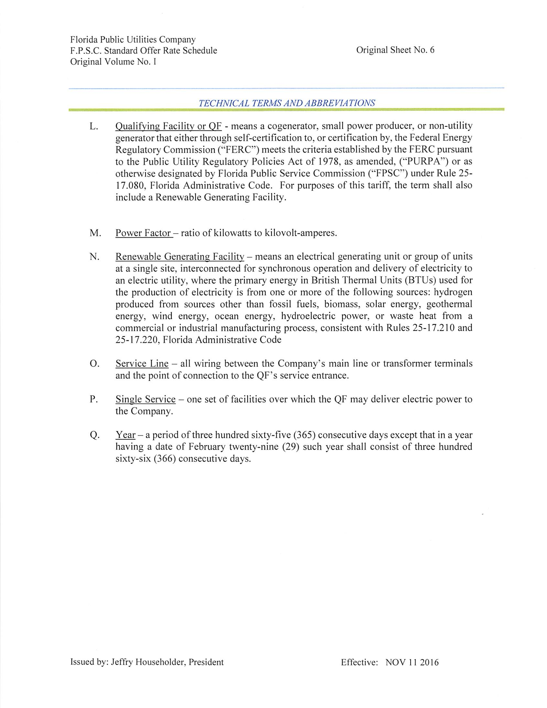

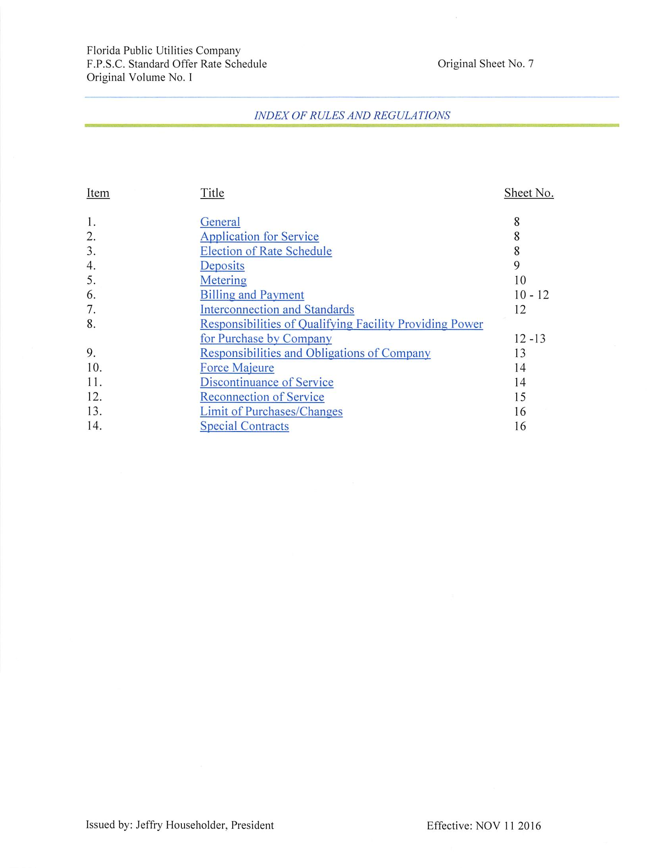

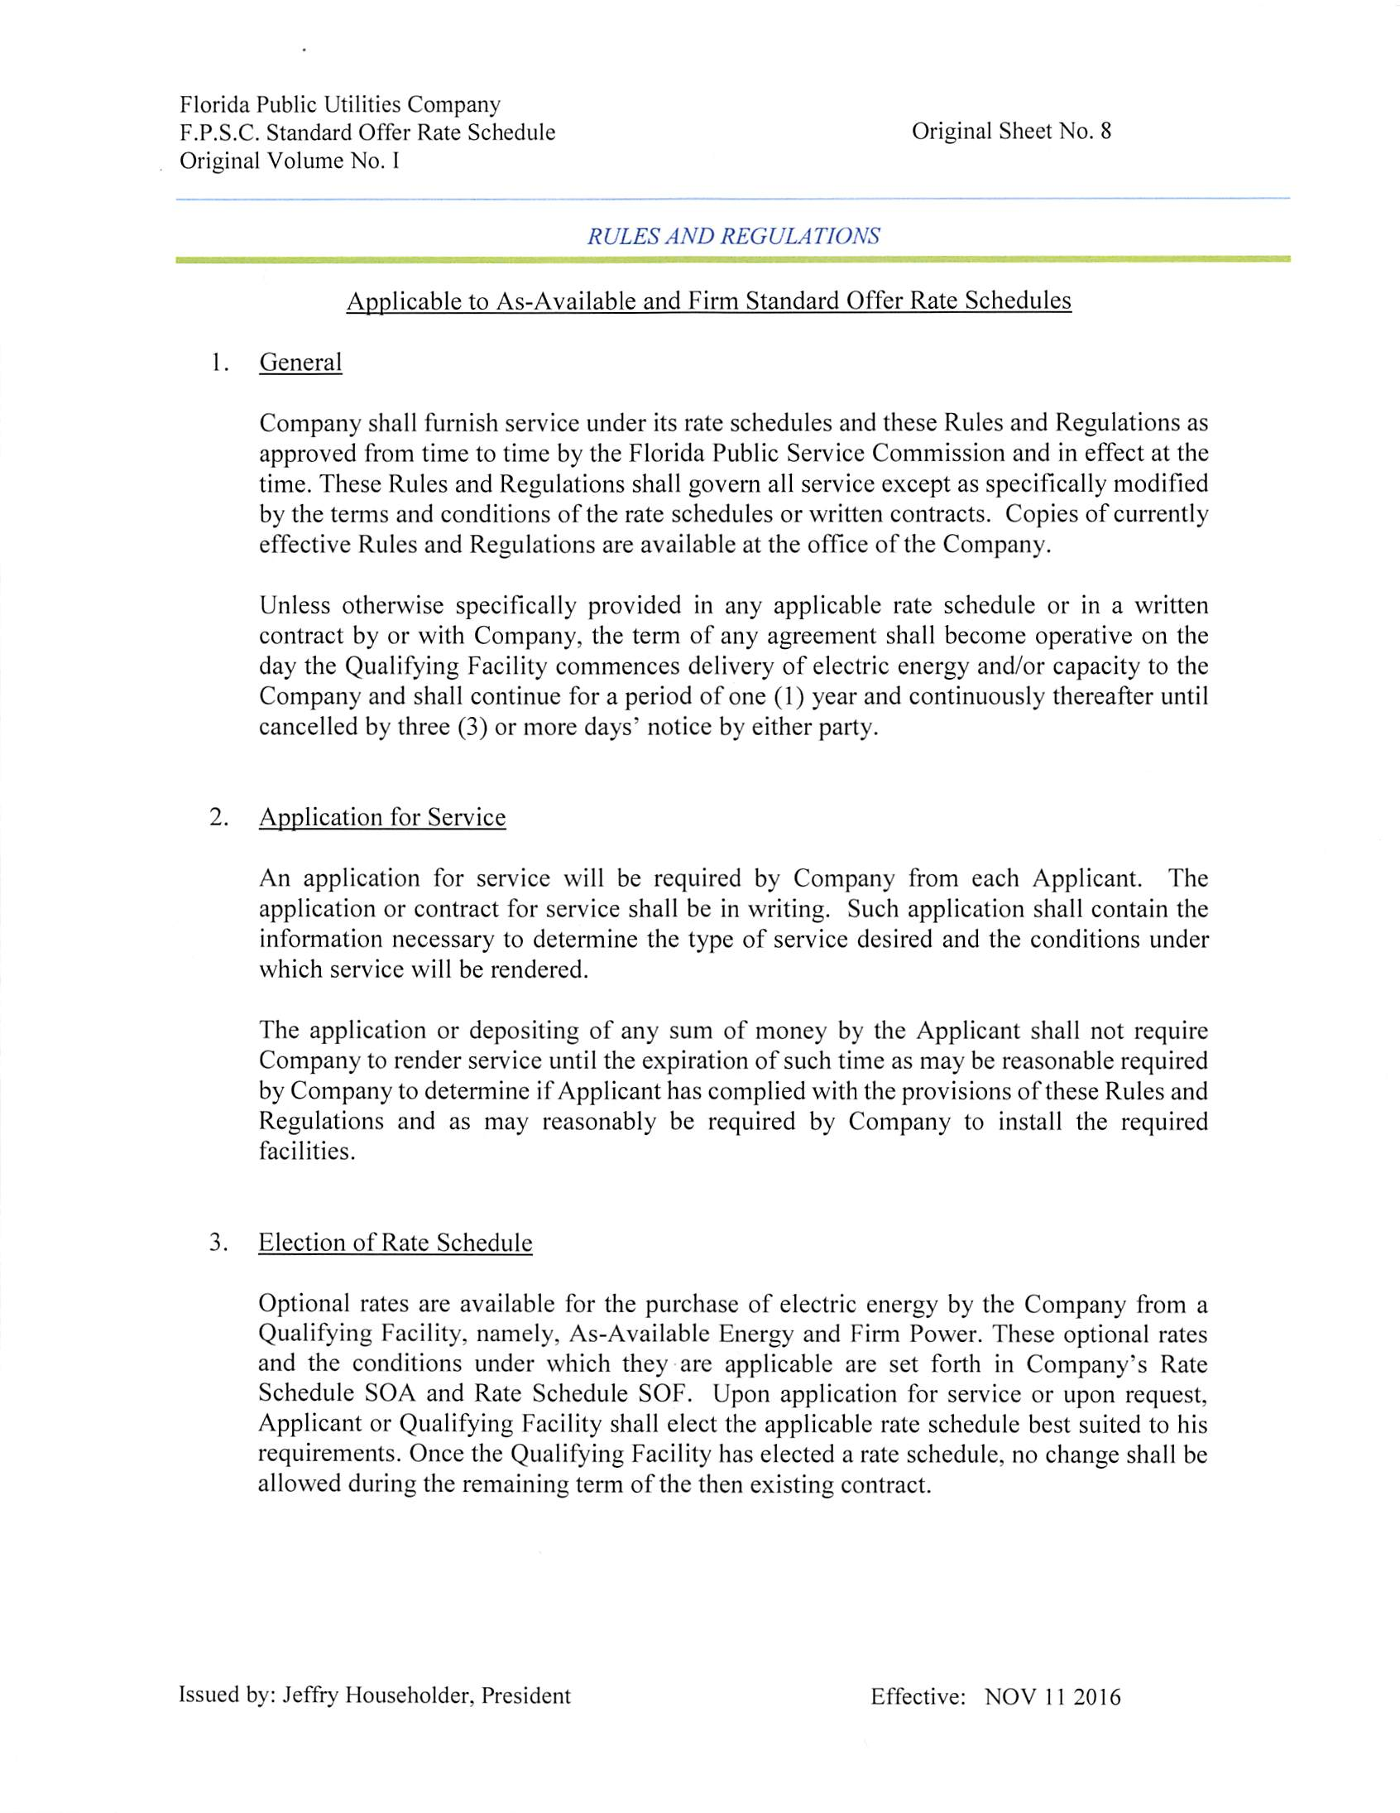

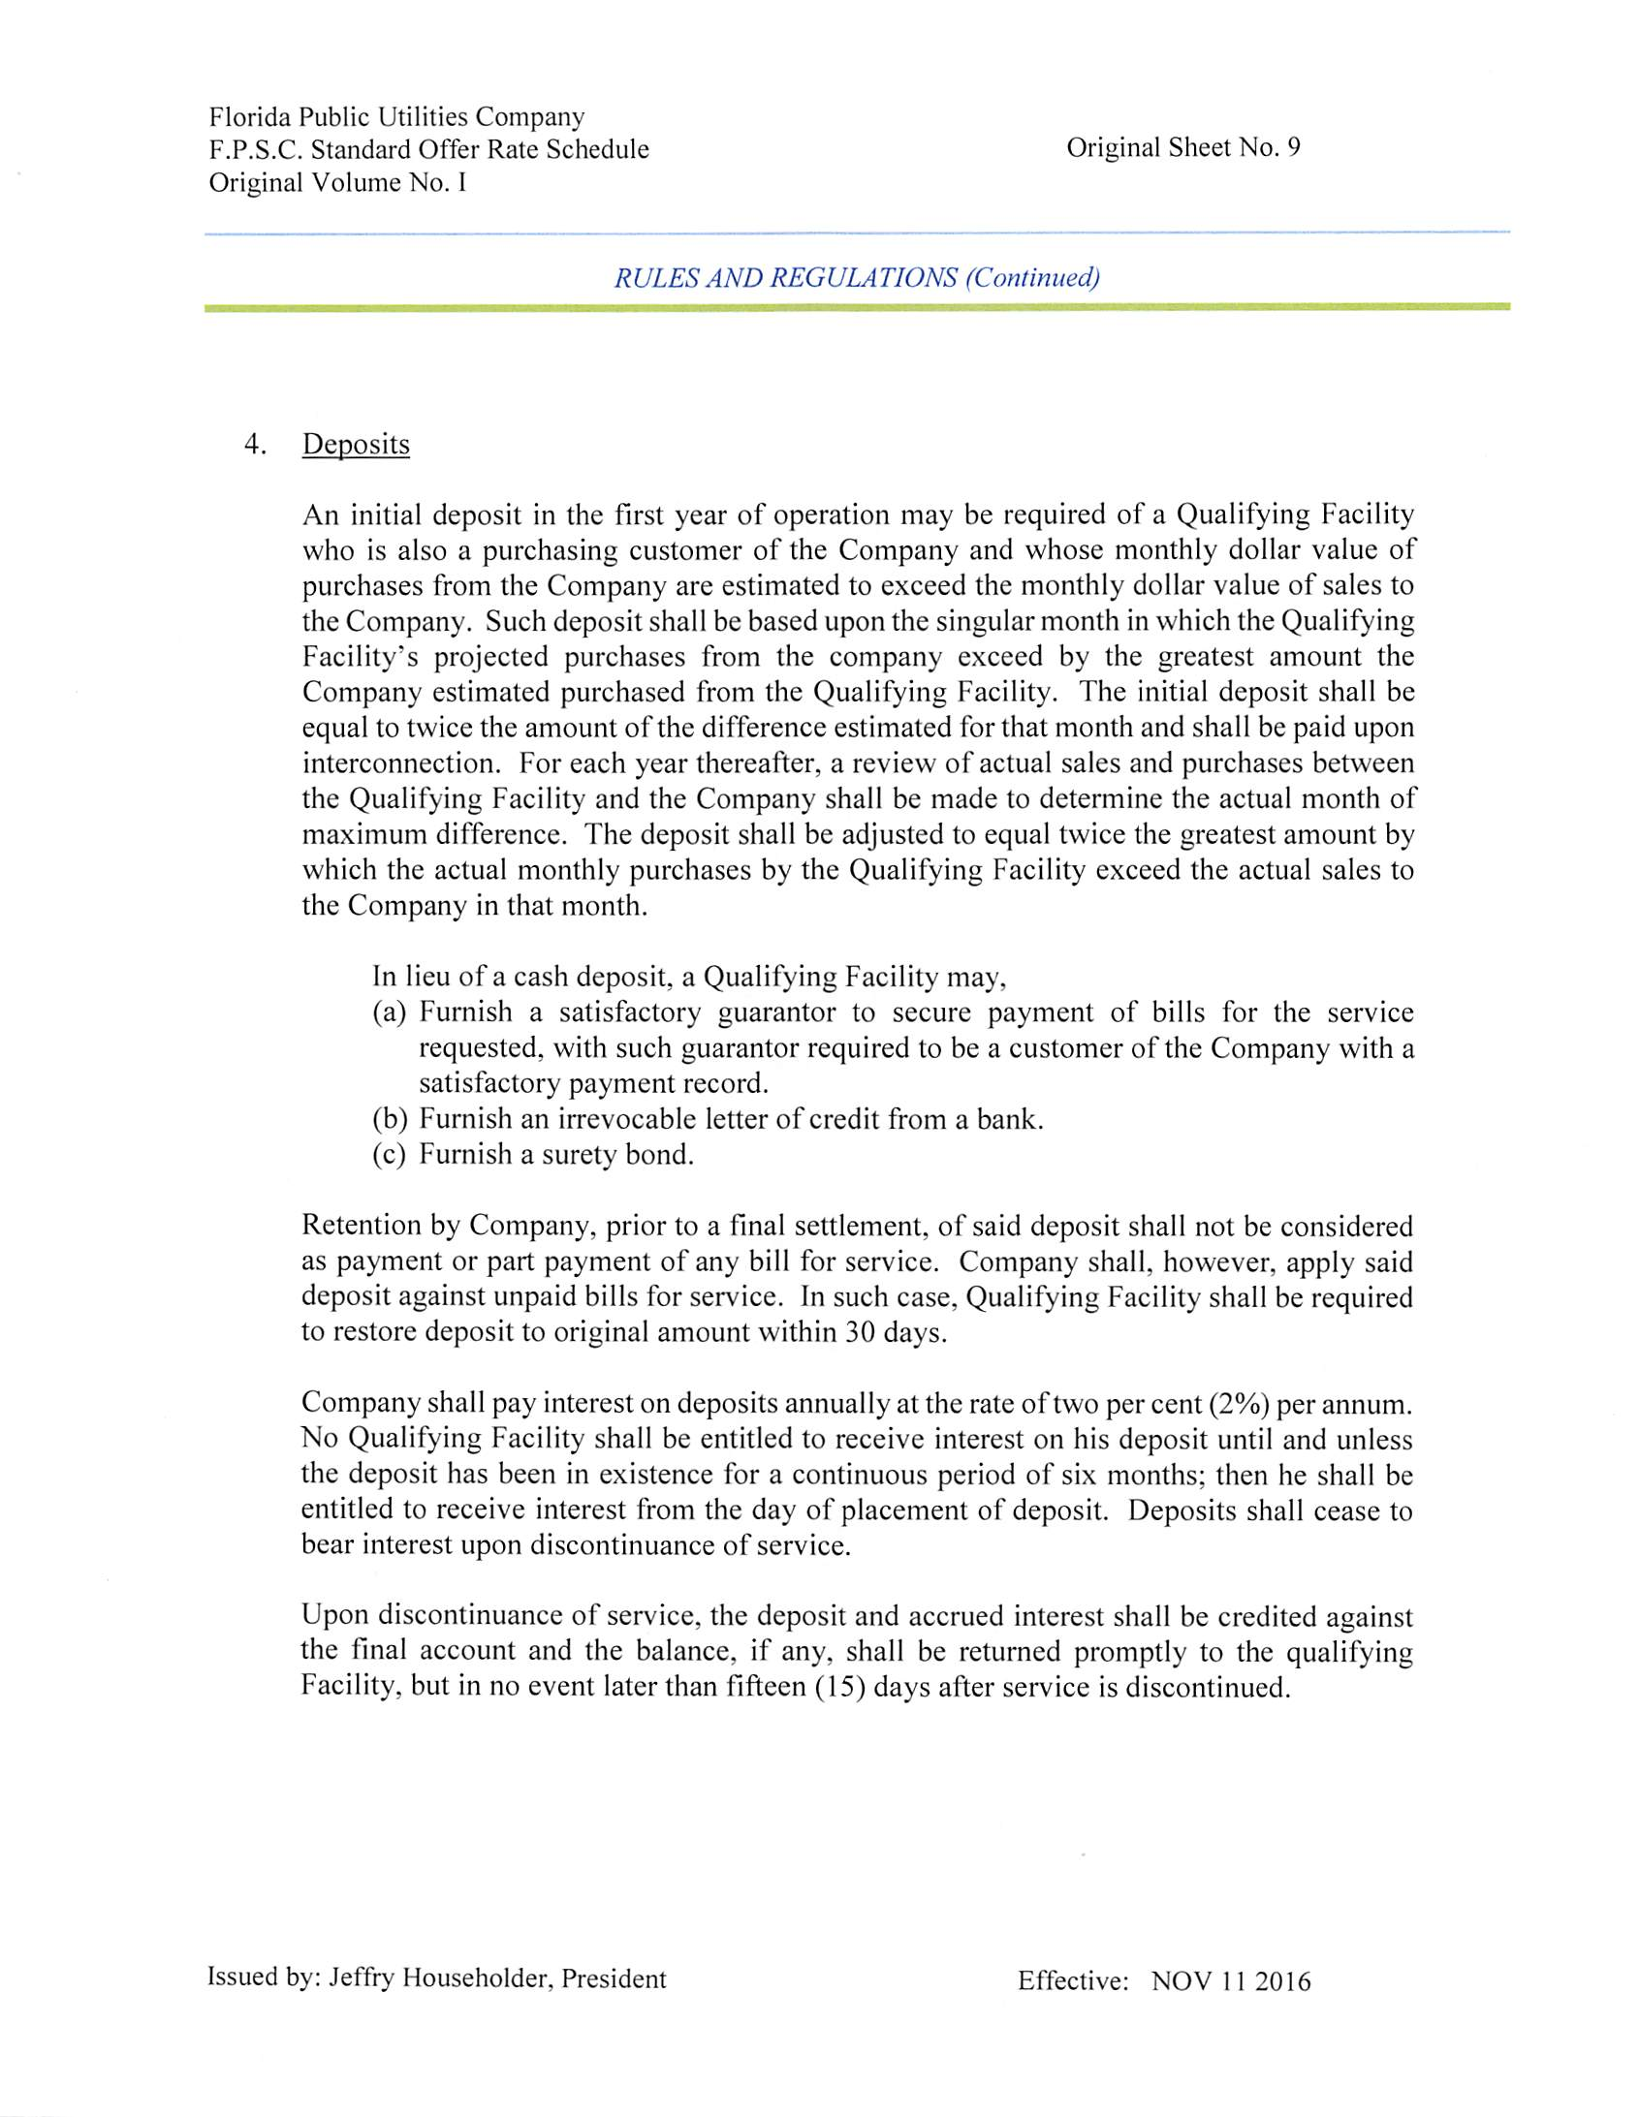

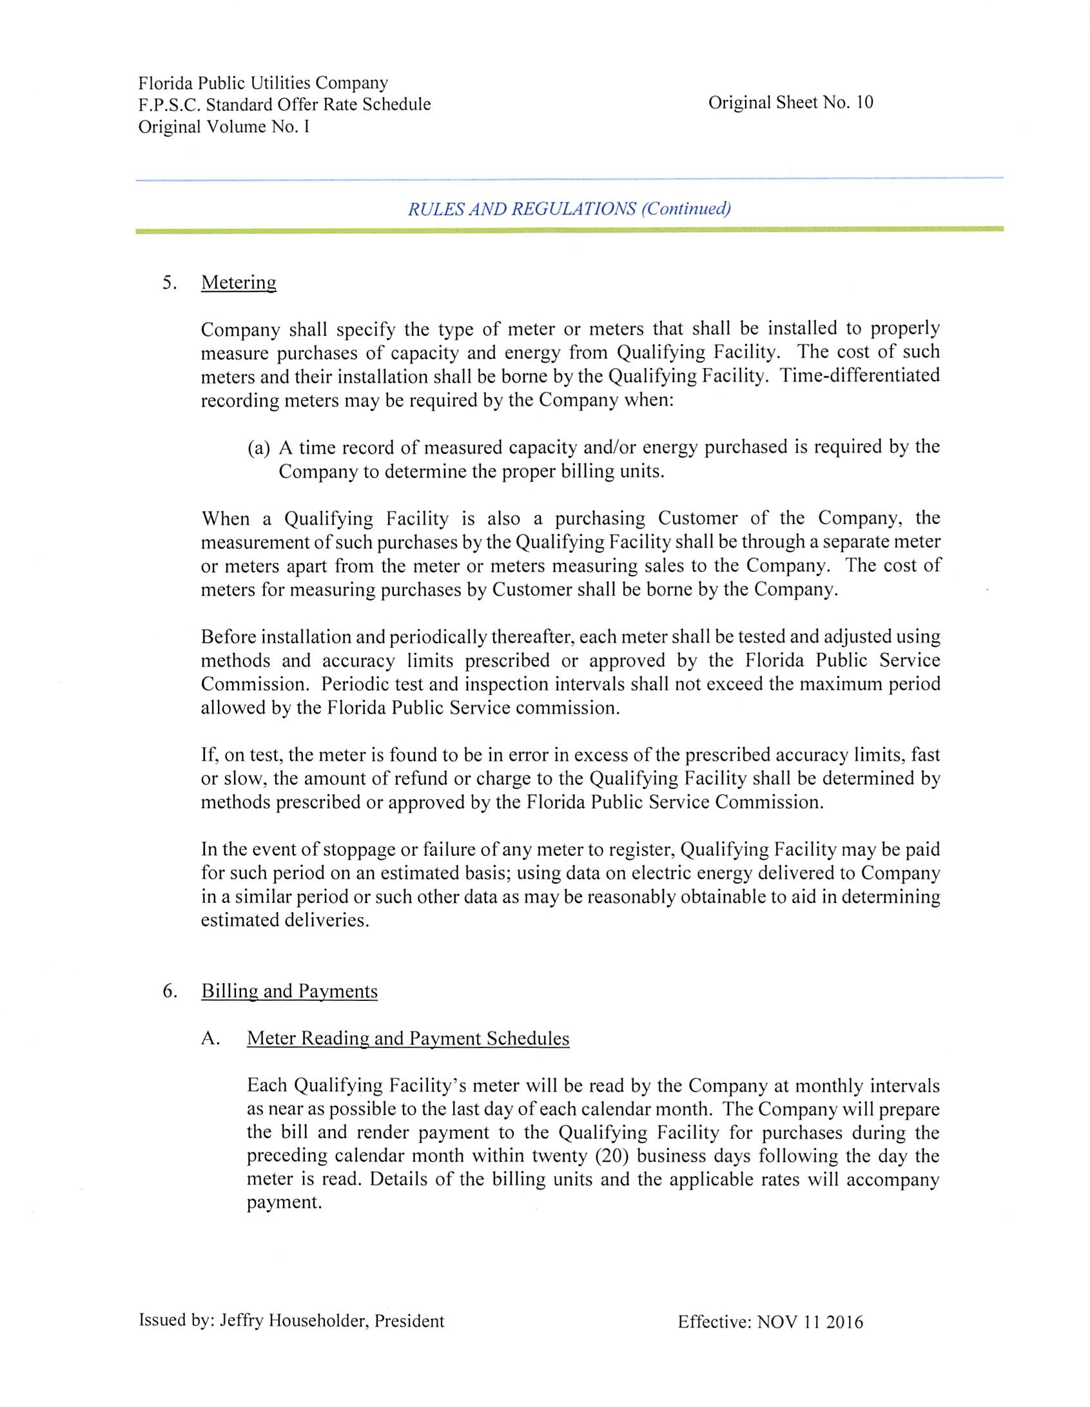

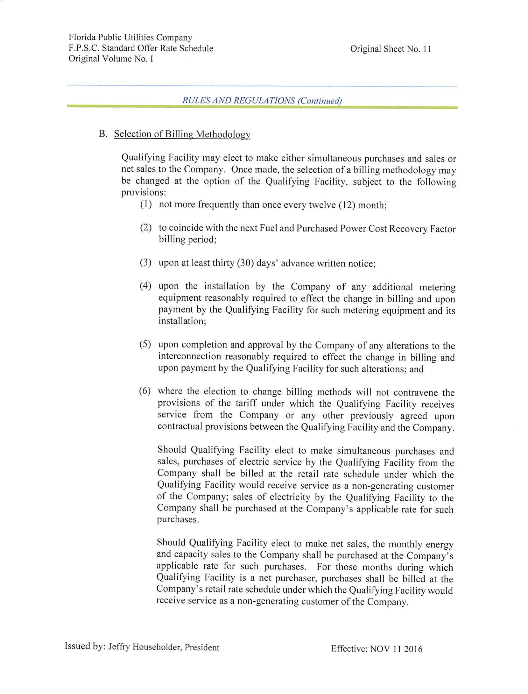

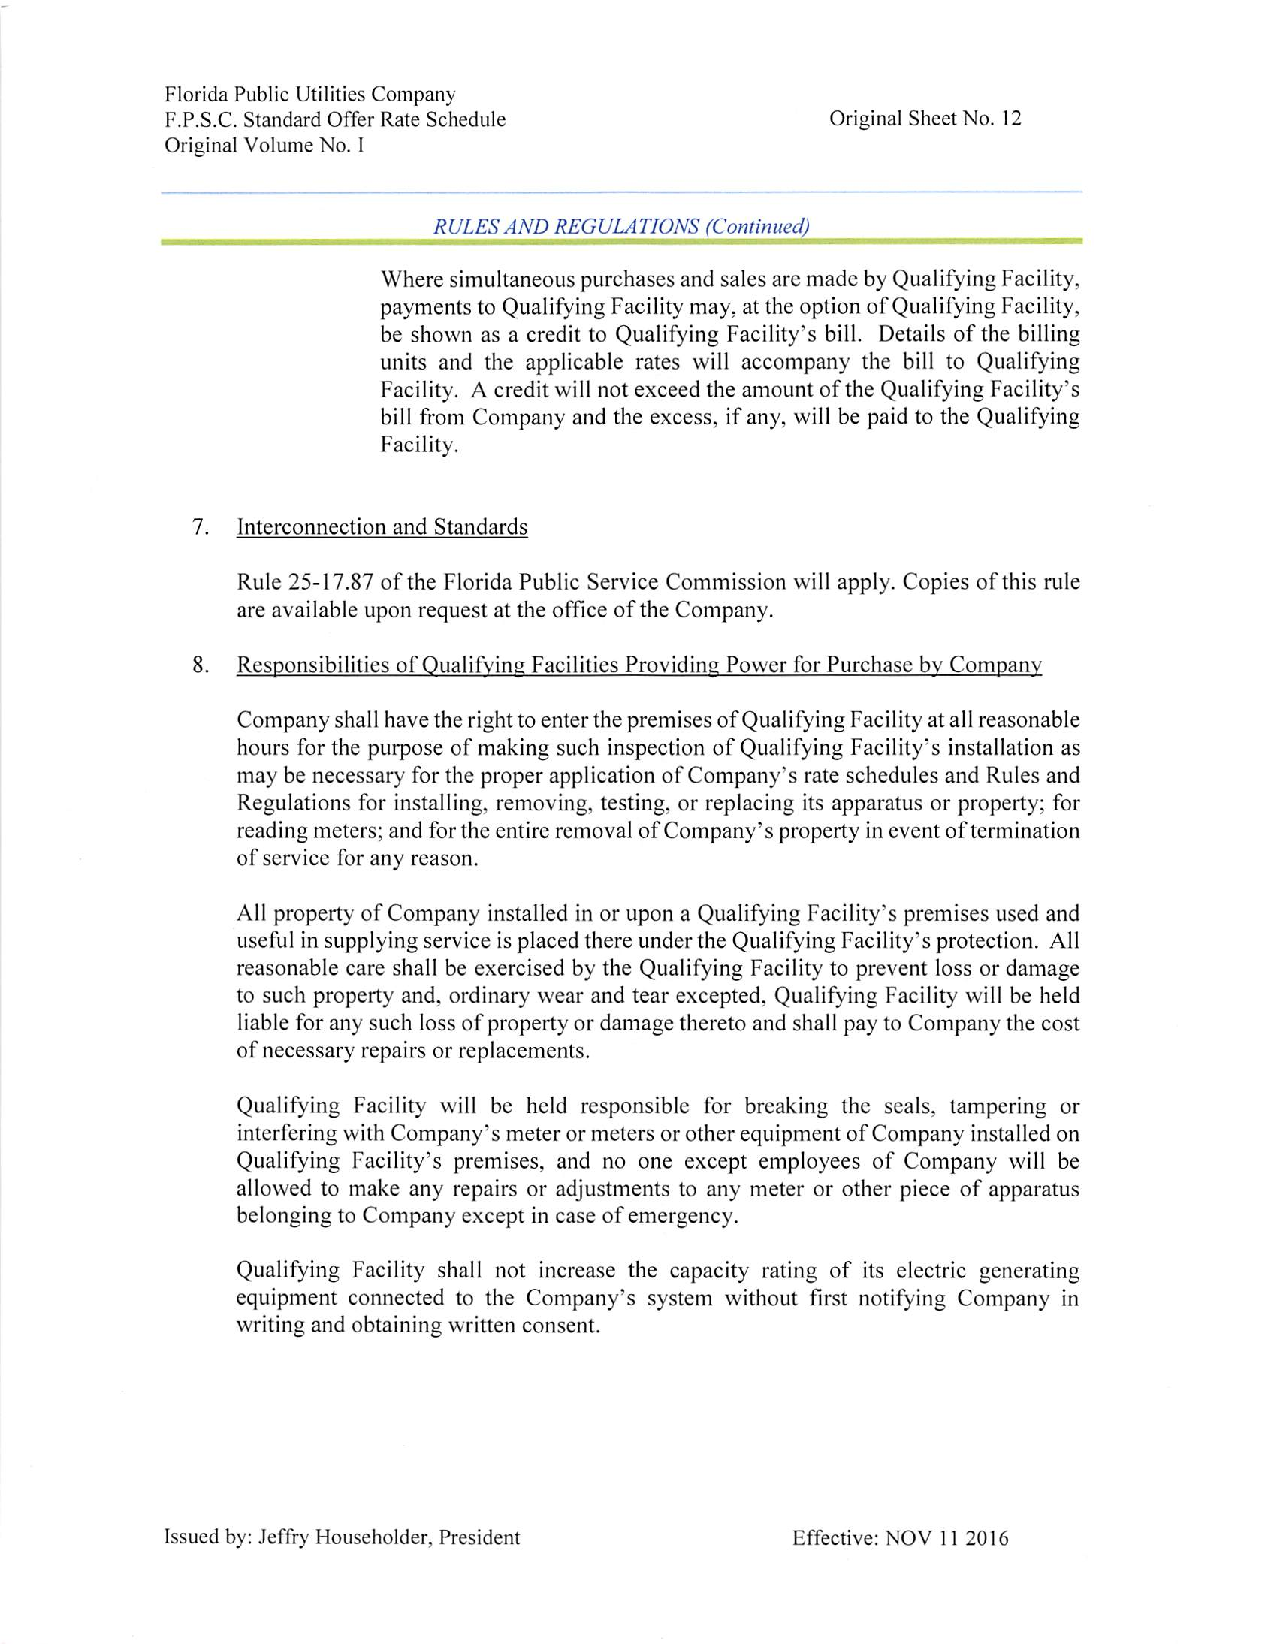

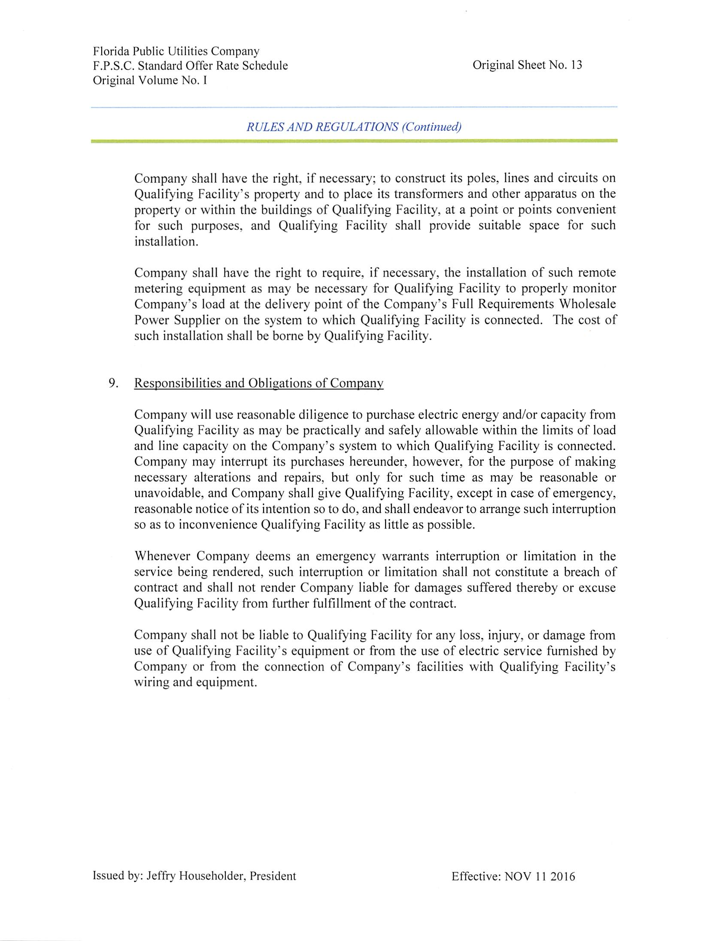

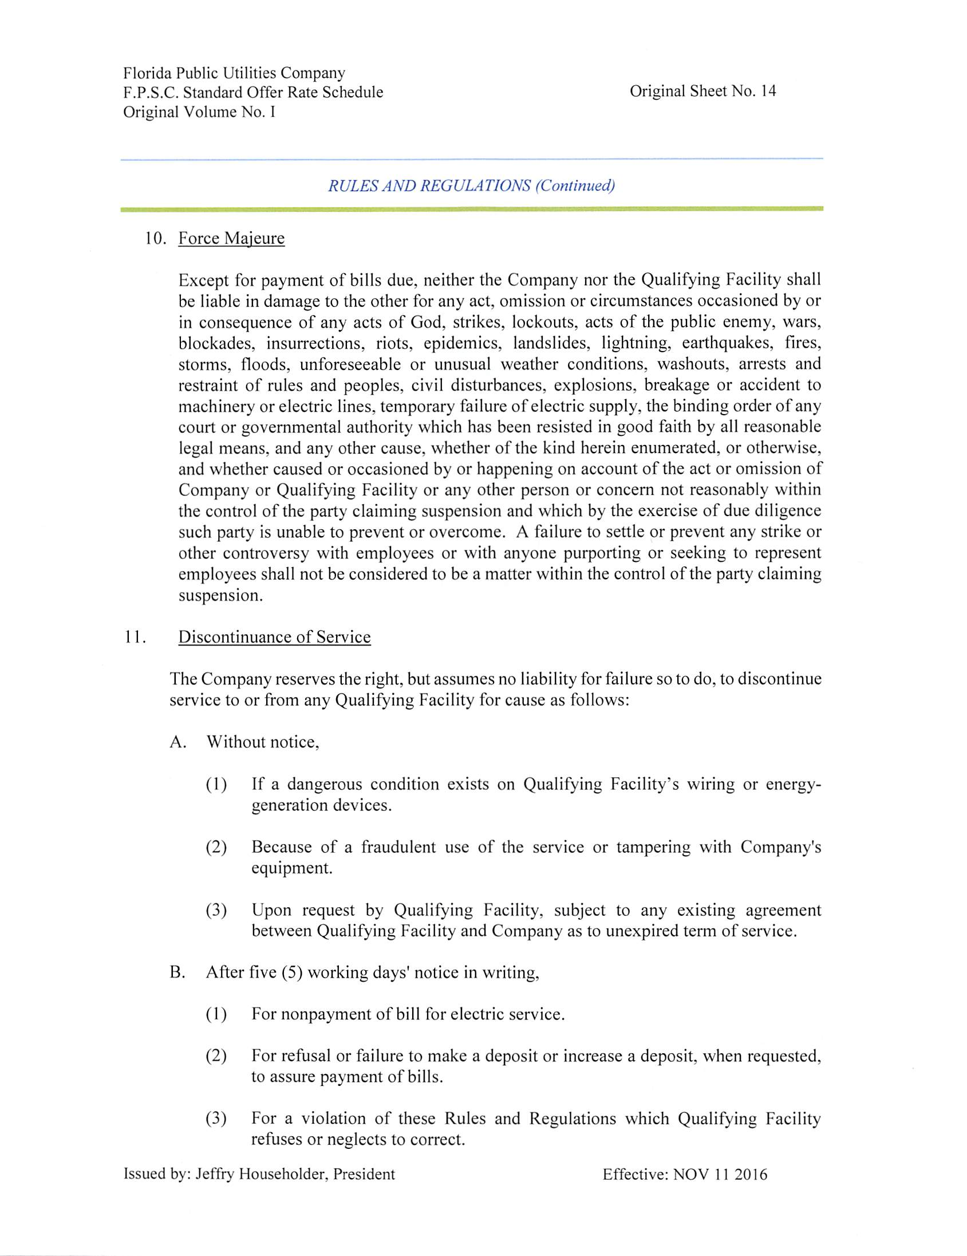

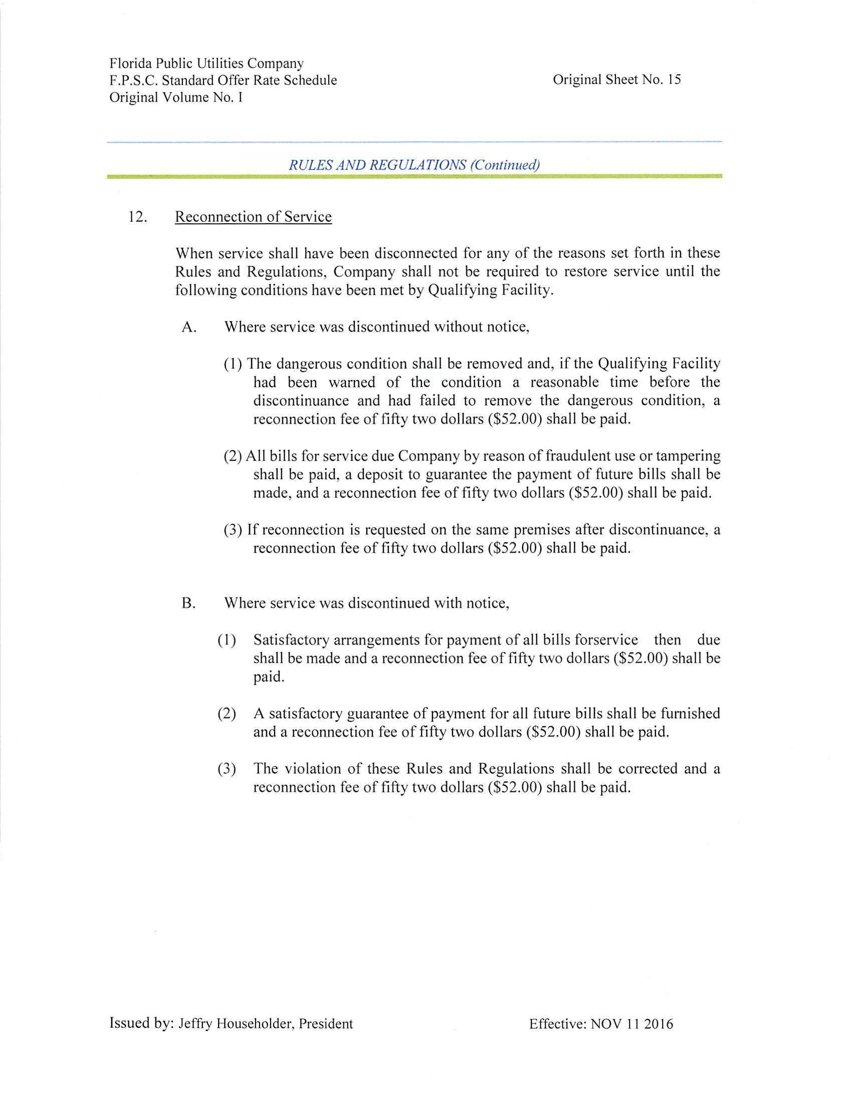

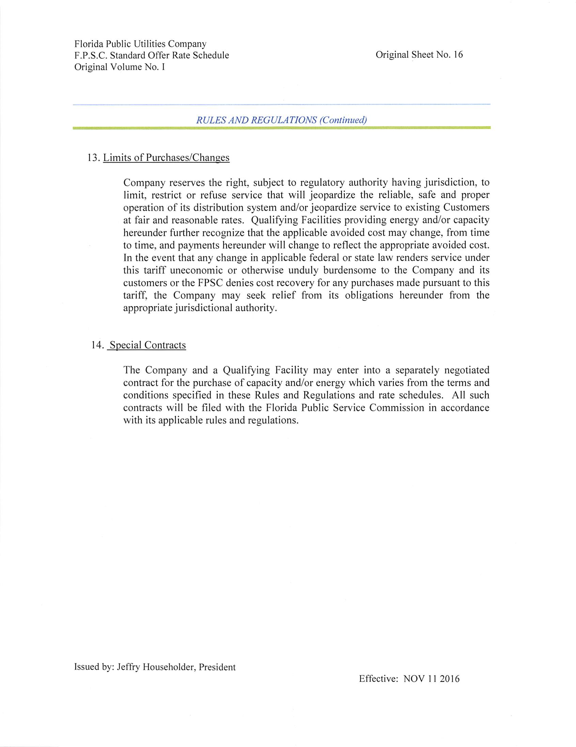

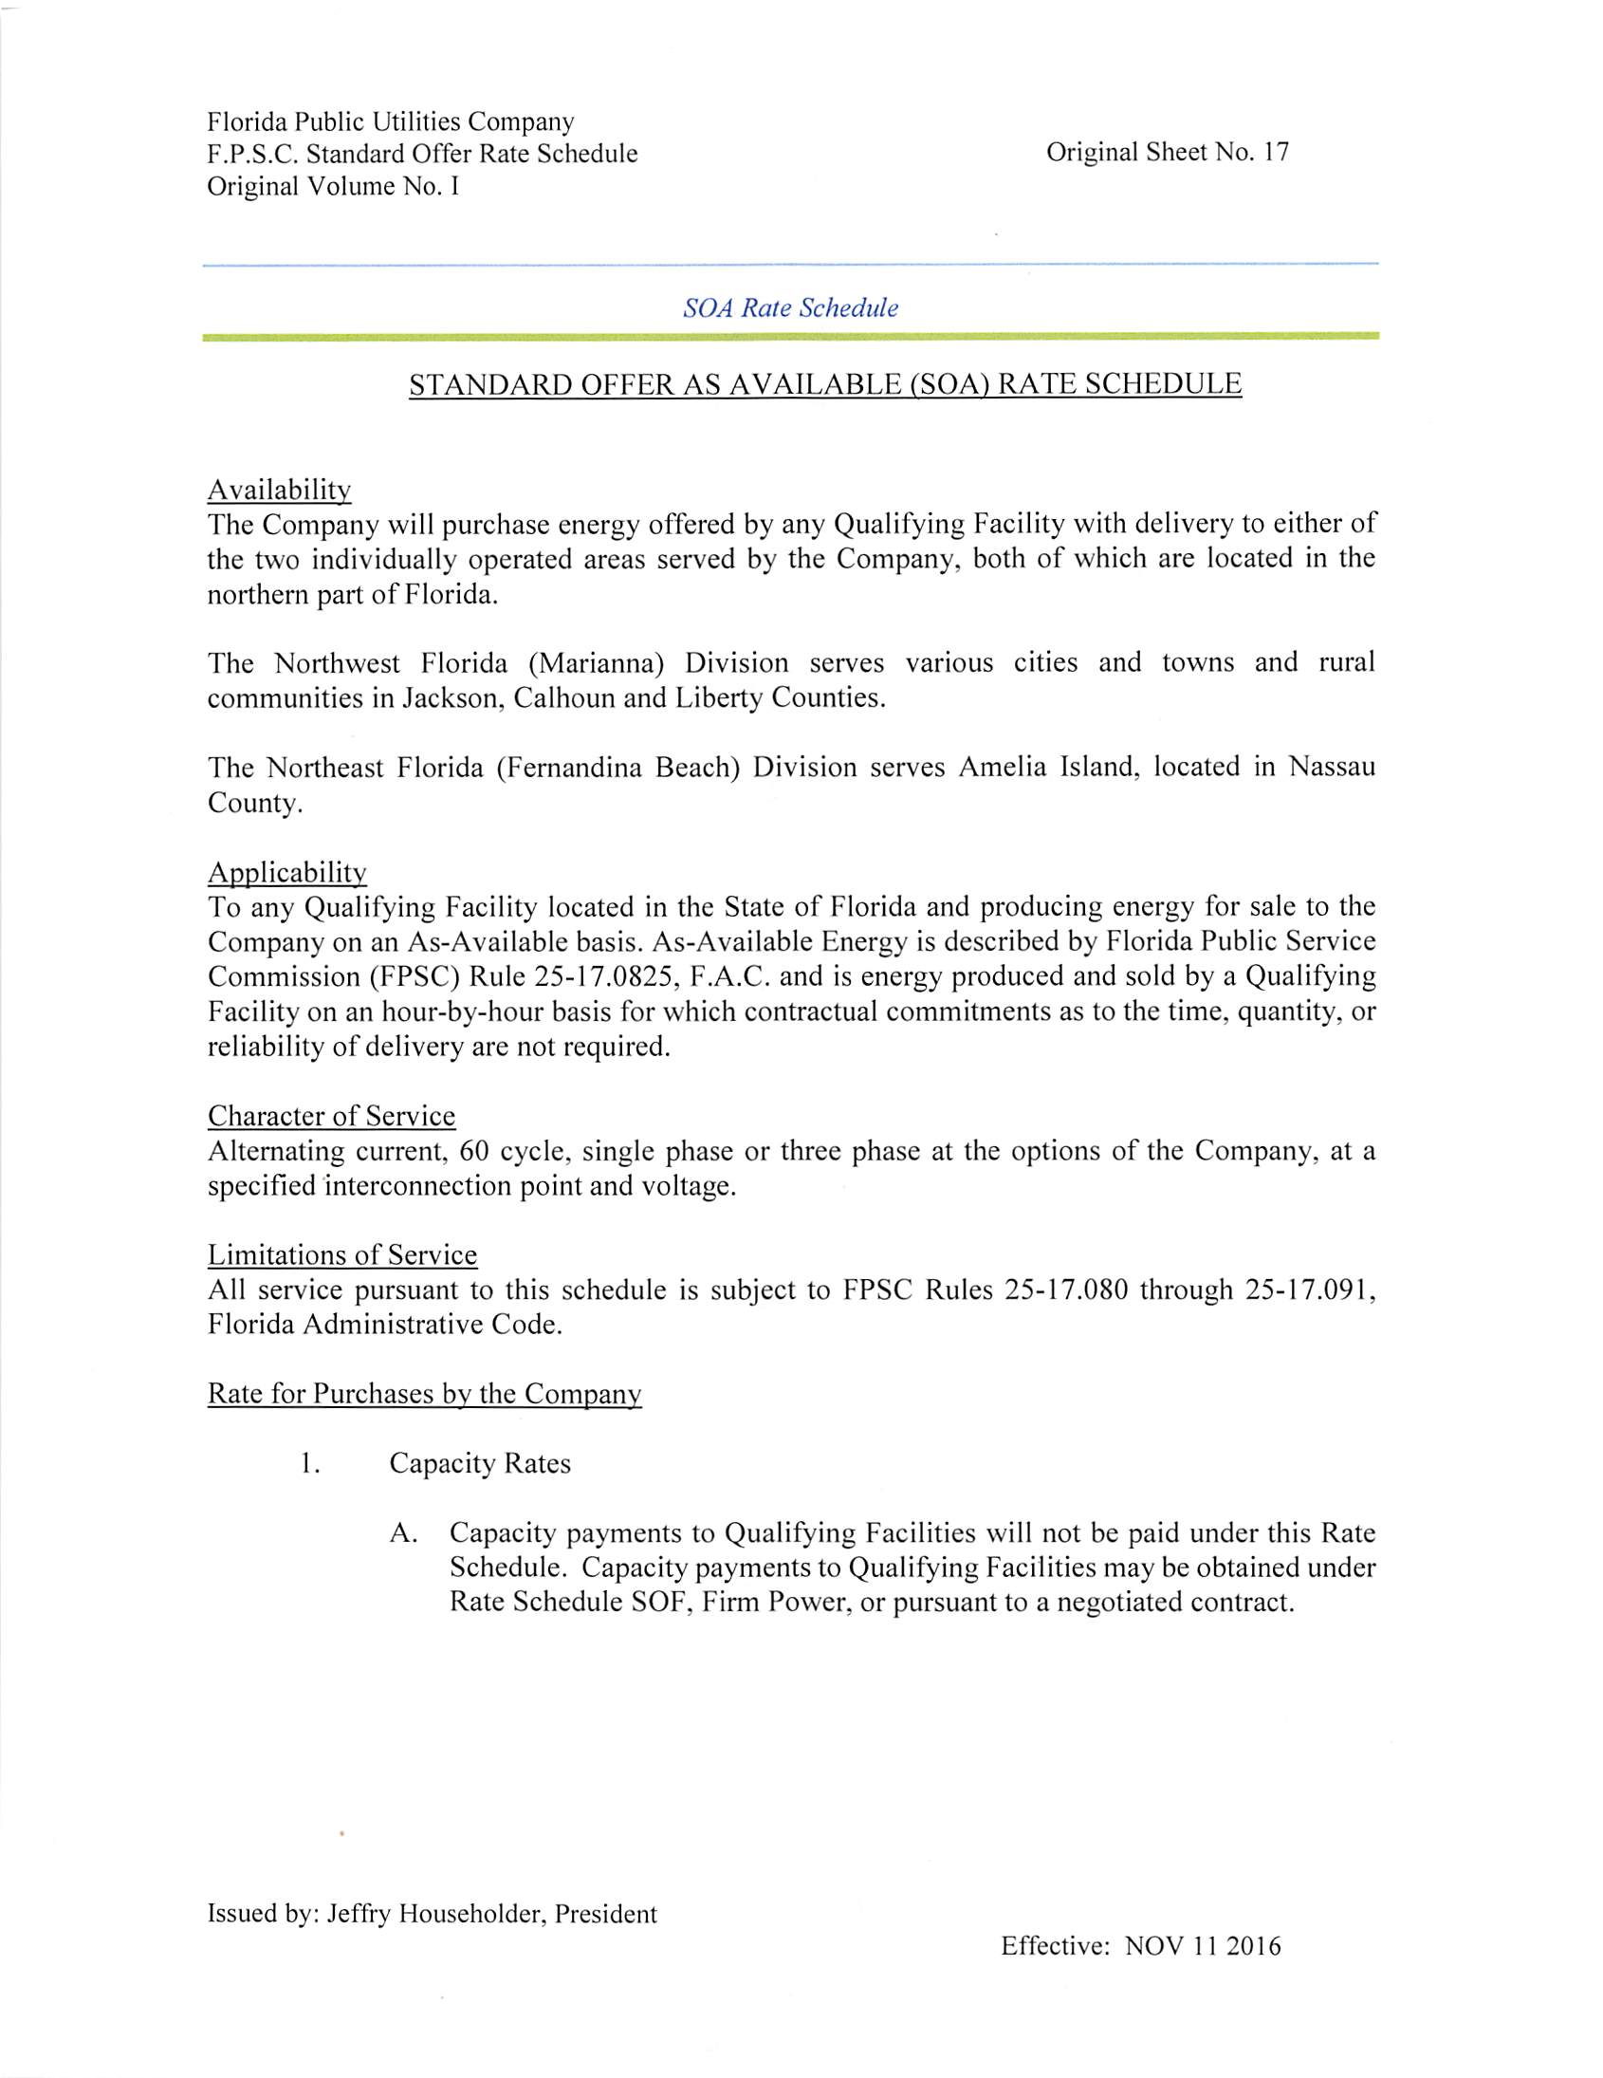

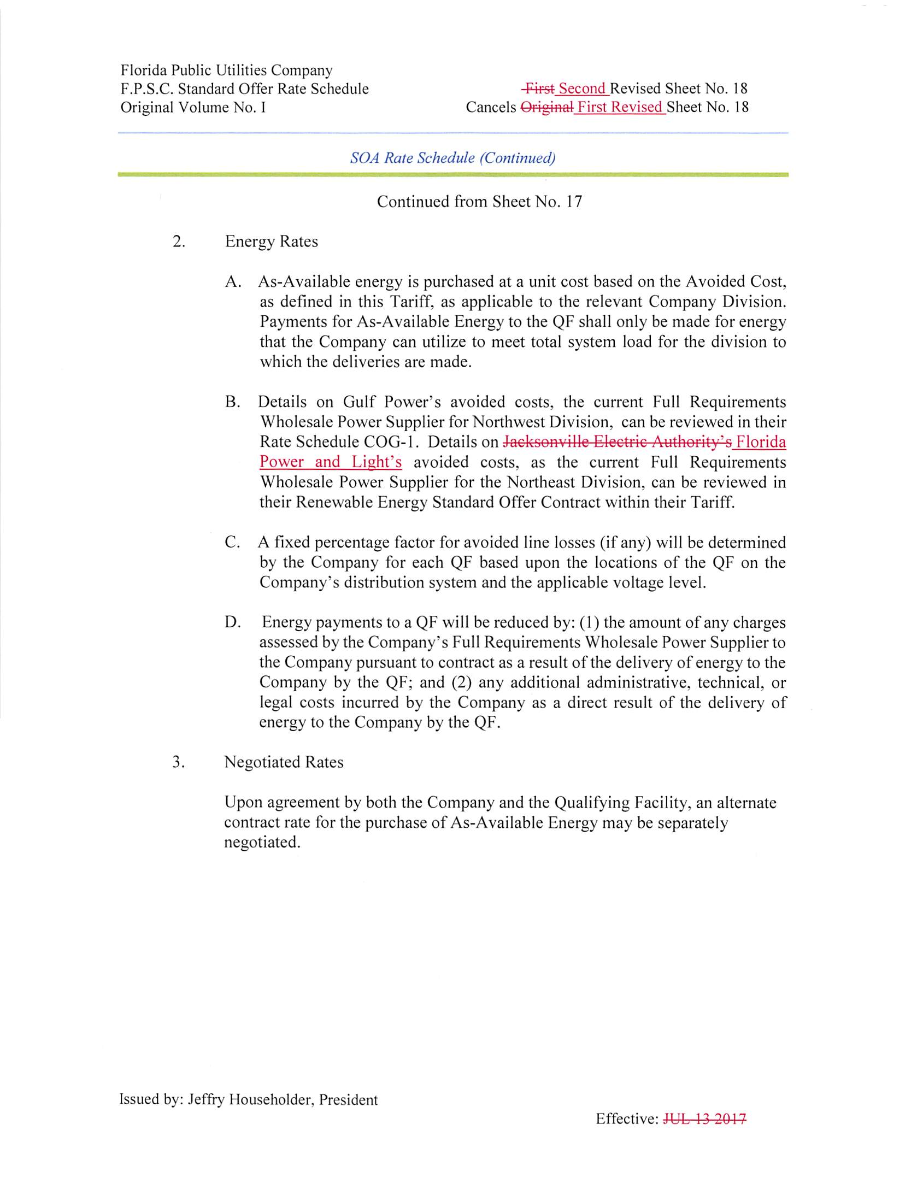

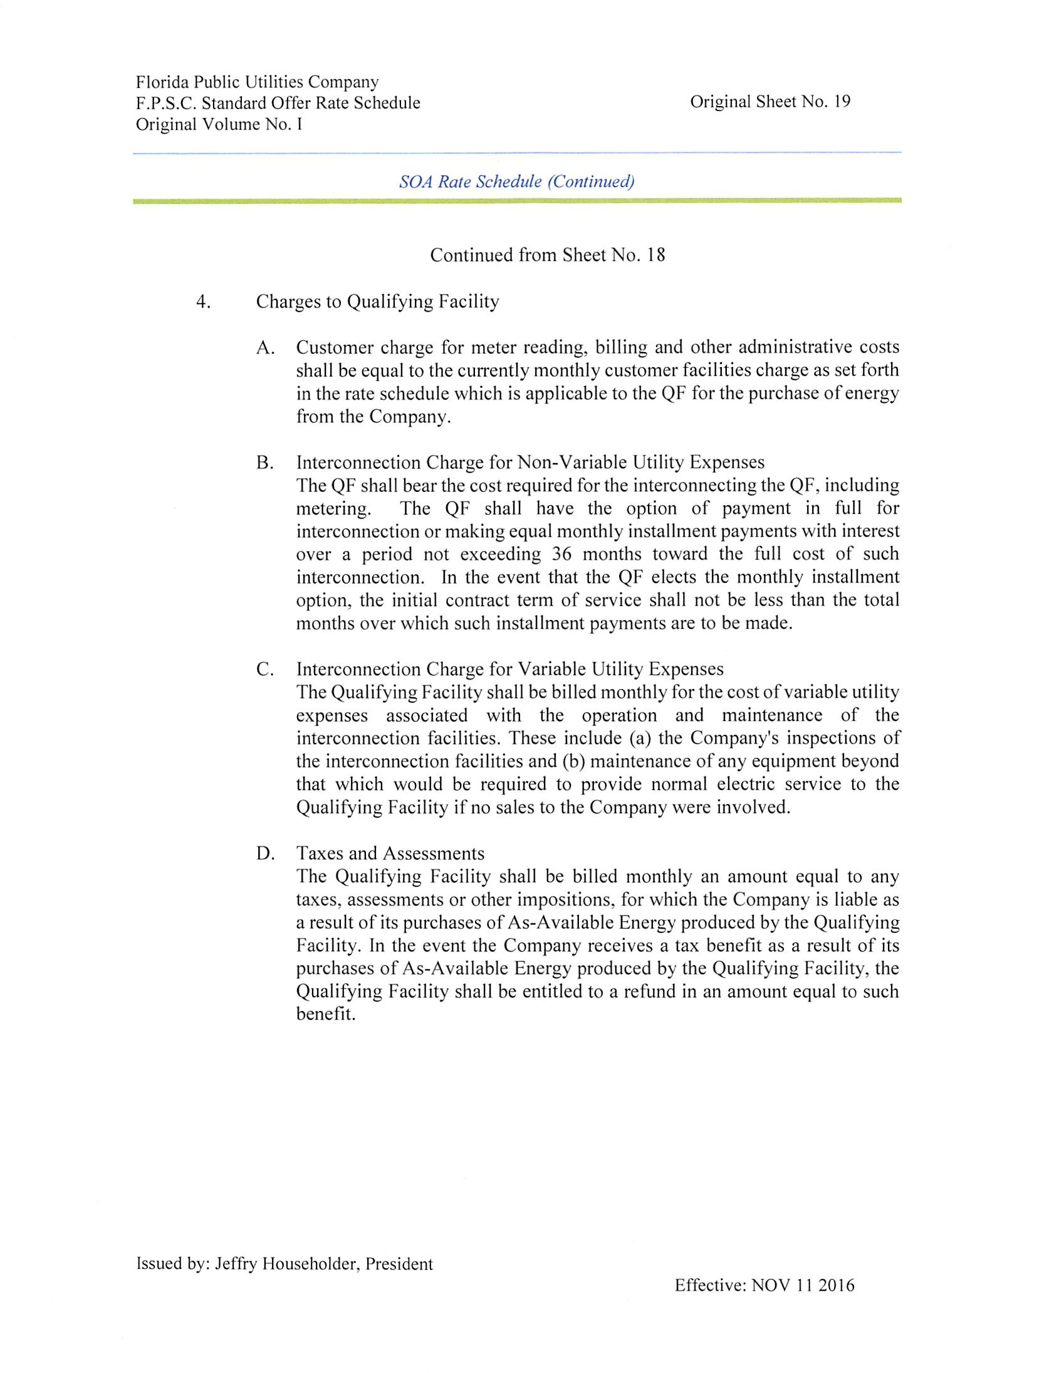

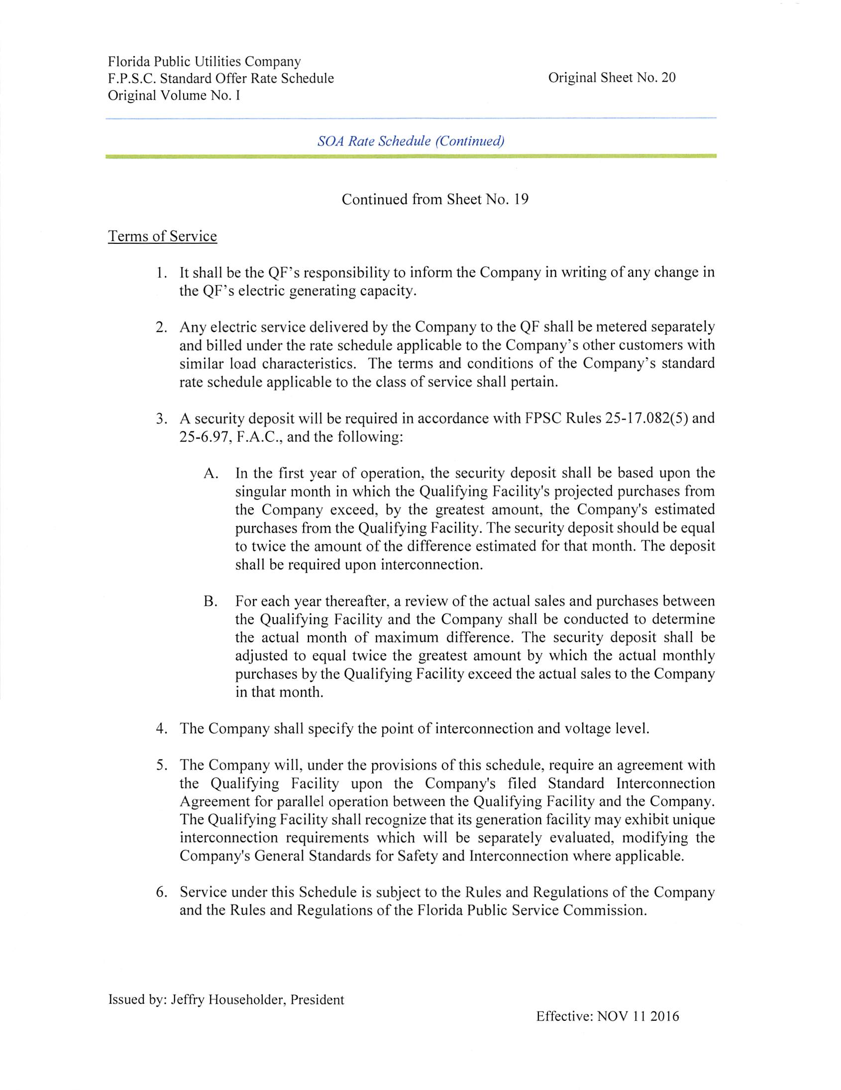

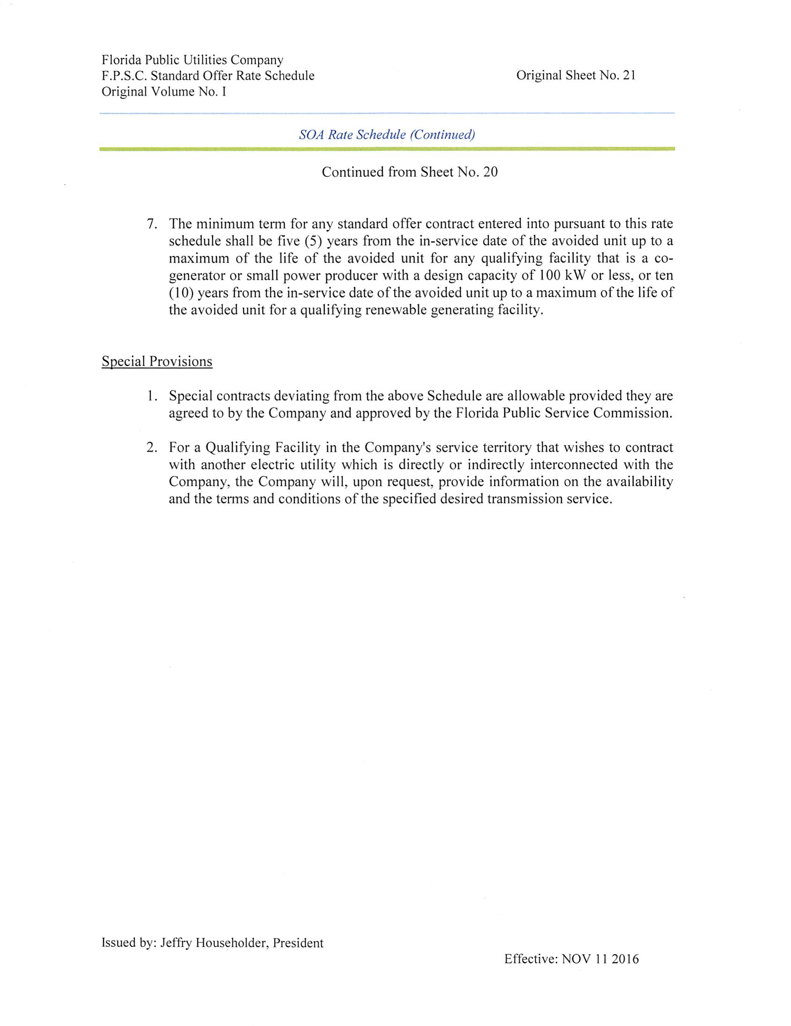

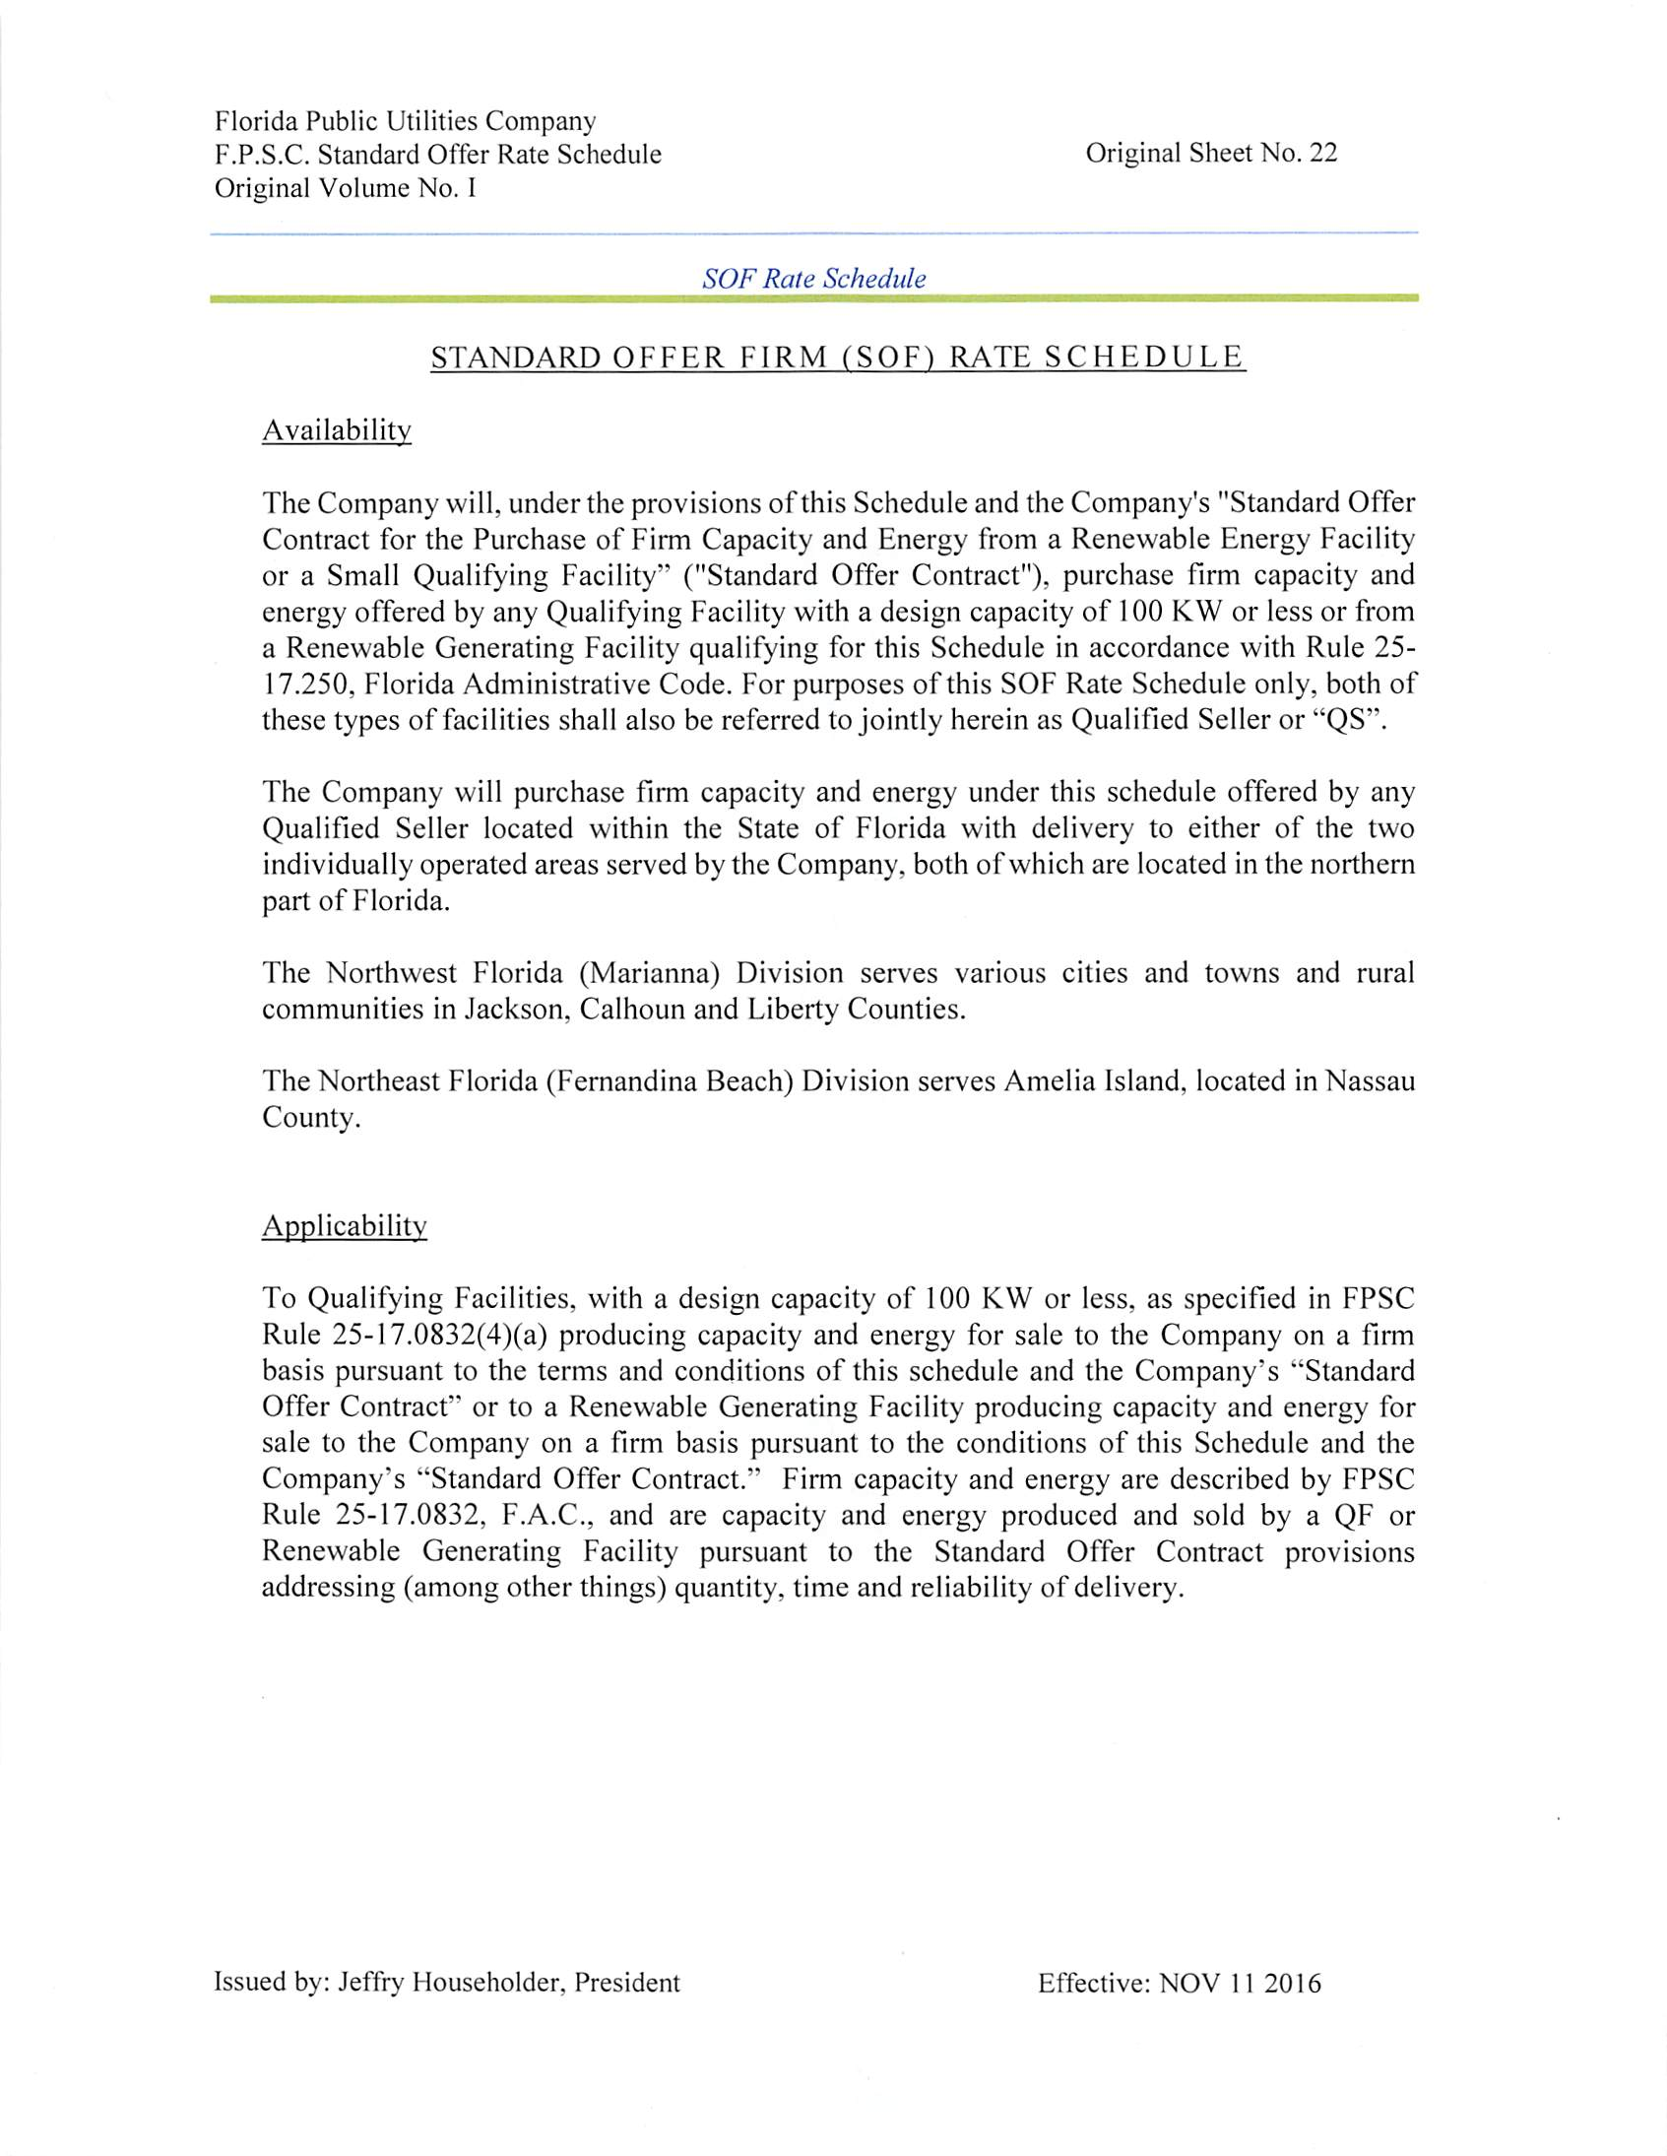

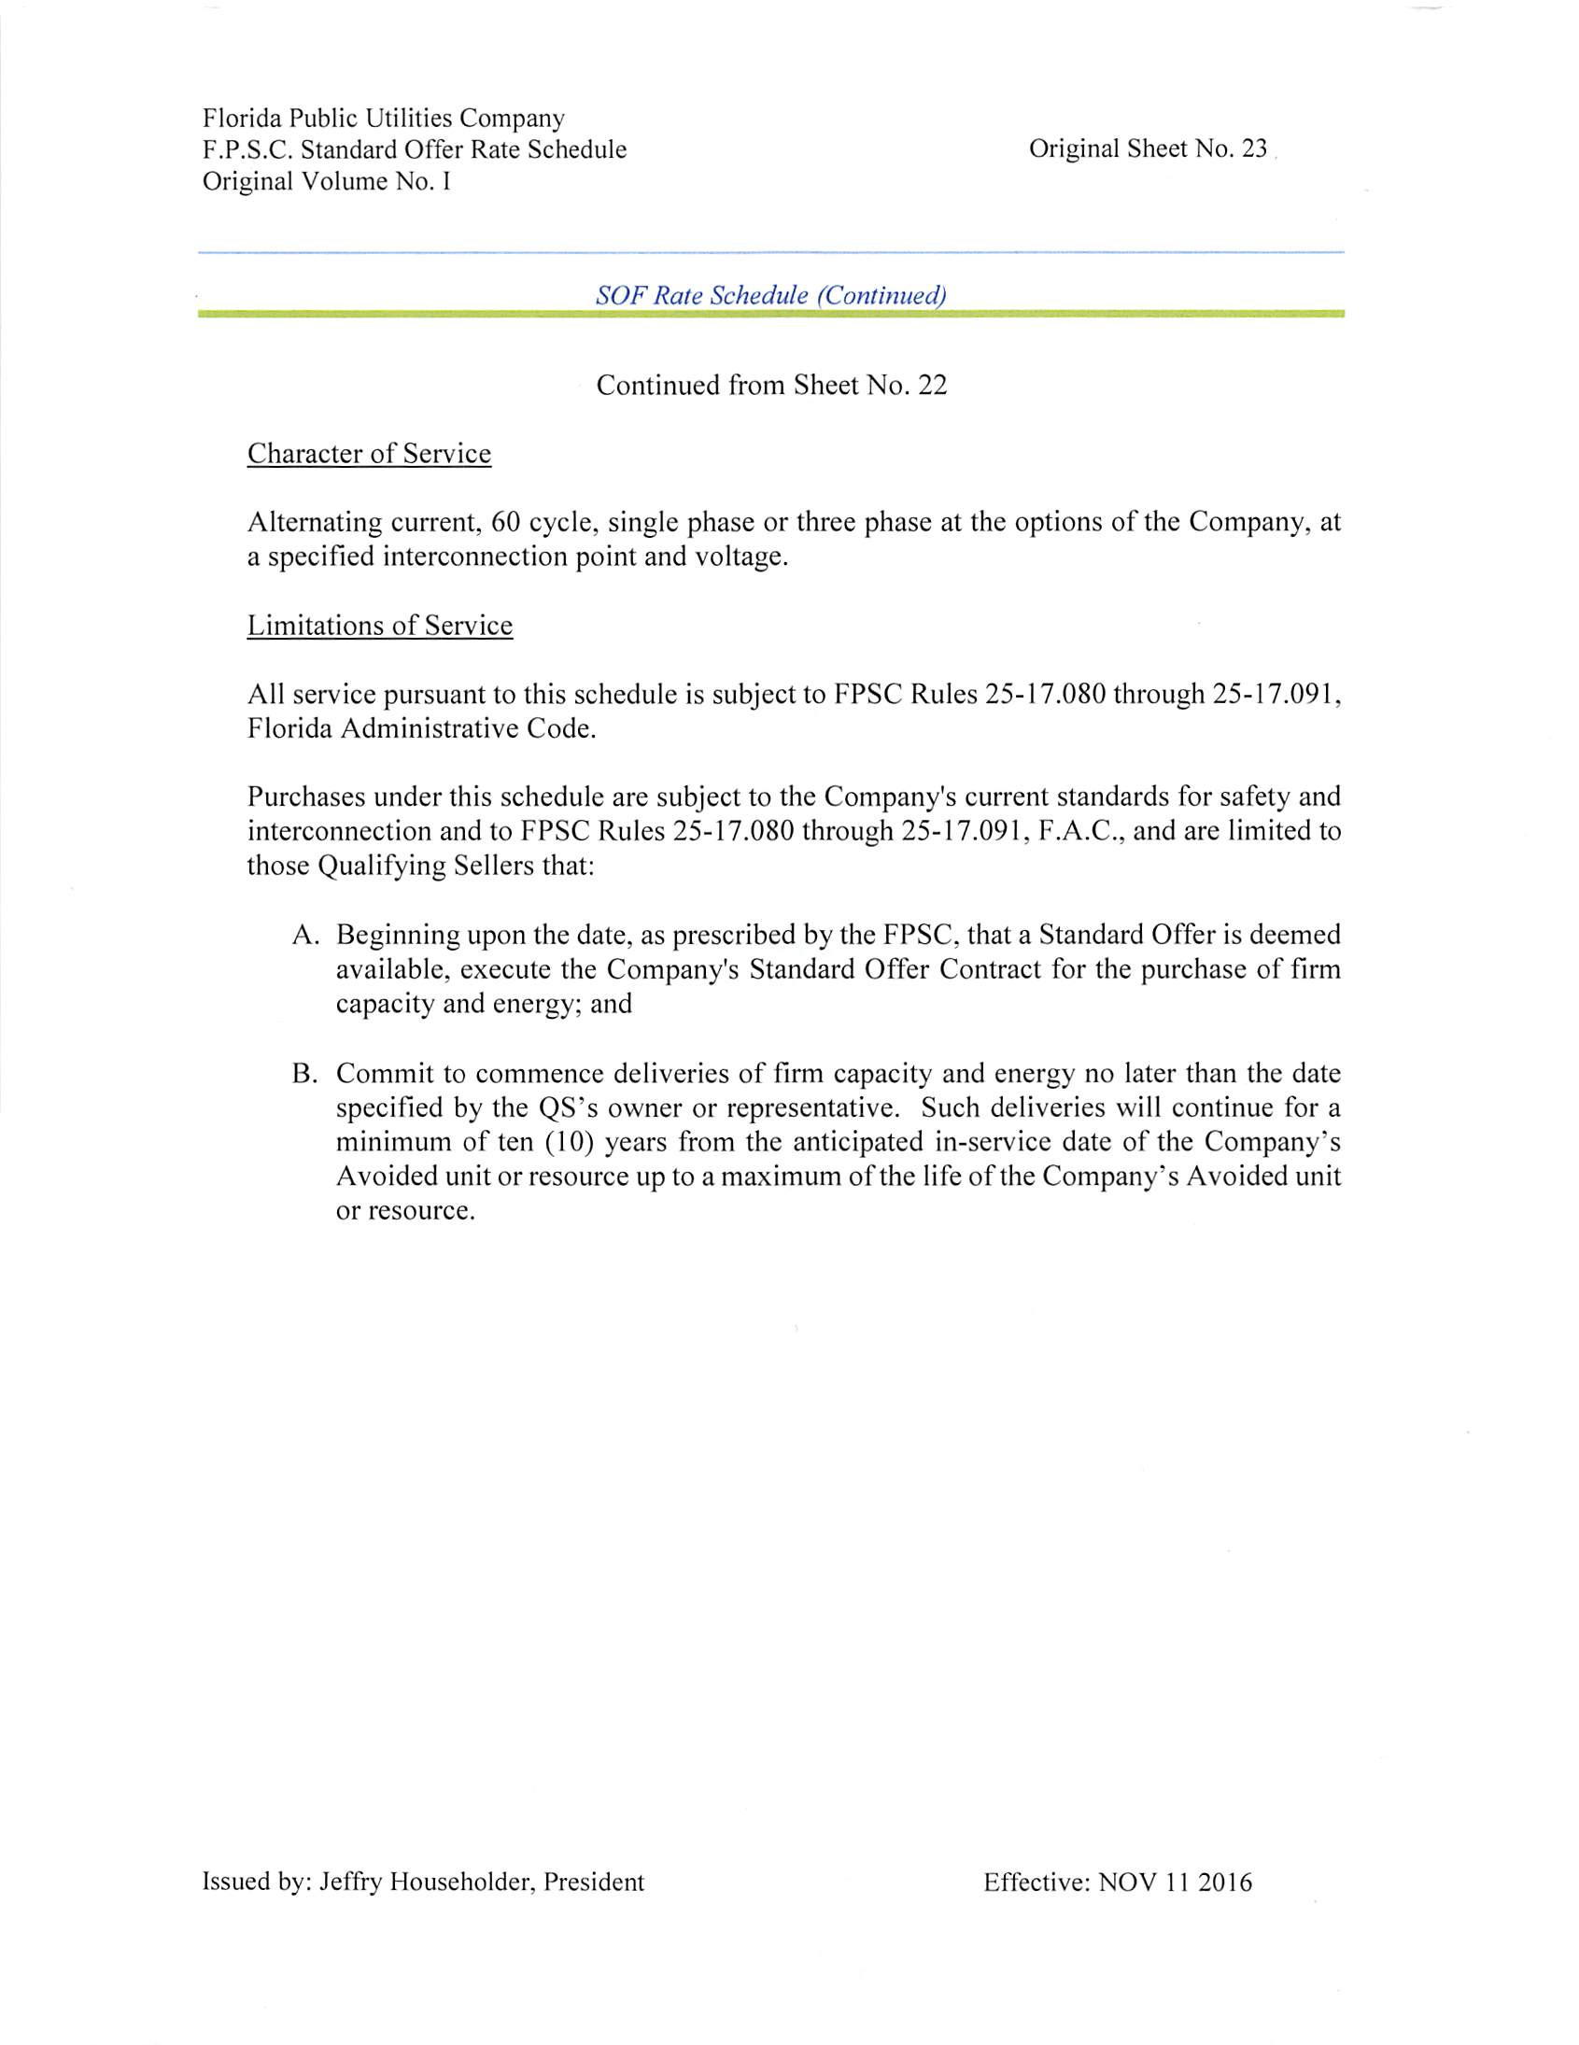

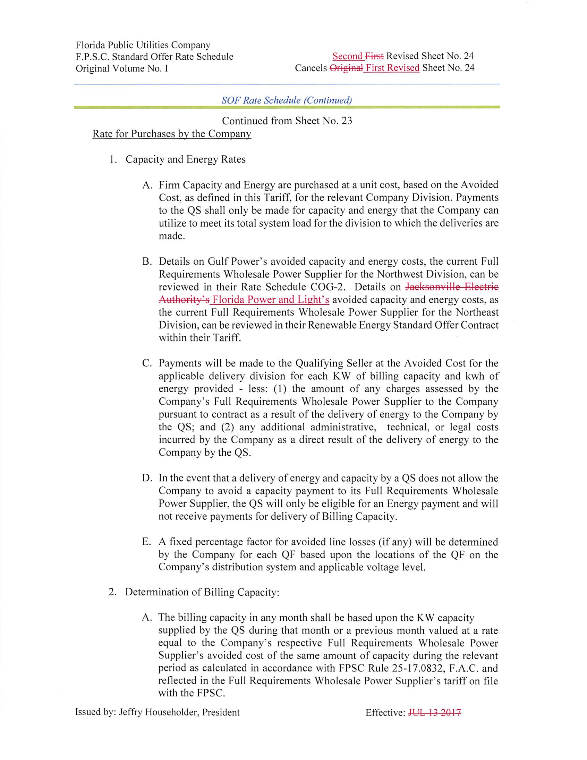

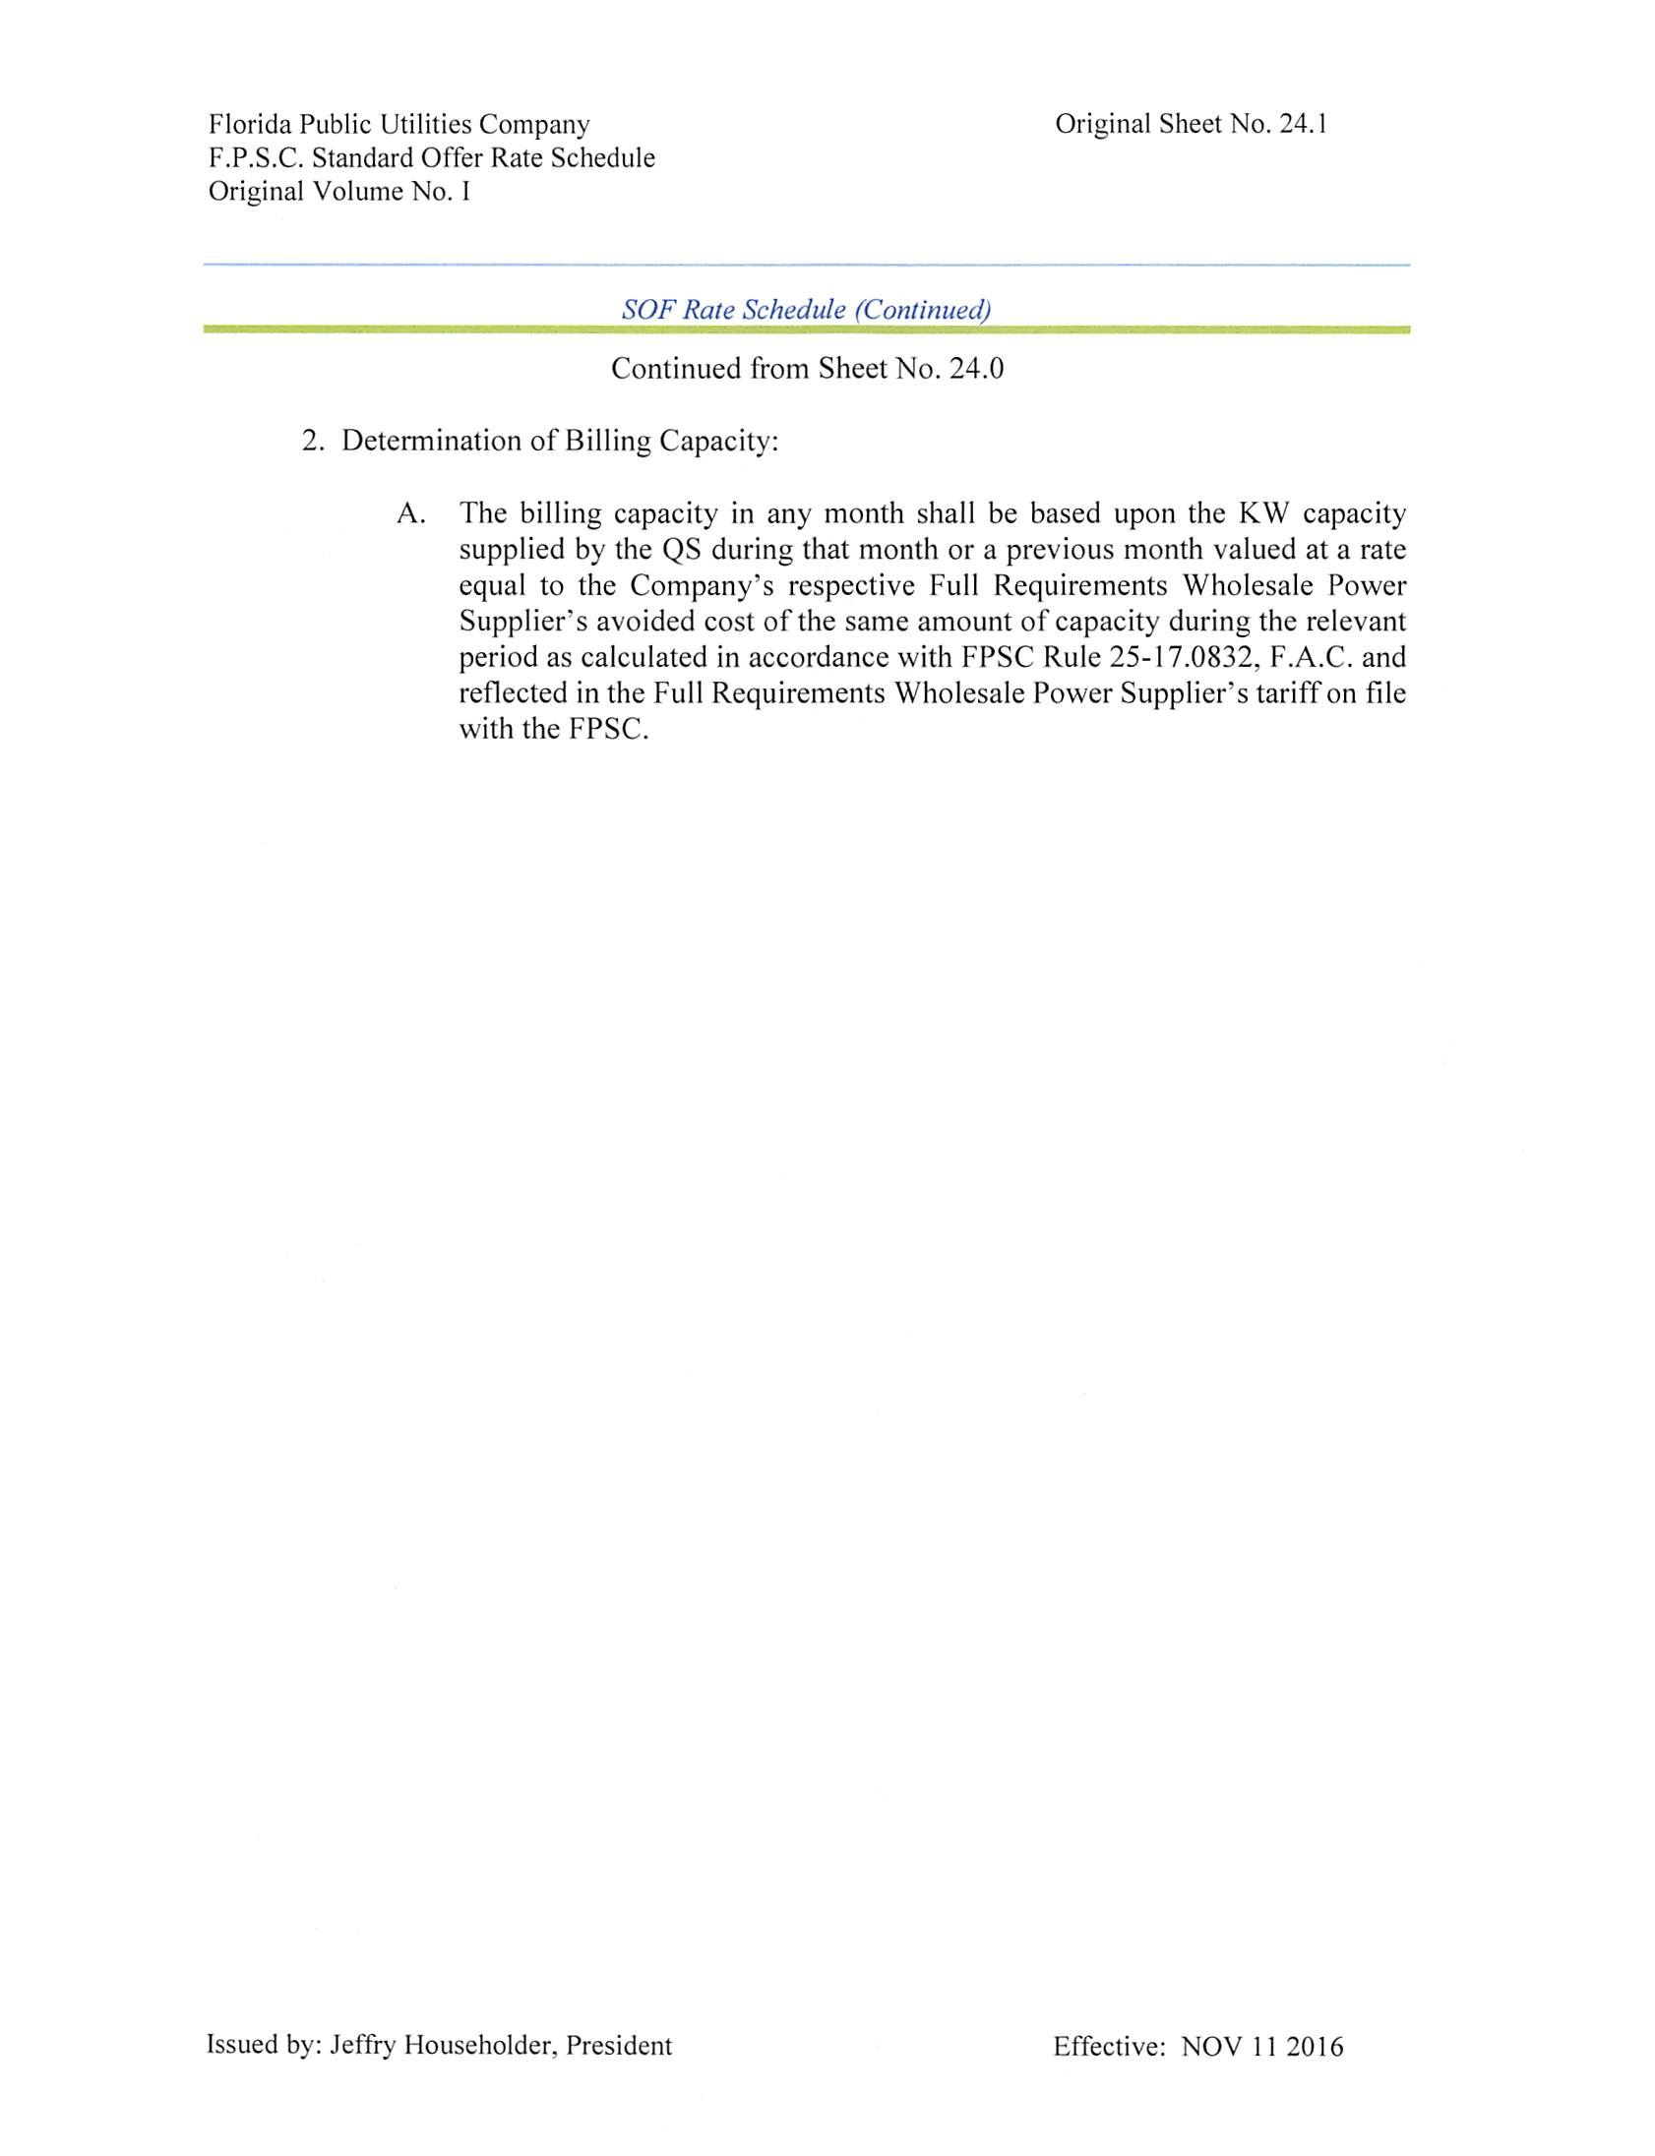

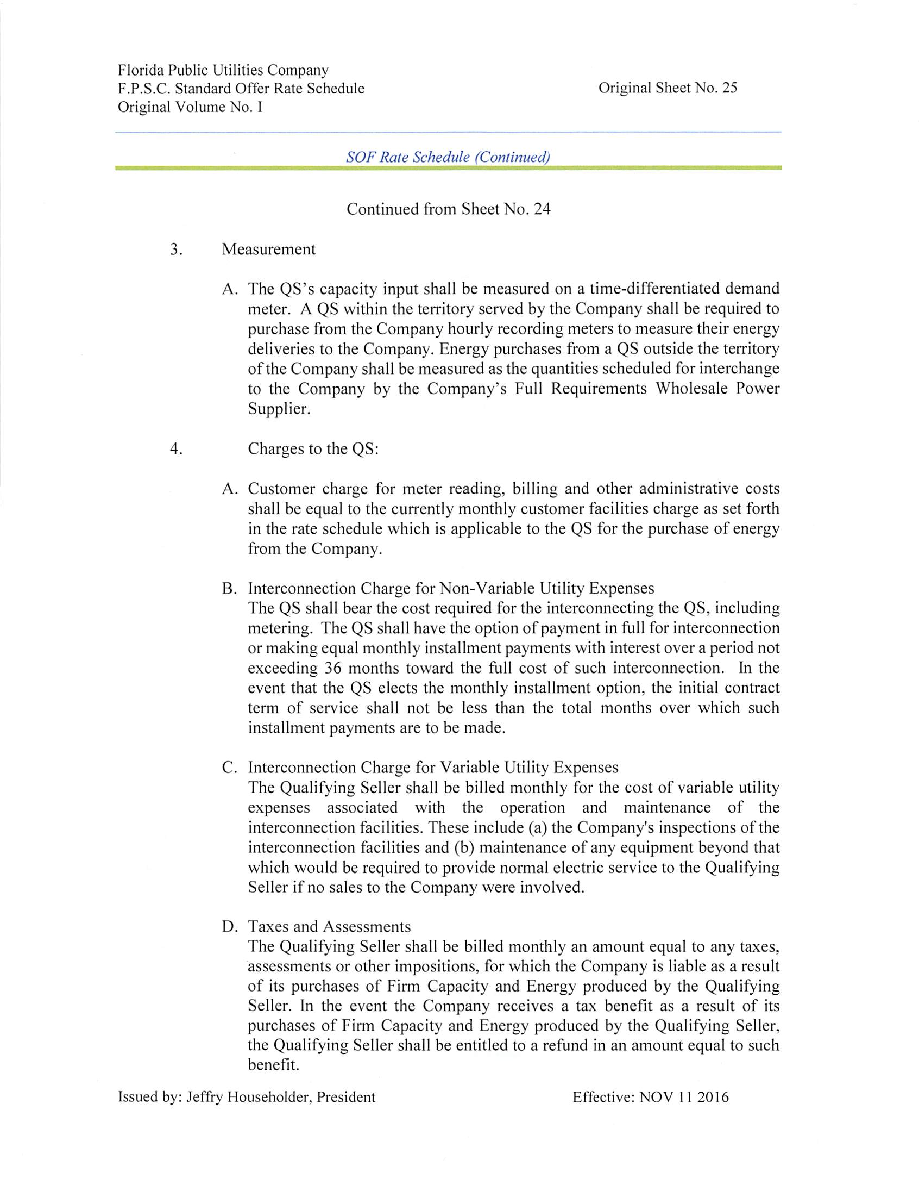

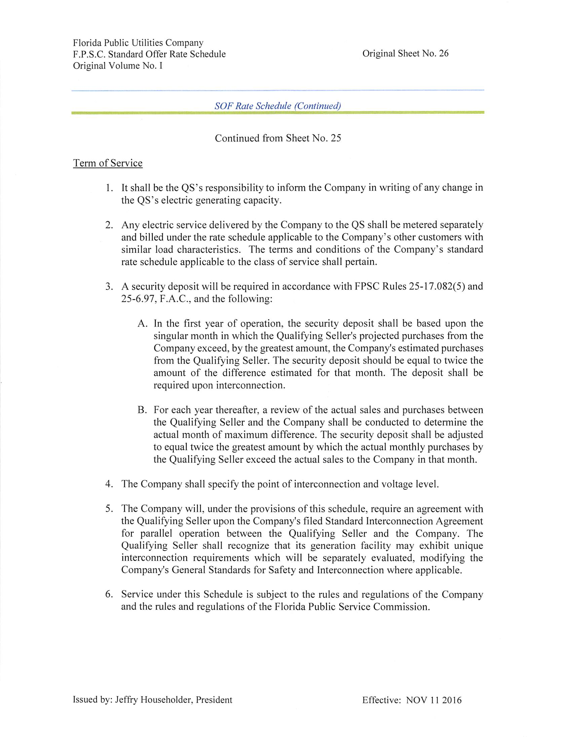

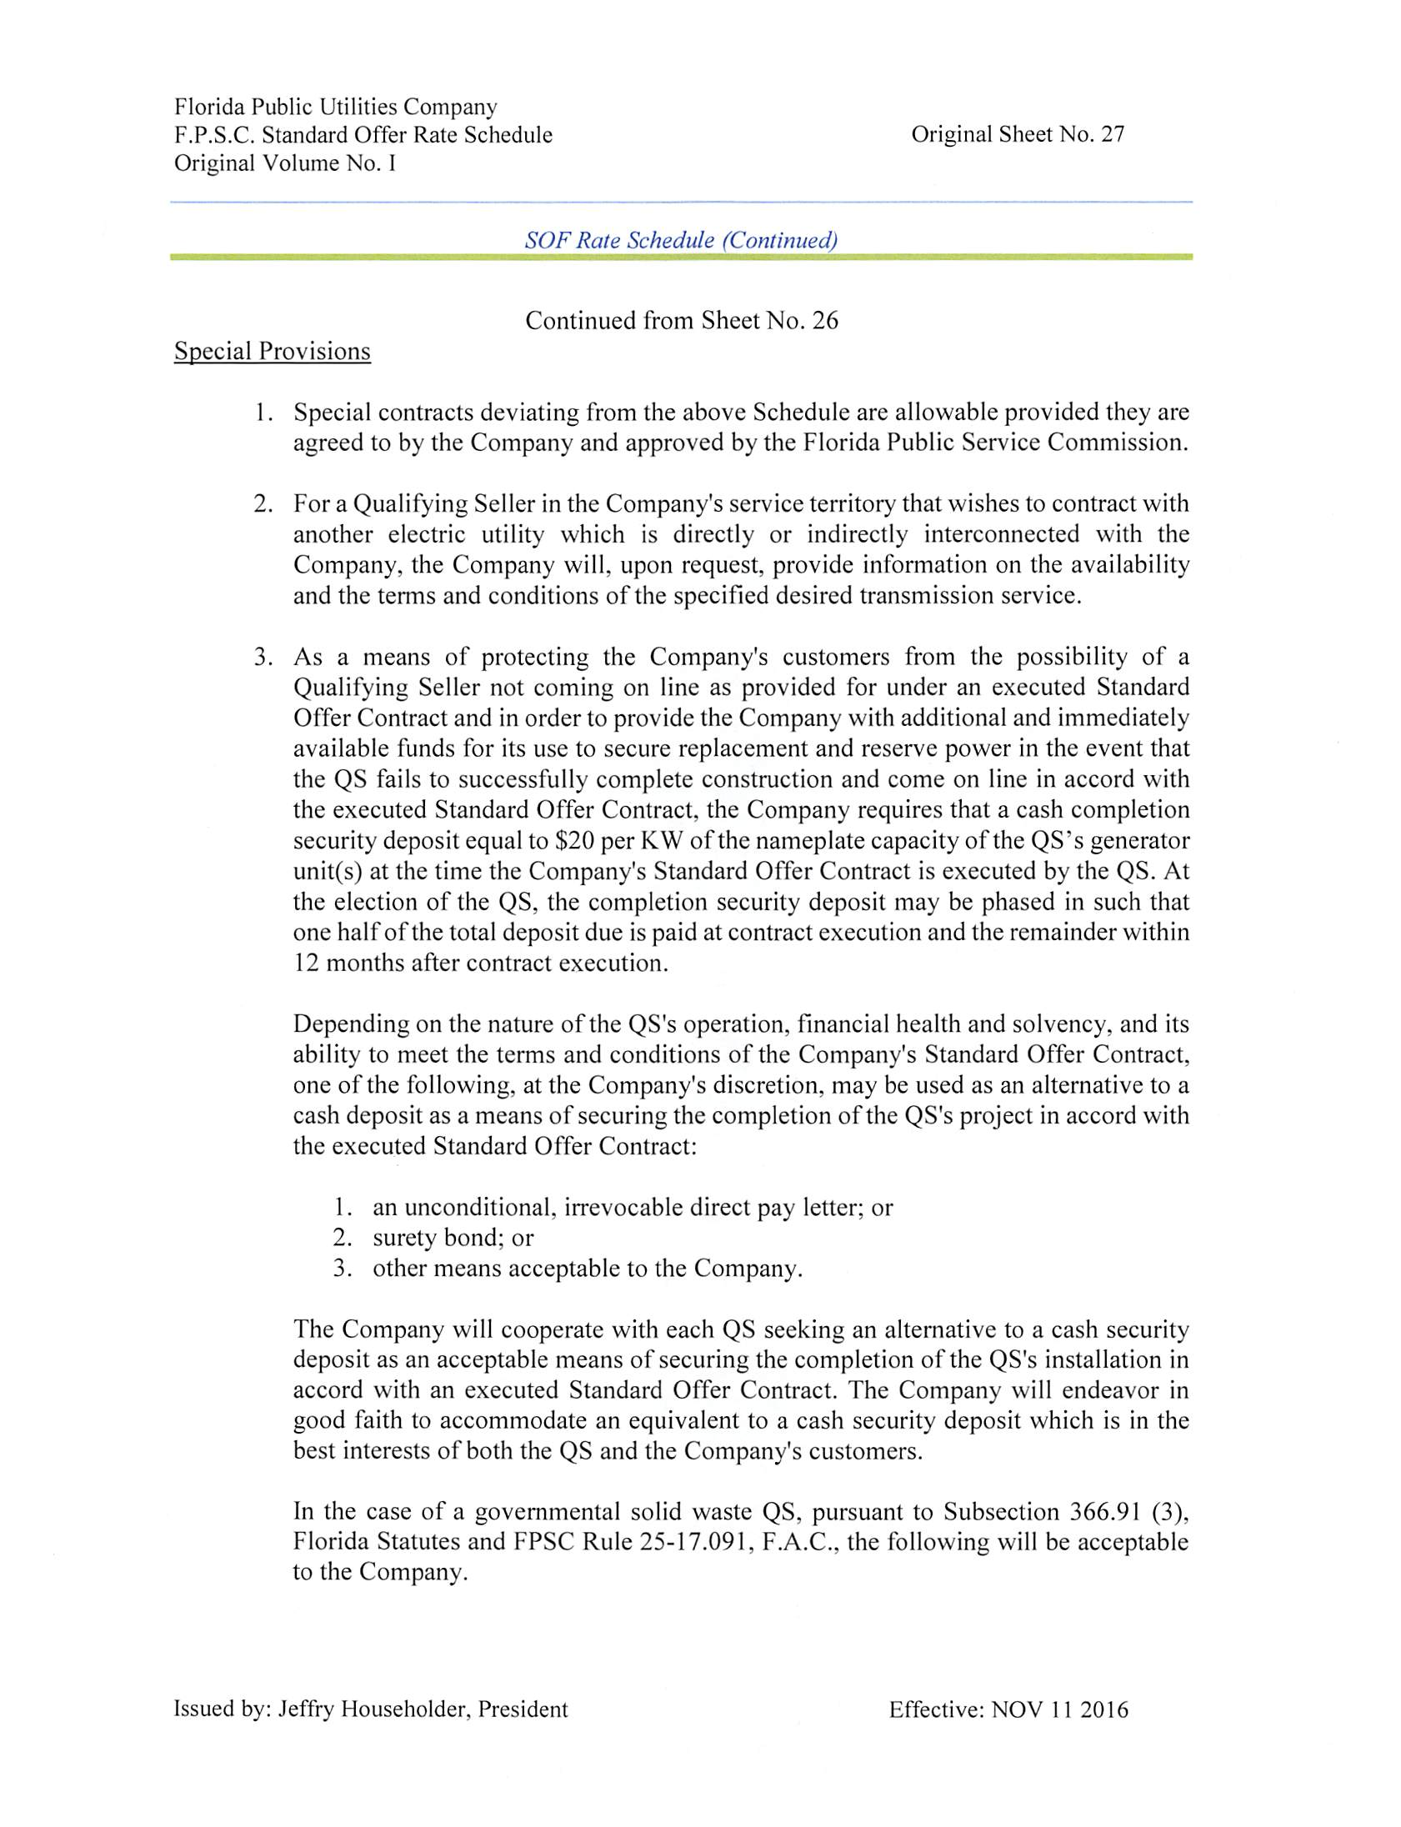

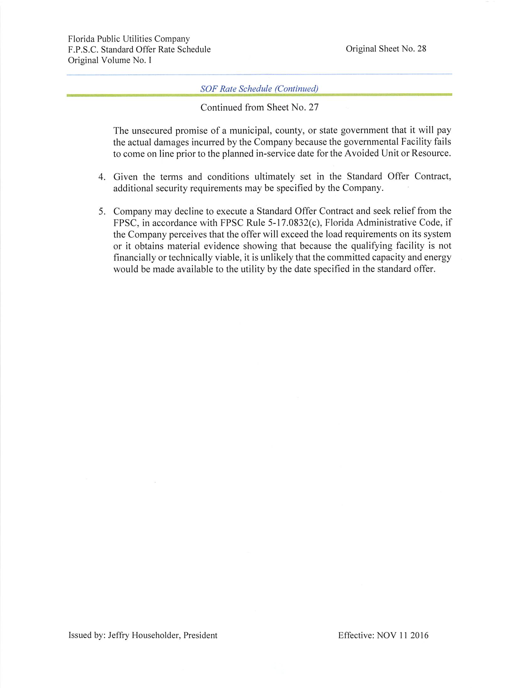

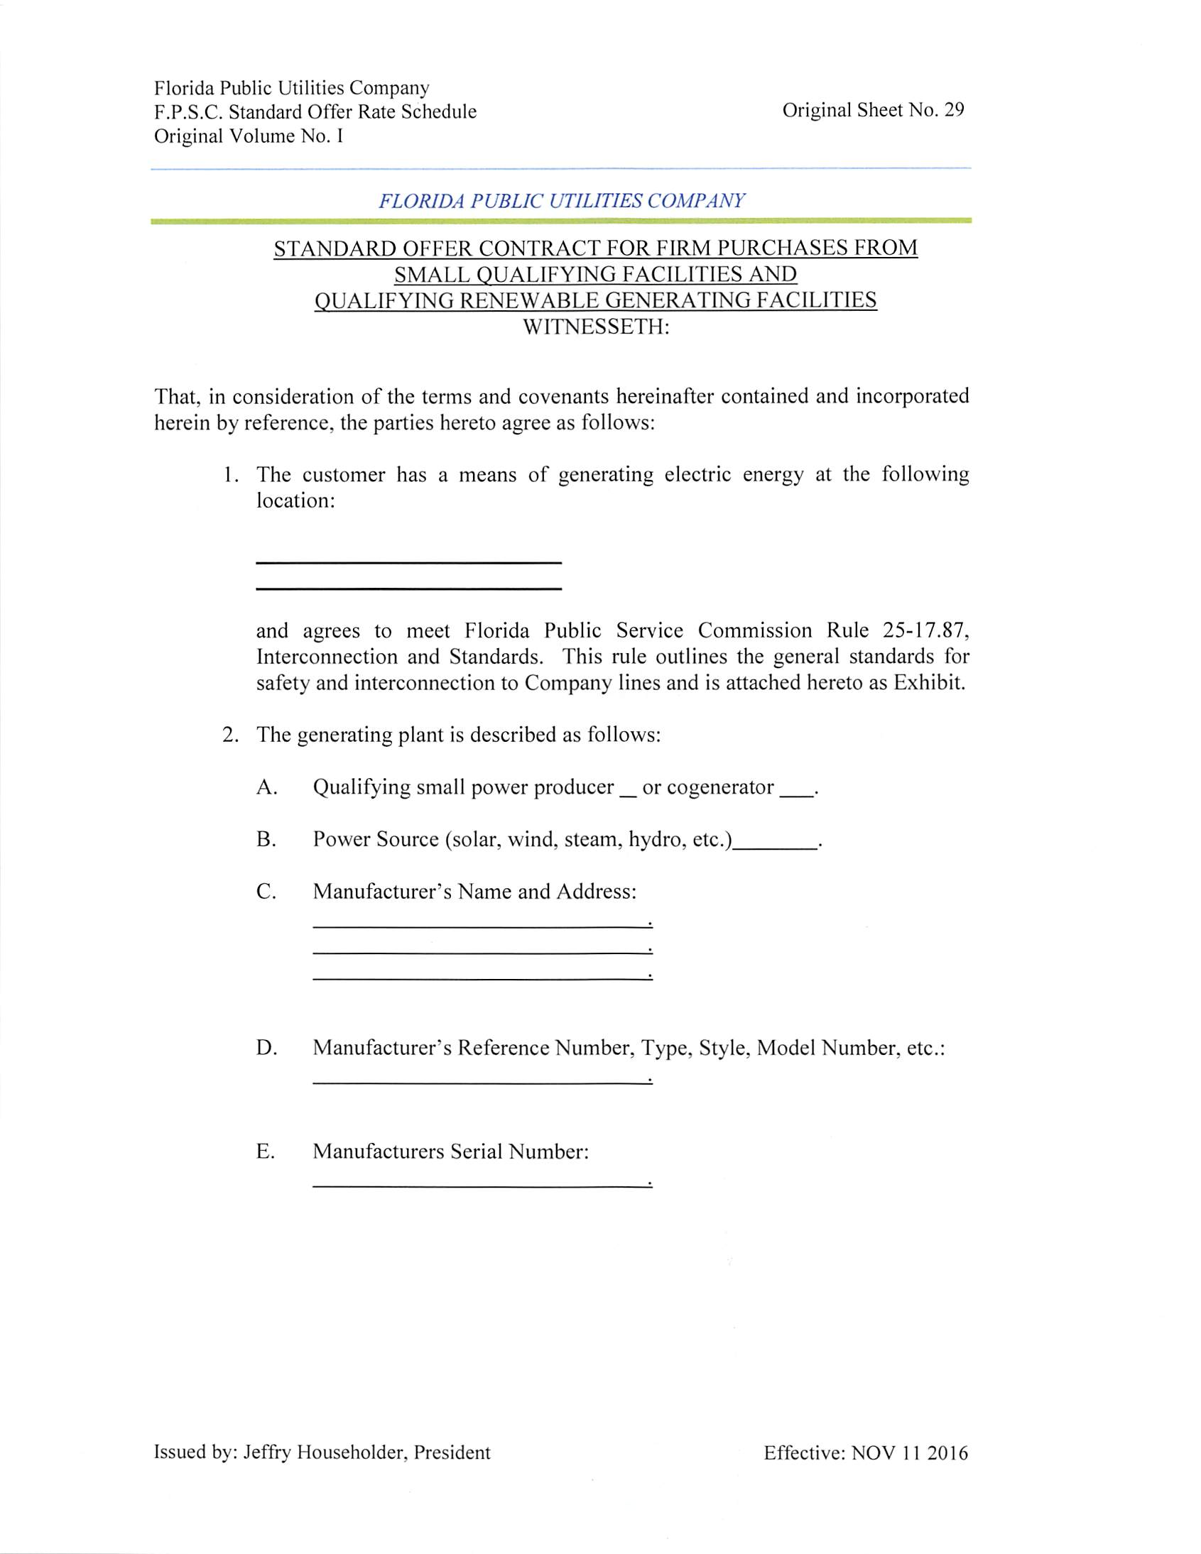

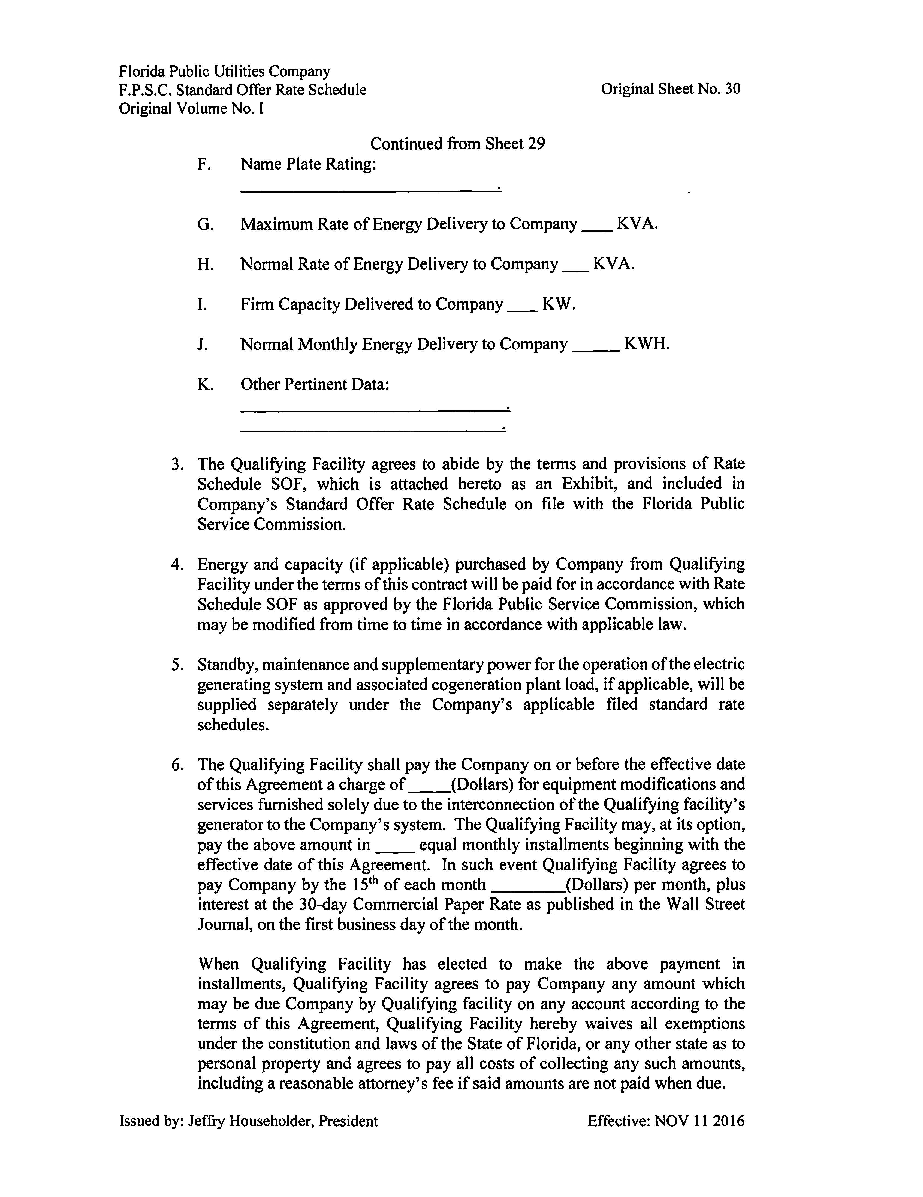

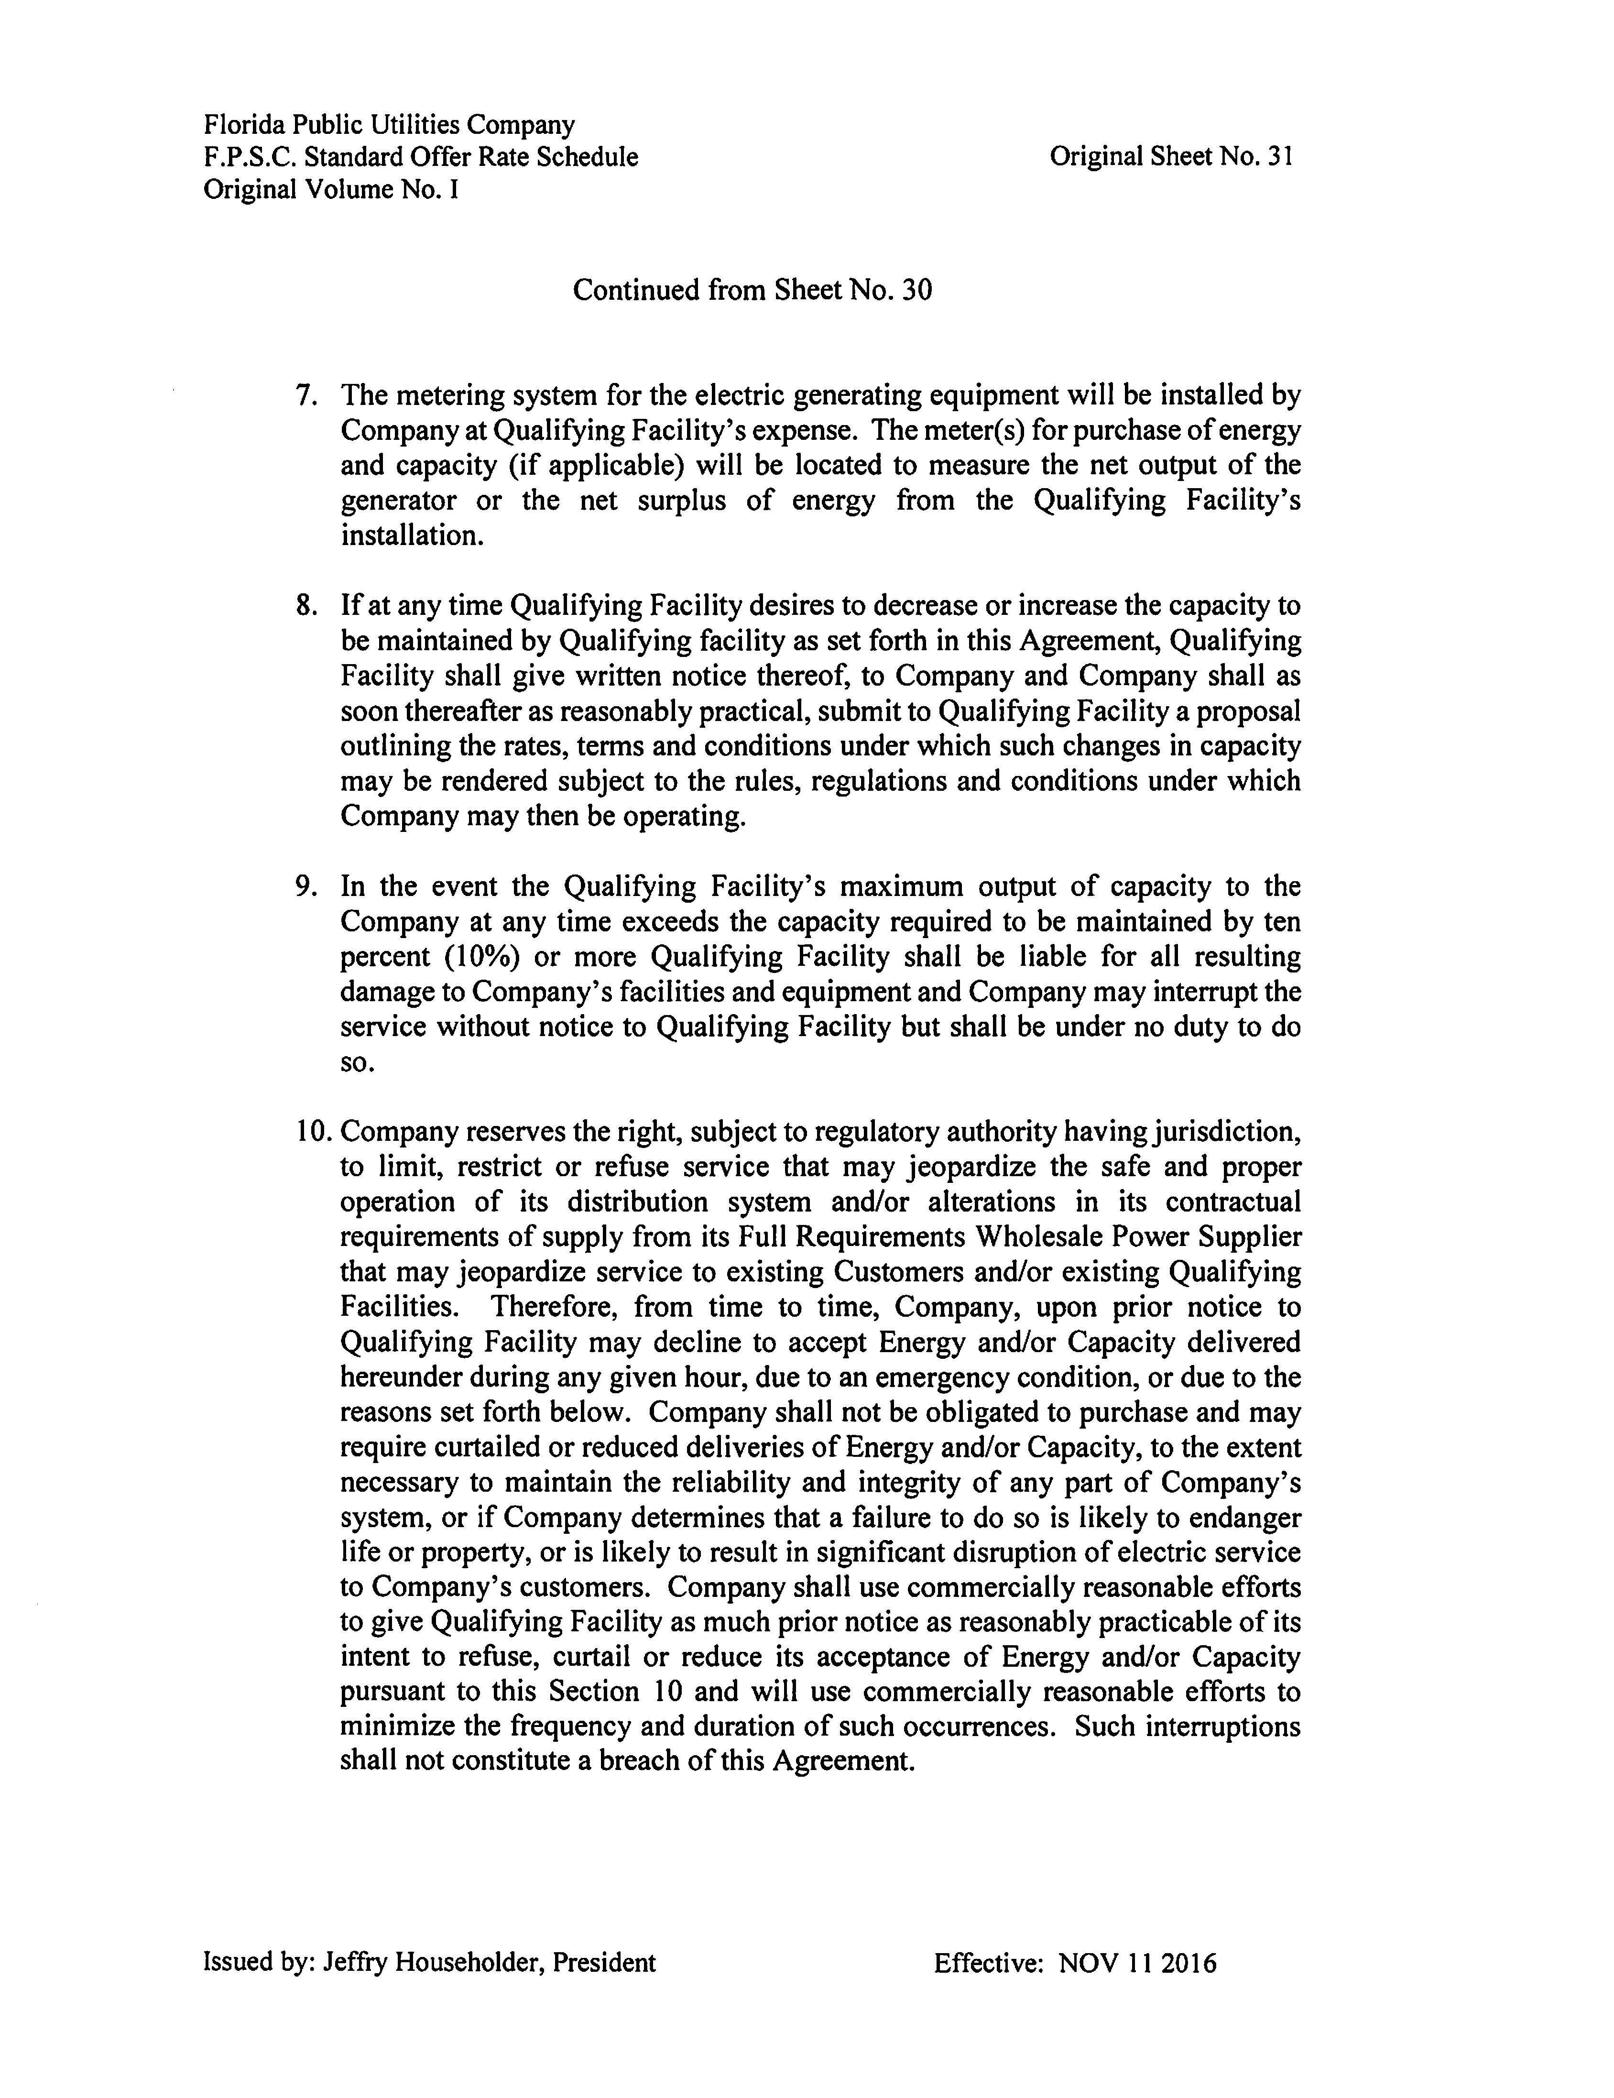

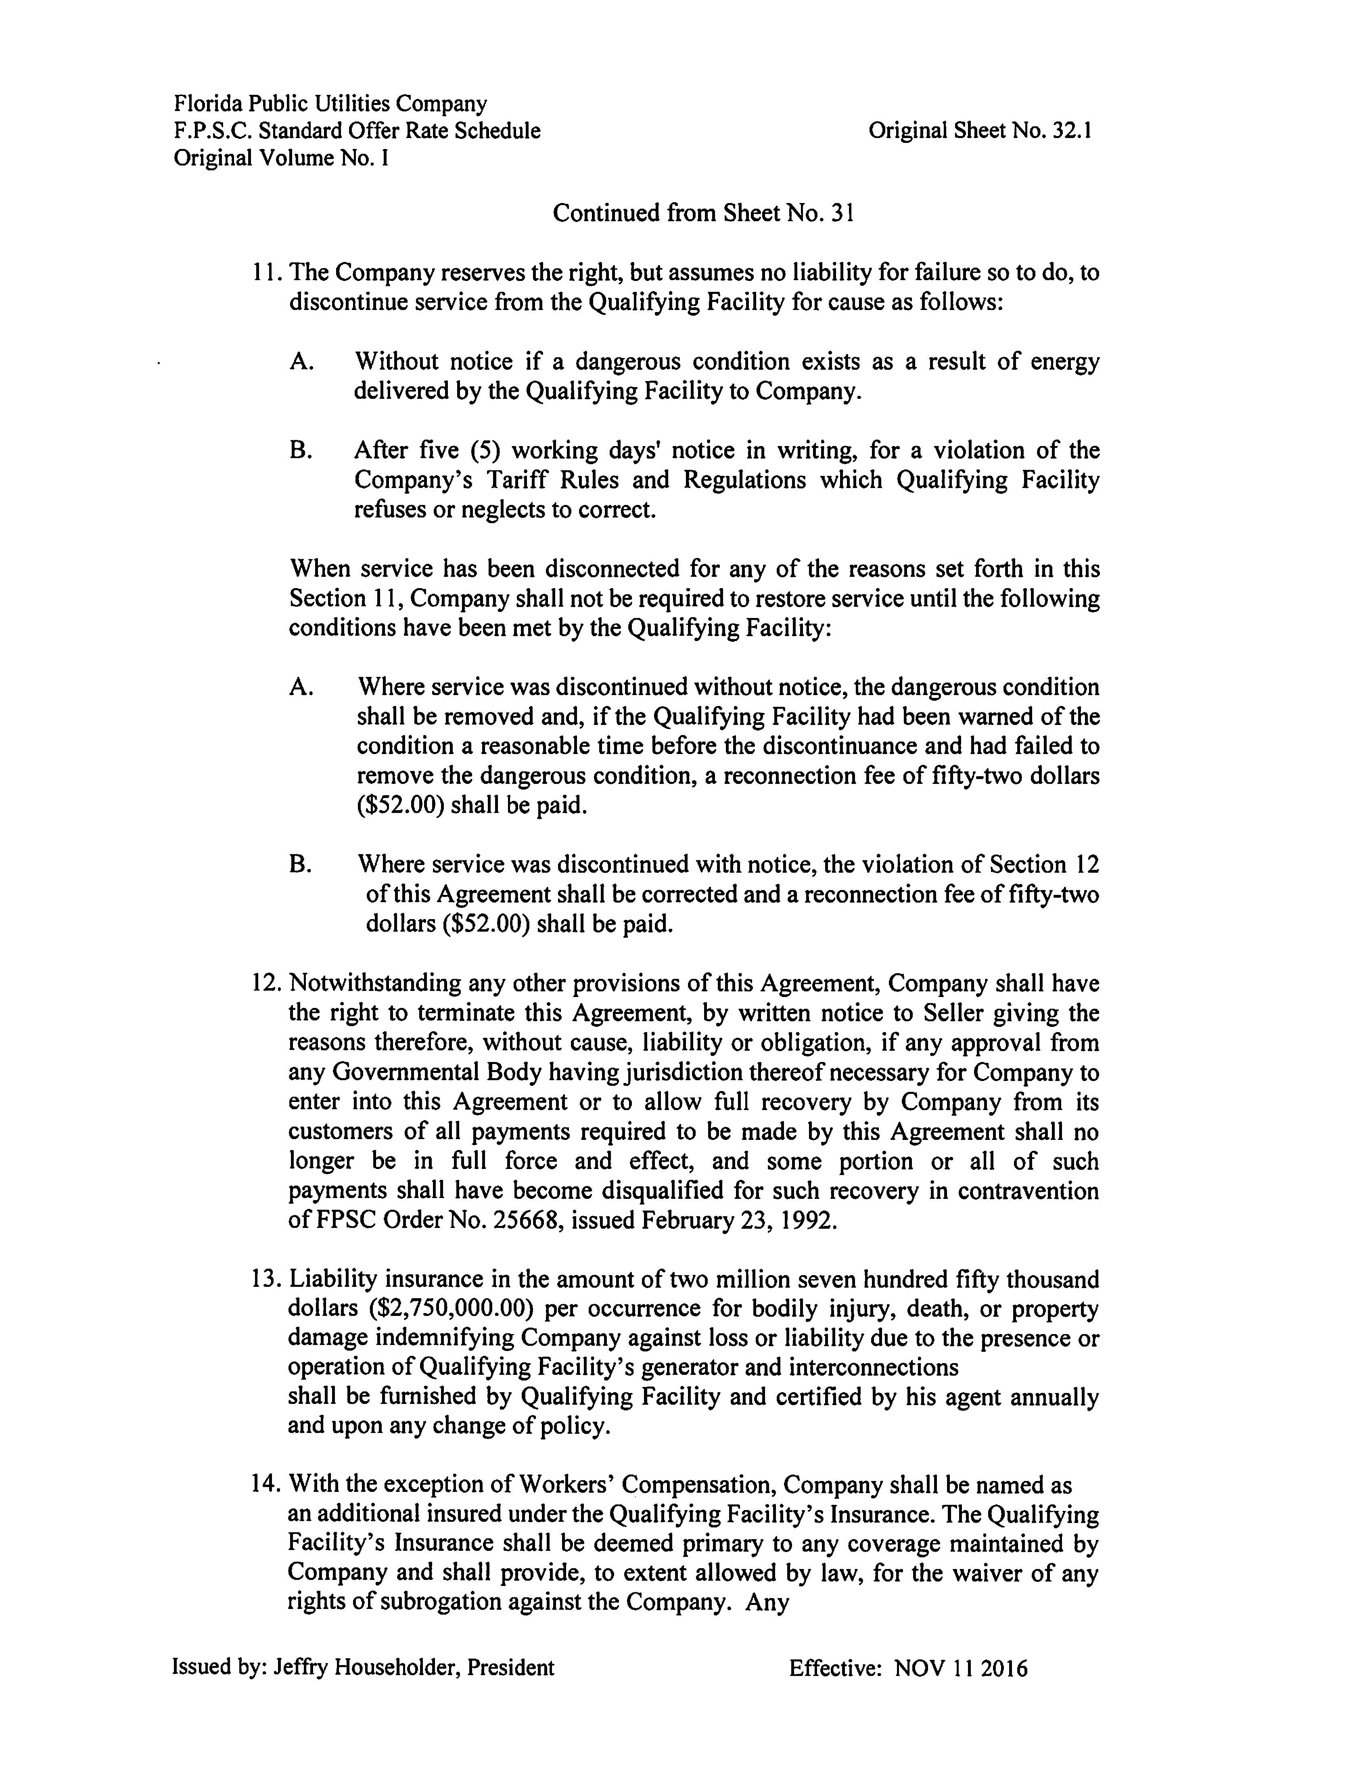

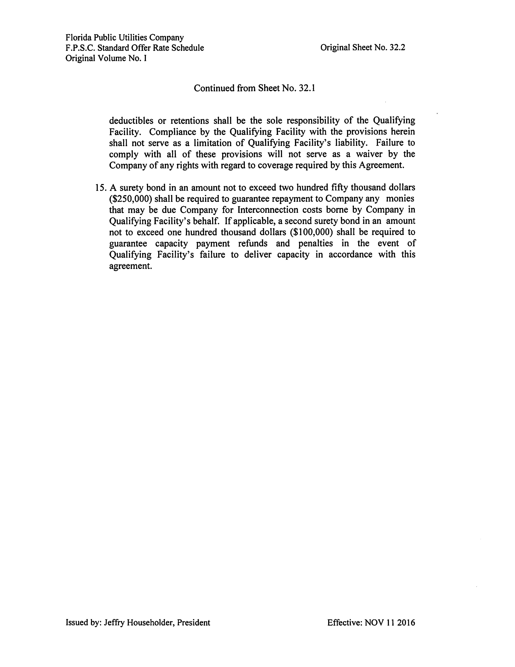

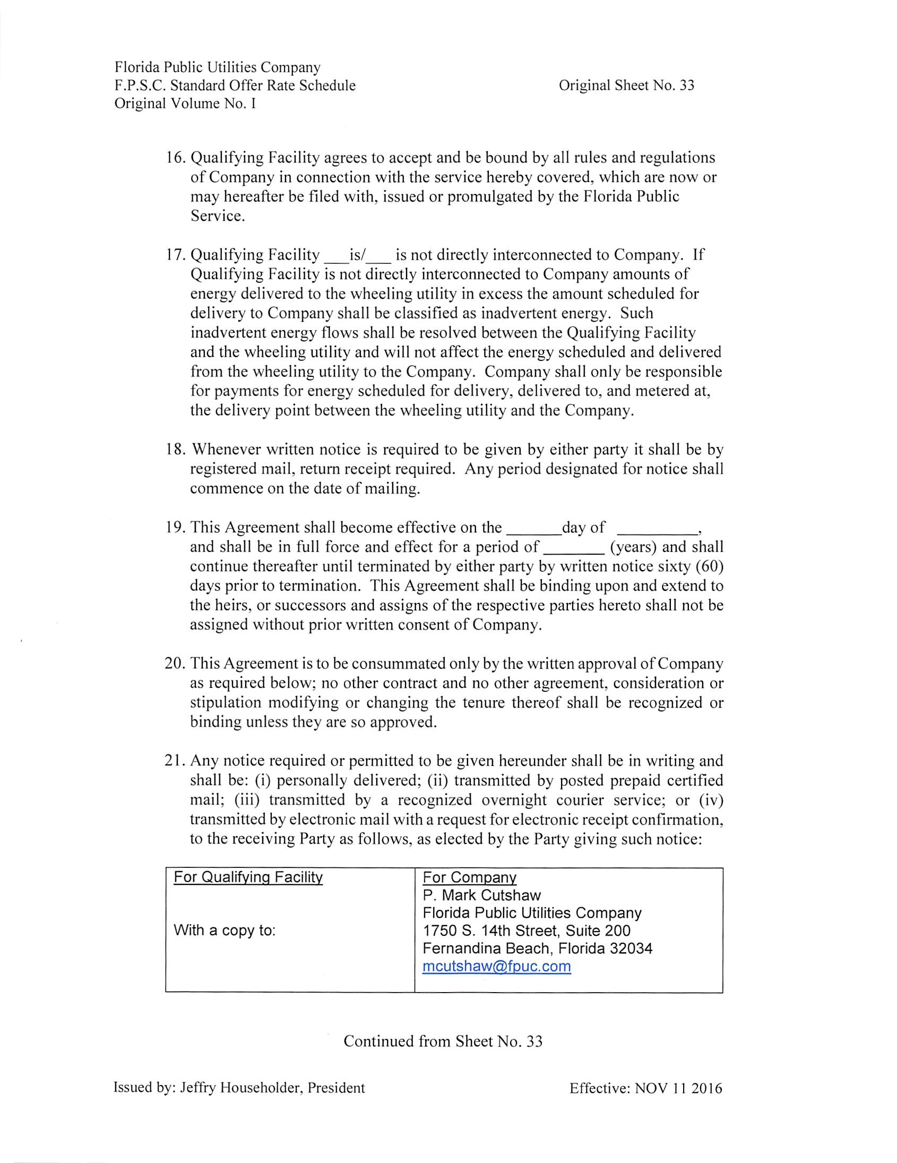

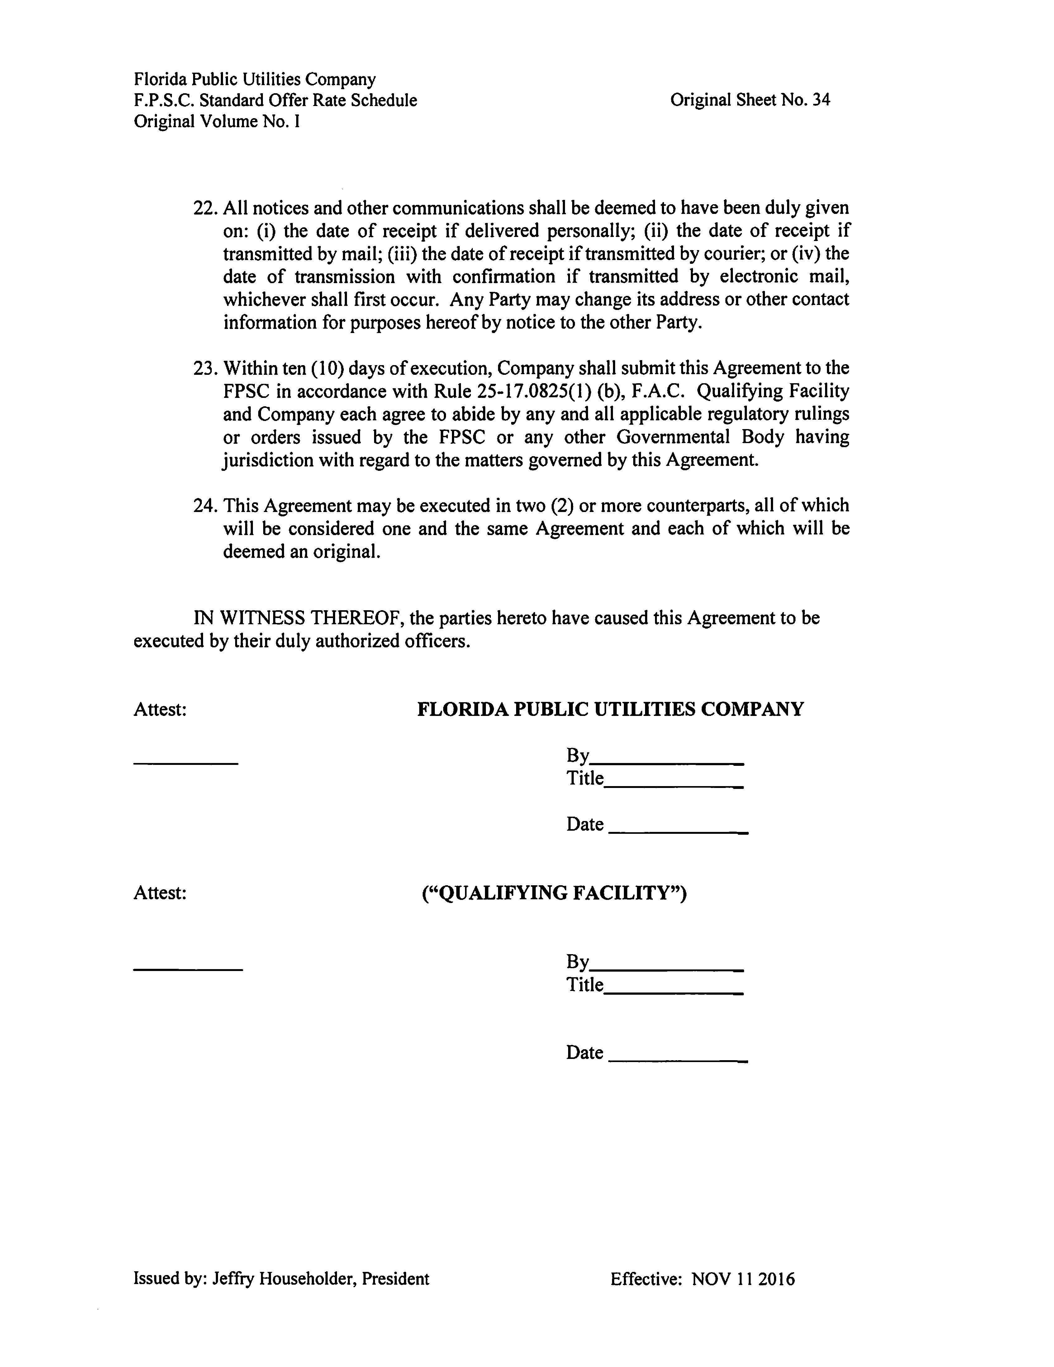

Document No. 03336-2018, filed April 30, 2018, in Docket No. 20180091-EQ.
Document No. 03336-2018, filed April 30, 2018, in Docket No. 20180091-EQ.

