State of Florida |  | Public Service Commission  Capital Circle Office Center ● 2540 Shumard Oak Boulevard  Tallahassee, Florida 32399-0850  -M-E-M-O-R-A-N-D-U-M-
DATE: | June 27, 2018
TO: | Office of Commission Clerk (Stauffer)
FROM: | Office of Industry Development and Market Analysis (Deas, Fogleman, Wendel)  Office of Auditing and Performance Analysis (Casey)  Office of the General Counsel (Murphy)
RE: | Docket No. 20180118-TL – Implementation of the 689 area code overlay in the existing 407/321 area code.
AGENDA: | 07/10/18 – Regular Agenda – Interested Persons May Participate
COMMISSIONERS ASSIGNED: |  |  | All Commissioners
PREHEARING OFFICER: |  |  | Brown
CRITICAL DATES: |  |  | None
SPECIAL INSTRUCTIONS: |  |  | None

Case Background
On May 16, 2018, the Florida Public Service Commission (Commission) received Notice from Neustar Inc., the North American Numbering Plan Administrator (NANPA), that the 407 area code is expected to exhaust in the next twelve months. (Attachment A) The 407 area code serves Orange, Osceola, Seminole and parts of Lake and Volusia Counties in Central Florida. (Attachment B) Calls within this area currently require ten digit dialing as a result of a limited area code overlay (321) approved by this Commission in 1998.

NANPA is the neutral third-party administrator responsible for forecasting the exhaust of geographic area codes and for area code relief planning. NANPA publishes its forecasted exhaust of all area codes on a semi-annual basis. This forecast is used in determining when to start the process of adding another area code. Area codes exhaust when all the prefixes (also known as central office codes) are assigned. Each area code contains 792 usable prefixes containing 10,000 numbers each. When all of these prefixes are assigned, another area code is needed.

On May 15, 2001, NANPA petitioned the Commission for approval to implement an overlay relief plan for the 407/321 Numbering Plan Areas (NPA). The petition was filed based upon NANPA’s projection that the central office codes (NXX codes) for the 407/321 NPA would exhaust during the fourth quarter of 2003. On March 25, 2002, by Order No. PSC-2002-0405-FOF-TL, the Commission approved an overlay area code relief plan for the 407/321 NPA. The approved relief plan was the implementation of a third area code overlay in the existing 407/321 NPA. NANPA assigned the 689 area code to the 407/321 NPA with an implementation date of July 15, 2002. However, prior to the implementation date, new exhaust dates were posted by NANPA. Based on the new information obtained from NANPA, there were approximately two-hundred 407 NXX codes remaining in the 407/321 NPA. It was estimated that the remaining life of the 407/321 NPA would be extended for approximately 8.77 years.

On May 31, 2002, the Commission issued Order No. PSC-2002-0743-FOF-TL indefinitely suspending the implementation of the 689 overlay due to the estimated exhaust dates for the 407/321 NPA having changed significantly. Also, the Commission directed NANPA to officially inform the Commission within one year of the exhaust of available 407 NXX codes. Since the issuance of that Order, thousand-block number pooling and code reclamation number conservation measures implemented by the Commission have delayed the need for another area code in the 407/321 NPA for 16 years.

By Order No. PSC-2002-0405-FOF-TL, the Commission also ordered that all unassigned 321 NXX codes would be reserved for assignment in Brevard County. Since that Order, NANPA inadvertently assigned 56 NXX codes outside of Brevard County. This represents approximately 7 percent of the 321 NXX codes. NANPA established processes to correct this problem and no 321 NXX codes have been assigned outside of Brevard County since 2015. Brevard County is only serviced by area code 321 and seven digit dialing is still utilized. Implementation of 689 area code will not directly affect Brevard County.

In accordance with Order No. PSC-2002-0743-FOF-TL, on May 16, 2018, NANPA notified the Commission that the current quantity of 407 NXX codes is only sufficient to meet demand for the next 12 months. Therefore, NANPA is requesting, on behalf of the industry, that the Commission lift the suspension on the implementation of the 689 overlay so that NANPA may begin the process of putting the 689 area code in place prior to the exhaust of the 407 NXX codes.

The Commission has jurisdiction to address this issue pursuant to Section 364.16(7) and 120.80(13)(d), Florida Statutes, and 47 C.F.R. § 52.19. Section 364.16(7), Florida Statutes provides that:

In order to ensure that consumers have access to different local exchange service providers without being disadvantaged, deterred, or inconvenienced by having to give up the consumer's existing local telephone number, the commission must make sure that all providers of local exchange services have access to local telephone numbering resources and assignments on equitable terms that include a recognition of the scarcity of such resources and that are in accordance with national assignment guidelines.

Section 120.80(13)(d), Florida Statutes provides that:

Notwithstanding the provisions of this chapter, in implementing the Telecommunications Act of 1996, Pub. L. No. 104-104, the Public Service Commission is authorized to employ procedures consistent with that act.

47 C.F.R. § 52.19 which provides in part that:

(a) State commissions may resolve matters involving the introduction of new area codes within their states. Such matters may include, but are not limited to: Directing whether area code relief will take the form of a geographic split, an overlay area code, or a boundary realignment; establishing new area code boundaries; establishing necessary dates for the implementation of area code relief plans; and directing public education efforts regarding area code changes.

(b) State commissions may perform any or all functions related to initiation and development of area code relief plans, so long as they act consistently with the guidelines enumerated in this part, and subject to paragraph (b)(2) of this section. For the purposes of this paragraph, initiation and development of area code relief planning encompasses all functions related to the implementation of new area codes that were performed by central office code administrators prior to February 8, 1996. Such functions may include: Declaring that the area code relief planning process should begin; convening and conducting meetings to which the telecommunications industry and the public are invited on area code relief for a particular area code; and developing the details of a proposed area code relief plan or plans.

Discussion of Issues

Issue 1:
Should the Commission lift its suspension of the implementation plan for the 689 overlay of the 407/321 NPA?

Recommendation:
Yes, Staff recommends that the Commission lift its suspension of the implementation plan for the 689 overlay of the 407/321 NPA. Staff also recommends that the Commission direct NANPA to notify the Commission of the proposed implementation date for the 689 overlay once it has been determined. (Deas, Fogleman, Wendel, Murphy, Casey)

Staff Analysis:
By Order No. PSC-2002-0743-FOF-TL, issued on May 31, 2002, the Commission ordered that the implementation of the 689 overlay for the 407/321 NPA be suspended indefinitely. The Commission also ordered NANPA to officially inform the Commission within one year of the exhaust of available 407 NXX codes.

On May 16, 2018, NANPA informed the Commission that the 407 NXX codes exhaust projection is within 12 months. According to NANPA, as of May 14, 2018, there were 19 NXX codes available for assignment in the 407 area code. In April 2018, NANPA reported the estimated exhaust date for the 407 NXX codes as the third quarter of 2020. However, the following month, in May of 2018, NANPA reported a delta projection to reflect the estimated exhaust date as the third quarter of 2019. NANPA is requesting the Commission lift the May 2002 suspension so that it can hold industry meetings to initiate the implementation process.

Based upon the most recent NANPA projections staff recommends that the Commission lift the suspension of the implementation plan for the 689 overlay of the 407/321 NPA. Staff, also recommends that NANPA inform the Commission once the proposed implementation date for the 689 overlay has been determined.

On June 5, 2018, Mr. Albert Erdmann added correspondence to this docket regarding the 55 NXX codes inadvertently assigned outside of Brevard County. Mr. Erdmann asked that numbers with the 321 area code that were inadvertently assigned outside of Brevard County be returned to Brevard County rate centers as part of the 689 overlay process. According to NANPA all of the 321 NXX codes in question have some utilization. Thus, moving these NXX codes will impact customers. Staff has requested NANPA to provide information regarding the technical feasibility, cost, customer impact and any industry input regarding returning the 321 NXX codes to the Brevard County rate centers.

Issue 2:
Should this docket be closed?

Recommendation:
No. This Docket should remain open for the Commission to acknowledge the implementation date for the 689 area code overlay. (Deas, Fogleman, Wendel, Murphy, Casey)

Staff Analysis:
This Docket should remain open for the Commission to acknowledge the implementation date for the 689 area code overlay.

May 16, 2018

Ms. Carlotta S. Stauffer
Commission Clerk
Florida Public Service Commission
2540 Shumard Oak Boulevard
Tallahassee, Florida 32399

Dear Ms. Stauffer,

On March 25, 2002, the Florida Public Service Commission (“PSC”) issued Order No. PSC-02-10405- FOF-TL in Docket No. 010743-TL specifying an all-services overlay as the relief method for the 407/321 area code. The 689 area code was assigned by NANPA with a scheduled implementation date of July 15,
2002. The 407/321 area code serves Orange, Osceola, Seminole and parts of Lake and Volusia Counties in Central Florida. The portion of the 321 area code serving Brevard County was to remain unchanged.

On May 31, 2002, the PSC, in Order No. PSC-02-0743-FOF-TL, indefinitely suspended the implementation of the 689 area code. The PSC directed the telecommunications industry, represented by NANPA, to provide notice when there is an estimated one-year supply of assignable central office codes (NXX codes) available.

This letter is to notify the PSC that the current quantity of 407 NXX codes is only sufficient to meet demand for the next 12 months. As of May 14, 2018, there were 19 codes available for assignment in the
407 area code. Therefore, the NANPA requests, on behalf of the industry, that the PSC lift the
suspension on the implementation of the 689 overlay so that NANPA may begin the process of putting the 689 area code in place prior to the exhaust of the 407 NXX codes. Once the PSC notifies NANPA of a lifting of the May 2002 suspension, the NANPA will hold an industry meeting to initiate the implementation process.

If you have any questions, please feel free to contact me at 571-434-5770 (john.manning@team.neustar)
or Heidi Wayman at 571-434-5765 (heidi.wayman@team.neustar).

Sincerely,

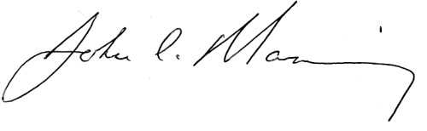

John Manning
Sr. Director – NANPA

cc: Greg Fogleman – Florida PSC
Heidi Wayman – NANPA Brent Struthers – NANPA Kimberly Miller – NANPA

Neustar, Inc. / 21575 Ridgetop Circle, Sterling, VA 20166 / tel: +1.571.434.5400 / fax: +1.571.434.5400 / www.neustar.biz

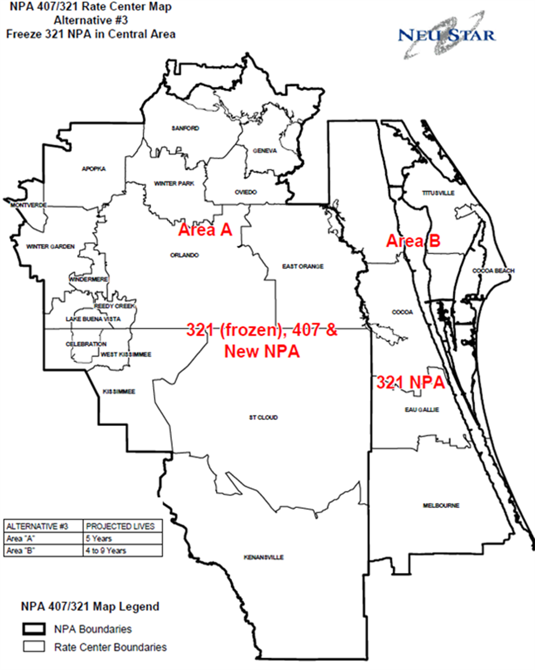

Commission Order No. PSC-98-1761.
Thousands-block number pooling is the process by which telephone companies share a pool of telephone numbers that have the same central office code. Historically, telephone numbers have been assigned to service providers in blocks of 10,000 numbers. Thousands-block number pooling allows phone numbers to be allocated to service providers in blocks of 1,000, instead of the historical 10,000 number blocks, which conserves numbers and provides for more efficient number utilization. A uncontaminated central office code in 1,000 blocks is subject to be reclaimed and returned to inventory if it is not activated within six months of being assigned and the carrier cannot provide the Commission a reason for extension of the reclamation date.

