State of Florida |  | Public Service Commission  Capital Circle Office Center ● 2540 Shumard Oak Boulevard  Tallahassee, Florida 32399-0850  -M-E-M-O-R-A-N-D-U-M-
DATE: | June 27, 2018
TO: | Office of Commission Clerk (Stauffer)
FROM: | Division of Economics (Doherty)  Office of the General Counsel (Trierweiler)
RE: | Docket No. 20180123-EI – Petition for approval of modifications to Section No. IV, general rules and regulations governing electric service, Part VIII billing, residential and non-residential budget billing, by Duke Energy Florida, LLC.
AGENDA: | 07/10/18 – Regular Agenda – Tariff Filing – Interested Persons May Participate
COMMISSIONERS ASSIGNED: |  |  | All Commissioners
PREHEARING OFFICER: |  |  | Administrative
CRITICAL DATES: |  |  | 07/23/18 (60-Day Suspension Date)
SPECIAL INSTRUCTIONS: |  |  | None

Case Background
On May 23, 2018, Duke Energy Florida, LLC (DEF) filed a petition to offer budget billing to commercial customers. The proposed budget billing tariff sheets Nos. 4.086 and 4.087 are shown in Attachment A to this recommendation.
Currently, the five Florida investor-owned electric utilities offer optional budget billing for residential customers. The Commission has approved budget billing for commercial customers for Florida Power & Light Company and Gulf Power Company. The Commission has jurisdiction under Sections 366.04, 366.05, and 366.06, Florida Statutes (F.S.).

Discussion of Issues

Issue 1:
Should the Commission approve DEF’s petition for approval of budget billing for commercial customers?

Recommendation:
Yes. The Commission should approve DEF’s petition for approval of budget billing for commercial customers. DEF’s proposed tariffs should become effective on July 10, 2018. (Doherty)

Staff Analysis:
Currently, budget billing is only offered to residential customers. DEF has proposed to extend the budget billing option to the commercial General Service – 1 (GS-1) and General Service Demand – 1 (GSD-1) class customers. DEF states in its petition that it can provide better customer service by extending the budget billing to commercial customers without affecting the general body of ratepayers.
Budget billing is an optional program that allows customers to reduce the variations in monthly bills that result from seasonal fluctuations in the usage of electricity. This leveling of the bill allows customers to more easily budget their electricity expenses. The methodology for determining the monthly budget bill for commercial customers will be the same as the methodology for determining the monthly budget bill for residential customers. The customer is billed based upon an average of their last 12 months’ kilowatt-hour (kWh) usage, rather than for their actual monthly usage.
The amount billed using the average method is subtracted from the amount which would have been billed based on actual usage. This difference is credited to a deferred balance account which maintains a running total of over- and under-collection. DEF recalculates the monthly budget billing amount every third month using the most recent 12 months’ billings plus any deferred balances. If the difference between the current and the newly calculated monthly budget billing amount is greater than 10 percent, the monthly budget billing amount will be re-established.
Customers may request termination of the budget billing at any time. Upon termination of the plan or disconnection of service, the customer must settle the account in full. Once the customer has been terminated, the customer may not rejoin the plan for 12 months.
The residential budget billing tariff provision is currently included on residential tariff sheet No. 6.121. DEF proposed to include the residential budget billing tariff provision, together with the proposed commercial budget billing provision, in its general rules and regulations section of its tariff, as shown in Attachment A.

Conclusion
Staff has reviewed DEF’s petition for approval of its budget billing for its commercial customers. Participation in the program is optional and will provide DEF’s commercial customers with benefits of budget billing that are currently available to its residential customers. Therefore, staff recommends that the Commission approve DEF’s petition for approval of budget billing for commercial customers. DEF’s proposed tariffs should become effective on July 10, 2018.

Issue 2:
Should this docket be closed?

Recommendation:
Yes. If a protest is filed within 21 days of the issuance of the order, these tariffs should remain in effect with any increase held subject to refund pending resolution of the protest. If no timely protest is filed, this docket should be closed upon the issuance of a consummating order. (Trierweiler)

Staff Analysis:
If a protest is filed within 21 days of the issuance of the order, these tariffs should remain in effect with any increase held subject to refund pending resolution of the protest. If no timely protest is filed, this docket should be closed upon the issuance of a consummating order.

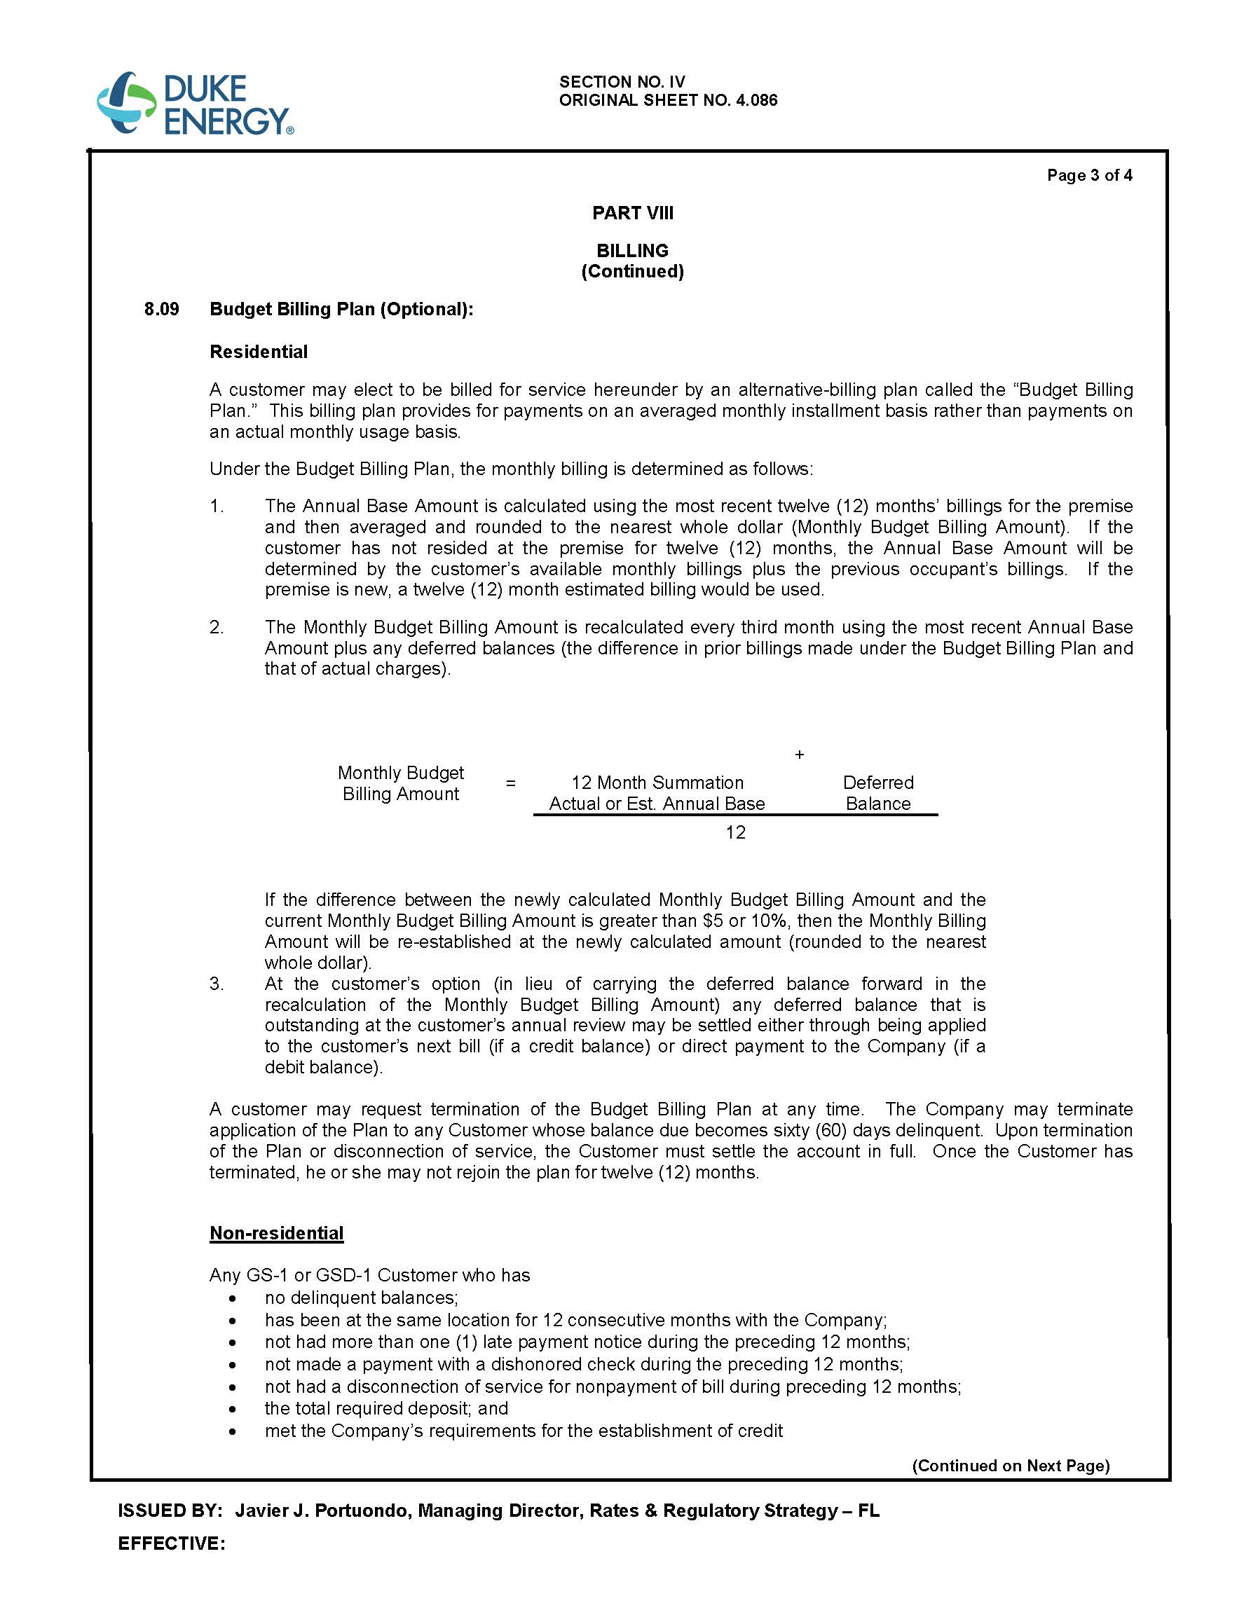

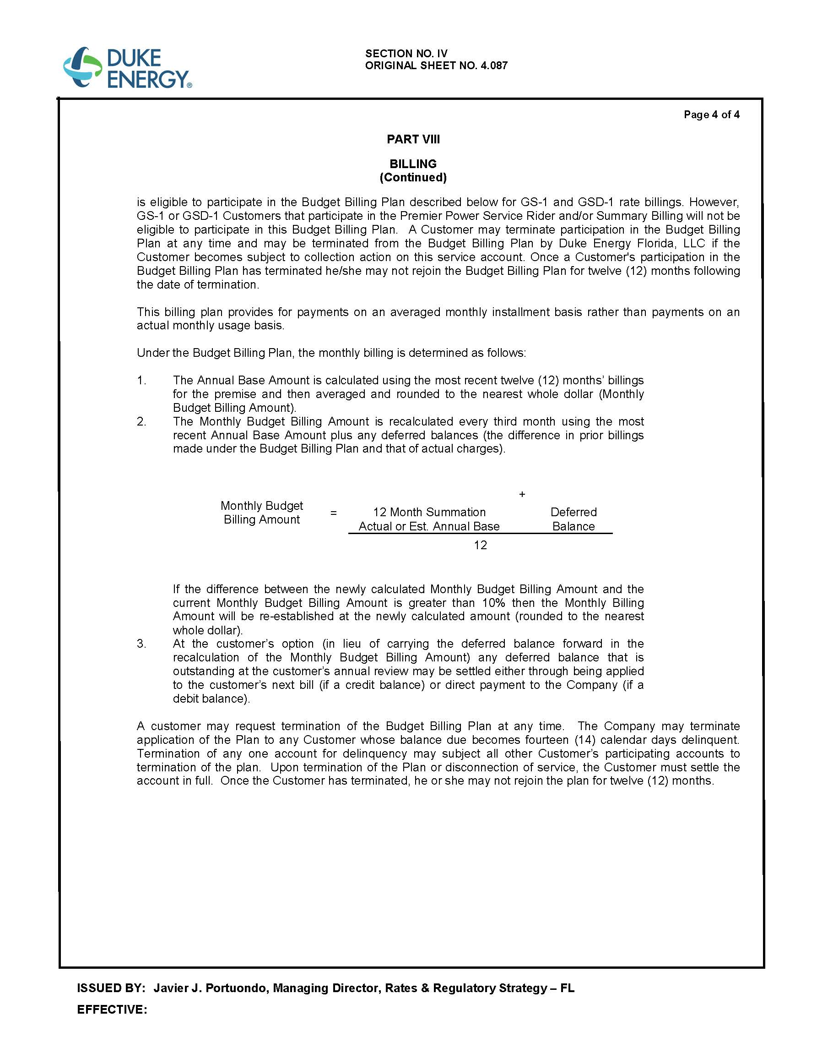

DEF’s petition included certain other non-substantive tariff changes (i.e., revision to index sheet) that have not been attached to the recommendation.
Order No. PSC-05-0951-TRF-EI, issued October 6, 2005, in Docket No. 20050486-EI, In re: Petition for approval of optional budget billing program for GS-1 rate customers by Florida Power & Light Company.
Order No. PSC-98-0747-FOF-EI, issued May 29, 1998, in Docket No. 19980530-EI, In re: Request for approval of Budget Billing tariff revisions by Gulf Power Company.

