State of Florida |  | Public Service Commission  Capital Circle Office Center ● 2540 Shumard Oak Boulevard  Tallahassee, Florida 32399-0850  -M-E-M-O-R-A-N-D-U-M-
DATE: | June 27, 2018
TO: | Office of Commission Clerk (Stauffer)
FROM: | Division of Engineering (Lee)  Division of Accounting and Finance (D. Smith)  Division of Economics (Guffey)  Office of the General Counsel (Schrader, Crawford)
RE: | Docket No. 20180084-EI – Petition for limited proceeding for approval to include in base rates the revenue requirement for the Citrus combined cycle project, by Duke Energy Florida, LLC.
AGENDA: | 07/10/18 – Regular Agenda – Tariff Filing – Interested Persons May Participate
COMMISSIONERS ASSIGNED: |  |  | All Commissioners
PREHEARING OFFICER: |  |  | Fay
CRITICAL DATES: |  |  | 12/2/18 (8-Month Effective Date)
SPECIAL INSTRUCTIONS: |  |  | None

Case Background
On May 27, 2014, Duke Energy Florida, LLC (DEF) filed a petition for a determination of need for the Citrus County Combined Cycle Power Plant Project (Citrus Combined Cycle Project). DEF is planning to complete the construction of the 1,640-megawatt, two-unit plant on a site adjacent to its Crystal River Energy Center in Citrus County, Florida, by December 2018. DEF was granted a determination of need for the Citrus Combined Cycle Project by the Florida Public Service Commission (Commission) by Order No. PSC-14-0557-FOF-EI. In that proceeding, the Commission found that the Citrus Combined Cycle Project, at an estimated construction cost of approximately $1.514 billion, represented the optimal resource option to meet DEF’s projected generation need.
On August 29, 2017, DEF filed a petition for a limited proceeding to approve its 2017 Second Revised and Restated Settlement Agreement (2017 Settlement). The 2017 Settlement was signed and executed by DEF, the Office of Public Counsel, the Florida Industrial Power Users Group, the Florida Retail Federation, White Springs Agricultural Chemicals, Inc. d/b/a PCS Phosphate, and the Southern Alliance for Clean Energy. The signatories to the 2017 Settlement are organizations that represent DEF’s major customer groups. The Commission approved the 2017 Settlement on November 20, 2017, by Order No. PSC-2017-0451-AS-EU. The applicable paragraphs of the 2017 Settlement are included in Attachment A.
If DEF constructs and places in service the Citrus Combined Cycle Project in 2018, Paragraph 14(a) of the 2017 Settlement provides a base rate increase referred to as the 2018 Generation Base Rate Adjustment (GBRA). As required under Paragraph 14(a) of the 2017 Settlement, DEF’s initial 2018 GBRA for the Citrus Combined Cycle Project should reflect the costs used to support the need determination case.
On April 2, 2018, DEF filed the instant petition for a limited proceeding for approval to include in base rates the revenue requirement for the Citrus Combined Cycle Project. The project is expected to be placed in service in two phases: September 2018 and November 2018. Phase 1 will include the construction of Unit 1 and the associated transmission/common equipment. Phase 2 will include the construction of Unit 2. DEF is requesting that the Commission approve the estimated revenue requirement of $200,488,588 for the entire GBRA and approve the necessary tariffs to reflect the change in base rates in October 2018 and December 2018.
DEF waived the 60-day file and suspend provision of Section 366.06(3), Florida Statutes (F.S.). The Commission has jurisdiction pursuant to Section 366.06 and 366.076, F.S.

Discussion of Issues

Issue 1:
Should the Commission approve DEF’s petition to include in base rates the revenue requirement for the Citrus Combined Cycle Project?

Recommendation:
Yes. Consistent with the 2017 Settlement, DEF’s 2018 GBRA for the Citrus Combined Cycle Project reflects the costs pursuant to which the need determination was granted. (Lee, D. Smith)

Staff Analysis:
DEF stated in its petition that the Citrus Combined Cycle Project will be placed in service in two phases: September 2018 and November 2018. DEF is requesting that the Commission approve the revenue requirement necessary for the rate increase in both phases, with an estimated retail revenue requirement totaling $200,488,588.
As discussed in the case background, the Commission evaluated the estimated cost for the Citrus Combined Cycle Project in the need determination and the GBRA cost recovery method was set forth in the 2017 Settlement. Discussed below is staff’s review of DEF’s cost estimate and revenue requirement calculations. The rate impact is discussed further in Issue 2.

Cost Estimate
Based upon Exhibit B, which DEF attached to its petition, the total operating expenses for Unit 1, Unit 2, and transmission/common equipment are $53,006,000, $38,811,000, and $2,406,000, respectively, for the first year. These costs include: operating and maintenance (O&M), depreciation, property insurance, and property tax. DEF affirms that these costs are the same as those used by DEF to support its need determination case, consistent with the requirement under Paragraph 14(a) of the 2017 Settlement.
The estimated capital cost of approximately $1.514 billion is the same as in the need determination. DEF stated that while this is a reasonable and accurate projection, there are a variety of events that can impact the schedule and cost of the overall project. These may include skilled labor and supply availability, severe weather events, and other force majeure events.
Paragraph 14(d) of DEF’s 2017 Settlement addresses the circumstance in which DEF’s actual capital cost is lower than the projected cost used to develop the initial 2018 GBRA factor. Under this circumstance, the lower actual cost will be the basis for the full revenue requirements and a one-time credit is required to be made through the Capacity Cost Recovery Clause. In addition, Paragraph 14(e) addresses the situation in which DEF’s actual capital cost is higher than the projected cost used to develop the initial 2018 GBRA factor. Under this circumstance, DEF may, at its option, initiate a limited proceeding to seek to increase the 2018 GBRA factor by the corresponding incremental revenue requirement. Staff believes these measures protect customers against unwarranted cost increases over the cost used in the need determination case.

Revenue Requirement Calculation

Based on the estimated cost of the project and the commercial in-service dates for the two phases as described above, DEF calculated a revenue requirement of $200,488,588 for the entire GBRA. DEF estimates the revenue requirement for Phase 1 to be $123,180,439 and $77,308,149 for Phase 2. In accordance with Paragraph 14(c) of the 2017 Settlement, DEF utilized its projected 13-month average capital structure for the first 12 months of operation, and a 10.50 percent return on equity to calculate the revenue requirement. The revenue requirement calculation also includes the recovery of O&M expenses, depreciation expense, property insurance, property tax, and income tax. Staff has verified the revenue requirement of $200,488,588 based on the capital structure provided by DEF reflecting a projected 13-month average capital structure for the first 12 months of operation. Staff recommends that $200,488,588 is the appropriate revenue requirement based on the 2017 Settlement.

Conclusion
Consistent with the 2017 Settlement, DEF’s 2018 GBRA for the Citrus Combined Cycle Project reflects the costs pursuant to which the need determination was granted. Therefore, staff recommends that DEF’s petition be approved.

Issue 2:
Should the Commission approve DEF’s proposed tariffs and associated charges needed to implement the two phases of the Citrus Combined Cycle Project?

Recommendation:
Yes. The Commission should give staff administrative authority to approve tariffs and associated charges that implement the Commission vote on Issue 1 regarding the Citrus Combined Cycle Project which will be placed in service in two phases. The tariffs and associated charges for Phase 1 should go into effect with the first billing cycle in October 2018, and the tariffs and associated charges for Phase 2 of the Citrus Combined Cycle Project should go into effect with the first billing cycle in December 2018. If the commercial in-service date of Phase 1 of the project is delayed, the tariff should become effective with the first billing cycle after Phase 1 is completed and placed in commercial service. If Phase 2 is delayed, the tariff should become effective with the first billing cycle after Phase 2 is completed and placed in commercial service. If the Commission order is protested, DEF should implement the rates subject to refund pending the results of any subsequent hearing. (Guffey)

Staff Analysis:

As discussed in Issue 1, staff is recommending approval of a revenue requirement totaling $200,488,588 for both phases of the Citrus Combined Cycle Project. Consistent with Paragraph 14(b) of DEF’s 2017 Settlement and as shown in Exhibit C of the petition, the requested total amount will be applied as a uniform percentage to all rate classes at 6.88 percent for Phase 1 and at 4.04 percent for Phase 2. At these uniform percentage rates, a residential customer using 1,000 kWh per month will see a bill increase of $3.59 for Phase 1 and $2.25 for Phase 2. The combined base rate increase of $5.84 on a 1,000 kWh bill is $0.71 lower than the estimated increase stated in Docket No. 20140110-EI.

Customer Notification
In response to staff’s first data request, DEF stated that the Company will notify its customers of the rate changes via bill inserts in their August 2018 bill for Phase 1 and via bill inserts in their October 2018 bill for Phase 2. Electronic bill customers will receive a link to the bill insert via email and the bill insert will also be posted on DEF’s website.

Conclusion
The Commission should give staff administrative authority to approve tariffs and associated charges that implement the Commission vote on Issue 1 regarding DEF’s Citrus Combined Cycle Project which will be placed in service in two phases. The tariffs and associated charges for Phase 1 should go into effect with the first billing cycle in October 2018, and the tariffs and associated charges for Phase 2 of the Citrus Combined Cycle Project should go into effect with the first billing cycle in December 2018. If the commercial in-service date of Phase 1 of the project is delayed, the tariff should become effective with the first billing cycle after Phase 1 is completed and placed in commercial service. If Phase 2 is delayed, the tariff should become effective with the first billing cycle after Phase 2 is completed and placed in commercial service. If the Commission order is protested, DEF should implement the rates subject to refund pending the results of any subsequent hearing.

Issue 3:
Should this docket be closed?

Recommendation:
Yes. If Issues 1 and 2 are approved and no timely protest is filed, this docket should be closed upon the issuance of a consummating order. If a protest is filed within 21 days of the issuance of the order, the tariff should remain in effect, with any revenues held subject to refund, pending resolution of the protest. (Schrader)

Staff Analysis:
If Issues 1 and 2 are approved and no timely protest is filed, this docket should be closed upon the issuance of a consummating order. If a protest is filed within 21 days of the issuance of the order, the tariff should remain in effect, with any revenues held subject to refund, pending resolution of the protest.

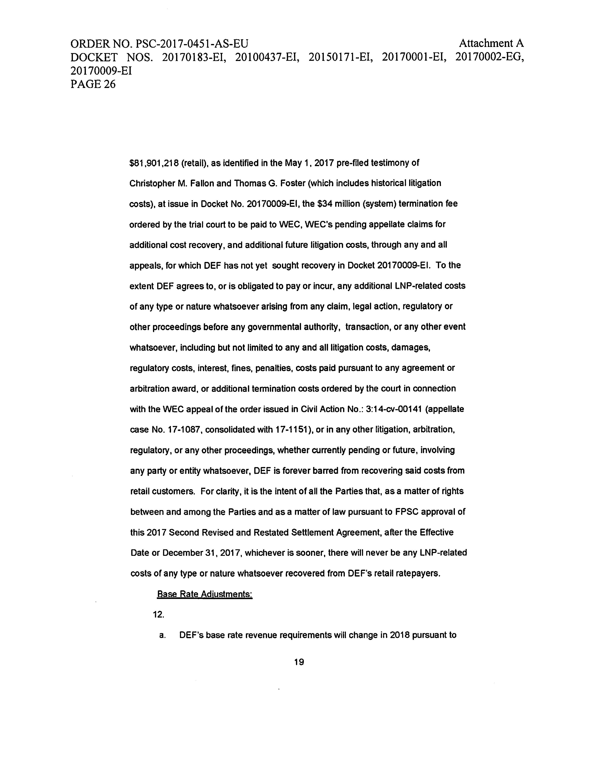

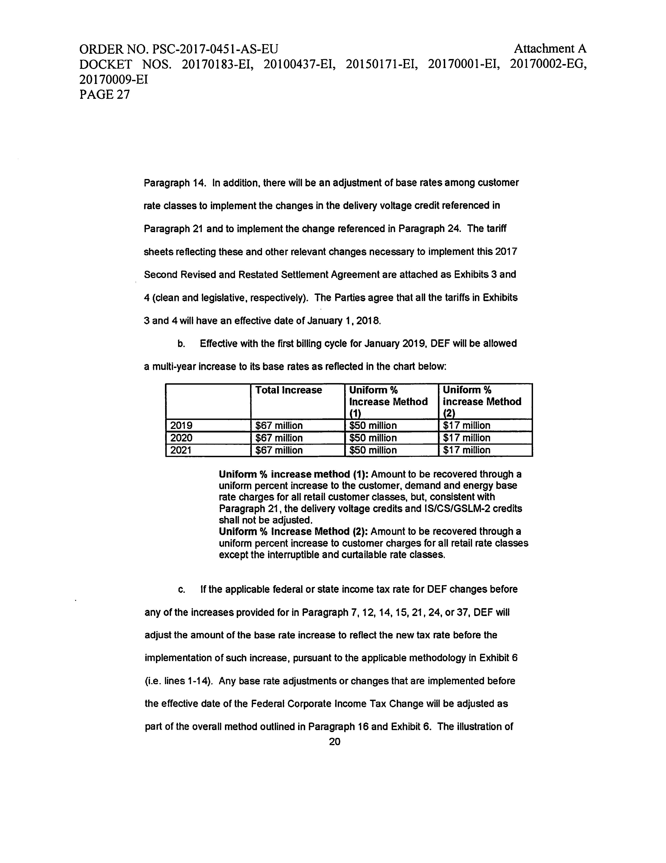
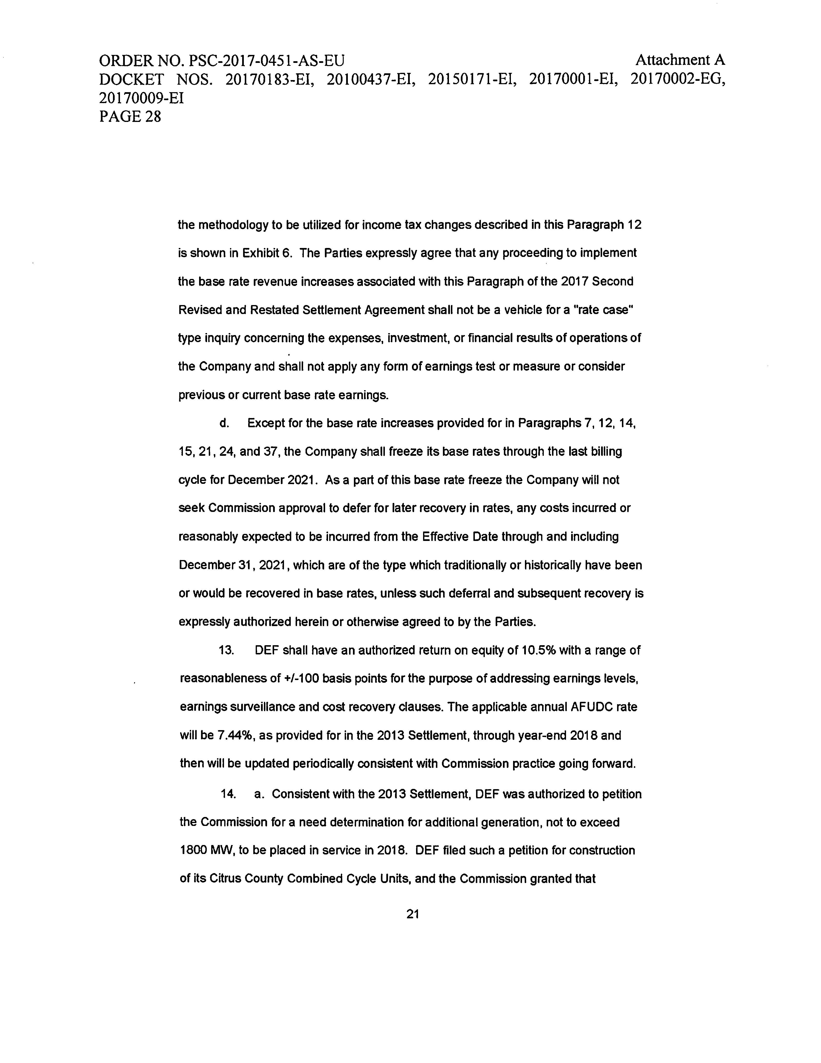

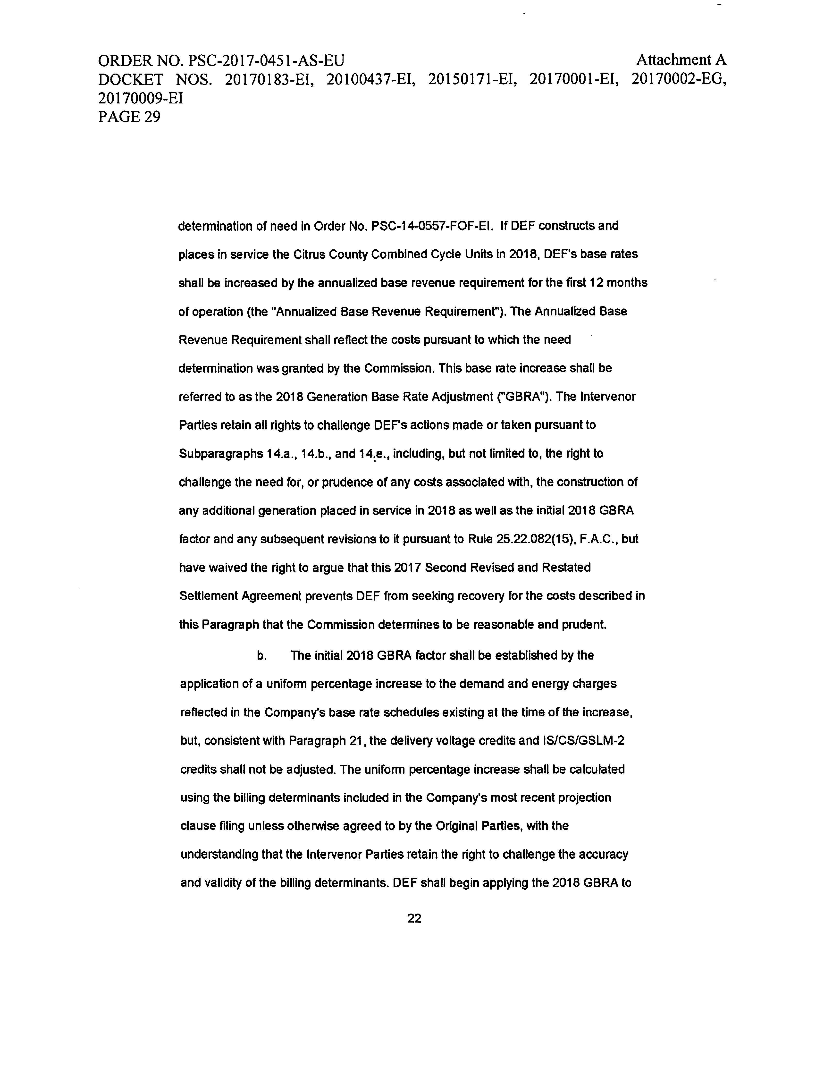

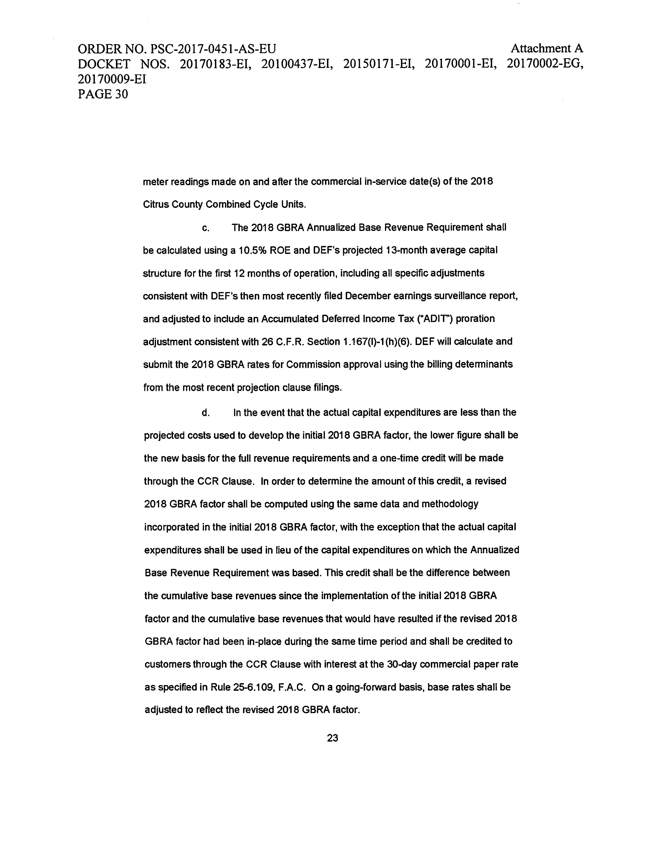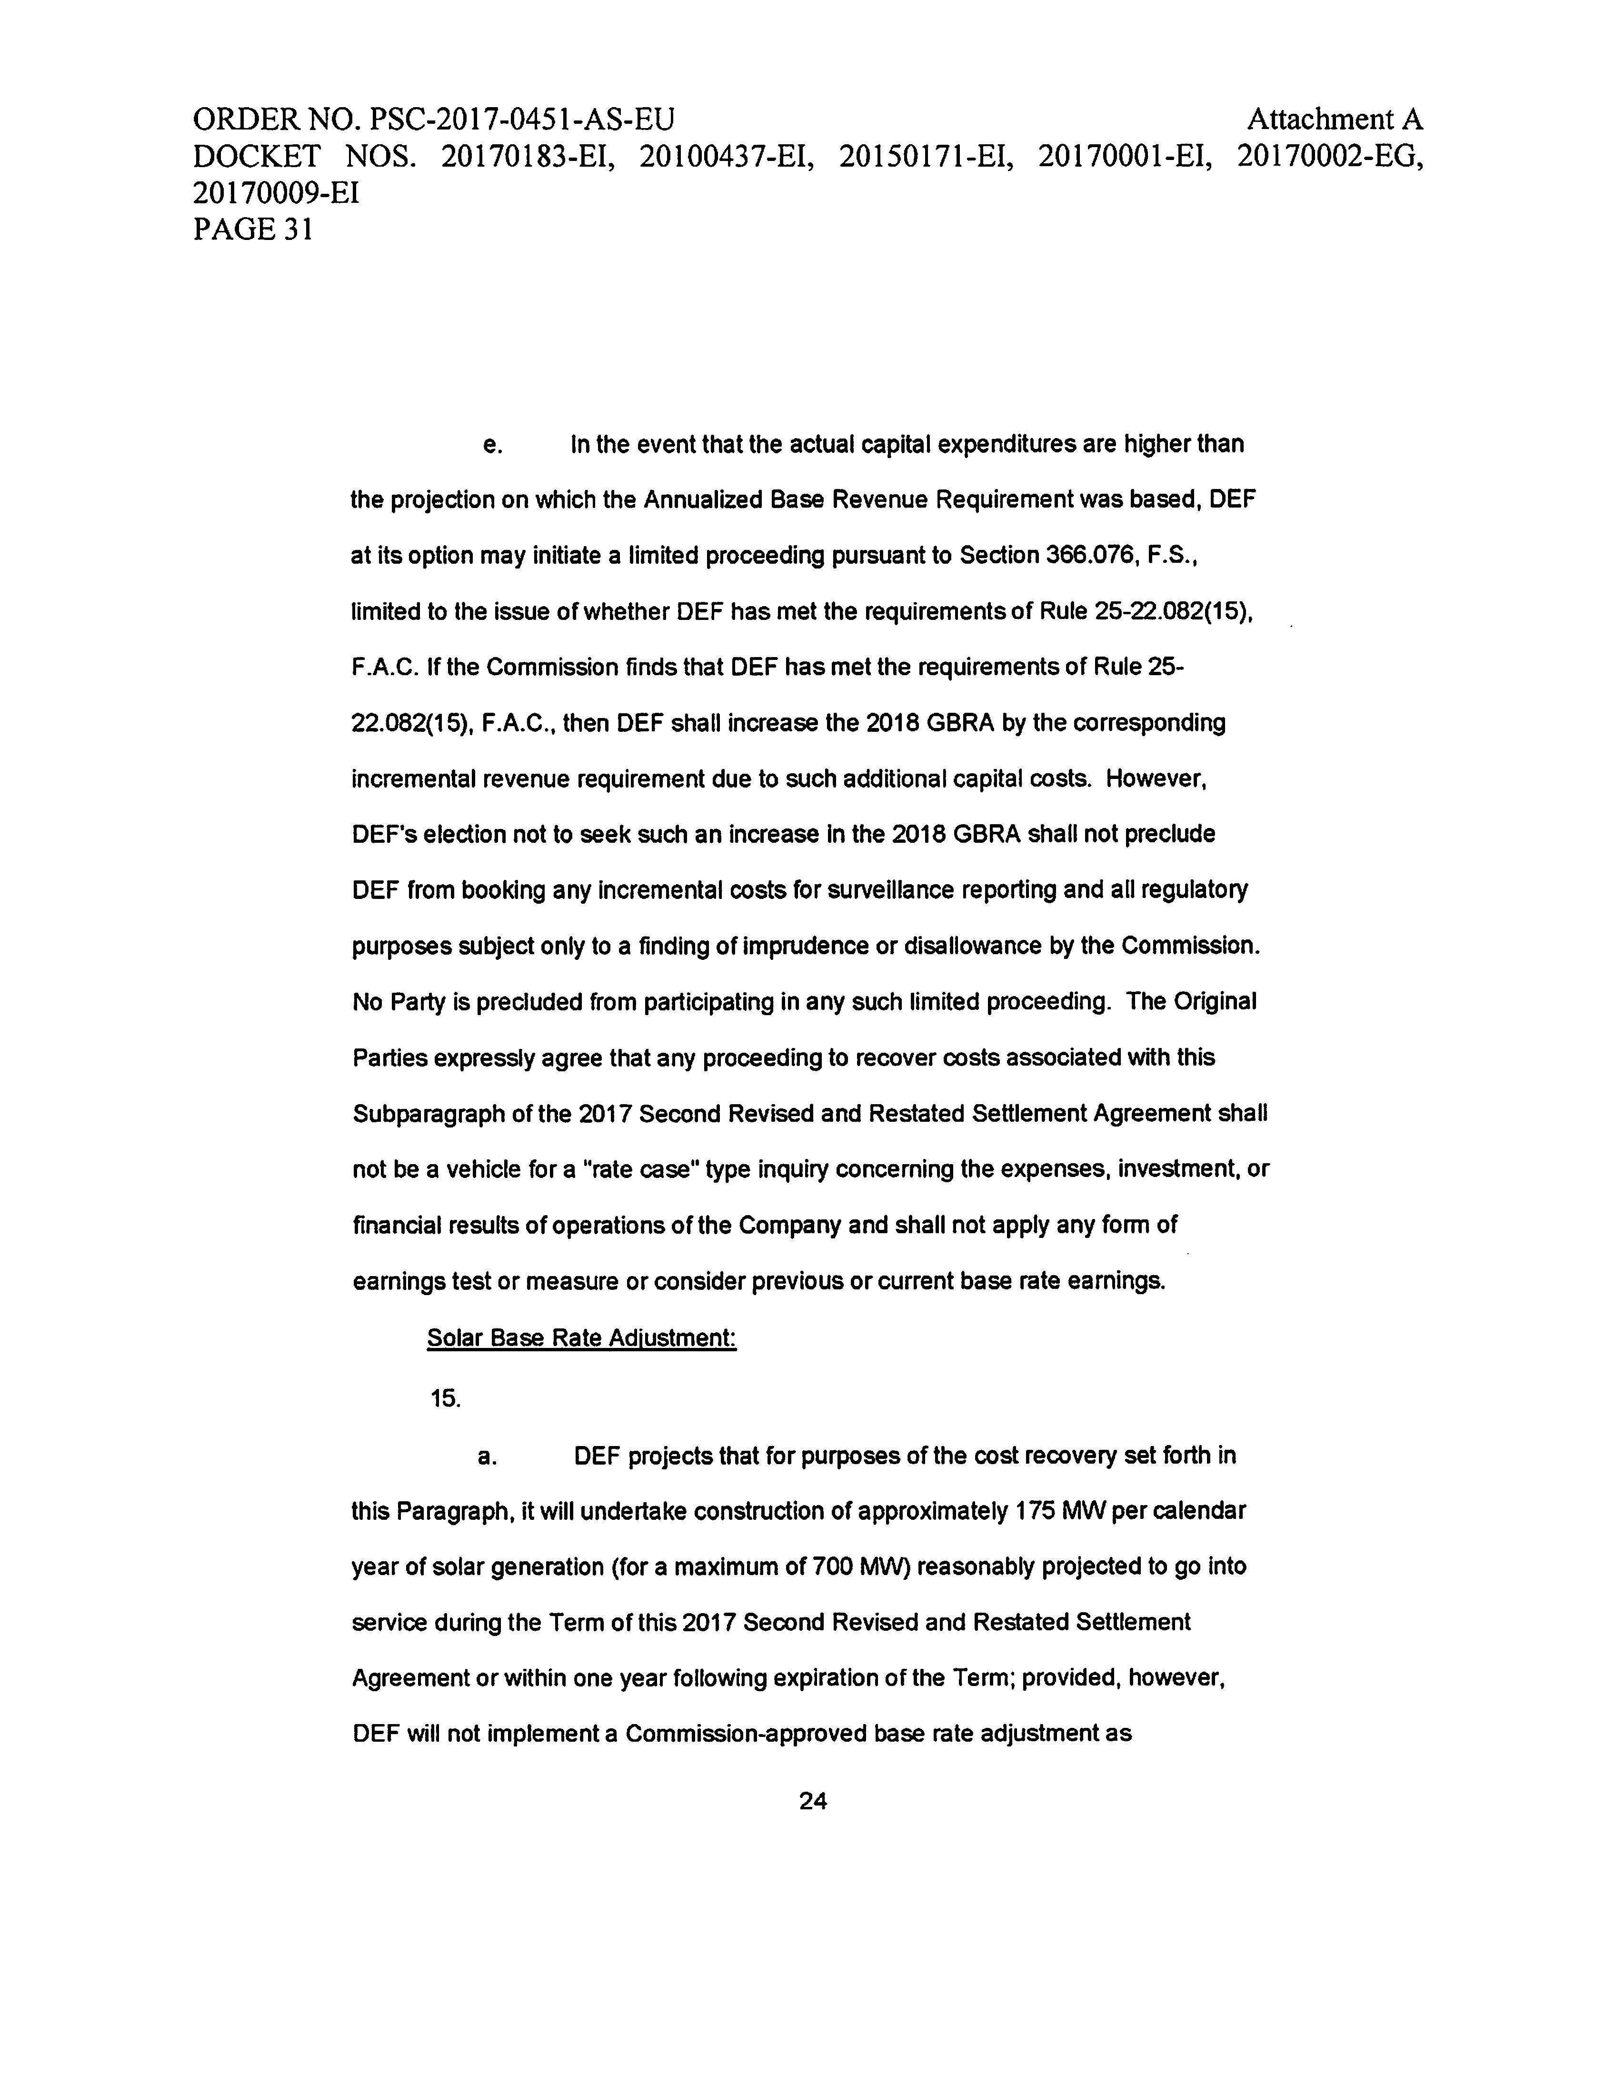

Order No. PSC-14-0557-FOF-EI, issued October 10, 2014, in Docket No. 20140110-EI, In re: Petition for determination of need for Citrus County Combined Cycle Power Plant, by Duke Energy Florida, Inc.
Order No. PSC-2017-0451-AS-EU, issued November 20, 2017, in Docket No. 20170183-EI, In re: Application for limited proceeding to approve 2017 second revised and restated settlement agreement, including certain rate adjustments, by Duke Energy Florida, LLC.
Document No. 03716-2018 – DEF’s response to staff’s second data request, No. 1.
Document No. 03532-2018 – DEF’s response to staff’s first data request, No. 4.
If the implementation of the tariff is delayed, the notice should be delayed accordingly.

