BEFORE THE FLORIDA PUBLIC SERVICE COMMISSION

In re: Petition for approval of modifications to Section No. IV, general rules and regulations governing electric service, Part VIII billing, residential and non-residential budget billing, by Duke Energy Florida, LLC. | DOCKET NO. 20180123-EI  ORDER NO. PSC-2018-0372-TRF-EI  ISSUED: July 30, 2018

The following Commissioners participated in the disposition of this matter:

ART GRAHAM, Chairman
JULIE I. BROWN
DONALD J. POLMANN
GARY F. CLARK
ANDREW GILES FAY

ORDER APPROVING PETITION TO MODIFY GENERAL RULES
AND REGULATIONS GOVERNING ELECTRIC SERVICE, BILLING,
RESIDENTIAL AND NON-RESIDENTIAL BUDGET BILLING

BY THE COMMISSION:

Background
On May 23, 2018, Duke Energy Florida, LLC (DEF) filed a petition to offer budget billing to commercial customers. The proposed budget billing tariff sheets Nos. 4.086 and 4.087 are shown in Attachment A.
Currently, the five Florida investor-owned electric utilities offer optional budget billing for residential customers. We have approved budget billing for commercial customers for Florida Power & Light Company and Gulf Power Company. We have jurisdiction under Sections 366.04, 366.05, and 366.06, Florida Statutes (F.S.).
Decision
Currently, budget billing is only offered to residential customers. DEF has proposed to extend the budget billing option to the commercial General Service – 1 (GS-1) and General Service Demand – 1 (GSD-1) class customers. DEF states in its petition that it can provide better customer service by extending the budget billing to commercial customers without affecting the general body of ratepayers.
Budget billing is an optional program that allows customers to reduce the variations in monthly bills that result from seasonal fluctuations in the usage of electricity. This leveling of the bill allows customers to more easily budget their electricity expenses. The methodology for determining the monthly budget bill for commercial customers will be the same as the methodology for determining the monthly budget bill for residential customers. The customer is billed based upon an average of their last 12 months’ kilowatt-hour (kWh) usage, rather than for their actual monthly usage.
The amount billed using the average method is subtracted from the amount which would have been billed based on actual usage. This difference is credited to a deferred balance account which maintains a running total of overcollection and undercollection. DEF recalculates the monthly budget billing amount every third month using the most recent 12 months’ billings plus any deferred balances. If the difference between the current and the newly calculated monthly budget billing amount is greater than 10 percent, the monthly budget billing amount will be re-established.
Customers may request termination of the budget billing at any time. Upon termination of the plan or disconnection of service, the customer must settle the account in full. Once the customer has been terminated, the customer may not rejoin the plan for 12 months.
The residential budget billing tariff provision is currently included on residential tariff sheet No. 6.121. DEF proposed to include the residential budget billing tariff provision, together with the proposed commercial budget billing provision, in its general rules and regulations section of its tariff, as shown in Attachment A.

Conclusion
We have reviewed DEF’s petition for approval of its budget billing for its commercial customers and determined that participation in the program is optional and will provide DEF’s commercial customers with benefits of budget billing that are currently available to its residential customers. Therefore, we approve DEF’s petition for approval of budget billing for commercial customers, effective on July 10, 2018.
Based on the foregoing, it is
ORDERED by the Florida Public Service Commission that Duke Energy Florida LLC’s petition for approval of budget billing for commercial customers is approved and the proposed tariffs shall become effective on July 10, 2018.
ORDERED that if a protest is filed within 21 days of issuance of the Order, the tariff shall remain in effect with any charges held subject to refund pending resolution of the protest. It is further
ORDERED that if no timely protest is filed, this docket shall be closed upon the issuance of a Consummating Order.
By ORDER of the Florida Public Service Commission this 30th day of July, 2018.

/s/ Carlotta S. Stauffer
CARLOTTA S. STAUFFER
Commission Clerk
Florida Public Service Commission
2540 Shumard Oak Boulevard
Tallahassee, Florida 32399
(850) 413-6770
www.floridapsc.com

Copies furnished: A copy of this document is provided to the parties of record at the time of issuance and, if applicable, interested persons.

WLT

NOTICE OF FURTHER PROCEEDINGS

The Florida Public Service Commission is required by Section 120.569(1), Florida Statutes, to notify parties of any administrative hearing or judicial review of Commission orders that is available under Sections 120.57 or 120.68, Florida Statutes, as well as the procedures and time limits that apply. This notice should not be construed to mean all requests for an administrative hearing or judicial review will be granted or result in the relief sought.

Mediation may be available on a case-by-case basis. If mediation is conducted, it does not affect a substantially interested person's right to a hearing.

The Commission's decision on this tariff is interim in nature and will become final, unless a person whose substantial interests are affected by the proposed action files a petition for a formal proceeding, in the form provided by Rule 28-106.201, Florida Administrative Code. This petition must be received by the Office of Commission Clerk, 2540 Shumard Oak Boulevard, Tallahassee, Florida 32399-0850, by the close of business on August 20, 2018.

In the absence of such a petition, this Order shall become final and effective upon the issuance of a Consummating Order.

Any objection or protest filed in this docket before the issuance date of this order is considered abandoned unless it satisfies the foregoing conditions and is renewed within the specified protest period.

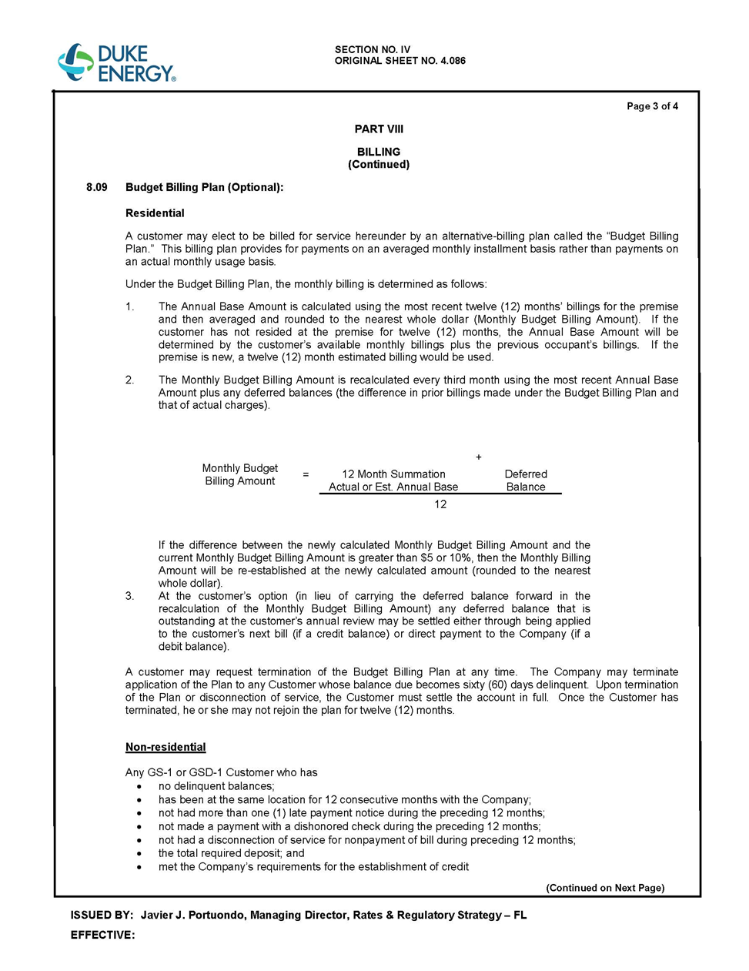

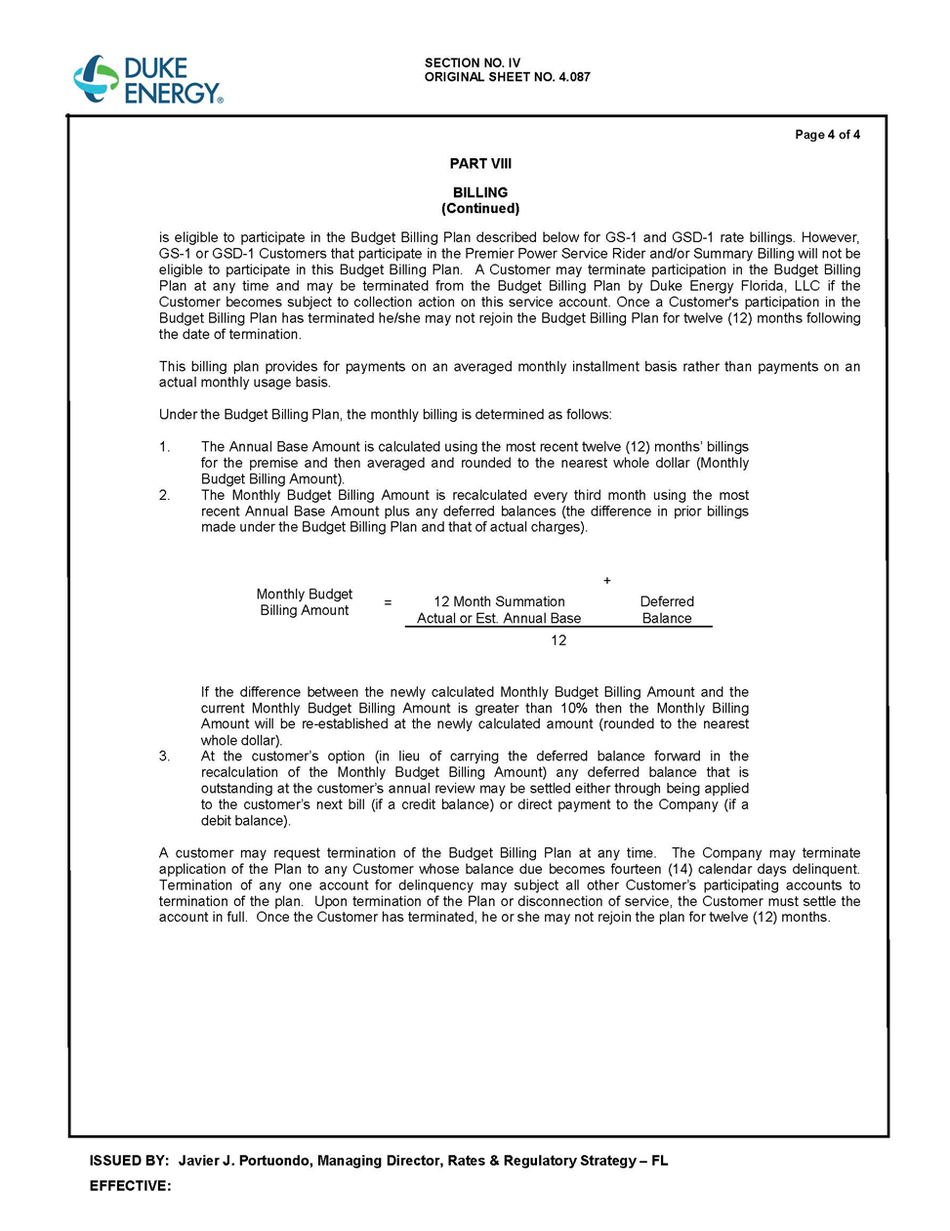

DEF’s petition included certain other non-substantive tariff changes (i.e., revision to index sheet) that have not been attached to the recommendation.
Order No. PSC-05-0951-TRF-EI, issued October 6, 2005, in Docket No. 20050486-EI, In re: Petition for approval of optional budget billing program for GS-1 rate customers by Florida Power & Light Company.
Order No. PSC-98-0747-FOF-EI, issued May 29, 1998, in Docket No. 19980530-EI, In re: Request for approval of Budget Billing tariff revisions by Gulf Power Company.

