BEFORE THE FLORIDA PUBLIC SERVICE COMMISSION

In re: Petition for approval of 2017 true-up, projected 2018 true-up, and 2019 revenue requirements and surcharges associated with cast iron/bare steel pipe replacement rider, by Peoples Gas System. | DOCKET NO. 20180173-GU  ORDER NO. PSC-2018-0540-TRF-GU  ISSUED: November 19, 2018

The following Commissioners participated in the disposition of this matter:

ART GRAHAM, Chairman
JULIE I. BROWN
DONALD J. POLMANN
GARY F. CLARK
ANDREW GILES FAY

ORDER APPROVING PEOPLES GAS SYSTEM’S 2017 TRUE-UP, PROJECTED 2018 TRUE UP AND 2019 REVENUE REQUIREMENTS AND SURCHARGES ASSOCIATED WITH CAST IRON/BARE STEEL REPLACEMENT RIDER

BY THE COMMISSION:

Background

On September 12, 2018, Peoples Gas System (Peoples or company) filed a petition for approval of its final 2017 true-up, projected 2018 true-up, and 2019 revenue requirement and surcharges associated with the cast iron/bare steel replacement rider (Rider CI/BSR or rider). The rider was originally approved in Order No. PSC-12-0476-TRF-GU (2012 order) to recover the cost of accelerating the replacement of cast iron and bare steel distribution pipes through a surcharge on customers’ bills. Peoples’ current surcharges were approved in Order No. PSC-2017-0433-TRF-GU. In the 2012 order, this Commission found that “replacement of these types of pipelines is in the public interest to improve the safety of Florida’s natural gas infrastructure, and reduce the possibility of loss of life and destruction of property should an incident occur.”
This Commission approved a comprehensive settlement agreement between Peoples and the Office of Public Counsel (OPC) in Order No. PSC-17-0066-AS-GU. The settlement agreement, in part, added problematic plastic pipe (PPP) installed in the company’s distribution system to eligible replacements under the rider. PPP was manufactured before 1983 and has significant safety concerns. In certain areas, the PPP is interspersed with, or connected to, the cast iron/bare steel pipe that is being replaced under the rider. As provided for in the settlement agreement, PPP replacements are included in the calculation of the 2019 rider surcharges.

At a September 12, 2018 hearing, we approved a settlement agreement between Peoples, OPC, and the Florida Industrial Power Users Group in Docket No. 20180044-GU addressing certain impacts of the Tax Cuts and Jobs Act of 2017 on Peoples. The settlement agreement provides for a reduction of Peoples’ 2019 depreciation expense of approximately $10.3 million resulting from extending the lives of certain mains and service assets, which, consequently, reduces the depreciation expense collected through the rider. Additionally, the settlement agreement provides that Peoples’ revenue requirement calculations incorporate the lower federal income tax rate effective February 6, 2018.

Peoples filed a revised petition and tariff sheet on October 17, 2018, to remove the Regulatory Assessment Fee (RAF) adjustment of $76,118 that Peoples had included in the original petition in the instant docket. The RAF adjustment was intended to correct an error Peoples had made in its rider surcharge calculations for the years 2013 through 2017. Peoples explained that while it remitted the correct RAF amounts to the Commission, it did not include a gross-up for RAF fees in its rider surcharge calculations from 2013 through 2017 (i.e., the rider surcharges for the years 2013 through 2017 did not include $76,118 in RAF fees paid to the Commission).

Peoples filed its response to staff’s first data request on October 3, 2018. OPC intervened in this docket on September 18, 2018, which was acknowledged by Order No. PSC-2018-0467-PCO-GU, issued September 19, 2018. The proposed revised tariff page is contained in Attachment B. This Commission has jurisdiction over this matter pursuant to Sections 366.03, 366.04, 366.05, and 366.06, Florida Statutes (F.S.).

Decision

Surcharges

The rider surcharges have been in effect since January 2013. In 2018, Peoples’ cast iron and bare steel replacement activity focused in St. Petersburg, Tampa, Miami, Jacksonville, and Sarasota, and Peoples’ PPP replacement activity focused in Pompano Beach, Orlando, and Lakeland. In 2019, Peoples states it will focus on replacement projects in Miami, Tampa, St. Petersburg, Orlando, and Sarasota. The original projected completion date for the CI/BSR replacement program was 2022 for mains and services, but Peoples now expects to complete the mains replacement activity in 2021 and services replacement activity in 2022. Replacement of PPP is expected to continue until 2028.

In the company’s 2017 Rider CI/BSR filing (Docket No. 20170192-GU), Peoples stated that it planned to secure additional contractors so that the replacement of cast iron and bare steel, as well as PPP, can be accelerated. In response to staff’s first data request in the instant docket, Peoples stated that construction costs were higher than estimated due to increased activity in congested urban areas and additional requirements for more extensive post-construction site restoration. This led to higher capital expenditures for replacements than anticipated.

Pipe Replacement Program

Attachment A to this Order contains tables which display the replacement progress and forecasts for Rider CI/BSR (Table 1) and for PPP (Table 2). In addition, Peoples provided a third table which consolidates actual and projected CI/BSR and PPP miles replaced, investment, and revenue requirement for each year of the replacement program, both actual and forecast (Table 3).

2017 True-up

Peoples’ calculation for the 2019 revenue requirement and surcharges includes a final true-up for 2017, an actual/estimated true-up for 2018, and projected costs for 2019. Pursuant to the 2012 order, the capital expenditures for 2017 through 2019 exclude the first $1 million of facility replacements each year because that amount is included in rate base and is thus excluded from recovery through the rider. Peoples has included depreciation expense savings as discussed in the 2012 order; however, Peoples has not identified any operations and maintenance savings.

Final True-up for 2017

Peoples stated that the revenues collected for 2017 were $4,273,612 compared to a revenue requirement of $6,942,323, resulting in an under-recovery of $2,668,711. The final 2016 over-recovery of $1,708,878, 2017 under-recovery of $2,668,711, and interest of $5,397 associated with any over- and under-recoveries results in a final 2017 under-recovery of $954,434.

Actual/Estimated 2018 True-up

Peoples provided actual revenues for January through July and forecast revenues for August through December of 2018, totaling $11,620,032, compared to an actual/estimated revenue requirement of $9,242,243, resulting in an over-recovery of $2,377,789. The 2017 under-recovery of $954,434, 2018 over-recovery of $2,377,789, and interest of $13,809 associated with any over- and under-recoveries results in a total 2018 over-recovery of $1,437,164.
Projected 2019 Costs

Peoples projects investment or capital expenditures of $35,630,000 for the replacement of cast iron/bare steel infrastructure and PPP in 2019. As shown in Table 3 of Attachment A, this consists of the CI/BSR investment of $27,080,000 and the PPP investment of $8,550,000. The return on investment (which includes federal income taxes, regulatory assessment fees, and bad debt), depreciation expense (less savings), and property tax expense associated with that investment are $12,317,077. After subtracting the total 2018 over-recovery of $1,437,164, the total 2019 revenue requirement is $10,879,912. Table 1 displays the 2019 revenue requirement calculation.

Table 1
2019 Revenue Requirement
2019 Projected Expenditures | $35,630,000
Return on Investment | $8,968,072
Depreciation Expense (less savings) | 1,639,999
Property Tax Expense | 1,709,005
2018 Revenue Requirement | $12,317,077
Less 2018 Over-recovery | -1,437,164
Total 2019 Revenue Requirement | $10,879,912
Source: Exhibit C, page 1 of the Revised Petition.
Proposed Surcharges

As established in the 2012 order, the total 2019 revenue requirement is allocated to rate classes using the same methodology that was used for the allocation of mains and services in the cost of service study used in Peoples’ most recent rate case. After calculating the percentage of total plant costs attributed to each rate class, the respective percentages were multiplied by the 2019 revenue requirement resulting in the revenue requirement by rate class. Dividing each rate class’s revenue requirement by projected therm sales provides the rider surcharge for each rate class.

The proposed 2019 rider surcharge for residential customers is $0.05274 per therm (compared to the current surcharge of $0.05285). The monthly bill impact is $1.05 for a residential customer who uses 20 therms. The proposed tariff page as revised on October 17, 2018, is provided in Attachment B.

Conclusion

After reviewing Peoples’ filings and supporting documentation we find that the calculations are consistent with the methodology approved in the 2012 order and are reasonable and accurate. We have verified that Peoples’ calculation of the 2018 true-up and 2019 projected cost calculations include the 21 percent federal tax rate starting February 6, 2018. Peoples has lowered the deprecation expense effective January 2019. We therefore approve Peoples’ proposed 2019 Rider CI/BSR surcharges as revised on October 17, 2018, effective for the period January through December 2019.

Based on the foregoing, it is

ORDERED by the Florida Public Service Commission that Peoples Gas System’s proposed 2019 rider surcharges as revised on October 17, 2018, effective for the period January through December 2019, effective for the period January through December 1019, is hereby approved. It is further

ORDERED that if a protest is filed within 21 days of issuance of the Order, the tariff shall remain in effect with any charges held subject to refund pending resolution of the protest. It is further

ORDERED that if no timely protest is filed, this docket shall be closed upon the issuance of a Consummating Order.

By ORDER of the Florida Public Service Commission this 19th day of November, 2018.

/s/ Carlotta S. Stauffer
CARLOTTA S. STAUFFER
Commission Clerk
Florida Public Service Commission
2540 Shumard Oak Boulevard
Tallahassee, Florida 32399
(850) 413-6770
www.floridapsc.com

Copies furnished: A copy of this document is provided to the parties of record at the time of issuance and, if applicable, interested persons.

WLT

NOTICE OF FURTHER PROCEEDINGS

The Florida Public Service Commission is required by Section 120.569(1), Florida Statutes, to notify parties of any administrative hearing or judicial review of Commission orders that is available under Sections 120.57 or 120.68, Florida Statutes, as well as the procedures and time limits that apply. This notice should not be construed to mean all requests for an administrative hearing or judicial review will be granted or result in the relief sought.

Mediation may be available on a case-by-case basis. If mediation is conducted, it does not affect a substantially interested person's right to a hearing.

The Commission's decision on this tariff is interim in nature and will become final, unless a person whose substantial interests are affected by the proposed action files a petition for a formal proceeding, in the form provided by Rule 28-106.201, Florida Administrative Code. This petition must be received by the Office of Commission Clerk, 2540 Shumard Oak Boulevard, Tallahassee, Florida 32399-0850, by the close of business on December 10, 2018.

In the absence of such a petition, this Order shall become final and effective upon the issuance of a Consummating Order.

Any objection or protest filed in this docket before the issuance date of this order is considered abandoned unless it satisfies the foregoing conditions and is renewed within the specified protest period.

Table 1
Peoples’ CI/BSR Replacement Program Progress
 | Main Replacement |  |  |  |  | Service Replacements
Year | Replaced Cast Iron (miles) | Replaced Bare Steel (miles) | Remaining Cast Iron at Year End (miles) | Remaining Bare Steel at Year End (miles) | Total Miles Remai-ing of CI/BS Mains | Replaced Number of Bare Steel Services | Total Number of Remaining Bare Steel Services
2012 |  |  | 100 | 354 | 454 |  | 14978
2013 | 13 | 38 | 87 | 316 | 403 | 907 | 14071
2014 | 2 | 18 | 85 | 298 | 383 | 7964 | 6107
2015 | 26 | 60 | 59 | 238 | 297 | 1019 | 5088
2016 | 15 | 35 | 44 | 203 | 247 | 1050 | 6963
2017 | 15 | 36* | 29 | 178* | 207 | 1135 | 4279
2018 ** | 10 | 64 | 19 | 114 | 133 | 1500 | 4685
2019 | 9 | 51 | 10 | 63 | 73 | 1200 | 3485
2020 | 5 | 45 | 5 | 18 | 23 | 1200 | 2285
2021 | 5 | 18 | 0 | 0 | 0 | 1200 | 1085
2022 | 0 | 0 | 0 | 0 | 0 | 0 | 0
*13 miles reclassified as Bare Steel and added to 2017 BS remaining total.
**Projected

Table 2
Peoples’ PPP Replacement Program Progress
 | PPP (miles) | Total Remaining PPP Mains (miles) | Replaced Number of PPP Services | Total Number of Remaining PPP Services
2016 | 0 | 551 | 0 | -
2017 | * | 509 | 1396 | 26,841*
2018 | 51 | 458 | 2100 | 24,741
2019 | 33 | 425 | Not yet determined | -
2020 | 50 | 375 | Not yet determined | -
2021 | 50 | 325 | Not yet determined | -
2022 | 50 | 275 | Not yet determined | -
2023 | 50 | 225 | Not yet determined | -
2024 | 45 | 180 | Not yet determined | -
2025 | 45 | 135 | Not yet determined | -
2026 | 45 | 90 | Not yet determined | -
2027 | 45 | 45 | Not yet determined | -
2028 | 45 | 0 | Not yet determined | -
*Estimated from any plastic service installed prior to 1983

Table 3
Peoples’ CI/BSR Replacement Program Progress
 | CI/BS Miles Replaced | PPP Miles Replaced | CI/ BS Investment | PPP Investment | CI/BS Revenue Requirement | PPP Revenue Requirement
2017 | 51 | * | $17,588,366 | $2,915,802 | $6,868,302 | $74,021
2018 | 74 | 51 | 23,663,223 | 14,068,995 | 8,361,137 | 881,106
2019 | 60 | 33 | 27,080,000 | 8,550,000 | 10,175,696 | 2,141,380
2020 | 50 | 50 | 19,617,274 | 16,065,338 | 12,655,856 | 3,307,722
2021 | 23 | 50 | 9,479,959 | 16,936,076 | 14,173,638 | 4,847,383
2022 |  | 50 |  | 17,359,478 | 14,618,848 | 6,350,953
2023 |  | 50 |  | 17,793,465 | 14,452,013 | 7,778,876
2024 |  | 45 |  | 16,563,052 | 14,267,295 | 9,223,330
2025 |  | 45 |  | 16,824,833 | 14,082,002 | 10,687,428
2026 |  | 45 |  | 17,245,454 | 13,896,689 | 12,171,746
2027 |  | 45 |  | 17,676,591 | 13,711,388 | 13,676,795
2028 |  | 45 |  | 18,118,505 | 13,526,075 | 15,203,100
*2017 investment costs for retiring PPP in early 2018

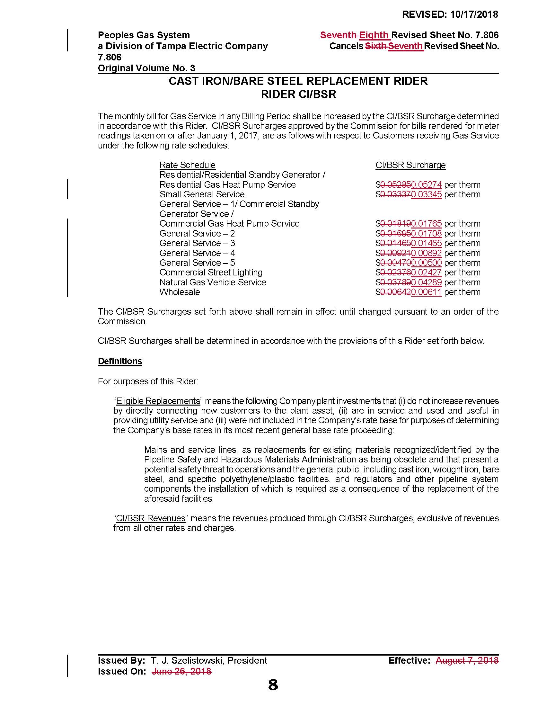

Order No. PSC-12-0476-TRF-GU, issued September 18, 2012 in Docket No. 110320-GU, In re: Petition for approval of Cast Iron/Bare Steel Pipe Replacement Rider (Rider CI/BSR), by Peoples Gas System. (2012 order)
Order No. PSC-2017-0433-TRF-GU, issued November 14, 2017, in Docket No. 20170433-GU, In re: Petition for approval of 2016 true-up, projected 2017 true-up and 2018 revenue requirements and surcharges associated with cast iron/bare steel pipe replacement rider, by Peoples Gas System. (2017 order)
Order No. PSC-17-0066-AS-GU, issued February 28, 2017, in Docket No. 160159-GU, In re: Petition for approval of settlement agreement pertaining to Peoples Gas System's 2016 depreciation study, environmental reserve account, problematic plastic pipe replacement, and authorized ROE.
Order No. PSC-2018-0501-S-GU, issued October 18, 2018, in Docket No. 20180044-GU, In re: Consideration of the tax impacts associated with Tax Cuts and Jobs Act of 2017 for Peoples Gas System.

