BEFORE THE FLORIDA PUBLIC SERVICE COMMISSION

In re: Petition for a limited proceeding to approve first solar base rate adjustment, by Duke Energy Florida, LLC. | DOCKET NO. 20180149-EI  ORDER NO. PSC-2018-0559-FOF-EI  ISSUED: November 21, 2018

The following Commissioners participated in the disposition of this matter:

ART GRAHAM, Chairman
JULIE I. BROWN
DONALD J. POLMANN
GARY F. CLARK
ANDREW GILES FAY

ORDER APPROVING TARIFFS

BY THE COMMISSION:

Background
Duke Energy Florida, LLC’s (DEF) petition for a limited proceeding to approve its 2017 Second Revised and Restated Settlement Agreement (2017 Settlement) was approved by this Commission on November 20, 2017, by Order No. PSC-2017-0451-AS-EU. Paragraph 12 of the 2017 Settlement allows DEF to implement an increase to base rates effective January 2019, and paragraph 15 of the 2017 Settlement allows DEF to petition this Commission for cost recovery of up to 350 megawatts (MW) of solar generation in 2019. According to paragraph 15 of the 2017 Settlement, the cost of the solar projects shall be reasonable and cost-effective.
On July 31, 2018, DEF filed a petition for a limited proceeding to approve its first solar base rate adjustment, which includes both the Hamilton Solar Power Plant (Hamilton Project) and the Columbia Solar Power Plant (Columbia Project). The Hamilton Project is expected to go into service in late 2018 and the Columbia Project is expected to go into service in early 2020. Each project has a rating of 74.9 MW.
On August 24, 2018, DEF filed a petition, also in Docket No. 20180149-EI, for approval of tariff changes to implement the 2019 base rate increase approved in the 2017 Settlement and the proposed base rate adjustment for the Hamilton Project. The tariffs filed with this petition also include the base rate increase for the second Citrus County Combined Cycle Power Block (Citrus Unit 2) which was approved for inclusion in base rates by Order No. PSC-2018-0367-TRF-EI (Citrus Order). The decisions to increase rates for the Citrus Unit 2 and the step increase authorized by paragraph 12 of the 2017 Settlement Agreement are final. This order combines these previously-approved increases with the solar base rate adjustment increase for administrative efficiency.
DEF requests that the tariffs filed on August 24, 2018, go into effect with the first billing cycle in January 2019; however, Duke acknowledges the tariff increases for the Hamilton Project and Citrus Unit 2 are contingent on DEF placing the units into service before the first billing cycle of January 2019. DEF has also requested that the rates for the Hamilton Project be subject to refund to allow this Commission to render a decision on the solar base rate adjustment petition. A hearing for the Hamilton and Columbia Projects is currently scheduled to be held in April 2019. A copy of the tariff to be approved is shown in Legislative format appended to this order as Attachment A.
This order addresses the tariffs DEF filed in its August 24, 2018, petition. DEF waived the 60-day file and suspend provision of Section 366.06(3), Florida Statutes (F.S.), until our October 30, 2018 Commission Conference. We have jurisdiction pursuant to Sections 366.06 and 366.076, F.S.
Decision
On August 24, 2018, DEF filed a petition and supplemental direct testimony of Marcia Olivier to support the calculations and proposed tariffs to go into effect with the first billing cycle in January 2019. The proposed tariffs reflect three base rate increases: (1) the Hamilton Project; (2) the base rate increase approved in the 2017 Settlement; and (3) the base rate increase to reflect Citrus Unit 2 approved in the Citrus Order. DEF explained that combining several rate increases into one tariff sheet filing smooths out the rate impact to customers and avoids the potential confusion of multiple tariff sheets. The three base rate changes are discussed in more detail below.

Hamilton Project

The proposed Hamilton Project is a 74.9 MW solar facility being constructed in Hamilton County and is at issue in the instant docket. DEF states that the Hamilton Project is expected to be in-service in December 2018. DEF requested to implement the base rate increase for the Hamilton Project with the first billing cycle in January 2019, subject to refund, pending the final Commission decision in this docket. DEF further stated that if the commercial in-service date of the Hamilton Project is delayed, then the tariff should become effective with the first billing cycle after the Hamilton Project is placed in commercial service and the Commission should provide staff authority to administratively approve the tariff sheets at the appropriate time.

The proposed annualized revenue requirement for the Hamilton Project is $15.2 million. Exhibit MO-2 of the supplemental direct testimony of Marcia Olivier shows the allocation of the $15.2 million revenue requirement to all rate classes. The uniform percentage increase to all rate classes is 0.69 percent. The residential base rate impact of the Hamilton Project is $0.46 on a 1,000 kWh bill.

Base Rate Increase approved in 2017 Settlement

Paragraph 12(b) of the 2017 Settlement provides for a $67 million base rate increase effective with the first billing cycle in January 2019. Paragraph 12(c) of the 2017 Settlement provides that if the applicable federal or state income tax rate for DEF changes, DEF will adjust the amount of the base increase to reflect the new tax rate before the implementation of such increase. DEF explained in the supplemental direct testimony of Marcia Oliver that DEF recalculated the base rate increase, in accordance with the 2017 Settlement, to reflect the new lower federal income tax rate resulting from the 2017 Tax Cuts and Jobs Act. We reviewed the calculation of the revised base rate increase and confirmed that DEF applied the tax changes in accordance with the 2017 settlement. The revised base rate increase is $55.1 million. The residential base rate impact of the 2017 Settlement is $1.84 on a 1,000 kWh bill.

Citrus Unit 2 Increase approved in Citrus Unit Order

The Citrus Order gave Commission staff the administrative authority to approve tariffs and associated charges that implement our approval regarding base rate inclusion of DEF’s Citrus Combined Cycle Project. As stated above, DEF’s tariff sheets filed on August 24, 2018, also reflect the Citrus Unit 2 increase. Citrus Unit 2 is scheduled to be placed in-service in December 2018. As provided for in the Citrus Order, in the event that Citrus Unit 2 is delayed, then the tariff should become effective with the first billing cycle after Citrus Unit 2 is placed in commercial service and Commission staff has authority to administratively approve the tariff sheets at the appropriate time. The residential base rate impact of Citrus Unit 2 is $2.25 on a 1,000 kWh bill.

Conclusion

The impact on a residential 1,000 kWh bill of the three base rate changes discussed above effective with the first billing cycle in January 2019 is an increase of $4.55. Duke will notify its customers of the rate changes in their December bills.

We hereby approve DEF’s tariffs filed on August 24, 2018, appended to this order as Attachment A. The tariffs shall go into effect with the first billing cycle in January 2019. The base rate increase associated with the Hamilton Project shall be subject to refund, pending our final determination regarding the Hamilton and Columbia Projects following the April administrative hearing. If the in-service date of the Hamilton Project is delayed, then the tariffs reflecting the Hamilton Project shall become effective, subject to refund, with the first billing cycle after the Hamilton Project is placed in commercial service, and Commission staff shall have authority to administratively approve the tariffs at the appropriate time. If the in-service date of the Hamilton Project and/or Citrus Unit 2 is delayed, DEF shall notify Commission staff of the delay(s) and file revised tariffs, for administrative approval by staff, effective with the first billing cycle of January 2019 to remove the portion of the base rate increase reflected with those units.
Based on the foregoing, it is

ORDERED by the Florida Public Service Commission that Duke Energy Florida, LLC’s tariffs filed on August 24, 2018, appended to this order as Attachment A, are hereby approved. The tariffs shall go into effect with the first billing cycle in January 2019. It is further

ORDERED that the base rate increase associated with the Hamilton Project shall be subject to refund, pending this Commissions’ final determination regarding the Hamilton and Columbia Projects following the April administrative hearing. If the in-service date of the Hamilton Project is delayed, then the tariffs reflecting the Hamilton Project shall become effective, subject to refund, with the first billing cycle after the Hamilton Project is placed in commercial service and Commission staff shall have authority to administratively approve the tariffs at the appropriate time. If the in-service date of the Hamilton Project and/or Citrus Unit 2 is delayed, DEF shall notify Commission staff of the delay(s) and file revised tariffs, for administrative approval by staff, effective with the first billing cycle of January 2019 to remove the portion of the base rate increase associated with those units. It is further

ORDERED that this docket shall remain open pending the Commission’s final decision on DEF’s petition.

By ORDER of the Florida Public Service Commission this 21st day of November, 2018.

/s/Carlotta S. Stauffer
CARLOTTA S. STAUFFER
Commission Clerk
Florida Public Service Commission
2540 Shumard Oak Boulevard
Tallahassee, Florida 32399
(850) 413-6770
www.floridapsc.com

Copies furnished: A copy of this document is provided to the parties of record at the time of issuance and, if applicable, interested persons.

JSC

NOTICE OF FURTHER PROCEEDINGS OR JUDICIAL REVIEW

The Florida Public Service Commission is required by Section 120.569(1), Florida Statutes, to notify parties of any administrative hearing or judicial review of Commission orders that is available under Sections 120.57 or 120.68, Florida Statutes, as well as the procedures and time limits that apply. This notice should not be construed to mean all requests for an administrative hearing or judicial review will be granted or result in the relief sought.

Mediation may be available on a case-by-case basis. If mediation is conducted, it does not affect a substantially interested person's right to a hearing.

Any party adversely affected by the decision herein approving rates subject to refund with respect to the Hamilton Project, which is preliminary, procedural or intermediate in nature, may request: (1) reconsideration within 10 days pursuant to Rule 25-22.0376, Florida Administrative Code; or (2) judicial review by the Florida Supreme Court, in the case of an electric, gas or telephone utility, or the First District Court of Appeal, in the case of a water or wastewater utility. A motion for reconsideration shall be filed with the Office of Commission Clerk, in the form prescribed by Rule 25-22.0376, Florida Administrative Code. Judicial review of a preliminary, procedural or intermediate ruling or order is available if review of the final action will not provide an adequate remedy. Such review may be requested from the appropriate court, as described above, pursuant to Rule 9.100, Florida Rules of Appellate Procedure.

Any party adversely affected by the Commission's final action in this matter may request: 1) reconsideration of the decision by filing a motion for reconsideration with the Office of Commission Clerk, 2540 Shumard Oak Boulevard, Tallahassee, Florida 32399-0850, within fifteen (15) days of the issuance of this order in the form prescribed by Rule 25-22.060, Florida Administrative Code; or 2) judicial review by the Florida Supreme Court in the case of an electric, gas or telephone utility or the First District Court of Appeal in the case of a water and/or wastewater utility by filing a notice of appeal with the Office of Commission Clerk, and filing a copy of the notice of appeal and the filing fee with the appropriate court. This filing must be completed within thirty (30) days after the issuance of this order, pursuant to Rule 9.110, Florida Rules of Appellate Procedure. The notice of appeal must be in the form specified in Rule 9.900(a), Florida Rules of Appellate Procedure.

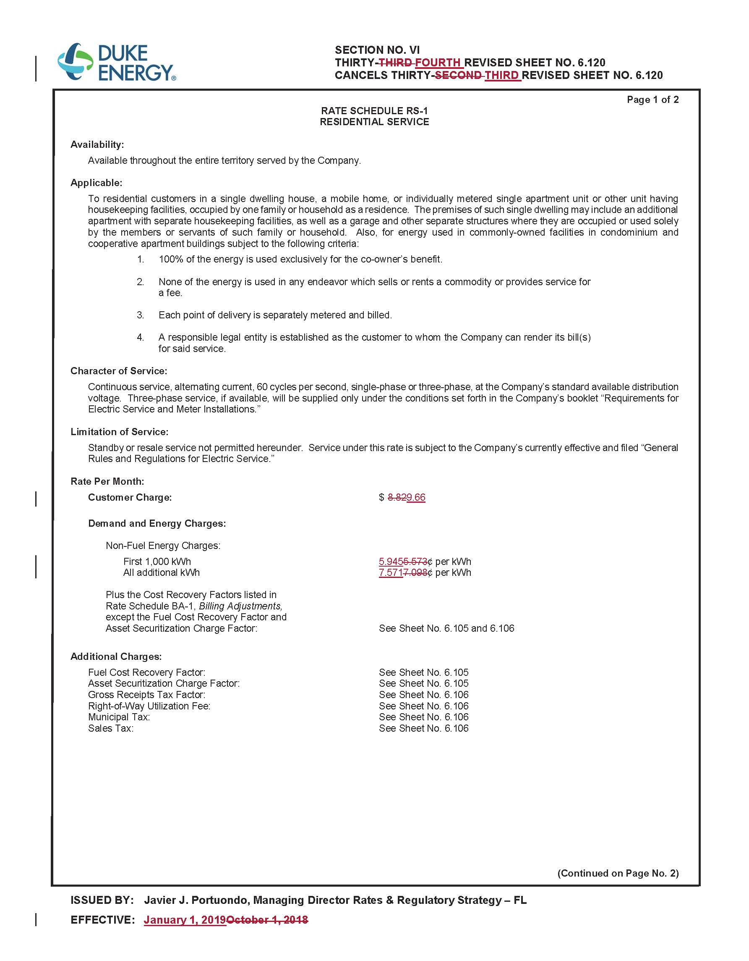

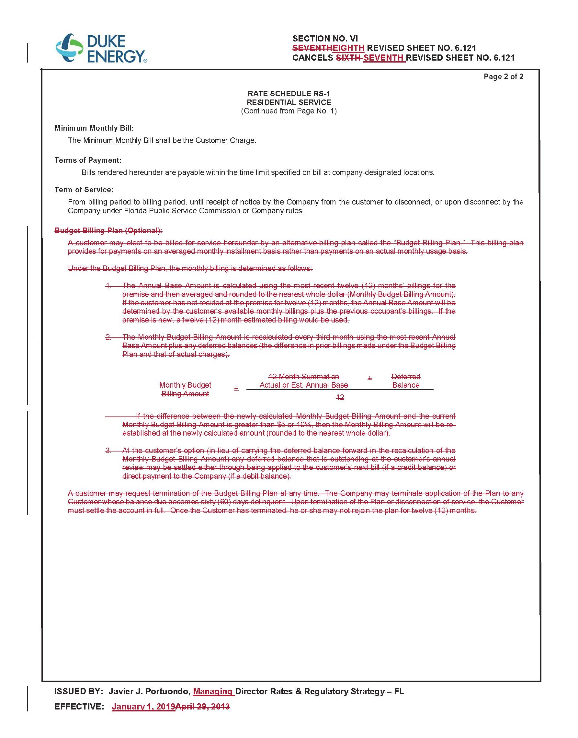
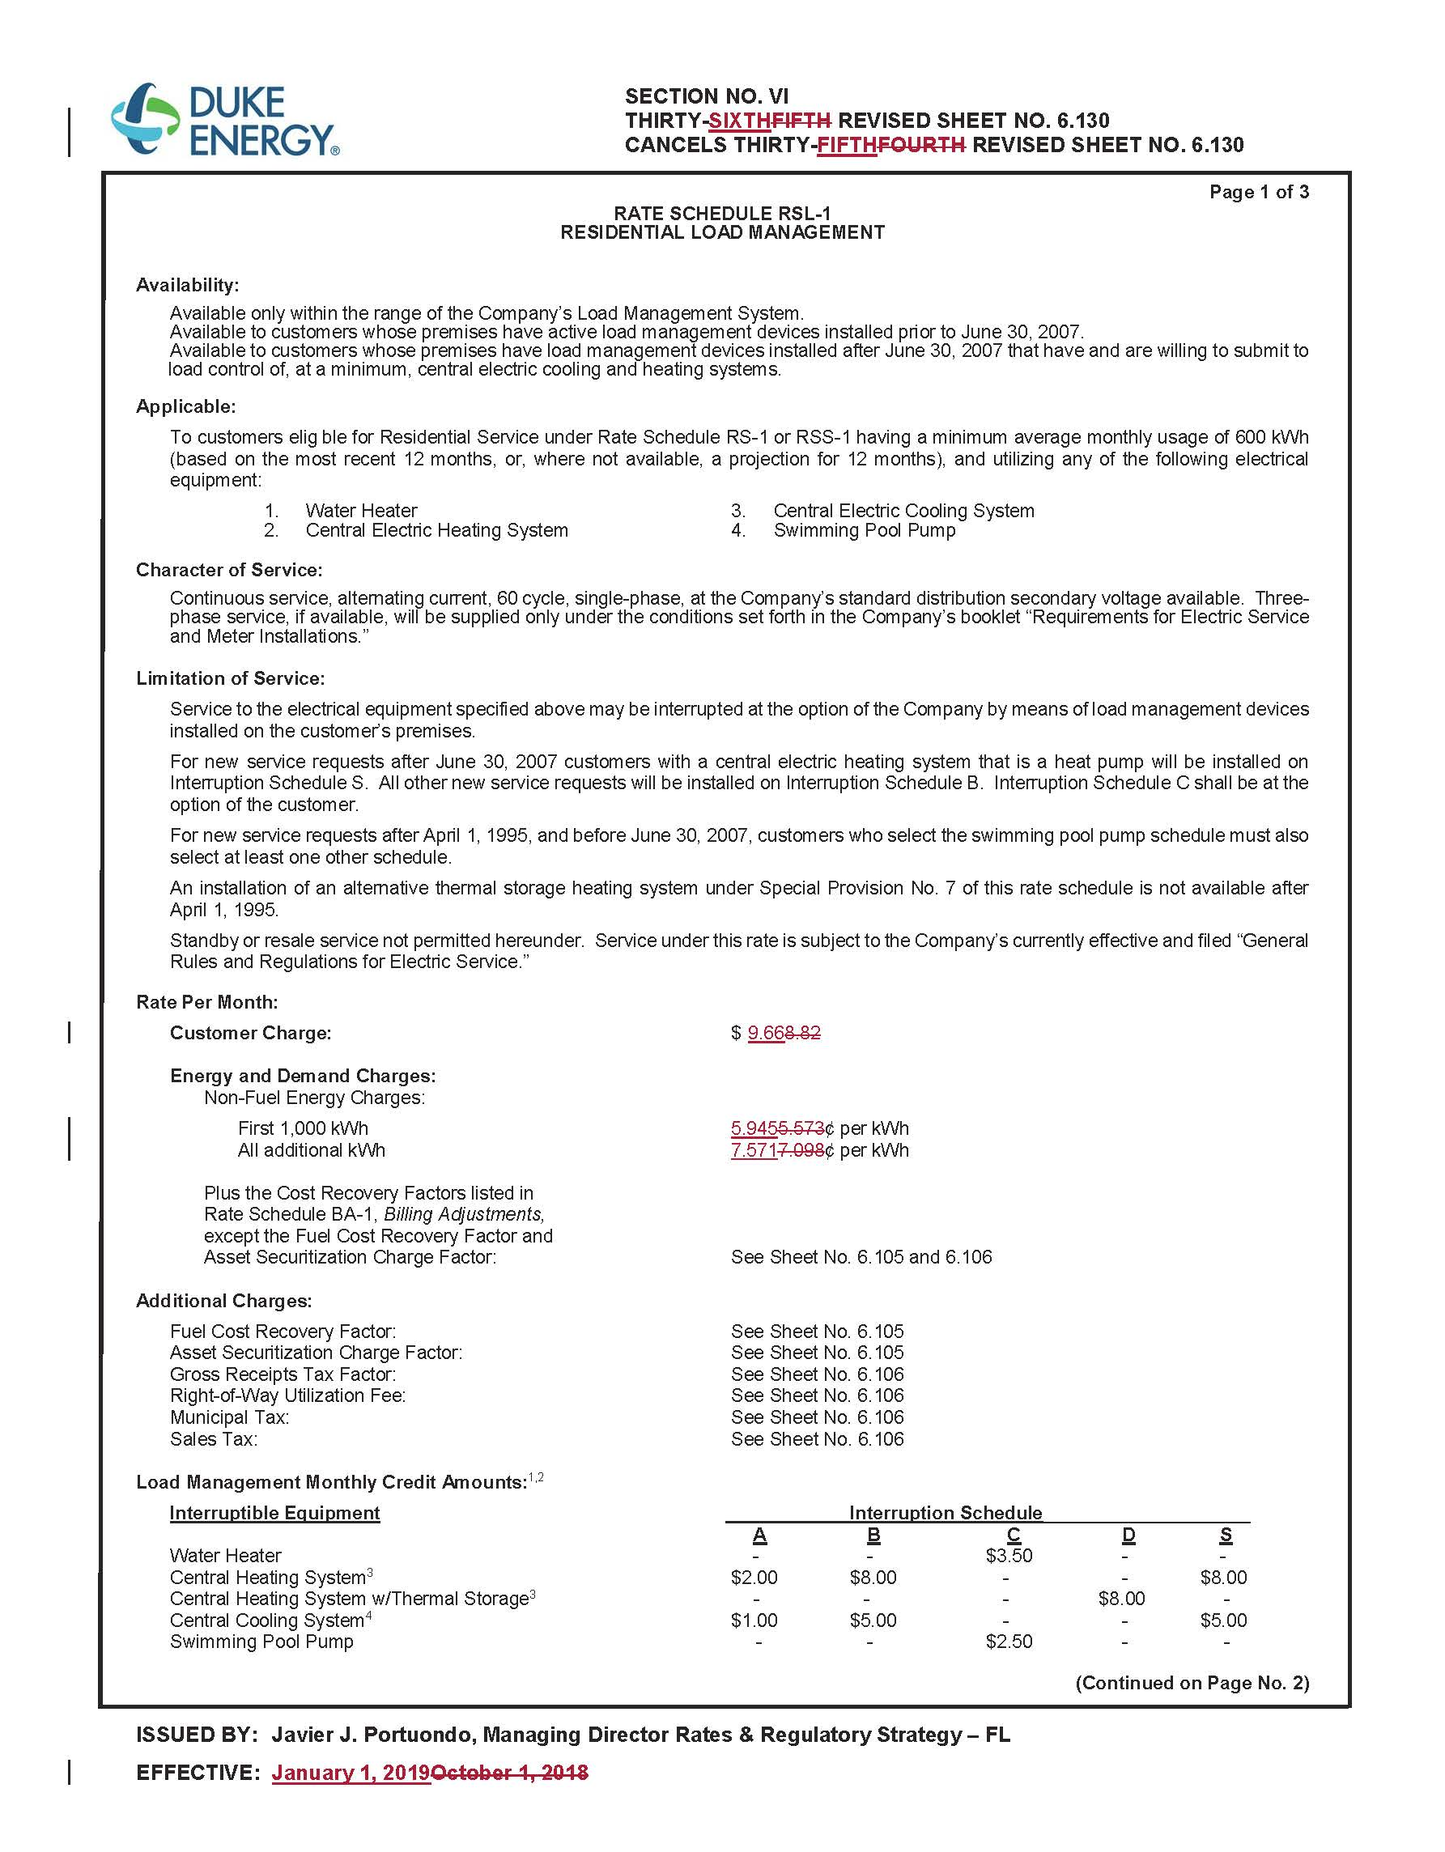

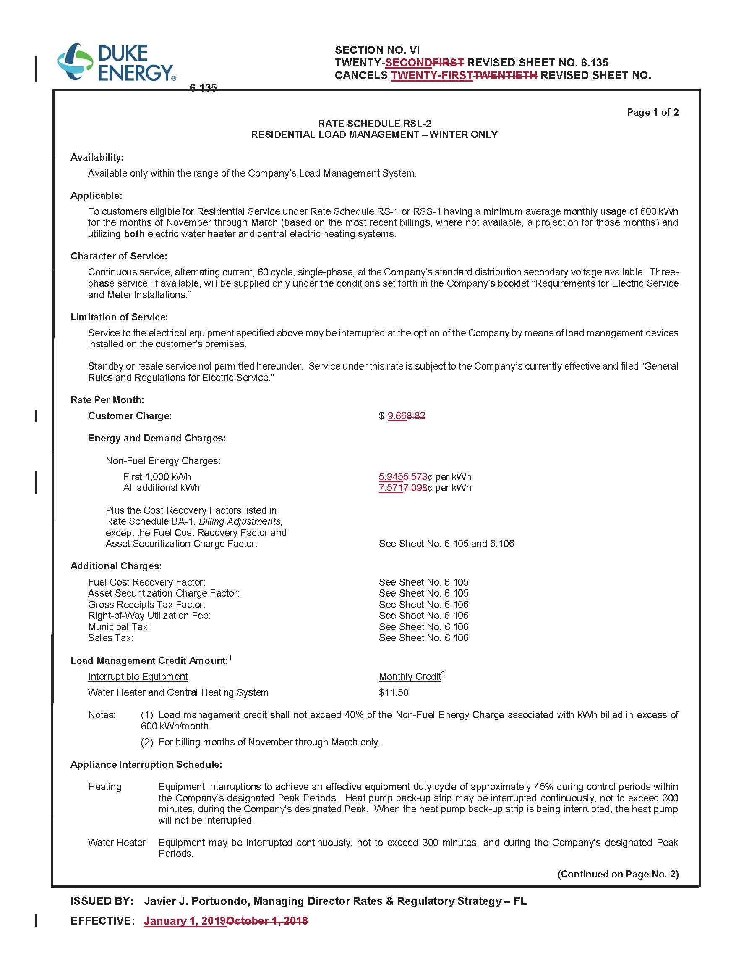
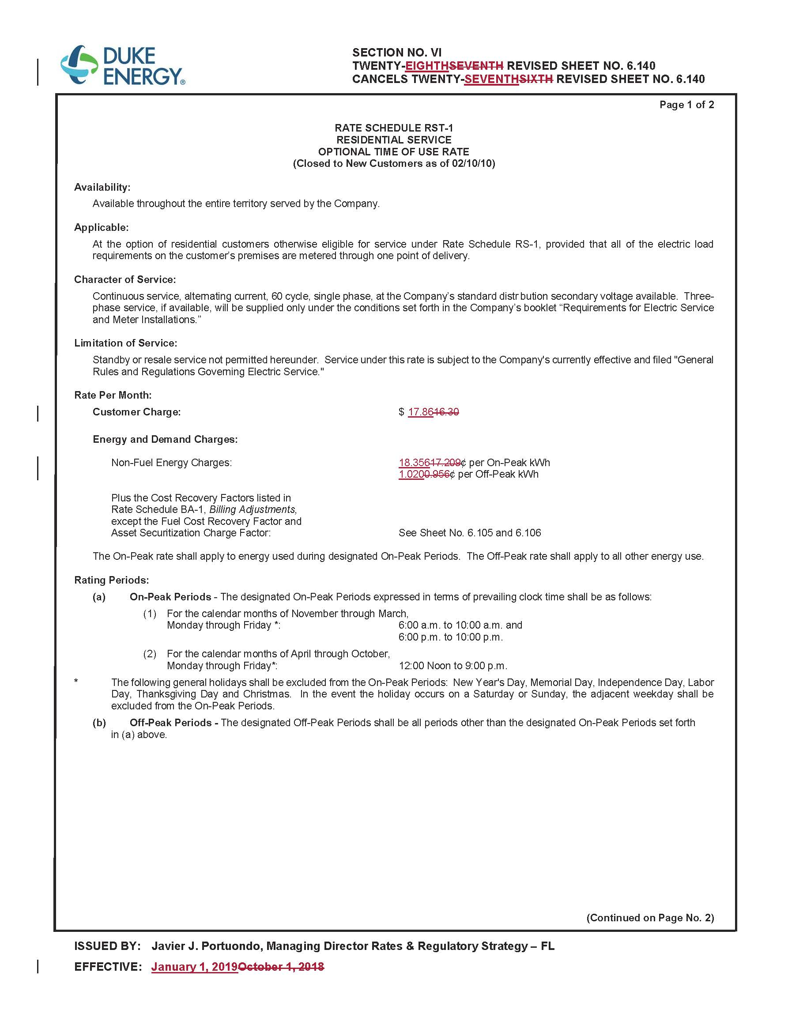

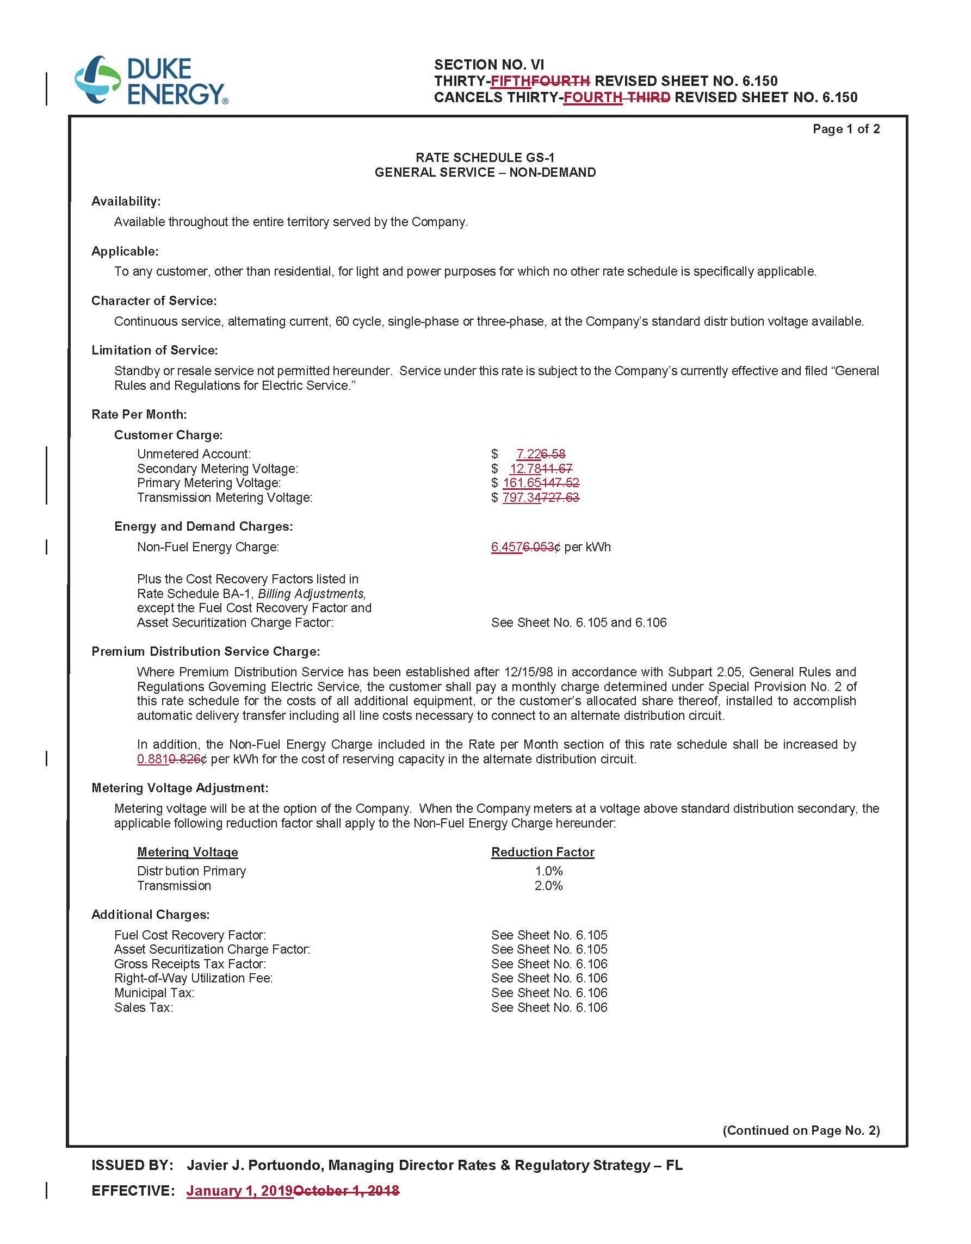
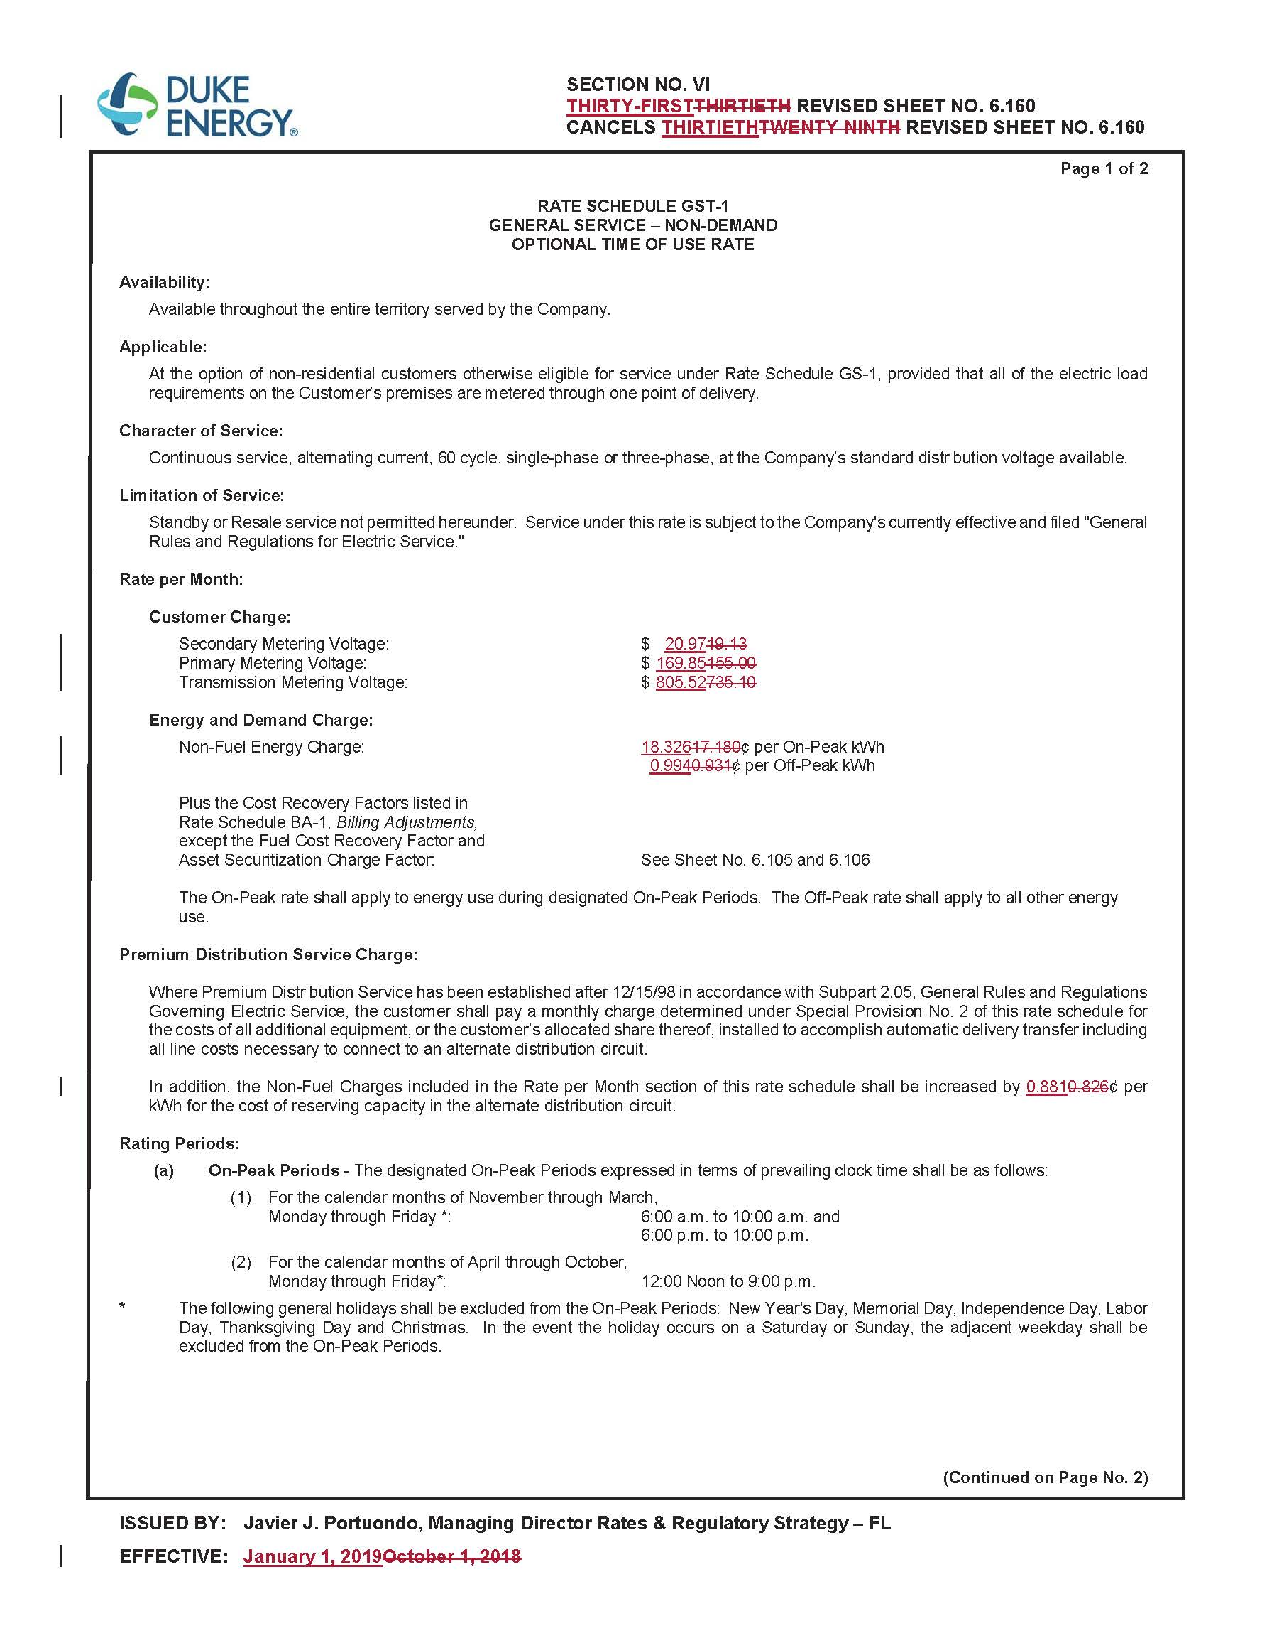

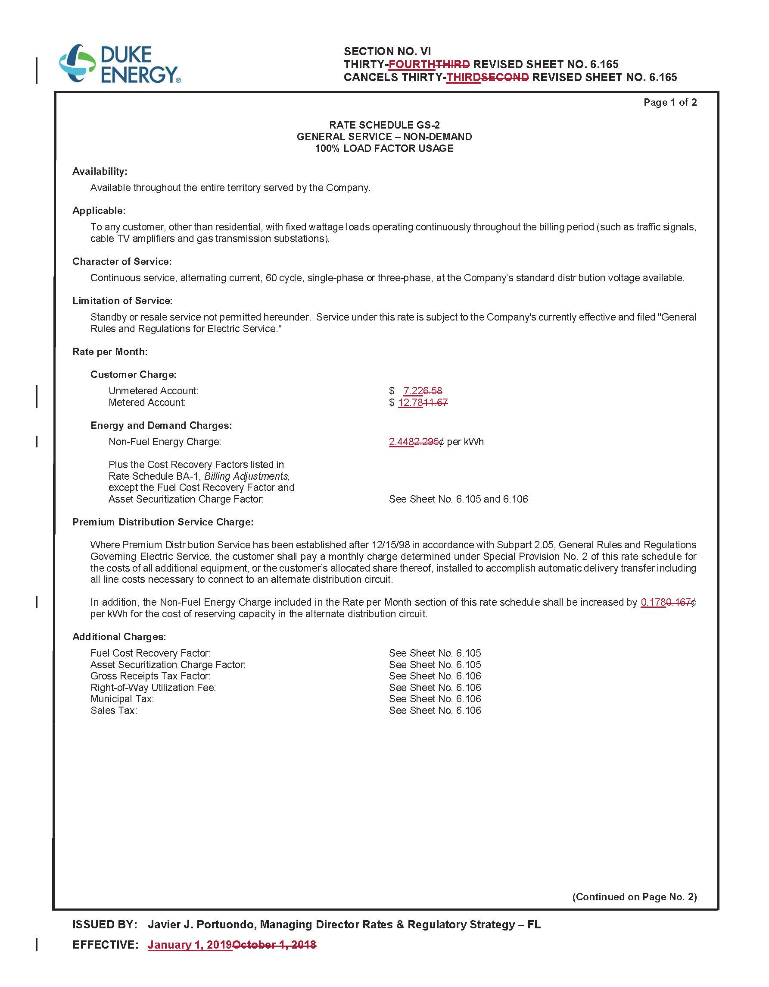
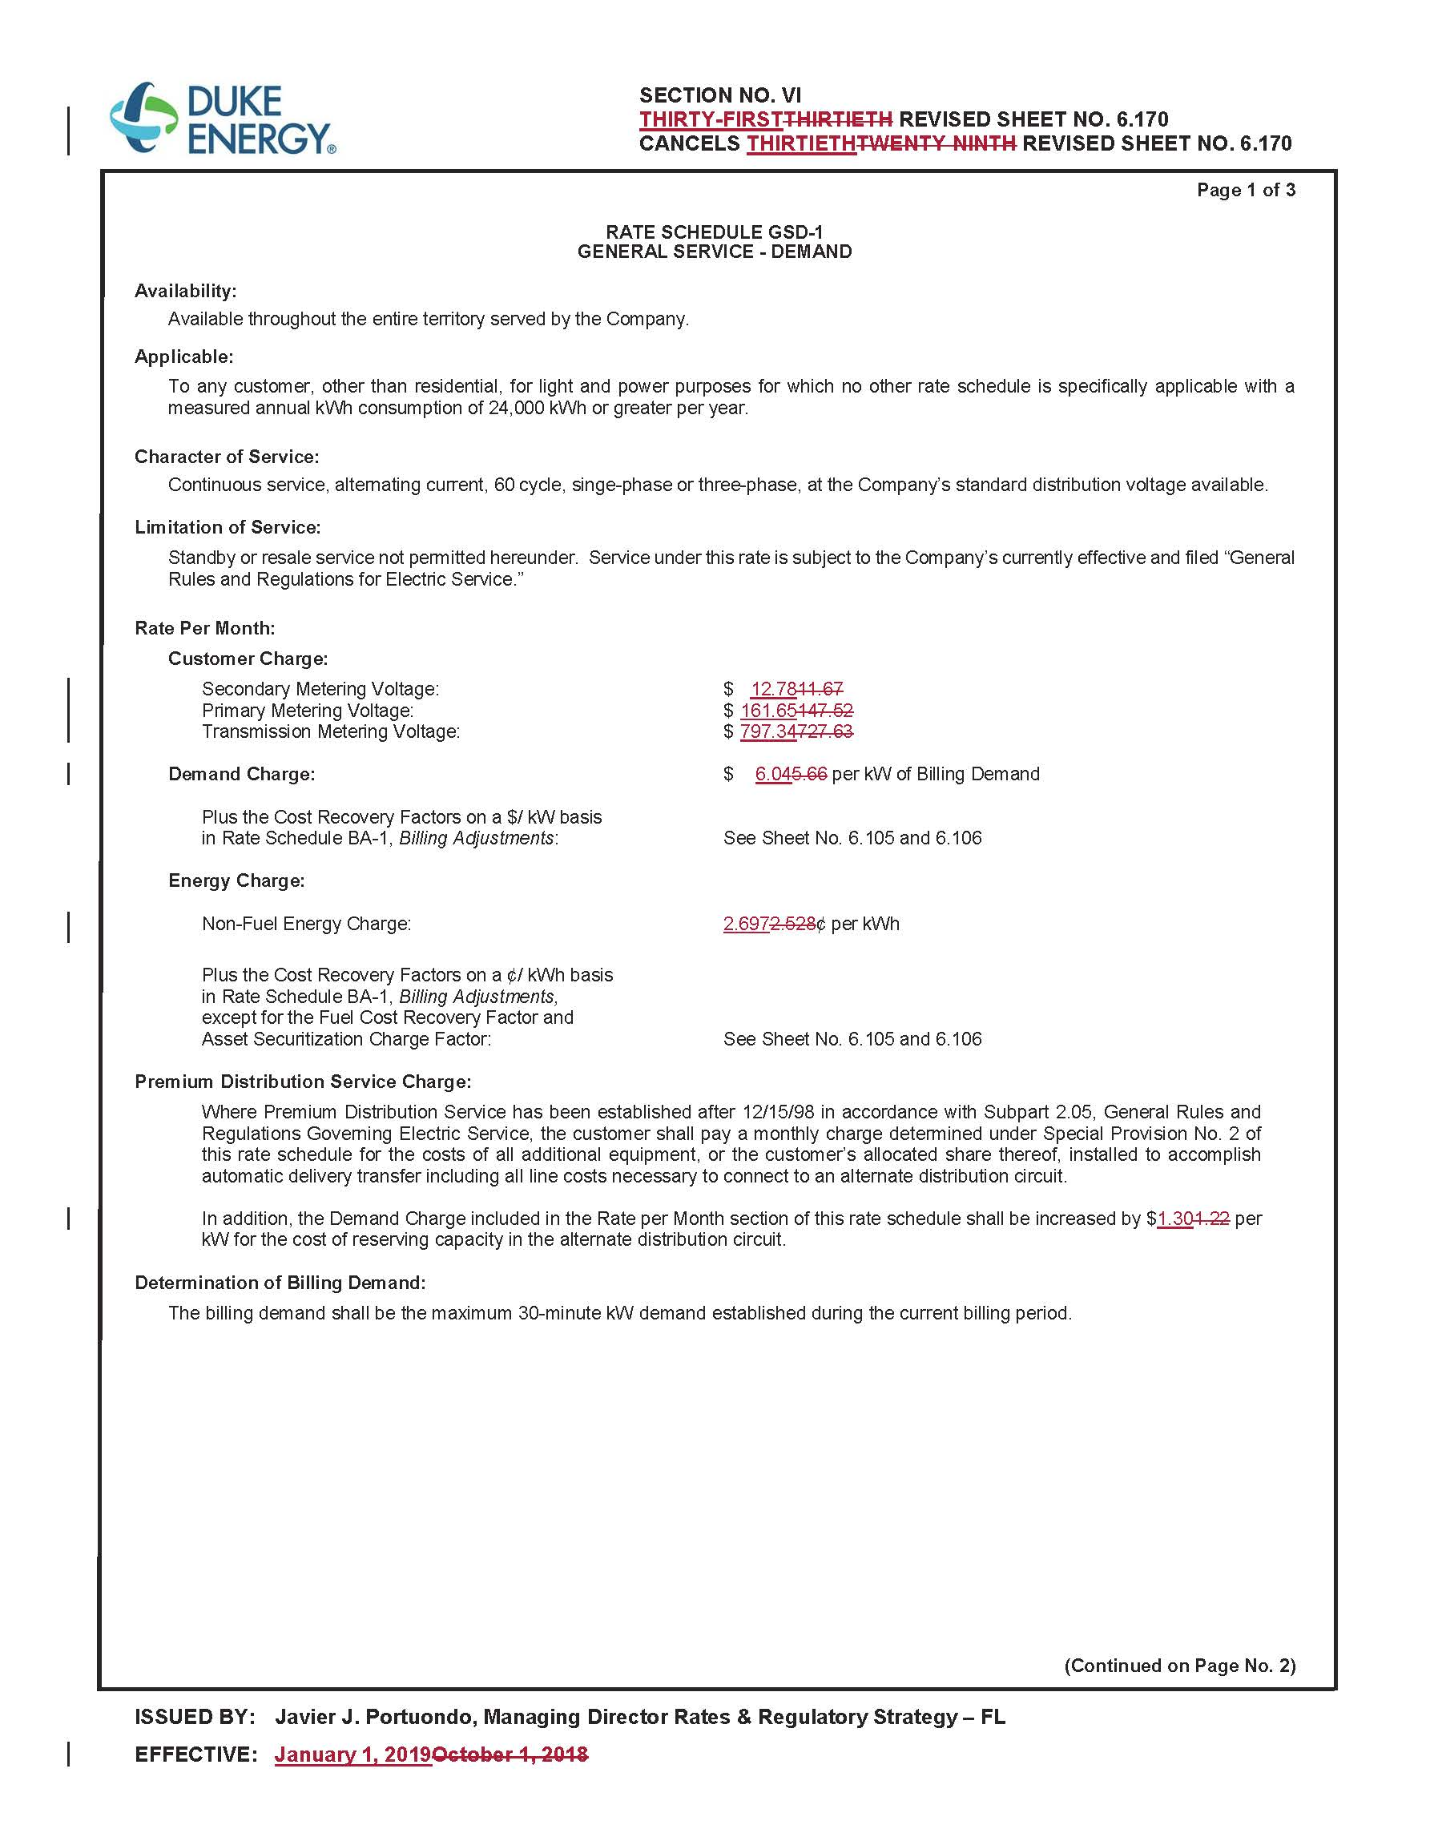

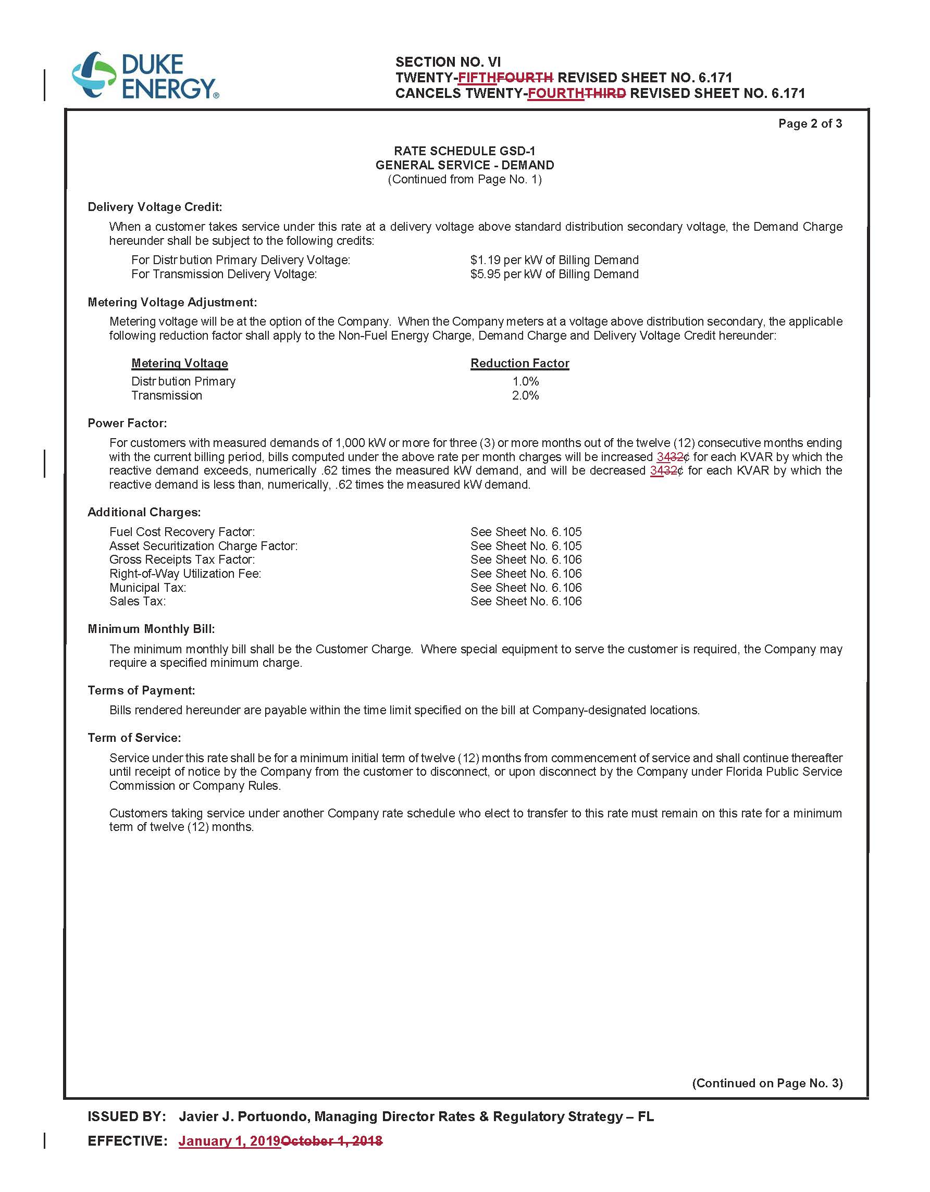

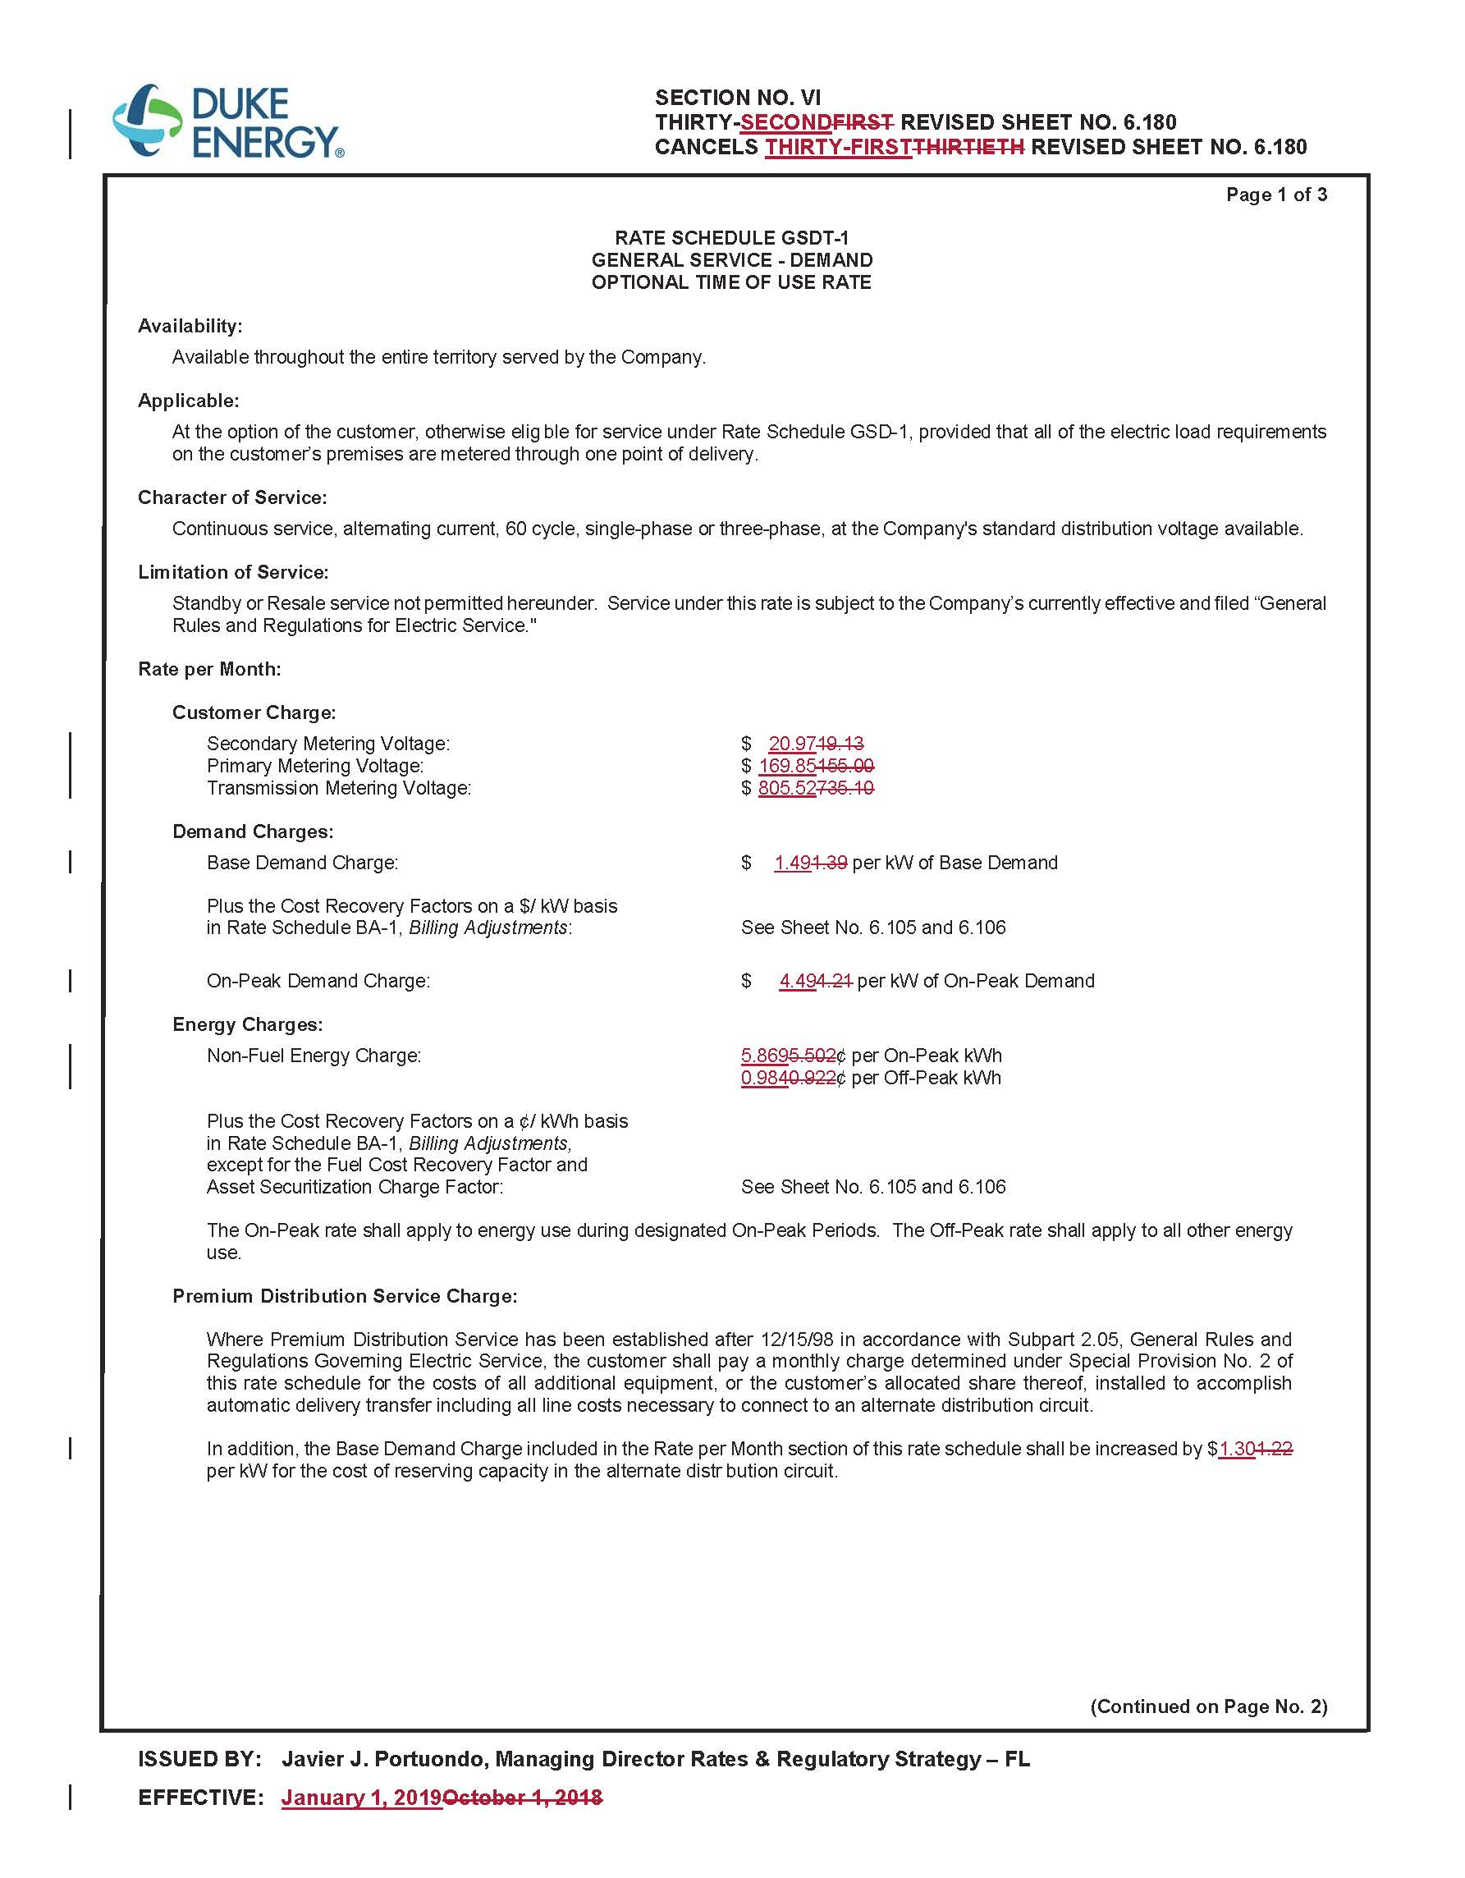

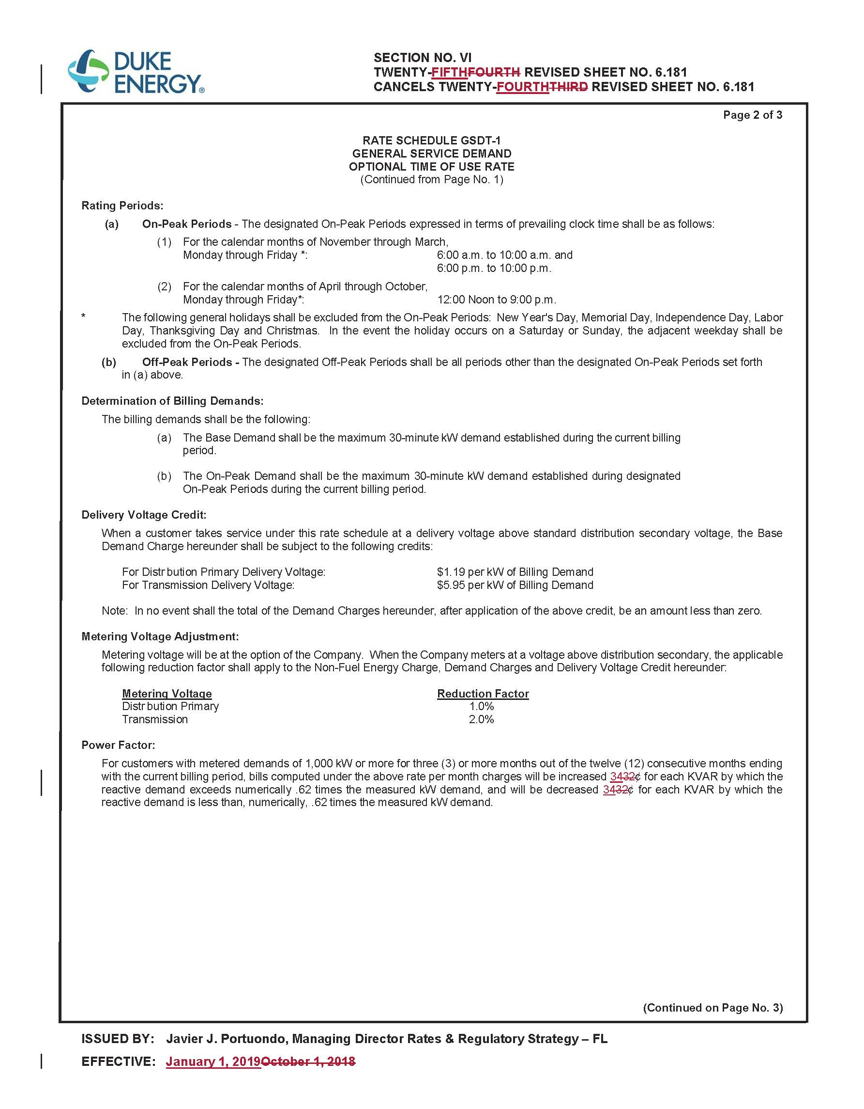
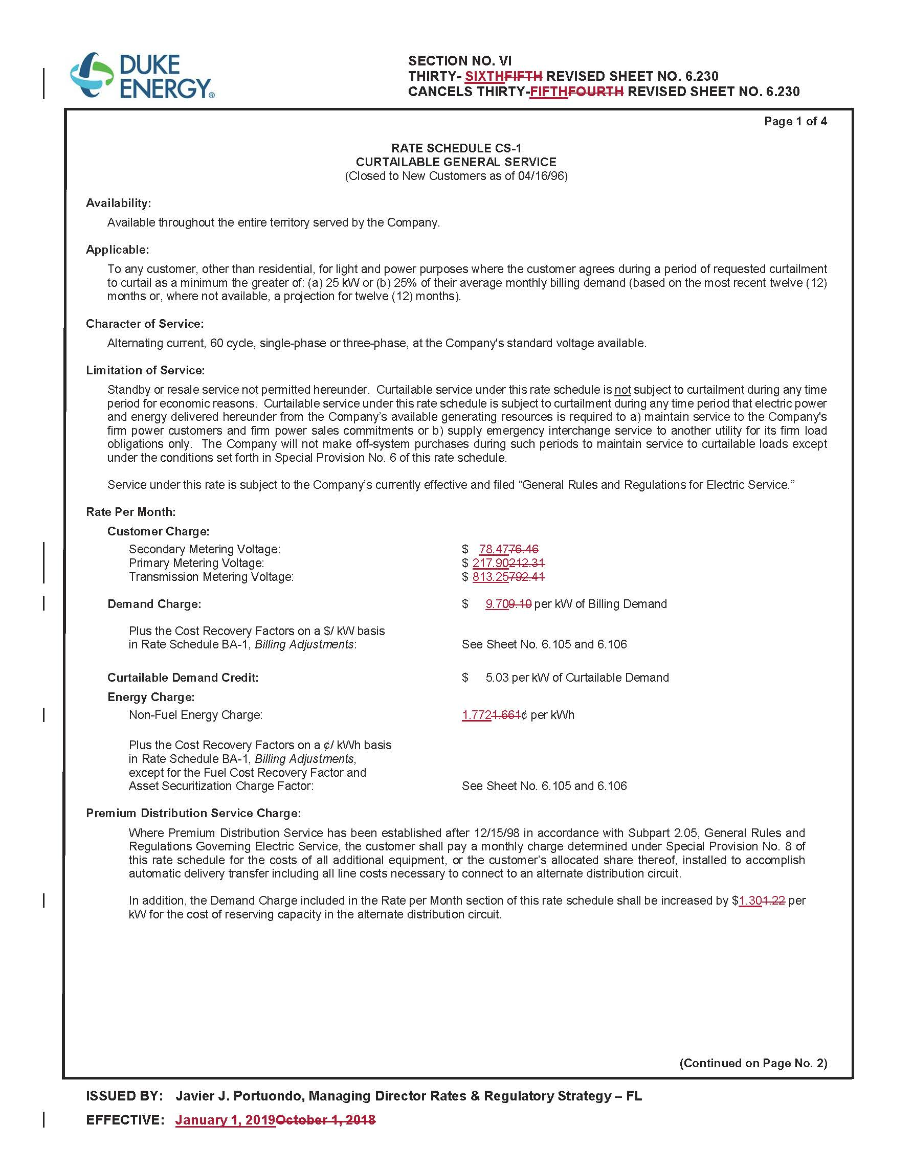

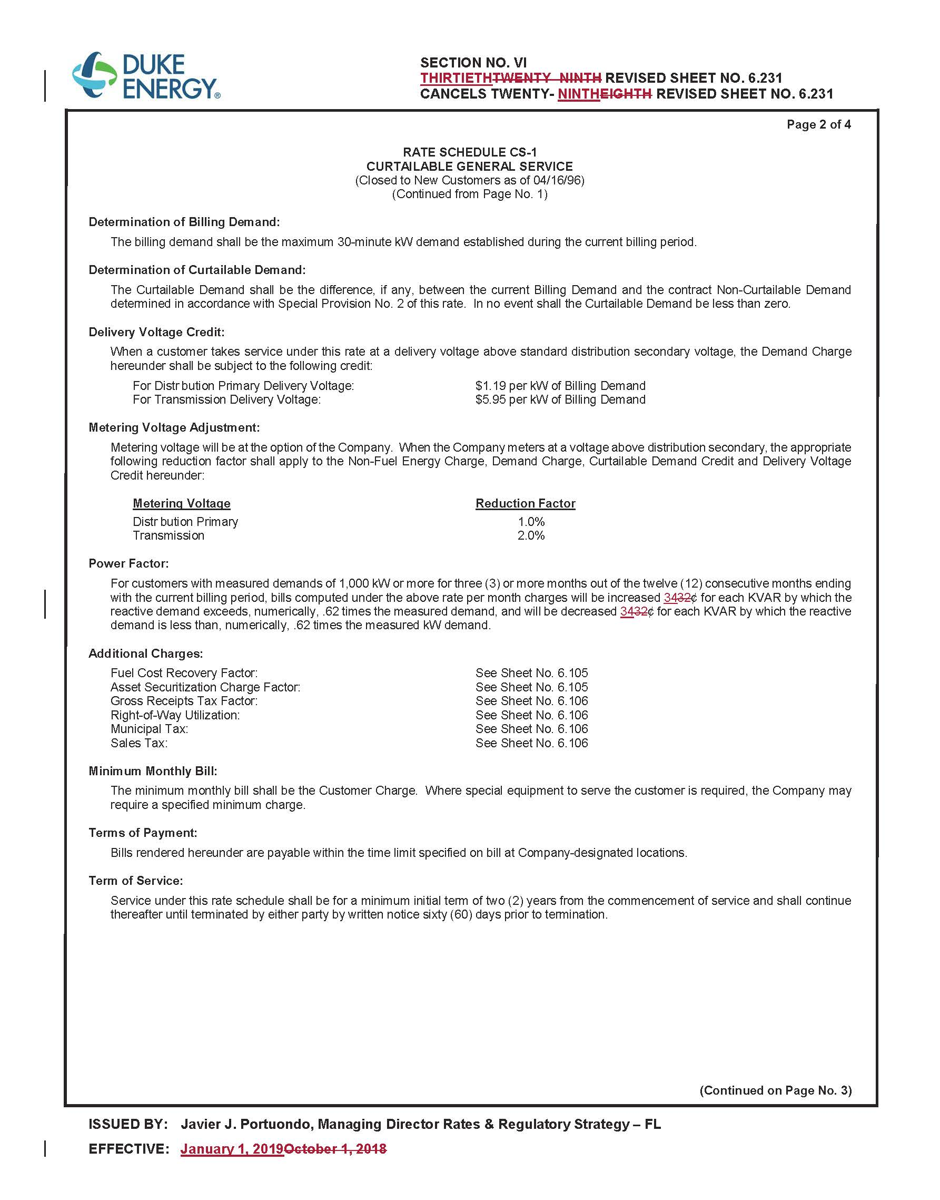
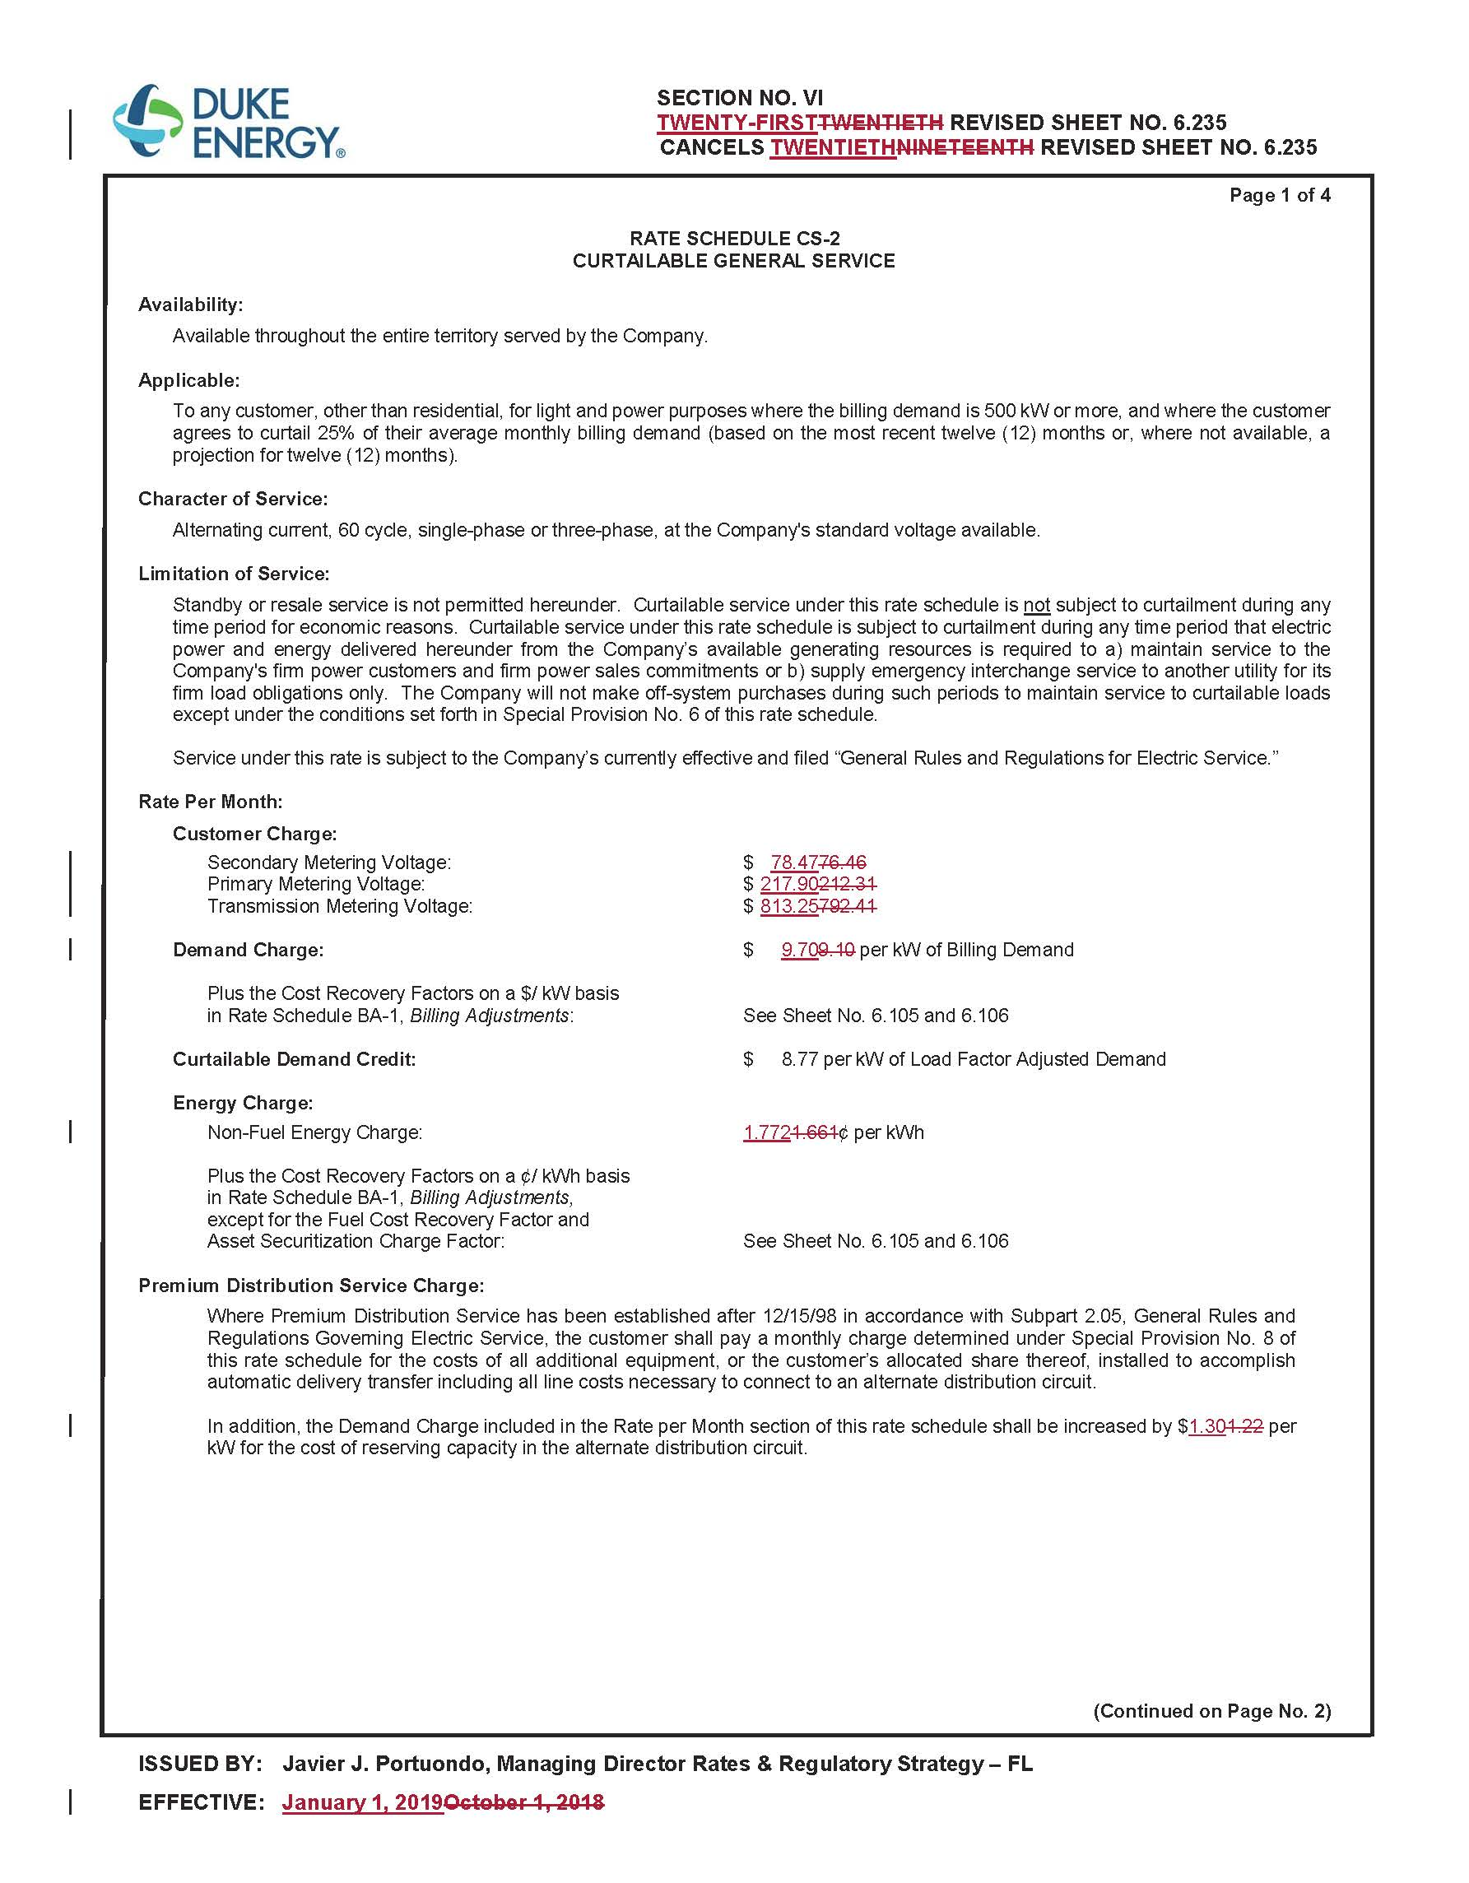

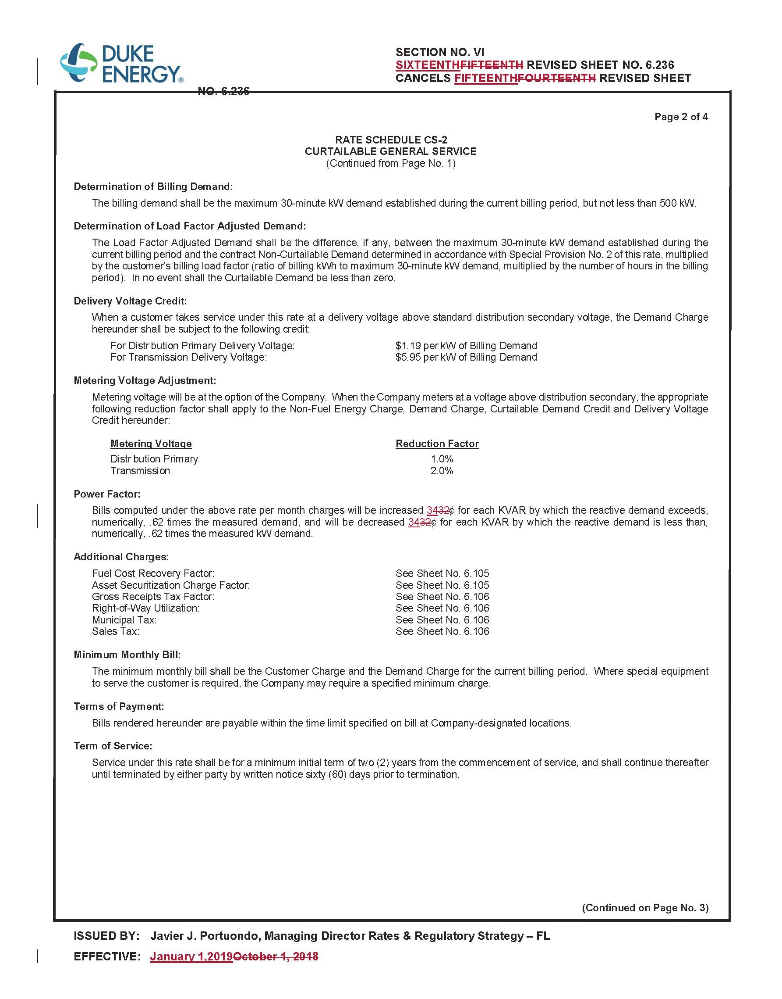
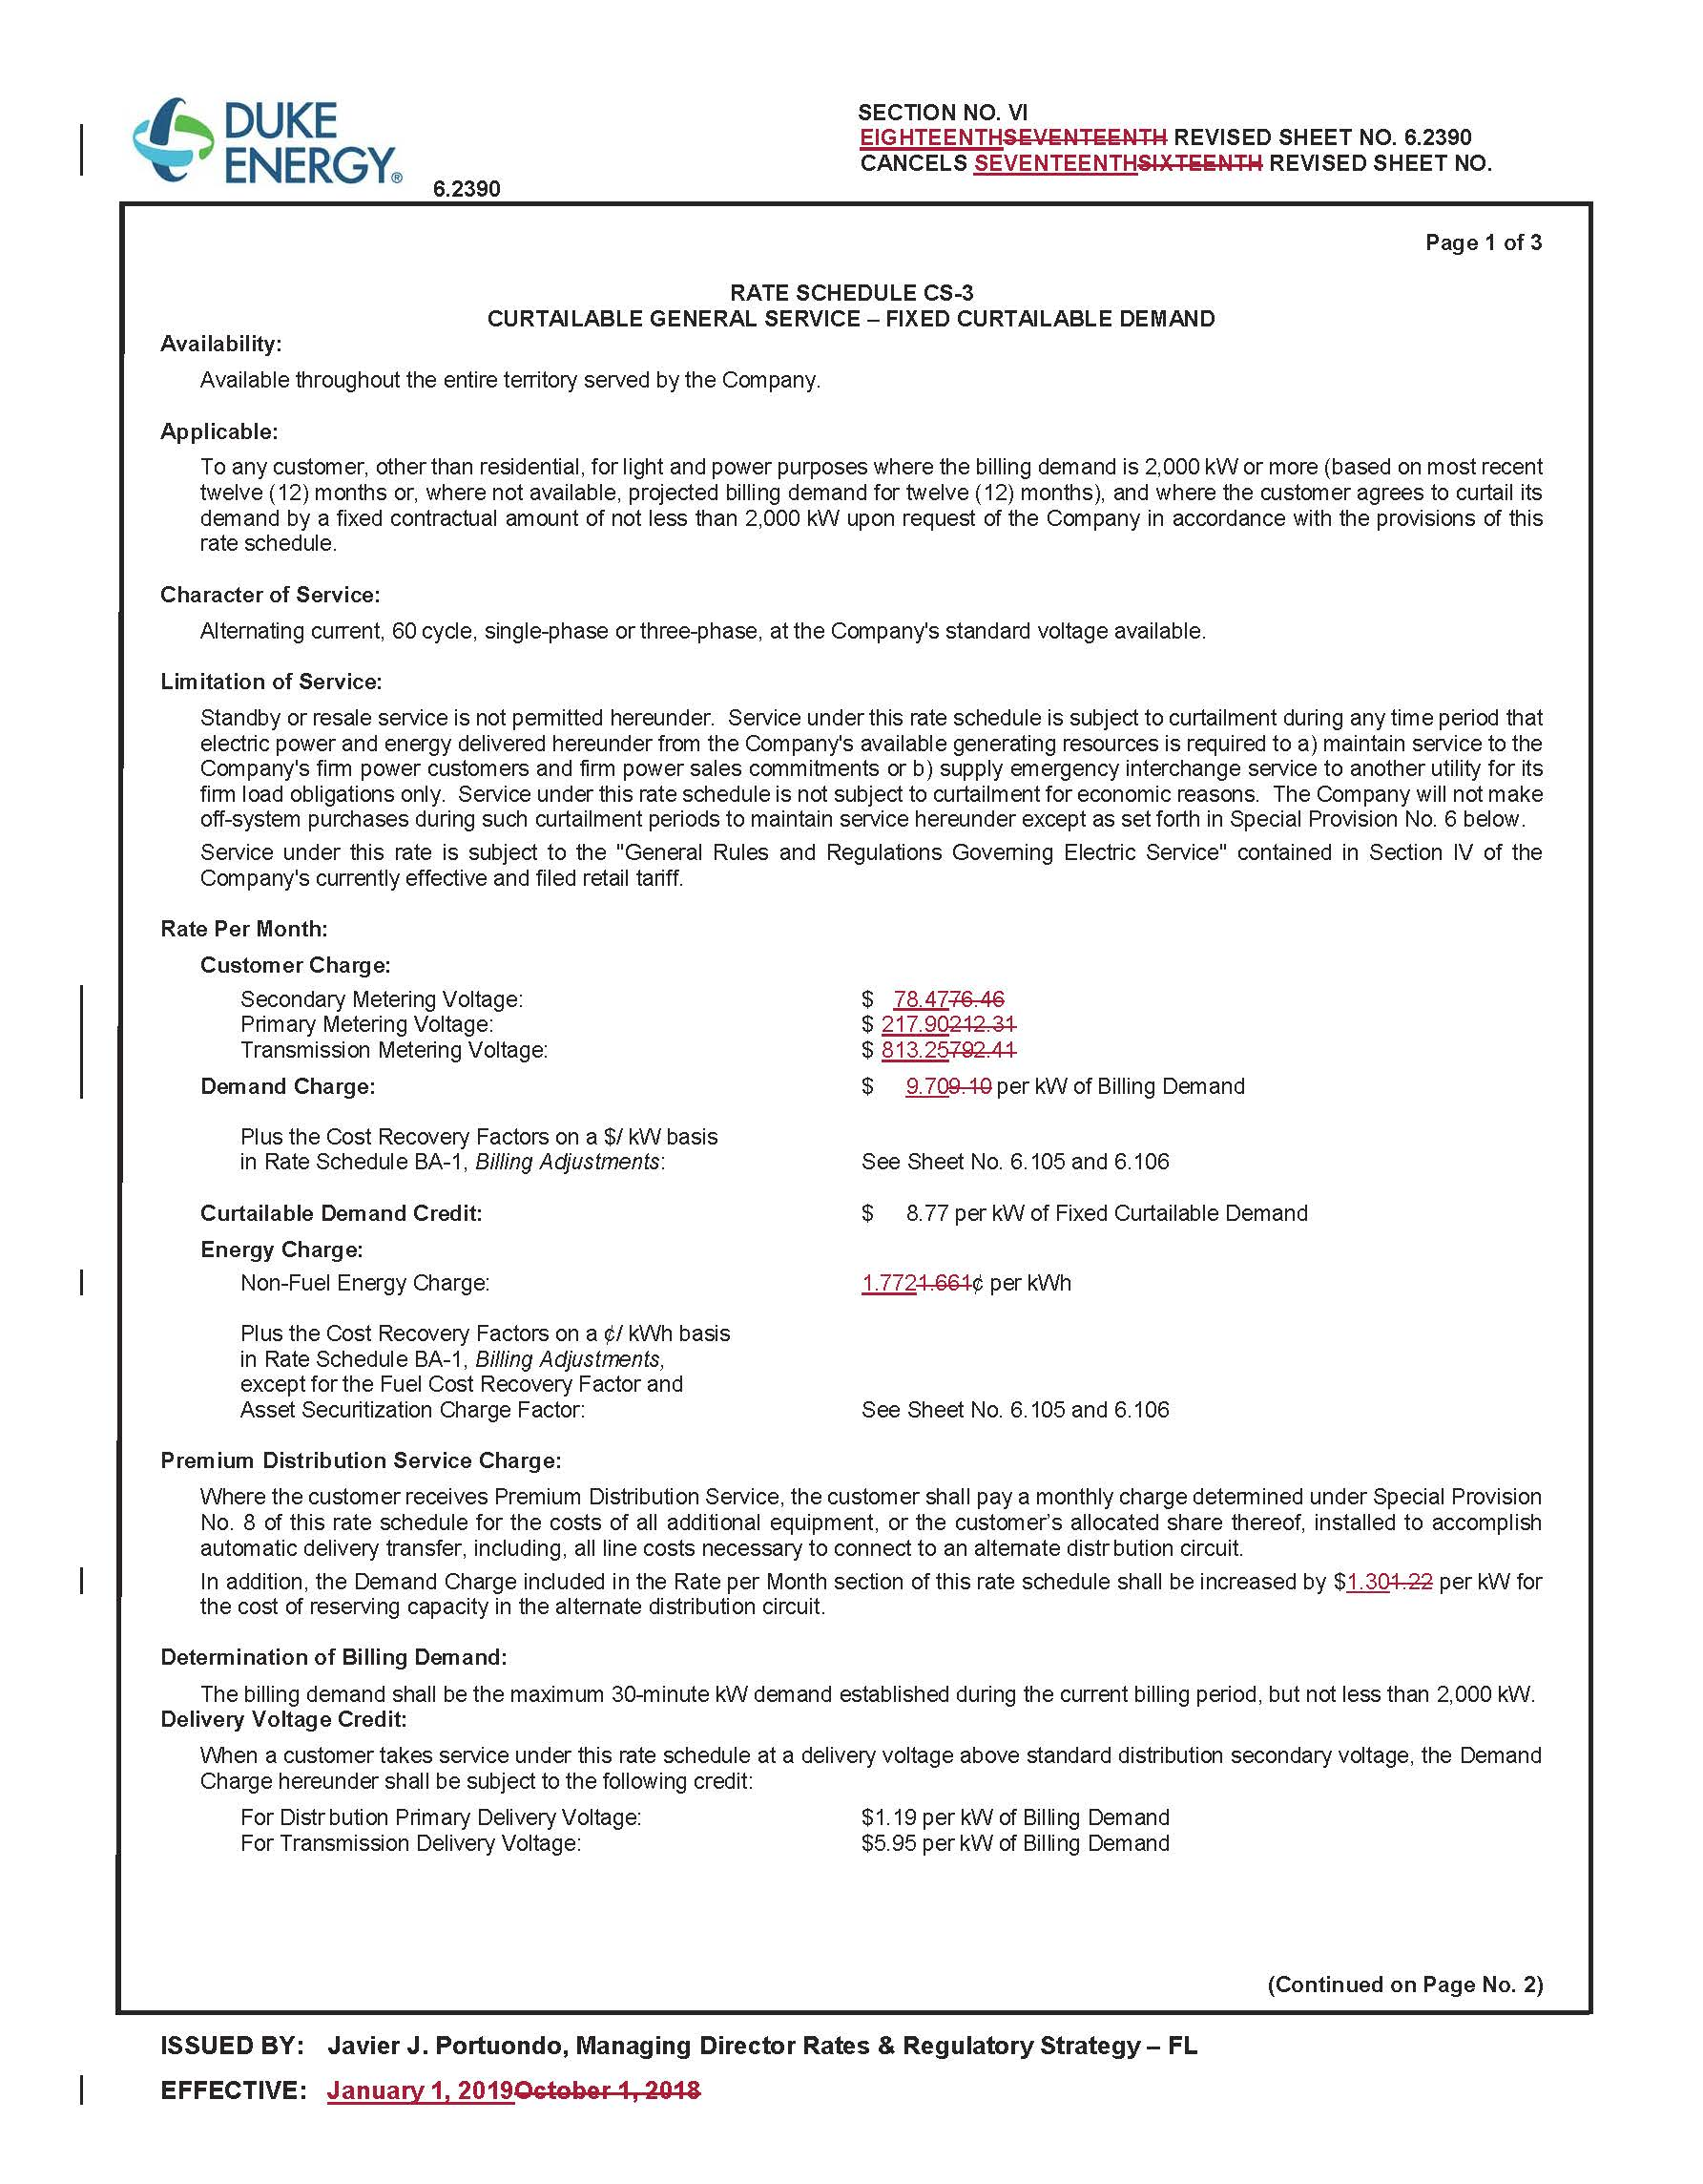

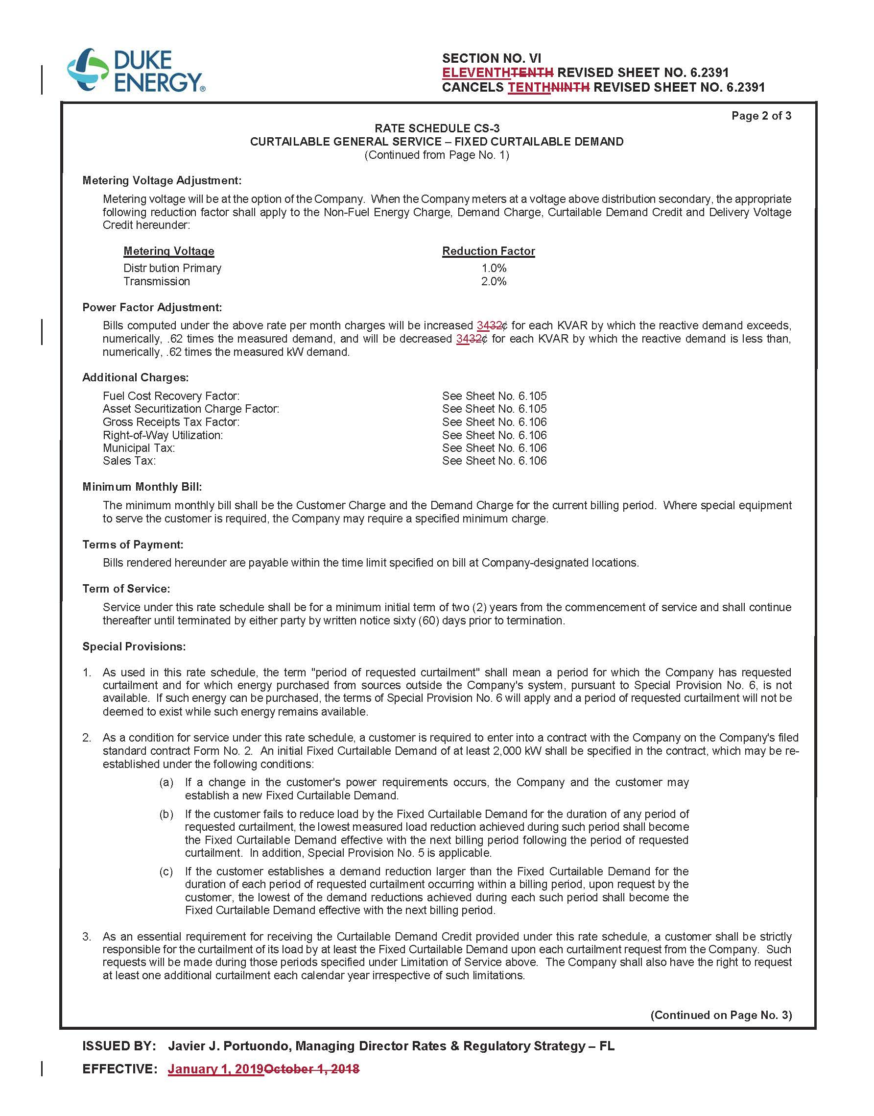
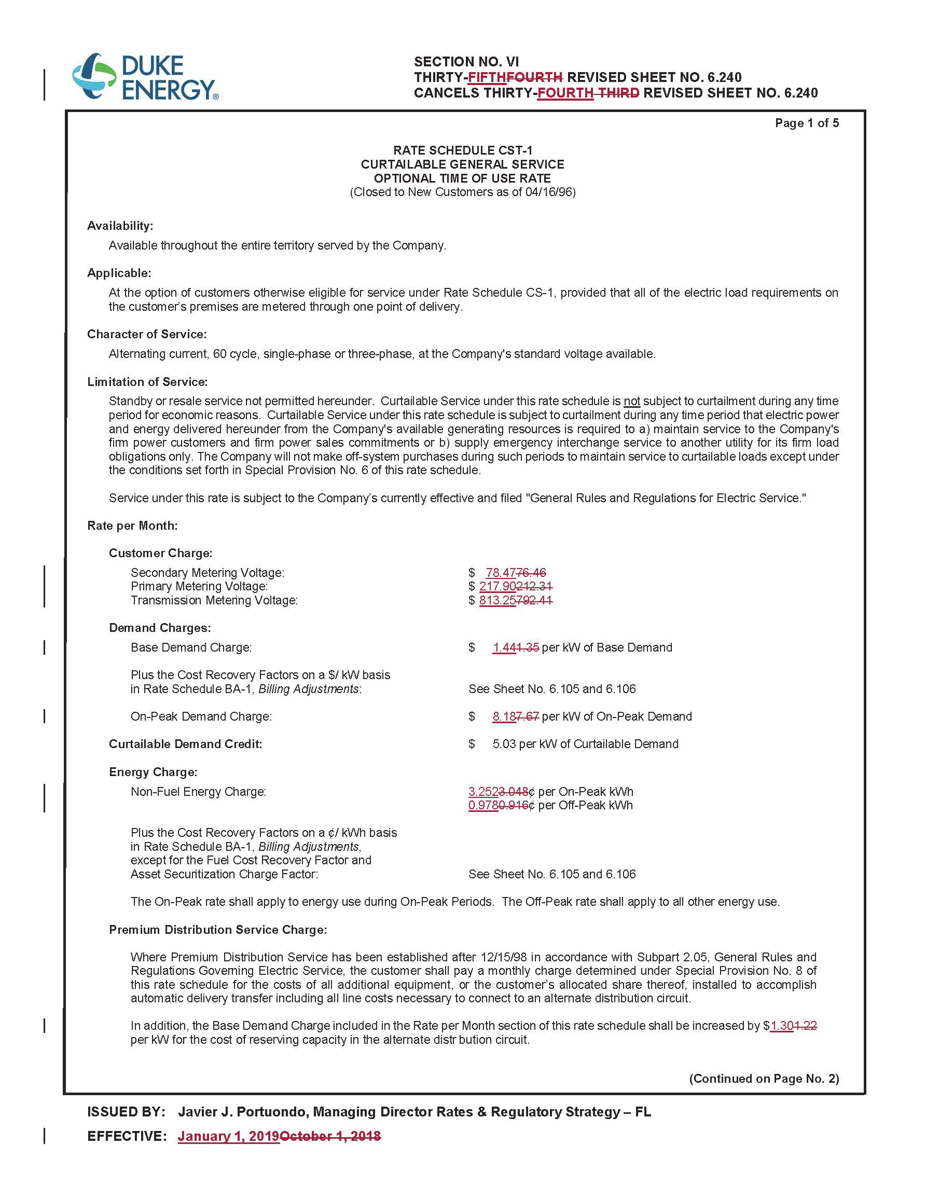

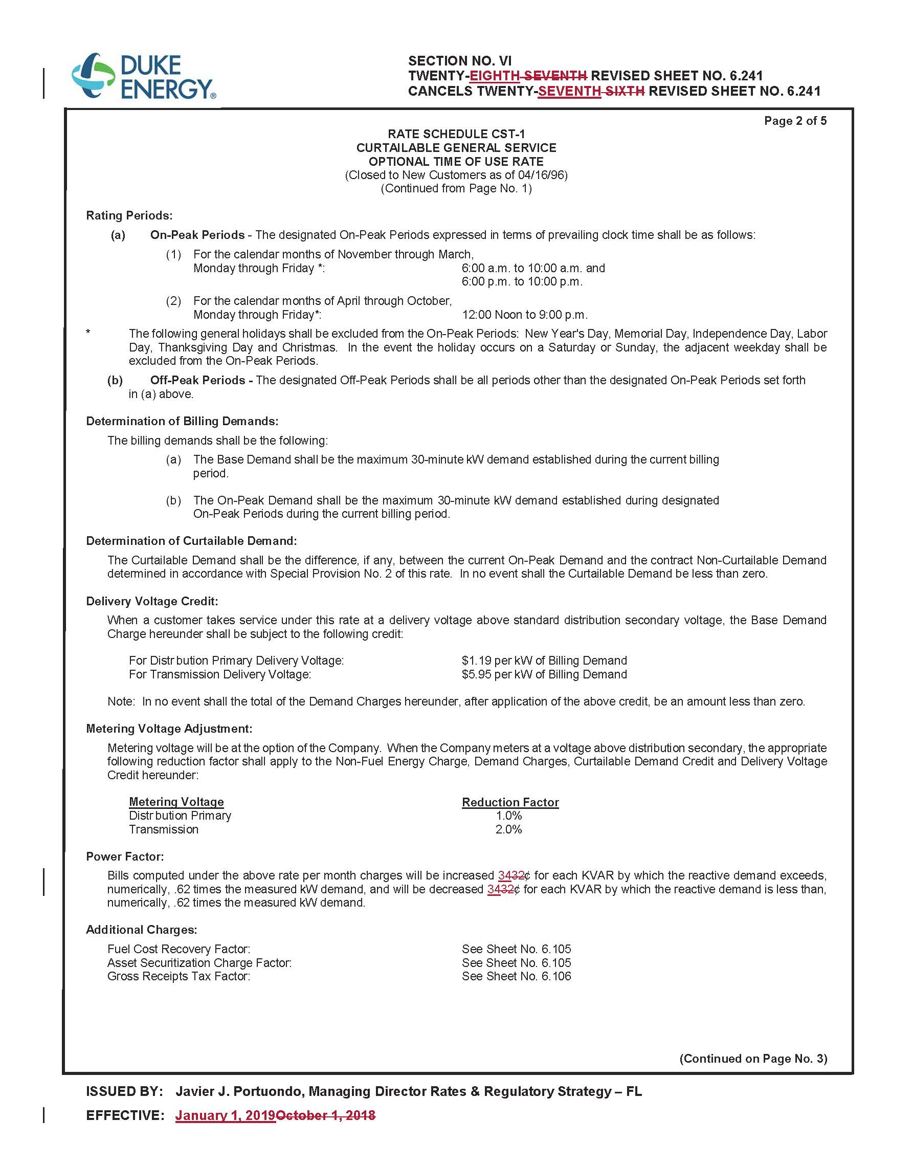
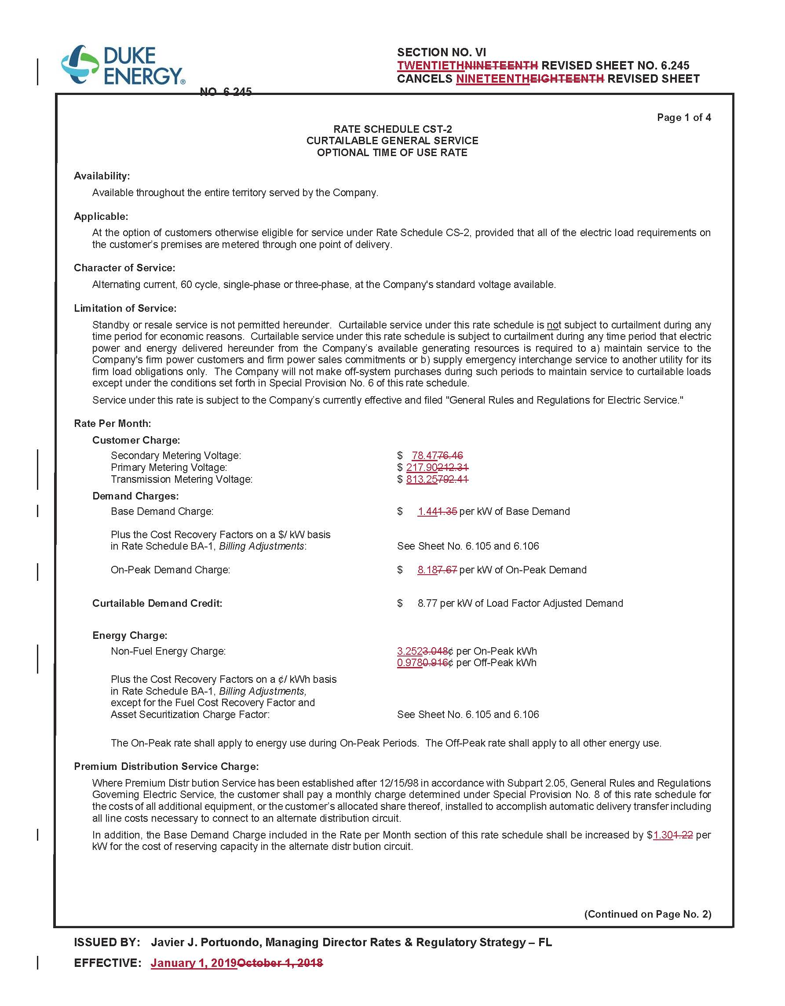

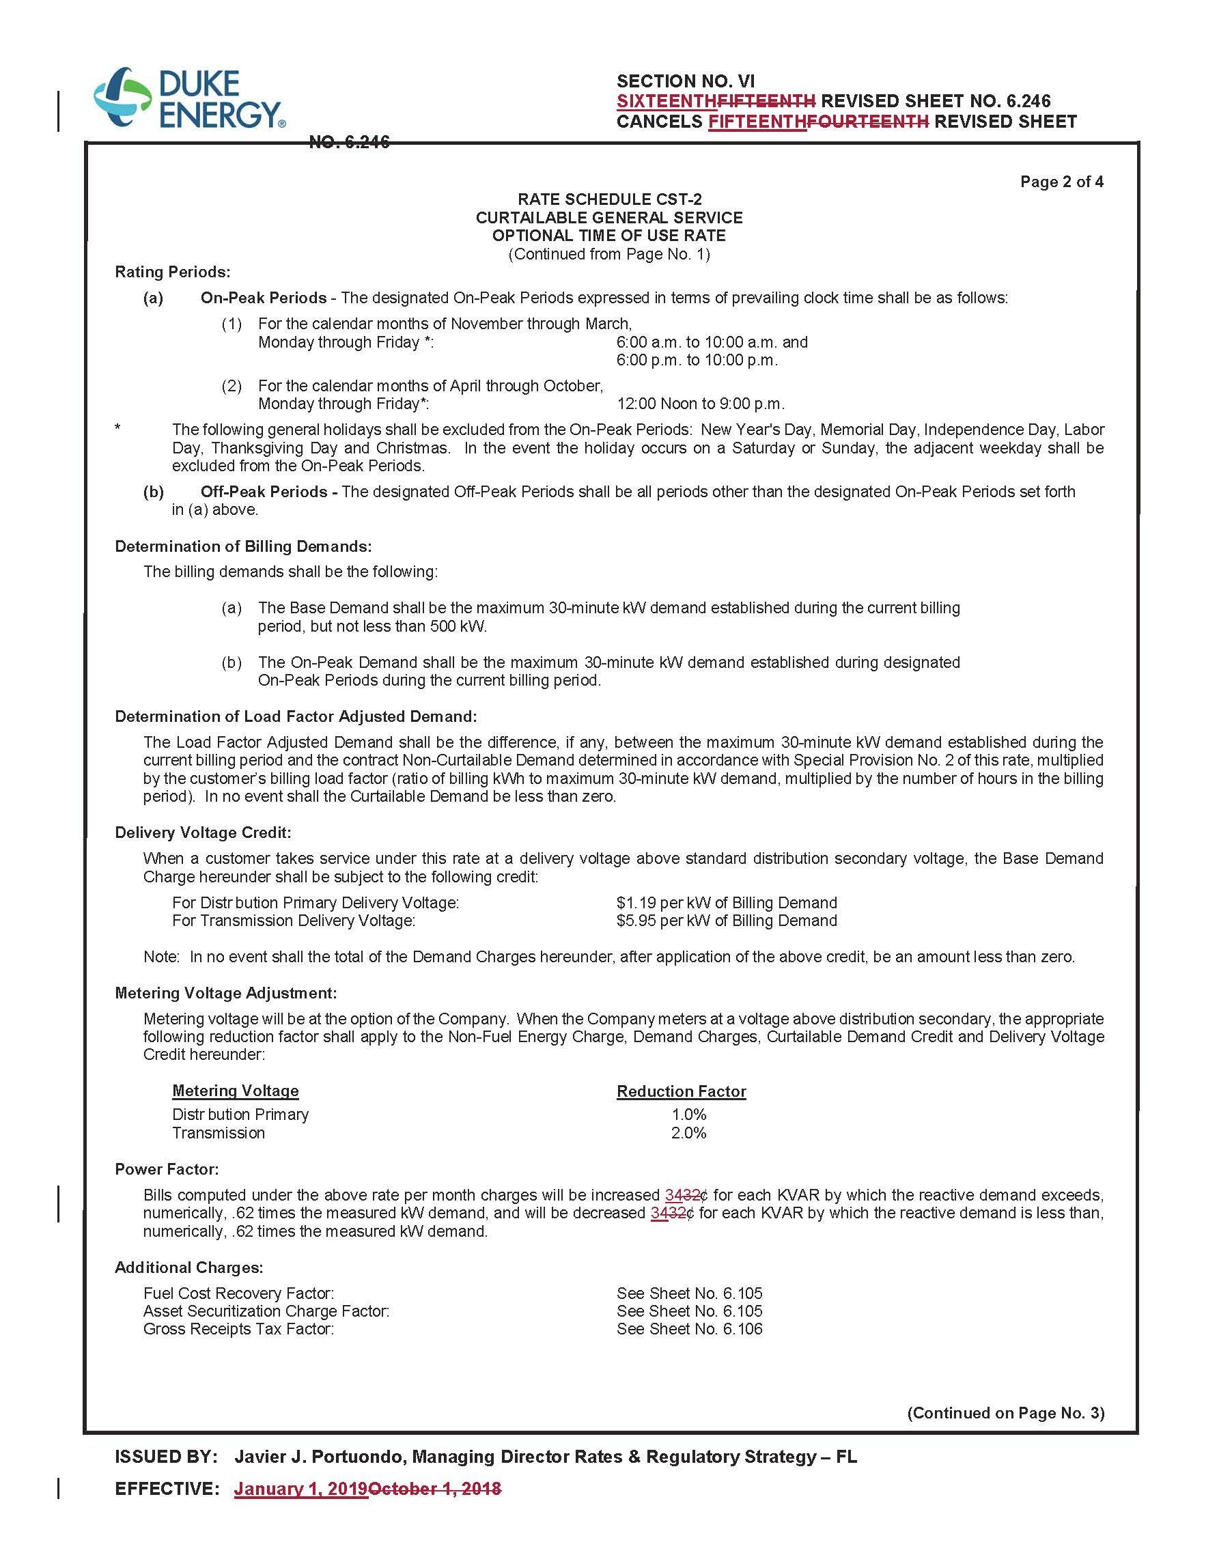
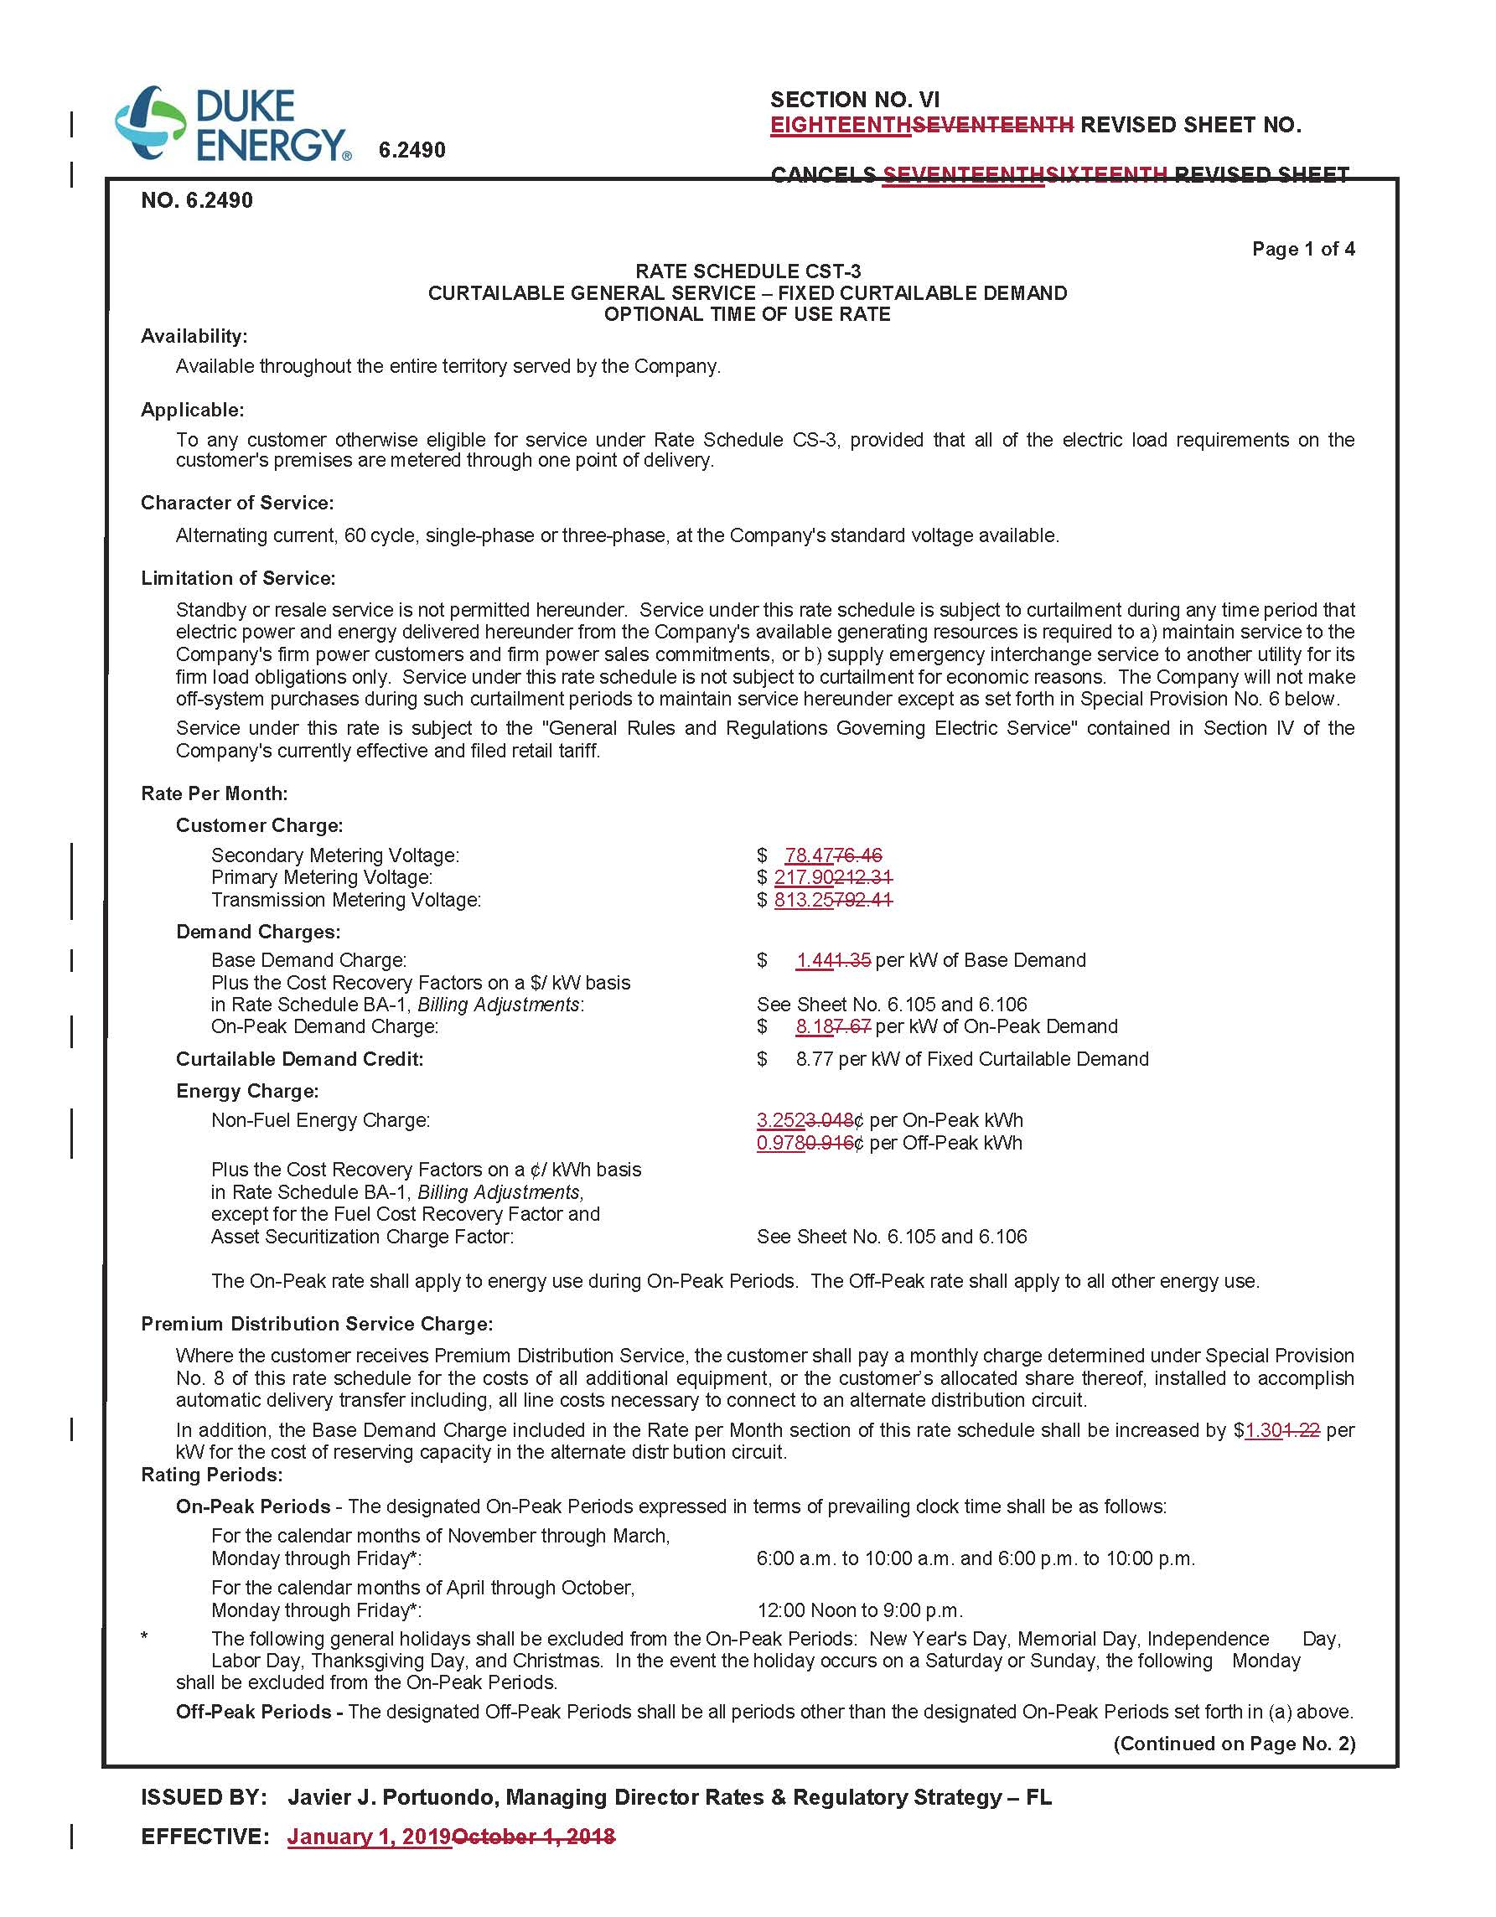

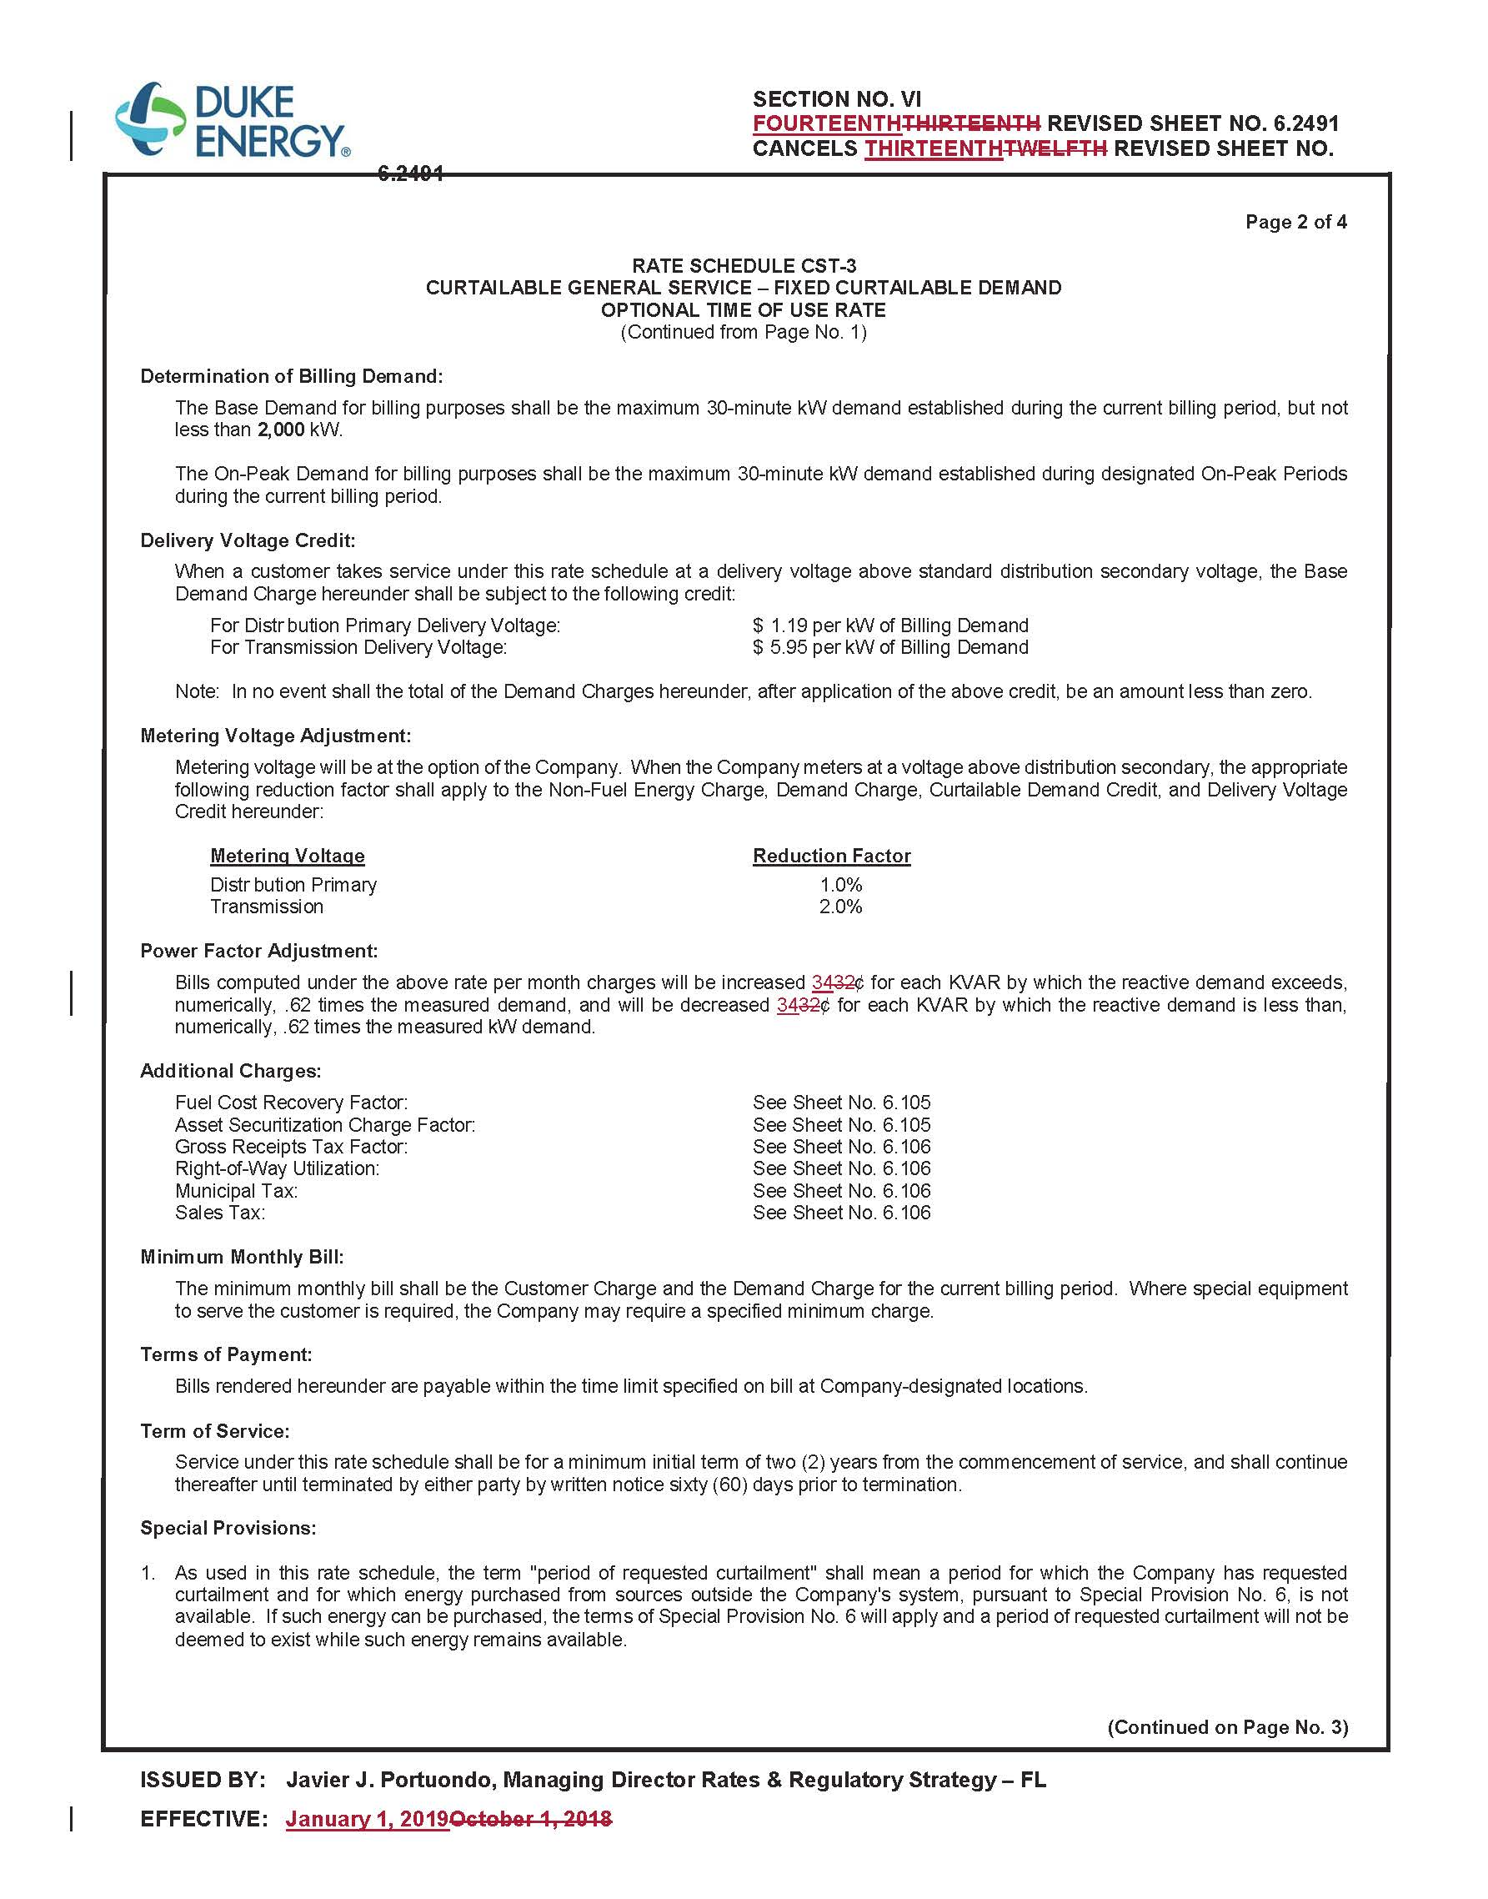
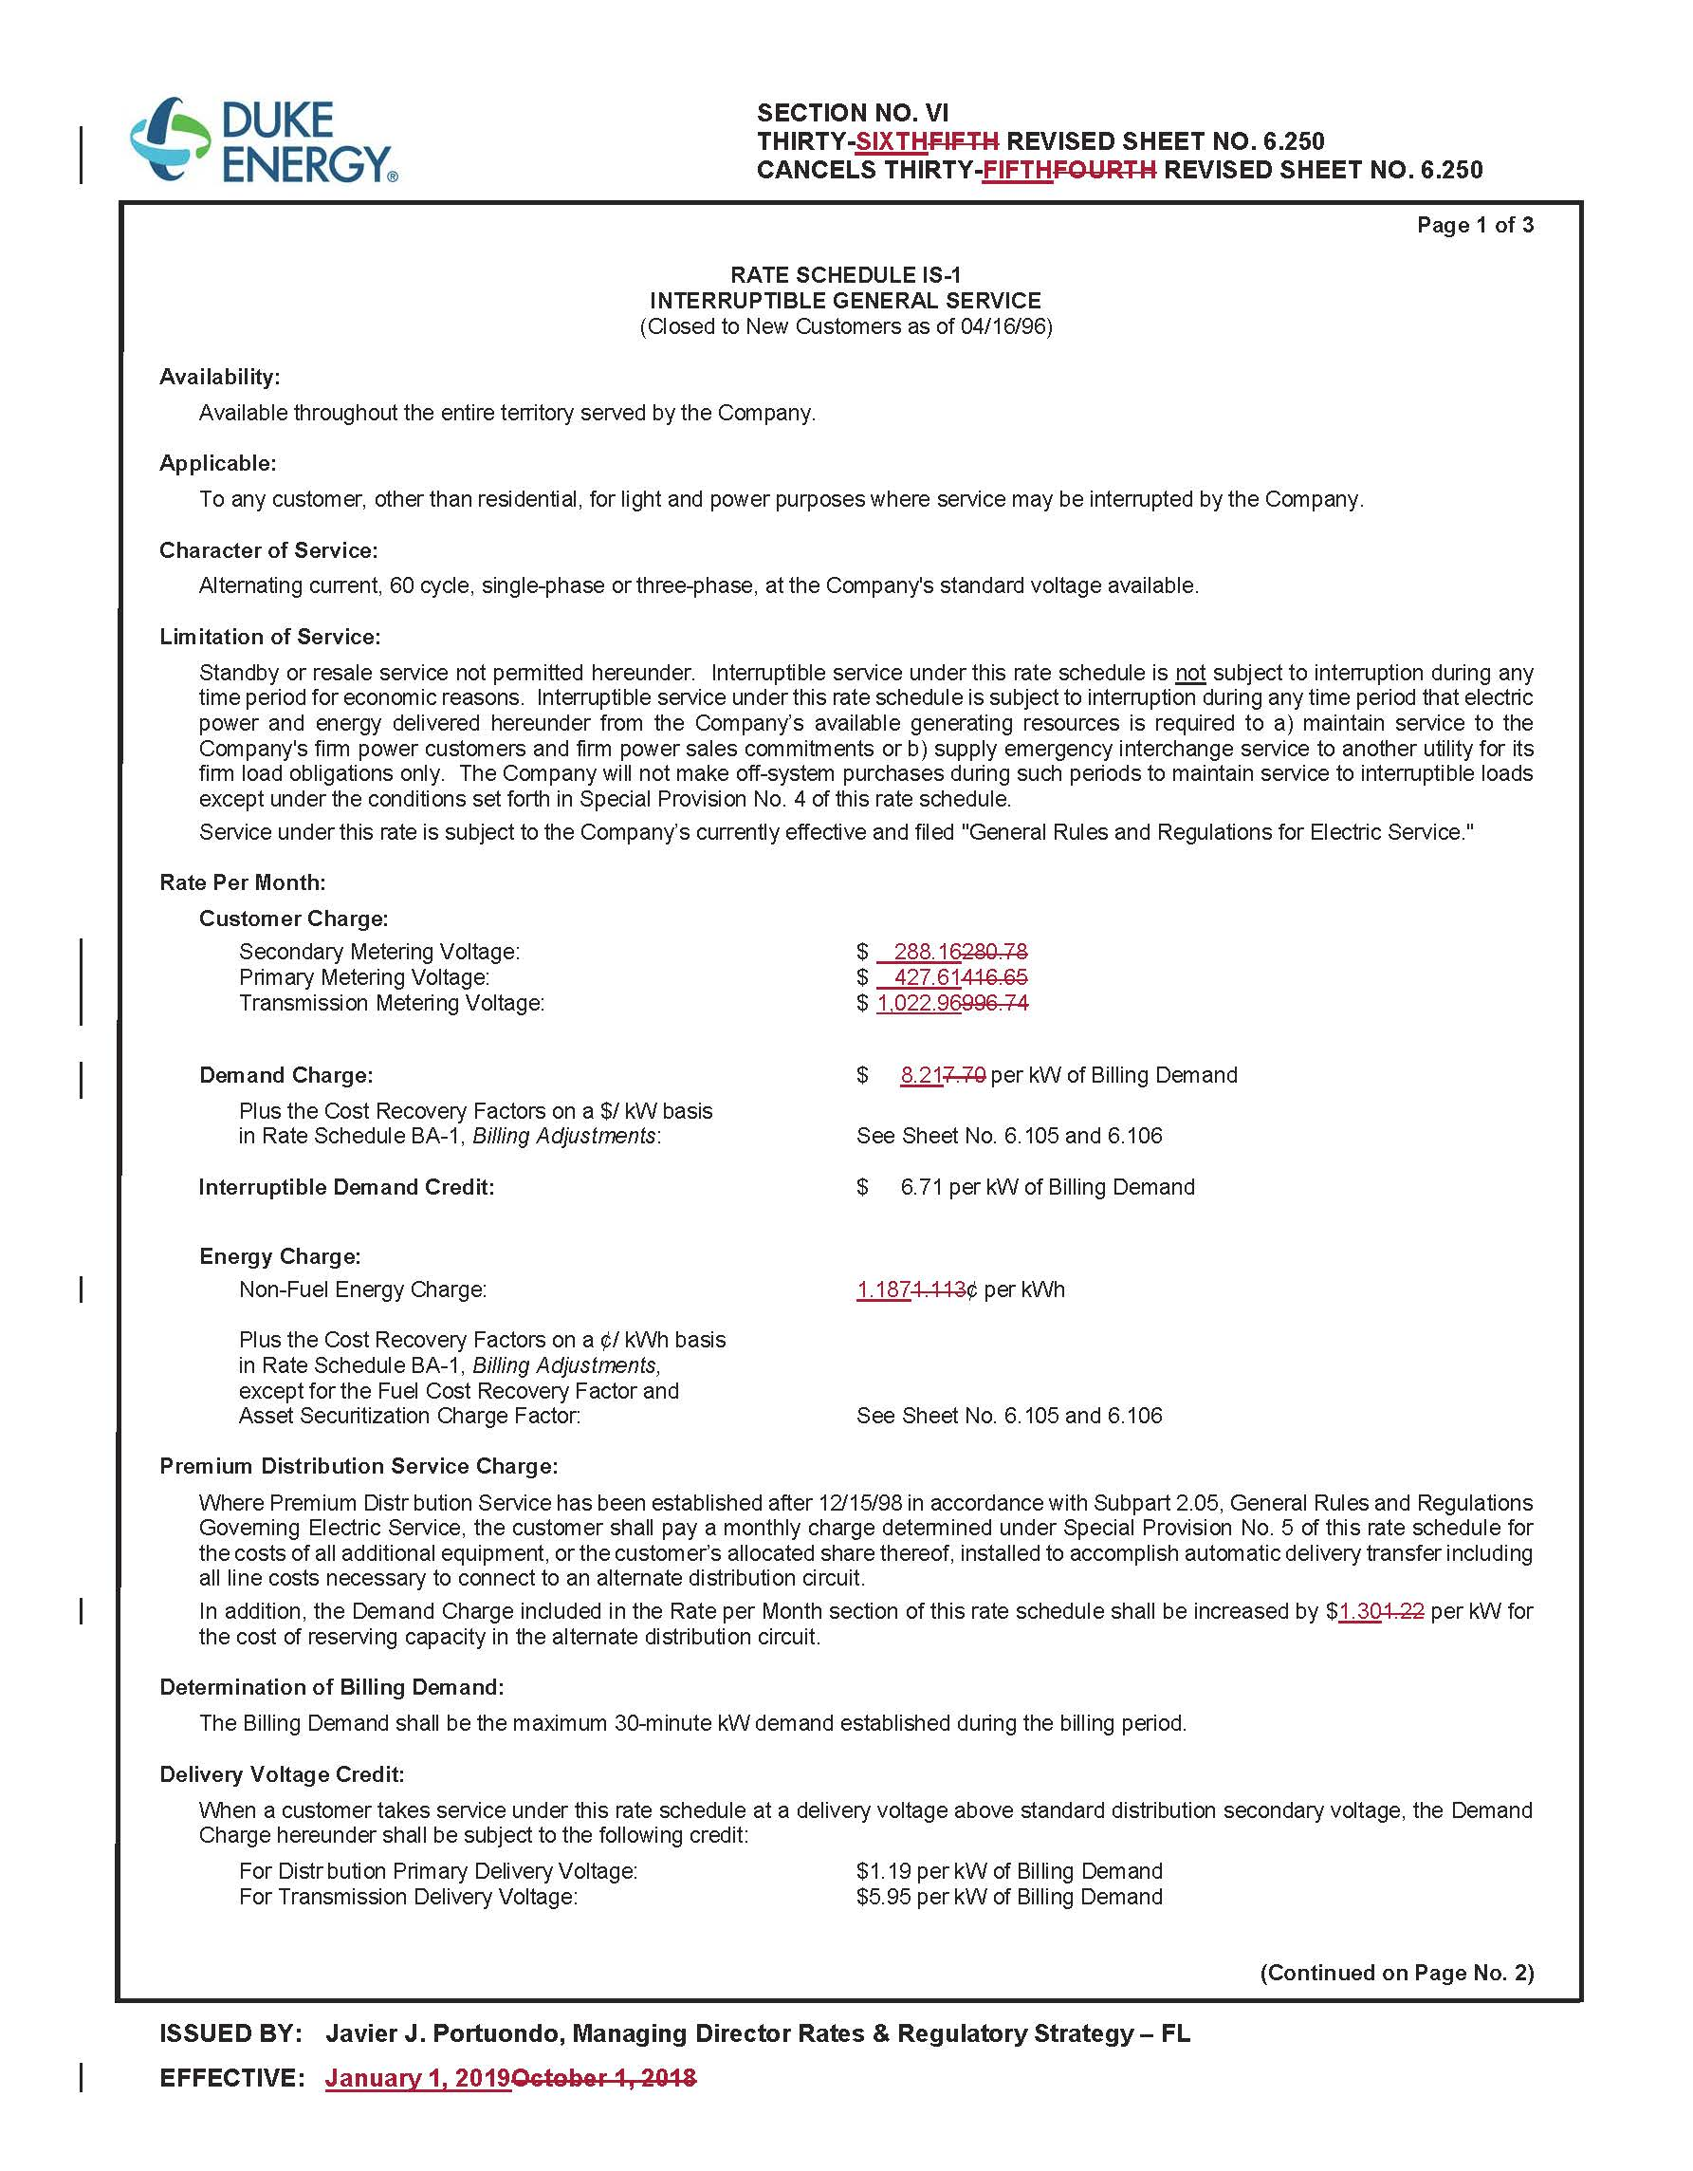

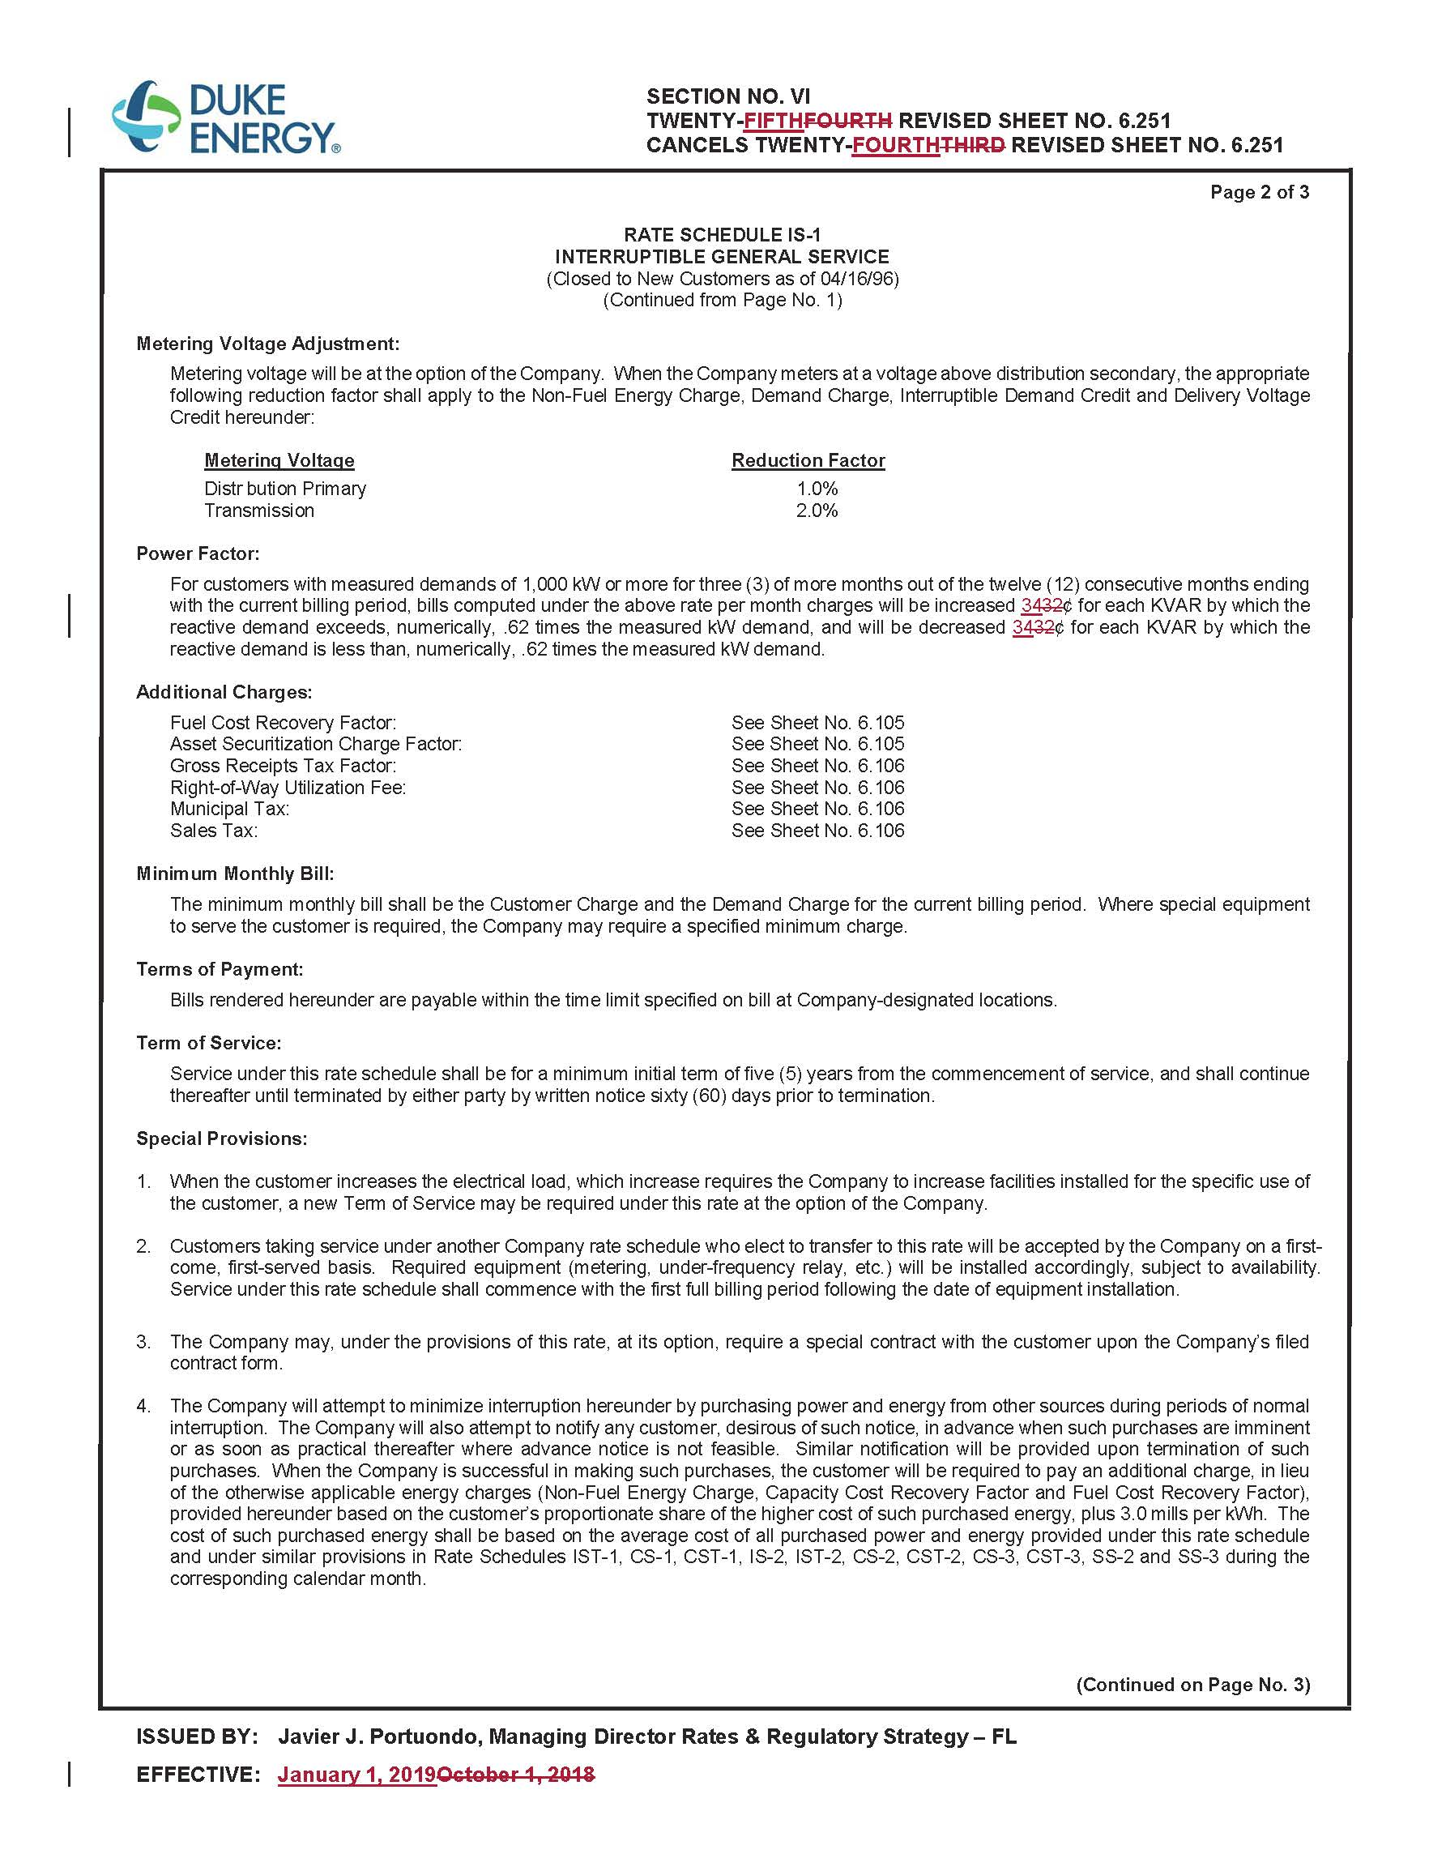
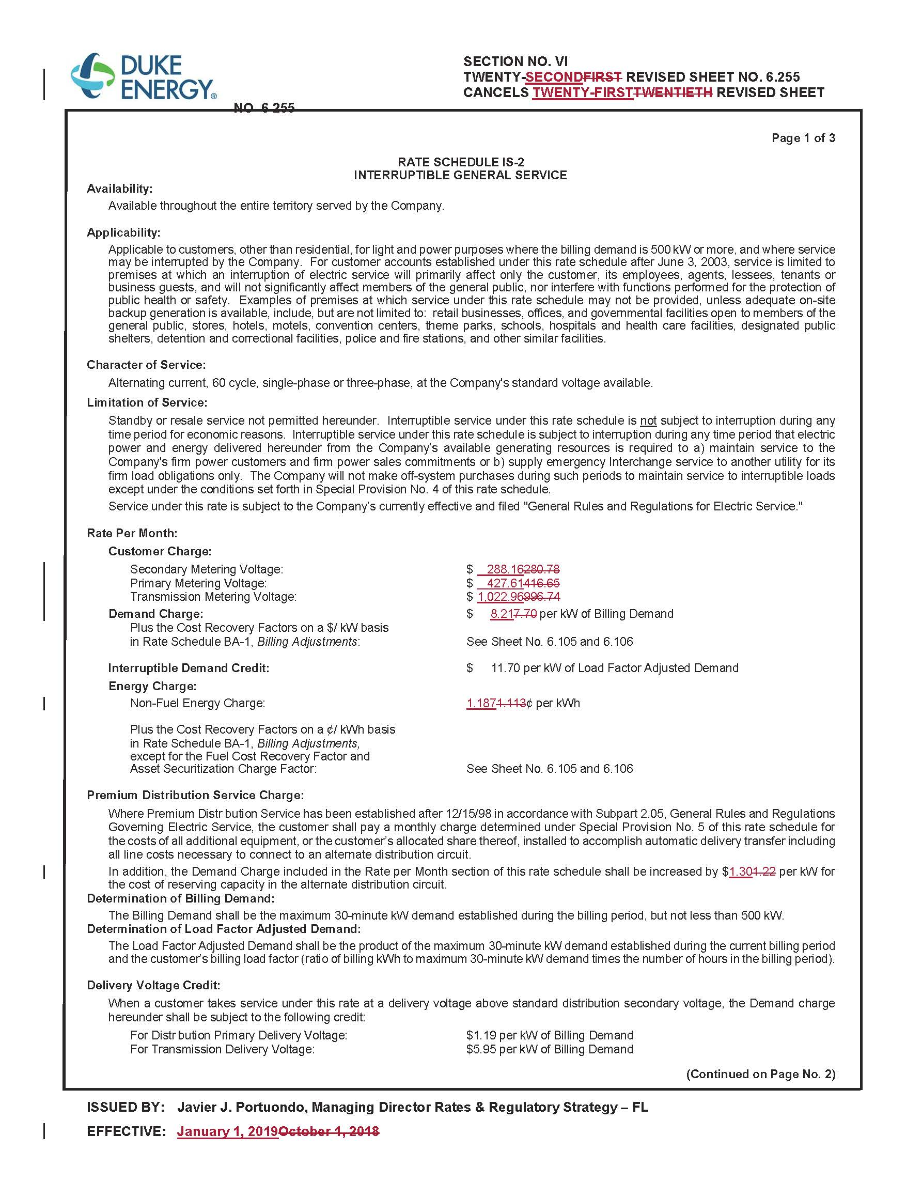

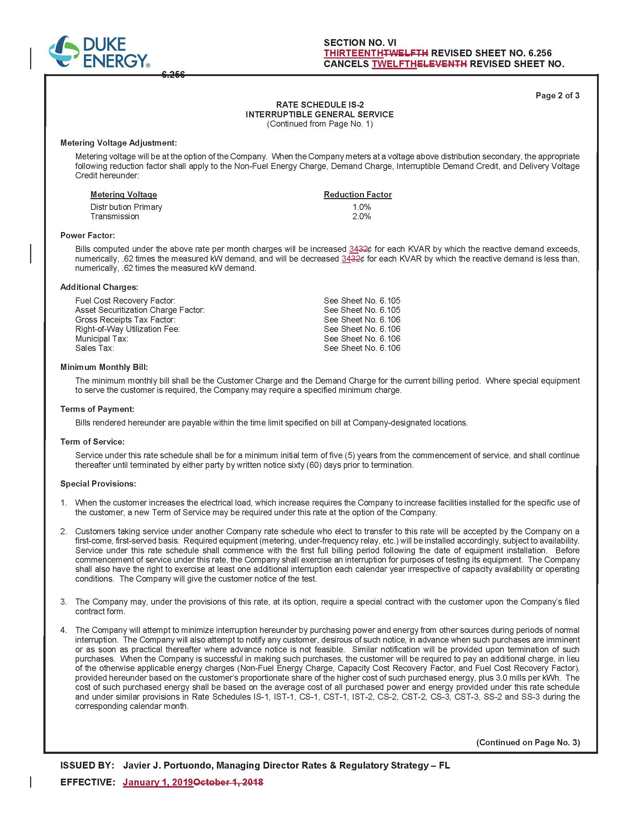
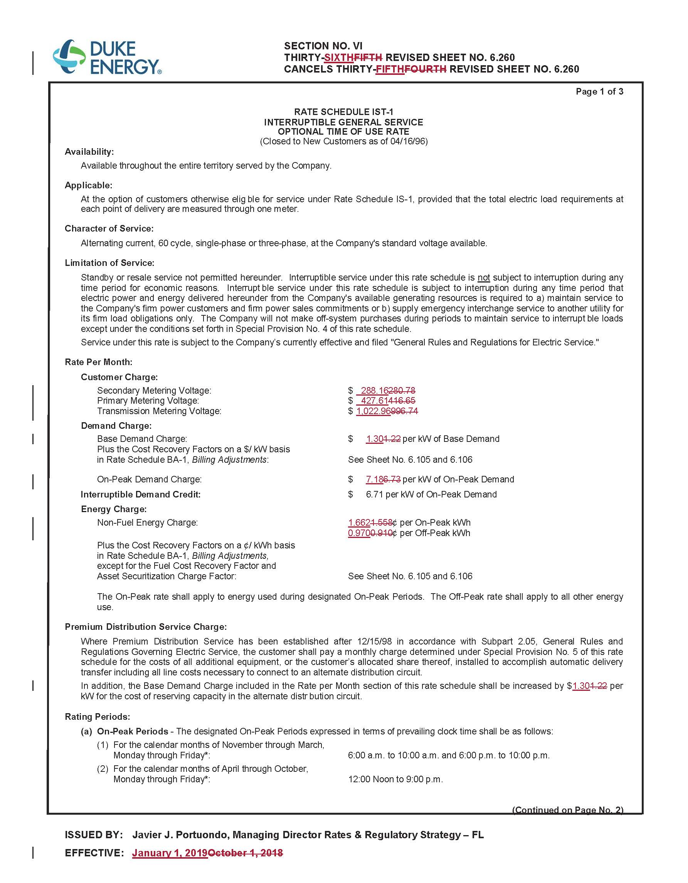

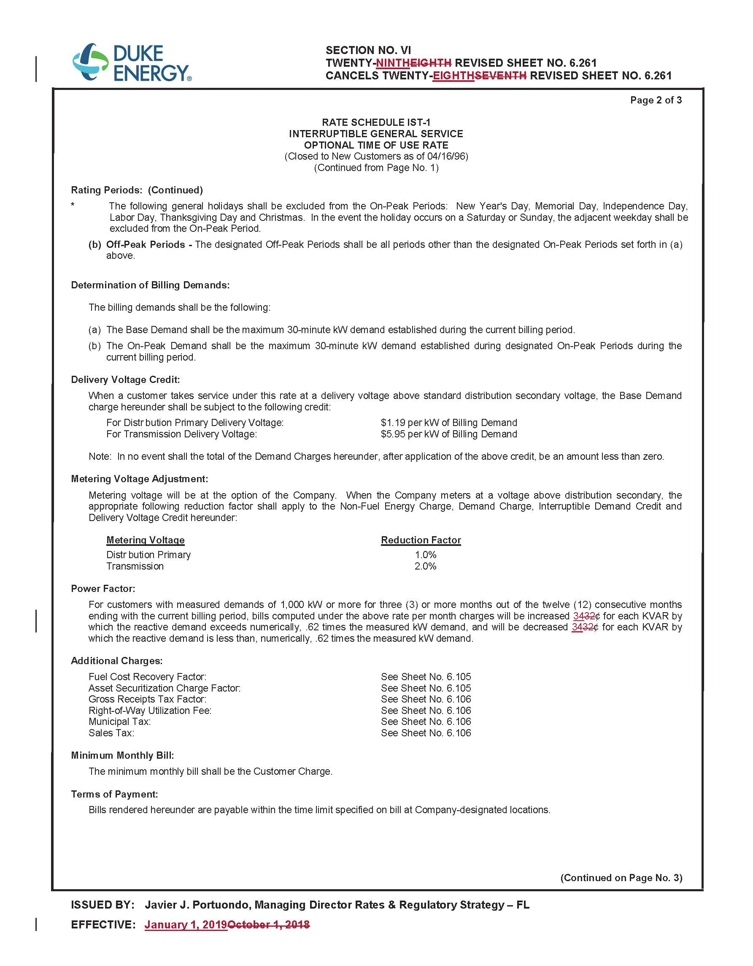
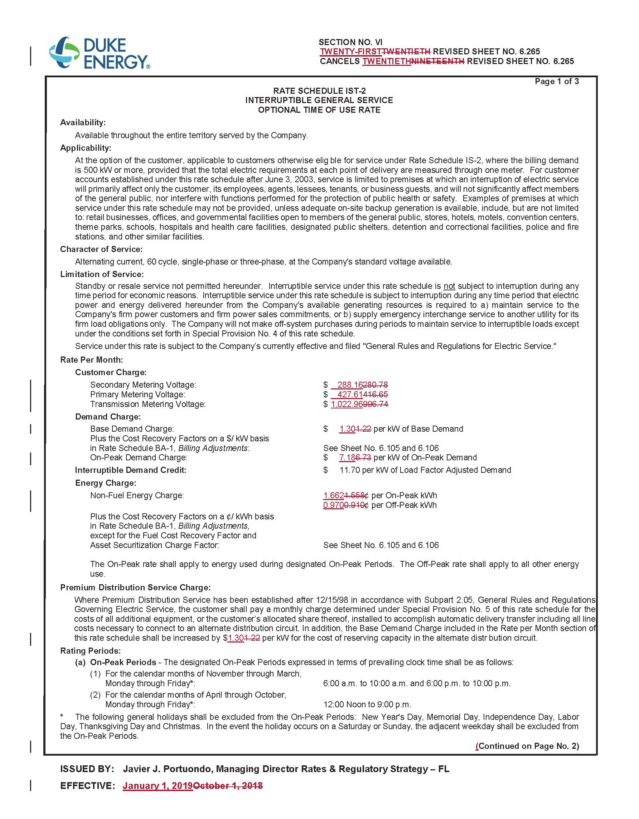

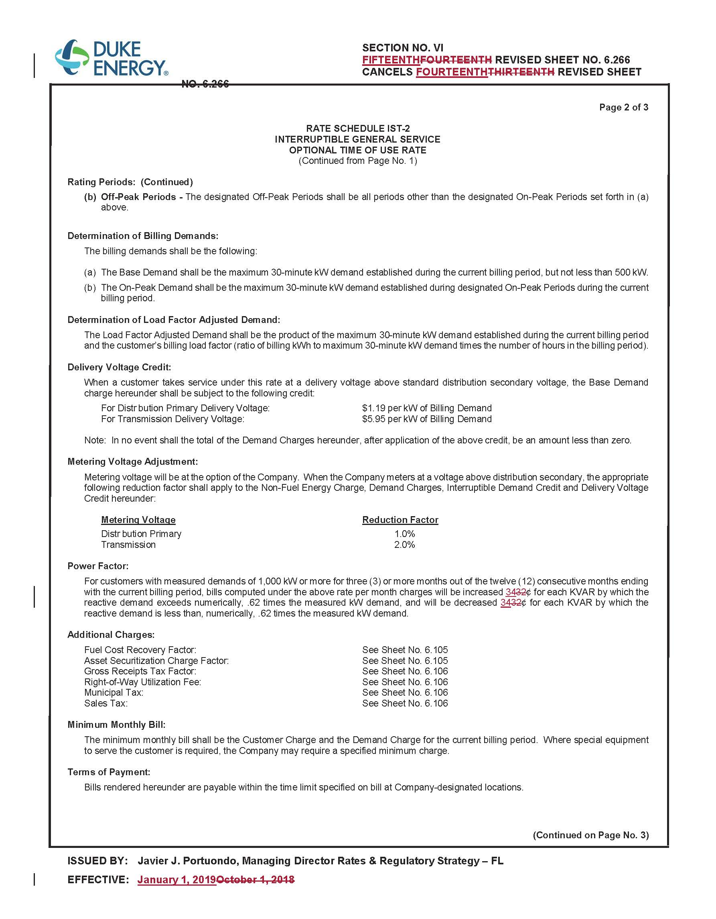
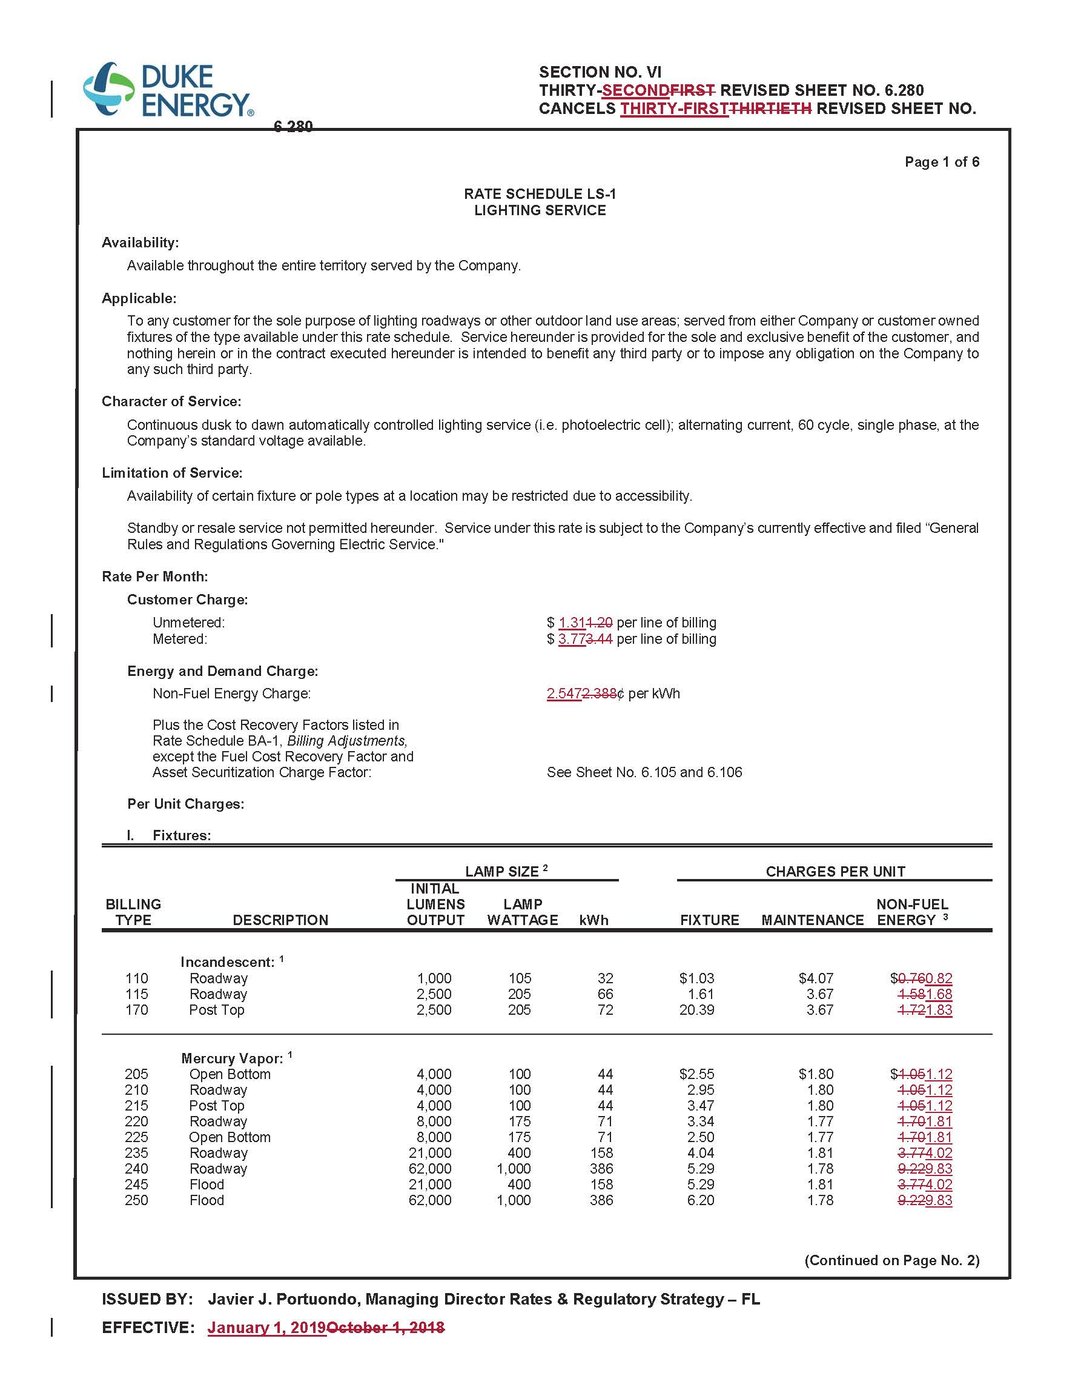

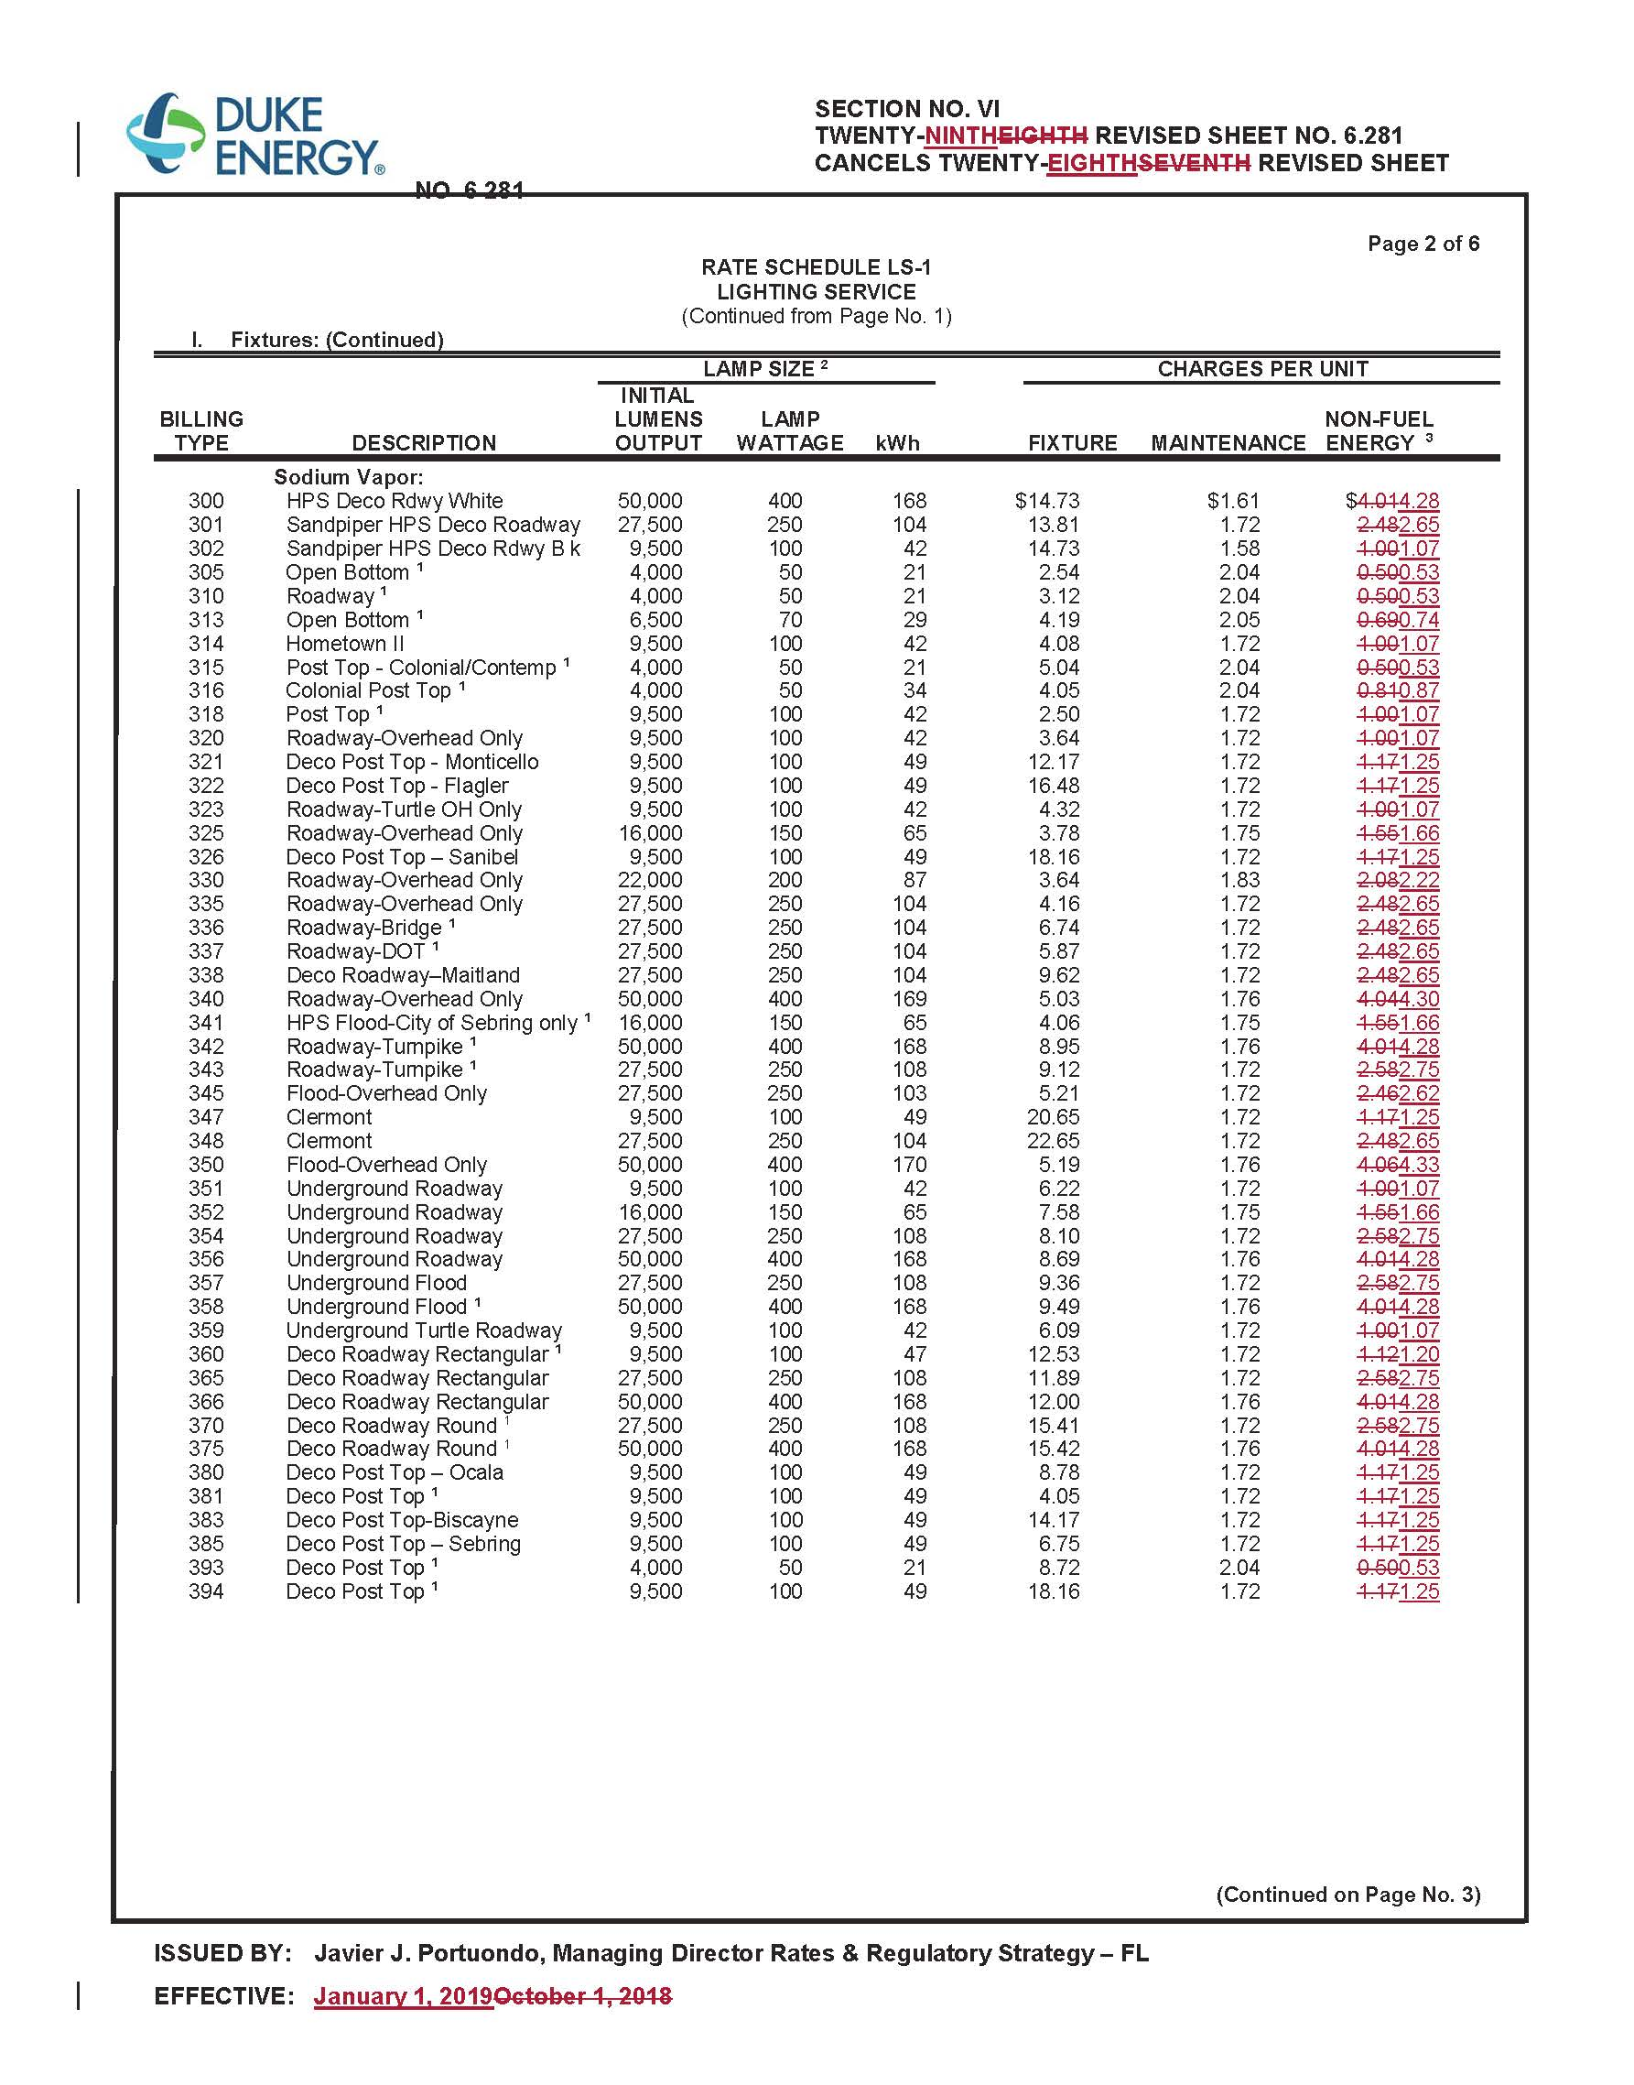
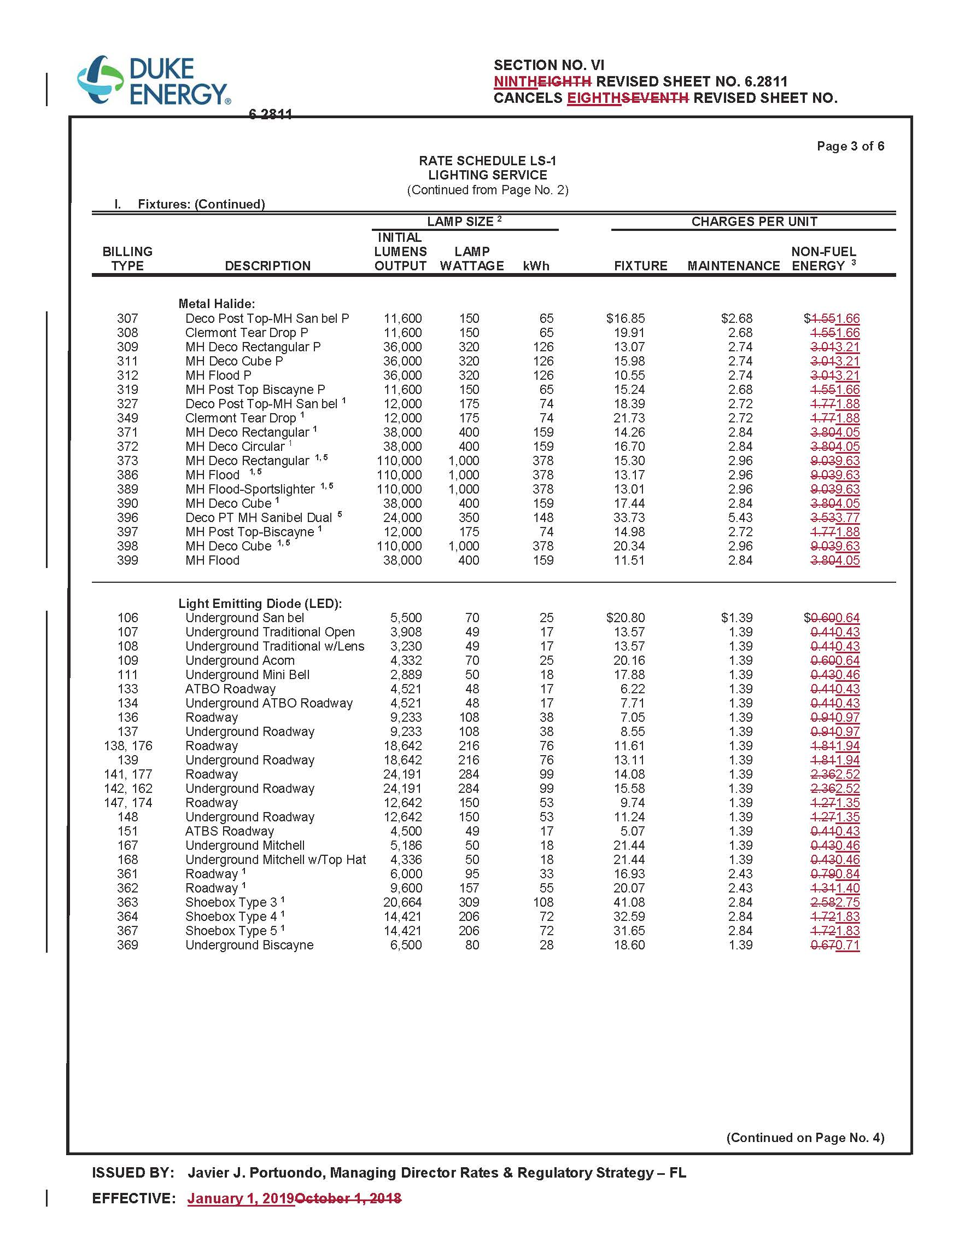

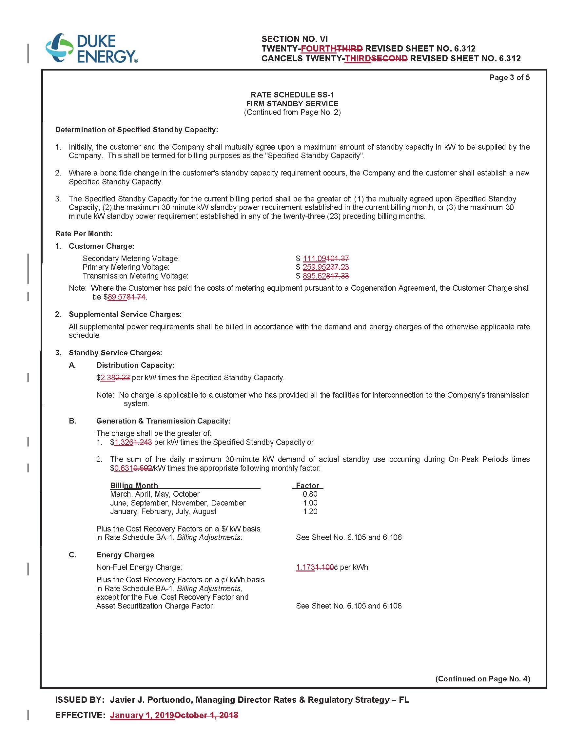
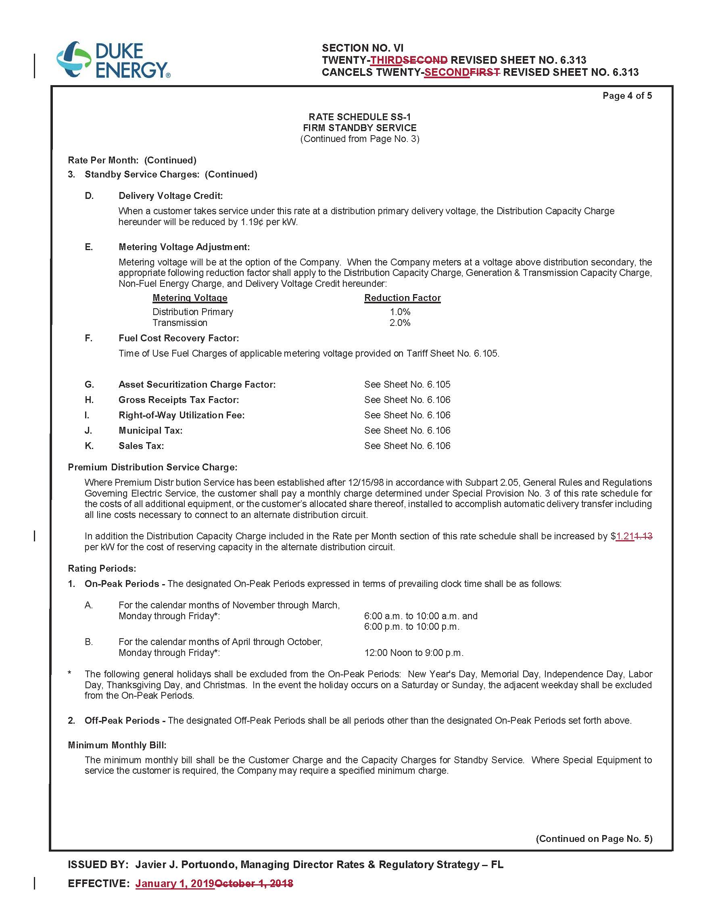

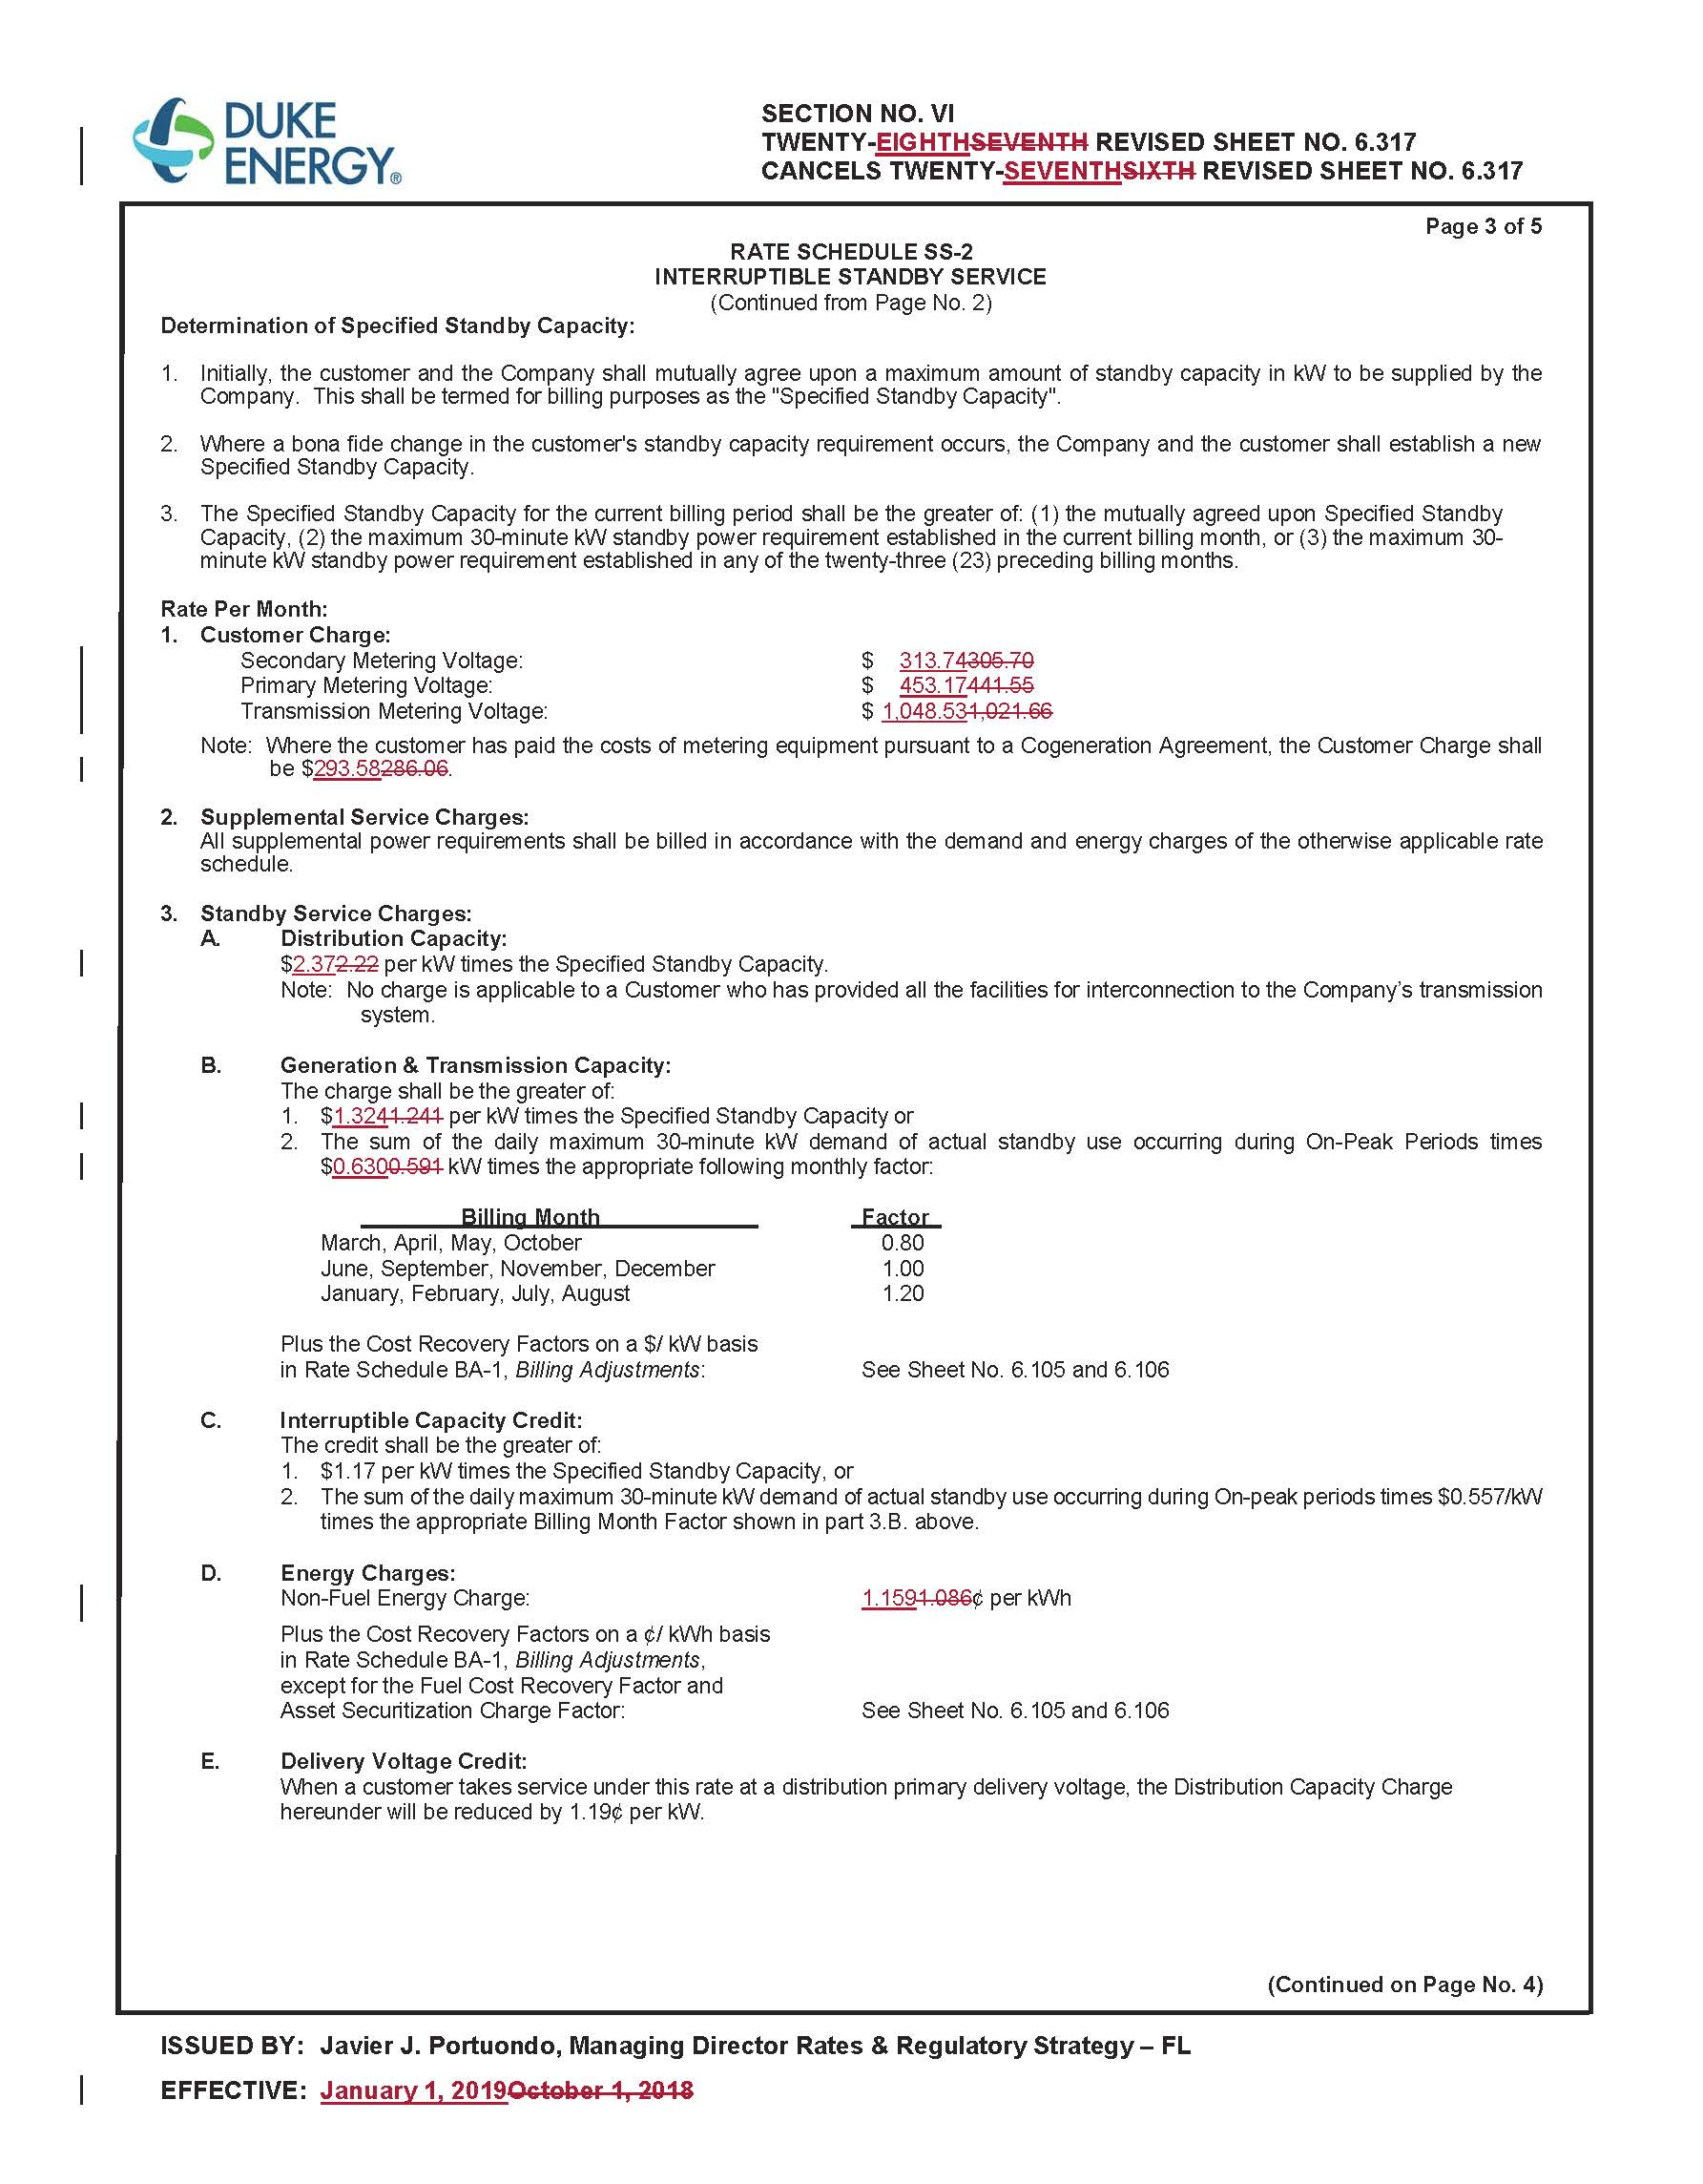
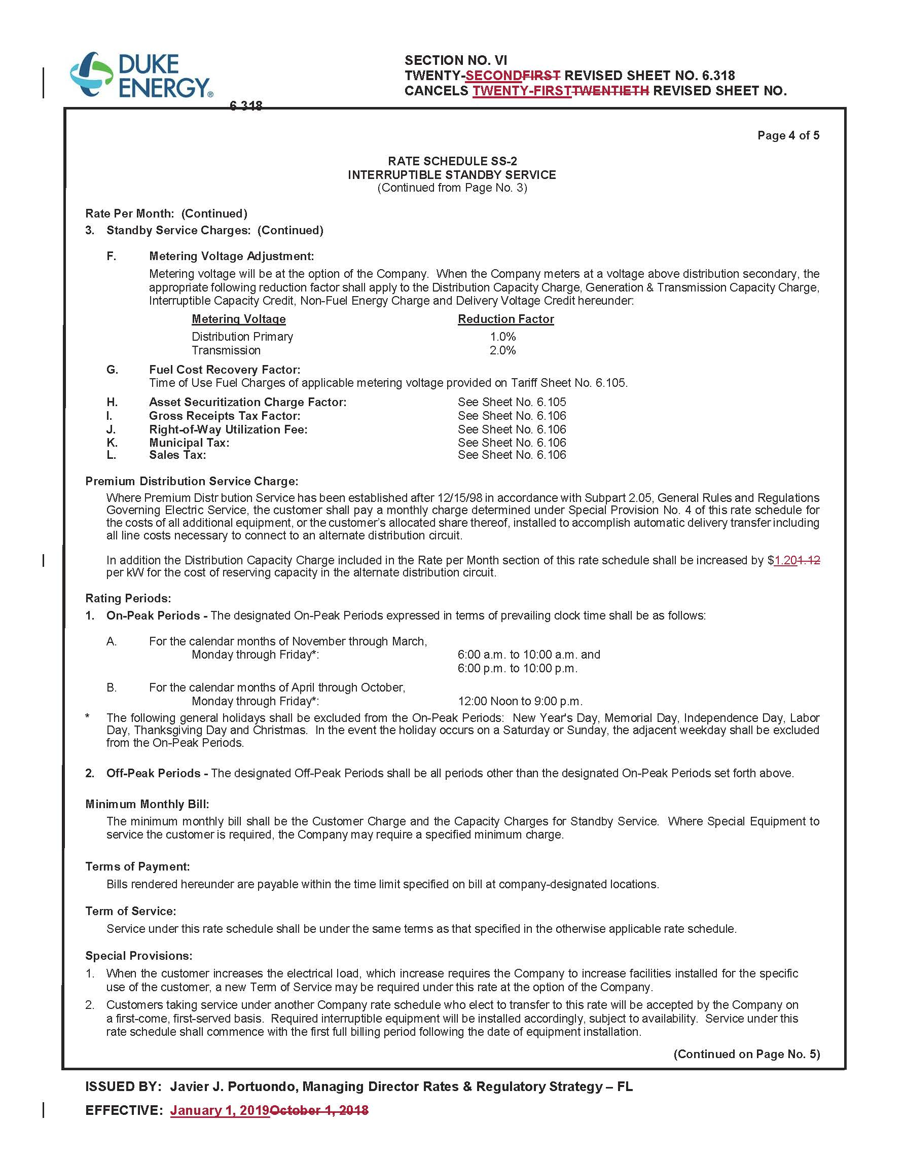

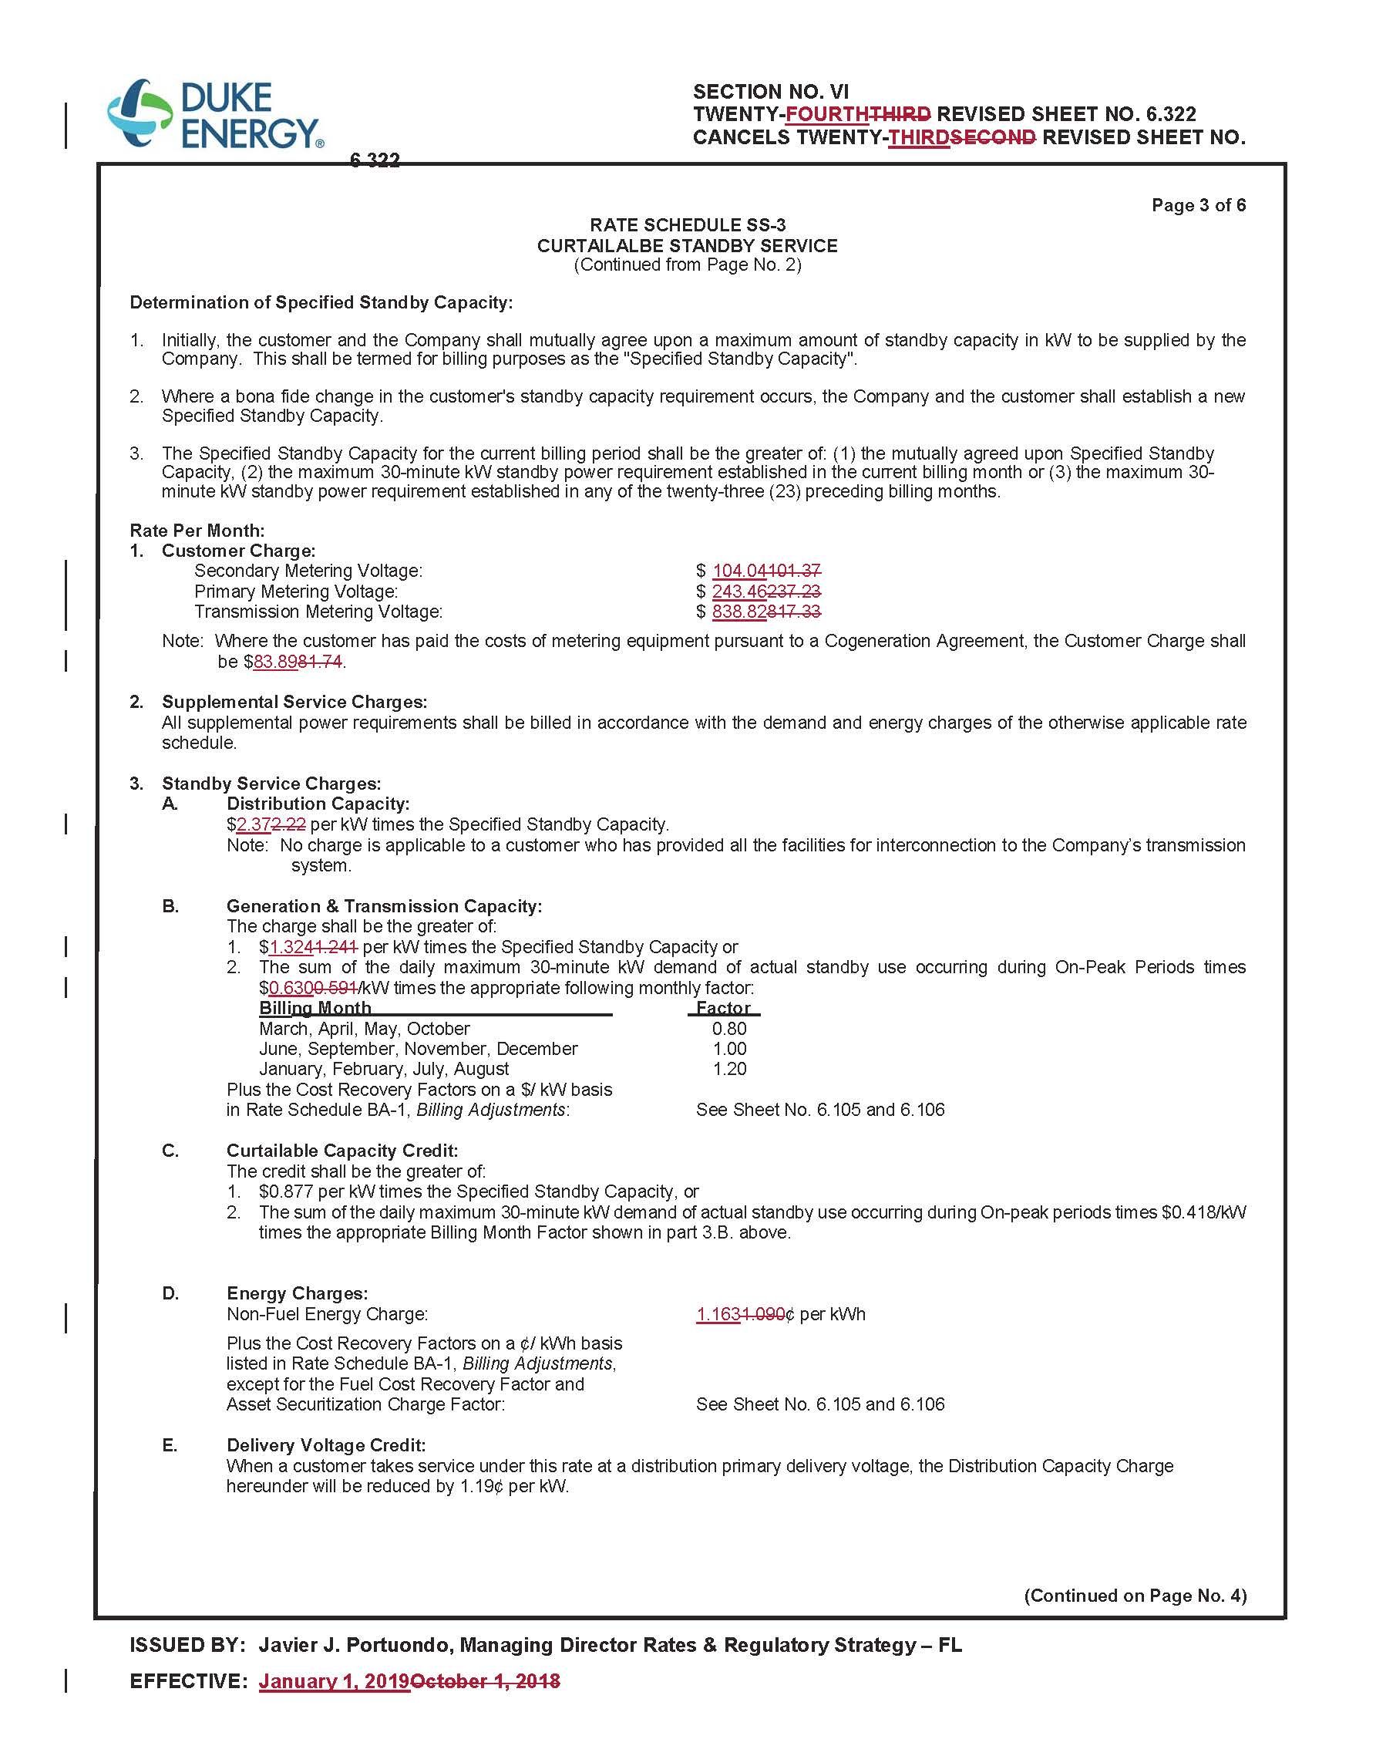
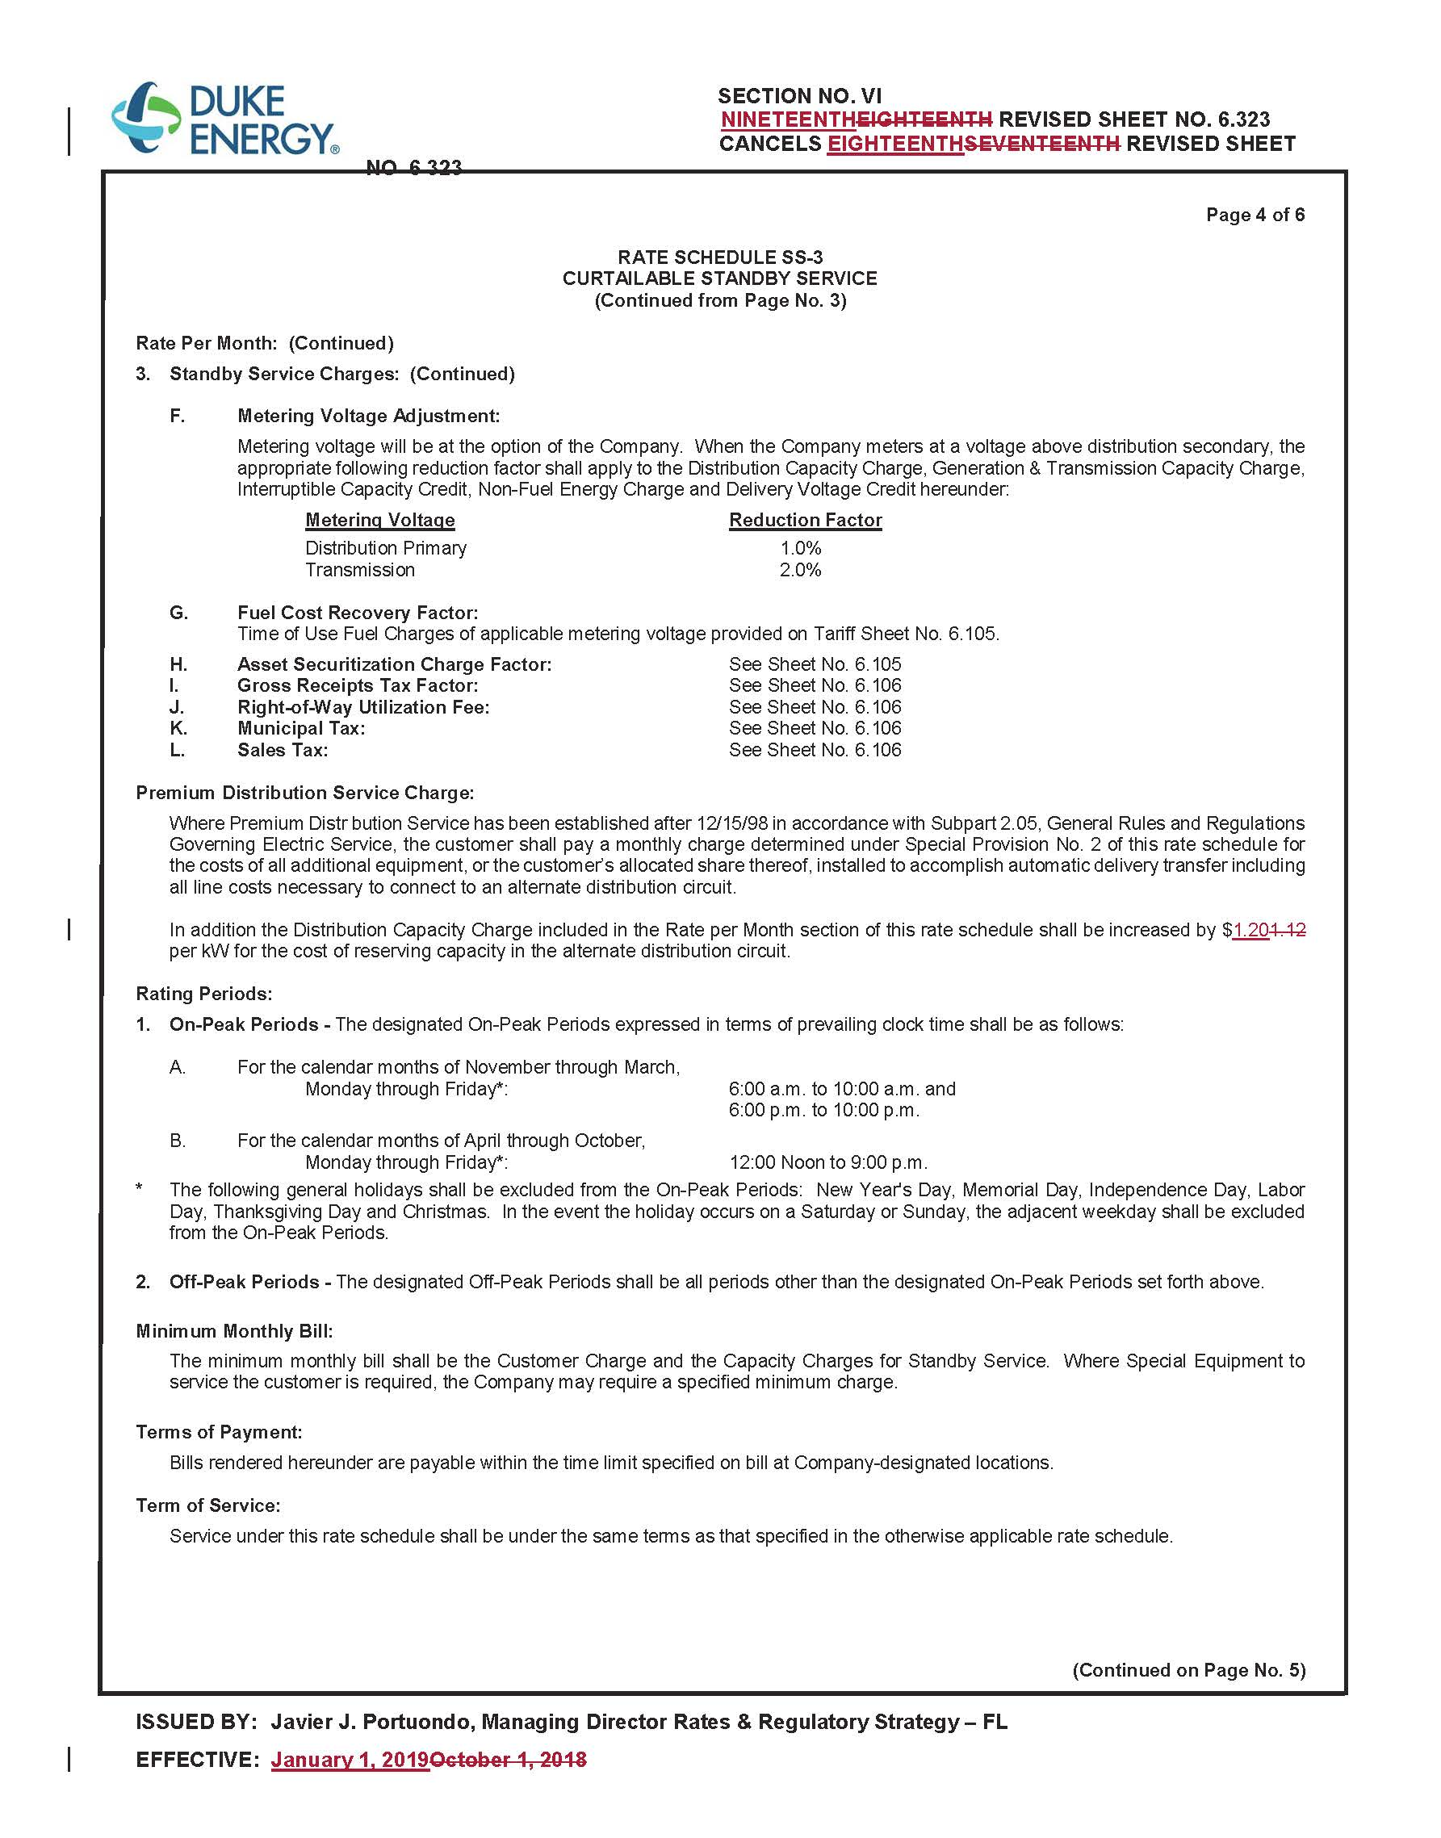

Order No. PSC-2017-0451-AS-EU, issued November 20, 2017, in Docket No. 20170183-EI, In re: Application for limited proceeding to approve 2017 second revised and restated settlement agreement, including certain rate adjustments, by Duke Energy Florida, LLC.
Order No. PSC-2018-0367-TRF-EI, issued July 25, 2018, in Docket No. 20180084-EI, In re: Petition for limited proceeding for approval to include in base rates the revenue requirement for the Citrus combined cycle project, by Duke Energy Florida, LLC.

