BEFORE THE FLORIDA PUBLIC SERVICE COMMISSION

In re: Petition for limited proceeding to approve second solar base rate adjustment (SoBRA), effective January 1, 2019, by Tampa Electric Company. | DOCKET NO. 20180133-EI  ORDER NO. PSC-2018-0571-FOF-EI  ISSUED: December 7, 2018

The following Commissioners participated in the disposition of this matter:

ART GRAHAM, Chairman
JULIE I. BROWN
DONALD J. POLMANN
GARY F. CLARK
ANDREW GILES FAY

APPEARANCES:

JAMES D. BEASLEY AND JEFF WAHLEN, ESQUIRES, Ausley Law Firm, P.O. Box 391, Tallahassee, Florida 32302
On behalf of Tampa Electric Company (TECO).

JON C. MOYLE AND KAREN PUTNAL, ESQUIRES, Moyle Law Firm, P.A., 118 North Gadsden Street, Tallahassee, Florida 32301
On behalf of Florida Industrial Power Users Group (FIPUG).

J.R. KELLY AND CHARLES J. REHWINKEL, ESQUIRES, 111 W. Madison Street, Room 812, Tallahassee, Florida 32399
On behalf of Office of the Public Counsel (OPC)

WALT TRIERWEILER AND KURT SCHRADER, ESQUIRES, Florida Public Service Commission, 2540 Shumard Oak Boulevard, Tallahassee, Florida 32399-0850
On behalf of the Florida Public Service Commission (Staff).

MARY ANNE HELTON, ESQUIRE, Deputy General Counsel, Florida Public Service Commission, 2540 Shumard Oak Boulevard, Tallahassee, Florida 32399-0850
Advisor to the Florida Public Service Commission.

KEITH HETRICK, ESQUIRE, General Counsel, Florida Public Service Commission, 2540 Shumard Oak Boulevard, Tallahassee, Florida 32399-0850
Florida Public Service Commission General Counsel

FINAL ORDER APPROVING TAMPA ELECTRIC COMPANY’S
SECOND SOLAR RATE BASE ADJUSTMENTS

BY THE COMMISSION:

BACKGROUND

On June 29, 2018, Tampa Electric Company (TECO) filed its amended Petition for a Limited Proceeding to Approve Second Solar Rate Base Adjustments (SoBRA), Effective January 1, 2019, as contemplated by the 2017 Amended and Restated Stipulation and Settlement Agreement (2017 Agreement) and Order No. PSC-2017-0456-S-EI, issued November 27, 2017. On June 5, 2018, the Commission entered Order No. PSC-2018-0288-FOF-EI in Docket No. 20170260-EI, approving TECO's First SoBRA, consisting of two solar projects (Balm and Payne Creek) totaling approximately 145 megawatts (MW). In this docket, TECO sought approval of (a) the Second SoBRA tranche specified in subparagraph 6(b) of the 2017 Agreement and (b) the associated tariff changes necessary to implement the Second SoBRA. The base rate adjustments for Second SoBRA will provide cost recovery for five solar projects within the Second SoBRA Tranche (Lithia, Grange Hall, Peace Creek, Bonnie Mine, and 32 MW of the total 49 MW in the Lake Hancock project) and will result in a total additional capacity of approximately 260.3 MW.

The Office of Public Counsel (OPC) and the Florida Industrial Power Users Group (FIPUG) intervened.

On October 26, 2018, TECO filed a letter with an attached set of proposed stipulations that, if approved, would resolve all issues in this proceeding (Attachment A). The final hearing was held on October 29, 2018, during which the testimony of all witnesses, the Comprehensive Exhibit List, all exhibits on the list, and Exhibit 11 (Attachment A) were entered into the record. TECO outlined each of the proposed stipulated issues and OPC affirmed its agreement to the stipulations in support of resolving all issues in this docket as being in the public interest. FIPUG stated that while it would not join the proposed stipulations, it did not oppose the agreement between TECO and OPC to resolve all matters in the docket. We have jurisdiction over the subject matter under the provisions of Chapter 366, Florida Statutes (F.S.).

DECISION

The Stipulations

The stipulations in Attachment A provide that the five projects in the company’s Second SoBRA Tranche satisfy the cost-effectiveness test specified in the 2017 Agreement:

- The projected installed cost of each project is under the $1,500 per kW_{ac} installed cost cap specified in 6(d) of the 2017 Agreement.
- Taken together, the projected installed cost of the seven projects in the First and Second SoBRA Tranches falls below the $1,475 per kW_{ac} installed cost threshold specified in subparagraph 6(c) of the 2017 Agreement.

- The stipulations result in an estimated annual revenue requirement of $46,045,000 for the five projects comprising the Second SoBRA Tranche, and Tariff changes necessary to collect the additional revenue required (Attachment B).

- Each of the five Second SoBRA Tranche projects meet the eligibility requirements for cost recovery pursuant to paragraph 6 of the 2017 Agreement. 250 MW is the base amount of solar capacity specified in paragraph 6(b) of the 2017 Agreement for the Second SoBRA Tranche. 5.3 MW is allowable in the Second SoBRA as unused capacity carried forward from the First SoBRA.

The stipulations also provide that the parties or the Commission may take appropriate action if at least 550 MW of solar generation is not built out and that the stipulations have no precedential value beyond this case and the 2017 Agreement.

Approval of the Stipulations

The standard for approval of a settlement agreement is whether it is in the public interest. A determination of public interest requires a case-specific analysis based on consideration of the proposed settlement taken as a whole.

Section 120.57(4), F.S., permits us to informally dispose of any proceeding by stipulation, agreed settlement, or consent order. Section 120.57(2), F.S., permits this Commission to proceed with hearings not involving disputed issues of material fact. We heard oral argument from the parties regarding TECO’s and OPC’s agreement and support of the proposed stipulations. TECO provided a detailed explanation of each of the proposed stipulations to the eight issues in the docket. OPC explained its support of the stipulations and agreed the proposed stipulations were in the public interest. FIPUG provided explanation as to why it could not join OPC in agreeing to the stipulations, and concluded it did not oppose the stipulations. Following some questioning and discussion, we approved the proposed stipulations in Attachment A as being in the public interest, resolving all of the matters within this docket.

Having approved TECO’s petition for cost recovery for the five projects in its Second SoBRA, we also approve the attached tariff sheets (Attachment B), which reflect the base rate adjustments necessary to recover the revenue requirement associated with these SoBRA projects and which result in rates that are fair, just and reasonable. These tariff revisions are approved with a January 1, 2019, effective date.

Based on the foregoing, it is

ORDERED by the Florida Public Service Commission that the stipulations in Attachment A, findings, and rulings herein are hereby approved. It is further

ORDERED that the tariff revisions in Attachment B are approved effective January 1, 2019. It is further

ORDERED that this docket shall be closed.

By ORDER of the Florida Public Service Commission this 7th day of December, 2018.

/s/ Carlotta S. Stauffer
CARLOTTA S. STAUFFER
Commission Clerk
Florida Public Service Commission
2540 Shumard Oak Boulevard
Tallahassee, Florida 32399
(850) 413-6770
www.floridapsc.com

Copies furnished: A copy of this document is provided to the parties of record at the time of issuance and, if applicable, interested persons.
WLT

NOTICE OF FURTHER PROCEEDINGS OR JUDICIAL REVIEW

The Florida Public Service Commission is required by Section 120.569(1), Florida Statutes, to notify parties of any administrative hearing or judicial review of Commission orders that is available under Sections 120.57 or 120.68, Florida Statutes, as well as the procedures and time limits that apply. This notice should not be construed to mean all requests for an administrative hearing or judicial review will be granted or result in the relief sought.

Any party adversely affected by the Commission's final action in this matter may request: 1) reconsideration of the decision by filing a motion for reconsideration with the Office of Commission Clerk, 2540 Shumard Oak Boulevard, Tallahassee, Florida 32399-0850, within fifteen (15) days of the issuance of this order in the form prescribed by Rule 25-22.060, Florida Administrative Code; or 2) judicial review by the Florida Supreme Court in the case of an electric, gas or telephone utility or the First District Court of Appeal in the case of a water and/or wastewater utility by filing a notice of appeal with the Office of Commission Clerk, and filing a copy of the notice of appeal and the filing fee with the appropriate court. This filing must be completed within thirty (30) days after the issuance of this order, pursuant to Rule 9.110, Florida Rules of Appellate Procedure. The notice of appeal must be in the form specified in Rule 9.900(a), Florida Rules of Appellate Procedure.

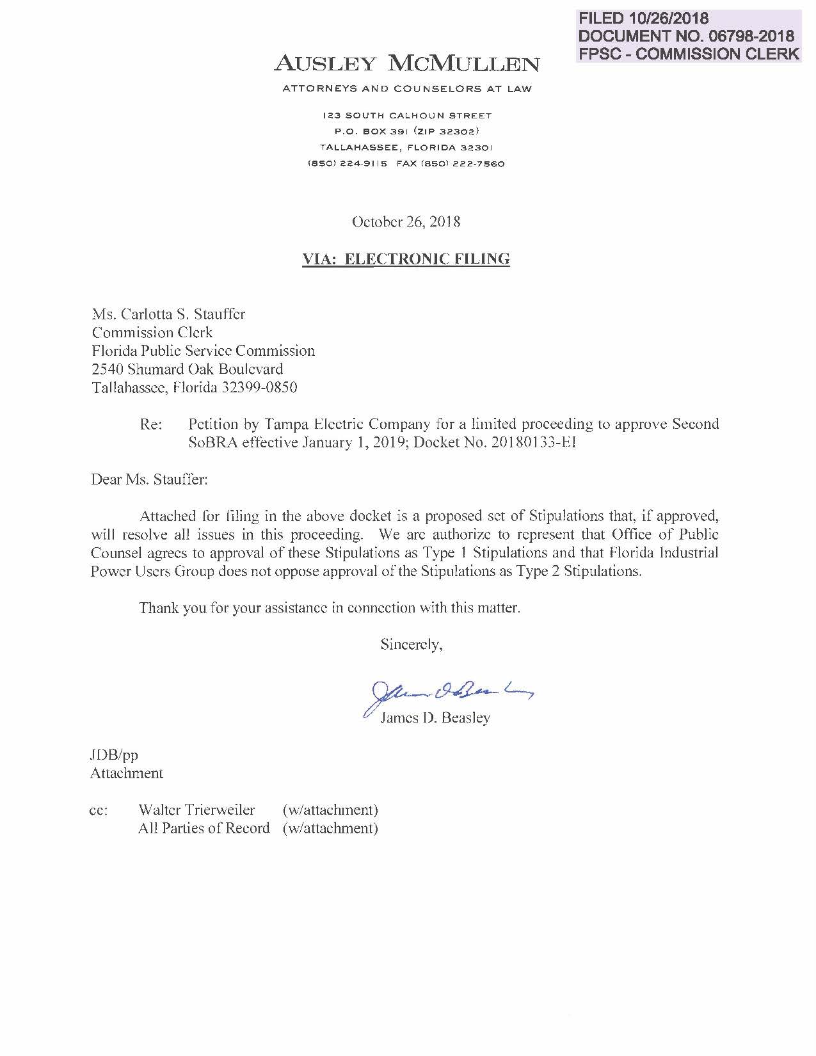

BEFORE THE FLORIDA PUBLIC SERVICE COMMISSION

In re: Petition for limited proceeding to approve second solar base rate adjustment (SoBRA), effective January 1, 2019, by Tampa Electric Company. | DOCKET NO. 20180133-EI

Stipulations

VII. BASIC POSITION

Tampa Electric seeks approval of its Second Solar Base Rate Adjustment (“SoBRA”) consistent, and in accordance with the 2017 Agreement. The 2017 Agreement is a carefully negotiated agreement – unique to Tampa Electric - that reflects a delicate balance of gives and takes among the parties, and which contains a collection of individual provisions that absent the others would likely not be acceptable to some or all of the parties if presented on a stand-alone basis. Paragraph 6, which authorizes a series of SoBRAs, is one such provision. Paragraph 9, which required Tampa Electric to make a one-time tax reform revenue requirement reduction of over $100 million effective January 2019 is another. There are many others.

The Parties to this docket have conducted extensive formal and informal discovery into the company’s proposed Second SoBRA, whether it conforms to the unique aspects of the company’s SoBRAs as intended by the parties and to ensure that the company met its burden of proof. Although OPC and FIPUG would not agree – absent the 2017 Agreement and its significant benefits to customers - to the kind of base rate increases proposed by the company in this docket, a deal is a deal. The company has shown by a preponderance of the evidence that the Second SoBRA projects are projected below the per project installed cost cap and are cost effective as specified and intended in the 2017 Agreement, and in the specific circumstances of this case, are otherwise prudent for Tampa Electric, regardless of the requirements of the Settlement. Accordingly, the Commission should (1) accept and adopt the stipulations of the parties on Issues 1 through 8, below, and (b) approve the Petition and the five proposed projects which comprise Tampa Electric’s Second SoBRA pursuant to the 2017 Agreement approved by the Commission in Order No. PSC-2017-0456-S-EI. The parties intend that doing so will have no precedential value beyond this case and the 2017 Agreement.

Upon approval of the Second SoBRA, and with its tax reform rate reduction, both effective in January 2019, Tampa Electric will have among the lowest retail rates in Florida.

VIII. ISSUES AND POSITIONS

ISSUE 1: Are the 2019 SoBRA projects proposed by TECO each eligible in their entirety for treatment pursuant to paragraph 6 of the 2017 Agreement?

Yes. The 2019 SoBRA projects totaling 260.3 MW proposed by TECO each meet in their entirety all of the eligibility requirements for treatment pursuant to paragraph 6 of the 2017 Agreement.

250 MW of this total is the base amount of capacity specified in paragraph 6(b) of the 2017 Agreement.

5.3 MW is allowable in the Second SoBRA as unused capacity carried forward from the First SoBRA.

The remaining 5 MW is the 2% variance specified in paragraph 6(c) of the 2017 Agreement and is allowable for two reasons. First, building all 49 MW of the Lake Hancock project capacity, but including only 32 MW of that capacity in the Second SoBRA, accommodates efficient planning and construction of the Lake Hancock project that includes the projected delivery of greater fuel savings from the entire project. Second, the company has committed that if the 2019 actual annual fuel savings available to the general body of rate payers from the incremental 5 MW and additional 17.7 MW not included in the Second SoBRA does not equal or exceed $1.0 million, it will refund the shortfall to the general body of rate payers using the SoBRA true-up process in paragraph 6 of the 2017 Agreement.

ISSUE 2: Are the 2019 SoBRA projects proposed by TECO cost effective pursuant to subparagraph 6(g) of the 2017 Agreement?

Yes. Paragraph 6 of the 2017 Settlement Agreement was intended by the parties to give Tampa Electric an opportunity to build 550 MW of cost-effective solar generation (plus an additional 50 MW if certain requirements are met) over a period of time. The total capacity was divided into three tranches (with an optional fourth) and staged or allocated to future time periods to accommodate orderly construction and to phase in and moderate the rate impact to retail customers. During the negotiations, the company disclosed its plans to purchase the solar modules for the entire 600 MW and then finalized the purchase in 2017. Although the specifics of the cost-effectiveness test contemplated in the 2017 Settlement Agreement are not spelled out in paragraph 6, the way in which the company has apportioned solar capacity value and value of other deferred capacity in its cumulative present value of revenue requirement (“CPVRR”) calculation is consistent with the way the parties discussed the solar additions in paragraph 6 of the 2017 Settlement Agreement and will have no precedential value beyond Tampa Electric’s solar base rate adjustments and the 2017 Settlement Agreement. The cost-effectiveness test in this case is unique to Tampa Electric.

Solar projects provide capacity value and can contribute to the deferral of the company’s next generating unit. For these reasons, Tampa Electric now uses the same basic approach considering capacity value and value of deferral when evaluating the cost-effectiveness of third-party solar PPA proposals. Doing so provides a consistent basis for evaluation and ensures that third-party solar is evaluated fairly against the company’s future self-build options. The 600 MW is now part of the current base case and any PPA proposals would receive a value of deferral for any unit deferrals compared to this base case.

Based on the company’s plans to build at least 550 MW of solar and as described in the answer to Staff’s Interrogatory 12A (revised September 27, 2018), the five projects covered by the Second SoBRA lower the company’s projected system CPVRR as compared to such CPVRR without the solar projects; therefore, the projects covered by the Second SoBRA satisfy the cost-effectiveness test in the 2017 Agreement. Without objection from Tampa Electric, the parties and the Commission have reserved or may reserve their rights to take appropriate action if at least 550 MW is not built out.

ISSUE 3: Are the projected installed costs of each of the 2019 SoBRA projects proposed by TECO less than or equal to the Installed Cost Cap of $1,500 per kW_{ac} pursuant to subparagraph 6(d) of the 2017 Agreement?

Yes. The projected installed costs of the five projects are as follows:

Project Name Projected Installed Cost (per kW_{ac})

Lithia Solar $1,494
Grange Hall Solar $1,437
Peace Creek Solar $1,492
Bonnie Mine Solar $1,464
Lake Hancock Solar $1,494

These installed costs are lower than the $1,500 per kW_{ac} Installed Cost Cap pursuant to subparagraph 6(d) of the 2017 Agreement.

ISSUE 4: Is the projected average capital cost of the 2018 and 2019 SoBRA projects proposed by TECO less than or equal to $1,475 per kW_{ac} pursuant to subparagraph 6(c) of the 2017 Agreement?

Yes. The projected average capital cost of the 2018 and 2019 SoBRA projects is less than or equal to $1,475 per kW_{ac} pursuant to subparagraph 6(c) of the 2017 Agreement.

ISSUE 5: What are the estimated annual revenue requirements associated with TECO’s 2019 SoBRA projects?

Considering the explanation of, and assurances regarding, the 2% variance specified in Issue 1, the estimated annual revenue requirement associated with Tampa Electric’s 2019 SoBRA projects is $46,045,000 including the incentive specified in the 2017 Agreement. This amount is calculated using the projected installed costs of the five projects and in accordance with the revenue requirement cost recovery provisions of the 2017 Agreement.

ISSUE 6: What are the appropriate base rates needed to collect the estimated annual revenue requirement for the solar projects in the 2019 SoBRA?

Considering the explanation of, and assurances regarding, the 2% variance specified in Issue 1, the appropriate base rates needed to collect the estimated annual revenue requirement for the solar projects in the 2019 SoBRA are those reflected in the redlined and clean tariffs set forth as Documents Nos. 6 and 7 of witness Ashburn’s Exhibit No. ___ (WRA-1, revised September 24, 2018), which are incorporated herein by reference.

ISSUE 7: Should the Commission approve the tariffs for TECO reflecting the base rate increases for the 2019 projects determined to be appropriate in these proceedings?

Yes. Considering the explanation of, and assurances regarding, the 2% variance specified in Issue 1, the Commission should approve the revised tariffs for Tampa Electric reflecting the base rate increases for the 2019 projects comprising the company’s Second SoBRA effective with the first meter reading in January 2019.

ISSUE 8: Should the docket be closed?

Yes. Once all issues in this docket are resolved, the docket should be closed.

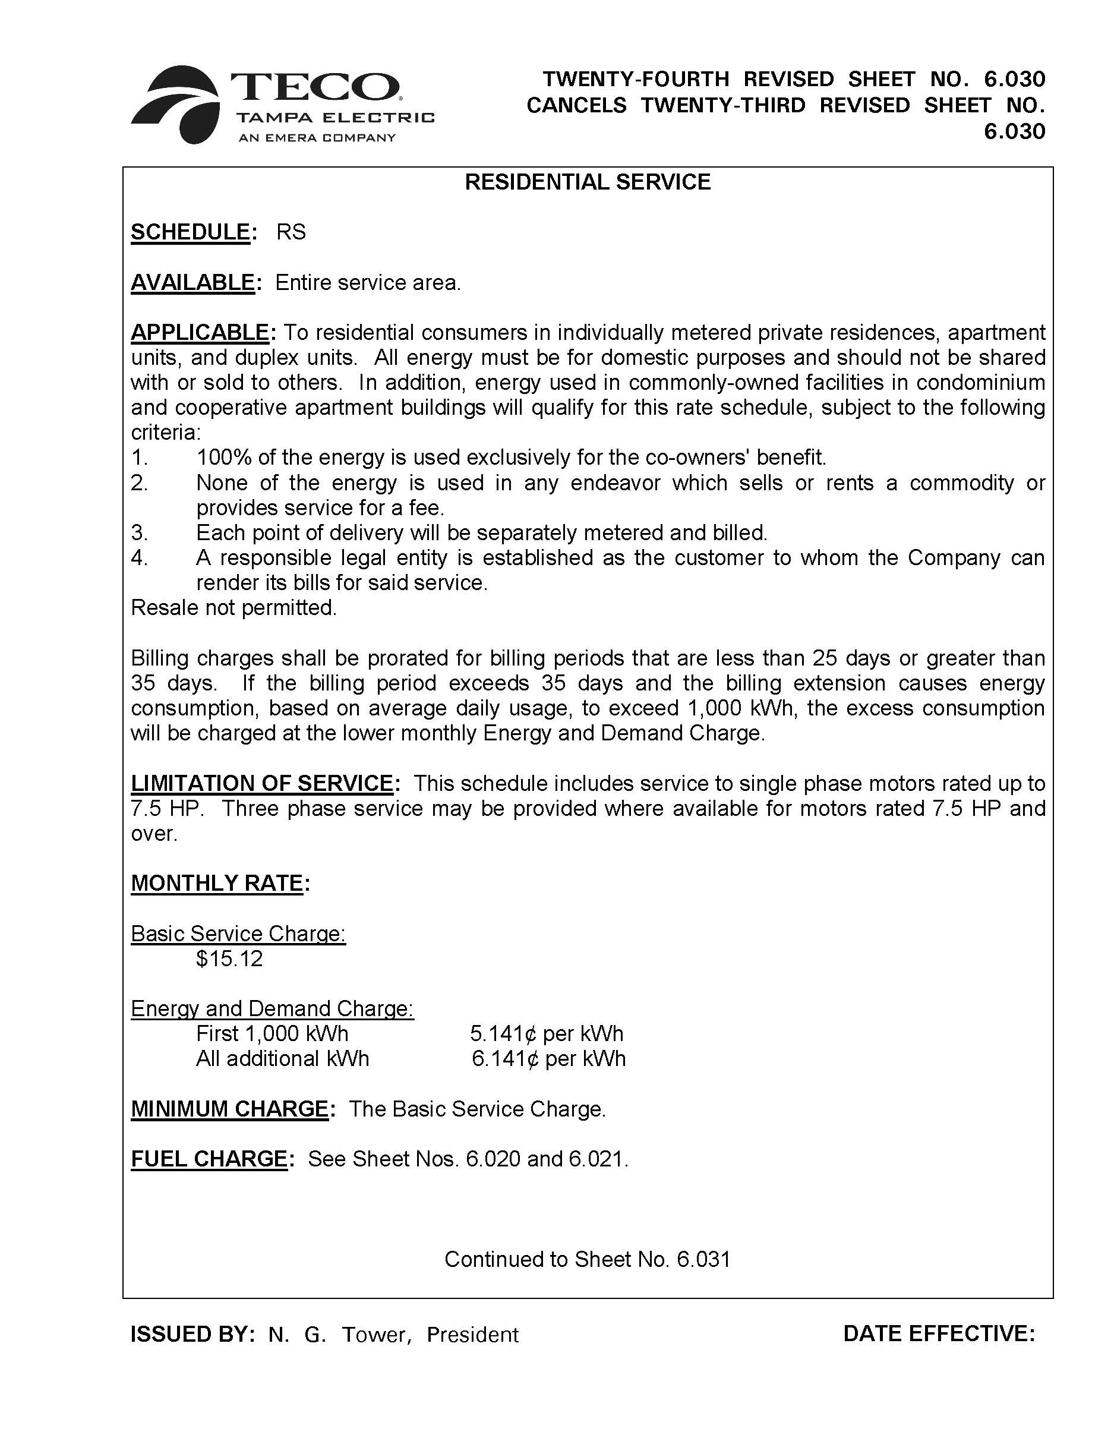
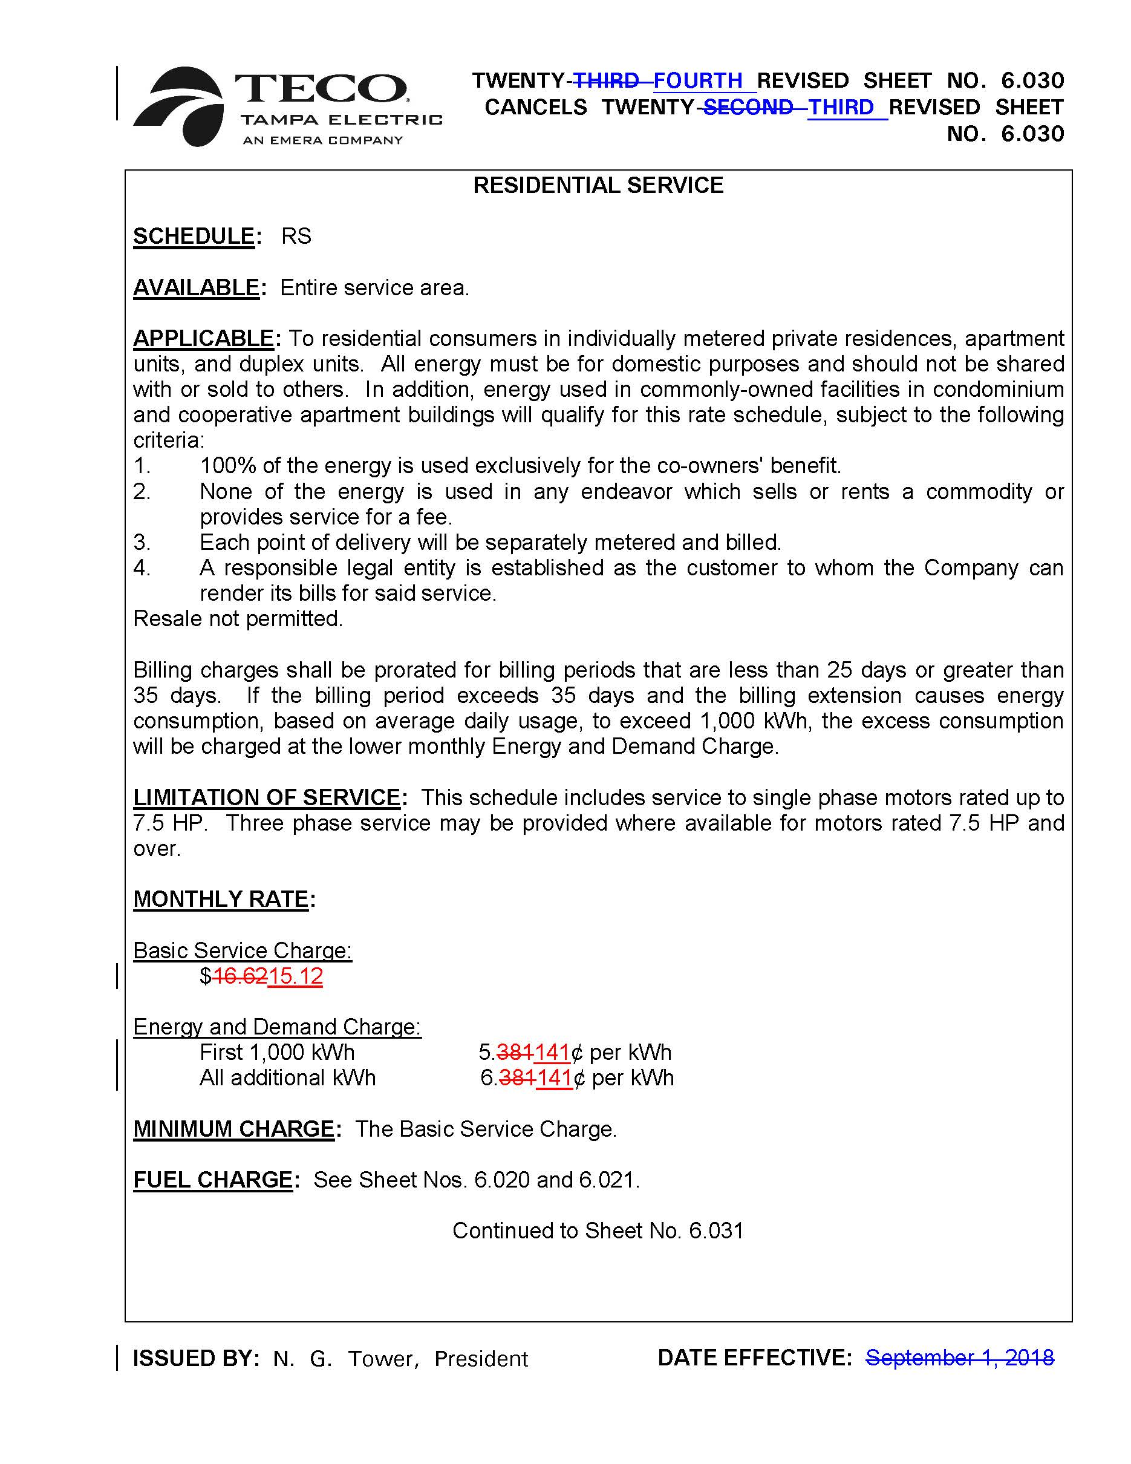
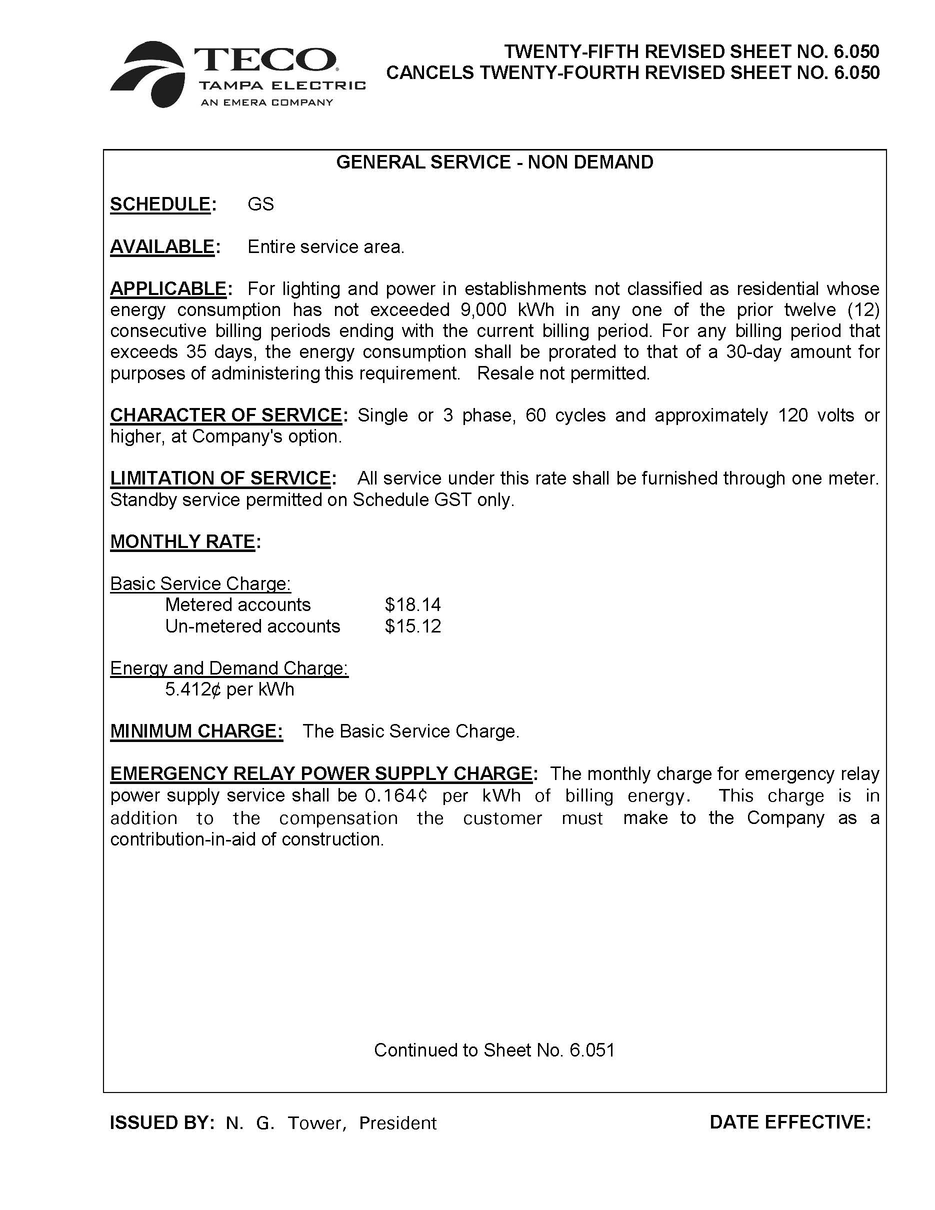
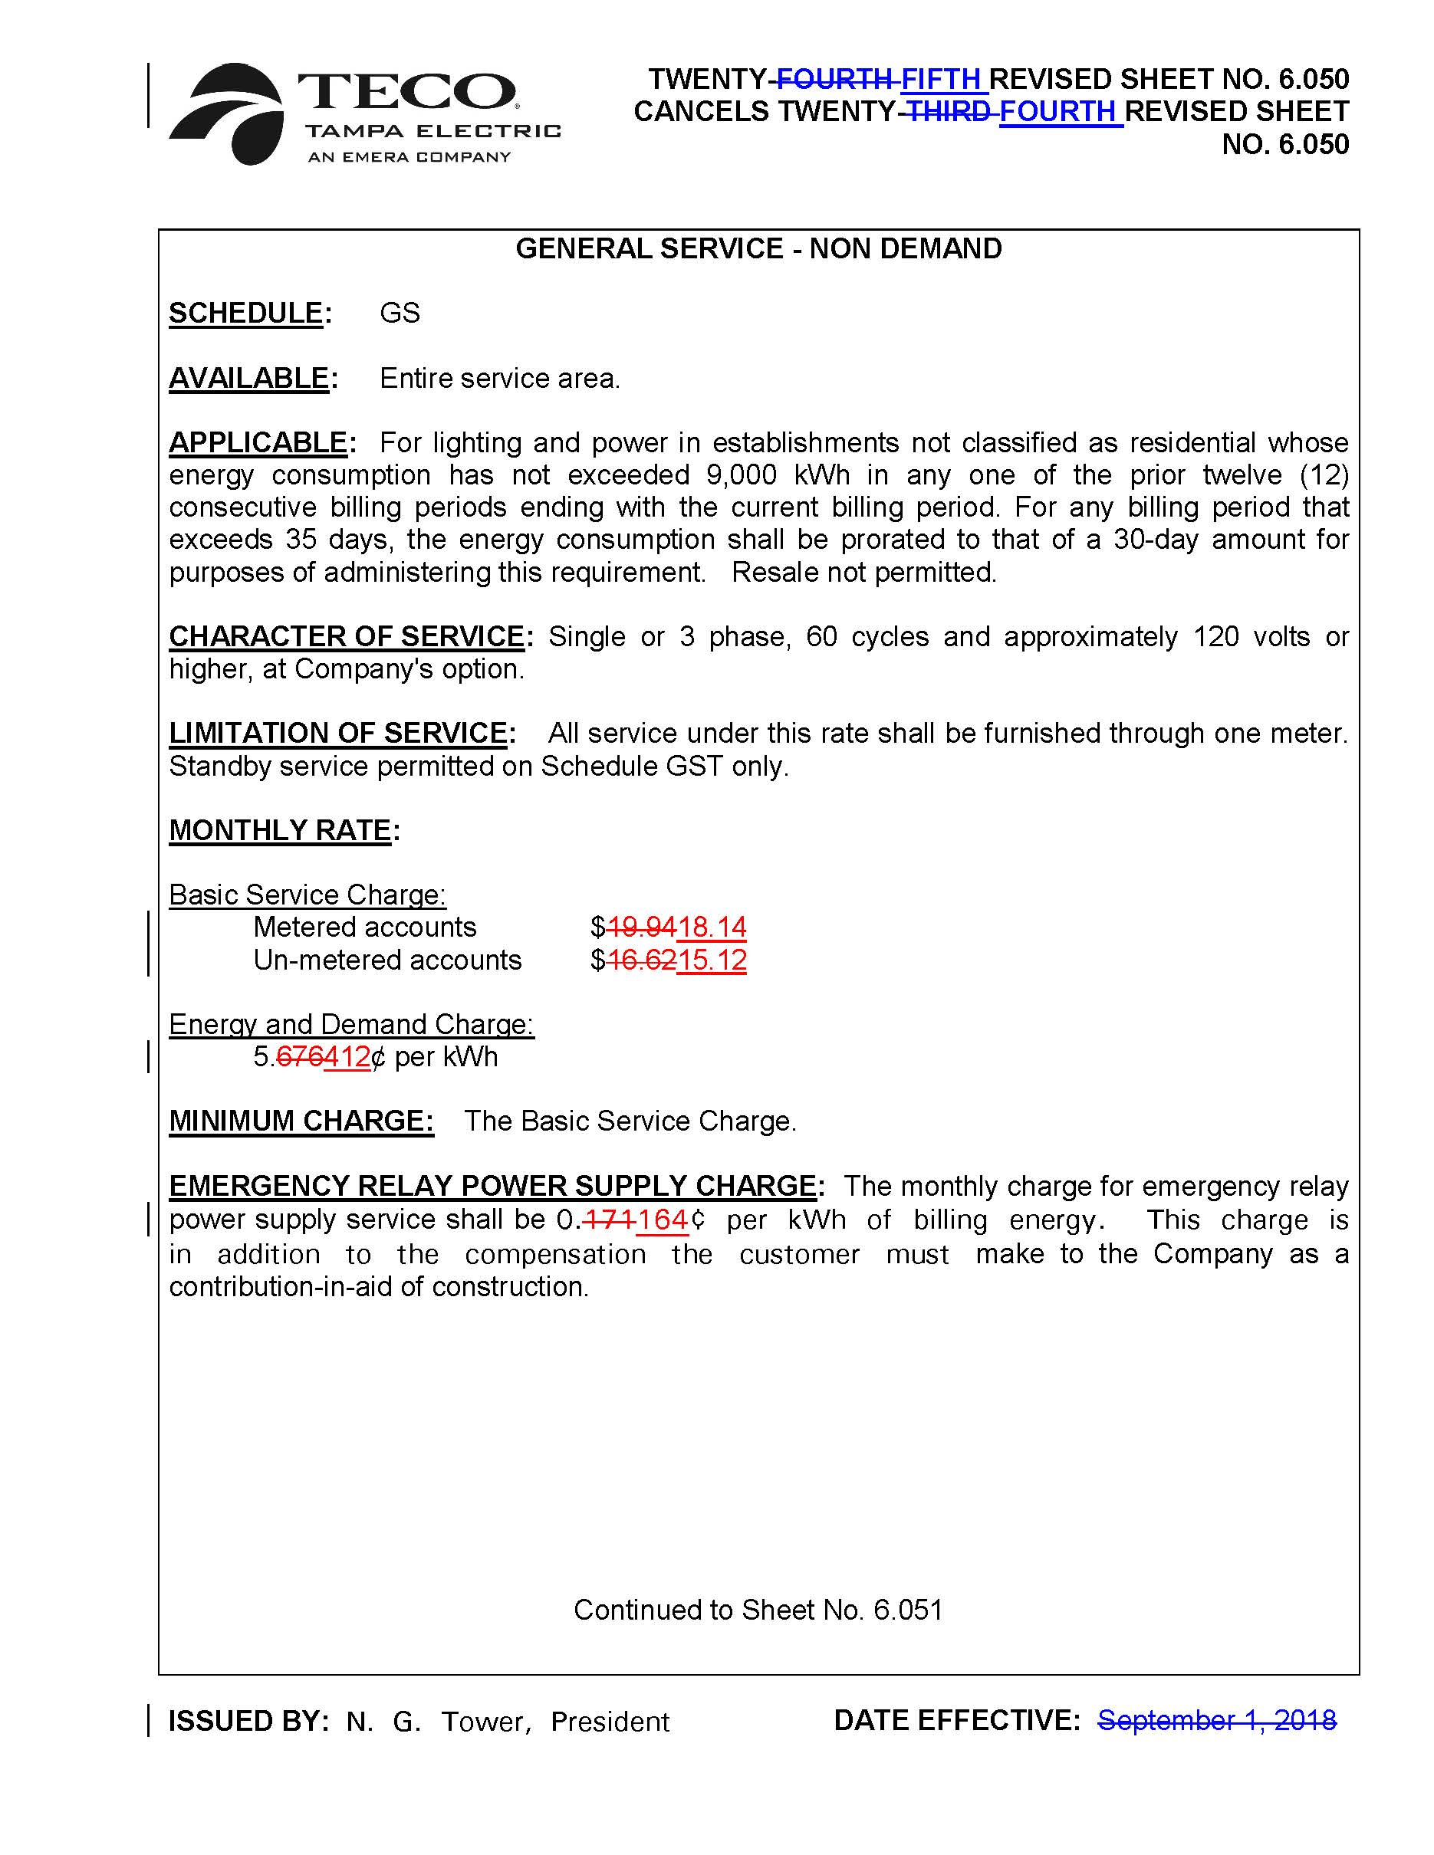
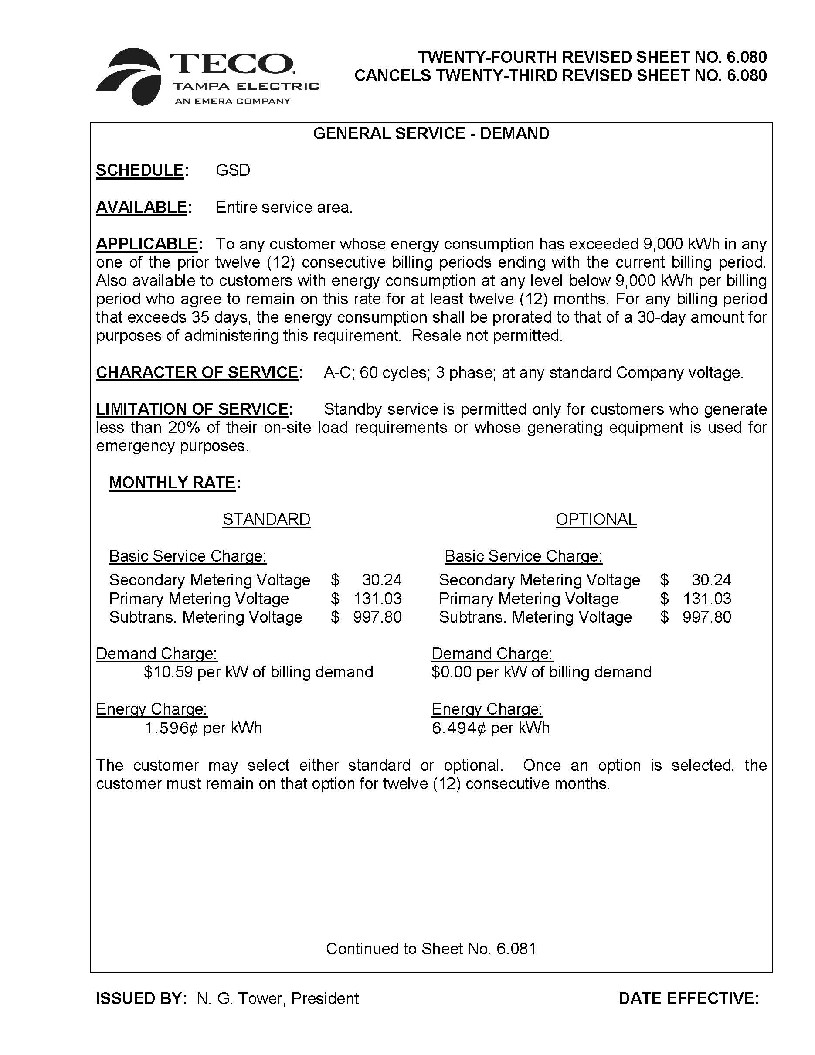
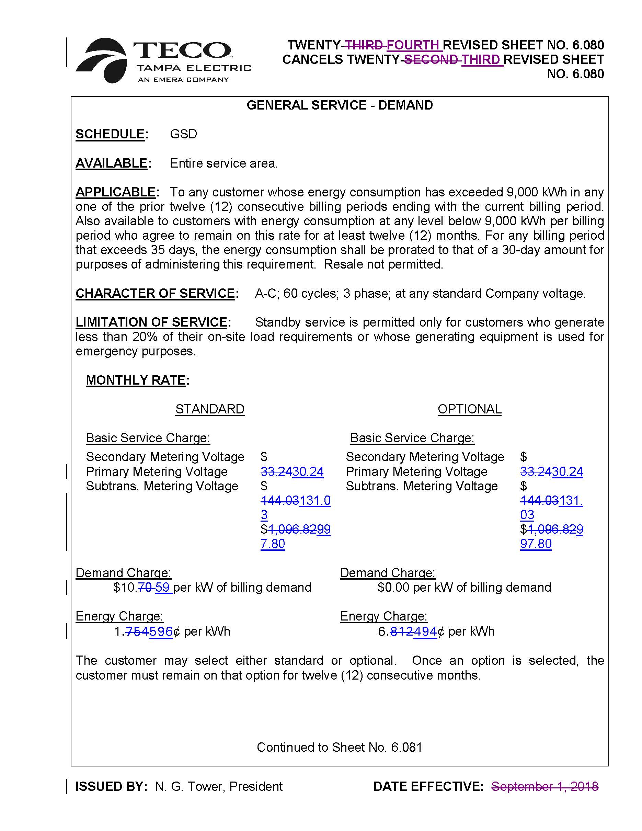
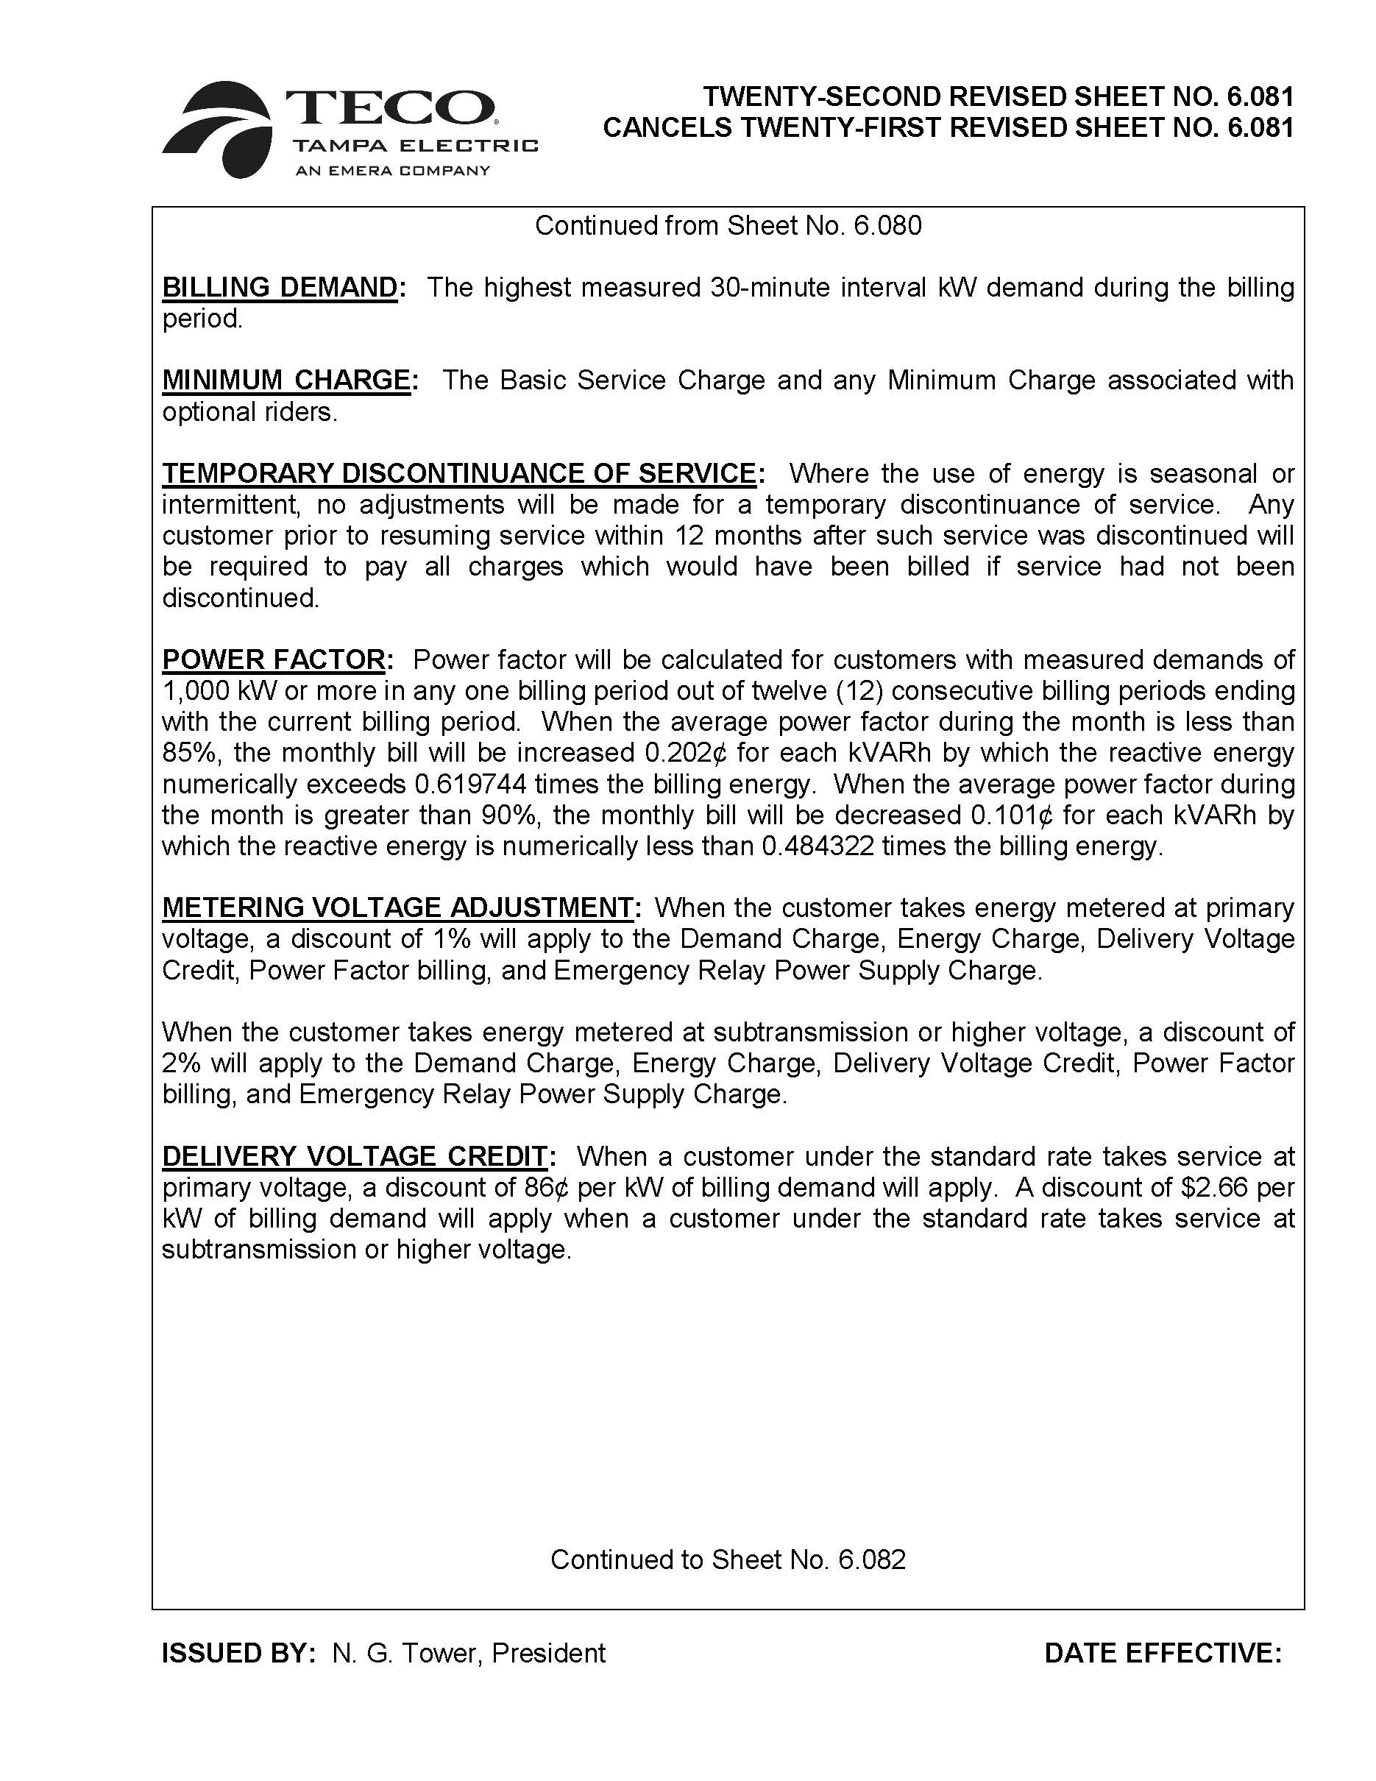
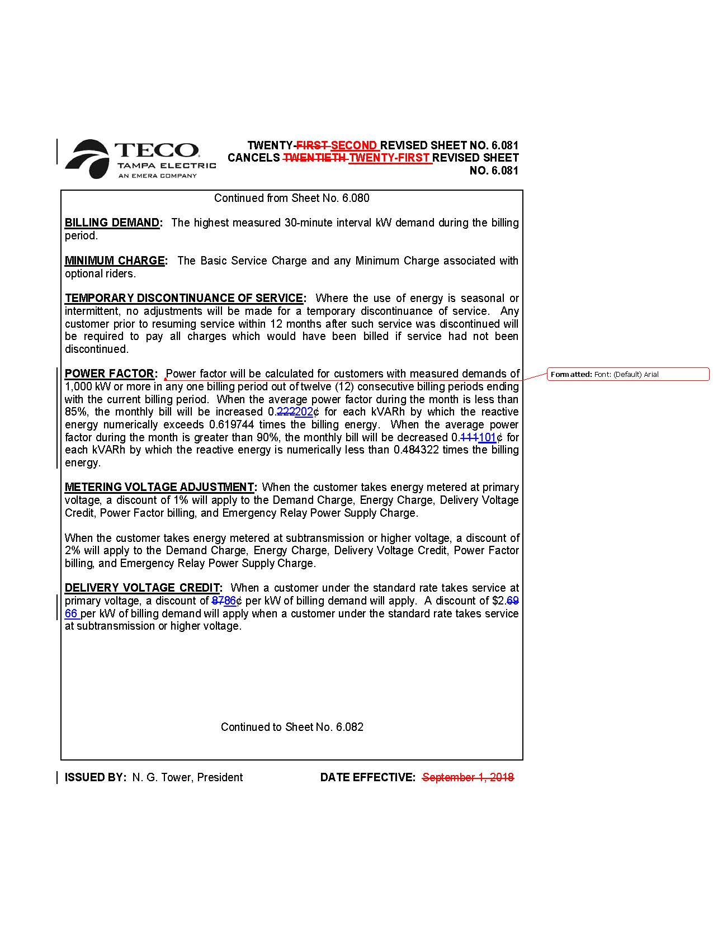
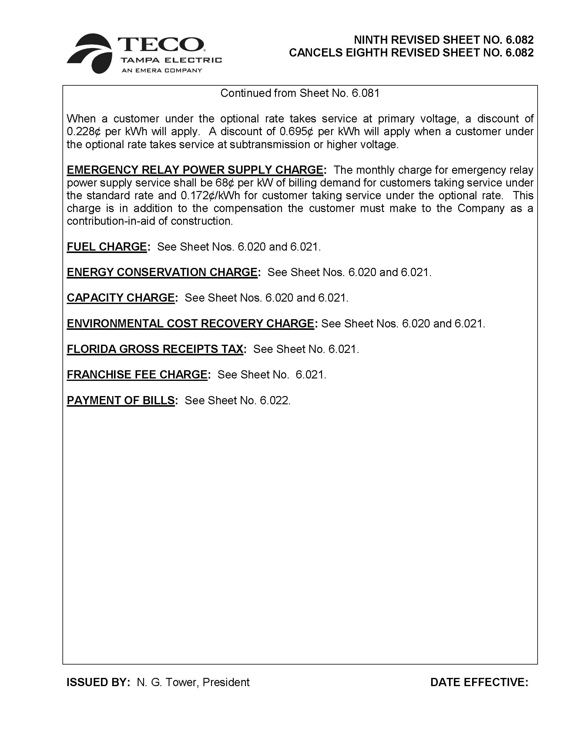
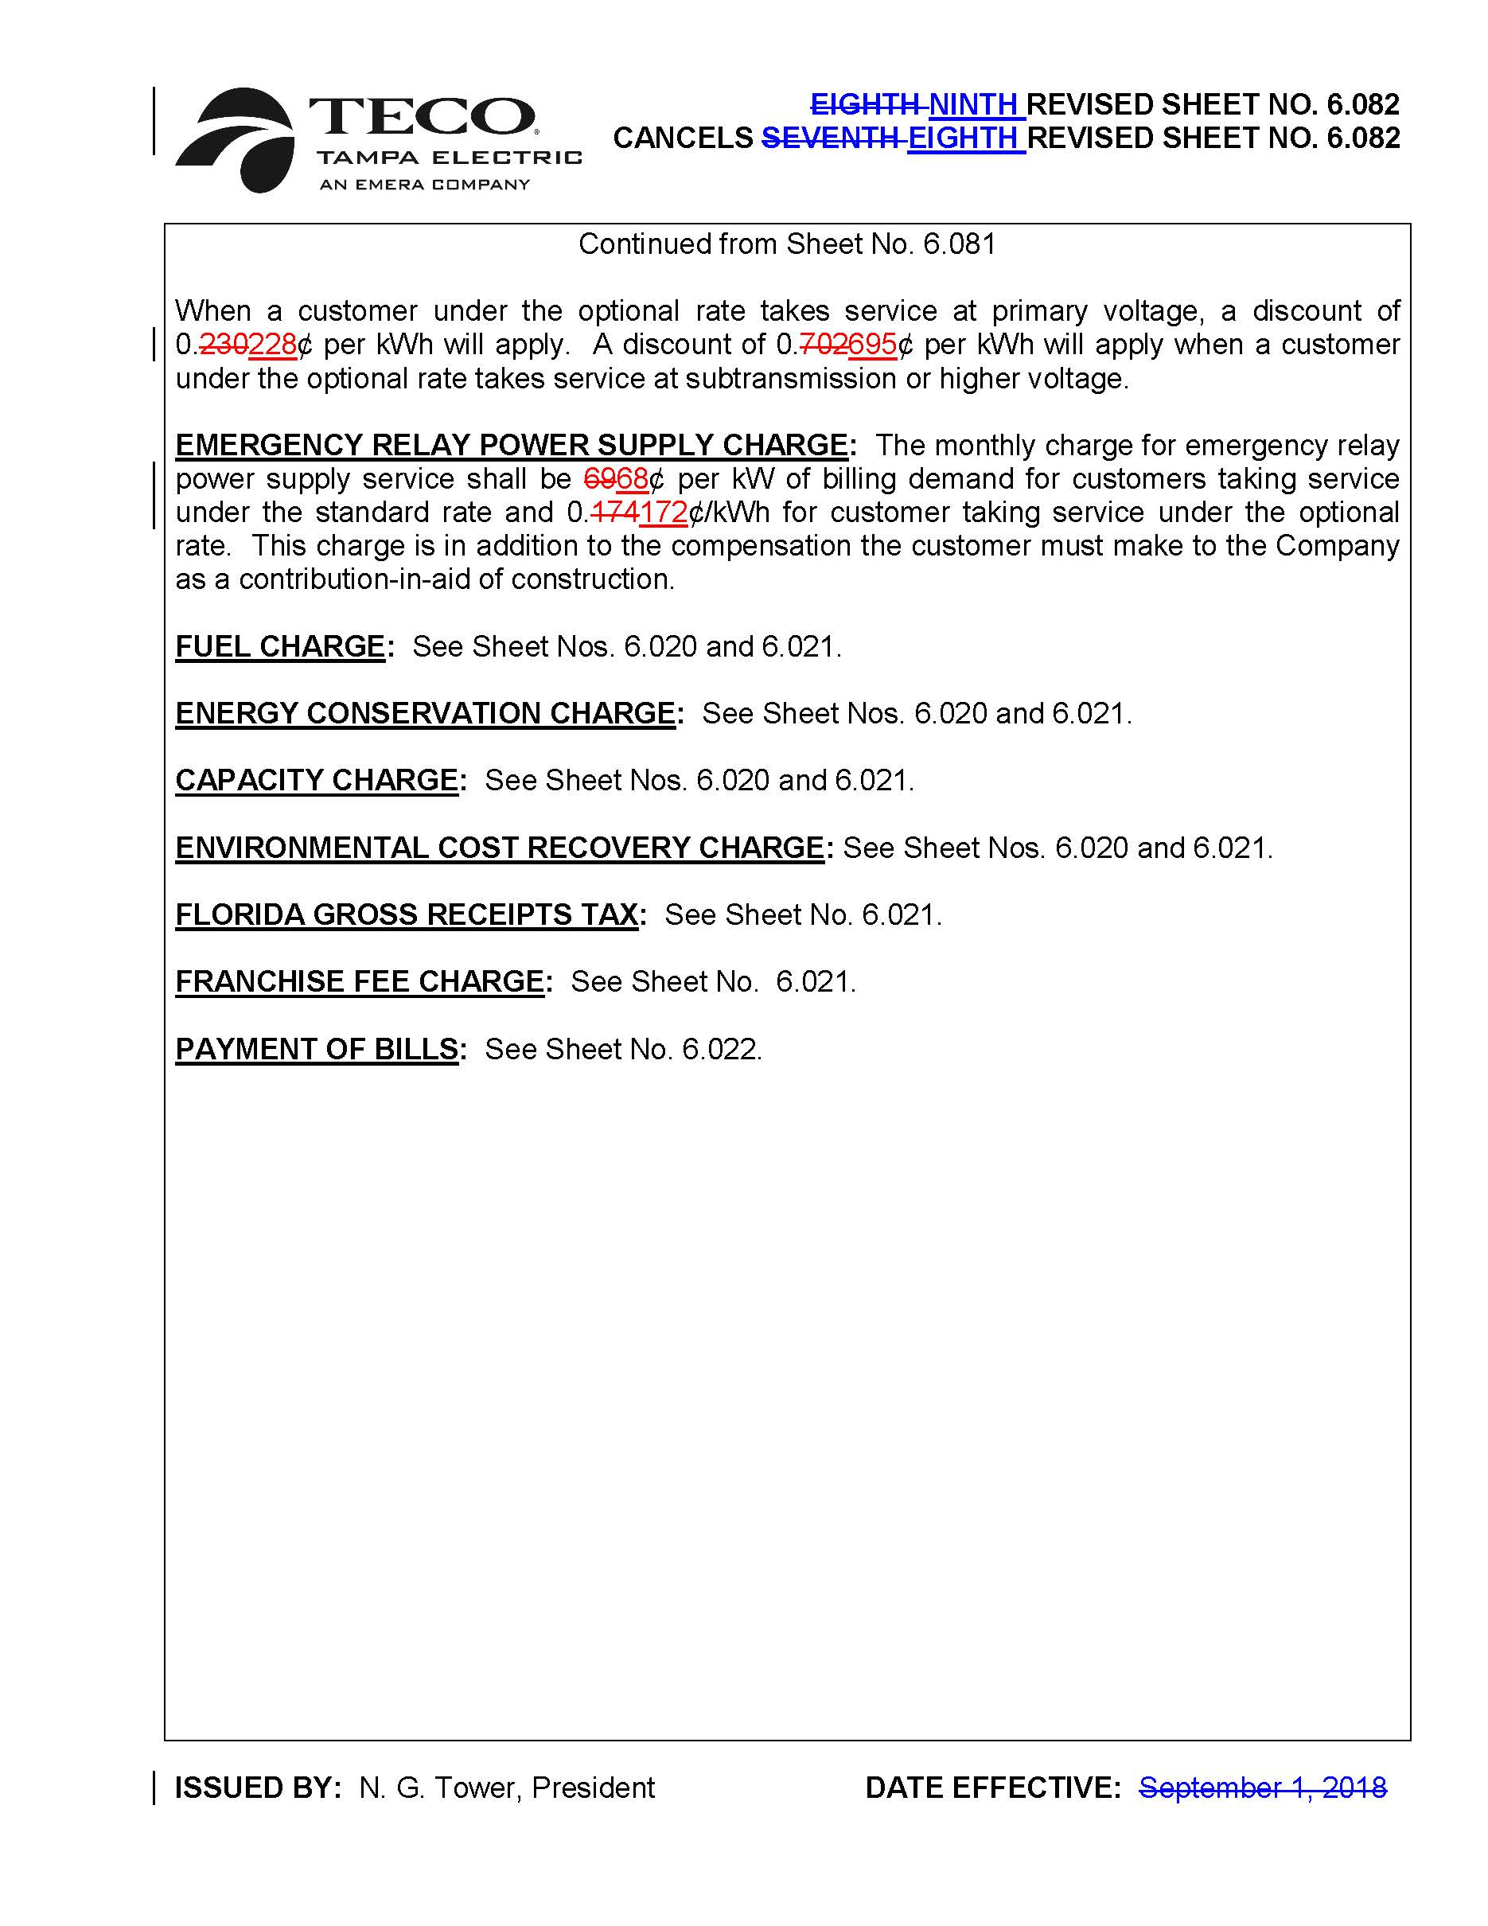
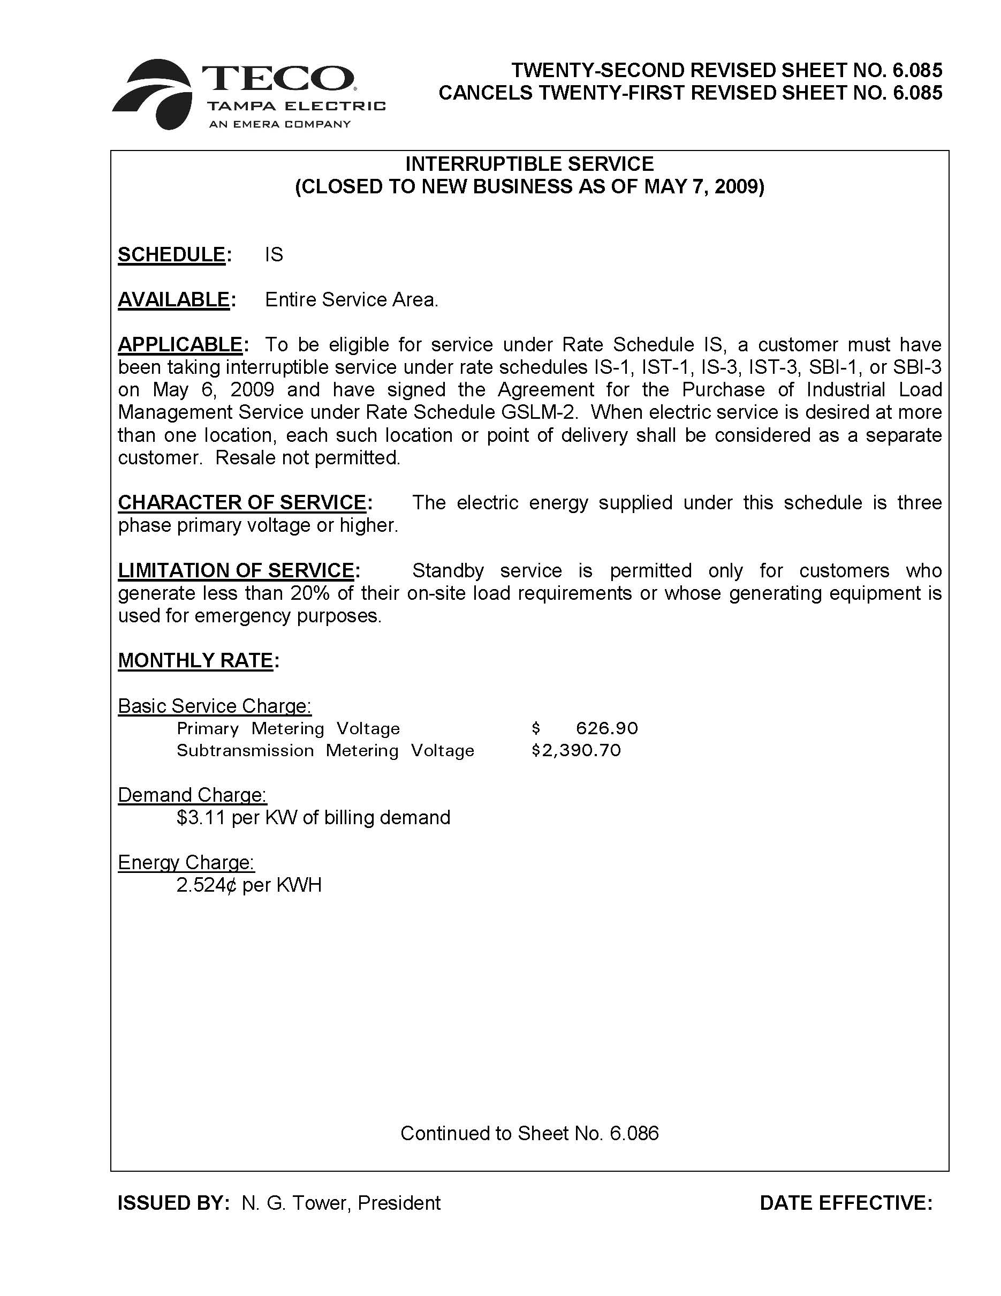
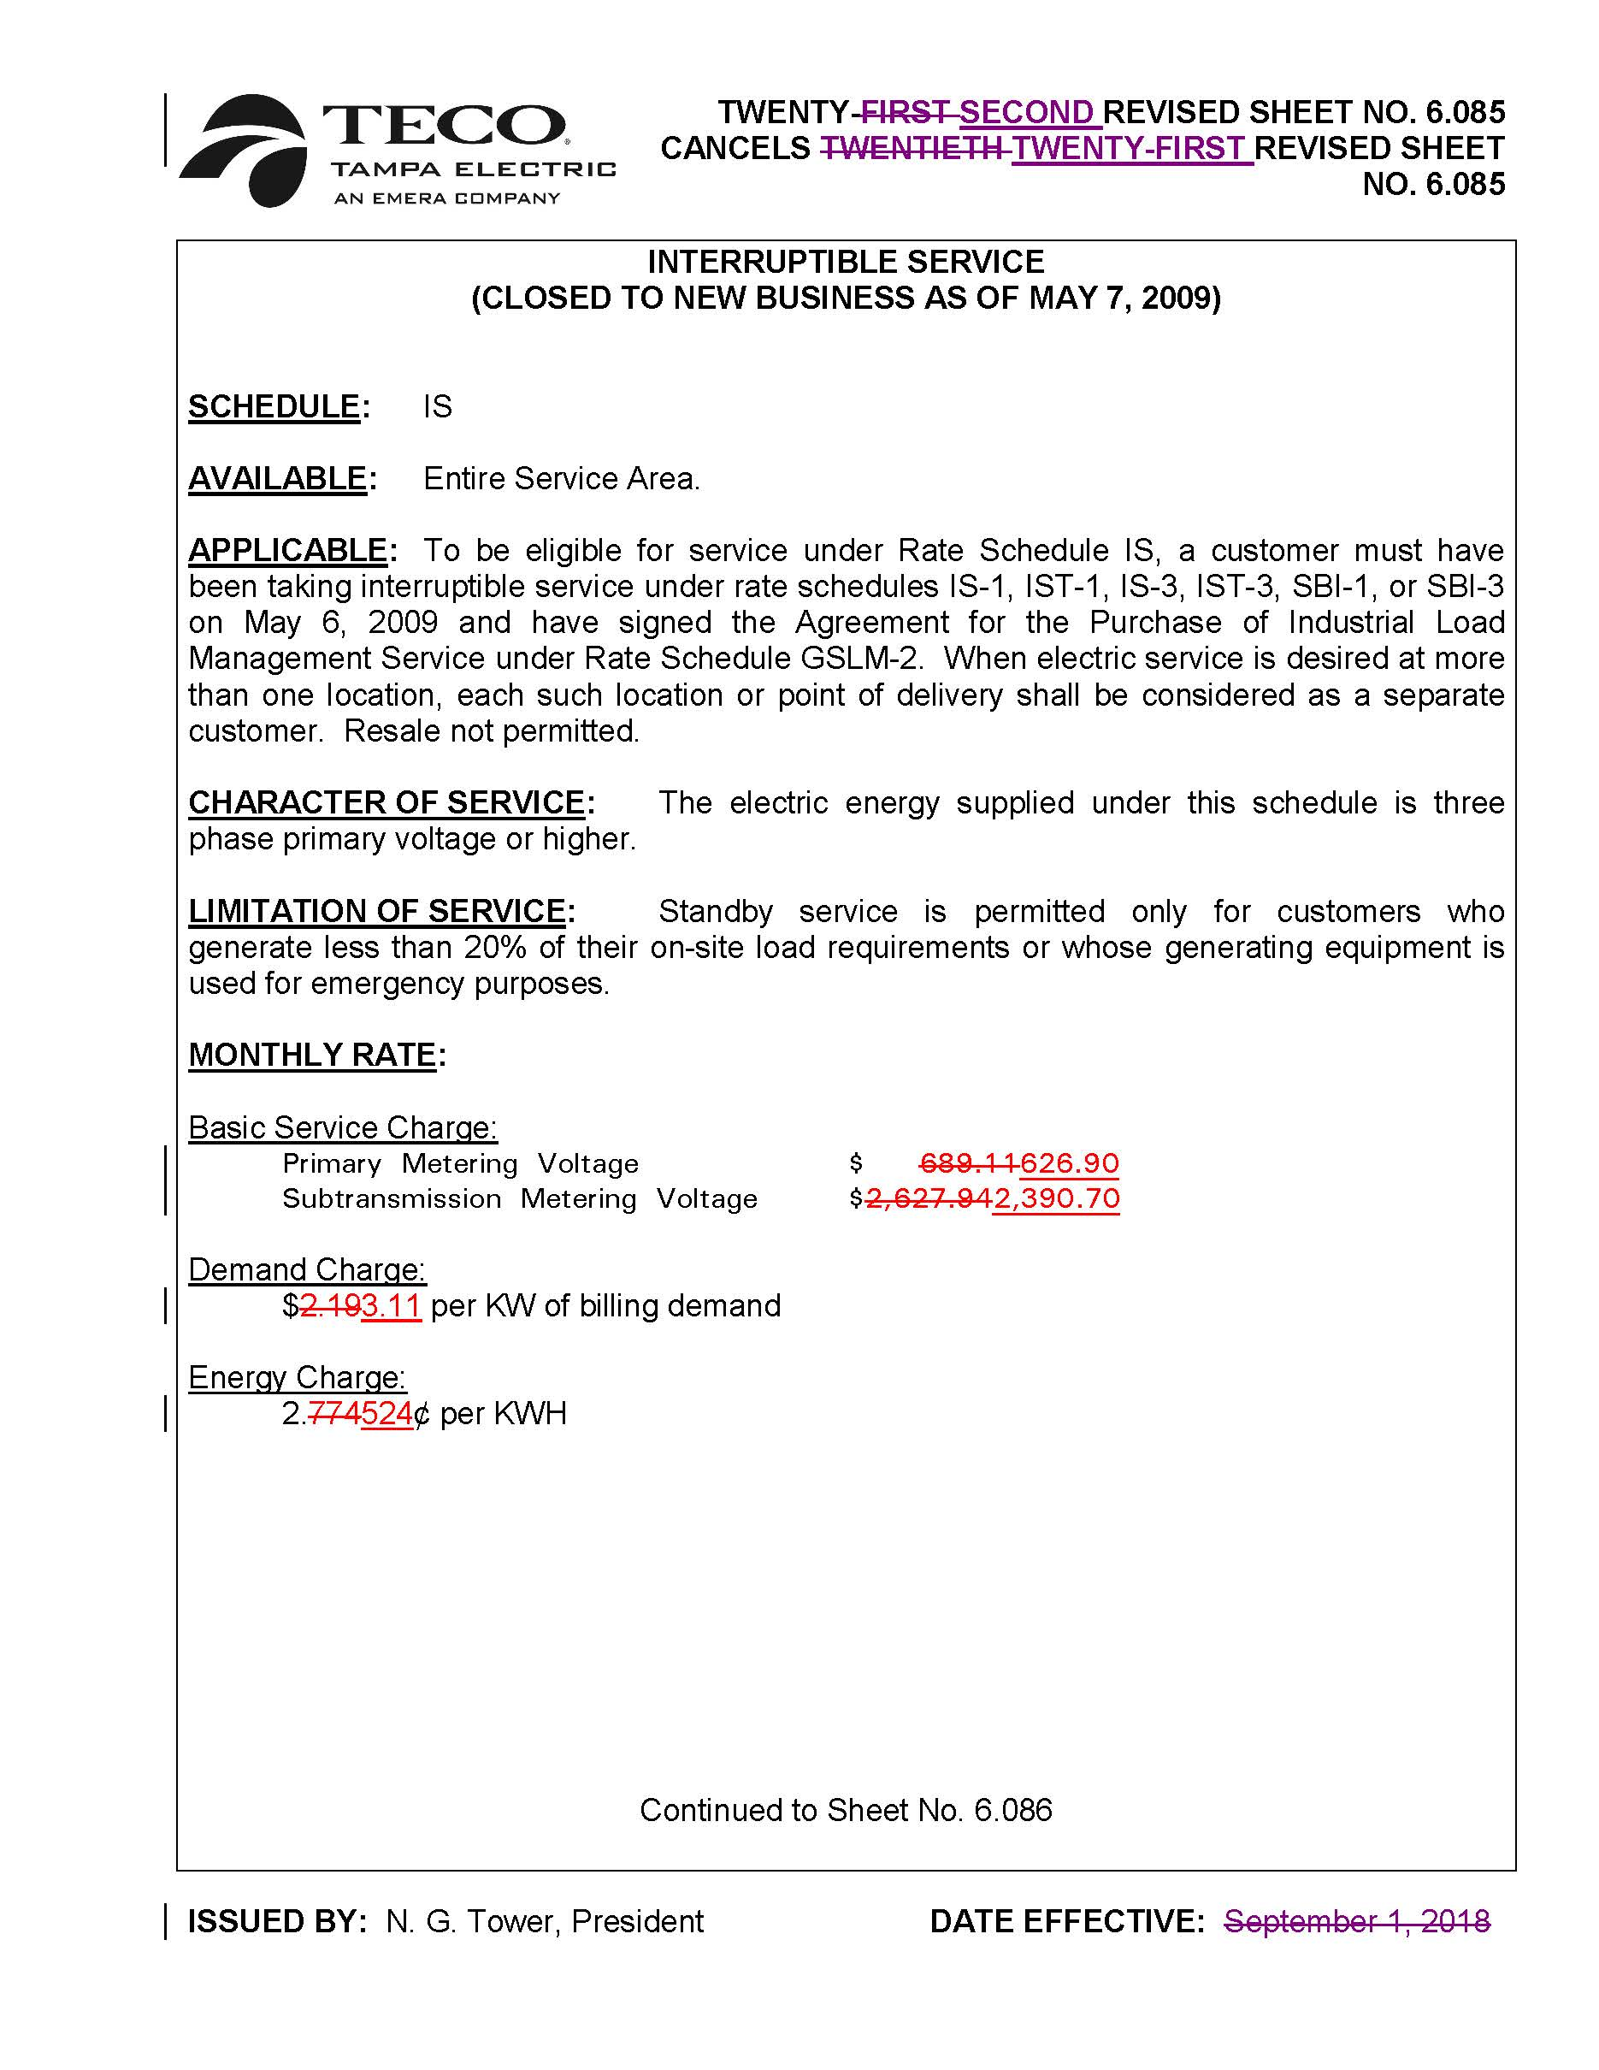
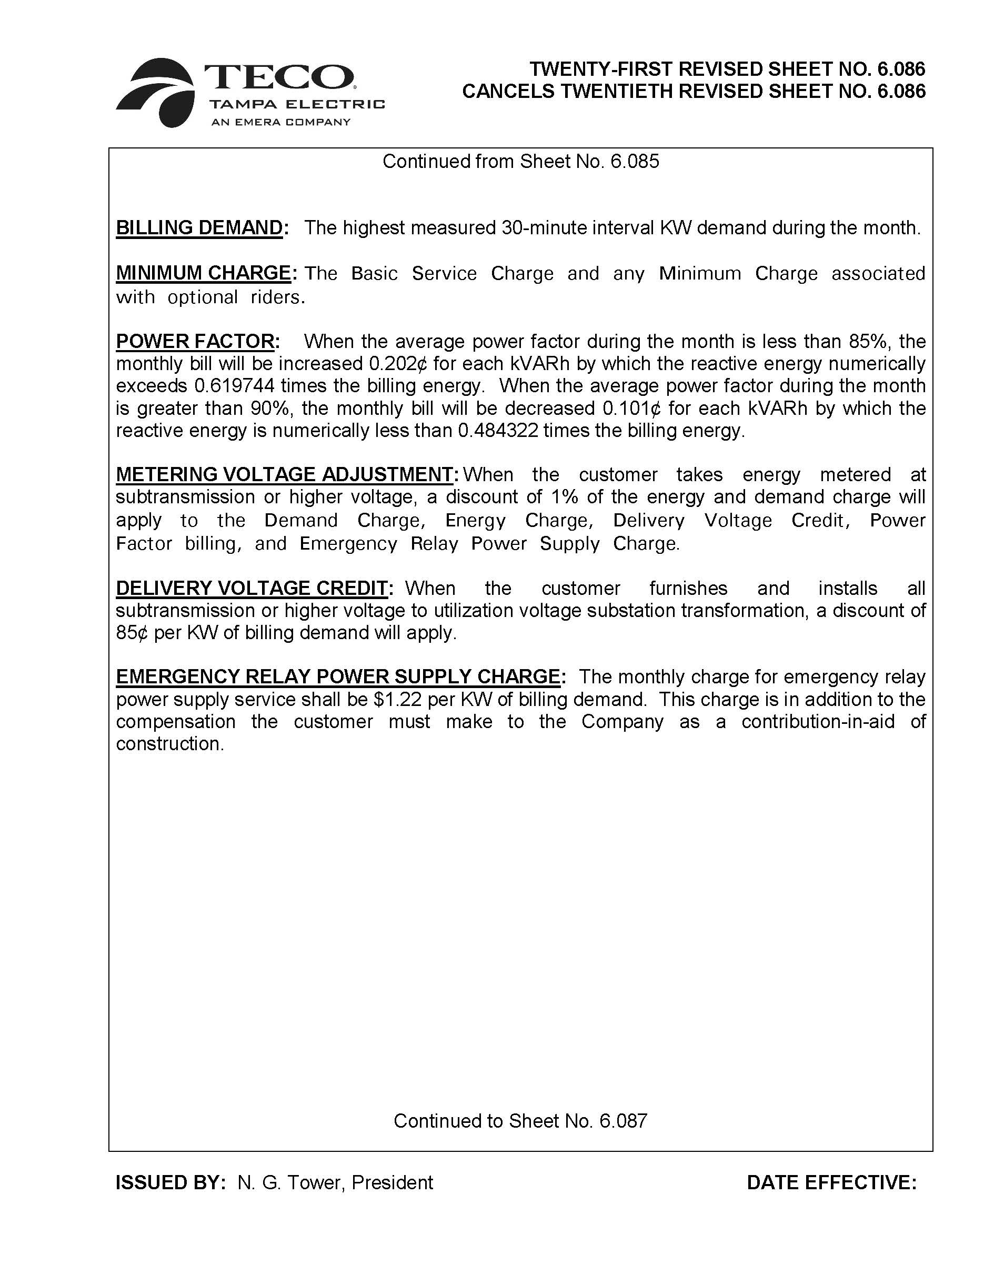
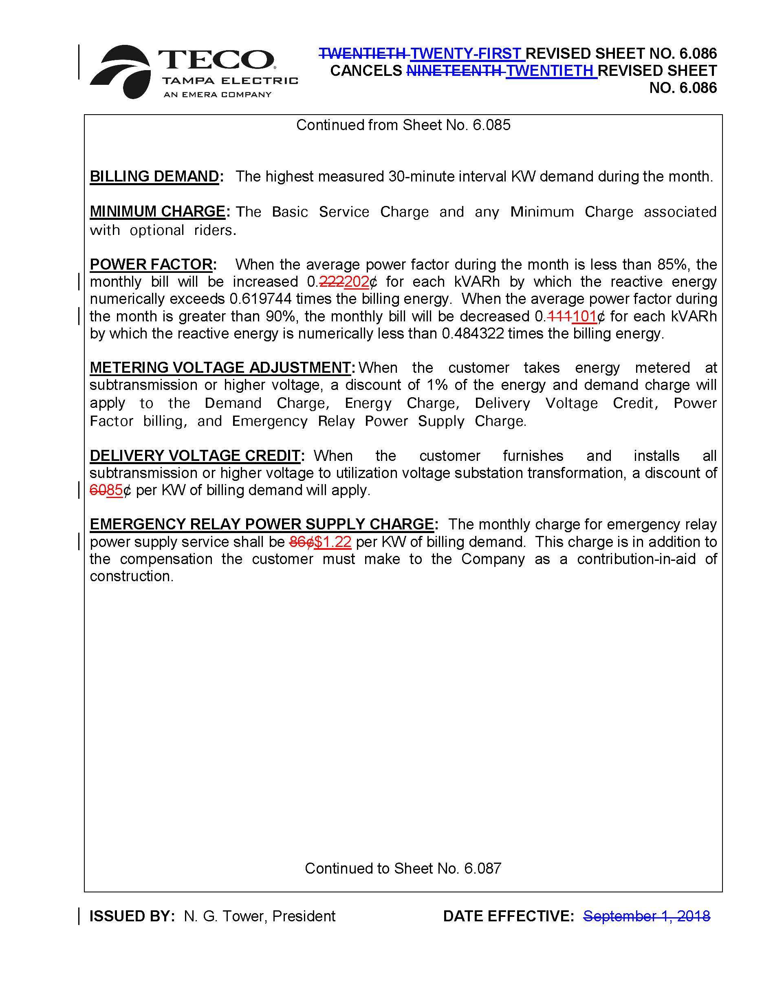
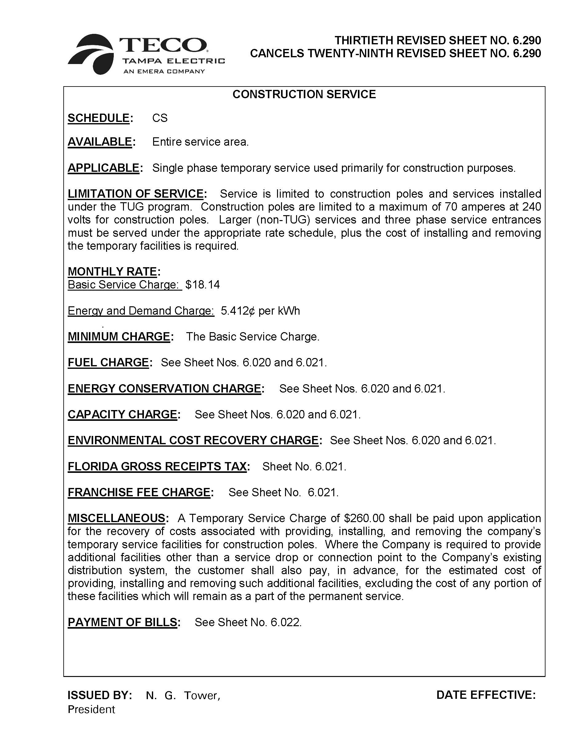
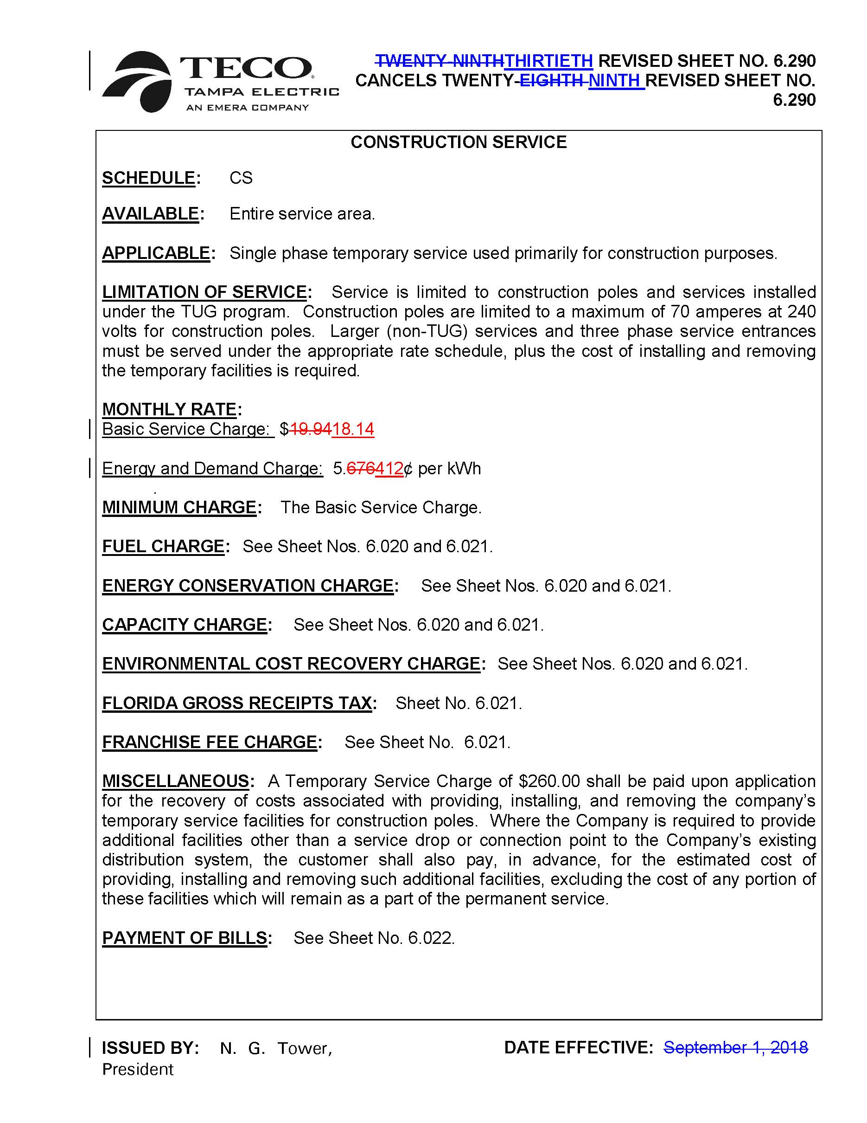
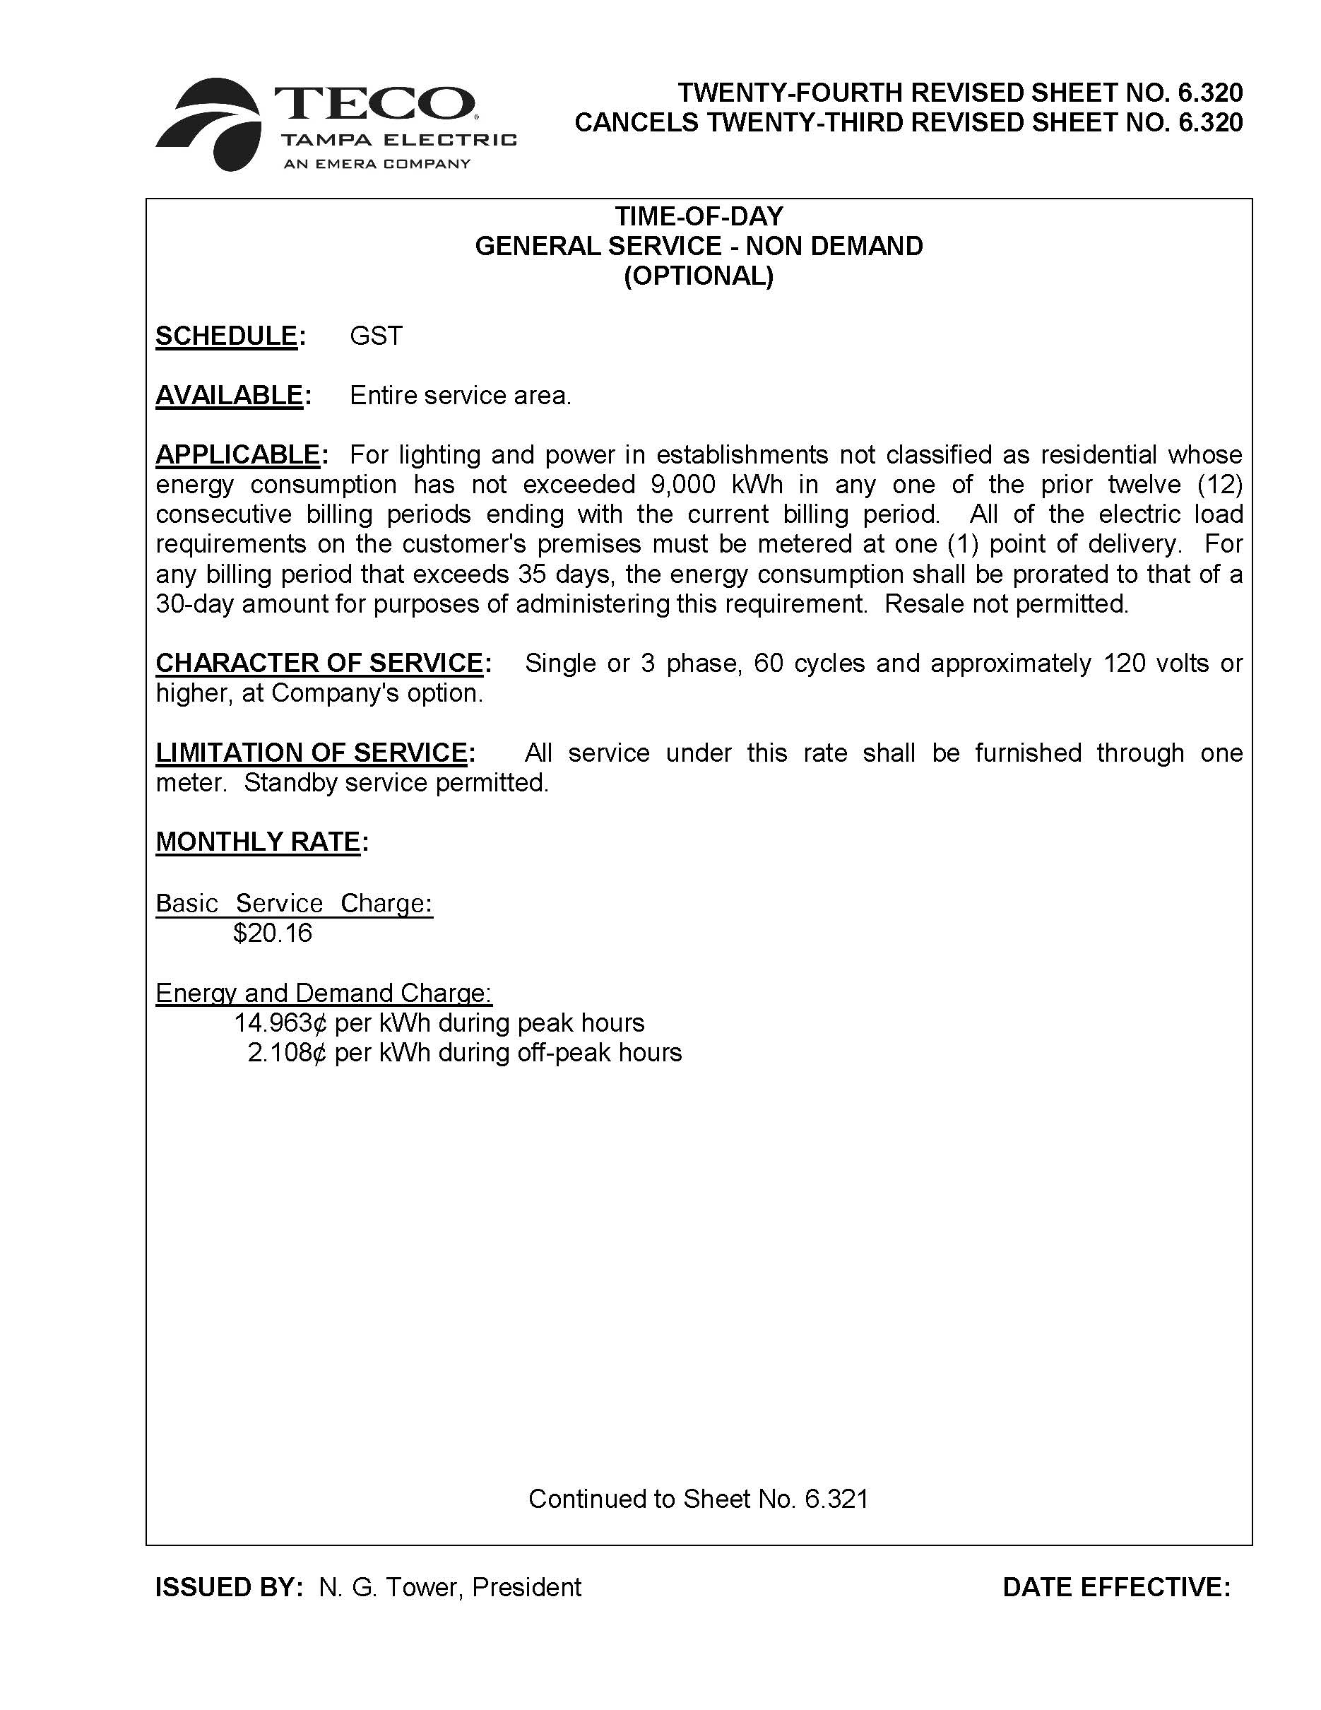
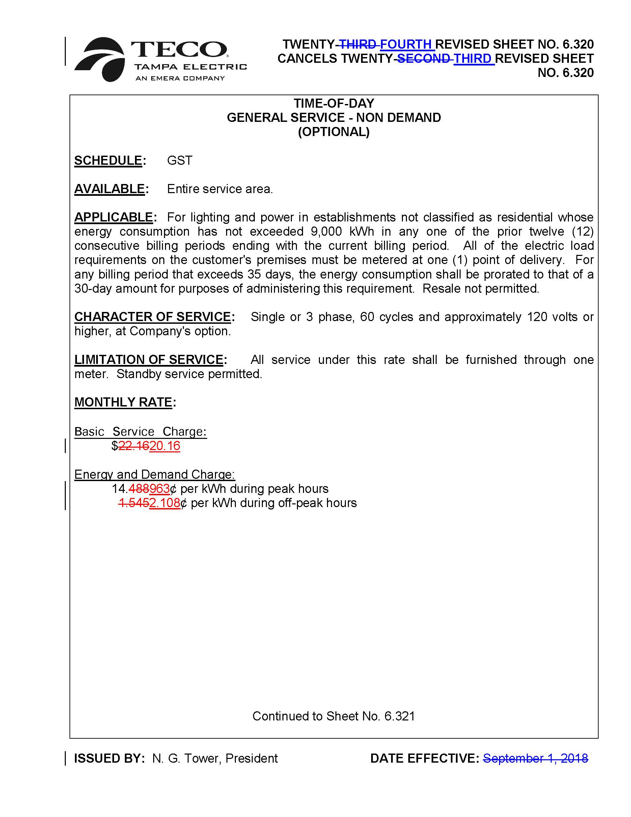
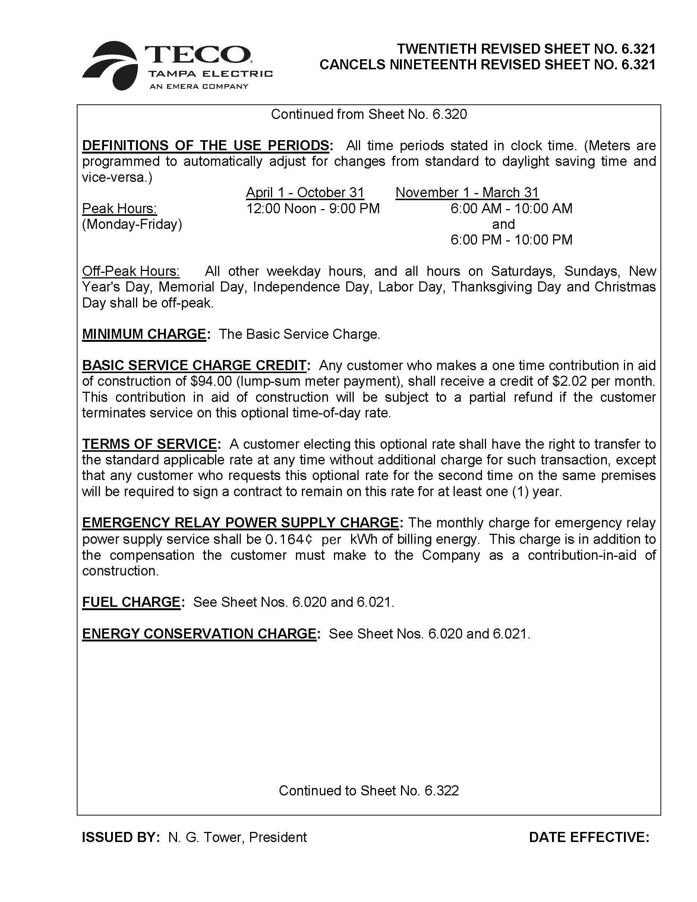
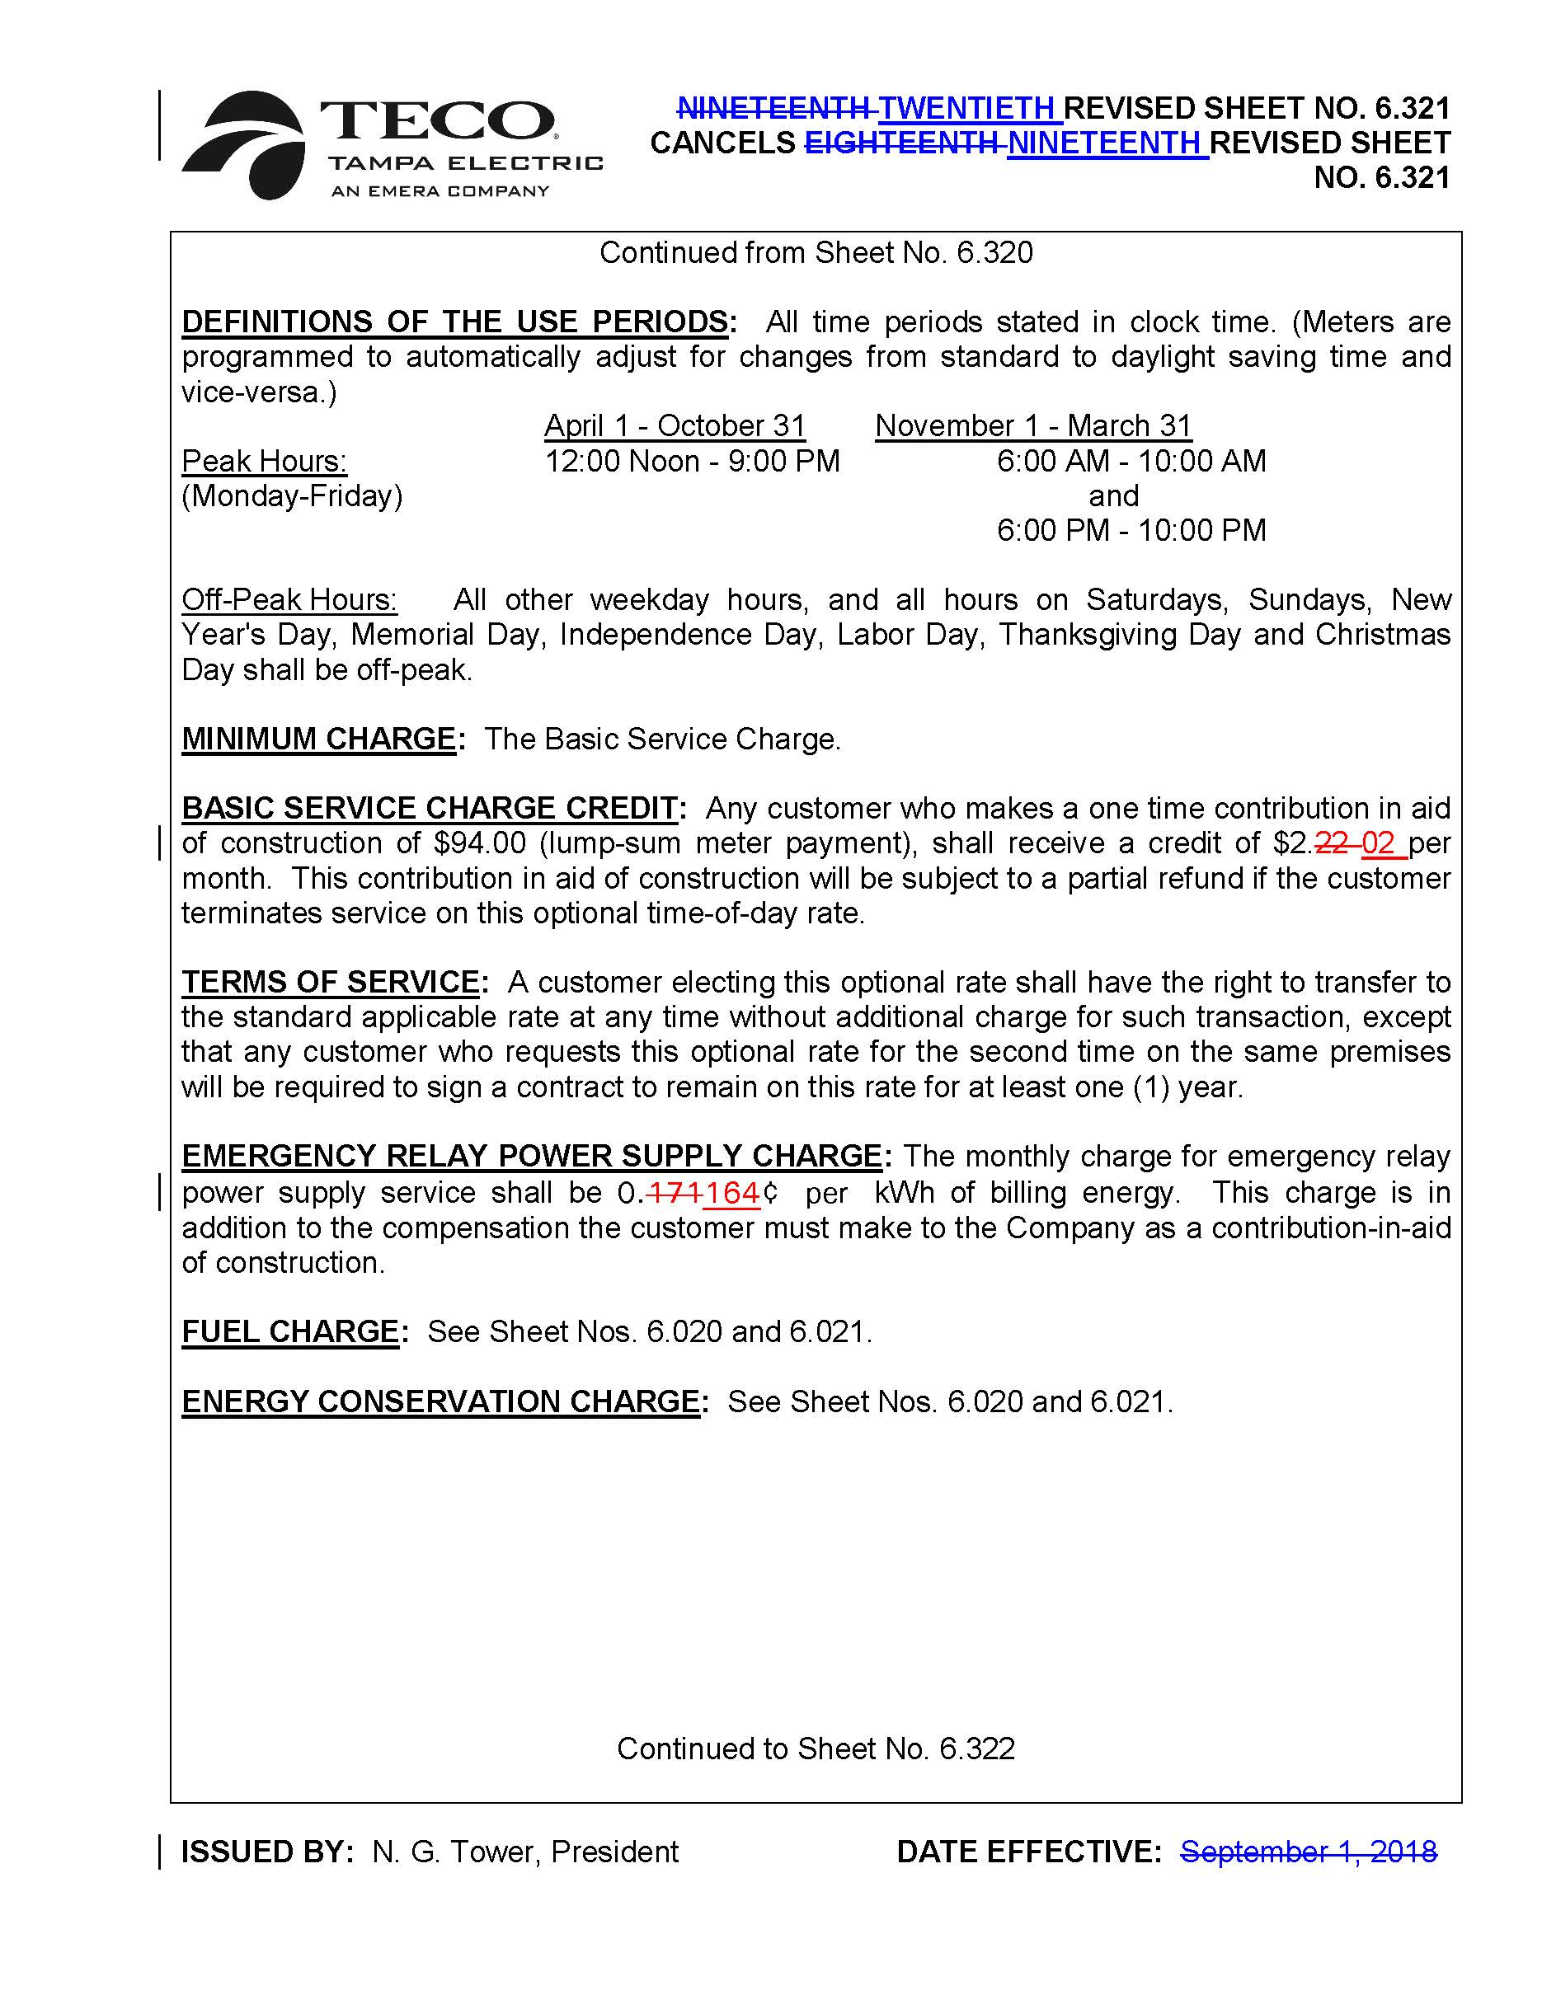
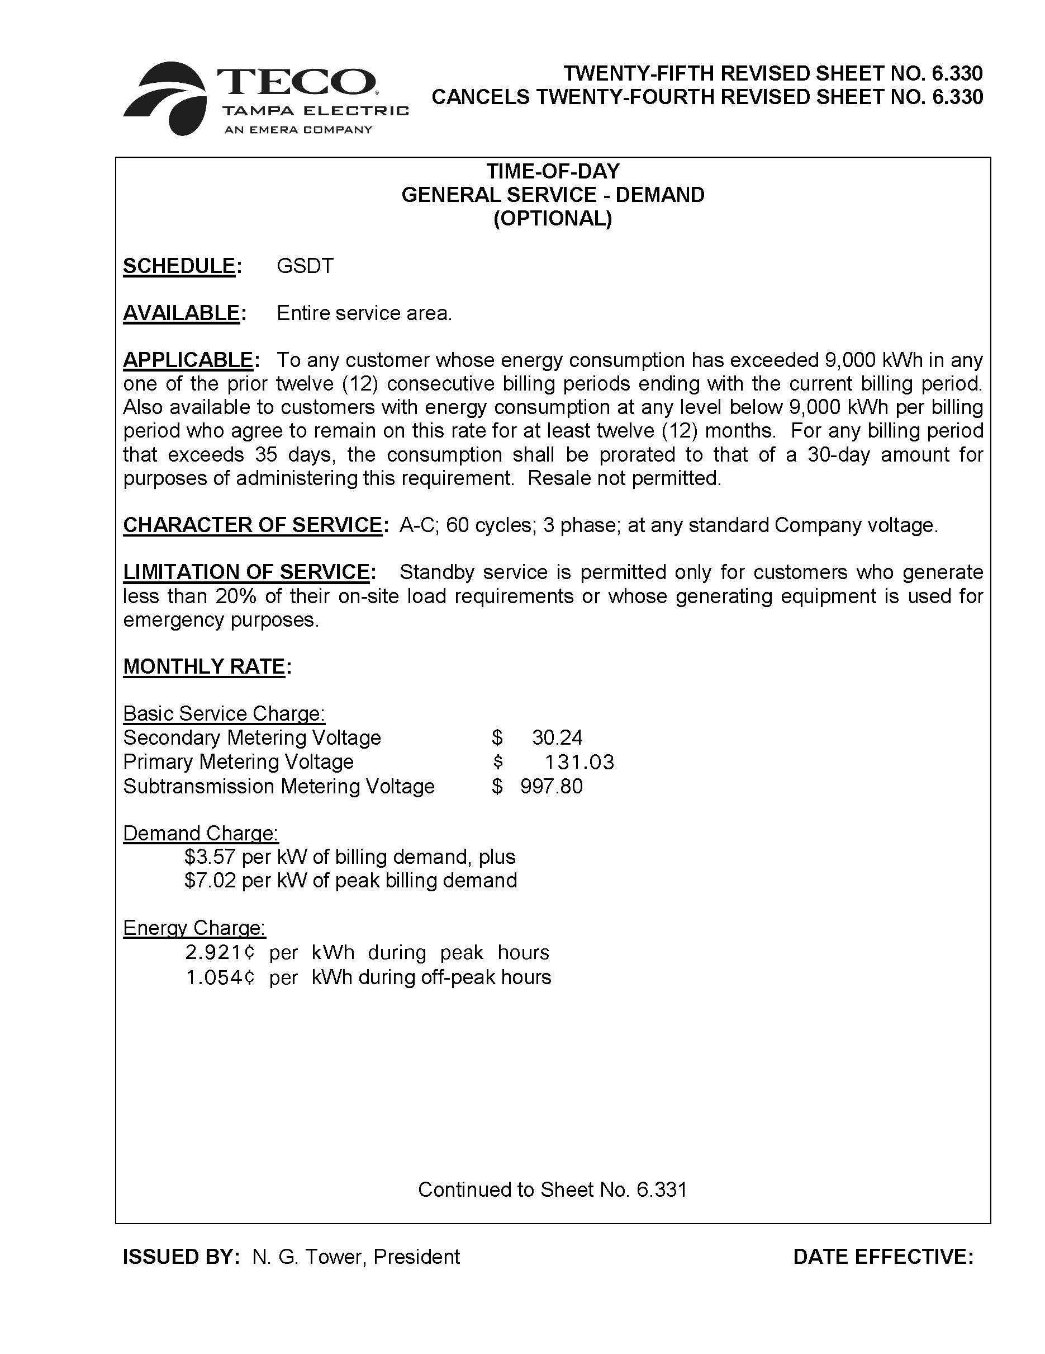
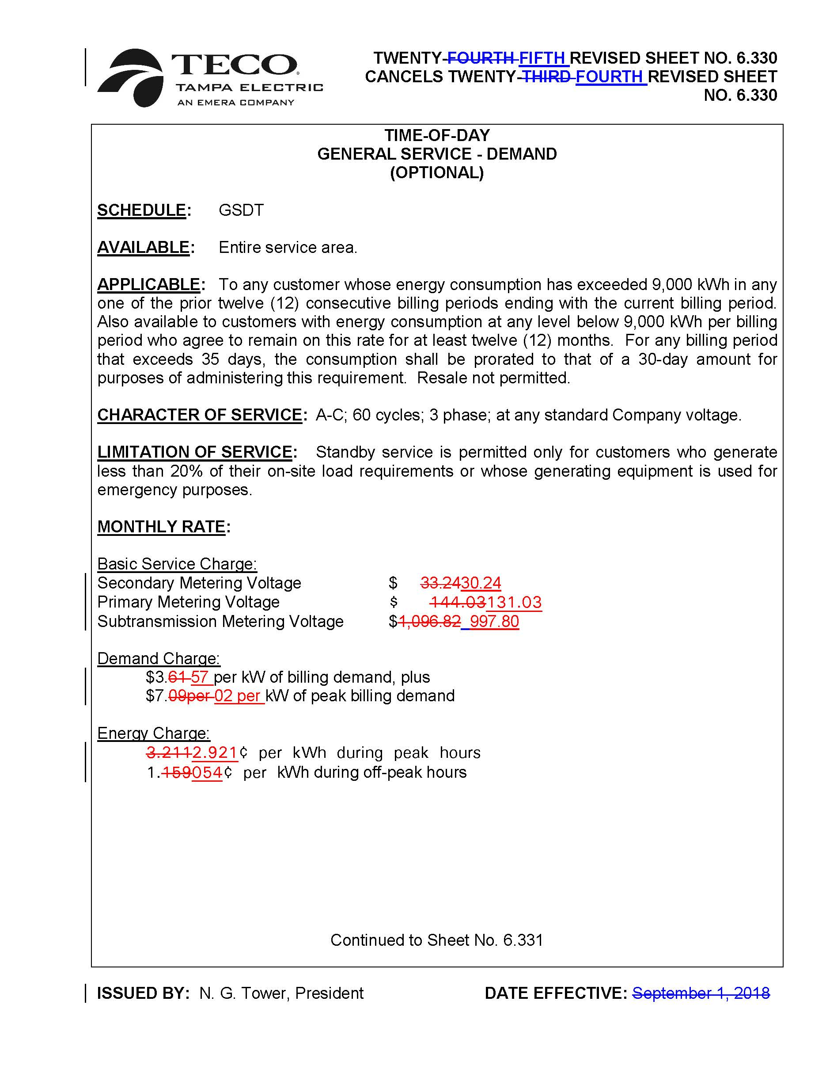
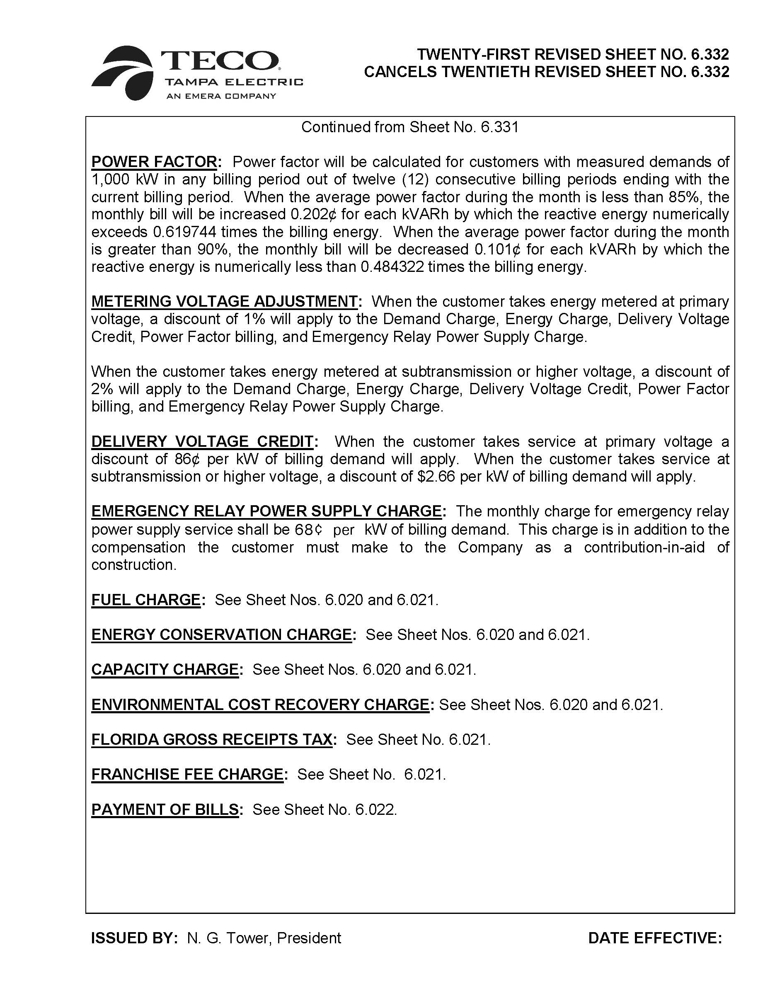
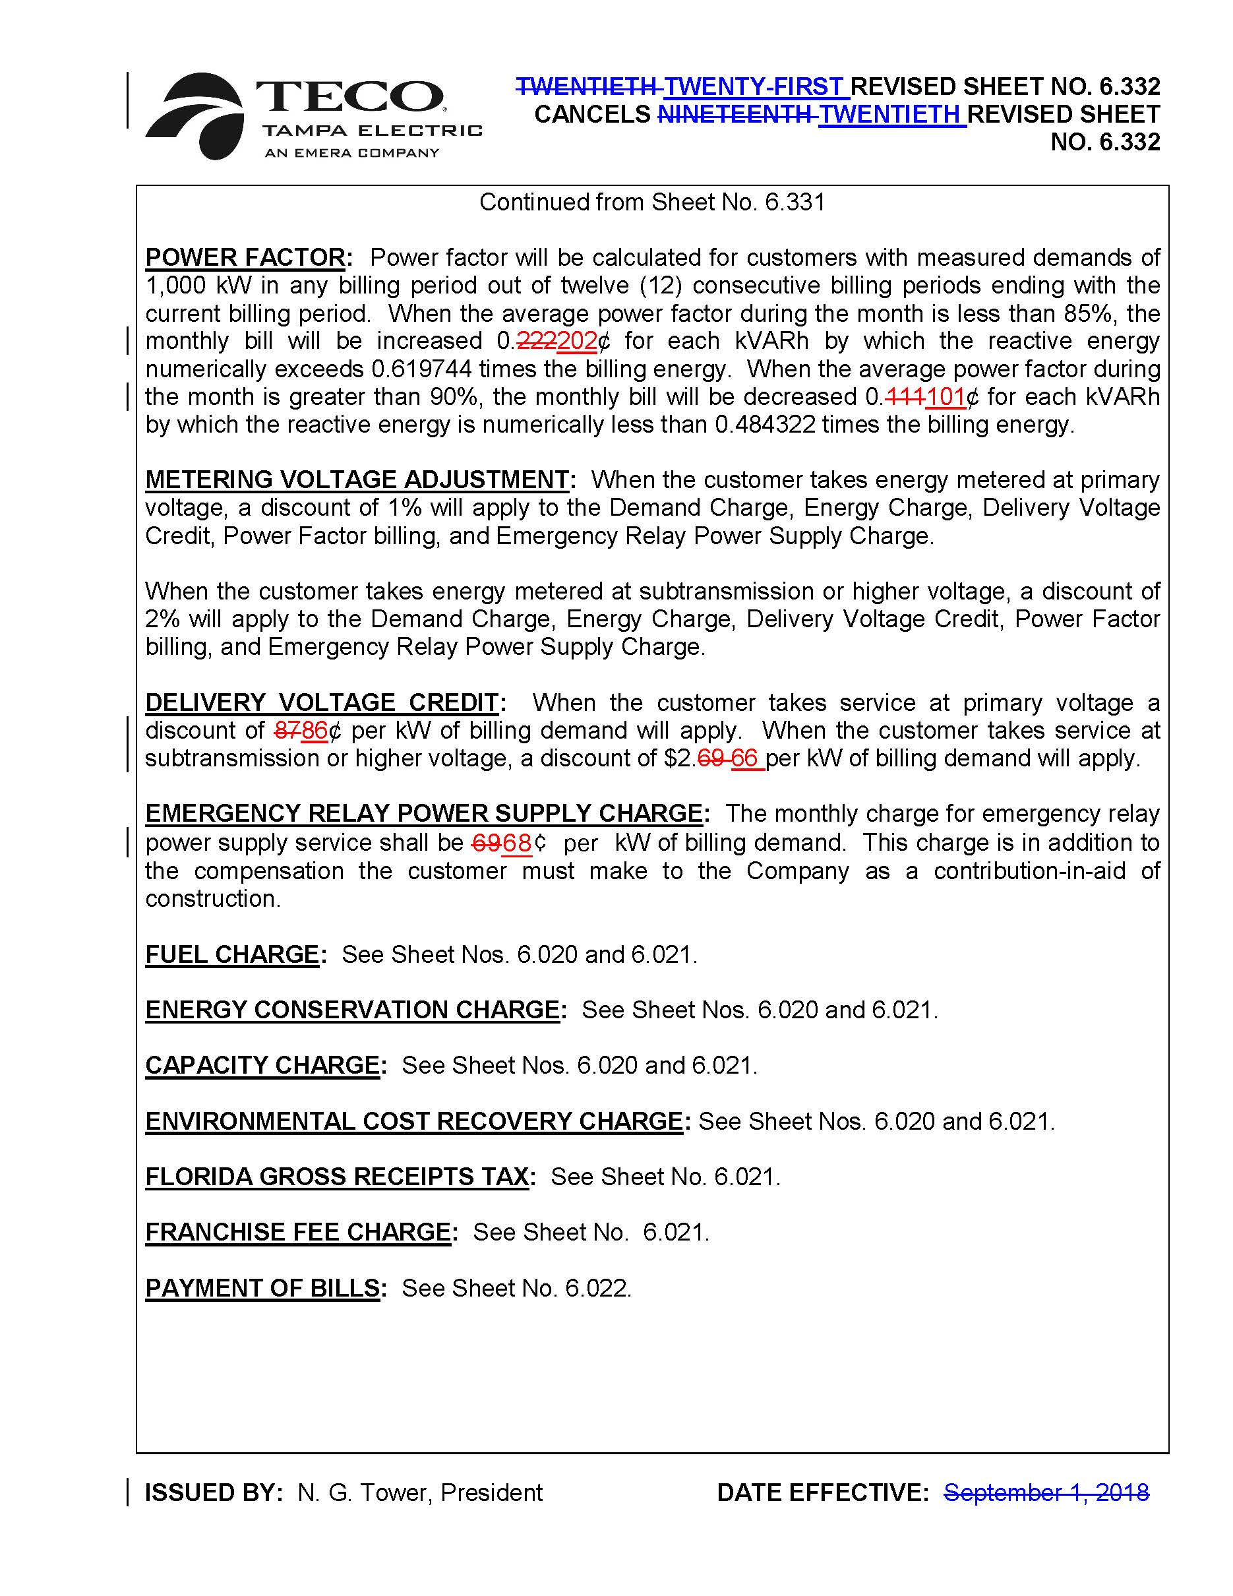
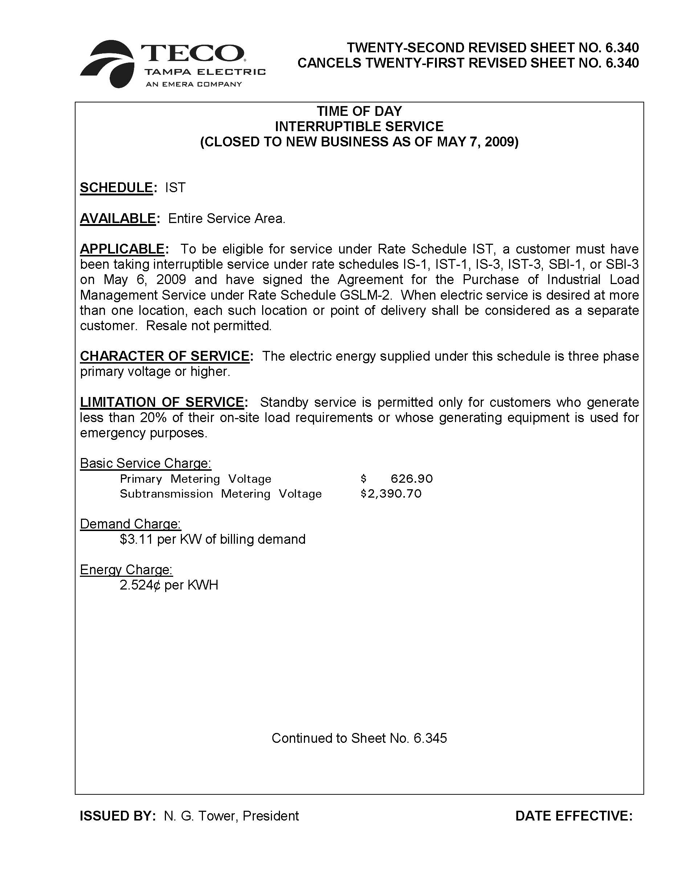
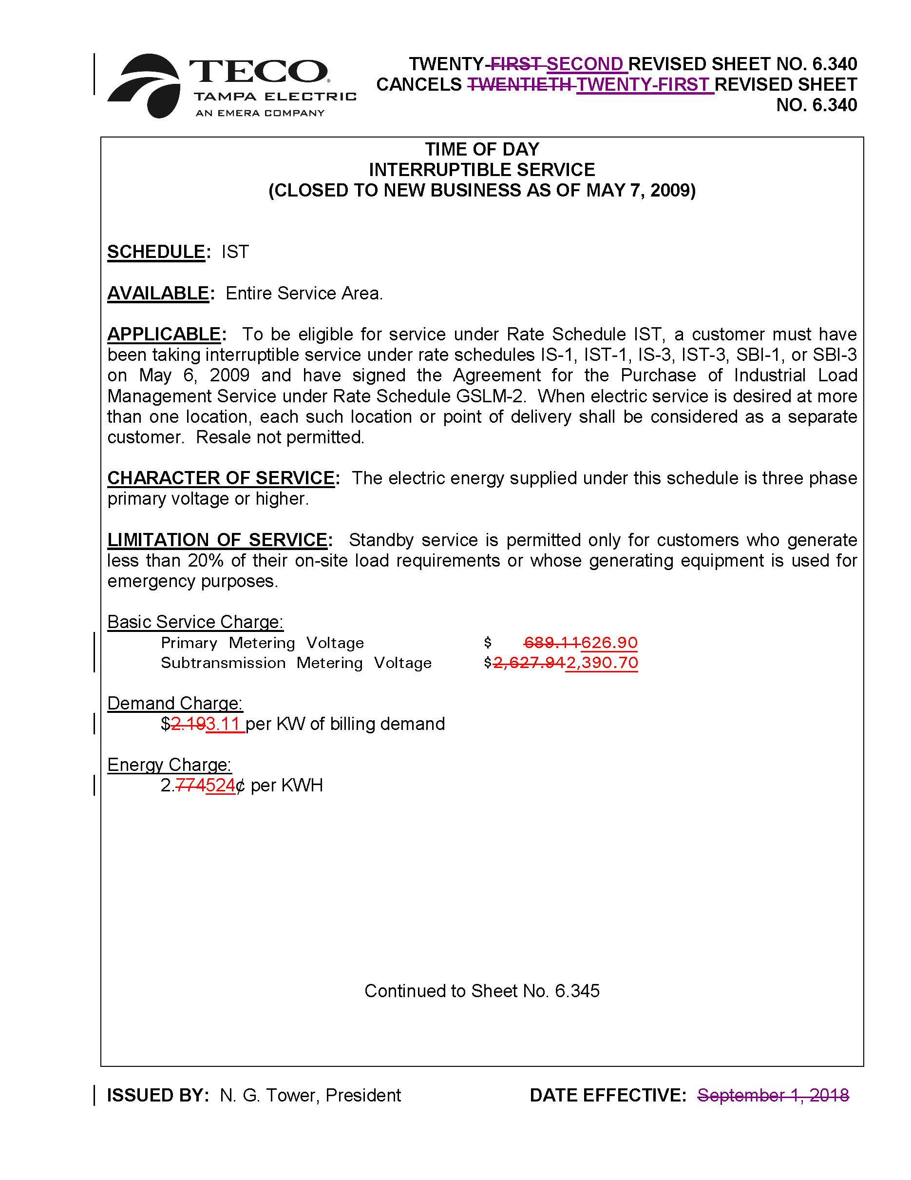
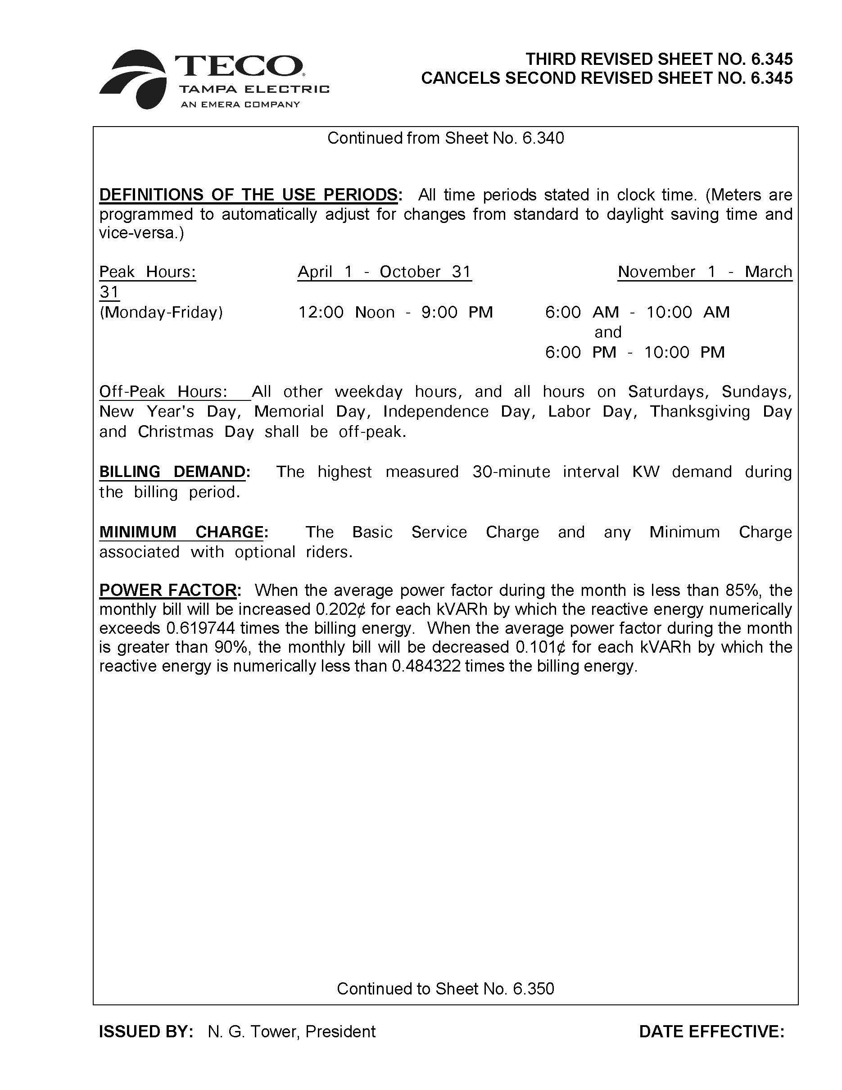
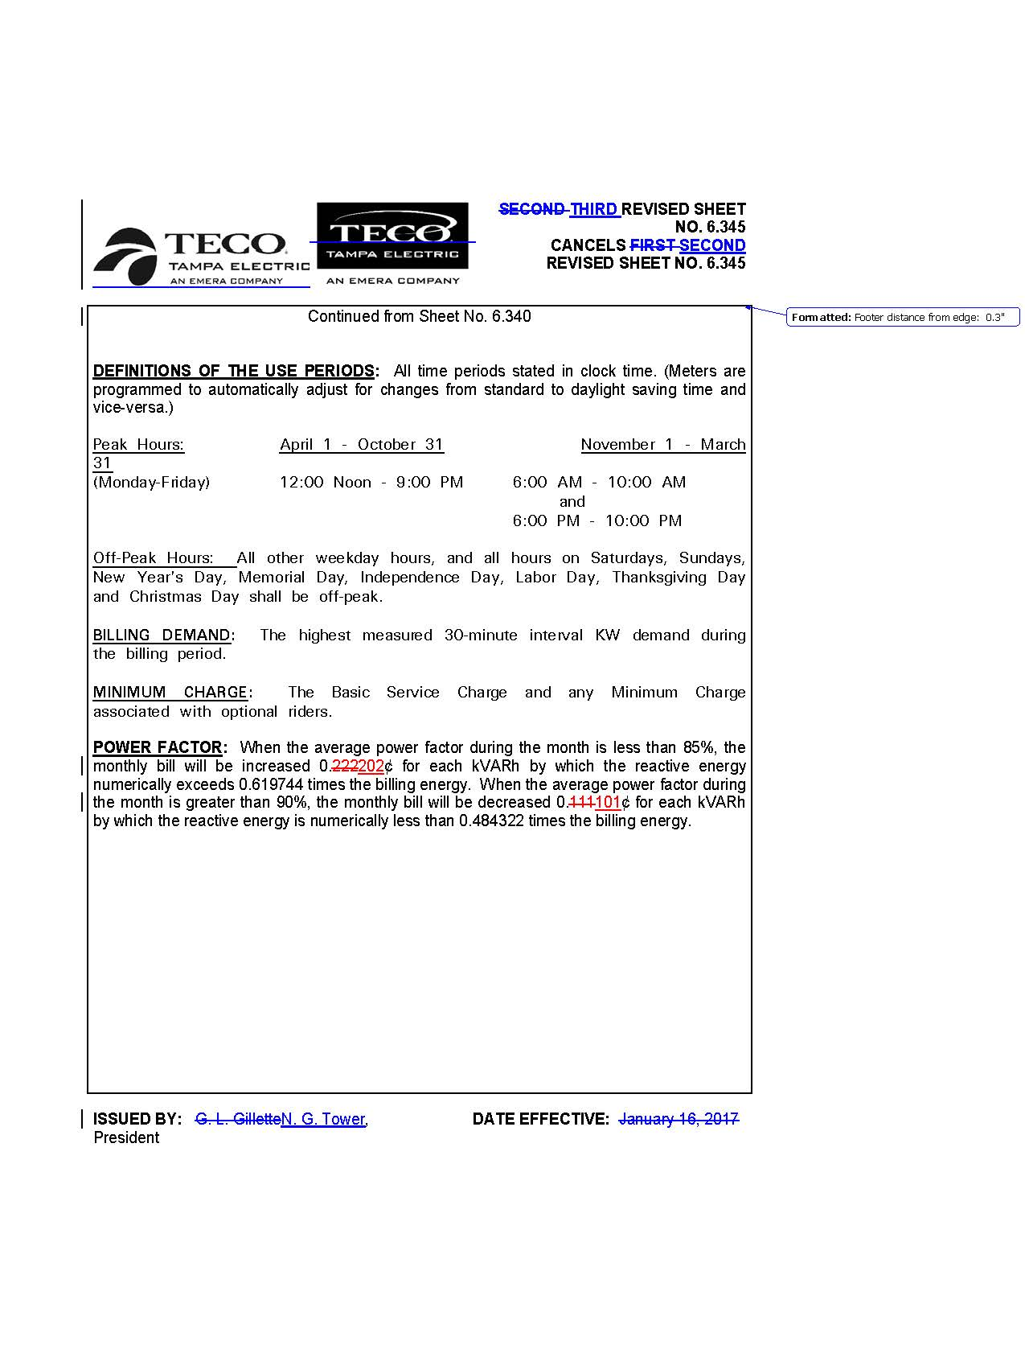
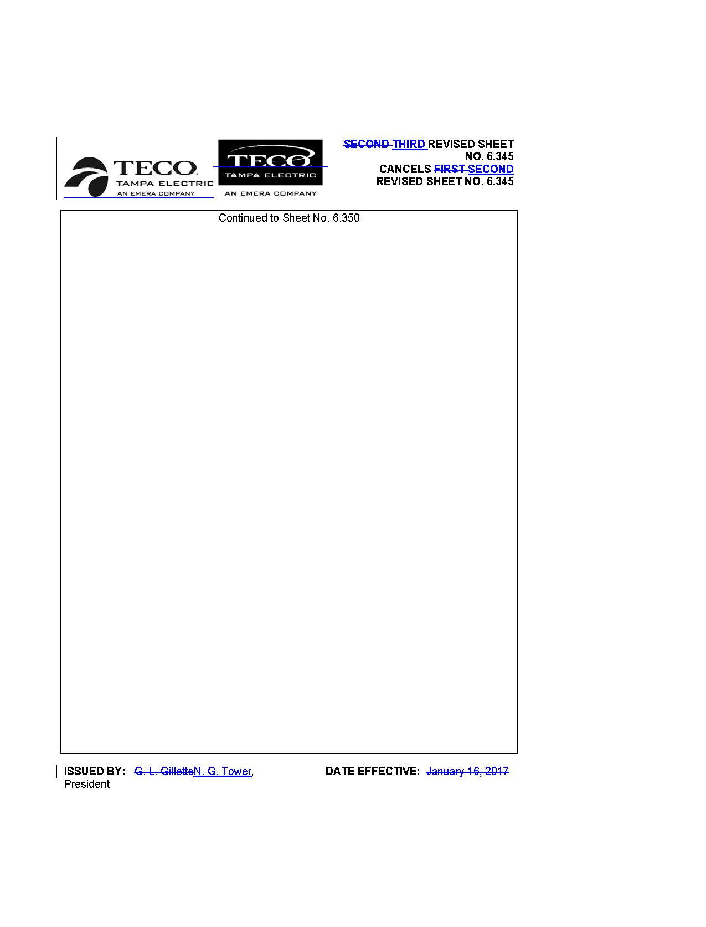
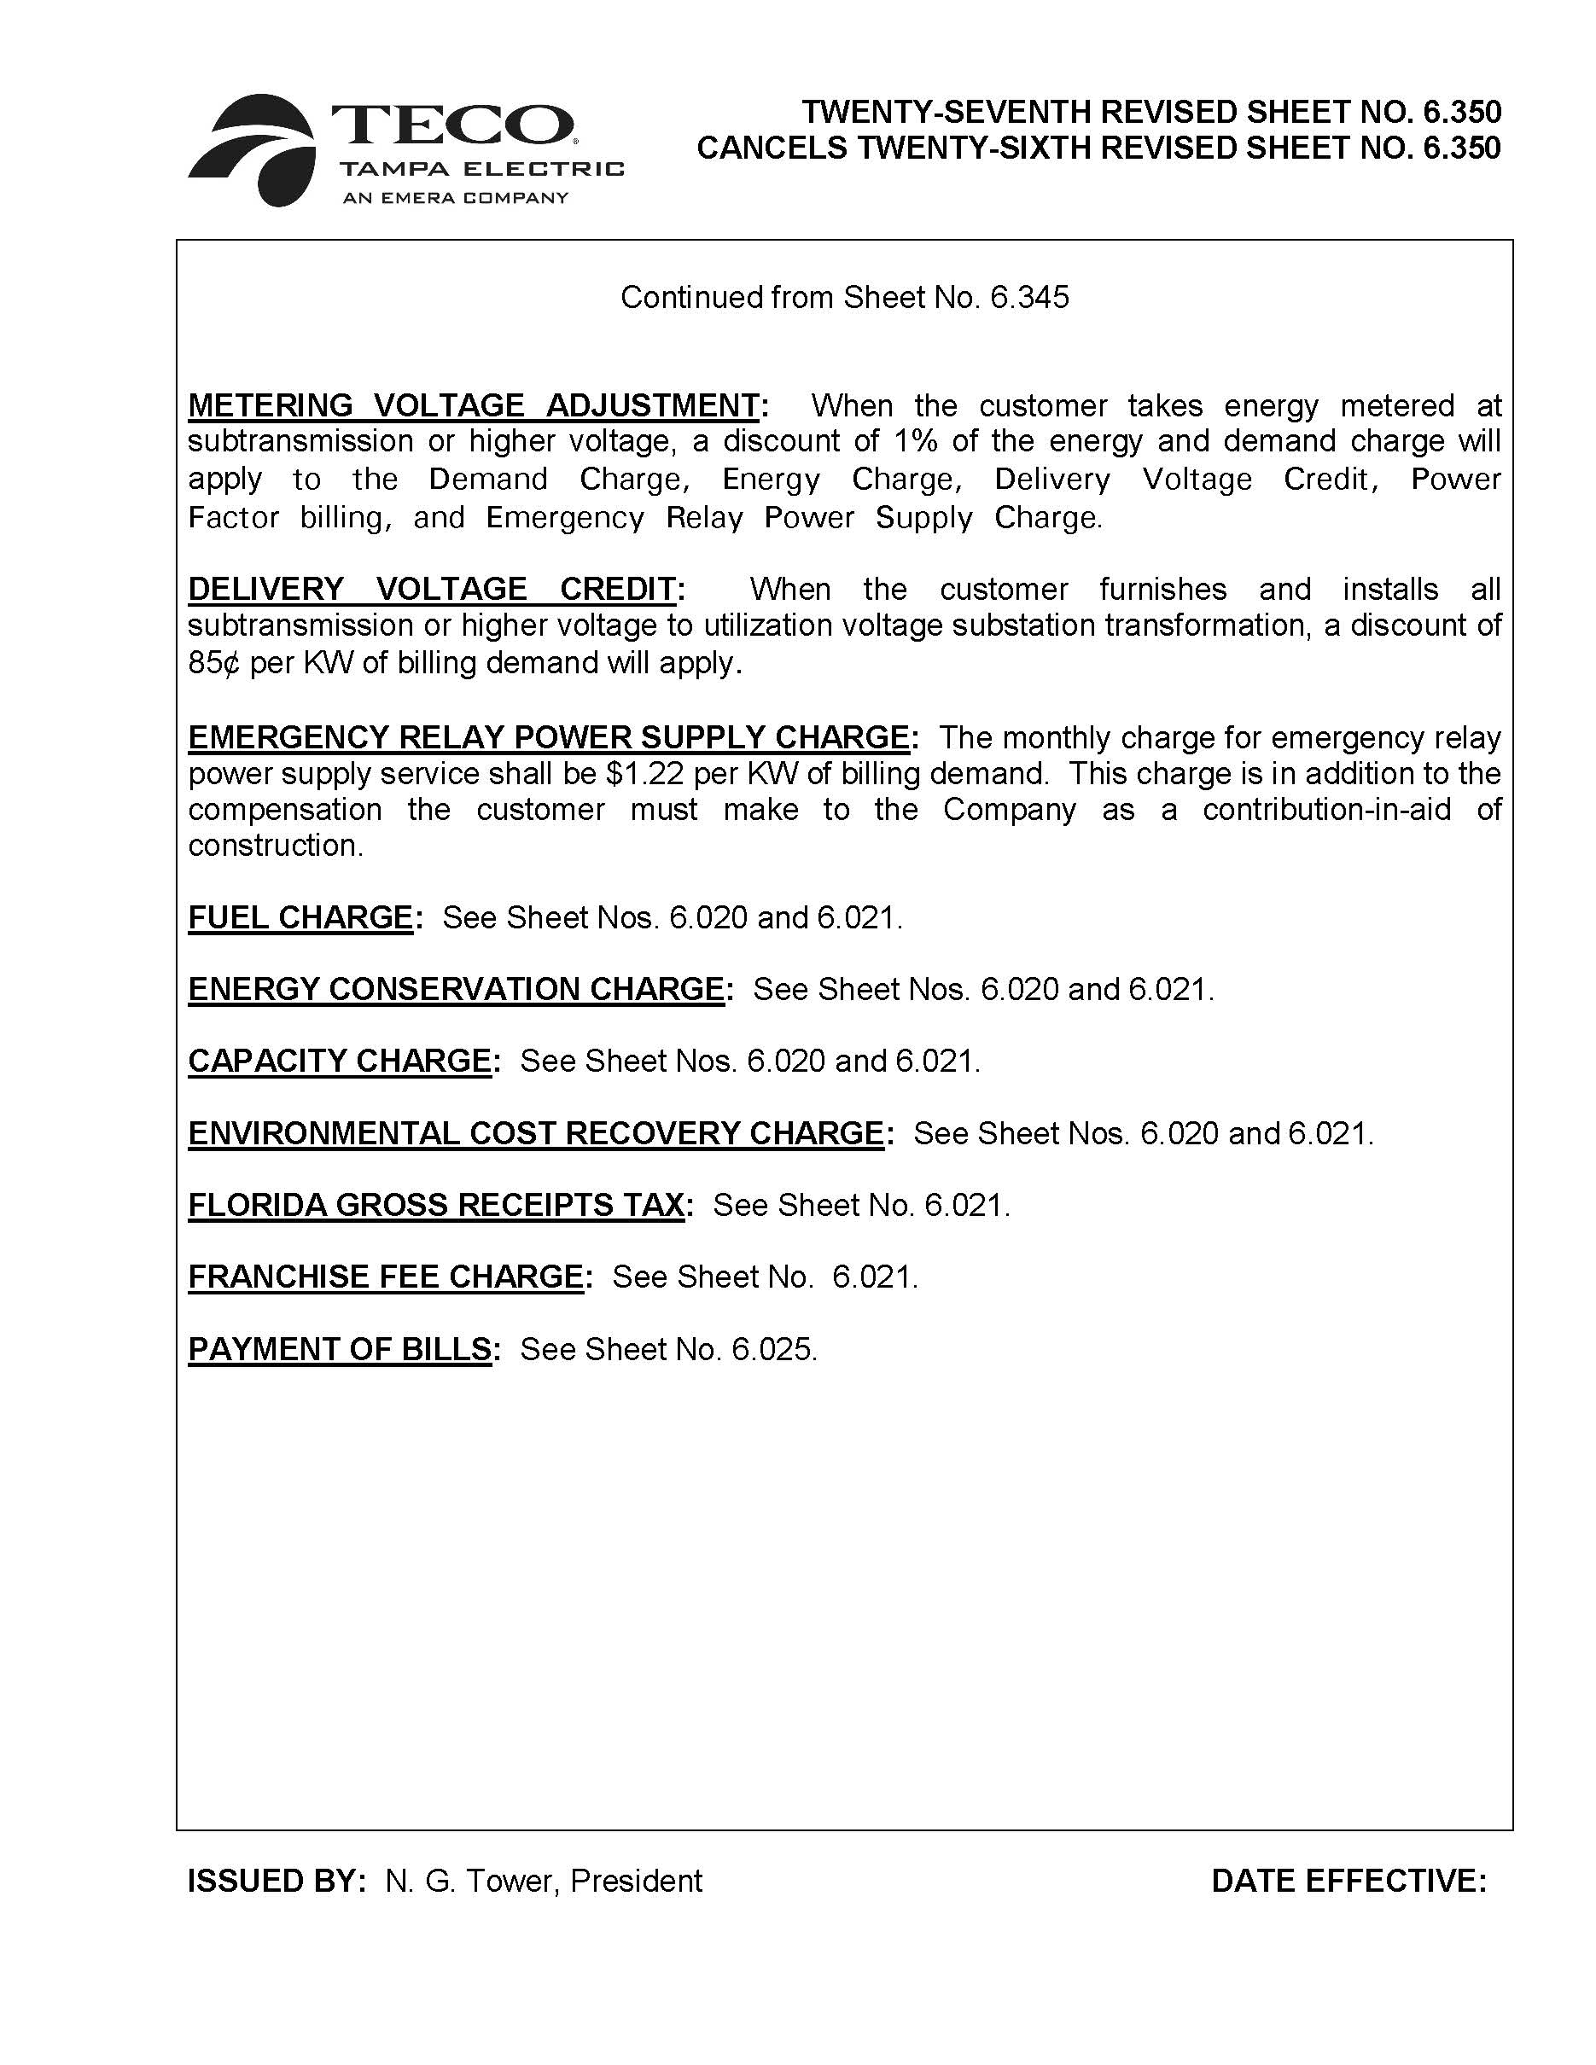
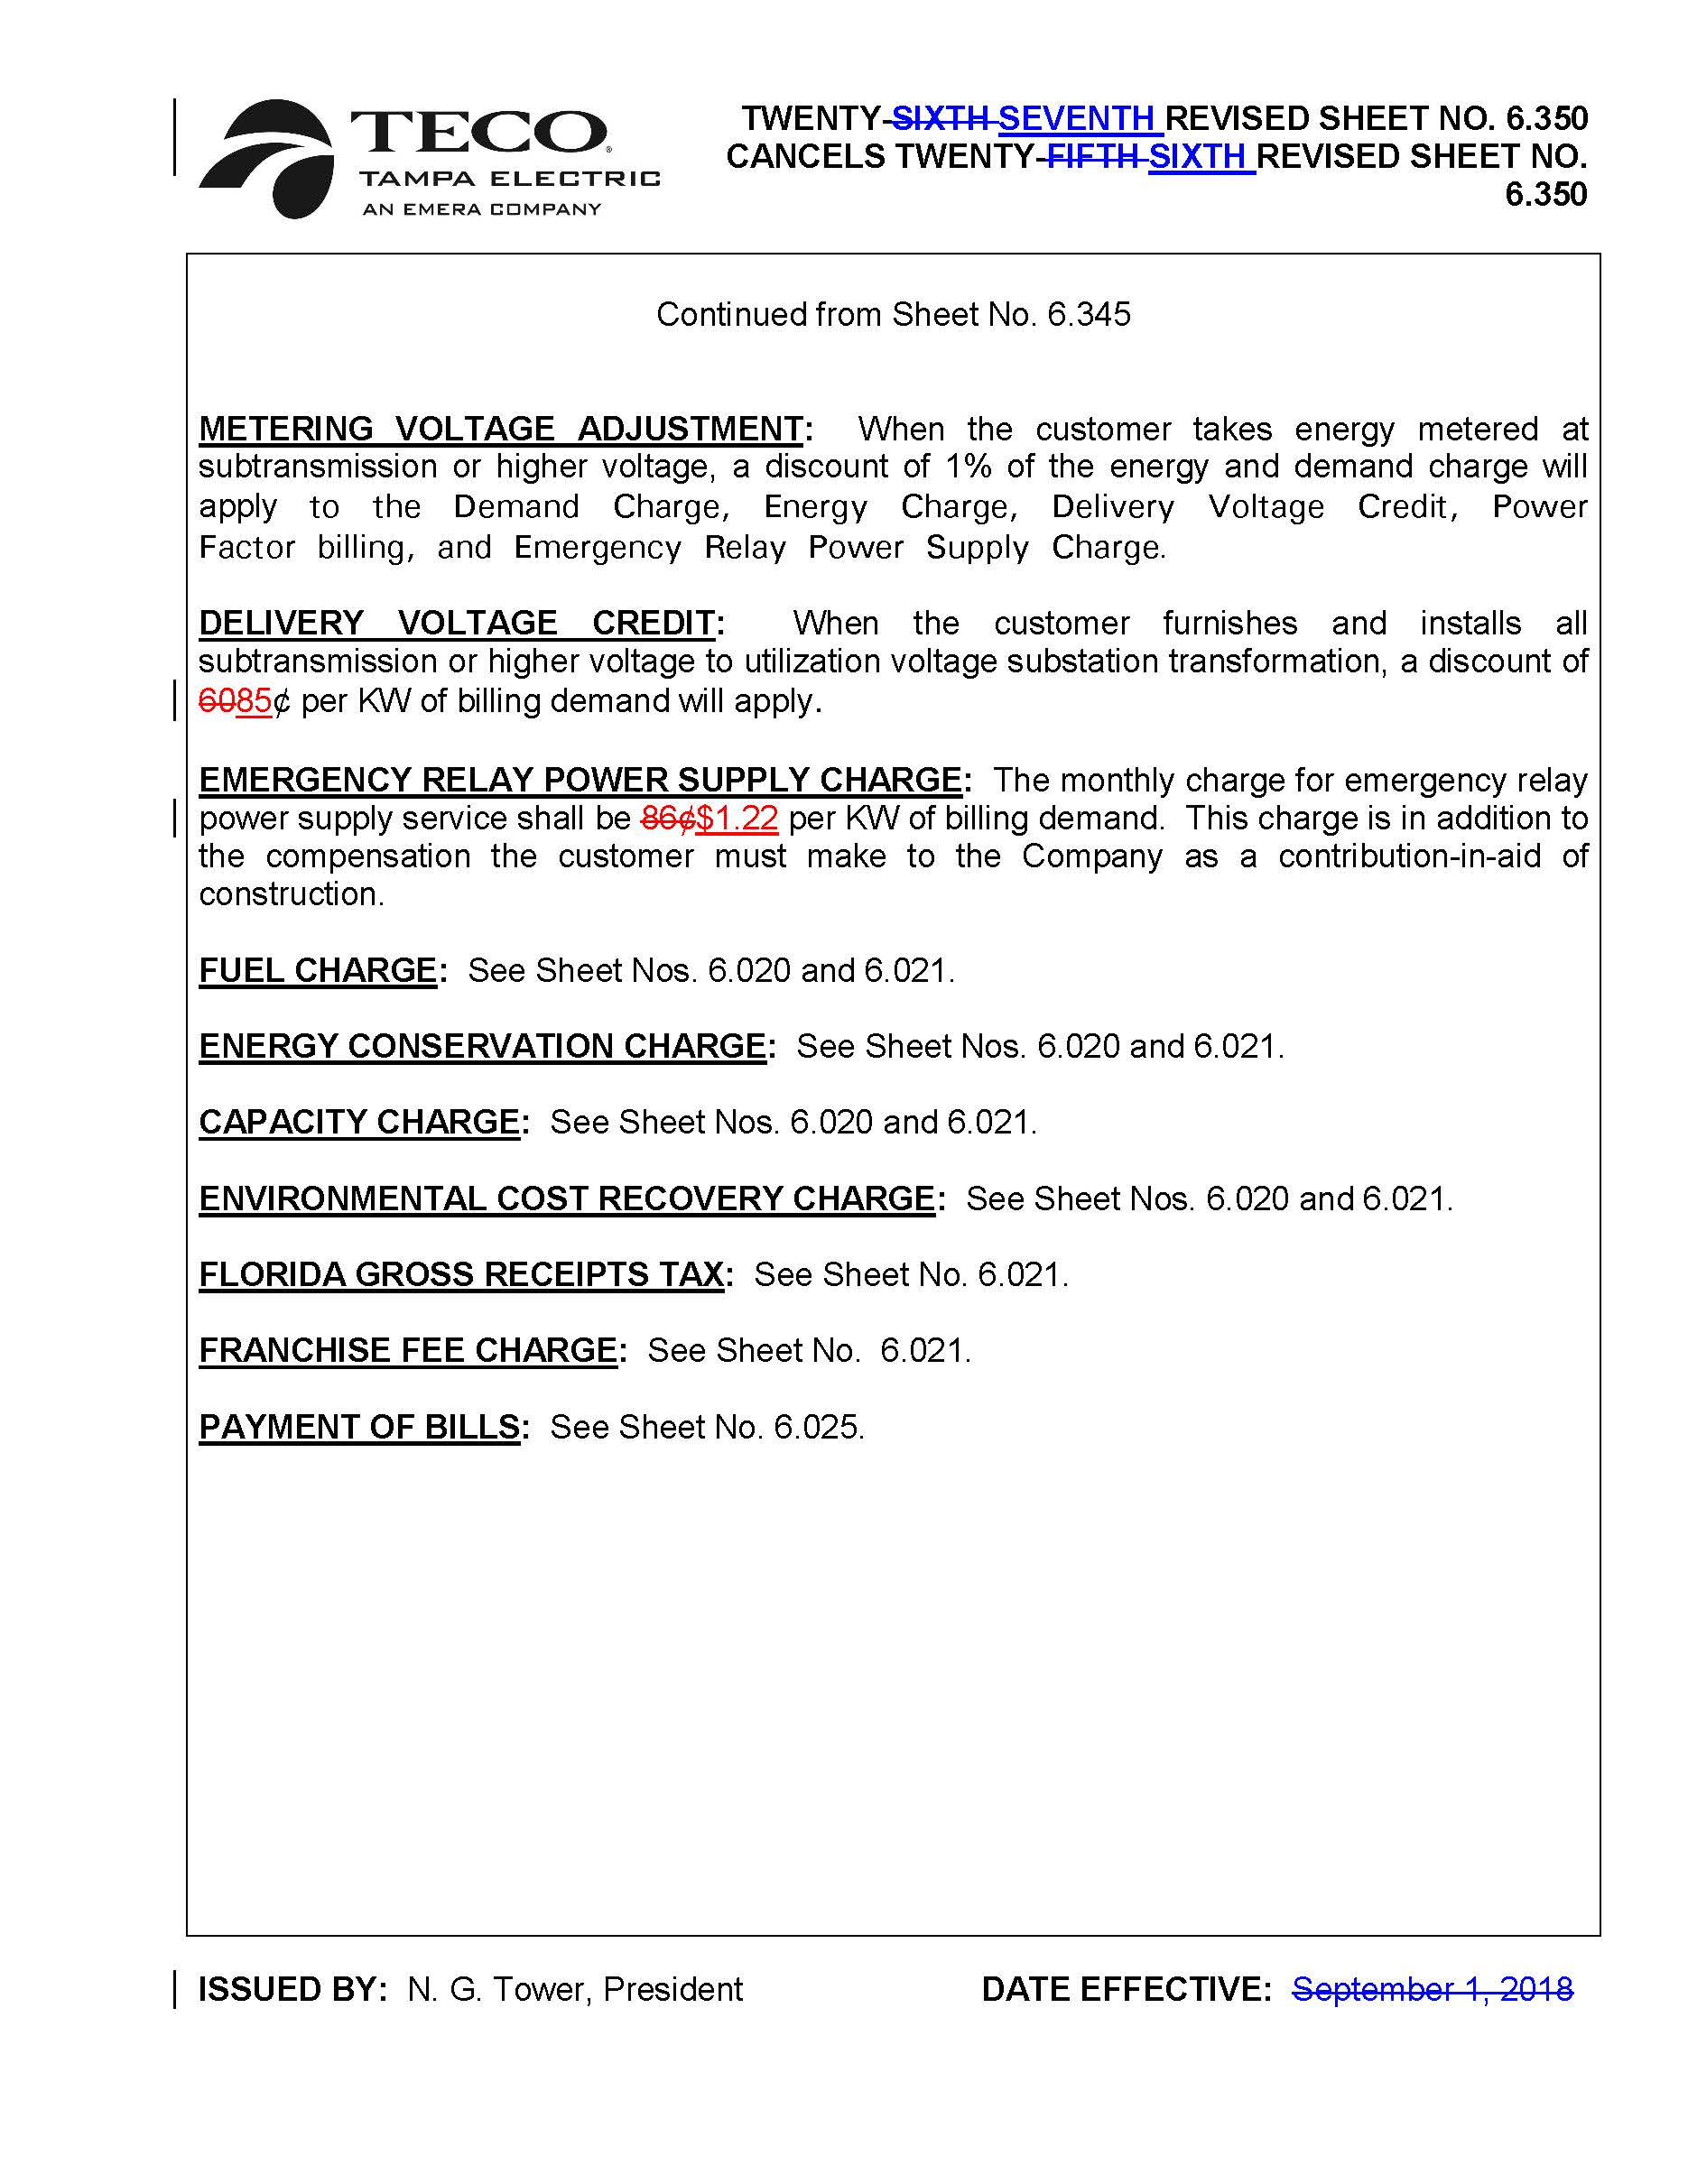
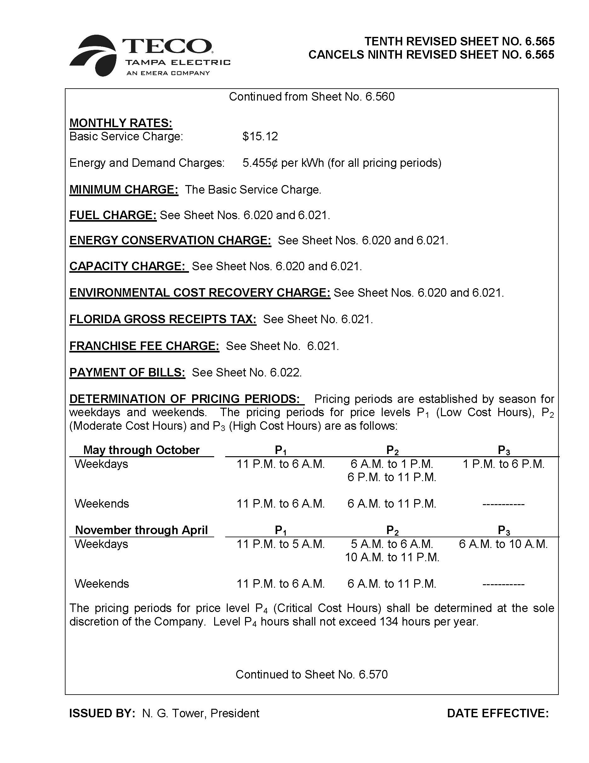
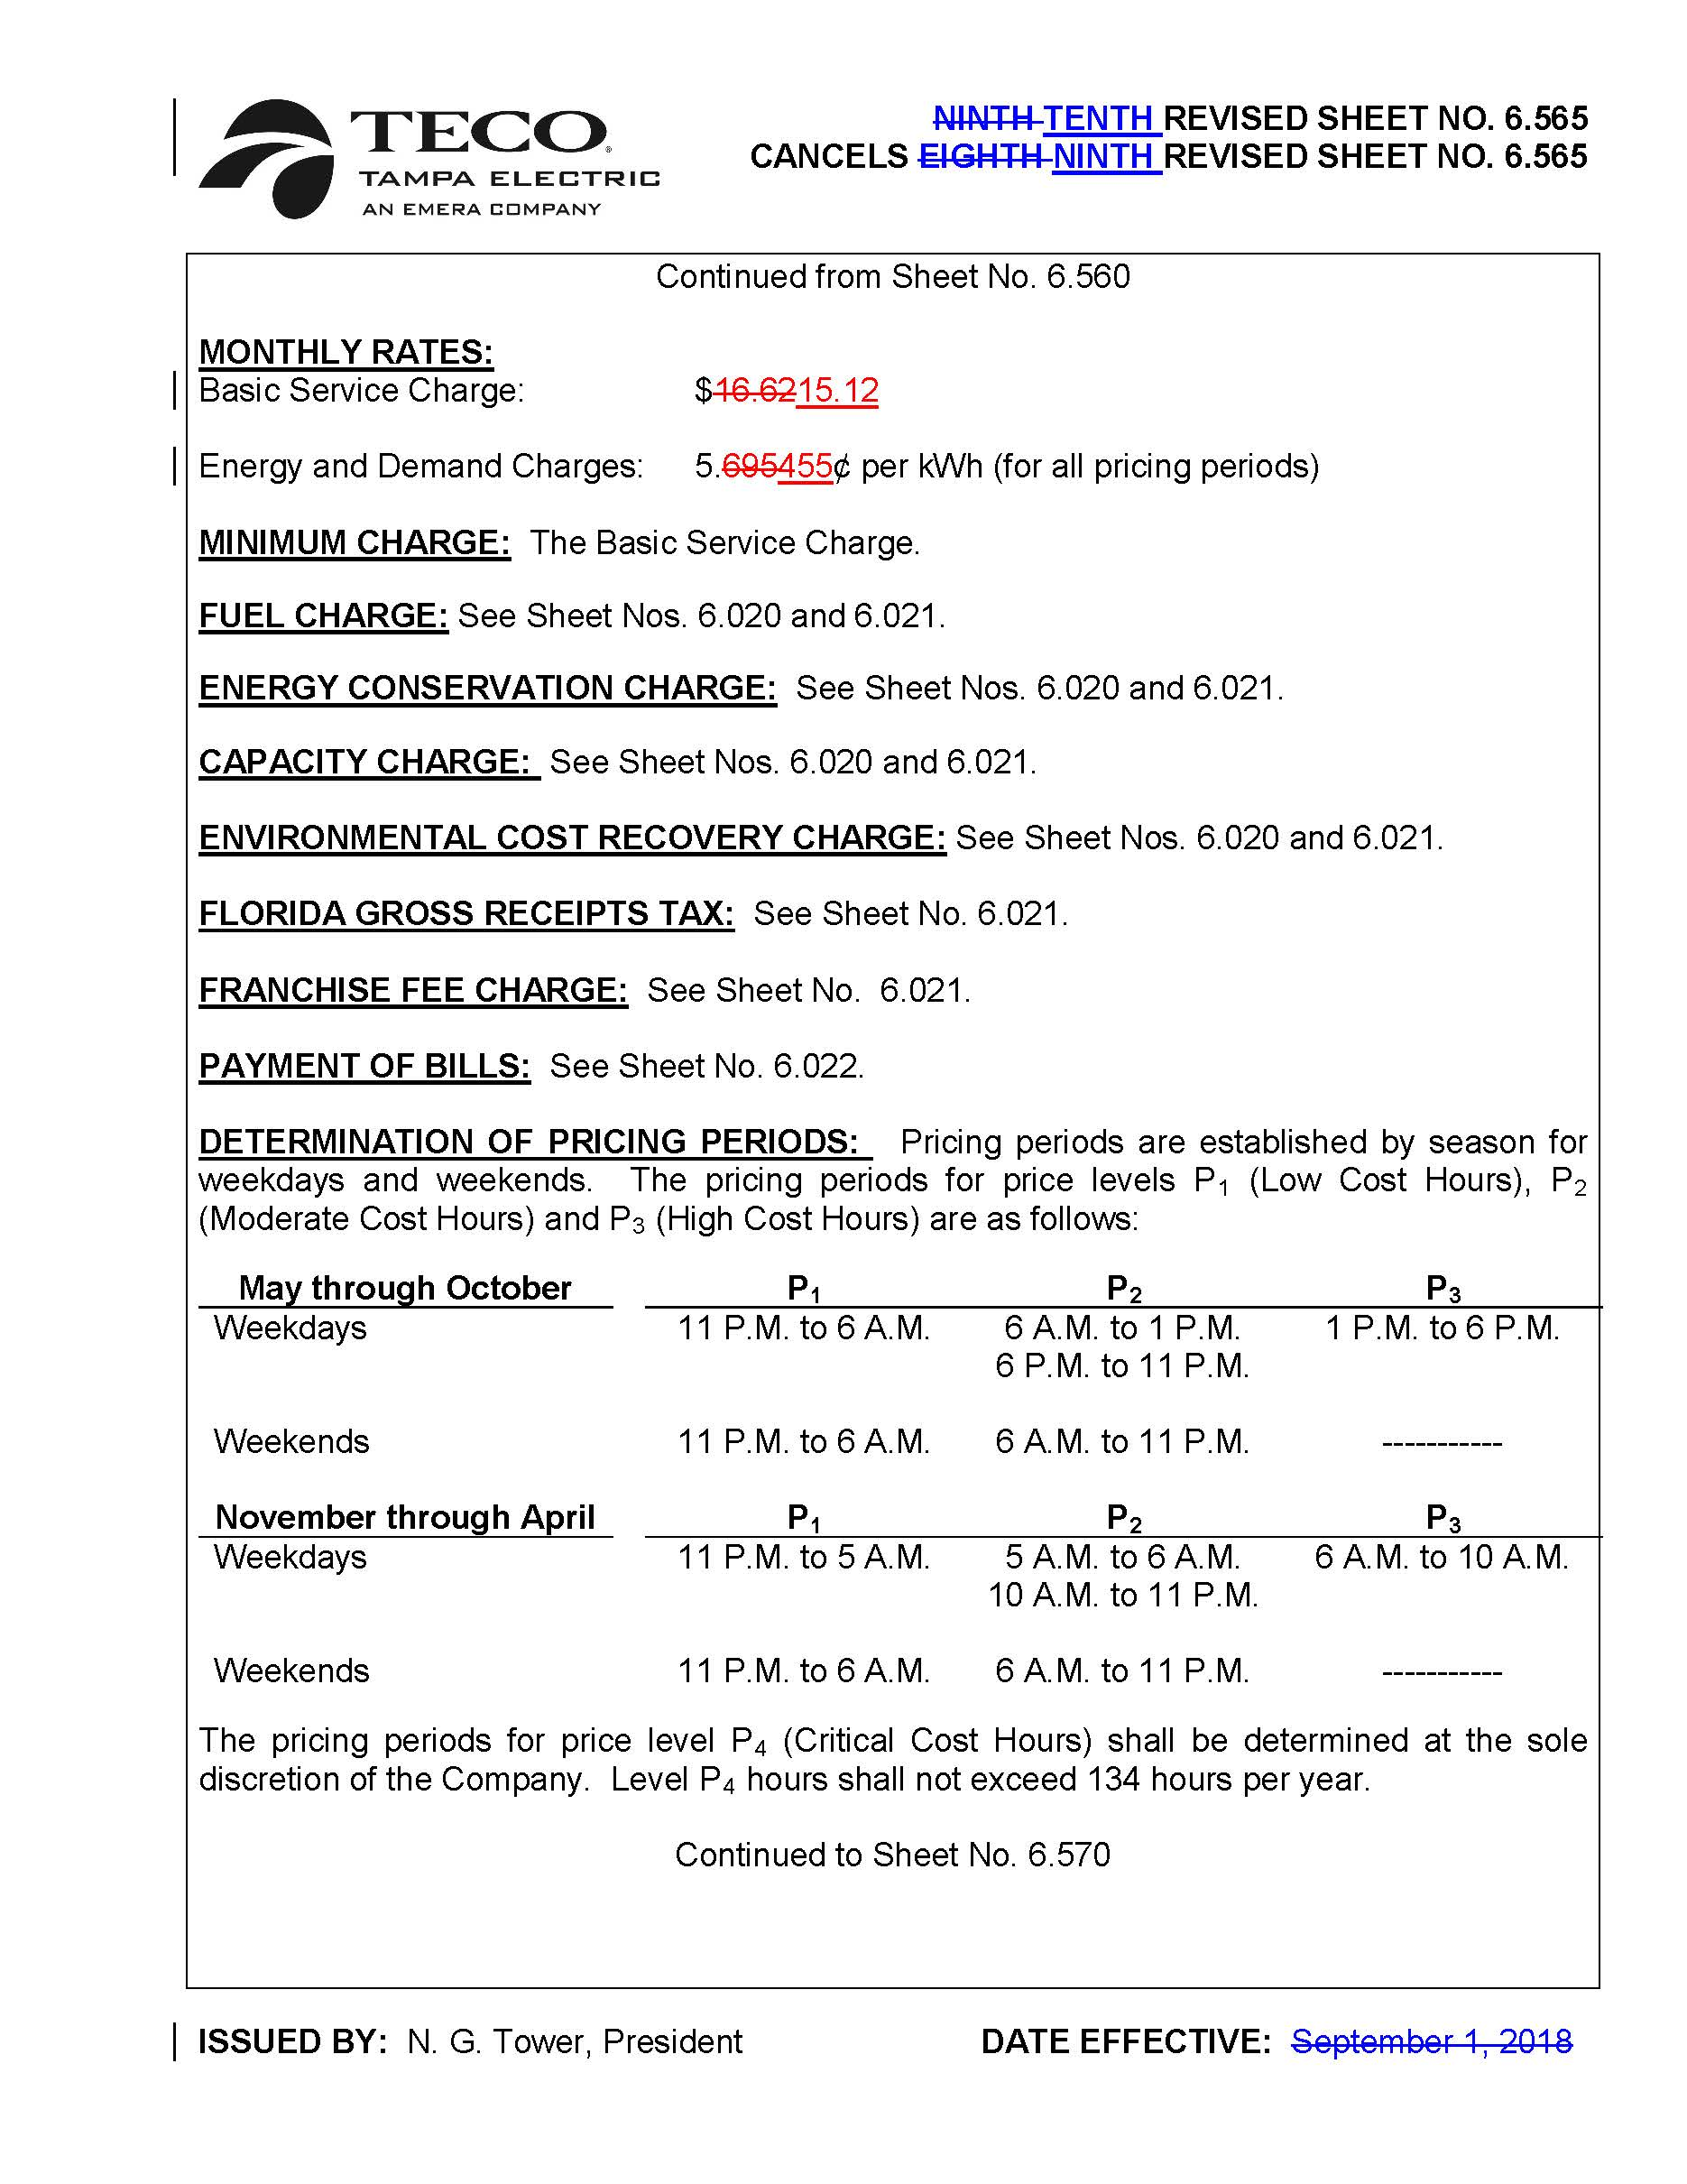
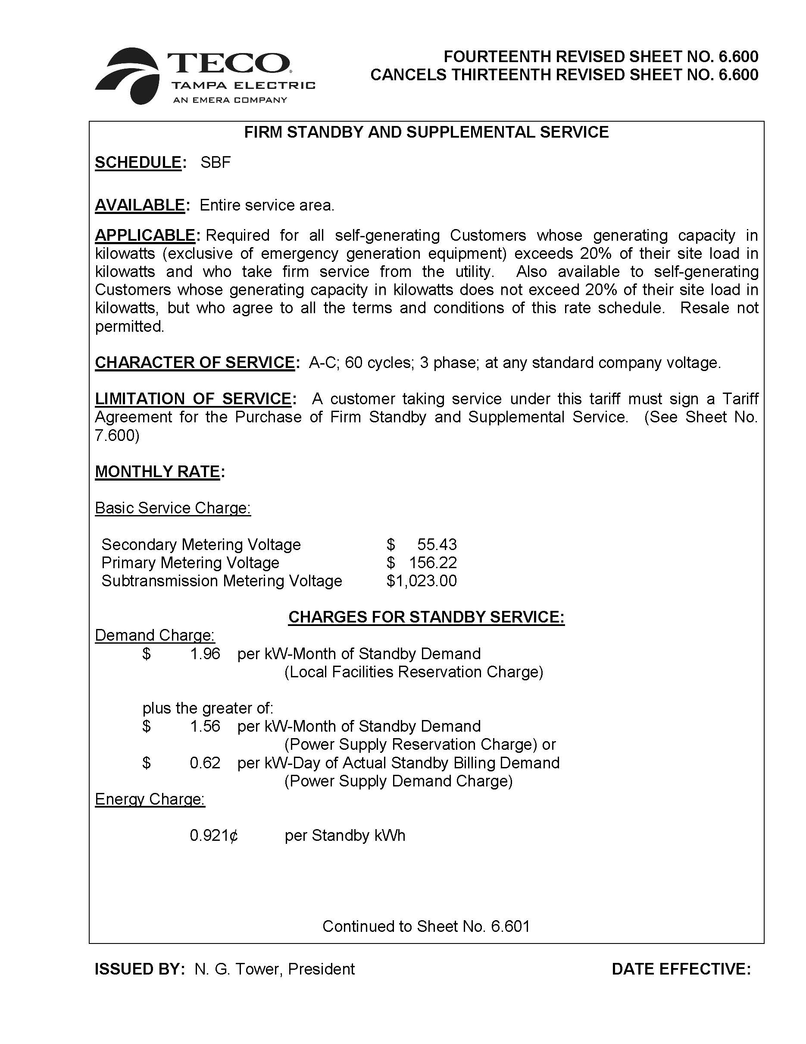
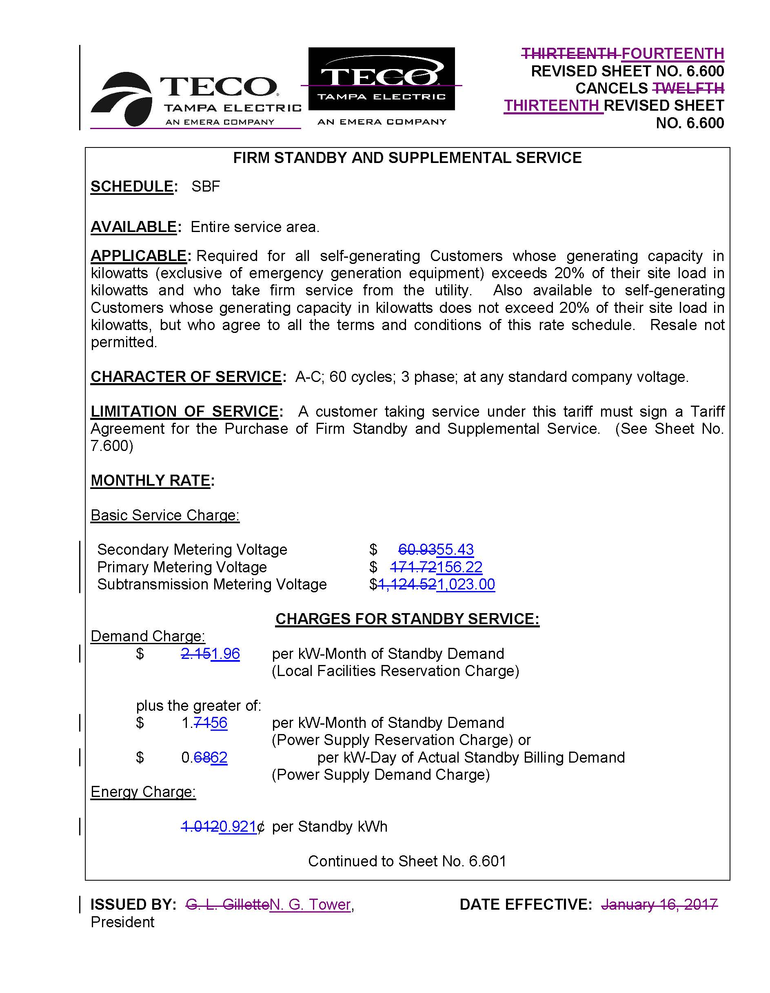
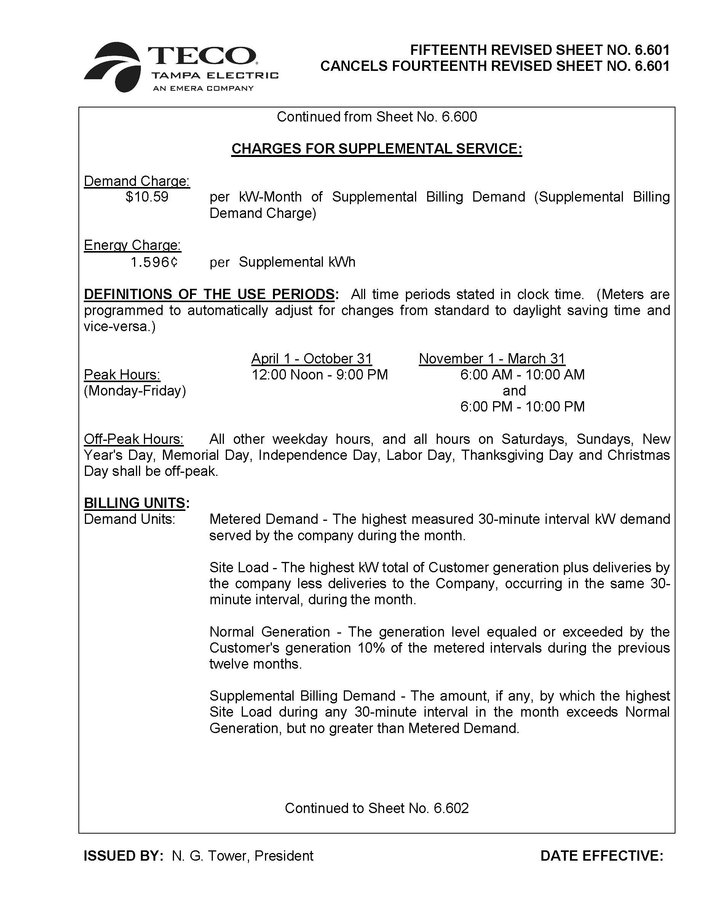
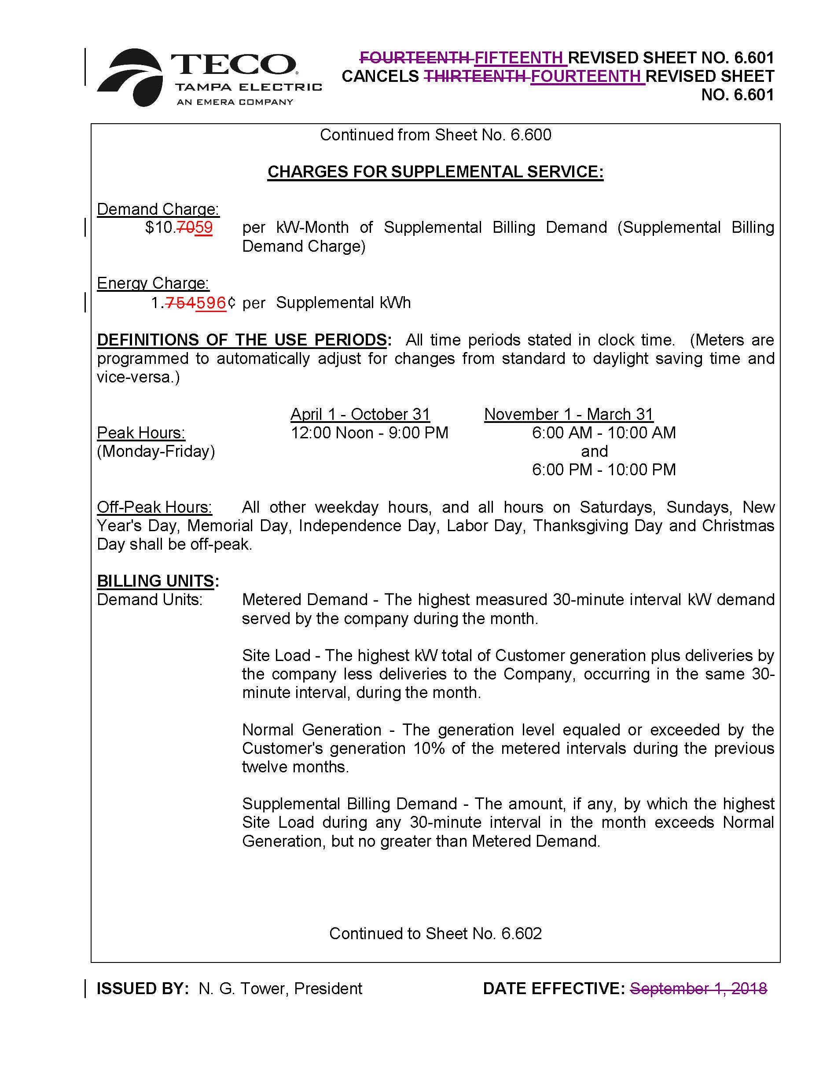
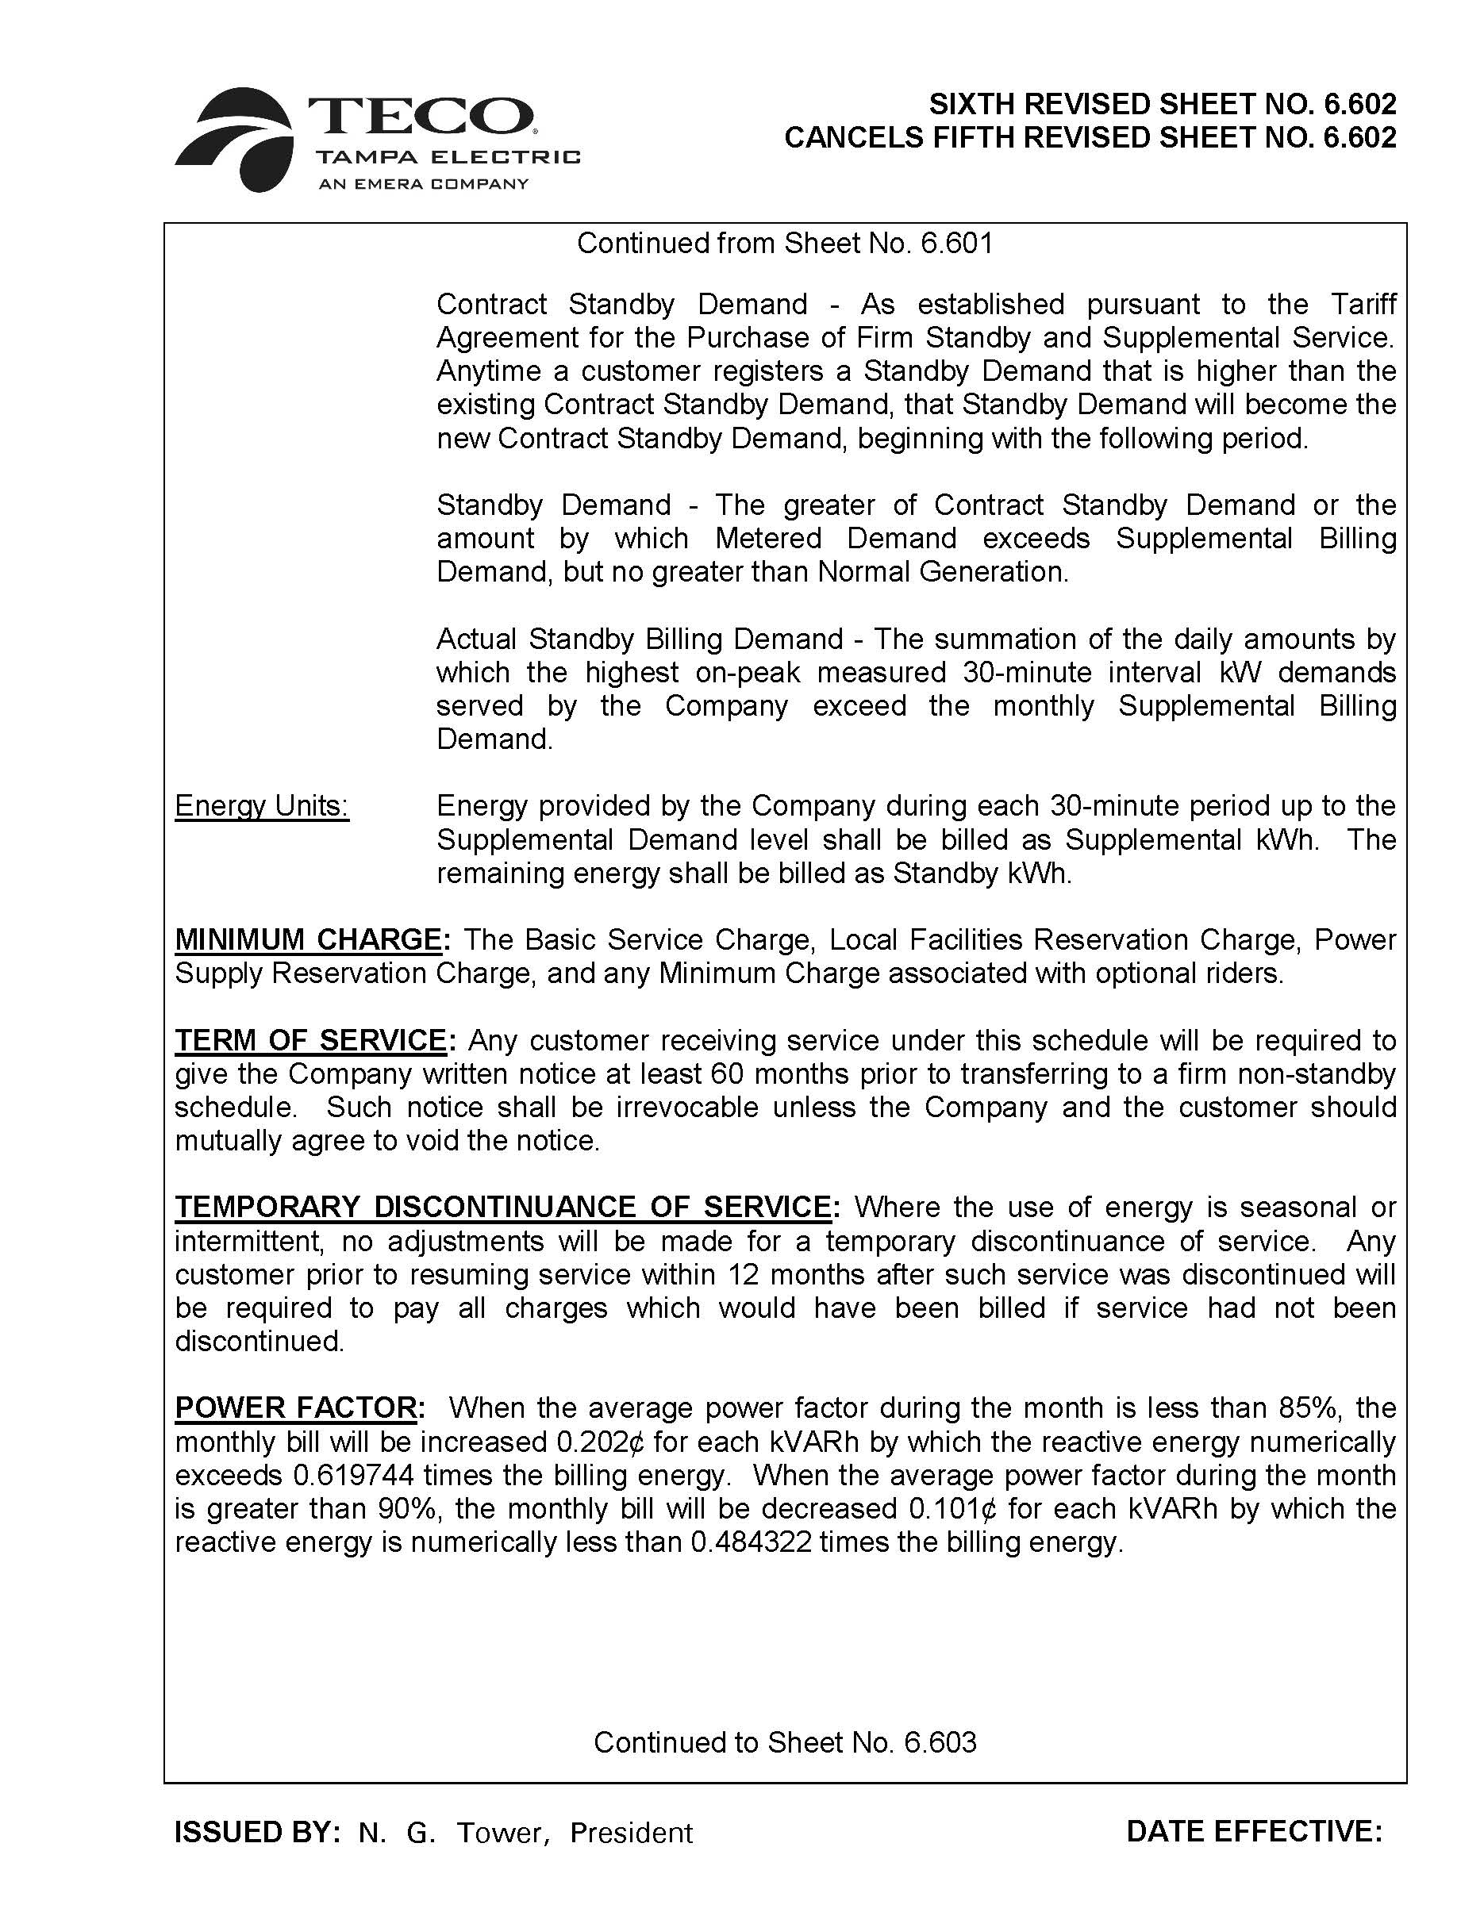
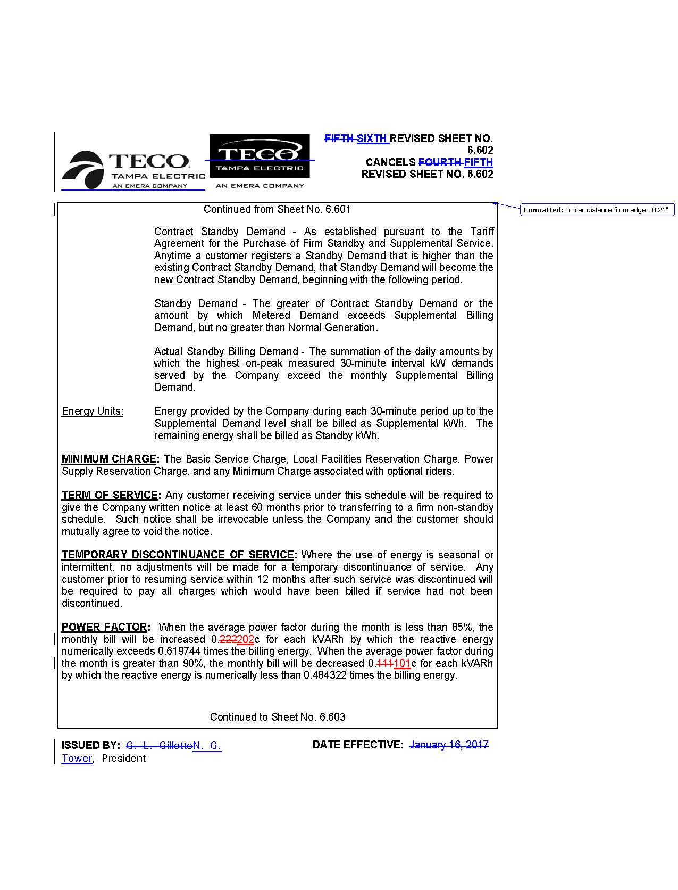
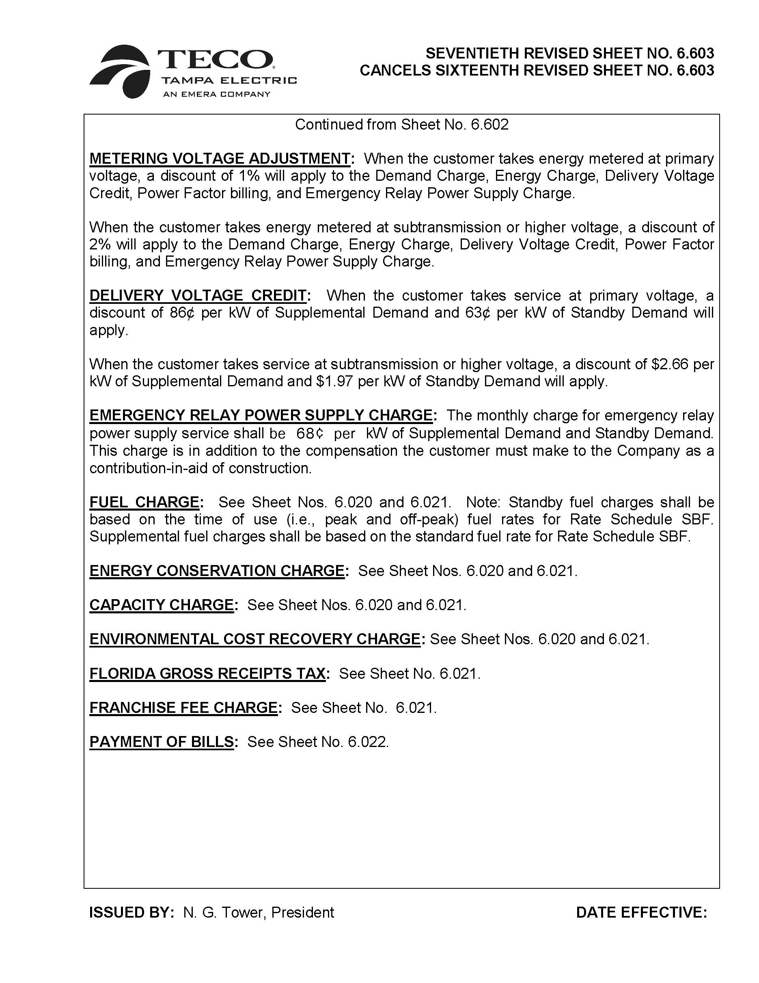
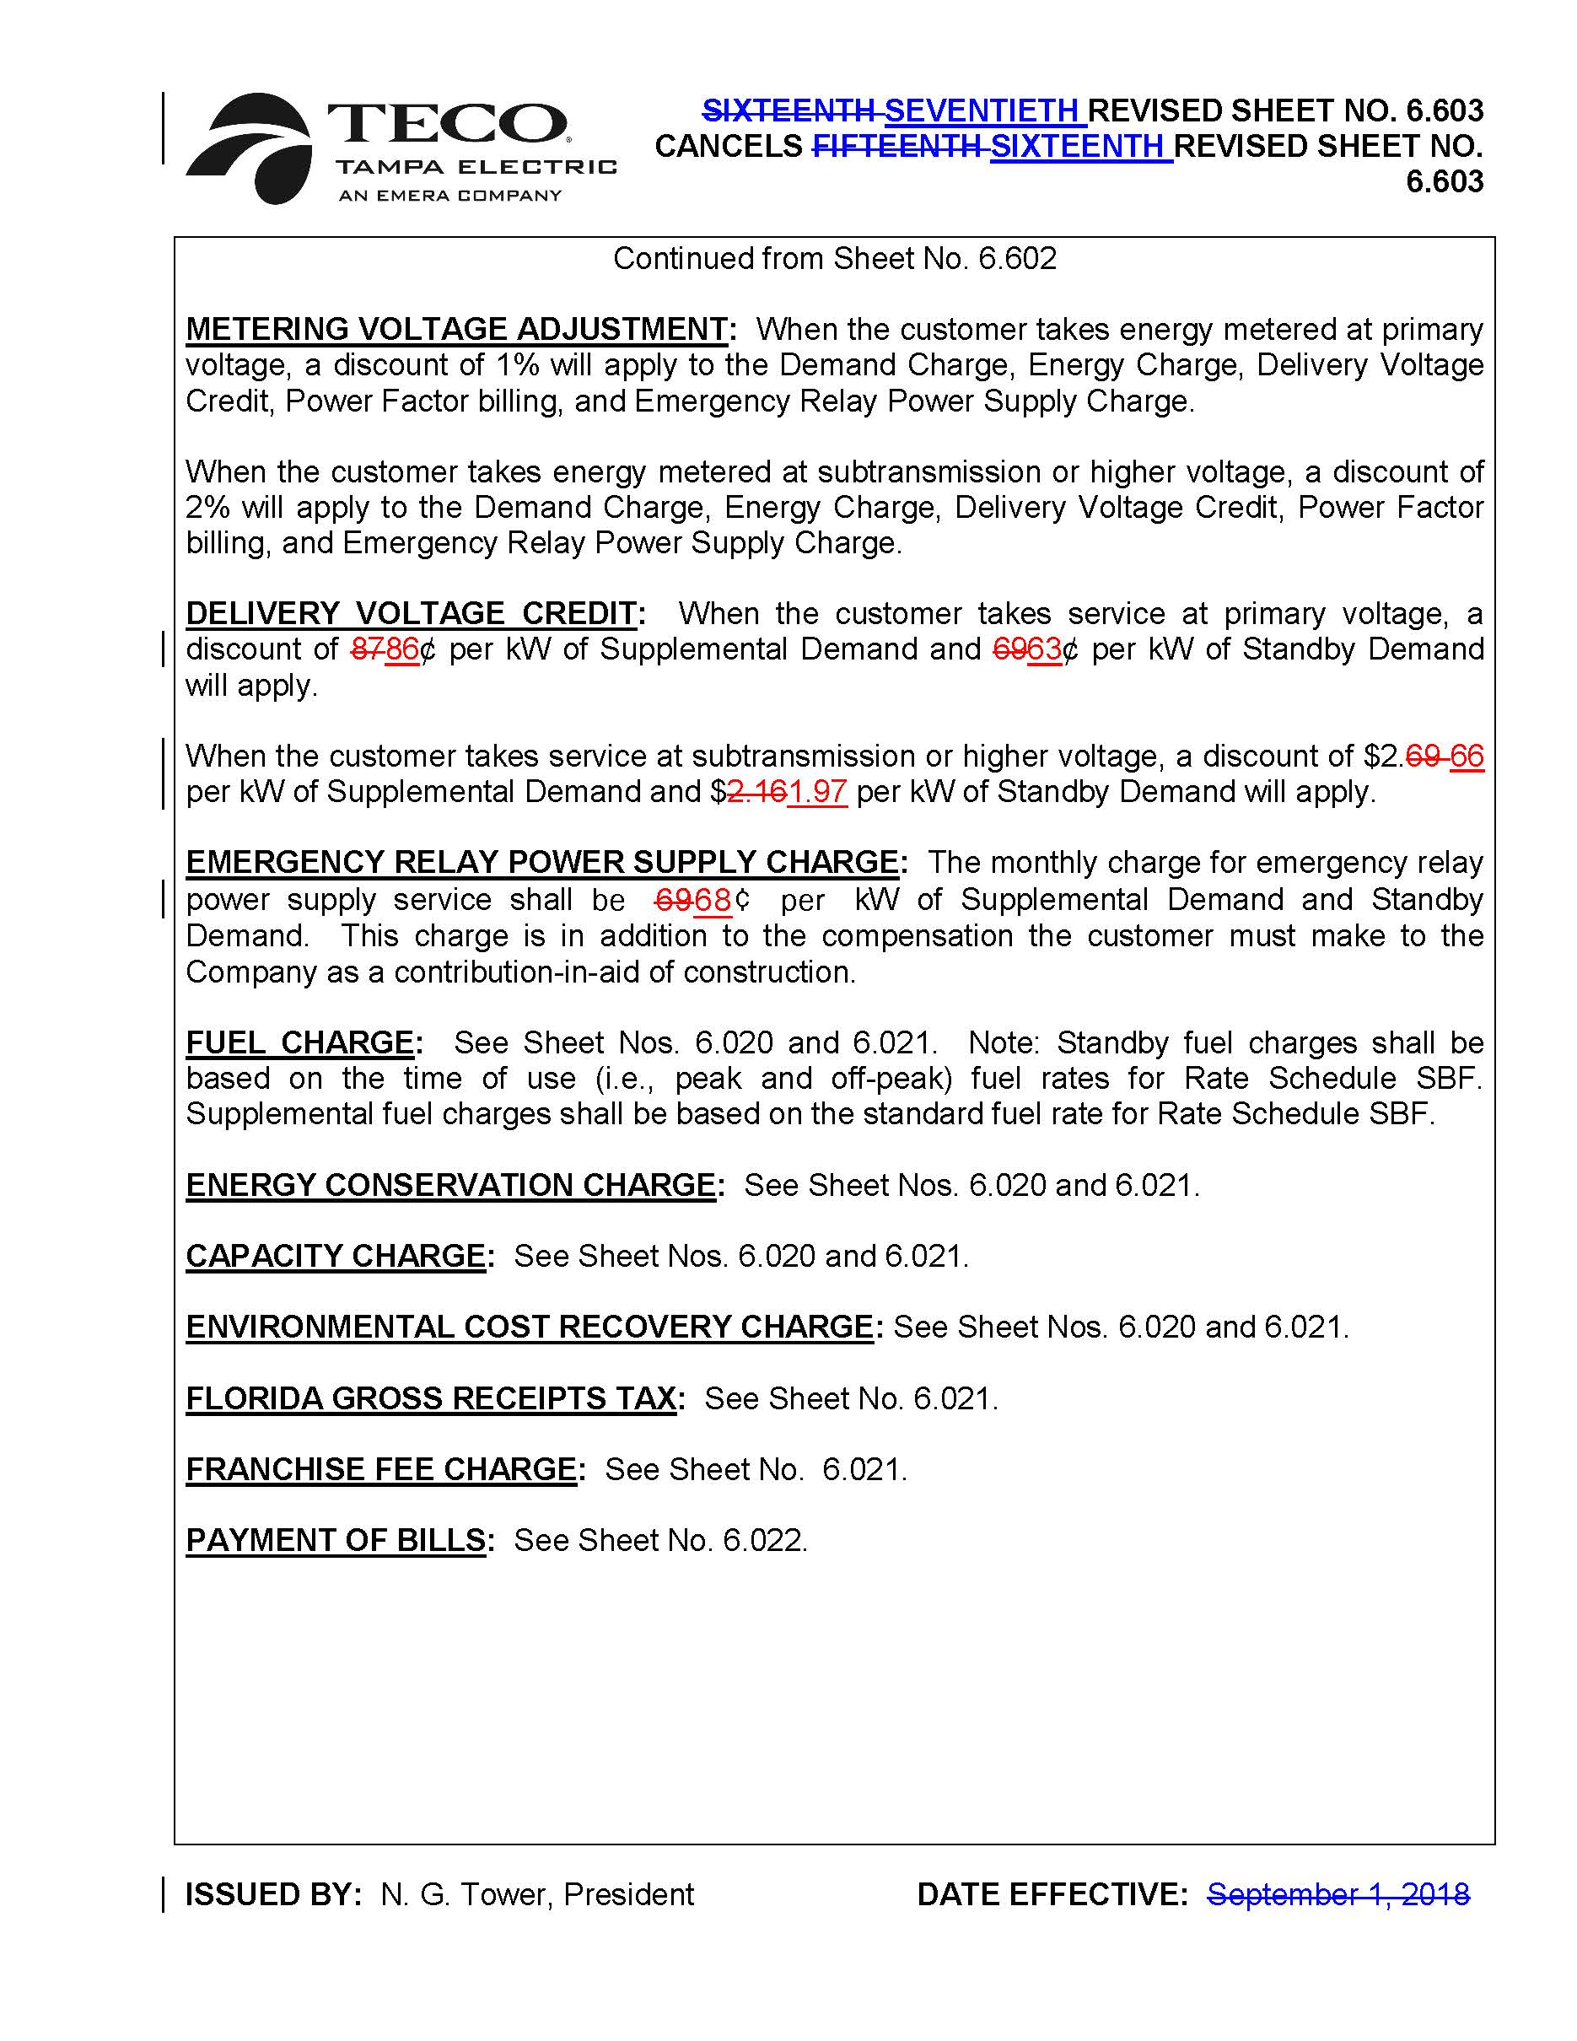
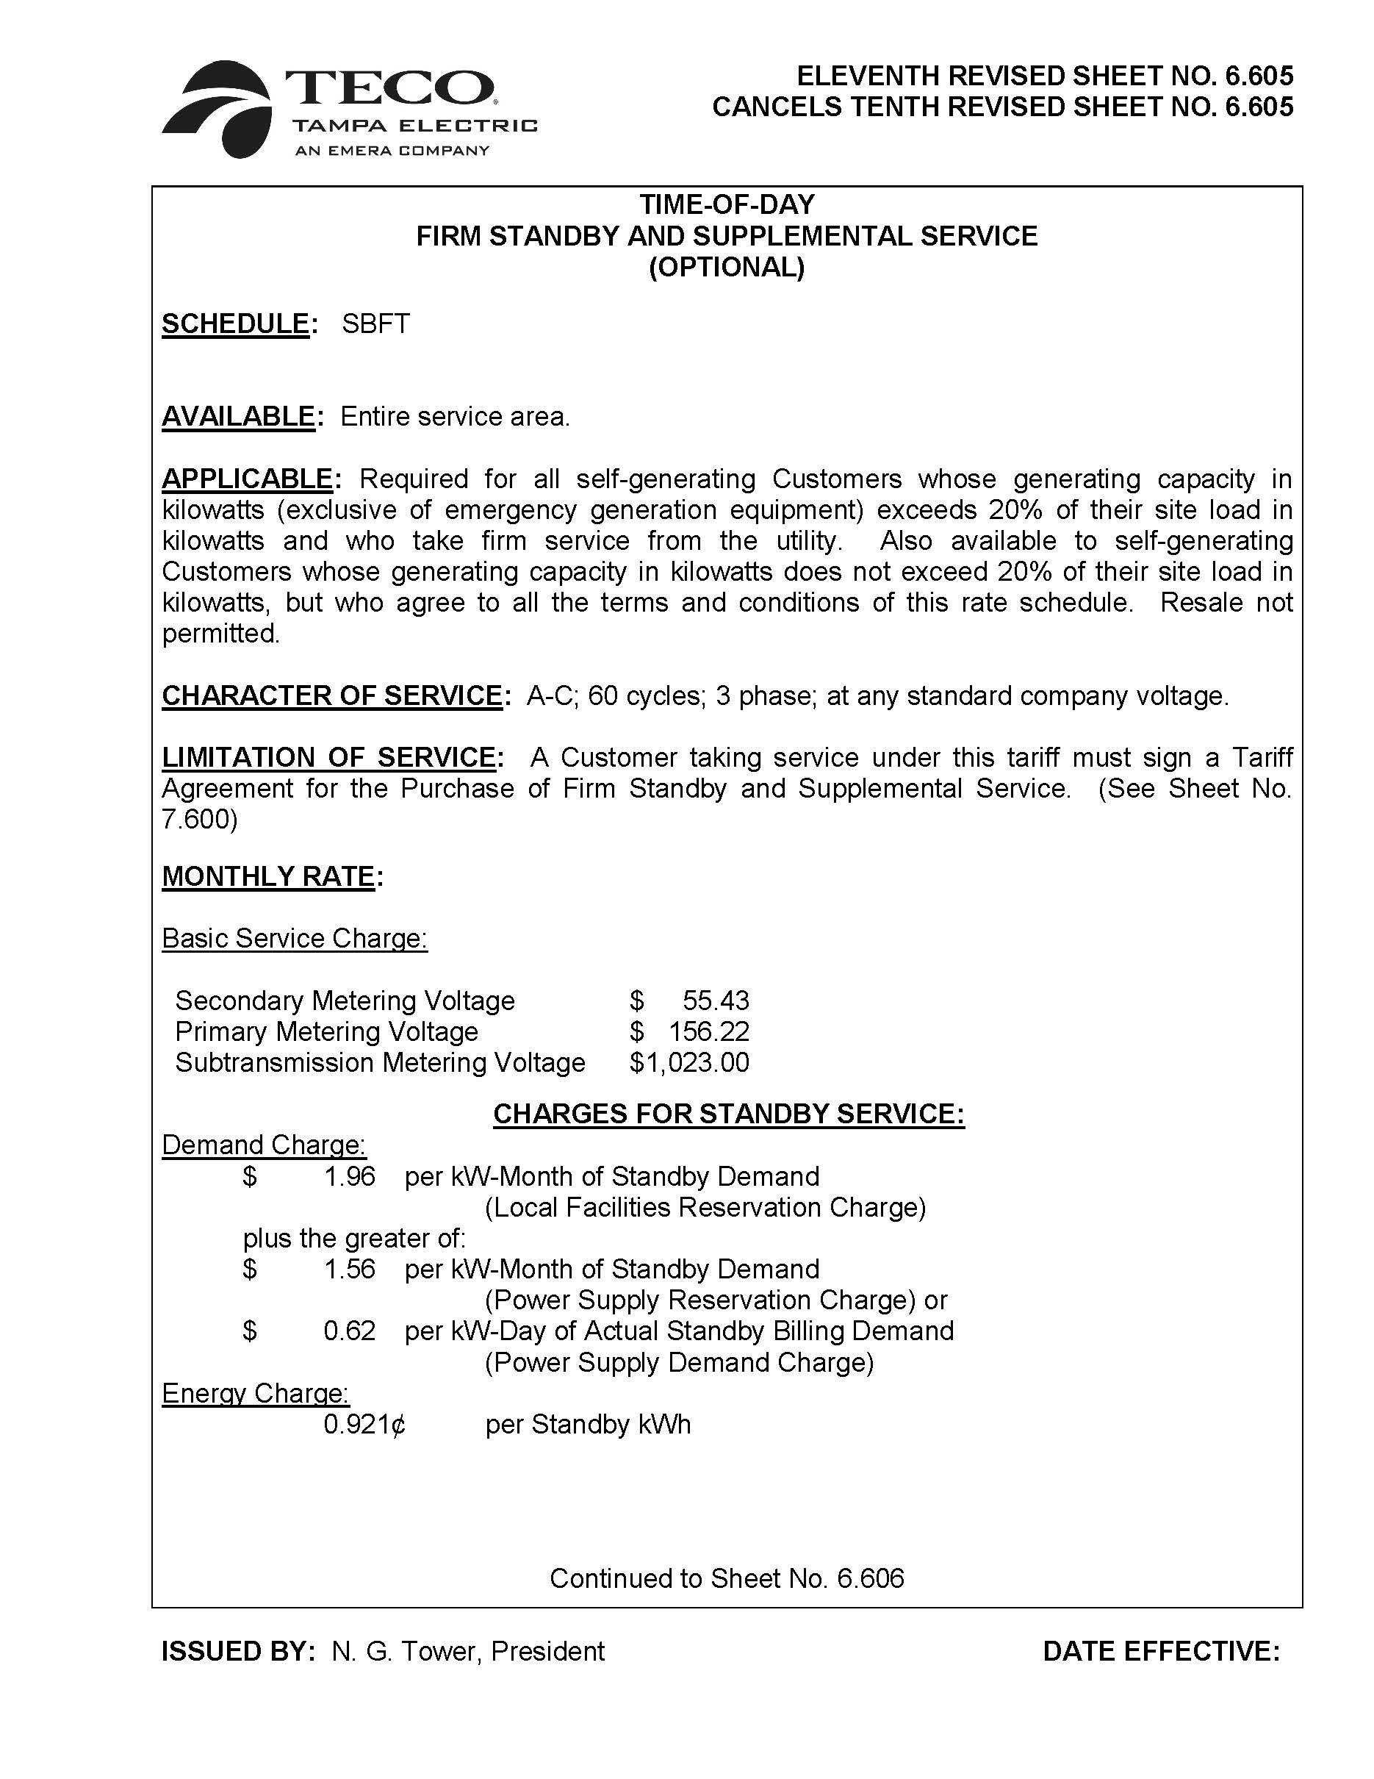
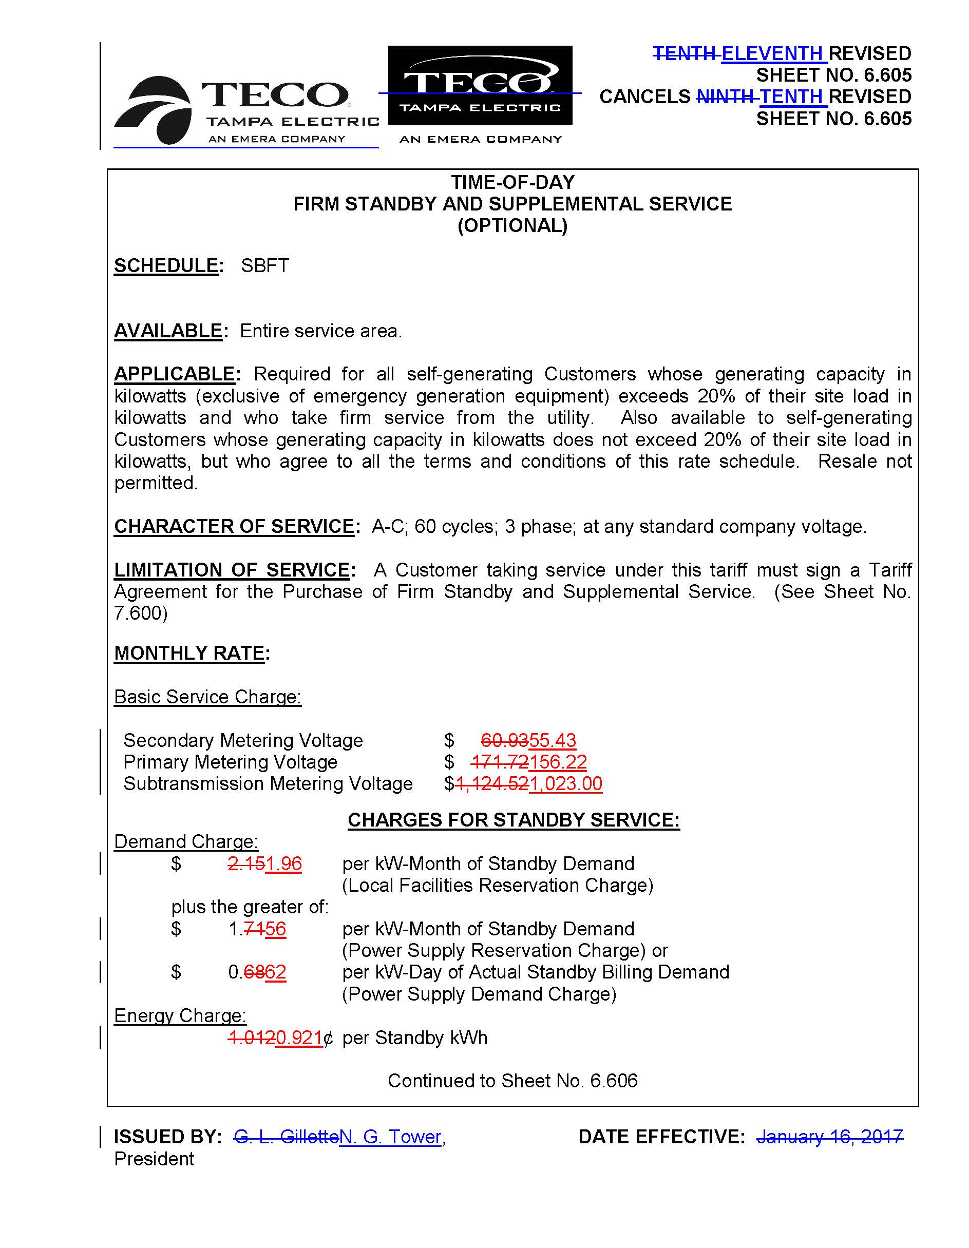
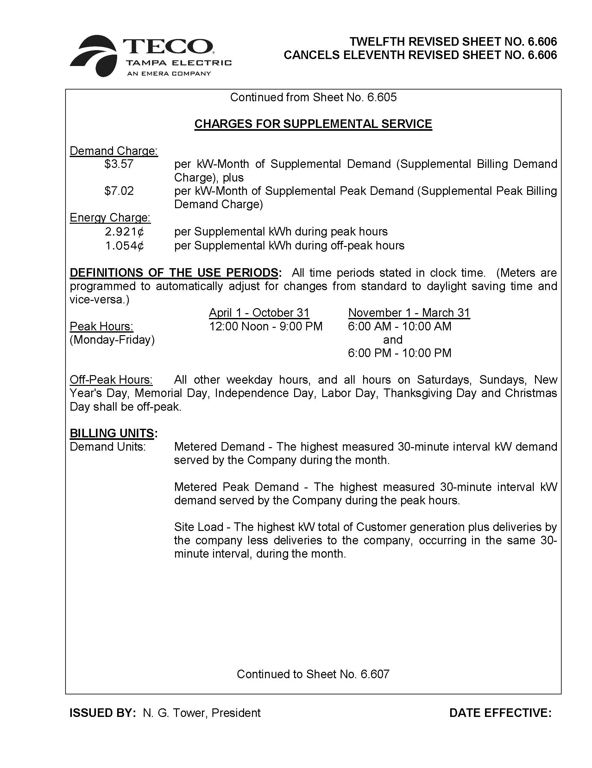
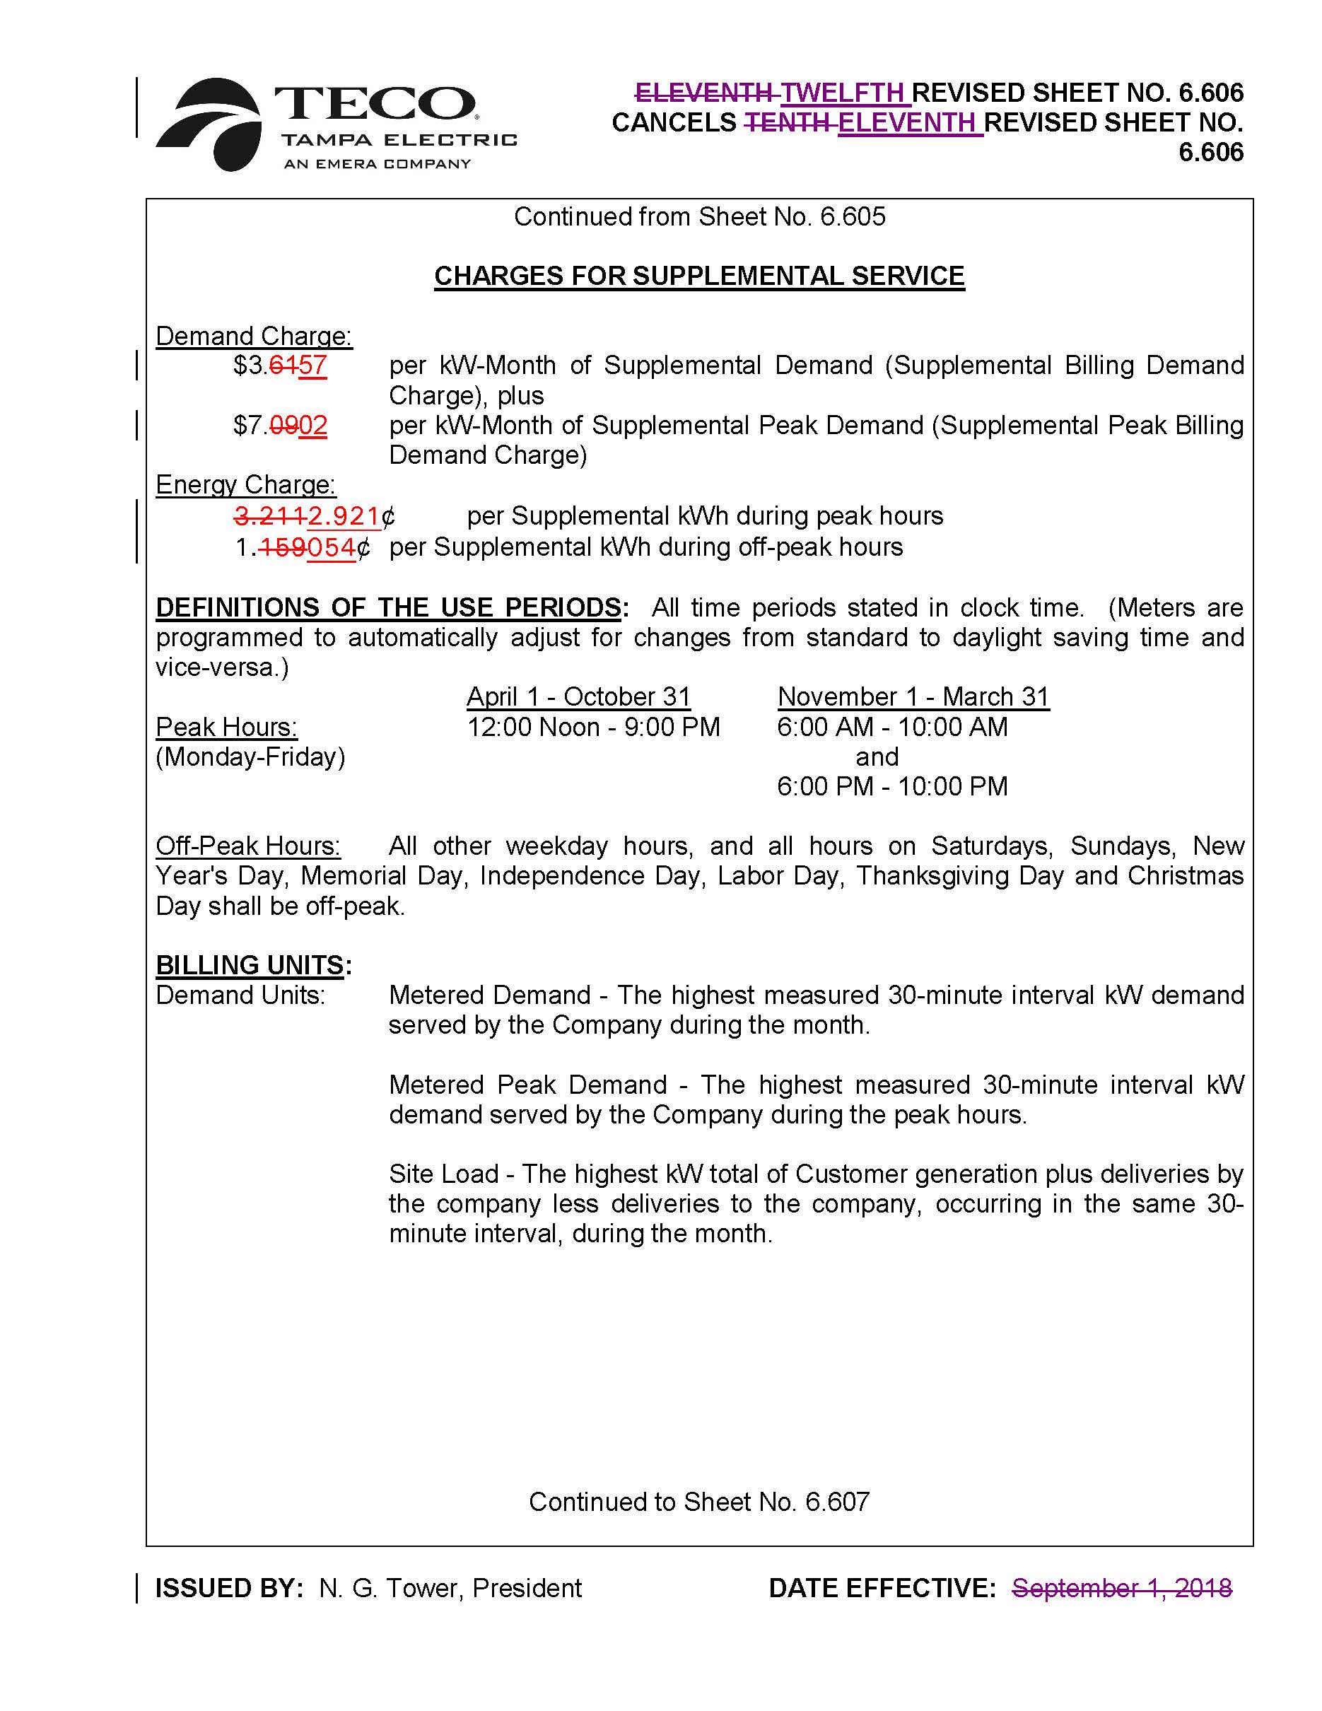
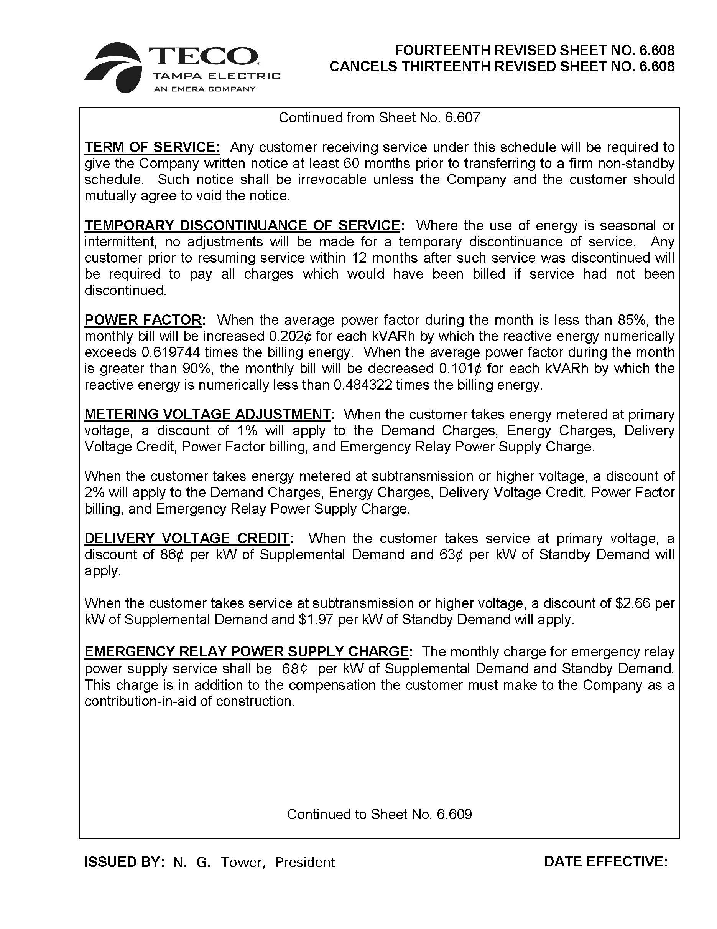
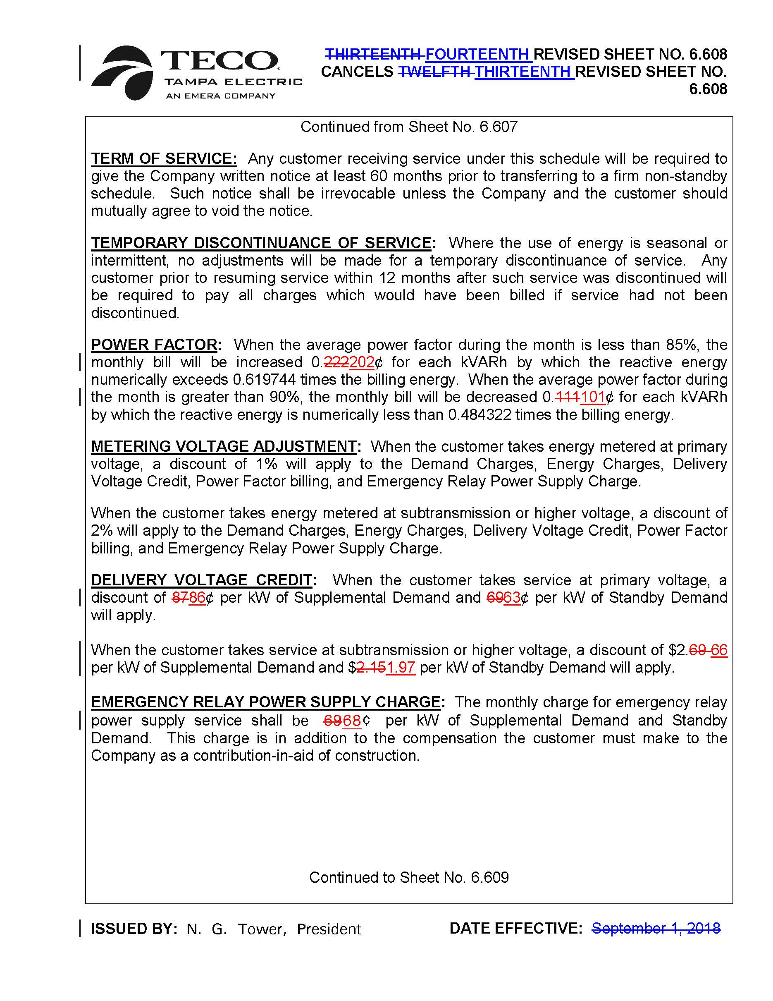
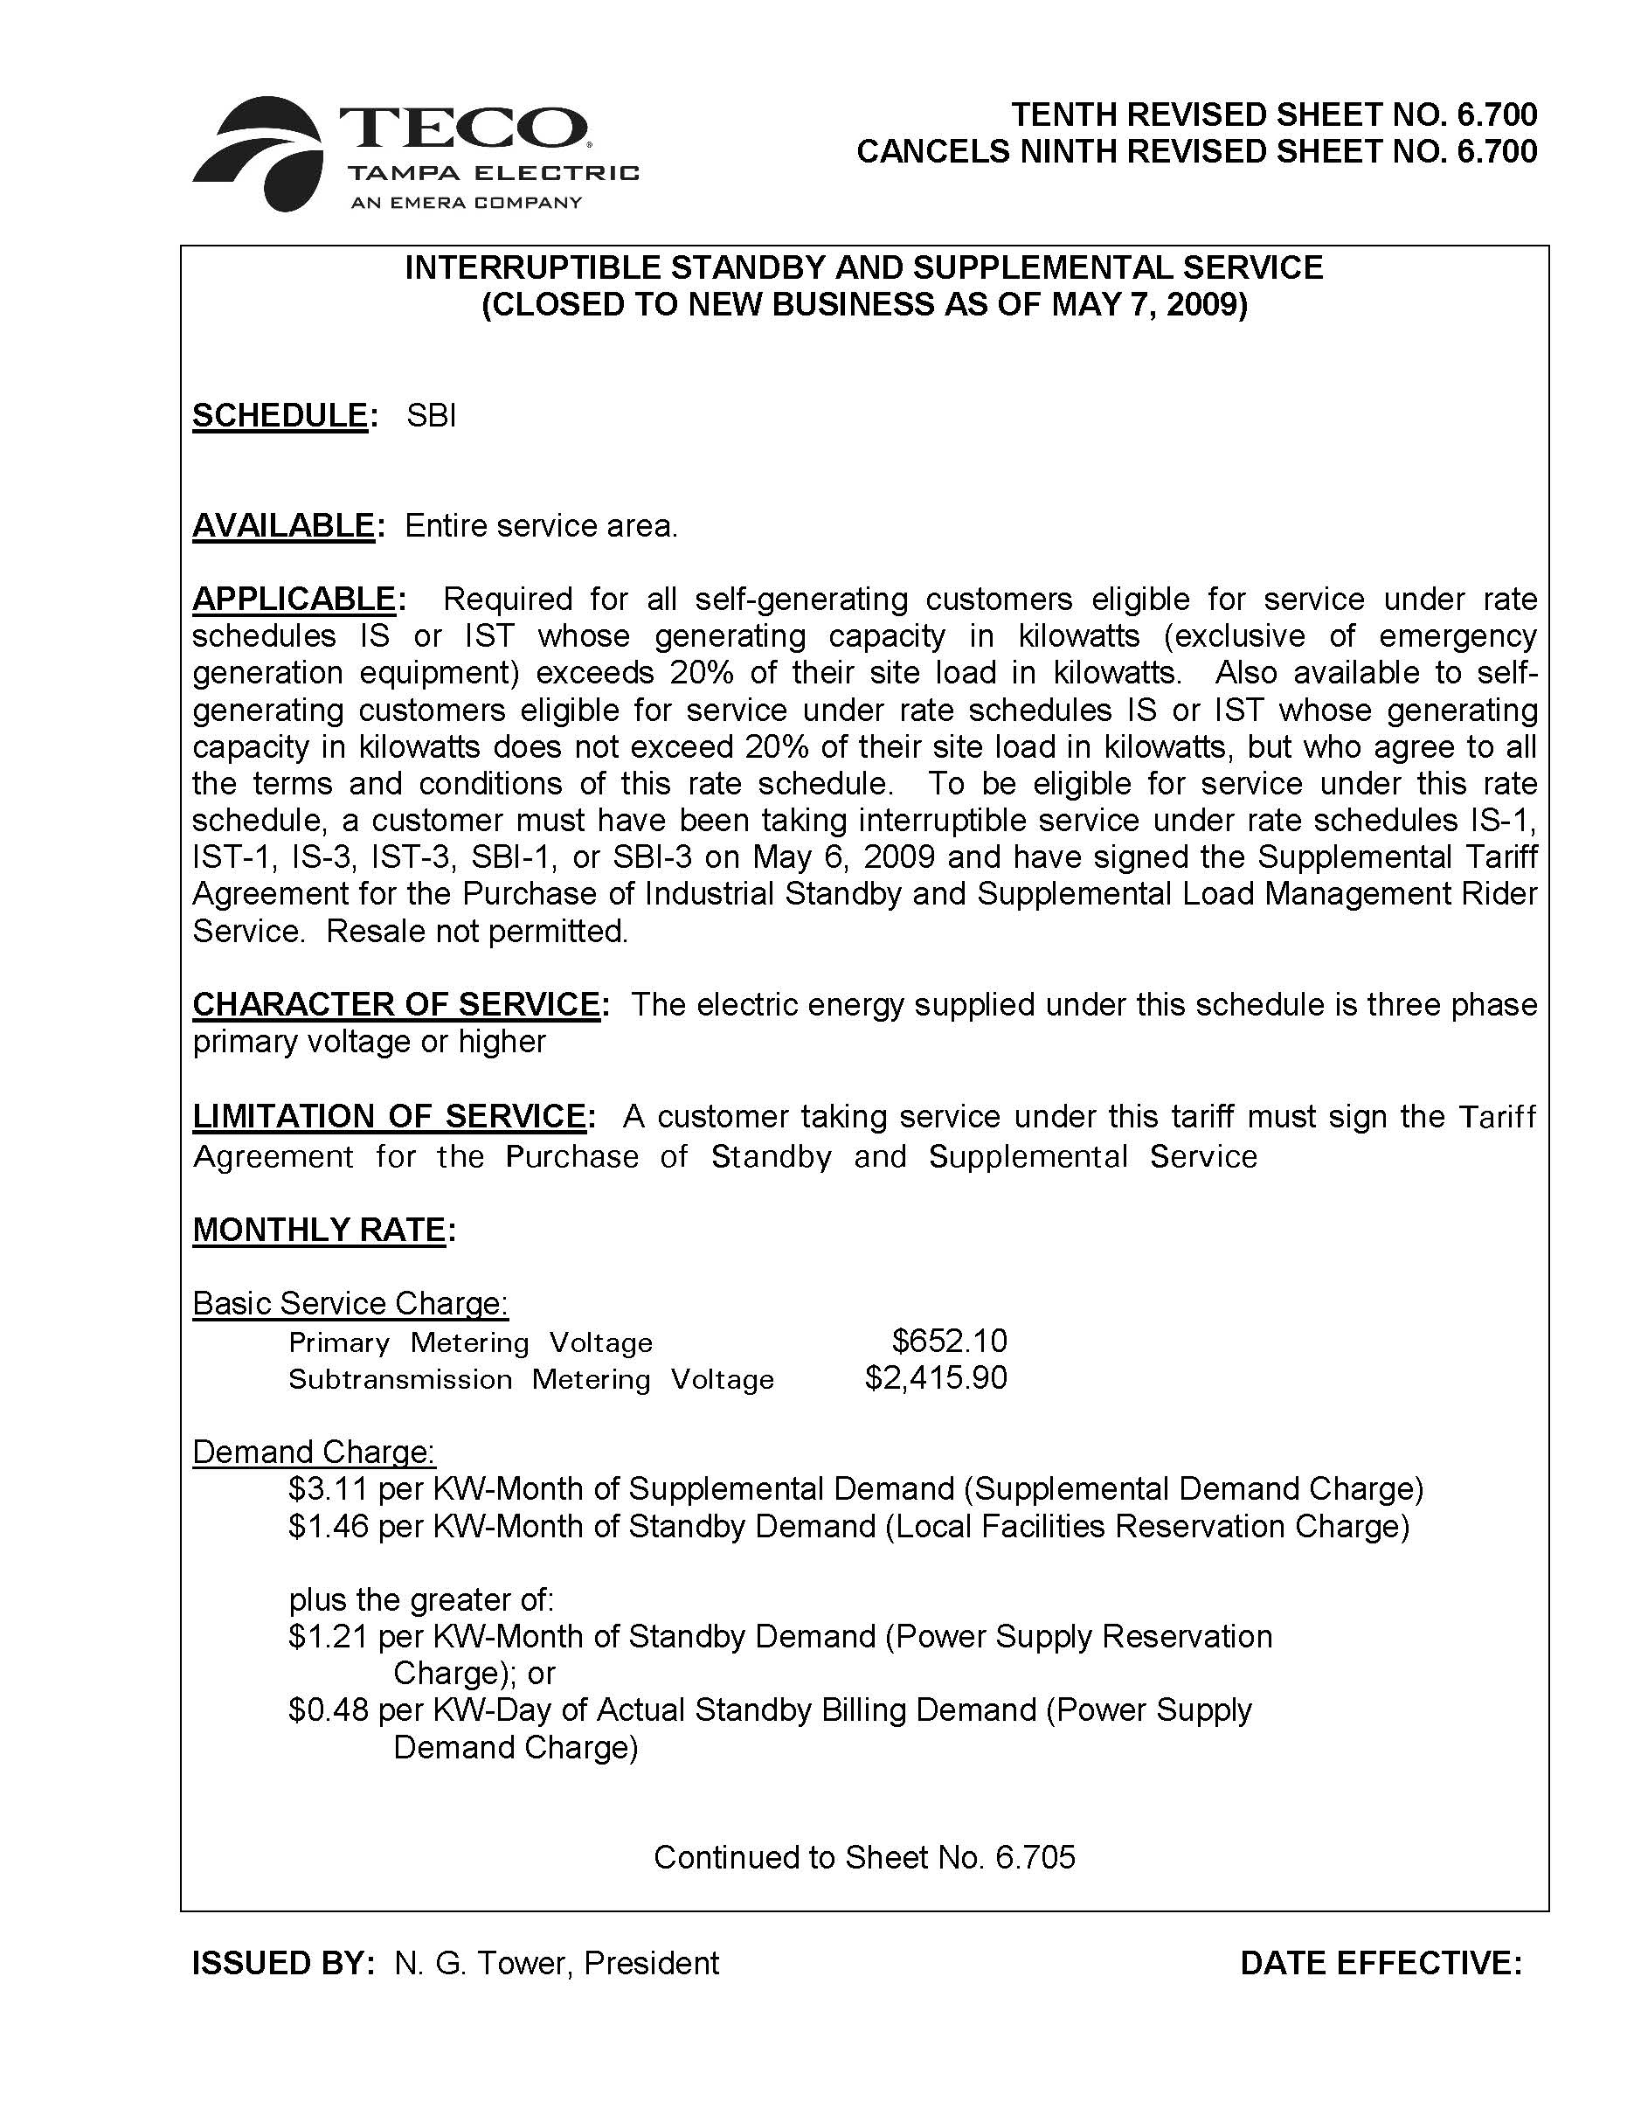
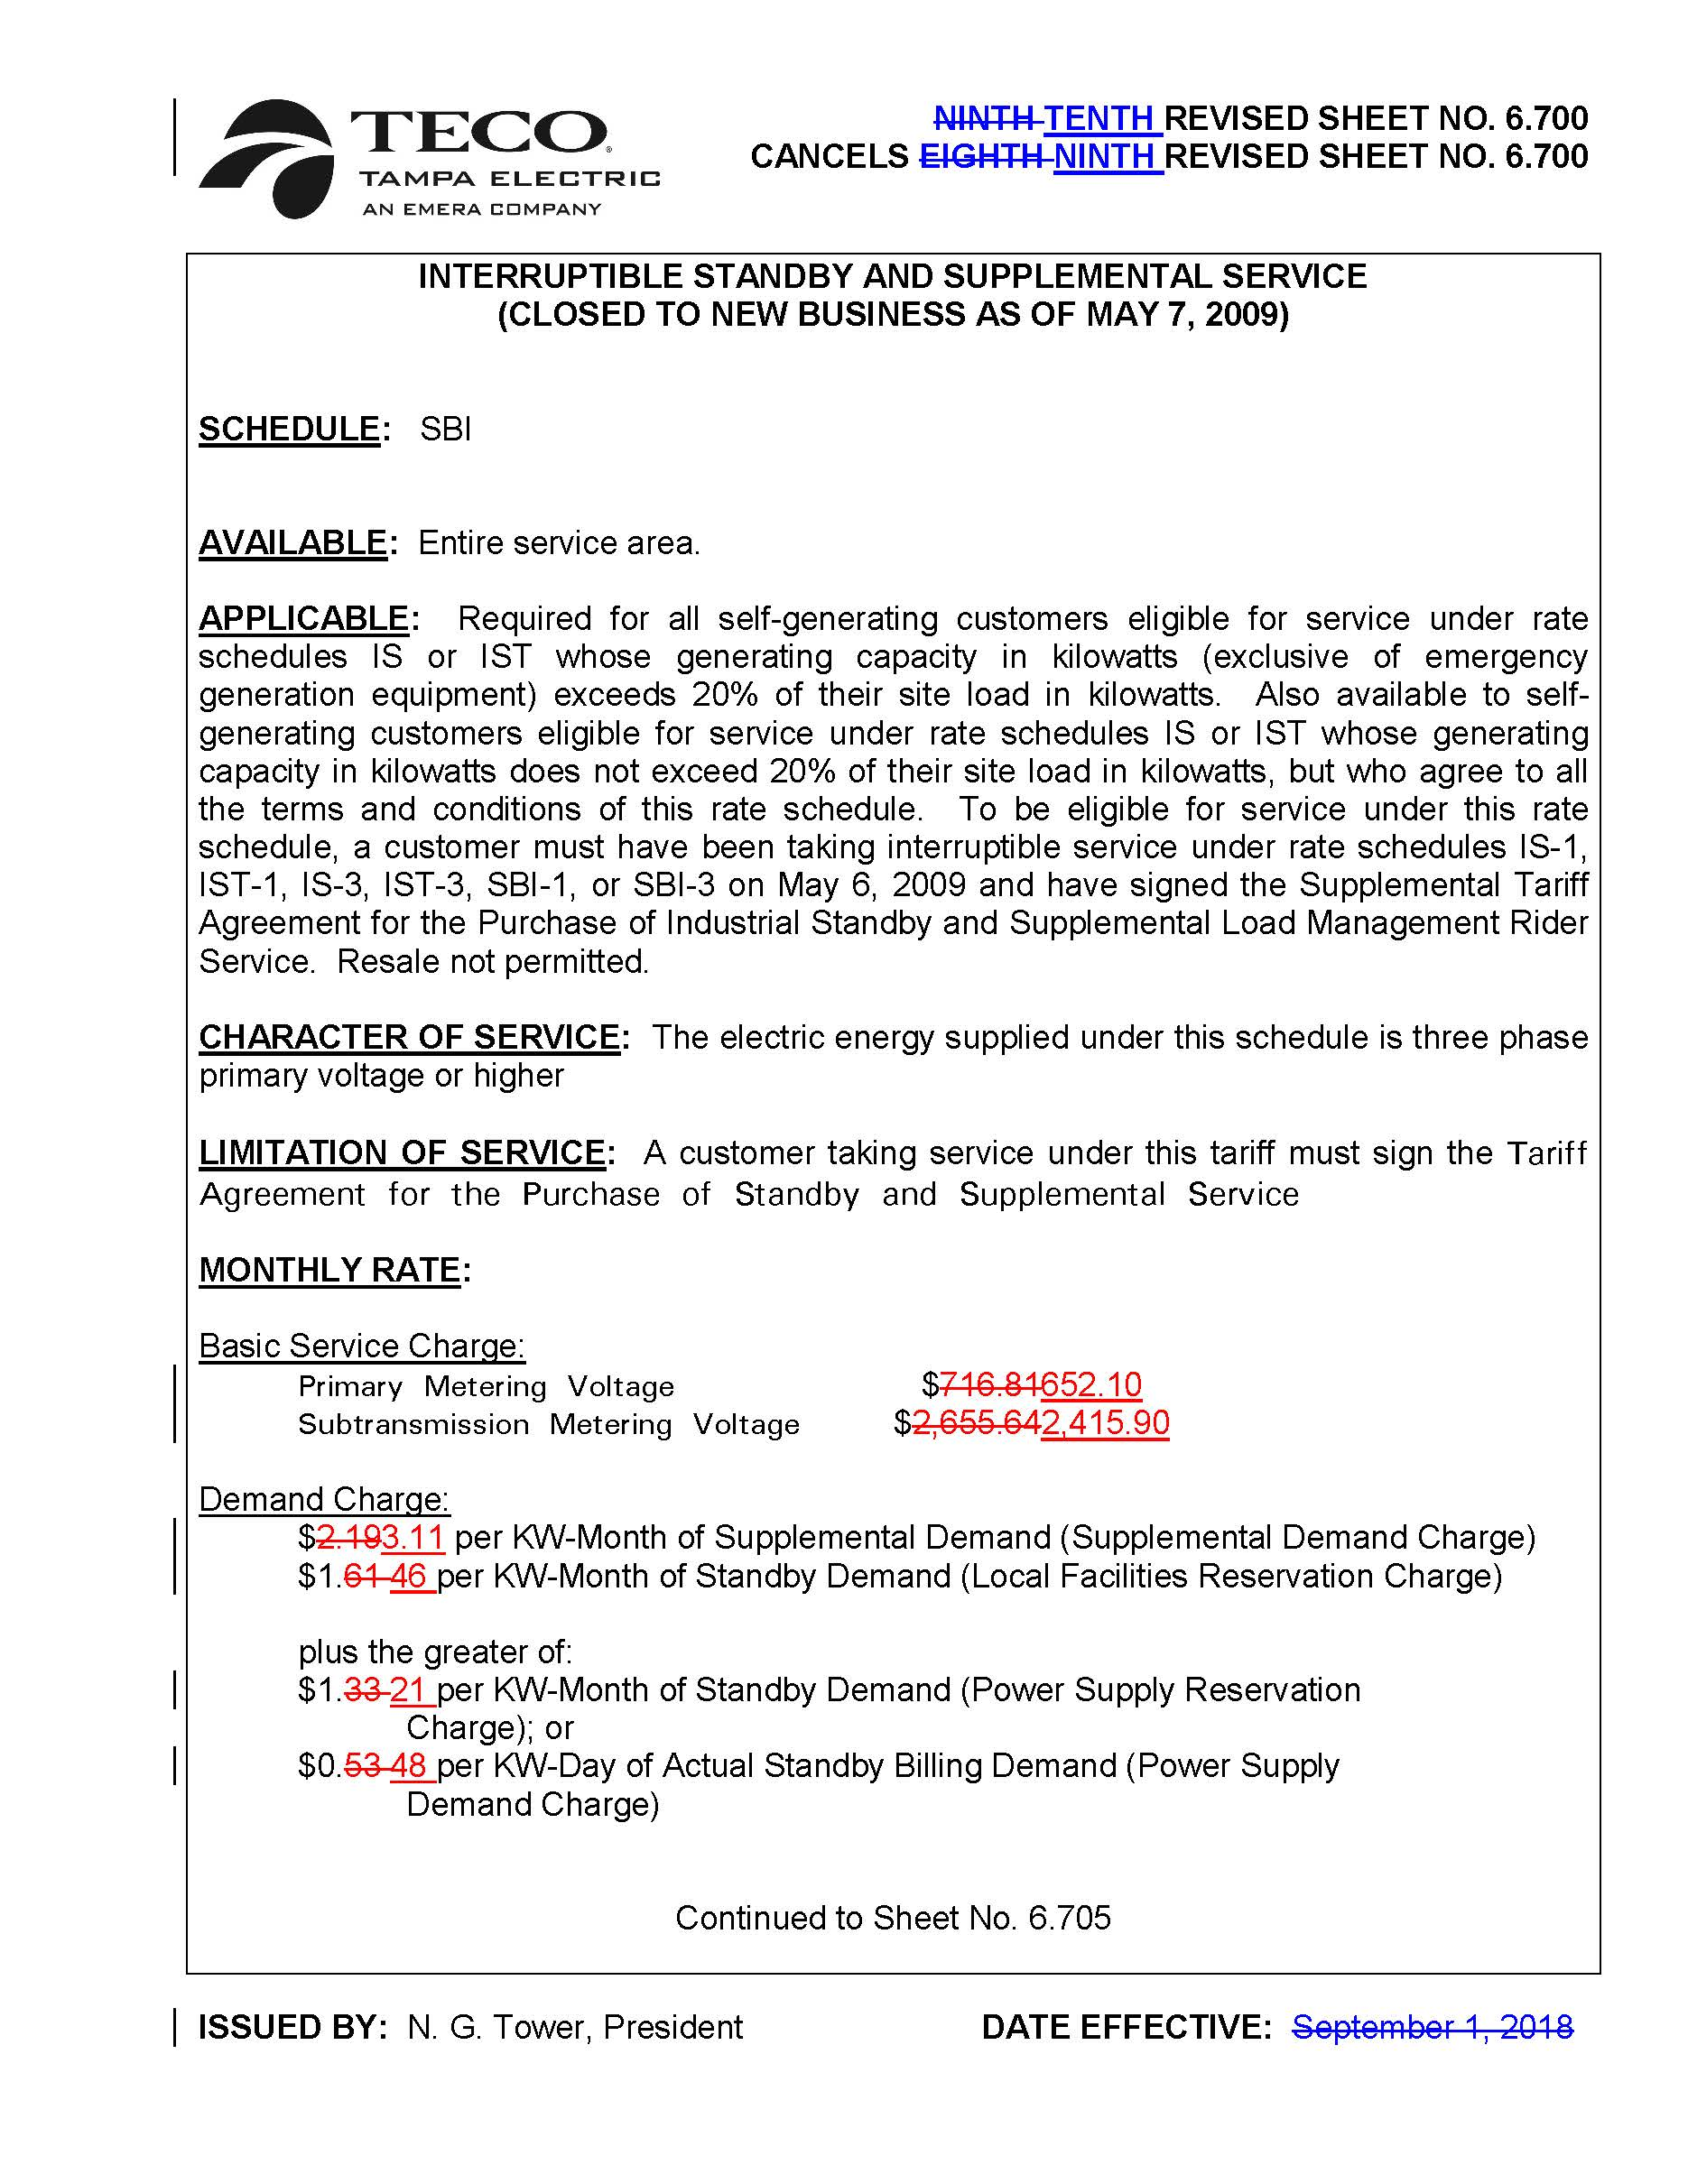
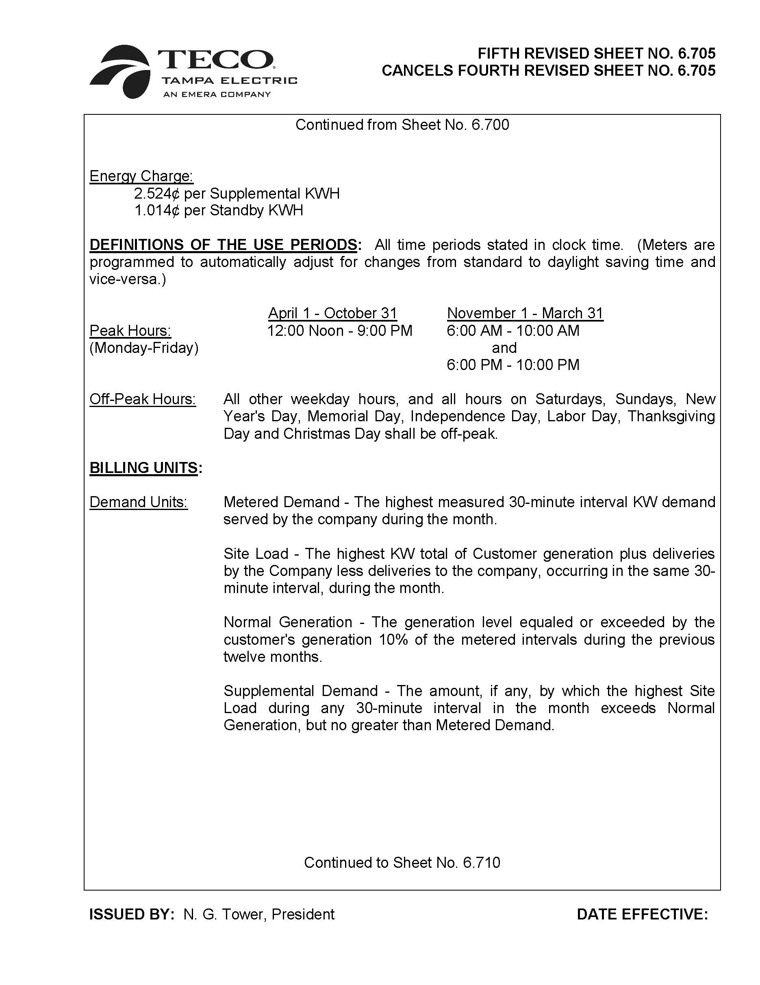
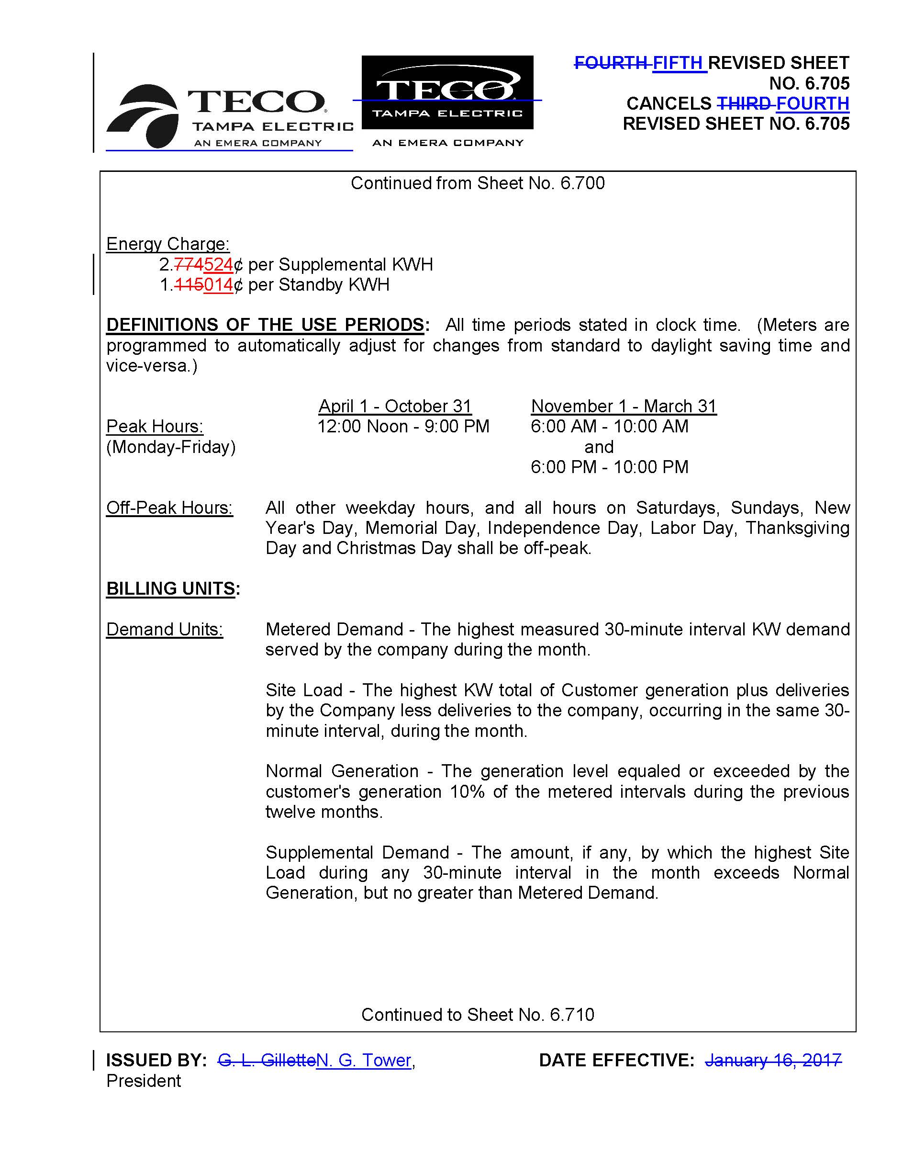
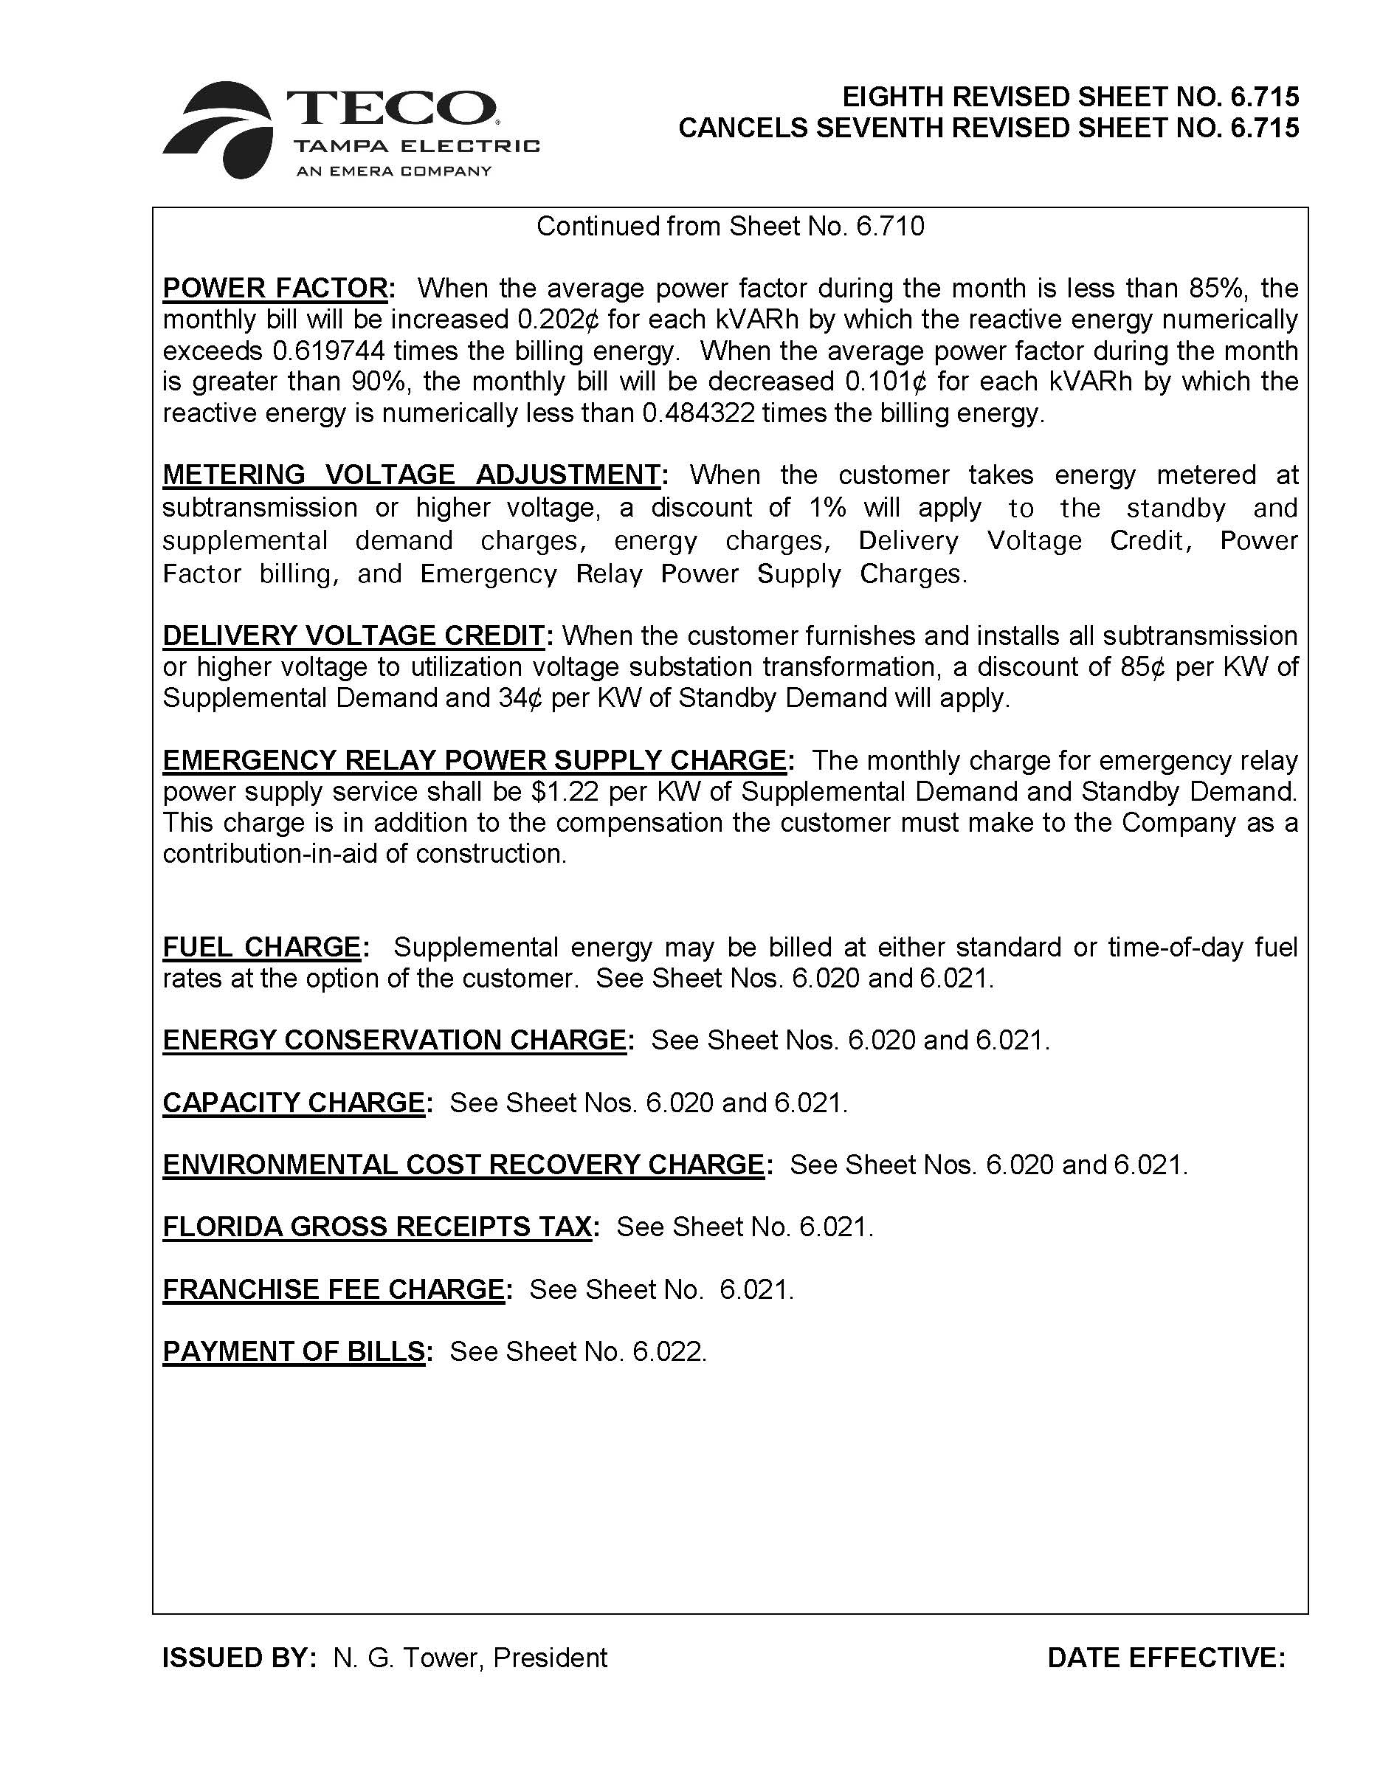
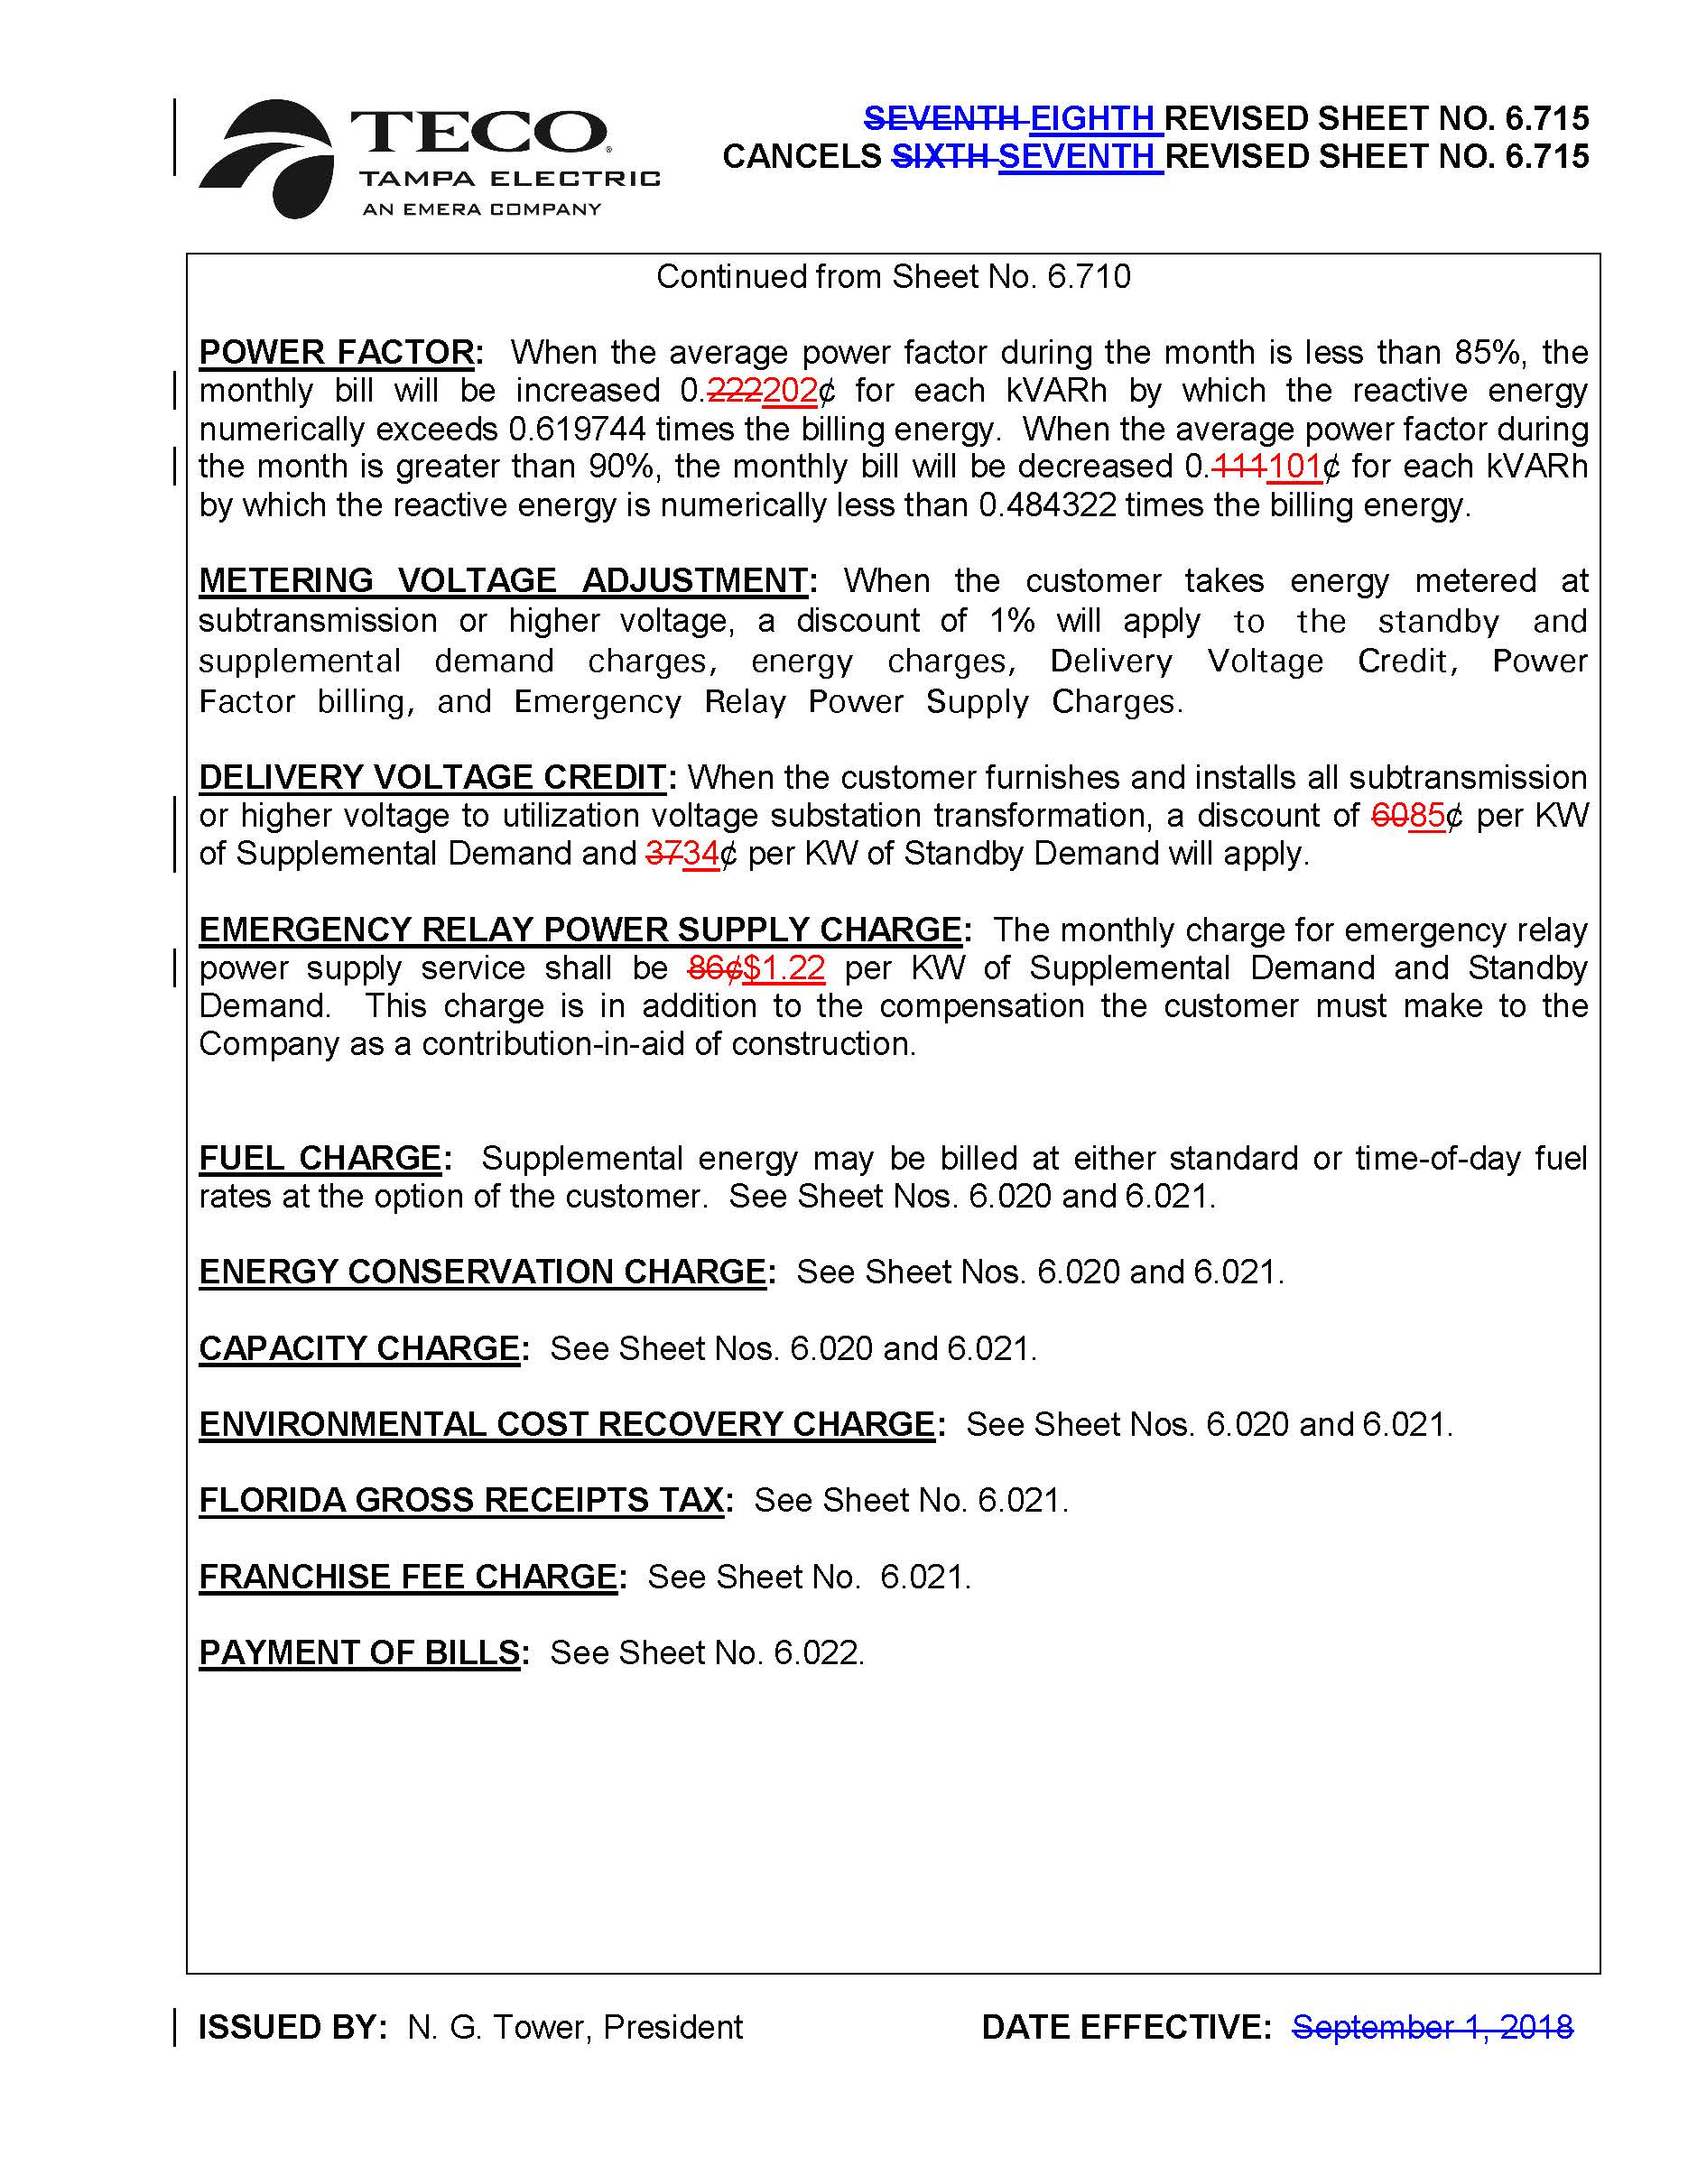

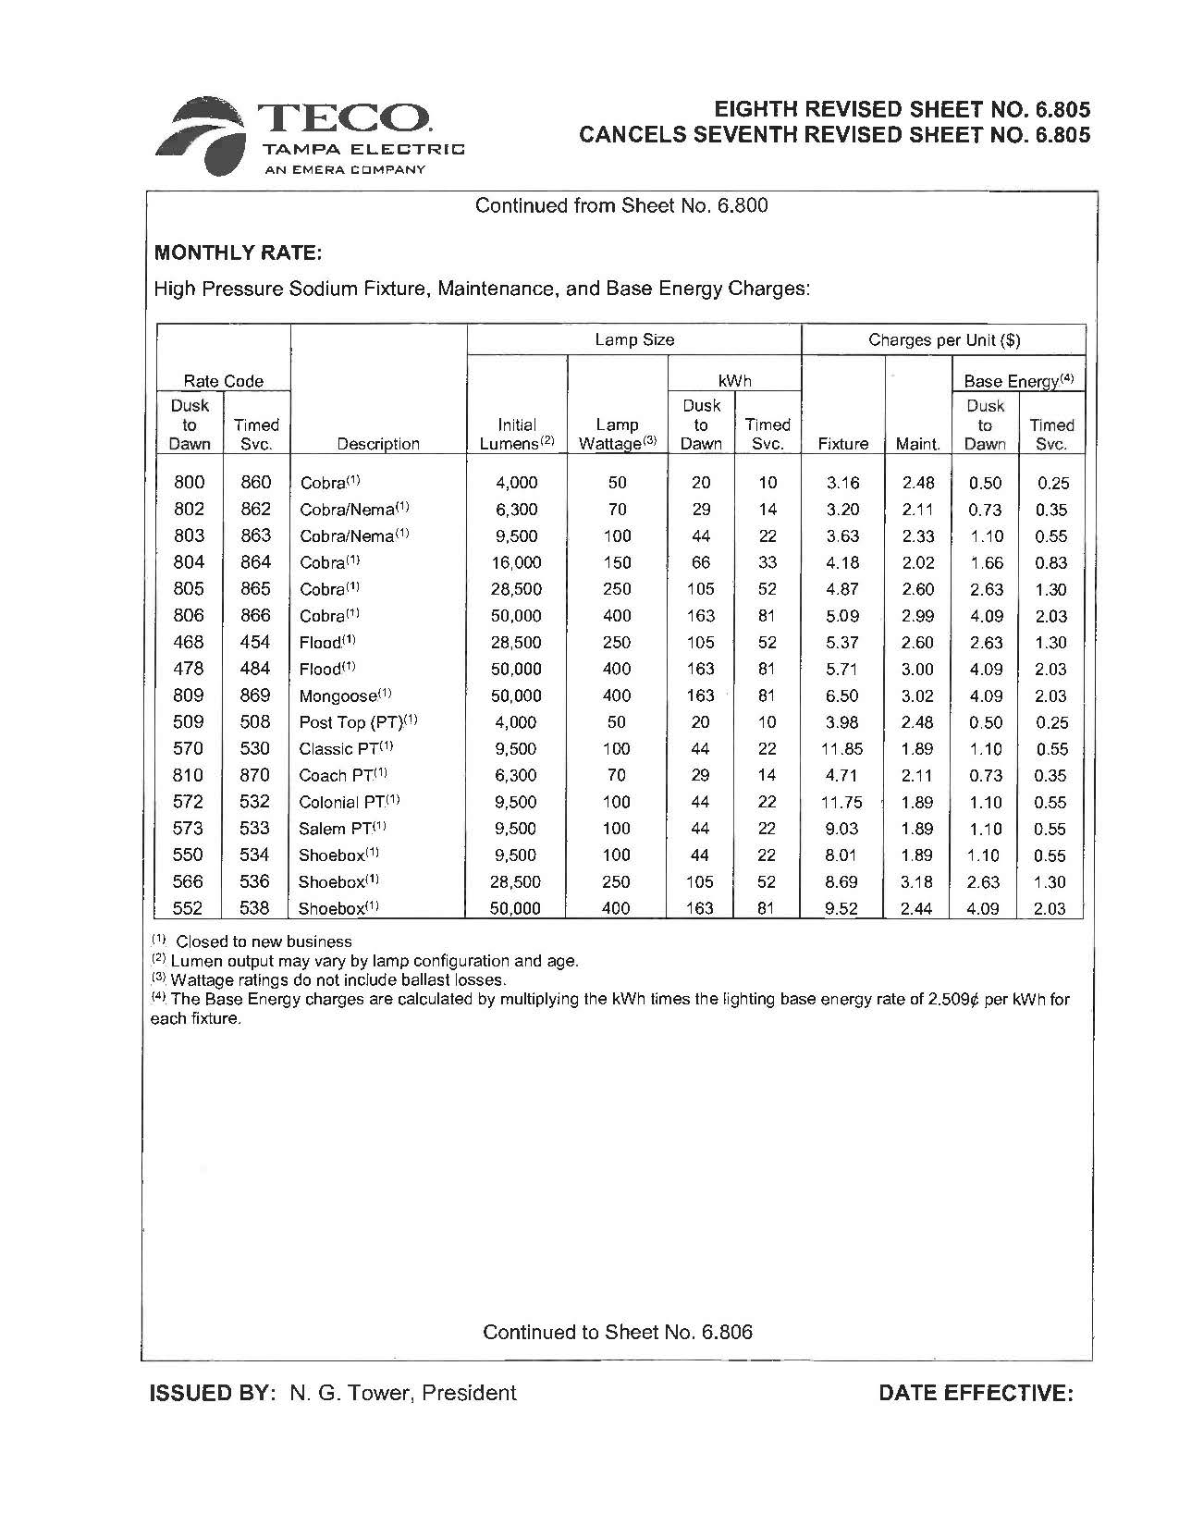
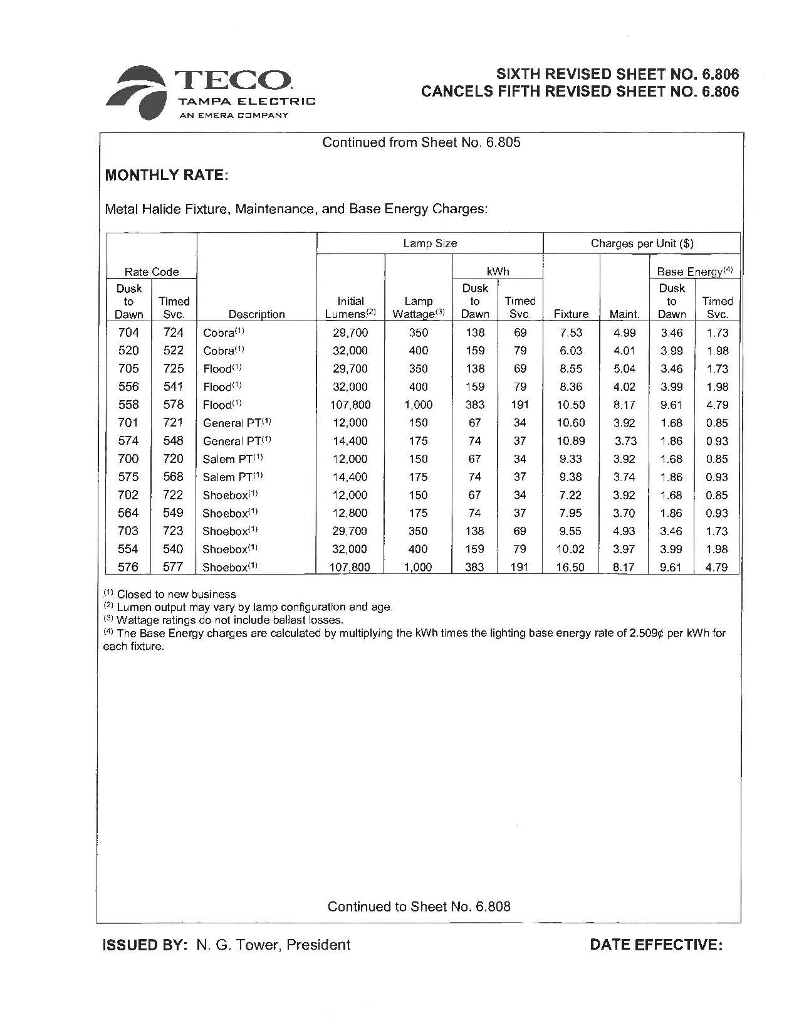
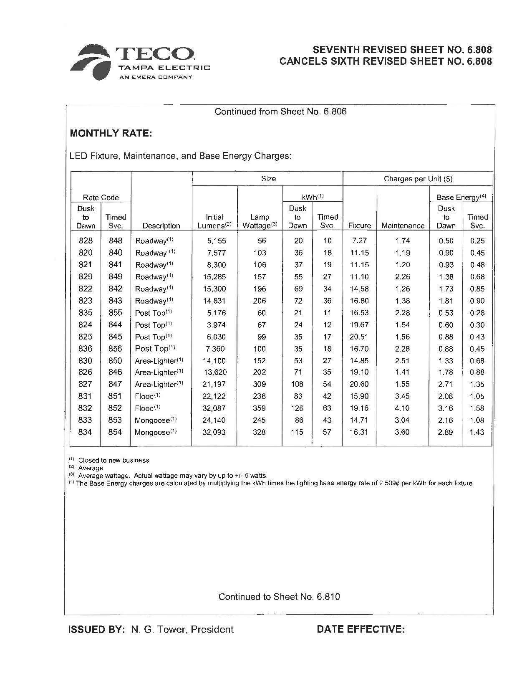
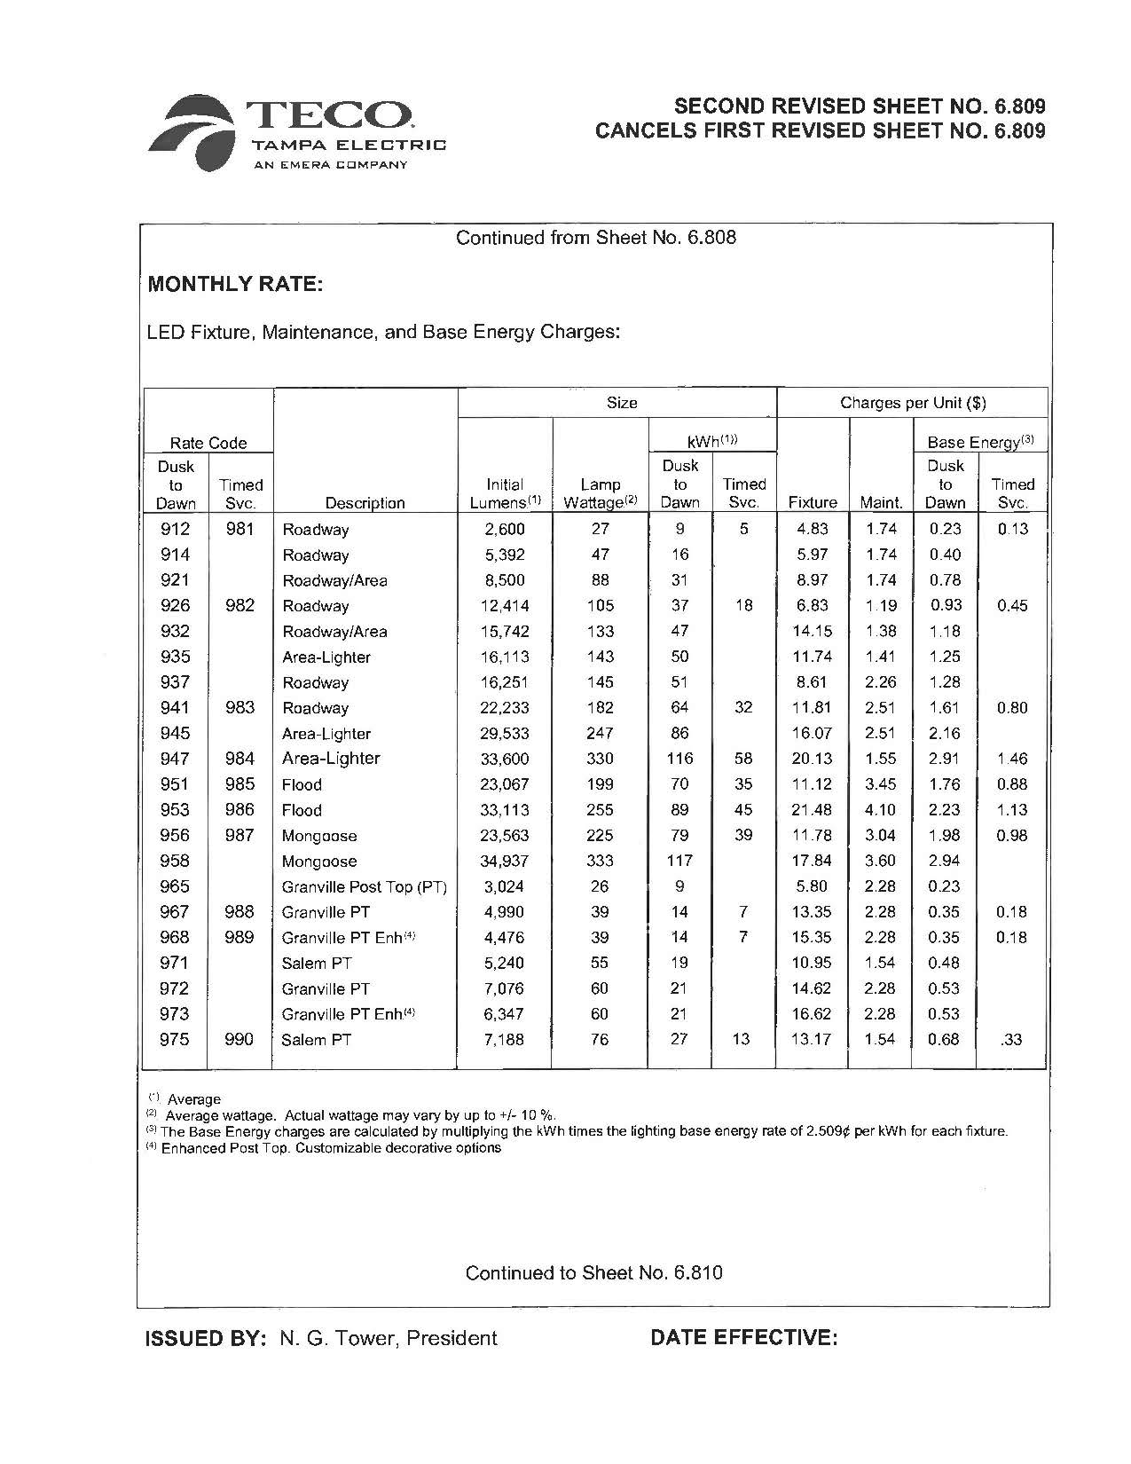
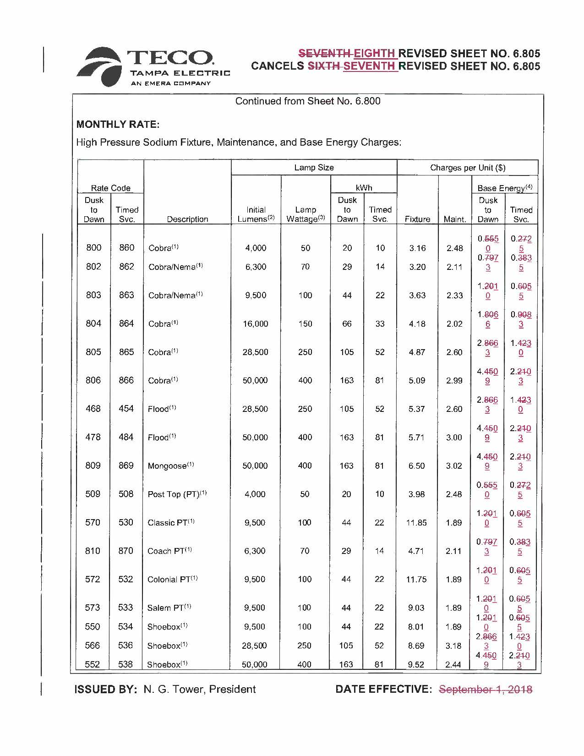
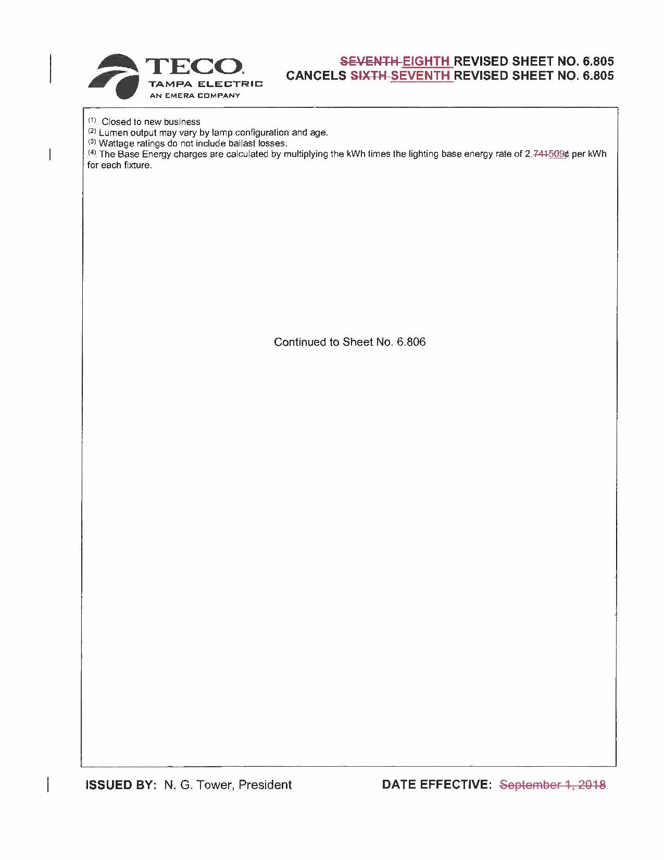
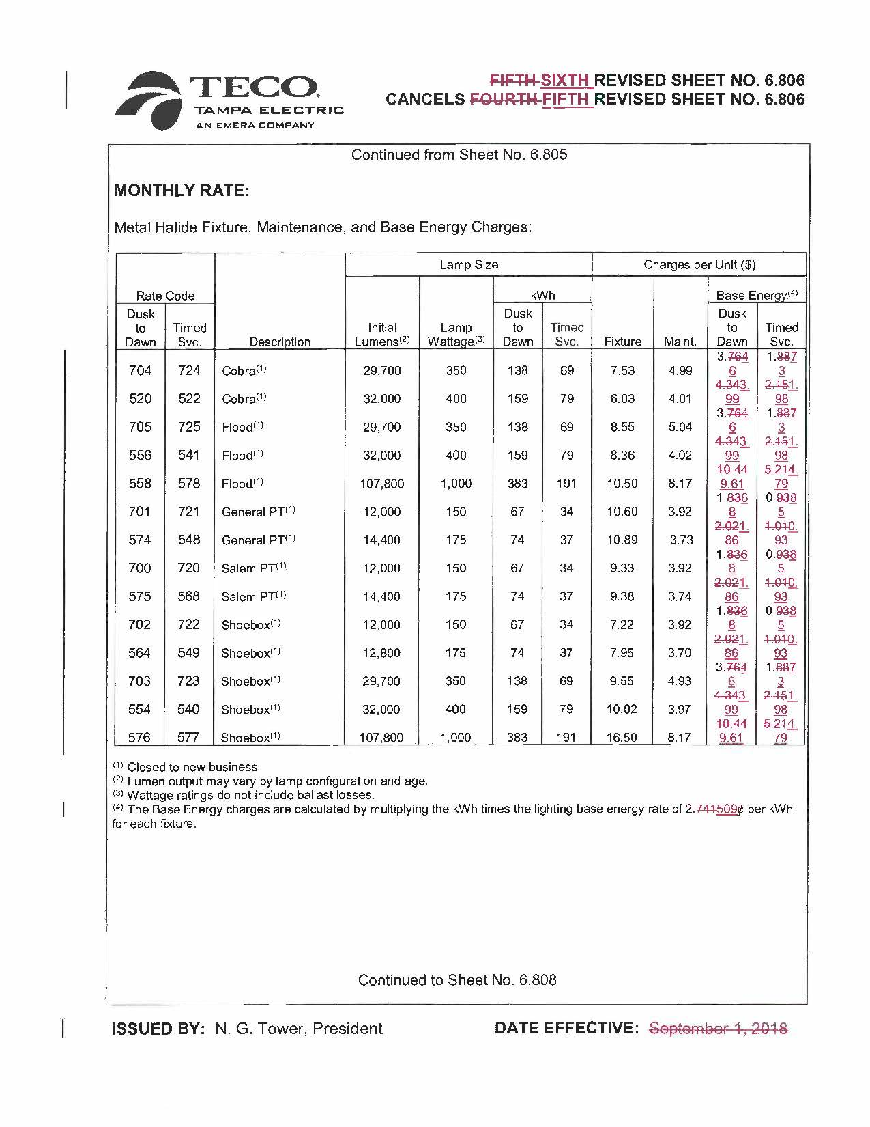
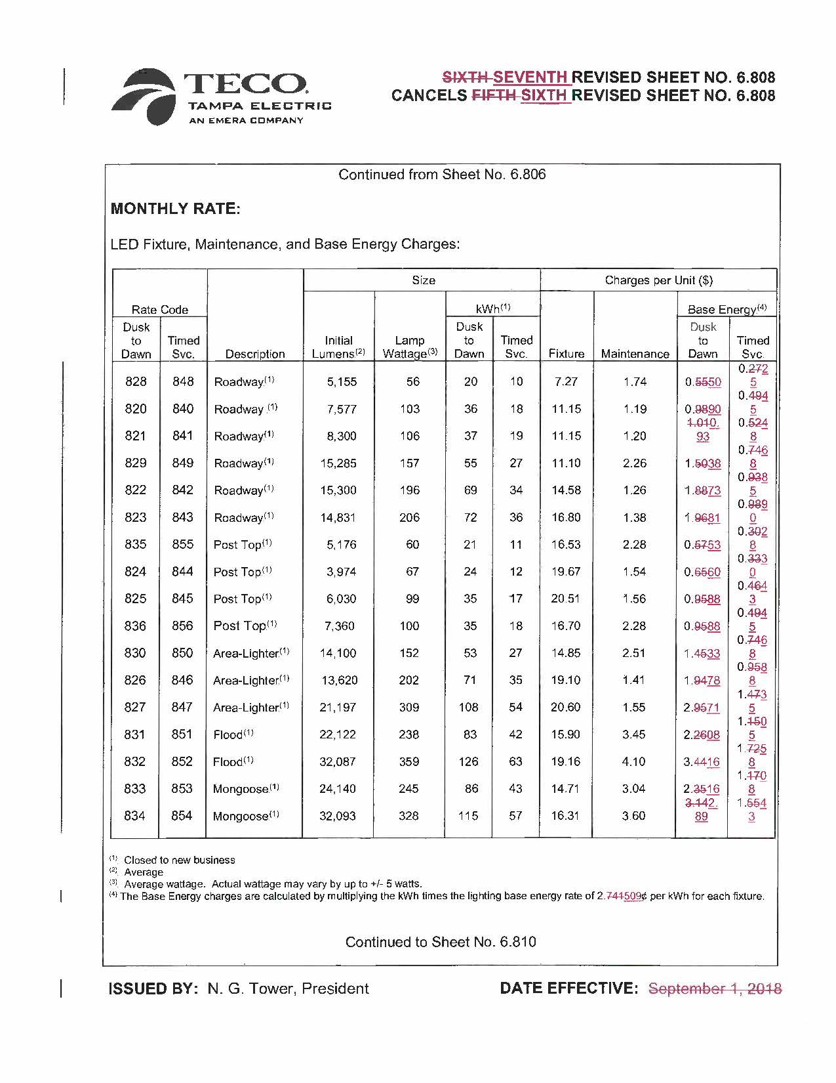
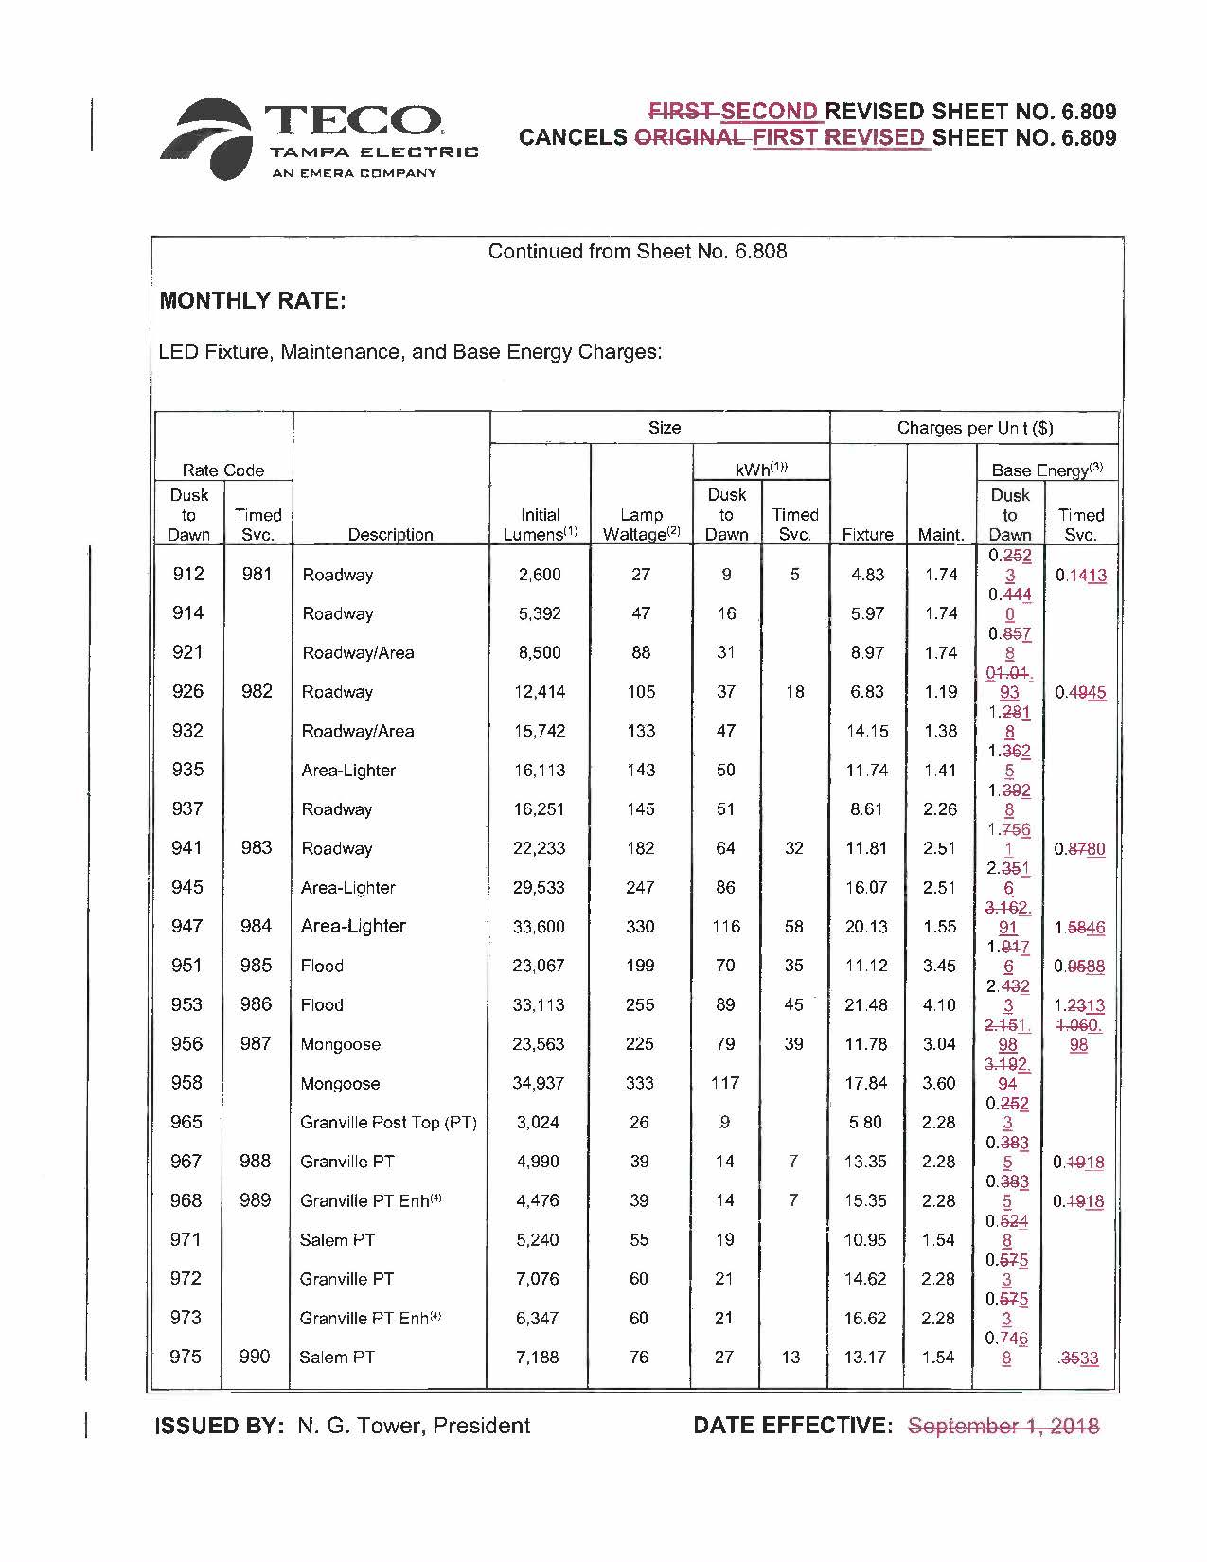
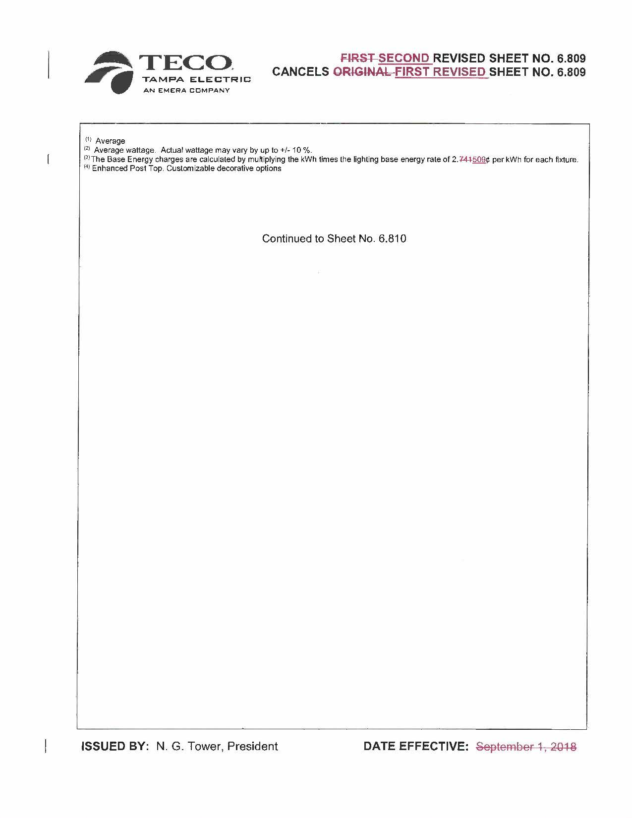
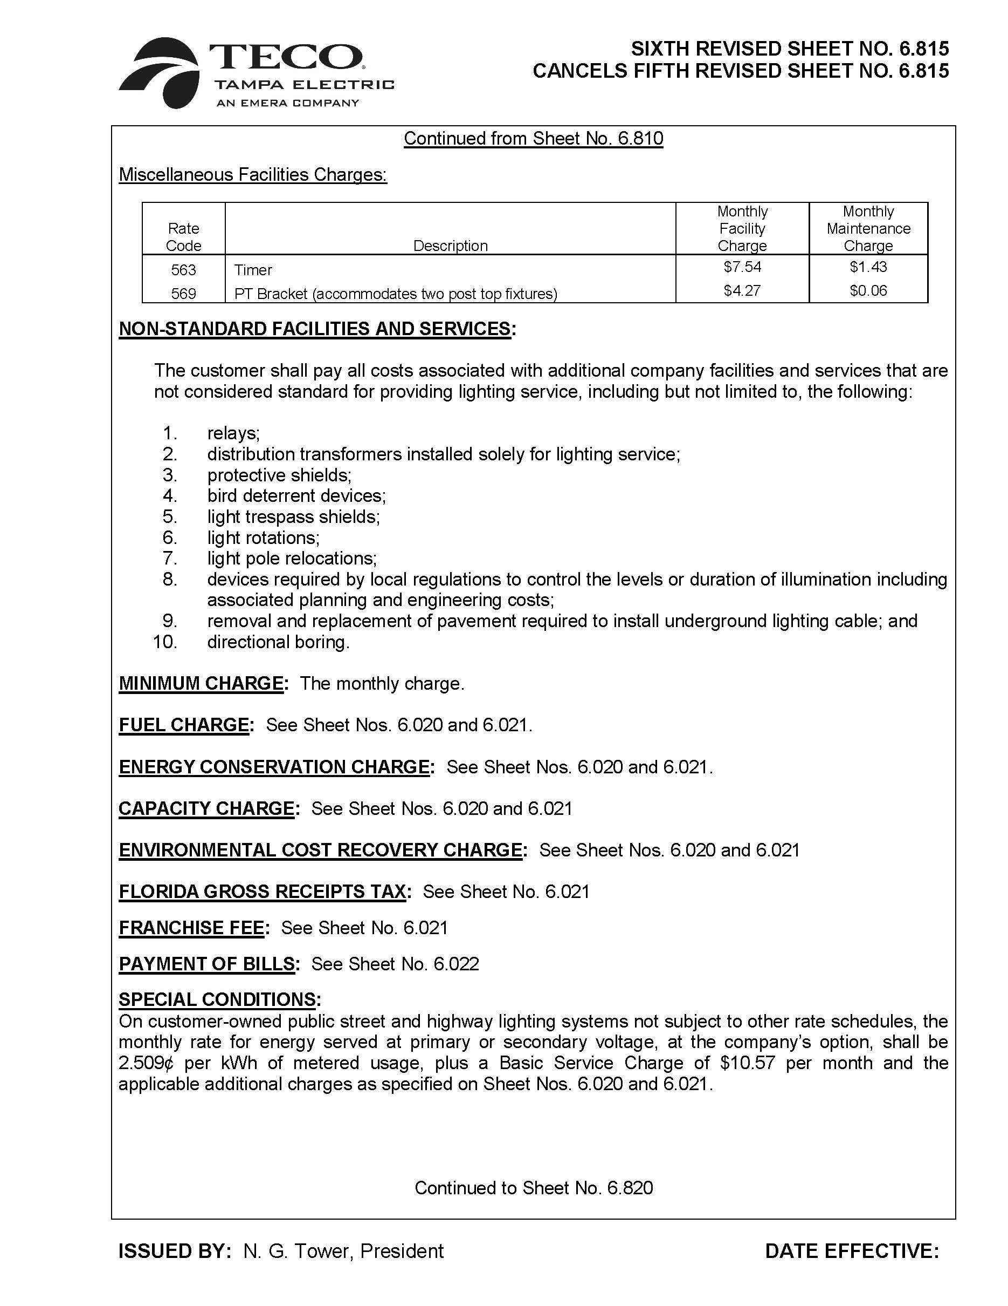
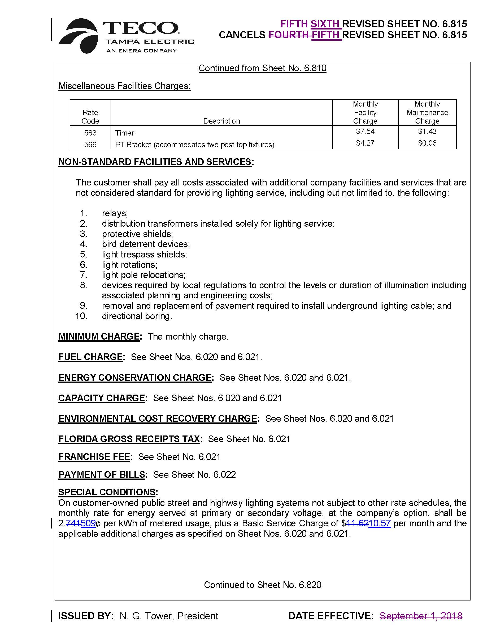

Order No. PSC-2018-0340-PCO-EI, issued July 10, 2018, acknowledged OPC’s intervention, and Order No. PSC-2018-0387-PCO-EI, issued October 2, 2018, granted FIPUG’s intervention request.
Order No. PSC-13-0023-S-EI, issued January 14, 2013, in Docket No. 120015-EI, In re: Petition for increase in rates by Florida Power & Light Company; Order No. PSC-11-0089-S-EI, issued February 1, 2011, in Docket Nos. 080677-EI and 090130, In re: Petition for increase in rates by Florida Power & Light Company and In re: 2009 depreciation and dismantlement study by Florida Power & Light Company; Order No. PSC-13-0023-S-EI, issued January 14, 2013, in Docket No. 120015-EI, In re: Petition for increase in rates by Florida Power & Light Company; PSC-10-0398-S-EI, issued June 18, 2010, in consolidated Docket Nos. 090079-EI, In re: Petition for increase in rates by Progress Energy Florida, Inc.; and 090144-EI, In re: Petition for limited proceeding to include Bartow repowering project in base rates, by Progress Energy Florida, Inc.; Docket No. 090145-EI, In re: Petition for expedited approval of the deferral of pension expenses, authorization to charge storm hardening expenses to the storm damage reserve, and variance from or waiver of Rule 25-6.0143(1)(c), (d), and (f), F.A.C., by Progress Energy Florida, Inc.; and Docket No. 100136-EI, In re: Petition for approval of an accounting order to record a depreciation expense credit, by Progress Energy Florida, Inc.; and Order No. PSC-05-0945-S-EI, issued September 28, 2005, in Docket No. 050078-EI, In re: Petition for rate increase by Progress Energy Florida, Inc.
Order No. PSC-13-0023-S-EI, at p. 7.

