State of Florida |  | Public Service Commission  Capital Circle Office Center ● 2540 Shumard Oak Boulevard  Tallahassee, Florida 32399-0850  -M-E-M-O-R-A-N-D-U-M-
DATE: | December 27, 2018
TO: | Office of Commission Clerk (Stauffer)
FROM: | Division of Economics (Guffey)  Office of the General Counsel (Nieves)
RE: | Docket No. 20180159-EU – Joint petition for approval of amendment to territorial agreement in Hardee, Highlands, Polk, and Osceola Counties, by Peace River Electric Cooperative and Duke Energy Florida, LLC.
AGENDA: | 01/08/19 – Regular Agenda – Proposed Agency Action - Interested Persons May Participate
COMMISSIONERS ASSIGNED: |  |  | All Commissioners
PREHEARING OFFICER: |  |  | Clark
CRITICAL DATES: |  |  | None
SPECIAL INSTRUCTIONS: |  |  | None

Case Background
On August 31, 2018, Peace River Electric Cooperative (PRECO) and Duke Energy Florida, LLC (DEF) filed a joint petition for approval of an amendment to their current territorial agreement in Hardee, Highlands, Polk, and Osceola Counties. The proposed agreement is shown in Attachment A and a map depicting the current service territories and proposed changes is shown in Attachment B to this recommendation. Detailed maps delineating the service boundaries and their written descriptions are provided in petition Exhibits A and B, respectively. Due to their voluminous nature, the detailed maps are not attached to this recommendation.
In 1994, the Commission approved a territorial agreement that established the boundaries for the utilities’ service territories in the counties mentioned above. The 1994 agreement contained a provision permitting DEF (Florida Power Corporation at the time) to provide transmission level electric service (69 kilovolt and higher) to certain phosphate mining companies in PRECO’s service territory. The mining companies have unique service requirements and PRECO did not have the appropriate facilities to meet the phosphate customers’ transmission level electric needs.
In 2006, the Commission approved an amendment to Sections 1.9 and 2.4 of the 1994 territorial agreement. These sections address the provision of electric service to the phosphate mining companies in PRECO’s service territory and the 2006 amendment clarified the parties’ obligations with respect to the existing phosphate mining customers in PRECO’s service territory. The number of phosphate mining customers served by DEF in PRECO’s service territory, pursuant to the 1994 territorial agreement, decreased from nine customers in 1994 to two customers in 2006. The 2006 agreement will expire on December 12, 2019.
PRECO and DEF entered into the proposed territorial agreement and filed the instant petition. The proposed agreement replaces the current 2006 agreement in its entirety while incorporating many provisions of the current agreement. Under the proposed agreement the territorial boundaries have been modified and, if approved, the agreement would result in the transfer of 2,858 customers from DEF to PRECO and 28 customers from PRECO to DEF.
During the review of this joint petition, staff issued a joint data request to DEF and PRECO on November 8, 2018, for which responses were received on November 20, 2018. Staff also had follow-up questions for which responses were received on December 20, 2018. The responses have been placed in the docket file. The Commission has jurisdiction over this matter pursuant to Section 366.04(2)(d), Florida Statutes (F.S.).

Discussion of Issues

Issue 1:
Should the Commission approve the joint petition by DEF and PRECO for approval of their territorial agreement in Hardee, Highlands, Polk, and Osceola Counties?

Recommendation:
Yes. The Commission should approve the joint petition by DEF and PRECO for approval of their territorial agreement in Hardee, Highlands, Polk, and Osceola Counties. The proposed territorial agreement is in the public interest and will enable DEF and PRECO to serve their customers in an efficient manner. (Guffey)

Staff Analysis:
Pursuant to Section 366.04(2)(d), F.S., and Rule 25-6.0440, Florida Administrative Code (F.A.C.), the Commission has the jurisdiction to approve territorial agreements between and among rural electric cooperatives, municipal electric utilities, and other electric utilities. Unless the Commission determines that the agreement will cause a detriment to the public interest, the agreement should be approved.
Through the proposed agreement, the joint petitioners desire to revise the service area boundaries within the four-county area in order to serve customers more reliably and economically. Under the proposed agreement, 2,858 customers in Hardee County and a small area in southern Polk County will be transferred from DEF to PRECO (409 commercial, 6 industrial, and 2,443 residential customers). The petitioners explained in their response to staff’s data request that over the years the service areas of the two utilities have overlapped and resulted in duplicate electric service facilities and that such evolution is not unusual in rural areas. As an example, the petitioners stated that in Hardee County, DEF has facilities on one side and PRECO has facilities on the other side of the same road. The petitioners stated that transferring customers from DEF to PRECO will eliminate the duplication of services, create operational efficiencies for both utilities, and will ensure customers continue to receive safe and reliable service.
In addition to the customer transfers discussed above, 28 PRECO customers will be transferred to DEF (two commercial and 26 residential customers). The petitioners stated that during due diligence field surveys of the service territory, 28 customers located in DEF’s service territory were identified as being inadvertently being served by PRECO. All the customers are expected to be transferred within 36 months of the effective date of this agreement and the petitioners will notify the Commission in writing if additional time is needed. The territorial boundary maps have been modified to reflect the customer transfers and have been updated to a GIS format to show the lines in greater detail. Additionally, parcels that were divided (between the two electric providers) by the prior territorial boundary lines have been modified to eliminate split parcels.
The petitioners explained that the customer transfer process includes the following steps: planning and coordinating between multiple departments of each utility, seeking Commission approval of the proposed agreement, conducting engineering studies, developing customer communications plan, evaluating facilities, conducting various field reviews, and conducting individual engineering work requests designed for each customer being transferred.
In accordance with Rule 25-6.0440(1)(d), F.A.C., the petitioners state that prior to the filing of this petition, the impacted customers were notified by mail of the transfer and provided a description of the differences in rates between DEF and PRECO. As of July 2018, the bill for a residential customer using 1,000 kilowatt hours (kWh) was $128.78 for PRECO and $124.16 for DEF. As of July 2018, the bill for a commercial non-demand customer using 1,500 kWhs was $207.63 for PRECO and $189.41 for DEF. Customer deposits for DEF and PRECO customers will be applied to their last electric bill and any surplus will be refunded directly to the customers.
Additionally, the joint petitioners held an open house in Wauchula on August 14, 2018, for customers affected by the proposed transfers. Issues and concerns discussed at the open house were regarding differences in rates, billing, customer deposits, and residential seasonal service programs. The petitioners stated that PRECO and DEF had several representatives present to answer questions and there were no outstanding concerns after the open house. The petition includes customer notification letters and a summary of customer issues and concerns stated at the open house.
Pursuant to Section 2.5 of the proposed agreement, DEF provides electric service to a phosphate mining customer in PRECO’s service territory. DEF’s service to the mining customer is limited to the electric requirements directly associated with the mining operations. The phosphate mining customer is referred to as a Special Industrial Customer in the agreement. The agreement provides that once the Special Industrial Customer operating in PRECO’s service territory completes its mining operations, all rights to serve the Special Industrial Customer in PRECO’s service territory will revert back to PRECO.
Pursuant to Section 3.4 of the proposed agreement, either utility may elect to purchase electric distribution facilities exclusively for providing electric service to the transferred customers. To determine the facilities’ value, the utilities will use a common engineering cost estimation methodology such as the Handy-Whitman index. In response to staff’s data request, the joint petitioners stated that they have not yet made a final decision regarding transferring or purchasing facilities, but will undertake a valuation of facilities once the proposed agreement is approved by the Commission.
Pursuant to Section 1.14 of the proposed agreement, the effective date of the agreement will be the date on which a final Order is issued by the Commission. The proposed agreement has been negotiated for an initial term of 30 years and may automatically be extended for succeeding periods of five years. The agreement may be terminated by either party upon one year’s written notification to the other utility. Section 5.1 of the agreement states that any modifications to the agreement must be submitted to the Commission for approval.

Conclusion
After review of the petition, the proposed territorial agreement, and the joint petitioners’ responses to staff’s data request, staff believes that the proposed amendments to the territorial agreement are in the public interest and will enable DEF and PRECO to serve their customers in an efficient manner. The joint petitioners in their responses state that they have worked collaboratively to structure the proposed amendments to their territorial agreement and that it furthers the goals of avoiding duplication of service and enables them to achieve operational efficiency. It appears that the proposed amendments will eliminate any potential uneconomic duplication of facilities and will not cause a decrease in the reliability of electric service to the customers. As such, staff believes that the proposed territorial agreement between DEF and PRECO will not cause a detriment to the public interest and recommends that the Commission approves it.

Issue 2:
Should this docket be closed?

Recommendation:
If no protest is filed by a person whose substantial interests are affected within 21 days of the issuance of the Order, this docket should be closed upon the issuance of a Consummating Order. (Nieves)

Staff Analysis:
If no protest is filed by a person whose substantial interests are affected within 21 days of the issuance of the Order, this docket should be closed upon the issuance of a Consummating Order.
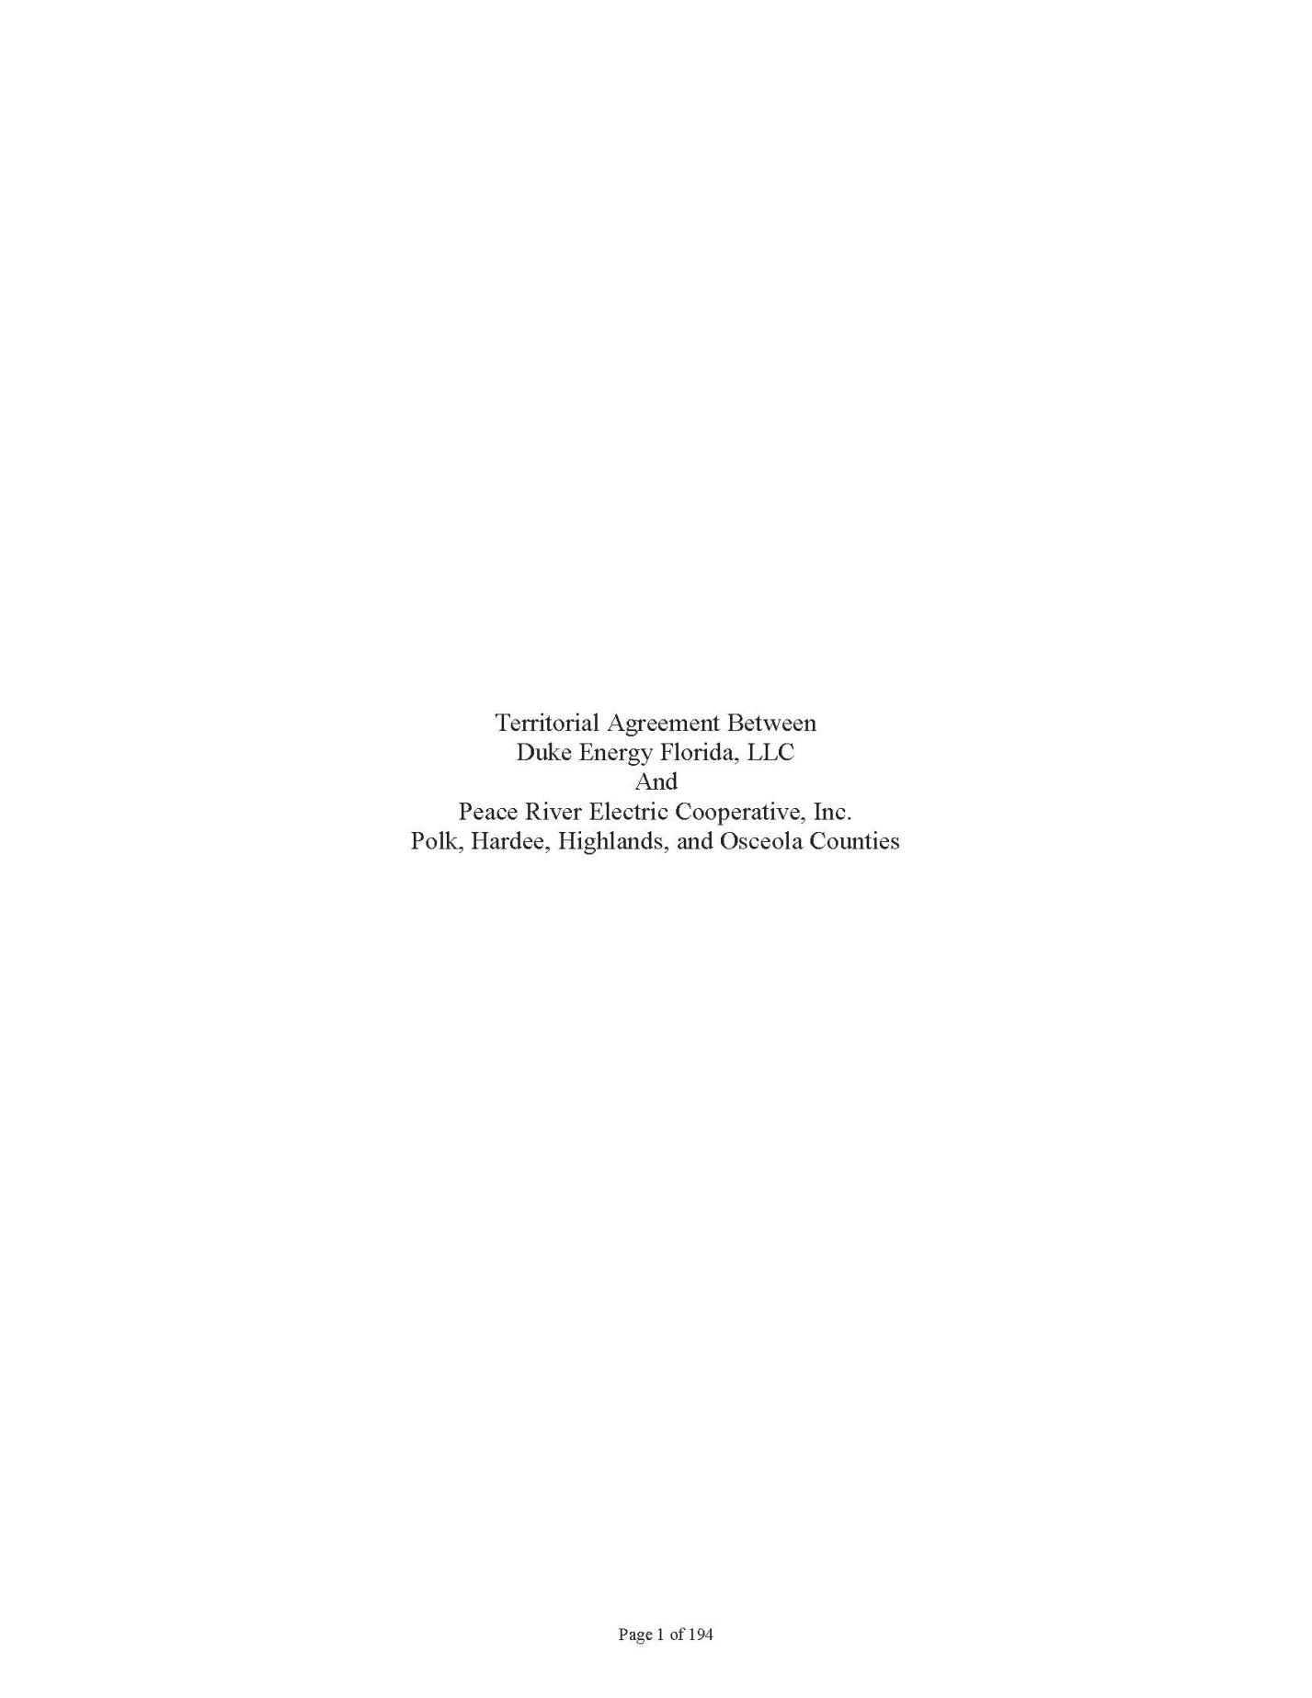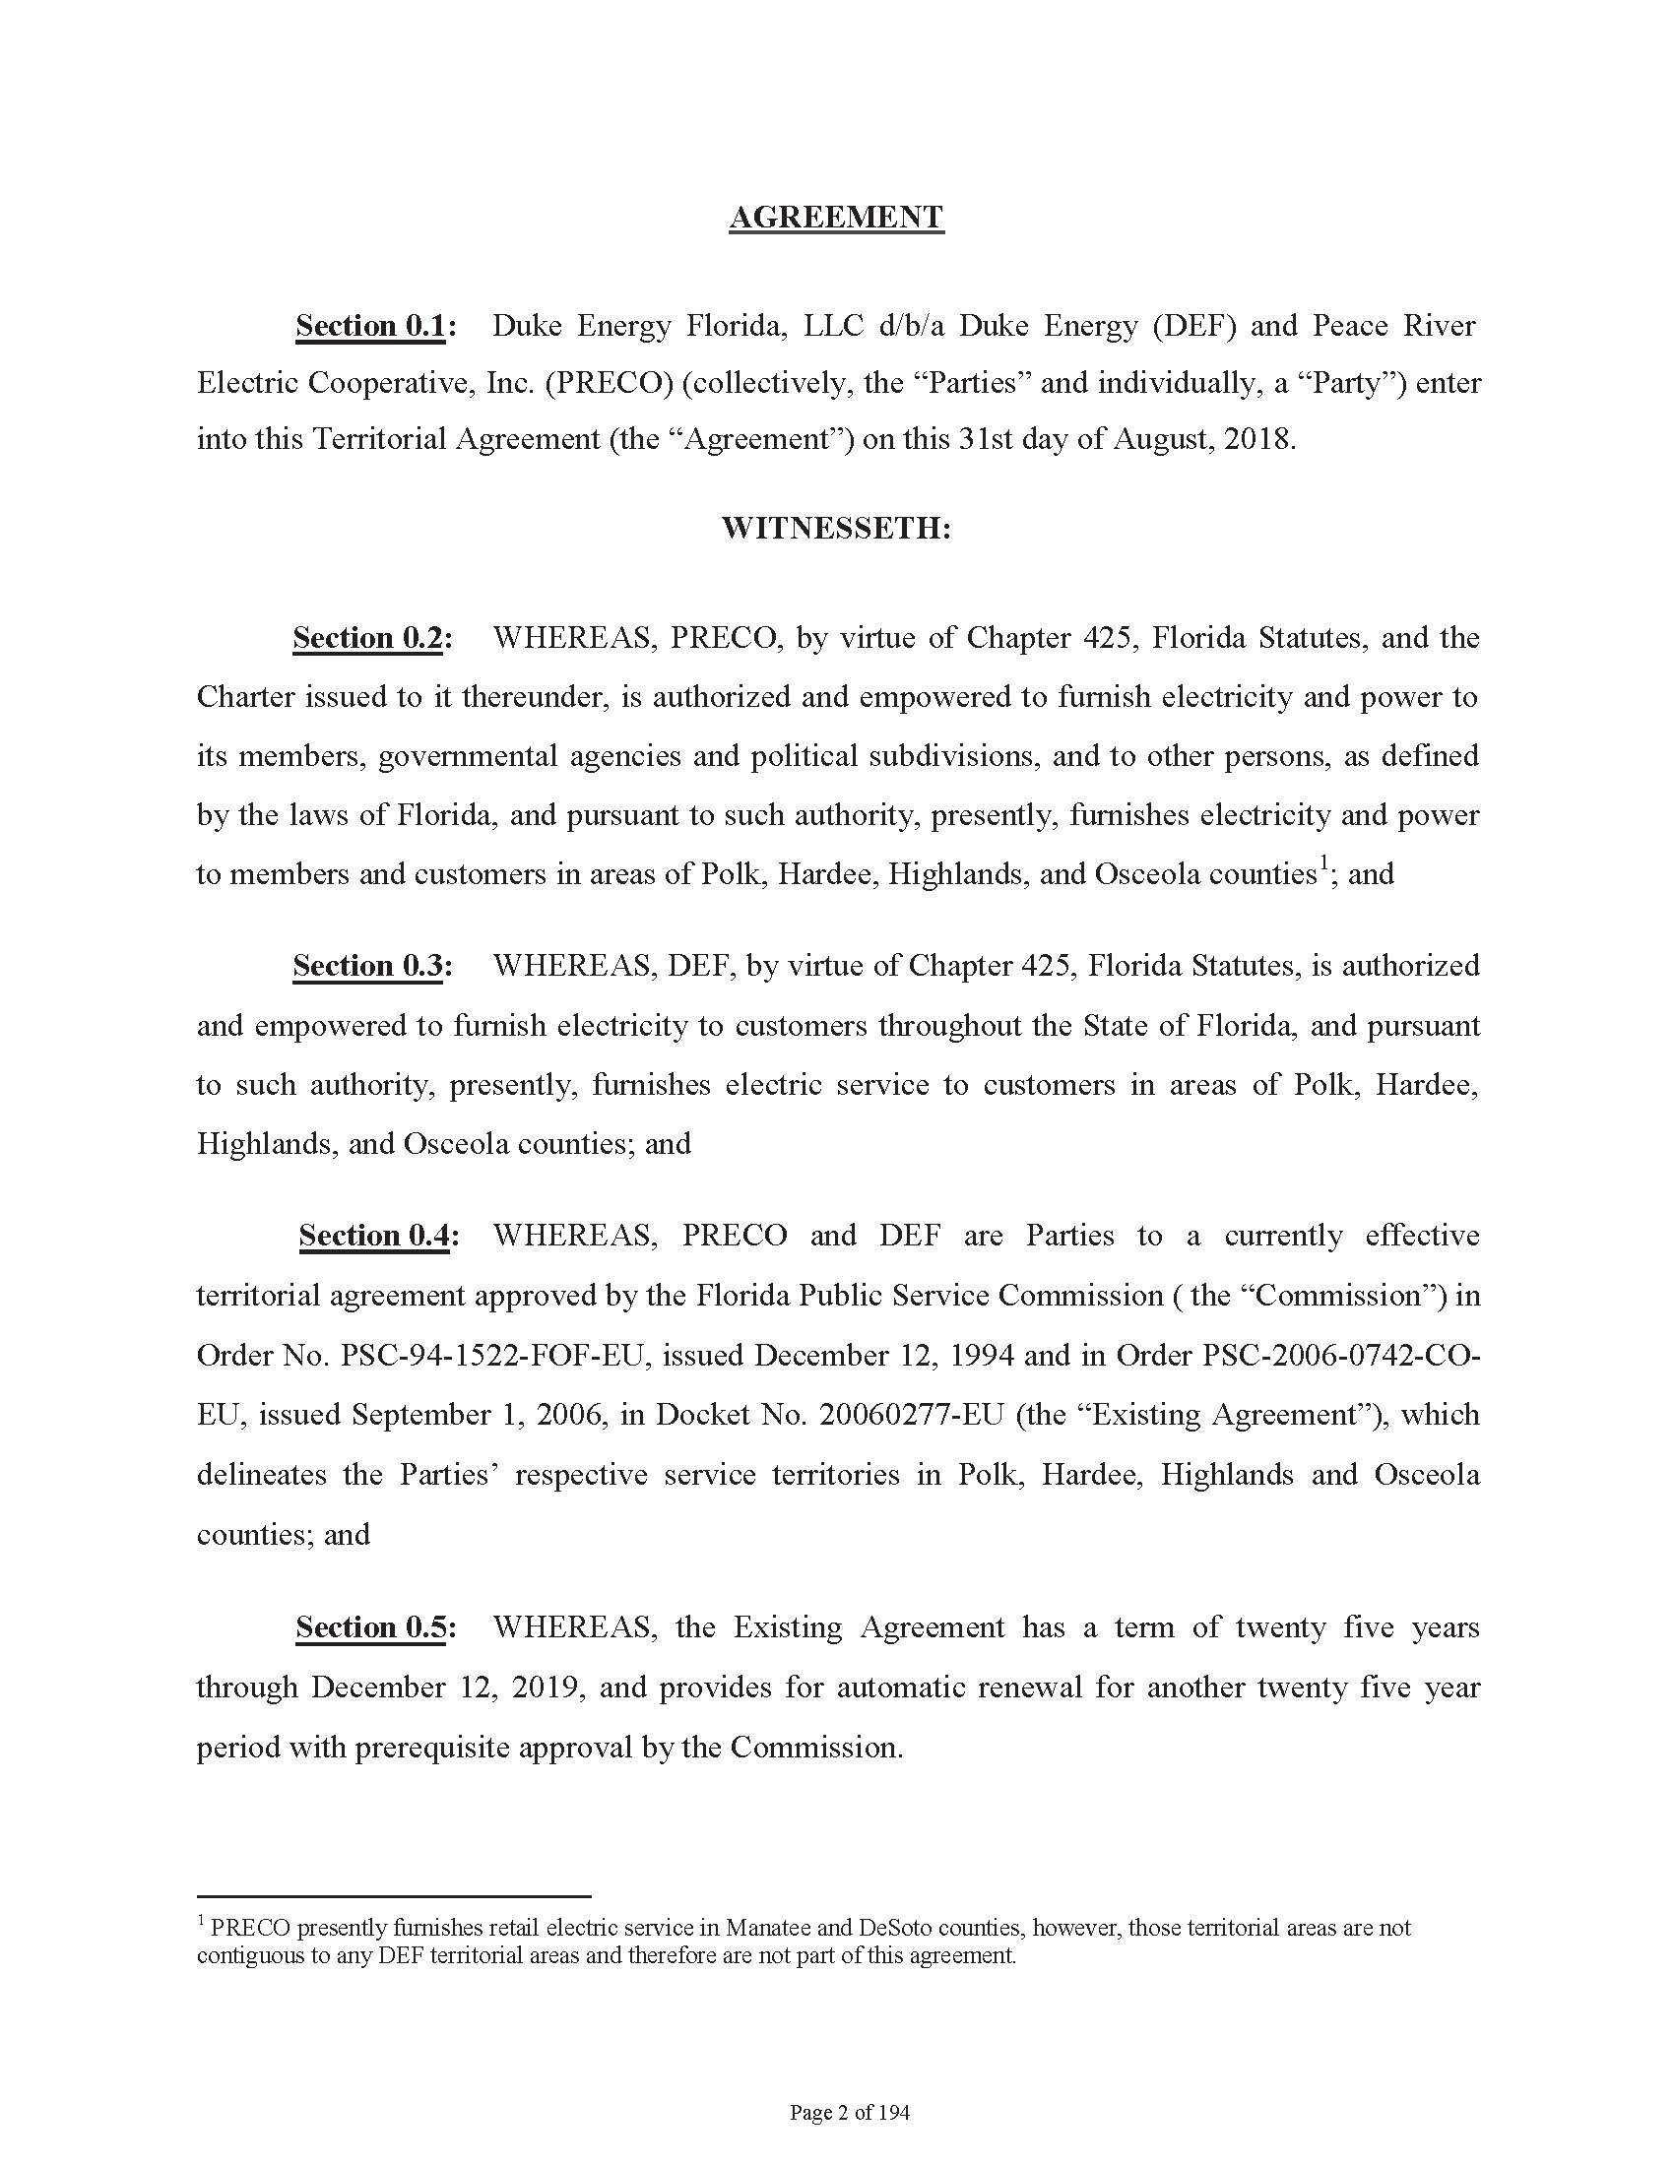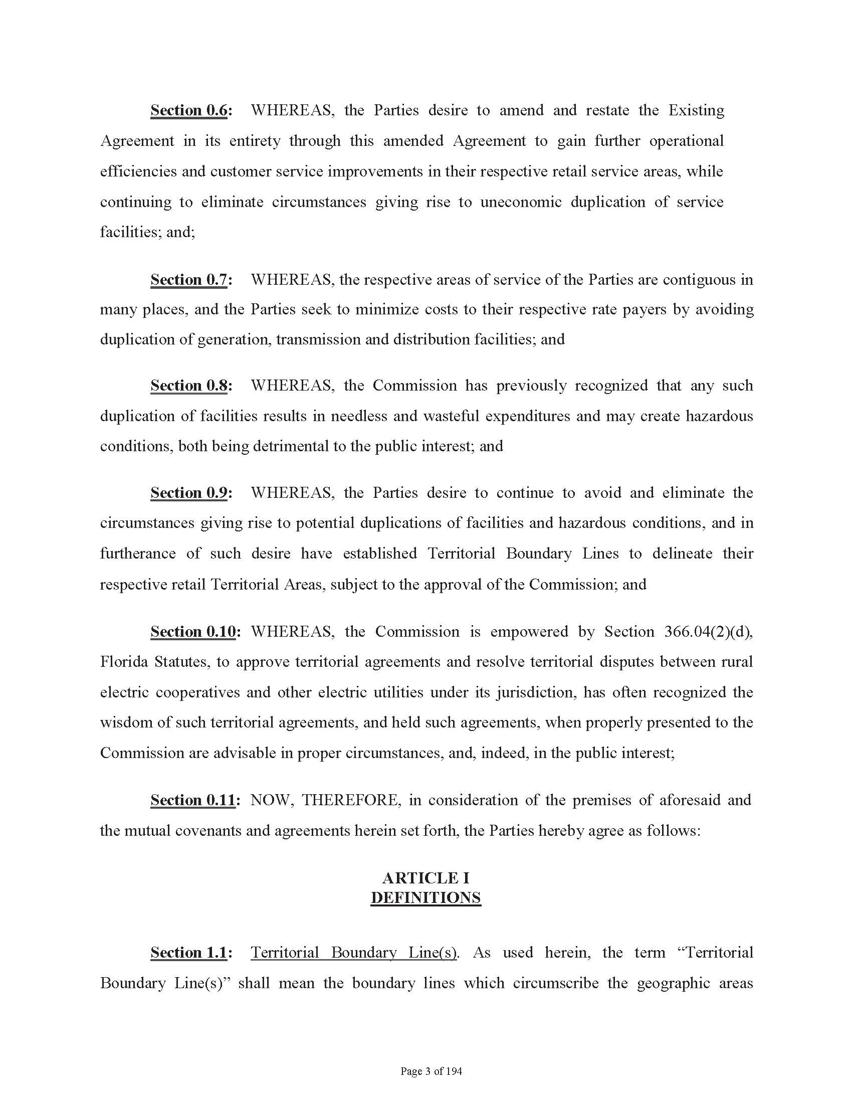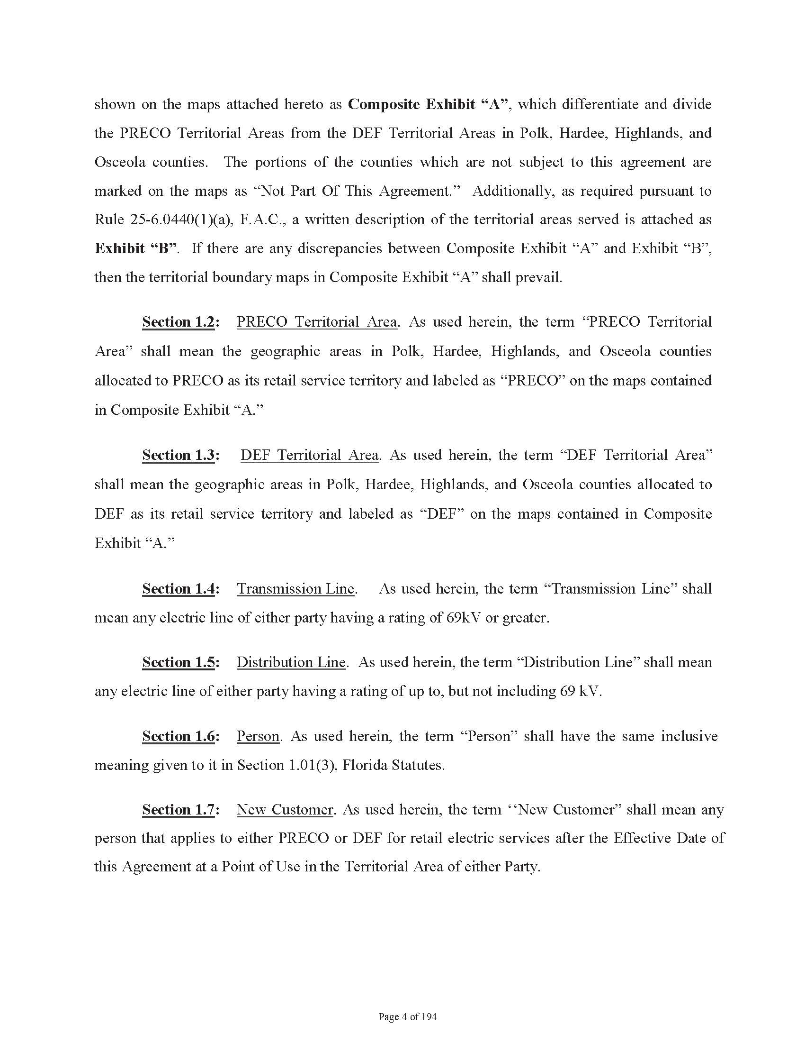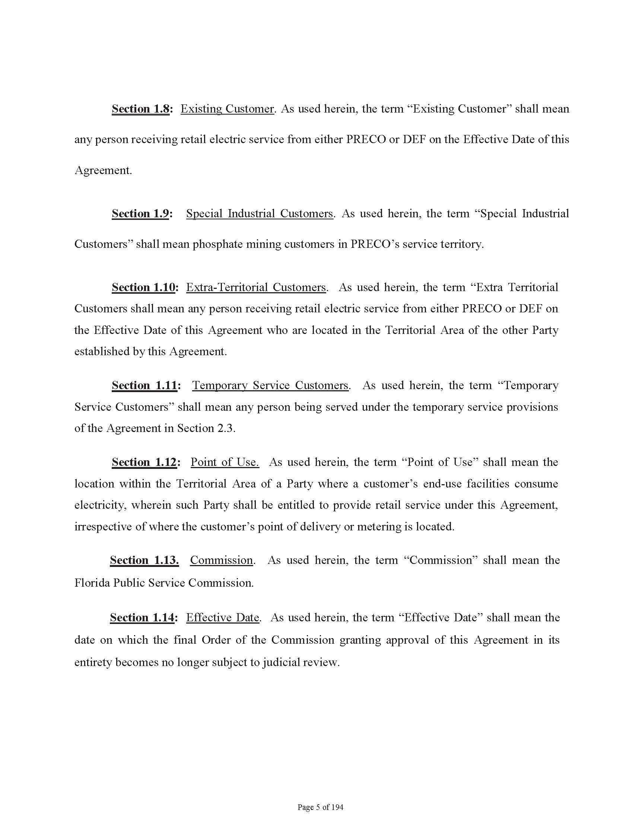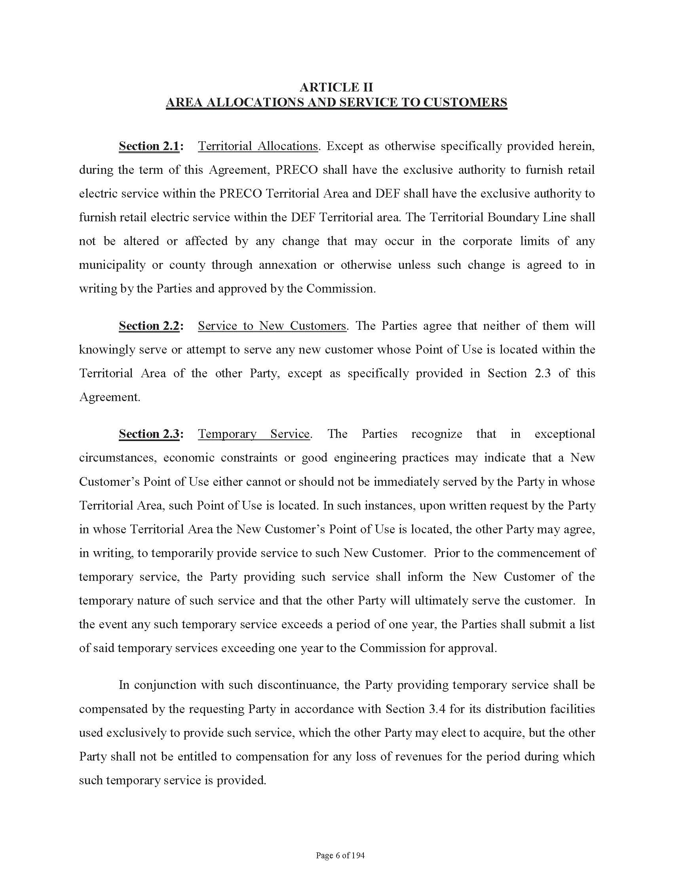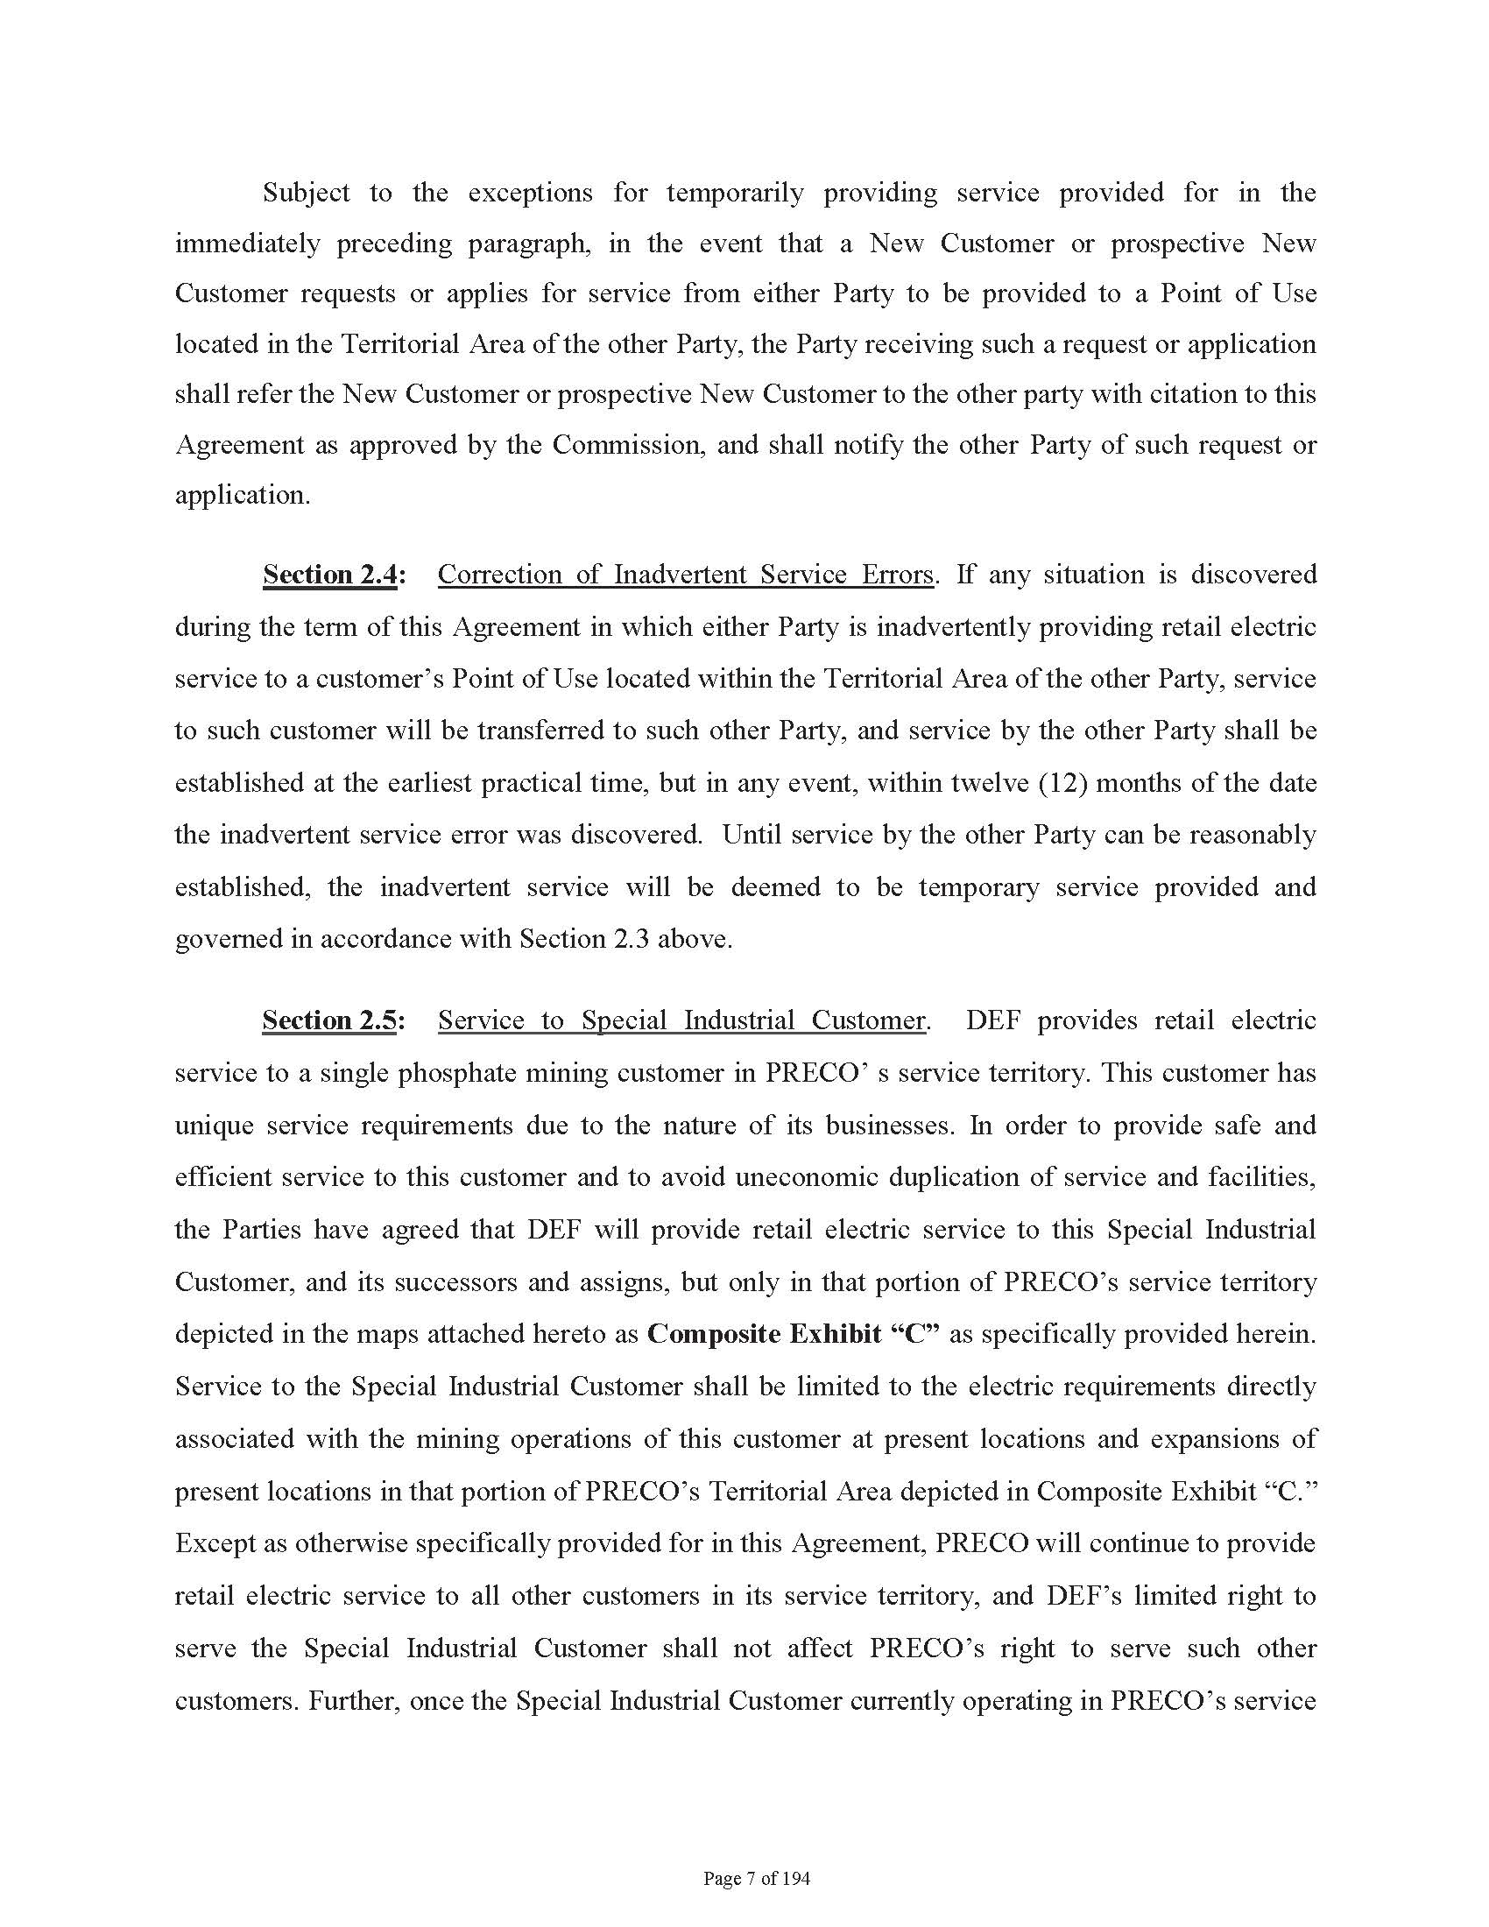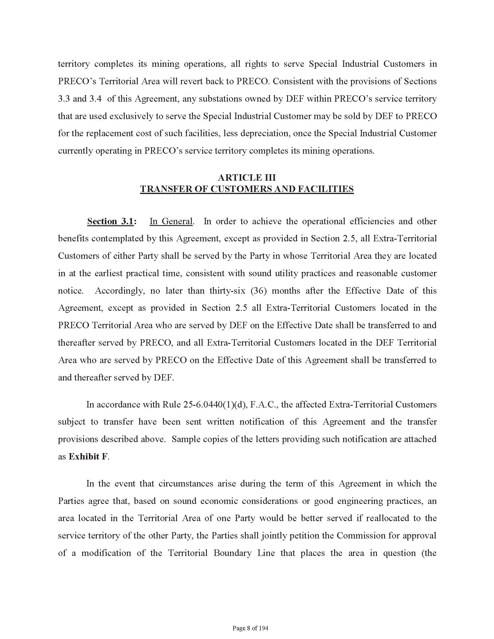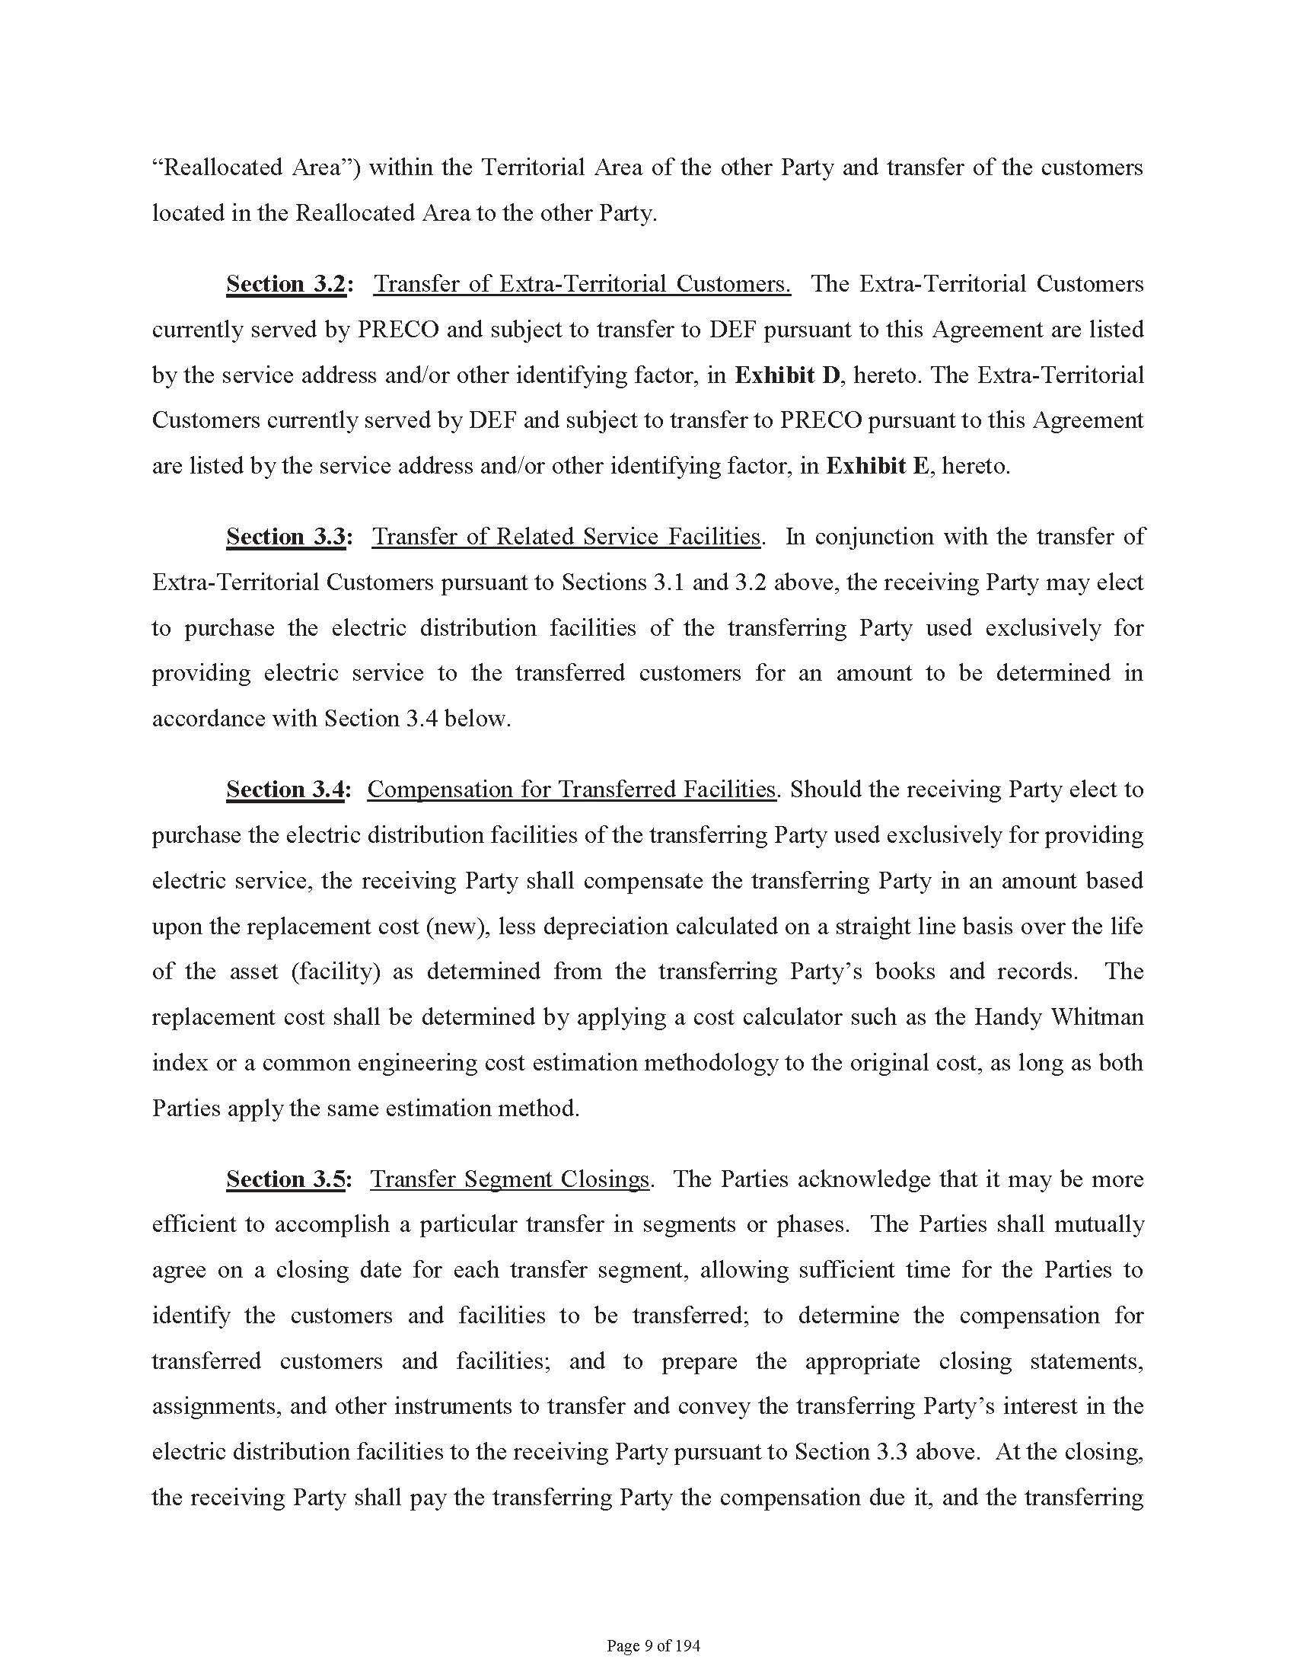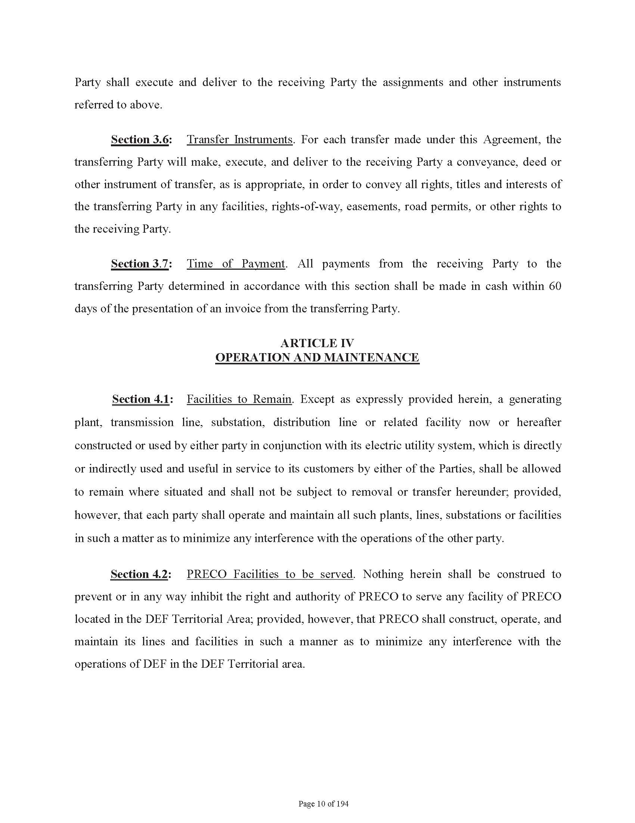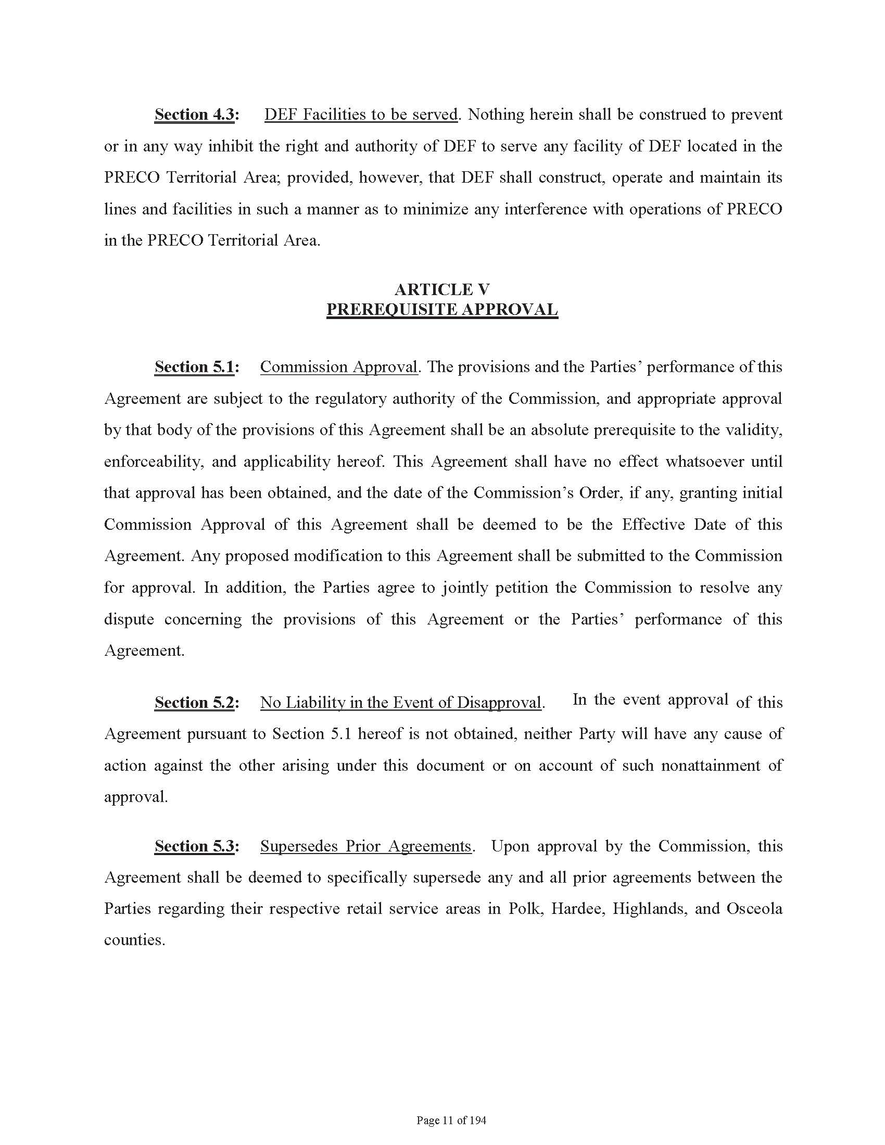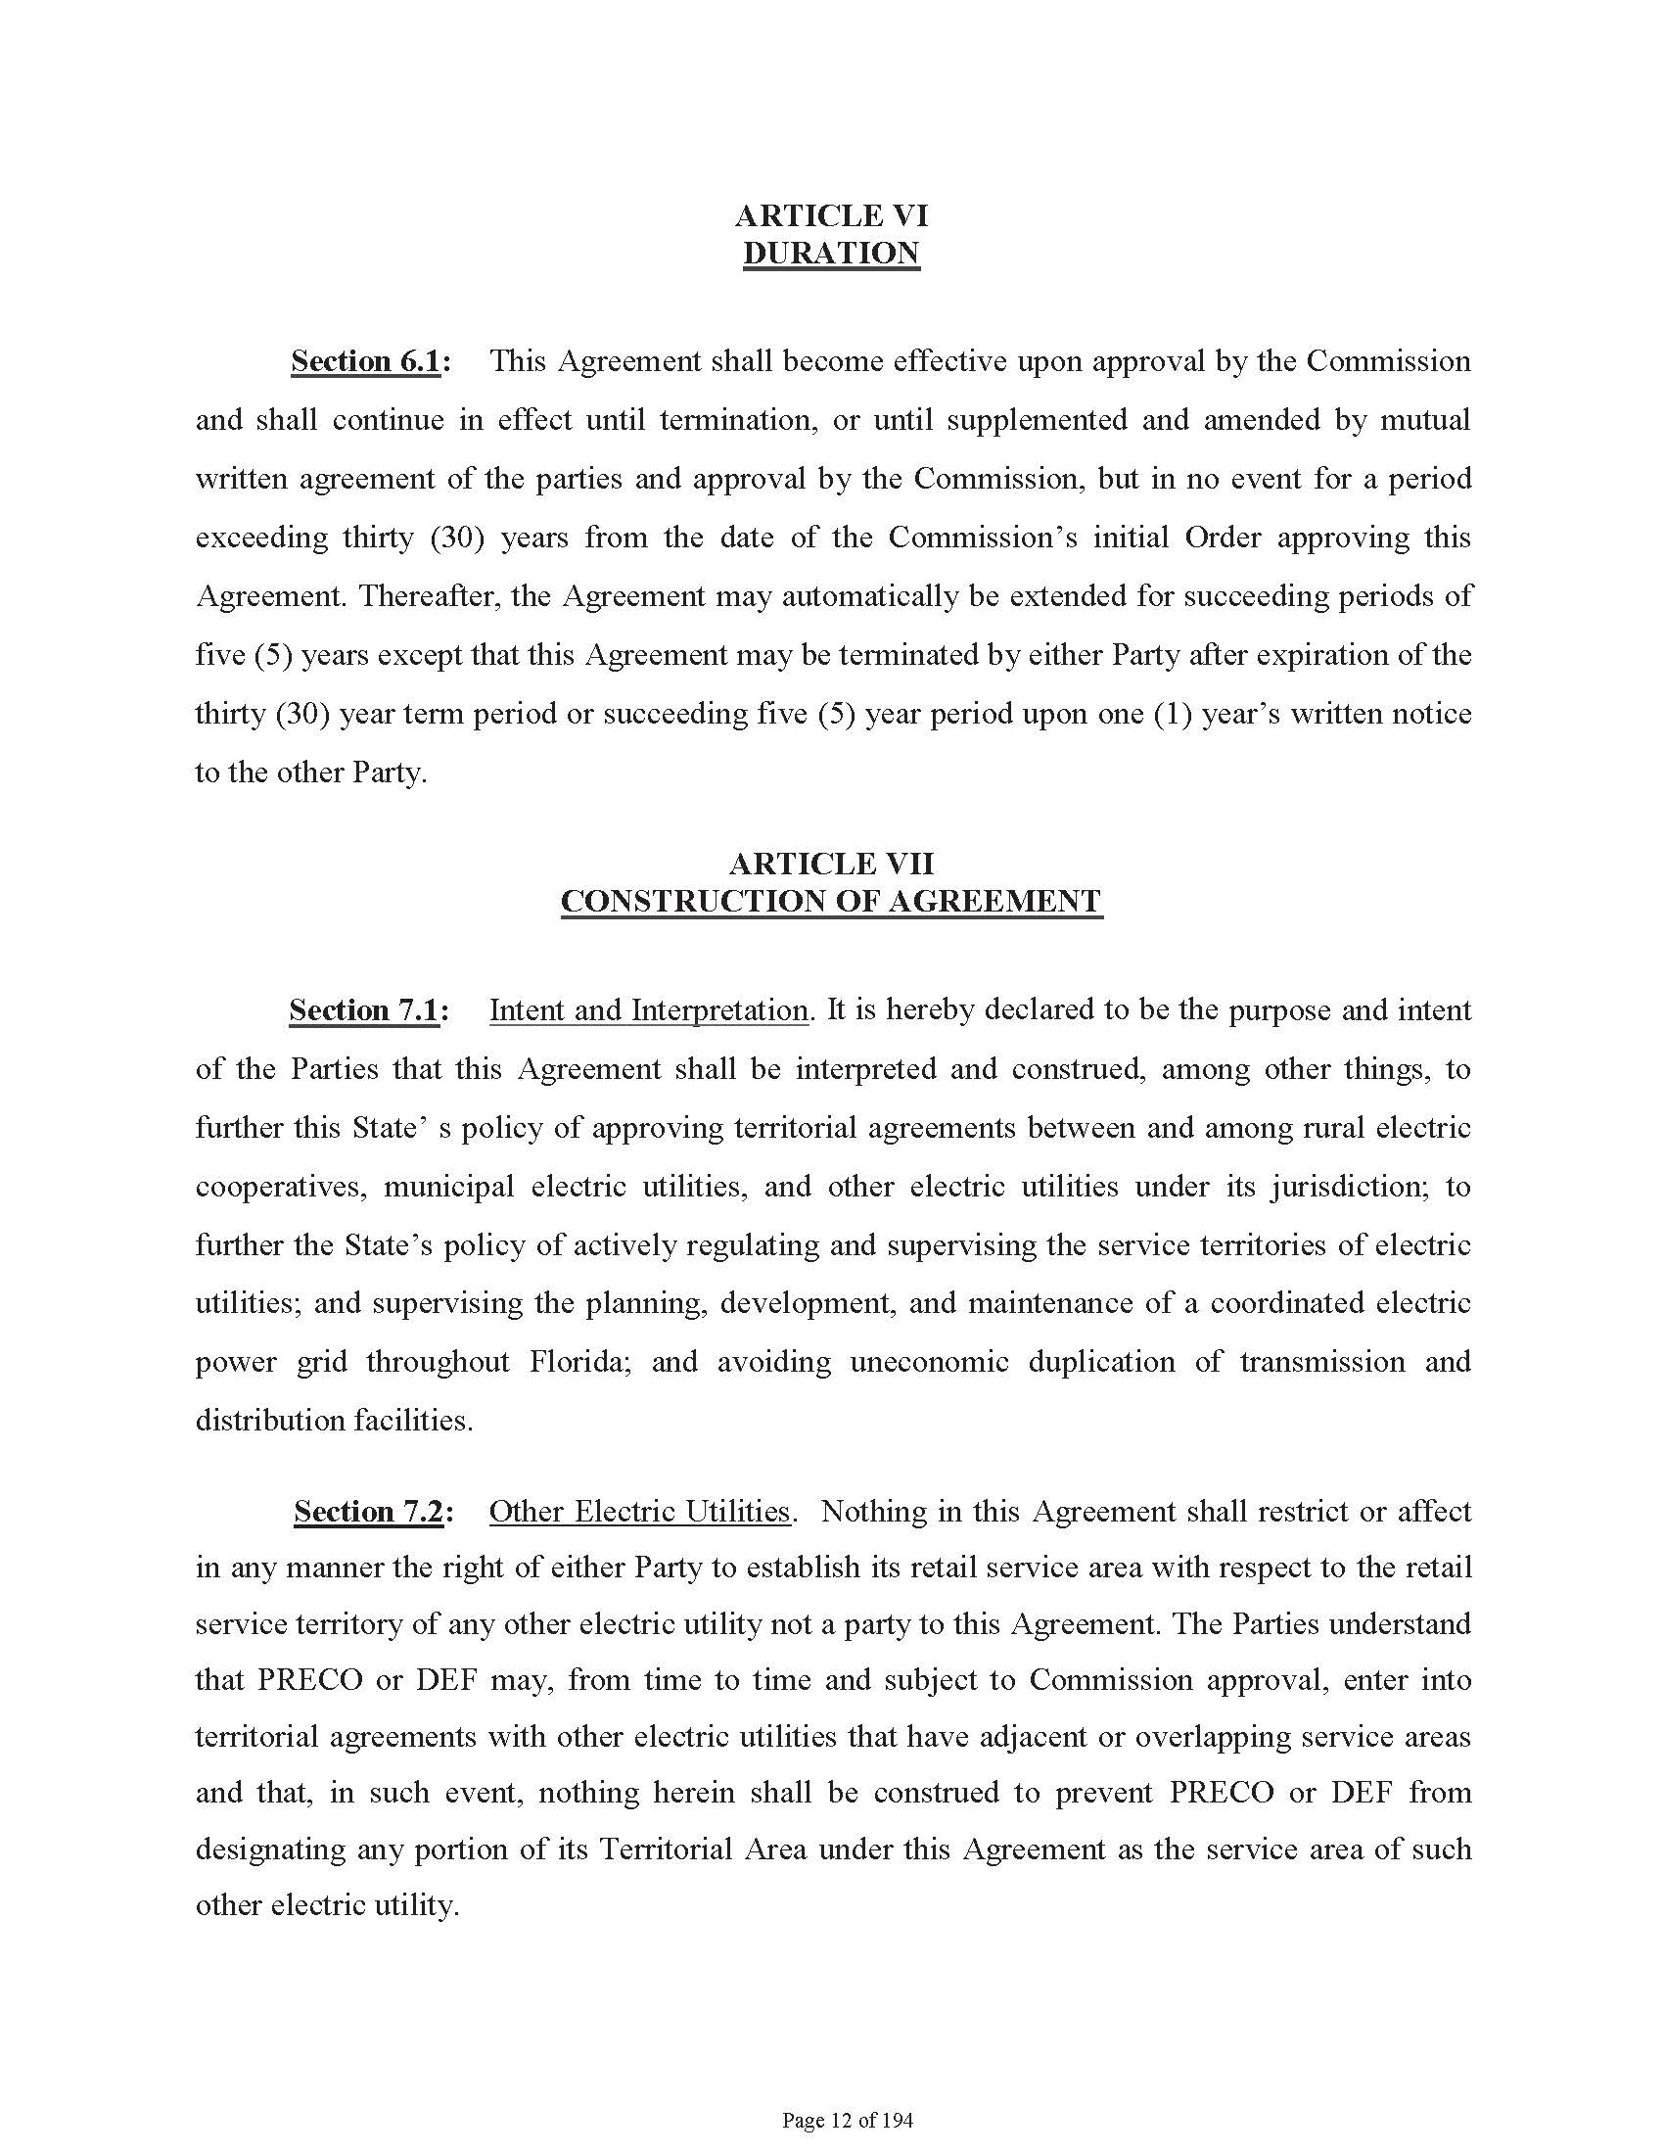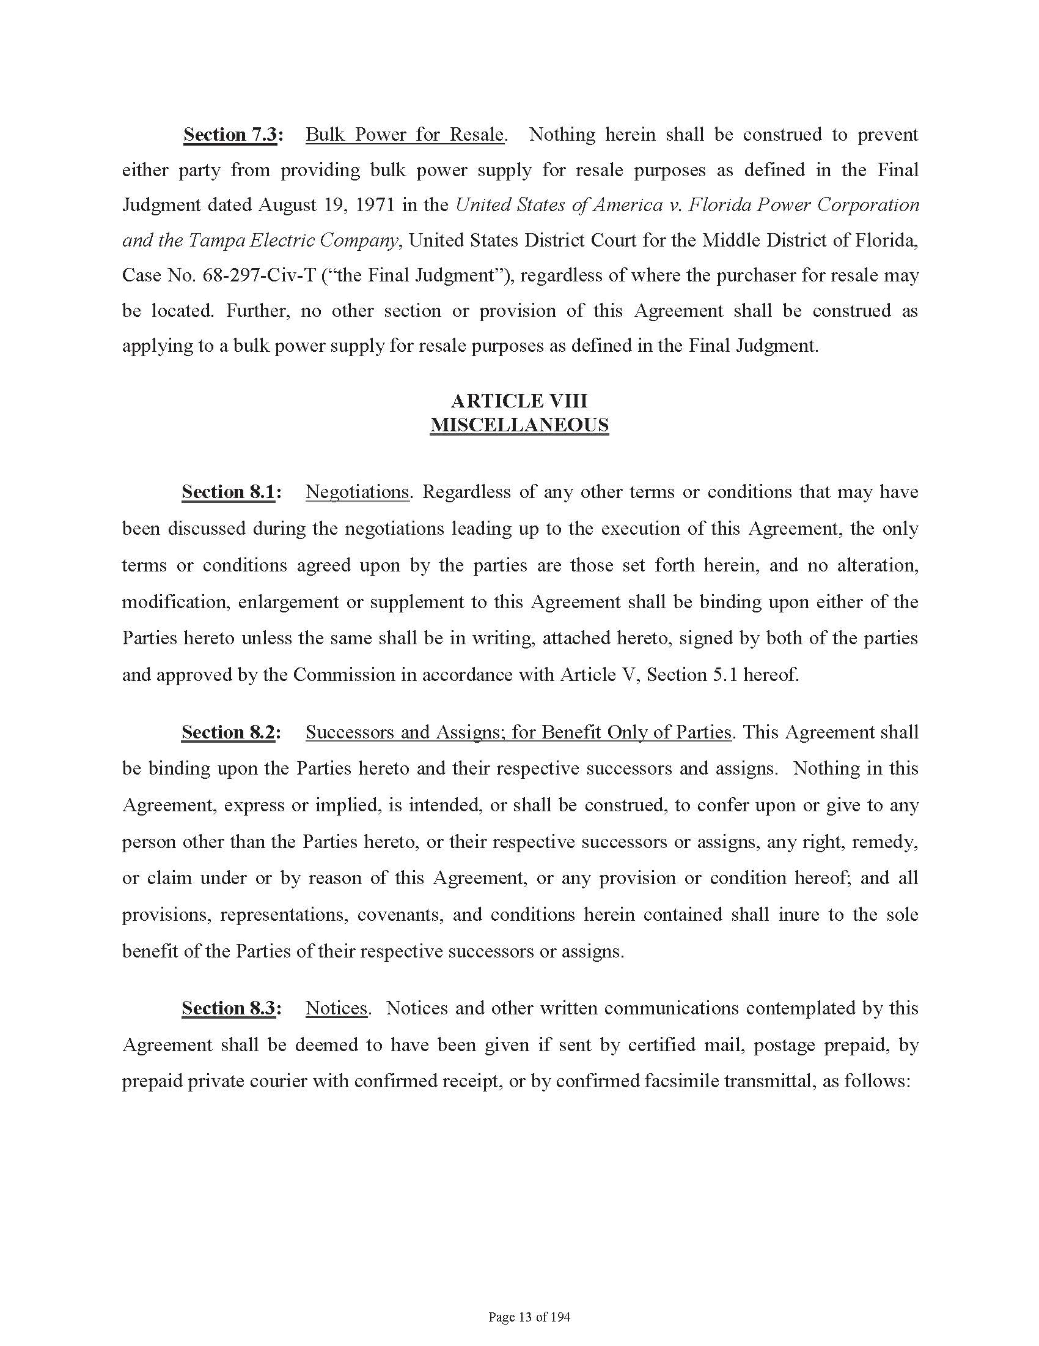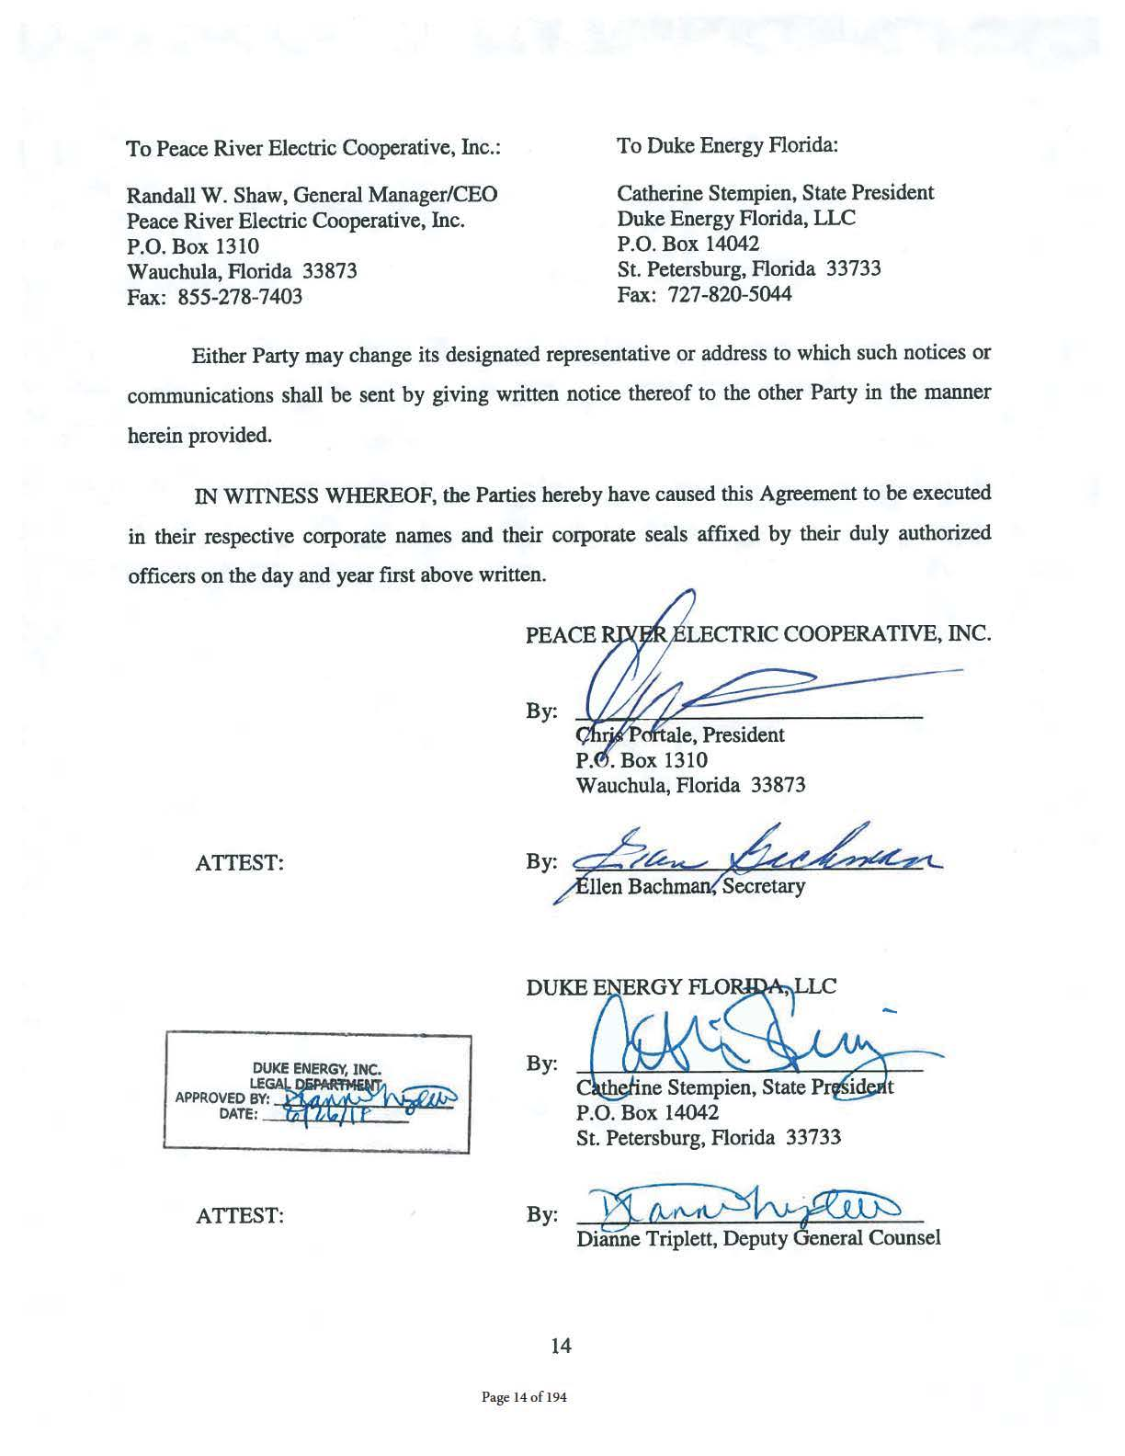

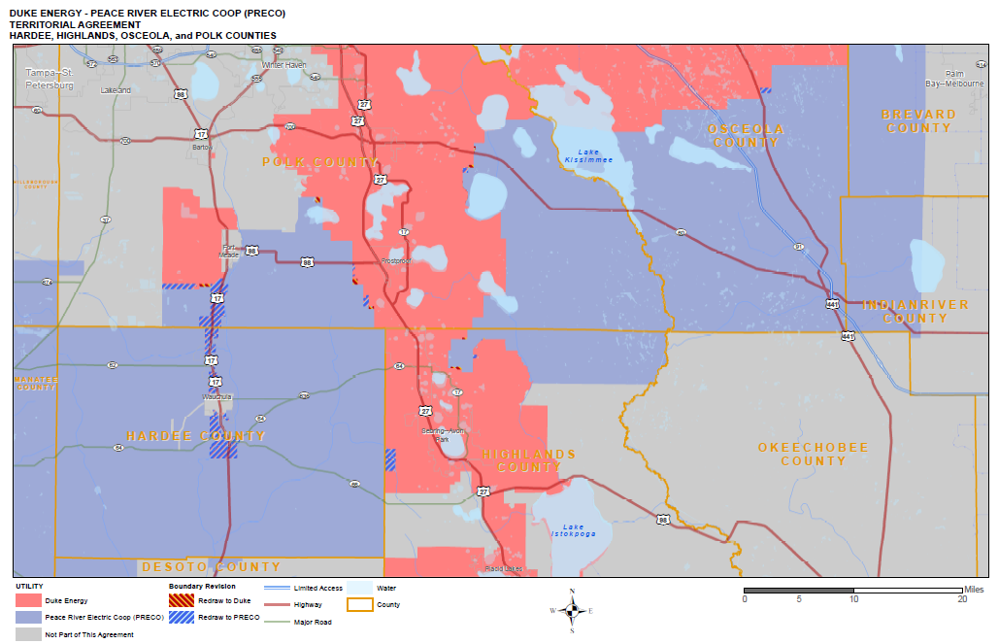

Order No. PSC-94-1522-FOF-EU, issued December 12, 1994, in Docket No. 940376-EU, In re: Joint Petition for approval of territorial agreement between Florida Power Corporation and Peace River Electric Cooperative, Inc.
Order No. PSC-06-0673-PAA-EU, issued August 7, 2006, in Docket No. 060277-EU, In re: Joint petition for approval of territorial amendment in Polk, Hardee, Highlands, Manatee, and Osceola Counties by Progress Energy Florida, Inc. and Peace River Electric Cooperative, Inc.
Utilities Commission of the City of New Smyrna Beach v. Florida Public Service Commission, 469 So. 2d 731 (Fla. 1985).
Composite Exhibit A of the petition.
Exhibit F of the petition.
Attachment 1 of the petition.

