State of Florida |  | Public Service Commission  Capital Circle Office Center ● 2540 Shumard Oak Boulevard  Tallahassee, Florida 32399-0850  -M-E-M-O-R-A-N-D-U-M-
DATE: | December 27, 2018
TO: | Office of Commission Clerk (Stauffer)
FROM: | Division of Economics (Bruce)  Division of Accounting and Finance (Cicchetti)  Office of the General Counsel (Crawford)
RE: | Docket No. 20180212-WS – Application for gross-up of CIAC in Brevard County, by Aquarina Utilities, Inc.
AGENDA: | 12/08/18 – Regular Agenda – Tariff Filing – Interested Persons May Participate
COMMISSIONERS ASSIGNED: |  |  | All Commissioners
PREHEARING OFFICER: |  |  | Administrative
CRITICAL DATES: |  |  | 01/14/19 (60-Day Suspension Date)
SPECIAL INSTRUCTIONS: |  |  | None

Case Background
Aquarina Utilities, Inc. (Aquarina or utility) is a Class B utility providing water and wastewater services in Brevard County to approximately 301 water, 123 non-potable, and 335 wastewater customers. The utility reported in its 2017 annual report operating revenues in the amount of $437,201 for water and $176,053 for wastewater. The utility did not collect contributions in aid of construction (CIAC) for water or wastewater in 2017.
On November 15, 2018, the utility filed an application for approval of tariffs to allow for gross-up of CIAC. As indicated in the utility’s application, the recent change in tax law may cause it to risk the loss of its opportunity to earn a reasonable return on its used and useful property if it is not allowed to collect the tax impact on receipt of CIAC. This recommendation addresses the utility’s request for approval of gross-up tariffs related to changes in the federal tax code effective in 2018. Any potential refund related to the change in the federal tax rate currently embedded in the utility’s rates is outside of this recommendation and will be addressed in the generic Docket No. 20180013-PU. The Commission has jurisdiction pursuant to Sections 367.081 and 367.091, Florida Statutes (F.S.).

Discussion of Issues

Issue 1:
Should Aquarina's request for approval of tariffs to allow the gross-up of CIAC be approved?

Recommendation:
Yes. The tariffs filed on November 15, 2018, should be approved. The utility should provide notice to all persons in the service areas included in the application who have filed a written request for service or who have been provided a written estimate for service within the 12 calendar months prior to the month the application was filed. The approved gross-up charges should be effective for connections made on or after the stamped approval date on the tariff sheets. The utility should provide proof of noticing within 10 days of rendering its approved notice. (Bruce, Crawford)

Staff Analysis:
Effective January 1, 2018, the Federal Tax Cuts and Jobs Act amended Section 118 of the Internal Revenue Code. Prior to the amendments, CIAC was exempt from taxable gross income for water and wastewater utilities. As a result of the amendments, both cash and property CIAC are now taxable gross income for water and wastewater utilities. In recognition of this change in the tax law, the Commission has opened Docket No. 20180013-PU, In re: Petition to establish a generic docket to investigate and adjust rates for 2018 tax savings by Office of Public Counsel to address the potential rate impacts on regulated electric, gas, water, and wastewater utilities.

A similar law, the Tax Reform Act of 1986, became effective in 1987. In Docket No. 19860184-PU, the Commission found that it was appropriate to allow water and wastewater utilities to recover the tax on CIAC from the contributor, including the tax associated with the gross-up tax on CIAC that would also become taxable income. For those utilities that were approved to collect the gross-up on CIAC, the gross-up amounts collected were held subject to refund and were evaluated on a case-by-case basis as to whether any refunds were subsequently required.

On November 15, 2018, the utility filed tariffs (Attachment A) to gross-up cash service availability charges and property contributions to recover the federal and state corporate income taxes associated with those contributions for water. However, for wastewater, Aquarina filed a tariff to gross-up only contributed wastewater property since it is not authorized to collect cash CIAC for wastewater service. According to the utility, Aquarina could risk loss of its opportunity to earn a reasonable return on its property used and useful in the public service if it is not allowed to collect the tax impact on receipt of CIAC.

The tariffs recognize that, for depreciable property, depreciation expense is tax deductible and the utility’s tax liability will be reduced by depreciation claimed for tax purposes. The proposed tariffs are mathematically the same, regarding the gross-up for taxes, as the tariff approved by the Commission following the hearing in Docket No. 19860184-PU. Because the proposed tariffs accurately depict the utility’s expected tax expense associated with CIAC, staff believes no further Commission action would be required once the gross-up formula has been approved. The proposed tariffs are the same as those approved in Order No. PSC-2018-0330-TRF-WS in Docket No. 20180042-WS, Order No. PSC-2018-0331-TRF-WS in Docket No. 20180059-WS, and Order No. PSC-2018-0269-TRF-WS in Docket No. 20180100-WS.

Based on the above, staff recommends that the tariffs be approved. The approved gross-up charges should be effective for connections made on or after the stamped approval date on the tariff sheets. The utility should provide notice to all persons in the service areas included in the application who have filed a written request for service or who have been provided a written estimate for service within the 12 calendar months prior to the month the application was filed. The utility should provide proof of noticing within 10 days of rendering its approved notice.

Issue 2:
Should this docket be closed?

Recommendation:
If a protest is filed by a substantially affected person within 21 days of issuance of the order, the tariffs should remain in effect, with any revenues held subject to refund, pending resolution of the protest. If no timely protest is filed, the order should become final upon the issuance of a consummating order. However, the docket should remain open to allow staff to verify that the appropriate notice has been filed by the utility and approved by staff. Once the utility has provided proof of noticing, the docket should be closed administratively. (Crawford)

Staff Analysis:
If a protest is filed by a substantially affected person within 21 days of issuance of the order, the tariffs should remain in effect, with any revenues held subject to refund, pending resolution of the protest. If no timely protest is filed, the order should become final upon the issuance of a consummating order. However, the docket should remain open to allow staff to verify that the appropriate notice has been filed by the utility and approved by staff. Once the utility has provided proof of noticing, the docket should be closed administratively.

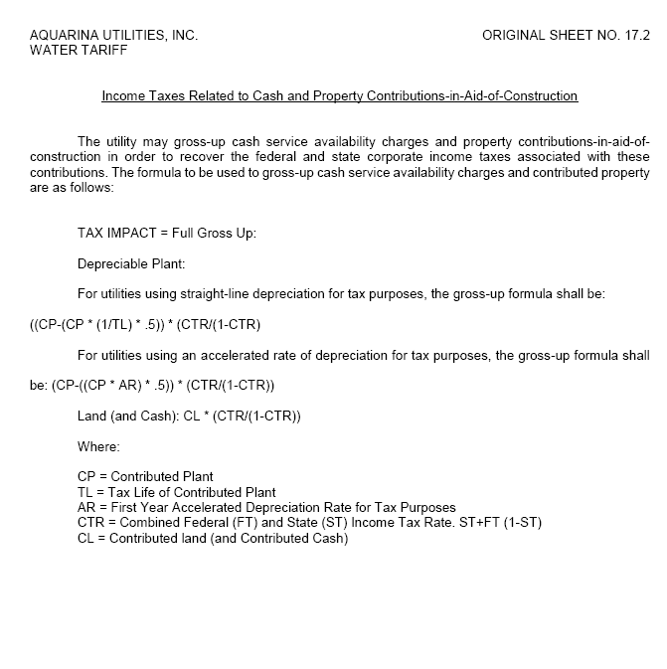

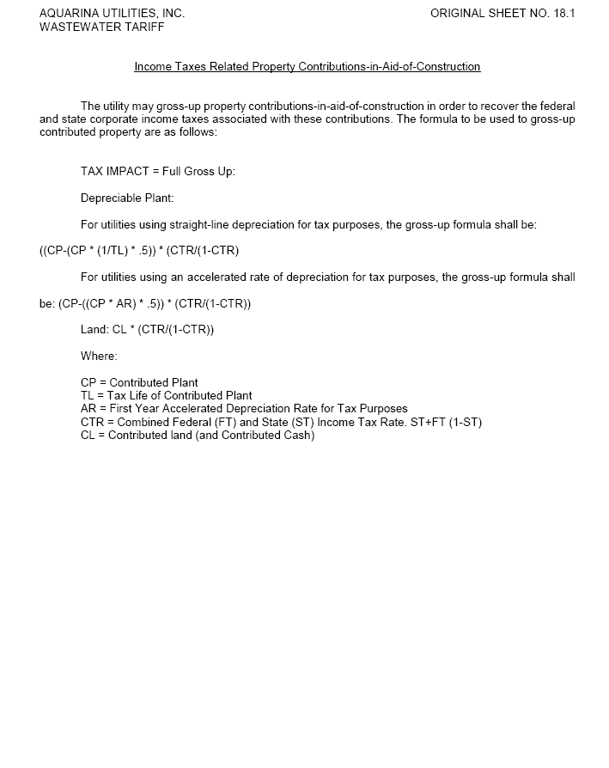

Docket No. 20180013-PU, In re: Petition to establish a generic docket to investigate and adjust rates for 2018 tax savings, by Office of Public Counsel.
The act was repealed in 1996.
Order No. 23541, issued October 1, 1990, in Docket No. 860184-PU, In re: Request by Florida Waterworks Association for investigation of proposed repeal of Section 118(b), Internal Revenue Code [Contributions-in-aid-of-construction].
Order No. PSC-2018-0330-TRF-WS, issued June 27, 2018, in Docket No. 20180042-WS, In re: Application for approval of tariff for the gross-up of CIAC in Martin County by Indiantown Company, Inc.; Order No. PSC-2018-0331-TRF-WS, issued June 27, 2018, in Docket No. 20180059-WS, In re: Application for approval of tariff for the gross-up of CIAC in Escambia County by Peoples Water Service Company of Florida, Inc.; and Order No. PSC-2018-0269-TRF-WS, issued May 30, 2018, in Docket No. 20180100-WS, In re: Application for approval of tariff for the gross-up of CIAC for water rates in Lee County and wastewater rates in Pasco County, by Ni Florida, LLC.

