BEFORE THE FLORIDA PUBLIC SERVICE COMMISSION

In re: Petition for approval of a COVID-19 small business assistance program, by Florida Power & Light Company. | DOCKET NO. 20200227-EI  ORDER NO. PSC-2020-0488-TRF-EI  ISSUED: December 11, 2020

The following Commissioners participated in the disposition of this matter:

GARY F. CLARK, Chairman
ART GRAHAM
JULIE I. BROWN
DONALD J. POLMANN
ANDREW GILES FAY

ORDER APPROVING FLORIDA POWER & LIGHT COMPANY’S
COVID-19 SMALL BUSINESS ASSISTANCE PROGRAM

BY THE COMMISSION:

On October 15, 2020, Florida Power & Light Company (FPL or utility) filed a petition requesting approval of its Main Street Recovery Credit Program Rider (MSR). The proposed tariff is designed to provide financial assistance to small business customers impacted by the COVID-19 global pandemic. Specifically, the proposed tariff would allow qualifying General Service, General Service Time of Use, and General Service Constant Usage customers to receive a 10 percent credit toward their monthly bill through December 31, 2021. FPL is requesting our consideration on an expedited basis to allow the tariff to be effective for eligible customers the month following our approval.
On October 16, 2020, FPL filed a revised tariff sheet No. 8.010, Index of Rate Schedules, to correct a scrivener’s error in its initial filing. The proposed Tariff Sheet Nos. 8.010 and 8.805 in legislative format are shown in Attachment A to this order. During the review of this petition, Commission staff issued a data request to FPL for which responses were received on November 4, 2020. We have jurisdiction over this matter pursuant to Sections 366.03, 366.04, 366.05, and 366.06, Florida Statutes (F.S.).
DECISION
The impact of the COVID-19 pandemic on Florida’s economy has been broad and far-reaching. In response to the economic challenges resulting from recent events, FPL has taken various actions to assist customers affected by the pandemic and its impact on the economy. FPL stated that it took many measures and initiatives at the onset of the pandemic to address the needs of its customers and continues to evaluate opportunities to provide additional support.
The utility noted that certain segments of its small business customer population, especially those in underserved and lower income communities, have been impacted by the COVID-19 pandemic due to required long-term closures and reductions of in-person patronage. In an effort to provide financial assistance to its small business customers, FPL proposed a new initiative, the Main Street Recovery Credit program. FPL stated that this new program would provide assistance to small businesses that may be most impacted by the economic effects of the pandemic. In addition, this program is designed to augment the objectives of the utility’s current economic development tariffs, which are designed for its medium-to-large business customers.
This program will offer qualifying customers a 10 percent energy charge credit on their bill each month through December 2021. To qualify, a customer must receive service under the General Service, General Service Time of Use, or General Service Constant Usage rate schedule; not exceed a monthly demand of 21 kilowatts; and meet one of the following criteria:
- The customer resumes business operations in a space that was previously inoperative for a minimum of six months; or
- The customer is a new business account; or
- The customer is located in an “Opportunity Zone,” as defined by the U.S. Department of the Treasury.

FPL considered several factors when developing the qualification criteria for the program. In determining the closure impact qualification, the utility noted that most small businesses were required to shut down in the March/April time-frame and remained closed until at least September, demonstrating an approximate six-month closure period. We find that FPL’s six-month approach is reasonable given the impact of the pandemic; however, the utility stated that it is not opposed to considering additional time parameters. In addition, the utility believes the economic impact of the pandemic has increased the challenges of opening new small businesses, and allowing new customers to qualify for the program would support their development and expansion.
Additionally, FPL noted that Opportunity Zones are designated by the U.S. Department of the Treasury, pursuant to the Opportunity Zone Program, which was created by the Federal Tax Cuts and Jobs Act of 2017. This program is designed to encourage businesses, developers and financial institutions to invest long-term capital in low-income census tract areas. FPL stated that there are approximately 170,000 qualifying customers operating in Opportunity Zones within its service territory.
To enroll in the program, a qualifying customer would submit an application request at any point prior to December 2021. FPL would notify potential customers about the program through its traditional communication protocol, which includes e-newsletters, social media and its website. In addition, the utility would execute targeted communications to small businesses in its Opportunity Zones.
Once enrolled, each month’s bill credit would be calculated using the customer’s prior month Base Energy Charge multiplied by the percentage discount. For new businesses, the first month’s credit will be estimated based on previous service, premise size, and estimated energy usage for similar businesses. The credit would be applied to a customer’s bill as a separate, program-specific line credit. Under this program, FPL anticipates approximately $16 million in credits would be issued to participating customers over the term of the program. The utility stated that it does not “intend to track or account for the lost revenues associated with the credit for purposes of recovery between rate cases or in FPL’s next rate case.”
Having reviewed the petition and the responses to Commission staff’s data request, we find that the proposed tariff will provide assistance to qualifying small businesses impacted by the economic challenges resulting from the COVID-19 pandemic. Therefore we approve FPL’s proposed MSR Tariff Sheet Nos. 8.010 and 8.805, as shown in Attachment A, effective January 1, 2021. The proposed MSR tariff allows qualifying small business customers the opportunity to receive a 10 percent monthly energy credit through December 31, 2021.
Based on the foregoing, it is

ORDERED by the Florida Public Service Commission that Florida Power & Light Company’s petition for approval of its Main Street Recovery Credit Program Rider, Tariff Sheet Numbers 8.010 and 8.805, is hereby approved. It is further

ORDERED that Tariff Sheet Numbers 8.010 and 8.805 shall be effective January 1, 2021. It is further

ORDERED that if a protest is filed within 21 days of issuance of this order, the tariff shall remain in effect pending resolution of the protest. It if further

ORDERED that if no timely protest is filed, this docket should be closed upon the issuance of a consummating order.

By ORDER of the Florida Public Service Commission this 11th day of December, 2020.

/s/ Adam J. Teitzman
ADAM J. TEITZMAN
Commission Clerk
Florida Public Service Commission
2540 Shumard Oak Boulevard
Tallahassee, Florida 32399
(850) 413-6770
www.floridapsc.com

Copies furnished: A copy of this document is provided to the parties of record at the time of issuance and, if applicable, interested persons.
SBr

Chairman Gary F. Clark dissents without opinion.

NOTICE OF FURTHER PROCEEDINGS

The Florida Public Service Commission is required by Section 120.569(1), Florida Statutes, to notify parties of any administrative hearing or judicial review of Commission orders that is available under Sections 120.57 or 120.68, Florida Statutes, as well as the procedures and time limits that apply. This notice should not be construed to mean all requests for an administrative hearing or judicial review will be granted or result in the relief sought.

Mediation may be available on a case-by-case basis. If mediation is conducted, it does not affect a substantially interested person's right to a hearing.

The Commission's decision on this tariff is interim in nature and will become final, unless a person whose substantial interests are affected by the proposed action files a petition for a formal proceeding, in the form provided by Rule 28-106.201, Florida Administrative Code. This petition must be received by the Office of Commission Clerk, 2540 Shumard Oak Boulevard, Tallahassee, Florida 32399-0850, by the close of business on January 4, 2021.

In the absence of such a petition, this Order shall become final and effective upon the issuance of a Consummating Order.

Any objection or protest filed in this docket before the issuance date of this order is considered abandoned unless it satisfies the foregoing conditions and is renewed within the specified protest period.

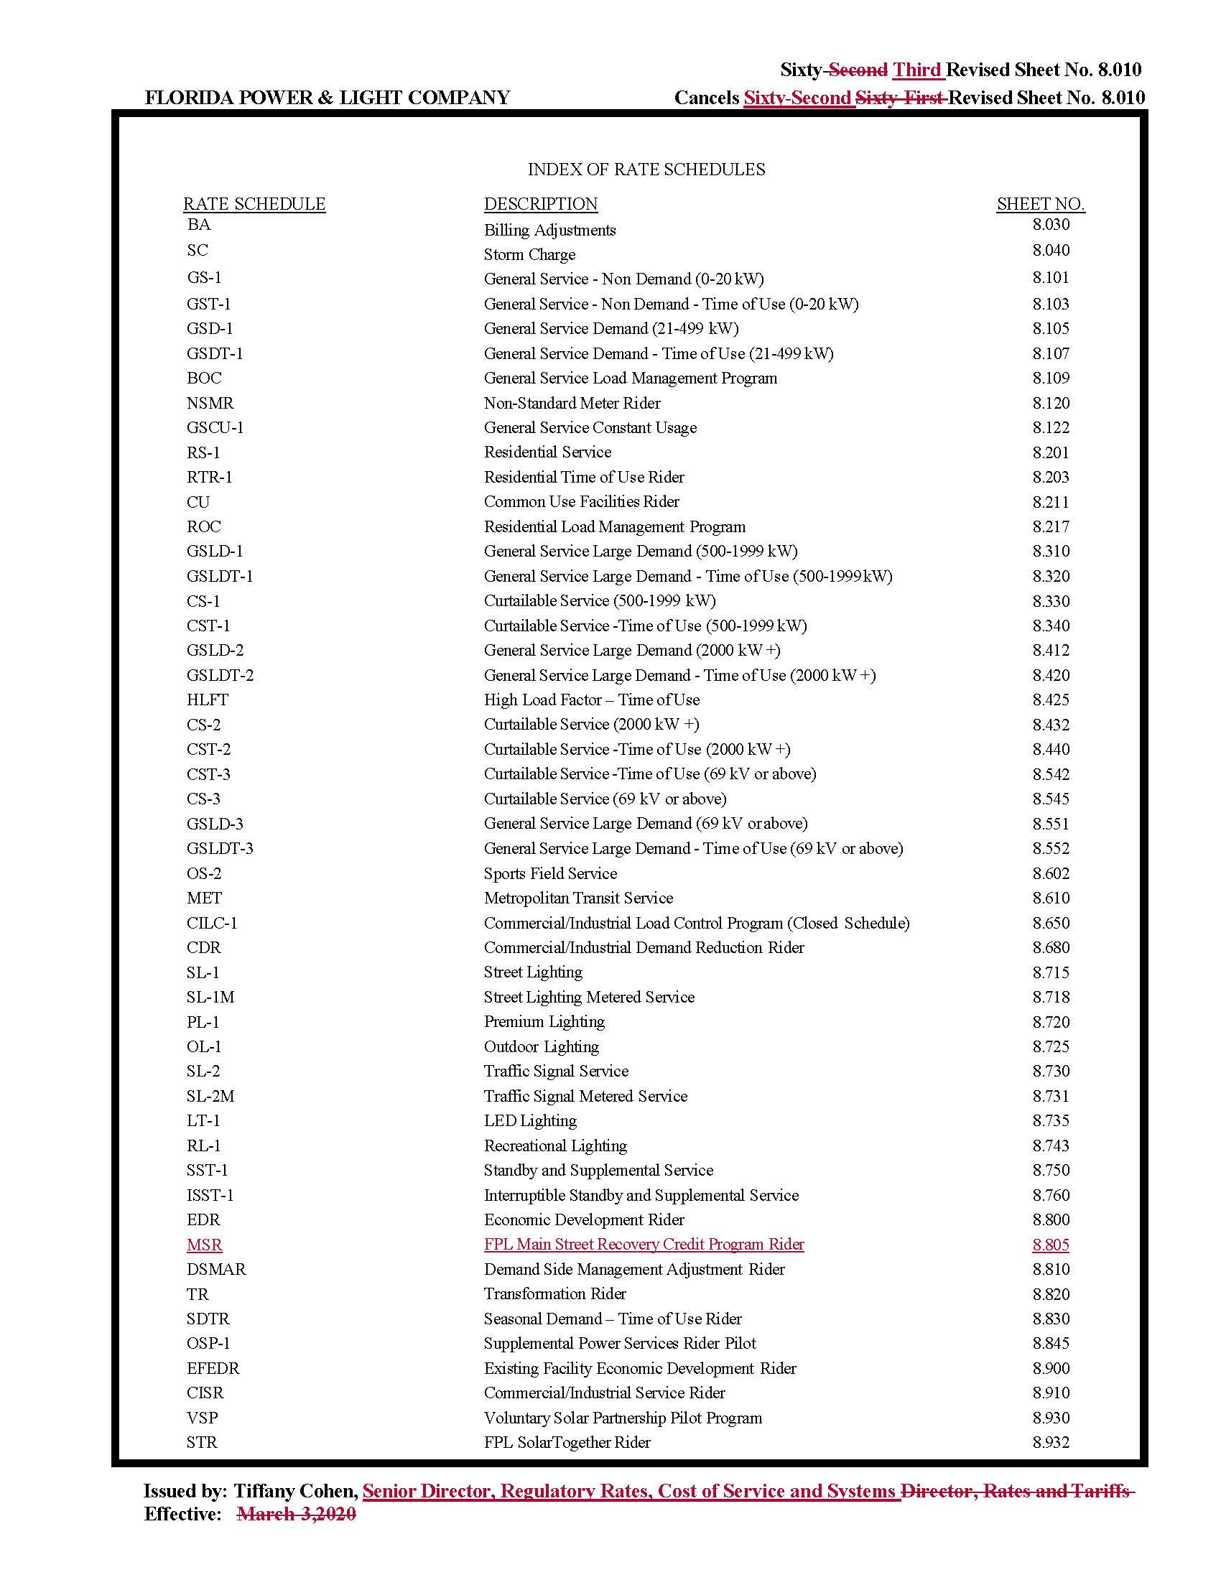

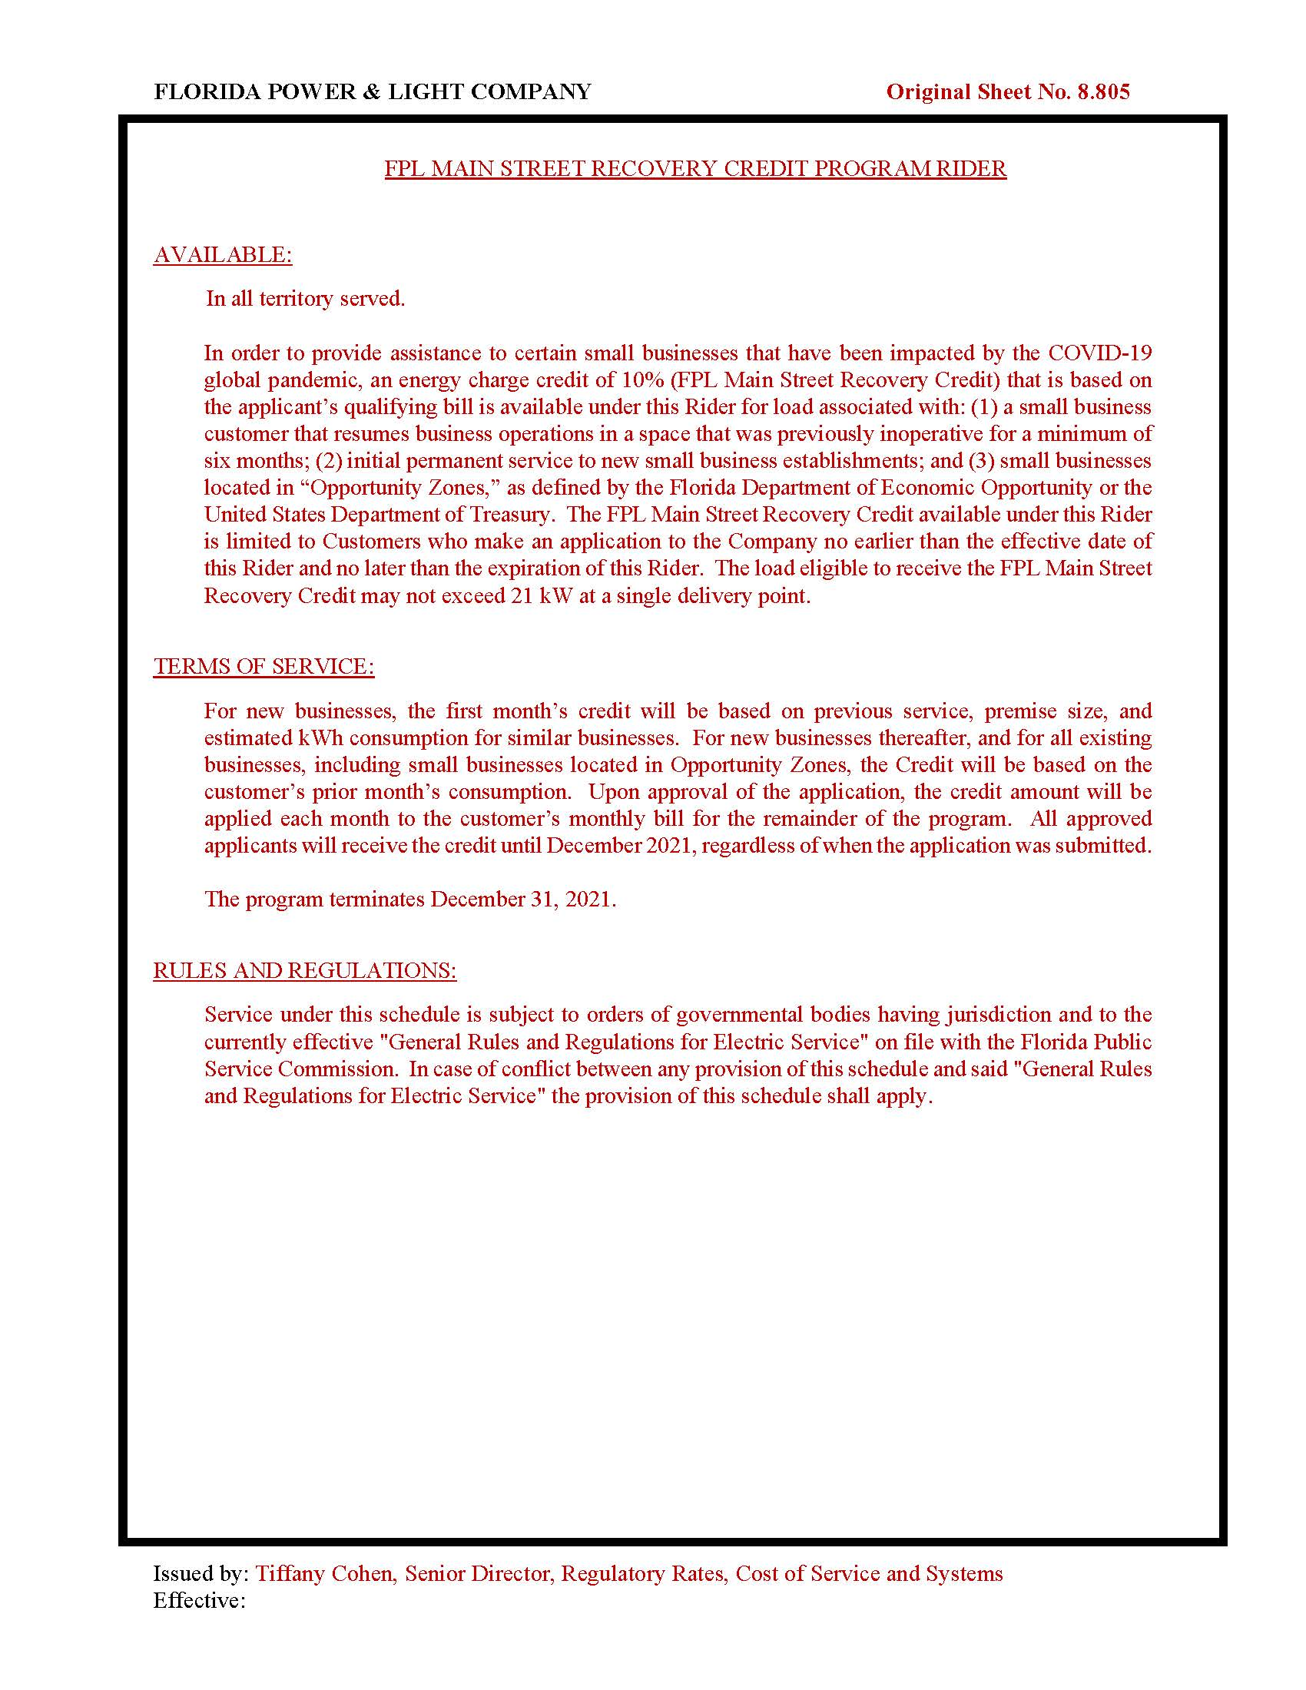

FPL’s Response to Staff’s First Data Request, Question 2.
FPL’s Response to Staff’s First Data Request, Question 3.
FPL’s Response to Staff’s First Data Request, Question 1.
FPL’s Response to Staff’s First Data Request, Question 5.
FPL’s Response to Staff’s First Data Request, Question 4.

