BEFORE THE FLORIDA PUBLIC SERVICE COMMISSION

In re: Petition for approval of optional electric vehicle public charging pilot tariffs, by Florida Power & Light Company. | DOCKET NO. 20200170-EI  ORDER NO. PSC-2020-0512-TRF-EI  ISSUED: December 21, 2020

The following Commissioners participated in the disposition of this matter:

GARY F. CLARK, Chairman
ART GRAHAM
JULIE I. BROWN
DONALD J. POLMANN
ANDREW GILES FAY

ORDER GRANTING PETITION FOR APPROVAL OF OPTIONAL
VEHICLE PUBLIC CHARGING PILOT TARIFFS
BY FLORIDA POWER & LIGHT COMPANY

BY THE COMMISSION:

Background
On June 19, 2020, Florida Power & Light Company (FPL or utility) filed a petition requesting approval of three optional electric vehicle (EV) public charging pilot tariffs. The first tariff, Utility-Owned Public Charging for Electric Vehicles (Rate Schedule UEV), would establish a charging rate for utility-owned fast charging stations. The second set of tariffs, Electric Vehicle Charging Infrastructure Riders for General Service Demand and General Service Large Demand (Rate Schedules GSD-1EV and GSLD-1EV) tariffs, would establish a tariff for third-party public charging stations operating in FPL’s service area. The tariffs and associated rates would limit the demand cost associated with general service demand rates billed to the charging stations. The utility requests that the three proposed tariffs take effect in January 2021 and remain in effect for a period of five years, unless extended by order of this Commission or terminated early by FPL following notice to us. FPL’s proposed tariffs are appended to this Order as Attachment A.
By Order No. PSC-2020-0398-PCO-EI, issued October 26, 2020, we suspended the 60-day file and suspend provision pursuant to Section 366.06(3), Florida Statutes (F.S.). There are sixteen interested persons in this docket. Comments were filed by Advanced Energy Economy (AEE); Tesla, Inc. (Tesla); Electrify America; EVgo Services (EVgo), LLC; Drive Electric Florida; the Edison Electric Institute; Greenlots; and the Florida Petroleum Marketers Association, Inc. These comments have been placed in the docket file. In addition, an email objecting to the proposed UEV rate as being too high has been placed in the docket file.
In support of its petition for the proposed pilot tariffs, FPL lists several benefits of EVs and cites Section 339.287(1)(f), F.S., that states that “ensuring the prompt installation of adequate, reliable charging stations is in the public interest.” Furthermore, Section 339.287(2), F.S., directs the Florida Department of Transportation, in consultation with the Commission and the Florida Office of Energy, to develop a master plan for electric vehicle charging infrastructure and submit the master plan to the Governor by July 1, 2021.
FPL began voluntarily implementing in 2019 an EV infrastructure pilot called FPL EVolution. Under the EVolution pilot, as of June 2020, FPL has installed 166 Level 2 (4-6 hours to full charge) charging stations at 27 locations with plans to install more than 1,000 additional charging stations over an approximate three-year period. The additional charging stations FPL plans to install will include Level 2 and fast charging stations at locations such as public parks, malls, companies that wish to install charging stations for public and employee use, high-traffic areas along highways such as the Florida Turnpike, Interstate-95, or Interstate-75, and along evacuation routes. Specifically, FPL estimates that it will install 1,150 Level 2 chargers and 218 fast charging stations. FPL stated that the average cost to install a single Level 2 charger is approximately $5,500 and for a fast charger approximately $80,000; however, actual cost could vary based on location and technology.
FPL contends that the EVolution pilot will help the state expand the number of EV charging stations and allow FPL to conduct research in areas such as: (1) FPL-owned charging stations, (2) partnering with commercial customers who wish to offer EV charging services on their premises, (3) rate structures, and (4) the effects of charging stations on system load and the electric distribution system.
FPL states that the utility intends to request base rate recovery of the EVolution infrastructure as part of its next base rate proceeding. FPL anticipates the total investment in the FPL EVolution pilot to be $30 million through the end of 2022; however, a portion of this investment will be offset by any revenues received under the proposed UEV tariff. FPL reflects the revenues, operating expenses, capital additions, and depreciation associated with the current and planned Level 2 and fast charging stations as above-the-line items on the Earnings Surveillance Reports filed with the Commission.
Under its general grant of authority and the flexibility afforded by the Florida Supreme Court in construing and applying these statutes, we have previously approved several EV pilot programs. In 1995, we approved an electric vehicle tariff for Tampa Electric Company. More recently, in 2017, we addressed EV charging stations owned by utilities in two rate case settlements. In Gulf Power Company’s rate case settlement, we permitted the utility to provide EV charging stations on a revenue neutral basis as a pilot program and stated that we “retain[] the ability to review and make a determination regarding the appropriate regulatory jurisdiction and regulatory treatment of EV charging stations.” In Duke Energy Florida, LLC’s (DEF) rate case settlement, we authorized the utility to purchase, install, own, and support Electric Vehicle Service Equipment as part of a five-year pilot program and the agreement provided that DEF may incur up to $8 million plus reasonable operating expenses.
In last year’s session, the Legislature enacted Section 339.287, F.S. This statute recognizes the emerging importance of EV charging stations and the important role of utilities in this effort. We also note that several public utility commissions in other states have approved utilities’ provision of EV charging to the public.
We have jurisdiction over this matter pursuant to Sections 366.03, 366.04, 366.05, and 366.06, F.S.

Decision
Proposed Optional Utility-Owned Public Charging for Electric Vehicles Pilot Tariff
The proposed UEV tariff would apply to customers charging electric vehicles that purchase charging services directly from FPL at certain FPL-owned public fast charging stations. Fast charging stations provide electricity at high voltage (the UEV tariff requires power to be delivered at 50 kilowatts or greater) which results in a charging time of approximately 30 minutes. FPL stated that the determination of which charging stations would use the proposed tariff would be made on a site by site basis and based on the site host’s preference. If the UEV tariff is not used, the site host would provide the charging services and pay FPL’s otherwise applicable commercial rates and retain the revenues collected for providing charging services.
The user of a utility-owned fast charging station must register an account with FPL’s mobile application, including payment information, prior to charging the EV. FPL currently does not have a tariff to charge customers who use charging stations the utility owns and operates under its EVolution pilot and, therefore, FPL is currently not charging drivers for charging services. Currently, the site host for each station is the customer of record and pays FPL standard rates for the electricity delivered to the site. The EV charging services are provided for free by the site host or the site host may charge a fee directly to the EV drivers.
FPL’s proposed volumetric rate is $0.30 per kilowatt-hour (kWh). FPL explained that the rate was chosen based on a comparison of various automotive fuel alternatives available to customers. Specifically, FPL stated that when comparing the average mileage efficiency of electric vehicles to gasoline-powered vehicles, the electricity price that equates to the same cost per mile is $0.31 per kWh. Furthermore, public fast charging prices in Florida offered by other providers, such as Tesla, EVgo, and Electrify America, average at $0.35 per kWh. However, FPL explained that the utility gave more consideration to the Tesla charging rate of $0.28 per kWh, because at the time the utility did the calculation, Tesla was the only EV provider charging on a per-kWh basis. EVgo and Electrify America offered per-minute charging rates and due to varying charging speeds may present a level of uncertainty when converting to a price per kWh. FPL asserts that the proposed $0.30 per kWh rate is reasonable compared to the equivalent cost per mile for gasoline-powered vehicles and the EV pricing options offered by non-utility providers.
The proposed $0.30 per kWh rate is not cost-based. FPL stated that the utility currently does not have data regarding actual sales volumes and operating costs of utility-owned public charging stations and, therefore, developing cost-based rates would be conjectural at this time. To support the proposed “market-based” rates, FPL referred to a decision by the Washington Utilities and Transportation Commission, which approved a pilot tariff for fast charging rate that is comparable to rates being charged by other public charging facilities.
Greenlots, the Edison Electric Institute, and Drive Electric in written comments support FPL’s proposed UEV tariff. AEE filed comments in the docket on June 19, 2020. AEE explained that it represents a diverse set of businesses and supports the creation of beneficial EV-specific rates. However, AEE expressed concern that FPL’s proposed rate of $0.30 per kWh is 15 percent lower than the average rate of $0.35 per kWh offered by non-utility providers, or third parties. AEE asserts that, based on a review of their members, there is “concern that the price differential could inadvertently create a tilted playing field that challenges third-party charging infrastructure development over time.”
Tesla filed comments on June 23, 2020. In its comments, Tesla suggests that the calculation of the FPL proposed rate should not include the price Tesla charges, or in the alternative the rate should be set on FPL’s expected costs of providing charging services. As shown in Chart 1 on page 10 of FPL’s petition, FPL included a Tesla charging rate of $0.28 per kWh in its calculation of the average charging rate of $0.35 per kWh offered by non-utility charging stations. Tesla asserts its business model for its charging network is “unique and not necessarily replicable by other charging operators.”
Electrify America, in its comments filed on August 14, 2020, advocated a shared-responsibility model for utility investment that can encourage third-party infrastructure development while limiting ratepayer risk. Electrify America states that it operates the nation’s largest public fast charging network, including 110 chargers in Florida and several more projects currently under construction. Electrify America states that several jurisdictions have encouraged investment in public charging through the shared-responsibility model. Electrify America did not address the proposed $0.30 per kWh rate.
EVgo, a competitive supplier of EV charging infrastructure, filed comments on October 5, 2020. EVgo contends that FPL’s petition is premature as there has been no forum in Florida to discuss the appropriate role of utilities in owning and operating EV infrastructure. EVgo stated that, given that the role of the utility in owning and operating fast charging infrastructure has not been debated, FPL’s proposed UEV tariff should be evaluated in FPL’s next rate case. Finally, EVgo states that the proposed $0.30 per kWh rate creates an uneven playing field if the utility is granted the ability to recover costs of its public charging infrastructure.
The Florida Petroleum Marketers Association, Inc. (FPMA) filed comments on November 10, 2020, objecting to FPL’s petition. Specifically, the FPMA states that the Commission does not have the authority to approve pilot programs and does not have authority to permit tariffs for EV charging stations by public utilities. Furthermore, the FPMA asserts that the Commission should not adopt rates that are unfair and biased and that all ratepayers should not have to subsidize the EV infrastructure used by on a small minority of EV owners.
FPL asserts that one of the goals of its petition is to learn more about EV driver needs and gather more specific usage and cost data to allow FPL to develop cost-based rates for EV charging services. The proposed UEV tariff is not cost-based, but based on a “market-rate.” Fast charging rates vary by provider, by location, and the level of charging offered. We find FPL’s calculation of the proposed UEV rate to be appropriate for the limited purpose of this pilot and that traditional cost-of-service based rates can not be accurately calculated at this early stage of utility-involvement in the EV market. We find that FPL’s proposed market-based rate is reasonable in the limited context of approving pilot tariffs with the specific goal to collect cost and usage data for utility-owned fast charging stations.
Section 339.287(2)(c)1, F.S., emphasizes the Legislature’s intent for an adequate supply of reliable EV charging stations to support and encourage a competitive market. The proposed UEV tariff appears to be consistent with the legislative objectives of Section 339.287, F.S. Allowing FPL to participate in the EV infrastructure build-out in Florida by offering a utility-based rate as an option to EV customers during this nascent stage of EV adoption and the EV charging market development, promotes the public interest and should provide value to EV customers. We find that FPL’s proposed tariff will facilitate the development of the competitive EV charging market by allowing the utility, together with other providers, to offer fast charging EV services. The increased availability of EV chargers will remove a barrier to adoption of electric vehicles in Florida.
FPL is not seeking approval of the costs associated with the EVolution pilot in the instant docket. We are not prejudging recovery of the EVolution investment and we retain full discretion to evaluate FPL’s request in the next rate case for recovery of its EVolution investment and its impact on the general body of ratepayers, including the benefits, if any, to the general body of ratepayers.
FPL explained that the utility will work with the site hosts to determine which fast charging stations installed by FPL under the EVolution pilot will utilize the proposed UEV tariff. Any revenues collected pursuant to UEV tariff would be used by FPL to offset the revenue requirement associated with the EVolution facilities. For any FPL EVolution fast charging stations that will not take service under the proposed UEV tariff, the revenue requirement would be recovered from the general body of ratepayers, if approved by us in the next rate case.
Conclusion
Based on the above, we approve FPL’s proposed optional UEV pilot tariff, effective January 1, 2021. As detailed below, FPL shall file annual reports by January 30, with the first report due January 30, 2022, for the reporting period of January through December 2021, to allow us to monitor the reasonableness of the UEV rate. The tariff shall remain in effect for a period of five years, unless extended, modified, or terminated by order of this Commission or terminated early by FPL upon notice to us. Not later than September 1, 2025, FPL shall file a petition to extend, modify, or terminate the UEV pilot tariff.

Reporting Requirements

This is the first request by a Florida utility for an EV charging rate applicable to utility-owned fast charging stations. During the pilot period, FPL shall file annual reports by January 30 providing capital and operating costs, revenue requirements, revenues collected, and energy sales of its utility-owned fast charging stations. FPL shall also collect data regarding charging times to measure time of use and demand for its utility-owned fast charging stations and shall include this information in the annual report. The first annual report is due January 30, 2022, for the reporting period January through December 2021. In addition, FPL shall evaluate and provide any updates to the market rates, i.e., rates charged by non-utility EV charging providers, to maintain consistency with the market rates. The information collected by FPL will allow our staff, and interested parties, to monitor the development of the EV charging under the UEV tariff and ultimately determine a cost-based rate. If FPL and/or Commission staff determine that the UEV rate should be modified during the five-year term of the pilot program, based on the data collected by the utility, staff will open a docket for Commission consideration. The annual reports are to be filed in this docket.
Proposed GSD-1EV and GSLD-1EV Pilot Tariffs
The proposed optional pilot tariffs would apply to customers that operate public fast charging stations and would remain in effect for five years. In response to a data request from Commission staff, FPL clarified that the tariff would apply to existing and new charging stations. Since the fast charging stations are typically commercial customers, they are billed on FPL’s standard commercial General Service Demand (GSD) or General Service Large Demand (GLSD) rate schedules. The GSD and GSLD rate schedules are comprised of an energy charge (based on the amount of energy, or kWh, consumed) and a dollar per kilowatt (kW) demand charge. The demand charge is billed on the highest usage, or demand, over a specified time interval (30 minutes). This peak usage determines the demand charge for the billing month.
FPL states that the current rate design poses a challenge to the economics of the public fast charging stations that experience a high demand and low levels of kWh energy sales, or utilization. At low levels of utilization, the electric bills incurred by the charging stations result in demand charges being spread over a relatively low volume of energy sales. This is referred to as a low load factor customer. Charging stations with higher kWh sales, i.e., high load factor customers are able to spread the billed demand cost over more energy sales and are, therefore, more likely to recover their costs.
FPL asserts that the demand charge included in standard demand rate schedules creates a barrier to entry during the early years of the EV market. FPL further states that fast charging providers and potential public charging site hosts have expressed concerns over their ability to recover costs in the early years of the EV market adoption.
To address the challenges FPL identified for public fast charging stations, the utility proposed tariffs that include a demand limiter mechanism. Under the tariffs, the amount of demand billed to the customer would be the lesser of the measured demand or the limited demand as calculated by dividing the kWh sales by a fixed constant of 75 hours. Mathematically, applying the 75 hours constant to the kWh sales results in a reduction in the demand billed to a customer with a load factor of less than ten percent. Customers with a load factor above ten percent would pay the standard demand charges contained in the GSD and GSLD rate schedules and would not receive a reduction in the electric bill.
Greenlots, the Edison Electric Institute, and Drive Electric in written comments support FPL’s proposed GSD-1EV and GSLD-1EV tariffs. EVgo Services supports FPL’s proposal; however, EVgo suggests increasing the demand limiter of 75 hours to a limiter of 100 to 200 hours and increasing the term of the pilot program from five to ten years. Tesla, Electrify America, and AEE also stated that increasing the demand limiters would help improve fast charging stations’ finances. Several interested persons referred to other states that have approved demand limiters of 100 or 200 hours, tariffs that reduce or eliminate demand charges, or no demand charges.
The proposed tariffs are not-cost based as FPL will not fully recover its demand-related, or fixed, costs from customers with low load factor fast charging stations. The demand limiter is designed to provide rate relief that will facilitate and encourage the development of EV fast charging infrastructure during this nascent stage of EV adoption and EV charging market development. We find that the proposed demand limiter pilot tariffs represent a balanced approach to encourage third-party market development at these early market stages, while limiting ratepayer risk. We find that this also aligns with the legislative intent to encourage the installation of EV infrastructure.
The proposed tariff could have an impact on the general body of ratepayers. Based on 2019 usage data of 41 fast charging stations, FPL estimated the annual lost revenues to be approximately $157,000. However, FPL asserts that if the proposed tariffs are successful in accelerating the adoption of EV use, any additional revenues will contribute to the recovery of fixed costs, reducing the impact on the general body of ratepayers.
As discussed above, some interested persons expressed a desire for a larger reduction in the demand charges. However, a larger incentive would have the potential of shifting more costs to the general body of ratepayers. We find that FPL’s proposed demand limiter balances the interests of low load factor fast charging stations and the general body of ratepayers that could be impacted by the associated revenue loss when base rates are reset in FPL’s next rate case.

Conclusion and Reporting Requirements

The proposed GSD-1EV and GSLD-1EV tariffs are designed to mitigate the impact of demand charges on fast charging stations with low utilization levels. Fast charging stations with a load factor over ten percent will pay the traditional tariffed rates. While the discount on the demand charges could cause a potential impact on the general body of ratepayers, we find that the impact would be minor. Additionally, the proposed pilot tariffs could facilitate the growth of the EV infrastructure in Florida and additional revenues could mitigate any adverse impact on the general body of ratepayers.
Based on the above, the proposed GSD-1EV and GSLD-1EV pilot tariffs are approved. Similarly to the reports for the UEV tariff, FPL shall file annual reports by January 30 reporting the number of fast charging stations taking service under the tariffs, the number of fast charging stations that received the benefit of mitigated demand charges, and the annual revenue loss resulting from the reduction in demand-related revenues from fast charging customers. The first annual report is due January 30, 2022, for the reporting period of January through December 2021, and the annual reports are to be filed in this docket. The GSD-1EV and GSLD-1EV pilot tariffs shall remain in effect for a period of five years, unless extended, modified, or terminated by order of this Commission. Not later than September 1, 2025, FPL shall file a petition to extend, modify, or terminate the tariffs.

Based on the foregoing, it is

ORDERED by the Florida Public Service Commission that Florida Power & Light Company’s proposed optional UEV pilot tariff is approved, effective January 1, 2021. It is further

ORDERED that FPL shall file annual reports by January 30, with the first report due January 30, 2022, for the reporting period of January through December 2021. The reports shall provide capital and operating costs, revenue requirements, revenues collected, and energy sales of its utility-owned fast charging stations, together with updated market rates, to allow us to monitor the reasonableness of the UEV rate. FPL shall also collect data regarding charging times to measure time of use and demand for its utility-owned fast charging stations and shall include this information in the annual report. It is further

ORDERED that the UEV pilot tariff shall remain in effect for a period of five years, unless extended, modified, or terminated by order of this Commission or terminated early by FPL upon notice to us. Not later than September 1, 2025, FPL shall file no later than September 1, 2025, a petition to extend, modify, or terminate the UEV pilot tariff. It is further

ORDERED by the Florida Public Service Commission that Florida Power & Light Company’s proposed GSD-1EV and GSLD-1EV pilot tariffs are approved, effective January 1, 2021. It is further

ORDERED that FPL shall file annual reports by January 30 reporting the number of fast charging stations taking service under the tariffs, the number of fast charging stations that received the benefit of mitigated demand charges, data regarding charging times to measure time of use and demand, and the annual revenue loss resulting from the reduction in demand-related revenues from fast charging customers. The first annual report is due January 30, 2022, for the reporting period of January through December 2021. It is further

ORDERED that the GSD-1EV and GSLD-1EV pilot tariffs shall remain in effect for a period of five years, unless extended, modified, or terminated by order of this Commission. Not later than September 1, 2025, FPL shall file a petition to extend, modify, or terminate the tariffs. It is further

ORDERED that if a protest is filed within 21 days of issuance of the Order, the tariff shall remain in effect with any charges held subject to refund pending resolution of the protest. It is further

ORDERED that if no timely protest is filed, this docket shall be placed in monitoring status upon the issuance of a consummating order so that the utility can file its reports in this docket.

By ORDER of the Florida Public Service Commission this 21st day of December, 2020.

/s/ Adam J. Teitzman
ADAM J. TEITZMAN
Commission Clerk
Florida Public Service Commission
2540 Shumard Oak Boulevard
Tallahassee, Florida 32399
(850) 413-6770
www.floridapsc.com

Copies furnished: A copy of this document is provided to the parties of record at the time of issuance and, if applicable, interested persons.

SPS

NOTICE OF FURTHER PROCEEDINGS

The Florida Public Service Commission is required by Section 120.569(1), Florida Statutes, to notify parties of any administrative hearing or judicial review of Commission orders that is available under Sections 120.57 or 120.68, Florida Statutes, as well as the procedures and time limits that apply. This notice should not be construed to mean all requests for an administrative hearing or judicial review will be granted or result in the relief sought.

Mediation may be available on a case-by-case basis. If mediation is conducted, it does not affect a substantially interested person's right to a hearing.

The Commission's decision on this tariff is interim in nature and will become final, unless a person whose substantial interests are affected by the proposed action files a petition for a formal proceeding, in the form provided by Rule 28-106.201, Florida Administrative Code. This petition must be received by the Office of Commission Clerk, 2540 Shumard Oak Boulevard, Tallahassee, Florida 32399-0850, by the close of business on January 11, 2021.

In the absence of such a petition, this Order shall become final and effective upon the issuance of a Consummating Order.

Any objection or protest filed in this docket before the issuance date of this order is considered abandoned unless it satisfies the foregoing conditions and is renewed within the specified protest period.

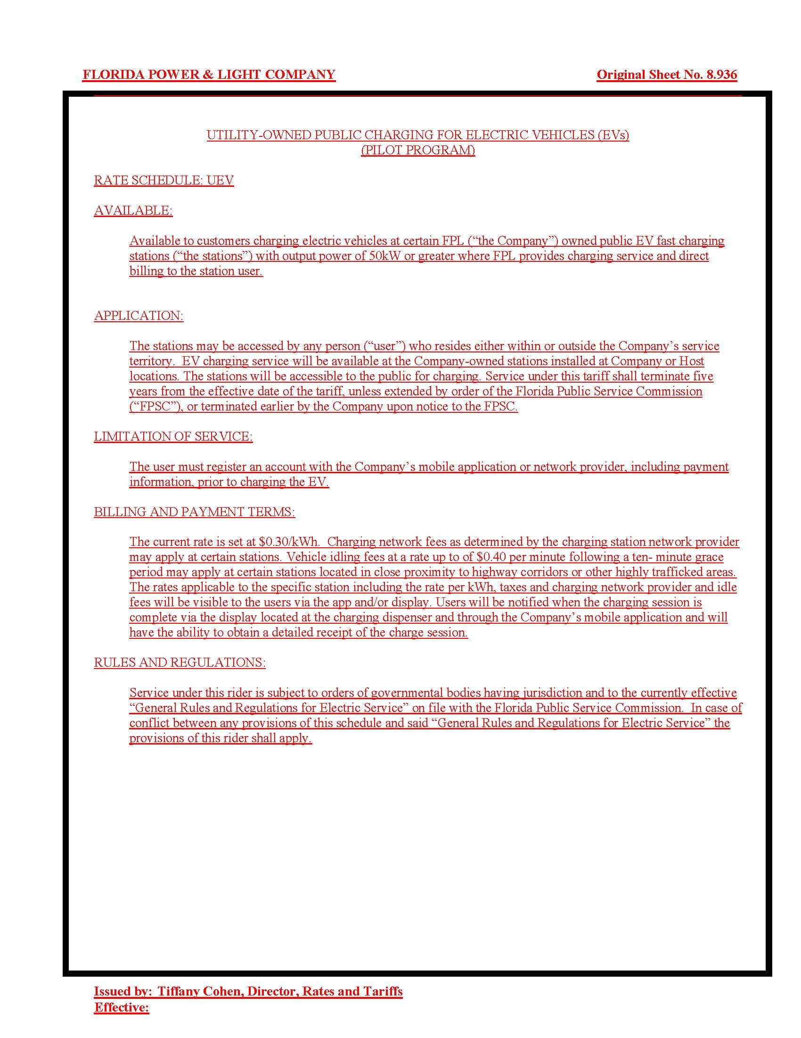

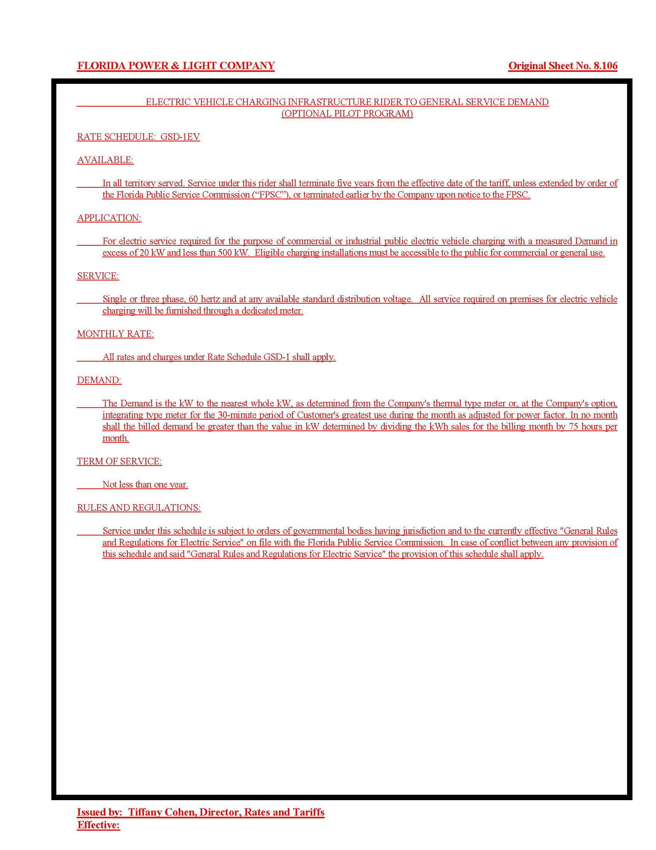

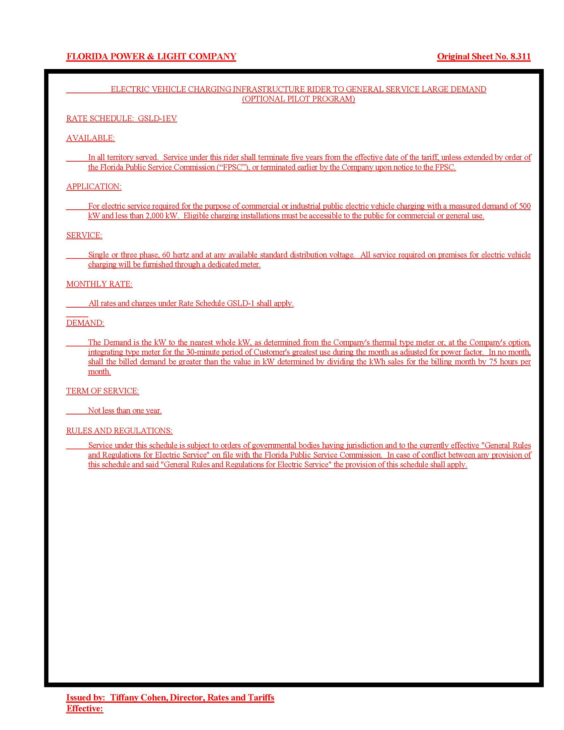

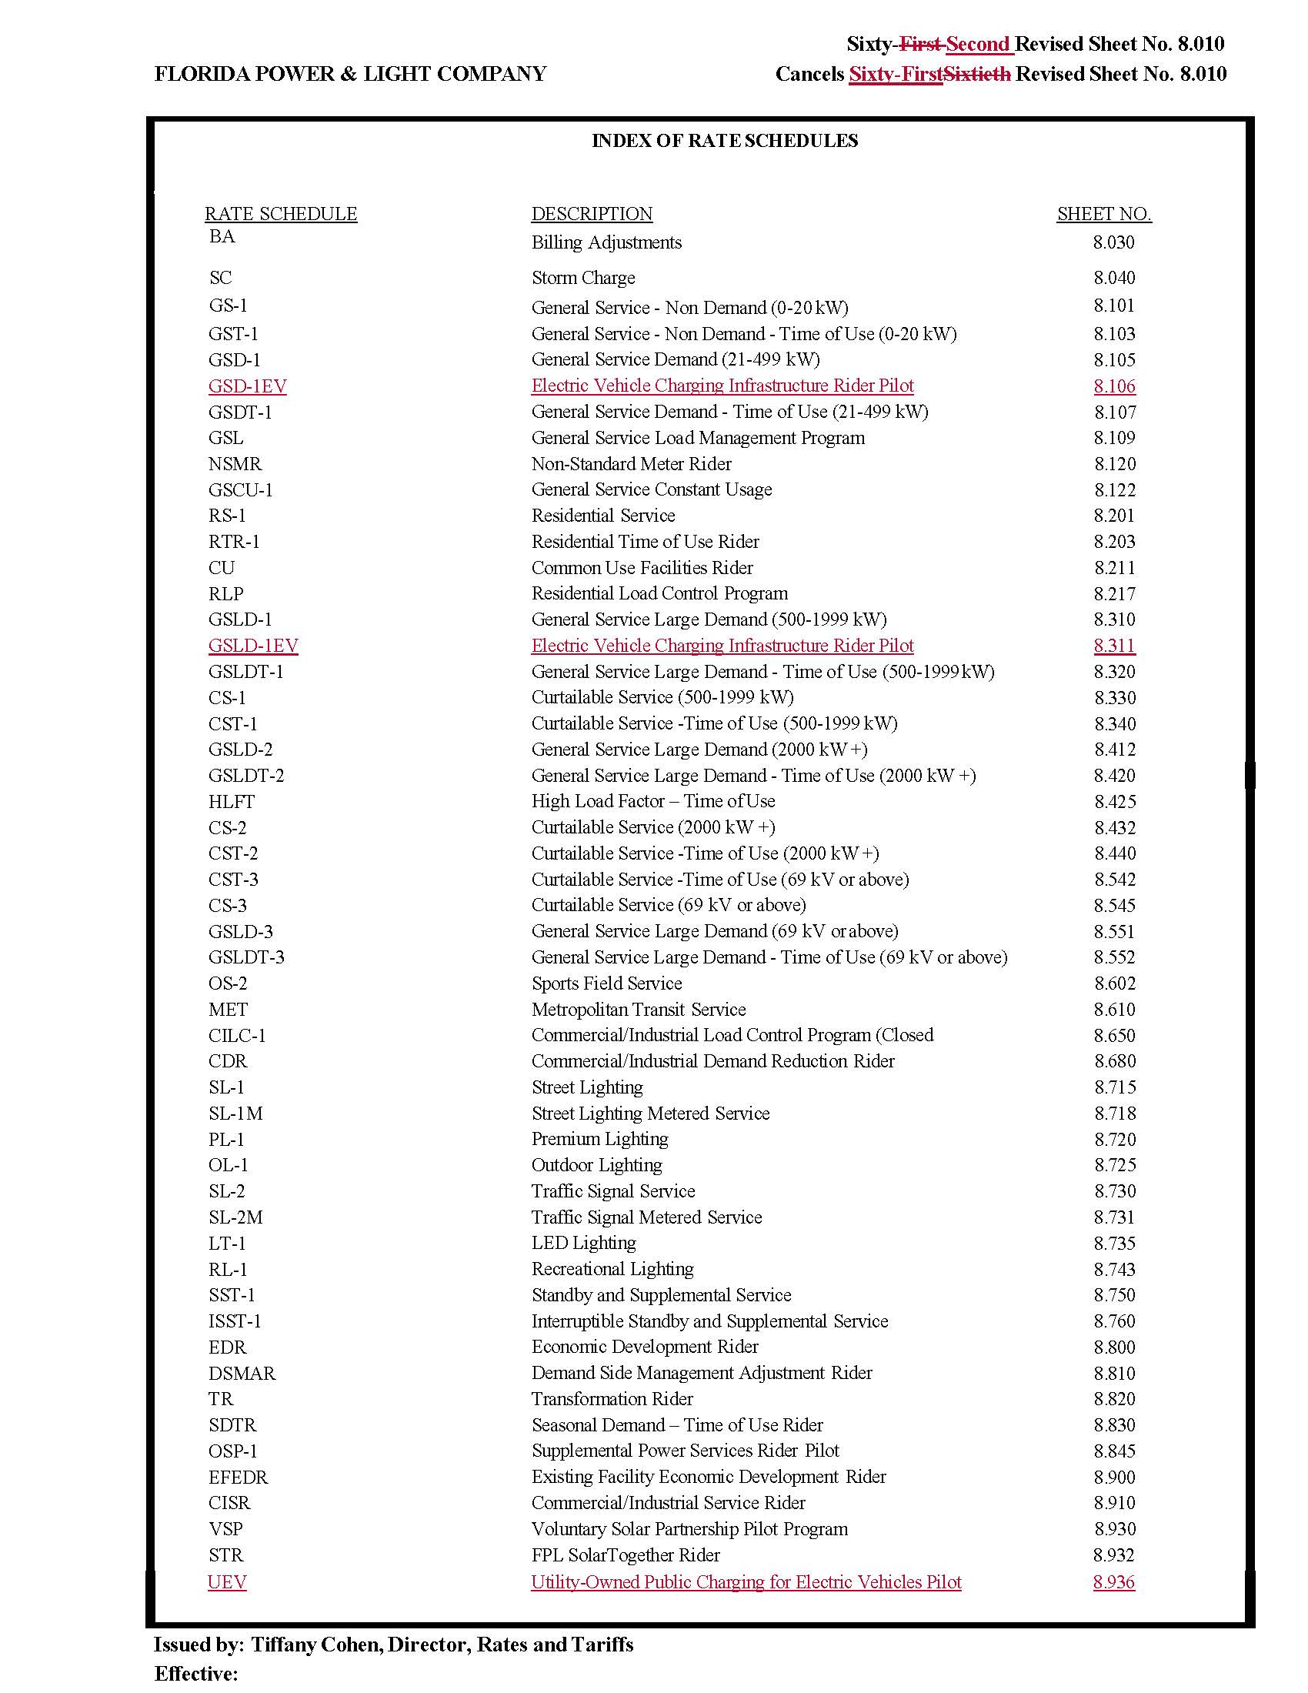

The interested persons are: Walmart, Inc.; Tesla, Inc.; Southern Alliance for Clean Energy; Sierra Club; Corey Ershow and Coley Girouard; the Office of Public Counsel; Florida Solar Energy Center; EVgo; Electrify America, LLC; Drive Electric Florida; Central Florida Clean Cities Coalition; Charge Point; Edison Electric Institute; Greenlots; Advanced Energy Economy; and the Florida Petroleum Marketers Association, Inc.
Document No. 04130-2020 in Correspondence Section of Docket file.
Section 366.02(2), F.S., provides that “electric utility” means any investor-owned electric utility which owns, maintains, or operates an electric generation, transmission, or distribution system within the state.
City of Tallahassee v. Florida Pub. Serv. Com'n, 433 So. 2d 505 (Fla. 1983)
Order No. PSC-95-0853-FOF-EG, issued July 17, 1995, in Docket No. 950517-EG, In Re: Petition for Approval of New Experimental Electric Vehicle Tariff by Tampa Electric Company.
Order No. PSC-17-0178-S-EI, issued May 16, 2017, in Docket No. 160170-EI, In re: Petition for approval of 2016 depreciation and dismantlement studies, approval of proposed depreciation rates and annual dismantlement accruals and Plant Smith Units 1 and 2 regulatory asset amortization, by Gulf Power Company.
Order No. PSC-2017-0451-AS-EU, issued November 20, 2019, in Docket No. 20170183-EI, In re: Application for limited proceeding to approve 2017 second revised and restated settlement agreement, including certain rate adjustments, by Duke Energy Florida, LLC.
Examples include Vermont, District of Columbia, California, Ohio, Nevada, and Oregon.
FPL stated that in October 2020, Electrify America announced a $0.43/kWh fast charging rate for Guest and Pass members and a $0.31/kWh rate for Pass+ members.

