State of Florida  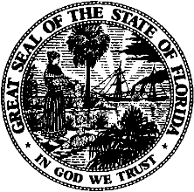 |  | Public Service Commission  Capital Circle Office Center ● 2540 Shumard Oak Boulevard  Tallahassee, Florida 32399-0850  -M-E-M-O-R-A-N-D-U-M-
DATE: | January 21, 2021
TO: | Office of Commission Clerk (Teitzman)
FROM: | Division of Engineering (Ramos, Lewis, Maloy)  Office of the General Counsel (Crawford, Stiller)
RE: | Docket No. 20190166-WS – Application for increase in water rates in Highlands County by HC Waterworks, Inc. – Joint Motion for Approval of Stipulation and Settlement Agreement
AGENDA: | 02/02/21 – Regular Agenda – Interested Persons May Participate
COMMISSIONERS ASSIGNED: |  |  | All Commissioners
PREHEARING OFFICER: |  |  | Fay
CRITICAL DATES: |  |  | None
SPECIAL INSTRUCTIONS: |  |  | None

Case Background
HC Waterworks, Inc. (HC or Utility) is a Class B utility providing water service to approximately 949 residential customers, 9 general service customers, and 1 private fire protection customer in the Leisure Lakes, Lake Josephine, and Sebring Lakes subdivisions in Highlands County. HC also provides wastewater service to 323 residential wastewater customers in the Leisure Lakes subdivision. On October 15, 2019, HC filed its application for an increase in water rates. The Utility requested that the application be processed using the Proposed Agency Action (PAA) procedure and a test year ended June 30, 2019. The Utility was notified of deficiencies in the MFRs on November 12, 2019, and December 6, 2019. The deficiencies were cured and December 13, 2019, was established as the official filing date.
On May 22, 2020, the Commission issued PAA Order No. PSC-2020-0168-PAA-WS (Order). In the Order, the Commission found the Utility’s quality of service to be unsatisfactory due to the high volume of customer complaints and therefore, reduced the Utility’s return on equity by 50 basis points. The Commission also ordered the Utility to work with its customers and the Office of Public Counsel (OPC) to resolve customer service issues. On June 12, 2020, OPC timely filed a petition protesting those portions of the Order related to the Commission’s decision on HC’s quality of service. On June 16, 2020, HC filed its response to OPC’s petition and also a cross petition requesting the Commission dismiss OPC’s protest.

On August 11, 2020, HC and OPC filed a joint motion for approval of a stipulation and settlement agreement (Attachment A). The agreement addresses issues associated with the Utility’s quality of service which the joint movants have entered into in order to resolve litigation. On September 15, 2020, Commission staff held an informal meeting with the parties to discuss the settlement agreement. Subsequently, staff sent a data request to the parties on December 18, 2020, requesting clarification of certain terms within the settlement agreement. HC and OPC filed their responses on December 21, 2020, and January 8, 2021, respectively. In response to staff’s data request, the joint movants indicate that the instant docket shall be closed upon the Utility’s filing of its final status report. Additionally, the responses confirm that OPC has scheduled a virtual meeting with customers, Highlands County Commission personnel, and HC to occur on January 21, 2021, which staff plans to attend.
The Commission should vote on whether or not to approve the joint stipulation and settlement agreement filed August 11, 2020 by HC and OPC. The Commission has jurisdiction pursuant to Sections 367.081 and 367.121, F.S.

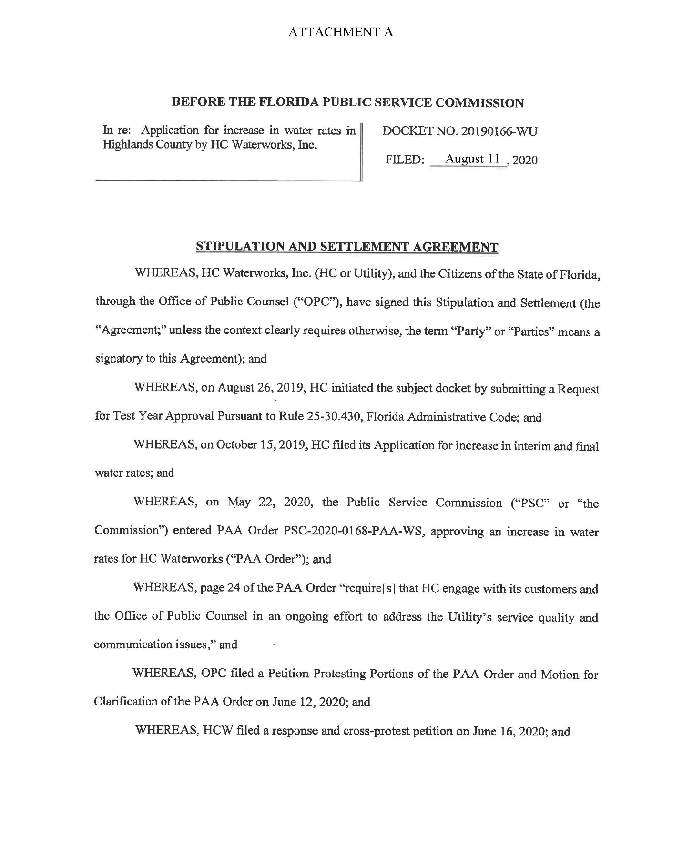
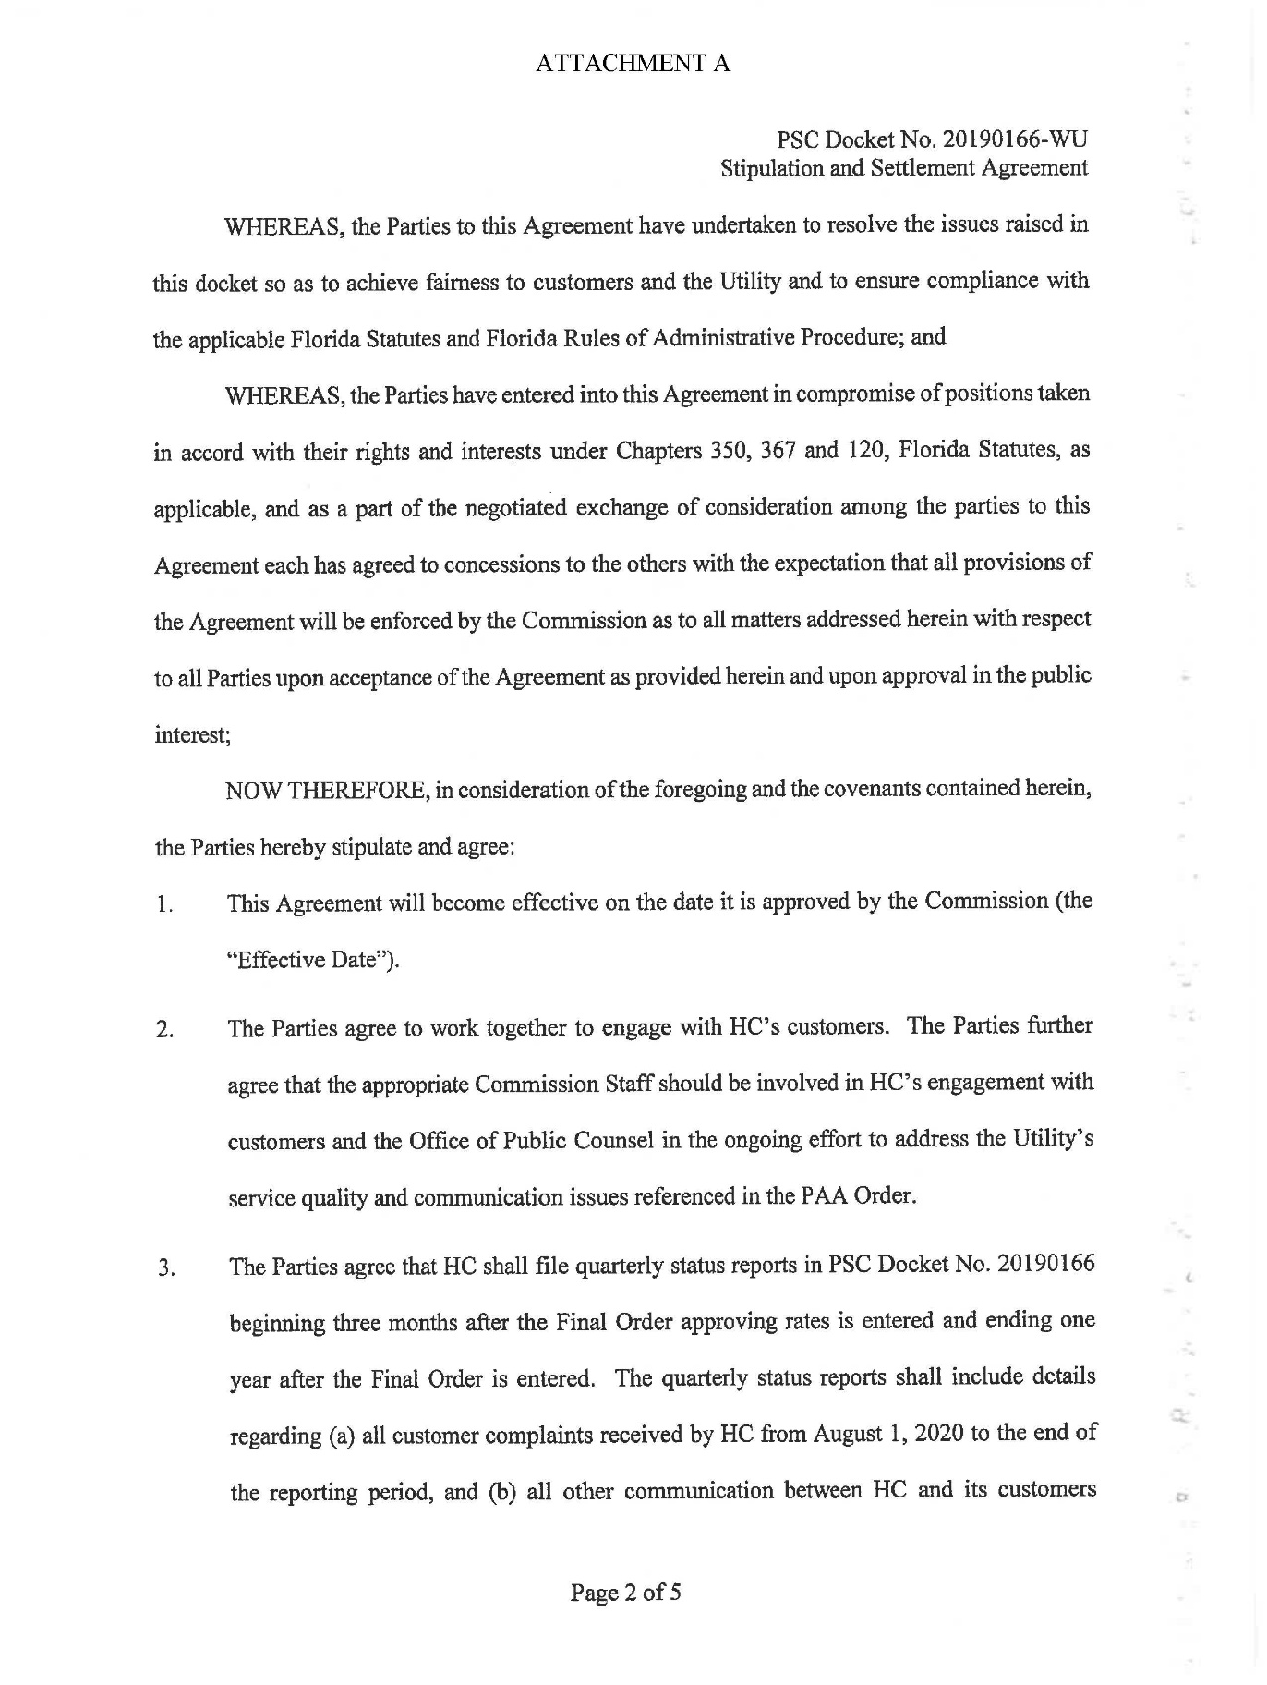
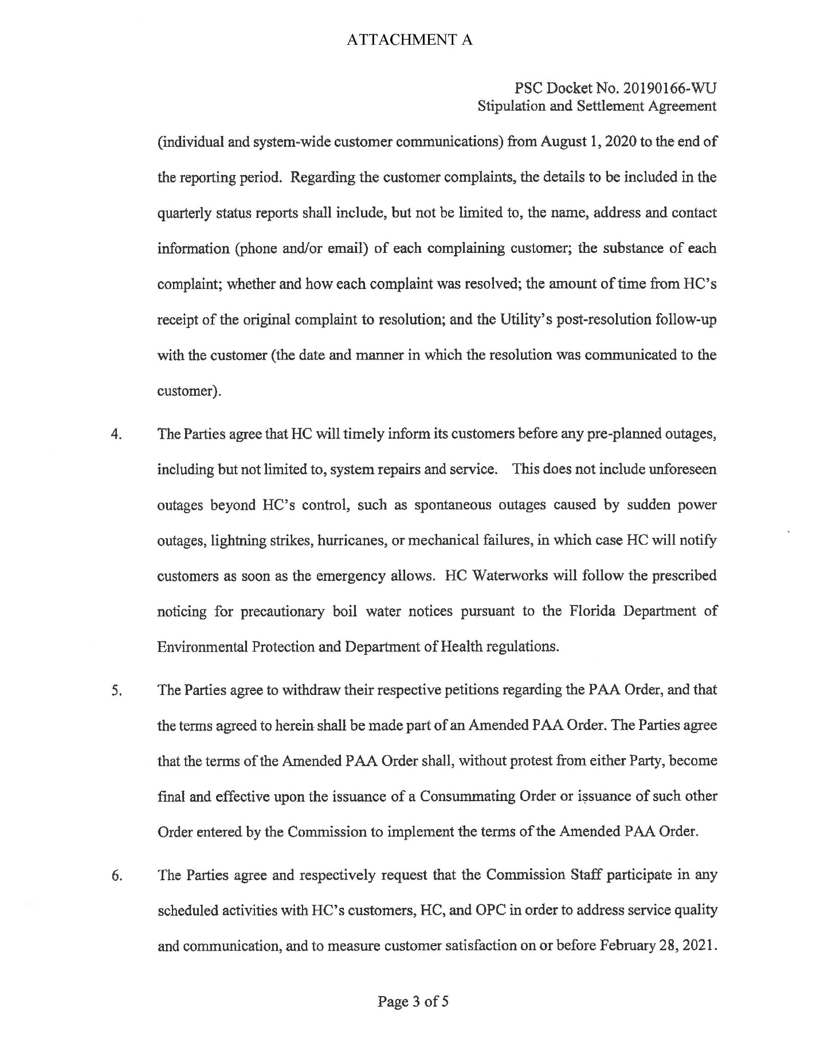

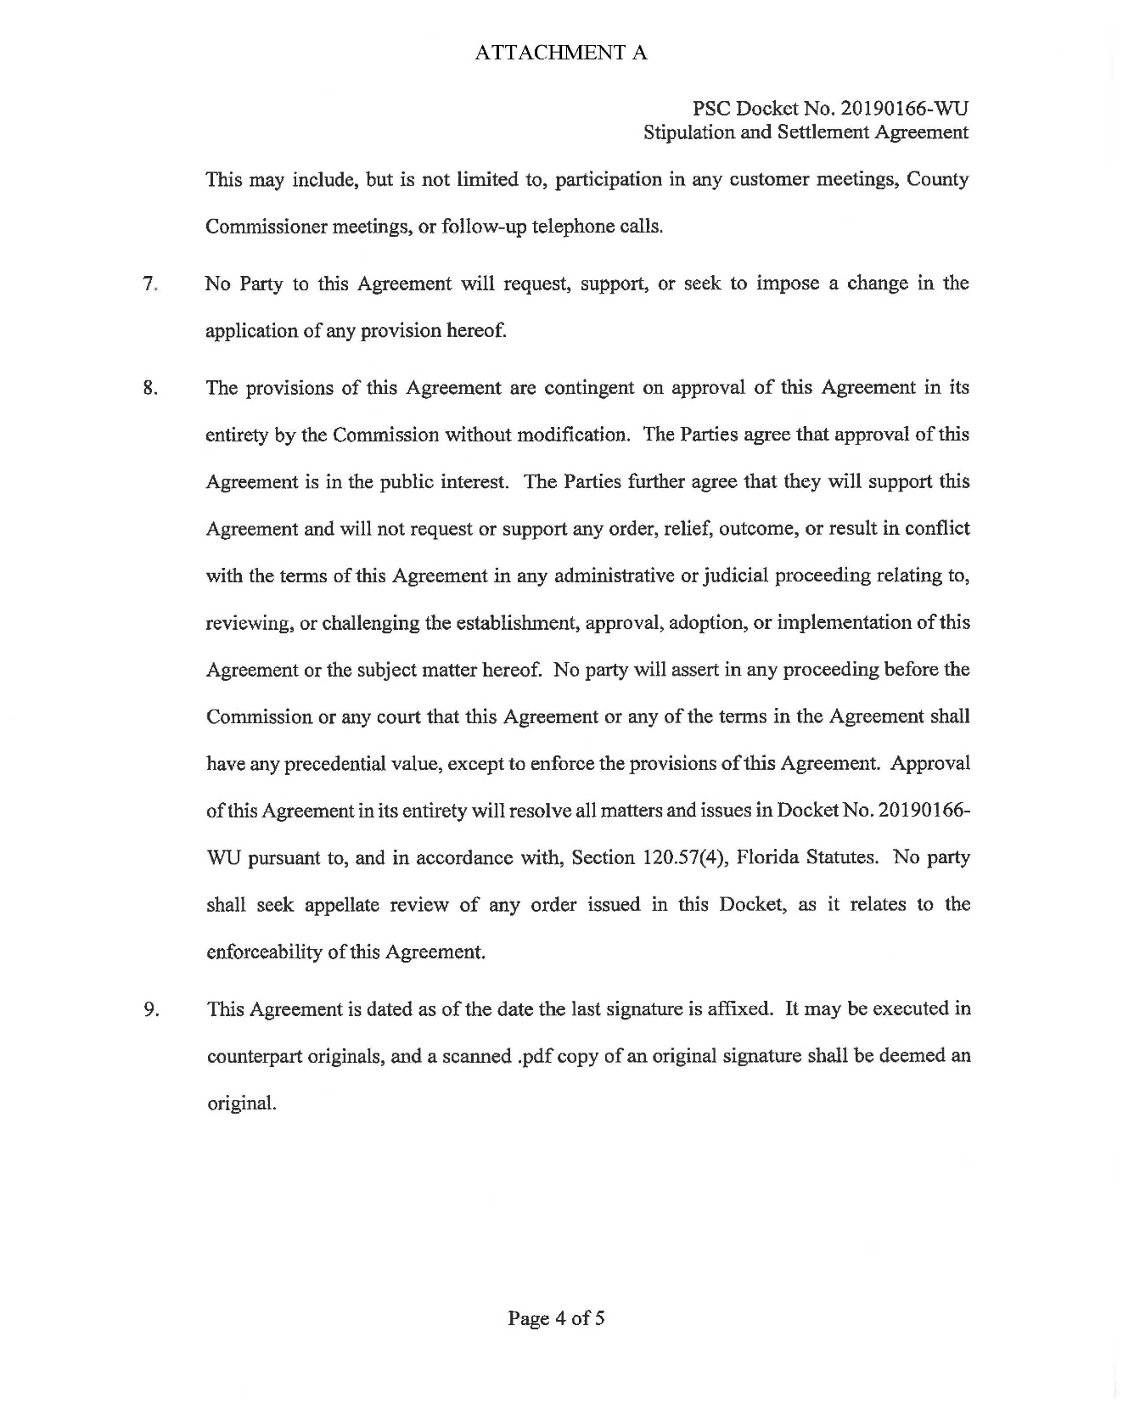

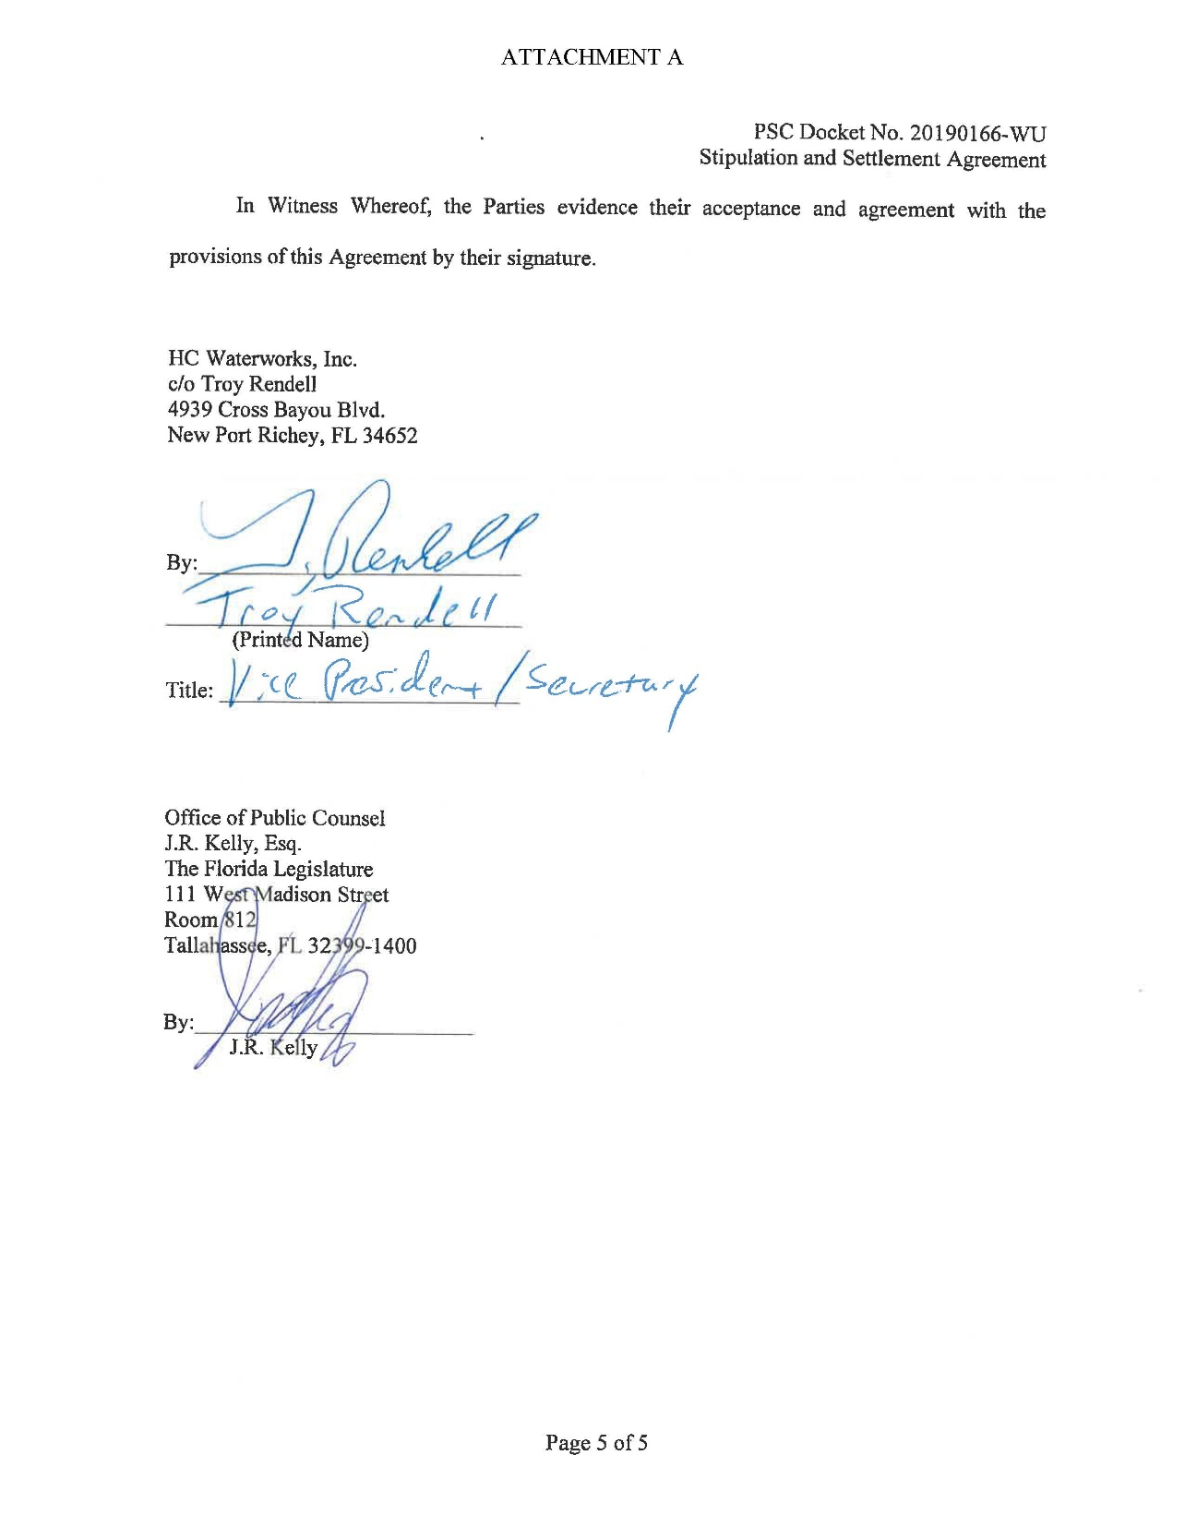

Document No. 03066-2020
Document No. 03112-2020
Document No. 04355-2020
Document No. 13667-2020
Document No. 00805-2021

