State of Florida |  | Public Service Commission  Capital Circle Office Center ● 2540 Shumard Oak Boulevard  Tallahassee, Florida 32399-0850  -M-E-M-O-R-A-N-D-U-M-
DATE: | March 19, 2021
TO: | Office of Commission Clerk (Teitzman)
FROM: | Division of Economics (Guffey)  Office of the General Counsel (Trierweiler)
RE: | Docket No. 20210018-EU – Joint petition for approval of modification to territorial agreement in Sumter, Lake, Marion, Levy, and Citrus Counties, by Sumter Electric Cooperative, Inc. and Duke Energy Florida, LLC.
AGENDA: | 04/01/21 – Regular Agenda – Proposed Agency Action – Interested Persons May Participate
COMMISSIONERS ASSIGNED: |  |  | All Commissioners
PREHEARING OFFICER: |  |  | Graham
CRITICAL DATES: |  |  | None
SPECIAL INSTRUCTIONS: |  |  | None

Case Background
On January 19, 2021, Sumter Electric Cooperative, Inc. (SECO) and Duke Energy Florida, LLC (DEF), collectively the joint petitioners, filed a petition seeking Commission approval of an amendment to their Territorial Agreement (Agreement) delineating their respective service boundaries in Sumter, Lake, Marion, Levy, and Citrus counties. The proposed amendment is the First Amendment to the Agreement, applicable to the petitioners’ service boundary in Lake County. The First Amendment to the Agreement and composite maps depicting the proposed boundary modifications in Lake County are shown in Attachment A to this recommendation.
In Order No. PSC-2020-0252-PAA-EU the Commission approved the currently effective Agreement dated March 27, 2020. The current Agreement includes the transfer of 546 DEF customers (including 379 customers in a mixed-use apartment complex in Lake County) to SECO and 49 SECO customers to DEF. The purpose of the transfers was to prevent duplication of facilities, correct encroachments, and have one service provider in residential developments when feasible.

In the instant petition, the joint petitioners seek to modify the current Agreement to redefine a specific service area boundary in Lake County, which would alleviate the need to transfer 379 DEF customers to SECO as approved by Order No. PSC-2020-0252-PAA-EU. Staff issued a data request to the joint petitioners for which the responses were received on February 12, 2021. The Commission has jurisdiction over this matter pursuant to Section 366.04, Florida Statutes (F.S.).

Discussion of Issues

Issue 1:
Should the Commission approve the proposed First Amendment to the Territorial Agreement between SECO and DEF in Sumter, Lake, Marion, Levy, and Citrus counties?

Recommendation:
Yes, the Commission should approve the proposed First Amendment to the Territorial Agreement between SECO and DEF in Sumter, Lake, Marion, Levy, and Citrus counties. The First Amendment to the Territorial Agreement will not cause a detriment to the public interest and will enable SECO and DEF to avoid duplication of facilities and to serve their customers in an efficient manner. (Guffey)

Staff Analysis:
Pursuant to Section 366.04(2)(d), F.S., and Rule 25-6.0440, Florida Administrative Code (F.A.C.), the Commission has the jurisdiction to approve territorial agreements between and among rural electric cooperatives, municipal electric utilities, and other electric utilities. Unless the Commission determines that the agreement will cause a detriment to the public interest, the agreement should be approved.

Proposed First Amendment to the Territorial Agreement
The joint petitioners are parties to the currently effective territorial agreement approved in Order No. PSC-2020-0252-PAA-EU, issued July 23, 2020. Per the order, DEF would transfer 379 customers (339 residential and 40 commercial) located in the Quarters Apartments complex to SECO. The customers have not been transferred to SECO yet and are still being served by DEF.

The joint petitioners explained that about the same time as the Commission Order was issued approving the current Agreement, the commissioners of the Town of Lady Lake unanimously approved a new development called Lady Lake Square Apartments which is in close proximity to the Quarters Apartments. The planned Lady Lake Square Apartments are currently within DEF’s service territory and would serve approximately 288 customers. Since the two apartment complexes are similar in size, SECO and DEF agreed to modify the currently approved territorial boundaries to allow DEF to continue serving the Quarters Apartments and for SECO to serve the planned Lady Lake Square Apartments. The joint petitioners stated that this would avoid the need to build duplicate facilities and eliminate the transfer of 379 DEF customers in the Quarters Apartments to SECO. As contemplated in the currently effective Agreement, the remaining customer transfers will be completed within 36 months.

The intent of the proposed First Amendment to the current Agreement is to redefine the specific service area boundaries in Lake County regarding the Quarters and Lady Lake Square Apartments. Specifically, Section 2.5 Reallocation of Areas of the amended Agreement seeks to redraw the Quarters Apartments to DEF’s service territory and redraw the planned Lady Lakes Square Apartments to SECO’s service territory. The terms and conditions of the currently effective Agreement will remain unchanged. The joint petitioners state that the proposed boundary modifications to the current Agreement will eliminate uneconomic duplication of facilities required for SECO to acquire the customers in the Quarters Apartments, will eliminate potential undue hardship on the existing customers subject to transfer, is in the public interest, and will not decrease the reliability of electric service to existing or future customers of either party. In response to staff’s data request, the joint petitioners stated that the 379 DEF customers will be notified by letter that they will no longer be transferred to SECO, as ordered in Order No. PSC-2020-0252-PAA-EU.

The effective date of the First Amendment to the Agreement would be the date on which the Commission issues its final order granting approval of this proposed Amendment in its entirety and it is no longer subject to judicial review.

Conclusion
The joint petitioners state that they have worked collaboratively to structure the proposed First Amendment to their current Agreement and that it furthers the goals of avoiding duplication of service and enables each to achieve operational efficiency. After review of the joint petition, the proposed First Amendment to the Territorial Agreement, and responses to staff’s data request, staff believes the First Amendment to the Territorial Agreement will not cause a detriment to the public interest, will eliminate any potential uneconomic duplication of facilities and will not cause a decrease in reliability of electric service to the present or future customers of SECO or DEF. Therefore, staff recommends that the Commission should approve the proposed First Amendment to the Territorial Agreement between SECO and DEF in Sumter, Lake, Marion, Levy, and Citrus counties.

Issue 2:
Should this docket be closed?

Recommendation:
Yes. If no protest is filed by a person whose substantial interests are affected within 21 days of the issuance of the Order, this docket should be closed upon the issuance of the Consummating Order. (Trierweiler)

Staff Analysis:
If no protest is filed by a person whose substantial interests are affected within 21 days of the issuance of the Order, this docket should be closed upon the issuance of the Consummating Order.

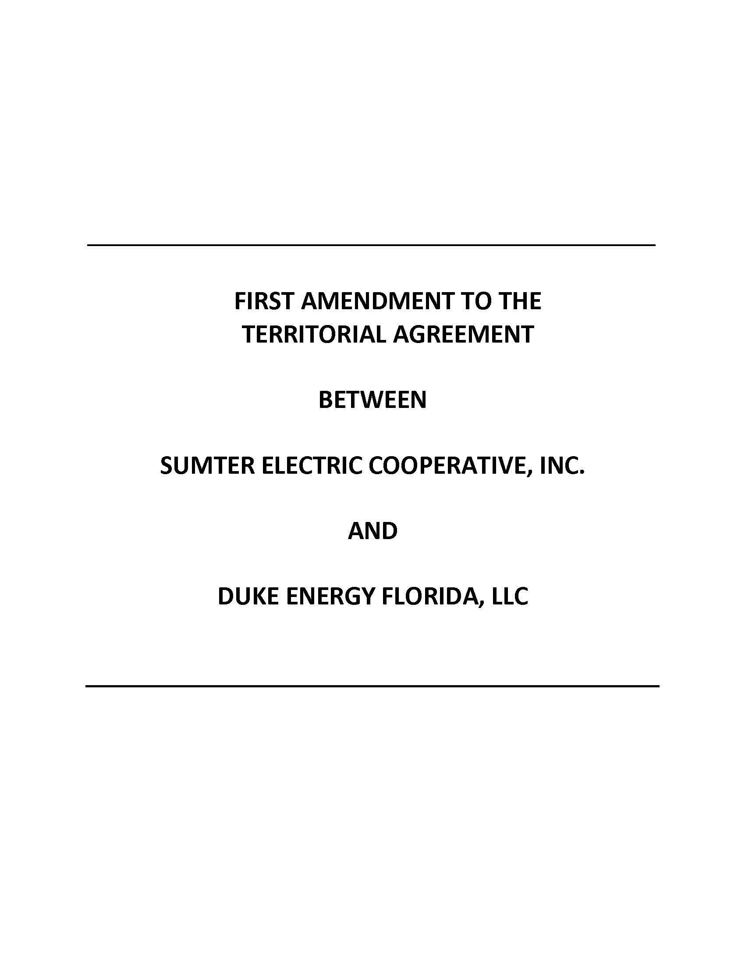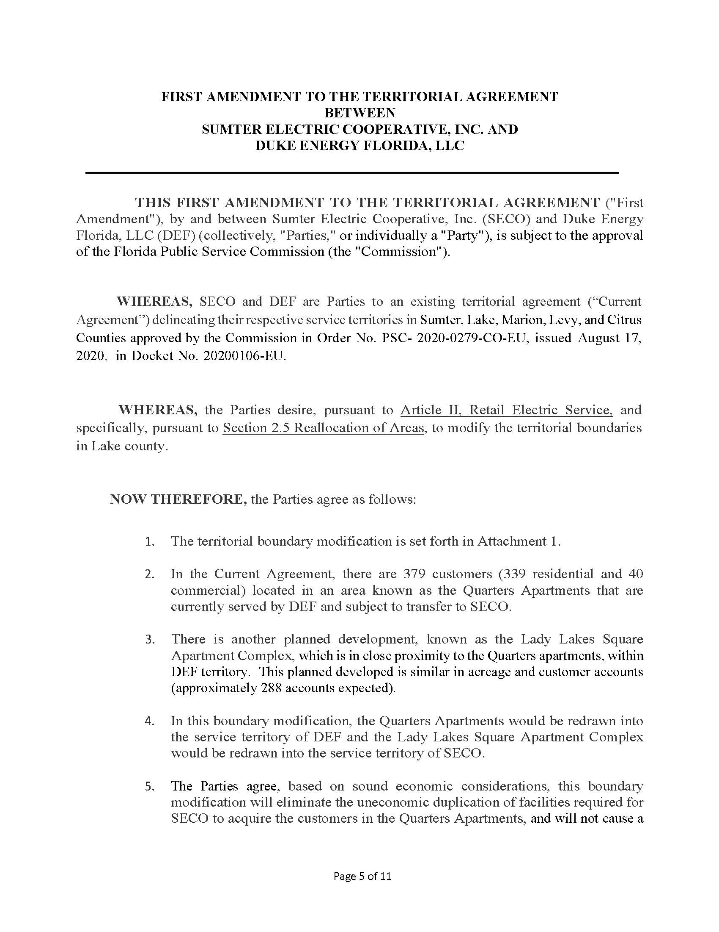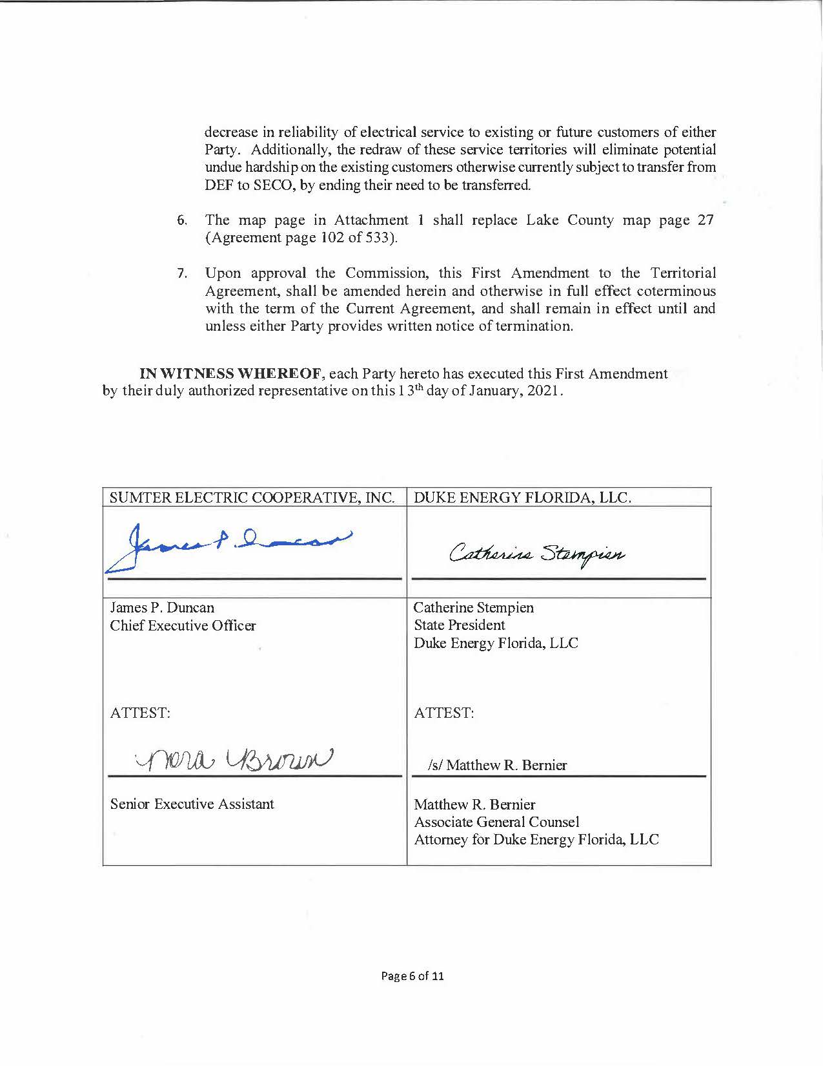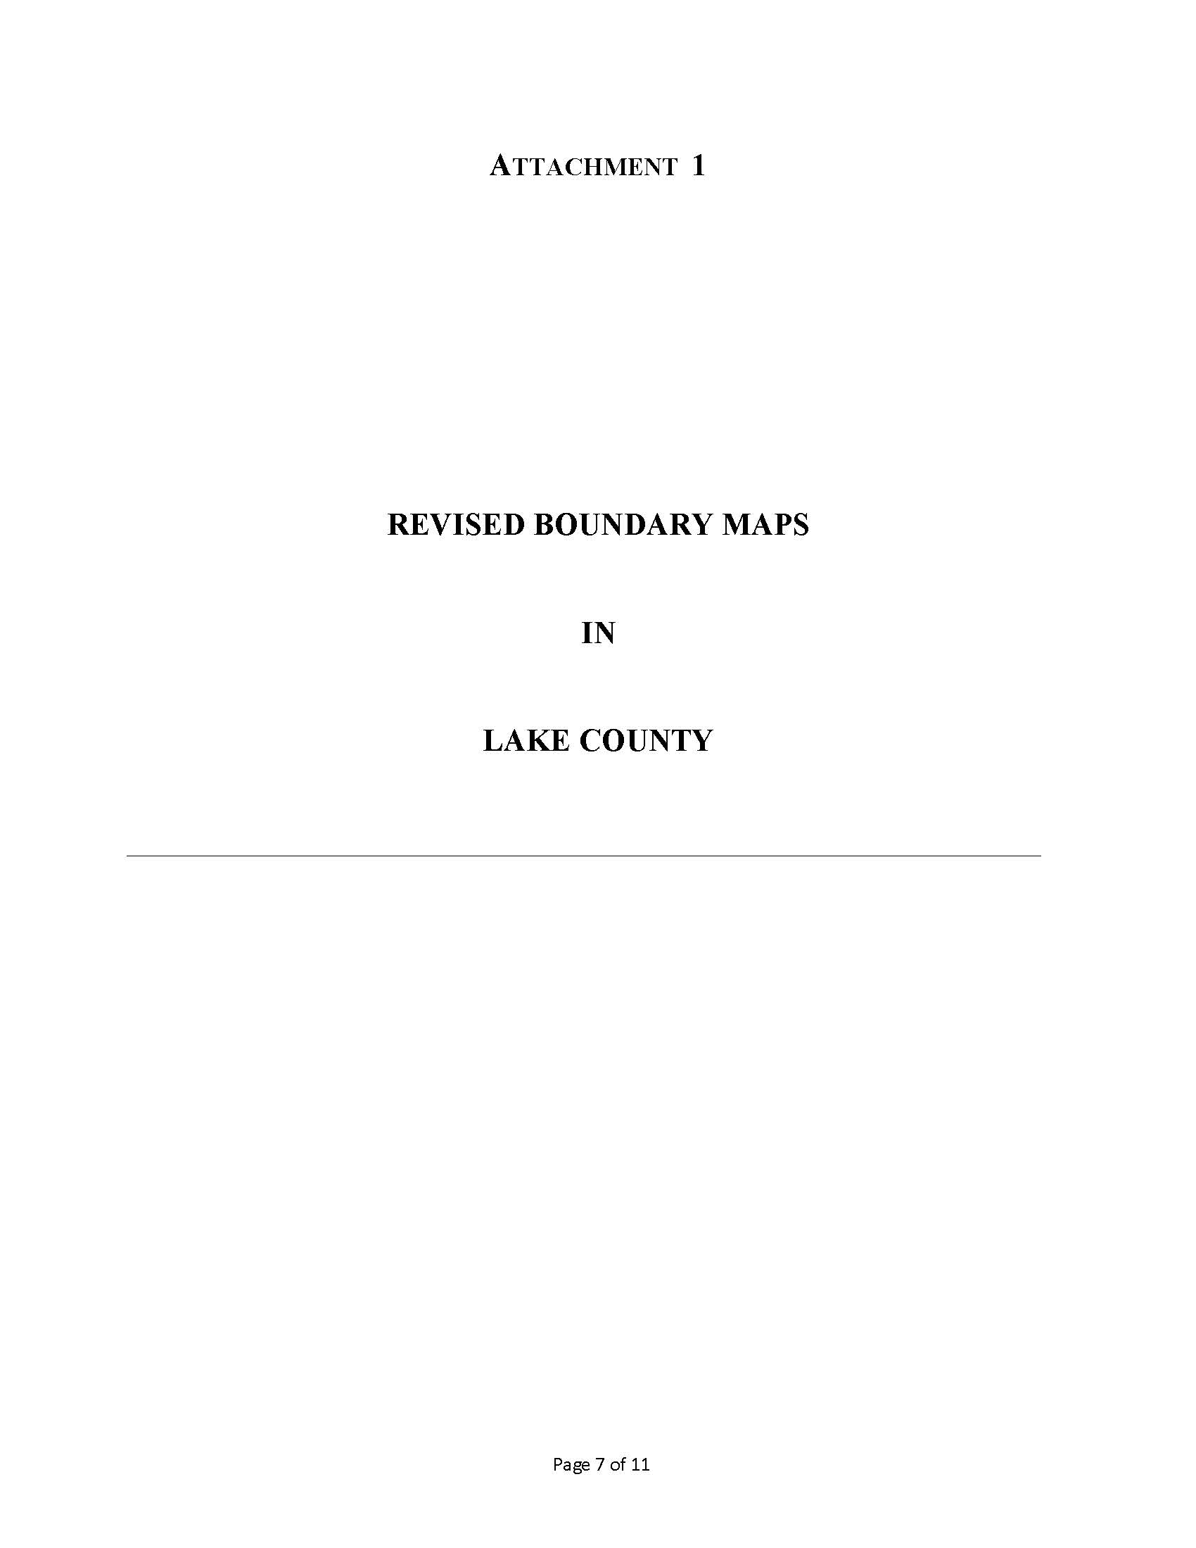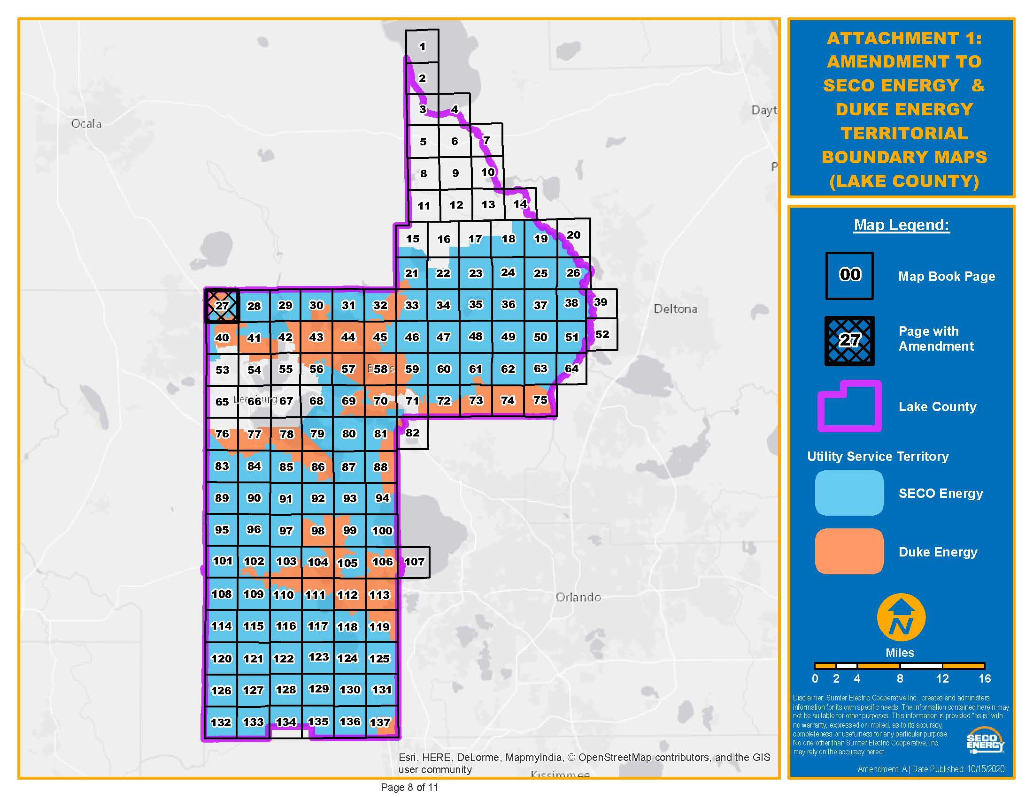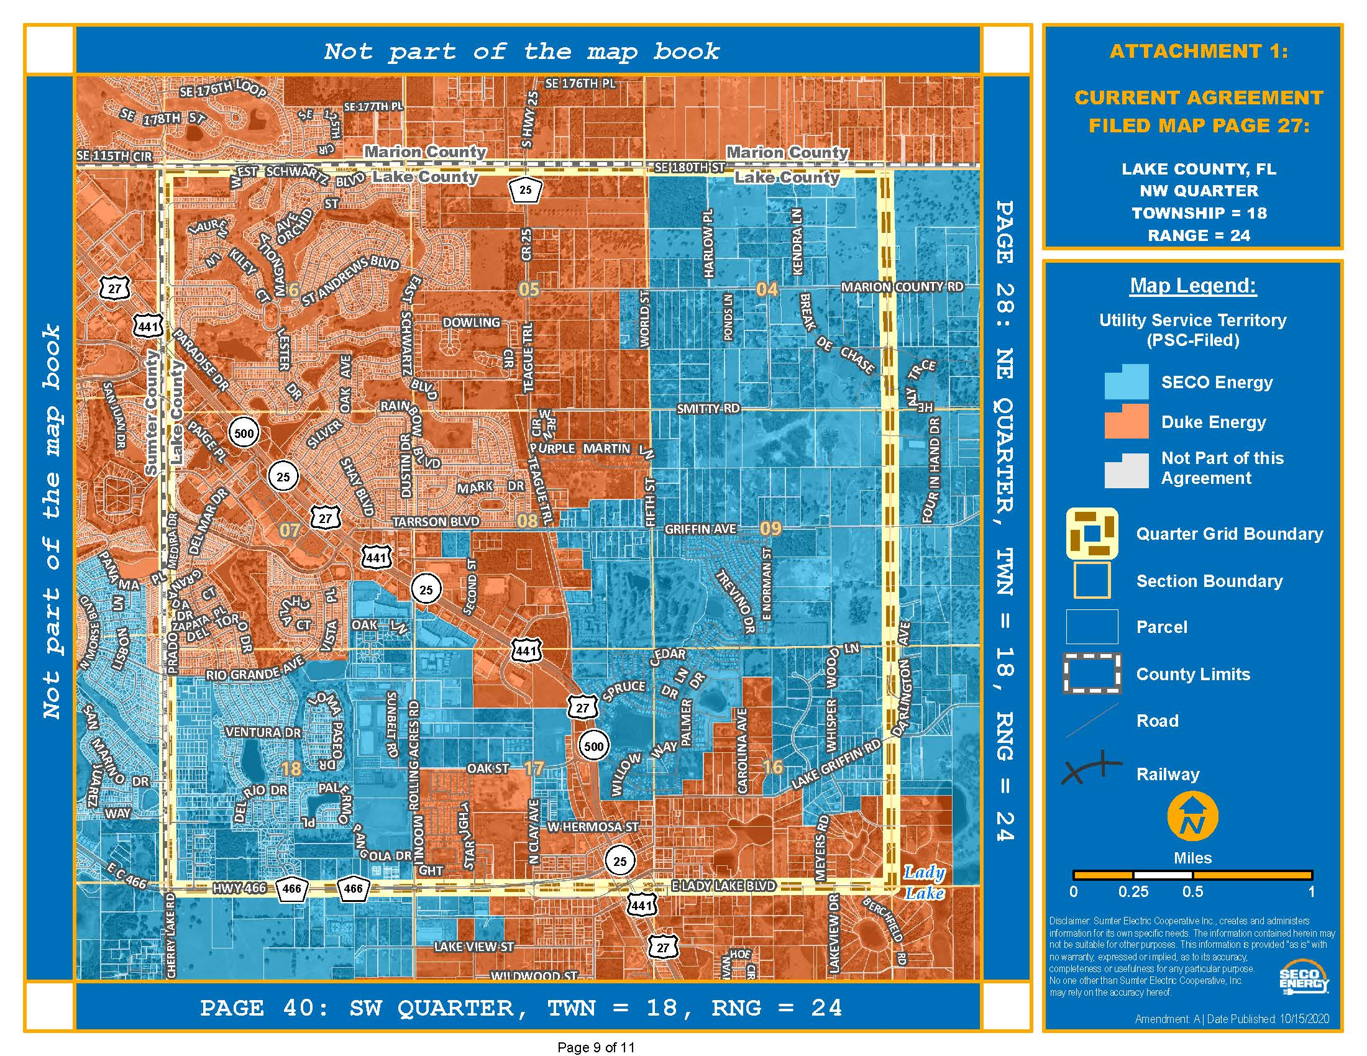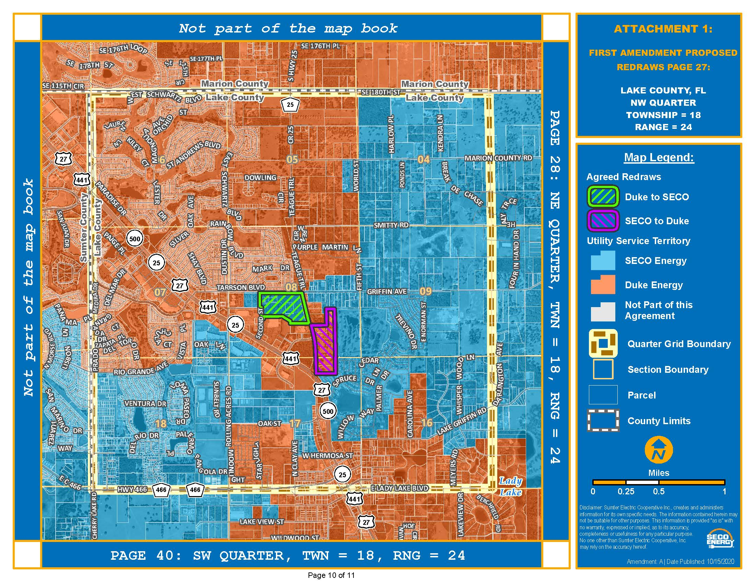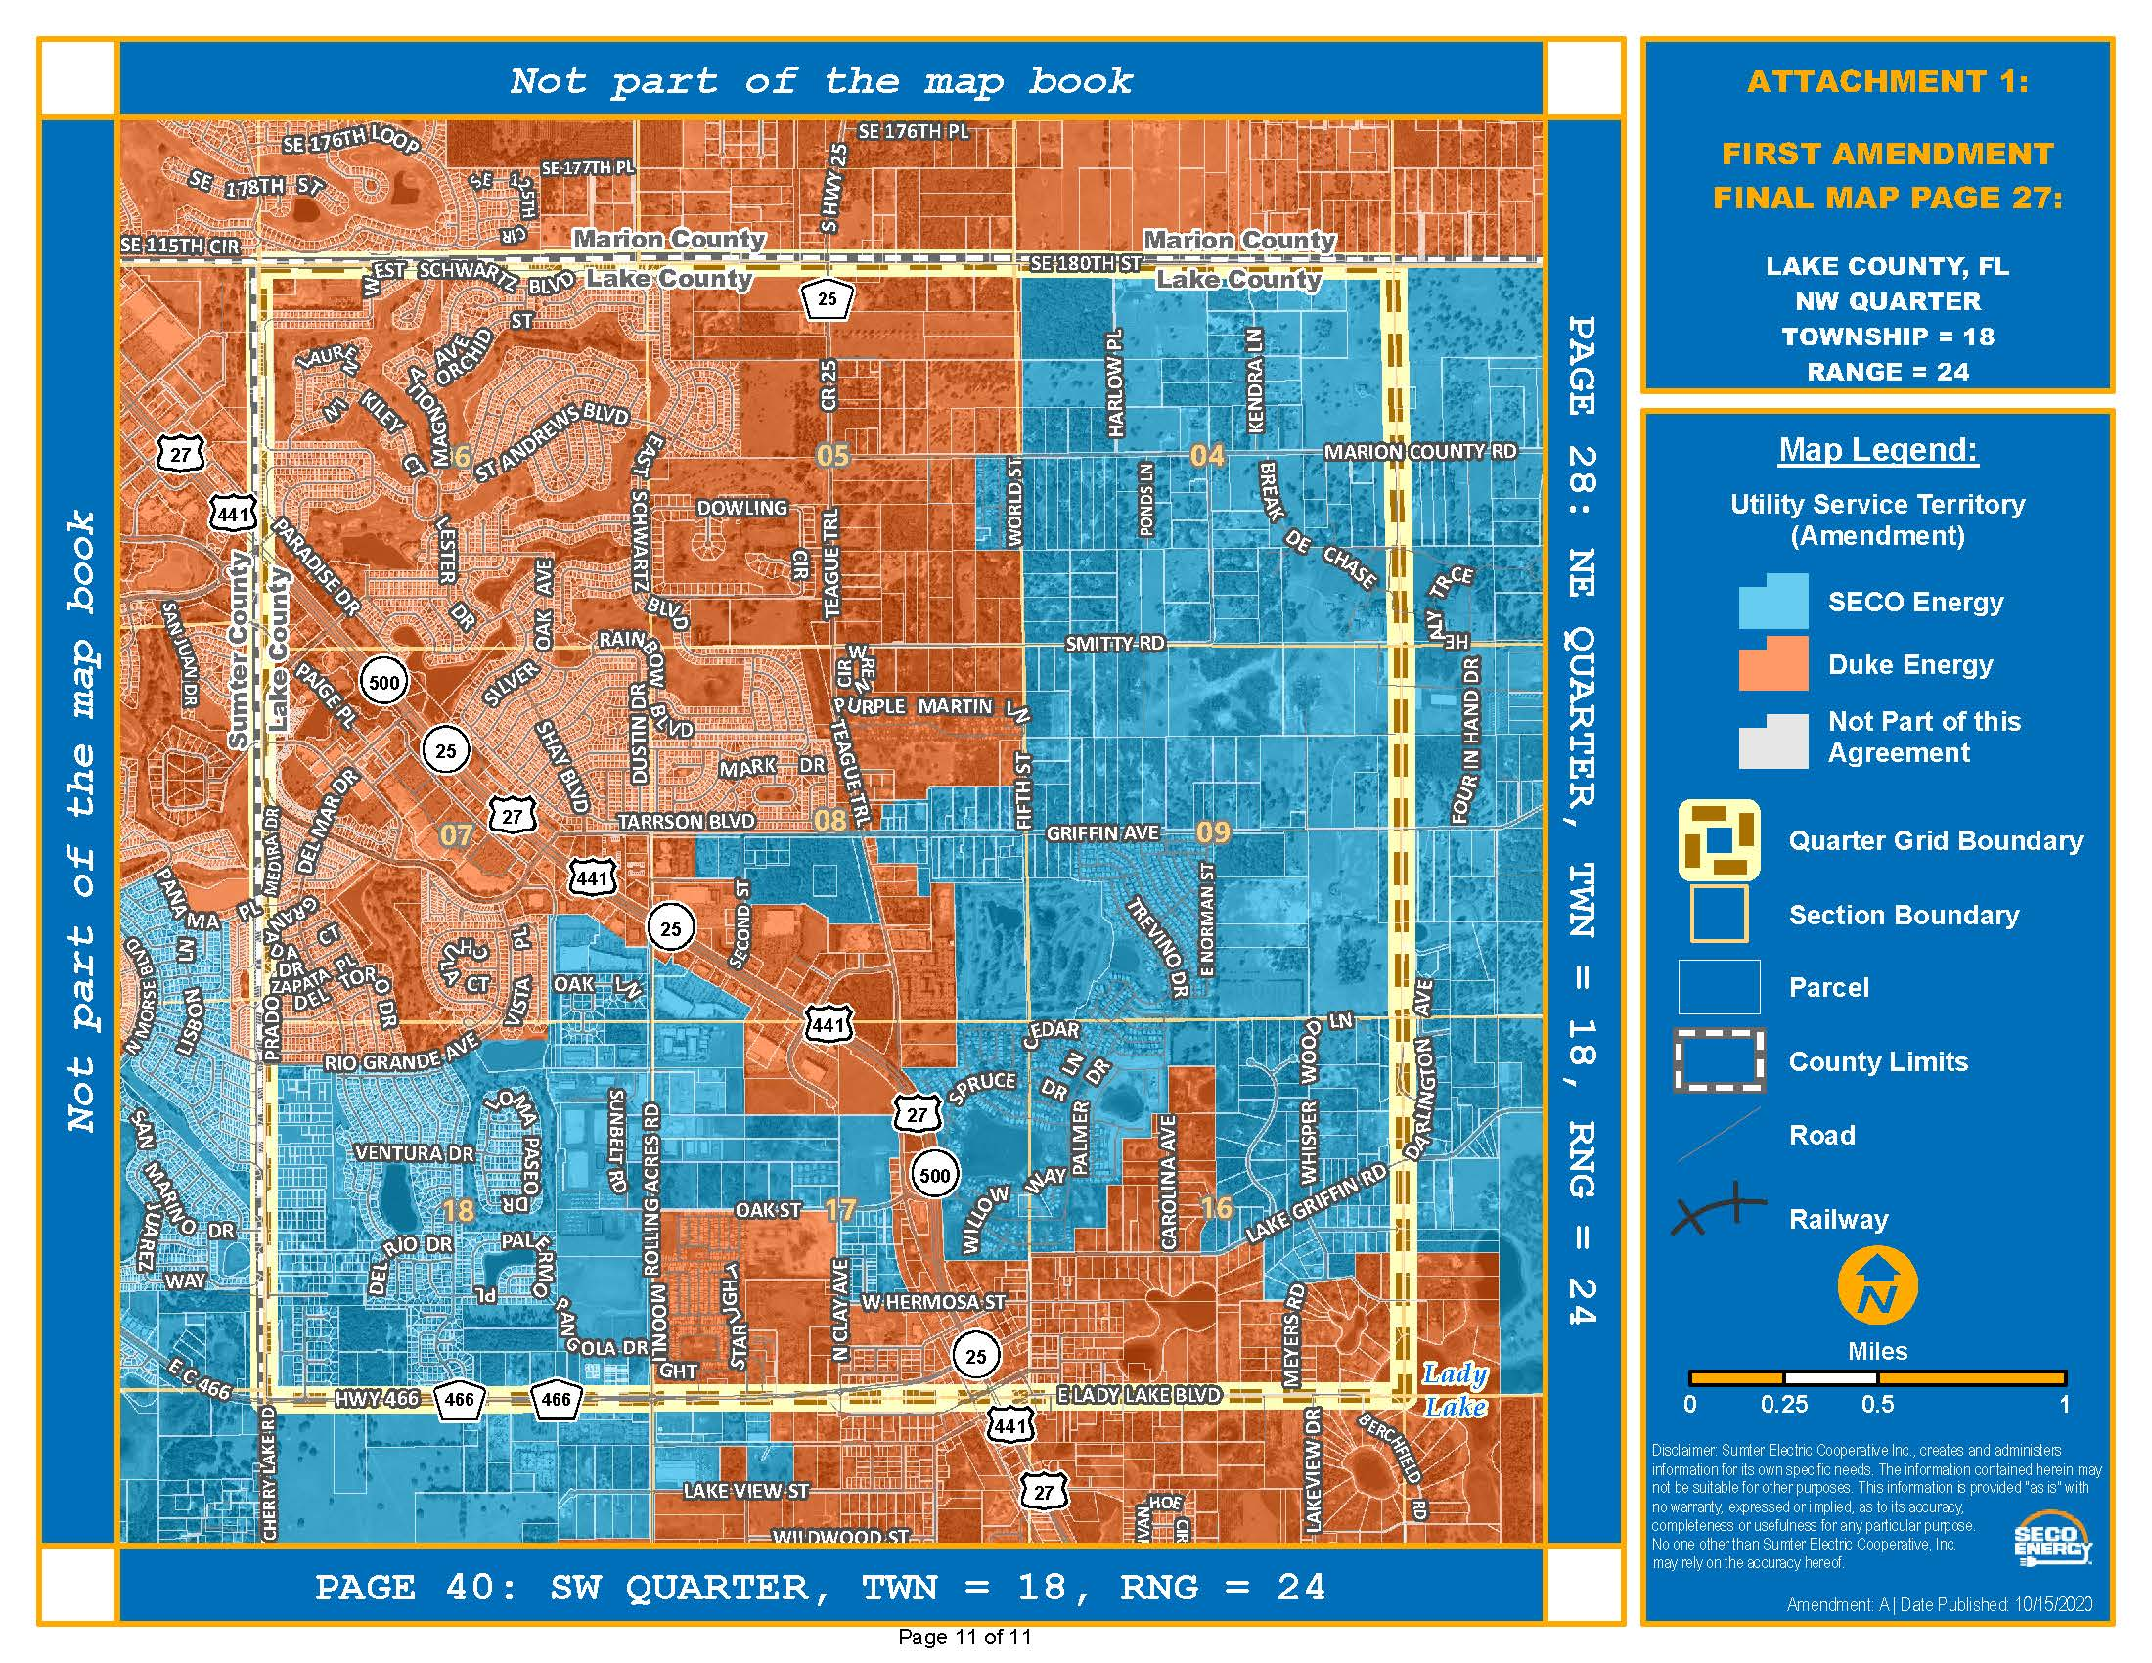

Order No. PSC-2020-0252-PAA-EU, issued July 23, 2020, in Docket No. 20200106-EU, In re: Joint petition to approve territorial agreement in Sumter, Lake, Marion, Levy, and Citrus Counties, by Sumter Electric Cooperative, Inc. and Duke Energy Florida, LLC.
Utilities Commission of the City of New Smyrna Beach v. Florida Public Service Commission, 469 So. 2d 731 (Fla. 1985).

