BEFORE THE FLORIDA PUBLIC SERVICE COMMISSION

In re: Joint petition for approval of modification to territorial agreement in Sumter, Lake, Marion, Levy, and Citrus Counties, by Sumter Electric Cooperative, Inc. and Duke Energy Florida, LLC. | DOCKET NO. 20210018-EU  ORDER NO. PSC-2021-0145-PAA-EU  ISSUED: April 21, 2021

The following Commissioners participated in the disposition of this matter:

GARY F. CLARK, Chairman
ART GRAHAM
ANDREW GILES FAY
MIKE LA ROSA

NOTICE OF PROPOSED AGENCY ACTION
ORDER APPROVING MODIFICATION TO TERRITORIAL AGREEMENT

BY THE COMMISSION:

NOTICE is hereby given by the Florida Public Service Commission that the action discussed herein is preliminary in nature and will become final unless a person whose interests are substantially affected files a petition for a formal proceeding, pursuant to Rule 25-22.029, Florida Administrative Code (F.A.C.).

I. Background

On January 29, 2021, Sumter Electric Cooperative, Inc. (SECO) and Duke Energy Florida, LLC (DEF), collectively the joint petitioners, filed a petition seeking our approval of an amendment to their Territorial Agreement (Agreement) delineating their respective service boundaries in Sumter, Lake, Marion, Levy, and Citrus counties. The proposed amendment is the First Amendment to the Agreement, applicable to the petitioners’ service boundary in Lake County. The First Amendment to the Agreement and composite maps depicting the proposed boundary modifications in Lake County are shown in Attachment A to this order.

In Order No. PSC-2020-0252-PAA-EU we approved the currently effective Agreement dated March 27, 2020. The current Agreement includes the transfer of 546 DEF customers (including 379 customers in a mixed-use apartment complex in Lake County) to SECO and 49 SECO customers to DEF. The purpose of the transfers was to prevent duplication of facilities, correct encroachments, and have one service provider in residential developments when feasible.

In the instant petition, the joint petitioners seek to modify the current Agreement to redefine a specific service area boundary in Lake County, which would alleviate the need to transfer 379 DEF customers to SECO as approved by Order No. PSC-2020-0252-PAA-EU. We have jurisdiction over this matter pursuant to Section 366.04, Florida Statutes (F.S.).

II. Decision
Pursuant to Section 366.04(2)(d), F.S., and Rule 25-6.0440, Florida Administrative Code (F.A.C.), we have the jurisdiction to approve territorial agreements between and among rural electric cooperatives, municipal electric utilities, and other electric utilities. Unless the we determine that the agreement will cause a detriment to the public interest, the agreement should be approved.

Proposed First Amendment to the Territorial Agreement

The joint petitioners were parties to the currently effective territorial agreement approved in Order No. PSC-2020-0252-PAA-EU, issued July 23, 2020. Per our order, DEF would have transferred 379 customers (339 residential and 40 commercial) located in the Quarters Apartments complex to SECO. As a result of the events described below, these customers have not been transferred to SECO and are still being served by DEF.

The joint petitioners explained that about the same time as our order was issued approving the current Agreement, the commissioners of the Town of Lady Lake unanimously approved a new development called Lady Lake Square Apartments which is in close proximity to the Quarters Apartments. The planned Lady Lake Square Apartments are currently within DEF’s service territory and would serve approximately 288 customers. Since the two apartment complexes are similar in size, SECO and DEF agreed to modify the currently approved territorial boundaries to allow DEF to continue serving the Quarters Apartments and for SECO to serve the planned Lady Lake Square Apartments. The joint petitioners stated that this would avoid the need to build duplicate facilities and eliminate the transfer of 379 DEF customers in the Quarters Apartments to SECO. As contemplated in the currently effective Agreement, the remaining customer transfers will be completed within 36 months.

The intent of the proposed First Amendment to the current Agreement is to redefine the specific service area boundaries in Lake County regarding the Quarters and Lady Lake Square Apartments. Specifically, Section 2.5 Reallocation of Areas of the amended Agreement seeks to redraw the Quarters Apartments to DEF’s service territory and redraw the planned Lady Lakes Square Apartments to SECO’s service territory. The terms and conditions of the currently effective Agreement will remain unchanged. The joint petitioners state that the proposed boundary modifications to the current Agreement will eliminate uneconomic duplication of facilities required for SECO to acquire the customers in the Quarters Apartments, will eliminate potential undue hardship on the existing customers subject to transfer, is in the public interest, and will not decrease the reliability of electric service to existing or future customers of either party. The joint petitioners state that the 379 DEF customers will be notified by letter that they will no longer be transferred to SECO, as ordered in Order No. PSC-2020-0252-PAA-EU.

The effective date of the First Amendment to the Agreement shall be the date on which we issue our final order granting approval of this proposed Amendment in its entirety and it is no longer subject to judicial review.

Conclusion

The joint petitioners state that they have worked collaboratively to structure the proposed First Amendment to their current Agreement and that it furthers the goals of avoiding duplication of service and enables each to achieve operational efficiency. After reviewing the joint petition, the proposed First Amendment to the Territorial Agreement, and the entire record of this docket, we find that approval of the First Amendment to the Territorial Agreement will not cause a detriment to the public interest, will eliminate any potential uneconomic duplication of facilities, and will not cause a decrease in reliability of electric service to the present or future customers of SECO or DEF. Therefore, the proposed First Amendment to the Territorial Agreement between SECO and DEF in Sumter, Lake, Marion, Levy, and Citrus counties is hereby approved.
Based on the foregoing, it is

ORDERED by the Florida Public Service Commission that the proposed First Amendment to the Territorial Agreement between SECO and DEF in Sumter, Lake, Marion, Levy, and Citrus counties is hereby approved. It is further

ORDERED that, with the exception of the modifications contained in the First Amendment, the terms and conditions of the existing agreement remain unchanged and in effect. It is further

ORDERED that the provisions of this Order, issued as proposed agency action, shall become final and effective upon the issuance of a Consummating Order unless an appropriate petition, in the form provided by Rule 28-106.201, Florida Administrative Code, is received by the Commission Clerk, 2540 Shumard Oak Boulevard, Tallahassee, Florida 32399-0850, by the close of business on the date set forth in the “Notice of Further Proceedings” attached hereto. It is further

ORDERED that in the event this Order becomes final, this docket shall be closed.

By ORDER of the Florida Public Service Commission this 21st day of April, 2021.

/s/ Adam J. Teitzman
ADAM J. TEITZMAN
Commission Clerk
Florida Public Service Commission
2540 Shumard Oak Boulevard
Tallahassee, Florida 32399
(850) 413-6770
www.floridapsc.com

Copies furnished: A copy of this document is provided to the parties of record at the time of issuance and, if applicable, interested persons.
WLT

NOTICE OF FURTHER PROCEEDINGS OR JUDICIAL REVIEW

The Florida Public Service Commission is required by Section 120.569(1), Florida Statutes, to notify parties of any administrative hearing that is available under Section 120.57, Florida Statutes, as well as the procedures and time limits that apply. This notice should not be construed to mean all requests for an administrative hearing will be granted or result in the relief sought.

Mediation may be available on a case-by-case basis. If mediation is conducted, it does not affect a substantially interested person's right to a hearing.

The action proposed herein is preliminary in nature. Any person whose substantial interests are affected by the action proposed by this order may file a petition for a formal proceeding, in the form provided by Rule 28-106.201, Florida Administrative Code. This petition must be received by the Office of Commission Clerk, 2540 Shumard Oak Boulevard, Tallahassee, Florida 32399-0850, by the close of business on May 12, 2021.

In the absence of such a petition, this order shall become final and effective upon the issuance of a Consummating Order.

Any objection or protest filed in this/these docket(s) before the issuance date of this order is considered abandoned unless it satisfies the foregoing conditions and is renewed within the specified protest period.

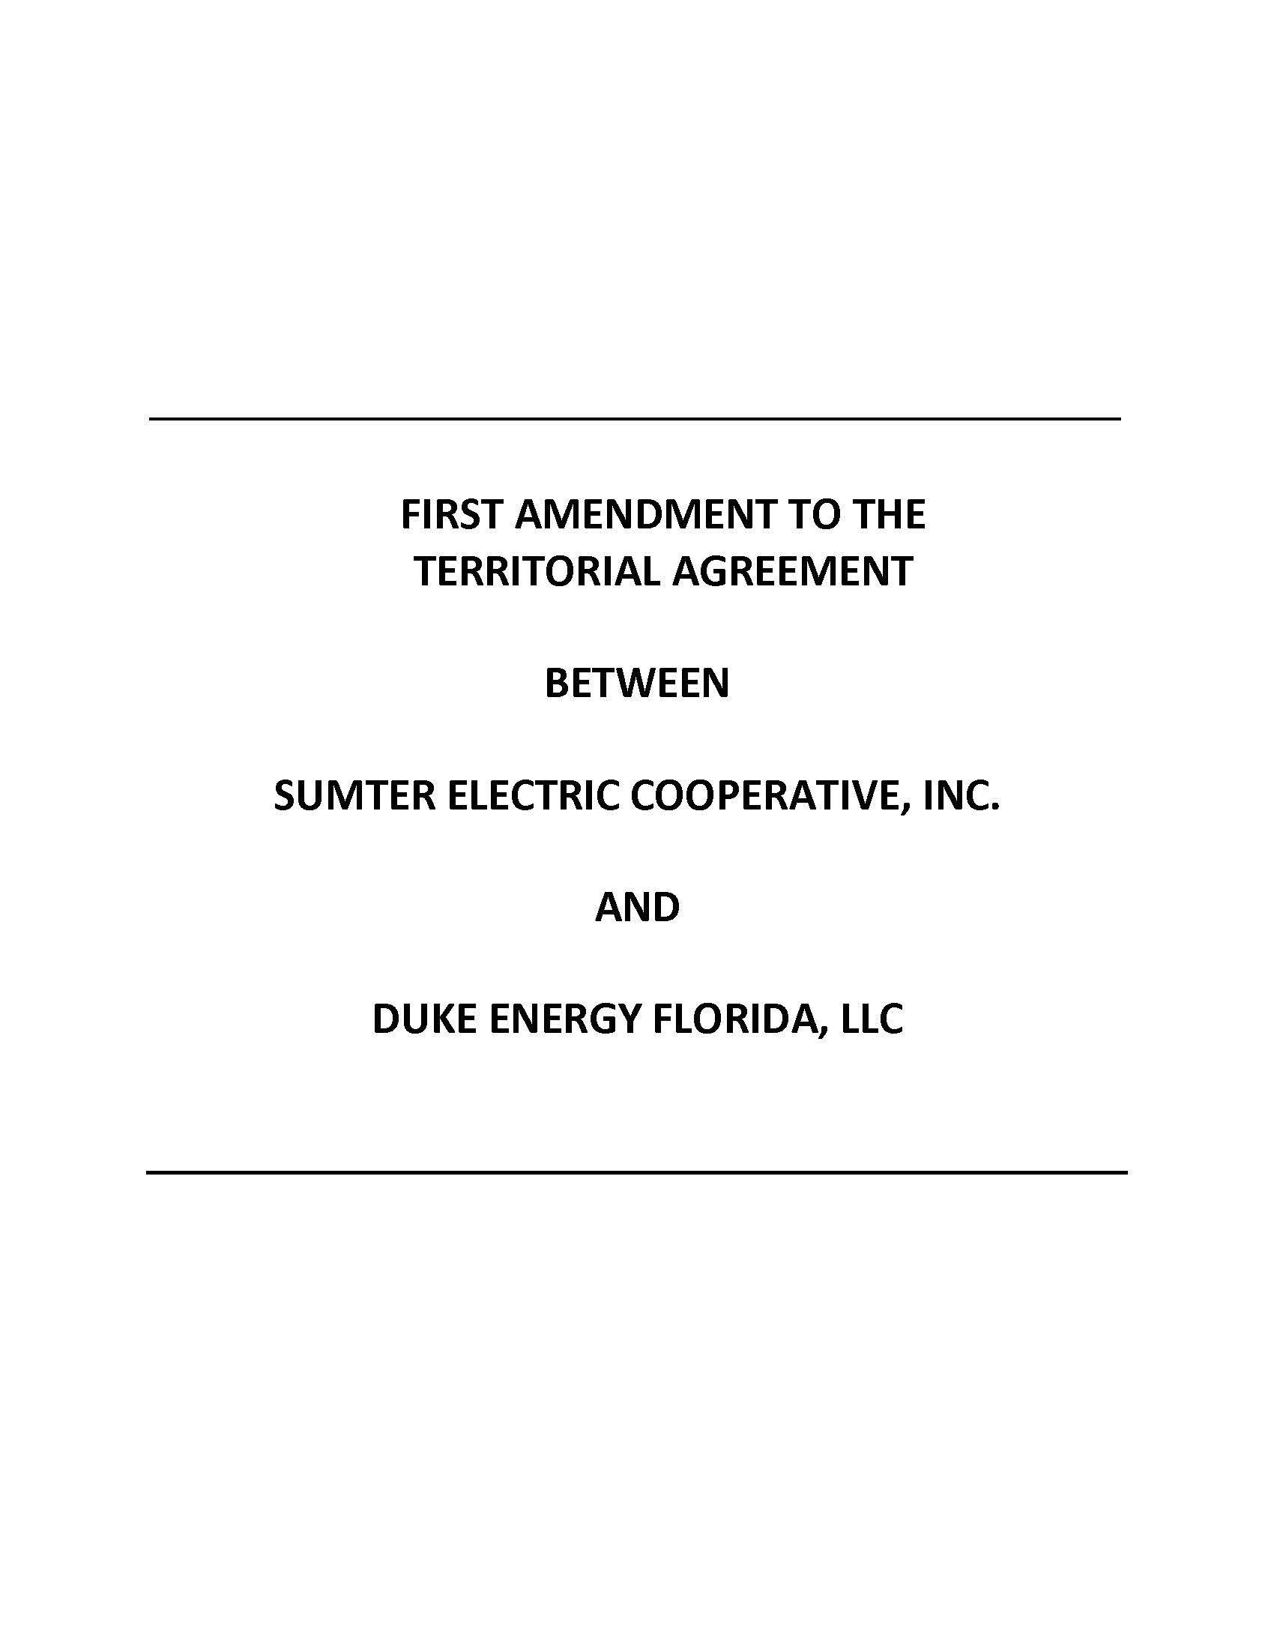

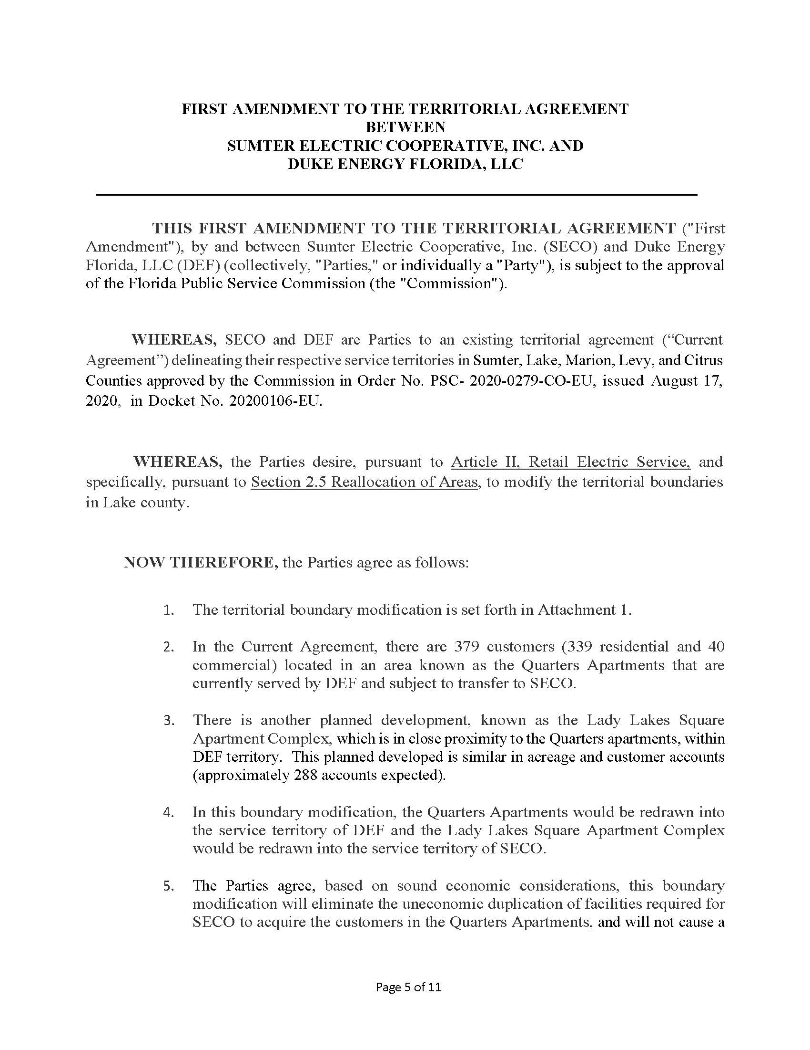

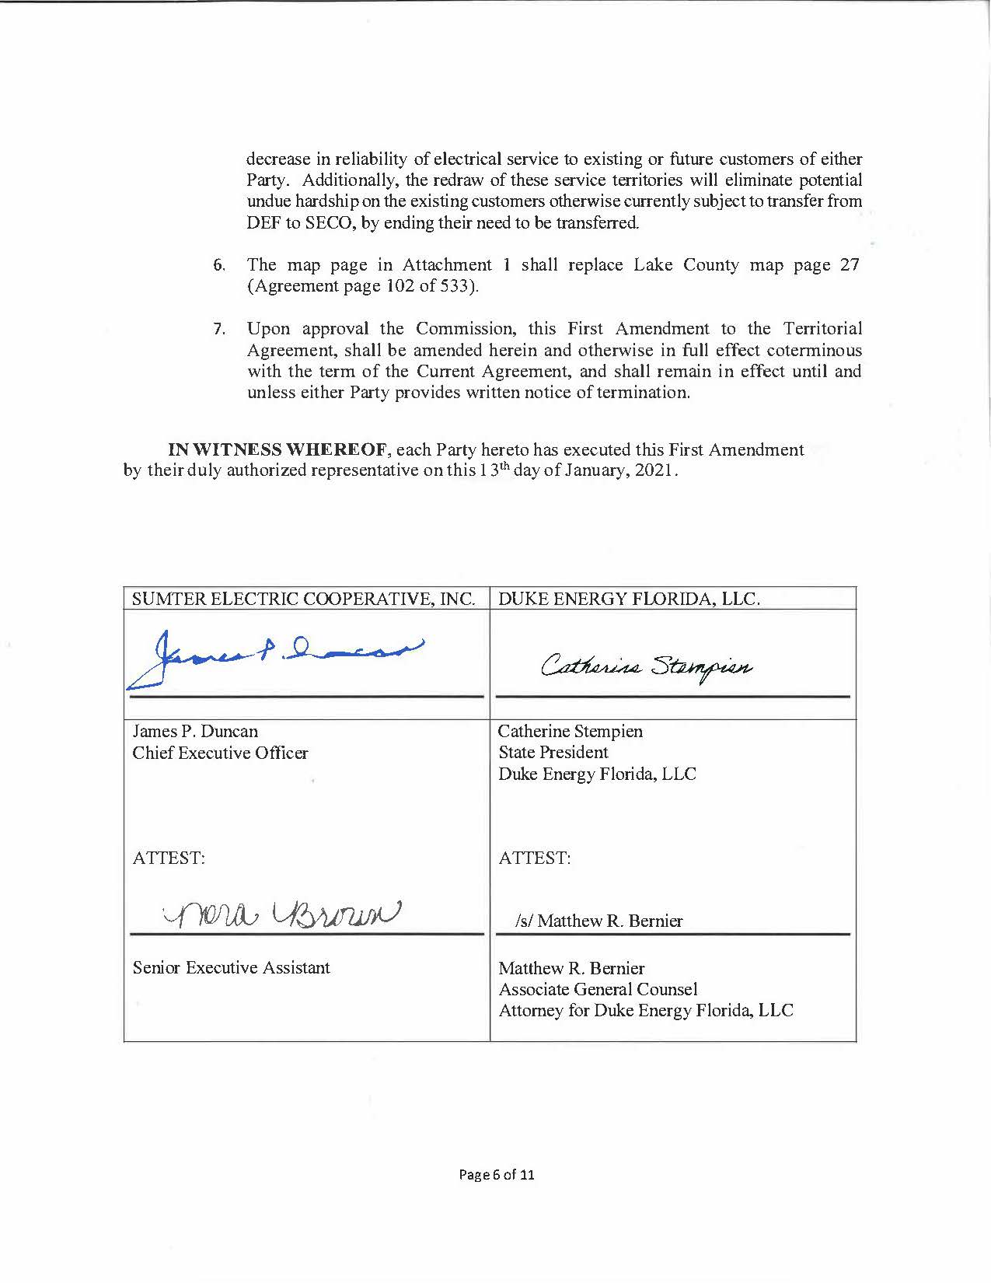

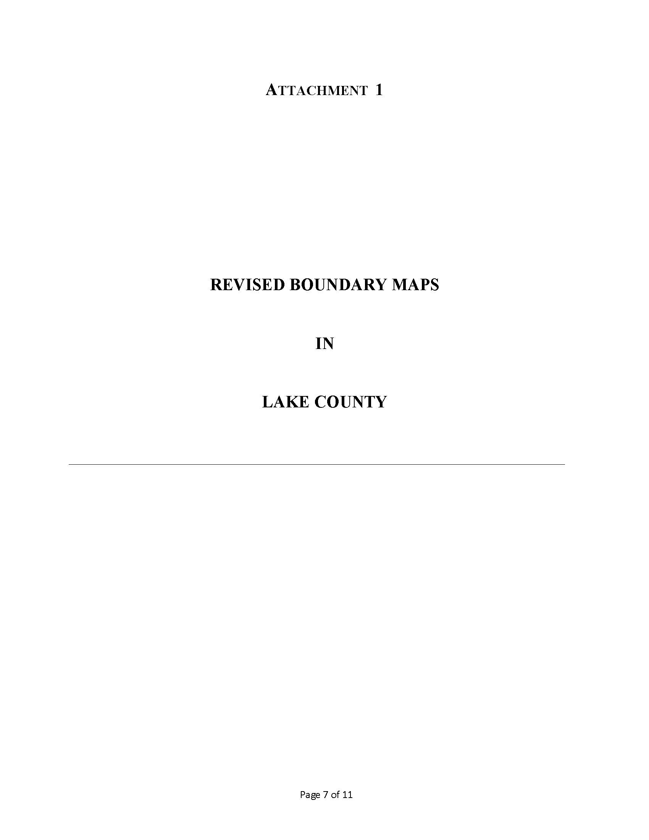

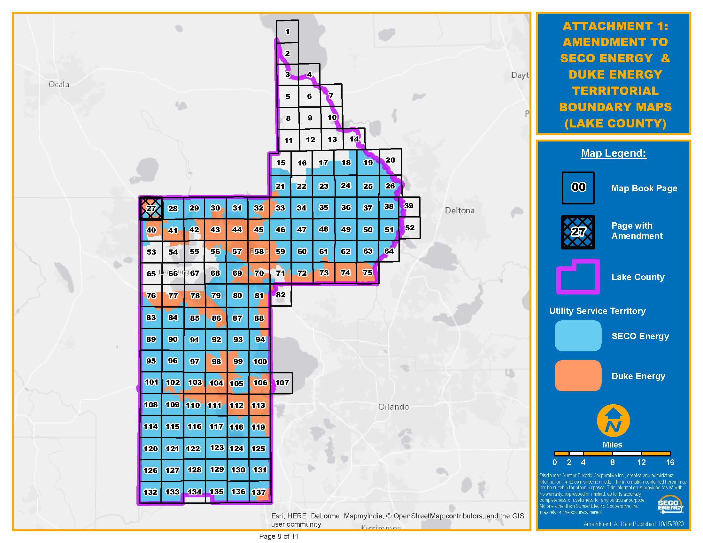
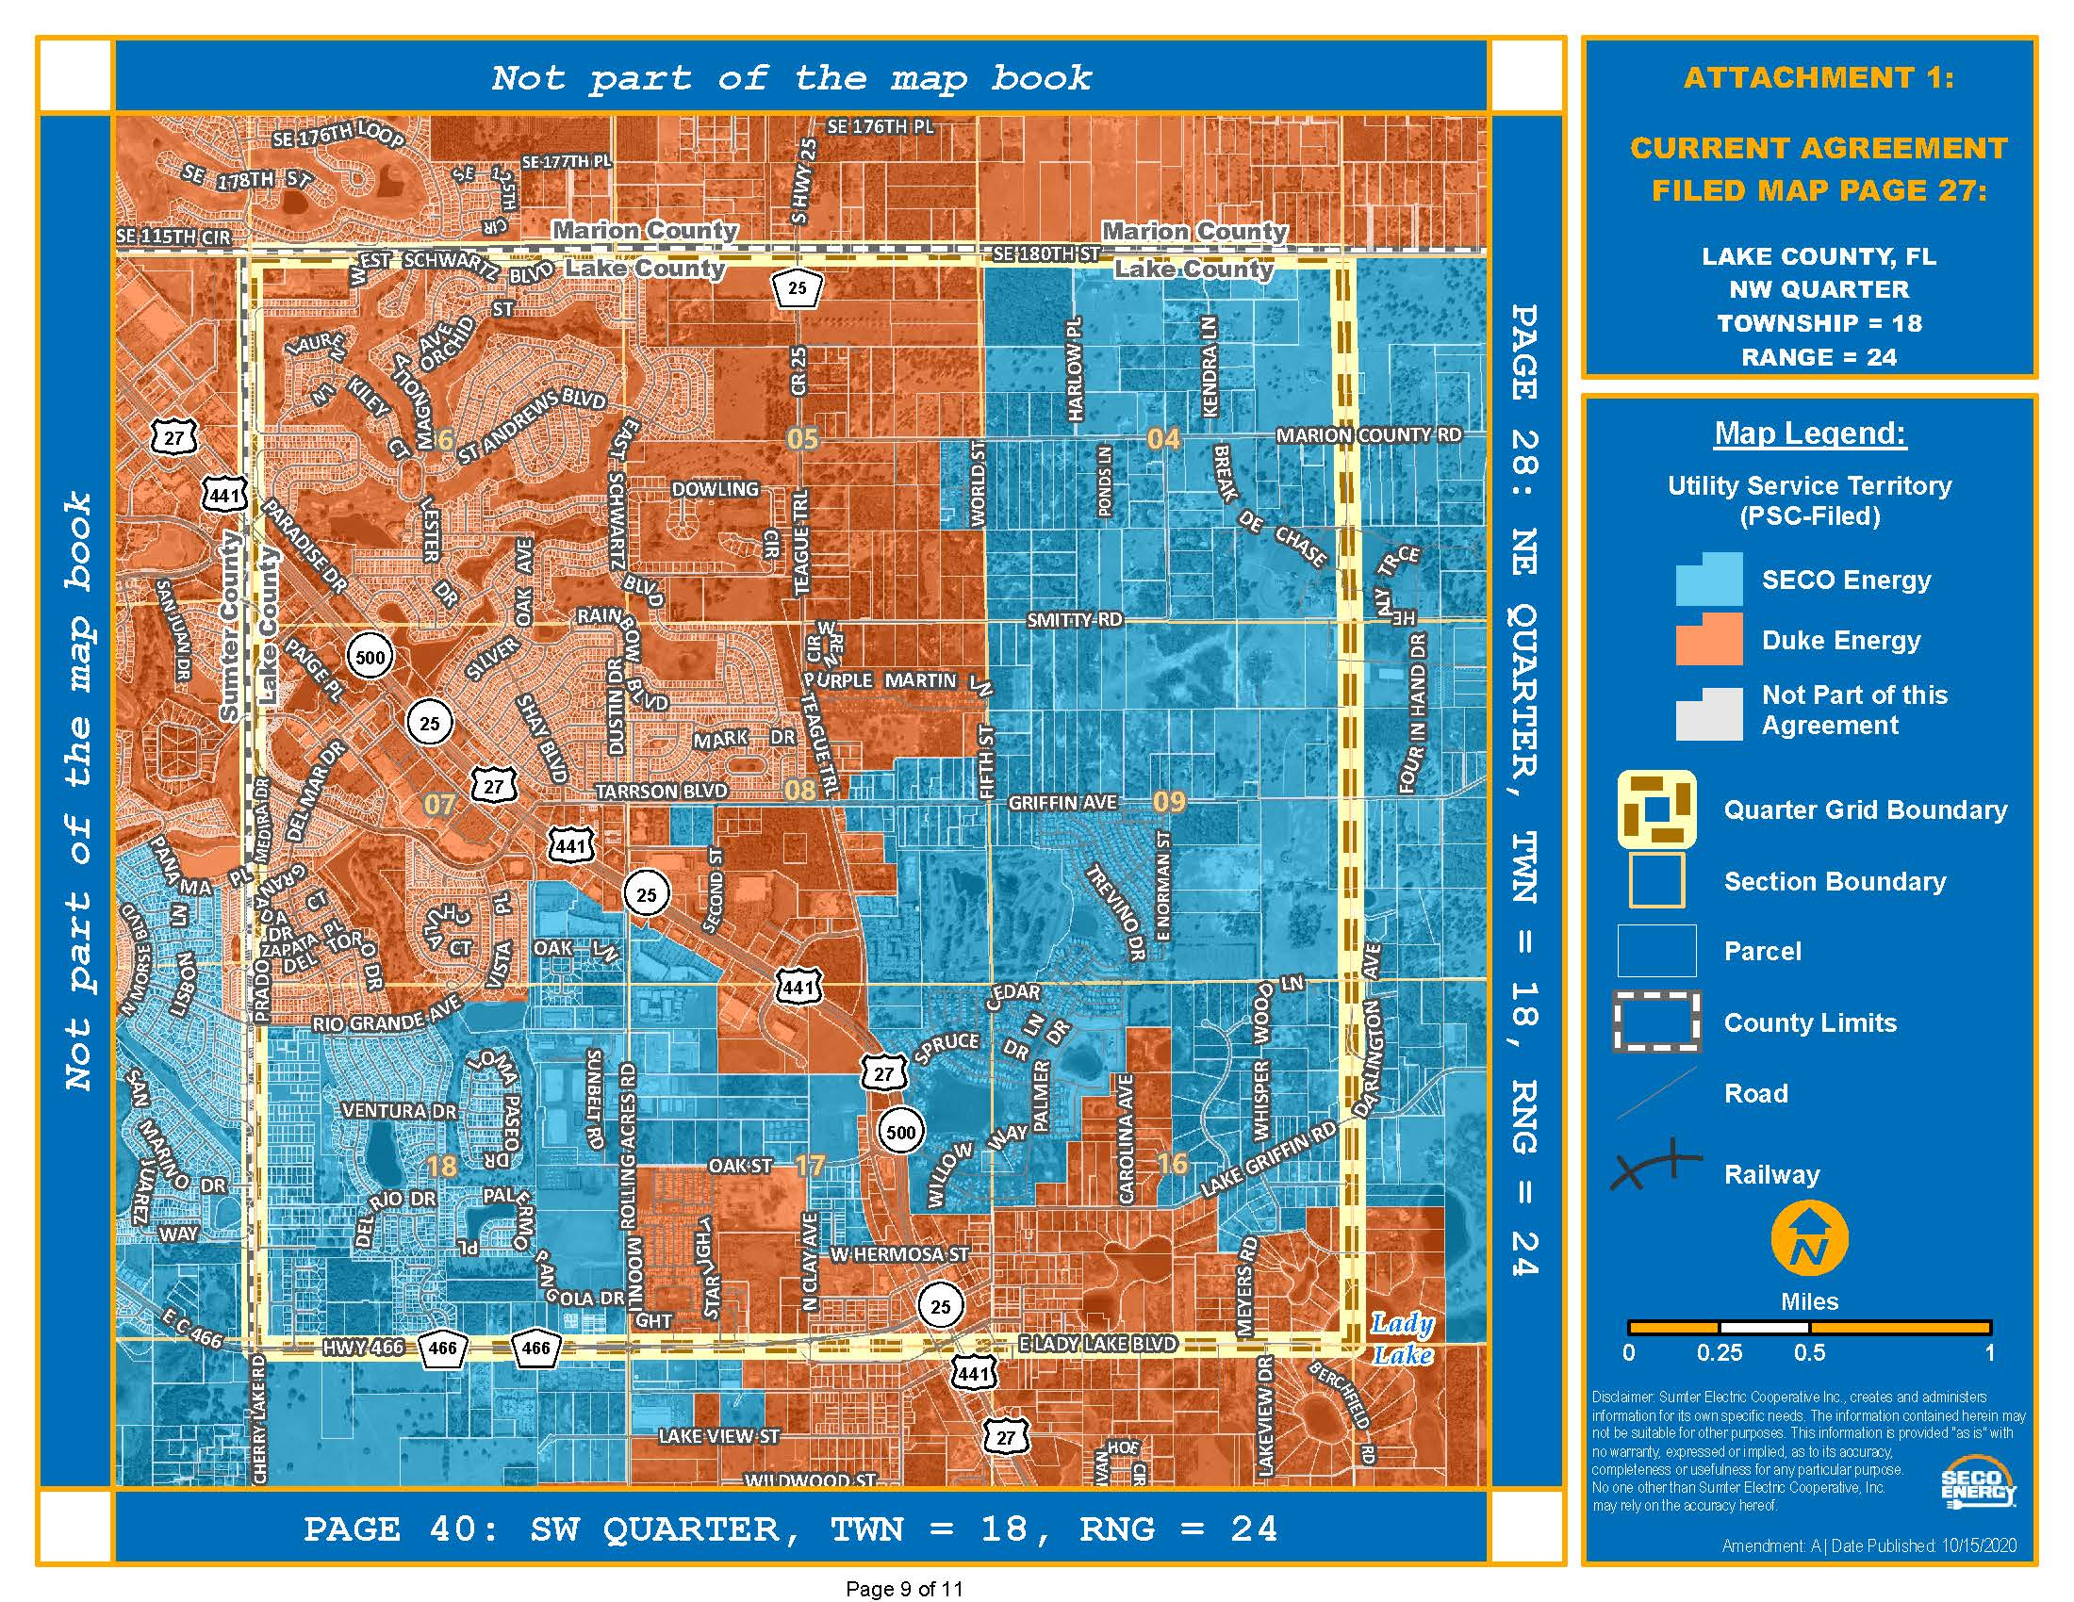

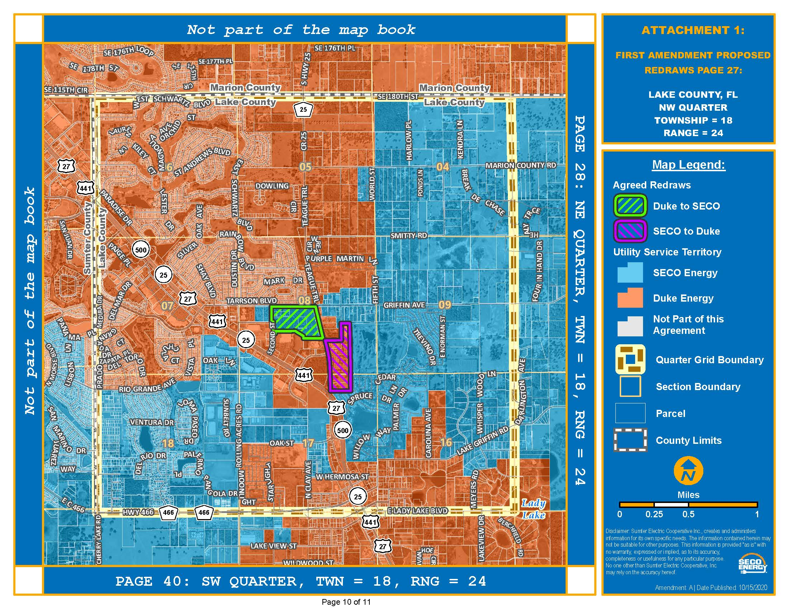

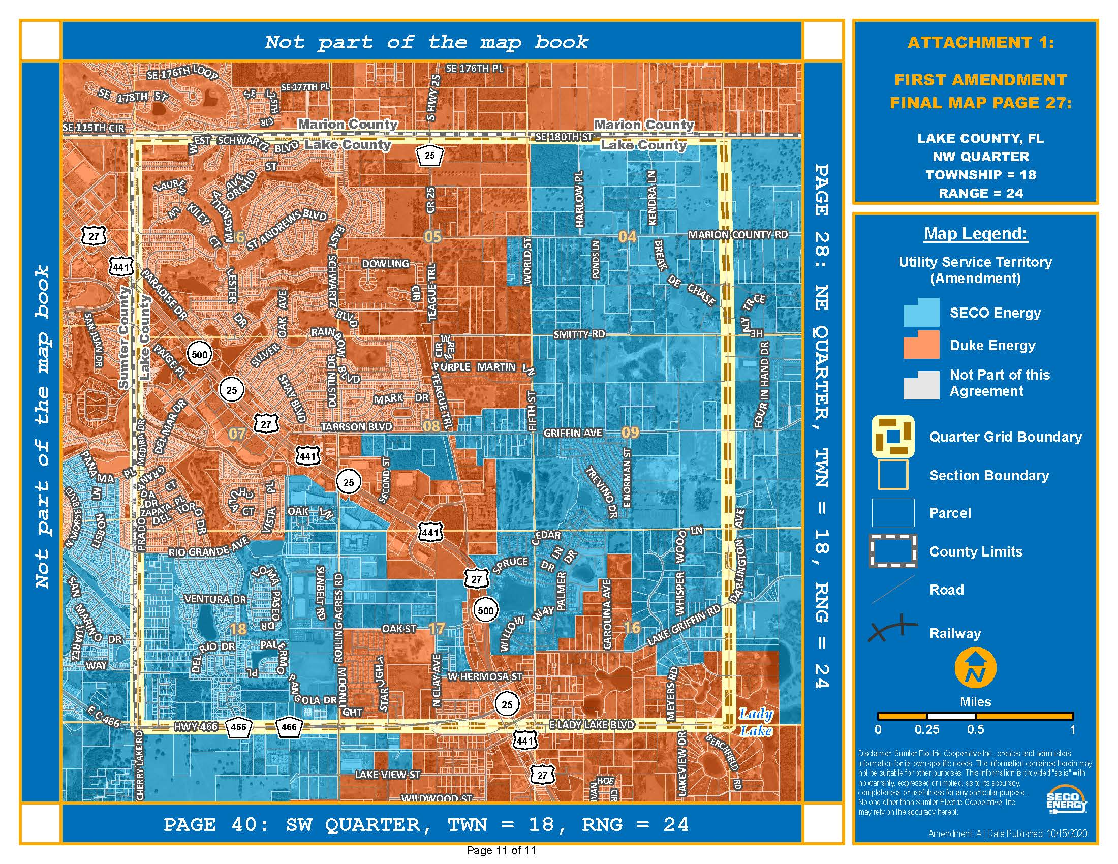

Order No. PSC-2020-0252-PAA-EU, issued July 23, 2020, in Docket No. 20200106-EU, In re: Joint petition to approve territorial agreement in Sumter, Lake, Marion, Levy, and Citrus Counties, by Sumter Electric Cooperative, Inc. and Duke Energy Florida, LLC.
Utilities Commission of the City of New Smyrna Beach v. Florida Public Service Commission, 469 So. 2d 731 (Fla. 1985).

