State of Florida |  | Public Service Commission  Capital Circle Office Center ● 2540 Shumard Oak Boulevard  Tallahassee, Florida 32399-0850  -M-E-M-O-R-A-N-D-U-M-
DATE: | April 22, 2021
TO: | Office of Commission Clerk (Teitzman)
FROM: | Division of Accounting and Finance (M. Andrews, Mouring)  Division of Economics (Coston, Forrest)  Division of Engineering (P. Buys, Ramos)  Office of the General Counsel (Stiller, J. Crawford, Osborn)
RE: | Docket No. 20200039-GU – Petition for approval to implement a temporary storm cost recovery surcharge, by St. Joe Natural Gas Company.
AGENDA: | 05/04/21 – Regular Agenda – Parties May Participate
COMMISSIONERS ASSIGNED: |  |  | All Commissioners
PREHEARING OFFICER: |  |  | Graham
CRITICAL DATES: |  |  | None
SPECIAL INSTRUCTIONS: |  |  | None

Case Background
On January 24, 2020, St. Joe Natural Gas Company (SJNG or Company) filed a petition to recover $381,512 in incremental storm restoration costs associated with Hurricane Michael. In the petition, the Company stated that it had incurred incremental costs of $312,012 and projected $60,500 in remaining costs to restore its gas system to pre-storm condition. By Order No. PSC-2020-0066-PCO-GU, issued March 2, 2020, the Office of Public Counsel’s (OPC) intervention was acknowledged. On March 20, 2020, the Commission issued an order allowing SJNG to implement an interim storm recovery surcharge beginning May 1, 2020. On February 19, 2021, SJNG filed a request to approve final costs based on an actual amount of $402,720 in incremental storm restoration costs.
On March 25, 2021, SJNG and OPC (the Parties) filed a Joint Petition for Approval of Stipulation and Settlement (Settlement Agreement). The Settlement Agreement is attached as Attachment A. The Settlement Agreement includes adjustments to the recoverable storm amount, an adjustment to base rates after the storm surcharge terminates, and storm restoration cost process improvements to facilitate cost effective and timely storm damage recovery and service restoration.
The Settlement Agreement allows SJNG to recover $330,115 in storm costs through its current storm charge levels established by Order No. PSC-2020-0117-PCO-GU. The storm surcharge will be extended through December 2024 at which time the surcharge will cease. Any under or over-recovery will be handled through the Natural Gas Conservation Cost Recovery Clause.
The Parties agree that it is appropriate for SJNG to record $77,761 associated with the remaining life value of lost capital assets in a regulatory asset and recover said amount over a period of 10 years through an increase to the Company’s base rates. The increase will be implemented after the storm surcharge terminates.
The Commission should vote on whether or not to grant the Joint Motion for Approval of Stipulation and Settlement which is attached as Attachment A.
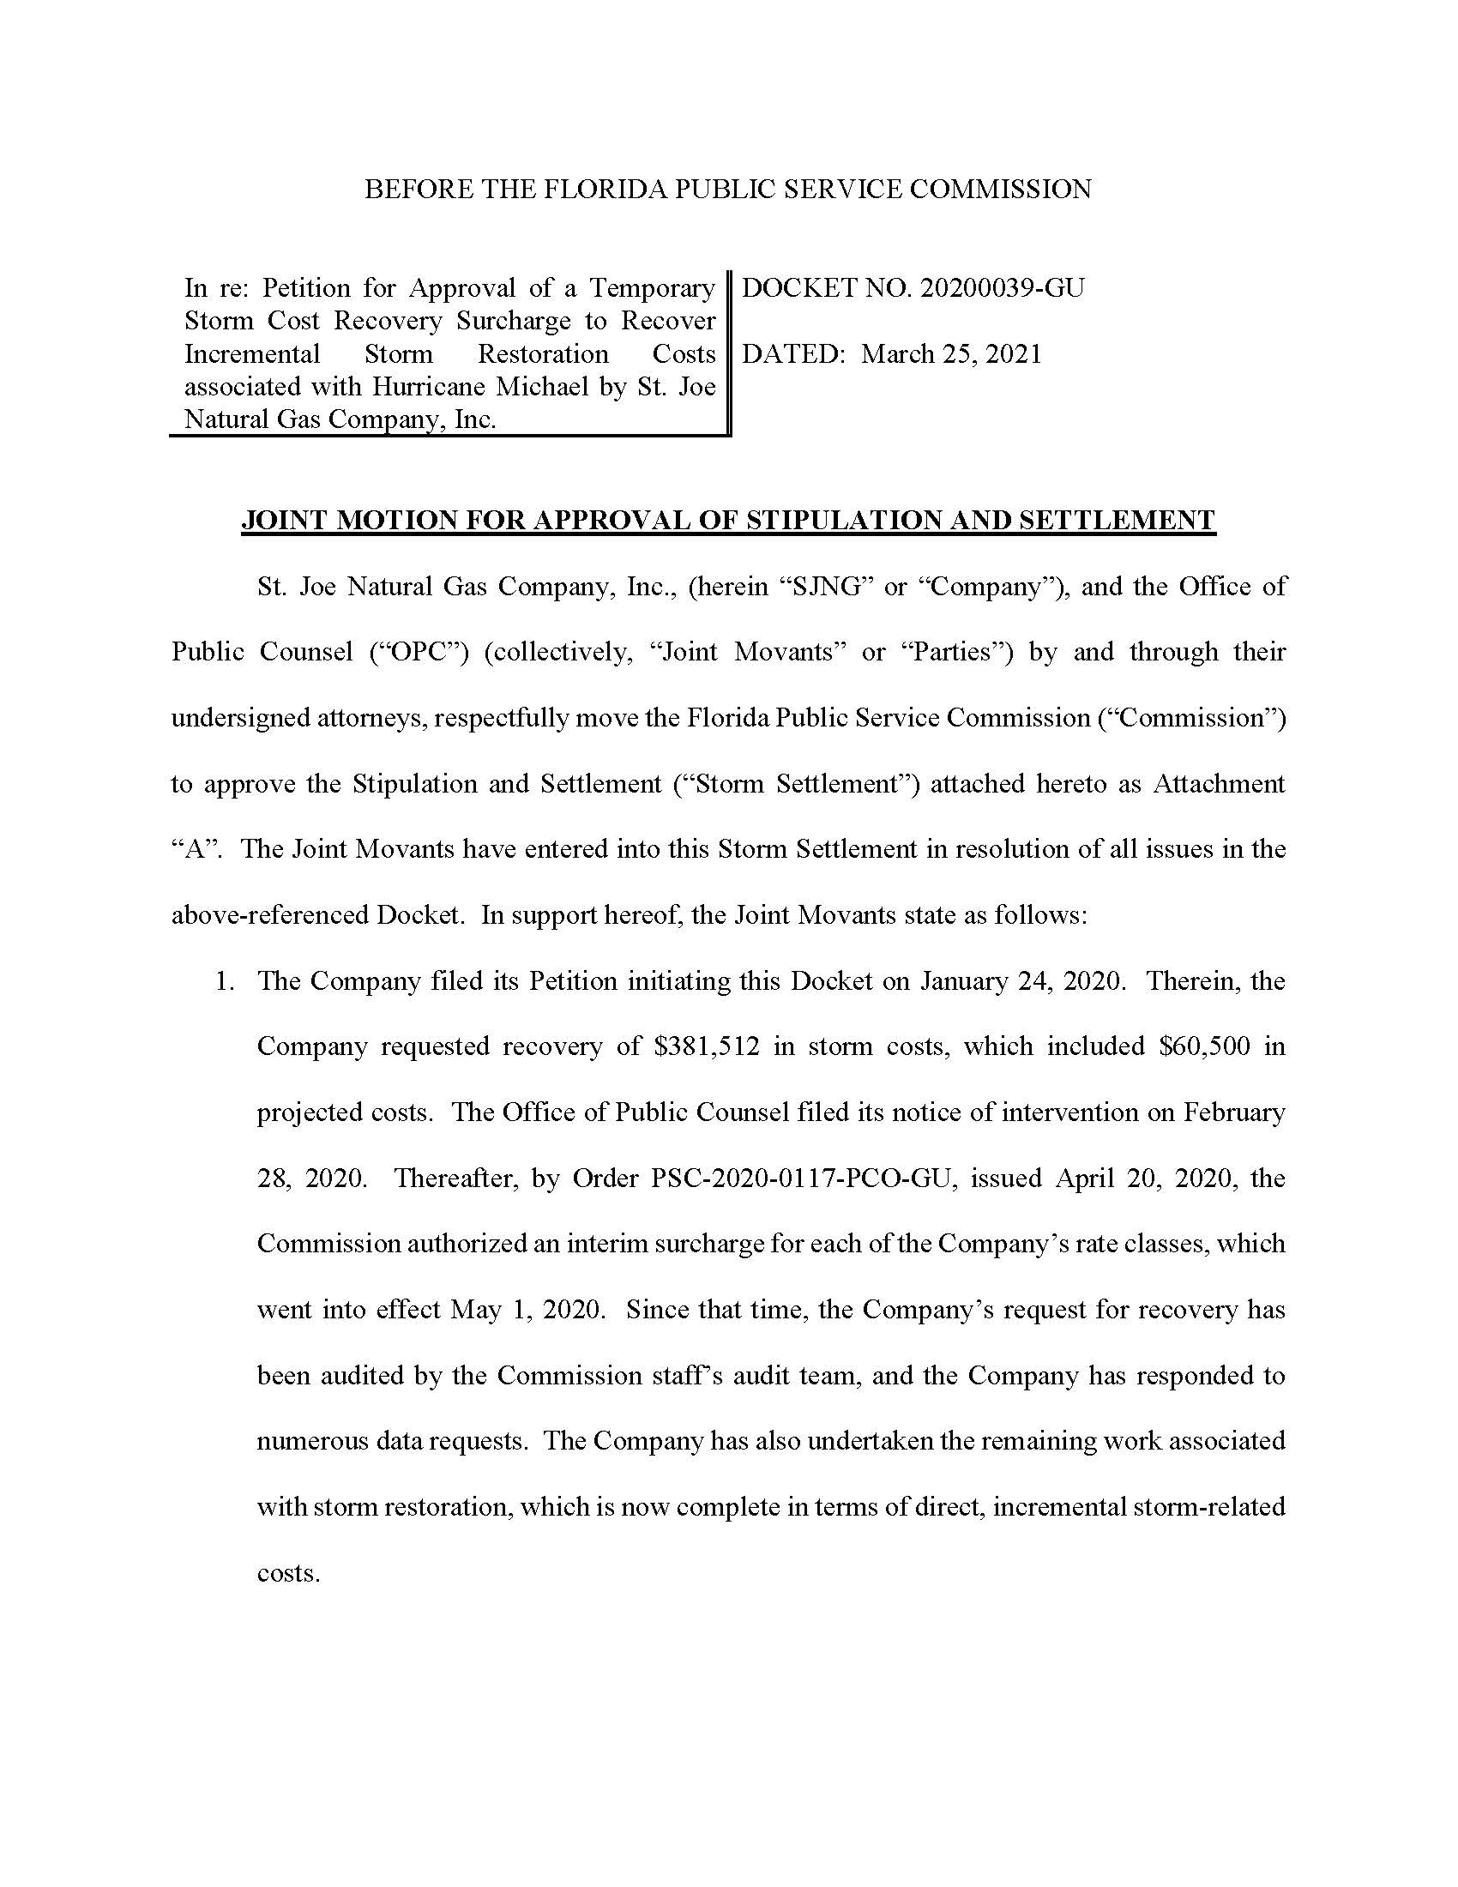

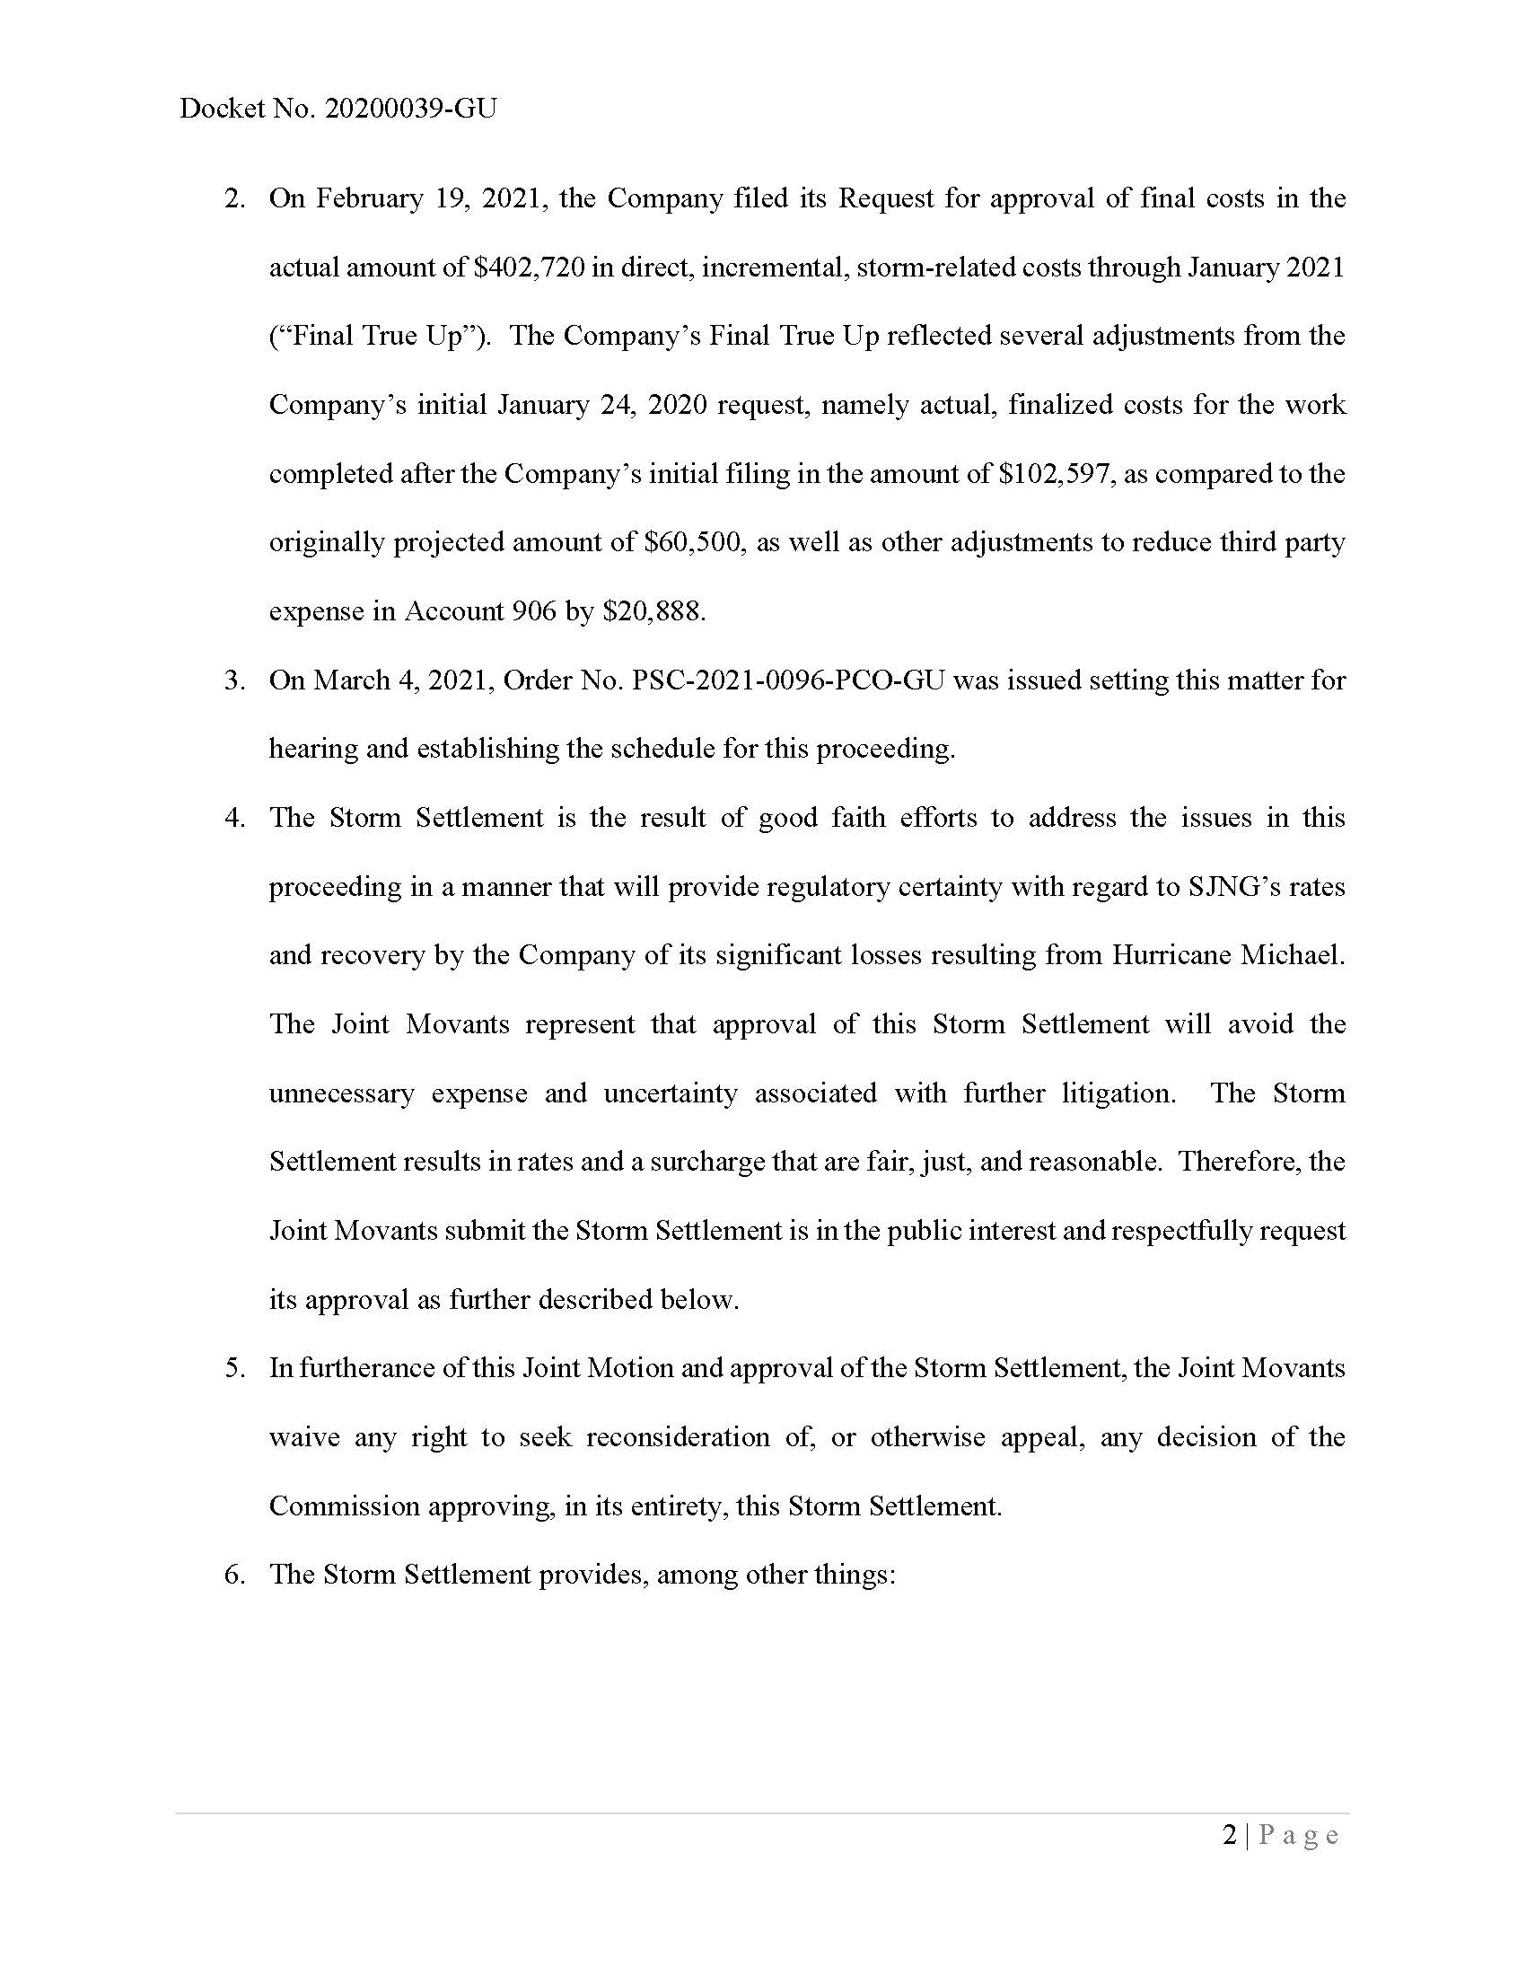

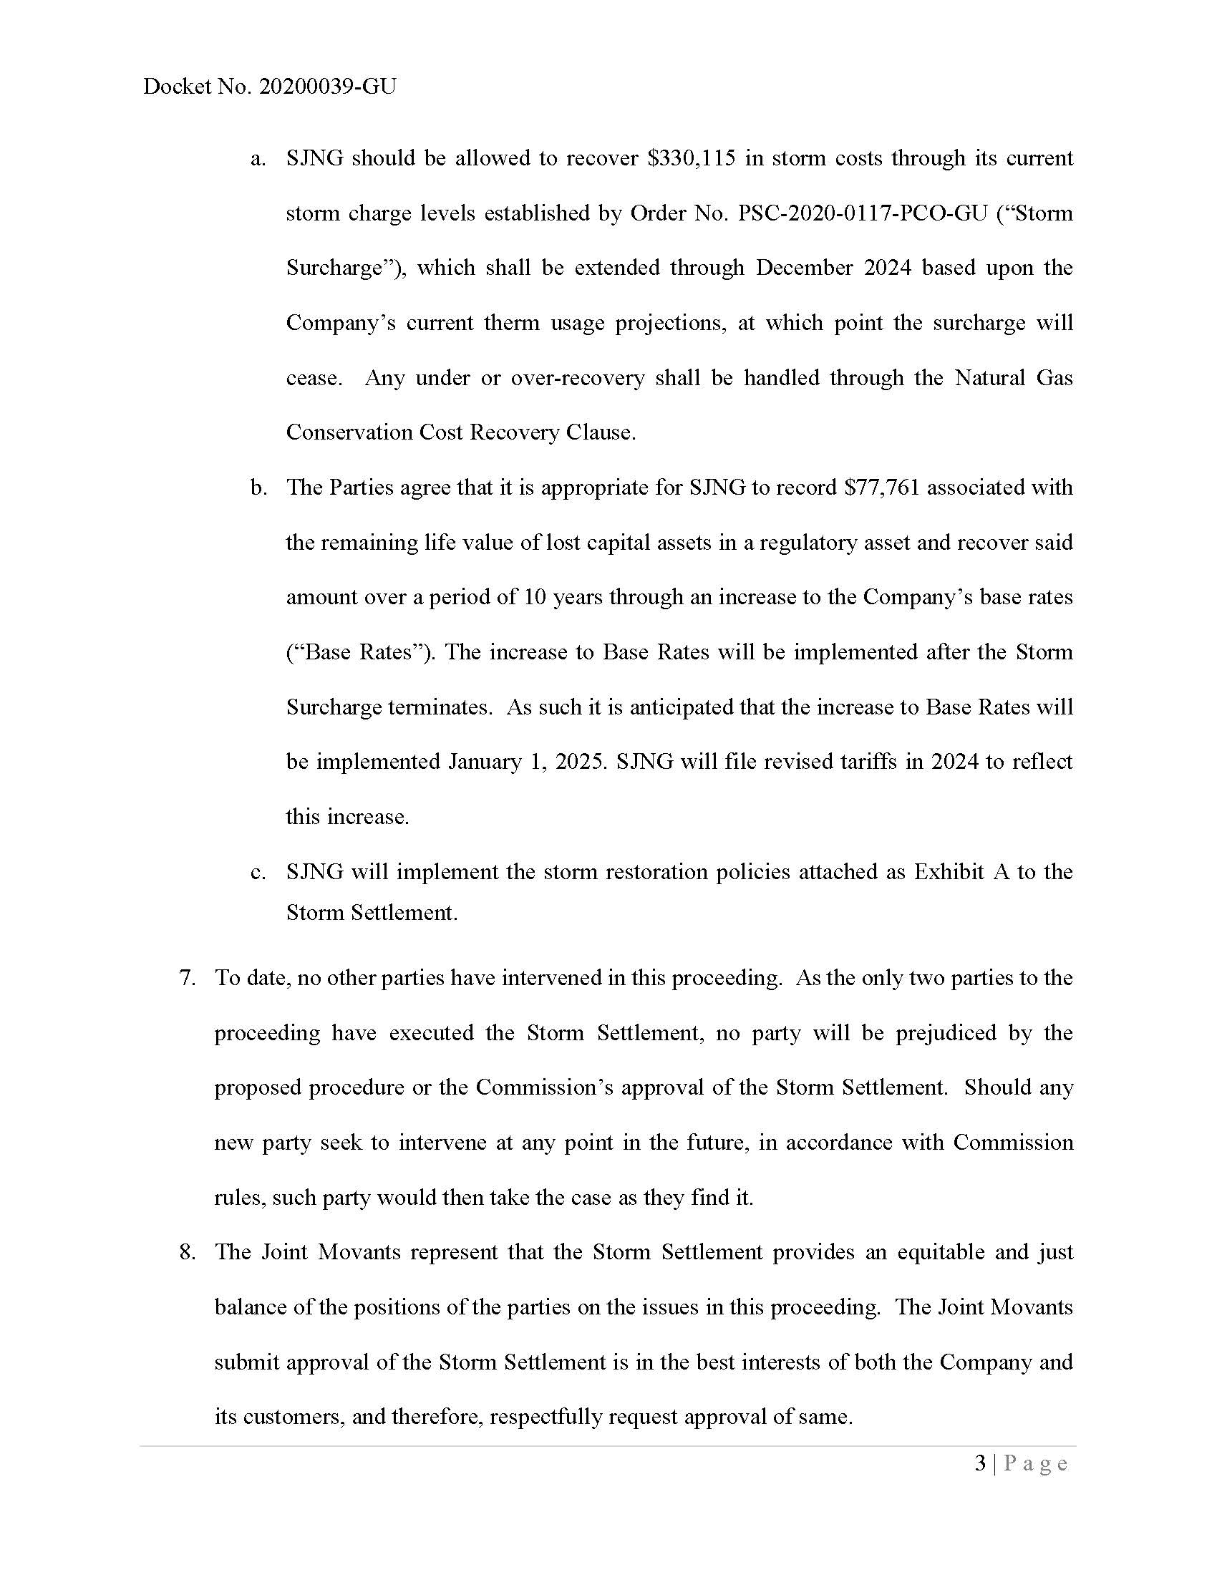

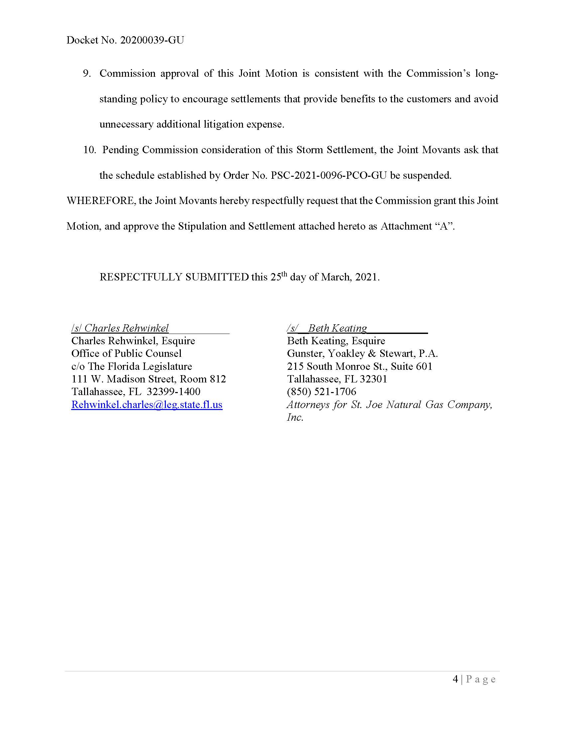

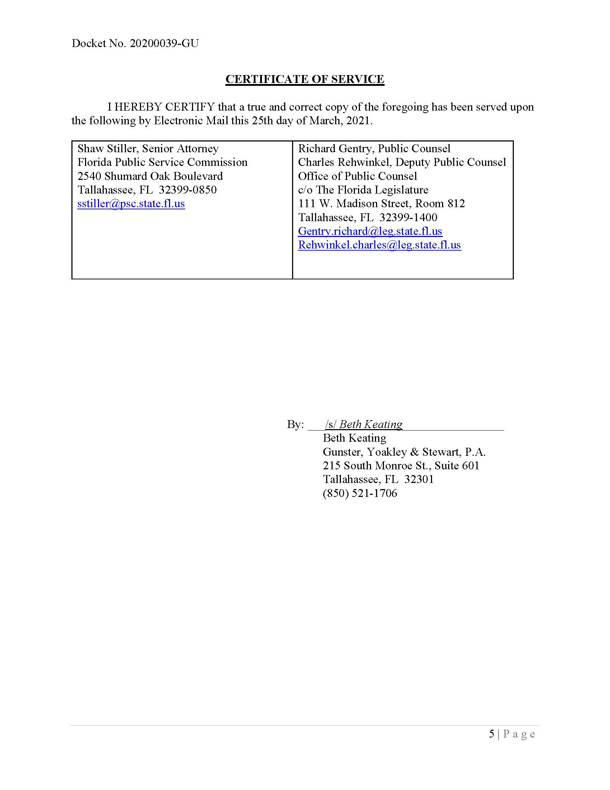

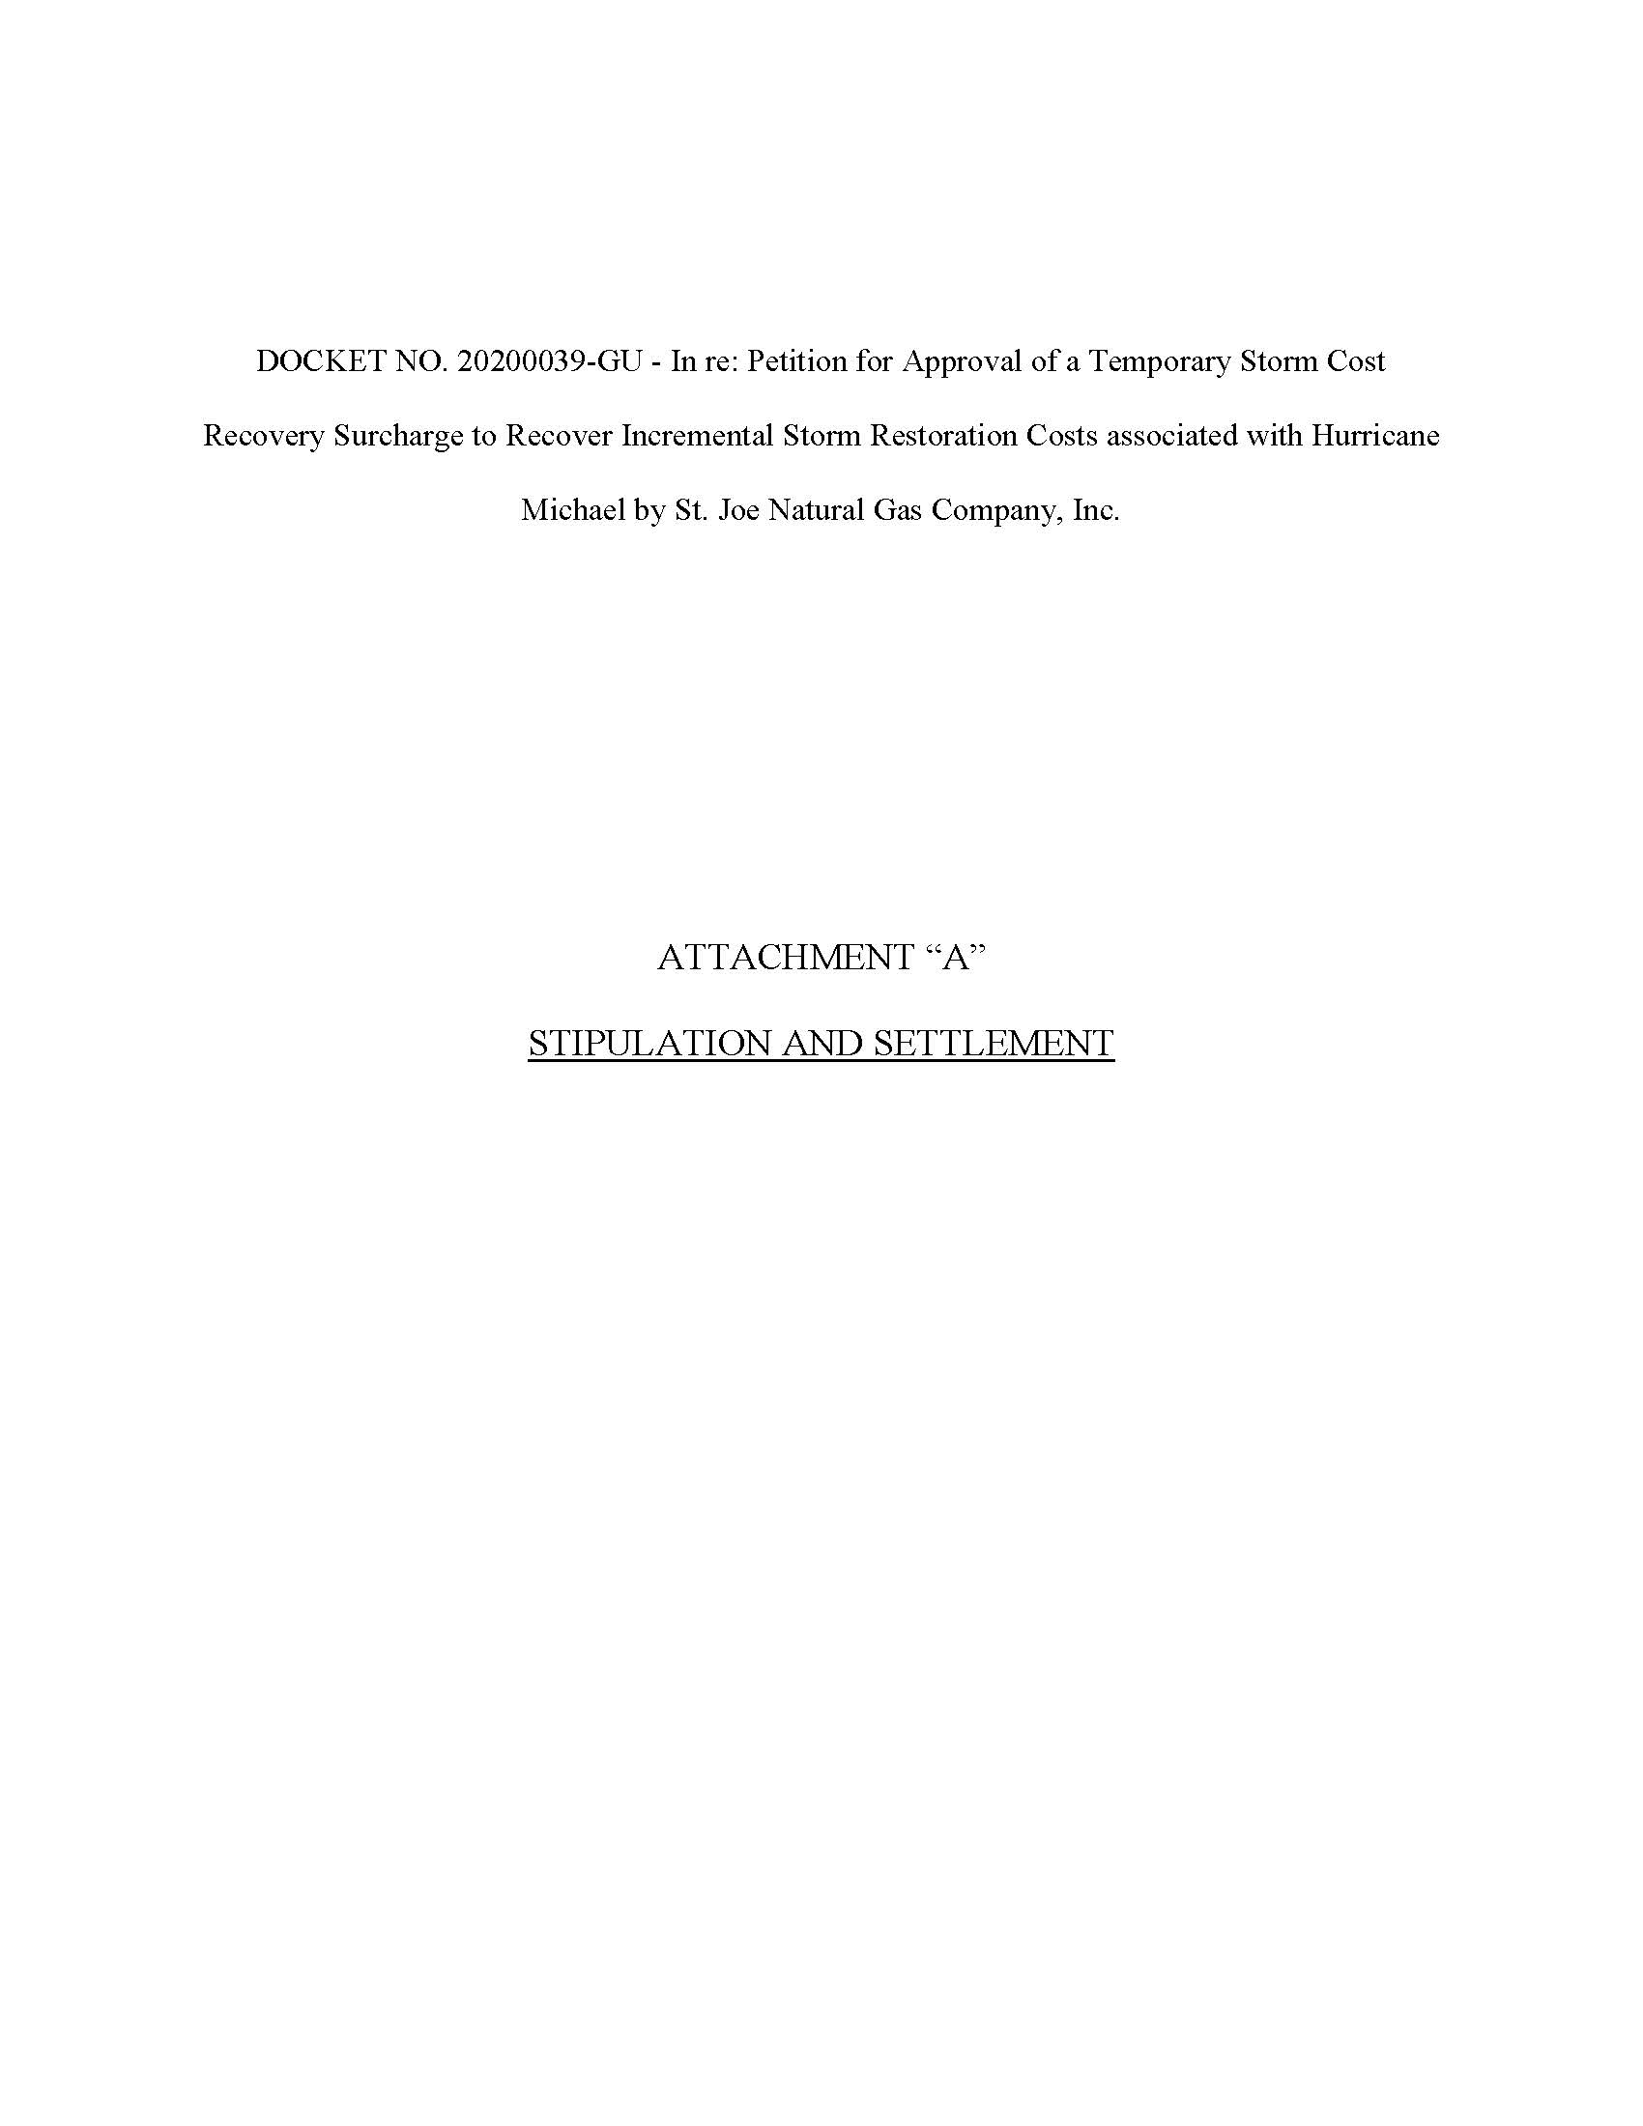

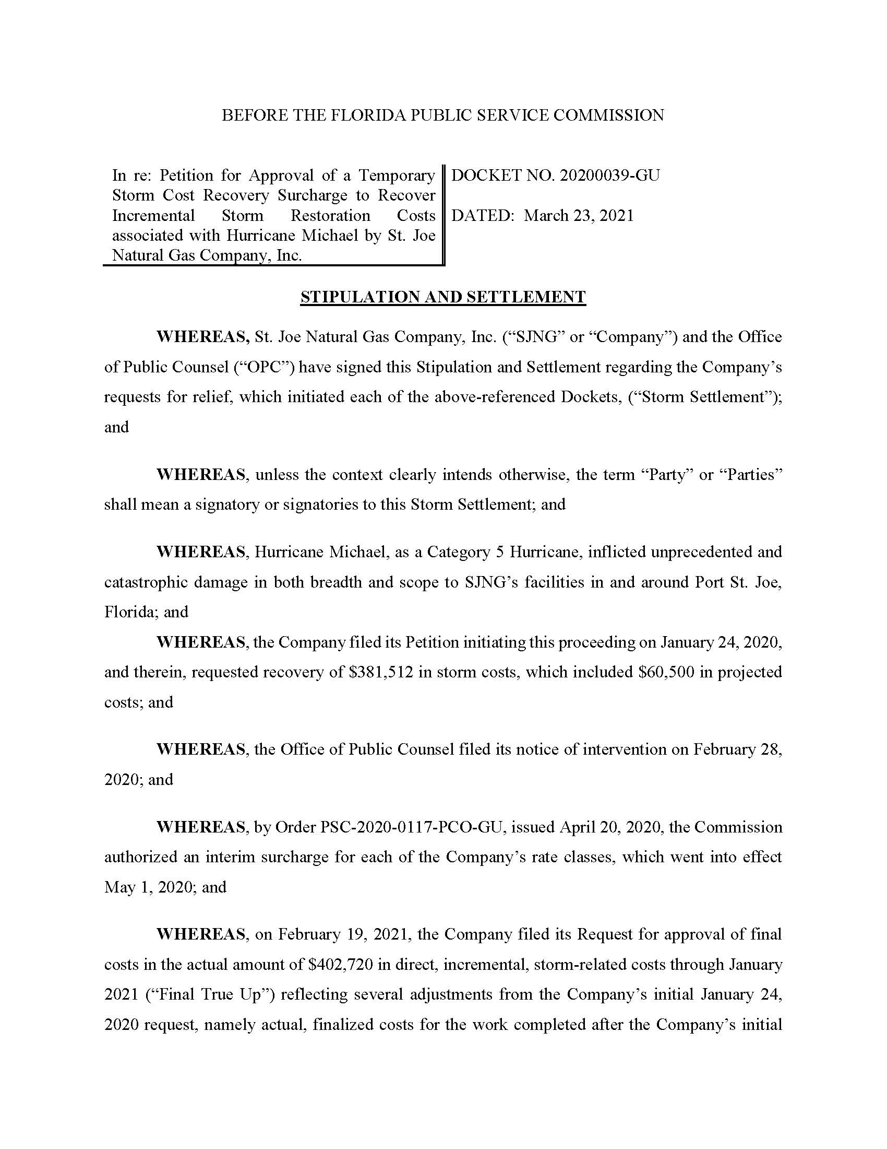

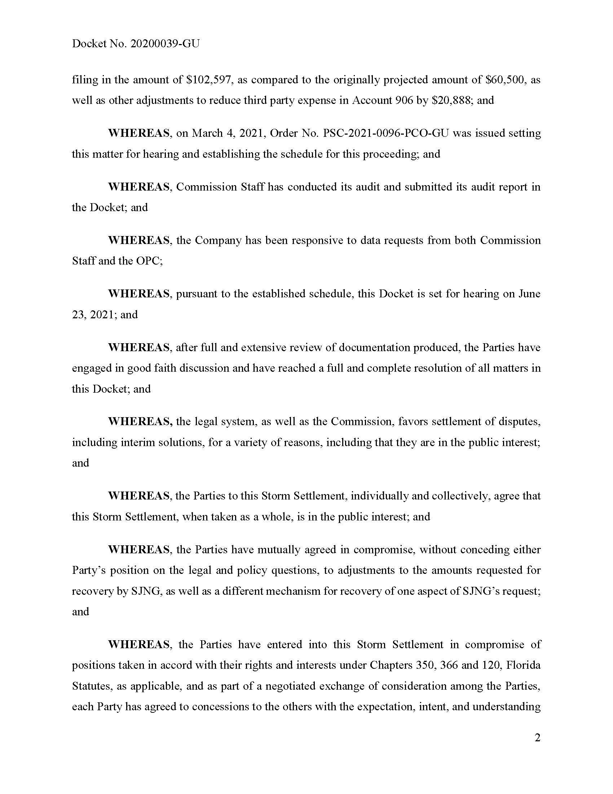

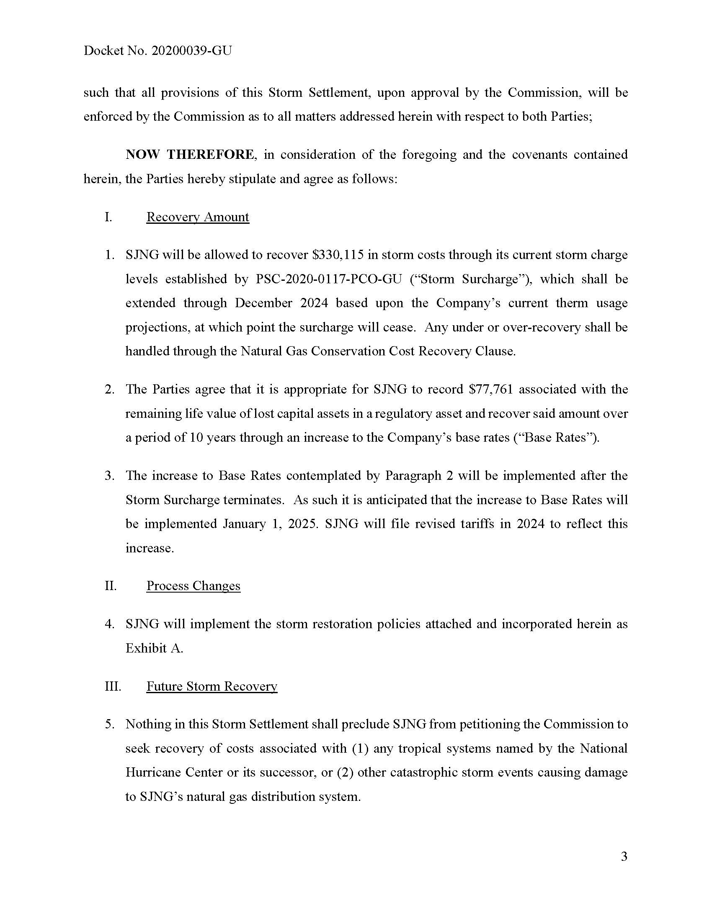

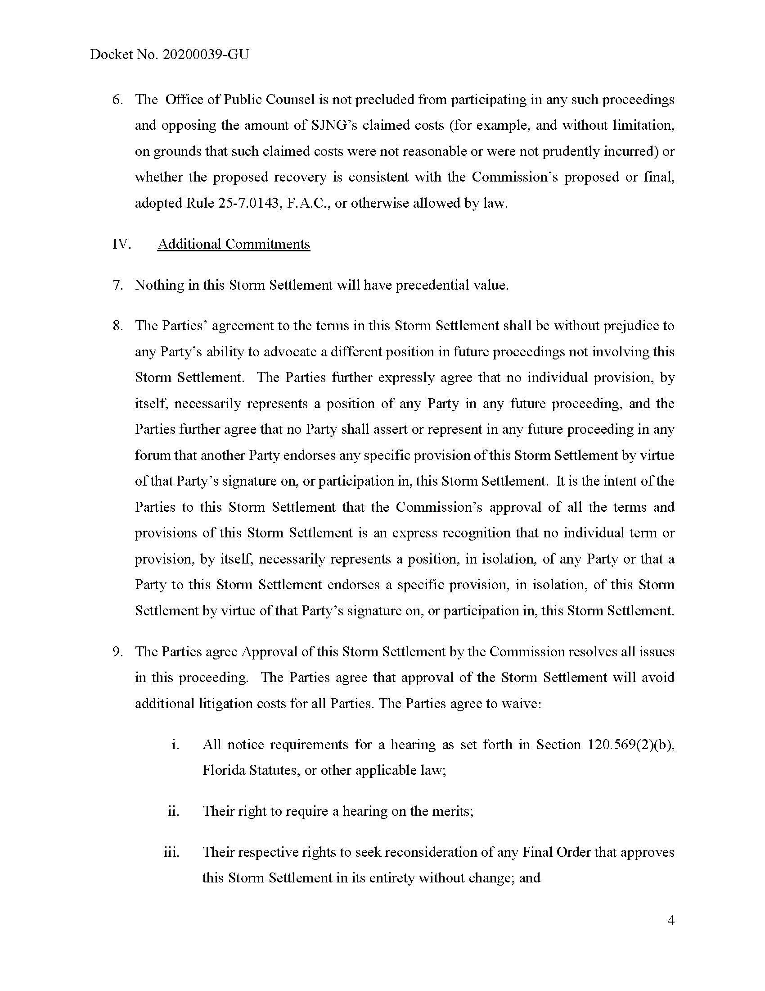

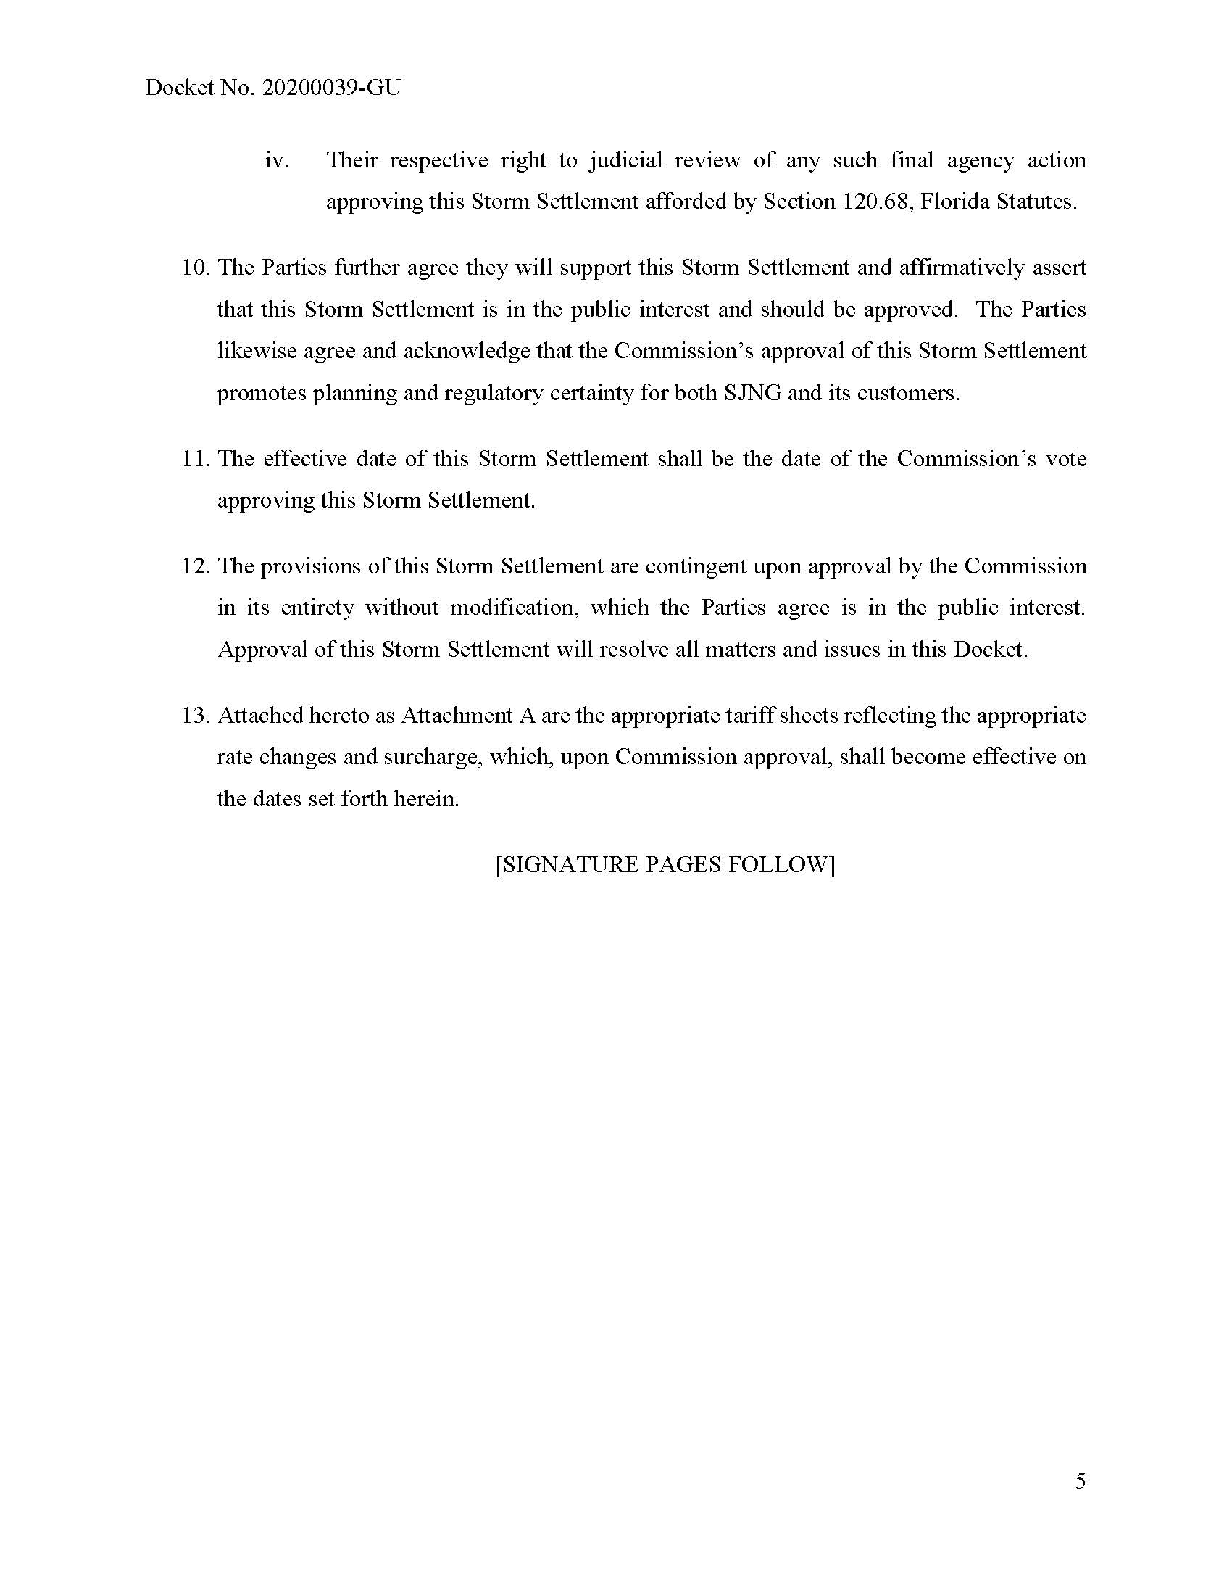

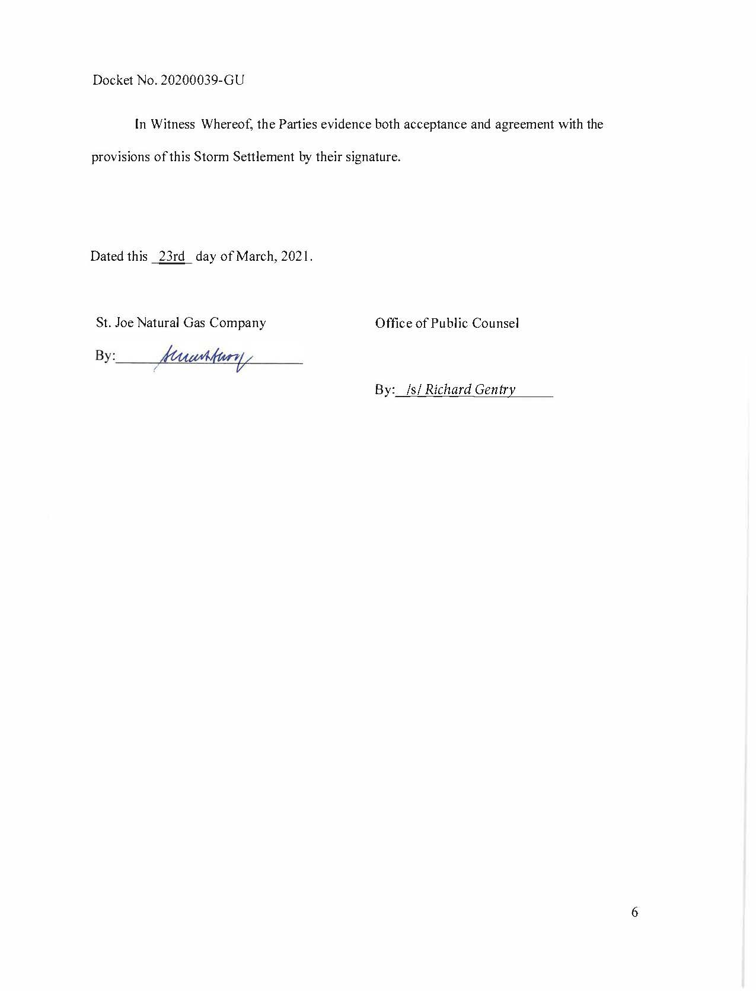

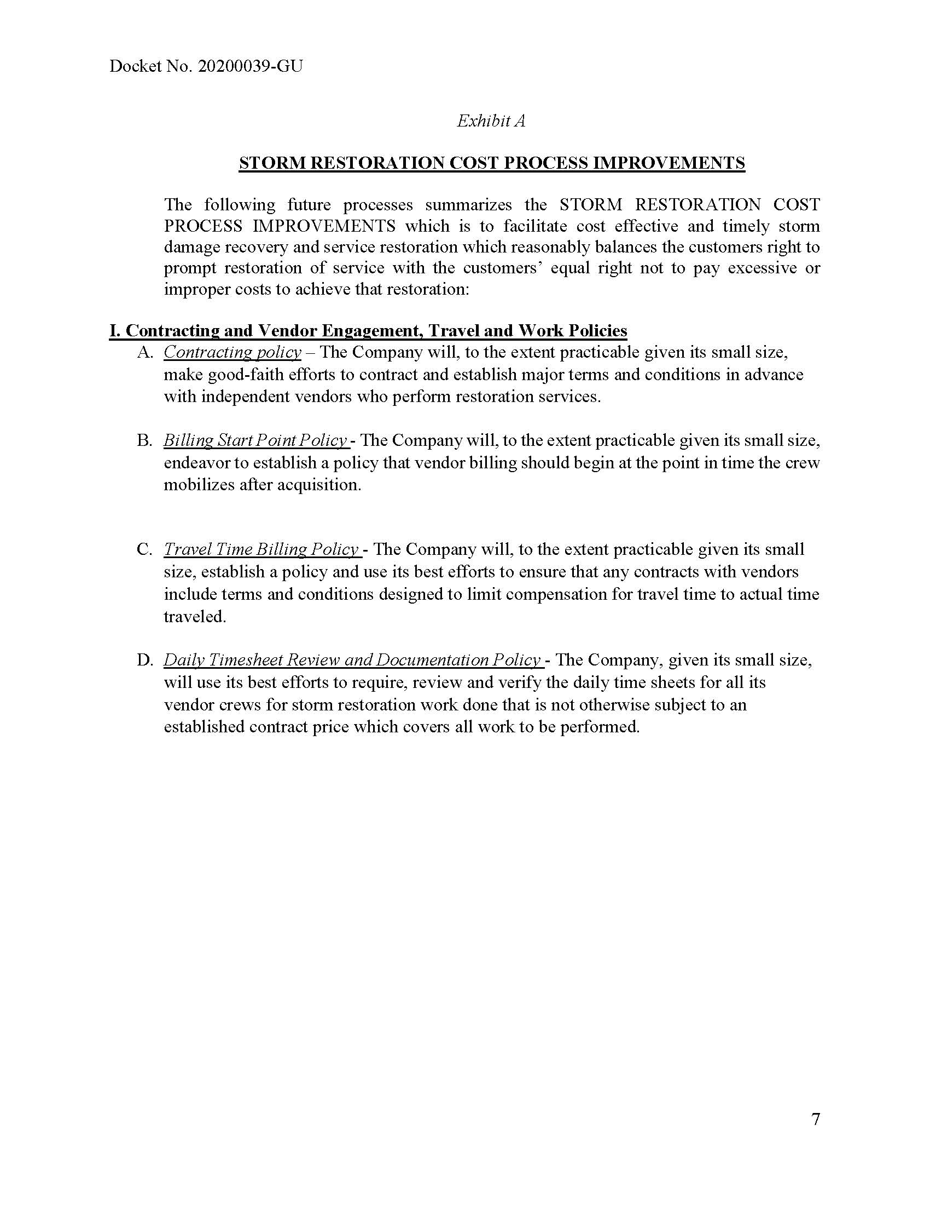

Order No. PSC-2020-0117-PCO-GU, issued April 20, 2020, in Docket No. 20200039-GU, Petition for approval to implement a temporary storm cost recovery surcharge, by St. Joe Natural Gas Company.

