State of Florida |  | Public Service Commission  Capital Circle Office Center ● 2540 Shumard Oak Boulevard  Tallahassee, Florida 32399-0850  -M-E-M-O-R-A-N-D-U-M-
DATE: | February 18, 2021 June 3, 2021
TO: | Office of Commission Clerk (Teitzman)
FROM: | Office of Industry Development and Market Analysis (Deas, Fogleman, Wendel)  Office of the General Counsel (Murphy)
RE: | Docket No. 20210013-TX – Application for designation as an eligible telecommunications carrier to receive rural digital opportunity fund auction (Auction 904) support for voice and broadband services and request for expedited consideration, by Bright House Networks Information Services (Florida), LLC.
AGENDA: | 03/02/21 06/15/21– Regular Agenda – Interested Persons May Participate
COMMISSIONERS ASSIGNED: |  |  | All Commissioners
PREHEARING OFFICER: |  |  | Graham
CRITICAL DATES: |  |  | June 7, 2021 for qualification for RDOF auction  disbursement. None
SPECIAL INSTRUCTIONS: |  |  | None

Case Background
On January 6, 2021, Bright House Networks Information Services (Florida), LLC (Bright House or Company) filed a petition with the Florida Public Service Commission (Commission) seeking designation as an eligible telecommunications carrier (ETC) to receive rural digital opportunity fund (RDOF) support. Bright House was granted competitive local exchange carrier certificate No. 8015 in 2002 under the name “Time Warner Cable Information Services (Florida) LLC.” Bright House is a majority-owned and wholly-controlled subsidiary of Charter Communications, Inc. (Charter). Charter provides customers with voice over internet protocol (VoIP) and broadband services under the brand name “Spectrum.” Bright House and its affiliates “offer a variety of services, some of which are regulated telecommunications services and some of which are not.” On December 7, 2020, Charter’s subsidiary CCO Holdings was selected as one of the winning bidders for the Federal Communications Commission’s (FCC) RDOF auction. Consistent with FCC rules, CCO Holdings assigned its winning bid to Bright House, its affiliate operating in Florida.

The RDOF is a form of high-cost support and is funded through the federal universal service fund (USF). The FCC’s RDOF initiative allocates up to $20.4 billion through a two-phase competitive auction to help connect millions of unserved rural homes and small businesses to high-speed broadband. Phase I of the auction will provide up to $16 billion to be used over a period of 10 years to service providers that commit to offer voice and broadband services to fixed locations in eligible unserved high-cost census blocks. In Florida, a total of eleven 11 bidders were selected to receive approximately $192 million of high-cost support in phase I. Bright House will receive $22.5 million in phase I to be used in specified census blocks in Florida.

An ETC designation is a requirement for telecommunications carriers to receive USF dollars for the Lifeline and High-Cost programs. The Lifeline program enables low-income households to obtain and maintain basic telephone and broadband services, and offers qualifying households a discount on monthly bills. The High-Cost program helps carriers provide voice and broadband service in remote and underserved communities. Although the FCC did not require RDOF auction participants to be designated as an ETC to apply, the FCC did require winning bidders to obtain ETC designation within 180 days of being selected.
47 U.S.C. 214(e)(2) authorizes state commissions to designate common carriers as follows:
(2) Designation of eligible telecommunications carriers
A State commission shall upon its own motion or upon request designate a common carrier that meets the requirements of paragraph (1) as an eligible telecommunications carrier for a service area designated by the State commission. Upon request and consistent with the public interest, convenience, and necessity, the State commission may, in the case of an area served by a rural telephone company, and shall, in the case of all other areas, designate more than one common carrier as an eligible telecommunications carrier for a service area designated by the State commission, so long as each additional requesting carrier meets the requirements of paragraph (1). Before designating an additional eligible telecommunications carrier for an area served by a rural telephone company, the State commission shall find that the designation is in the public interest.
47 U.S.C. 214(e)(6) provides that the FCC will make such ETC designations in cases where a state commission lacks jurisdiction over the common carrier as follows:
(6) Common carriers not subject to State commission jurisdiction
In the case of a common carrier providing telephone exchange service and exchange access that is not subject to the jurisdiction of a State commission, the Commission shall upon request designate such a common carrier that meets the requirements of paragraph (1) as an eligible telecommunications carrier for a service area designated by the Commission consistent with applicable Federal and State law. Upon request and consistent with the public interest, convenience and necessity, the Commission may, with respect to an area served by a rural telephone company, and shall, in the case of all other areas, designate more than one common carrier as an eligible telecommunications carrier for a service area designated under this paragraph, so long as each additional requesting carrier meets the requirements of paragraph (1). Before designating an additional eligible telecommunications carrier for an area served by a rural telephone company, the Commission shall find that the designation is in the public interest.
Bright House asserts that it meets all applicable federal requirements for designation as an ETC in Florida pursuant to 47 U.S.C. 214(e) and 47 C.F.R. 54.201. On February 9, 2021, Bright House filed Supplemental Authority in Support (Supplemental Filing) of its ETC application in which the Company clarified that, although its corporate affiliates offer a retail VoIP service that is not a telecommunications service, the Company offers switched access service and local interconnection service that are telecommunications services. The Company further clarified that these services are offered to the public for hire in Florida by the use of mixed-use facilities that also include telecommunications related equipment and facilities.

Bright House acknowledges and asserts that, if approved, it will comply with Sections 364.10 and 364.105, Florida Statutes (F.S.), and Rule 25-4.0665, Florida Administrative Code (F.A.C.), which govern Lifeline service and provide for a transitional discount for those customers no longer eligible for Lifeline.
In addition to the federal rules and statutes discussion above, the Commission has jurisdiction in this matter pursuant to Section 364.10 F.S.

Discussion of Issues

Issue 1:
Should the Commission grant Bright House Networks Information Services (Florida), LLC ETC status in Florida to Receive Rural Digital Opportunity Fund Auction (Auction 904) Support for Voice and Broadband Services?

Recommendation:
Yes. Bright House Networks Information Services (Florida), LLC is a telecommunications company certificated to provide service in Florida and meets all of the requirements for designation as an ETC under Section 364.10, F.S., and applicable federal law. The Company has acknowledged the requirement to comply with Sections 364.10 and 364.105, F.S., and Rule 25-4.0665, F.A.C., which govern Lifeline service and provide for a transitional discount for those customers no longer eligible for Lifeline. (Murphy, Deas, Fogleman, Wendel)

Staff Analysis:
Pursuant to 47 U.S.C. 214(e)(2), and 47 C.F.R. 54.201(b), state commissions have the primary responsibility to designate carriers as ETCs. In instances where a state lacks jurisdiction, the FCC is to make such a designation. Section 364.10(1)(a), F.S., defines an ETC as “a telecommunications company, as defined by s. 364.02, which is designated as an eligible telecommunications carrier by the commission pursuant to 47 C.F.R. s. 54.201.” A “telecommunications company” is an entity offering “two-way telecommunications service to the public for hire within [Florida] by the use of a telecommunications facility.” Section 364.02(13), F.S. Thus, whether a carrier is offering a telecommunications service is the threshold question for whether the Commission is authorized to grant an ETC designation. Staff recommends that, as clarified in its Supplemental Filing, Bright House is a telecommunications company for purposes of receiving an ETC designation in accordance with Section 364.10, F.S., and is certificated as a competitive local exchange carrier. Although the Commission does not have jurisdiction over VoIP providers and “Spectrum Voice” service is an “information service” and not a “telecommunications service,” because Bright House provides telecommunications services in Florida in addition to nonregulated services, the regulatory status of VoIP service is not relevant to the Commission’s decision in this docket.

To qualify as an ETC, telecommunications carriers must provide the services identified in 47 C.F.R. 54.101 as follows:

(a) Services designated for support. Voice telephony services shall be supported by federal universal service support mechanisms. Eligible voice telephony services must provide voice grade access to the public switched network or its functional equivalent; minutes of use for local service provided at no additional charge to end users; access to emergency services provided by local government or other public safety organizations, such as 911 and enhanced 911, to the extent the local government in an eligible carrier's service area has implemented 911 or enhanced 911 systems; and toll limitation services to qualifying low-income consumers as provided in subpart E of this part.

(b) An eligible telecommunications carrier must offer voice telephony service as set forth in paragraph (a) of this section in order to receive federal universal service support.

(c) An eligible telecommunications carrier (ETC) subject to a high-cost public interest obligation to offer broadband internet access services and not receiving Phase I frozen high-cost support must offer broadband services within the areas where it receives high-cost support consistent with the obligations set forth in this subpart and subparts D, K, L, and M of this part.

(d) Any ETC must comply with subpart E of this part.

In addition, ETCs must advertise the availability of such services and the associated charges using media of general distribution.

Staff has reviewed Bright House’s petition for ETC designation in Florida, as well as additional documents filed with the Commission. Staff has confirmed that Bright House meets the above requirements to qualify as an ETC in Florida. In addition, the Company has demonstrated sufficient financial, managerial, and technical capabilities.

Furthermore, staff notes that the FCC awarded CCO Holdings, an affiliate of Bright House, as the winning RDOF bidder in the census blocks for which Bright House is seeking ETC designation. Each Carrier was required, as part of its bid, to acknowledge that it would meet the FCC’s requirements for building out its network and meet the FCC’s minimum broadband service obligations.

47 U.S.C. 214(e)(2) requires state commissions to determine if an ETC designation is consistent with the public interest, convenience, and necessity for rural areas. Bright House asserts granting its ETC designation will create- significant public and private investment in Florida. Additionally, it will provide more access to high-speed broadband internet service in unserved communities. Based on staff’s review, along with Bright House commitment to abide by both state and federal requirements, staff recommends that designating Bright House as an ETC meets this requirement.

In conclusion, Bright House meets all requirements for designation as an ETC under Section 364.10, F.S., and applicable federal law. Therefore, staff recommends Bright House Networks Information Services (Florida), LLC should be granted ETC designation in the census blocks listed in Attachment A of this recommendation. Staff further recommends that if there is a future change of Company ownership, the new owners should be required to file a petition with the Commission and make a showing of public interest to maintain the Company's ETC designation.

Issue 2:
Should this docket be closed?

Recommendation:
Yes. If no person whose substantial interests are affected by the proposed agency action files a protest within 21 days of the issuance of the Proposed Agency Action Order, this docket should be closed upon the issuance of a consummating order. (Murphy)

Staff Analysis:
At the conclusion of the protest period, if no protest is filed, this docket should be closed upon the issuance of a consummating order.

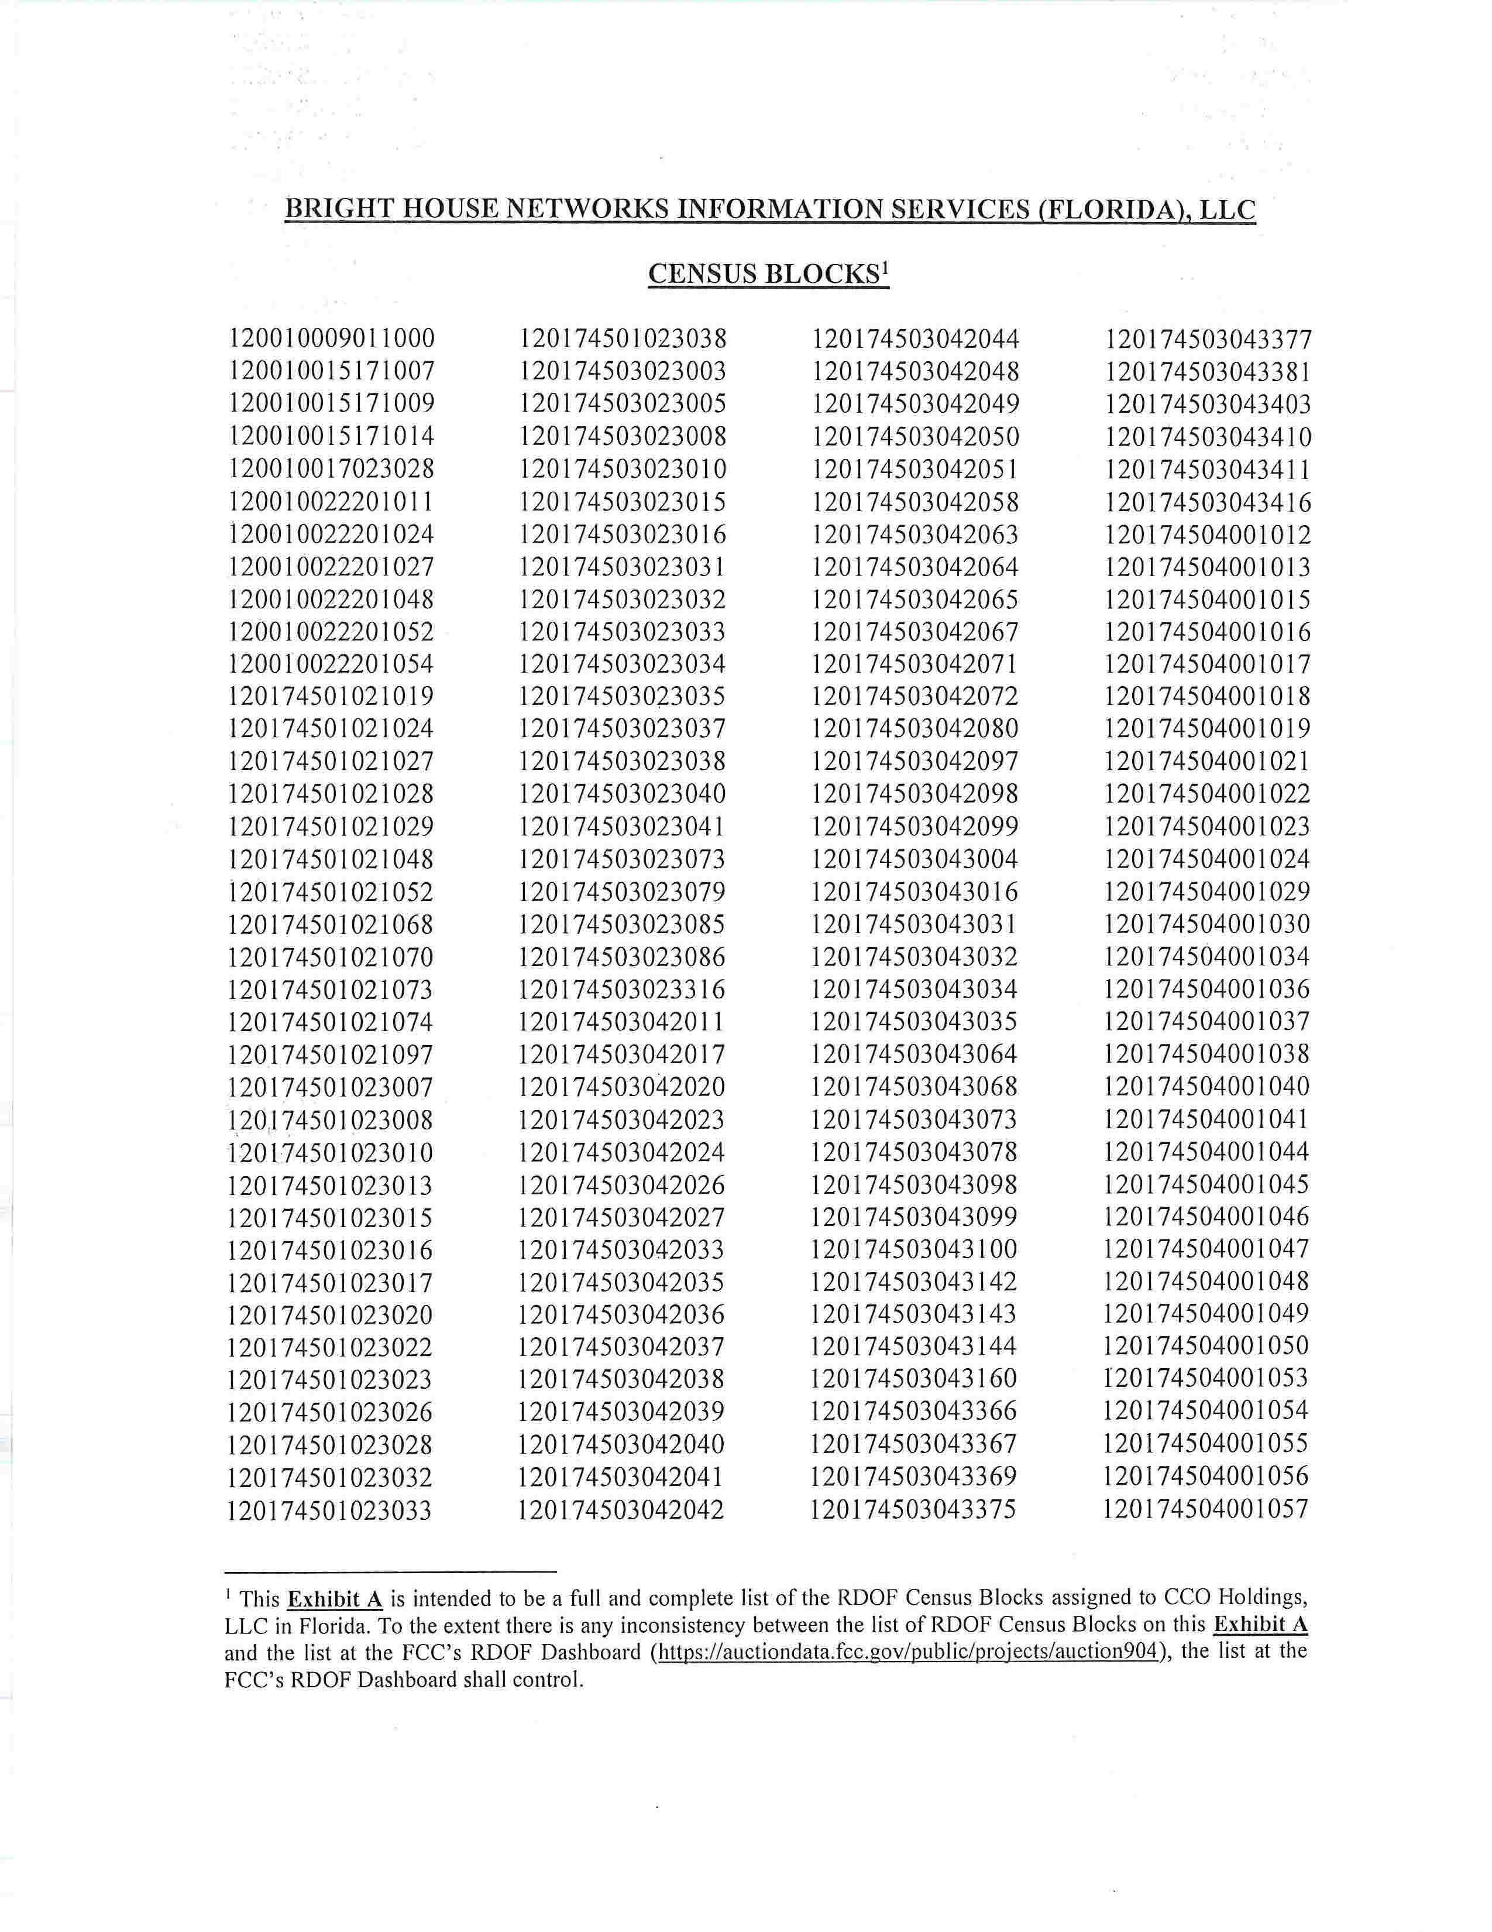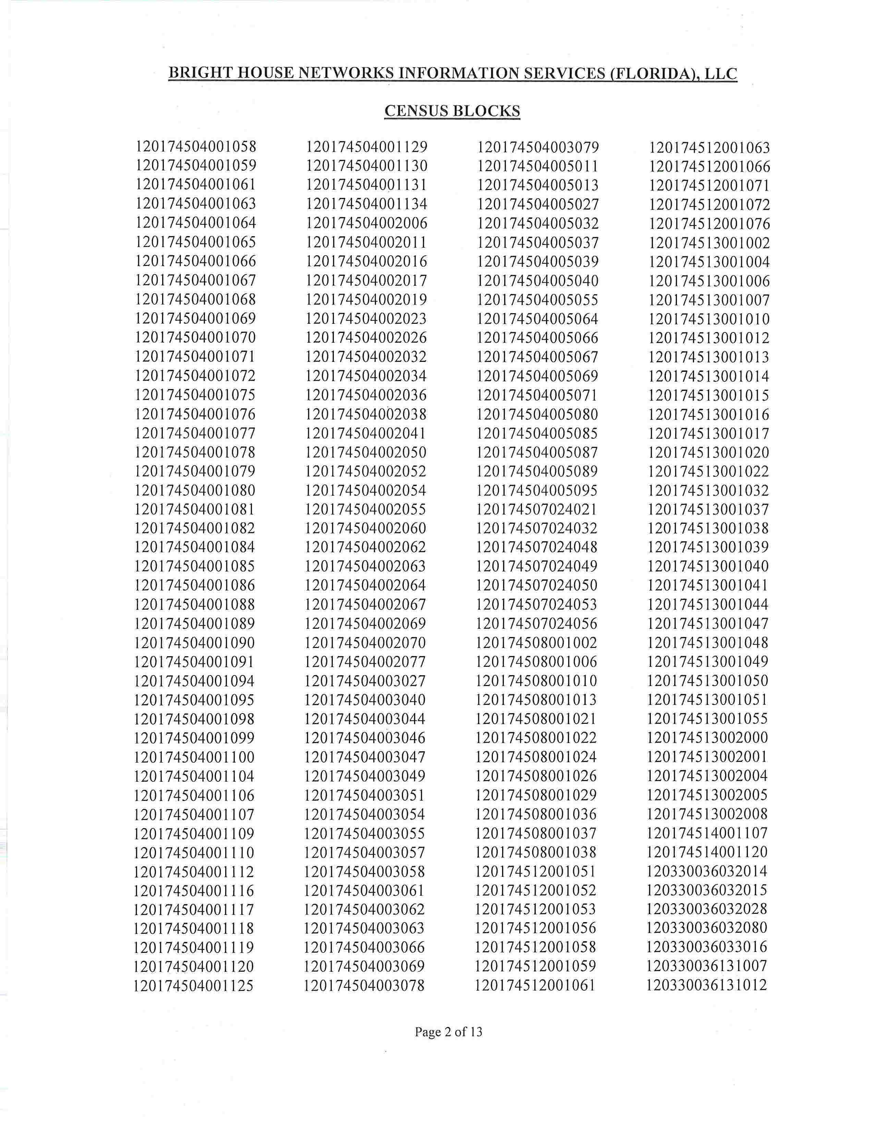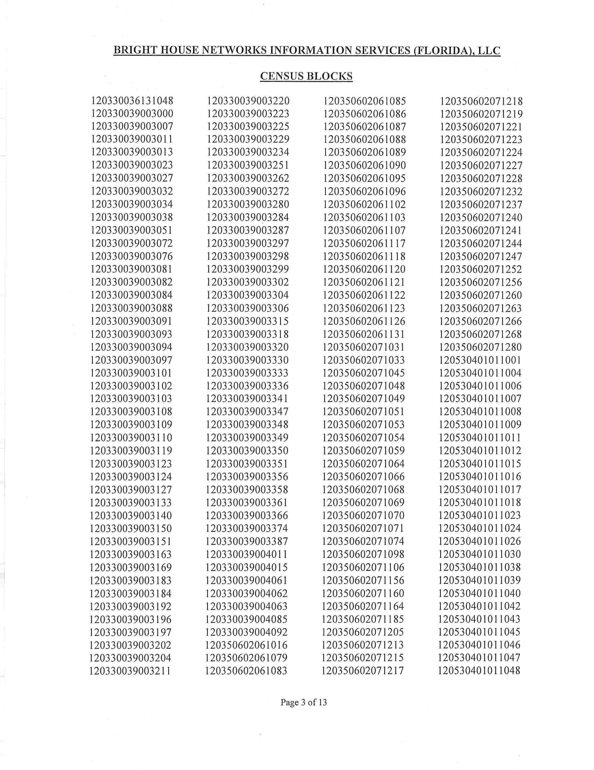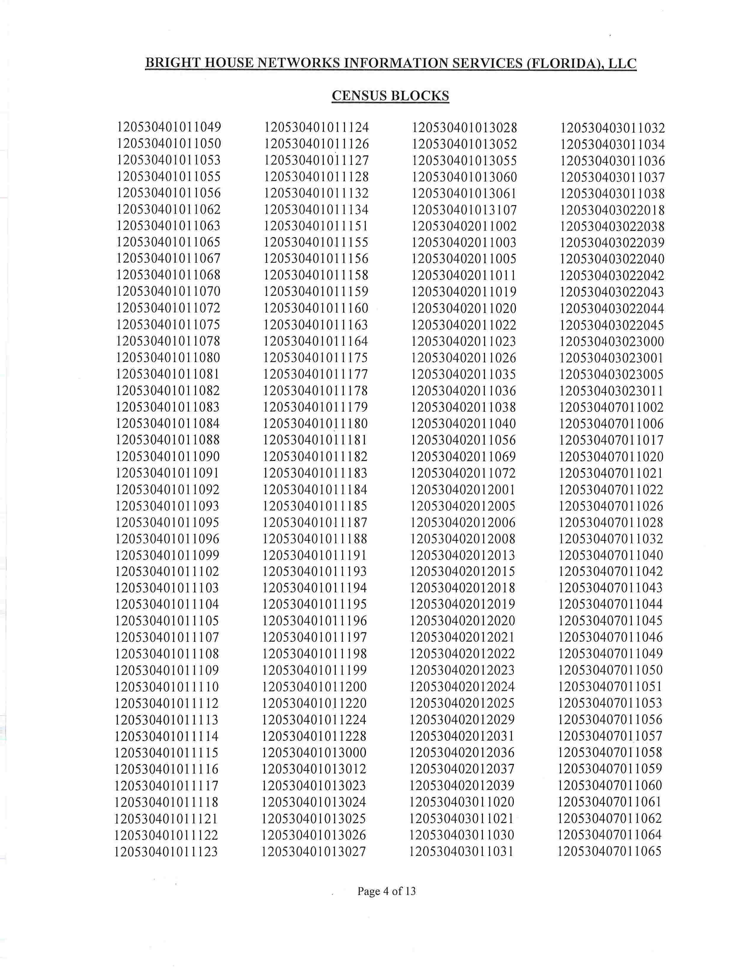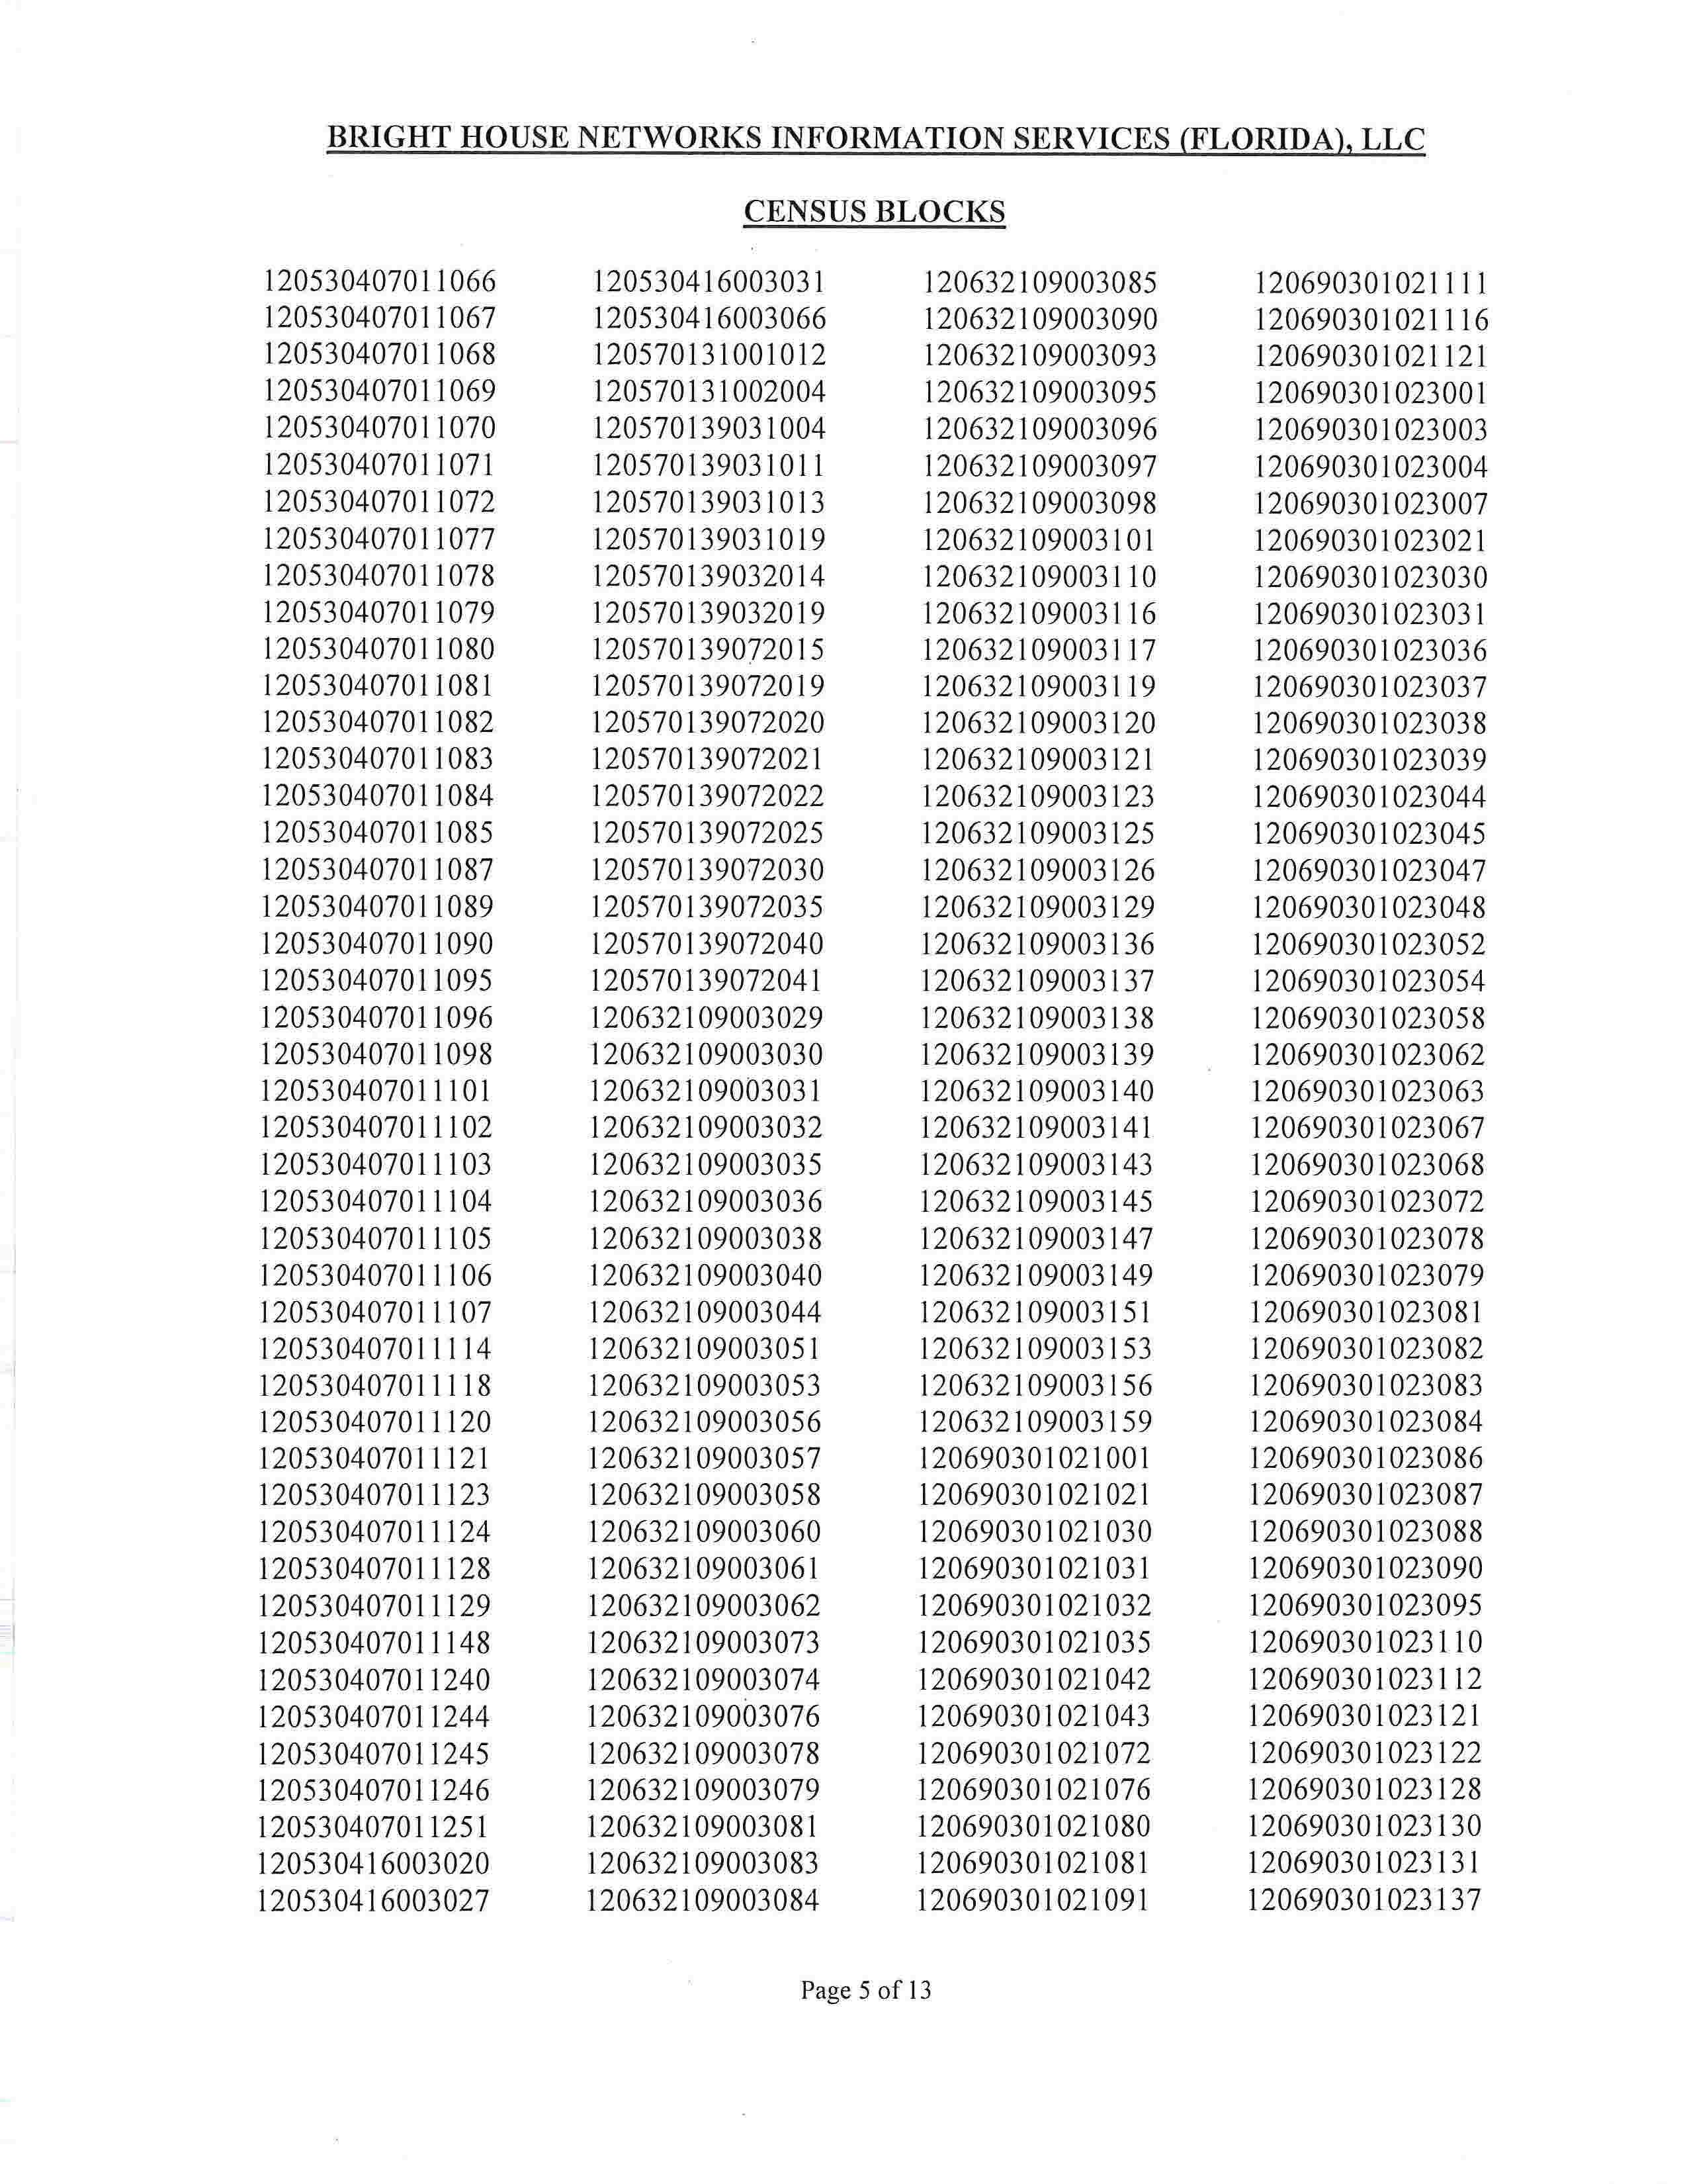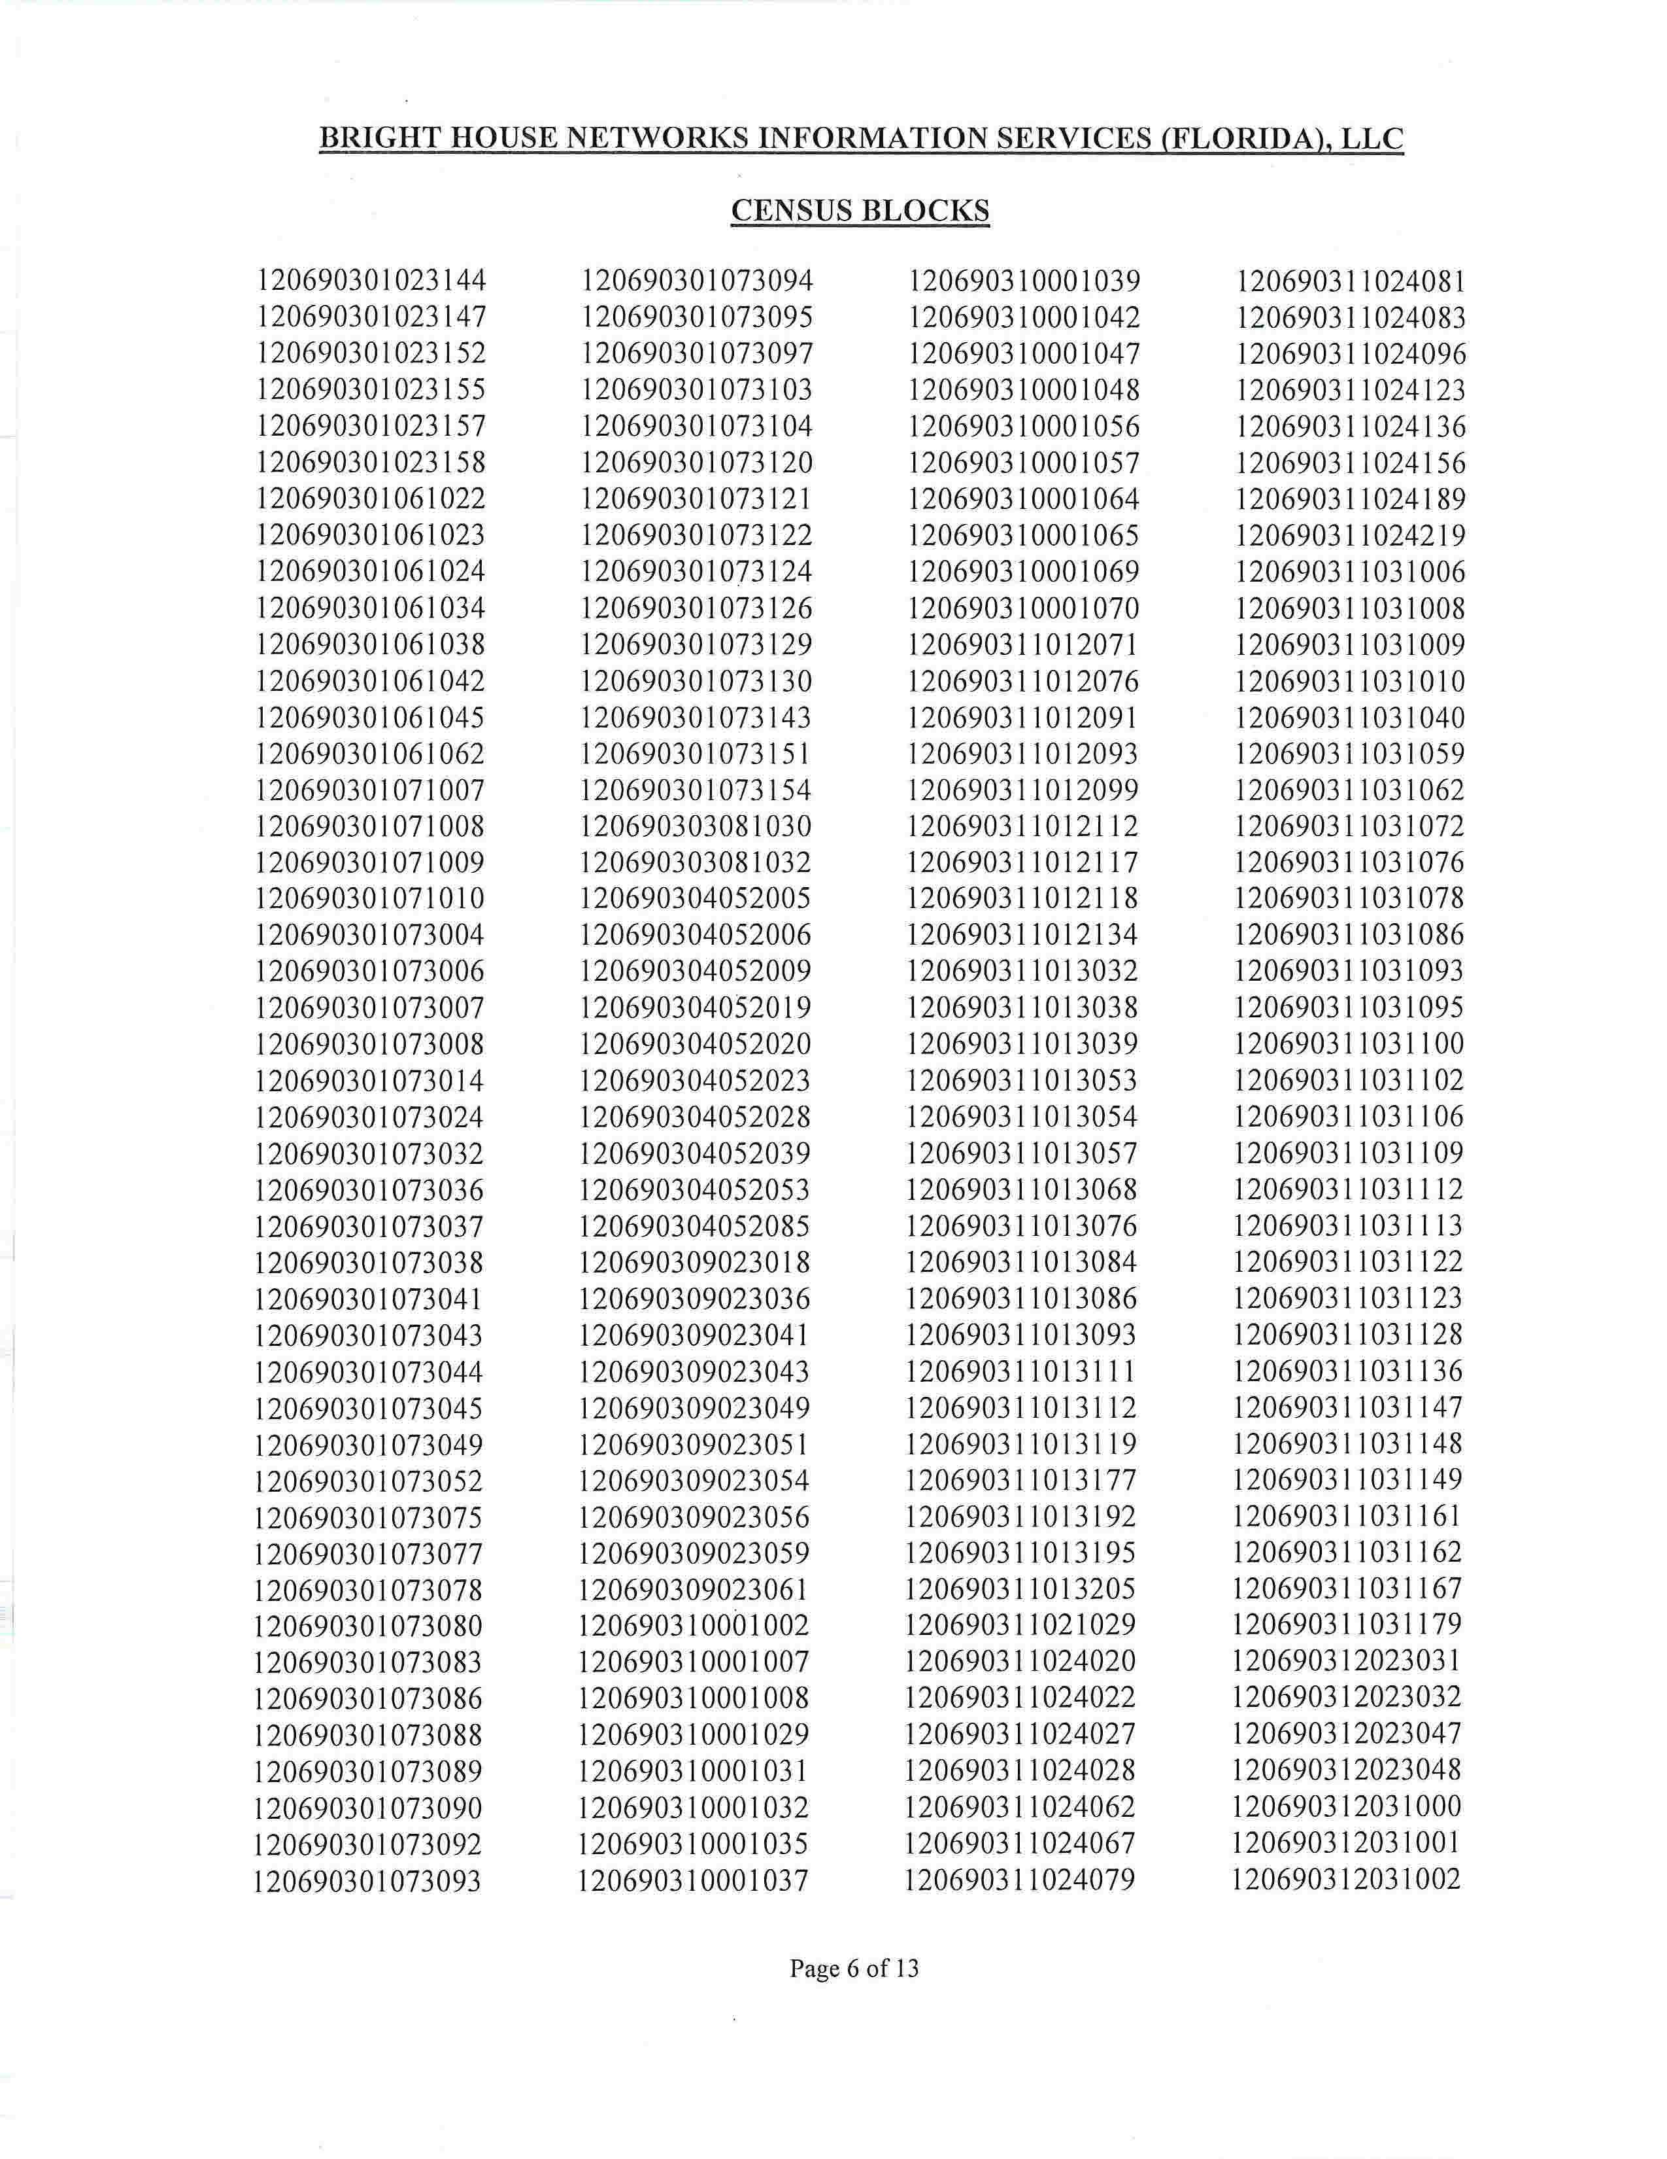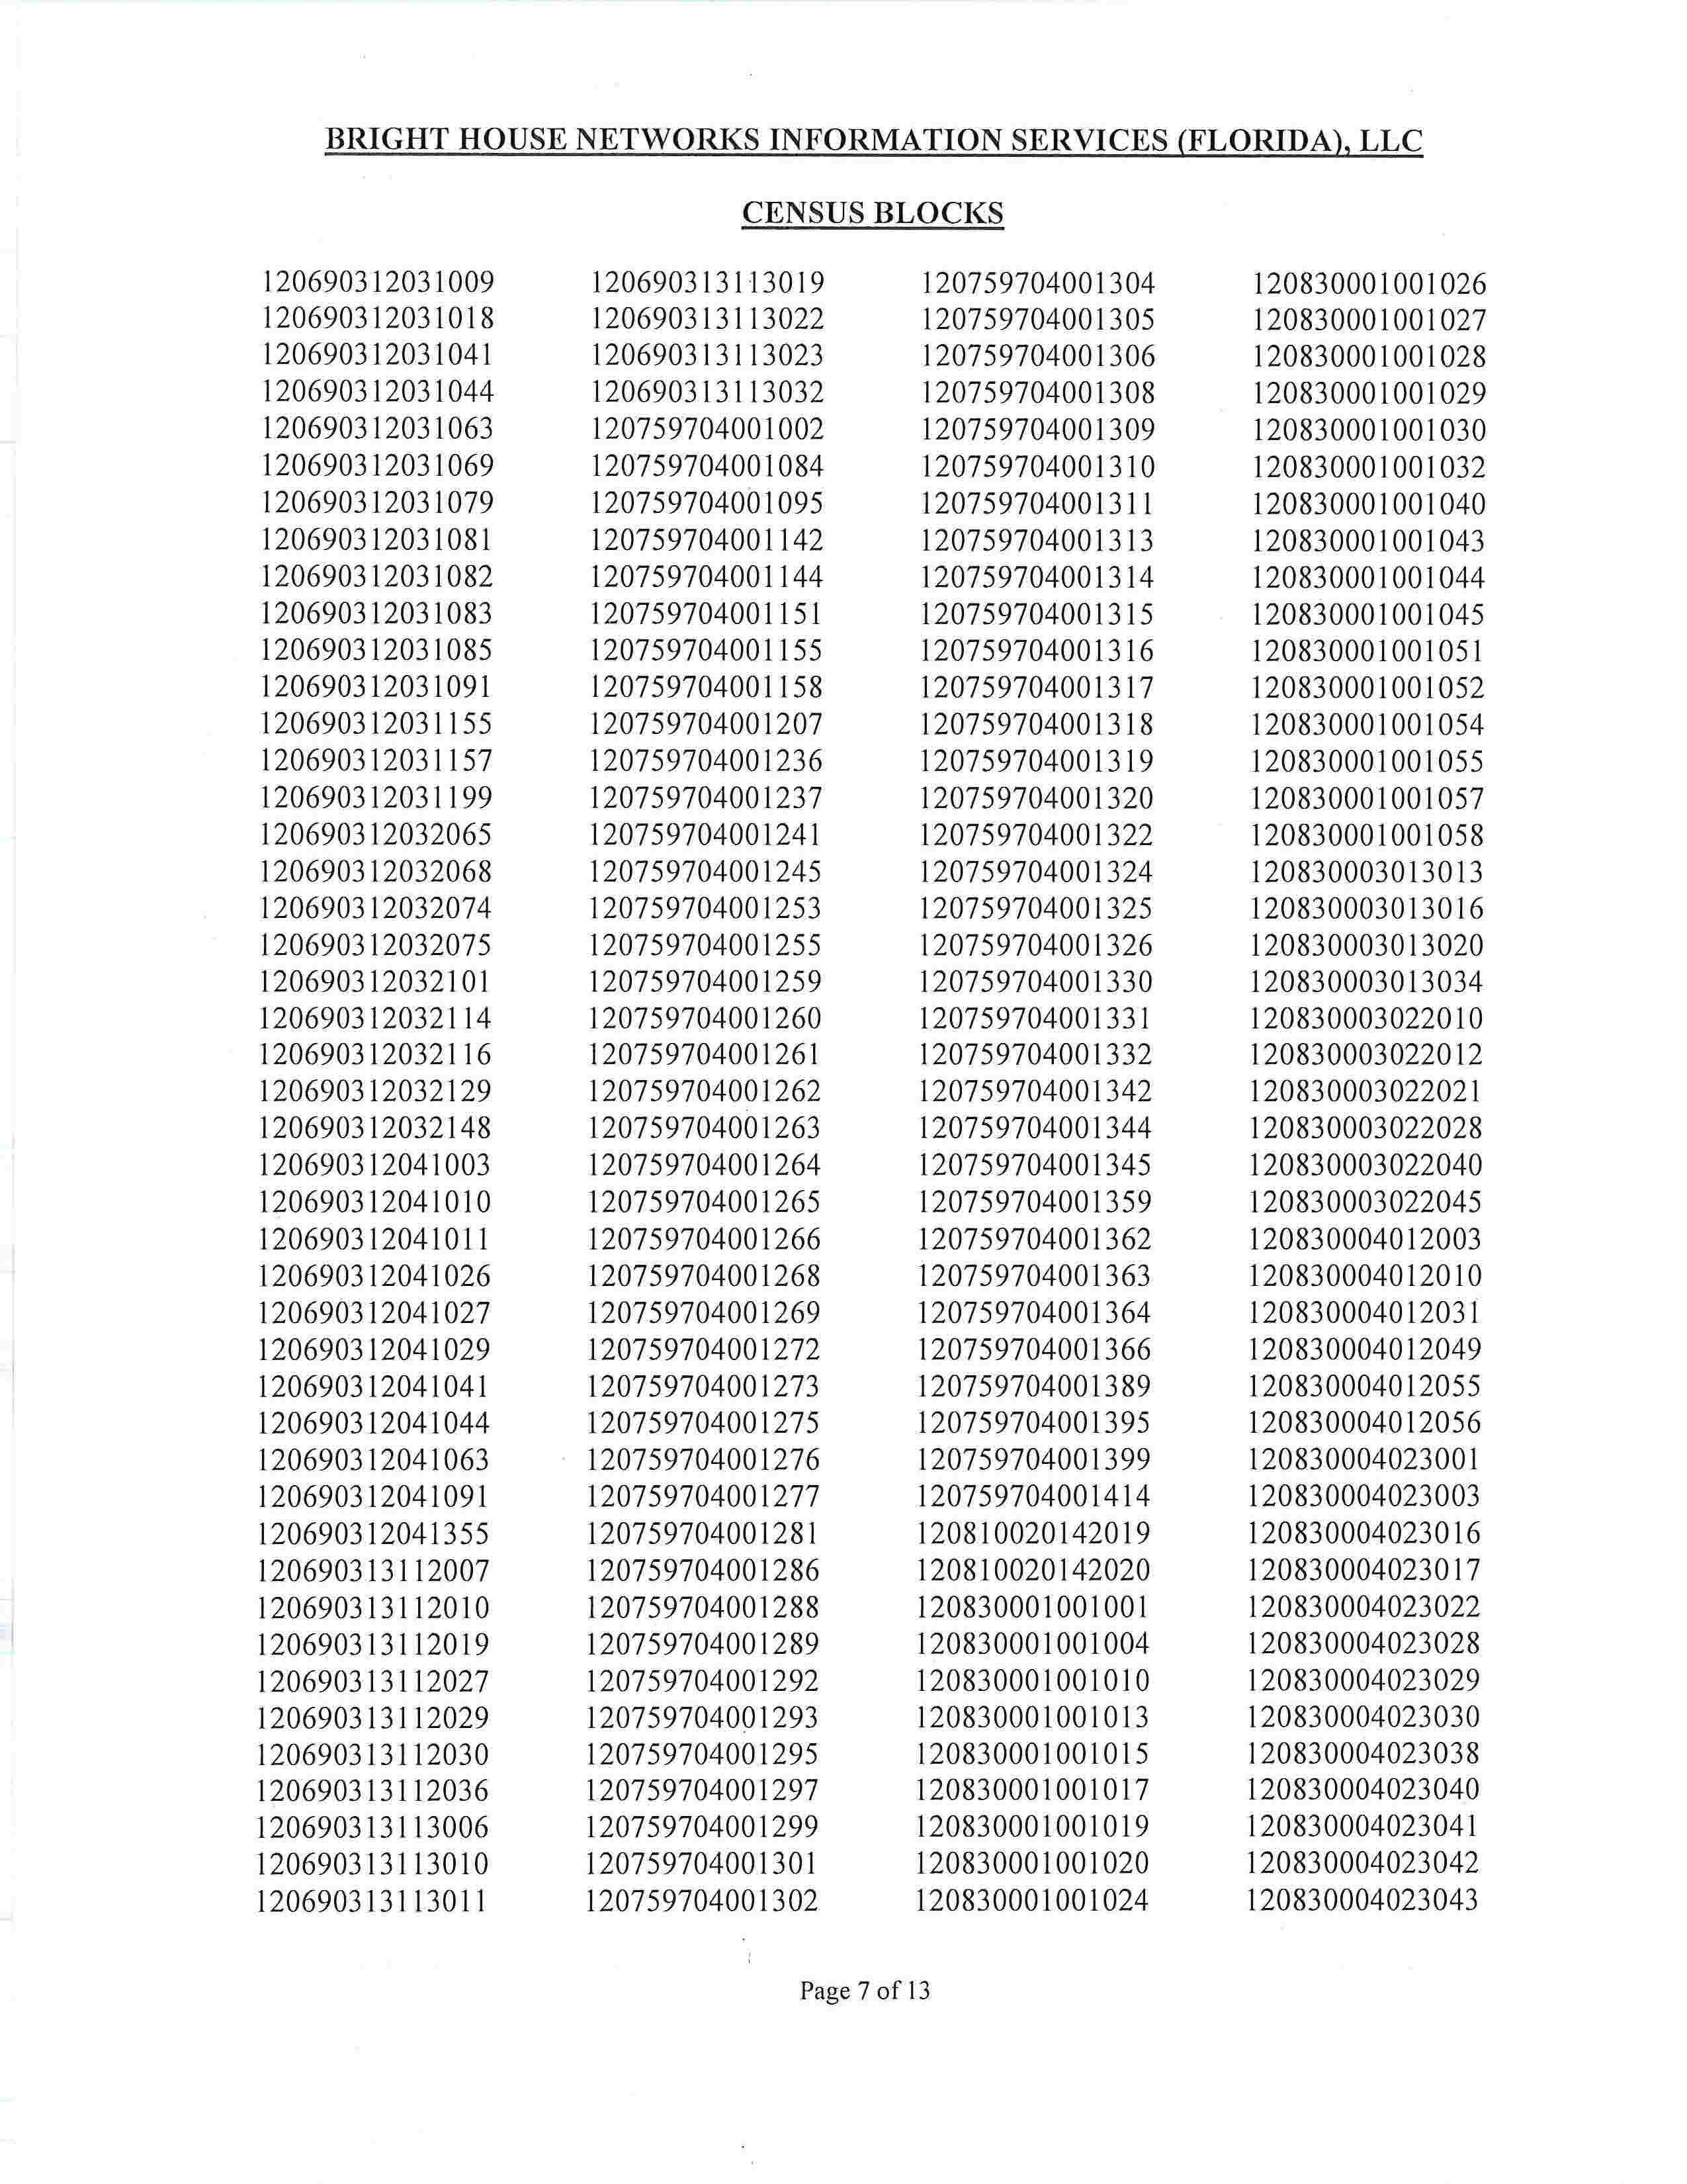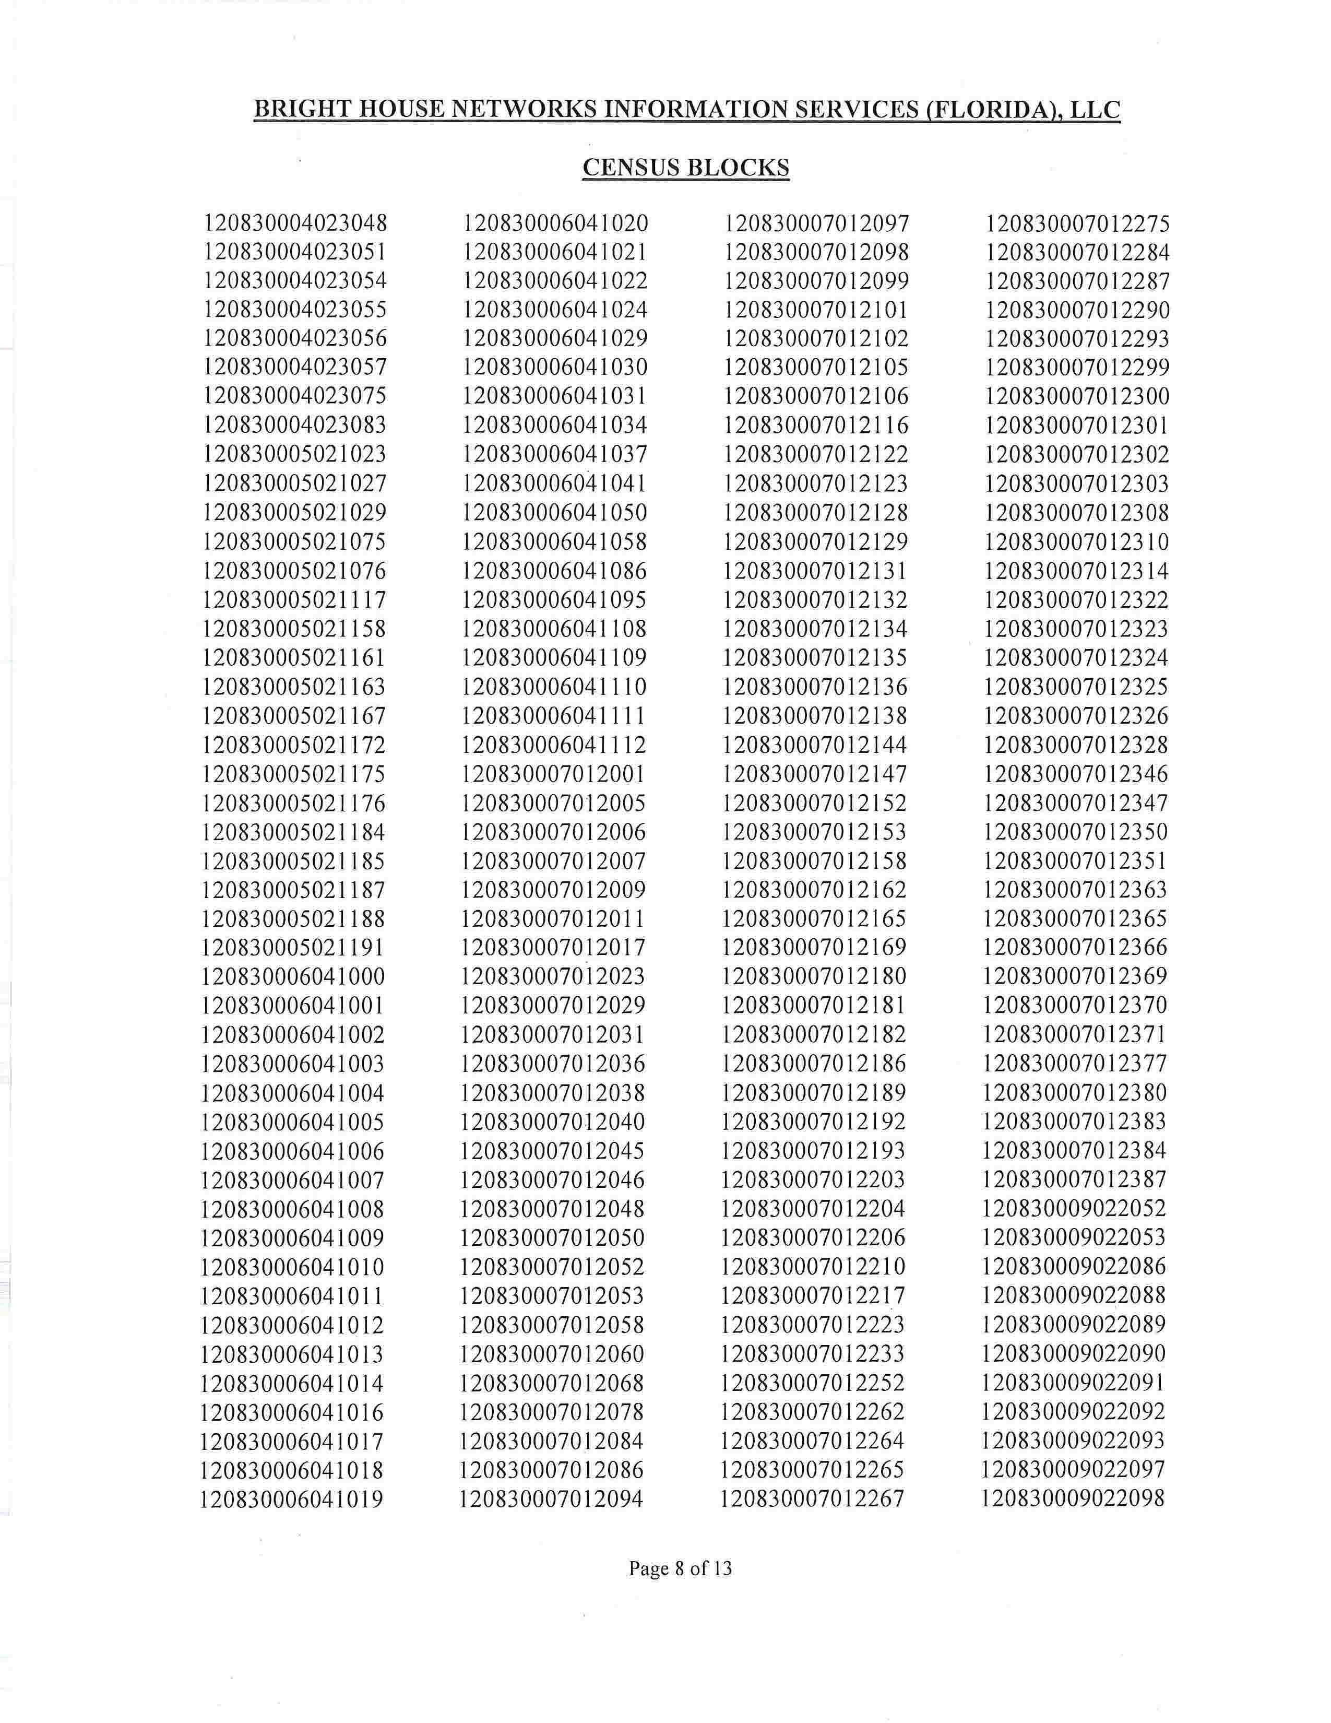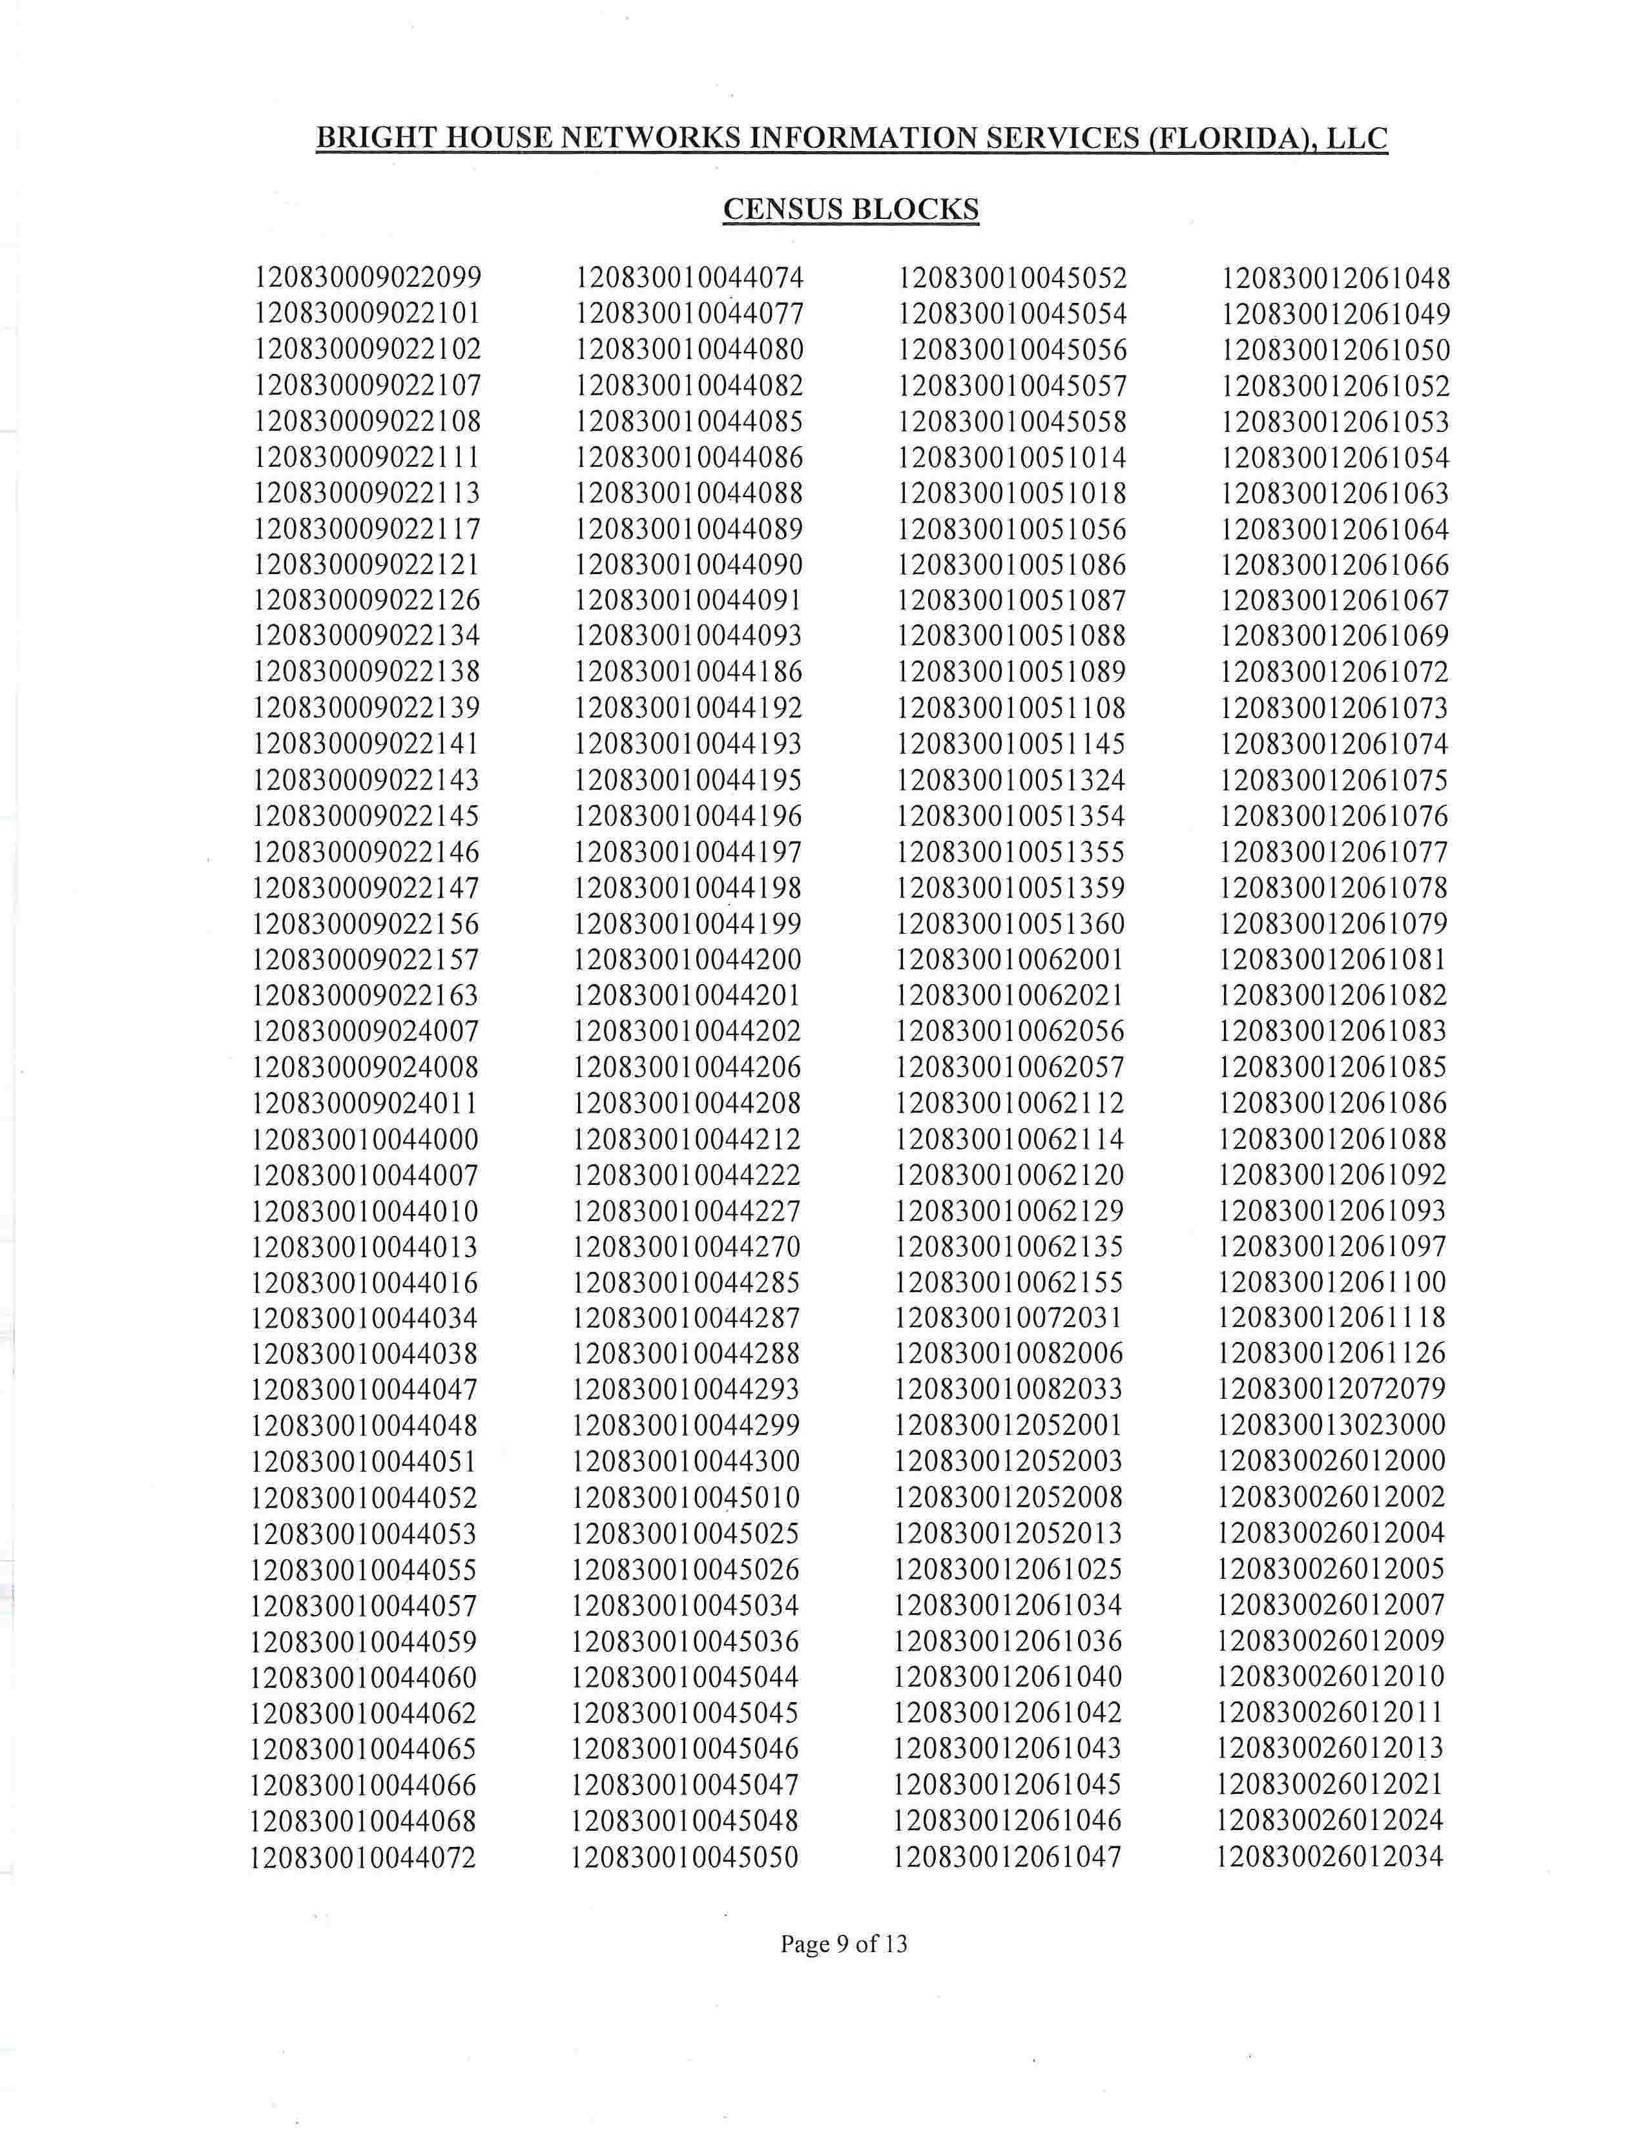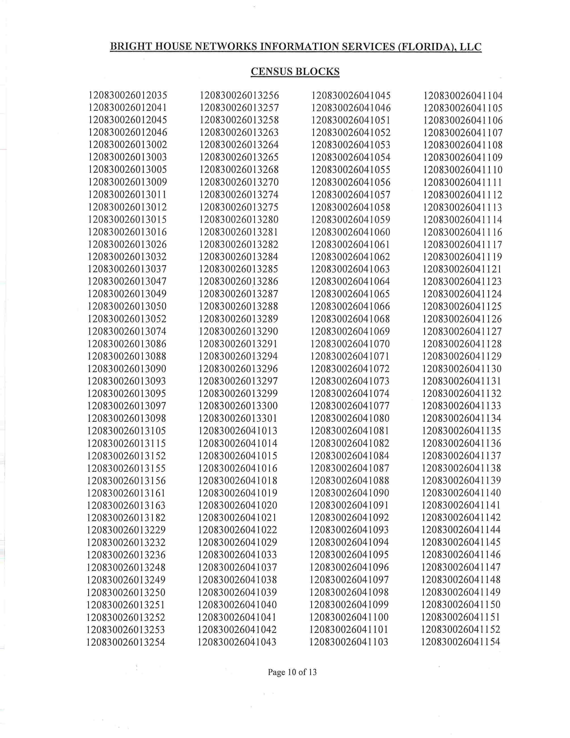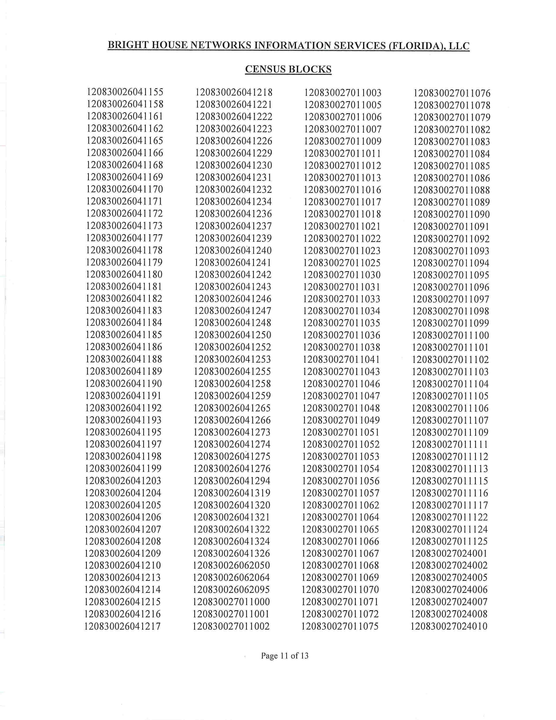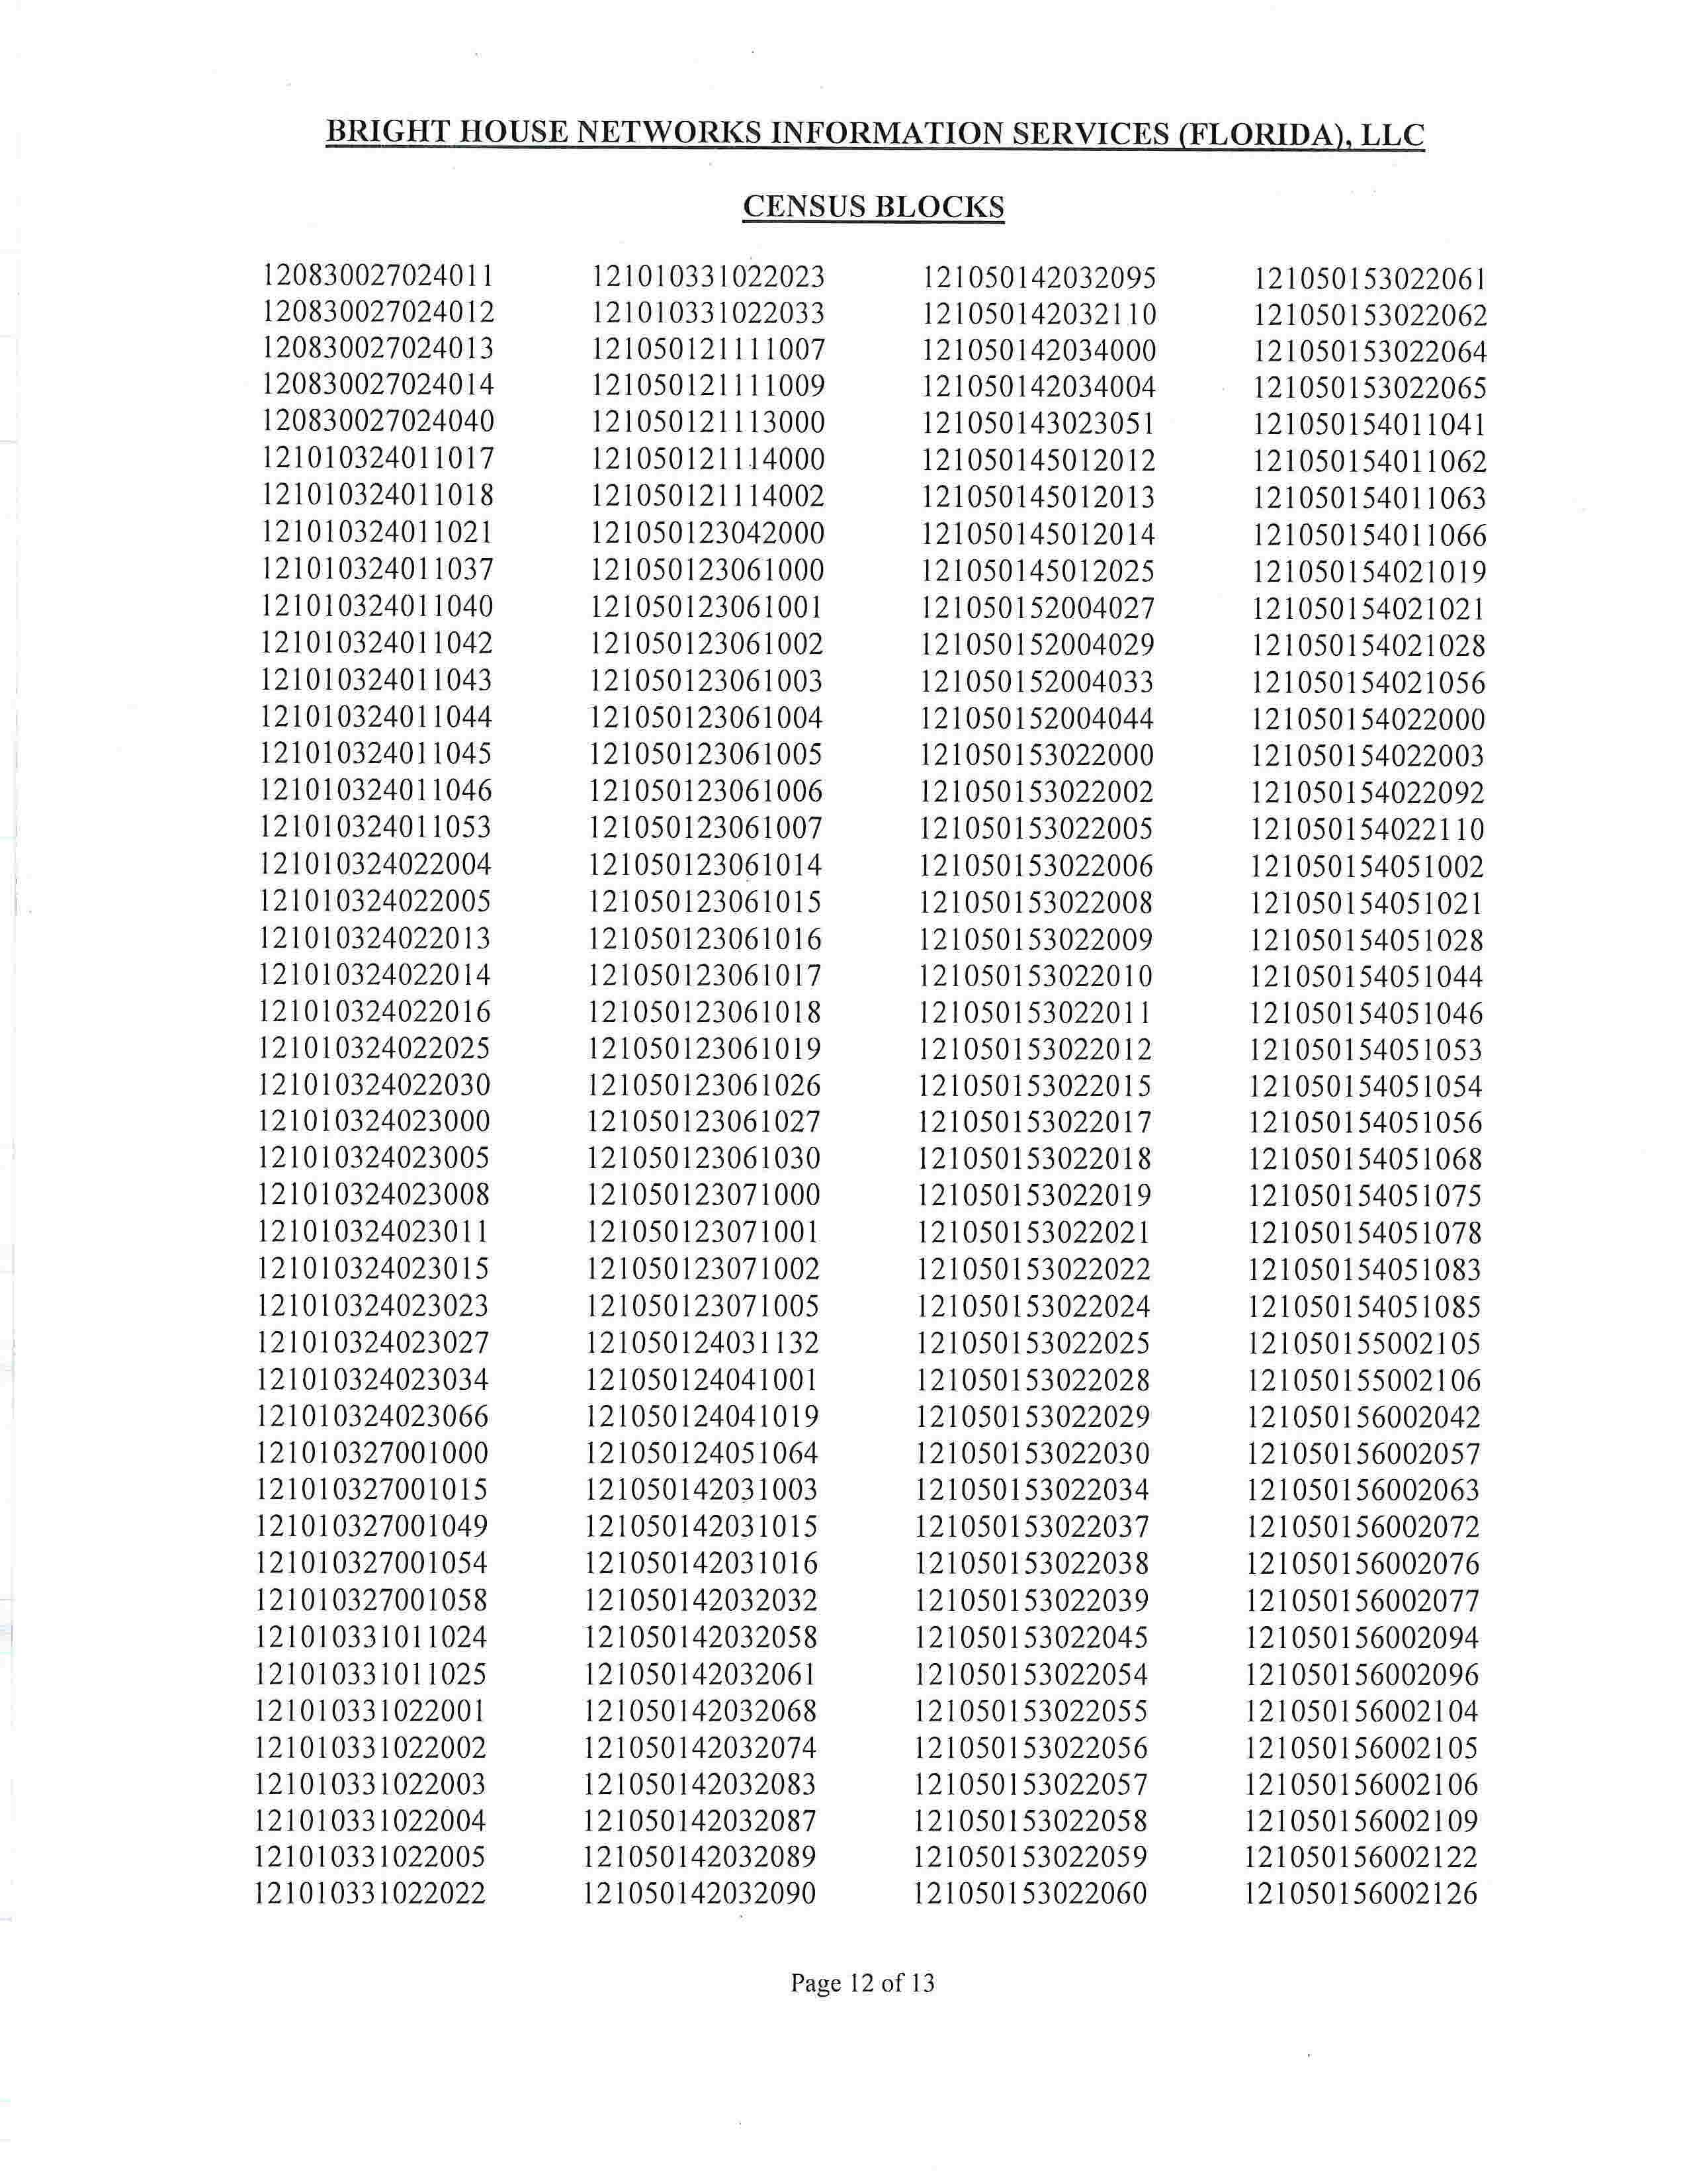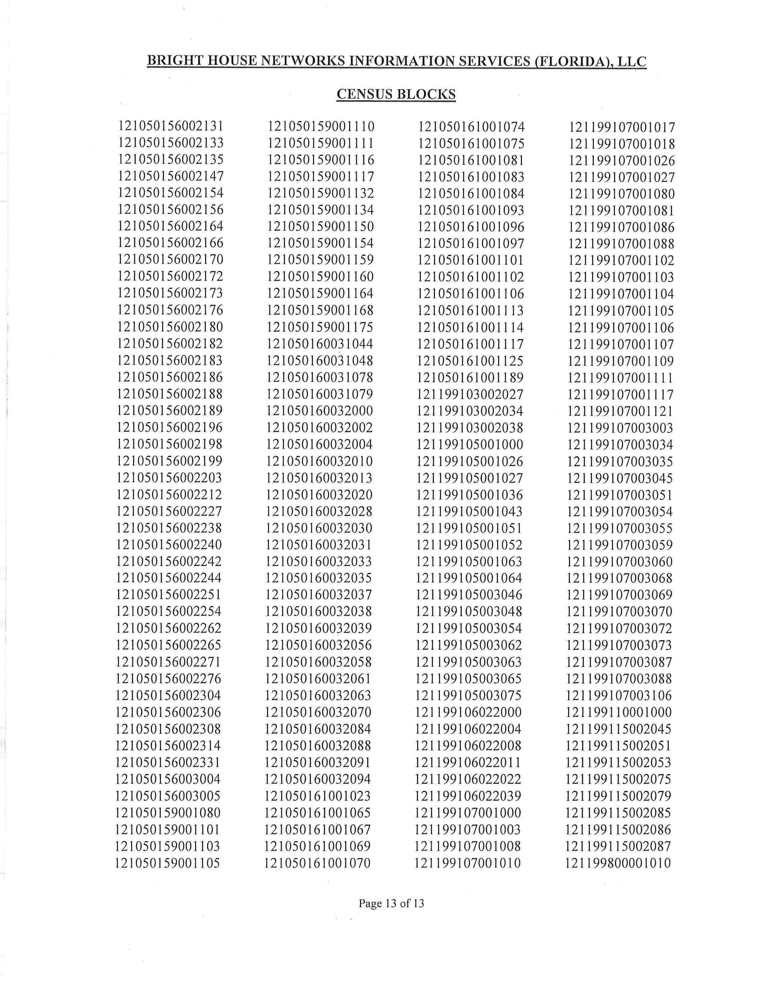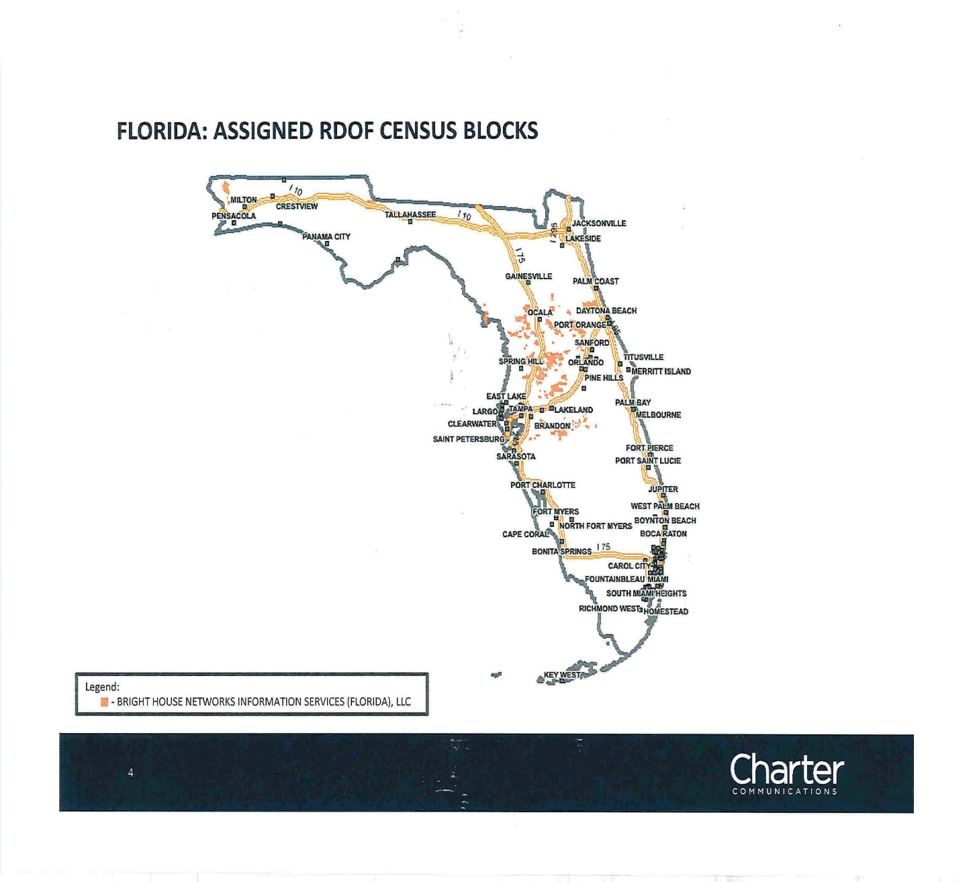

Order No. PSC-02-0070-CO-TX issued on January 10, 2002, in Docket No. 20011617-TX, Application for certificate to provide alternative local exchange telecommunications service by Time Warner Cable Information Services (Florida), LLC d/b/a Time Warner Cable Information Services d/b/a Time Warner Cable d/b/a Time Warner Communications (Consummating Order No PSC-2001-2467-PAA-TX). See also Order No. PSC-03-0989-FOF-TX., issued on September 3, 2003, in Docket No. 20030713-TX, In re: Request for name change on CLEC Certificate No. 8015 from Time Warner Cable Information Services (Florida), LLC d/b/a Time Warner Cable Information Services d/b/a Time Warner Cable d/b/a Time Warner Communications to Bright House Networks Information Services (Florida), LLC.
FCC, DA 20-1422, Public Notice, 904 Winning Bidders, https://docs.fcc.gov/public/attachments/DA-20-1422A1.pdf, accessed February 1, 2021.
Id., Attachment B, https://docs.fcc.gov/public/attachments/DA-20-1422A3.pdf, accessed February 1, 2021.
Id., Attachment A (See CCO Holdings which has assigned its winning bid to its affiliate Bright House.) https://docs.fcc.gov/public/attachments/DA-20-1422A2.pdf, accessed February 1, 2021.
47 U.S.C. 214(e)(6)
In this context, a “telecommunications facility” includes real estate, easements, apparatus, property, and routes used and operated to provide two-way telecommunications service to the public for hire within [Florida]. 364.02(14). “Service” is to be construed in its broadest and most inclusive sense;” however, the term “does not include broadband service or voice-over-Internet protocol service for purposes of regulation. Id.at (12).
Section 364.011(3), F.S.
Charter Advanced Services (MN), LLC v. Lange, 903 F.3d 715, (Eighth Circuit 2018) cert denied, Lipschultz v. Charter Advanced Services (MN) LLC, 140 S.CT. 6 (Supreme Court of the United States 2019). (The case involved a Bright House affiliate in Minnesota that had been created to offer only nonjurisdictional services).
Subpart E addresses Universal Service Support for Low-Income Consumers. See 47 C.F.R. §54,400 through §54,422.
Subparts D, K, L, and M refer to rules regarding Universal Service Support for High Cost Areas, Interstate Common Line Support Mechanisms for Rate-of-Return Carriers, Mobility Fund and 5G Fund, and High-Cost Loop Support for Rate-of-Return Carriers, respectively.
47 U.S.C. §214(e)(1)(B)

