State of Florida |  | Public Service Commission  Capital Circle Office Center ● 2540 Shumard Oak Boulevard  Tallahassee, Florida 32399-0850  -M-E-M-O-R-A-N-D-U-M-
DATE: | June 3, 2021
TO: | Office of Commission Clerk (Teitzman)
FROM: | Division of Economics (Coston, Ward)  Office of the General Counsel (Trierweiler)
RE: | Docket No. 20200093-GU – Petition for approval of tariff modifications for liquified natural gas service by Peoples Gas System.
AGENDA: | 06/15/21 – Regular Agenda – Tariff Filing - Interested Persons May Participate
COMMISSIONERS ASSIGNED: |  |  | All Commissioners
PREHEARING OFFICER: |  |  | Fay
CRITICAL DATES: |  |  | Company waived the 12-month Effective Date
SPECIAL INSTRUCTIONS: |  |  | None

Case Background
On March 16, 2020, Peoples Gas System (Peoples or utility) filed a petition (original petition) for approval of a Liquified Natural Gas (LNG) Service tariff. LNG is natural gas that has been cooled to negative 260 degrees Fahrenheit, which causes the gas to condense into a liquid. Once in liquid form, the natural gas is 1/600th of its original volume, allowing for increased storage potential. LNG is currently used in Florida as a transportation fuel for maritime, rail, and other applications. The original petition would have allowed the utility to build facilities to convert natural gas into liquid form (liquefaction), provide necessary LNG storage, and allow for the regasification of the LNG on the customer’s behalf.
Peoples waived the 60-day file and suspend provision pursuant to Section 366.06(3), Florida Statutes (F.S.), in an email dated April 9, 2020. Staff issued two data requests on the original petition. Staff issued its first data request to Peoples on April 2, 2020, to which the utility responded on April 17, 2020. Staff issued its second data request on July 31, 2020, to which the utility responded on August 7, 2020. The Commission acknowledged the intervention of the Office of the Public Counsel (OPC) in this docket by Order No. PSC-2020-0181-PCO-GU, issued June 10, 2020. OPC served interrogatories and requests for production on Peoples on June 5, 2010, which Peoples responded to on July 6, 2020.
On May 22, 2020, a noticed informal telephonic meeting was held with Commission staff, Peoples, OPC, and other interested persons. At the meeting, Peoples provided a presentation that has been placed in the docket file. On July 31, 2020, Eagle LNG Partners (Eagle LNG), an interested person in the docket, submitted a letter to the Commission stating its opposition to the proposal as presented in the original petition. On August 13, 2020, Peoples submitted to the Commission a letter in response to Eagle LNG’s letter of opposition. Copies of both letters have been filed as correspondence in this docket. On August 17, 2020, a second noticed informal telephonic meeting was held with Commission staff, Peoples, OPC, Eagle LNG, and other interested persons.
The staff recommendation on Peoples’ original petition was presented at the September 1, 2020 Agenda Conference. During the Agenda Conference, several Commissioners, OPC, and Eagle LNG expressed concerns about the proposed tariff’s potential risk to the general body of ratepayers. In addition, Eagle LNG stated that it believed there are potential competitive market concerns with the proposal. The Chairman deferred the item to allow Peoples additional time to evaluate revisions to its petition and proposed tariff in response to the discussion and comments made at the September 1, 2020 Agenda Conference.
On February 2, 2021, Peoples filed a letter in the docket notifying the Commission that the utility waived the 12-month deadline for final Commission action, per Section 366.06(3), F.S.
On February 22, 2021, Peoples filed a modification (modified filing) to its original petition and an amended tariff sheet that the utility believes addresses the questions and concerns raised at the September 2020 Agenda Conference. In its modified filing, the utility states it will no longer offer liquefaction service under the amended tariff, rather the tariff would only allow for the storage and regasification of LNG. Peoples stated in its modified filing that the amended tariff should reduce the average cost to provide LNG service by approximately 40 to 60 percent from the original petition. On March 24, 2021, staff issued its third data request regarding the modified filing, for which responses were received from the utility on April 8, 2021. On May 14, 2021, Peoples filed an additional amendment to its LNG tariff to include a provision regarding ratepayer protections.
This recommendation addresses the modified filing and amended tariff. The amended tariff, as filed by Peoples on May 14, 2021, is included as Attachment A of the recommendation. For clarity, Attachment B shows in legislative format the revisions from the tariff as filed with the original petition and the tariff filed on May 14, 2021.
Commission Jurisdiction
Section 366.02(1), F.S., in part, defines a "public utility" as an entity that supplies gas (natural, manufactured, or similar gaseous substance) to the public within Florida. Section 366.02(1), F.S., also excludes from the definition of “public utility” municipal utilities, rural cooperatives, and:

persons supplying liquefied petroleum gas, in either liquid or gaseous form, irrespective of the method of distribution or delivery, or owning or operating facilities beyond the outlet of a meter through which natural gas is supplied for compression and delivery into motor vehicle fuel tanks or other transportation containers, unless such person also supplies electricity or manufactured or natural gas. [Emphasis added]

Therefore, staff believes that Peoples’ proposed LNG service would fall under the activities of a public utility, as contemplated under Section 366.02(1), F.S., and the Commission may exercise jurisdiction over Peoples’ rates and service in this area, pursuant to Section 366.04, F.S. Based on this interpretation, the Commission would also have jurisdiction over this matter pursuant to Sections 366.03, 366.05, and 366.06, F.S.

Discussion of Issues

Issue 1:
Should the Commission approve Peoples’ amended proposed LNG tariff?

Recommendation:
Yes. Staff recommends that the Commission should approve Peoples’ amended proposed LNG tariff, as shown in Attachment A, effective on June 15, 2021. The LNG tariff would provide Peoples with an opportunity to provide storage and regasification LNG services to interested customers. A participating customer would enter into a contract with Peoples and all capital and operating costs associated with the LNG facility would be borne by the customer. If Peoples petitions the Commission to evaluate cost recovery for any tariff default or under-recovery in a future rate petition, the utility should be put on notice that, as part of its review, the Commission will complete a thorough analysis of the utility’s due diligence in entering into the contract, including the sufficiency of contract provisions designed to protect the general body of ratepayers. (Coston, Ward)

Staff Analysis:
In its original petition, Peoples stated that major maritime and cruise companies, along with several of Florida’s largest ports, have expressed interest in the utility providing an LNG fuel option through the development of LNG infrastructure. The utility highlighted that the International Maritime Organization, the specialized United Nations agency that sets global standards for the safety, security and environmental performance of international shipping, has required the marine sector to reduce sulphur oxide (SOx) emissions from ships by 80 percent beginning January 1, 2020. As a result, many maritime companies are considering natural gas as a fuel for cruise ships, container vessels, and bulk carriers.
In addition to the maritime industry, the utility also stated that other industries have expressed an interest in using LNG for transportation fuel. Examples provided in the petition include refuse companies using natural gas for transportation fleets and railroads using natural gas to power locomotives. Peoples stated that a significant challenge to using LNG as a transportation fuel is the lack of storage facilities in Florida. The proposed tariff would allow Peoples the opportunity to work with these industries to create the supply infrastructure needed to meet the growing demand for LNG.
Potential Benefits of LNG
Peoples stated that the benefit of natural gas in its liquid state is that it is approximately 600 times less voluminous than gas in its traditional gaseous state. Converting natural gas into a liquid state makes it possible to transport natural gas to places that pipelines may not currently serve, thus potentially expanding the use of natural gas as a transportation fuel. Additionally, on-site LNG could serve as an immediate solution for customers who are unable to wait for pipeline infrastructure installation. The utility stated that LNG facilities could also provide greater resiliency for participating customers by avoiding disruptions caused by weather or supply interruptions. Currently, Florida does not have any large-scale storage facilities and relies on natural gas to be transported through interstate and intrastate pipeline systems.
Peoples’ original petition is the first request by a Florida investor-owned natural gas company for an LNG tariff. The operators currently providing LNG services in Florida are not subject to the Commission’s jurisdiction. Peoples seeks to include certain LNG service under its regulated tariff, rather than through an unregulated subsidiary, because the utility believes that doing so creates operating efficiencies in terms of customer points of contact, operations and management expense, and economies of scale. Peoples explains that a prospective LNG customer would typically issue a Request for Proposals for the construction and maintenance of LNG facilities and Peoples could potentially compete with other unregulated LNG providers for the provision of certain LNG service.
Proposed Amended Liquified Natural Gas Tariff
Under Peoples’ proposed amended tariff, a participating customer would pay a monthly LNG services charge specific to that customer, which would be calculated based on Peoples’ gross investment in the storage and regasification facilities that serve the customer, as established in the LNG tariff. These facilities would be installed and maintained by Peoples and could be installed on either utility-owned property or the customer’s premises. Peoples stated that “each LNG facility built by Peoples pursuant to the tariff will be unique to the particular customer(s) and industries served by such facility.” Peoples stated in its modified filing that the services offered under this tariff would be limited to LNG storage and regasification. This is a significant change from the original petition, which also included the option to provide liquefaction facilities.
As outlined in the amended tariff, Peoples would enter into an agreement with the customer to construct an LNG facility to store and re-gasify LNG. The agreement would include the required monthly services charge, which is designed for all costs to be fully paid by the customer over the life of the agreement. The utility asserted that the monthly services charge would be designed to recover the cost of service to provide LNG service to a customer. The cost of service would include, but not be limited to, depreciation expense, return on capital, property taxes, insurance, operational expenses, and the fuel and electricity used to operate the LNG facilities. The costs of an LNG facility would include all of the necessary components and equipment needed to build the specific LNG facility for a customer’s end use. Peoples stated that each facility would be designed for the specific needs and anticipated demand of each customer and the final costs would reflect that specific unit. Proposed tariff sheet No. 7.406, as shown in Attachment A to the recommendation, provides a listing of specific equipment that could be necessary for the construction of an LNG facility.
Comments filed by Eagle LNG and Peoples’ Response
On July 31, 2020, Eagle LNG submitted a letter to the Commission requesting that the Commission deny Peoples’ originally-proposed LNG tariff. Eagle LNG asserted four reasons as to why the Commission should deny the original petition. Eagle LNG stated that the LNG market is competitive and Commission regulation is only required when there is a natural monopoly. Second, approval of the tariff would put the general body of ratepayers at risk if the LNG customer can not fulfill its obligation under the contract and ratepayer risk is not justified in a competitive market. Third, Eagle LNG believed that Peoples should offer LNG services through a separate, non-regulated, company (i.e., a subsidiary of the corporate parent Emera). Finally, Eagle LNG believed that approval of the originally-proposed LNG tariff sends the wrong signal to the competitive LNG market in Florida and puts Eagle LNG at a competitive disadvantage.
On August 13, 2020, Peoples submitted a letter to the Commission in response. First, Peoples asserted that the originally-proposed tariff does not require Commission oversight of the LNG market; rather the LNG tariff is a natural extension of Peoples’ natural gas business. Second, Peoples stated that the LNG tariff would not put ratepayers at risk as Peoples will not be building speculative facilities, rather the utility will be building specific facilities to meet a requesting customer’s needs. Peoples further stated it will be contracting with well-capitalized customers and it is thus extremely unlikely that a LNG customer would default or declare bankruptcy. Third, Peoples stated the originally-proposed LNG tariff will not cause cross subsidization or regulatory inefficiency. Creating a separate company for LNG services would create greater inefficiencies and adding additional customers benefits the general body of ratepayers. Finally, Peoples asserted that the proposed LNG tariff would provide another LNG option to potential customers, increasing competition.
At the September 1, 2020 Agenda Conference addressing the original petition, Eagle addressed the Commission stating their objection to Peoples’ proposal. In Peoples’ modified filing, the utility stated that it had discussions with Eagle addressing its concerns. Peoples stated that these discussions resulted in the utility removing the liquefaction services from its proposed amended tariff to address Eagles’ concerns. Specifically, this change would require a customer to obtain liquefaction services from a separate provider prior to Peoples storing, and potentially, re-gasifying the LNG for the customer. The utility stated that while the amended tariff does not offer liquefaction, its ability to provide storage and regasification would still offer additional options to customers and the LNG market in Florida.
Similar Tariff Concepts
The utility believes that the Commission has previously approved tariffs for Peoples that are similar in concept. The Commission first approved Peoples’ Natural Gas Vehicle Service (NGVS) tariffs in 1992 and more recently modified the NGVS tariff in 2017. The NGVS tariffs provide options for Peoples to install and maintain private or public fueling stations for compressed natural gas customers while allowing Peoples to recover its cost of providing these services. The monthly services charge calculation methodology under this tariff is 1.6 times the utility’s gross investment in the facilities. Similar to the LNG market, the provision of fueling stations for compressed natural gas customers is a competitive market.

In 2017, the Commission approved a tariff to accommodate the receipt of renewable natural gas (RNG) on Peoples’ distribution system. The RNG tariff allows Peoples to recover from biogas producers the cost of upgrading the biogas and does not contain standard charges, as the services provided vary based on the steps needed to upgrade the biogas to RNG. The monthly services charge is equal to a mutually agreed upon percentage (between Peoples and the biogas producer) multiplied by Peoples’ gross investment in the facilities necessary to provide biogas upgrading services.

In January 2021, the Commission approved a comparable RNG tariff for Florida City Gas. This tariff is designed similar to Peoples’ RNG tariff in that it includes a monthly services charge to recover all investment costs from the biogas customer.

Impact on General Body of Ratepayers
Peoples asserted in its modified filing that the LNG tariff is designed such that the capital investment, operational expenses, and its return on investment are borne by the LNG customer, via a negotiated contract. In response to staff’s third data request, the utility modified its amended tariff on May 14, 2021, to incorporate language emphasizing that the tariff would not cause any additional costs to non-participants. In addition, the utility stated that the assets, revenue, and expenses associated with this tariff would be included as part of its rate base surveillance reports; however, the utility stated that the LNG monthly services charge received from the LNG customer would fully offset the revenue requirements for these facilities.

Project Costs
Under the original petition, which allowed for the liquefaction of natural gas, Peoples stated that the potential costs to construct an LNG facility could range from $25 million to over $100 million. Under the amended tariff, which only allows for storage and regasification of LNG, the utility states that a typical facility would cost between $5 million and $35 million. This represents a reduction of approximately 40 to 60 percent from the original petition request. Peoples stated in its response to staff’s third data request that the removal of liquefaction facilities from the tariff “reduces the magnitude of risk to the Company and its ratepayers.”

Corporate Review
The utility stated that it would evaluate each potential customer’s credit worthiness prior to initiating an agreement under the tariff. Specifically, proposed tariff sheet No. 7.406-1 states that:
The agreement between Company and Customer may require a commitment by the Customer to purchase LNG Service for a minimum period of time, to take or pay for a minimum amount of LNG Service, to make a contribution in aid of construction, to furnish a guarantee, such as a surety bond, letter of credit, other means of establishing credit, and/or to comply with other provisions as determined appropriate by the Company.
In addition, Peoples stated that the contract agreements under the proposed LNG tariff would be required to comply with the utility’s Corporate Governance policy. This policy requires that contracts of a certain amount be reviewed and authorized by differing levels of senior management prior to execution. For the contract to be authorized by Peoples’ governance body, the customer must have demonstrated that it meets or exceeds a level of credit worthiness. Peoples stated that this step would help ensure that a customer taking service under this tariff should have the long-term financial stability to meet its obligations under the LNG service agreement. Peoples does not intend to bring individual LNG contracts before the Commission for approval.

Ratepayer Risk
Peoples stated in its modified filing that while it believes a customer default under the LNG tariff is unlikely, it would pursue the appropriate legal options to resolve and recover any outstanding costs as a result of a contract default. In addition, the utility stated that the physical assets would be owned by the utility and would have value and the potential for repurposing if a default occurs. Further, Peoples stated in its modified filing that prior to any unrecovered costs being included in rate base, the utility would need to request, and receive, approval from the Commission.

An additional impact on the general body of ratepayers under this tariff could be potential technical and administrative personnel costs associated with implementing the tariff. Peoples stated in response to staff’s second data request that the utility does not anticipate incurring significant upfront costs to implement this tariff. The utility does anticipate hiring technical and administrative support in order to respond to customer requests for LNG services and will incorporate this program into its existing pipeline, compressed natural gas, and renewable natural gas development team. The utility stated that the additional staffing cost would be subject to review by the Commission as part of a future base rate proceeding.

Under this tariff, the utility would actively participate in Requests for Proposals by companies interested in obtaining LNG services. This process will require Peoples to place resources towards bidding for, and potentially negotiating, an LNG services contract. In response to staff’s data request, the utility stated that it does not anticipate requesting recovery from its general body of ratepayers of any costs incurred as a result of an LNG bid or contract negotiations that does not result in a constructed facility.

With respect to the Commission’s Purchased Gas Adjustment (PGA) clause, Peoples asserted in response to OPC’s interrogatory No. 2 that the proposed LNG tariff is not contemplated to have any impact on the PGA costs for the general body of ratepayers. Peoples explained that an LNG customer will procure its own natural gas supply and, therefore, will not be included as a PGA customer.

Staff is recommending approval of the amended tariff, based in part based on Peoples’ assertion that it will implement a reasonable process to evaluate the credit worthiness of a potential customer and the utility’s internal risk assessment policies. Based on this process, the utility does not anticipate any cost impact on the general body of ratepayers. Staff notes that PGS has added language to the amended proposed tariff clarifying that non-participants would not incur any additional costs as a result of the tariff. In addition, the amended proposed tariff removes approximately half of the capital investment required to construct and operate these facilities, as compared to the original petition and tariff.

Nonetheless, staff does recognize that, if approved, the Commission may be asked to evaluate cost recovery for any contract default that results from the proposed tariff or any under-recovery in a future rate petition. If this occurs, the utility should be put on notice that, as part of its review, the Commission will complete a thorough analysis of the utility’s due diligence in entering into the contract, including the sufficiency of contract provisions designed to protect the general body of ratepayers.

Potential Benefit to the General Body of Ratepayers
Peoples stated that the proposed amended tariff would provide a benefit to the general body of ratepayers. The utility stated that potential customers under this tariff would increase the volume of gas on the existing distribution system. The utility stated this should result in lower overall costs to Peoples’ general body of ratepayers through economies of scale, by spreading fixed costs across a larger customer base. Peoples noted that customers receive the same benefit through its existing NGVS tariff.

In addition, Peoples stated that LNG has been used as a viable option by natural gas utilities to meet peak customer demand. While not currently planned, the utility highlighted that there could be a potential scenario in which Peoples could expand its supply portfolio for diversity and reliability using LNG by partnering with a customer under this tariff, potentially taking advantage of economies of scale. If this scenario were to arise, the utility stated that the capacity or reliability needs that benefit the general body of ratepayers would require recovery through a general base rate proceeding.

Conclusion
Staff has reviewed Peoples’ proposed amended LNG tariff language, the utility’s responses to staff’s and OPC’s data and discovery requests, and the letter submitted by Eagle LNG and Peoples’ response. Staff believes that Peoples’ proposed LNG service would fall under the activities of a public utility, as contemplated under Section 366.02(1), F.S., and the Commission may exercise jurisdiction over Peoples’ rates and service in this area, pursuant to Section 366.04, F.S. Based on this interpretation, the Commission would also have jurisdiction over this matter pursuant to Sections 366.03, 366.05, and 366.06, F.S.
Staff recognizes that while Peoples’ modified filing reduces the costs of any projects, if approved, the Commission may be asked to evaluate cost recovery for any tariff default or under-recovery in a future rate petition. If this occurs, the utility should be put on notice that, as part of its review, the Commission will complete a thorough analysis of the utility’s due diligence in entering into the contract, including the sufficiency of contract provisions designed to protect the general body of ratepayers.
Staff recommends approval of Peoples’ proposed amended LNG tariff, as shown in Attachment A, effective on June 15, 2021. The LNG tariff would provide Peoples with an opportunity to provide LNG storage and regasification services to interested customers and the utility has demonstrated a reasonable approach to implementing the tariff. A participating customer would enter into a contract with Peoples and all capital and operating costs associated with the LNG facility would be borne by the customer over the life of the contract.
Issue 2:
Should this docket be closed?

Recommendation:
Yes. If Issue 1 is approved and a protest is filed within 21 days of the issuance of the order, the tariffs should remain in effect, with any revenues held subject to refund, pending resolution of the protest. If no timely protest is filed, this docket should be closed upon the issuance of a consummating order. (Trierweiler)
Staff Analysis: If Issue 1 is approved and a protest is filed within 21 days of the issuance of the order, the tariffs should remain in effect, with any revenues held subject to refund, pending resolution of the protest. If no timely protest is filed, this docket should be closed upon the issuance of a consummating order.

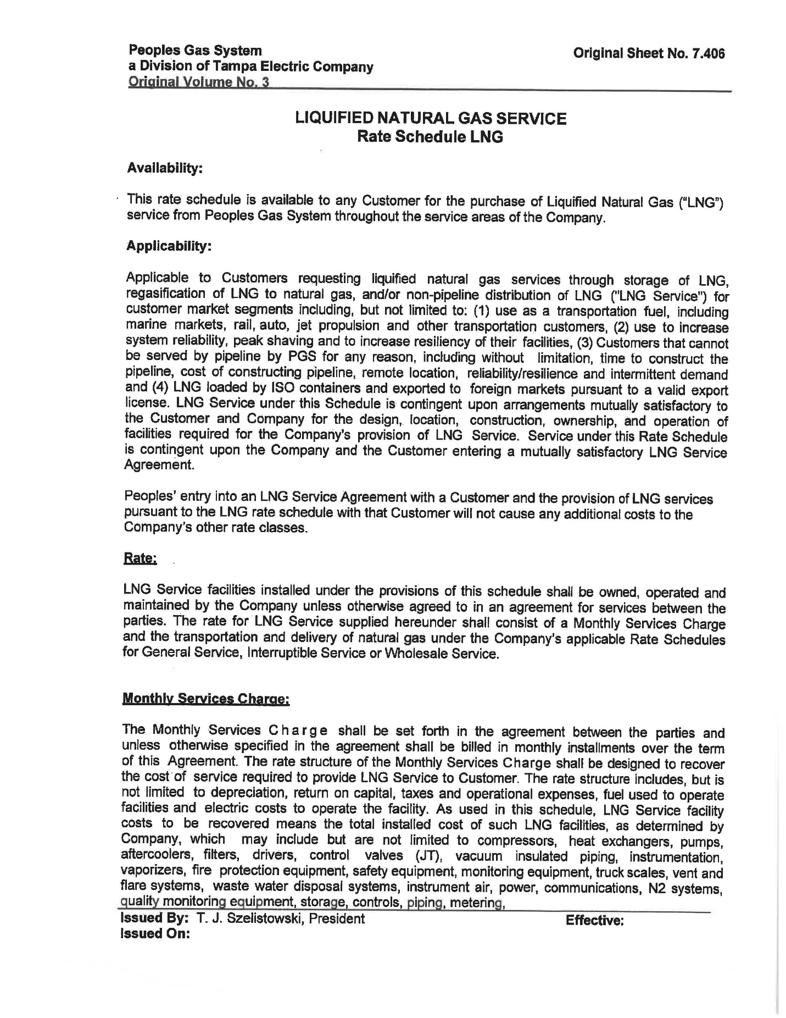

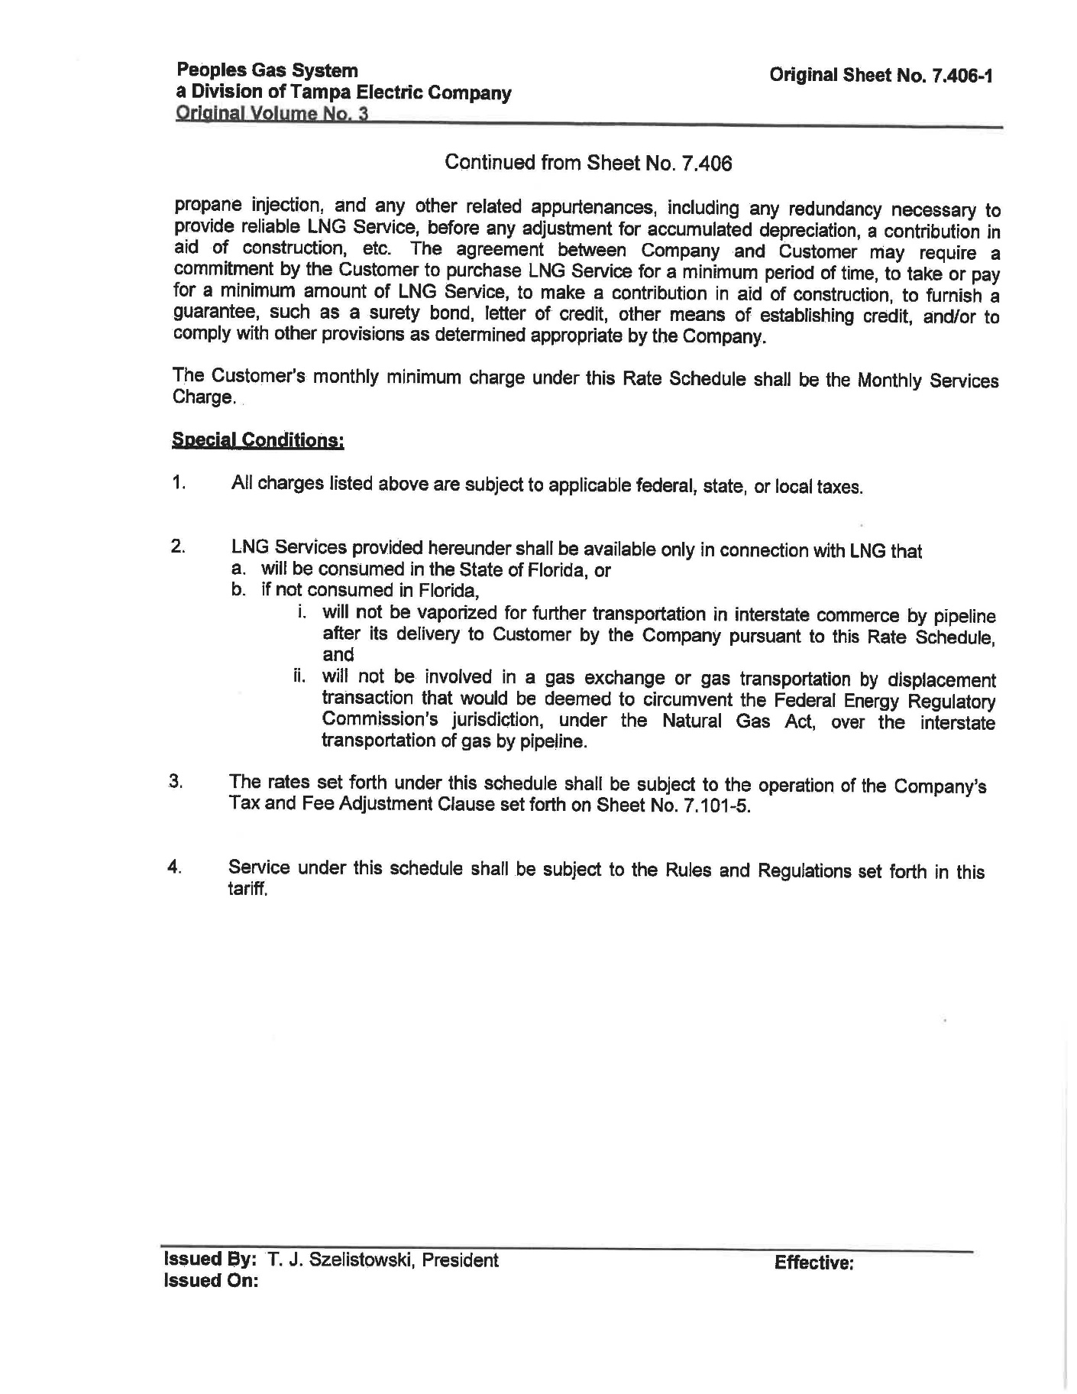

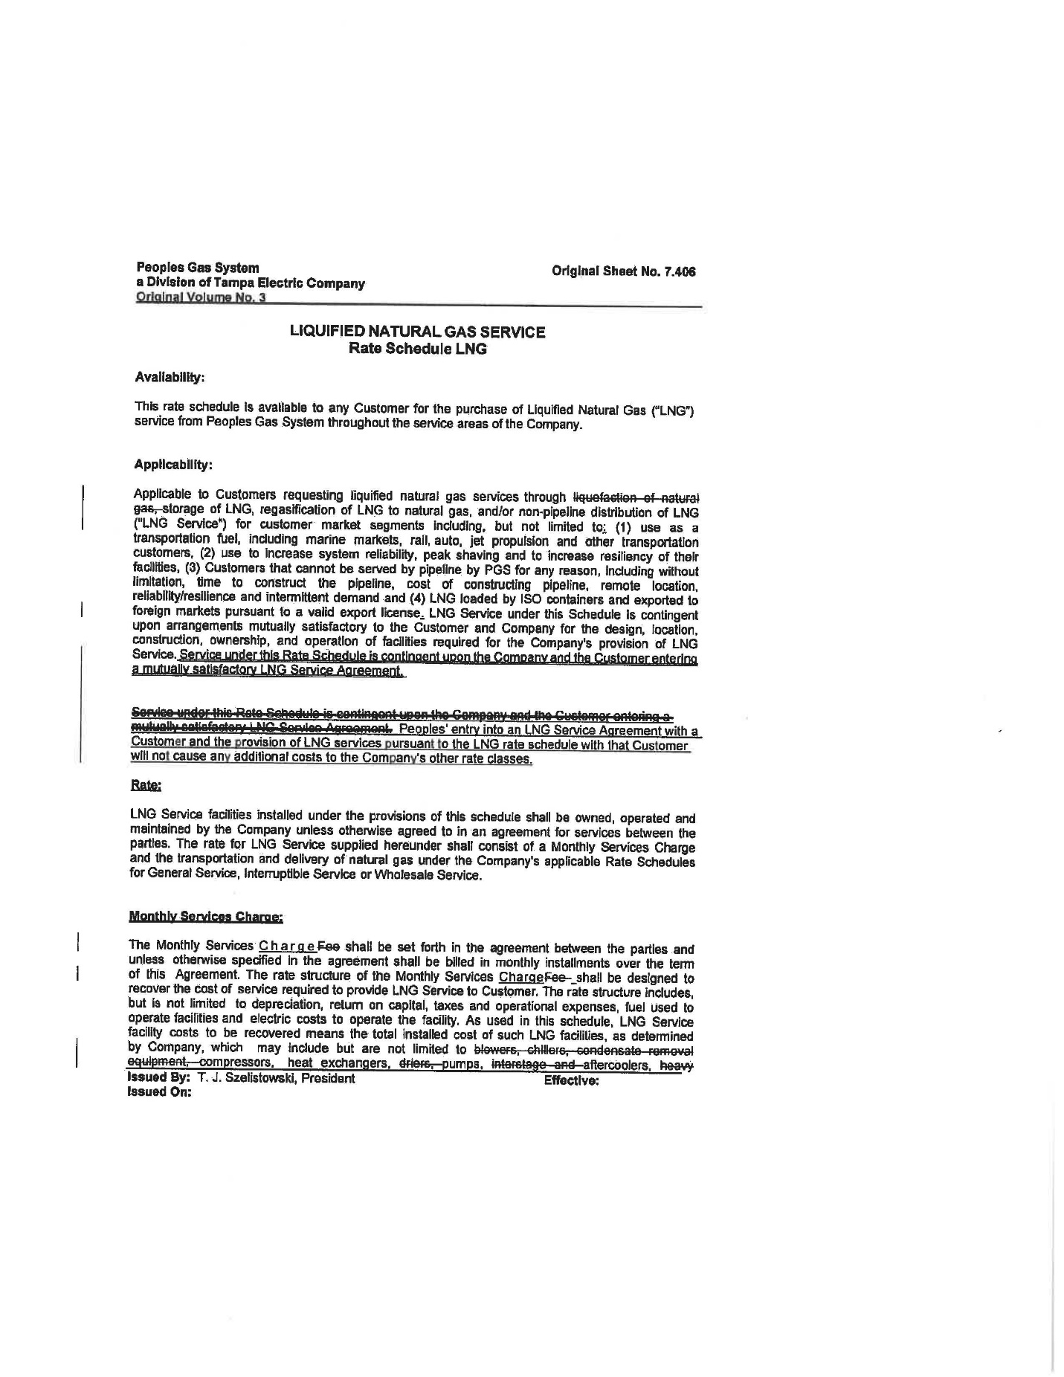

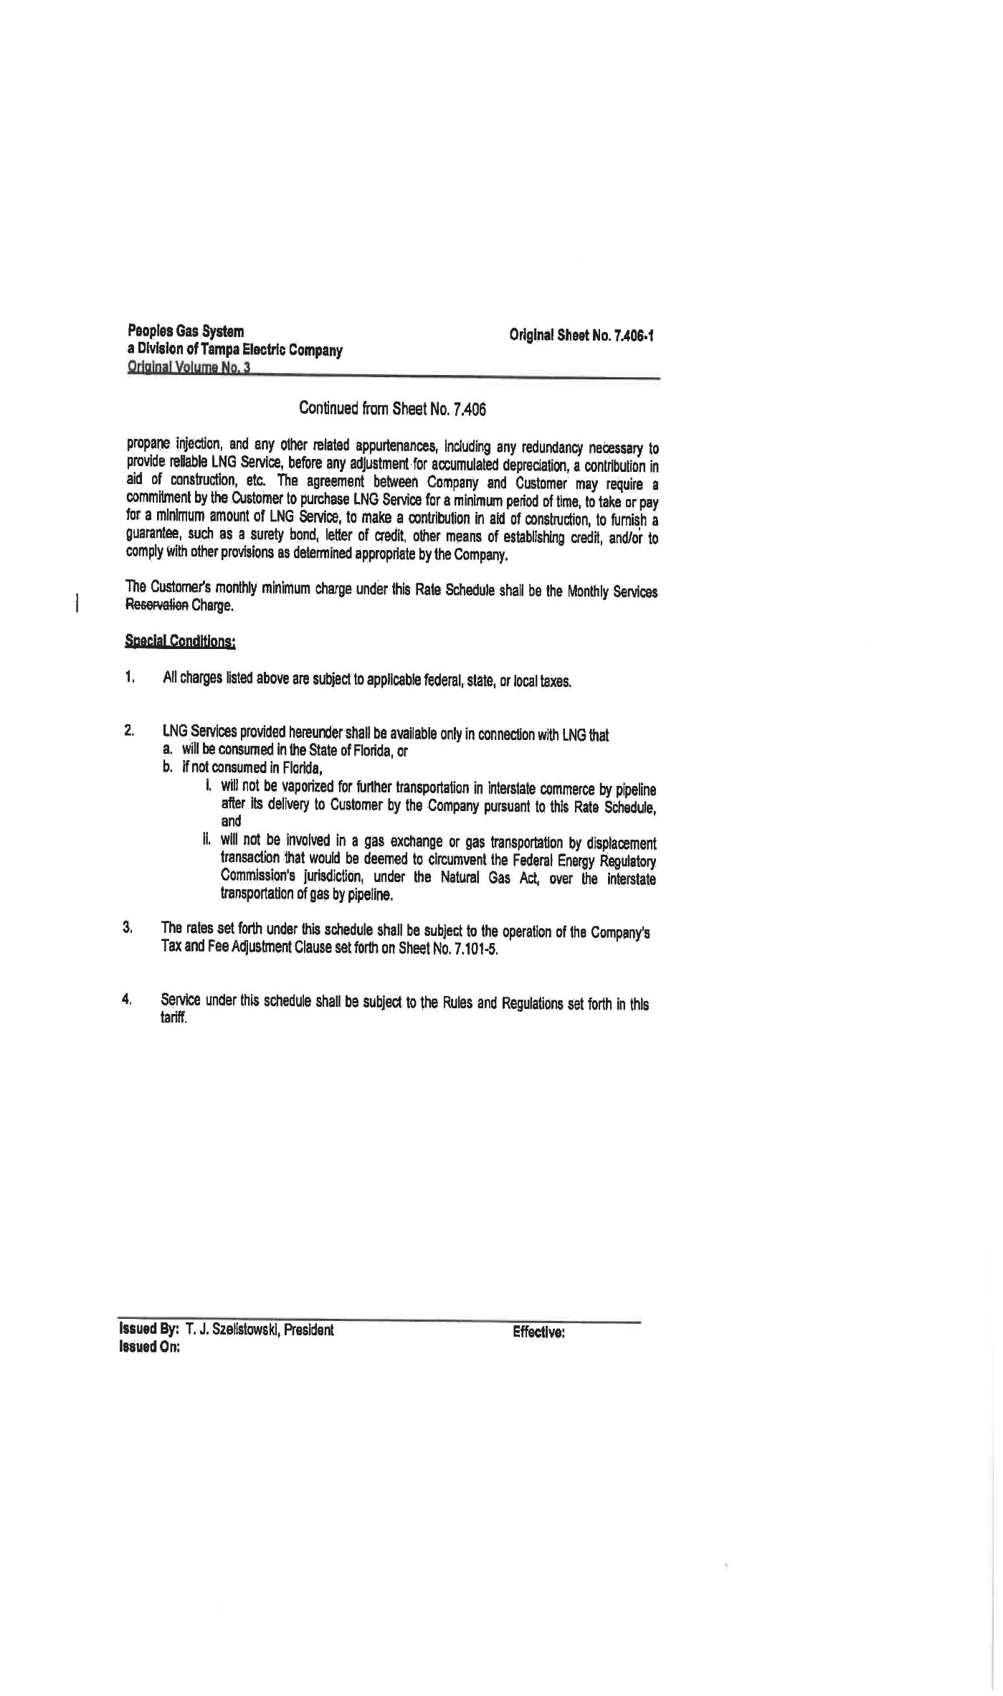
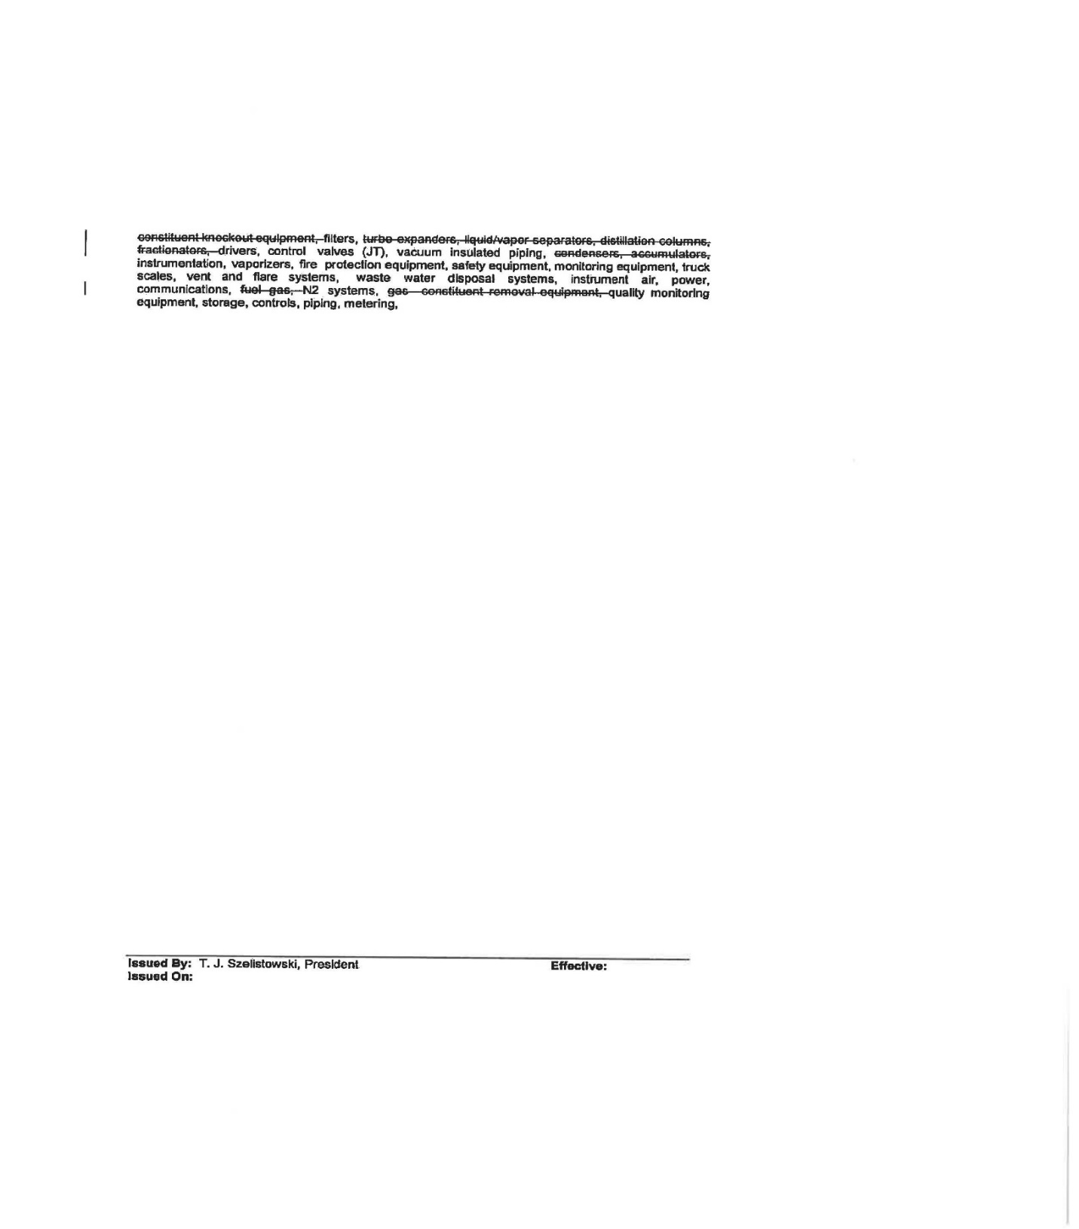

Document No. 01864-2020.
Interested persons in the docket are: Eagle LNG Partners LLC, Thigpen Solutions LLC, Applied LNG Technologies LLC, Zion Jacksonville LLC, and Nopetro – CH4 Holdings LLC.
Document No. 02719-2020.
Document No. 04200-2020.
Document No. 04409-2020.
Document No. 04754-2020.
Document No. 04081-2021.
Peoples’ response to staff’s second data request No. 2 (Document No. 04280-2020).
Order No. 25626, issued January 22, 1992, Docket No. 910942-EG, In re: Petition for approval of Natural Gas Vehicle Conservation Program by Peoples Gas System, Inc.
Order No. PSC-2017-0195-TRF-GU, issued May 19, 2017, Docket No. 170038-GU, In re: Request for approval of tariff modifications related to natural gas vehicles and fueling facilities by Peoples Gas System.
Order No. PSC-2017-0497-TRF-GU, issued December 29, 2017, Docket No. 20170206-GU, In re: Petition for approval of tariff modifications to accommodate receipt and transportation of renewable natural gas from customers, by Peoples Gas System.
Order No. PSC 2020-0459-PCO-GU, issued January 25, 2021, Docket No. 20200214-GU, in Re: Request for approval of tariff modifications to accommodate receipt and transportation of renewable natural gas from customers, by Florida City Gas.
Peoples’ response to staff’s third data request No. 3 (Document No. 03296-2021).
Peoples’ response to staff’s second data request No. 2 (Document No. 04280-2020).
Peoples’ response to staff’s first data request No. 3 (Document No. 02065-2020).
Peoples’ response to staff’s third data request No. 2 (Document No. 03296-2021).
Peoples’ response to staff’s second data request No. 1 (Document No. 04280-2020).
Docket No. 20200003-GU, In re: Purchased gas adjustment (PGA) true-up.
Order No. PSC-2017-0195-TRF-GU, issued May 19, 2017, Docket No. 2010038-GU, In re: Request for approval of tariff modifications related to natural gas vehicles and fueling facilities by Peoples Gas System.

