BEFORE THE FLORIDA PUBLIC SERVICE COMMISSION

In re: Petition for approval to implement a temporary storm cost recovery surcharge, by St. Joe Natural Gas Company. | DOCKET NO. 20200039-GU  ORDER NO. PSC-2021-0196-AS-GU  ISSUED: June 3, 2021

The following Commissioners participated in the disposition of this matter:

GARY F. CLARK, Chairman
ART GRAHAM
ANDREW GILES FAY
MIKE LA ROSA

FINAL ORDER APPROVING SETTLEMENT AGREEMENT

BY THE COMMISSION:

Background
On January 24, 2020, St. Joe Natural Gas Company (SJNG or Company) filed a petition to recover $381,512 in incremental storm restoration costs associated with Hurricane Michael. In the petition, the Company stated that it had incurred incremental costs of $312,012 and projected $60,500 in remaining costs to restore its gas system to pre-storm condition. By Order No. PSC-2020-0066-PCO-GU, issued March 2, 2020, the Office of Public Counsel’s (OPC) intervention was acknowledged. On March 20, 2020, we issued an order allowing SJNG to implement an interim storm recovery surcharge beginning May 1, 2020. On February 19, 2021, SJNG filed a request to approve final costs based on an actual amount of $402,720 in incremental storm restoration costs.
On March 25, 2021, SJNG and OPC (the Parties) filed a Joint Petition for Approval of Stipulation and Settlement (Settlement Agreement). The Settlement Agreement is attached as Attachment A. The Settlement Agreement includes adjustments to the recoverable storm amount, an adjustment to base rates after the storm surcharge terminates, and storm restoration cost process improvements to facilitate cost effective and timely storm damage recovery and service restoration.
The Settlement Agreement allows SJNG to recover $330,115 in storm costs through its current storm charge levels established by Order No. PSC-2020-0117-PCO-GU. The storm surcharge will be extended through December 2024 at which time the surcharge will cease. Any under or over-recovery will be handled through the Natural Gas Conservation Cost Recovery Clause.
The Parties agree that it is appropriate for SJNG to record $77,761 associated with the remaining life value of lost capital assets in a regulatory asset and recover said amount over a period of 10 years through an increase to the Company’s base rates. The increase will be implemented after the storm surcharge terminates.

We have jurisdiction over this matter pursuant to Sections 366.04, 366.05, and 366.06, Florida Statutes (F.S.).
Decision
The standard for approval of a settlement agreement is whether it is in the public interest. A determination of whether a settlement is in the public interest requires a case-specific analysis based on consideration of the proposed settlement taken as a whole.
The Agreement contains a series of stipulations regarding storm cost recovery for SJNG. These stipulations address all issues raised by OPC in this docket. The Parties contend that approval of the Agreement is in the public interest for a number of reasons, foremost of which are promoting efficiency and avoiding the expense and delay of litigation. The Parties assert that the Settlement results in rates that are fair, just, and reasonable.

Having carefully reviewed the Agreement, we find that, taken as a whole, the Agreement provides a reasonable resolution of the issues. We find, therefore, that the Agreement, Attachment A hereto, is in the public interest, and we hereby approve it.

Based on the foregoing, it is

ORDERED by the Florida Public Service Commission that the Joint Petition for Approval of Stipulation and Settlement filed March 25, 2021, is granted. It is further

ORDERED that the Agreement attached hereto as Attachment A, and incorporated by reference, is hereby approved. It is further

ORDERED that this docket shall be closed.

By ORDER of the Florida Public Service Commission this 3rd day of June, 2021.

/s/ Adam J. Teitzman
ADAM J. TEITZMAN
Commission Clerk
Florida Public Service Commission
2540 Shumard Oak Boulevard
Tallahassee, Florida 32399
(850) 413-6770
www.floridapsc.com

Copies furnished: A copy of this document is provided to the parties of record at the time of issuance and, if applicable, interested persons.

SPS

NOTICE OF FURTHER PROCEEDINGS OR JUDICIAL REVIEW

The Florida Public Service Commission is required by Section 120.569(1), Florida Statutes, to notify parties of any administrative hearing or judicial review of Commission orders that is available under Sections 120.57 or 120.68, Florida Statutes, as well as the procedures and time limits that apply. This notice should not be construed to mean all requests for an administrative hearing or judicial review will be granted or result in the relief sought.

Any party adversely affected by the Commission's final action in this matter may request: 1) reconsideration of the decision by filing a motion for reconsideration with the Office of Commission Clerk, 2540 Shumard Oak Boulevard, Tallahassee, Florida 32399-0850, within fifteen (15) days of the issuance of this order in the form prescribed by Rule 25-22.060, Florida Administrative Code; or 2) judicial review by the Florida Supreme Court in the case of an electric, gas or telephone utility or the First District Court of Appeal in the case of a water and/or wastewater utility by filing a notice of appeal with the Office of Commission Clerk, and filing a copy of the notice of appeal and the filing fee with the appropriate court. This filing must be completed within thirty (30) days after the issuance of this order, pursuant to Rule 9.110, Florida Rules of Appellate Procedure. The notice of appeal must be in the form specified in Rule 9.900(a), Florida Rules of Appellate Procedure.

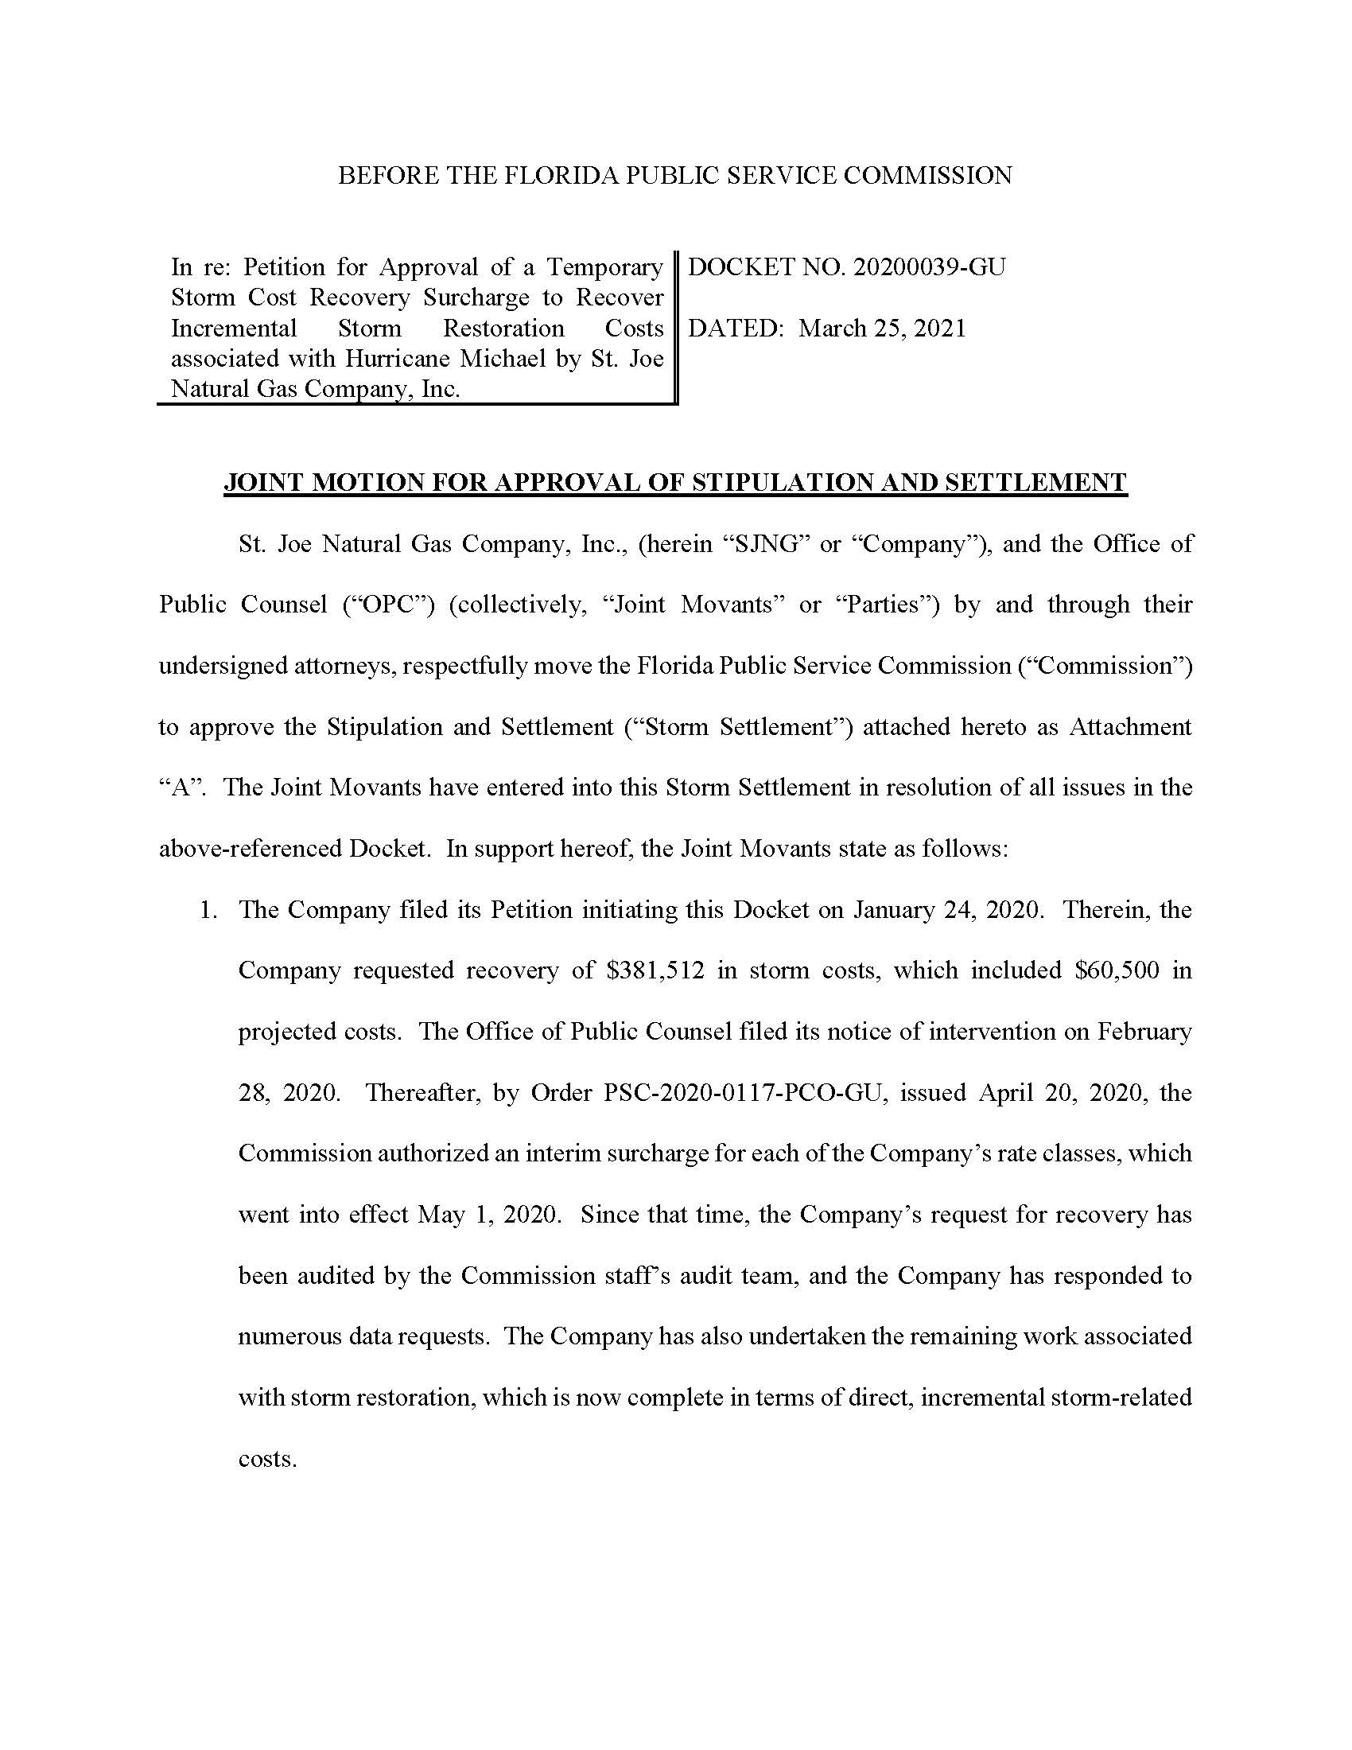

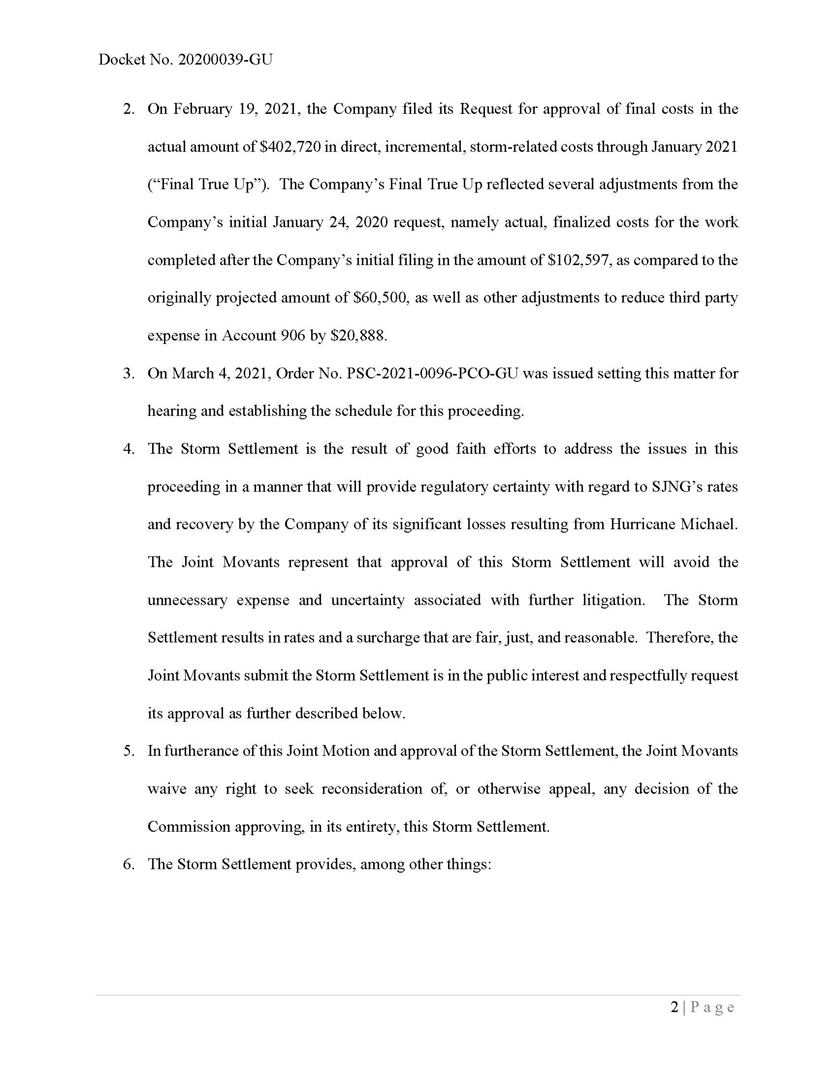

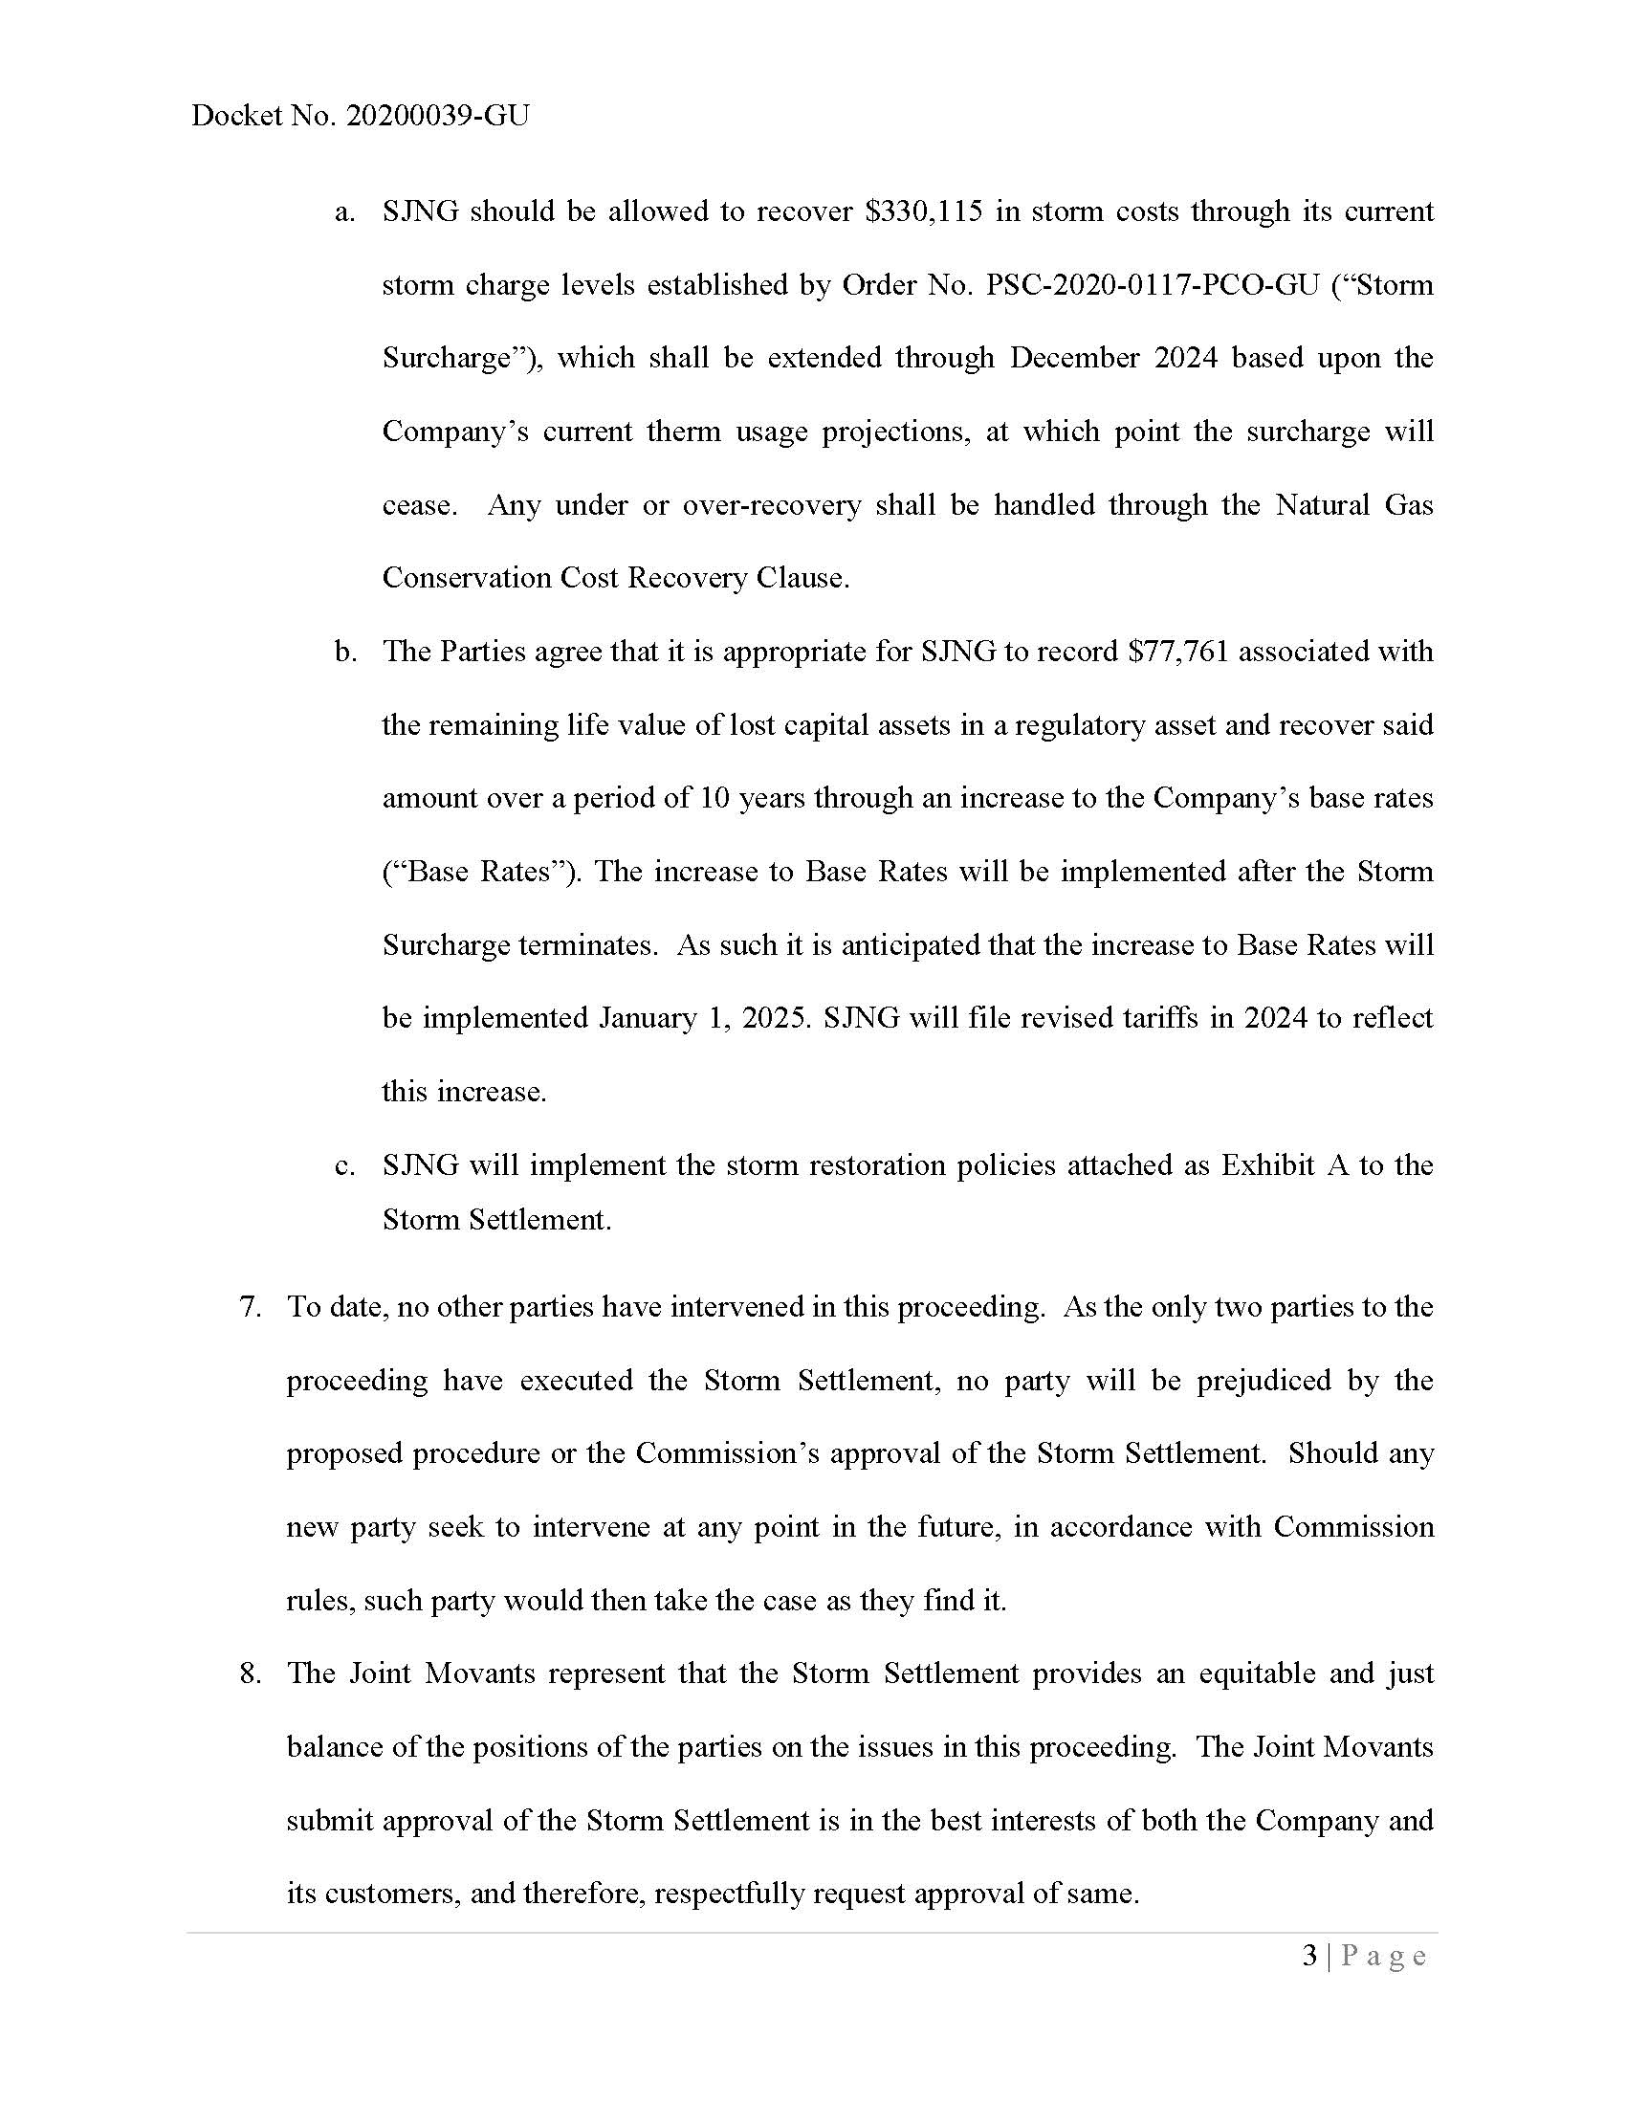

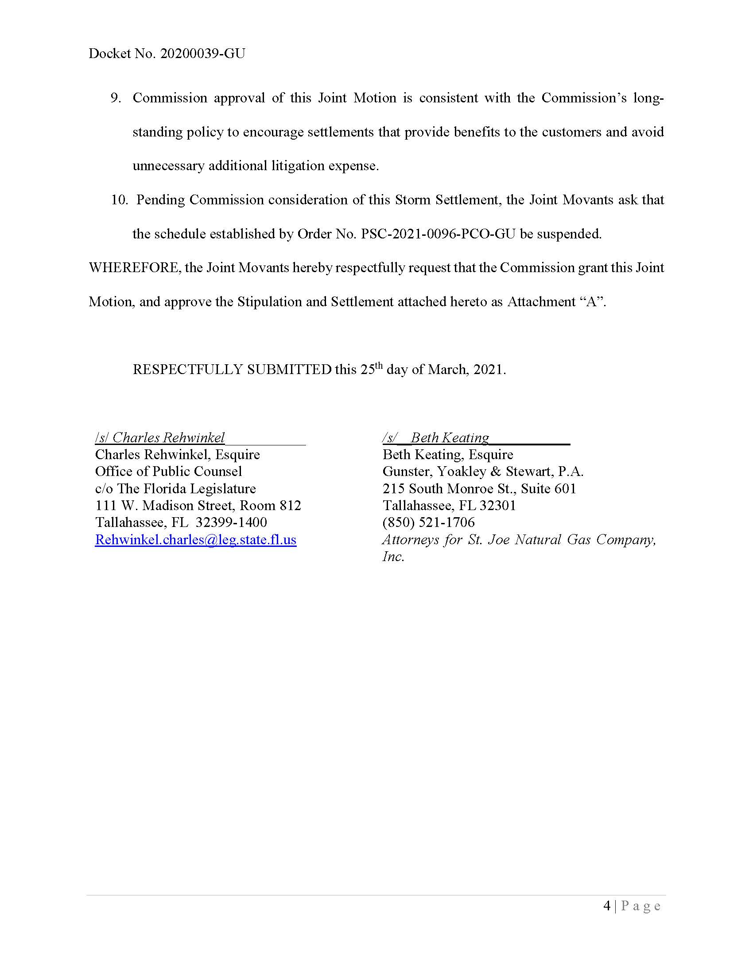

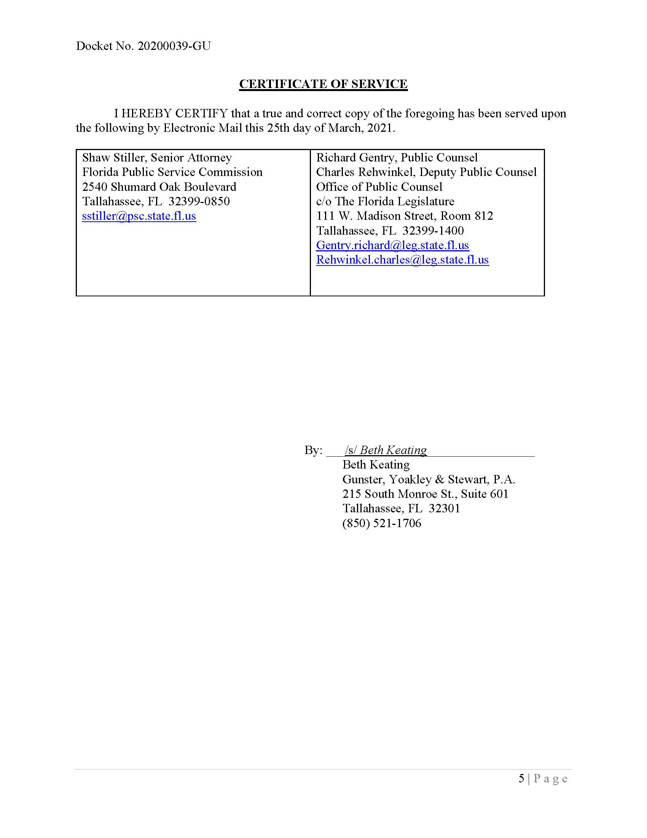

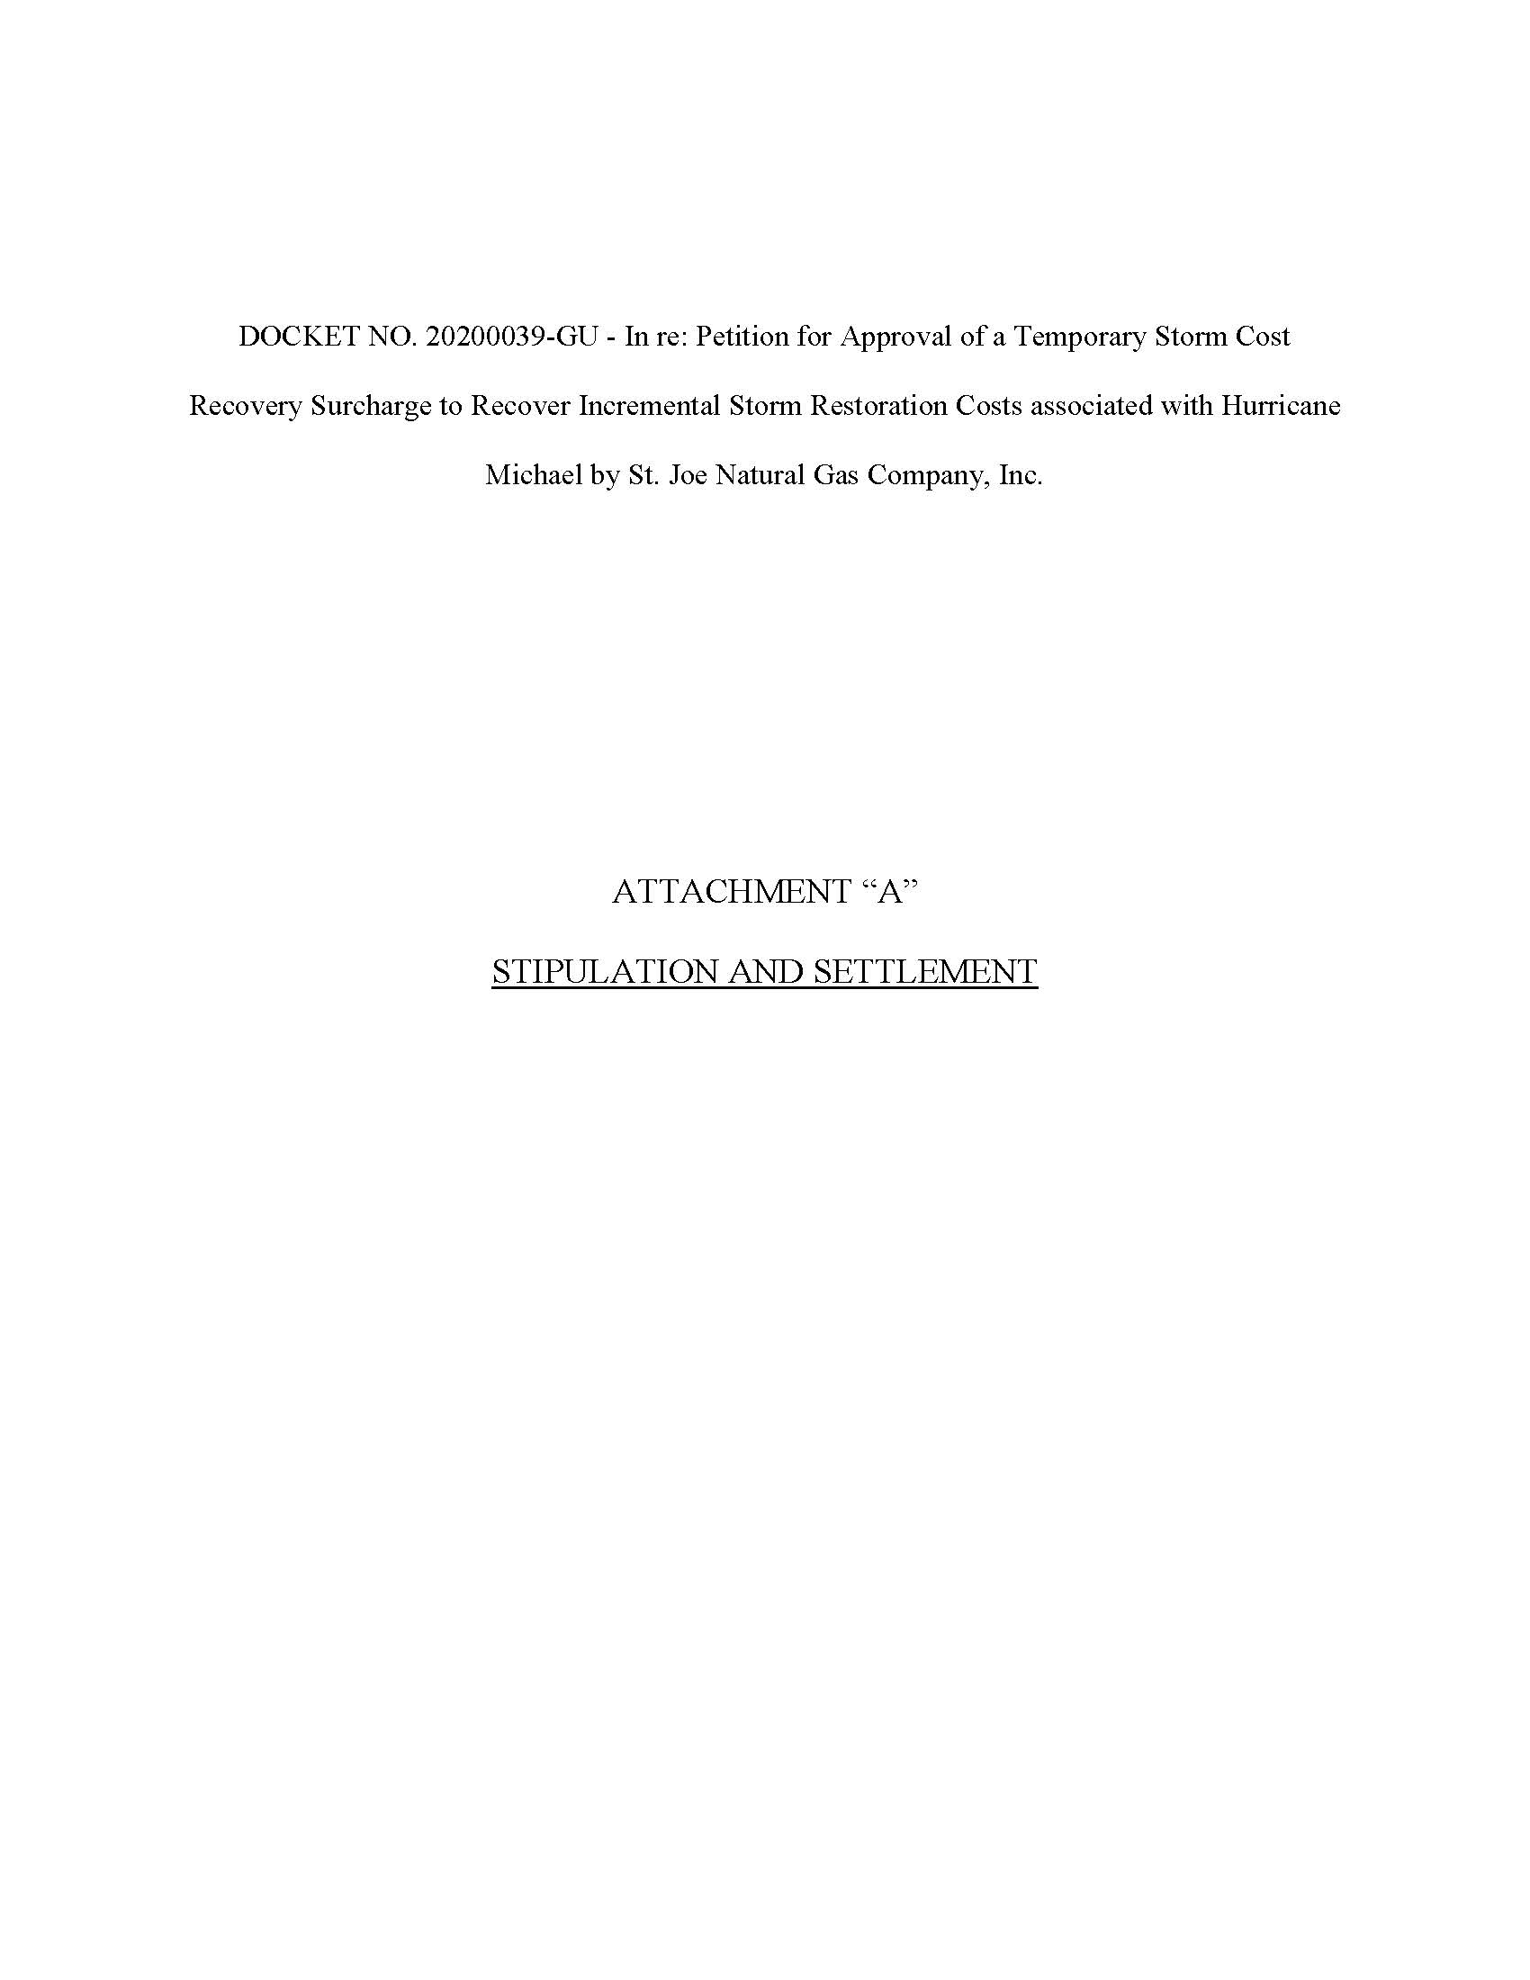

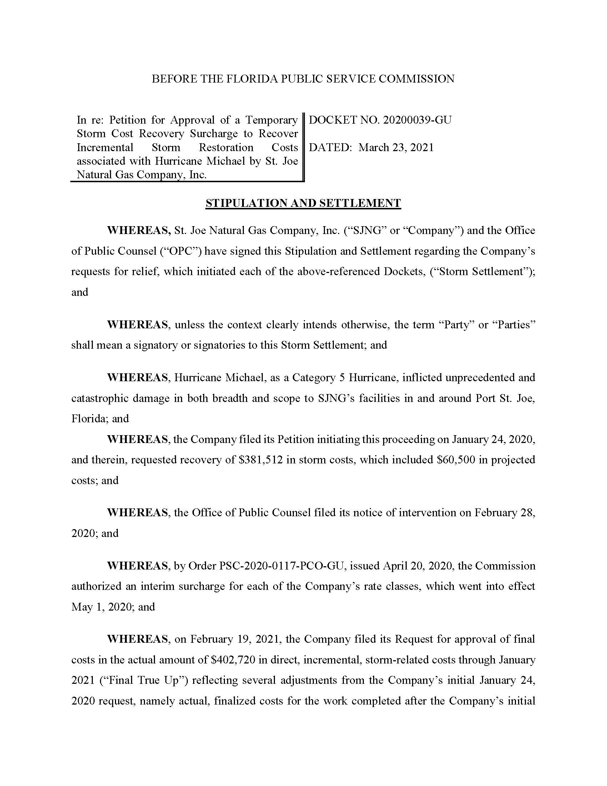

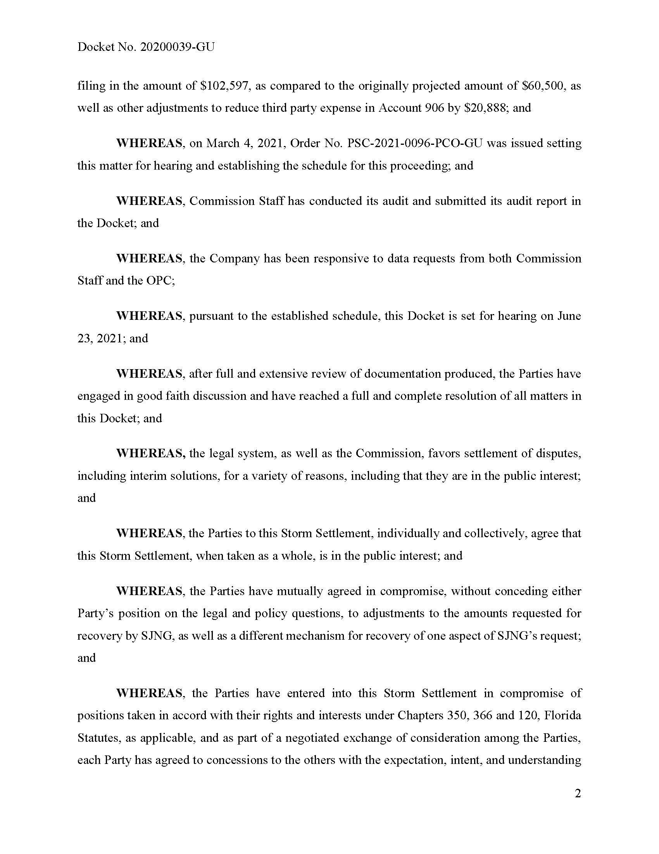

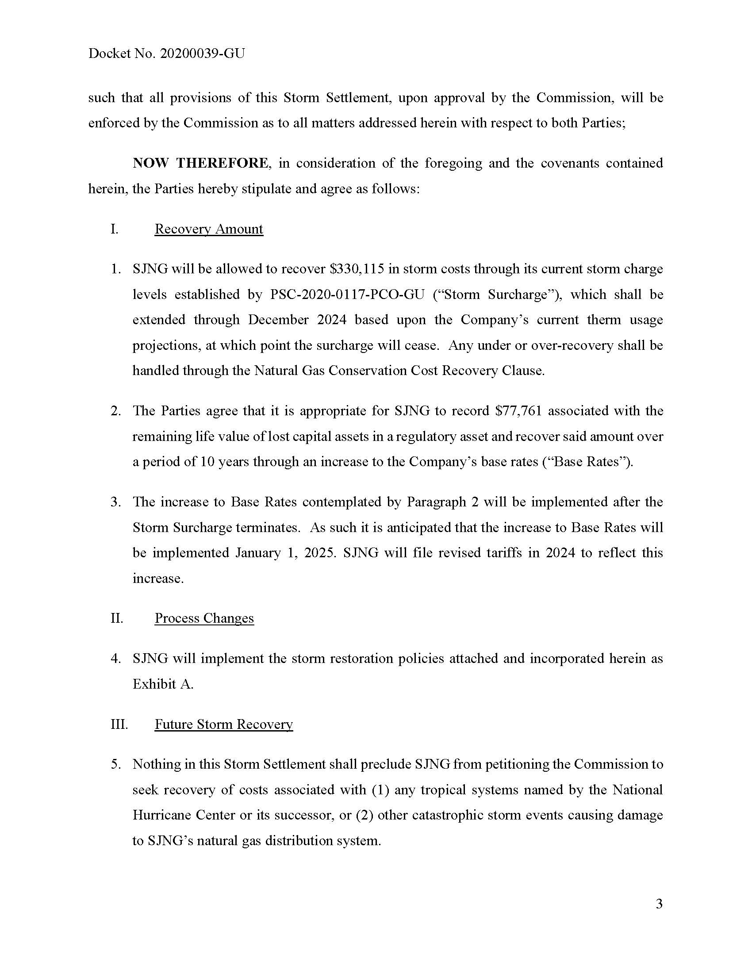

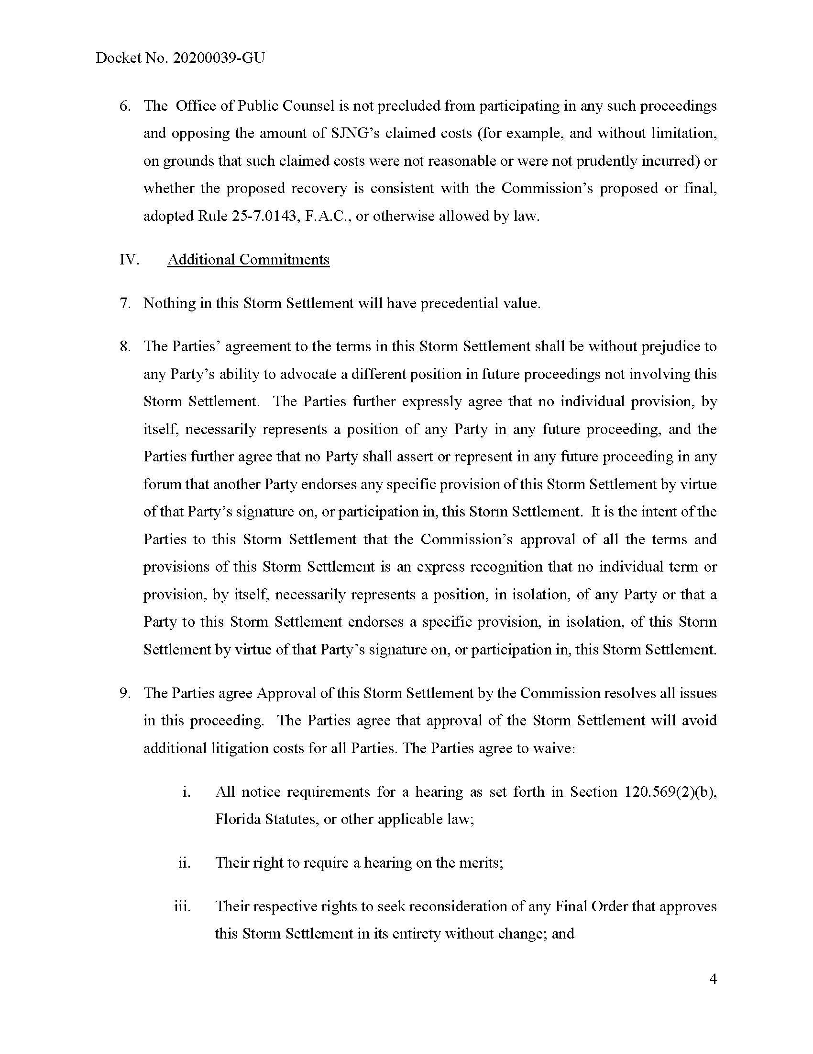

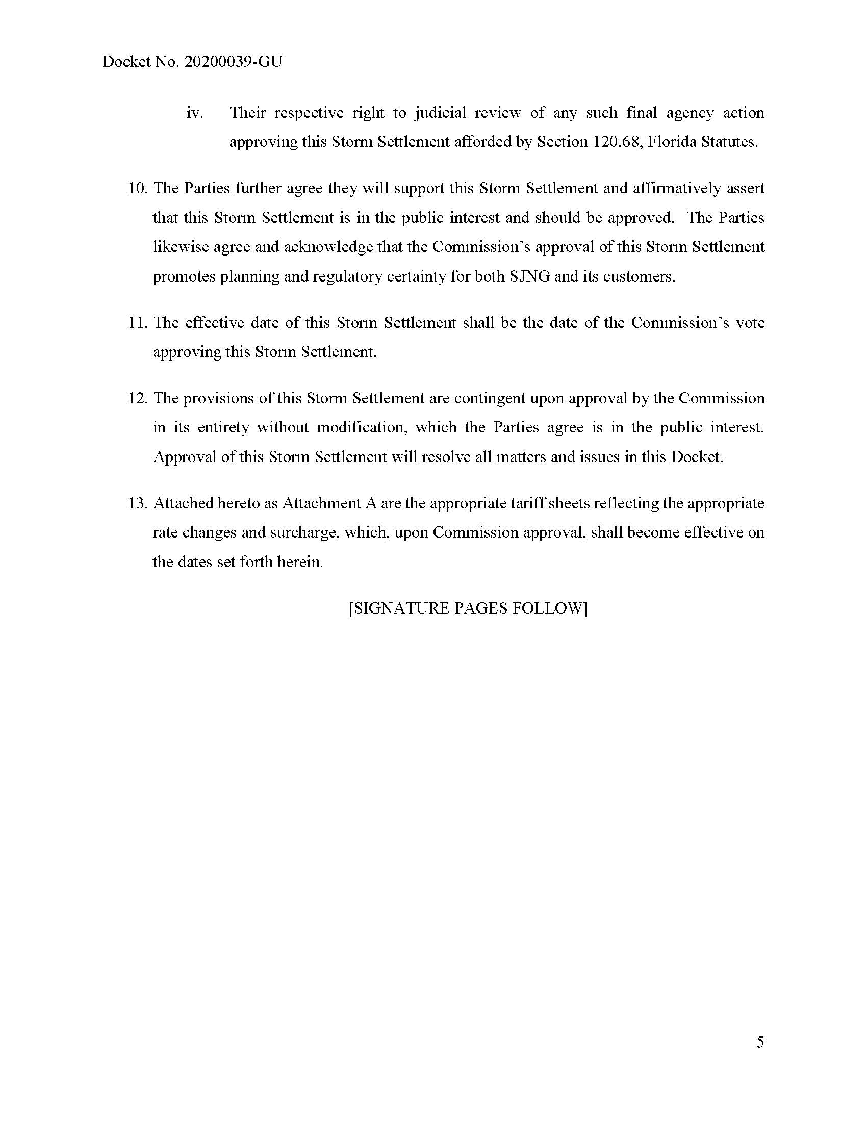

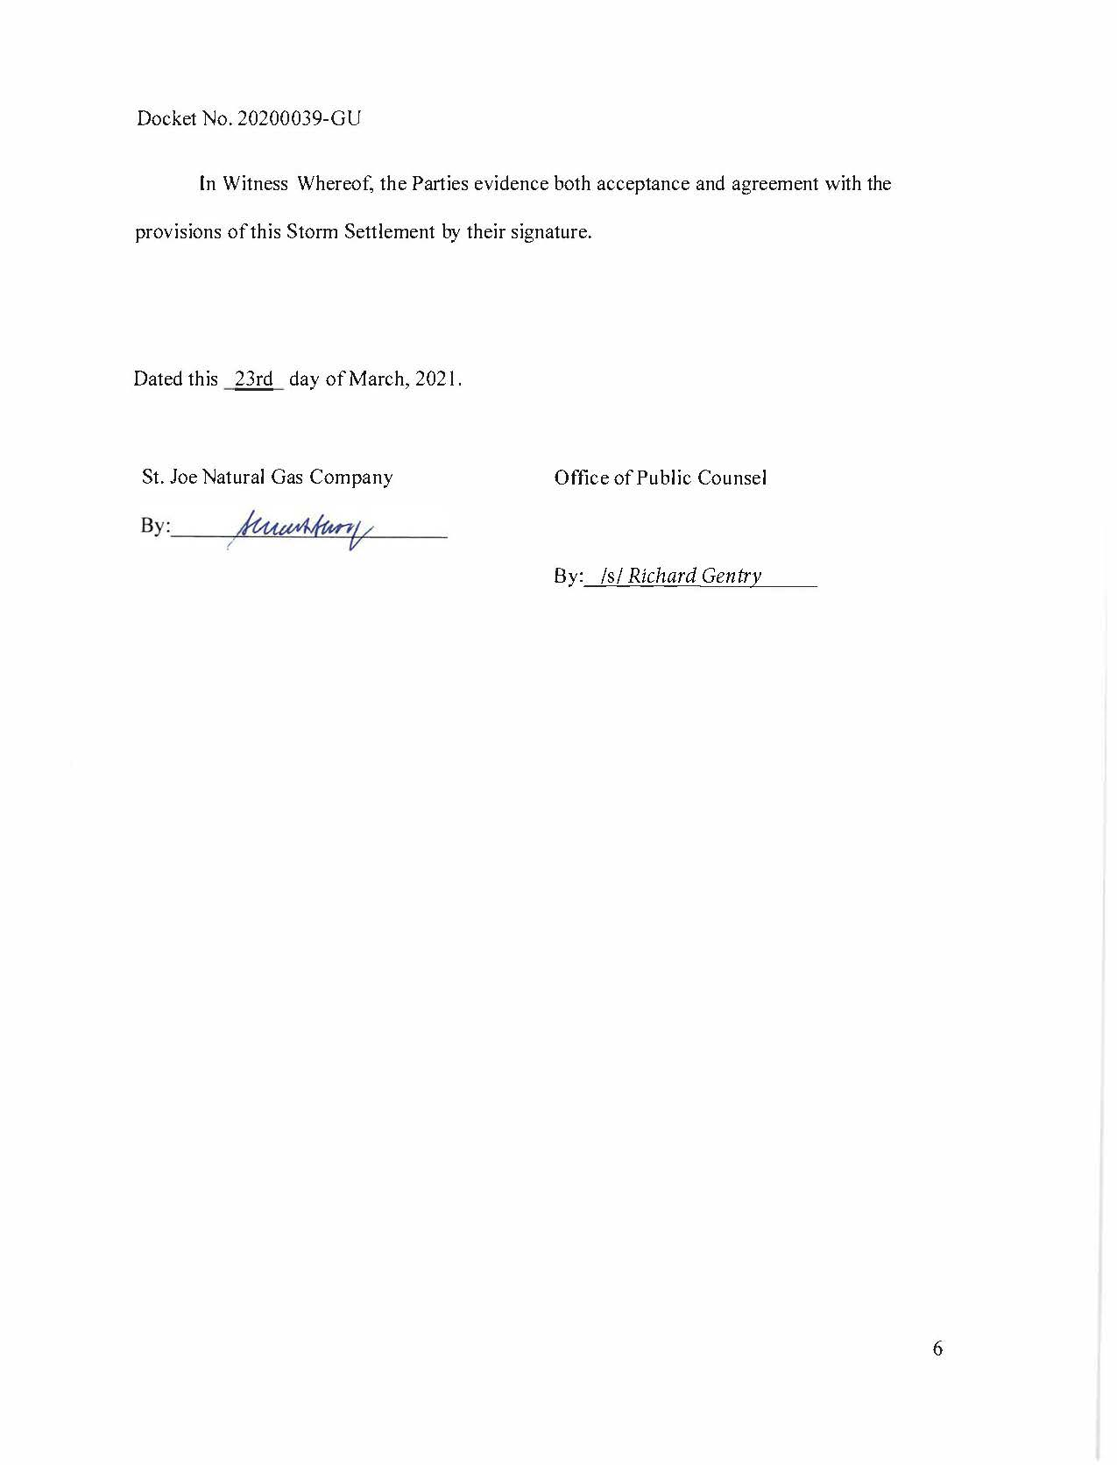

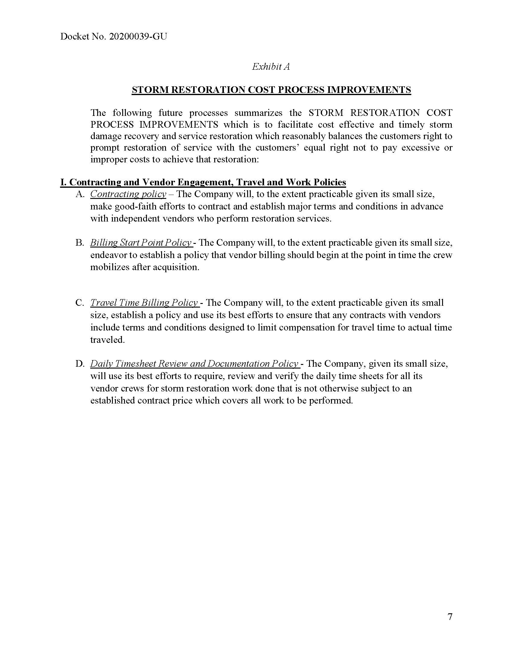

Order No. PSC-2020-0117-PCO-GU, issued April 20, 2020, in Docket No. 20200039-GU, In re: Petition for approval to implement a temporary storm cost recovery surcharge, by St. Joe Natural Gas Company.
Sierra Club v. Brown, 243 So. 3d 903, 910-913 (Fla. 2018); Order No. PSC-13-0023-S-EI, issued on January 14, 2013, in Docket No. 120015-EI, In re: Petition for increase in rates by Florida Power & Light Company; Order No. PSC-11-0089-S-EI, issued February 1, 2011, in Docket Nos. 080677-EI and 090130-EI, In re: Petition for increase in rates by Florida Power & Light Company and In re: 2009 depreciation and dismantlement study by Florida Power & Light Company; Order No. PSC-10-0398-S-EI, issued June 18, 2010, in Docket Nos. 090079-EI, 090144-EI, 090145-EI, and 100136-EI, In re: Petition for increase in rates by Progress Energy Florida, Inc., In re: Petition for limited proceeding to include Bartow repowering project in base rates, by Progress Energy Florida, Inc., In re: Petition for expedited approval of the deferral of pension expenses, authorization to charge storm hardening expenses to the storm damage reserve, and variance from or waiver of Rule 25-6.0143(1)(c), (d), and (f), F.A.C., by Progress Energy Florida, Inc., and In re: Petition for approval of an accounting order to record a depreciation expense credit, by Progress Energy Florida, Inc.; Order No. PSC-05-0945-S-EI, issued September 28, 2005, in Docket No. 050078-EI, In re: Petition for rate increase by Progress Energy Florida, Inc.
Order No. PSC-13-0023-S-EI, at p. 7.

