BEFORE THE FLORIDA PUBLIC SERVICE COMMISSION

In re: Application for designation as an eligible telecommunications carrier to receive rural digital opportunity fund auction (Auction 904) support for voice and broadband services and request for expedited consideration, by Bright House Networks Information Services (Florida), LLC. | DOCKET NO. 20210013-TX  ORDER NO. PSC-2021-0222-PAA-TX  ISSUED: June 17, 2021

The following Commissioners participated in the disposition of this matter:

GARY F. CLARK, Chairman
ART GRAHAM
ANDREW GILES FAY
MIKE LA ROSA
GABRIELLA PASSIDOMO

ORDER GRANTING FLORIDA
ELIGIBLE TELECOMMUNICATIONS CARRIER STATUS
TO
BRIGHT HOUSE NETWORKS INFORMATION SERVICES (FLORIDA), LLC

BY THE COMMISSION:

Case Background
On January 6, 2021, Bright House Networks Information Services (Florida), LLC (Bright House or Company) filed a petition with the Florida Public Service Commission (Commission) seeking designation as an eligible telecommunications carrier (ETC) to receive rural digital opportunity fund (RDOF) support. Bright House was granted competitive local exchange carrier certificate No. 8015 in 2002 under the name “Time Warner Cable Information Services (Florida) LLC.” Bright House is a majority-owned and wholly-controlled subsidiary of Charter Communications, Inc. (Charter). Charter provides customers with voice over internet protocol (VoIP) and broadband services under the brand name “Spectrum.” Bright House and its affiliates “offer a variety of services, some of which are regulated telecommunications services and some of which are not.” On December 7, 2020, Charter’s subsidiary CCO Holdings was selected as one of the winning bidders for the Federal Communications Commission’s (FCC) RDOF auction. Consistent with FCC rules, CCO Holdings assigned its winning bid to Bright House, its affiliate operating in Florida.

The RDOF is a form of high-cost support and is funded through the federal universal service fund (USF). The FCC’s RDOF initiative allocates up to $20.4 billion through a two-phase competitive auction to help connect millions of unserved rural homes and small businesses to high-speed broadband. Phase I of the auction will provide up to $16 billion to be used over a period of 10 years to service providers that commit to offer voice and broadband services to fixed locations in eligible unserved high-cost census blocks. In Florida, a total of 11 bidders were selected to receive approximately $192 million of high-cost support in phase I. Bright House will receive $22.5 million in phase I to be used in specified census blocks in Florida.

An ETC designation is a requirement for telecommunications carriers to receive USF dollars for the Lifeline and High-Cost programs. The Lifeline program enables low-income households to obtain and maintain basic telephone and broadband services, and offers qualifying households a discount on monthly bills. The High-Cost program helps carriers provide voice and broadband service in remote and underserved communities. Although the FCC did not require RDOF auction participants to be designated as an ETC to apply, the FCC did require winning bidders to obtain ETC designation within 180 days of being selected.
47 U.S.C. 214(e)(2) authorizes state commissions to designate common carriers as follows:
(2) Designation of eligible telecommunications carriers
A State commission shall upon its own motion or upon request designate a common carrier that meets the requirements of paragraph (1) as an eligible telecommunications carrier for a service area designated by the State commission. Upon request and consistent with the public interest, convenience, and necessity, the State commission may, in the case of an area served by a rural telephone company, and shall, in the case of all other areas, designate more than one common carrier as an eligible telecommunications carrier for a service area designated by the State commission, so long as each additional requesting carrier meets the requirements of paragraph (1). Before designating an additional eligible telecommunications carrier for an area served by a rural telephone company, the State commission shall find that the designation is in the public interest.
47 U.S.C. 214(e)(6) provides that the FCC will make such ETC designations in cases where a state commission lacks jurisdiction over the common carrier as follows:
(6) Common carriers not subject to State commission jurisdiction
In the case of a common carrier providing telephone exchange service and exchange access that is not subject to the jurisdiction of a State commission, the [FCC] shall upon request designate such a common carrier that meets the requirements of paragraph (1) as an eligible telecommunications carrier for a service area designated by the [FCC] consistent with applicable Federal and State law. Upon request and consistent with the public interest, convenience and necessity, the [FCC] may, with respect to an area served by a rural telephone company, and shall, in the case of all other areas, designate more than one common carrier as an eligible telecommunications carrier for a service area designated under this paragraph, so long as each additional requesting carrier meets the requirements of paragraph (1). Before designating an additional eligible telecommunications carrier for an area served by a rural telephone company, the [FCC] shall find that the designation is in the public interest.
Bright House asserts that it meets all applicable federal requirements for designation as an ETC in Florida pursuant to 47 U.S.C. 214(e) and 47 C.F.R. 54.201. On February 9, 2021, Bright House filed Supplemental Authority in Support (Supplemental Filing) of its ETC application in which the Company clarified that, although its corporate affiliates offer a retail VoIP service that is not a telecommunications service, the Company offers switched access service and local interconnection service that are telecommunications services. The Company further clarified that these services are offered to the public for hire in Florida by the use of mixed-use facilities that also include telecommunications related equipment and facilities.

Bright House acknowledges and asserts that, if approved, it will comply with Sections 364.10 and 364.105, Florida Statutes (F.S.), and Rule 25-4.0665, Florida Administrative Code (F.A.C.), which govern Lifeline service and provide for a transitional discount for those customers no longer eligible for Lifeline.
In addition to the federal rules and statutes discussion above, this Commission has jurisdiction in this matter pursuant to Section 364.10 F.S.

Review and Decision
Pursuant to 47 U.S.C. 214(e)(2), and 47 C.F.R. 54.201(b), state commissions have the primary responsibility to designate carriers as ETCs. In instances where a state lacks jurisdiction, the FCC is to make such a designation. Section 364.10(1)(a), F.S., defines an ETC as “a telecommunications company, as defined by s. 364.02, which is designated as an eligible telecommunications carrier by the [C]ommission pursuant to 47 C.F.R. s. 54.201.” A “telecommunications company” is an entity offering “two-way telecommunications service to the public for hire within [Florida] by the use of a telecommunications facility.” Section 364.02(13), F.S. Thus, whether a carrier is offering a telecommunications service is the threshold question for whether we are authorized to grant an ETC designation. Upon review, we find that, as clarified in its Supplemental Filing, Bright House is a telecommunications company for purposes of receiving an ETC designation in accordance with Section 364.10, F.S., and is certificated as a competitive local exchange carrier. Although we do not have jurisdiction over VoIP providers and “Spectrum Voice” service is an “information service” and not a “telecommunications service,” because Bright House provides telecommunications services in Florida in addition to nonregulated services, the regulatory status of VoIP service is not relevant to our decision in this docket.

To qualify as an ETC, telecommunications carriers must provide the services identified in 47 C.F.R. 54.101 as follows:

(a) Services designated for support. Voice telephony services shall be supported by federal universal service support mechanisms. Eligible voice telephony services must provide voice grade access to the public switched network or its functional equivalent; minutes of use for local service provided at no additional charge to end users; access to emergency services provided by local government or other public safety organizations, such as 911 and enhanced 911, to the extent the local government in an eligible carrier's service area has implemented 911 or enhanced 911 systems; and toll limitation services to qualifying low-income consumers as provided in subpart E of this part.

(b) An eligible telecommunications carrier must offer voice telephony service as set forth in paragraph (a) of this section in order to receive federal universal service support.

(c) An eligible telecommunications carrier (ETC) subject to a high-cost public interest obligation to offer broadband internet access services and not receiving Phase I frozen high-cost support must offer broadband services within the areas where it receives high-cost support consistent with the obligations set forth in this subpart and subparts D, K, L, and M of this part.

(d) Any ETC must comply with subpart E of this part.

In addition, ETCs must advertise the availability of such services and the associated charges using media of general distribution.

We have reviewed Bright House’s petition for ETC designation in Florida, as well as additional documents filed with this Commission. We have confirmed that Bright House meets the requirements to qualify as an ETC in Florida. In addition, the Company has demonstrated sufficient financial, managerial, and technical capabilities.

Furthermore, we note that the FCC awarded CCO Holdings, an affiliate of Bright House, as the winning RDOF bidder in the census blocks for which Bright House is seeking ETC designation. Each Carrier was required, as part of its bid, to acknowledge that it would meet the FCC’s requirements for building out its network and meet the FCC’s minimum broadband service obligations.

47 U.S.C. 214(e)(2) requires state commissions to determine if an ETC designation is consistent with the public interest, convenience, and necessity for rural areas. Bright House asserts that granting it ETC designation will create- significant public and private investment in Florida and provide more access to high-speed broadband internet service in unserved communities. Based upon our review, along with Bright House’s commitment to abide by both state and federal requirements, we find that designating Bright House as an ETC meets the requirements of 47 U.S.C. 214(e)(2).

We find that Bright House meets all requirements for designation as an ETC under Section 364.10, F.S., and applicable federal law. Therefore, Bright House Networks Information Services (Florida), LLC shall be granted ETC designation in the census blocks listed in Attachment A of this Order. If there is a future change of Company ownership, the new owners shall be required to file a petition with this Commission and make a showing of public interest to maintain the Company's ETC designation.

Based on the foregoing, it is

ORDERED by the Florida Public Service Commission that Bright House Networks Information Services (Florida), LLC is hereby granted ETC status in Florida. It is further

ORDERED that if no person whose substantial interests are affected by this proposed agency action files a protest within 21 days of the issuance of the Proposed Agency Action Order, this docket shall be closed upon the issuance of a consummating order.

By ORDER of the Florida Public Service Commission this 17th day of June, 2021.

/s/ Adam J. Teitzman
ADAM J. TEITZMAN
Commission Clerk
Florida Public Service Commission
2540 Shumard Oak Boulevard
Tallahassee, Florida 32399
(850) 413-6770
www.floridapsc.com

Copies furnished: A copy of this document is provided to the parties of record at the time of issuance and, if applicable, interested persons.

CWM

NOTICE OF FURTHER PROCEEDINGS OR JUDICIAL REVIEW

The Florida Public Service Commission is required by Section 120.569(1), Florida Statutes, to notify parties of any administrative hearing that is available under Section 120.57, Florida Statutes, as well as the procedures and time limits that apply. This notice should not be construed to mean all requests for an administrative hearing will be granted or result in the relief sought.

Mediation may be available on a case-by-case basis. If mediation is conducted, it does not affect a substantially interested person's right to a hearing.

The action proposed herein is preliminary in nature. Any person whose substantial interests are affected by the action proposed by this order may file a petition for a formal proceeding, in the form provided by Rule 28-106.201, Florida Administrative Code. This petition must be received by the Office of Commission Clerk, 2540 Shumard Oak Boulevard, Tallahassee, Florida 32399-0850, by the close of business on July 8, 2021.

In the absence of such a petition, this order shall become final and effective upon the issuance of a Consummating Order.

Any objection or protest filed in this/these docket(s) before the issuance date of this order is considered abandoned unless it satisfies the foregoing conditions and is renewed within the specified protest period.

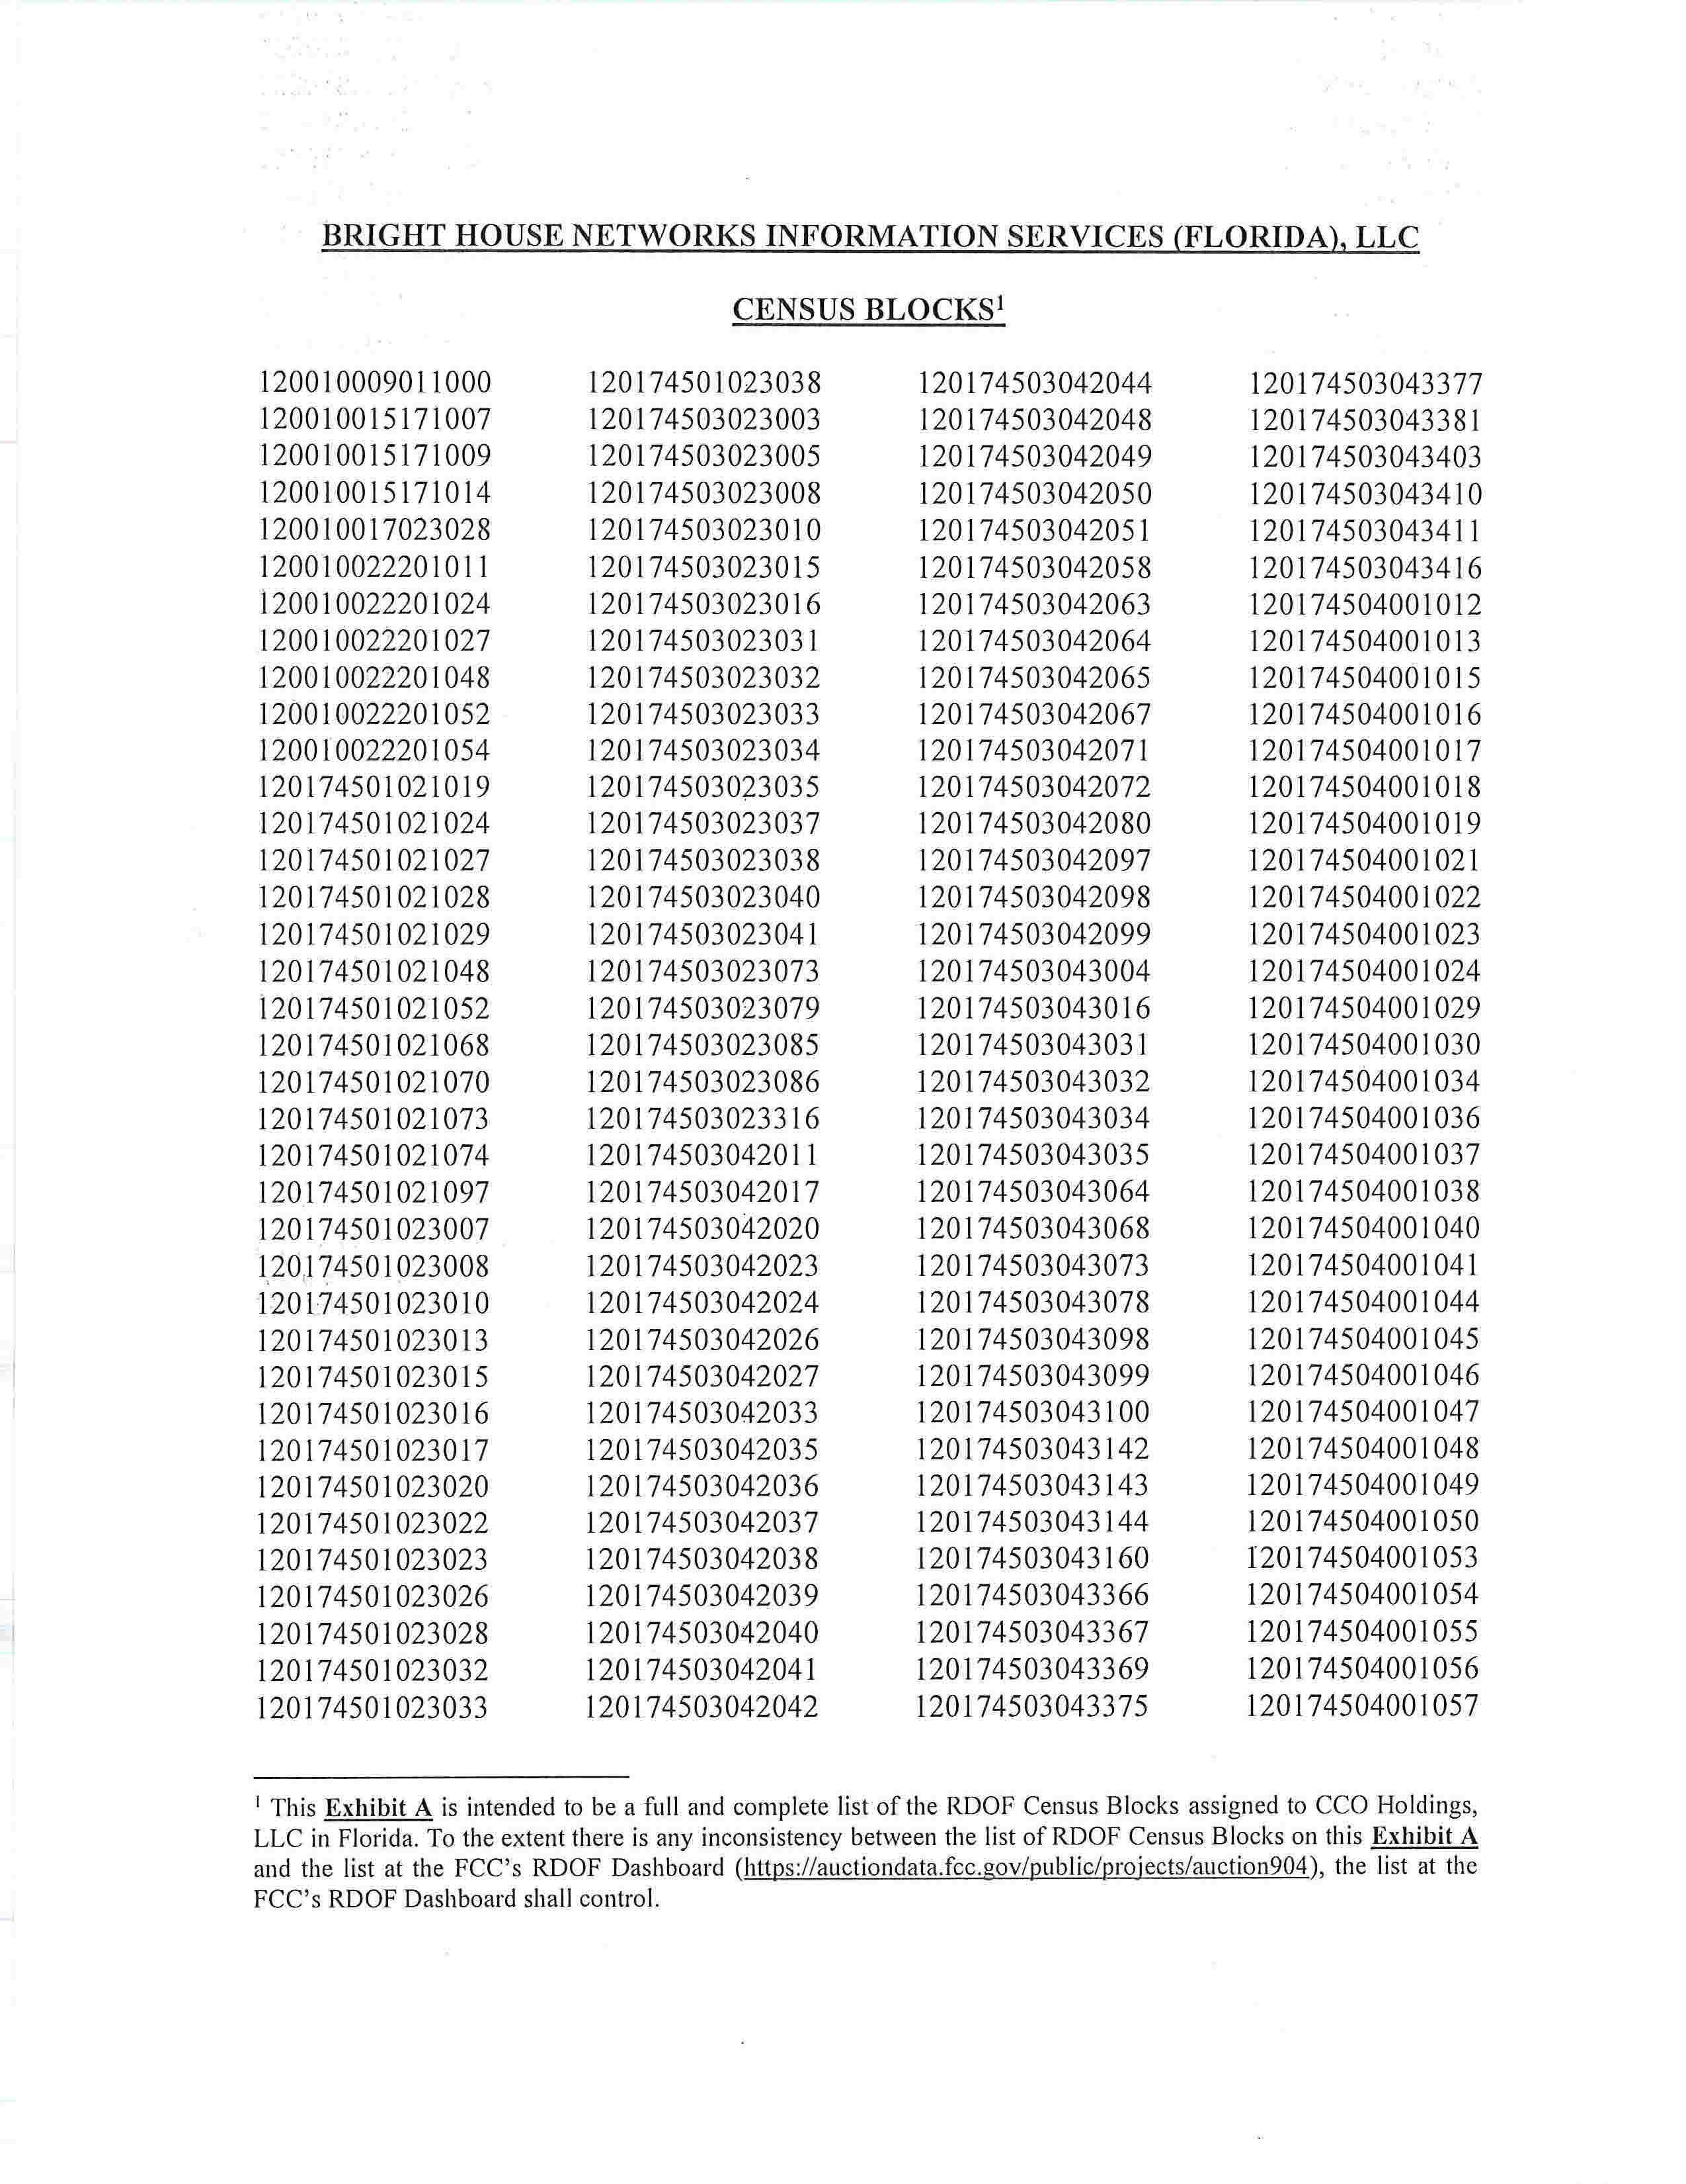
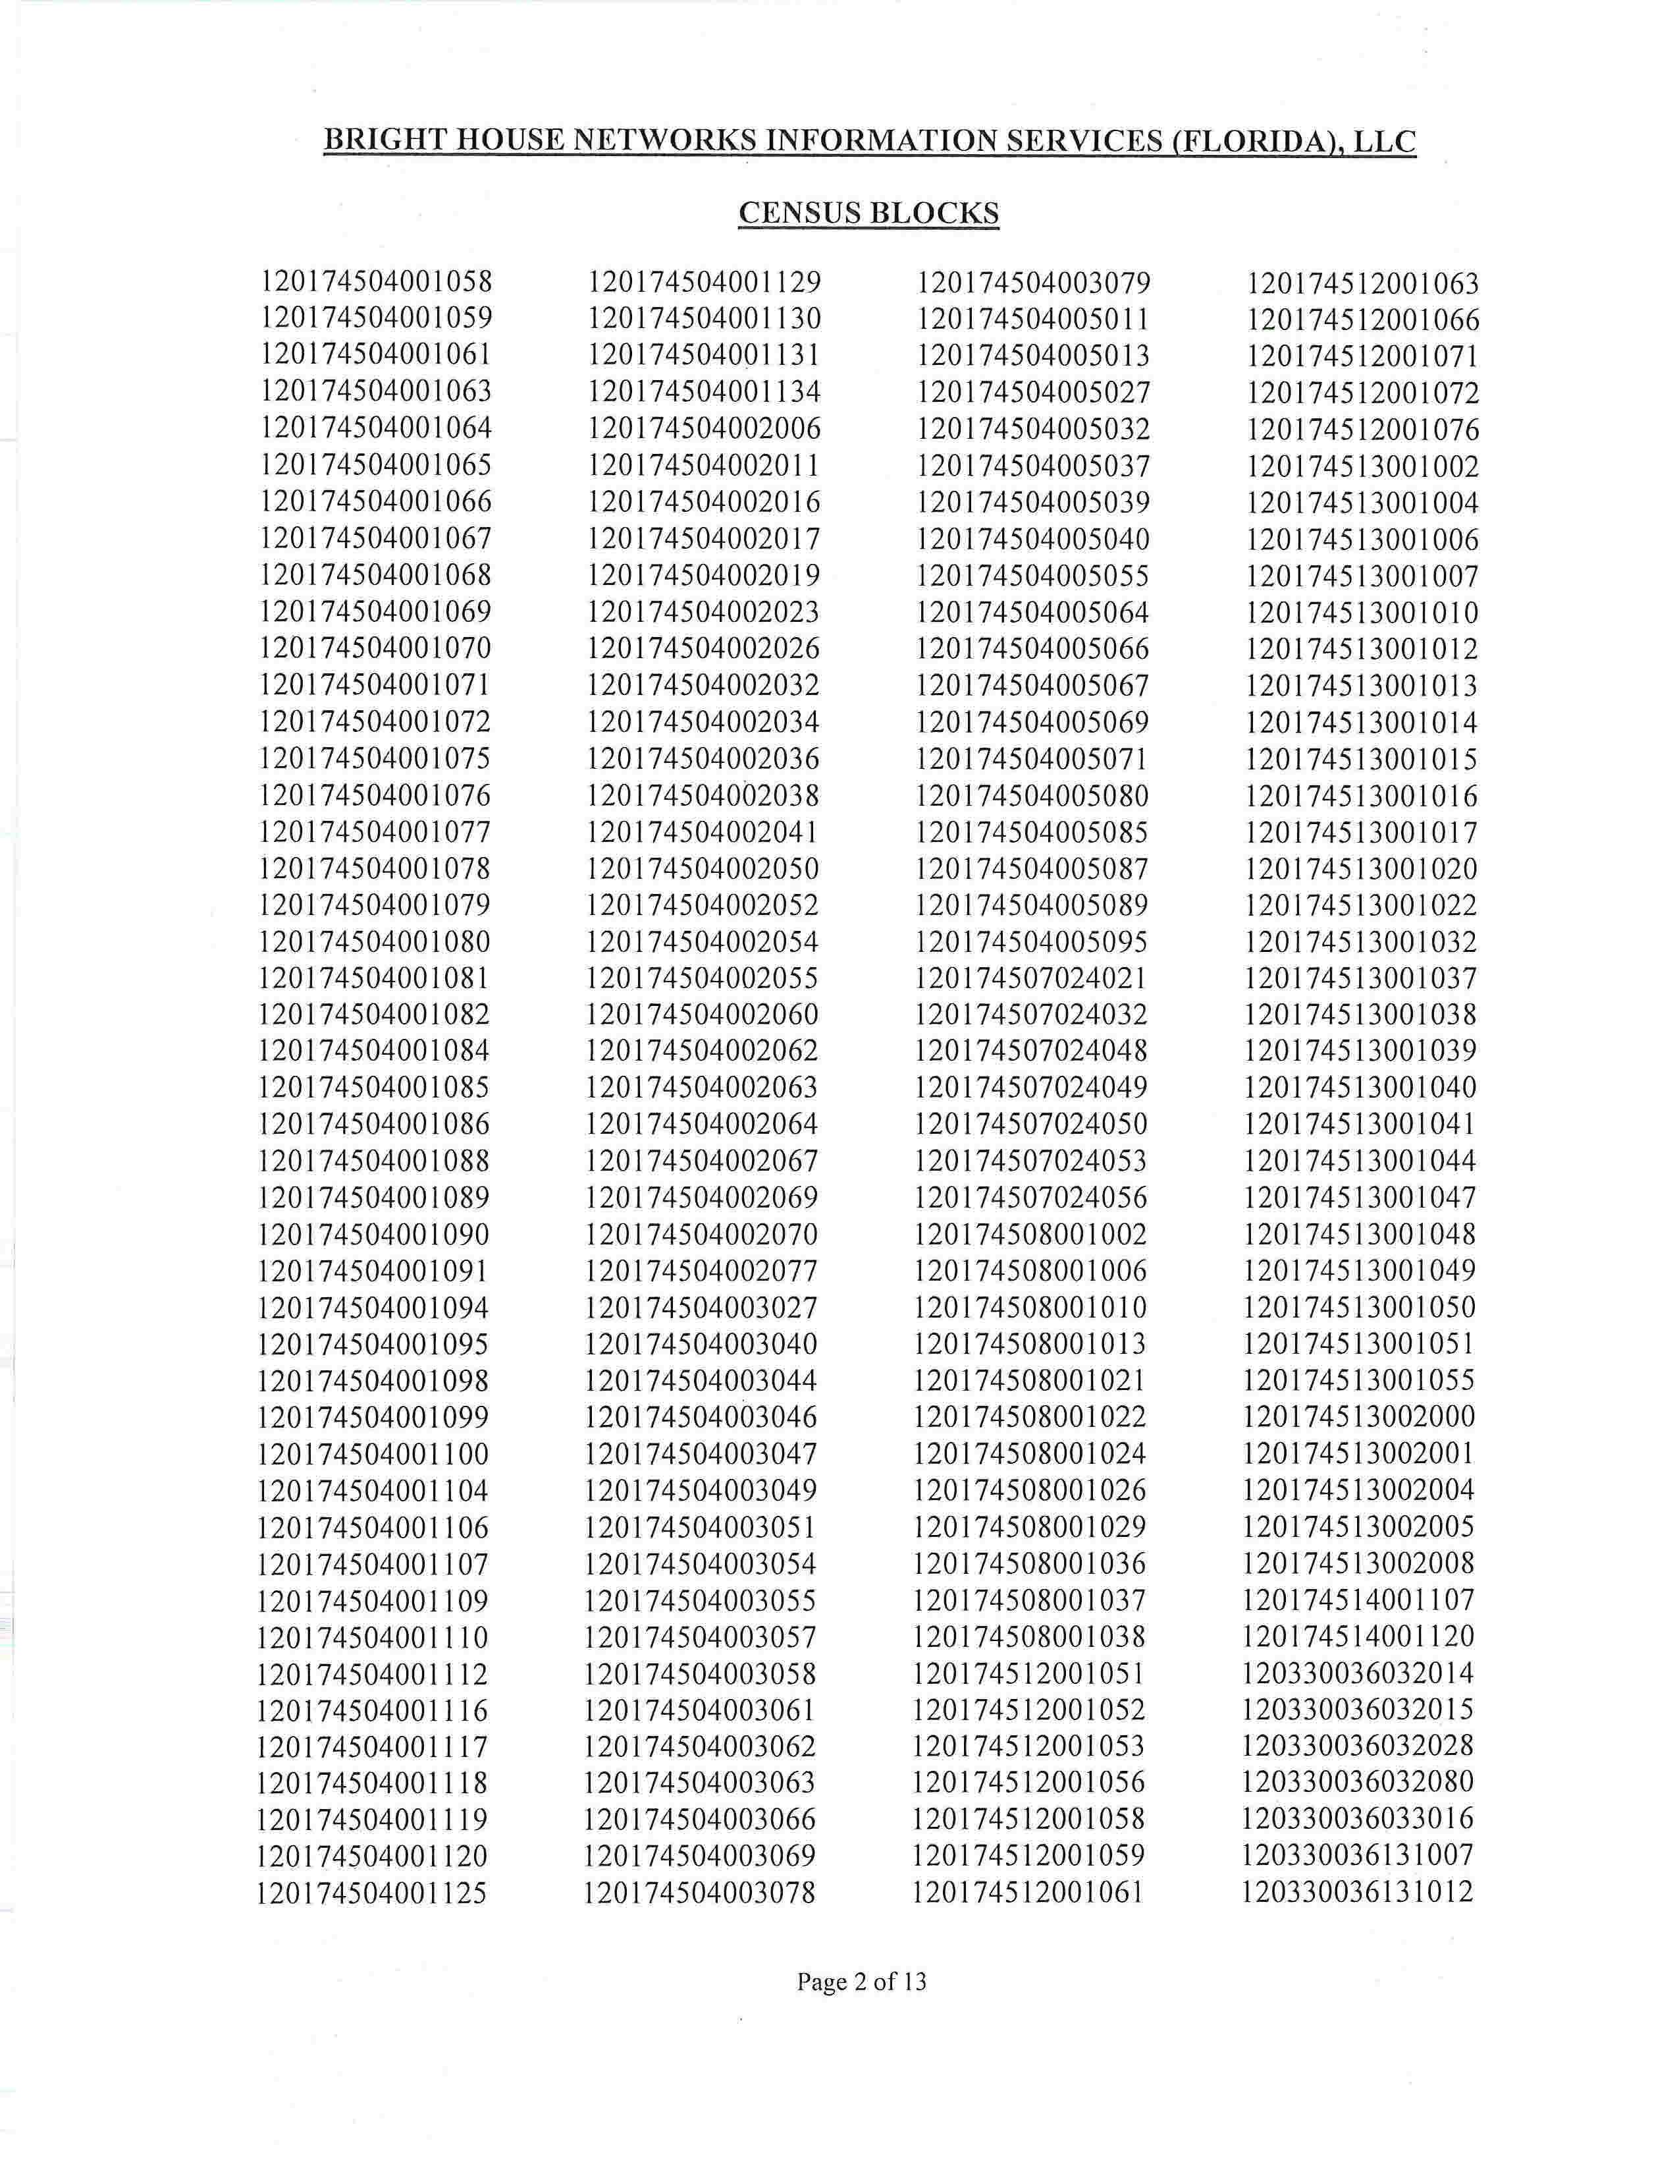
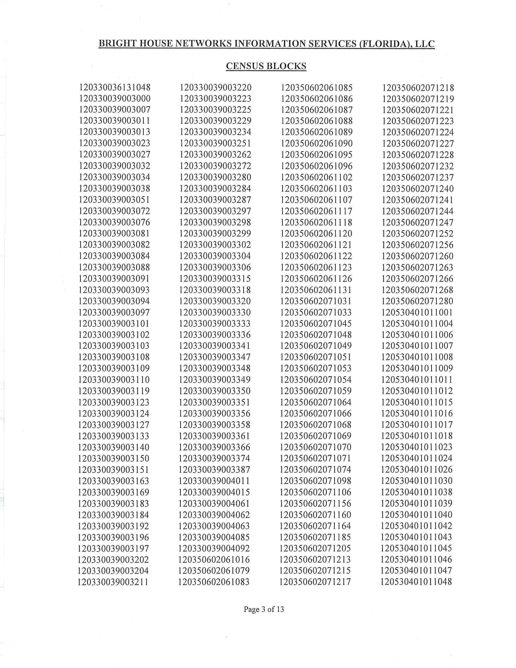
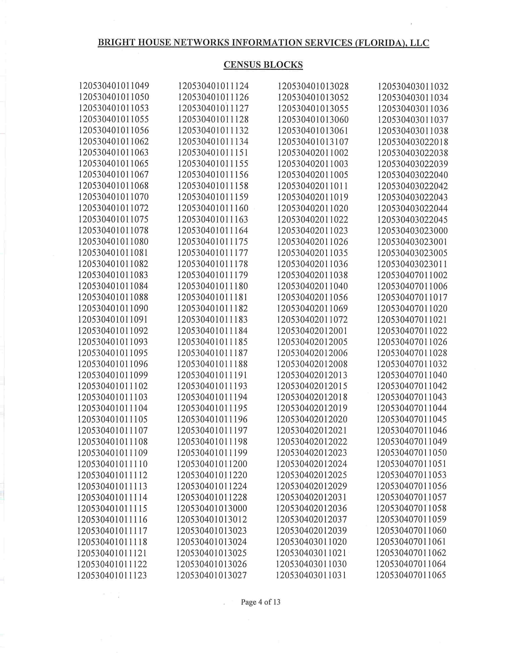
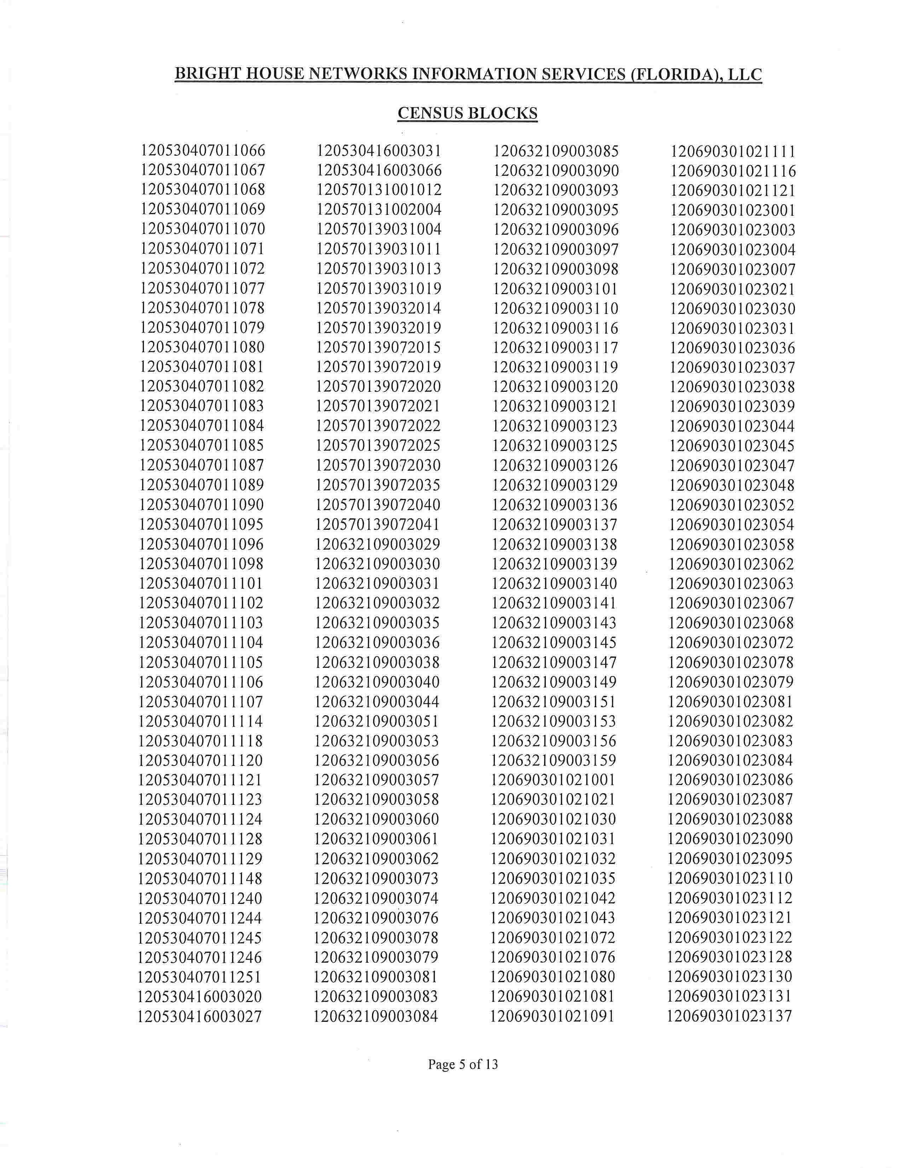
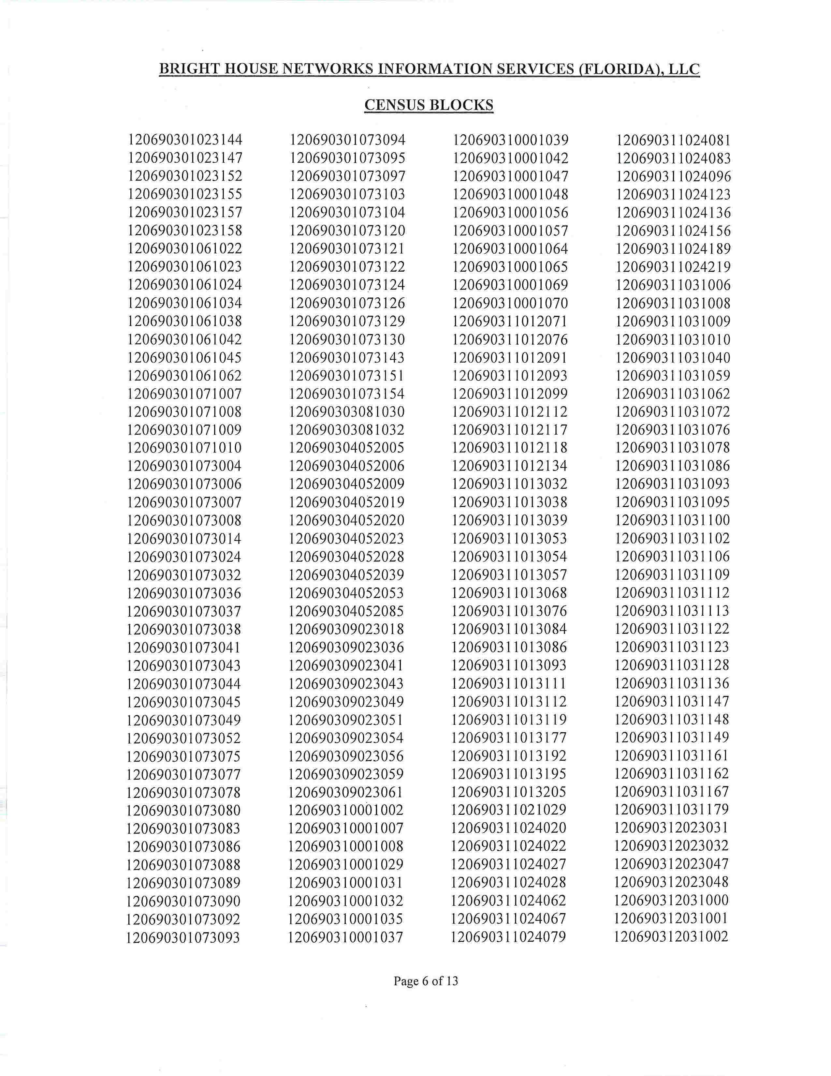
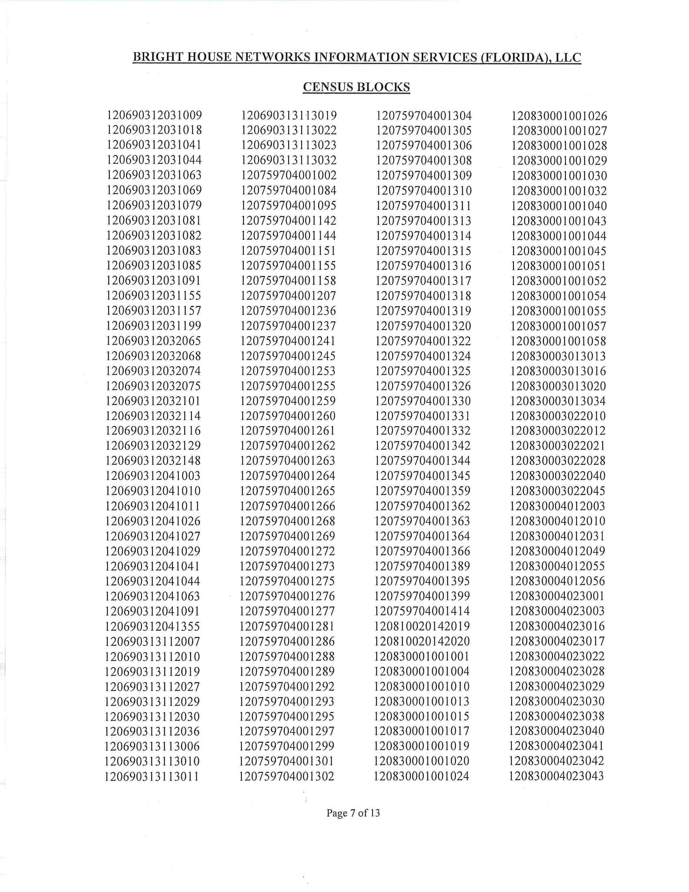
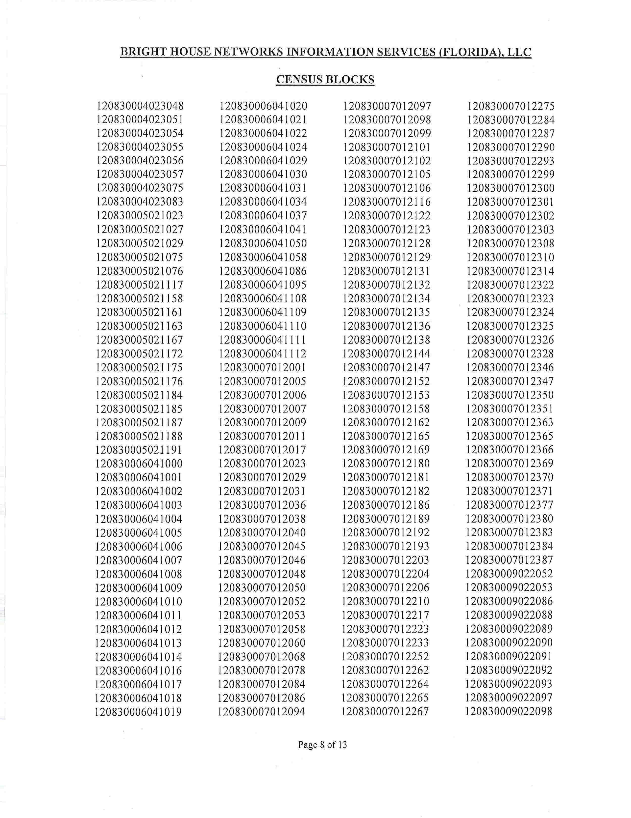
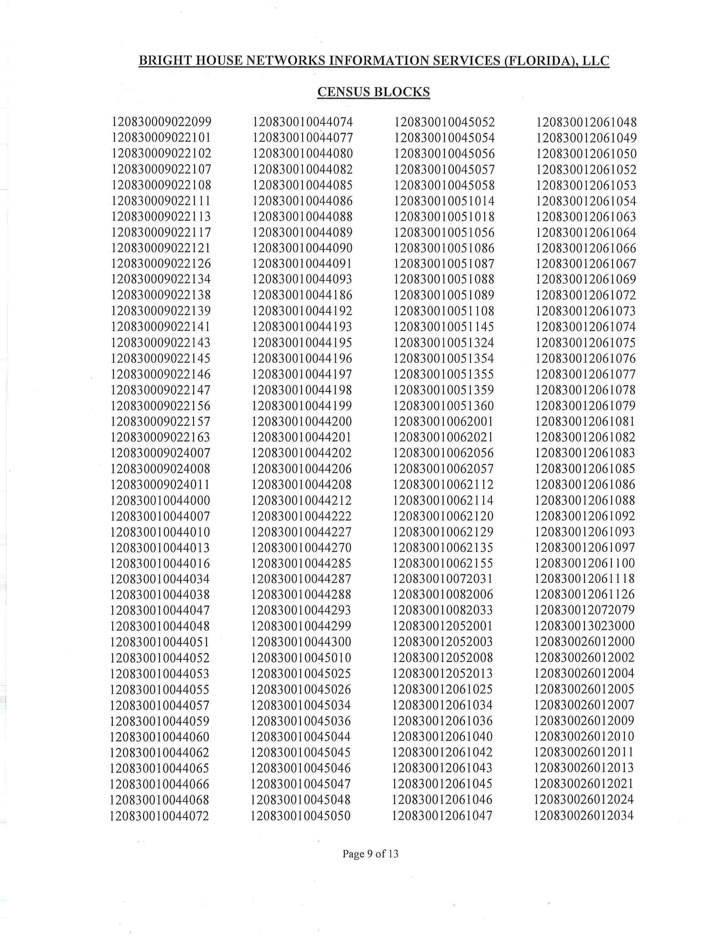
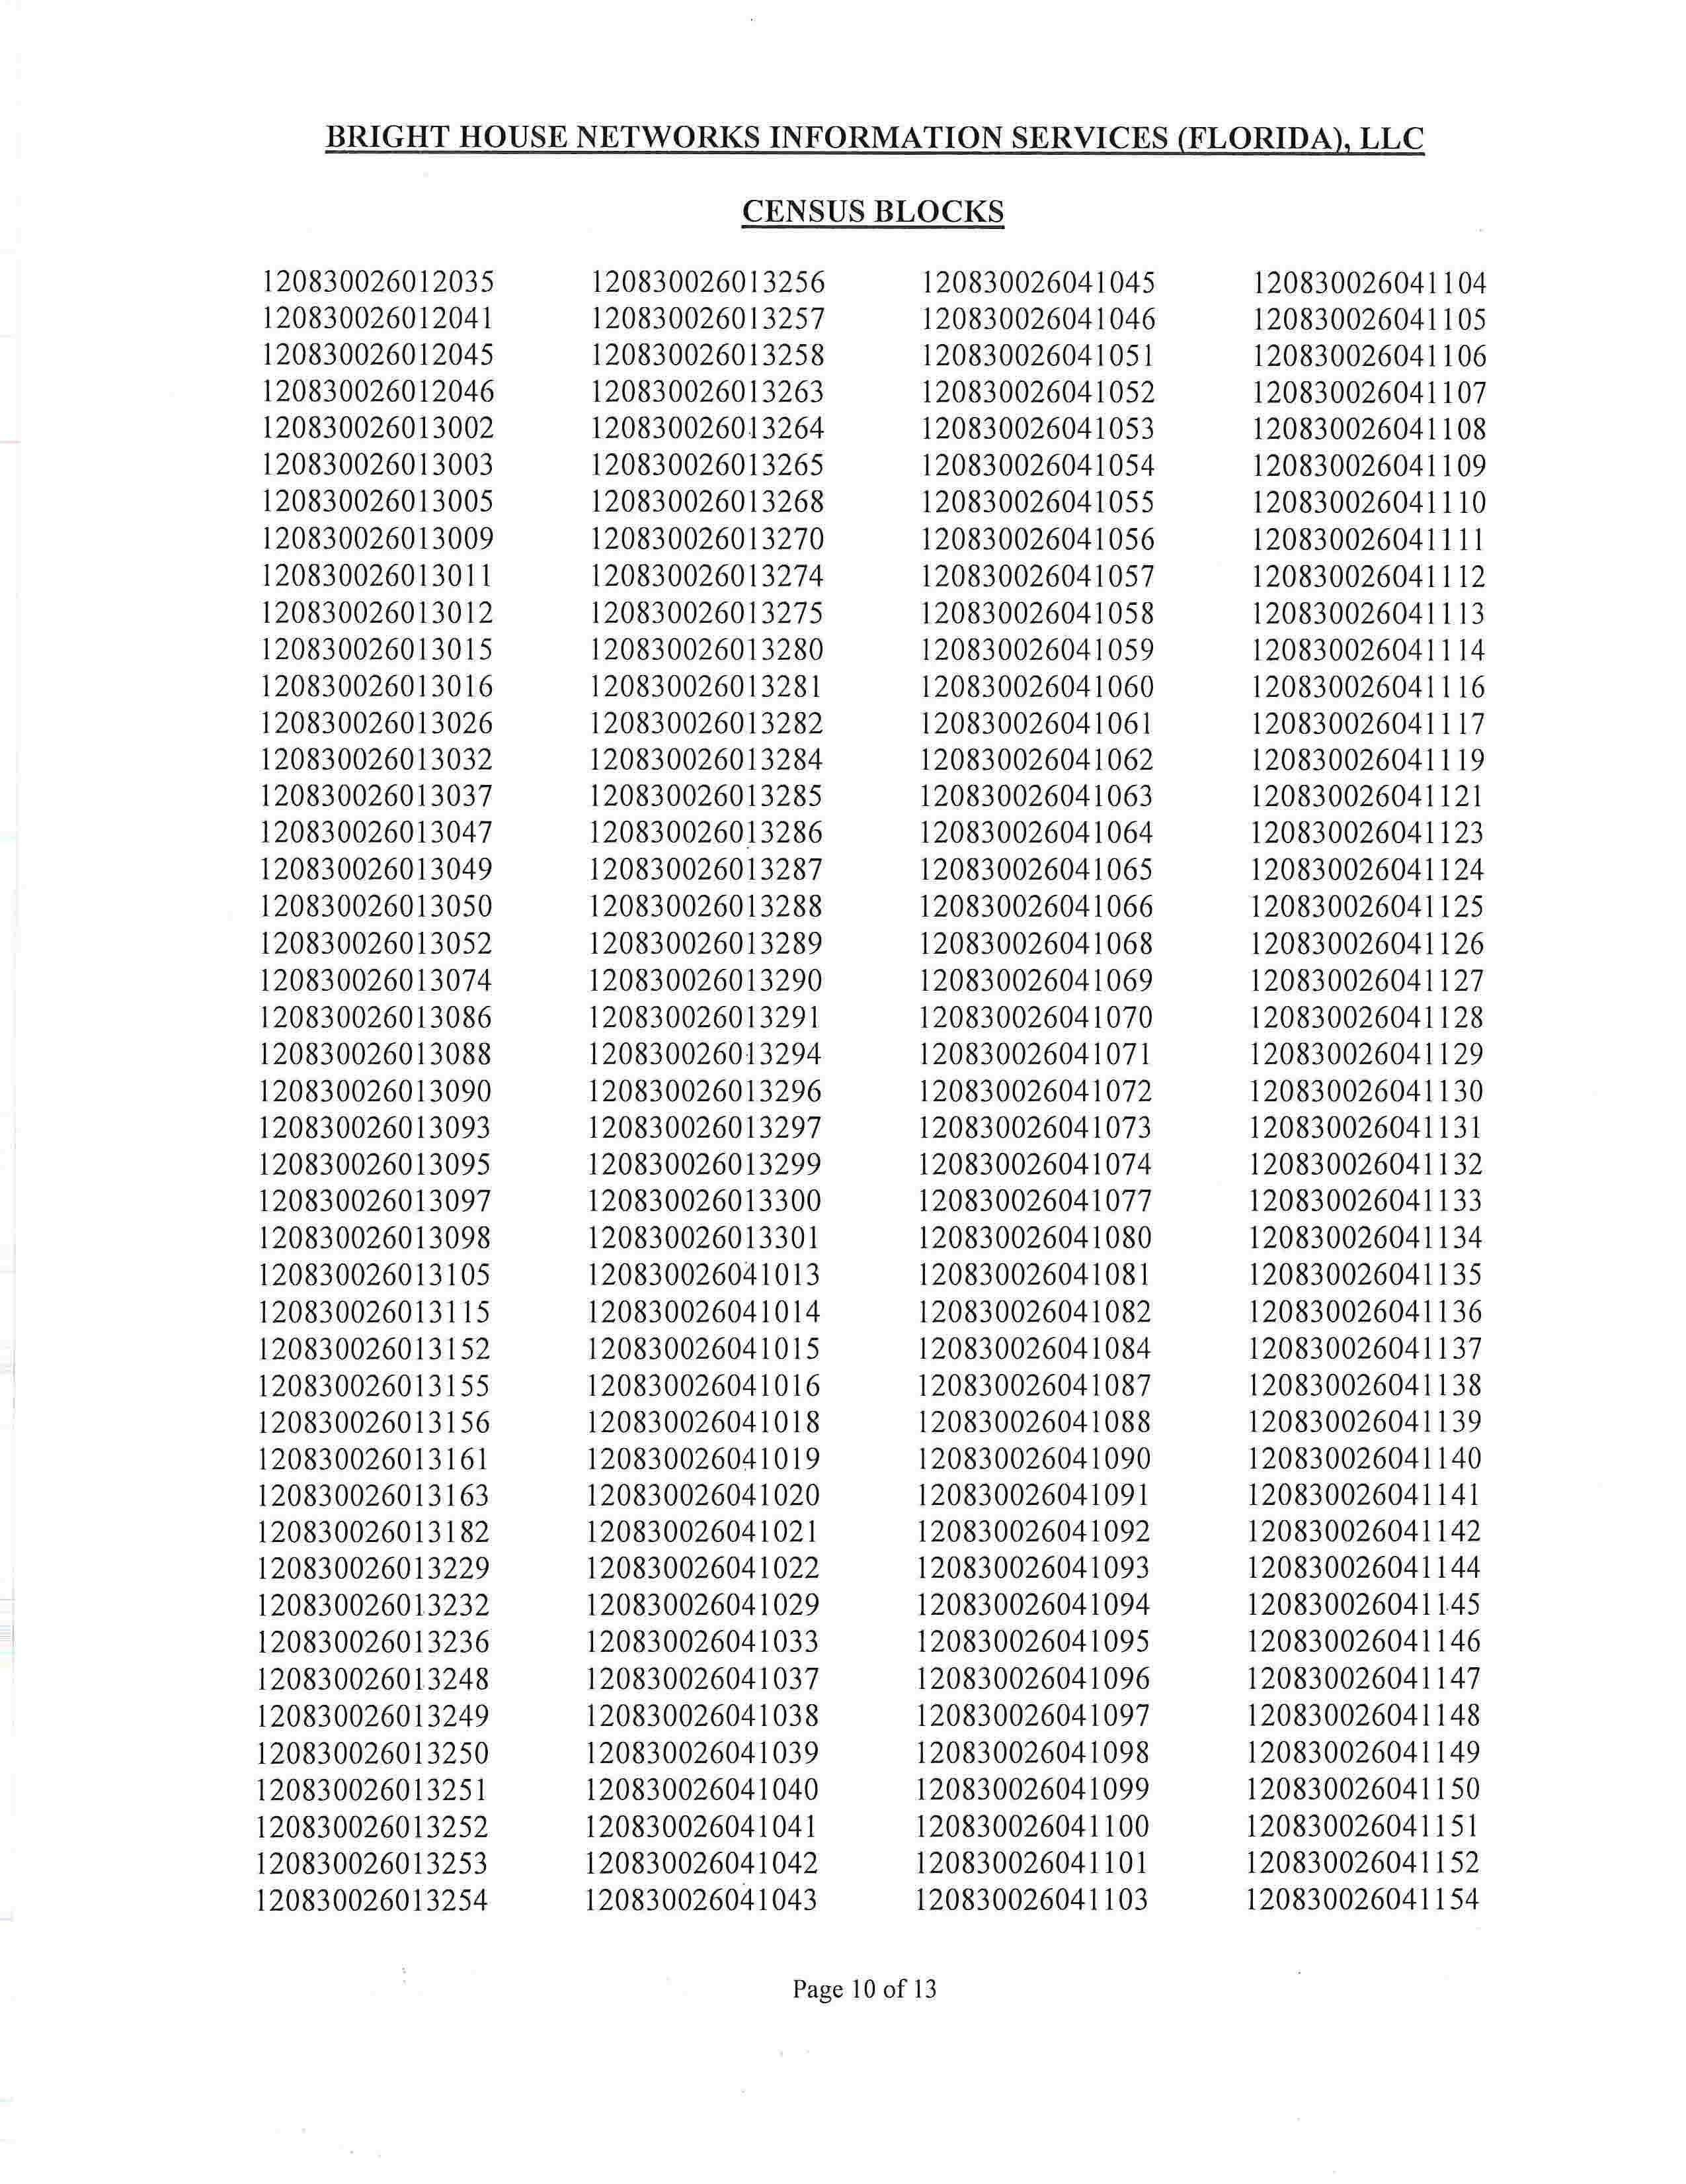
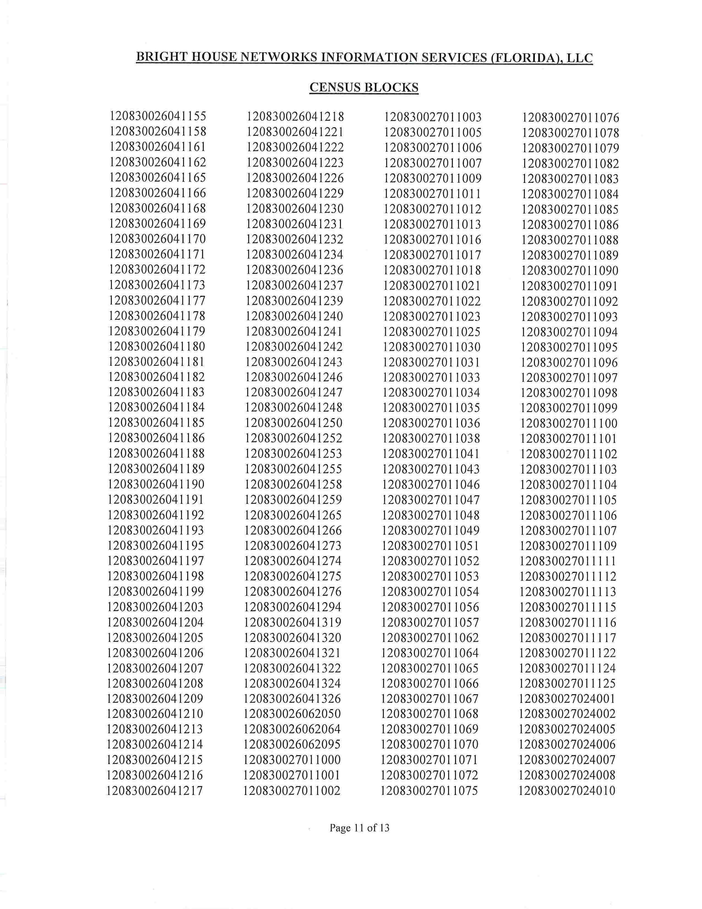
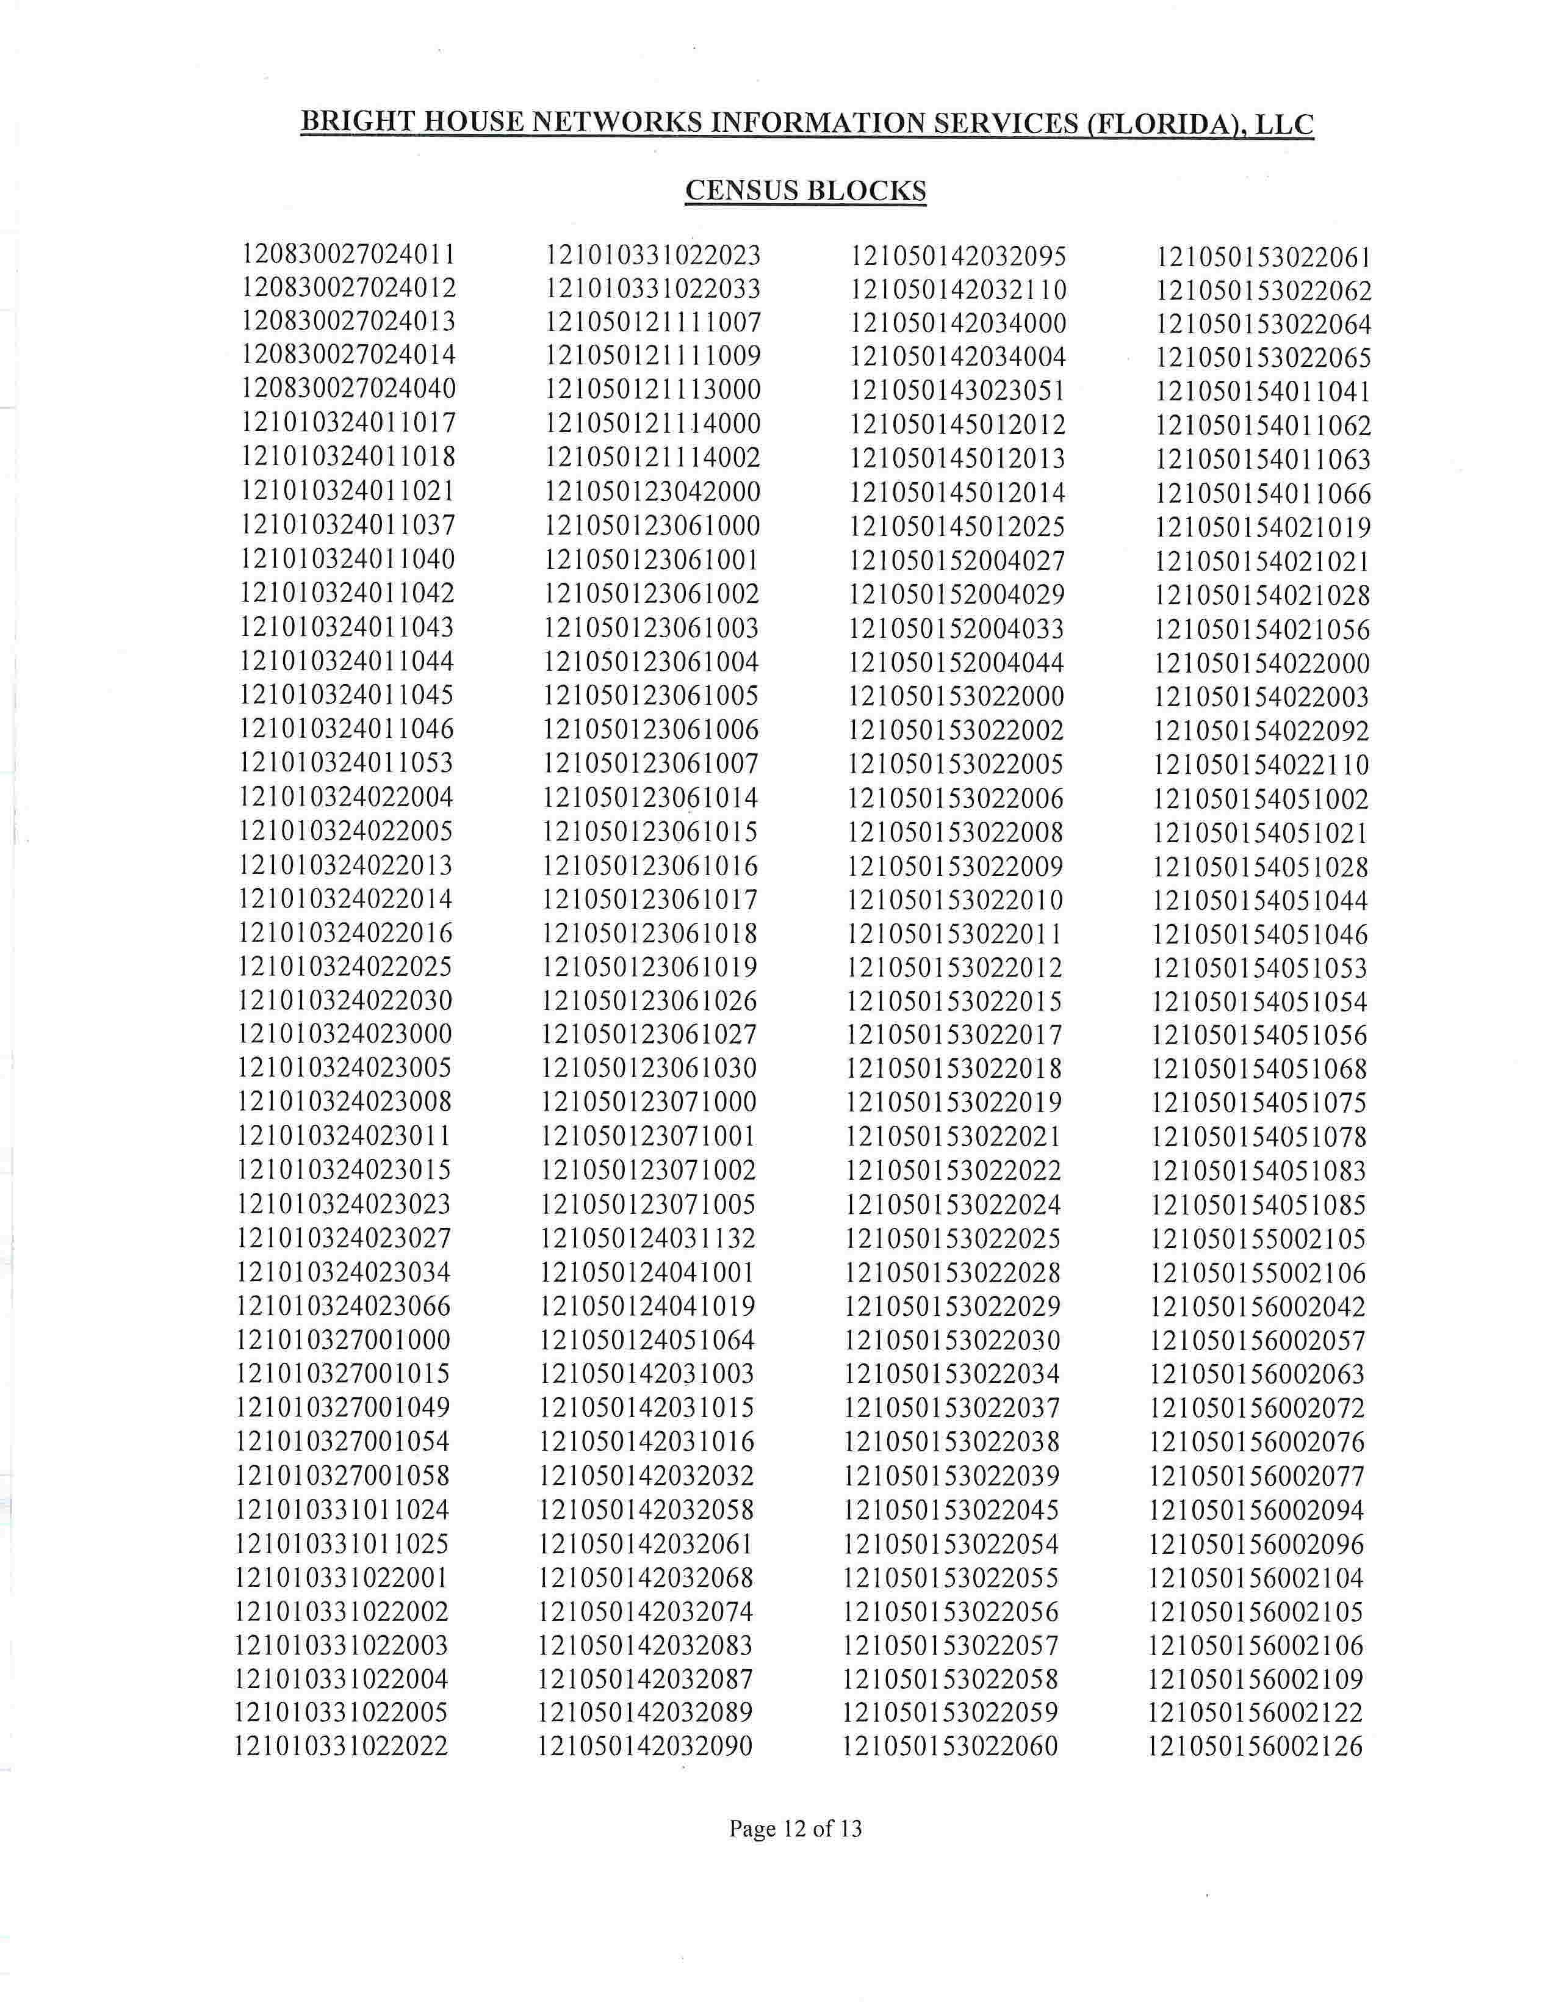
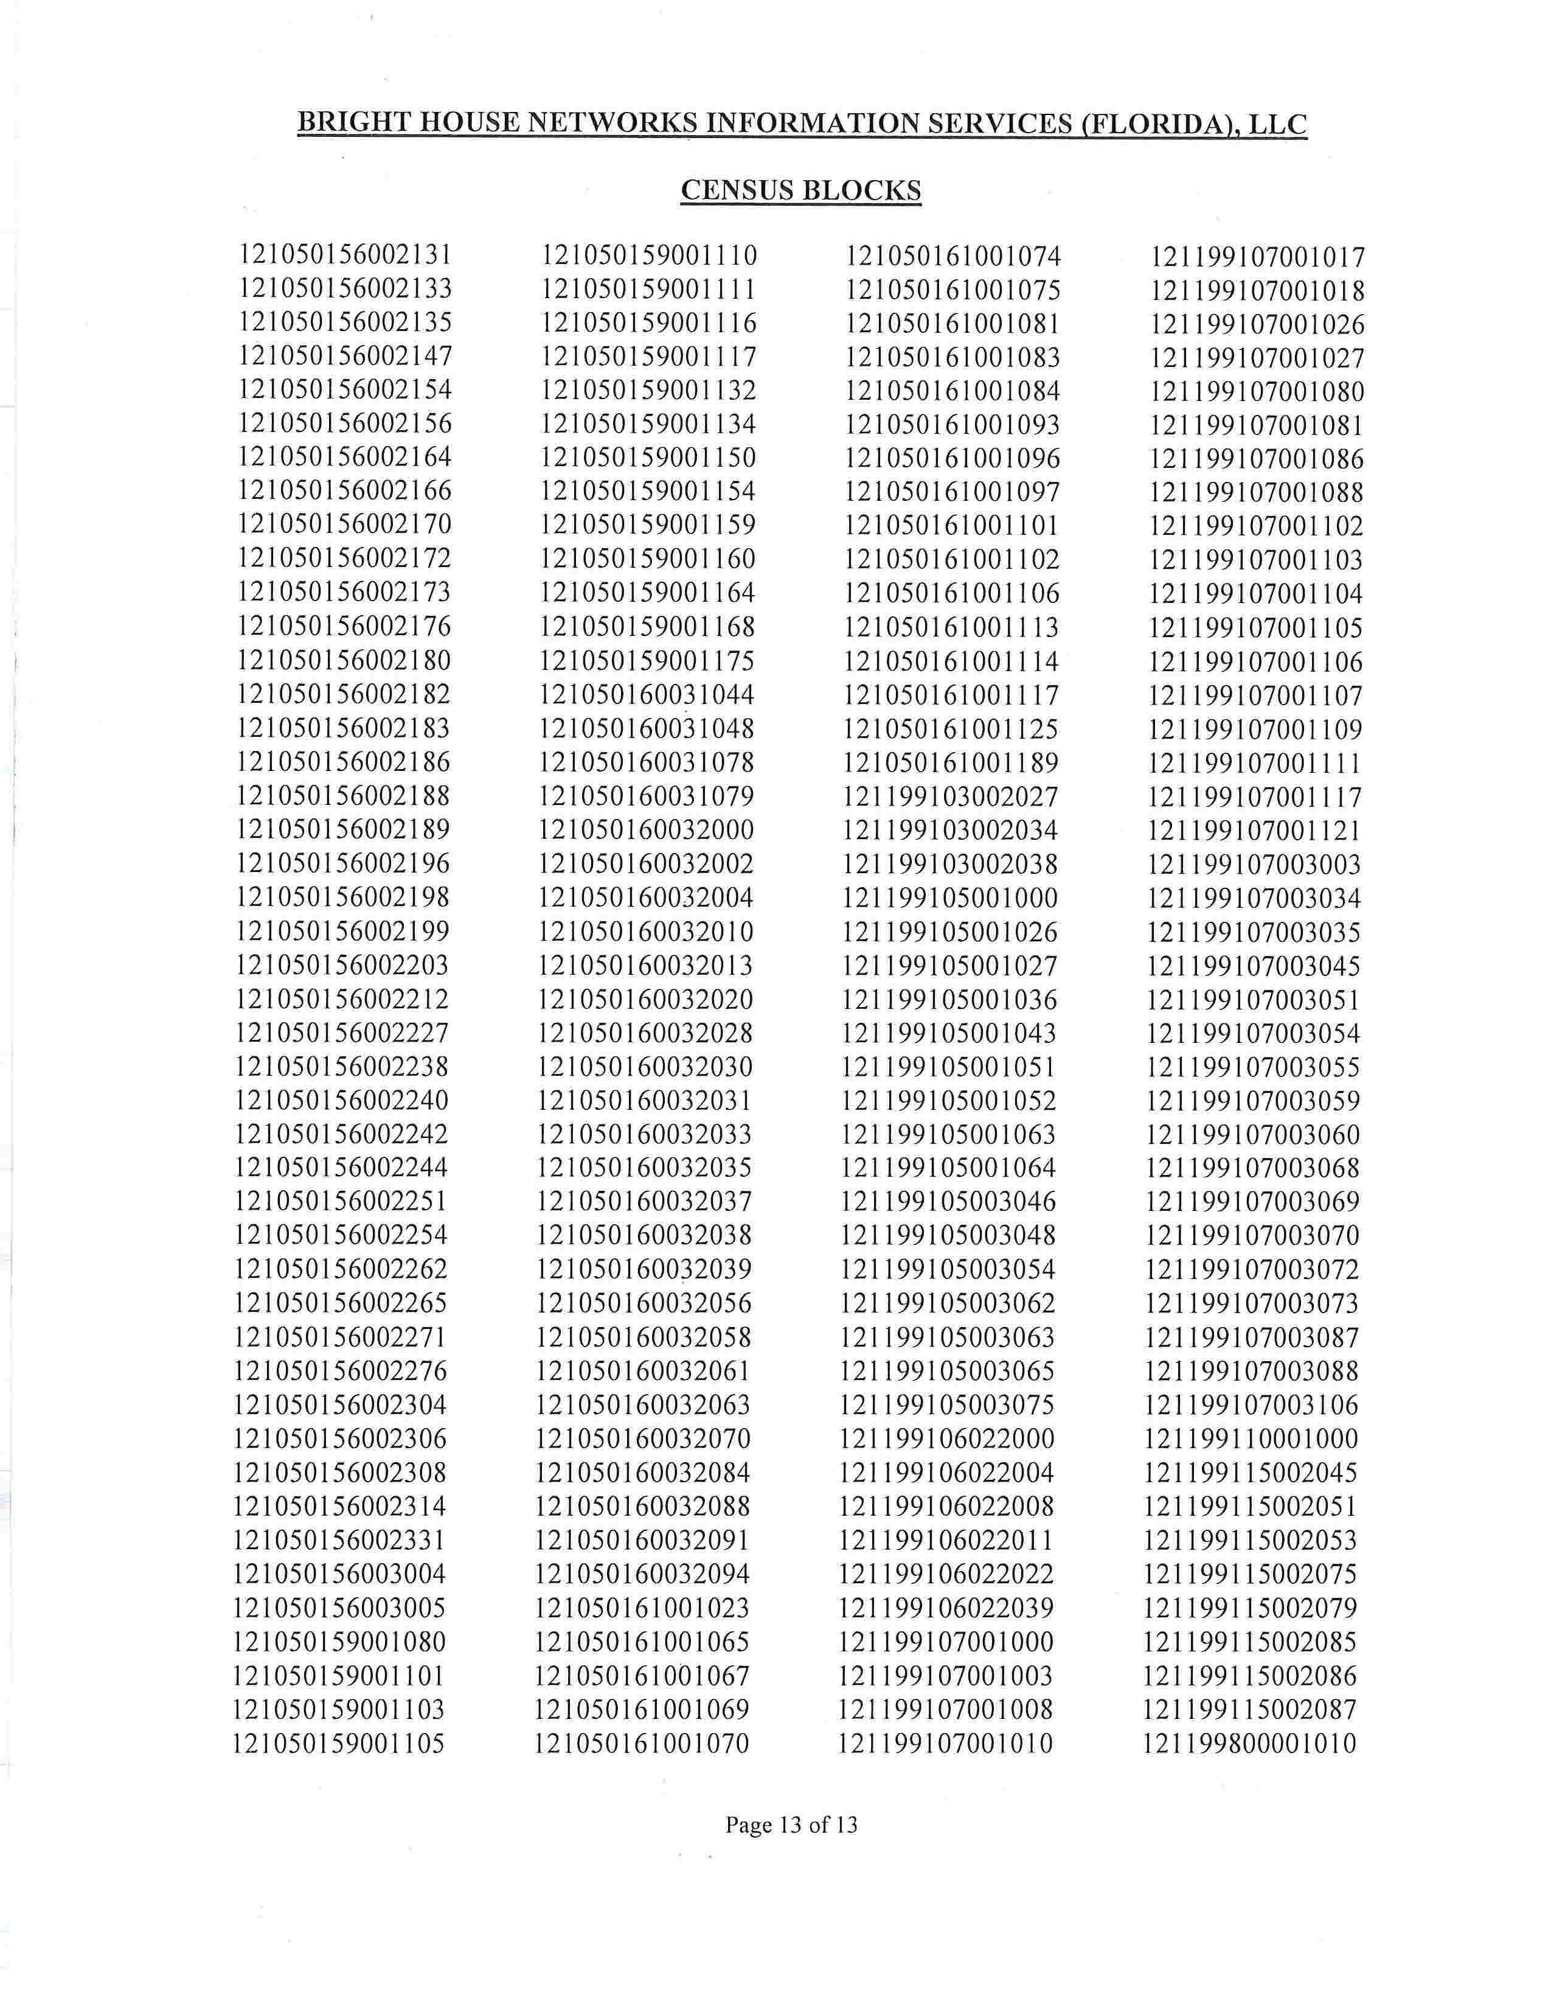
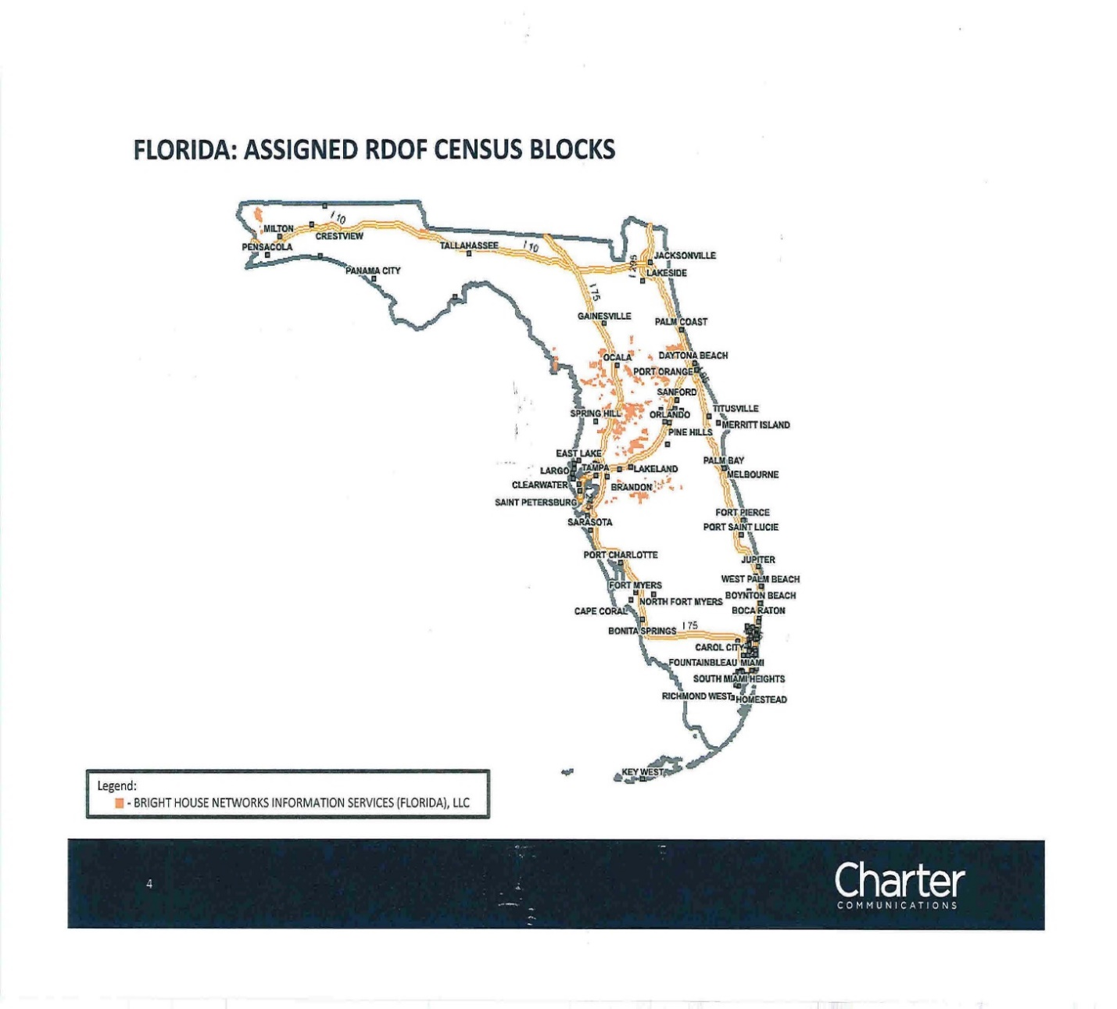

Order No. PSC-02-0070-CO-TX issued on January 10, 2002, in Docket No. 20011617-TX, Application for certificate to provide alternative local exchange telecommunications service by Time Warner Cable Information Services (Florida), LLC d/b/a Time Warner Cable Information Services d/b/a Time Warner Cable d/b/a Time Warner Communications (Consummating Order No PSC-2001-2467-PAA-TX). See also Order No. PSC-03-0989-FOF-TX., issued on September 3, 2003, in Docket No. 20030713-TX, In re: Request for name change on CLEC Certificate No. 8015 from Time Warner Cable Information Services (Florida), LLC d/b/a Time Warner Cable Information Services d/b/a Time Warner Cable d/b/a Time Warner Communications to Bright House Networks Information Services (Florida), LLC.
FCC, DA 20-1422, Public Notice, 904 Winning Bidders, https://docs.fcc.gov/public/attachments/DA-20-1422A1.pdf, accessed February 1, 2021.
Id., Attachment B, https://docs.fcc.gov/public/attachments/DA-20-1422A3.pdf, accessed February 1, 2021.
Id., Attachment A (See CCO Holdings which has assigned its winning bid to its affiliate Bright House.) https://docs.fcc.gov/public/attachments/DA-20-1422A2.pdf, accessed February 1, 2021.
47 U.S.C. 214(e)(6)
In this context, a “telecommunications facility” includes real estate, easements, apparatus, property, and routes used and operated to provide two-way telecommunications service to the public for hire within [Florida]. 364.02(14). “Service” is to be construed in its broadest and most inclusive sense;” however, the term “does not include broadband service or voice-over-Internet protocol service for purposes of regulation. Id.at (12).
Section 364.011(3), F.S.
Charter Advanced Services (MN), LLC v. Lange, 903 F.3d 715, (Eighth Circuit 2018) cert denied, Lipschultz v. Charter Advanced Services (MN) LLC, 140 S.CT. 6 (Supreme Court of the United States 2019). (The case involved a Bright House affiliate in Minnesota that had been created to offer only nonjurisdictional services).
Subpart E addresses Universal Service Support for Low-Income Consumers. See 47 C.F.R. §54,400 through §54,422.
Subparts D, K, L, and M refer to rules regarding Universal Service Support for High Cost Areas, Interstate Common Line Support Mechanisms for Rate-of-Return Carriers, Mobility Fund and 5G Fund, and High-Cost Loop Support for Rate-of-Return Carriers, respectively.
47 U.S.C. §214(e)(1)(B)

