BEFORE THE FLORIDA PUBLIC SERVICE COMMISSION

In re: Petition for approval of demand-side management plan, by Peoples Gas System. | DOCKET NO. 20190210-EG  ORDER NO. PSC-2021-0242-PAA-EG  ISSUED: July 2, 2021

The following Commissioners participated in the disposition of this matter:

GARY F. CLARK, Chairman
ART GRAHAM
ANDREW GILES FAY
MIKE LA ROSA
GABRIELLA PASSIDOMO

NOTICE OF PROPOSED AGENCY ACTION
ORDER APPROVNG PEOPLES GAS SYSTEM’S
DEMAND SIDE MANAGEMENT PLAN

BY THE COMMISSION:

NOTICE is hereby given by the Florida Public Service Commission that the action discussed herein is preliminary in nature and will become final unless a person whose interests are substantially affected files a petition for a formal proceeding, pursuant to Rule 25-22.029, Florida Administrative Code (F.A.C.).

Background
Enacted in 1980, Sections 366.80 through 366.83, and 403.519, Florida Statutes (F.S.), known collectively as the Florida Energy Efficiency and Conservation Act (FEECA), requires us to adopt conservation goals to increase the efficiency of energy consumption. Additionally, FEECA emphasizes reducing the growth rates of weather-sensitive peak demand, reducing and controlling the growth rates of electricity consumption, reducing the consumption of expensive resources such as petroleum fuels, and encouraging demand-side renewable energy resources. We most recently established conservation goals for Peoples Gas System (PGS or Utility) by Order No. PSC-2019-0361-PAA-GU, issued August 26, 2019 (2019 Goalsetting Order).
Pursuant to Section 366.82(7), F.S., after goals are established, we shall require each utility subject to FEECA to develop a demand-side management (DSM) plan to meet the conservation goals. On November 20, 2019, PGS filed a petition requesting approval of its original DSM Plan. As part of this filing, PGS provided a cost-effectiveness analysis of the proposed programs pursuant to Rule 25-17.009, F.A.C. The cost-effectiveness analysis includes the Gas Rate Impact Measure (G-RIM) Test and the Participants Test.
We issued multiple data requests to PGS regarding the original DSM Plan, which featured individual programs per measure. In June 2020, the Utility informed us of its intention to refile its original petition in order to revise its proposed programs. On February 26, 2021, PGS filed its revised petition, regrouping the programs included in the original petition to more closely reflect the programs used to establish the Utility’s conservation goals in the 2019 Goalsetting Order. As part of its February 2021 filing, PGS provided an updated cost-effectiveness analysis for the revised programs, and provided the program administrative standards.
We have jurisdiction over this matter pursuant to Sections 366.80 through 366.83 and 403.519, F.S.

Decision
The criteria used to review the appropriateness of the conservation programs are as follows: (1) whether the program advances the policy objectives of FEECA and its implementing rules; (2) whether the program is directly monitorable and yields measurable results; and (3) whether the program is cost-effective. We have reviewed PGS’s proposed DSM Plan, including its energy savings, cost-effectiveness, and rate impact. PGS’s proposed DSM Plan exceeds the goals set in the 2019 Goalsetting Order, and we hereby approve it.
Description of DSM Plan

PGS’s proposed DSM Plan consists of 11 programs in total, 4 residential and 7 commercial/industrial. Some of these programs have been renamed, but otherwise, they are essentially continuations of PGS’s existing programs. As required by Rule 25-17.003, F.A.C., and as approved in the 2019 Goalsetting Order, PGS’s proposed DSM Plan now offers energy audits to residential customers, and PGS also now voluntarily offers audits to commercial/industrial customers. Table 1-1 provides a complete list of the programs and the program status (modified or new). A description of each program can be found in Attachment A.

Table 1-1
PGS DSM Plan Program Listing
Program Name | Program Status
 | Modified | New
Residential Programs
Residential Customer Assisted Energy Audit |  | X
Residential New Construction | X
Residential Retrofit | X
Residential Retention | X
Commercial/Industrial Programs
Commercial Walk-Through Energy Audit |  | X
Commercial New Construction | X
Commercial Retrofit | X
Commercial Retrofit Combined Heat and Power (CHP) | X
Commercial Retrofit Electric Replacement | X
Commercial Retention | X
Conservation Research and Development (R&D) | X
Source: Document No. 02477-2021
PGS’s proposed DSM Plan features two audit programs: the Residential Customer Assisted Energy Audit and the Commercial Walk-Through Energy Audit. PGS received approval in the 2019 Goalsetting Order to add these programs to ensure that the full requirements of FEECA are being met.
The primary changes made to the modified programs were renaming, and updates to the rebate levels available within the programs. Programs that will be replacing electric systems/equipment with energy-efficient natural gas systems/equipment will now be referred to as “Retrofit” for clarity as opposed to “Replacement” as previously named. PGS will continue to use the term “Retention,” which is the replacement of existing natural gas systems/equipment with energy efficient natural gas systems/equipment. As an example of a rebate update, PGS increased the rebate amount for the dryer in the Residential Retention Program from $100 to $150.
The other changes made to the modified programs are as follows: (1) Gas Space Conditioning was added as a measure to the respective residential and commercial retrofit and retention programs instead of continuing as a singular program; (2) the Oil Heat Replacement program was eliminated due to low historical participation totals; (3) the Commercial Retention CHP program was eliminated due to its failure to achieve cost-effectiveness; and (4) for the Conservation R&D program, PGS combined its existing Monitoring and Research program with its Conservation Demonstration and Development program to become a single Conservation R&D program.
PGS also submitted its administrative program standards along with its proposed DSM Plan, which can be found in Attachment B. We have reviewed the administrative program standards and they appear consistent with the Utility’s proposed DSM Plan.
Program Participation

PGS projects program participation based on historical program participation trends. The projected annual program participation for each program in PGS’s proposed DSM Plan is provided in Table 1-2.

Table 1-2
PGS’s DSM Plan Annual Program Participation by Program
Program Name | 2021 | 2022 | 2023 | 2024 | 2025 | 2026 | 2027 | 2028
Residential Programs
Residential Customer Assisted Energy Audit | 4,500 | 4,500 | 4,500 | 4,500 | 4,500 | 4,500 | 4,500 | 4,500
Residential New Construction | 8,700 | 8,900 | 9,000 | 9,100 | 9,200 | 9,300 | 9,400 | 9,500
Residential Retrofit | 2,420 | 2,514 | 2,558 | 2,641 | 2,699 | 2,767 | 2,825 | 2,910
Residential Retention | 16,400 | 16,916 | 17,332 | 17,709 | 18,061 | 18,448 | 18,800 | 19,326
Commercial Programs
Commercial Walk-Through Energy Audit | 500 | 500 | 500 | 500 | 500 | 500 | 500 | 500
Commercial New Construction | 96 | 100 | 103 | 105 | 109 | 112 | 114 | 116
Commercial Retrofit | 88 | 90 | 92 | 95 | 96 | 99 | 101 | 104
Commercial Retrofit CHP | 0 | 0 | 0 | 0 | 0 | 0 | 0 | 0
Commercial Retrofit Electric Replacement | 1 | 1 | 1 | 1 | 1 | 1 | 1 | 1
Commercial Retention | 293 | 300 | 307 | 314 | 321 | 328 | 336 | 345
Source: Document No. 02477-2021
As seen in Table 1-2, the Commercial Retrofit Combined Heat and Power (CHP) program is projected to have zero participation. PGS forecasted zero participation for this DSM program based upon the program’s historical participation rate. PGS believes that participation will increase in this program as commercial customers seek technologies to reduce energy costs and greenhouse gas emissions. CHP technologies improve energy efficiency since the energy is produced at the point of use, and involves the recovery of thermal energy that would otherwise be wasted. The Utility modified the Commercial Retrofit CHP program to clarify what qualifies for the incentive. The Utility also proposed an increase to the incentive, and added the requirement to offset some amount of gas usages. PGS believes these modifications will attract participation to this DSM program.

Comparison of DSM Plan to Goals

As in the 2019 Goalsetting Order, PGS estimated program savings through a combination of state and national industry sources, current building code and appliance standards, and a review of historical DSM program activity. Based our review and as shown in Table 1-3, PGS’s proposed DSM Plan will exceed our established annual goals. The annual energy savings associated with PGS’s proposed DSM Plan and our established goals are summarized in Table 1-3 for the residential and commercial/industrial sectors.

Table 1-3
Commission’s Goals vs. PGS’s DSM Plan
Year | Residential  (Therms) |  | Commercial  (Therms)
 | Goal | DSM  Plan | Goal | DSM  Plan
2021 | 355,569 | 373,753 | 227,968 | 245,612
2022 | 363,728 | 383,682 | 233,833 | 251,869
2023 | 371,562 | 389,725 | 239,661 | 258,120
2024 | 379,045 | 395,866 | 245,457 | 264,386
2025 | 386,682 | 401,594 | 251,338 | 270,678
2026 | 394,475 | 407,663 | 257,304 | 277,076
2027 | 402,429 | 413,392 | 263,357 | 283,612
2028 | 410,546 | 420,592 | 269,500 | 290,246
Total | 3,749,583 | 3,904,732 | 2,426,634 | 2,613,791
Source: Document No. 02477-2021
The values presented above are projections based upon participation rates which may or may not occur. PGS will be responsible for monitoring actual participation rates and seeking our action, if necessary, to modify, add, or remove programs. If PGS is unable to meet our goals, the Utility may be subject to appropriate action by us, up to and including financial penalties.
Section 366.82(10), F.S., requires us to provide an annual report to the Governor and Legislature on the progress of each utility toward meeting the established goals. PGS will continue to submit to us an annual report no later than March 1 of each year, summarizing the achievements of its DSM Plan. We will continue to monitor and report the actual amount of DSM savings each year, on an annual and cumulative basis, as part of the FEECA Report.
Cost-Effectiveness Review

As required by Rule 25-17.009, F.A.C., PGS provided a cost-effectiveness analysis of the proposed programs using the G-RIM and the Participants Tests. Below, we address PGS’s results of its cost-effectiveness analysis.

Cost-Effectiveness Test Results

All of PGS’s proposed programs pass both the G-RIM and Participants Tests. These tests consist of the program benefits divided by the program costs so that programs are determined to be cost-effective if the result of the test is a ratio greater than 1.00. The data PGS used to develop the costs associated with the cost-effectiveness tests was obtained from PGS’s current costs in facilitating existing programs, and from costs currently incurred by the Utility and customers for energy efficient natural gas equipment and infrastructure. The cost-effectiveness test results for each program are provided in Table 1-4.
Table 1-4
PGS’s DSM Plan Cost-Effectiveness Test Results by Program
Program Name | G-RIM Test | Participants Test
Residential Programs
Residential New Construction | 1.502 | 1.041
Residential Retrofit | 1.321 | 1.103
Residential Retention | 1.412 | 1.579
Commercial Programs
Commercial New Construction | 2.871 | 1.098
Commercial Retrofit | 3.326 | 1.316
Commercial Retrofit CHP | 2.225 | 1.846
Commercial Retrofit Electric Replacement | 4.404 | 1.218
Commercial Retention | 1.009 | 4.094
Source: Document No. 02477-2021
Rate Impact

We reviewed the projected program costs for PGS’s proposed DSM Plan. Table 1-5 shows the total projected program costs for each program in PGS’s proposed DSM Plan. PGS projects that the total cost for its proposed DSM Plan will be approximately $190 million.

Table 1-5
Total Program Costs of PGS’s DSM Plan
Program Name | Program Costs
Residential Programs
Residential Customer Assisted Energy Audit | $1,725,000
Residential New Construction | $100,928,500
Residential Retrofit | $10,153,221
Residential Retention | $62,804,741
Commercial/Industrial Programs
Commercial Walk-Through Energy Audit | $720,000
Commercial New Construction | $1,990,514
Commercial Retrofit | $4,450,111
Commercial Retrofit CHP | $0
Commercial Retrofit Electric Replacement | $80,000
Commercial Retention | $6,060,429
Conservation R&D | $1,000,000
Source: Document No. 03066-2021
As shown in Table 1-5, PGS projects zero program costs for the Commercial Retrofit CHP program due the zero projected program participation previously discussed. However, we hereby find that PGS shall update us on program costs and all other relevant program information should program participation be achieved.

The cost to implement PGS’s proposed DSM Plan will flow through to the ratepayers through the NGCCR proceeding. In the NGCCR proceeding, PGS will file annually for recovery of incentives, and equipment and administrative costs. The NGCCR amounts represent a monthly bill impact to customers as part of the non-fuel cost of energy charges on their bills. Much like investments in generation, transmission, and distribution, investments in energy efficiency have an immediate rate impact, but may produce savings over time.

Table 1-6 is an estimate of the monthly bill impact on a typical residential and commercial customer for PGS’s proposed DSM Plan. The estimated NGCCR factors are based upon the participation rates and administrative costs used in the cost-effectiveness analysis discussed above and are not final.

Table 1-6
PGS’s Estimated Monthly Bill Impact of Proposed DSM Plan
Year | Residential Customer  20 Therms/mo | Commercial Customer  1,500 Therms/mo
 | Monthly Bill Impact ($)
2021 | 1.81 | 28.73
2022 | 2.03 | 32.24
2023 | 2.01 | 31.85
2024 | 1.98 | 31.42
2025 | 1.95 | 30.99
2026 | 1.93 | 30.57
2027 | 1.90 | 30.13
2028 | 1.88 | 29.78
Source: Document No. 03066-2021
Conclusion

The DSM Plan proposed by PGS is projected to exceed the annual numeric conservation goals approved by us in the 2019 Goalsetting Order. PGS’s proposed DSM Plan is primarily a continuation, with some minor modifications, of its preliminary DSM portfolio used to establish the goals approved by us in 2019 Goalsetting Order. The programs within PGS’s proposed DSM Plan are projected to be cost-effective based upon both the G-RIM and Participants Tests.
Therefore, we hereby permit PGS to file for cost recovery of the programs included in its proposed DSM Plan in the NGCCR proceeding. However, PGS must demonstrate that the expenditures to implement its DSM programs are reasonable and prudent in order to recover those expenditures.
PGS also submitted its administrative program standards with its proposed DSM Plan. We have reviewed PGS’s administrative program standards and find that they are consistent with the Utility’s proposed DSM Plan. PGS shall notify us prior to any changes being made to the program standards as filed.
Based on the foregoing, it is

ORDERED by the Florida Public Service Commission that Peoples Gas System’s demand side management plan, as described in Attachment A, is approved. It is further

ORDERED that Peoples Gas System’s demand side management plan program standards, as described in Attachment B, are approved. It is further

ORDERED that the provisions of this Order, issued as proposed agency action, shall become final and effective upon the issuance of a Consummating Order unless an appropriate petition, in the form provided by Rule 28-106.201, Florida Administrative Code, is received by the Commission Clerk, 2540 Shumard Oak Boulevard, Tallahassee, Florida 32399-0850, by the close of business on the date set forth in the “Notice of Further Proceedings” attached hereto. It is further

ORDERED that if no person whose substantial interests are affected by the proposed agency action files a protest within 21 days of the issuance of the order, this docket shall be closed upon the issuance of a Consummating Order.

By ORDER of the Florida Public Service Commission this 2nd day of July, 2021.

/s/ Adam J. Teitzman
ADAM J. TEITZMAN
Commission Clerk
Florida Public Service Commission
2540 Shumard Oak Boulevard
Tallahassee, Florida 32399
(850) 413-6770
www.floridapsc.com

Copies furnished: A copy of this document is provided to the parties of record at the time of issuance and, if applicable, interested persons.

AJW

NOTICE OF FURTHER PROCEEDINGS OR JUDICIAL REVIEW

The Florida Public Service Commission is required by Section 120.569(1), Florida Statutes, to notify parties of any administrative hearing that is available under Section 120.57, Florida Statutes, as well as the procedures and time limits that apply. This notice should not be construed to mean all requests for an administrative hearing will be granted or result in the relief sought.

Mediation may be available on a case-by-case basis. If mediation is conducted, it does not affect a substantially interested person's right to a hearing.

The action proposed herein is preliminary in nature. Any person whose substantial interests are affected by the action proposed by this order may file a petition for a formal proceeding, in the form provided by Rule 28-106.201, Florida Administrative Code. This petition must be received by the Office of Commission Clerk, 2540 Shumard Oak Boulevard, Tallahassee, Florida 32399-0850, by the close of business on July 23, 2021.
In the absence of such a petition, this order shall become final and effective upon the issuance of a Consummating Order.

Any objection or protest filed in this/these docket(s) before the issuance date of this order is considered abandoned unless it satisfies the foregoing conditions and is renewed within the specified protest period.

Peoples Gas System
Residential Programs

Residential Customer-Assisted Energy Audit
The Residential Customer-Assisted Energy Audit Program allows for residential customers to engage in an online energy audit.

Residential New Construction
The Residential New Construction Program offers rebates to builders and developers who construct new single family and multi-family homes with the installation of energy efficient natural gas appliances.

Natural Gas Appliance/System | Incentive/Appliance Installation
Dryer | $200
Range/Cooktop | $300
Tank Water Heater | $550
ENERGY STAR Tank Water Heater | $650
Tankless Water Heater | $700
Central Heating | $725

Residential Retrofit
The Residential Retrofit Program offers rebates to current and new natural gas customers who replace electric equipment with new, energy efficient natural gas equipment.

Natural Gas Appliance/System | Incentive/Appliance Installation
Dryer | $200
Range/Cooktop | $300
Tank Water Heater | $550
ENERGY STAR Tank Water Heater | $650
Tankless Water Heater | $700
Central Heating | $725
Space Heater | $65
Space Conditioner | $500/ton

Residential Retention
The Residential Retention Program offers rebates to current natural gas customers who replace less efficient natural gas equipment with new, energy efficient natural gas equipment.

Natural Gas Appliance/System | Incentive/Appliance Installation
Range/Cooktop | $100
Dryer | $150
Tank Water Heater | $350
ENERGY STAR Tank Water Heater | $400
Central Heating | $500
Tankless Water Heater | $550
Space Conditioner | $150/ton

Commercial Programs

Commercial Walk-Through Energy Audit
In the Commercial Walk-Through Energy Audit Program, an audit is conducted by a trained commercial energy analyst who will provide tailored recommendations to encourage the customer to implement cost-effective measures.

Commercial New Construction
The Commercial New Construction Program offers rebates to builders and developers who construct commercial and industrial facilities with the installation of energy efficient natural gas appliances.

Natural Gas Appliance/System | Incentive/Appliance Installation
Range/Cooktop | $2,000
Dryer | $2,500
ENERGY STAR Tank Water Heater | $2,500
Fryer | $3,500
Tankless Water Heater | $3,500

Commercial Retrofit
The Commercial Retrofit Program offers rebates to current and new natural gas customers who replace electric equipment with new, energy efficient natural gas equipment.

Natural Gas Appliance/System | Incentive/Appliance Installation
Range/Cooktop | $2,000
Dryer | $2,500
Tank Water Heater | $2,500
Fryer | $3,500
Tankless Water Heater | $3,500
Space Conditioner | $500/ton

Commercial Retrofit Combined Heat and Power
The Commercial Retrofit Combined Heat and Power Program offers customer rebates for installing new, energy-efficient natural gas combined heat and power equipment to utilize waste heat to displace portions of natural gas usage for on-site heating, cooling, and water heating.
- Maximum Incentive: $300/kW of actual electric demand reduced of installed combined heat and power equipment

Commercial Retrofit Electric Replacement
The Commercial Retrofit Electric Replacement Program offers rebates to current and new natural gas customers who install new, energy efficient natural gas equipment.
- Maximum Incentive: $100/kW reduction for qualifying natural gas equipment

Commercial Retention
The Commercial Retention Program offers rebates to current natural gas customers who replace less efficient natural gas equipment with new, energy efficient natural gas equipment.

Natural Gas Appliance/System | Incentive/Appliance Installation
Range/Cooktop | $1,500
Tank Water Heater | $1,500
Dryer | $2,000
Tankless Water Heater | $2,000
Fryer | $3,000
Space Conditioner | $150/ton

Research and Development

Conservation Research and Development (R&D)
The Conservation R&D Program allows PGS to explore DSM measures that have insufficient data on cost-effectiveness, and the impact on PGS and its ratepayers. Program costs are estimated at $125,000 per year for a five-year period; however, the total program cost shall not exceed $500,000 for the five-year period.

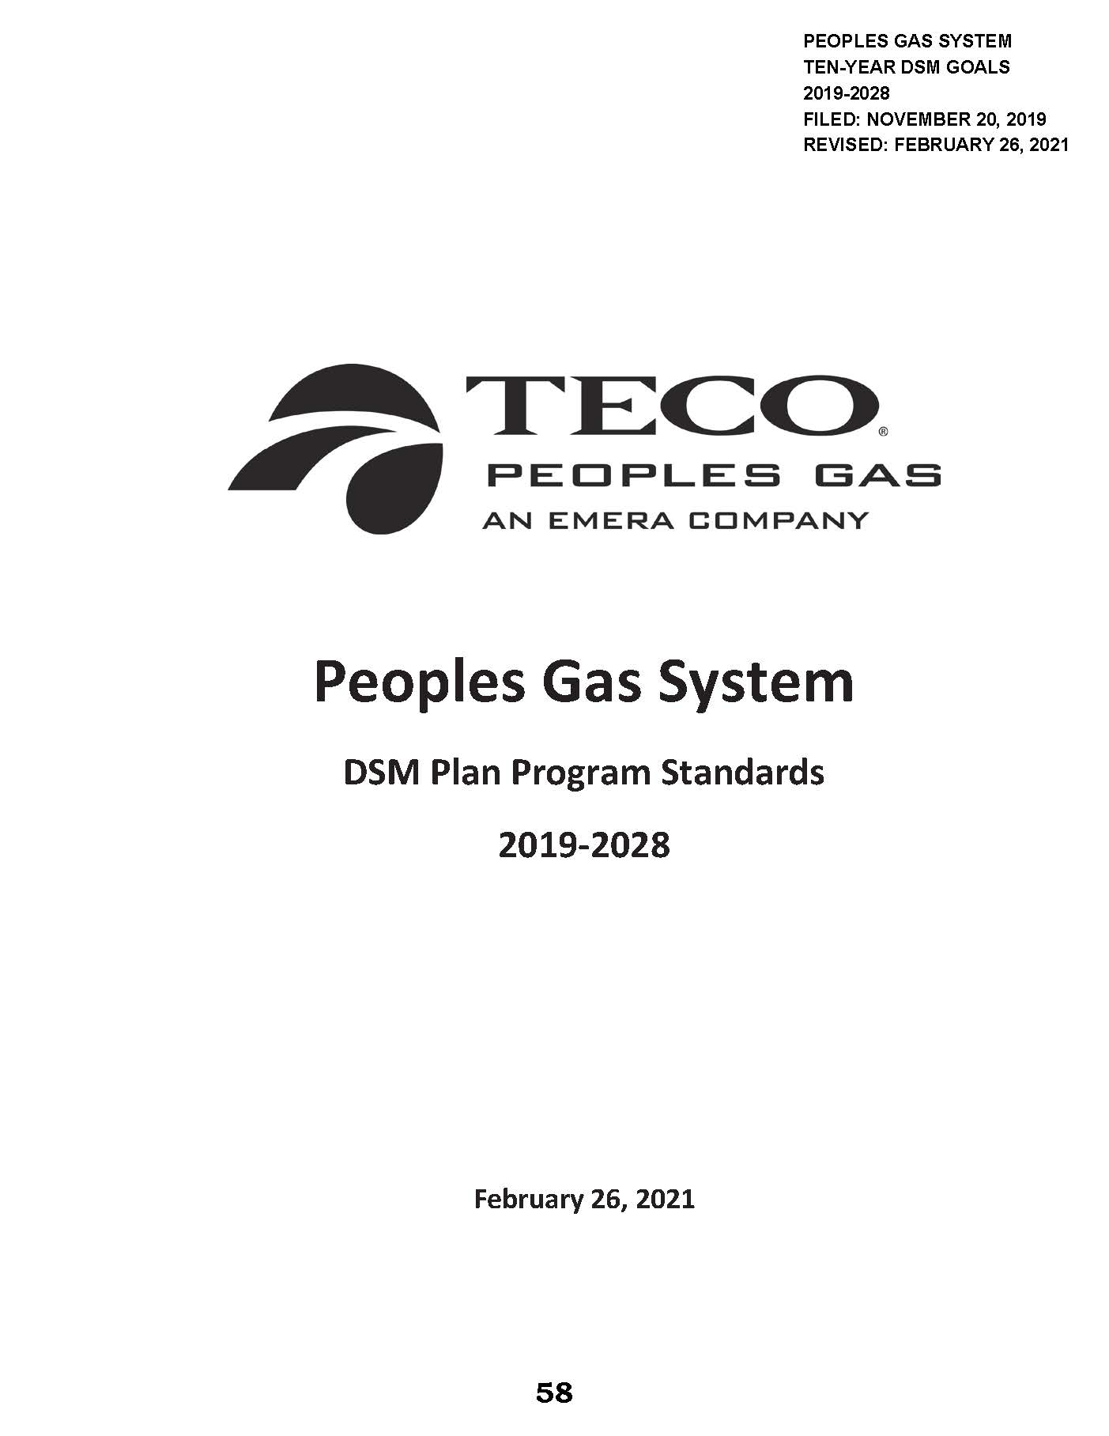
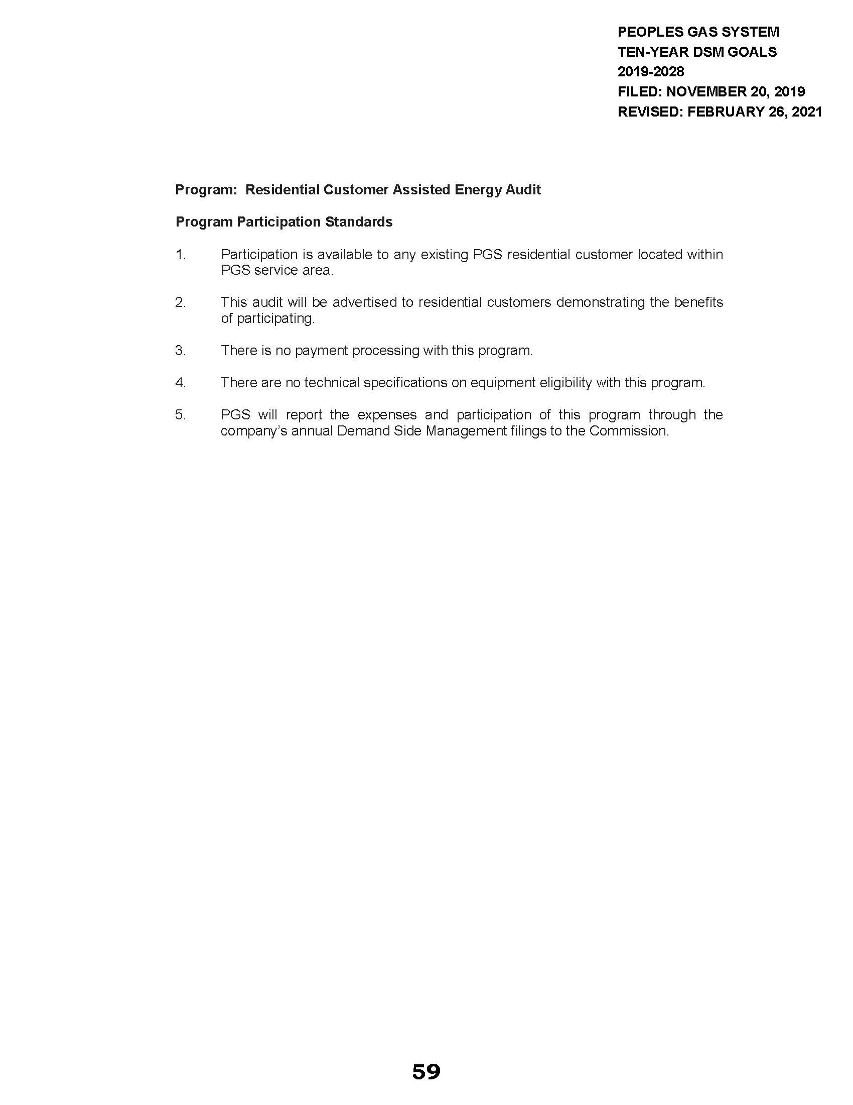
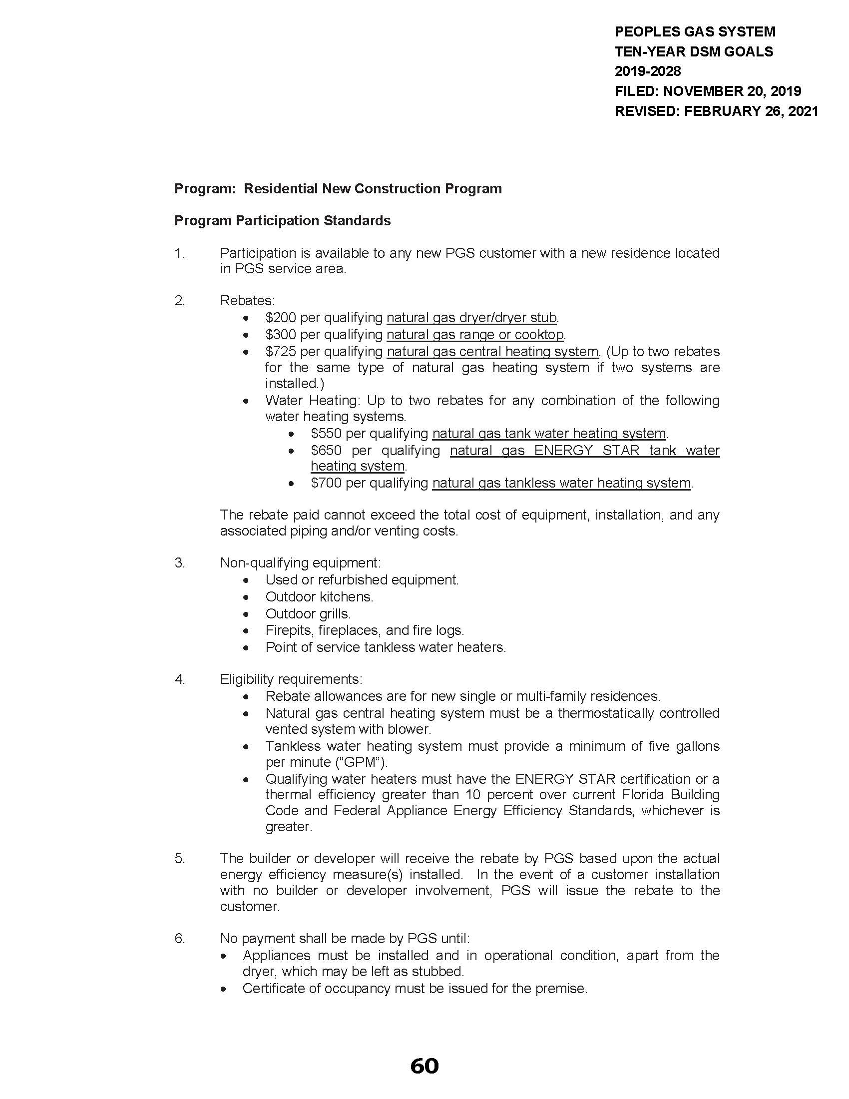
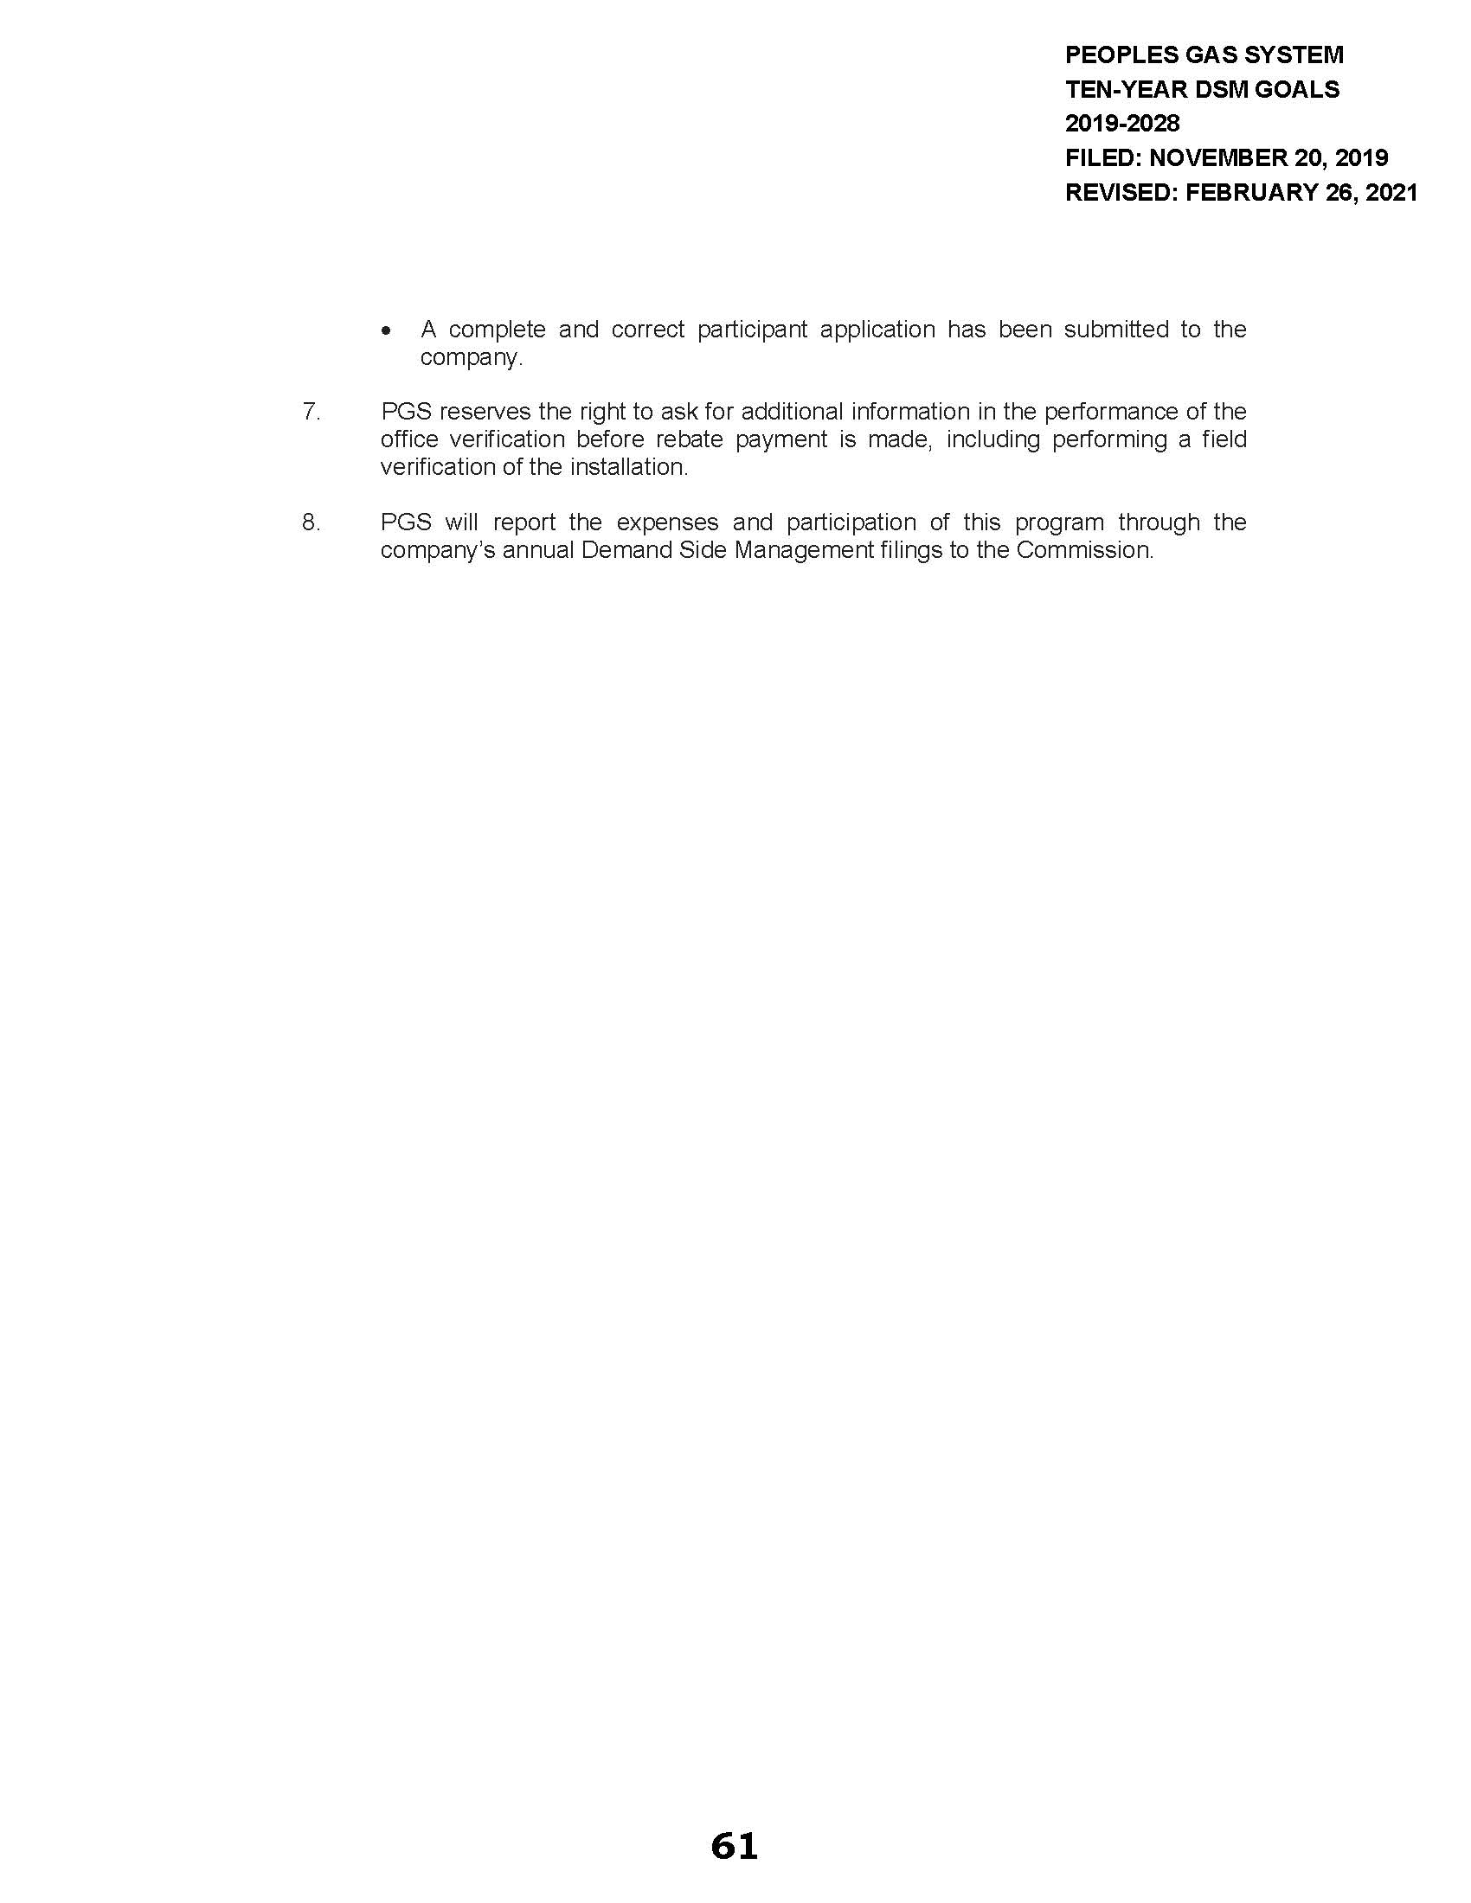
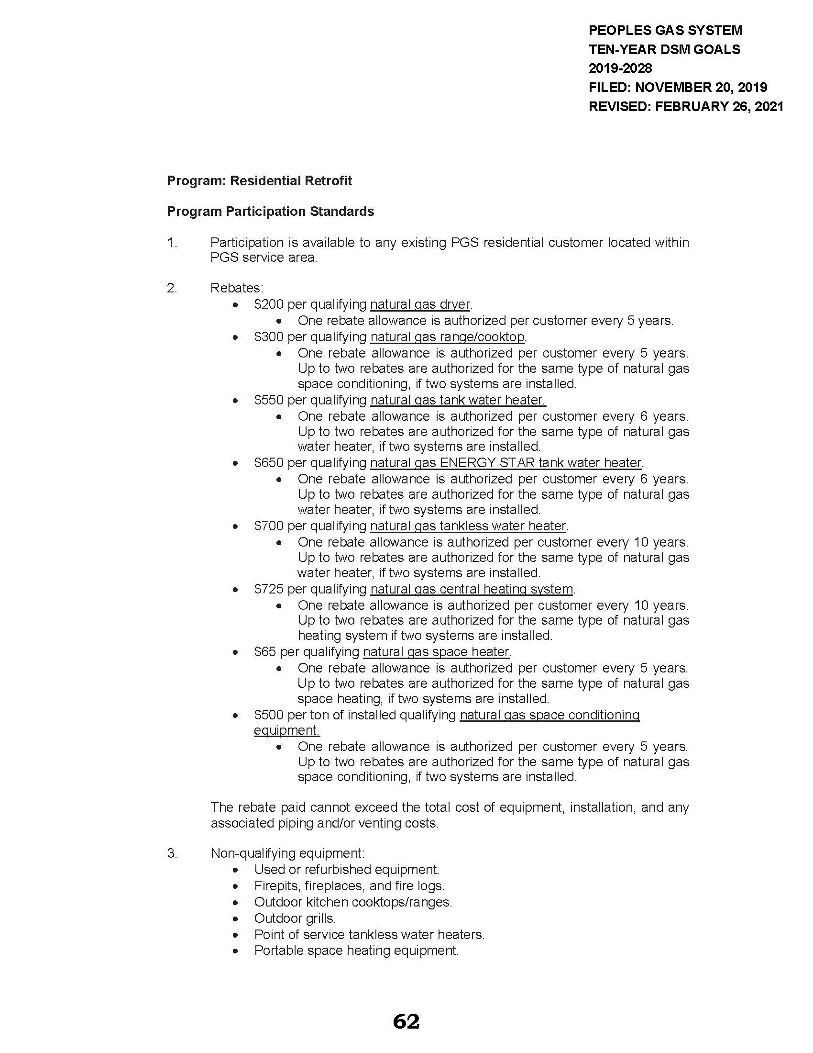
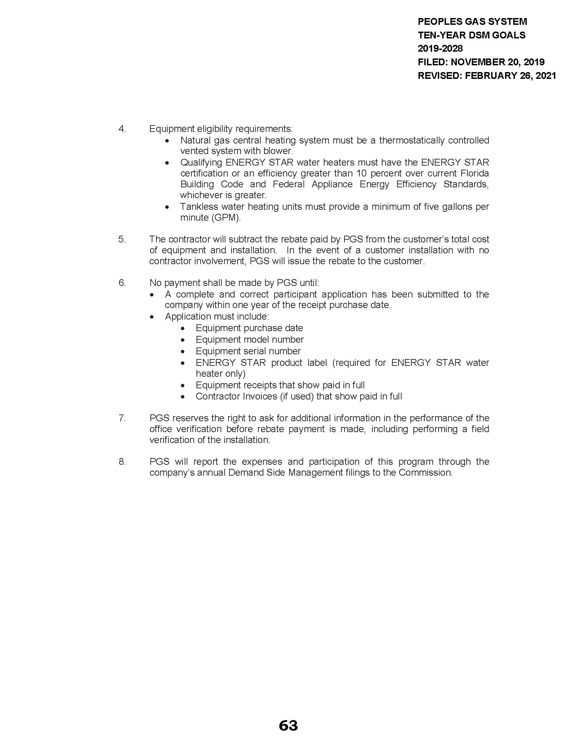
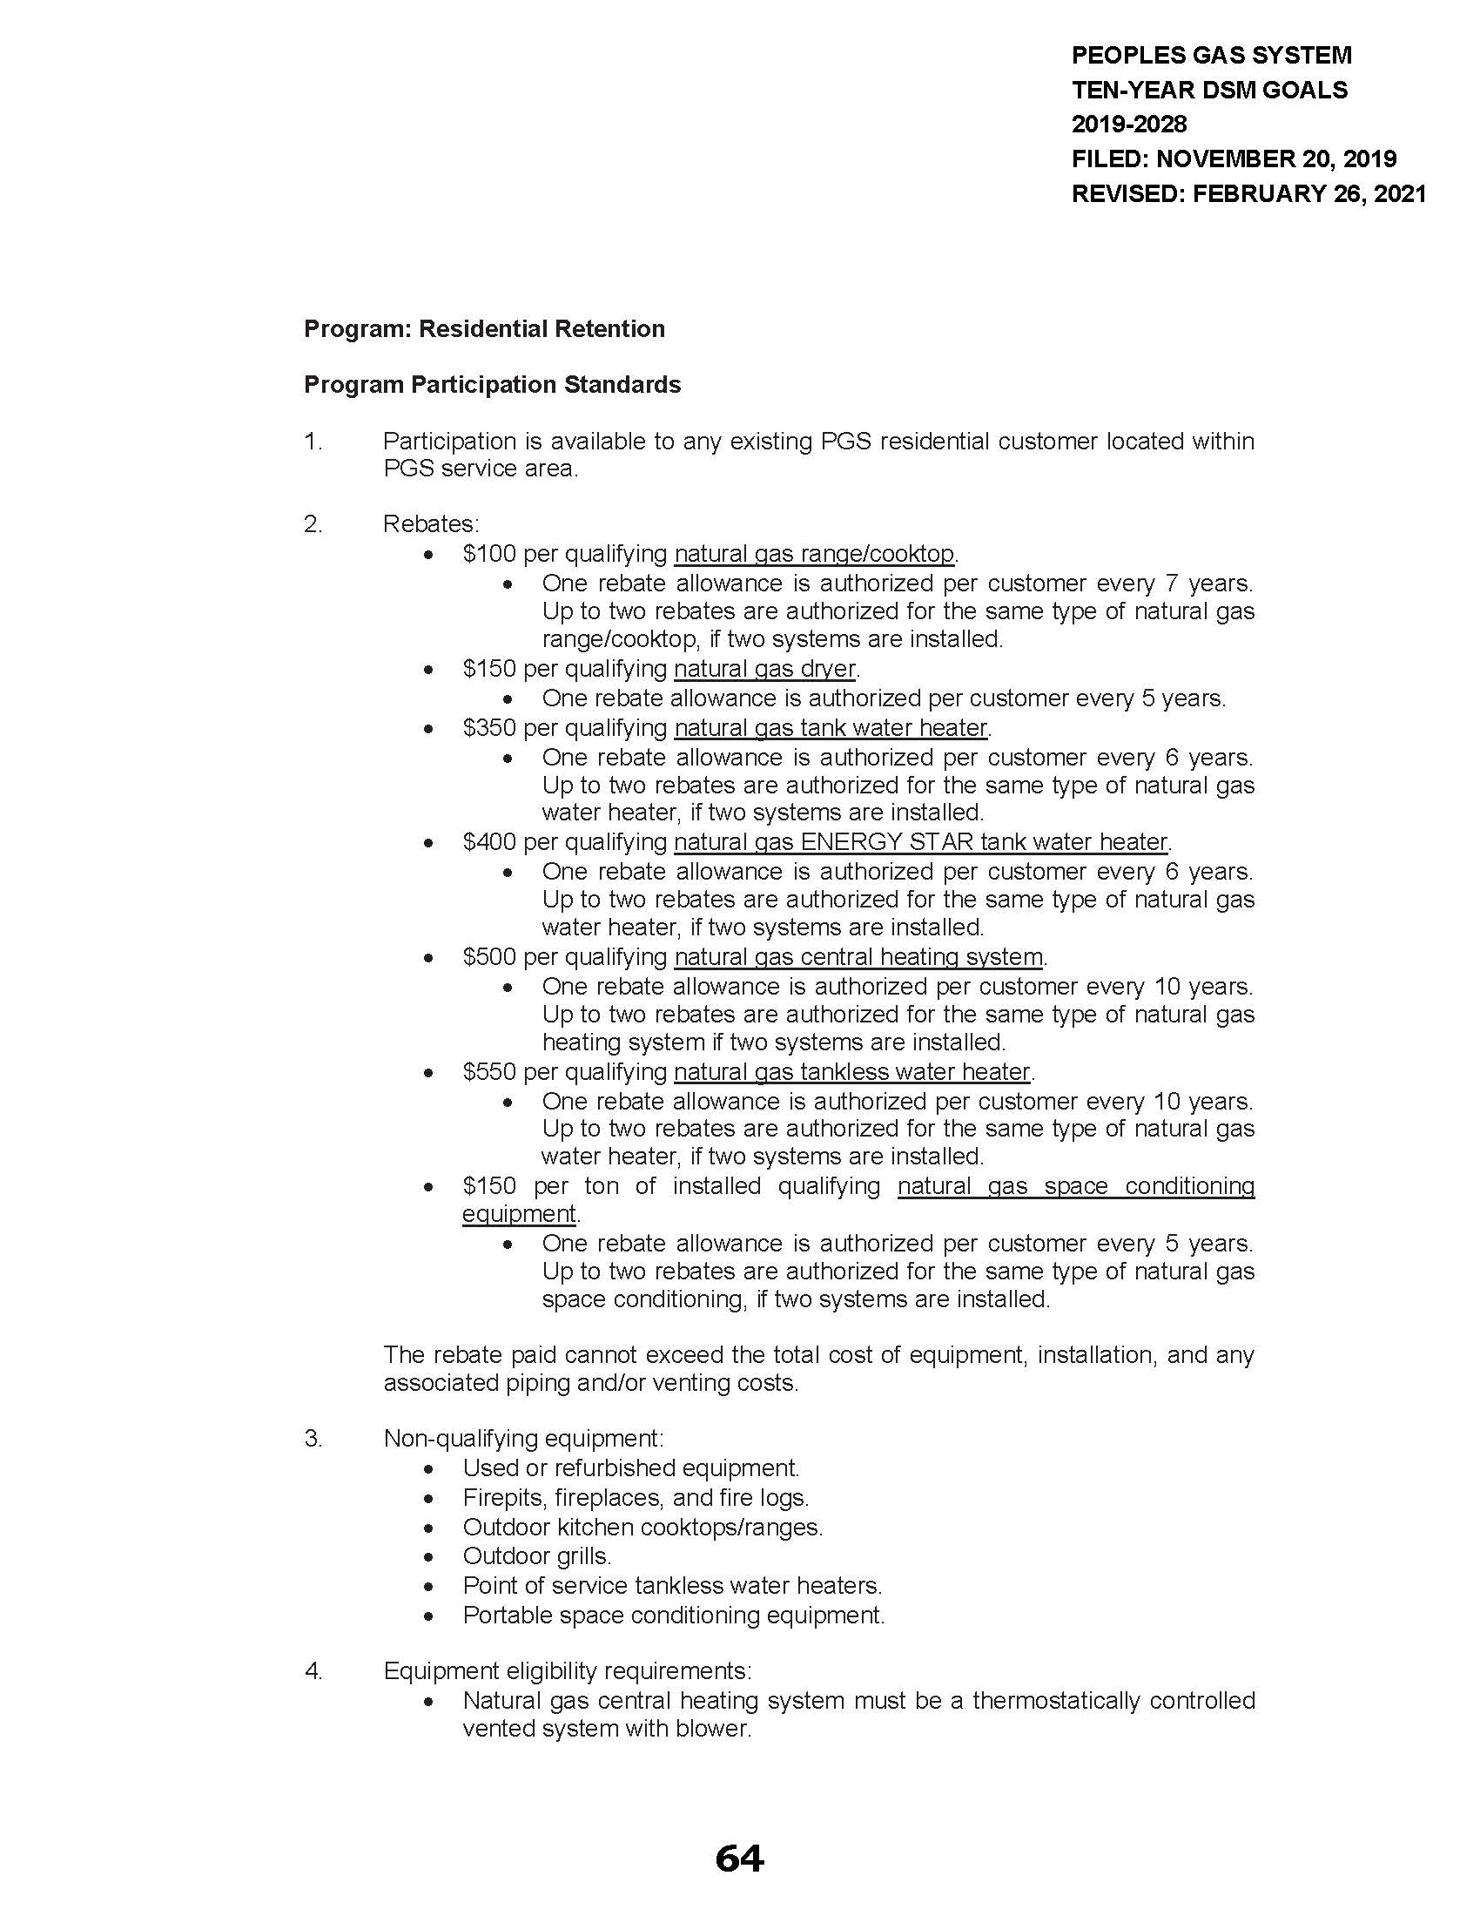
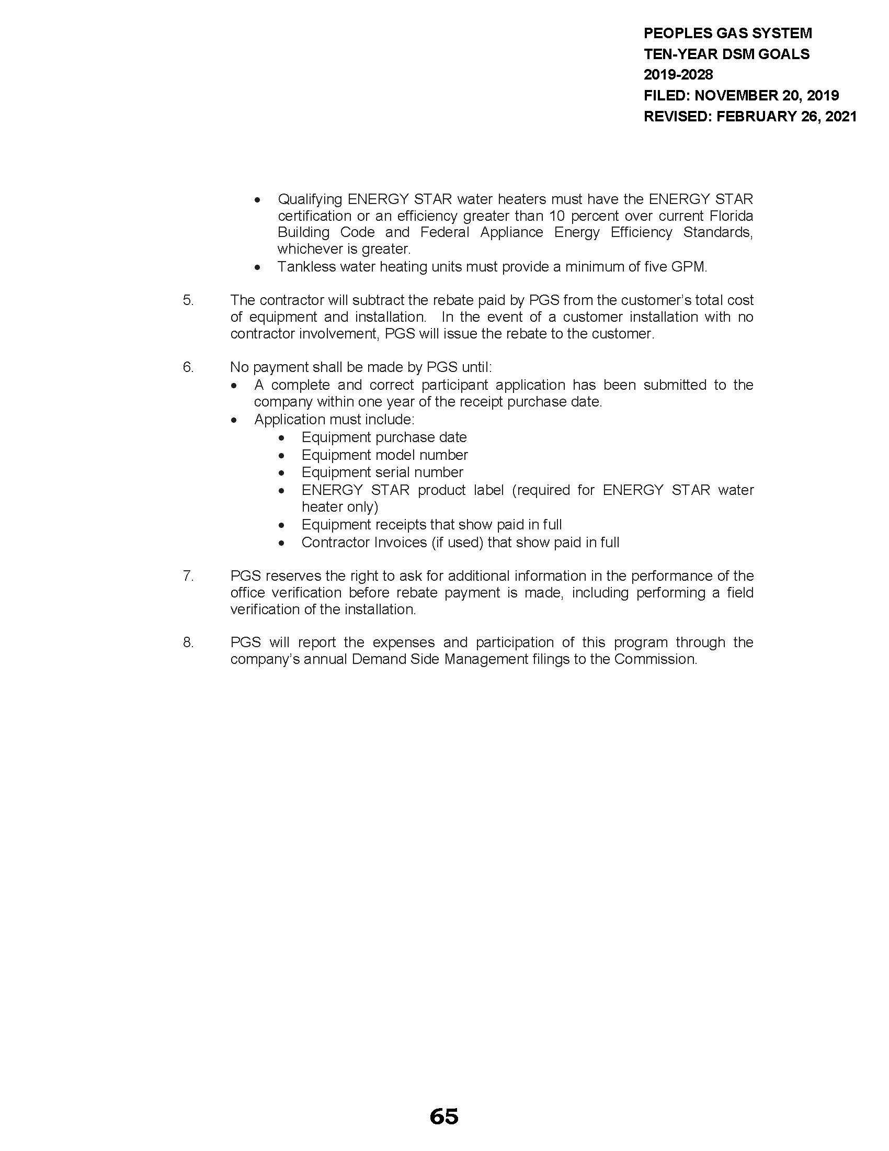
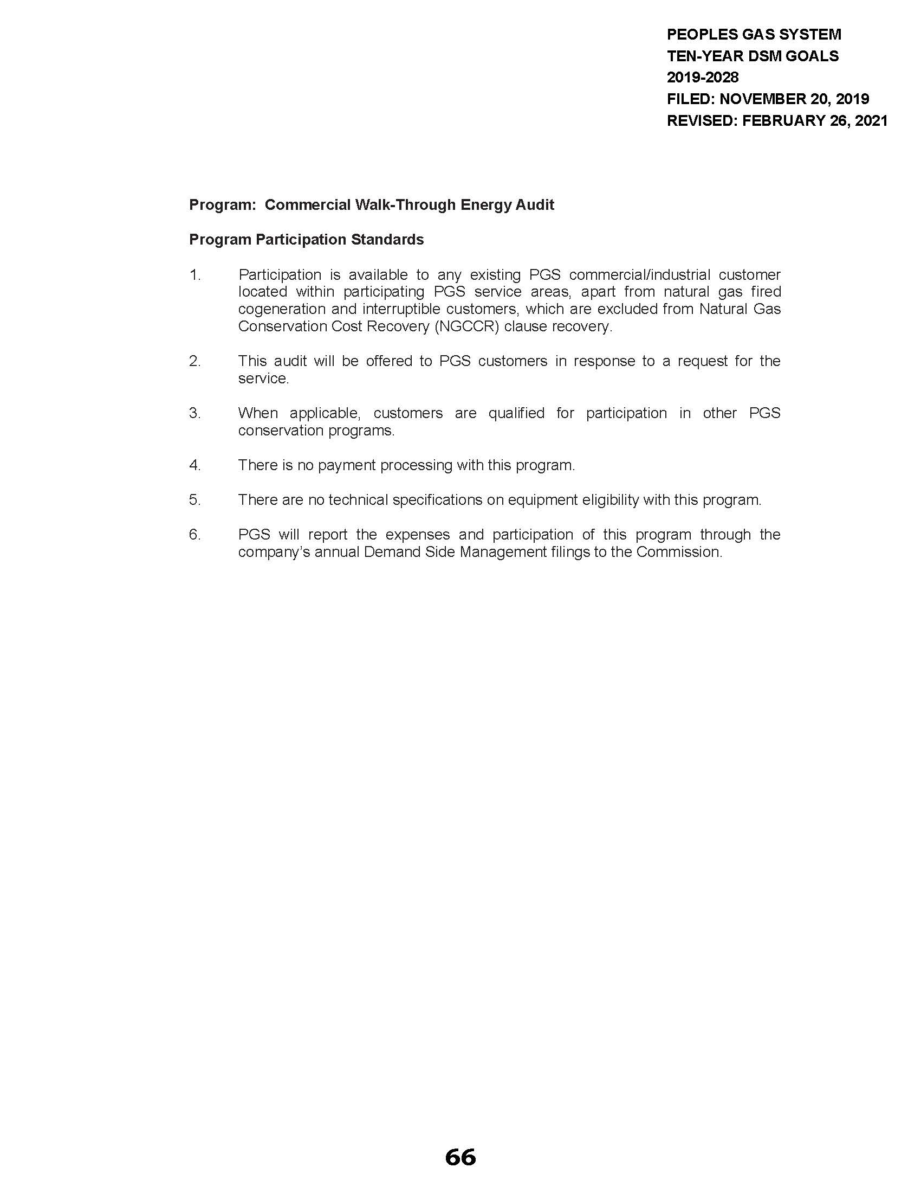
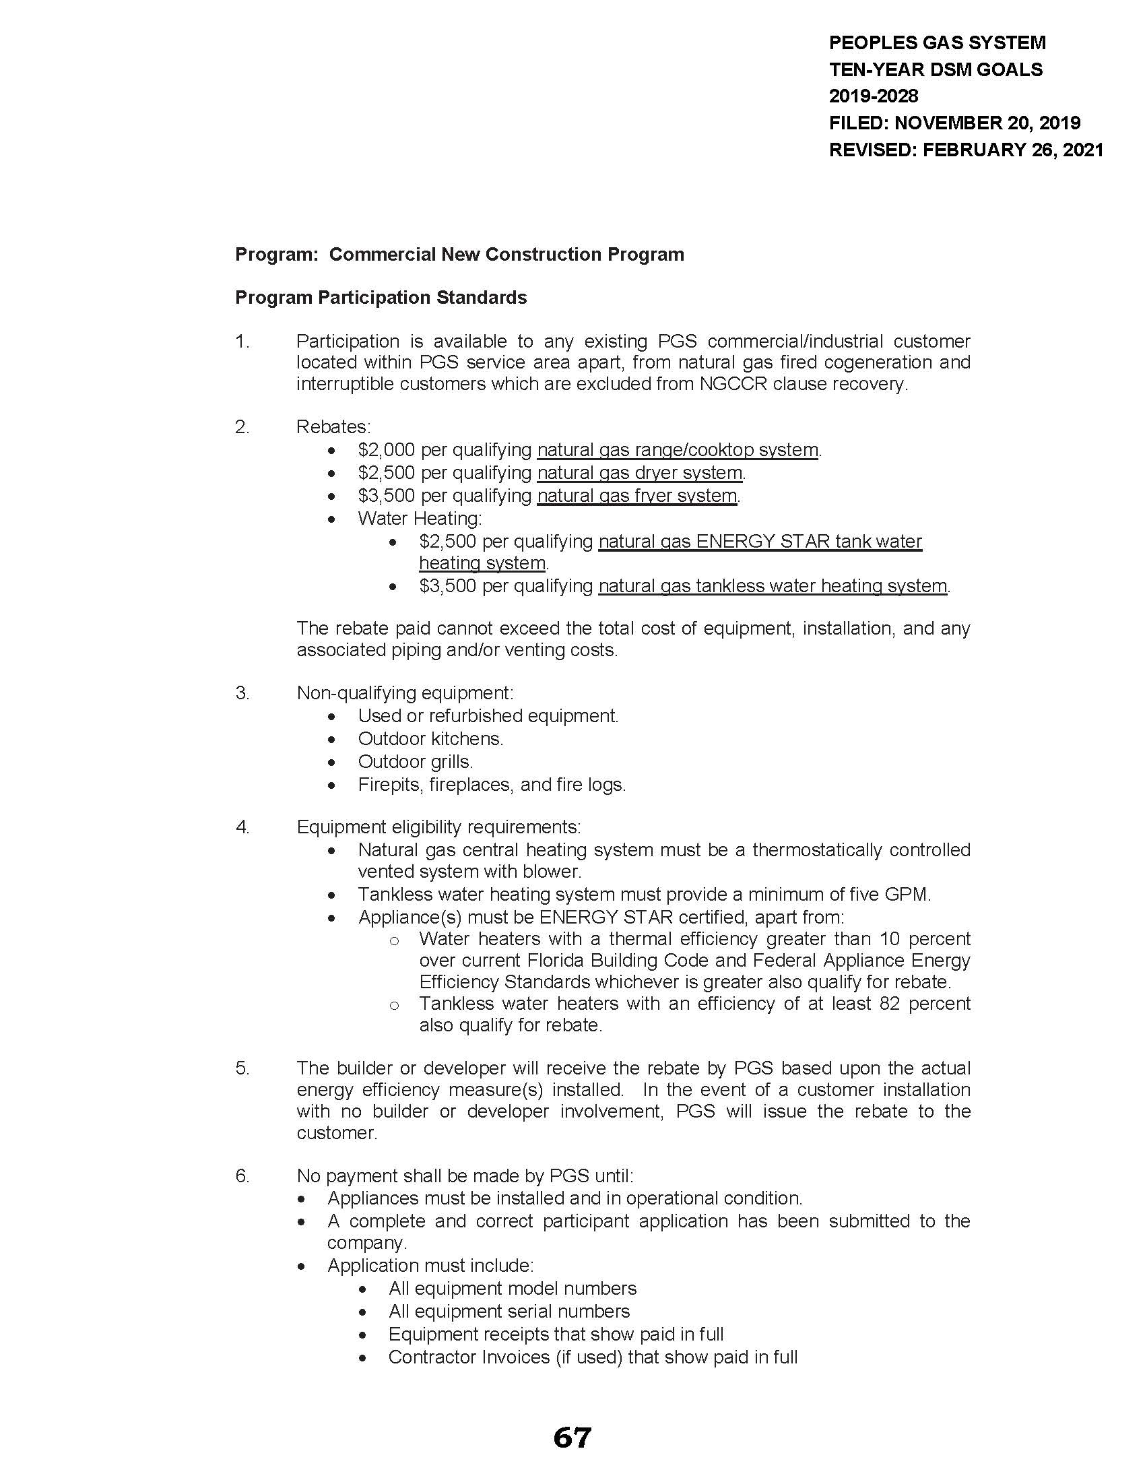
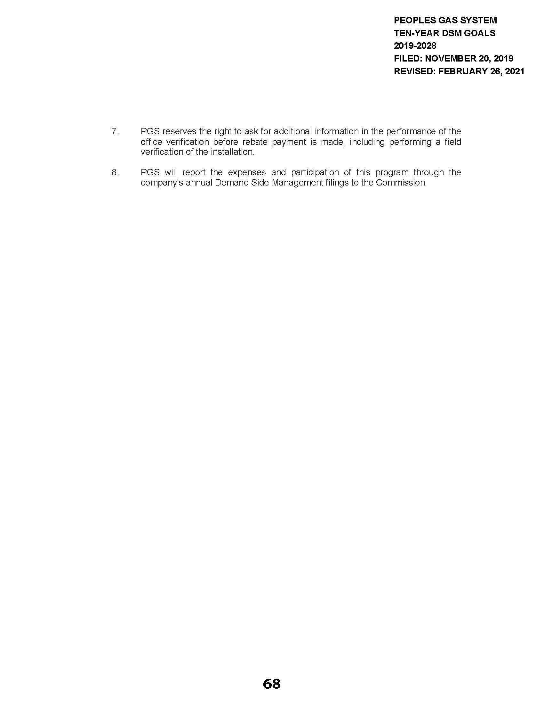
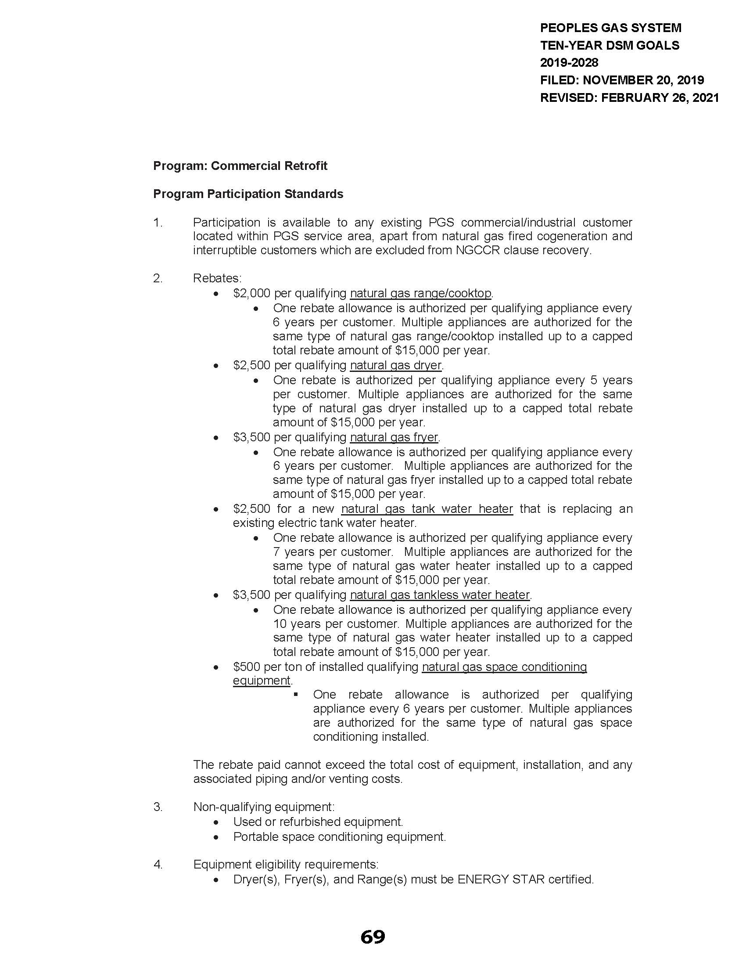
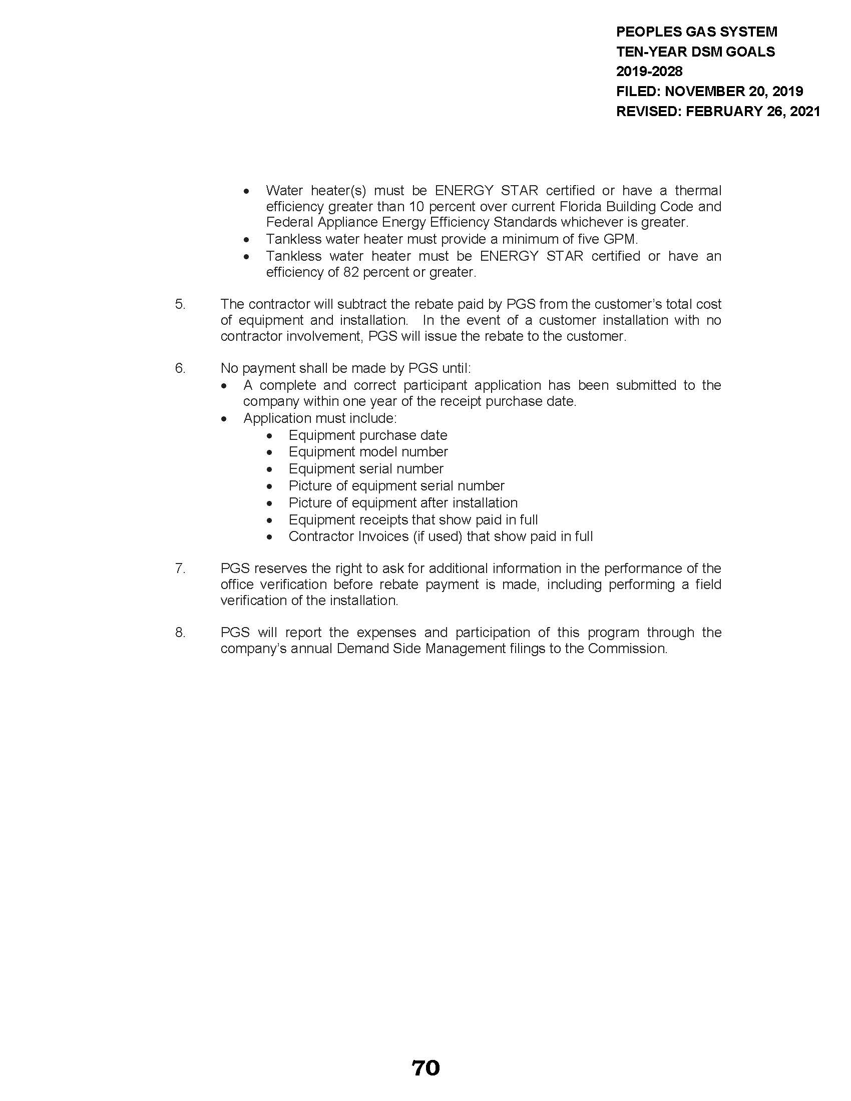
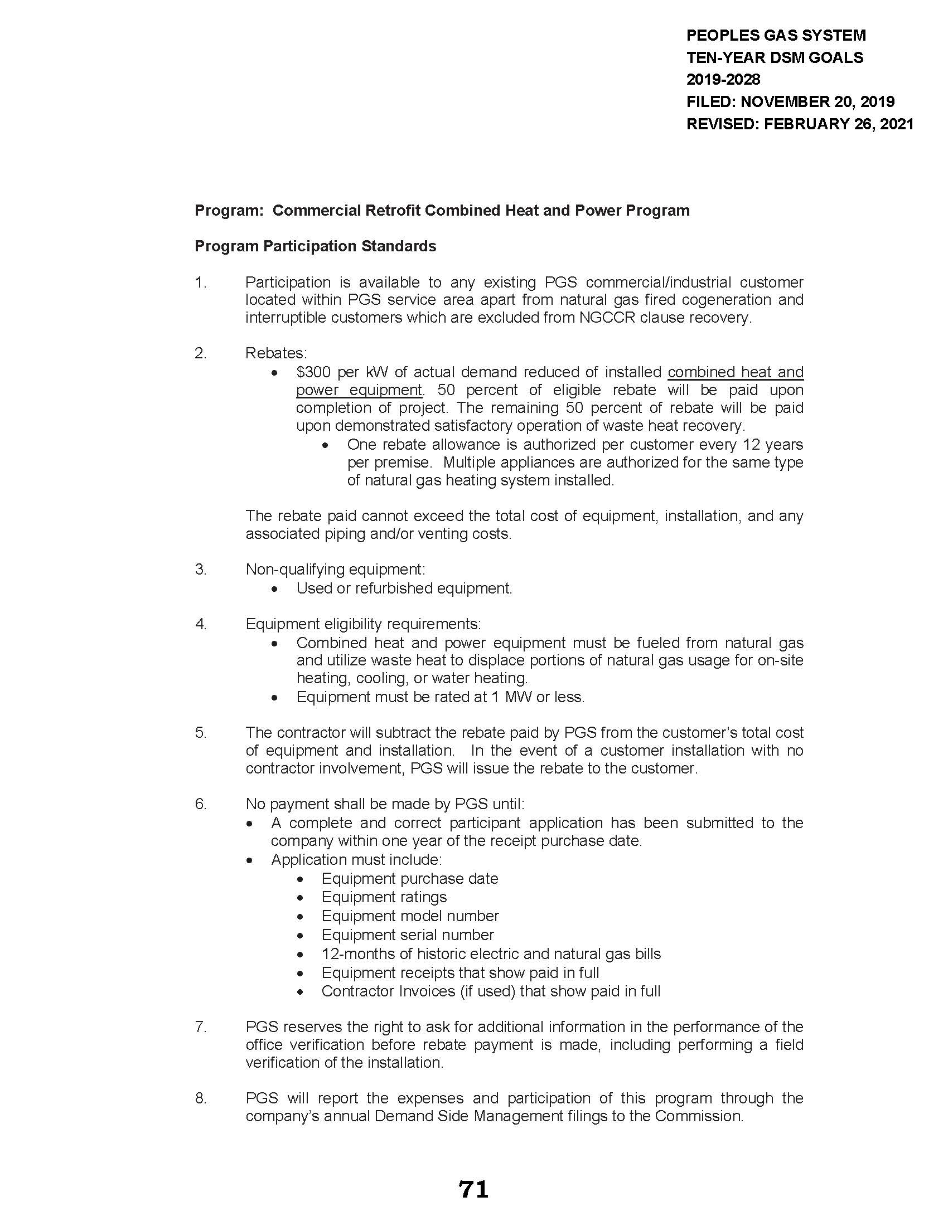
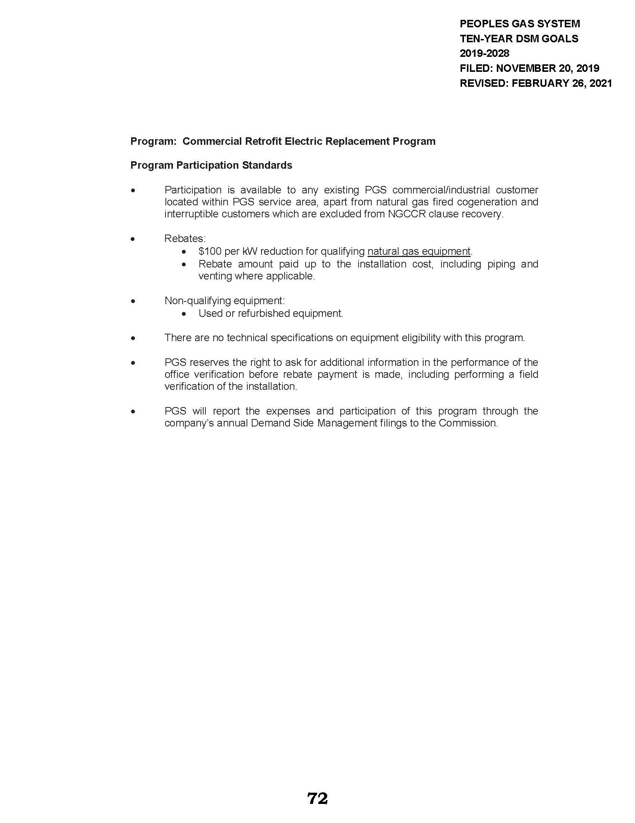
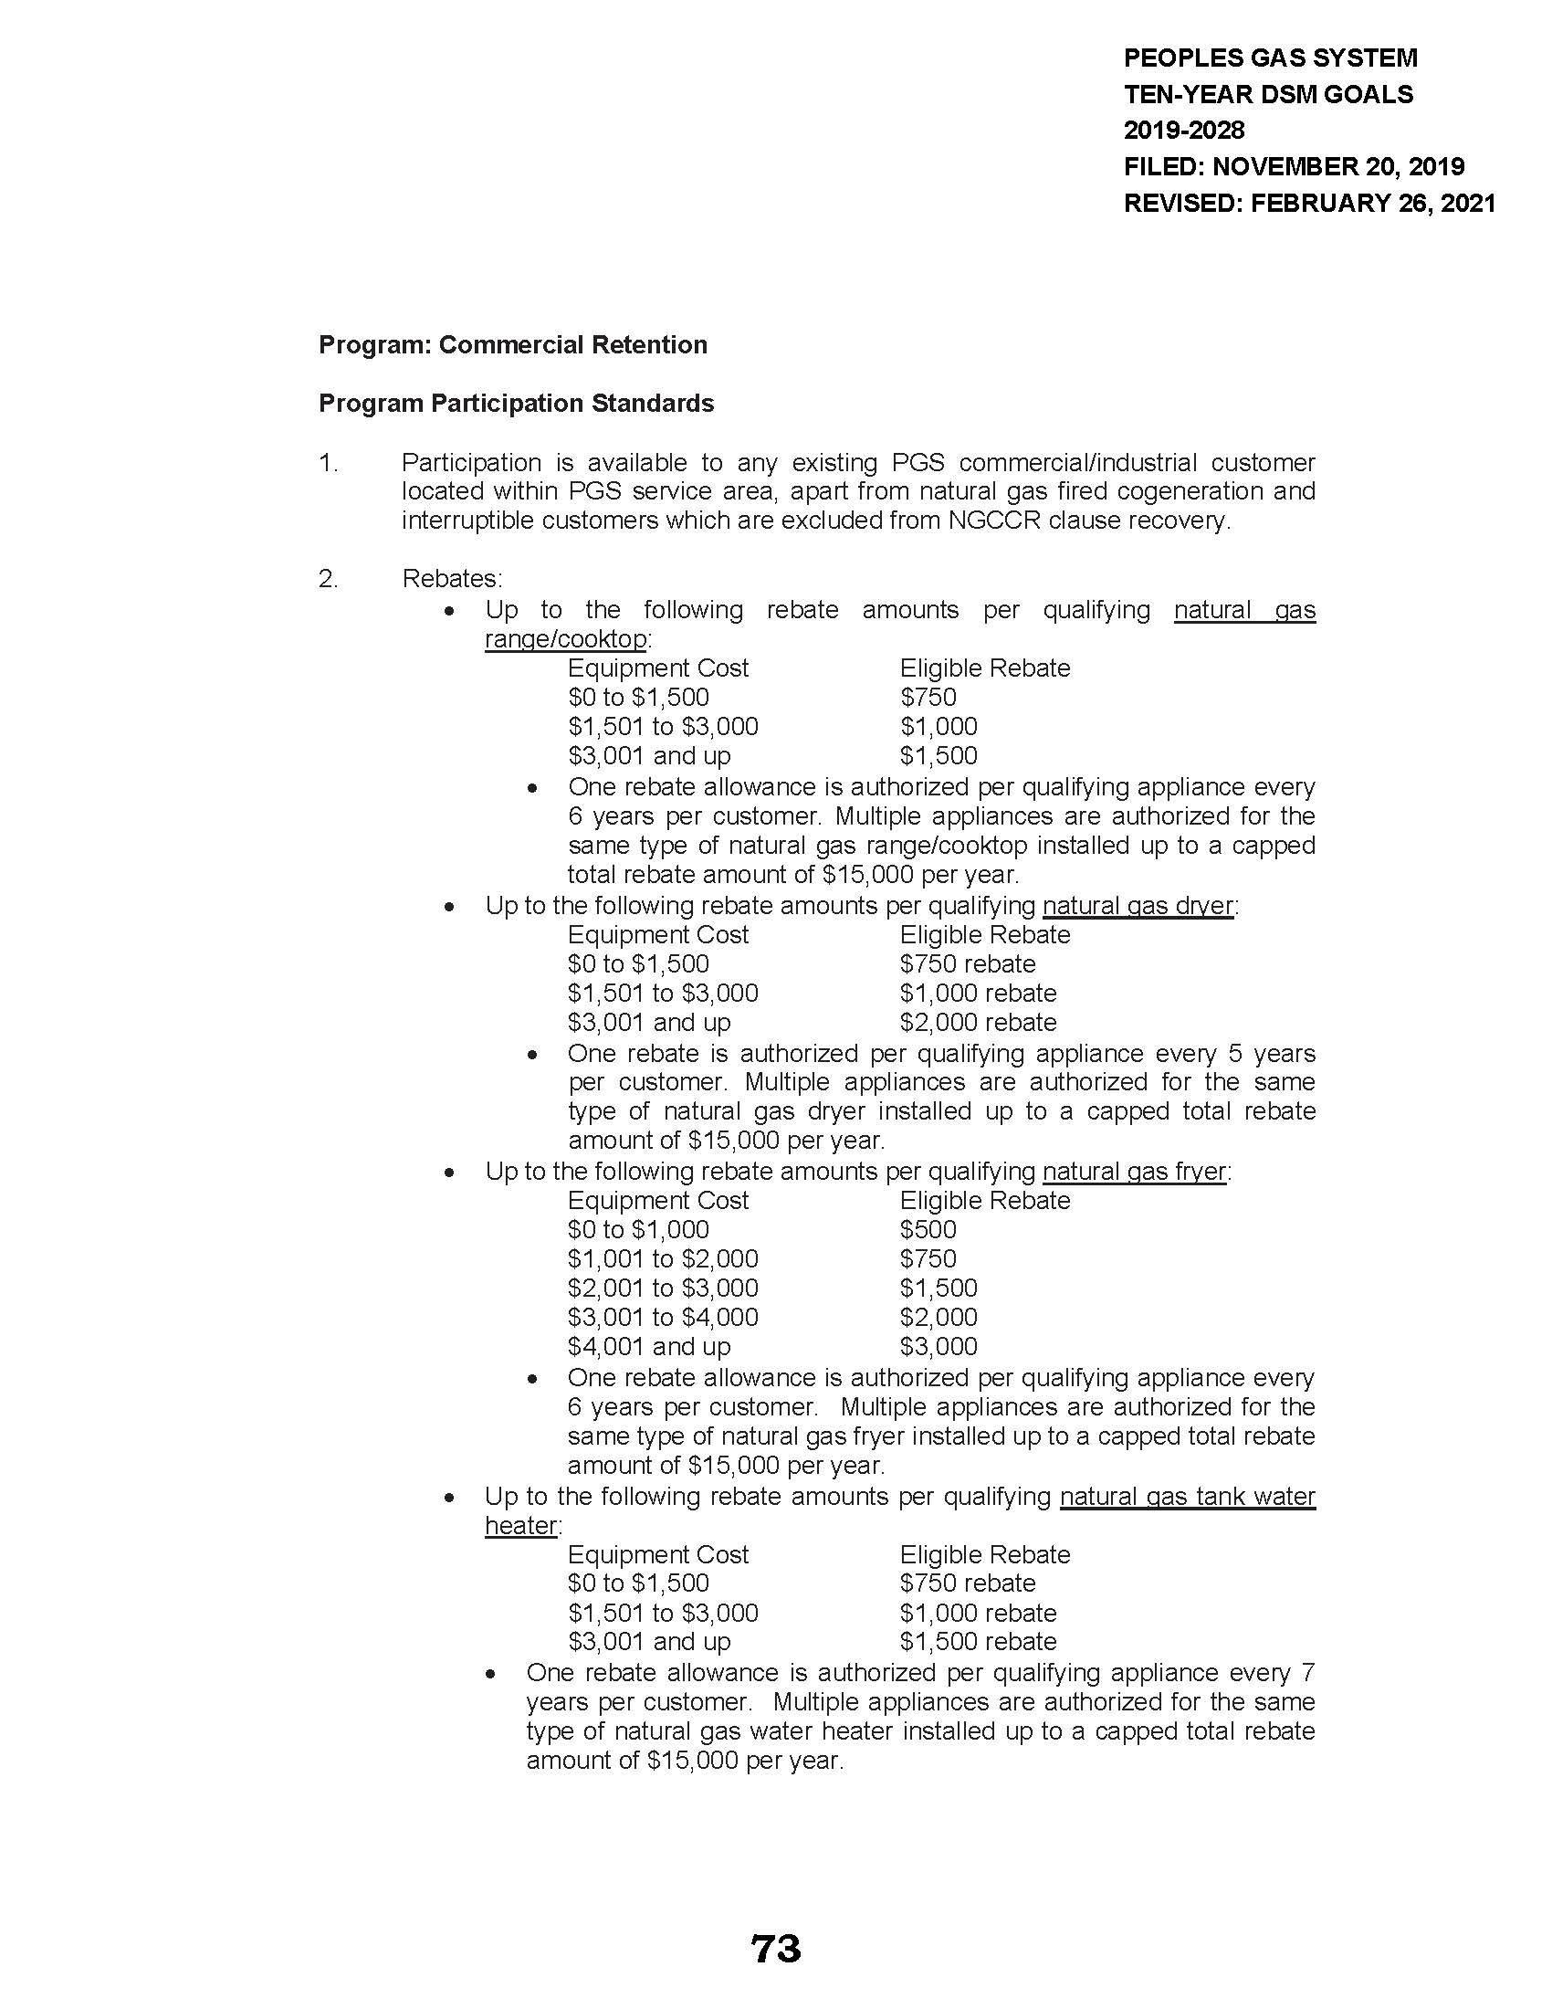
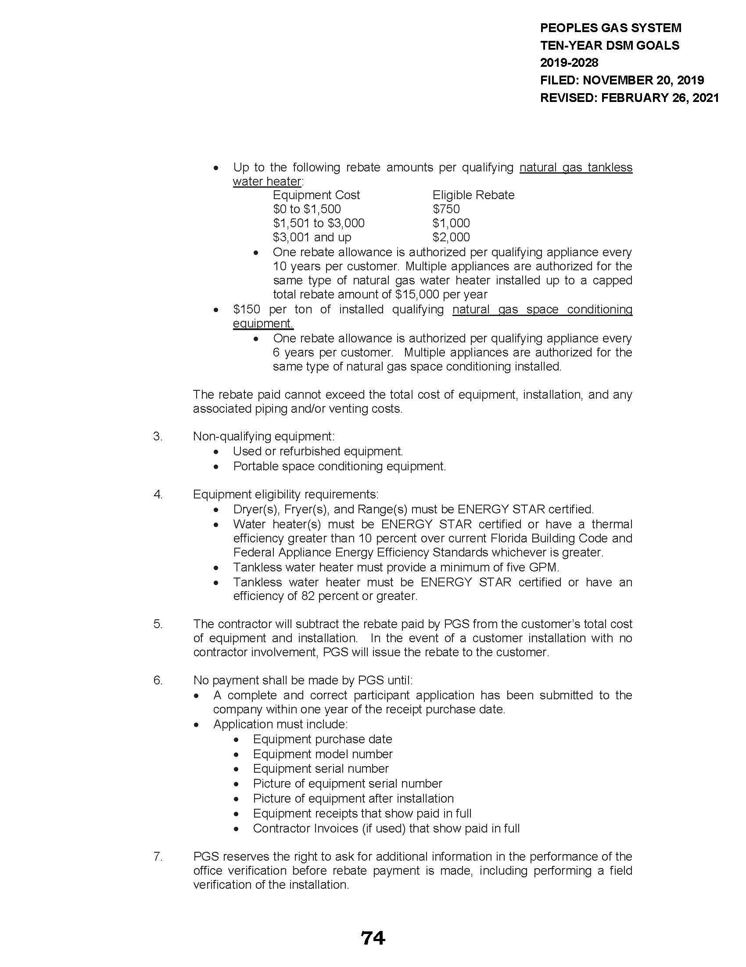
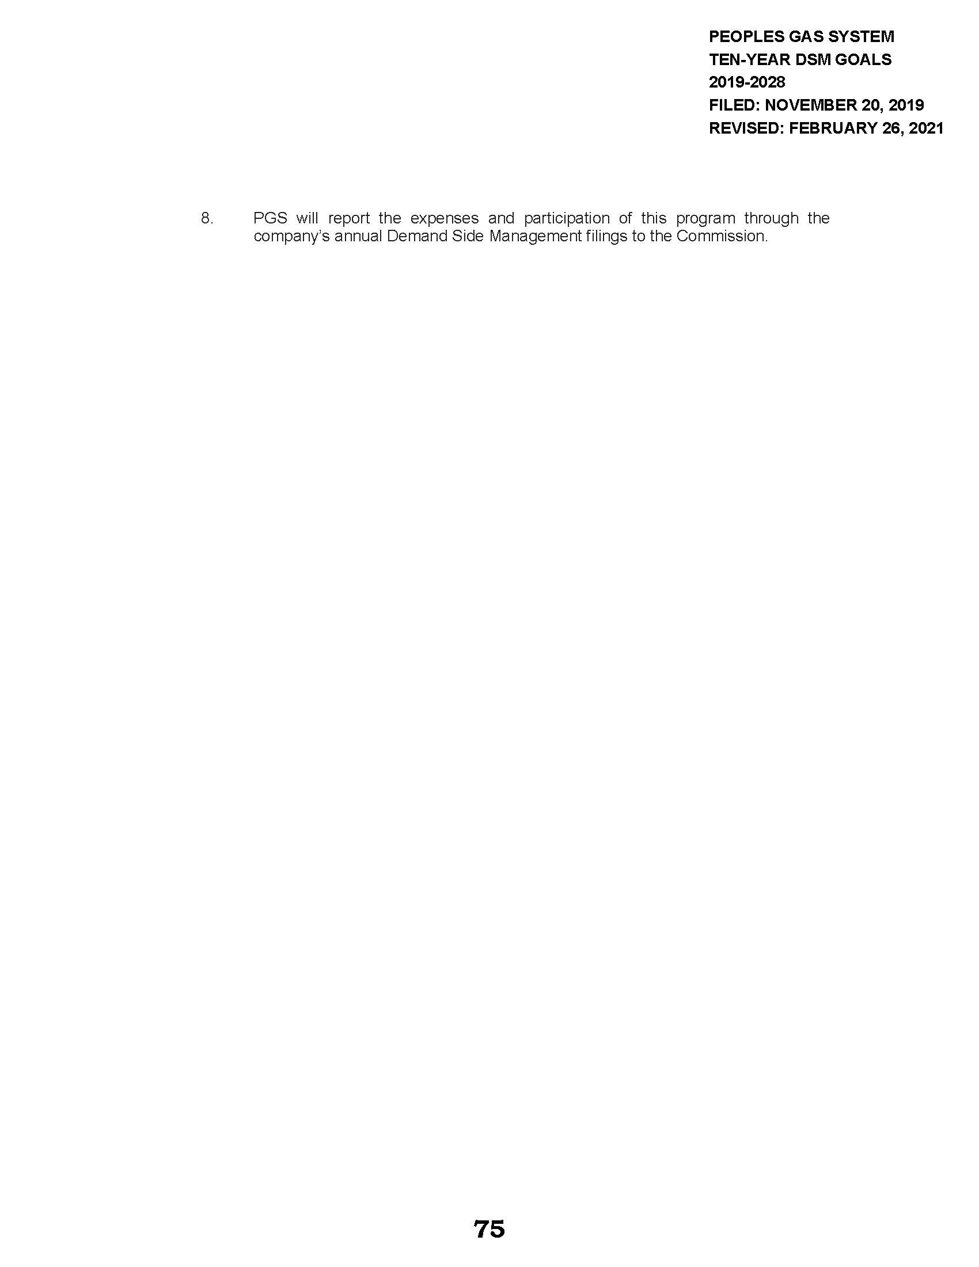
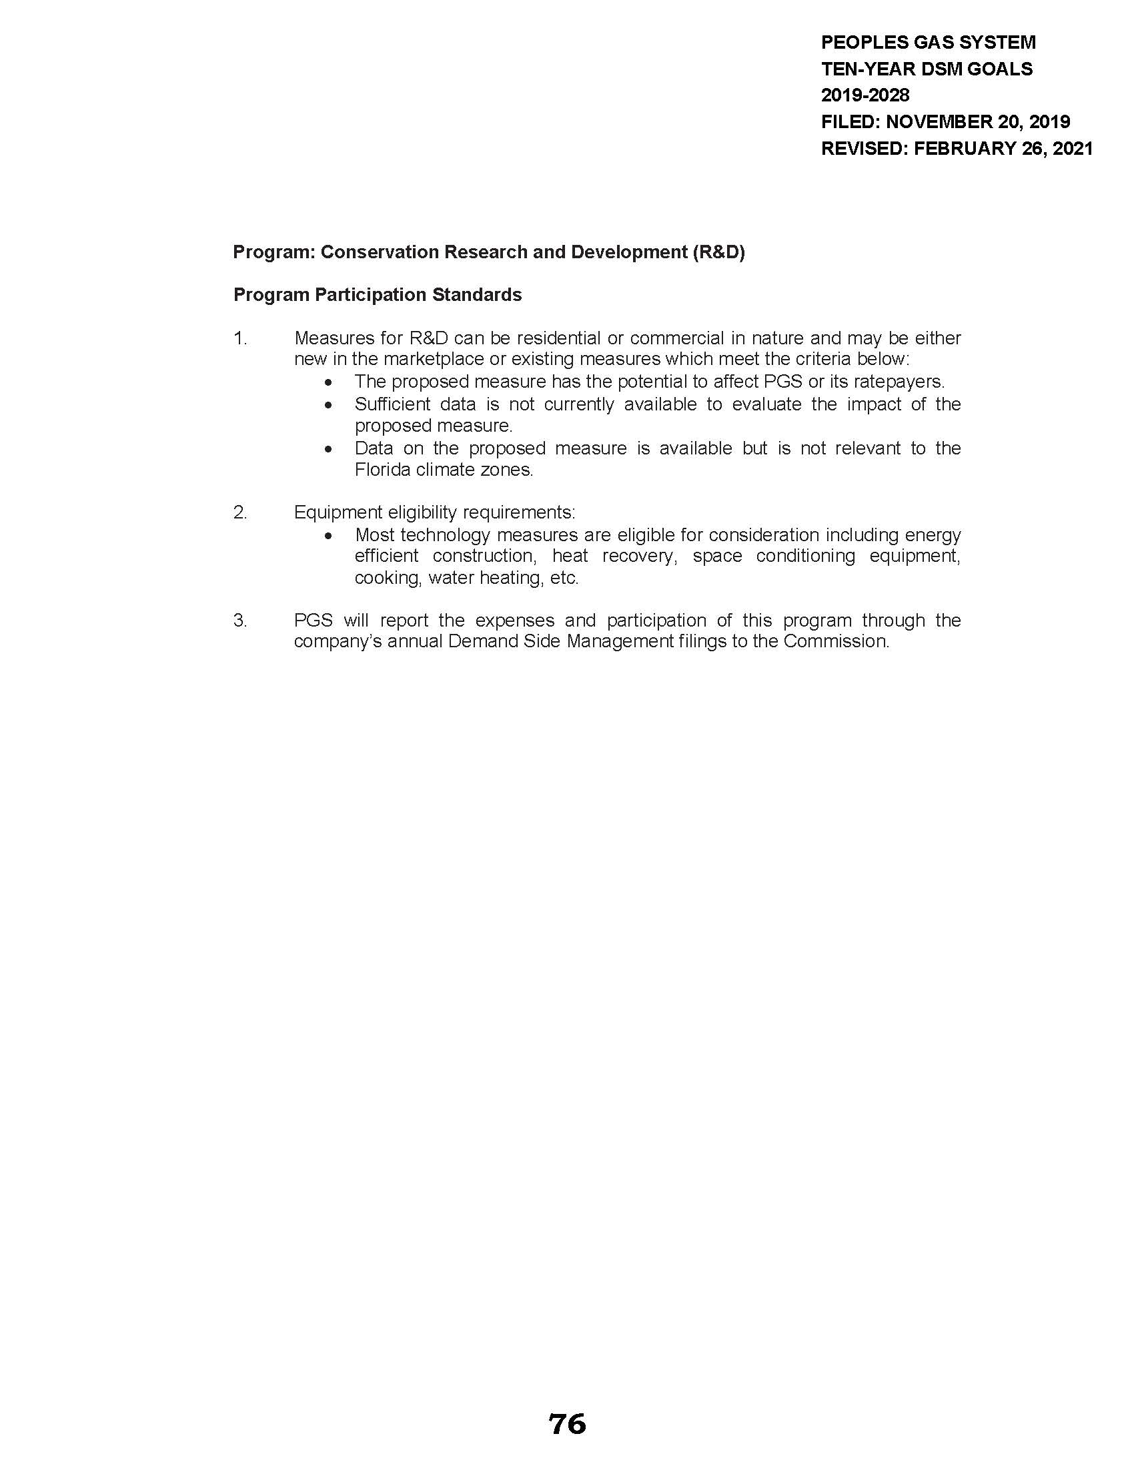

Order No. PSC-2019-0361-PAA-GU, issued August 26, 2019, in Docket No. 20180186-GU, In re: Petition for approval of demand side management goals and residential customer assisted and commercial walk-through energy audit programs, by Peoples Gas System.
PSC Order No. 22176, issued November 14, 1989, in Docket No. 19890737-PU, In re: Implementation of Section 366.80-.85, F.S., Conservation Activities of Electric and Natural Gas Utilities.
Order No. PSC-2019-0361-PAA-GU, issued August 26, 2019, in Docket No. 20180186-GU, In re: Petition for approval of demand side management goals and residential customer assisted and commercial walk-through energy audit programs, by Peoples Gas System.

