BEFORE THE FLORIDA PUBLIC SERVICE COMMISSION

In re: Petition for approval of regulatory assets to record costs incurred due to COVID-19, by Florida Public Utilities Company, Florida Public Utilities Company - Indiantown Division, Florida Public Utilities Company - Fort Meade, Florida Division of Chesapeake Utilities Corporation. | DOCKET NO. 20200194-PU
In re: Petition for approval of a regulatory asset to record costs incurred due to COVID-19, by Gulf Power Company. | DOCKET NO. 20200151-EI  ORDER NO. PSC-2021-0266-S-PU  ISSUED: July 22, 2021

The following Commissioners participated in the disposition of this matter:

GARY F. CLARK, Chairman
ART GRAHAM
ANDREW GILES FAY
MIKE LA ROSA
GABRIELLA PASSIDOMO

APPEARANCES:

JOEL T. BAKER AND RUSSELL BADDERS, ESQUIRES, Gulf Power Company, One Energy Place, Pensacola, Florida, 32520-0100
On behalf of Gulf Power Company (GULF).

BETH KEATING, ESQUIRE, Gunster, Yoakley & Stewart P.A., 215 South Monroe Street, Suite 601, Tallahassee, Florida 32301
On behalf of Florida Public Utilities Companies (FPUC).

RICHARD GENTRY, CHARLES REHWINKEL, STEPHANIE MORSE, ANASTACIA PIRRELLO, AND PATRICIA A. CHRISTENSEN, ESQUIRES, Office of Public Counsel, c/o The Florida Legislature, 111 West Madison Street, Room 812, Tallahassee, Florida 32399-1400
On behalf of the Citizens of the State of Florida (OPC).

SHAW P. STILLER, WALTER TRIERWEILER, AND JENNIFER S. CRAWFORD, ESQUIRES, Florida Public Service Commission, 2540 Shumard Oak Boulevard, Tallahassee, Florida 32399-0850
On behalf of the Florida Public Service Commission (Staff).

MARY ANNE HELTON, ESQUIRE, Deputy General Counsel, Florida Public Service Commission, 2540 Shumard Oak Boulevard, Tallahassee, Florida 32399-0850
Advisor to the Florida Public Service Commission.

KEITH HETRICK, ESQUIRE, General Counsel, Florida Public Service Commission, 2540 Shumard Oak Boulevard, Tallahassee, Florida 32399-0850
Florida Public Service Commission General Counsel

FINAL ORDER APPROVING STIPULATION AND SETTLEMENT
BETWEEN FLORIDA PUBLIC UTILITIES COMPANY
AND OFFICE OF PUBLIC COUNSEL

BY THE COMMISSION:

BACKGROUND

On August 11, 2020, Florida Public Utilities Company, Florida Public Utilities Company – Indiantown Division, Florida Public Utilities Company – Fort Meade, and Florida Public Utilities Company – Electric Division, as well as the Florida Division of Chesapeake Utilities Corporation (collectively FPUC) filed a petition for approval to establish regulatory assets for each entity listed above to record costs incurred due to COVID-19. FPUC requested deferral of incremental bad debt expense, incremental operating expenses, and safety-related costs attributable to COVID-19. On October 26, 2020, the Commission issued PAA Order PSC-2020-0404-PAA-PU, approving the request of FPUC. On November 16, 2020, the Office of Public Counsel (OPC) filed a Petition Protesting a Proposed Agency Action and requested an administrative hearing on the proposed action. On March 12, 2021, this docket was consolidated with Docket Nos. 20200151-EI and 20200189-WU and scheduled for final hearing to commence June 16, 2021.

On June 11, 2021, FPUC and OPC filed a Joint Motion for Approval of a Stipulation and Settlement Agreement (Settlement) dated June 11, 2021, which resolved all outstanding issues in the case. A copy of the Settlement is appended to this order as Attachment A. A final hearing on the Settlement was held on July 8, 2021. At the final hearing, the testimonies of Michael D. Galtman, Derrick M. Craig, and J. Terry Deason on behalf of FPUC, and Daniel J. Lawton on behalf of OPC, were admitted into the record as though read. A Comprehensive Exhibit List was also admitted into the record as well as the exhibits identified thereon. The parties, supporting the Settlement, waived the right to file post-hearing briefs, and a bench vote was taken at the conclusion of the hearing.
We have jurisdiction pursuant to Sections 366.04, 366.05, and 366.06, Florida Statutes.

DECISION

On March 1, 2020, Governor Ron DeSantis issued Executive Order number 20-51, directing the State Health Officer and Surgeon General to declare a public health emergency due to COVID-19. On March 9, 2020, the Governor issued Executive Order number 20-52 declaring the existence of a state of emergency in the State of Florida. The Governor signed several Executive Orders extending the state of emergency. The final sixty-day extension expired June 26, 2021, at which time the state of emergency was lifted.

During the state of emergency, many local governments throughout the State enacted ordinances implementing heightened safety requirements. FPUC undertook numerous measures to comply with these mandates and also to protect its employees and customers independent of and in addition to direct government requirements. During this same period, FPUC experienced an increase in unpaid, past due balances due to the economic downturn and negative impacts on customers resulting from the pandemic.

FPUC sought to establish a regulatory asset to record and ultimately recover the above-referenced safety-related expenses and incremental increase in bad debt. FPUC also sought to record and recover amounts related to an alleged reduced insurance premium, hazard pay, health claims, communication, consulting, legal, and a category labelled “other.” OPC protested numerous aspects of the request made by FPUC. As a resolution of these disputes, the parties executed the attached Settlement, which contains the following material terms:

- FPUC may establish a regulatory asset in a total amount of $2,085,759, as full recovery of all safety-related expenses and incremental bad debt incurred due to COVID-19 through June 30, 2021. All other COVID-19 related costs incurred by FPUC prior to June 30, 2021, are deemed to have been fully recovered through other savings and are not eligible for future recovery.

- Any COVID-19 related expenses incurred after June 30, 2021, shall be deemed a different event.

- FPUC shall be allowed to amortize and recover the regulatory asset over two years through the Purchased Gas Adjustment and Swing Service mechanisms for the natural gas business units and the Fuel and Purchased Power Cost Recovery clause mechanism for the electric division beginning with the factors established for the calendar year 2022.

The standard for approval of a settlement agreement is whether it is in the public interest. A determination of public interest requires a case-specific analysis based on consideration of the proposed settlement taken as a whole. The costs at issue in this proceeding were incurred by FPUC as a result of COVID-19. OPC and Commission staff have conducted extensive discovery in this case and have reviewed detailed material concerning COVID-19 related costs supplied by FPUC. After this extensive review, as statutory representative of Florida’s citizens, OPC negotiated this Settlement of all issues. In light of OPC’s participation in this Settlement of issues relating to customer and employee health and safety and the unforeseen economic impacts caused by a pandemic, we find that the Settlement when taken as a whole provides a reasonable resolution of issues regarding the recovery of costs incurred due to COVID-19. Therefore, we find that the Settlement is in the public interest and hereby approve it.

Based on the foregoing, it is

ORDERED by the Florida Public Service Commission that the Joint Motion of Office of Public Counsel and Florida Public Utilities Company for Approval of Stipulation and Settlement Agreement is hereby granted. It is further

ORDERED that the Stipulation and Settlement Agreement, attached hereto as Attachment A, and incorporated by reference, is hereby approved. It is further

ORDERED that the effective date of the Stipulation and Settlement Agreement, attached hereto as Attachment A, and incorporated by reference, shall be July 8, 2021.
By ORDER of the Florida Public Service Commission this 22nd day of July, 2021.

/s/ Adam J. Teitzman
ADAM J. TEITZMAN
Commission Clerk
Florida Public Service Commission
2540 Shumard Oak Boulevard
Tallahassee, Florida 32399
(850) 413-6770
www.floridapsc.com

Copies furnished: A copy of this document is provided to the parties of record at the time of issuance and, if applicable, interested persons.

SPS

NOTICE OF FURTHER PROCEEDINGS OR JUDICIAL REVIEW

The Florida Public Service Commission is required by Section 120.569(1), Florida Statutes, to notify parties of any administrative hearing or judicial review of Commission orders that is available under Sections 120.57 or 120.68, Florida Statutes, as well as the procedures and time limits that apply. This notice should not be construed to mean all requests for an administrative hearing or judicial review will be granted or result in the relief sought.

Any party adversely affected by the Commission's final action in this matter may request: 1) reconsideration of the decision by filing a motion for reconsideration with the Office of Commission Clerk, 2540 Shumard Oak Boulevard, Tallahassee, Florida 32399-0850, within fifteen (15) days of the issuance of this order in the form prescribed by Rule 25-22.060, Florida Administrative Code; or 2) judicial review by the Florida Supreme Court in the case of an electric, gas or telephone utility or the First District Court of Appeal in the case of a water and/or wastewater utility by filing a notice of appeal with the Office of Commission Clerk, and filing a copy of the notice of appeal and the filing fee with the appropriate court. This filing must be completed within thirty (30) days after the issuance of this order, pursuant to Rule 9.110, Florida Rules of Appellate Procedure. The notice of appeal must be in the form specified in Rule 9.900(a), Florida Rules of Appellate Procedure.

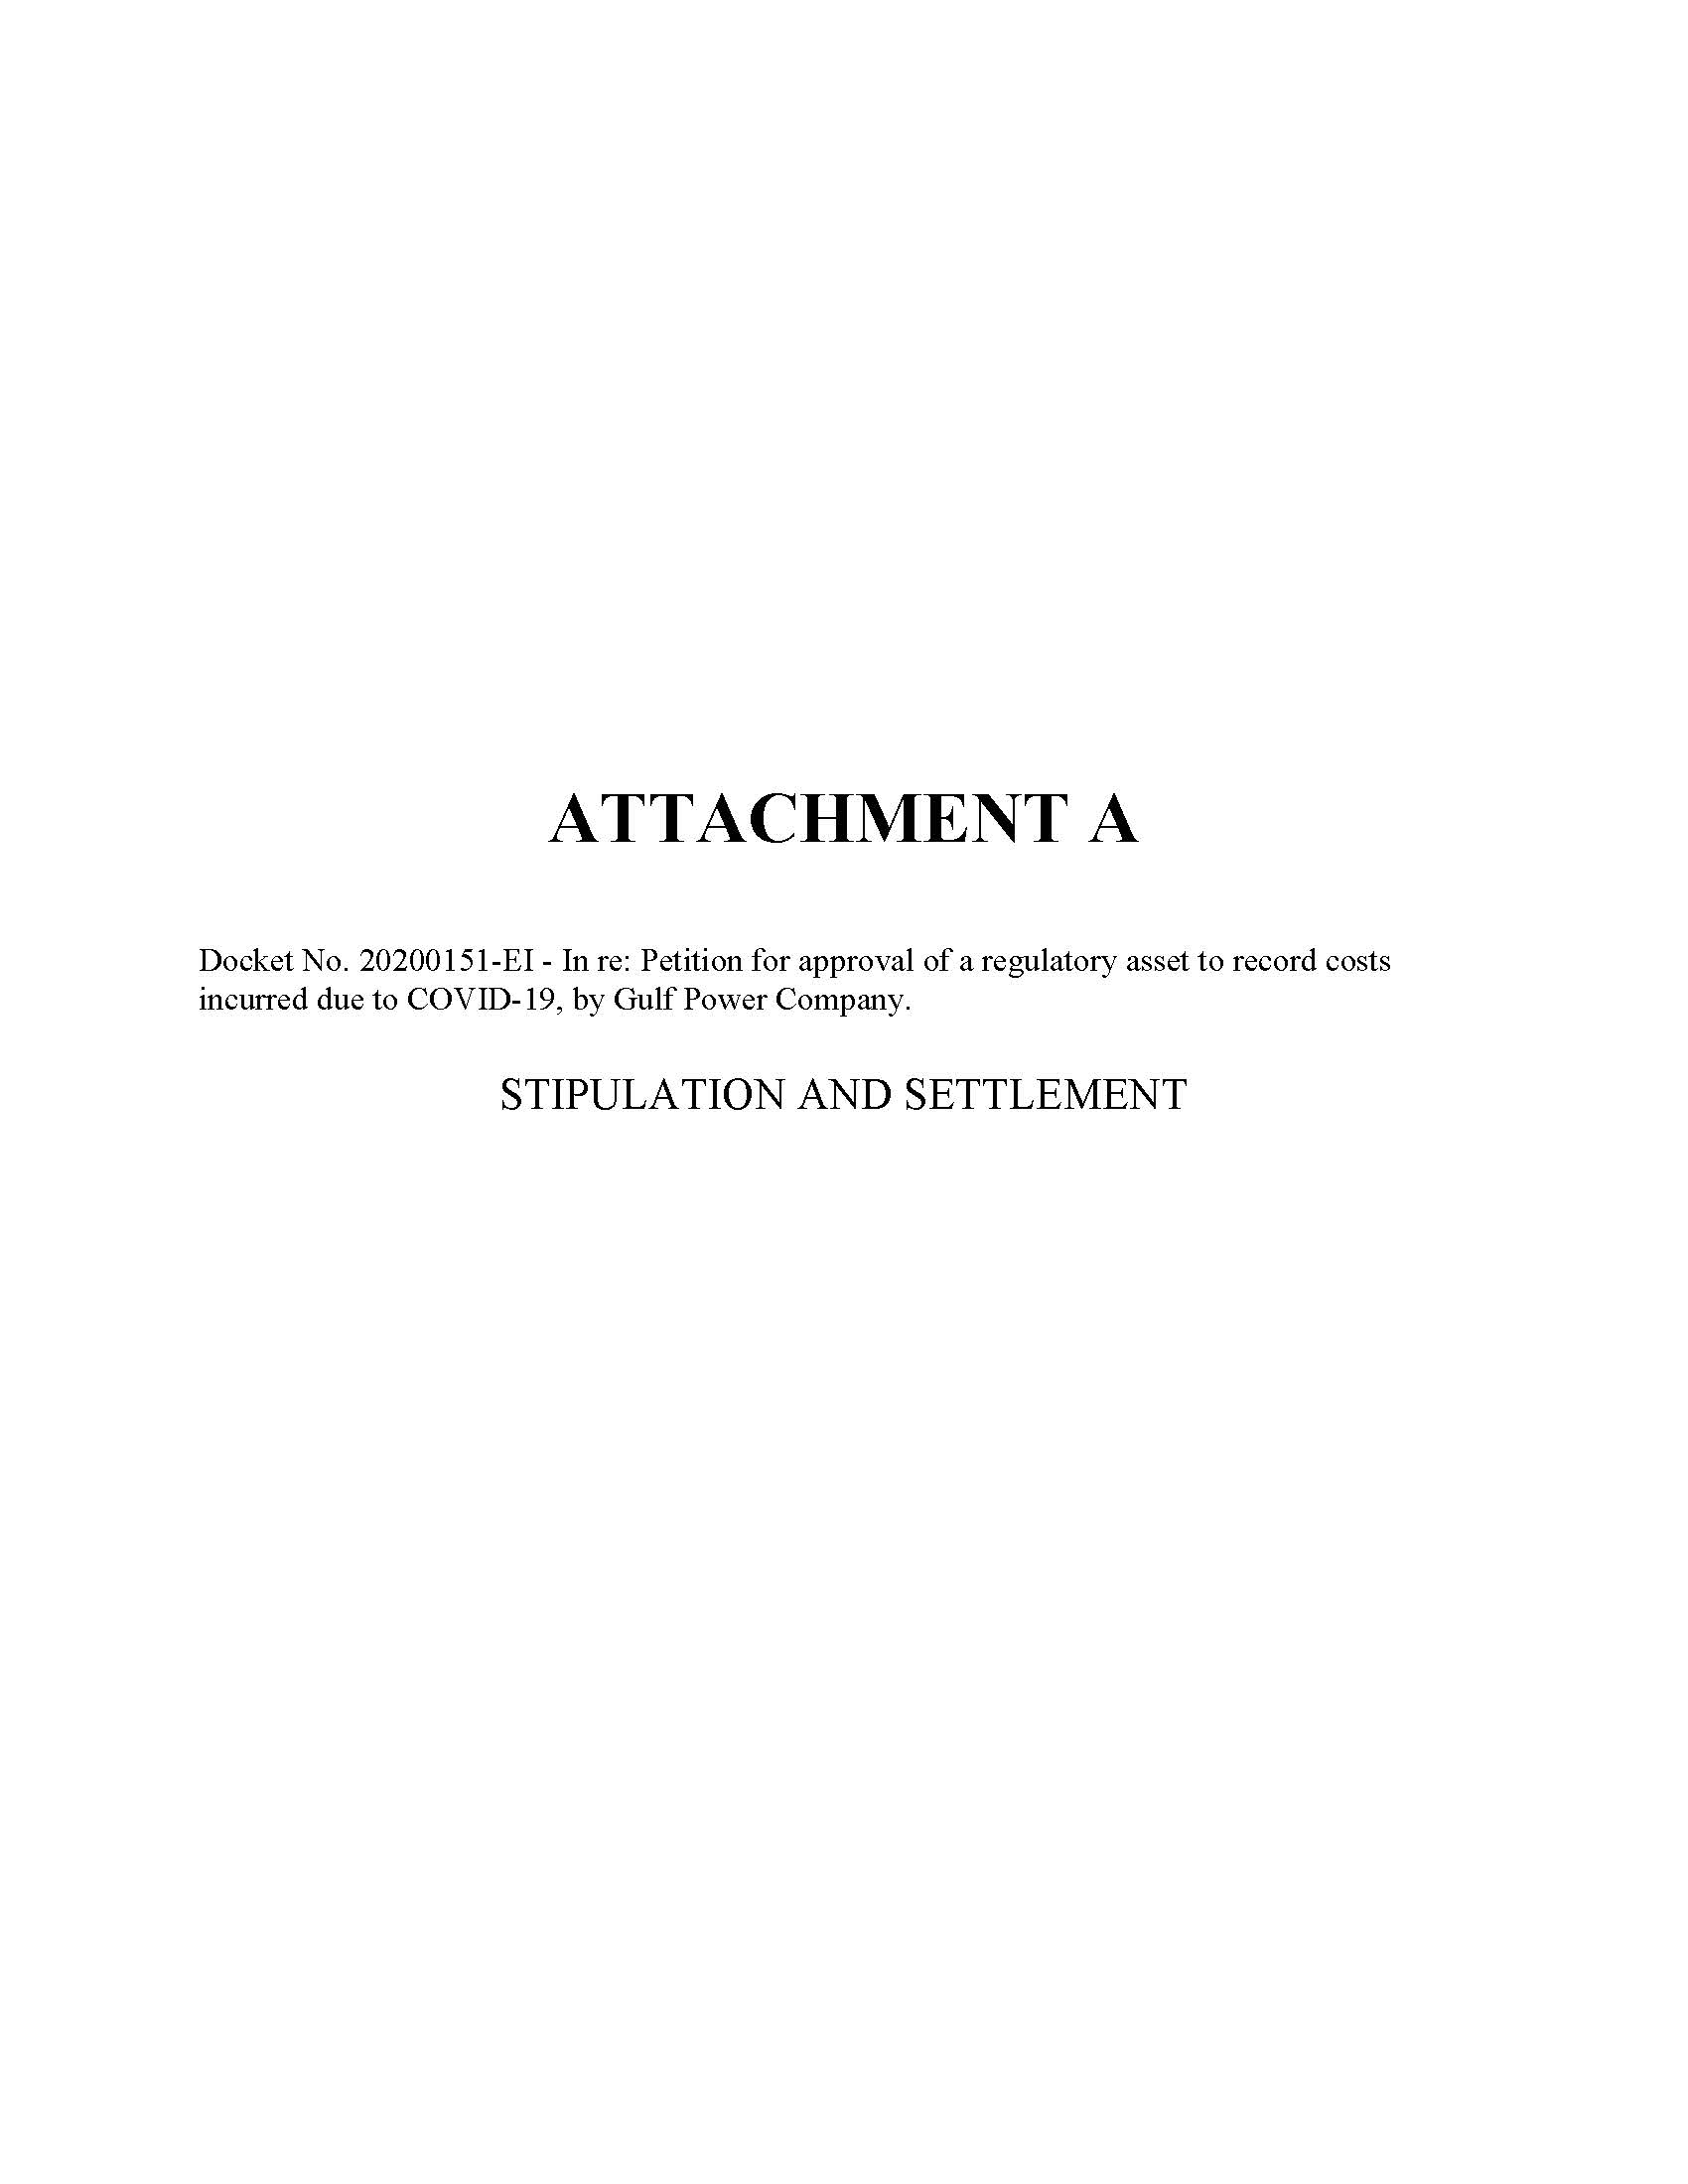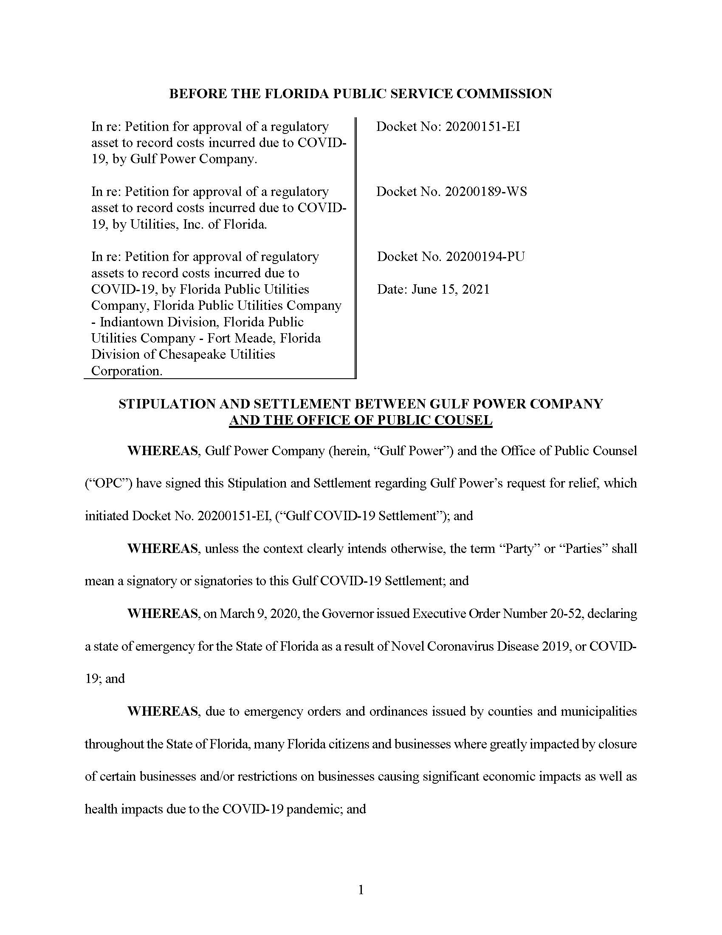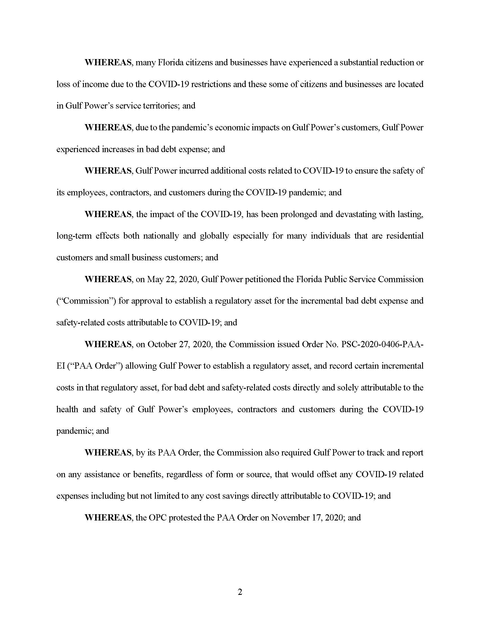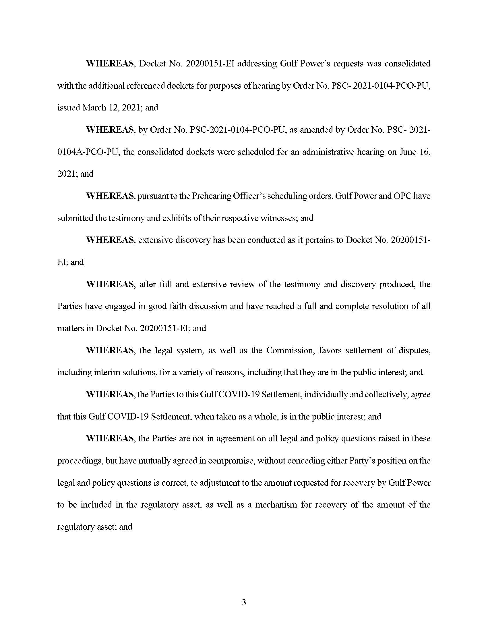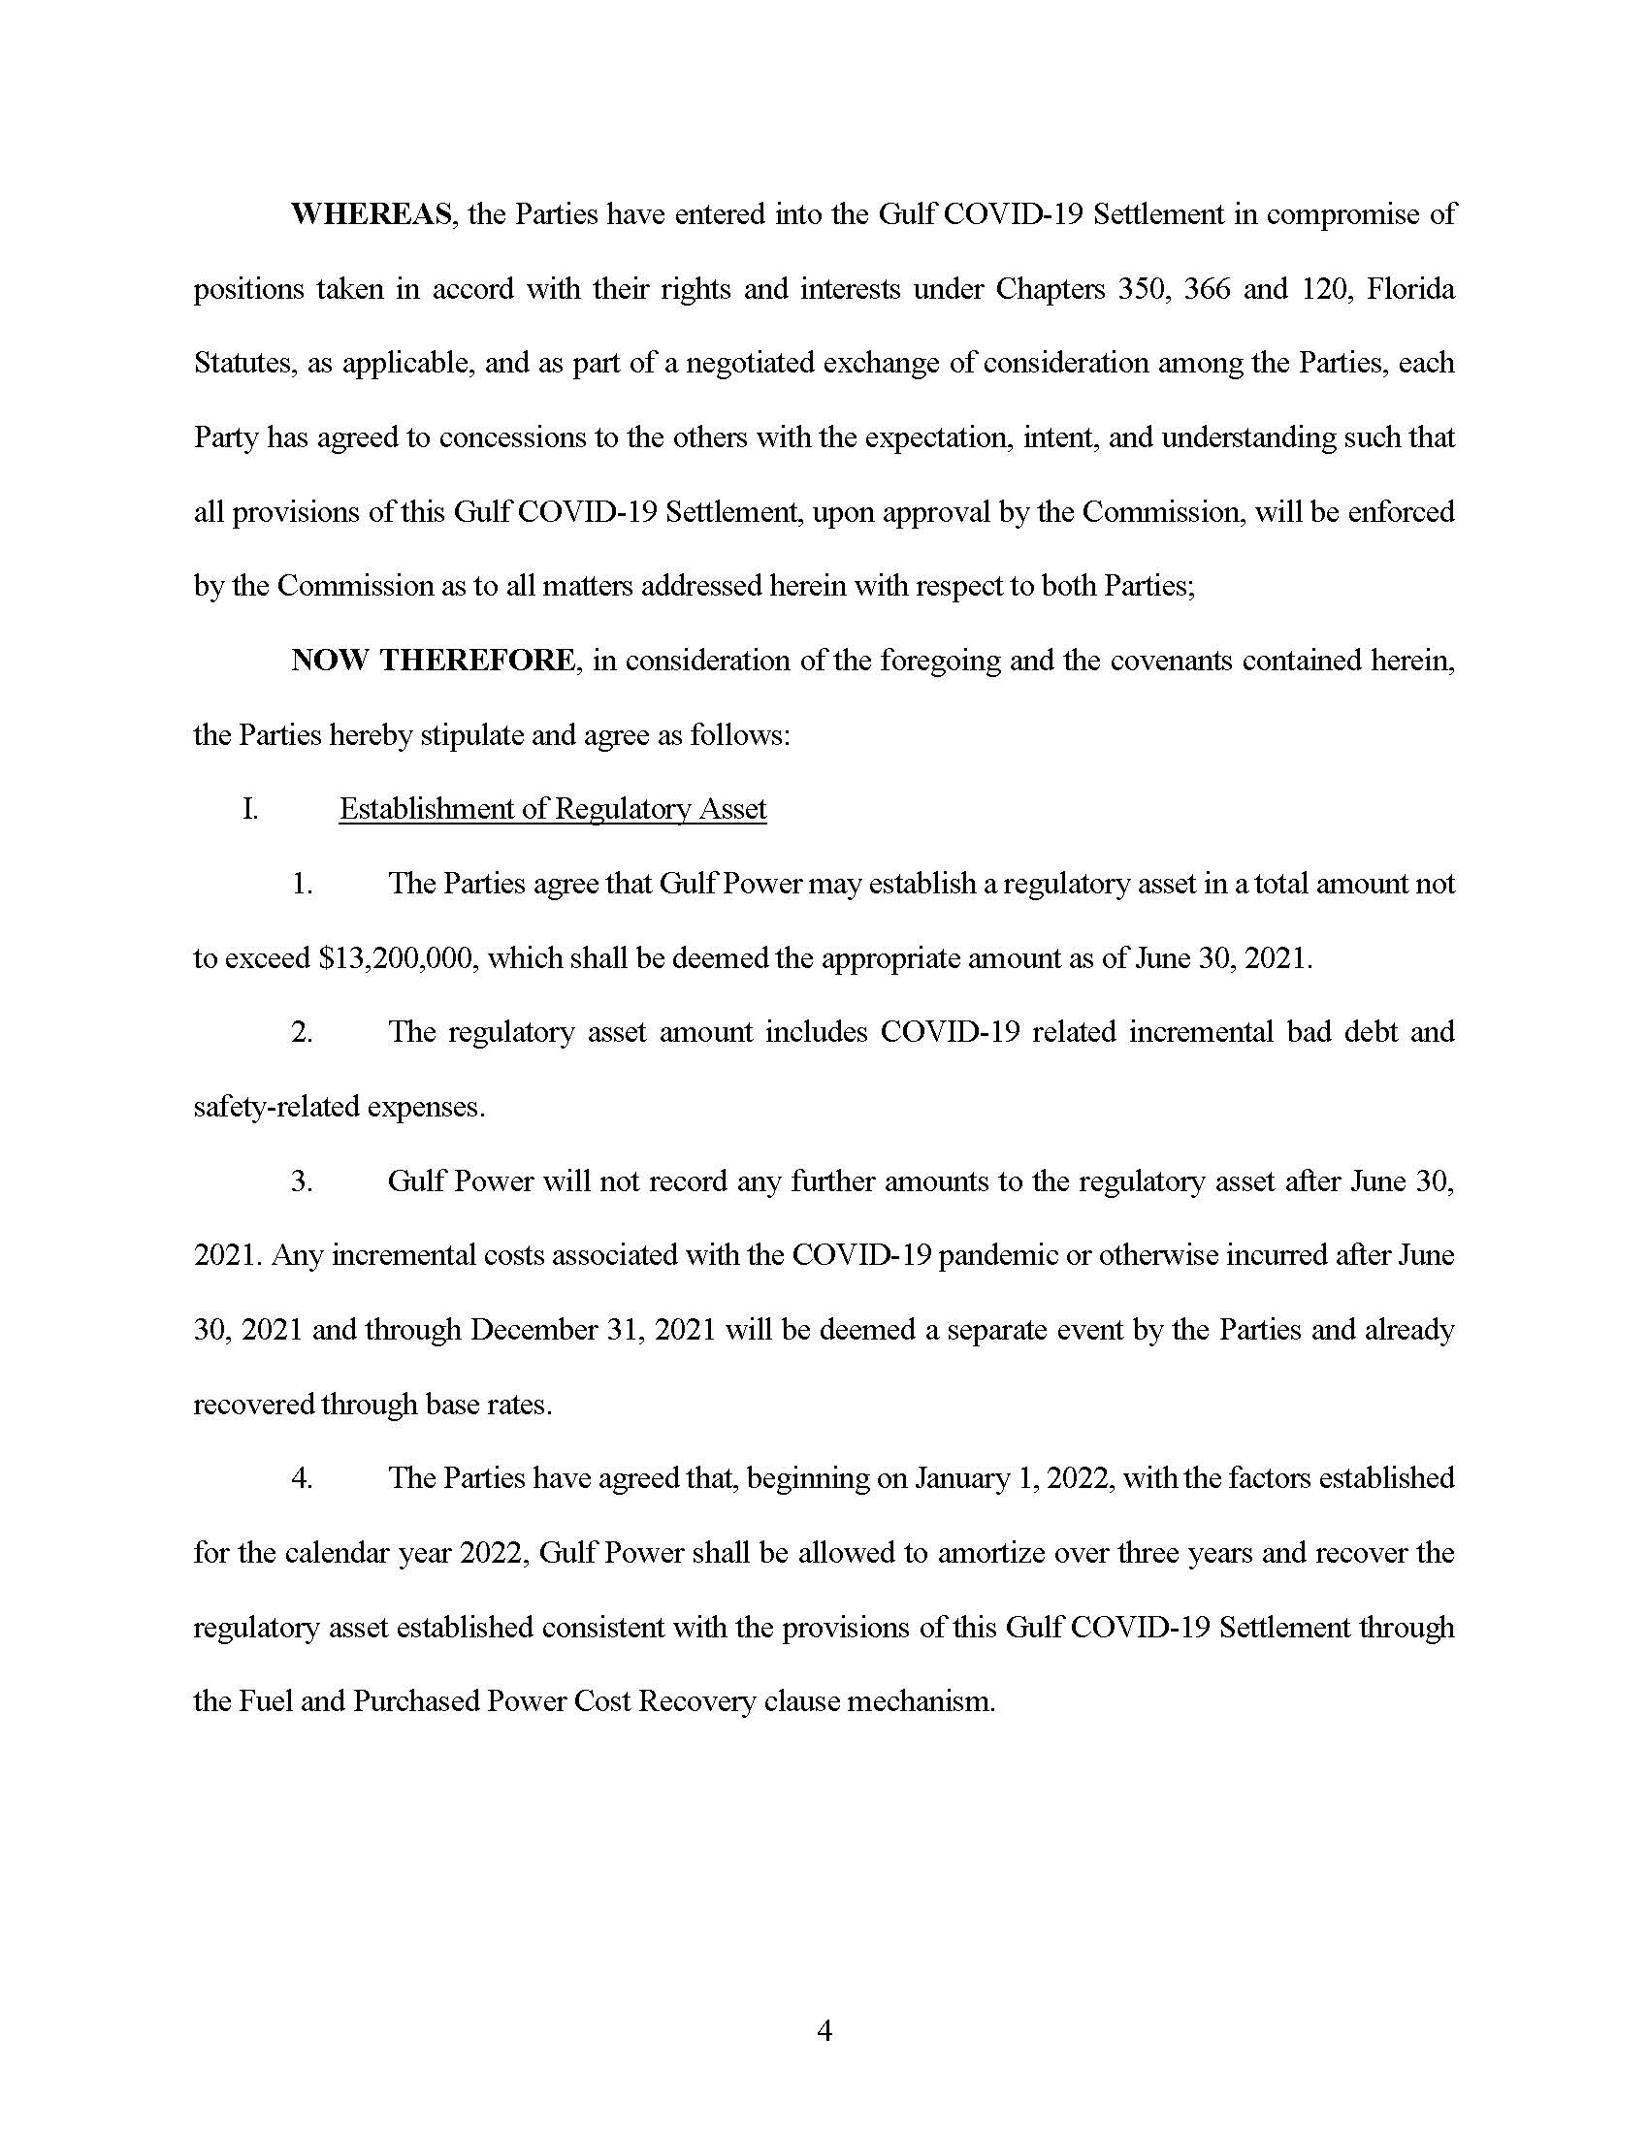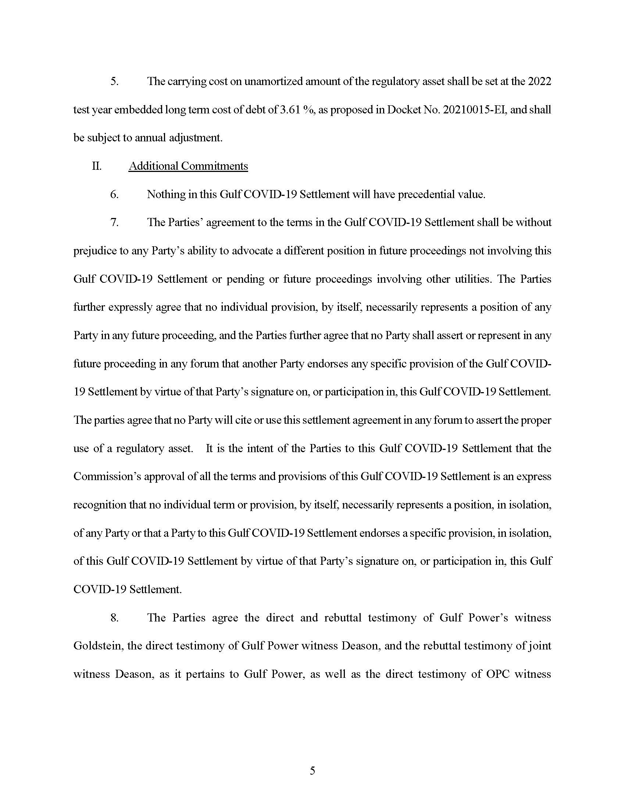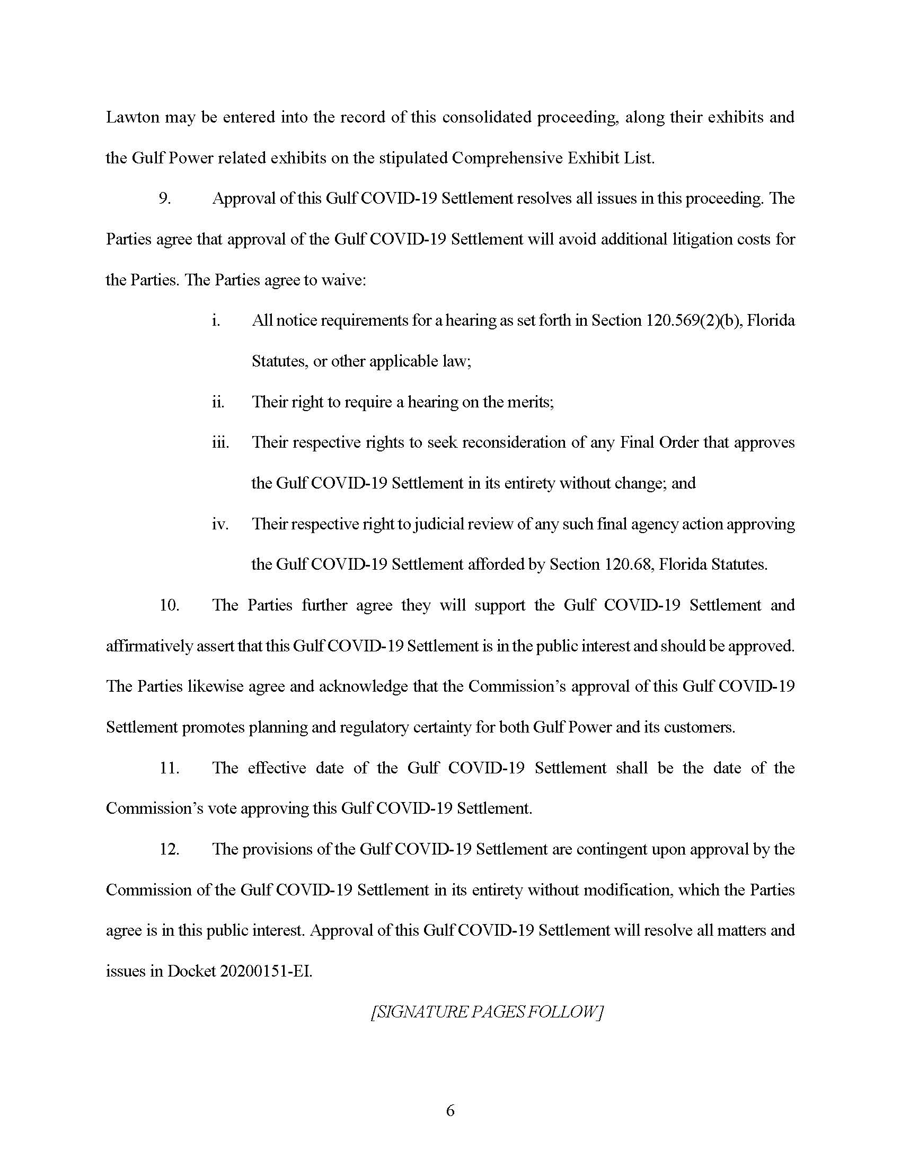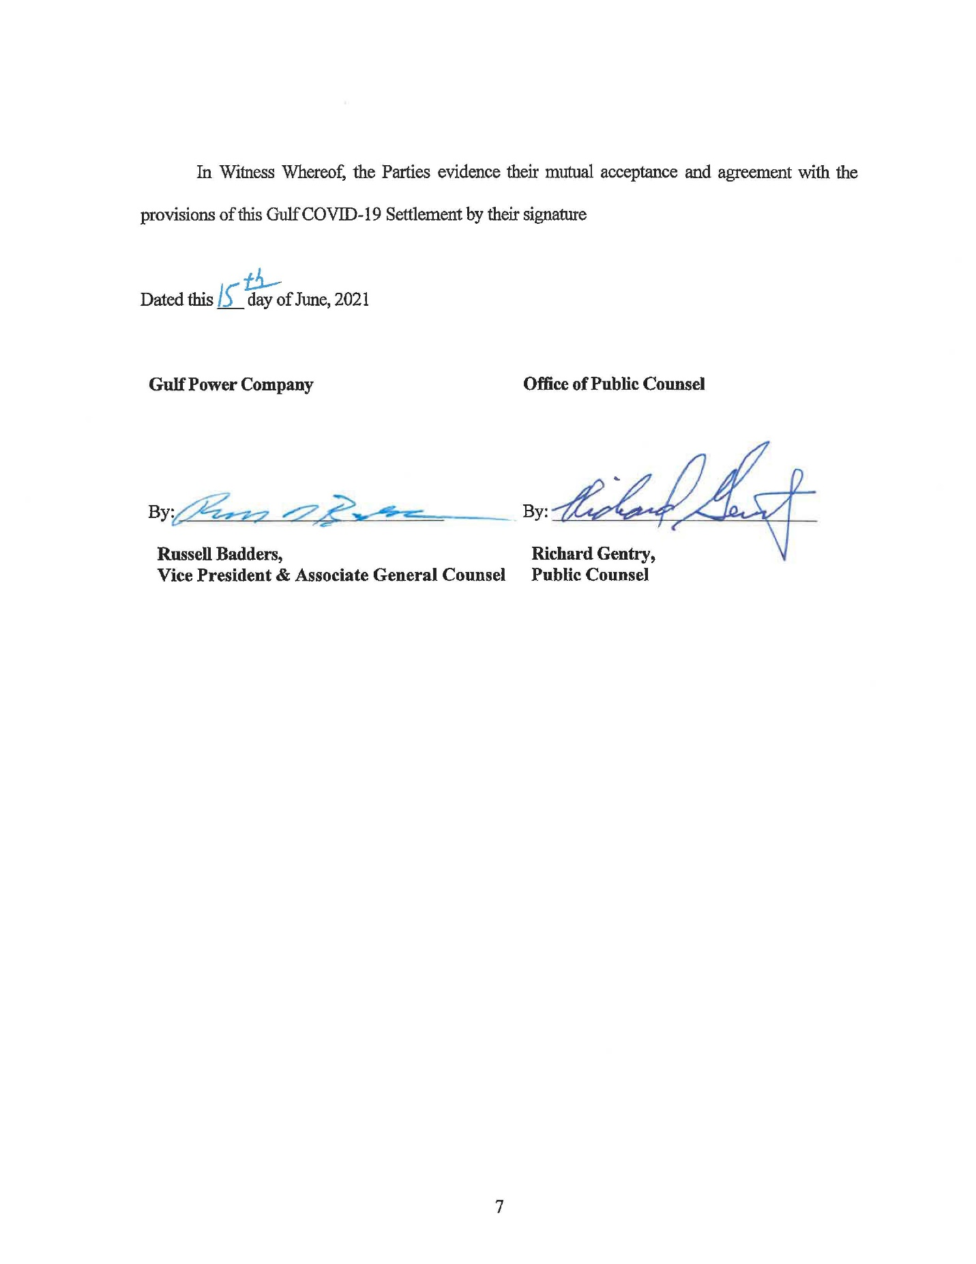

On March 30, 2021, Utilities, Inc. of Florida filed a Notice of Voluntary Dismissal Without Prejudice of its Petition filed in Docket No. 20200189-WS, which dismissal was acknowledged by the Commission in Order No. PSC-2021-0241-FOF-WS, issued July 1, 2021. Gulf Power Company and OPC entered into a Stipulation and Settlement Agreement in Docket No. 20200151-EI, which was approved by unanimous vote of the Commission on July 8, 2021.
Order No. PSC-2017-0488-PAA-EI, issued December 26, 2017, in Docket No. 20170150-EI, In re: Petition for limited proceeding to include reliability and modernization projects in rate base, by Florida Public Utilities Company; Order No. PSC-13-0023-S-EI, issued on January 14, 2013, in Docket No. 120015-EI, In re: Petition for increase in rates by Florida Power & Light Company; Order No. PSC-11-0089-S-EI, issued February 1, 2011, in Docket Nos. 080677 and 090130, In re: Petition for increase in rates by Florida Power & Light Company and In re: 2009 depreciation and dismantlement study by Florida Power & Light Company; Order No. PSC-10-0398-S-EI, issued June 18, 2010, in Docket Nos. 090079-EI, 090144-EI, 090145-EI, 100136-EI, In re: Petition for increase in rates by Progress Energy Florida, Inc., In re: Petition for limited proceeding to include Bartow repowering project in base rates, by Progress Energy Florida, Inc., In re: Petition for expedited approval of the deferral of pension expenses, authorization to charge storm hardening expenses to the storm damage reserve, and variance from or waiver of Rule 25-6.0143(1)(c), (d), and (f), F.A.C., by Progress Energy Florida, Inc., and In re: Petition for approval of an accounting order to record a depreciation expense credit, by Progress Energy Florida, Inc.; Order No. PSC-05-0945-S-EI, issued September 28, 2005, in Docket No. 050078-EI, In re: Petition for rate increase by Progress Energy Florida, Inc.
Order No. PSC-13-0023-S-EI, at p. 7.

