State of Florida |  | Public Service Commission  Capital Circle Office Center ● 2540 Shumard Oak Boulevard  Tallahassee, Florida 32399-0850  -M-E-M-O-R-A-N-D-U-M-
DATE: | October 21, 2021
TO: | Office of Commission Clerk (Teitzman)
FROM: | Division of Engineering (M. Watts, Knoblauch)  Division of Economics (Bethea, Hudson)  Office of the General Counsel (Trierweiler)
RE: | Docket No. 20210109-WS – Application for amendment of Certificates 496-W and 465-S to extend territory in Lake County, by Utilities, Inc. of Florida.
AGENDA: | 11/02/21 – Regular Agenda – Interested Persons May Participate
COMMISSIONERS ASSIGNED: |  |  | All Commissioners
PREHEARING OFFICER: |  |  | Administrative
CRITICAL DATES: |  |  | None
SPECIAL INSTRUCTIONS: |  |  | None

Case Background
On June 2, 2021, Utilities, Inc. of Florida filed an application with the Florida Public Service Commission (Commission) to amend Certificate Nos. 496-W and 465-S, to add territory in Lake County, and petition for partial variance or waiver of Rule 25-30.030(5)(b), Florida Administrative Code (F.A.C.). Certificate No. 496-W was initially granted to Lake Utility Services, Inc. (LUSI) in 1987, and was subsequently amended four times to add territory in 1990, 1991, and 1992. Certificate No. 465-S was initially granted to Lake Groves Utilities, Inc. (Lake Groves) in 1990, and was subsequently amended four times to add territory in 1992, 1993, 1999, and 2000.
In 2002, LUSI and Lake Groves were merged. Certificate No. 496-W was amended to include Lake Groves’ water service territory, and Lake Groves’ water certificate was cancelled. Certificate No. 465-S was amended to reflect the merger of Lake Groves into LUSI. Following the merger, Certificate Nos. 496-W and 465-S were amended three times to add territory, as well as to transfer assets from an exempt entity and amend Certificate No. 465-S to add the affected territory. In 2015, the Commission approved the corporate reorganization of several utilities, including LUSI, and the utilities’ certified names were changed to Utilities, Inc. of Florida (UIF or Utility).
UIF currently serves the Orlando Recreational Vehicle (RV) Resort Thousand Trails, consisting of 846 RV lots and ancillary buildings. The proposed service area is adjacent to UIF’s current service territory and will include 92 RV lots that will be added as a second phase of the Orlando RV Resort Thousand Trails.
This recommendation addresses the Utility’s request to extend its water and wastewater service territory. The Commission has jurisdiction pursuant to Section 367.045, Florida Statutes (F.S.).

Discussion of Issues

Issue 1:
Should the Commission approve UIF’s application for amendment of Certificate Nos. 496-W and 465-S to extend its water and wastewater territory in Lake County?

Recommendation:
Yes. The Commission should amend Certificate Nos. 496-W and 465-S to include the territory as described in Attachment A, effective the date of the Commission’s vote. The resultant order should serve as UIF’s amended certificate and should be retained by the Utility. The Utility should charge future customers in the territory added herein the rates and charges contained in its current tariffs until a change is authorized by the Commission in a subsequent proceeding. (M. Watts, Knoblauch, Bethea)

Staff Analysis:
The Utility’s application to amend its authorized service territory is in compliance with the governing statute, Section 367.045, F.S., and Rule 25-30.036, F.A.C. UIF provided notice of the application pursuant to Section 367.071, F.S. and Rule 25-30.030(5)(b), F.A.C., however Rule 25-30.030(5)(b), F.A.C., was partially waived by the Commission regarding the requirement that the notice be provided to all customers and property owners within its existing service area. In lieu of noticing all of its customers by mail, UIF was ordered to place a staff-approved notice of its application on its website for 30 days, which UIF has satisfied. This notice also provided 30 days for customers to file an objection to the transfer. No objections to the application have been received and the time for filing such has expired.
UIF provided sufficient service territory maps and territory descriptions to the Commission. According to the application, the provision of water and wastewater services in the proposed service territory is consistent with the Lake County Comprehensive Plan.
The Utility was granted a rate increase in 2021. At that time, the Commission found the overall quality of service of the Utility to be satisfactory, and there currently appears to be no outstanding Consent Orders or Notices of Violation from the Department of Environmental Protection. The Utility has filed its 2020 Annual Report and is current with the payment of its 2020 and 2021 Regulatory Assessment Fees.
The Utility stated in its application that the proposed service territory will be served by its existing 6.00 million gallon per day (MGD) water treatment plant (WTP) and its 0.99 MGD wastewater treatment plant (WWTP). UIF stated that the capacity of both its existing WTP and WWTP are sufficient to serve both its existing and proposed service territories.
UIF stated in its application that the water and wastewater service to the proposed service territory will be master metered, and that the owner of the RV lots will pay for the construction of the interconnection and donate them to UIF. As such, it anticipates that there will be no material impact on the Utility’s capital structure. Additionally, since UIF has more than 60,000 customers, the addition of 92 RV lots will have an immaterial impact on its monthly rates or service availability charges. Based on the foregoing analysis, staff recommends that UIF has the technical and financial ability to service the amended territory.
Conclusion
Based on the information above, staff recommends that the Commission should amend Certificate Nos. 496-W and 465-S to include the territory as described in Attachment A, effective the date of the Commission’s vote. The resultant order should serve as UIF’s amended certificate and should be retained by the Utility. The Utility should charge future customers in the territory added herein the rates and charges contained in its current tariffs until a change is authorized by the Commission in a subsequent proceeding.

Issue 2:
Should this docket be closed?

Recommendation:
If the Commission approves staff’s recommendation, no further action will be necessary, and this docket should be closed upon issuance of the order. (Trierweiler)

Staff Analysis:
If the Commission approves staff’s recommendation, no further action will be necessary, and this docket should be closed upon issuance of the order.

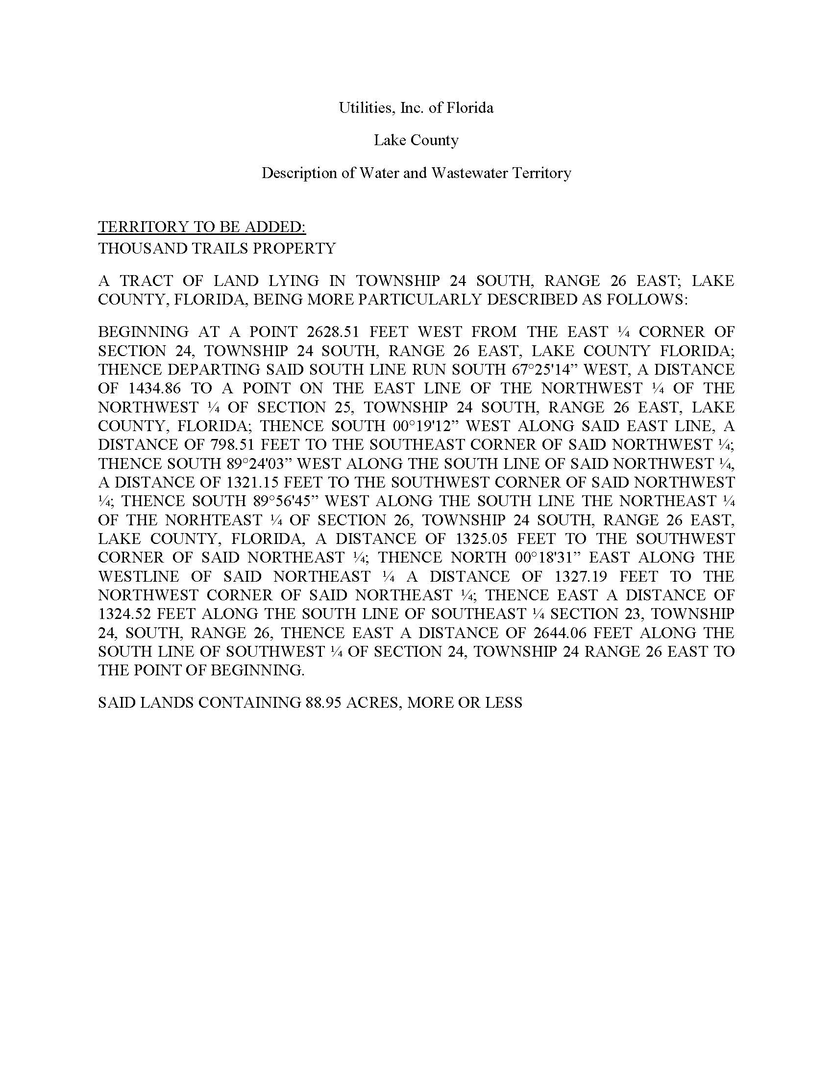

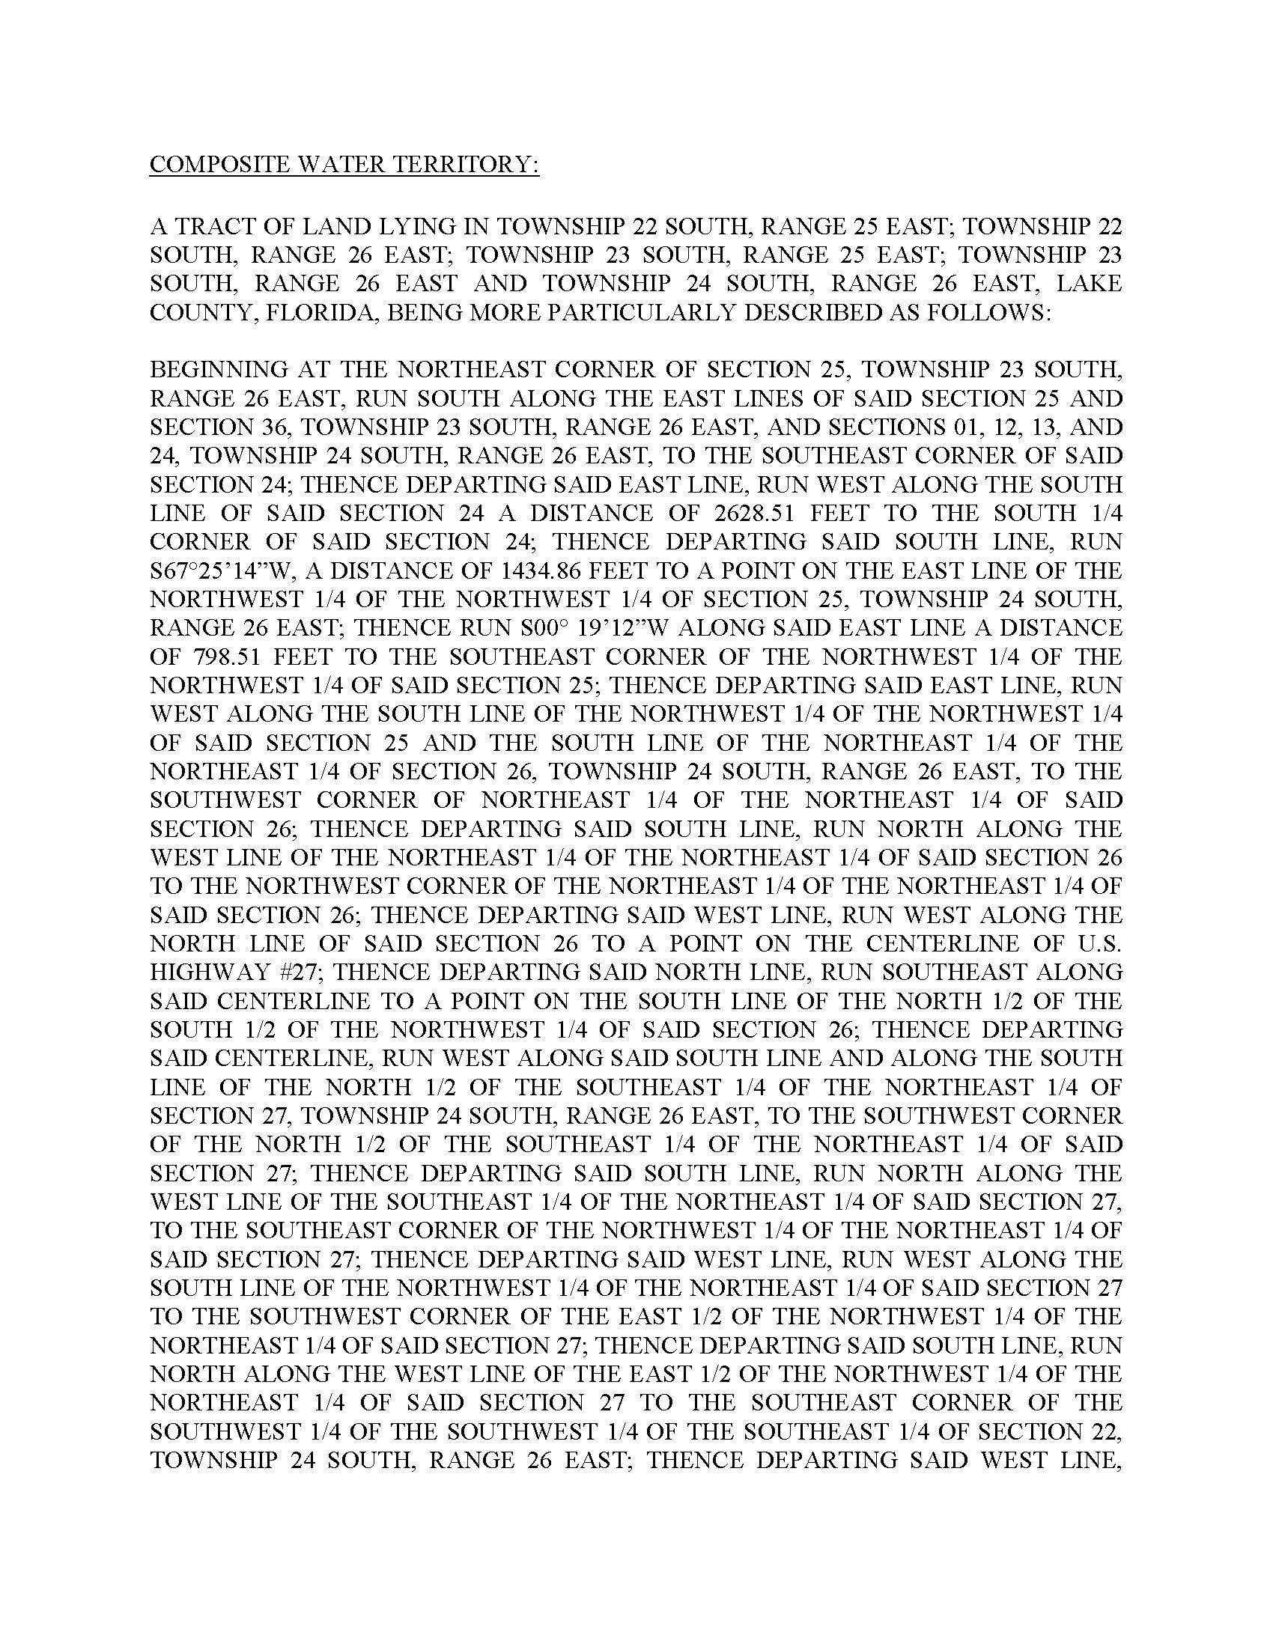

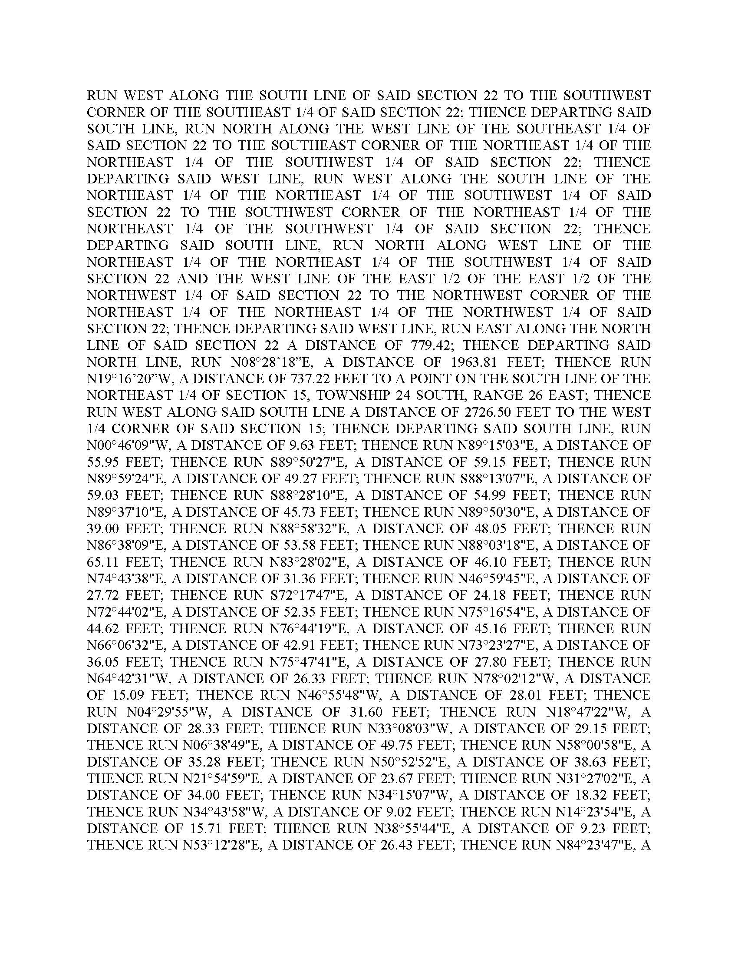

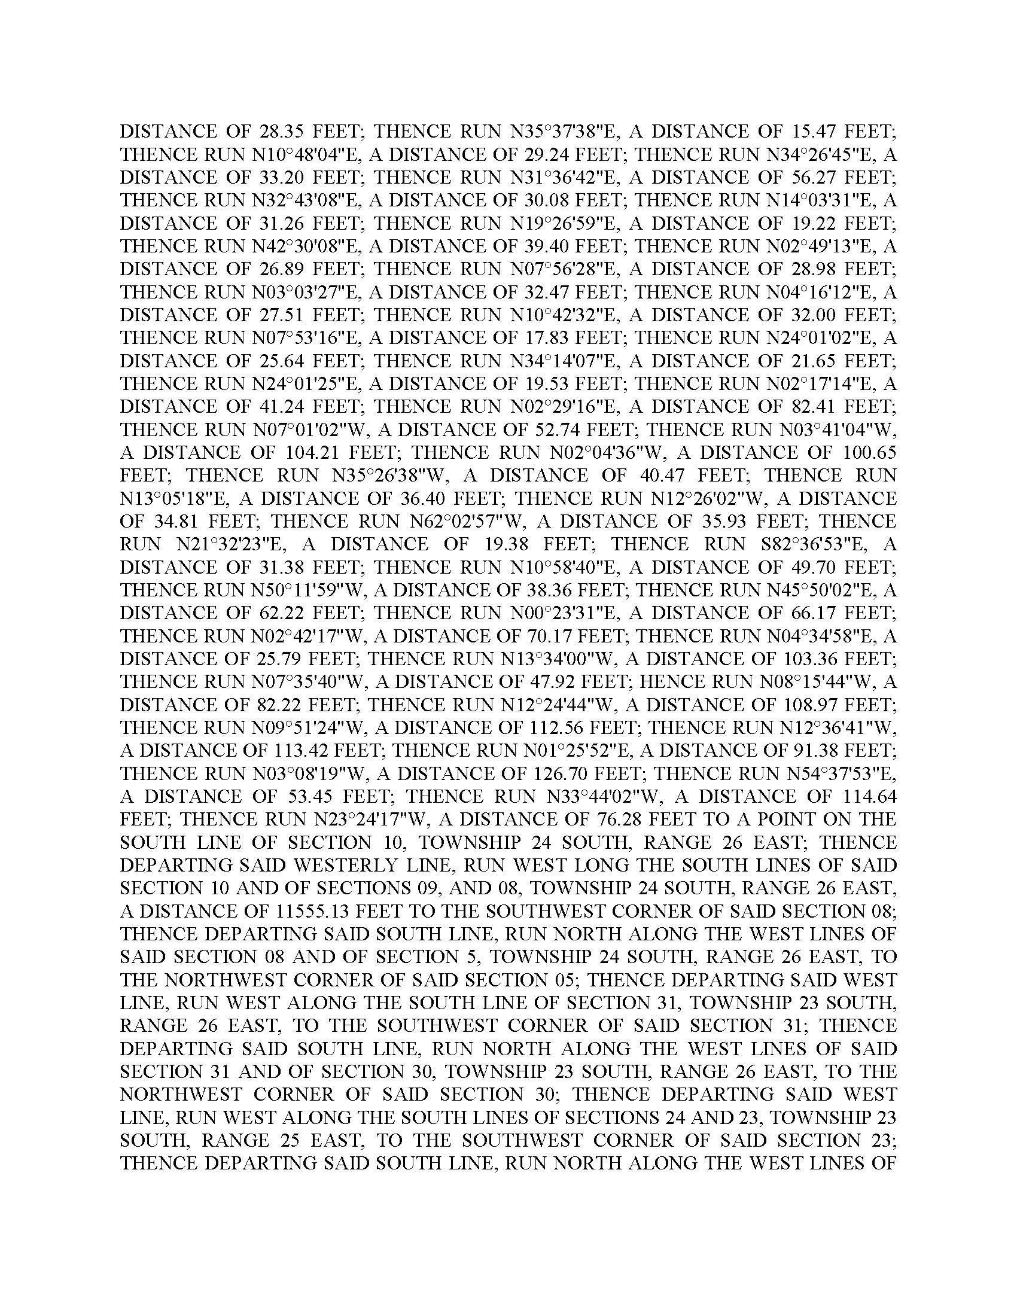

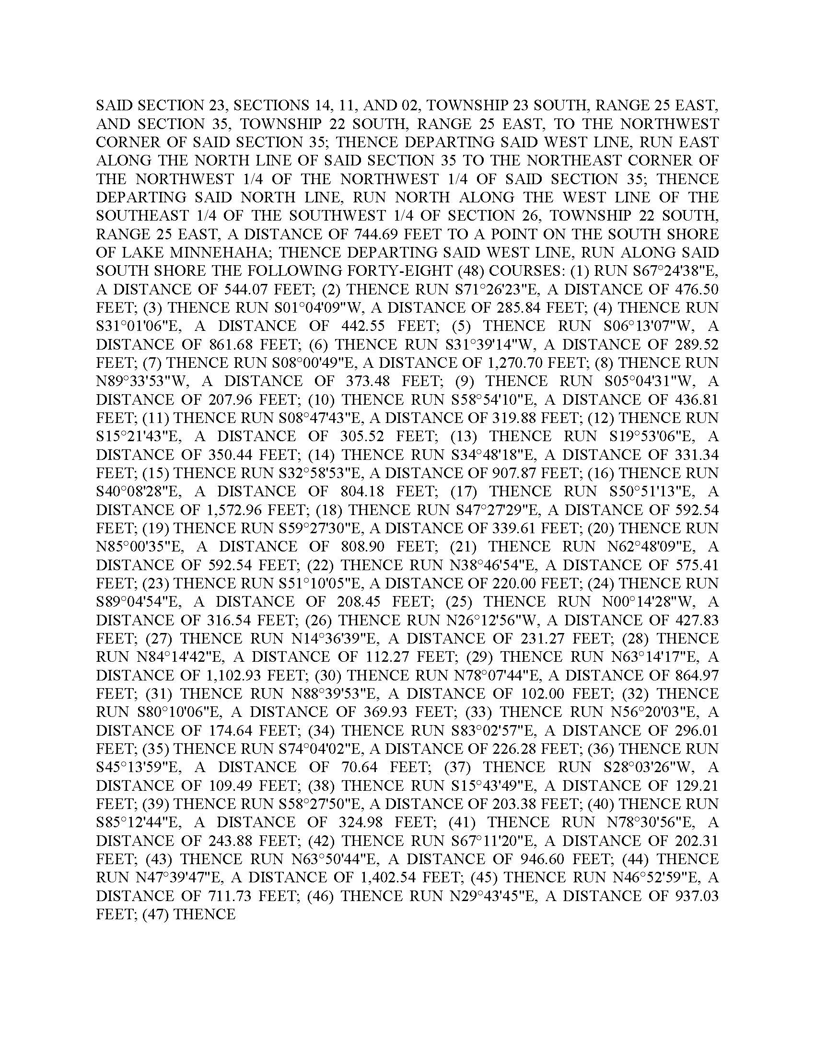

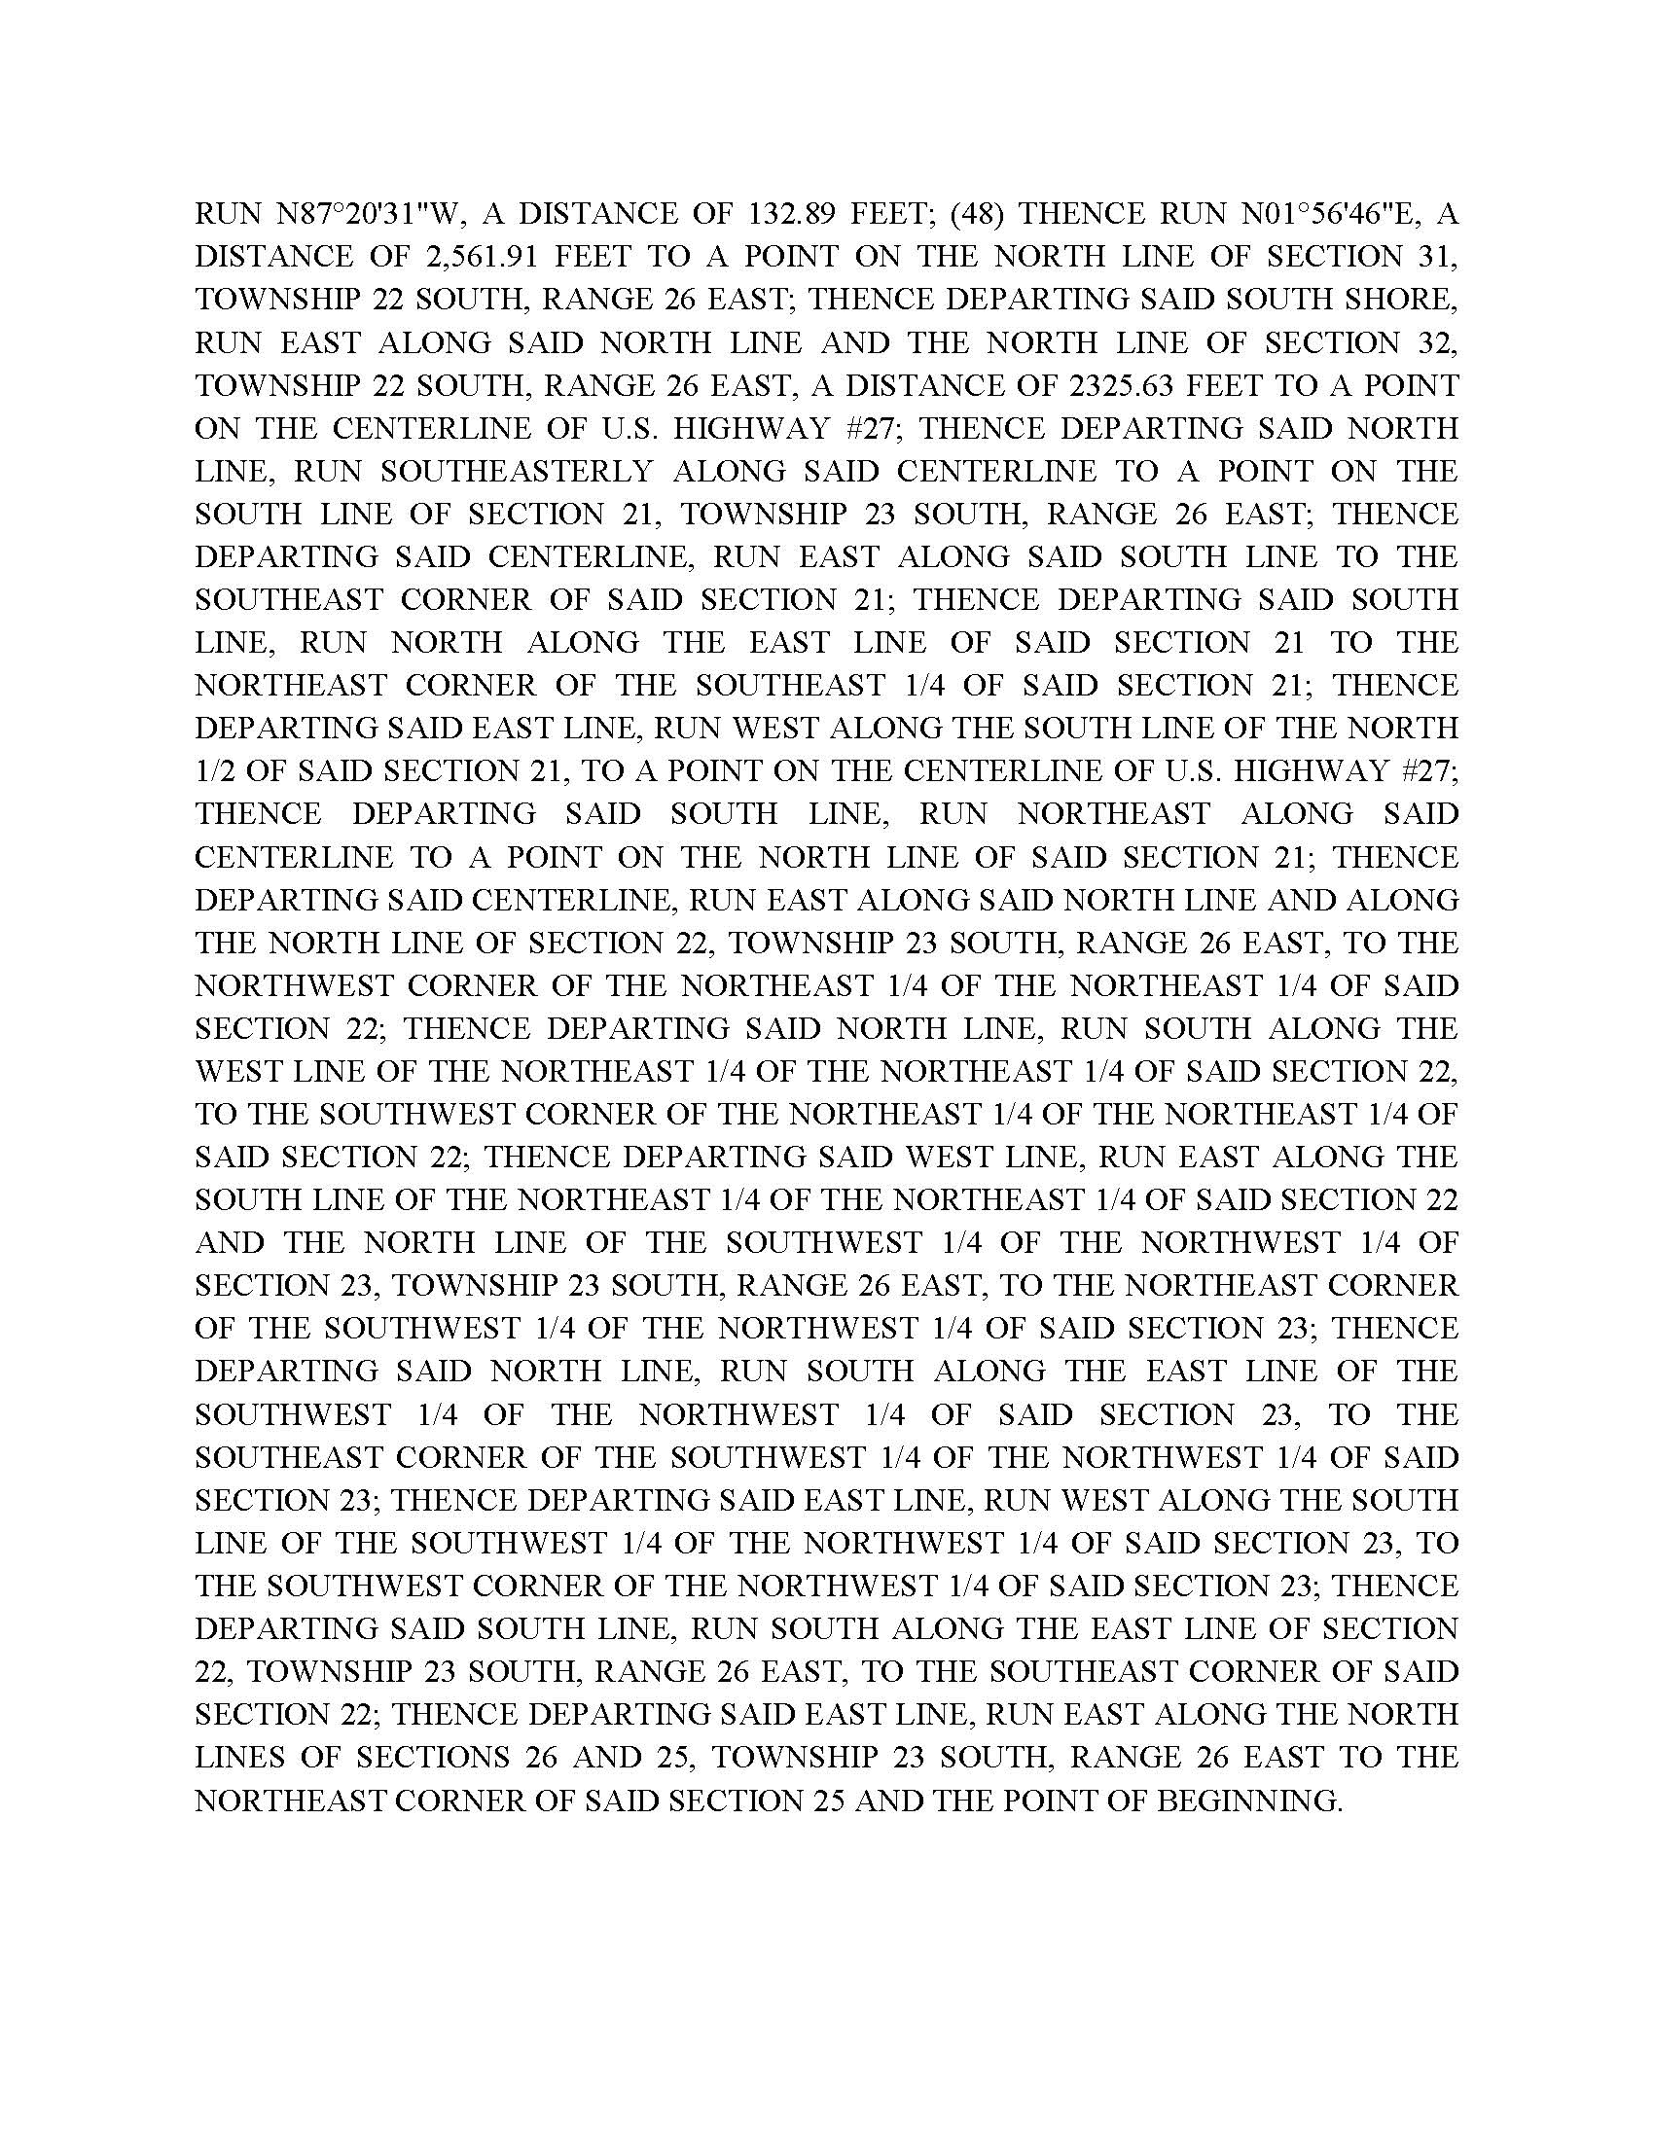

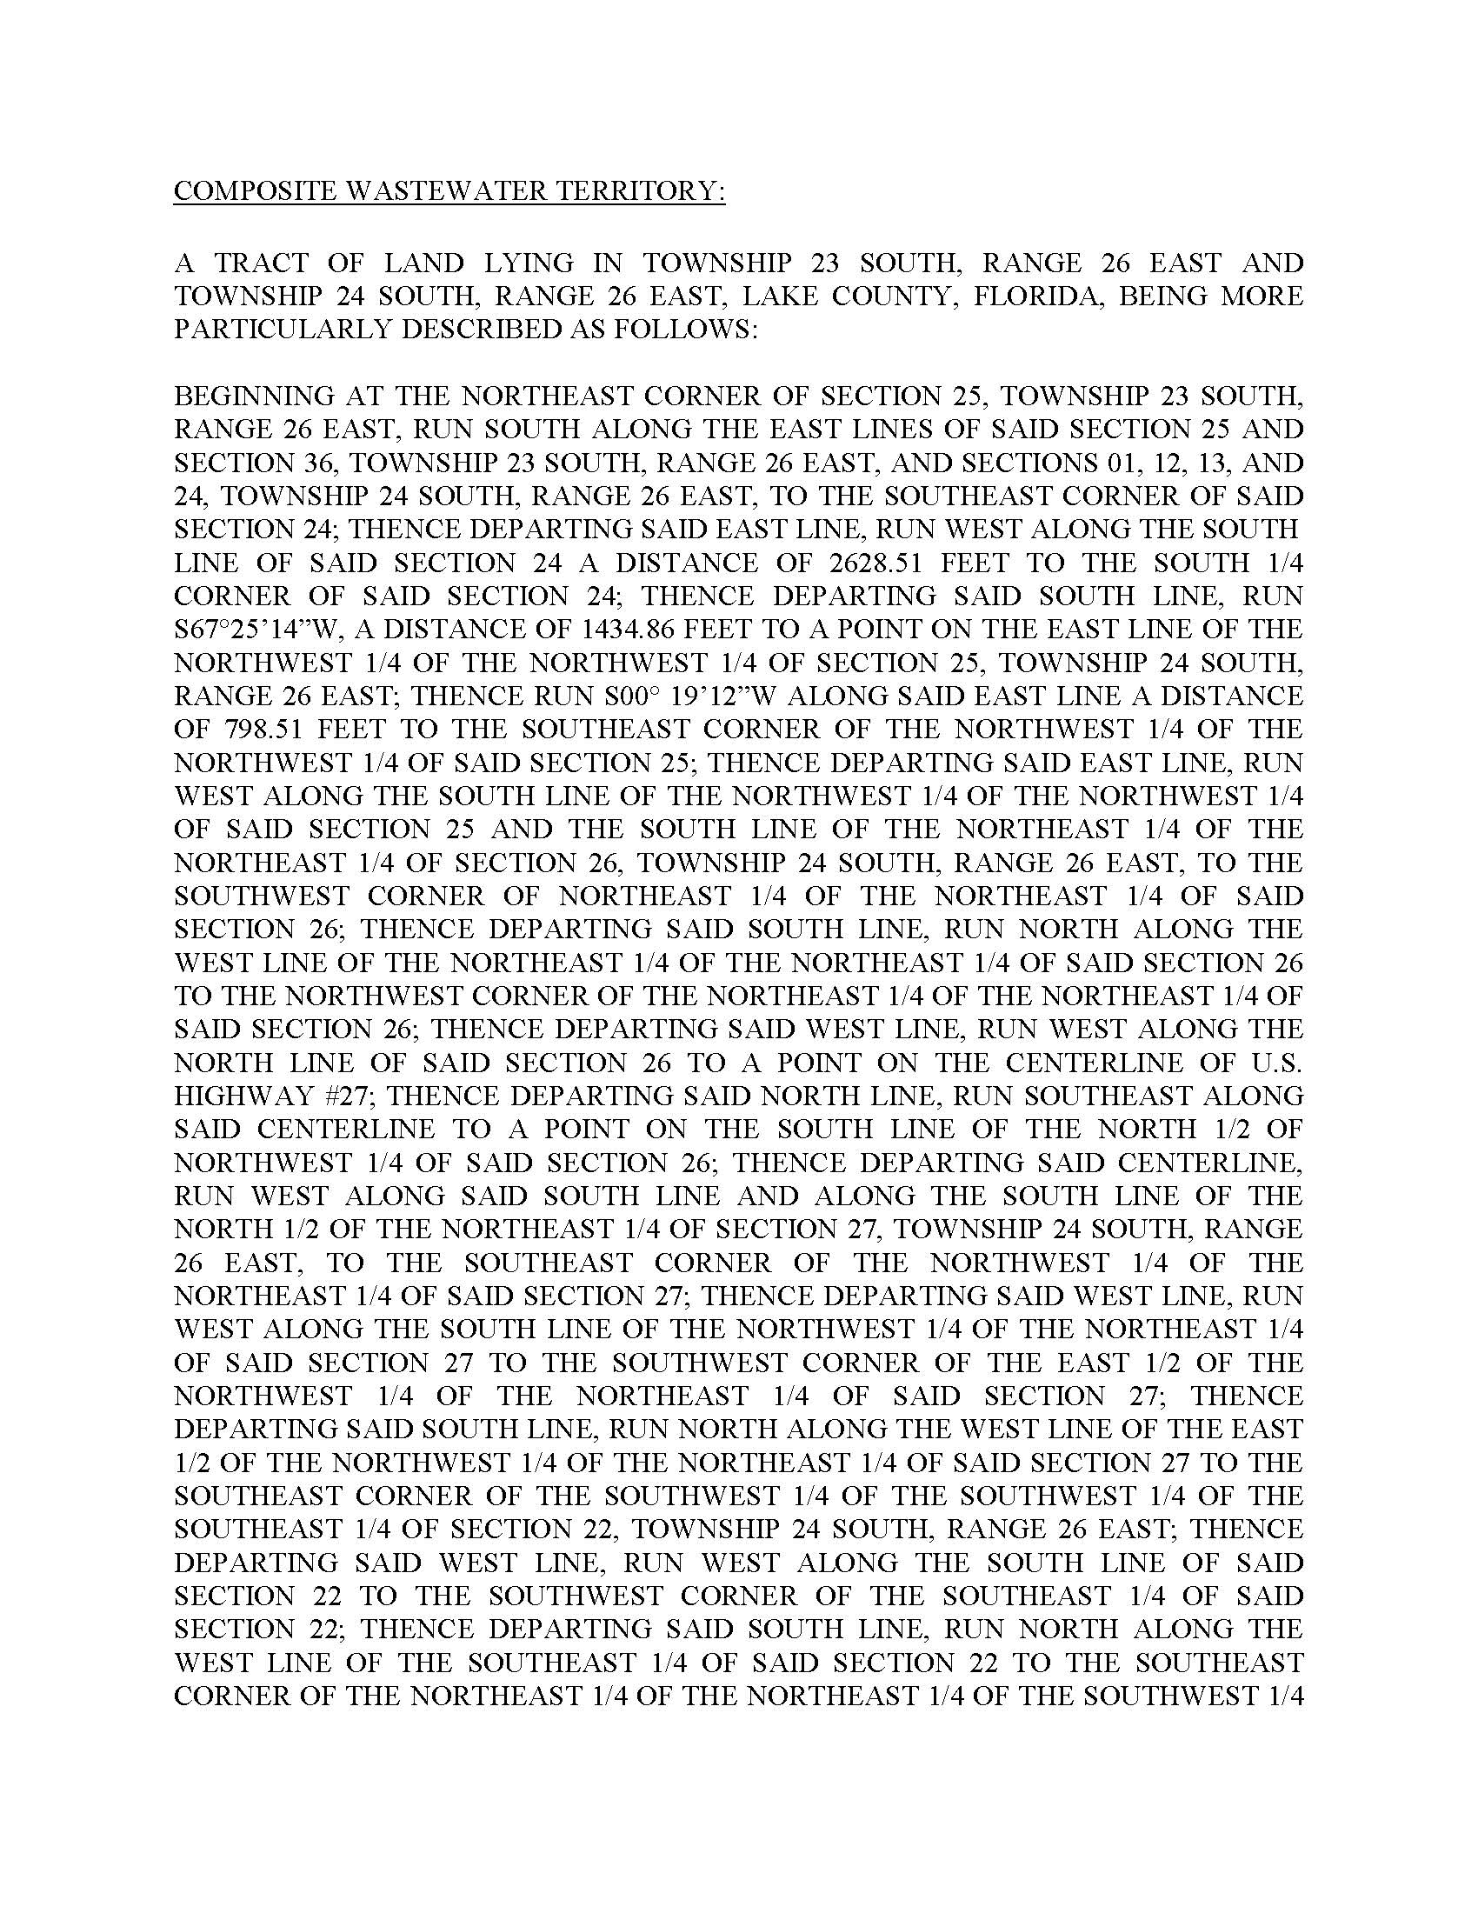

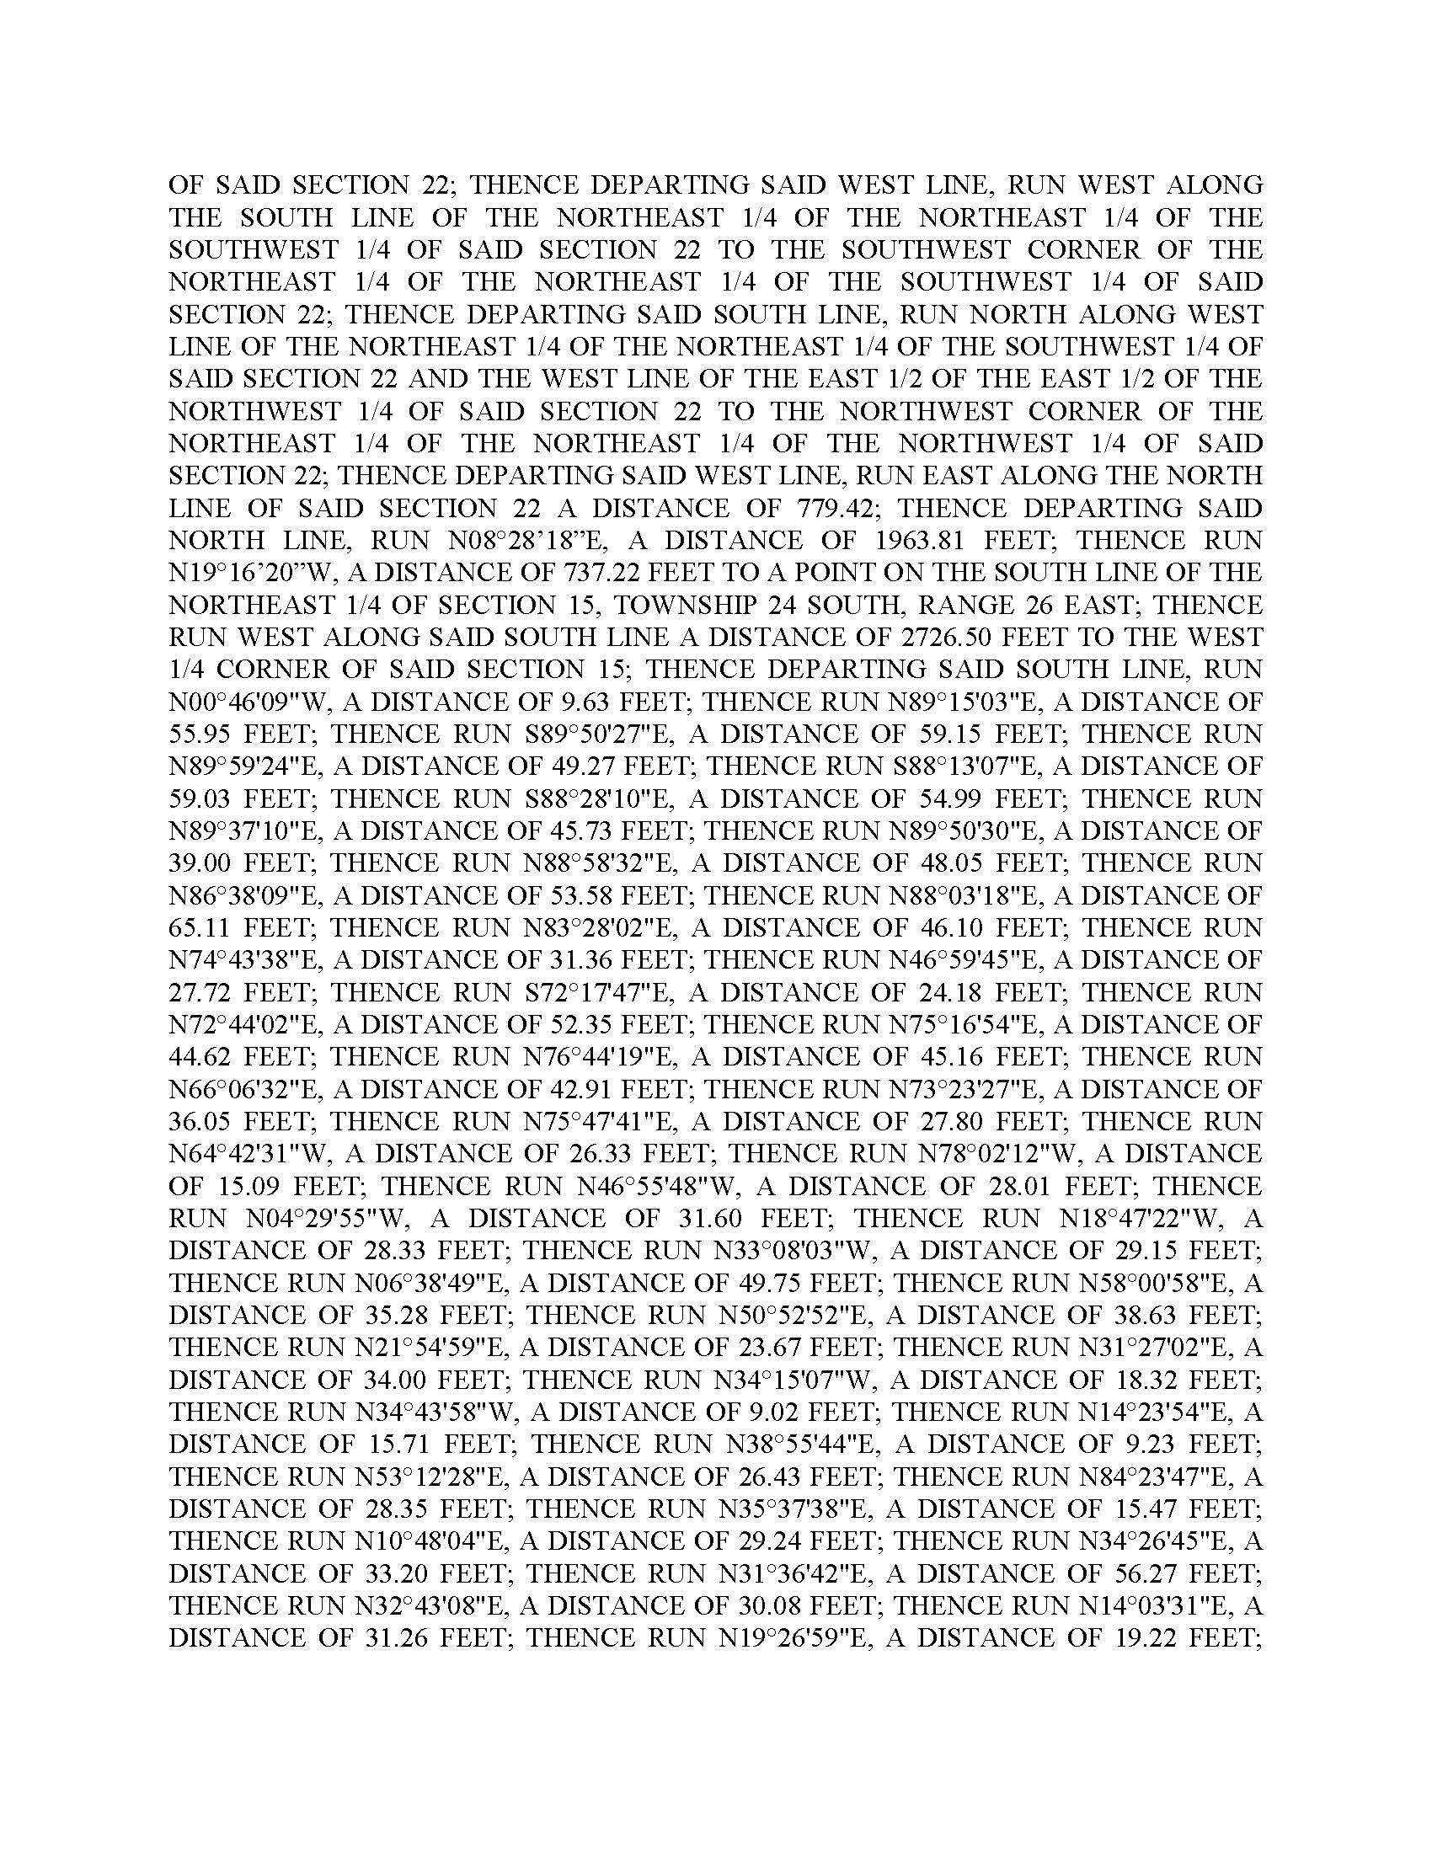

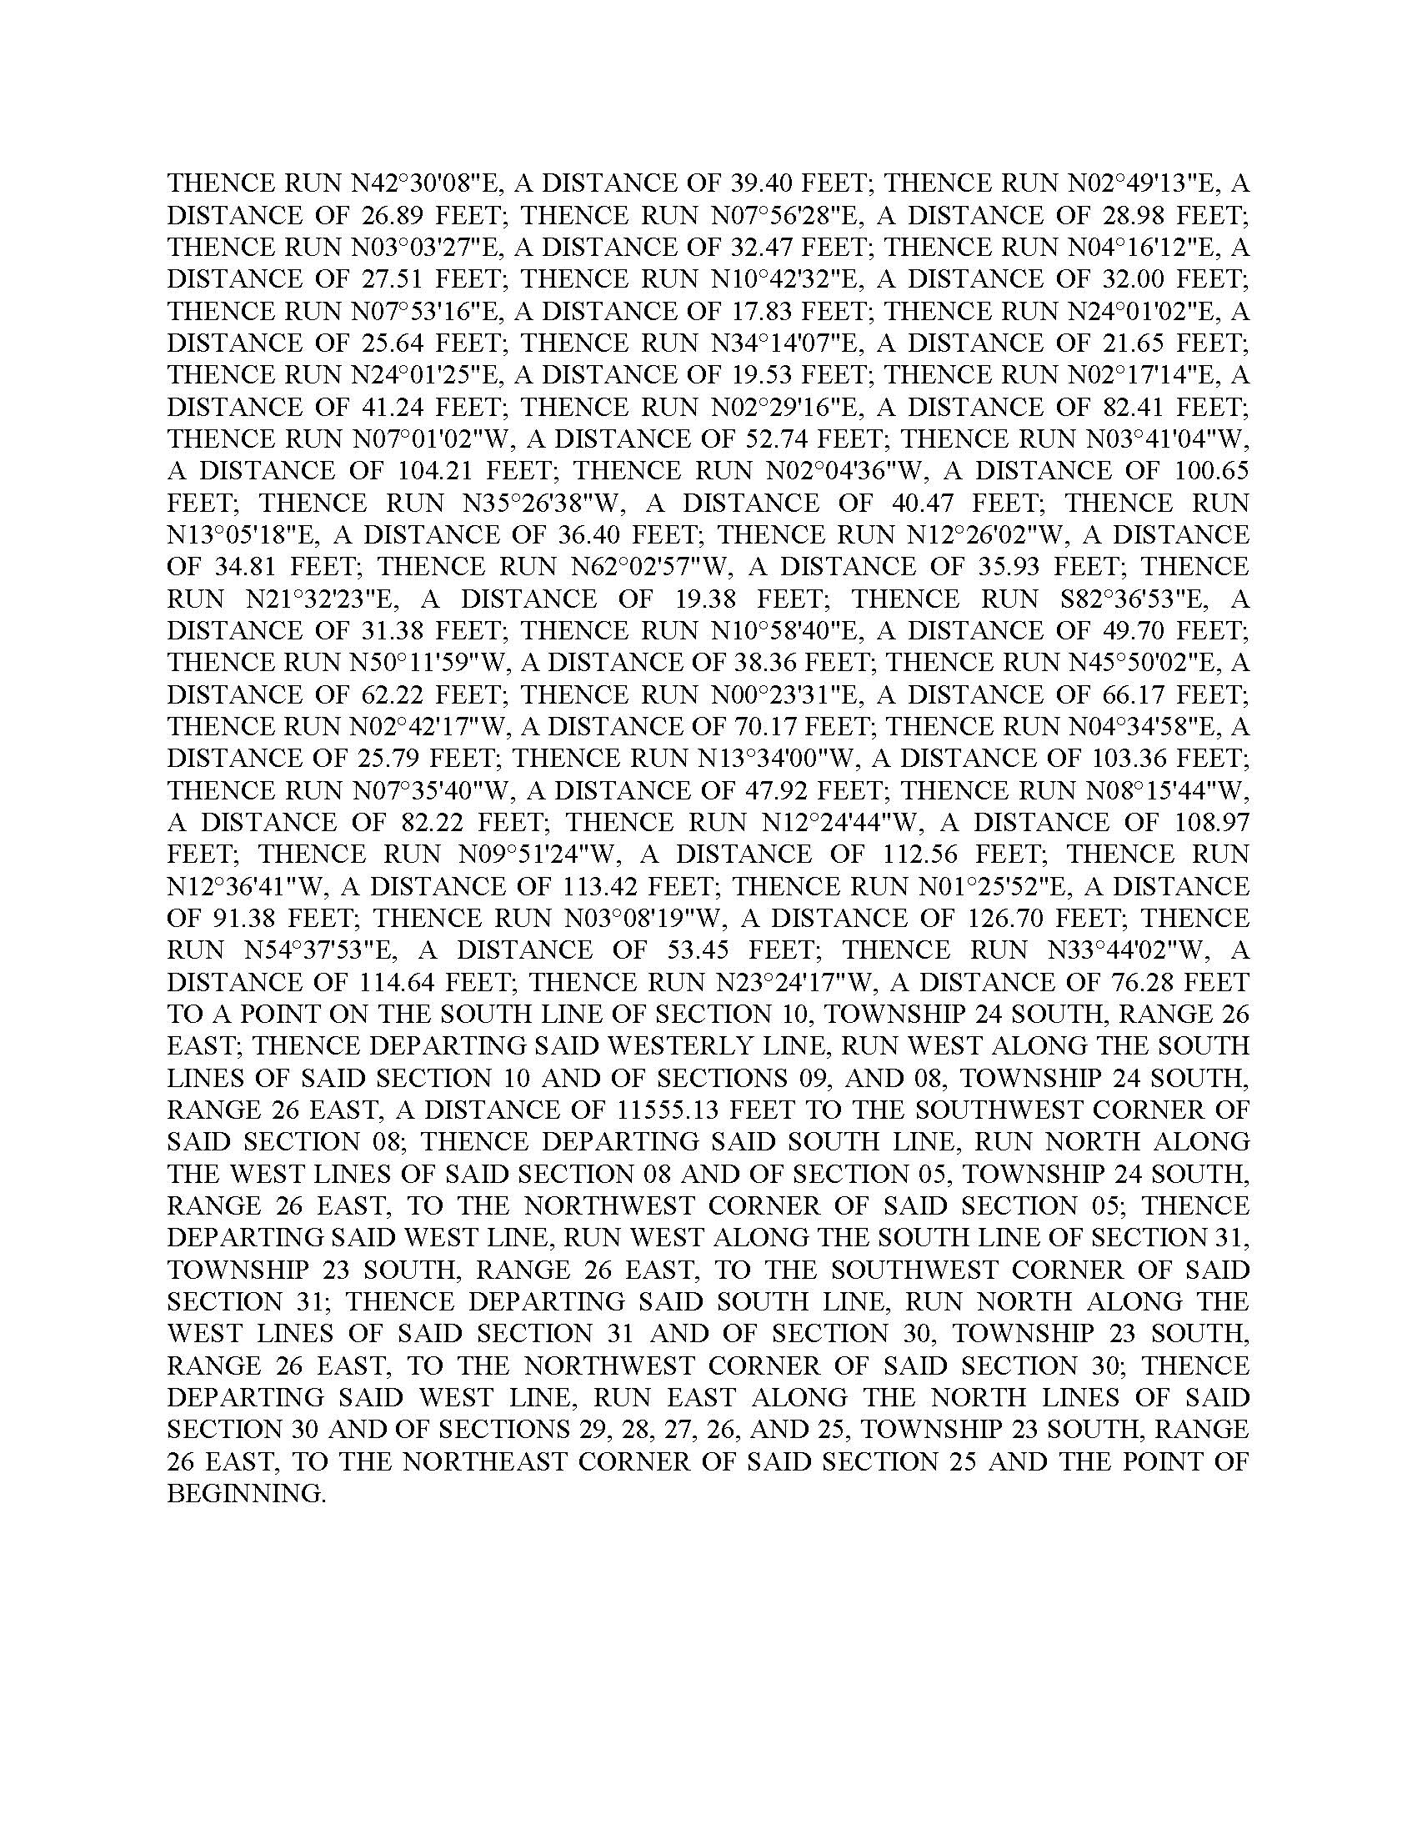

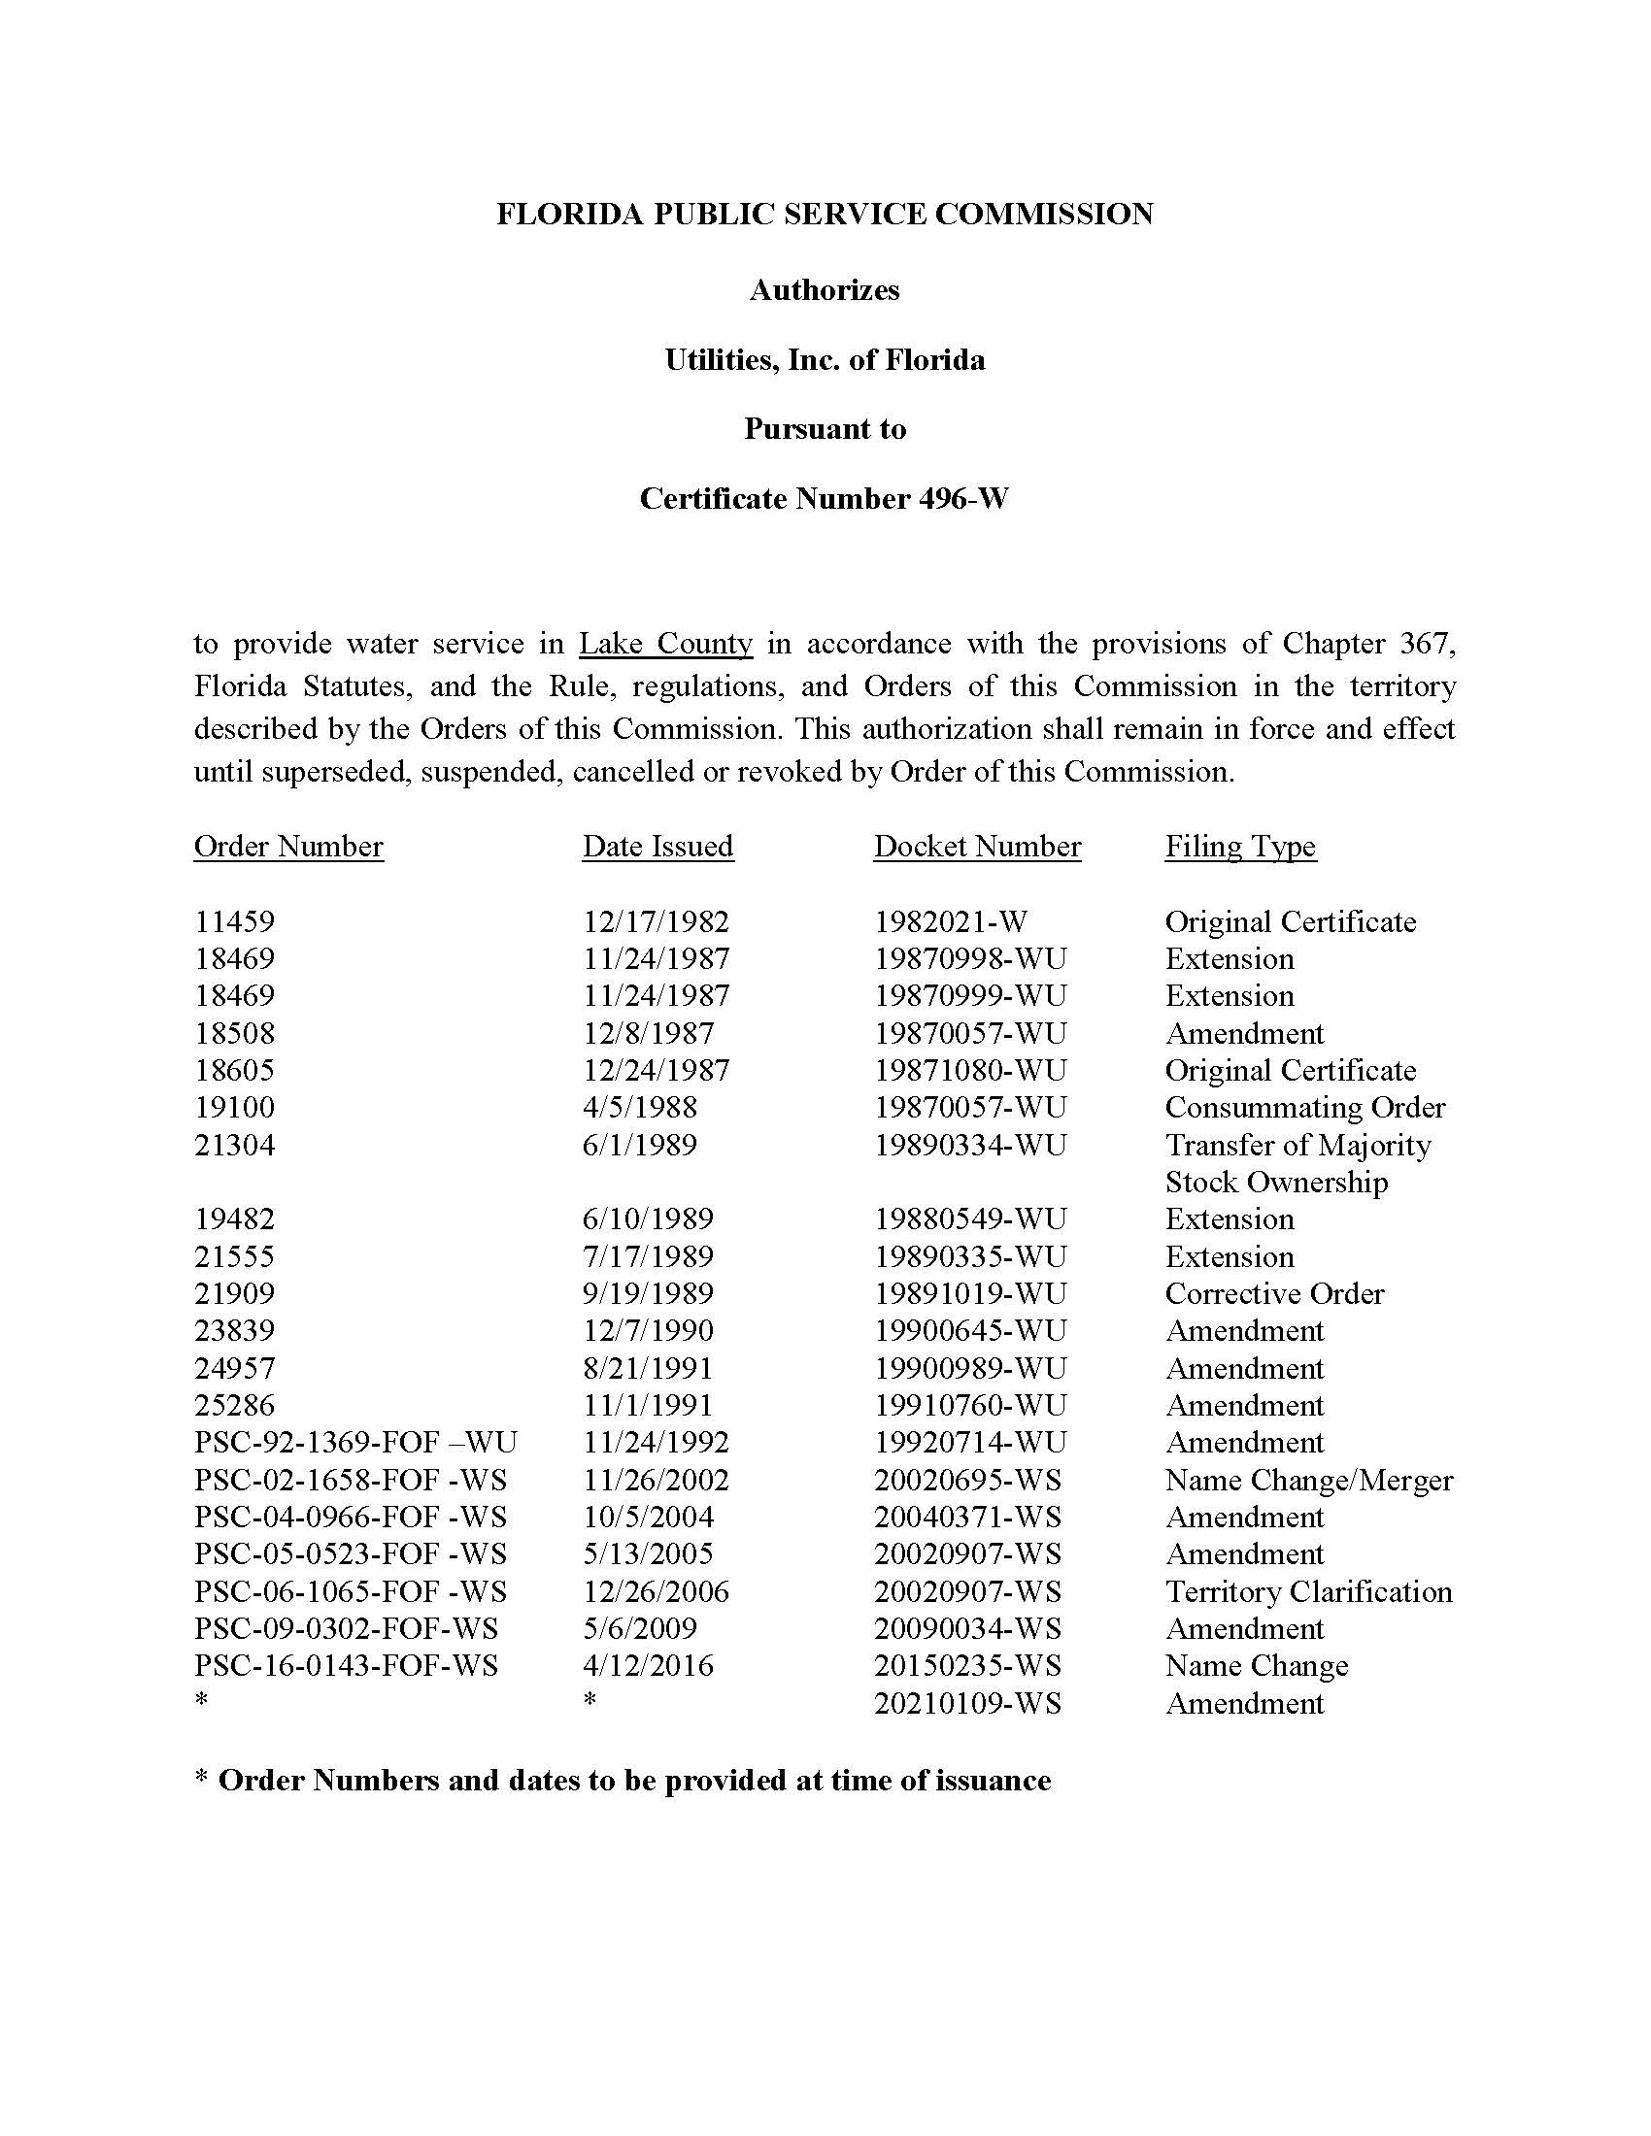

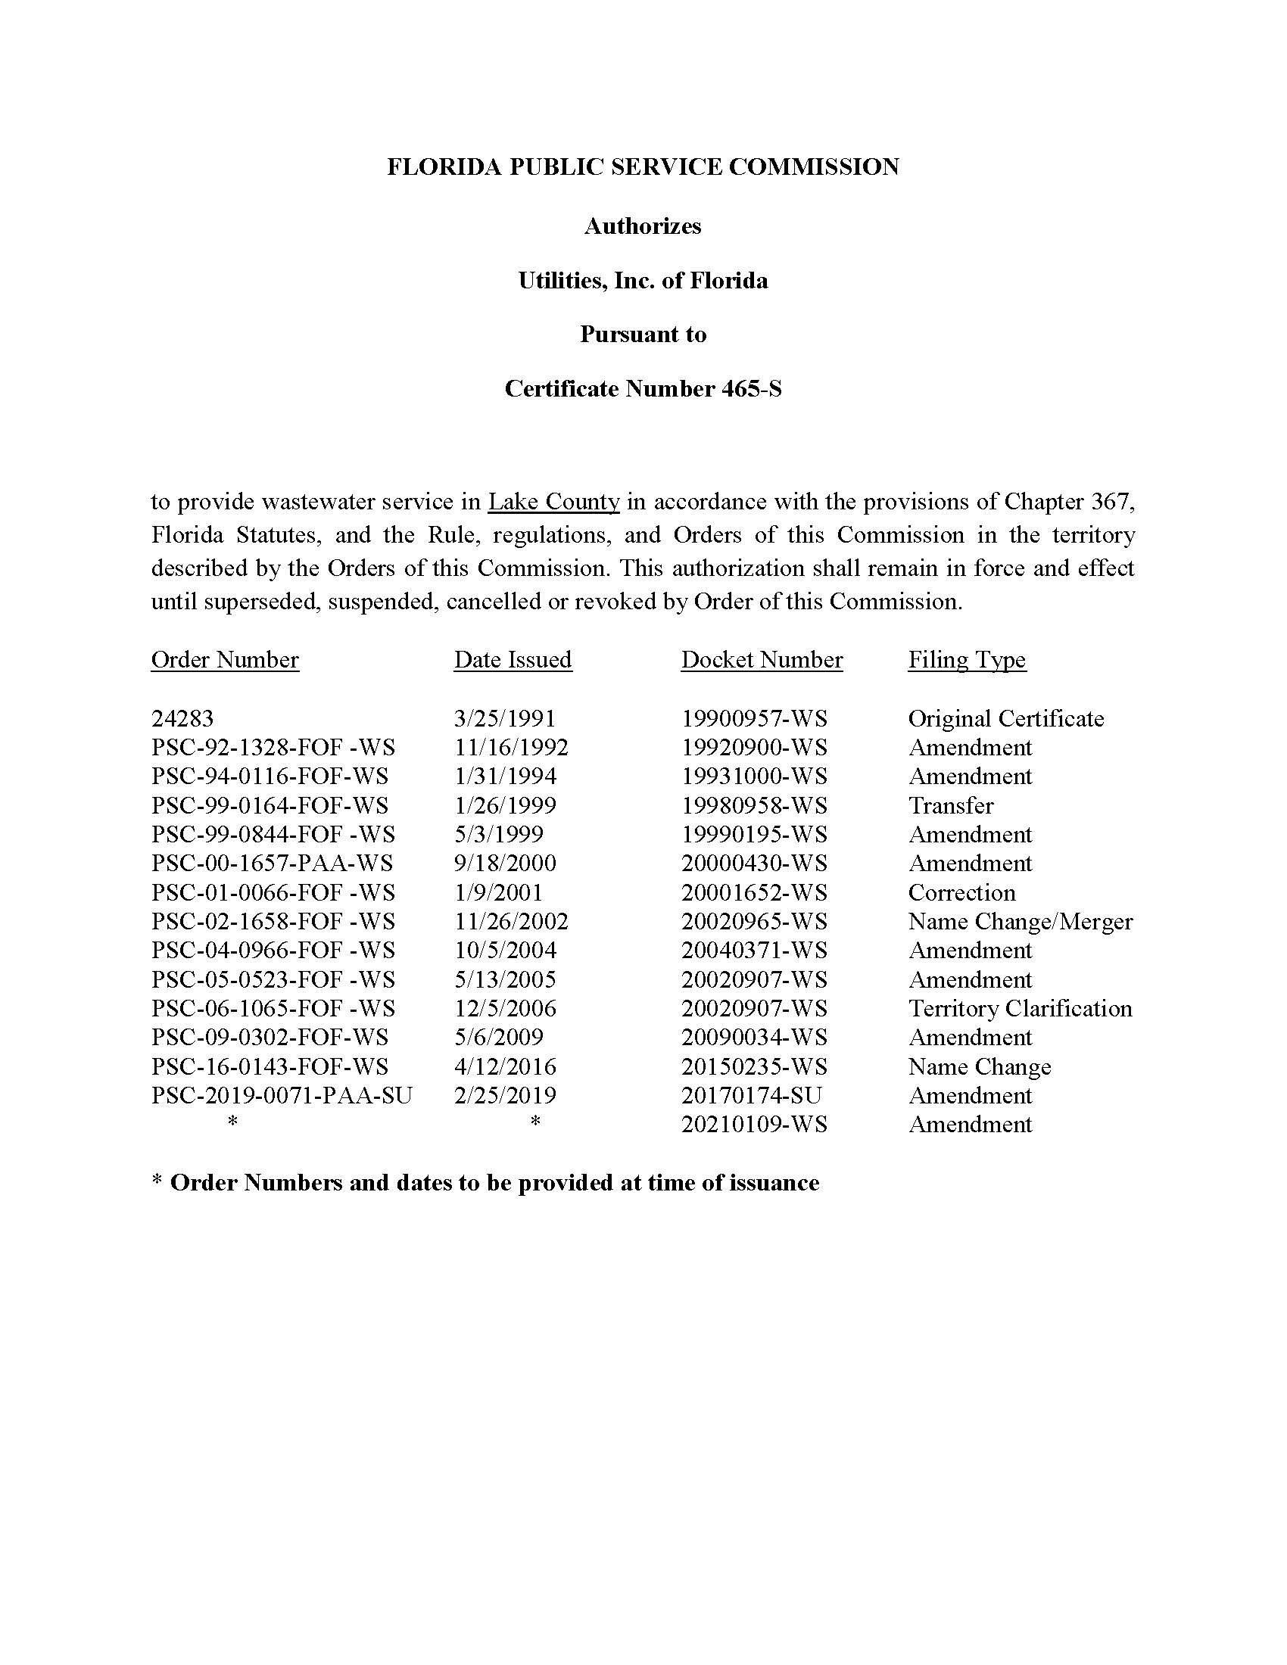

Order No. 18605, issued December 24, 1987, in Docket No.19871080-WU, In re: Application by LAKE UTILITY SERVICES, INC., for an original water certificate in Lake County.
Order Nos. 23839, issued December 7, 1990, in Docket No.19900645-WU, In re: Application of Lake Utility Services, Inc. for amendment of Certificate No. 496-W in Lake County; 23839-A, issued December 19, 1990, in Docket No.19900645-WU, In re: Application of Lake Utility Services, Inc. for amendment of Certificate No. 496-W in Lake County; 24957, issued August 21, 1991, in Docket No. 19900989-WU, In re: Application of Lake Utility Services, Inc. for amendment of Certificate No. 496-W in Lake County, Florida.
Order No. 25286, issued November 1, 1991, in Docket No.19910760-WU, In re: Application for amendment of Certificate No. 496-W to include Lake Saunders Acres Subdivision in Lake County by Lake Utility Services, Inc.
Order No. PSC-92-1369-FOF-WU, issued November 24, 1992, in Docket No. 19920174-WU, In re: Application for Amendment of Certificate No. 496-W in Lake County by LAKE UTILITY SERVICES, INC.
Order No. 24283, issued March 25, 1991, in Docket No. 19900957-WS, In re: Application of Lake Groves Utilities, Inc. for water and sewer certificates in Lake County.
Order No. PSC-92-1328-FOF-WS, issued November 16, 1992, in Docket No. 19920900-WS, In re: Application of Lake Groves Utilities, Inc. for amendment of Certificates Nos. 534-W and 465-S in Lake County, Florida.
Order No. PSC-94-0116-FOF-WS, issued January 31, 1994, in Docket No. 19931000-WS, In re: Application for Amendment of Certificates Nos. 534-W and 465-S in Lake County by Lake Groves Utilities, Inc.
Order No. PSC-99-0884-FOF-WS, issued May 3, 1999, in Docket No. 19990195-WS, In re: Application for Amendment of Certificates Nos. 534-W and 465-S to add additional territory in Lake County by Lake Groves Utilities, Inc.
Order No. PSC-00-1657-PAA-WS, issued September 18, 2000, in Docket No. 20000430-WS, In re: Application for amendment of Certificates Nos. 534-W and 465-S to add territory in Lake County by Lake Groves Utilities, Inc.
Order No. PSC-02-1658-FOF-WS, issued November 26, 2002, in Docket No. 20020695-WS, In re: Application for name change on certificate No. 465-S in Lake County from Lake Groves Utilities, Inc. to Lake Utility Services, Inc., holder of Certificate No. 496-W, pursuant to merger of Lake Groves with Lake Utility, and request for cancellation of Certificate No. 534-W held by Lake Groves.
Order Nos. PSC-05-0523-FOF-WS, issued May 13, 2005, in Docket No. 20020907-WS, In re: Application for amendment of Certificate Nos. 496-W and 465-S to extend water and wastewater service areas in Lake County by Lake Utility Services, Inc.; PSC-06-1065-FOF-WS, issued December 26, 2006, in Docket No. 20020907-WS, In re: Application for amendment of Certificate Nos. 496-W and 465-S to extend water and wastewater service areas in Lake County by Lake Utility Services, Inc.; PSC-04-0966-FOF-WS, issued October 5, 2004, in Docket No. 20040371-WS, In re: Application for amendment of Certificates 465-S and 496-W to extend water and wastewater service areas to include certain land in Lake County by Lake Utility Services, Inc.; PSC-09-0302-FOF-WS, issued May 6, 2009, in Docket No. 20090034-WS, In re: Application for quick-take amendment of Certificate Nos. 496-W and 465-S to extend service area in Lake County, by Lake Utility Services, Inc.
Order No. PSC-2019-0071-PAA-SU, issued February 25, 2019, in Docket No. 20170174-SU, In re: Application for transfer of assets of exempt utility, amendment of Certificate No.465-S, and petition for partial variance or waiver of Rule 25-30.030(5)(b), F.A.C. by Utilities, Inc. of Florida.
Order No. PSC-16-0143-FOF-WS, issued April 12, 2016, in Docket No. 20150235-WS, In re: Joint application for acknowledgement of corporate reorganization and request for approval of name changes on water and/or wastewater certificates of Cypress Lakes Utilities, Inc. in Polk County; Utilities, Inc. of Eagle Ridge in Lee County; Utilities, Inc. of Florida in Marion, Orange, Pasco, Pinellas, and Seminole Counties; Labrador Utilities, Inc. in Pasco County; Lake Placid Utilities, Inc. in Highlands County; Lake Utility Services, Inc. in Lake County; Utilities, Inc. of Longwood in Seminole County; Mid-County Services, Inc. in Pinellas County; Utilities, Inc. of Pennbrooke in Lake County; Utilities, Inc. of Sandalhaven in Charlotte County; Sanlando Utilities Corporation in Seminole County; and Tierra Verde Utilities, Inc. in Pinellas County, to Utilities, Inc. of Florida.
Order No. PSC-2021-0315-PAA-WS, issued August 20, 2021, in Docket No. 20210109-WS, In re: Application for amendment of Certificates 496-W and 465-S to extend territory in Lake County, by Utilities, Inc. of Florida.
Order No. PSC-2021-0206-FOF-WS, issued June 4, 2021, in Docket No. 20210139-WS, In re: Application for increase in water and wastewater rates in Charlotte, Highlands, Lake, Lee, Marion, Orange, Pasco, Pinellas, Polk, and Seminole Counties, by Utilities, Inc. of Florida.

