State of Florida |  | Public Service Commission  Capital Circle Office Center ● 2540 Shumard Oak Boulevard  Tallahassee, Florida 32399-0850  -M-E-M-O-R-A-N-D-U-M-
DATE: | October 21, 2021
TO: | Office of Commission Clerk (Teitzman)
FROM: | Office of the General Counsel (Harper, Cowdery)  Office of Industry Development and Market Analysis (Wendel)
RE: | Docket No. 20210137-PU – Proposed adoption of Rule 25-18.010, F.A.C., Pole Attachment Complaints.
AGENDA: | 11/02/21 – Regular Agenda – Rule Proposal – Interested Persons May Participate
COMMISSIONERS ASSIGNED: |  |  | All Commissioners
PREHEARING OFFICER: |  |  | Fay
RULE STATUS: |  |  | Proposal May Be Deferred – Rule must be proposed by January 1, 2022.
SPECIAL INSTRUCTIONS: |  |  | None

Case Background

Purpose of this Rulemaking
This rulemaking was initiated in order to implement the 2021 Florida Legislature’s amendments to Section 366.04, Florida Statutes (F.S.), Jurisdiction of Commission, that require the Florida Public Service Commission (Commission) to regulate and enforce rates, charges, terms, and conditions of certain pole attachments to ensure that such rates, charges, terms, and conditions are just and reasonable.
Under the new law, the Commission is required to hear and resolve complaints concerning rates, charges, terms, conditions, voluntary agreements, or any denial of access relative to pole attachments. When taking action upon such complaints, the Commission must establish just and reasonable cost-based rates, terms, and conditions for pole attachments by applying the decisions and orders of the Federal Communications Commission (FCC) unless a pole owner or attaching entity establishes by competent, substantial evidence in a Section 120.569 and 120.57, F.S., proceeding that an alternative cost-based pole attachment rate is just and reasonable and in the public interest.
The Commission is required to propose procedural rules to administer and implement this authority no later than January 1, 2022.

Certification to the Federal Communications Commission
Under Section 366.04(8)(g), F.S., after the proposed rule has been filed with the Department of State and becomes effective, the Commission must provide certification to the FCC pursuant to 47 U.S.C. § 224(c)(2). After Rule 25-18.010, F.A.C., becomes effective, staff intends to bring a recommendation to the next available Commission Conference for Commission approval and issuance of a certification order. The certification must include a statement that:

- The Commission regulates the rates, terms, and conditions for pole attachments pursuant to the authority of Section 366.04(8), F.S.; and
- The Commission in so regulating such rates, terms, and conditions has the authority to consider and does consider the interests of the subscribers of the services offered via such attachments, as well as the interests of the consumers of the utility services, under the authority of Section 366.04(8)(b), F.S.
In order to be considered to regulate the rates, terms, and conditions for pole attachments, the Commission must have issued and made effective rules and regulations implementing the Commission’s regulatory authority over pole attachments. In addition, the Commission must take final action on a complaint within 180 days after the complaint is filed with the Commission or within the period prescribed for final action in the implementing rule, not to extend beyond 360 days after the complaint is filed.

Procedural Issues
A Notice of Rule Development for this rule appeared in the August 17, 2021 edition of the Florida Administrative Register, Vol. 47, No. 159. A staff rule development workshop was held on September 1, 2021. Participating at the workshop were AT&T, CTIA, Comcast, Crown Castle Fiber LLC (Crown Castle), Florida Internet and Television Association, Inc. (FIT), Duke Energy Florida (DEF), Florida Power & Light Company (FPL), and Tampa Electric Company (TECO). Post-workshop written comments were provided by CTIA, Crown Castle, DEF, FPL, FIT, Frontier Communications, and TECO.

Rules adopted by the Commission to implement Section 366.04(8), F.S., are not subject to Section 120.541, F.S., Statement of estimated regulatory costs (SERC). For this reason, a SERC has not been prepared for this rule. The Commission has jurisdiction pursuant to Sections 120.54, 350.127(2), and 366.04(8)(g), F.S.

Discussion of Issues

Issue 1:
Should the Commission propose the adoption of Rule 25-18.010, F.A.C., Pole Attachment Complaints?

Recommendation:
Yes, the Commission should propose the adoption of Rule 25-18.010, F.A.C., Pole Attachment Complaints, as set forth in Attachment A. Also, the Commission should certify Rule 25-18.010, F.A.C., as a minor violation rule. (Wendel, Cowdery, Harper)

Staff Analysis:
Draft Rule 25-18.010, F.A.C., implements Section 366.04(8), F.S., which requires the Commission to regulate and enforce rates, charges, terms, and conditions of pole attachments. The Commission is required to hear and resolve complaints concerning rates, charges, terms, conditions, voluntary agreements, or any denial of access relative to pole attachments. The Commission must propose procedural rules to administer and implement this subsection no later than January 1, 2022, and upon adoption of the rules, it must provide its certification to the FCC pursuant to 47 U.S.C. § 224(c)(2).

Complaints
Sections (1) and (2) of draft Rule 25-18.010, F.A.C., address complaints. Subsection (1) lists the information that must be included in a complaint filed with the Commission by a pole owner or attaching entity. If the complaint requires the Commission to establish just and reasonable cost-based rates, terms, and conditions for pole attachments, the complaint must contain an explanation of the methodology the complainant is requesting the Commission to apply. Subsection (2) of the draft rule specifies that the filing date for the complaint is the date that a complaint is filed with the Commission Clerk containing all required information set forth in subsection (1) of the rule.
FPL’s post-workshop comments suggest that Rule 25-18.010, F.A.C., should require a complainant to certify that it is in compliance with all unchallenged or undisputed provisions of the applicable agreement. FPL states that this will help ensure that the parties narrow the scope of the complaint to only those provisions truly at issue and ensure that all pre-complaint efforts to resolve the dispute are as fruitful as possible. FPL also states that by requiring such certification, the Commission would help eliminate the unfair practice that occurs when attaching entities withhold the entire amount of an outstanding rental payment rather than solely the amount in dispute.
Staff does not recommend that a certification of compliance with undisputed provisions of a pole attachment agreement should be required in the complaint because the issues in dispute will be identified as part of the complaint proceeding. Draft subsection (1)(e) requires the complaint to include a statement of disputed issues of material fact or a statement that there are no disputed issues of material fact. A respondent has the opportunity to identify what it believes to be the issues in dispute in its response. If a Section 120.569 and 120.57, F.S., hearing is requested, specific issues to be resolved will be identified during the course of the proceeding.

Responses
Subsection (3) states that a pole owner or attaching entity that is the subject of the complaint may file a response to the complaint. The response must be filed with the Commission Clerk within 30 calendar days of the date the complaint was served on that party, unless the Prehearing Officer grants a motion for extension of time as provided in the Uniform Rules of Procedure. The 30 day filing requirement is intended to assure that the docket may proceed expeditiously, while recognizing the Prehearing Officer’s authority to grant a motion for extension of time in appropriate situations.
Subsection (4) of the draft rule states that if a response is filed, it must include a statement of whether a Section 120.569 and 120.57, F.S., evidentiary hearing is being requested to resolve the complaint. In addition, if the complaint requires the Commission to establish just and reasonable cost-based rates, terms, and conditions for pole attachments, the response must contain an explanation of the methodology the respondent is requesting the Commission to apply. The rule does not limit the information that may be included in the response, and, therefore, the respondent may include any relevant information that it wants the Commission to consider in response to the complaint.
FPL’s post-workshop comments suggest that the rule should state that a pole owner or attaching entity that is the subject of the complaint must file its initial response with the Commission within 30 calendar days of the date the complaint was served on that party. Staff does not envision a respondent filing more than one response to a complaint. If additional time is needed for a response, subsection (3) states that a motion for extension of time to file the response may be filed. If a Section 120.569 and 120.57, F.S., hearing is properly requested, the Prehearing Officer will issue an Order Establishing Procedure (OEP) that will govern the proceeding under the applicable Florida Administrative Code procedural rules. Staff anticipates that the OEP may address the timeframe for discovery, prefiled testimony and exhibits, prehearing statements by the parties, a prehearing order, hearing date(s), and post-hearing briefs by the parties.

Time Deadline for Commission Final Action on a Complaint
Subsection (5) of the draft rule states that the Commission will take final action on a complaint concerning rates, charges, terms, conditions, and voluntary agreements relative to pole attachments at a Commission Conference no later than 360 days after the complaint’s filing date as set forth in subsection (2). Subsection (6) states that for complaints limited to denial of access relative to pole attachments, the Commission will take final action no later than 180 days after the complaint’s filing date as established under subsection (2).

Stakeholders’ Comments
CTIA suggests that the Commission should consider a 180-day deadline, perhaps less, particularly for complaints regarding access to poles for attaching entities, which it states are significantly easier to adjudicate than rate-based complaints. CTIA states that the FCC has implemented a 60-day accelerated docket for pole attachment complaints under its jurisdiction and that Maine requires a final order from its Public Utilities Commission resolving a dispute within seven business days of a complaint being filed.
Crown Castle states that it believes that the 360-day resolution timeline for complaints involving matters such as rates of pole attachment is appropriate; however a short timeline for resolution is necessary for pole access complaints.
FIT suggests a 90-day timeframe for pole attachment complaints alleging denial of access, stating that unlike a rate dispute that can be remedied with true-ups or refunds, a denial of pole access has immediate and irreparable harm not only to the broadband provider but to the consumers who rely on those services. FIT states that all other pole attachment complaints should be resolved “within 180 days of the complaint’s filing and in no case later than 360 days after the complaint’s filing date as set forth in subsection (2) of this rule.”
DEF suggests that the Commission should take final action on pole access complaints no later than 180 days after the complaint’s filing date. FPL did not comment on the time frames for taking final action on complaints. TECO did not specifically state that the rule should provide for resolution of complaints in less than 360 days, instead suggesting that the rule provide that the Commission may adopt an expedited schedule for resolution for cause shown. In addition, TECO suggested that if the Commission decides to adopt a shorter time period for resolving pole access complaints, such as 180 days, the rule should be clear that the expedited time frame applies only to pole access complaints and not to complaints about the rates, terms, or conditions associated with pole access.

Staff Analysis
Under Section 366.04(8)(g), F.S., the Commission must provide its 47 U.S.C. 224(c)(2) certification to the FCC upon adoption of Rule 25-18.010, F.A.C. Section 224(c)(3)B. of 47 U.S.C. requires the Commission to take action on pole attachment complaints within 180 days after the complaint is filed or within the time prescribed for such final action by Commission rule, not to exceed 360 days after the complaint is filed.
Staff recommends in subsection (5) of the draft rule that the Commission take final action on a complaint concerning rates, charges, terms, conditions, and voluntary agreements relative to pole attachments at a Commission Conference no later than 360 days after the complaint’s filing date as set forth in subsection (2). Staff is recommending the maximum time allowed by the FCC in recognition that the Commission will be addressing complex matters not previously under its jurisdiction. Section 366.04(8)(f), F.S., recognizes this by enacting a procedure allowing any petitioning pole owner or attaching entity to participate as an intervenor with full party rights under Chapter 120, F.S., in the first four formal administrative proceedings conducted to determine pole attachment rates. The Legislature stated that “[t]hese initial four proceedings are intended to provide commission precedent on the establishment of pole attachment rates by the commission and help guide negotiations toward voluntary pole attachment agreements.” Staff believes that allowing 360 days for the Commission to take final agency action on a complaint will assure sufficient time for discovery, hearing, post-hearing briefs, and staff preparation of a recommendation for the Commission. Further, the Prehearing Officer will set the schedule, and there is no impediment to the Commission taking final action in less time if circumstances warrant.
Rulemaking participants appeared in general agreement that the rule should require that complaints concerning denial of access relative to pole attachments be resolved in less time than pole attachment complaints involving rates and charges. Final action by the FCC on pole access denial complaints is expected no later than 180 days from the date the complaint is filed with the FCC “except in extraordinary circumstances.” Staff recommends in subsection (6) that for complaints limited to denial of access relative to pole attachments, the Commission take final action no later than 180 days after the complaint’s filing date as established under subsection (2) of the rule. Again, there would be no impediment to the Commission taking final action in fewer than 180 days if circumstances allow.
Staff notes that Frontier suggested that a provision be added to the rule stating: “A party’s right of non-discriminatory access to a pole under Section 366.04(8), Florida Statutes, is identical to the rights afforded under 47 U.S.C. 224(f).” This language is a restatement of the requirement of Section 366.04(8)(d), F.S., and for this reason is not needed to implement the statute. Under Section 120.545(1)(c), F.S., the Joint Administrative Procedure Committee (JAPC) reviews agency rules, one of the purposes of which is to determine whether the rule reiterates or paraphrases statutory material. For this reason, the Commission does not reiterate statutory language in its rules.

Methodology for Establishing Rates and Charges
As described below, a point of disagreement among the companies participating in this rulemaking was whether Rule 25-18.010, F.A.C., should include the FCC’s rate formula set forth in 47 C.F.R. § 1.1406(d) (“FCC Formula”) as the Commission’s default method of calculating pole attachment rates. 47 C.F.R. § 1.1406(d) is attached hereto as Attachment B.

Stakeholders in Favor of Adopting the FCC Formula for Establishing Rates
Crown Castle, CTIA and FIT argue that in resolving complaints requiring establishment of rates and charges, Rule 25-18.010, F.A.C., should provide that the FCC Formula is the default method of calculating pole attachment rates.
Crown Castle believes that access to utility poles and conduit and streamlined processes and rules that promote the safe, expeditious, and cost-effective deployment of telecommunications facilities on utility infrastructure are key to its network expansion efforts. Crown Castle states that regulated pole attachment rates in Florida have been calculated using the FCC Formula for many years, making it an appropriate baseline from which a pole owner or attaching entity may propose an alternative rate in the context of a complaint proceeding.
CTIA states that by codifying the FCC Formula, the Commission would further the goal of streamlining and encouraging broadband deployment and would encourage investment by helping to ensure a just and reasonable rate and, therefore, greater economic certainty for attaching entities. CTIA states that the FCC Formula for pole attachment rates is cost-based and has been consistently held by courts and regulatory bodies to be compensatory and reasonable for pole owners.
FIT believes that the Commission should adopt not only the FCC Formula, but also, at a minimum, should add explicit language to the draft rule stating that the Commission will apply all of the FCC’s substantive rules regarding the rates, terms, and conditions of pole attachments, FCC orders, and appellate decisions, in resolving pole attachment complaints. FIT states that the Commission should exclude purely procedural FCC rules so that the Commission can follow its own procedure. FIT states that the language of Section 366.04(8)(e), F.S., supports this approach because it requires the Commission to apply the decisions and orders of the FCC and any appellate court decisions reviewing an order of the FCC when acting on pole attachment complaints. FIT states that if the Commission’s rule does not explain that the FCC rules are the default to be applied, the Section 366.04(8), F.S., language allowing a party to establish an alternative rate is unclear. FIT also states that the FCC pole rate rules are transparent and easy to administer.
FIT further argues that adopting the FCC’s substantive rules would also help further the Legislature’s goal to “encourage parties to enter voluntary pole attachment agreements” by giving clear guidance that will allow parties to negotiate agreements with greater understanding of their baseline rights, diminishing the likelihood of a dispute. FIT states that applying the FCC’s rules is supported by sound public policy based on four decades of experience and that the FCC has well established rules and precedents governing the maximum just and reasonable annual rental rates that may be lawfully charged to attaching entities.

Stakeholders Against Adopting the FCC Formula for Establishing Rates
DEF, FPL and TECO argue against adopting the FCC Formula as the default rate to be used by the Commission in establishing just and reasonable rates in pole attachment complaint proceedings. They point out that the methodology to be used for determining the reasonableness of a rate is a substantive matter that should not be included in a procedural rule. DEF and FPL specifically state that adopting the substantive FCC Formula would exceed the Commission’s legislatively granted authority that limits the Commission to adopting procedural rules.
FPL states that FIT is incorrect in arguing that the “alternative rate” referenced in Section 366.08, F.S., assumes it would be an alternative to the FCC Formula rate. FPL argues that not all agreements subject to the Commission’s new jurisdiction use the FCC Formula rate. FPL states that this is because the Commission’s regulatory jurisdiction under Section 366.08(a), F.S., is broader than the FCC’s jurisdiction in that cable and telecommunications attachments to streetlight poles are outside the FCC’s jurisdiction and that the FCC rates are inapplicable. Additionally, joint use agreements, which are almost always between incumbent local exchange carriers and electric utilities, rarely use the FCC Formula because the contract terms are so different from the terms of pole attachment agreements between competitive local exchange carriers or cable providers and electric utilities. FPL states that if the Commission were to adopt the FCC Formula, existing agreements not utilizing the FCC rate would effectively be required to do so. Instead, the Commission should allow arm’s-length negotiated agreements to continue and consider appropriate rates on a case-by-case basis.
FPL and TECO maintain that adopting the FCC Formula is not supported by Section 366.04(8), F.S., pointing out that Section 366.04(8)(e), F.S., states that FCC precedent is not binding upon the Commission in the exercise of its authority. FPL notes that the statute does not state that the FCC Formula is the default rate formula or require the Commission to use that formula.
Additionally, FPL and DEF note that Section 366.08(f), F.S., states that the initial four proceedings in which the Commission establishes rates are intended to provide Commission precedent on the establishment of pole attachment rates and help guide negotiations toward voluntary pole attachment agreements. As stated by DEF: “This indicates that the legislature intends for precedent to be developed on an ad hoc basis, with the benefit of factual records, rather than through an initial set of substantive rules in the absence of any factual record.”

Staff Analysis
The participants quote from different parts of Section 366.04(8)(e), F.S., in arguing whether adopting the FCC Formula in the rule is consistent with the grant of authority to the Commission. This important language is as follows:
(e) The commission shall hear and resolve complaints concerning rates, charges, terms, conditions, voluntary agreements, or any denial of access relative to pole attachments. Federal Communications Commission precedent is not binding upon the commission in the exercise of its authority under this subsection. When taking action upon such complaints, the commission shall establish just and reasonable cost-based rates, terms, and conditions for pole attachments and shall apply the decisions and orders of the Federal Communications Commission and any appellate court decisions reviewing an order of the Federal Communications Commission regarding pole attachment rates, terms, or conditions in determining just and reasonable pole attachment rates, terms and conditions unless a pole owner or attaching entity establishes by competent substantial evidence pursuant to proceedings conducted pursuant to ss. 120.569 and 120.57 that an alternative cost-based pole attachment rate is just and reasonable and in the public interest. (emphasis added)
The first sentence clearly sets out the Commission’s jurisdiction and is not in dispute. The statute does not state that the Commission is required to adopt the rules of the FCC. Staff does not see internal conflict in the language of paragraph (8)(e), which directs the Commission in establishing cost-based rates to apply decisions and orders of the FCC unless a pole owner or attaching entity proves that an alternative cost-based pole attachment rate is just and reasonable and in the public interest. Because the FCC’s orders are presumably based in some manner on its rules, it is likely that one of the parties to the evidentiary rate proceeding will argue that the FCC Formula should be followed, presumably based on certain FCC orders or appellate decisions. However, an argument that the rates should be established based on application of FCC decisions, orders, and court decisions may be overcome if the opposing entity meets the statutory burden of proving an alternative cost-based rate is just and reasonable and in the public interest.
Staff believes it is significant that Section 366.04(8)(f), F.S., creates a procedure under which the initial four Section 120.569 and 120.57, F.S., proceedings in which the Commission will establish pole attachment rates are intended: “to provide [C]ommission precedent on the establishment of pole attachment rates by the [C]ommission and help guide negotiations toward voluntary pole attachment agreements.” These four proceedings are to include any petitioning pole owner or attaching entity as intervenors “with full party rights.” This procedure will give all interested entities the opportunity to provide the Commission with information on methodologies that may be used in establishing just and reasonable rates. Staff believes it would be premature to settle on a particular methodology as a “default” formula in the rule before the Commission has conducted any evidentiary hearings as contemplated by the statute.

Minor Violation Rules Certification
Pursuant to Section 120.695, F.S., the agency head must certify for each rule filed for adoption whether any part of the rule is designated as a rule the violation of which would be a minor violation. Violation of Rule 25-18.010, F.A.C., would not result in economic or physical harm to a person or have an adverse effect on the public health, safety, or welfare or create a significant threat of such harm. Thus, staff recommends that the Commission certify Rule 25-18.010, F.A.C., as a minor violation rule.

Conclusion
Based on the foregoing, staff recommends that the Commission should propose adoption of Rule 25-18.010, F.A.C., Pole Attachment Complaints, as set forth in Attachment A. Staff also recommends that the Commission certify Rule 25-18.010, F.A.C., as a minor violation rule.

Issue 2:
Should this docket be closed?

Recommendation:
No, the docket should not be closed. After the proposed rule has been filed with the Department of State for adoption and becomes effective, staff intends to bring a recommendation to the next available Commission Conference for the Commission to issue a certification order as required by Section 366.04(8)(g), F.S. (Cowdery, Harper)

Staff Analysis:
If no requests for hearing, information regarding the SERC, proposals for a lower cost regulatory alternative, or JAPC comments are filed, the rule should be filed with the Department of State for adoption. After the rule becomes effective, staff intends to bring a recommendation to the next available Commission Conference for the Commission to issue a certification order as required by Section 366.04(8)(g), F.S. The certification order will be provided to the FCC as required by 47 U.S.C. § 224(c)(2), as described in the Case Background.

25-18.010 Pole Attachment Complaints
(1) A complaint filed with the Commission by a pole owner or attaching entity pursuant to Section 366.04(8), F.S., must contain:
(a) The name, address, email address, and telephone number of the complainant or complainant’s attorney or qualified representative;
(b) A statement describing the facts that give rise to the complaint;
(c) Names of the party or parties against whom the complaint is filed;
(d) A copy of the pole attachment agreement, if applicable, and identification of the pole attachment rates, charges, terms, conditions, voluntary agreements, or any denial of access relative to pole attachments that is the subject matter of the complaint;
(e) A statement of the disputed issues of material fact or a statement that there are no disputed issues of material fact;
(f) If the complaint requires the Commission to establish just and reasonable cost-based rates, terms, and conditions for pole attachments, the complaint must contain an explanation of the methodology the complainant is requesting the Commission to apply.
(g) If applicable, the dollar amount in dispute;
(h) A statement of the relief requested, including whether a Section 120.569 and 120.57, F.S., evidentiary hearing is being requested to resolve the complaint; and
(i) A certificate of service that copies of the complaint have been furnished by email to the party or parties identified in paragraph (1)(c) of this rule.
(2) The filing date for the complaint is the date that a complaint is filed with the Commission Clerk containing all required information set forth in subsection (1) of this rule.
(3) The pole owner or attaching entity that is the subject of the complaint may file a response to the complaint. The response must be filed with the Commission Clerk within 30 calendar days of the date the complaint was served on the respondent, unless the Prehearing Officer grants a motion for extension of time filed pursuant to Rule 28-106.204, F.A.C., or Rule 28-106.303, F.A.C., as appropriate.
(4) A response filed under subsection (3) of this rule must include the following:
(a) A statement of whether a Section 120.569 and 120.57, F.S., evidentiary hearing is being requested to resolve the complaint; and
(b) If the complaint requires the Commission to establish just and reasonable cost-based rates, terms, and conditions for pole attachments, the response must contain an explanation of the methodology the respondent is requesting the Commission to apply.
(5) The Commission will take final action on a complaint concerning rates, charges, terms, conditions, and voluntary agreements relative to pole attachments at a Commission Conference no later than 360 days after the complaint’s filing date as set forth in subsection (2) of this rule.
(6) The Commission will take final action on a complaint limited to denial of access relative to pole attachments at a Commission Conference no later than 180 days after the complaint’s filing date as established under subsection (2) of this rule.
Rulemaking Authority 350.127(2), 366.04(8)(g) FS. Law Implemented 366.04(8) FS. History-New__________

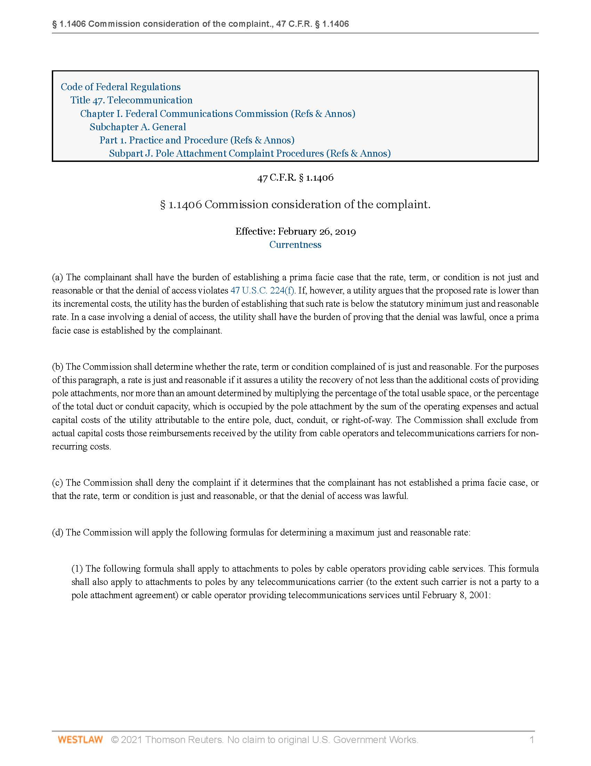

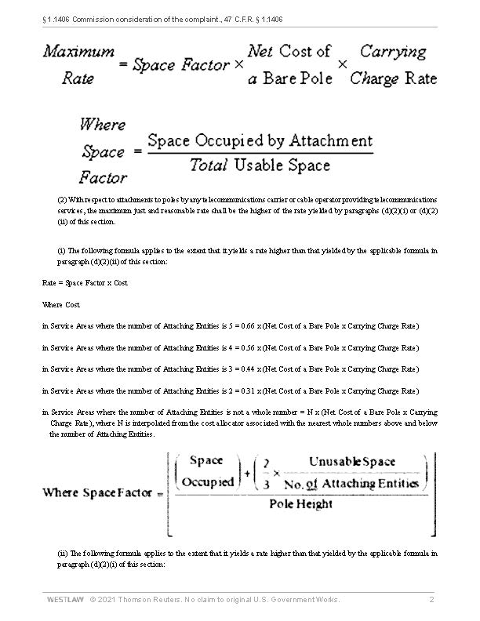

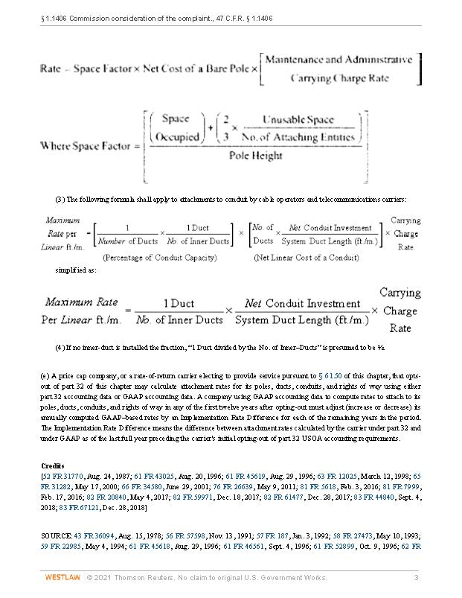

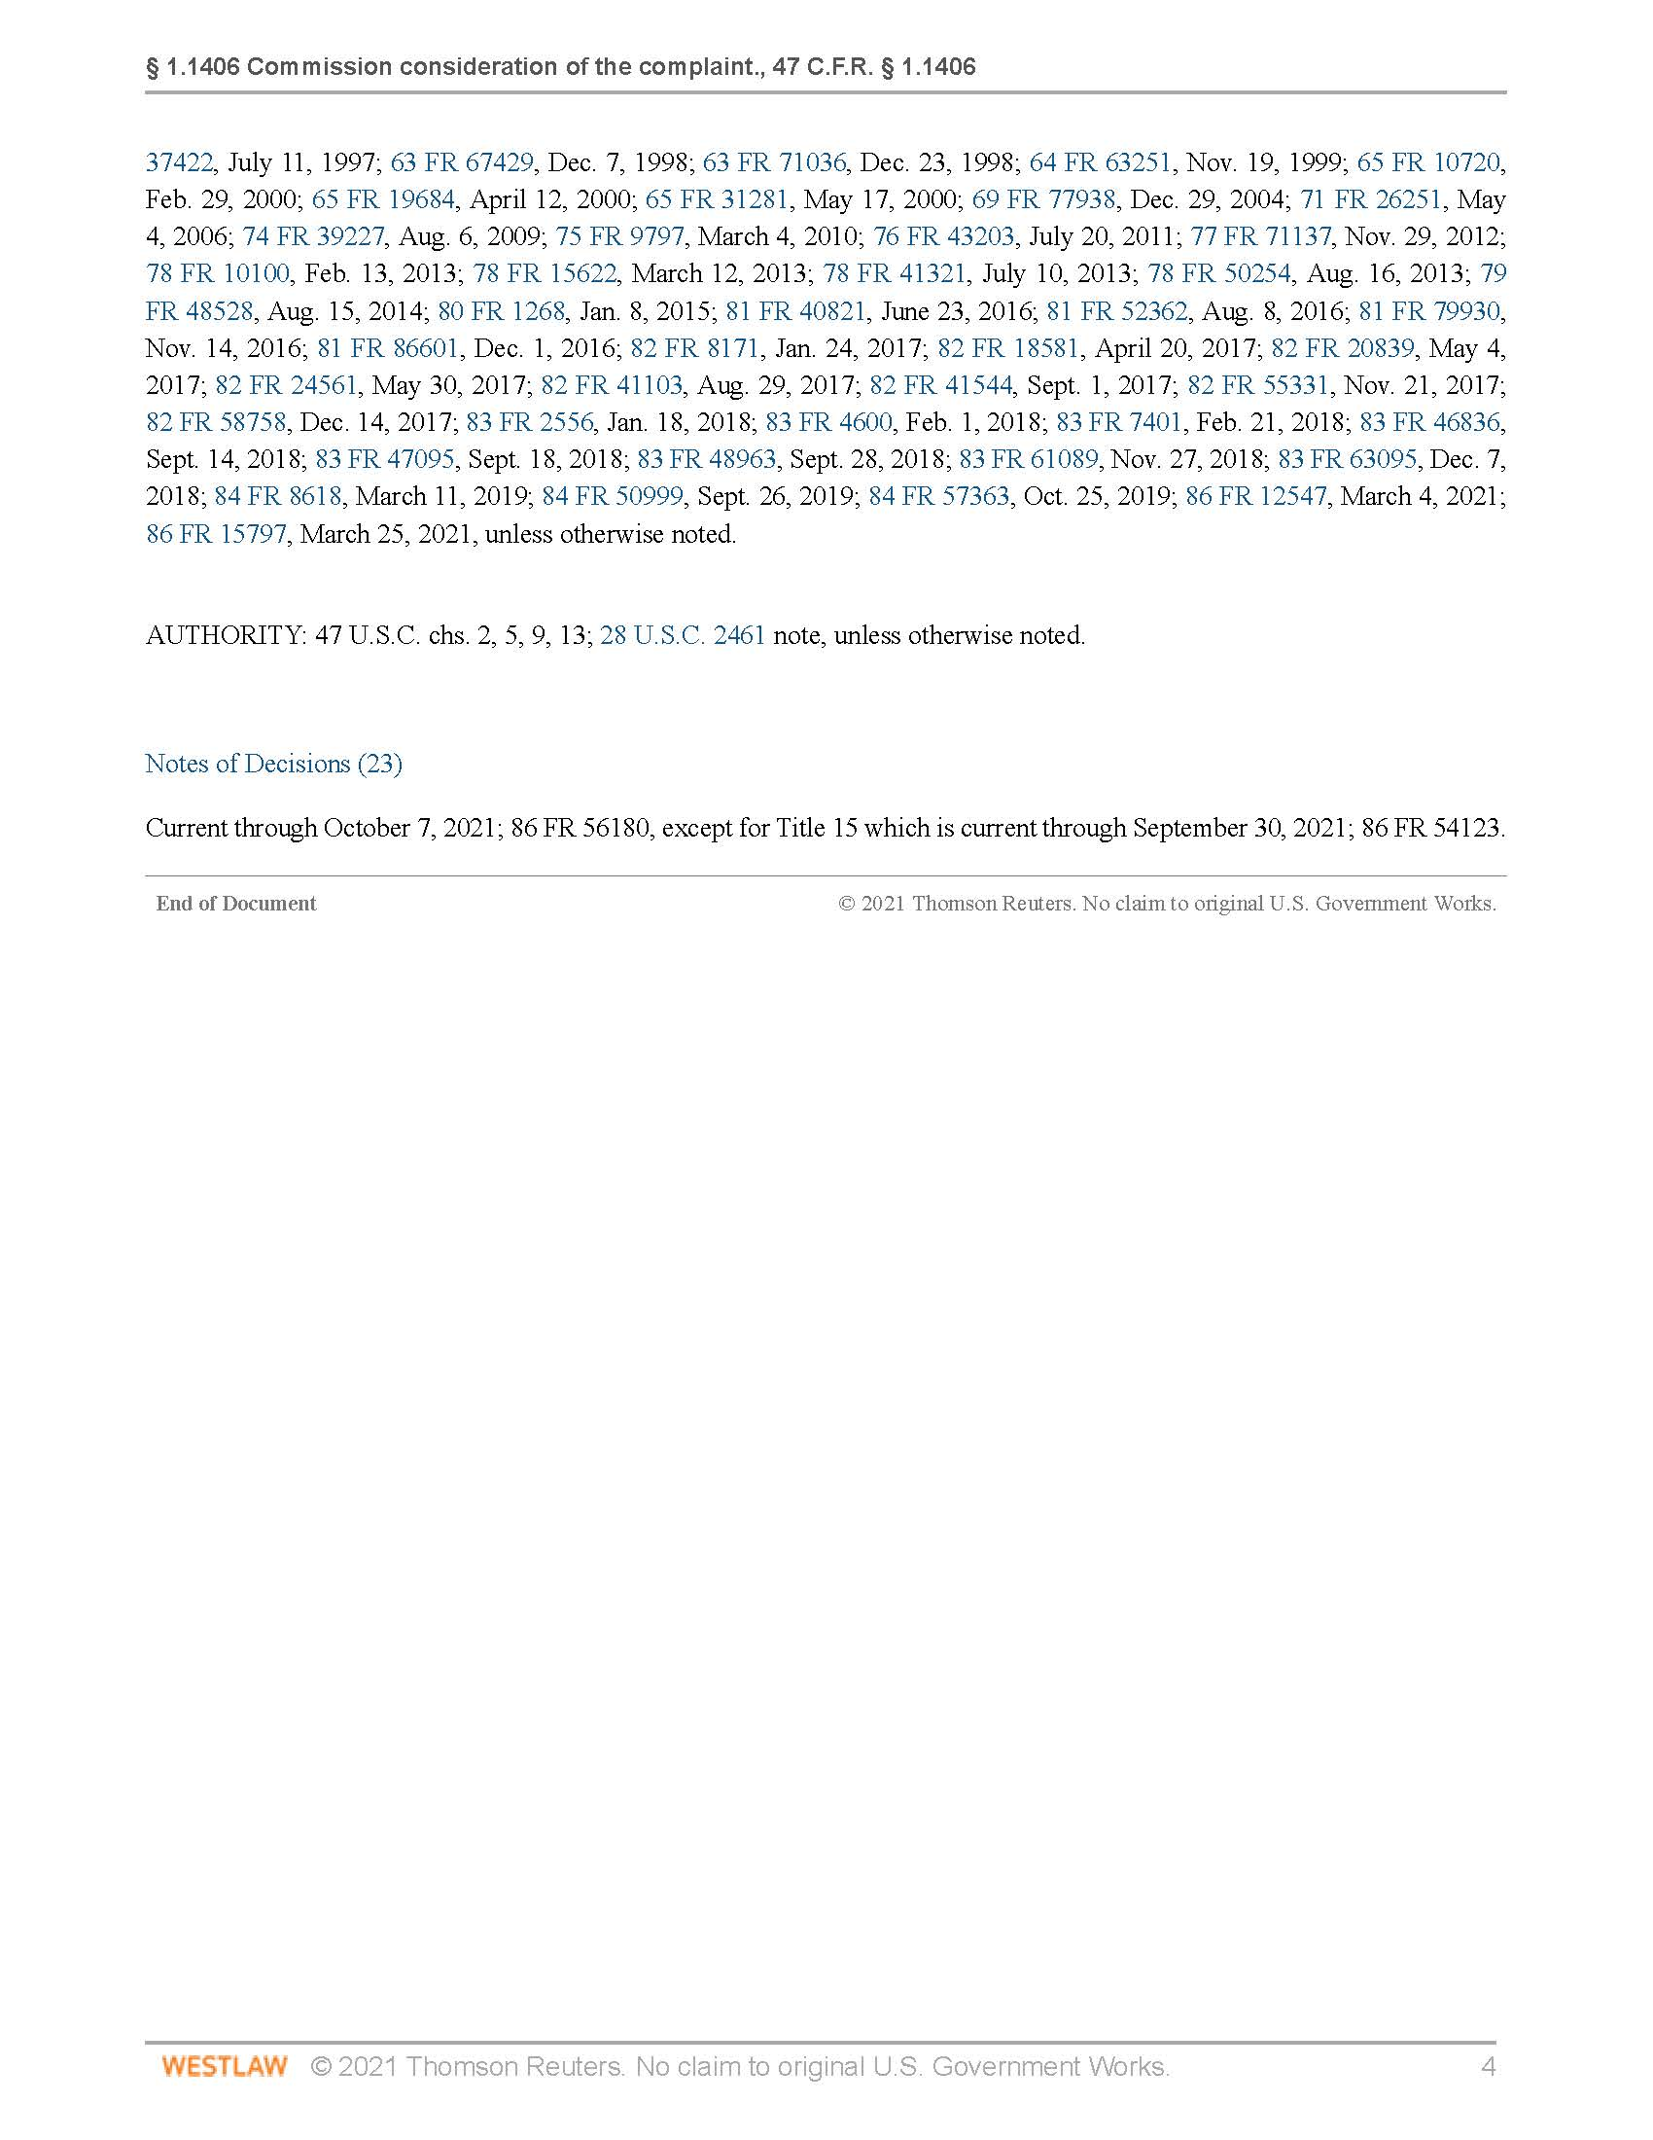

Section 366.02(7), F.S., defines “pole attachment” as “any attachment by a public utility, local exchange carrier, communications services provider, broadband provider, or cable television operator to a pole, duct, conduit, or right-of-way owned or controlled by a pole owner.”
Section 366.04(8)(a), F.S.
Section 366.04(8)(e), F.S.
Section 366.02(8), F.S., defines “pole owner” as “a local exchange carrier, a public utility, a communications services provider, or a cable television operator that owns a pole.”
Section 366.02(4), F.S., defines “attaching entity” as “a person that is a local exchange carrier, a public utility, a communications services provider, a broadband service provider, or a cable television operator that owns or controls pole attachments.”
Section 366.04(8)(e), F.S.
Section 366.04(8)(g), F.S.
47 U.S.C. § 224(c)(2)(B)
47 U.S.C. §224(c)(3)(A)
47 U.S.C. §224(c)(3)(B)
CTIA states that it represents the U.S. wireless communications industry and the companies throughout the mobile ecosystem, including wireless carriers, device manufacturer, and suppliers as well as app and content companies.
Crown Castle states that it is the largest independent owner and operator of shared infrastructure in the U.S., deploying fiber optic and wireless infrastructure, with more than twenty-five years of experience building and operating network infrastructure, having more than 40,000 towers, 70,000 small wireless facilities constructed or under contract, and more than 80,000 route miles of fiber in the U.S.
Section 120.80(13)(g), F.S.
47 C.F.R. §1.736 allows parties to pole attachment complaint proceedings to request inclusion on the FCC’s Accelerated Docket, which is subject to shorter pleading deadlines and other modifications to procedural rules governing formal complaint proceedings. Commission staff has discretion to decide whether a complaint, or portion of a complaint, is suitable for inclusion on the Accelerated Docket. 47 C.F.R. §1.736(d).
Staff notes that Maine’s Expedited Pole Attachment Complaint Process requires Commission staff designated as the Commission Rapid Response Team (CRRT) to issue a final order within 7 business days of the filing of the complaint “unless the parties and our staff agree that additional time is necessary,” after which the CRRT’s final order may be appealed to the full Maine Public Utilities Commission. Maine has not extended its time period for resolution of disputes to 360 days, and therefore is subject to the 180 day resolution time period. Maine Public Utilities Commission Investigation into Practices and Acts Regarding Access to Utility Poles, Docket No 2010-371, Order issued July 12, 2011, 2011 WL 2745071 (ME PUC); 65-407 CMR Ch 880, §§ 8 and Att. A.
47 C.F.R. § 1.1414(a)

