State of Florida |  | Public Service Commission  Capital Circle Office Center ● 2540 Shumard Oak Boulevard  Tallahassee, Florida 32399-0850  -M-E-M-O-R-A-N-D-U-M-
DATE: | October 21, 2021
TO: | Office of Commission Clerk (Teitzman)
FROM: | Division of Economics (Hampson)  Office of the General Counsel (Sandy, Crawford)
RE: | Docket No. 20210150-GU – Joint petition for approval to implement gas reliability infrastructure program (GRIP) cost recovery factors for January 2022 through December 2022 by Florida Public Utilities Company, Florida Public Utilities Company-Fort Meade and the Florida Division of Chesapeake Utilities Corporation.
AGENDA: | 11/02/21 – Regular Agenda – Tariff Filing – Interested Persons May Participate
COMMISSIONERS ASSIGNED: |  |  | All Commissioners
PREHEARING OFFICER: |  |  | Administrative
CRITICAL DATES: |  |  | 8-Month Effective Date: 04/30/22
SPECIAL INSTRUCTIONS: |  |  | None

Case Background
On September 1, 2021, Florida Public Utilities Company (FPUC), Florida Public Utilities Company-Fort Meade (Fort Meade), and Florida Division of Chesapeake Utilities Corporation d/b/a Central Florida Gas (Chesapeake), collectively the companies, filed a joint petition for approval of their gas reliability infrastructure program (GRIP or program) cost recovery factors for the period January through December 2022. The GRIP for FPUC and Chesapeake was first approved in Order No. PSC-12-0490-TRF-GU (2012 Order) to recover the cost of accelerating the replacement of cast iron and bare steel distribution mains and services, including a return on investment, through a surcharge on customers’ bills. Fort Meade’s GRIP was originally approved in Order No. PSC-15-0578-TRF-GU, and allowed Fort Meade to file its annual petition for GRIP factors concurrently with FPUC and Chesapeake. The current GRIP charges for January through December 2021 were approved in Order No. PSC-2020-0510-TRF-GU.
During the evaluation of the petition, staff issued a data request to the companies, for which responses were received on September 29, 2021. At the October 12, 2021 Agenda Conference, the joint petition was suspended to allow staff a sufficient opportunity to gather and evaluate all pertinent information related to the tariff proposals in order to present the Commission with an informed recommendation.
Attachment A to this recommendation includes tables showing pipe replacement progress for each of the companies. Attachment B contains the proposed tariff sheets for each of the companies. The Commission has jurisdiction over this matter pursuant to Sections 366.03, 366.04, 366.05, and 366.06, F.S.

Discussion of Issues

Issue 1:
Should the Commission approve FPUC’s, Chesapeake’s, and Fort Meade’s proposed GRIP surcharges for the period January through December 2022?

Recommendation:
Yes, the Commission should approve FPUC’s, Chesapeake’s, and Fort Meade’s proposed GRIP surcharges for the period January through December 2022. (Hampson)

Staff Analysis:
The GRIP surcharges have been in place since January 2013 for FPUC and Chesapeake, while Fort Meade’s surcharges were first implemented in January 2017. In response to staff’s data request, FPUC stated that during 2021, replacement projects were completed in Palm Beach, West Palm Beach, and Lantana. For 2021, Chesapeake completed replacement projects in Winter Haven, Haines City, and Plant City. The companies stated that they prioritize the potential replacement projects focusing on areas of high consequence and areas more susceptible to corrosion.

Fort Meade completed its replacement program in 2019 and Chesapeake competed its replacement program in 2021. As contemplated in the 2012 Order, FPUC will complete its remaining replacement projects in Palm Beach, West Palm Beach, Boynton Beach, Delray Beach, and Lake Worth by July 2022. Attachment A provides an update of mains and services replaced and replacement forecasts.

FPUC’s True-ups by Year
FPUC’s calculation for the 2022 GRIP revenue requirement and surcharges includes a final true-up for 2020, an actual/estimated true-up for 2021, and projected costs for 2022. In its 2008 rate case, FPUC was authorized to recover $747,727 of annual bare steel replacement expenses in base rates. Therefore, the $747,727 recovered from base rates is excluded from the GRIP surcharge calculation.

Final True-up for 2020
FPUC stated that the revenues collected through the GRIP surcharges for 2020 were $9,369,115, compared to a revenue requirement of $11,020,034, resulting in an under-recovery of $1,650,921. Therefore, the 2019 over-recovery of $1,965,077, the 2020 under-recovery of $1,650,921, and interest of $11,962 associated with any over- and under-recoveries results in a final 2020 over-recovery of $326,118.

Actual/Estimated 2021 True-ups
FPUC provided actual revenues for January through July 2021 and estimated revenues for August through December 2021, totaling $10,637,538, compared to an actual/estimated revenue requirement for 2021 of $12,747,807, resulting in an under-recovery of $2,110,269. Therefore, the 2020 over-recovery of $326,118, the 2021 under-recovery of $2,110,269, and interest of $112 results in a total 2021 under-recovery of $1,784,263.

Projected 2022 Costs
FPUC expects capital expenditures of $5,294,520 for the replacement of cast iron/bare steel infrastructure in 2022. This compares with final 2020 expenditures of $18,862,373 and actual/estimated 2021 expenditures of $21,618,655. The return on investment (which includes federal income taxes, regulatory assessment fees, and bad debt), depreciation expense, and property tax and customer notification expense associated with that investment are $14,949,687. Subtracting the revenue requirement for bare steel replacement included in base rates results in a 2022 revenue requirement of $14,201,960. After including the total 2021 under-recovery of $1,784,263, the 2022 revenue requirement is $15,986,222. Table 1-1 shows FPUC’s 2022 revenue requirement calculation.
Table 1-1
FPUC 2022 Revenue Requirement Calculation
2022 Projected Expenditures |  | $5,294,520
Return on Investment | $9,267,172
Depreciation Expense | 3,043,810
Property Tax and Customer Notice Expense | 2,638,705
2022 Revenue Requirement | $14,949,687
Less Revenue Requirement in Base Rates | -747,727
2022 GRIP Revenue Requirement | $14,201,960
Plus 2021 Under-recovery | +1,784,263
2022 Total Revenue Requirement | $15,986,222
Source: Witness Craig Testimony Schedules C-2, Page 4, and D-1, Page 5

Chesapeake’s True-ups by Year
Chesapeake’s calculation for the 2022 GRIP revenue requirement and surcharges includes a final true-up for 2020, an actual/estimated true-up for 2021, and projected costs for 2022. Chesapeake does not have a replacement recovery amount embedded in base rates.

Final True-up for 2020
Chesapeake stated that the revenues collected for 2020 were $3,089,373, compared to a revenue requirement of $3,970,339, resulting in an under-recovery of $880,966. The 2019 over-recovery of $599,886, 2020 under-recovery of $880,966 and $2,804 for interest associated with any over- and under-recoveries results in a final 2020 under-recovery of $278,276.

Actual/Estimated 2021 True-up
Chesapeake provided actual GRIP revenues for January through July 2021 and estimated revenues for August through December 2021, totaling $4,218,111, compared to an actual/estimated revenue requirement of $4,097,241, resulting in an over-recovery of $120,870. The 2020 under-recovery of $278,276, 2021 over-recovery of $120,870, and interest of $97 associated with any over- and under-recoveries results in a total 2021 under-recovery of $157,503.

Projected 2022 Costs
Chesapeake projects zero capital expenditures for the replacement of cast iron/bare steel infrastructure in 2022, as the company completed the replacement program in 2021. Therefore, the 2022 GRIP factors are designed to only collect the remaining 2021 under-recovery of $157,503, and the revenue requirement of $4,074,608 associated with the 2021 year-end total investment. Table 1-2 shows Chesapeake’s 2022 revenue requirement calculation.
Table 1-2
Chesapeake 2022 Revenue Requirement Calculation
2022 Projected Expenditures | $0
Return on Investment | $2,466,896
Depreciation Expense | 873,132
Property Tax Expense | 734,580
2022 Revenue Requirement | $4,074,608
Plus 2021 Under-recovery | +157,503
2022 Total Revenue Requirement | $4,232,110
Source: Witness Craig Testimony Schedules C-2, Page 10, and D-1, Page 11

Fort Meade’s True-ups by Year
Fort Meade started its replacement program in 2016 and first implemented GRIP surcharges in January 2020. Unlike FPUC and Chesapeake, only bare steel services (and no mains) require replacement in Fort Meade.

Final True-up for 2020
Fort Meade stated that the revenues collected for 2020 were $31,904, compared to a revenue requirement of $25,486, resulting in an over-recovery of $6,418. Adding the 2019 over-recovery of $1,972, the 2020 over-recovery of $6,418, and $37 for interest associated with any over- and under-recoveries, the final 2020 over-recovery is $8,427.

Actual/Estimated 2021 True-up
Fort Meade provided actual GRIP revenues for January through July 2021 and estimated revenues for August through December 2021 totaling $21,743, compared to an actual/estimated revenue requirement of $24,363, resulting in an under-recovery of $2,620. Adding the 2020 over-recovery of $8,427, the 2021 under-recovery of $2,620, and interest of $2 associated with any over- and under-recoveries, the resulting total 2021 true-up is an over-recovery of $5,808.

Projected 2022 Costs
Fort Meade projects zero capital expenditures for the replacement of cast iron/bare steel infrastructure in 2022. Therefore, the 2022 GRIP factors are designed to only collect the remaining 2021 over-recovery of $5,808 and the revenue requirement of $23,918 associated with the 2021 year-end total investment. Table 1-3 shows Fort Meade’s 2022 revenue requirement calculation.
Table 1-3
Fort Meade 2022 Revenue Requirement Calculation
2022 Projected Expenditures | $0
Return on Investment | $13,766
Depreciation Expense | 5,592
Property Tax Expense | 4,560
2022 Revenue Requirement | $23,918
Less 2021 Over-recovery | -5,808
2022 Total Revenue Requirement | $ 18,109
Source: Witness Craig Testimony Schedules C-2, Page 16, and D-1, Page 17

Proposed Surcharges for FPUC, Chesapeake, and Fort Meade
As established in the 2012 order approving the GRIP program, the total 2022 revenue requirement is allocated to the rate classes using the same methodology used for the allocation of mains and services in the cost of service study used in the utilities’ most recent rate case. The respective percentages were multiplied by the 2022 revenue requirements and divided by each rate class’ projected therm sales to provide the GRIP surcharge for each rate class.
The proposed 2022 GRIP surcharge for FPUC’s residential customers on the Residential Service (RS) schedule is $0.31642 per therm (compared to the current surcharge of $0.22417 per therm). The monthly bill impact is $6.33 for a residential customer using 20 therms per month. The proposed FPUC GRIP surcharges are shown in Attachment B, Tariff Sheet No. 7.907.
The proposed 2022 GRIP surcharge for Chesapeake’s residential customers on the FTS-1 schedule is $0.11405 per therm (compared to the current surcharge of $0.11567). The monthly bill impact is $2.28 for a residential customer using 20 therms per month. The proposed Chesapeake GRIP surcharges are shown in Attachment B, Tariff Sheet Nos. 7.907 and 7.910.
The proposed 2022 GRIP surcharge for Fort Meade’s residential customers on the RS schedule is $0.15245 per therm (compared to the current surcharge of $0.16325). The monthly bill impact is $3.05 for a residential customer using 20 therms per month. The proposed Fort Meade GRIP surcharges are shown on Tariff Sheet No. 7.906 in Attachment B.

Conclusion
Staff believes the calculation of the 2022 GRIP surcharge revenue requirements and the proposed GRIP surcharges for FPUC, Chesapeake, and Fort Meade are reasonable and accurate. Staff recommends that the Commission should approve FPUC’s, Chesapeake’s, and Fort Meade’s proposed GRIP surcharges for the period January through December 2022.

Issue 2:
Should this docket be closed?

Recommendation:
Yes. If Issue 1 is approved and a protest is filed within 21 days of the issuance of the order, the tariffs should remain in effect, with any revenues held subject to refund, pending resolution of the protest. If no timely protest is filed, this docket should be closed upon the issuance of a consummating order. (Sandy)

Staff Analysis:
If Issue 1 is approved and a protest is filed within 21 days of the issuance of the order, the tariffs should remain in effect, with any revenues held subject to refund, pending resolution of the protest. If no timely protest is filed, this docket should be closed upon the issuance of a consummating order.
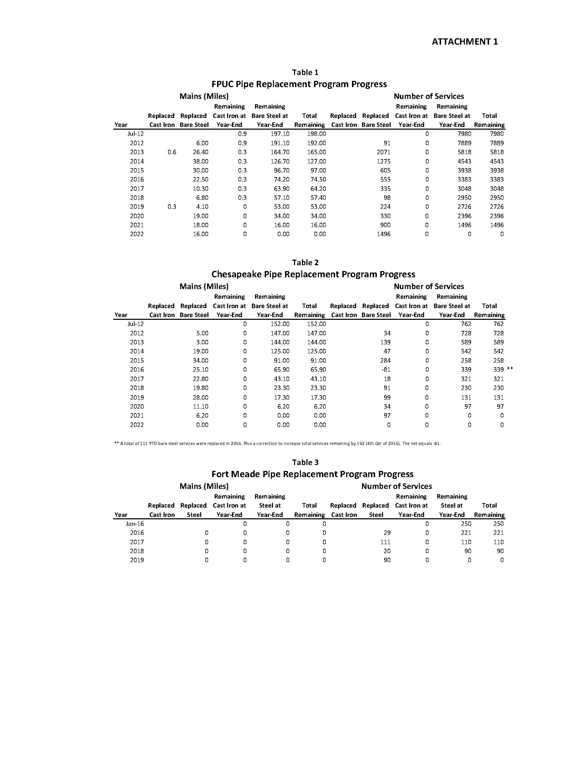
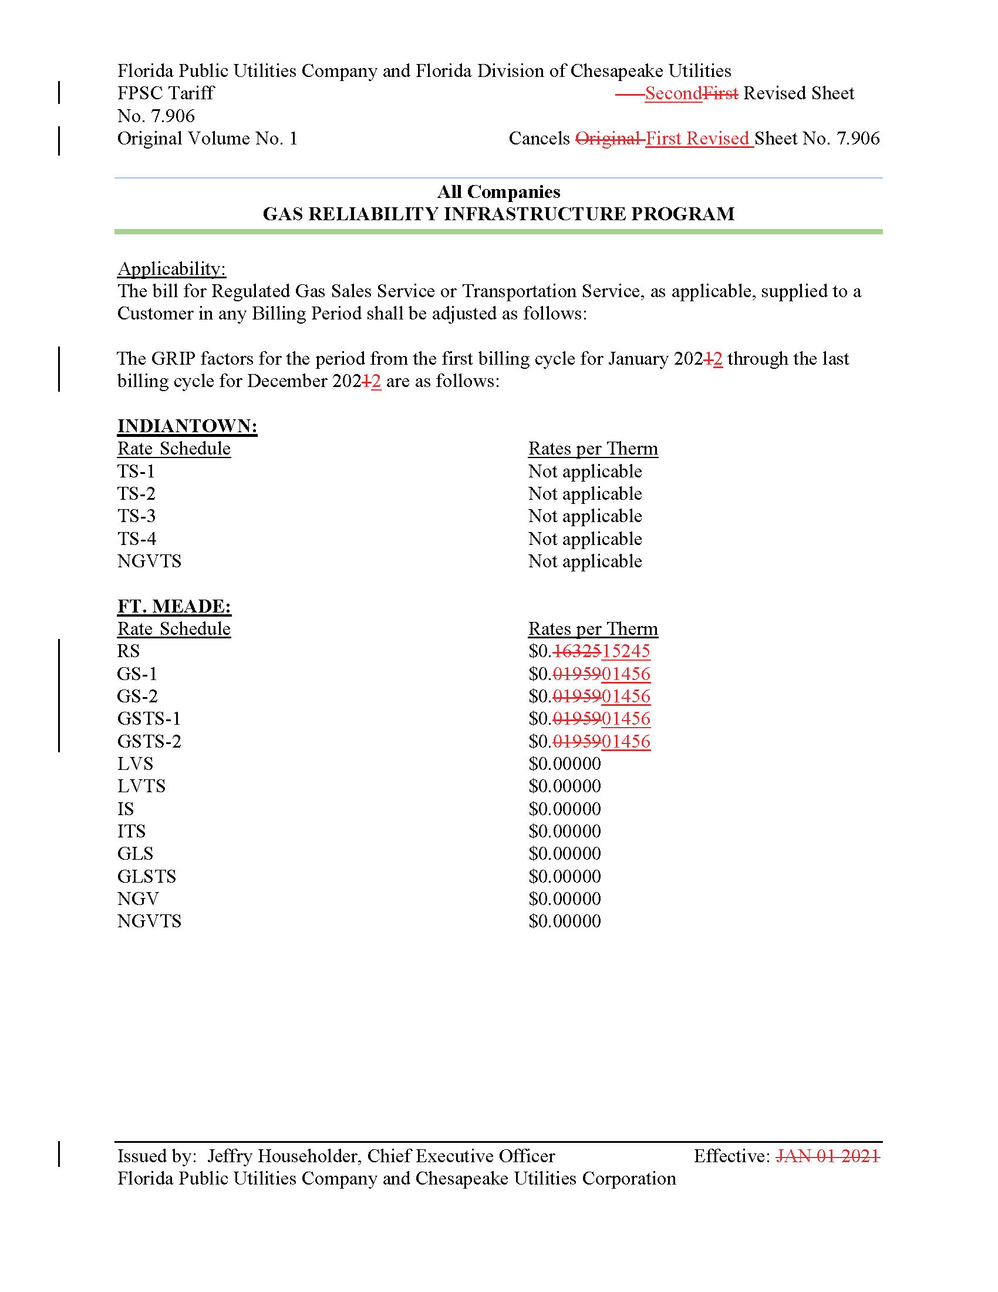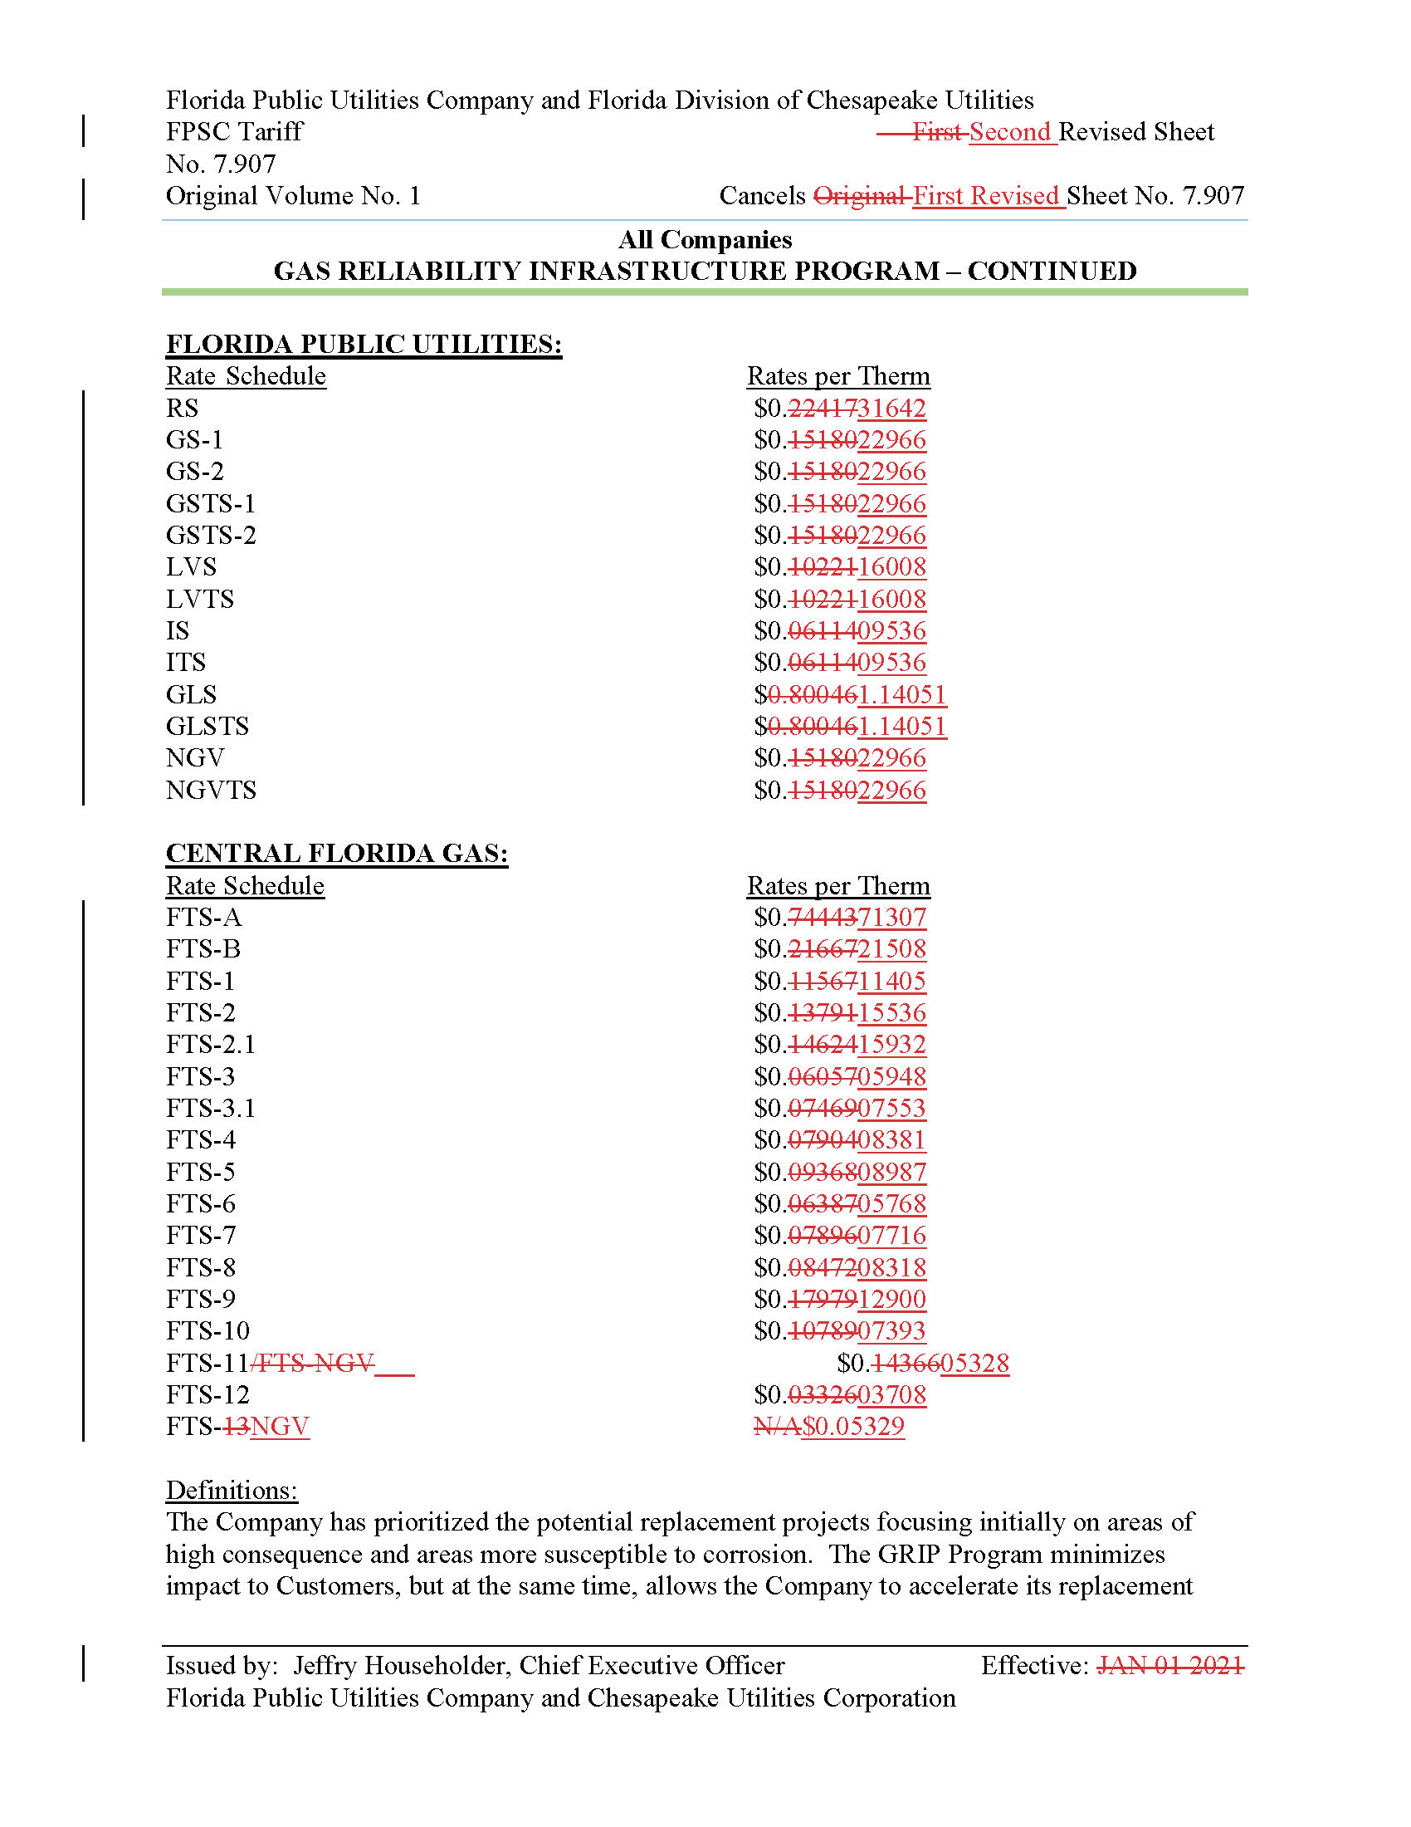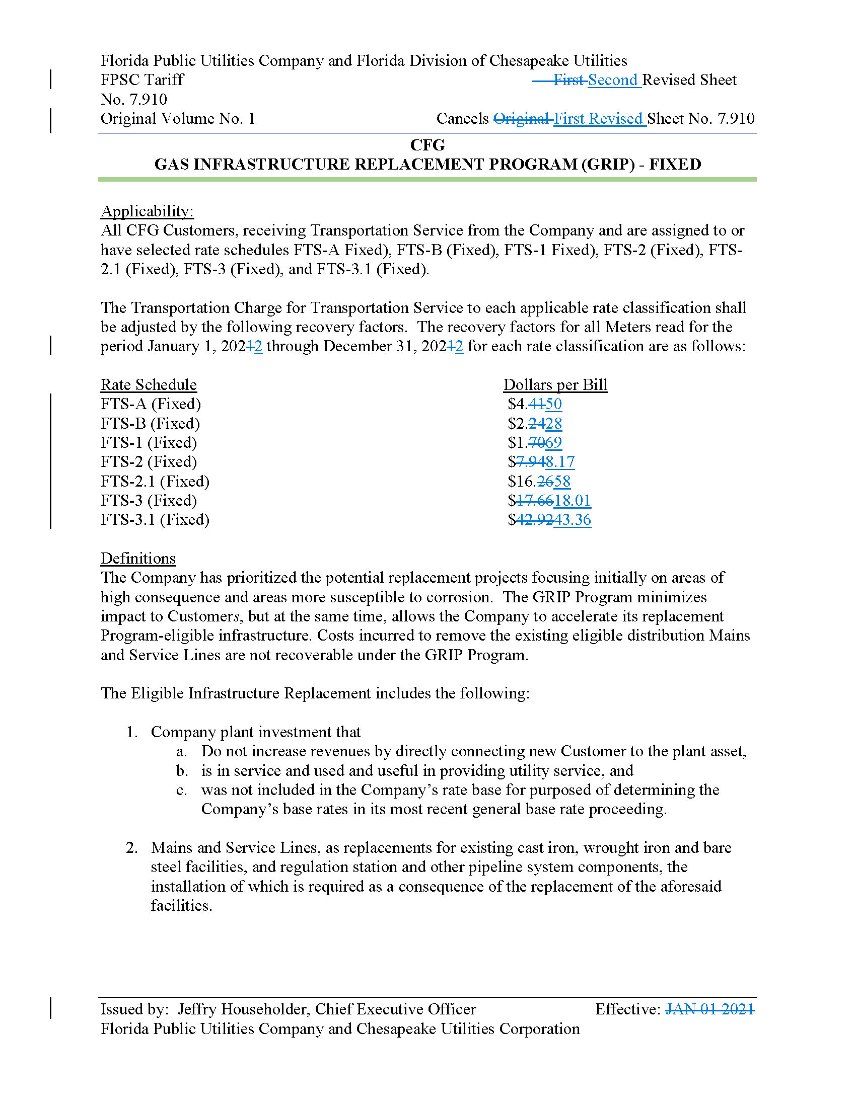

Order No. PSC-12-0490-TRF-GU, issued September 24, 2012, in Docket No. 20120036-GU, In re: Joint petition for approval of Gas Reliability Infrastructure Program (GRIP) by Florida Public Utilities Company and the Florida Division of Chesapeake Utilities Corporation.
Order No. PSC-15-0578-TRF-GU, issued December 21, 2015, in Docket No. 20150191-GU, In re: Joint petition for approval to implement gas reliability infrastructure program (GRIP) for Florida Public Utilities Company-Fort Meade and for approval of GRIP cost recovery factors by Florida Public Utilities Company, Florida Public Utilities Company-Fort Meade and the Florida Division of Chesapeake Utilities Corporation.
Order No. PSC-2020-0510-TRF-GU, issued December 21, 2020, in Docket No. 20200207-GU, In re: Joint petition for approval of GRIP cost recovery factors for January 2021 through December 2021, by Florida Public Utilities Company, Florida Public Utilities Company-Fort Meade, and Florida Division of Chesapeake Utilities Corporation.
Order No. PSC-12-0490-TRF-GU, issued September 24, 2012, in Docket No. 20120036-GU, In re: Joint petition for approval of Gas Reliability Infrastructure Program (GRIP) by Florida Public Utilities Company and the Florida Division of Chesapeake Utilities Corporation.
Order No. PSC-09-0375-PAA-GU, issued May 27, 2009, in Docket No, 20080366-GU, In re: Petition for rate increase by Florida Public Utilities Company.

