State of Florida  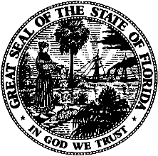 |  | Public Service Commission  Capital Circle Office Center ● 2540 Shumard Oak Boulevard  Tallahassee, Florida 32399-0850  -M-E-M-O-R-A-N-D-U-M-
DATE: | October 21, 2021
TO: | Office of Commission Clerk (Teitzman)
FROM: | Division of Economics (Guffey)  Office of the General Counsel (Sandy, Crawford)
RE: | Docket No. 20210131-EU – Joint petition for approval of territorial Agreement in Calhoun, Jackson, and Washington Counties between Gulf Coast Electric Cooperative, Inc. and West Florida Electric Cooperative Association, Inc.
AGENDA: | 11/02/21 – Regular Agenda – Proposed Agency Action – Interested Persons May Participate
COMMISSIONERS ASSIGNED: |  |  | All Commissioners
PREHEARING OFFICER: |  |  | Fay
CRITICAL DATES: |  |  | None
SPECIAL INSTRUCTIONS: |  |  | None

Case Background
On August 5, 2021, Gulf Coast Electric Cooperative, Inc. (Gulf Coast) and West Florida Electric Cooperative Association, Inc. (West Florida), collectively the joint petitioners, filed a petition seeking Commission approval of a Territorial Agreement (Agreement) delineating their respective retail service boundaries in Calhoun, Jackson, and Washington counties. The proposed Agreement is the joint petitioners’ first Agreement applicable to the petitioners’ service boundaries specific to Calhoun, Jackson, and Washington counties. The Agreement is Attachment A and composite maps depicting the proposed boundaries is Attachment B to this recommendation.
The joint petitioners assert that Gulf Coast and West Florida each have electric facilities adjacent to each other in Calhoun, Jackson, and Washington counties. The joint petitioners negotiated the proposed Agreement to establish defined retail area service boundaries in order to avoid duplication of facilities and expenditures, avoid hazardous conditions, and serve their current and future customers in a safe manner.
During the review process, staff issued two data requests to the joint petitioners to which responses were received on September 10, 2021 and September 21, 2021. The Commission has jurisdiction over this matter pursuant to Section 366.04, Florida Statutes (F.S.).

Discussion of Issues

Issue 1:
Should the Commission approve the proposed Territorial Agreement in Calhoun, Jackson, and Washington counties between Gulf Coast Electric Cooperative, Inc. (Gulf Coast) and West Florida Electric Cooperative Association, Inc. (West Florida)?

Recommendation:
Yes, the Commission should approve the proposed Territorial Agreement in Calhoun, Jackson, and Washington counties between Gulf Coast and West Florida. The approval of this Agreement will not be a detriment to the public interest and it will enable Gulf Coast and West Florida to avoid duplication of facilities and expenditures, avoid hazardous conditions, and serve their current and future customers in a safe manner. The proposed Agreement between Gulf Coast and West Florida should become effective on the date the Commission order approving the Agreement becomes final and no longer subject to judicial review. (Guffey)

Staff Analysis:
Pursuant to Section 366.04(2)(d), F.S., and Rule 25-6.0440(2), F.A.C., the Commission has the jurisdiction to approve territorial agreements between and among rural electric cooperatives, municipal electric utilities, and other electric utilities. Unless the Commission determines that the Agreement will cause a detriment to the public interest, the Agreement should be approved.

The Proposed Territorial Agreement
In response to staff’s first data request, the joint petitioners stated Gulf Coast does not currently serve in any municipalities within the service territory subject to this Agreement, but over the term of the Agreement, Gulf Coast estimates that it will serve approximately 5,383 customers. Currently, West Florida provides service in the Town of Grand Ridge (in Jackson County), and in the Town of Wausau (in Washington County) and over the term of the Agreement, West Florida estimates it will serve approximately 18,370 customers (including existing customers in Grand Ridge and Wausau) within its service territory in Calhoun, Jackson, and Washington counties. In responses to staff’s second data request, the joint petitioners confirmed that both Gulf Coast and West Florida have the capacity and ability to serve their expected future customers without negatively impacting their existing customer base. The joint petitioners also affirm that the proposed Agreement would enhance the service reliability by avoiding any potential uneconomic duplication of facilities and hazardous conditions.
Pursuant to Paragraph 5 of the petition, there are no customer transfers contemplated in this Agreement. Therefore, no notice to customers is required pursuant to Rule 25-6.0440, F.A.C. Pursuant to Section 3.1 of the Agreement, there will be no electric facilities transferred between the two cooperatives. Section 1.10 of the Agreement states that, as of the date of this Agreement, there are no extra-territorial customers. If the parties discover extra-territorial member-customers, they will be transferred to the appropriate cooperative within 12 months of discovering the inadvertent service error pursuant to Section 2.4 of the Agreement.
The duration of this proposed Agreement is 30 years pursuant to Section 5.1. Thereafter, the Agreement may automatically be extended for succeeding 5-year terms. The Agreement may be terminated by either party after the expiration of the initial 30-year term or succeeding 5-year term by providing one year prior notification to the other party to terminate the Agreement.

Conclusion
After review of the petition, the proposed Agreement, and the joint petitioners’ responses to staff’s data requests, staff believes that the proposed Agreement is in the public interest and will enable Gulf Coast and West Florida to serve their customers in an efficient manner. As such, staff believes that the Commission should approve the proposed Agreement in Calhoun, Jackson, and Washington counties between Gulf Coast and West Florida. The approval of this Agreement will not be a detriment to the public interest and it will enable Gulf Coast and West Florida to avoid duplication of facilities and expenditures, avoid hazardous conditions, and serve their current and future customers in a safe manner. The proposed Agreement between Gulf Coast and West Florida should become effective on the date the Commission order approving the Agreement becomes final and no longer subject to judicial review.

Issue 2:
Should this docket be closed?

Recommendation:
If no protest is filed by a person whose substantial interests are affected within 21 days of the issuance of the Order, this docket should be closed upon the issuance of a Consummating Order. (Sandy, Crawford)

Staff Analysis:
If no protest is filed by a person whose substantial interests are affected within 21 days of the issuance of the Order, this docket should be closed upon the issuance of a Consummating Order.

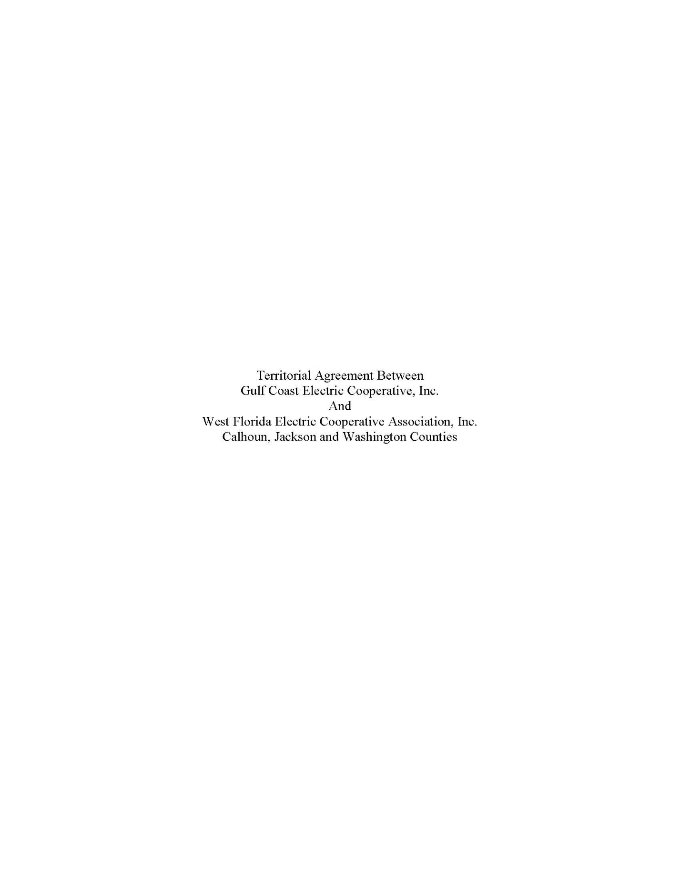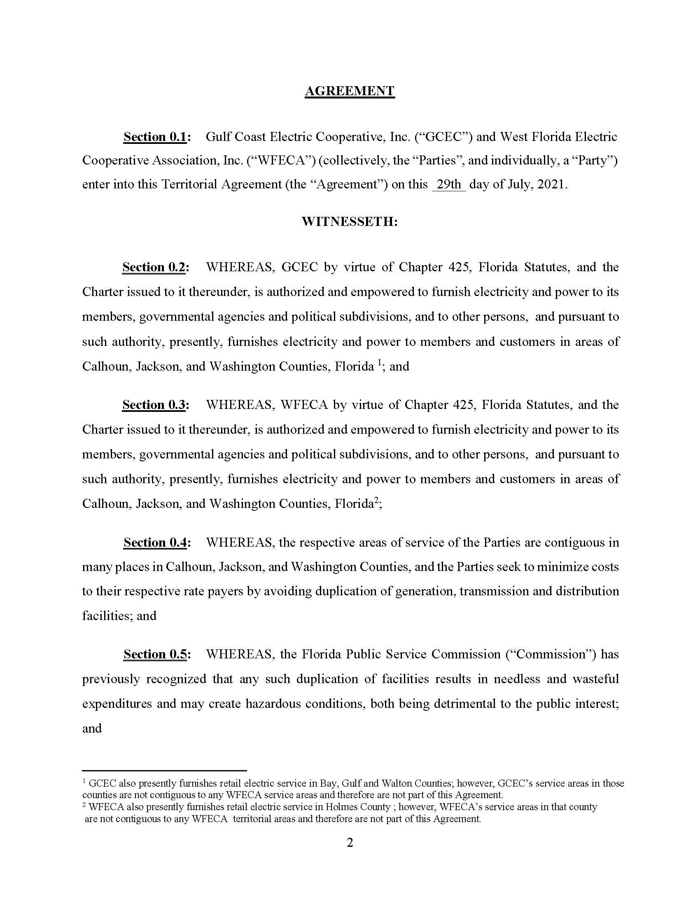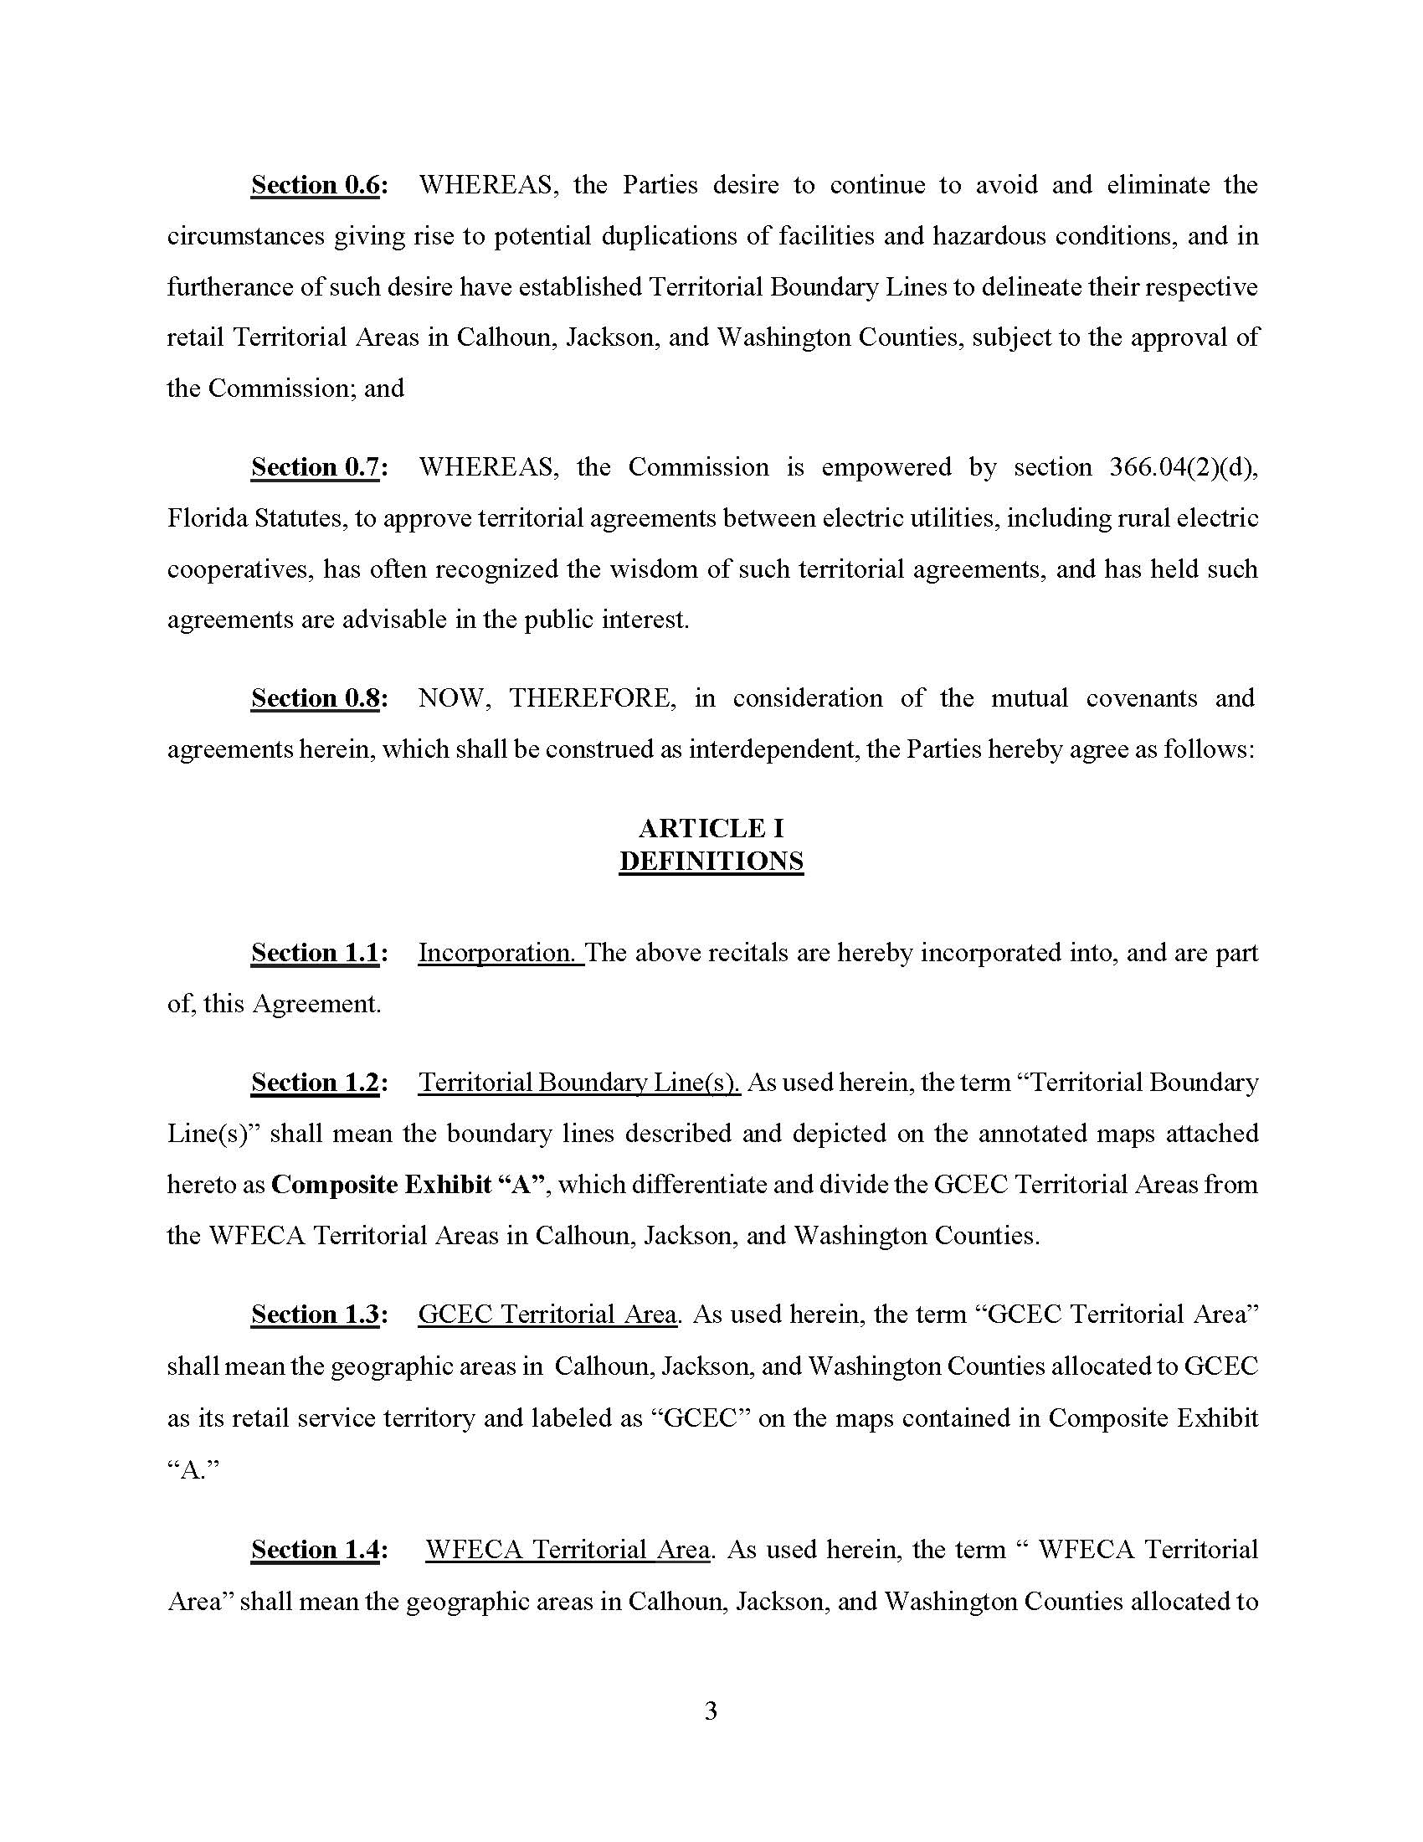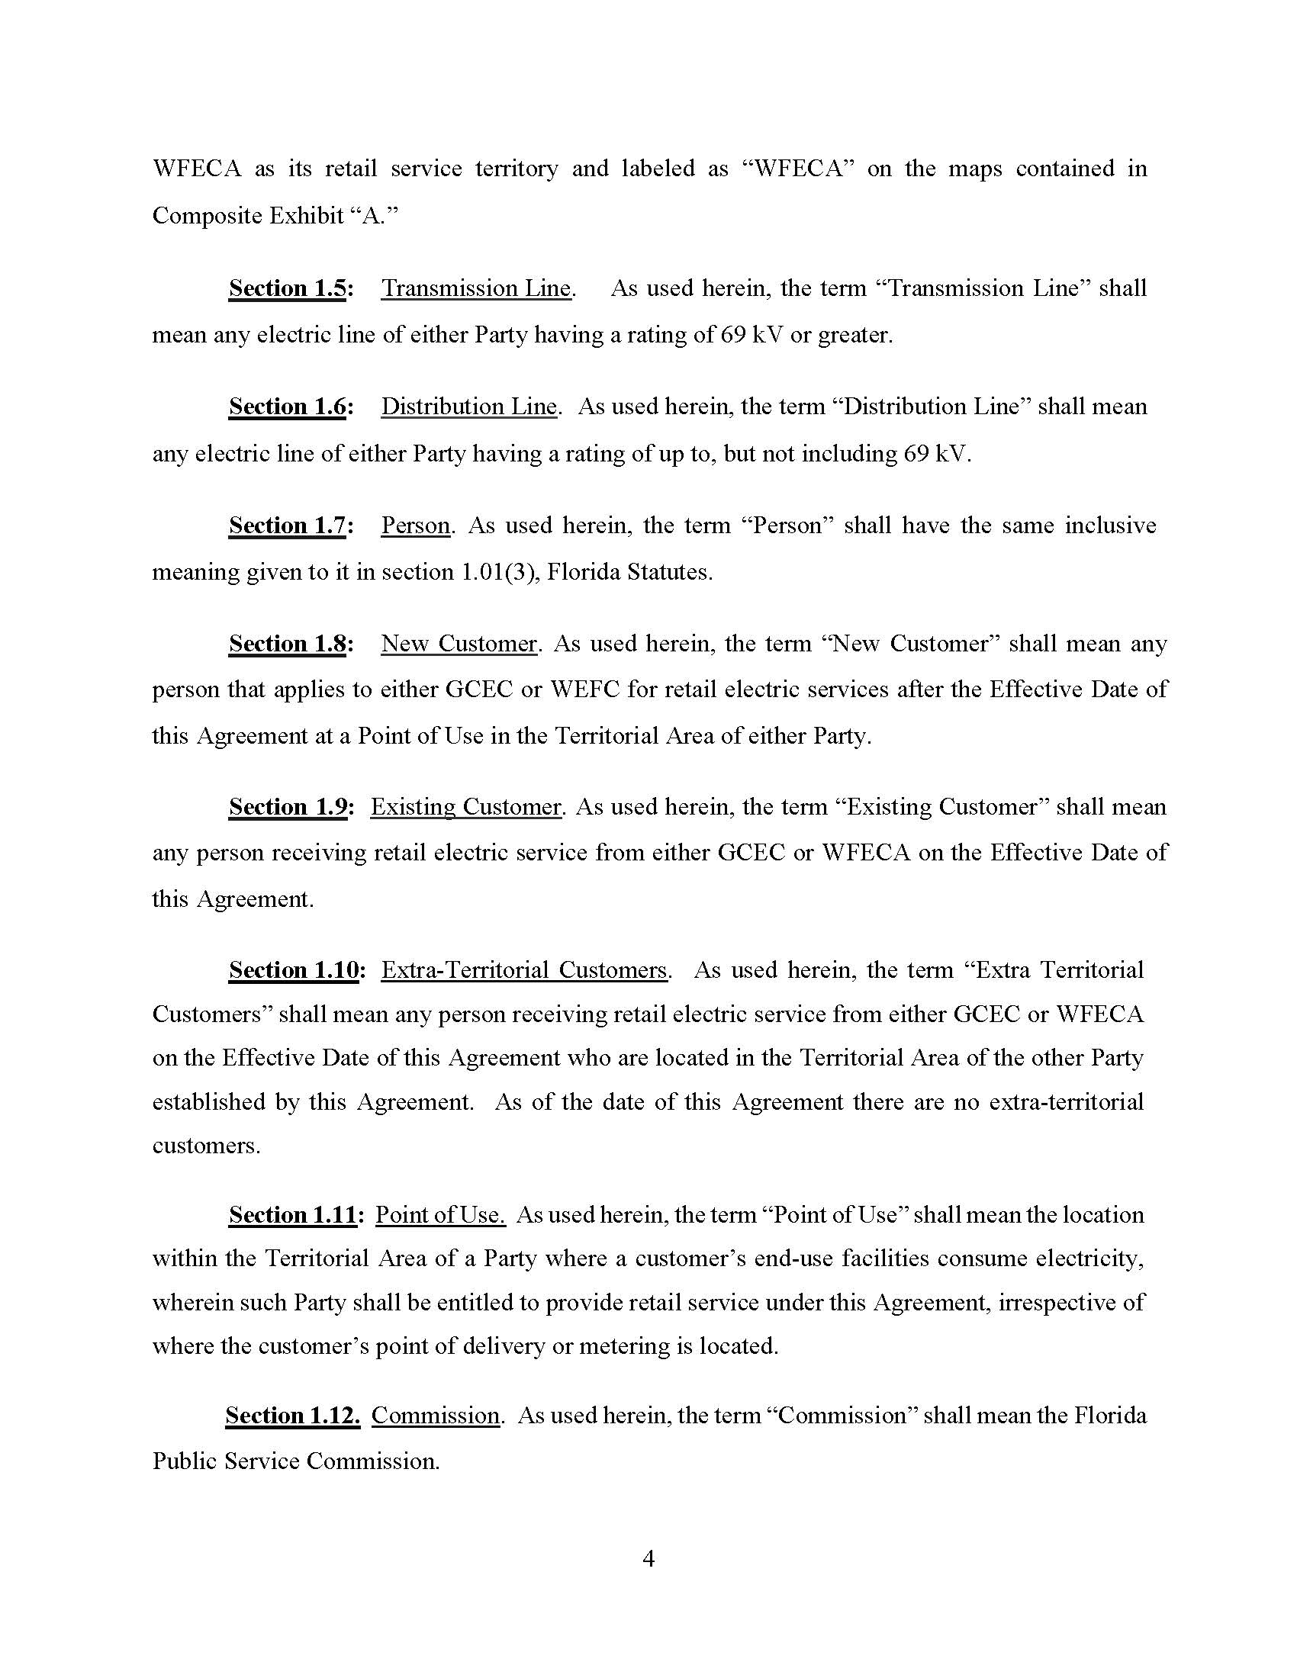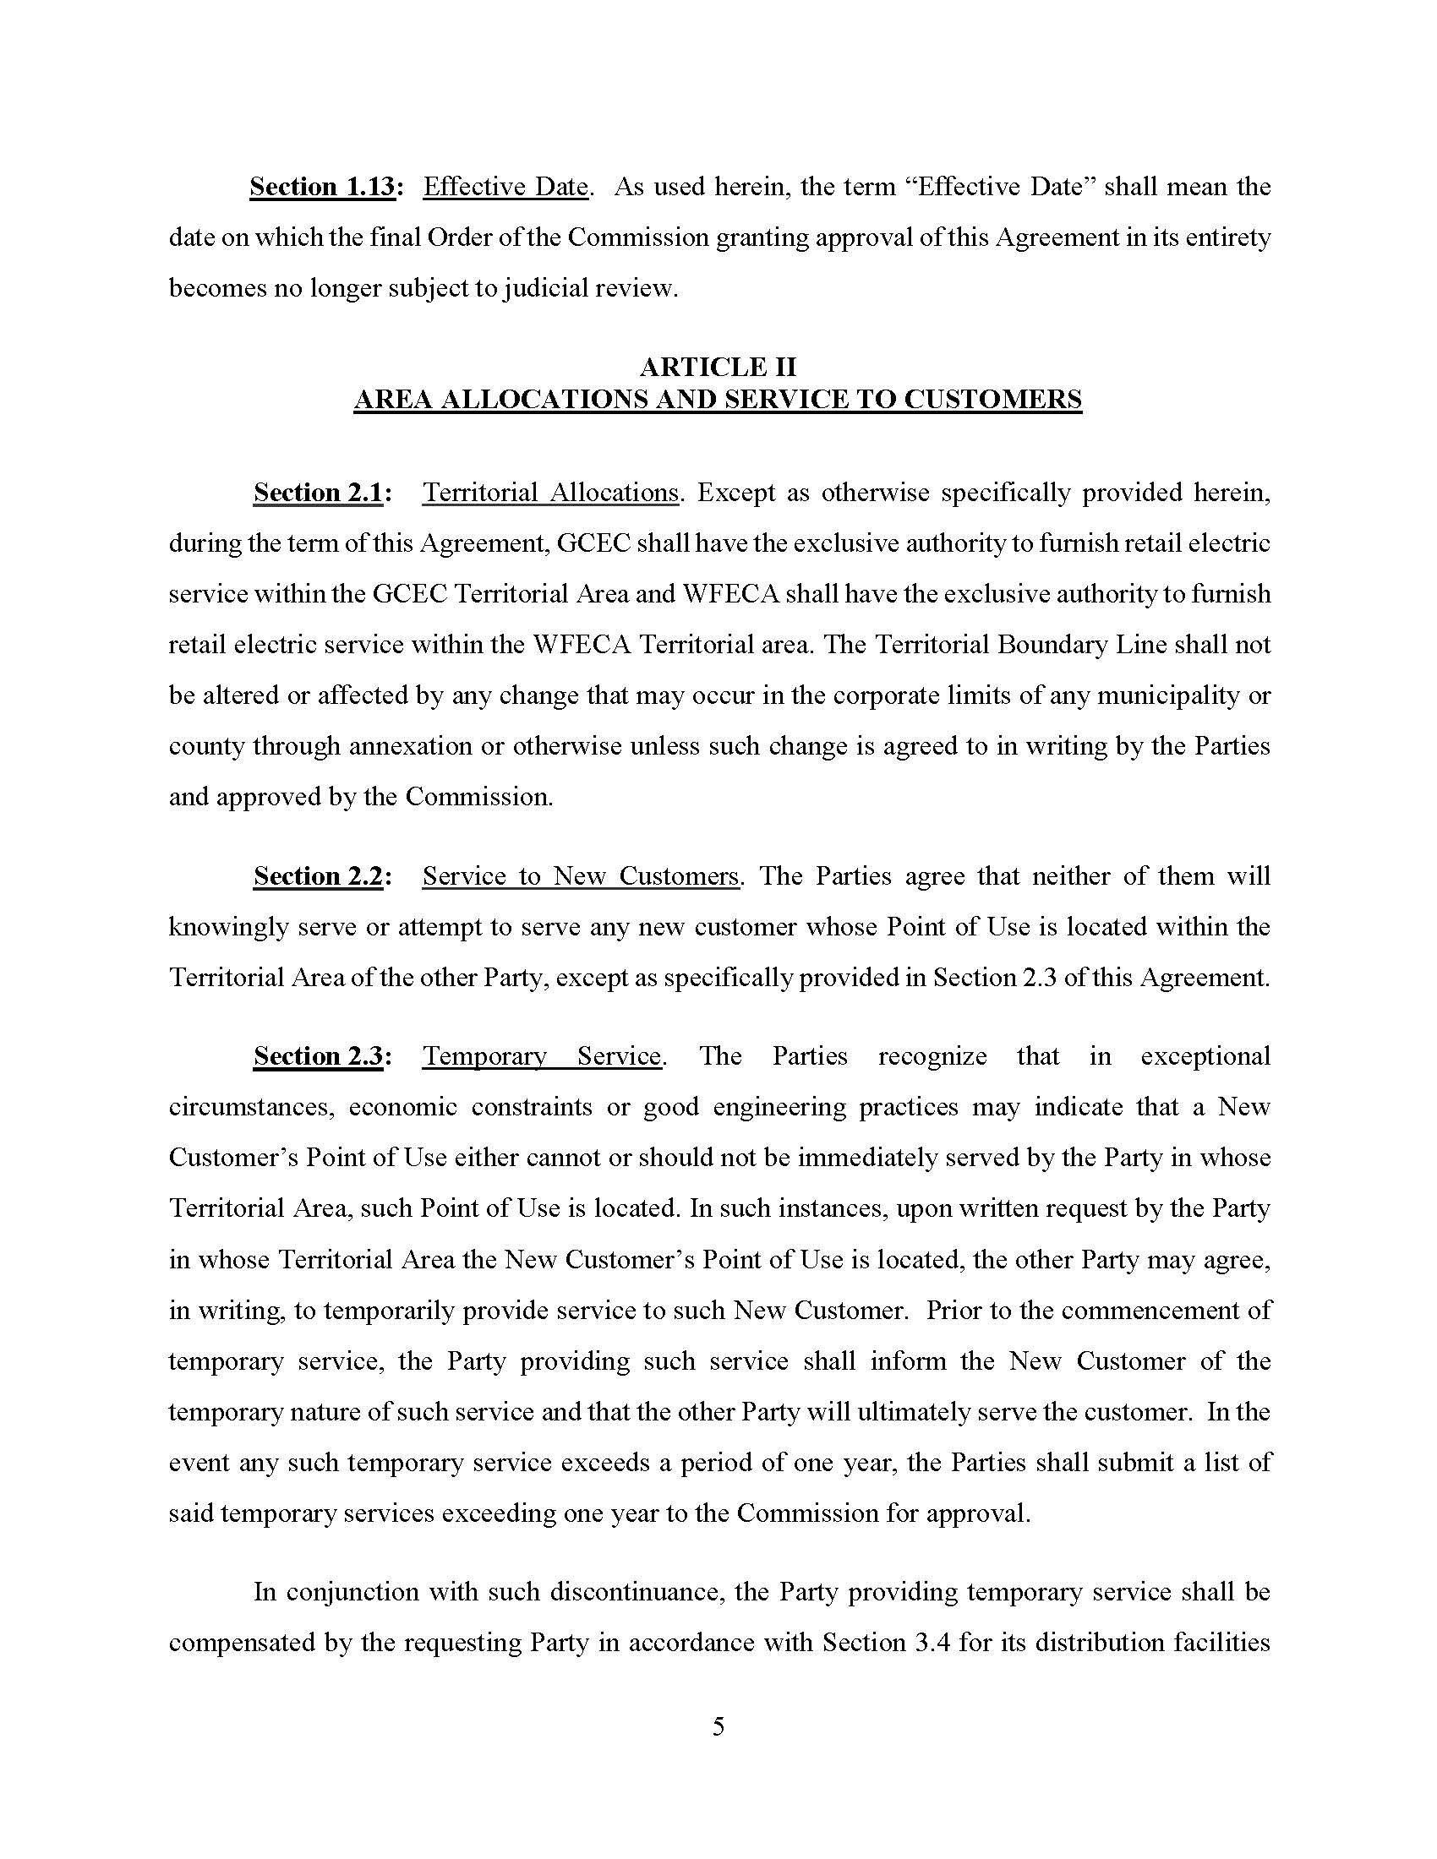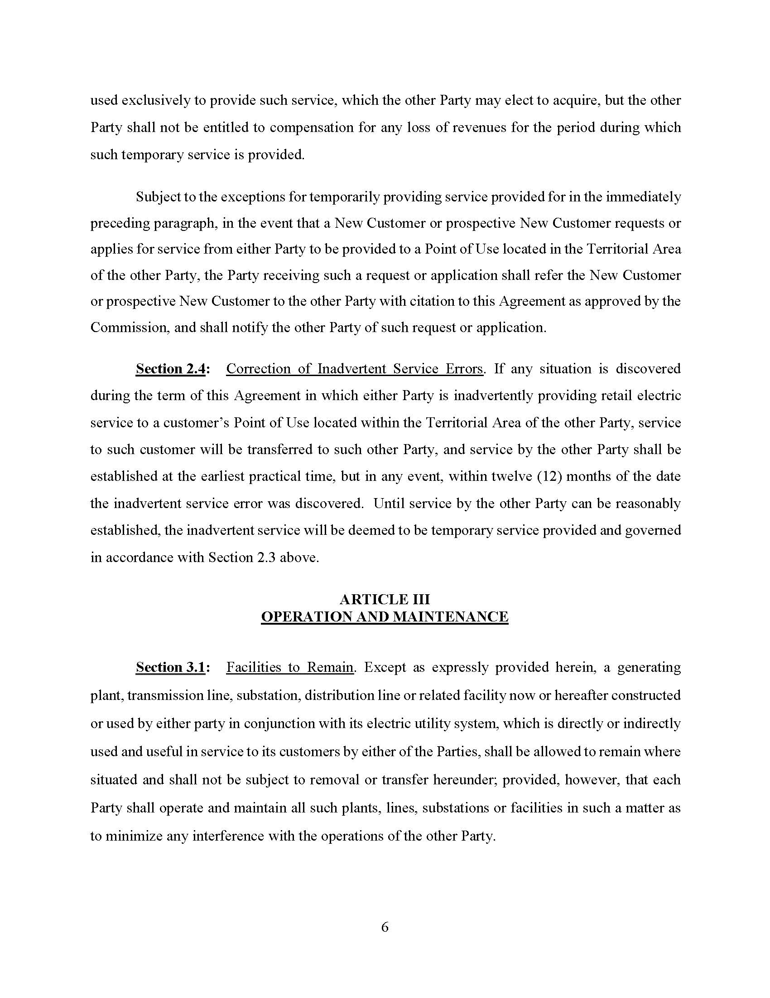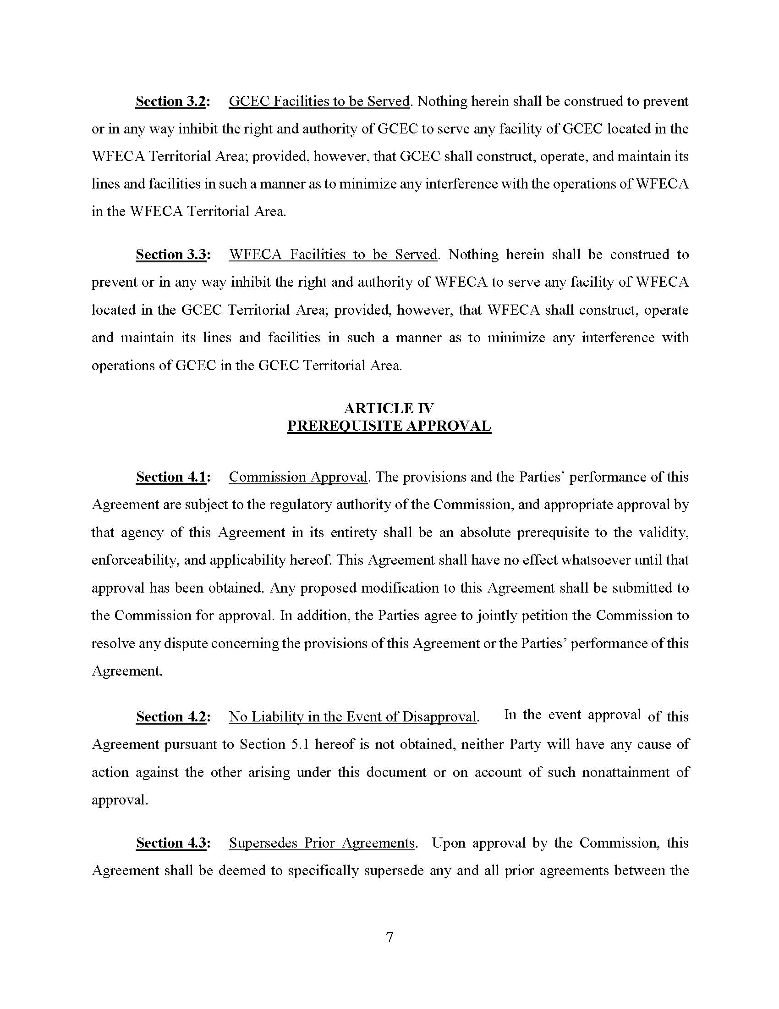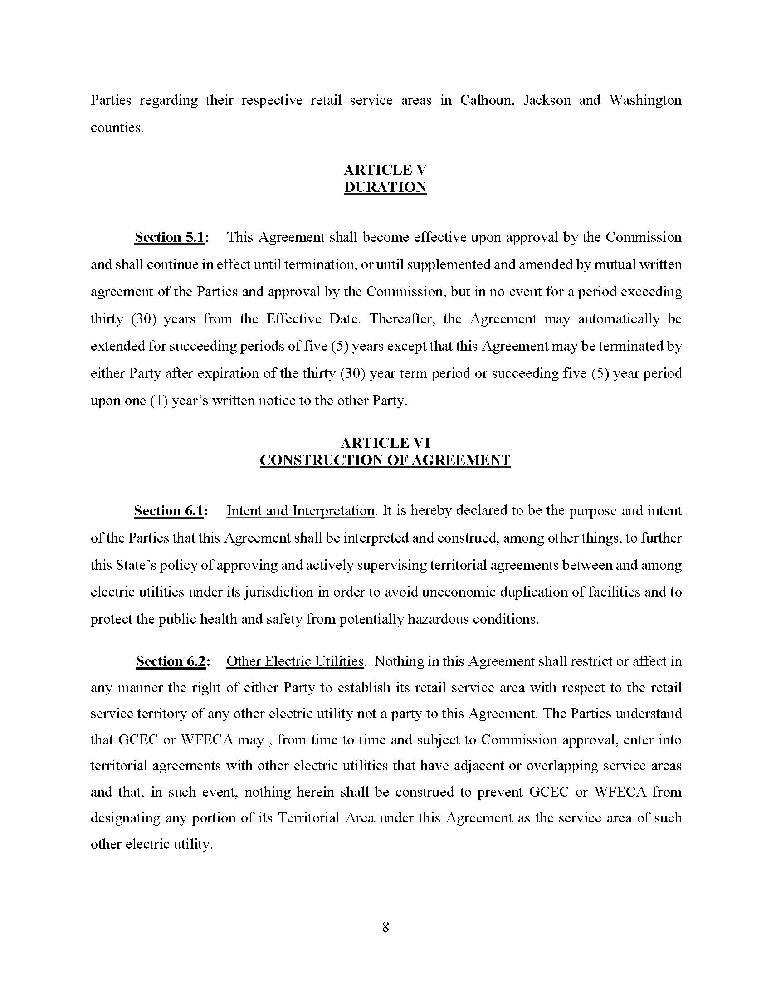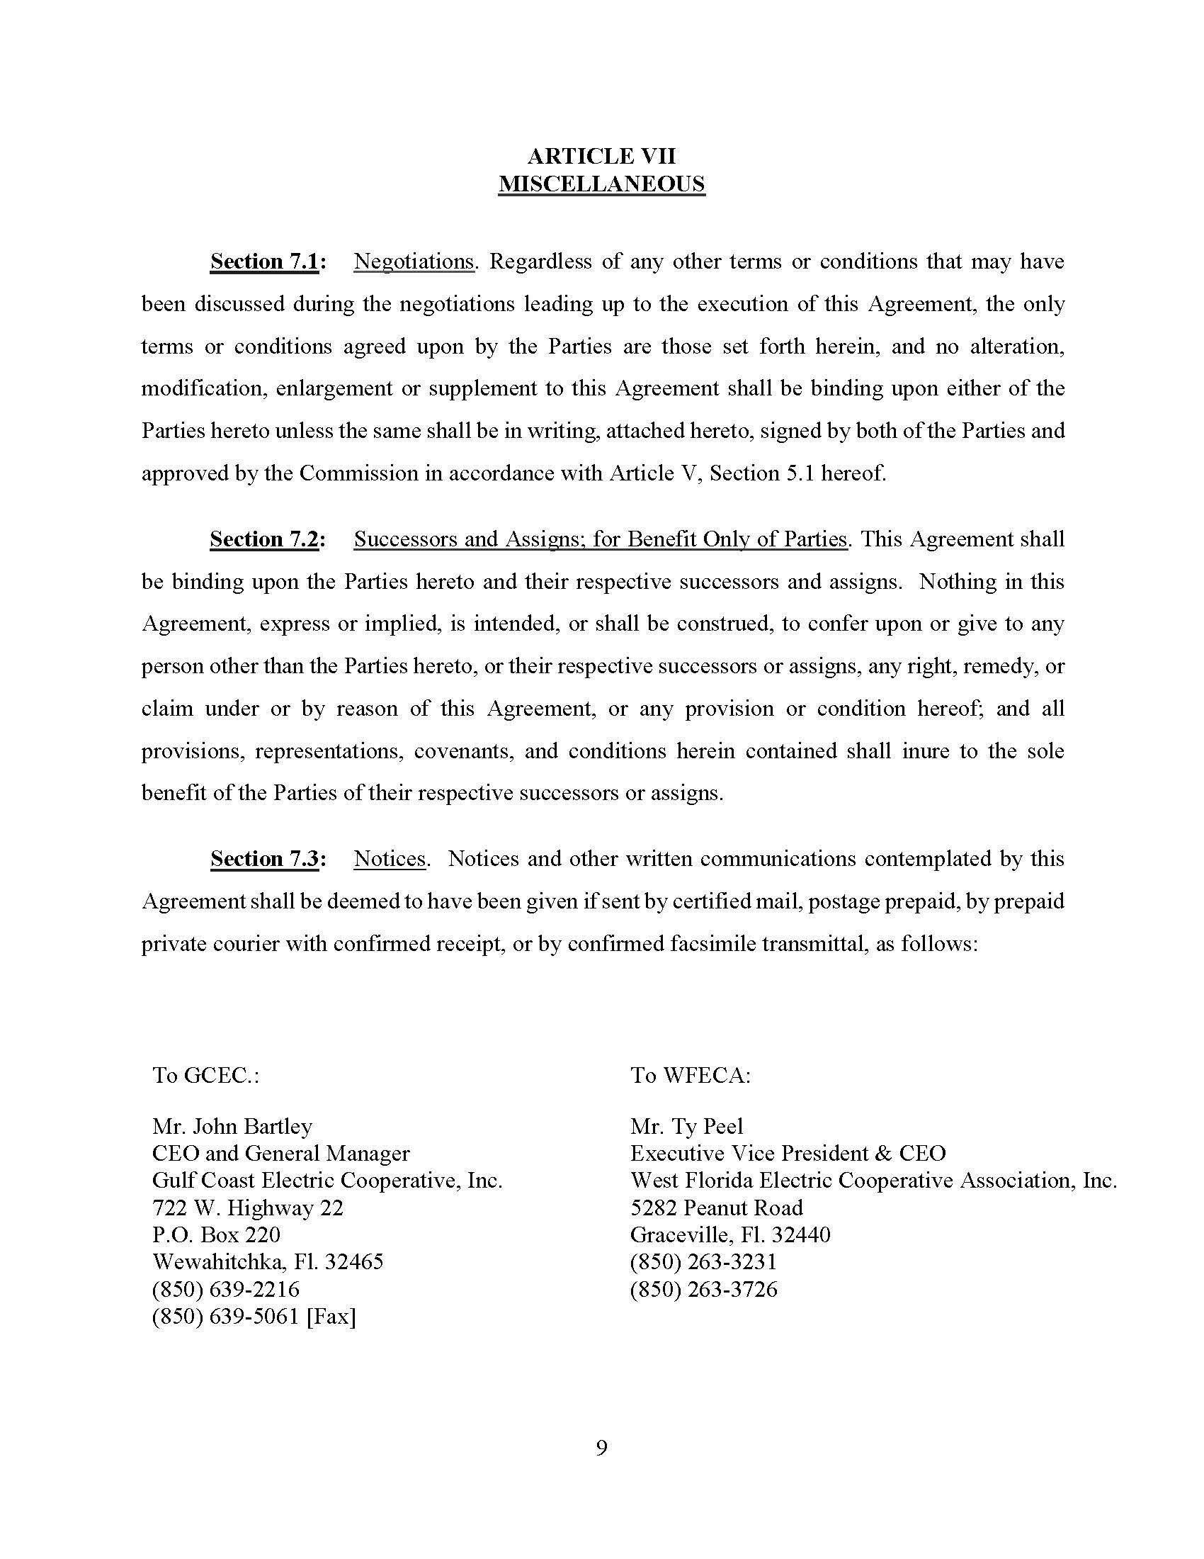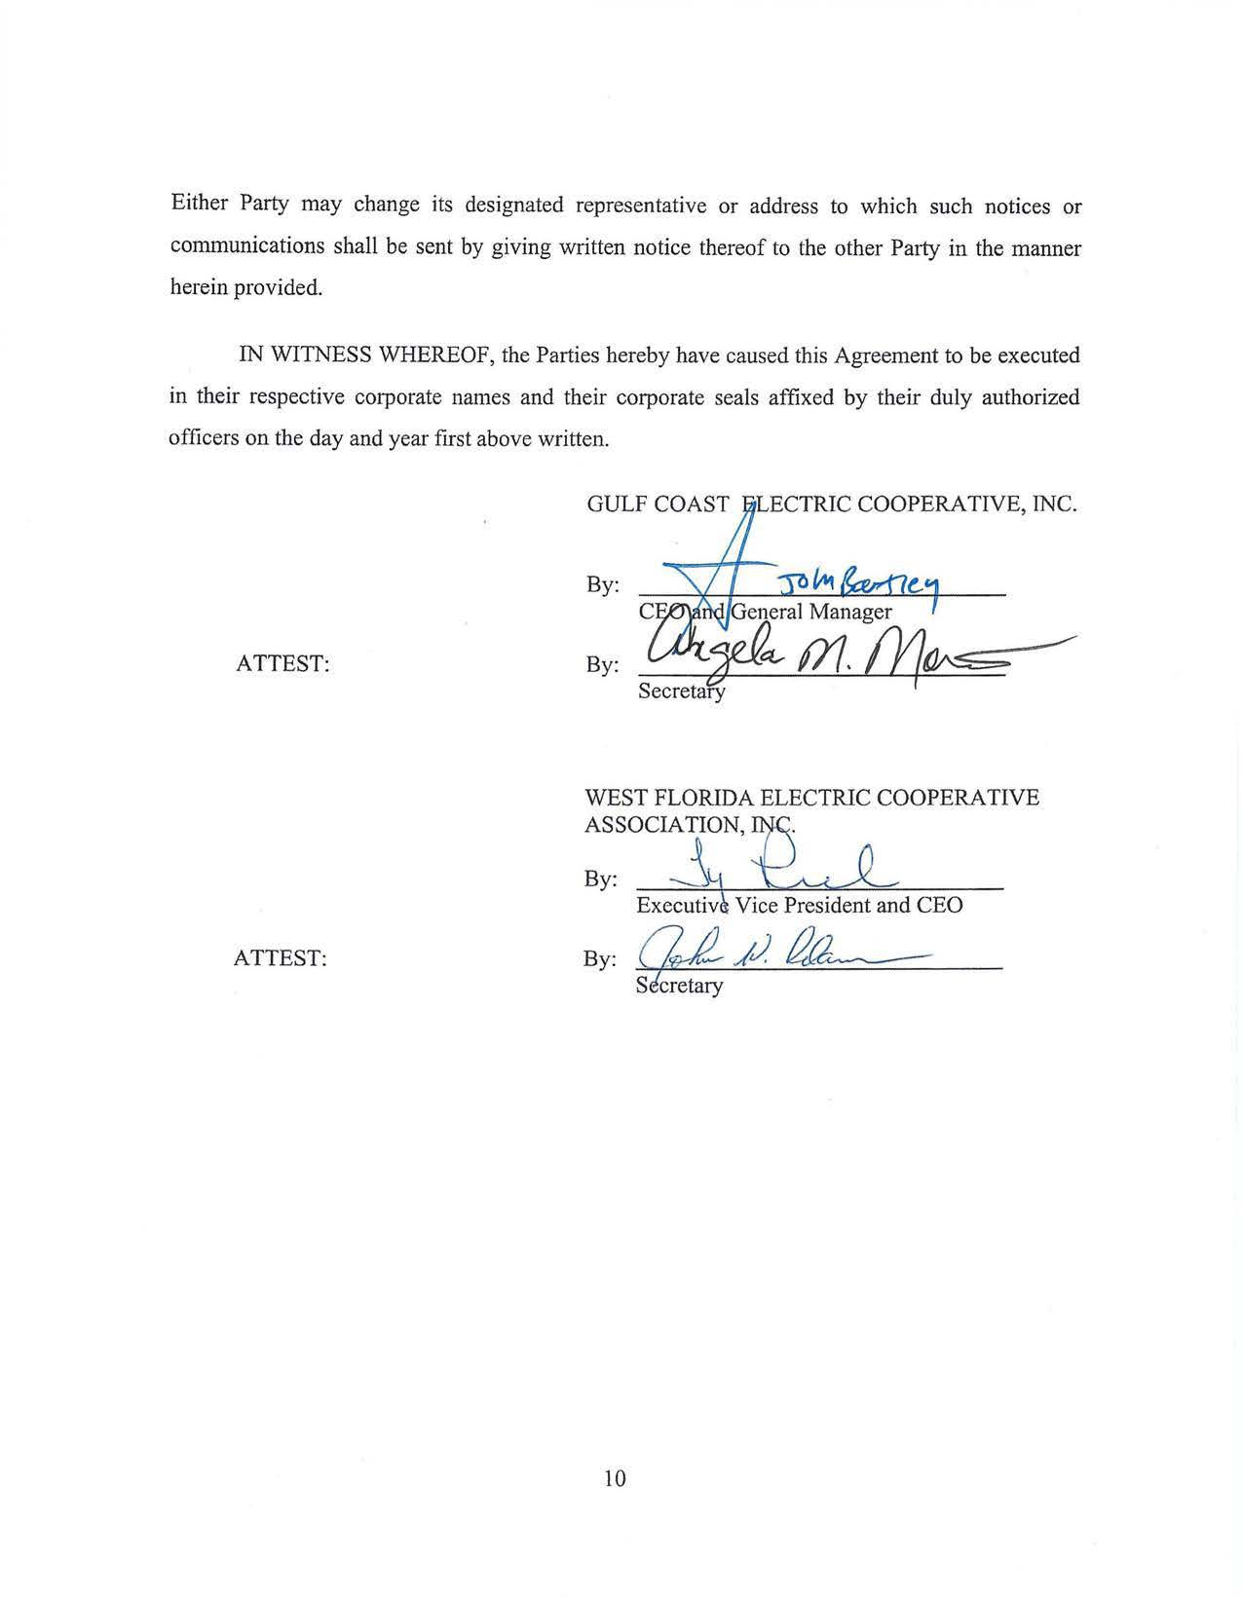
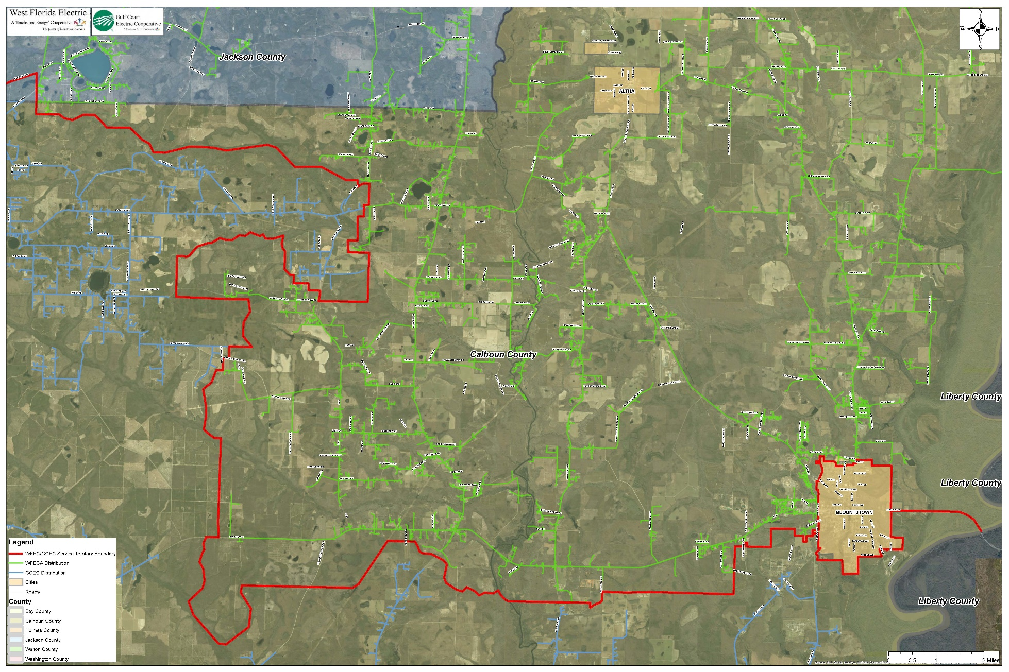
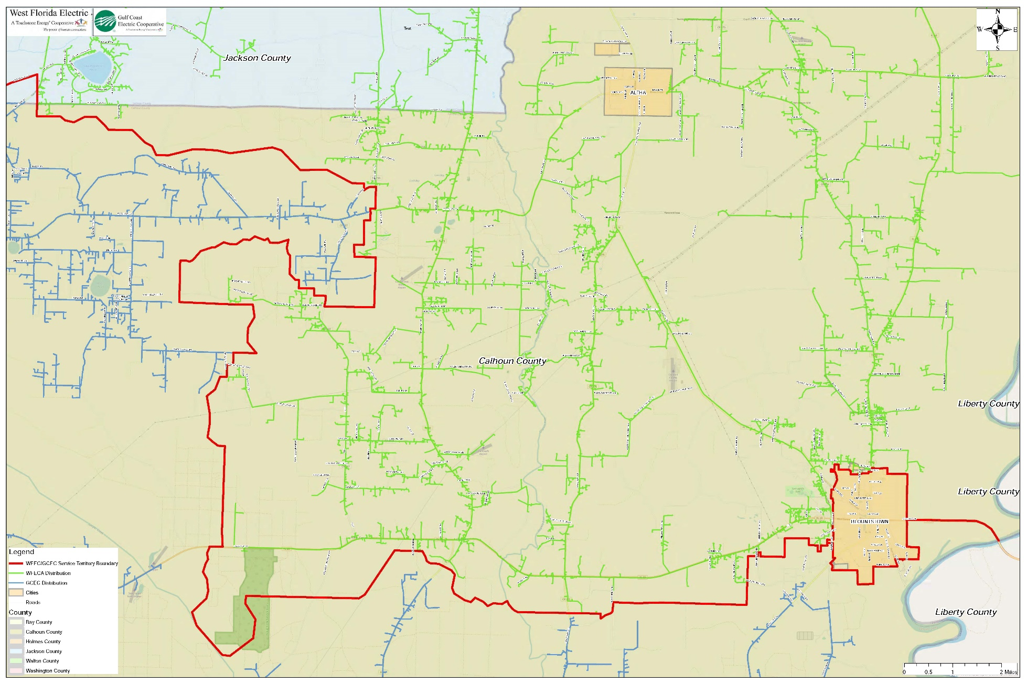
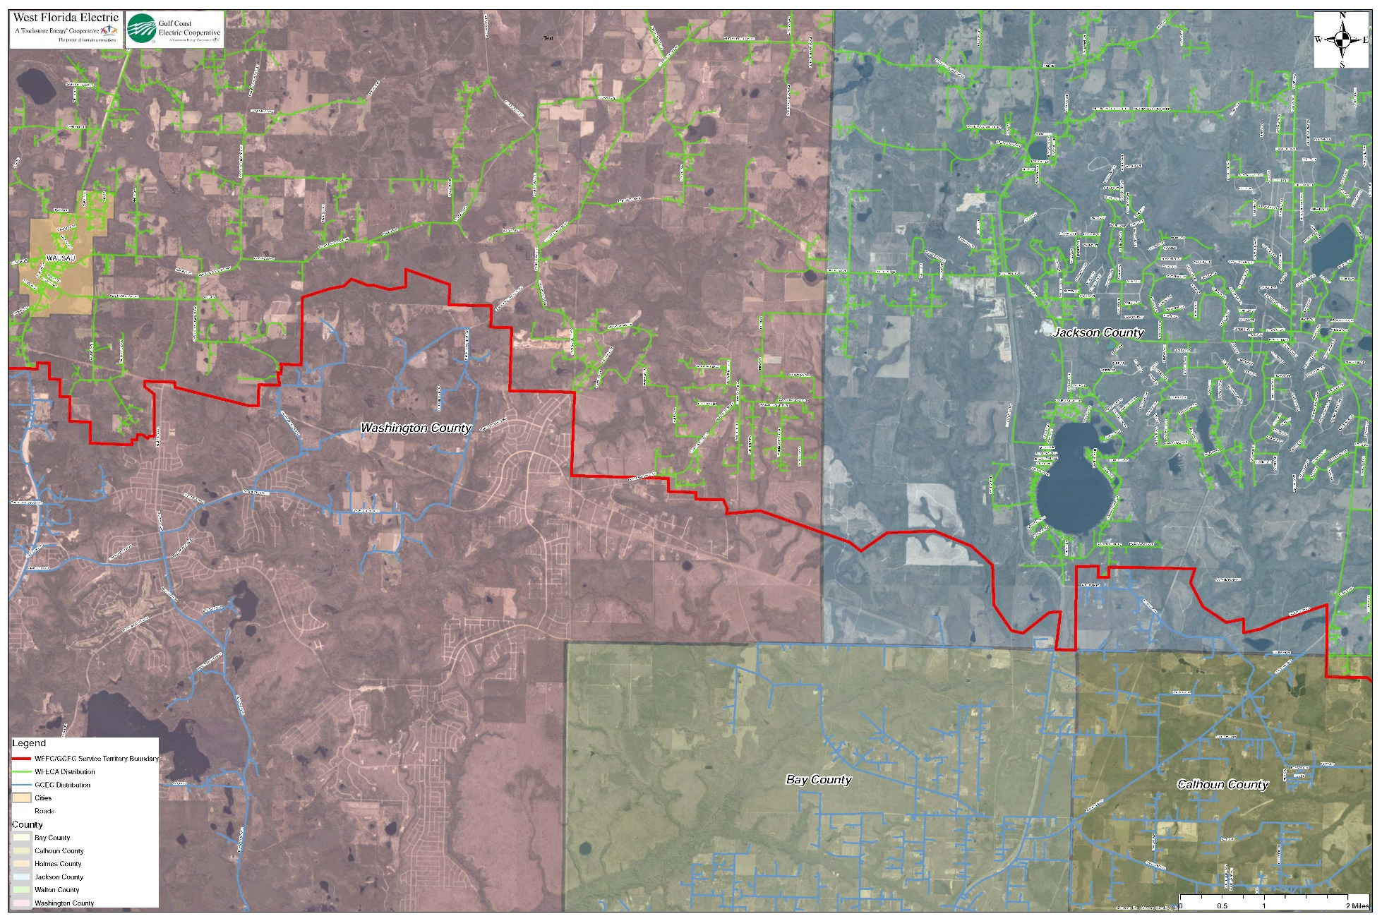
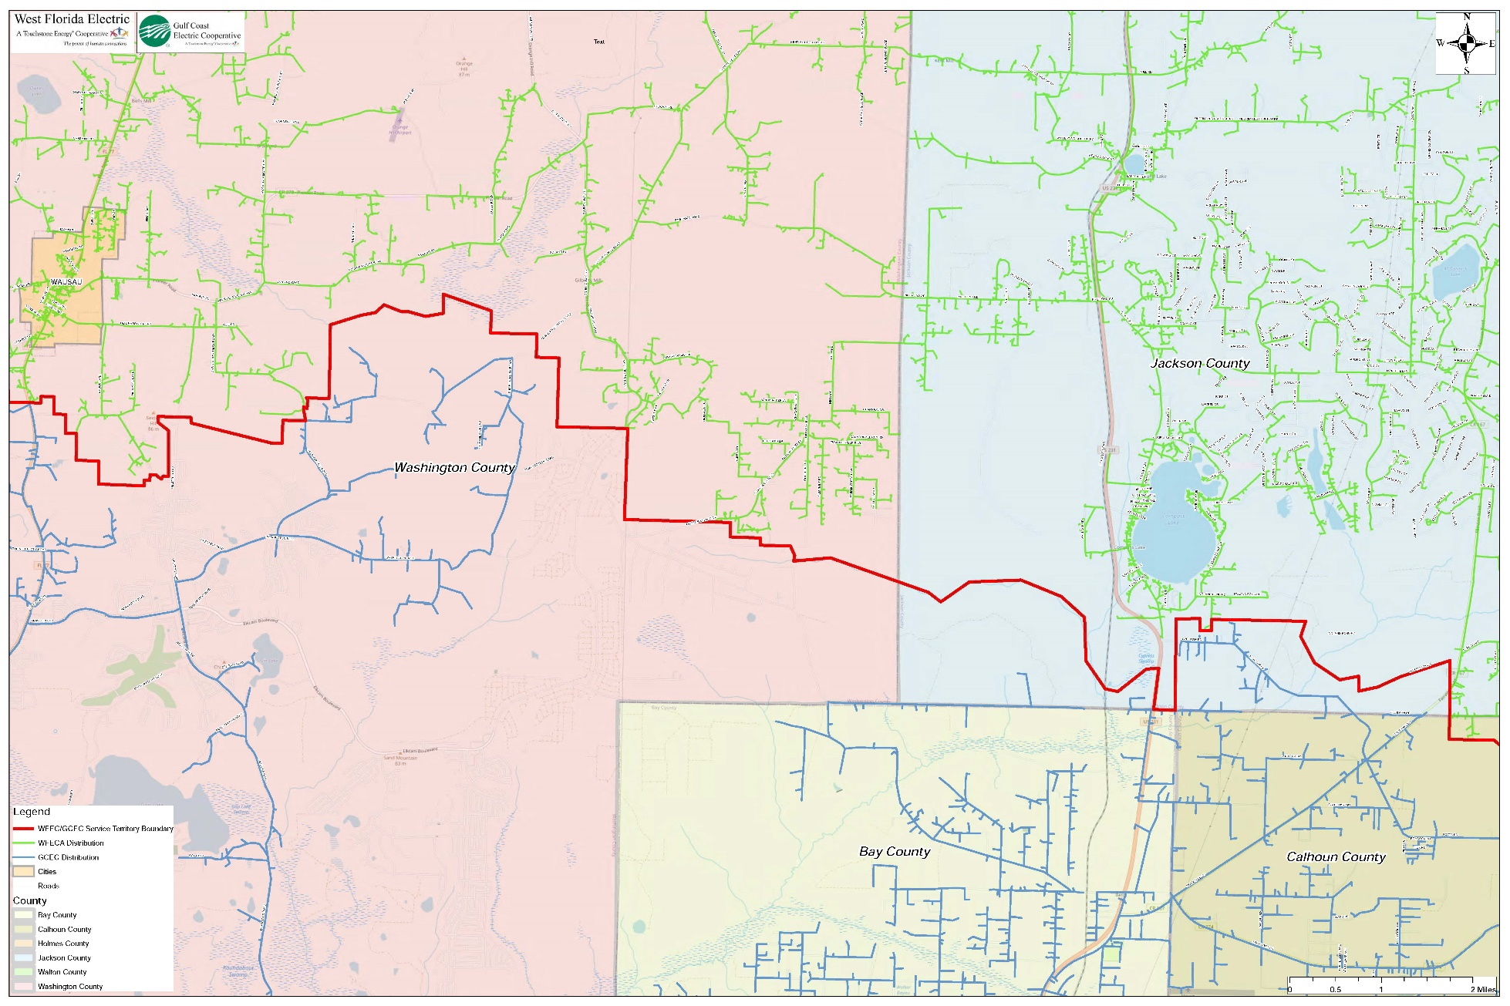

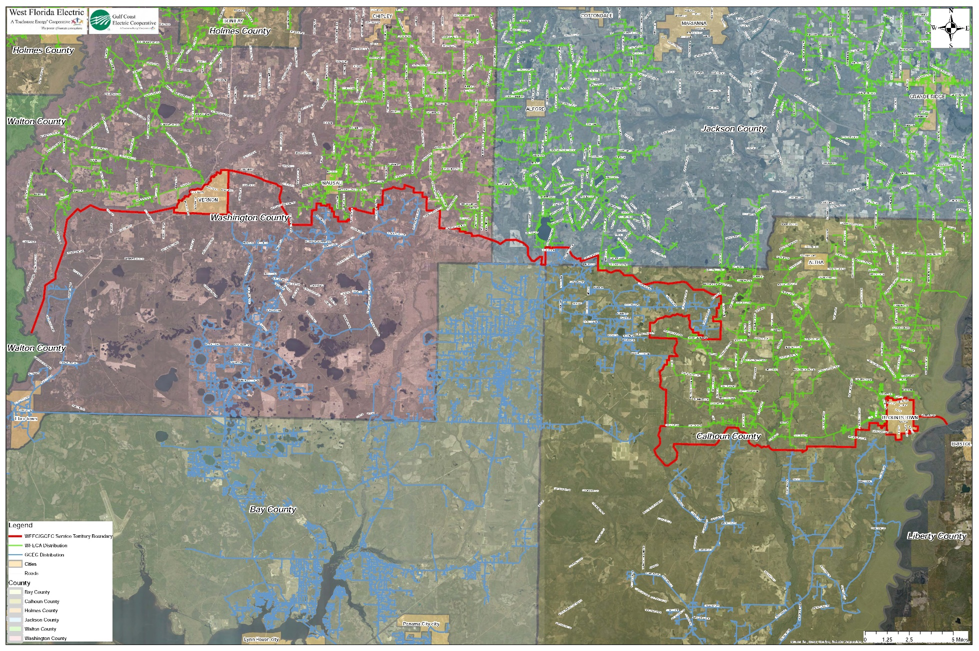
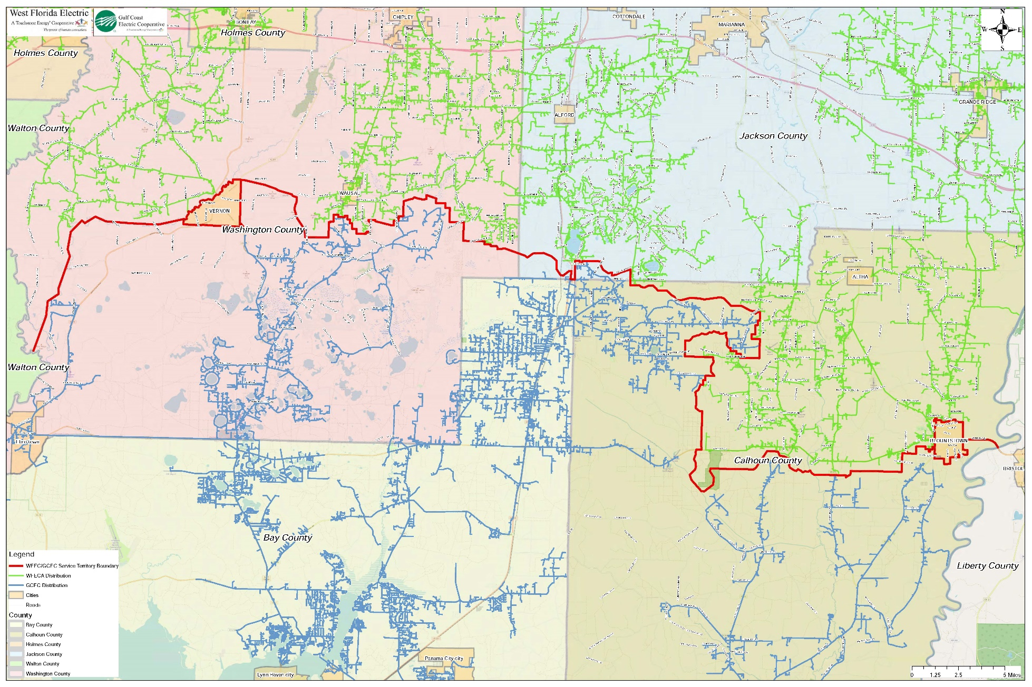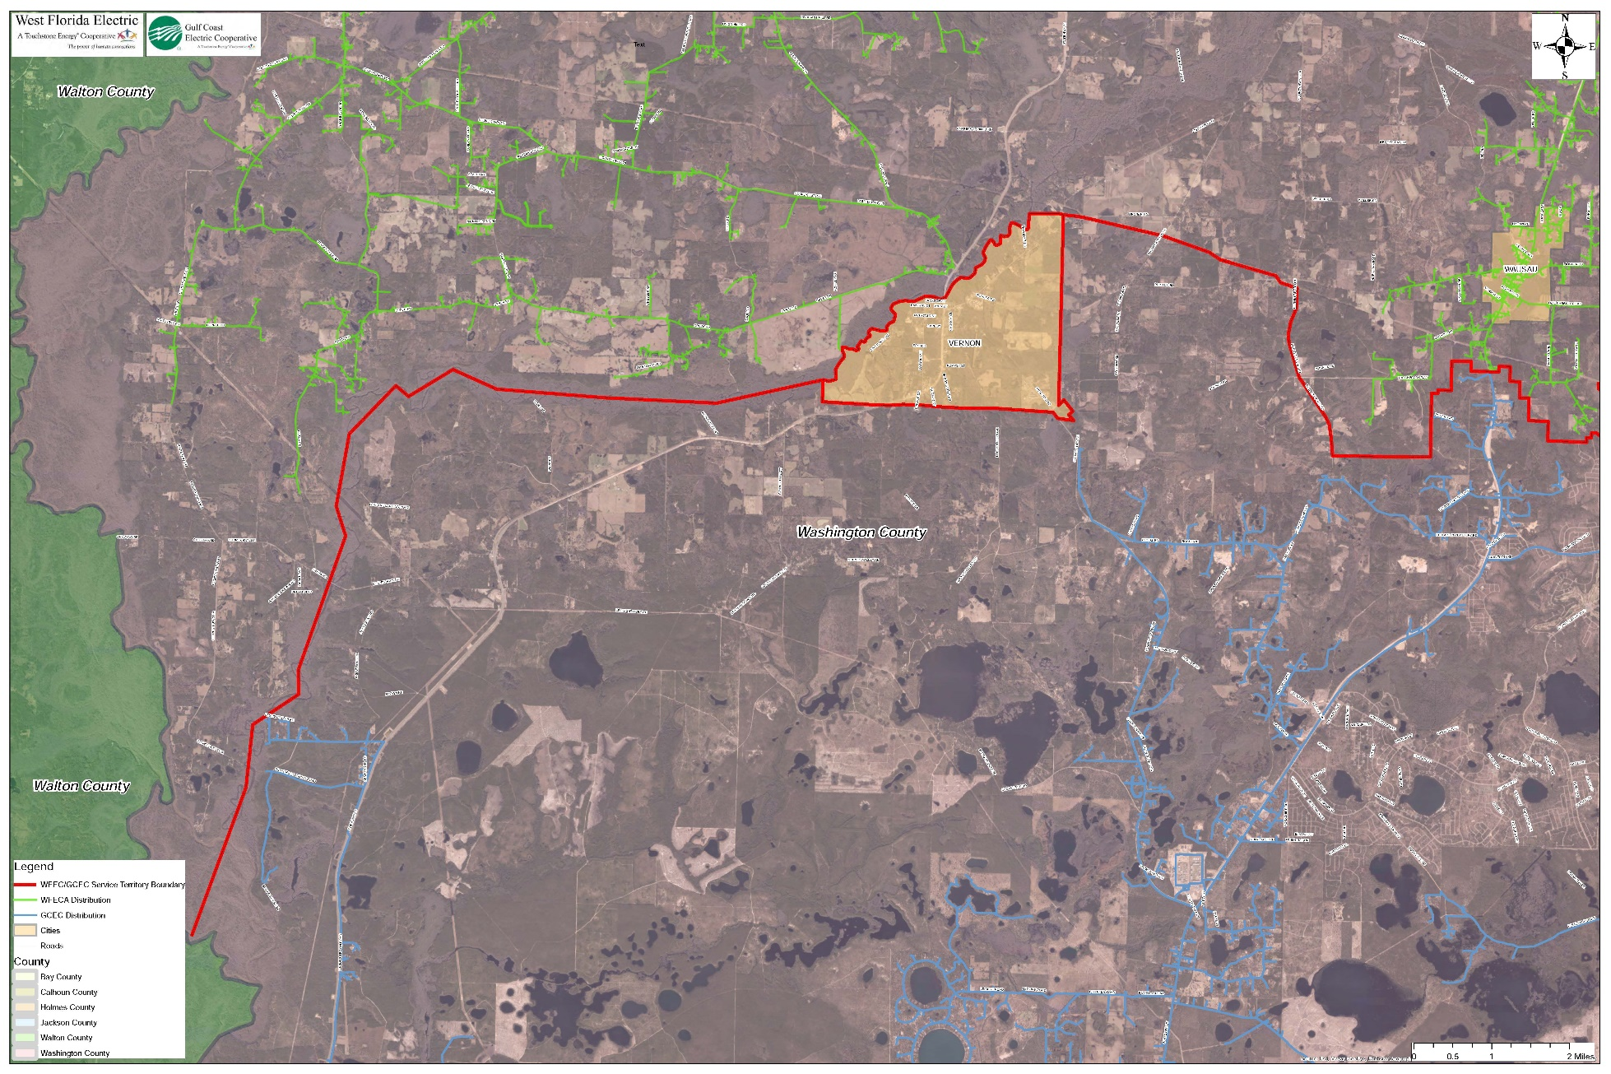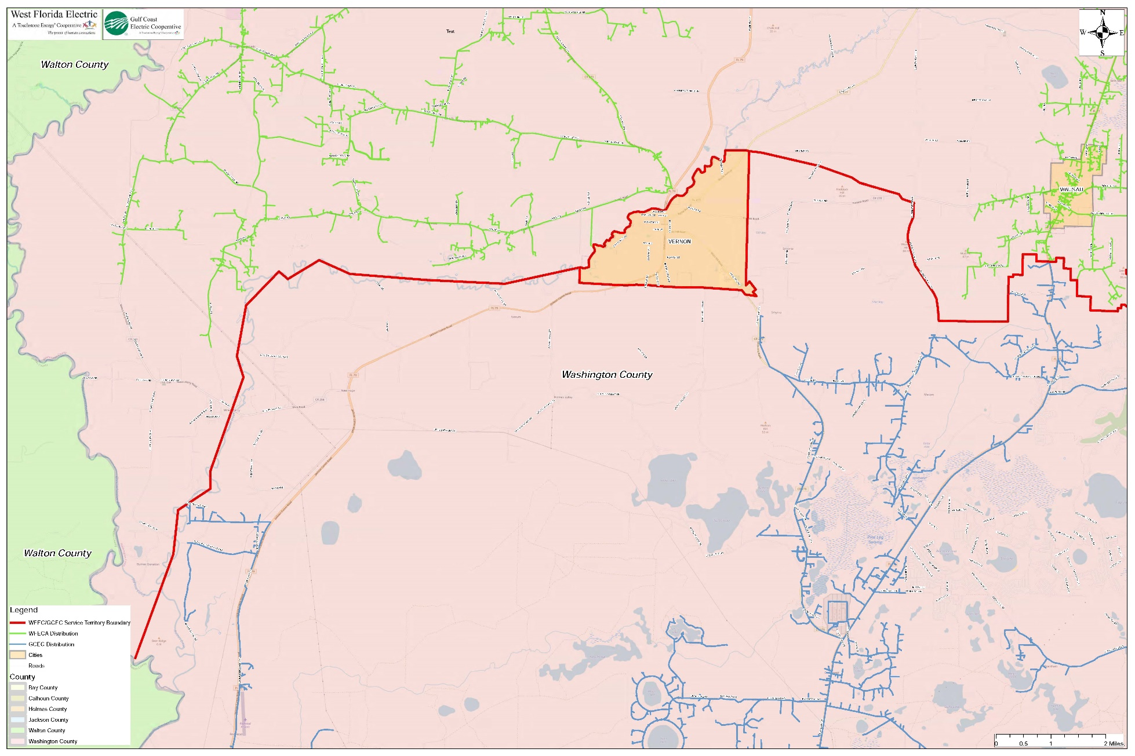

Responses 1 and 2 in Staff’s First Data Request, Document No. 11046-2021.
Utilities Commission of the City of New Smyrna Beach v. Florida Public Service Commission, 469 So. 2d 731 (Fla. 1985).
Responses 3 and 5 to Staff’s First Data Request, Document No. 11046-2021.
Responses 4 and 6 to Staff’s First Data Request, Document No. 11046-2021.
Responses 2 and 4 to Staff’s Second Data Request, Document No. 11323-2021.
Responses 1 and 3 to Staff’s Second Data Request, Document No. 11323-2021.
Pursuant to Section 1.10 Extra-Territorial Customers shall mean any person receiving retail electric service from either Gulf Coast or West Florida on the effective date of this agreement who are located in the territorial area of the other party established by this agreement.

