BEFORE THE FLORIDA PUBLIC SERVICE COMMISSION

In re: Joint petition for approval of modification to territorial agreement in Orange County, by City of Winter Park and Duke Energy Florida, LLC. | DOCKET NO. 20210160-EU  ORDER NO. PSC-2021-0453-PAA-EU  ISSUED: December 9, 2021

The following Commissioners participated in the disposition of this matter:

GARY F. CLARK, Chairman
ART GRAHAM
ANDREW GILES FAY
MIKE LA ROSA
GABRIELLA PASSIDOMO

NOTICE OF PROPOSED AGENCY ACTION
ORDER APPROVING FIRST AMENDMENT TO TERRITORIAL AGREEMENT

BY THE COMMISSION:

NOTICE is hereby given by the Florida Public Service Commission that the action discussed herein is preliminary in nature and will become final unless a person whose interests are substantially affected files a petition for a formal proceeding, pursuant to Rule 25-22.029, Florida Administrative Code (F.A.C.).

Background

On September 27, 2021, the City of Winter Park (Winter Park or City) and Duke Energy Florida, LLC (DEF) filed a joint petition for approval of an amendment (First Amendment) to their currently effective territorial agreement in Orange County. In 2005, the City of Winter Park purchased DEF’s facilities and established a municipal utility to provide service within the City. In 2014, we approved the joint petitioners’ currently effective territorial agreement. The proposed First Amendment to the agreement seeks to further redefine the parties’ specific service areas in Winter Park. The proposed First Amendment and associated maps indicating the service area revisions are included in Attachment A to this order.

During the review process, our staff issued two data requests to the joint petitioners, to which the responses were received on October 26 and on November 9, 2021. On November 17, 2021, DEF provided an email, which has been placed in the docket file, with additional clarifications on the process leading up to the proposed First Amendment. On November 19, 2021, our staff had an informal conference call meeting with the joint petitioners to obtain further clarifications related to the proposed First Amendment.

Decision
Pursuant to Section 366.04(2)(d), Florida Statutes (F.S.), and Rule 25-6.0440(2), F.A.C., we have jurisdiction to approve territorial agreements between and among rural electric cooperatives, municipal electric utilities, and other electric utilities. Unless we determine that the Agreement will cause a detriment to the public interest, the Agreement should be approved.
Through this proposed First Amendment, the joint petitioners desire to redraw certain small sections of the territorial boundaries in Winter Park. The joint petitioners explained that after the separation of the City from DEF and the 2014 territorial agreement, DEF continued to serve certain small areas within the City. The proposed First Amendment addresses those areas still served by DEF within the City and would eliminate potential duplicate facilities, create contiguous boundaries, and address certain parcels that were split by the current territorial boundaries. Pursuant to Paragraph 3 of the First Amendment, 11 DEF customers (nine commercial and two residential) will be transferred to Winter Park. Revised Exhibit F, as shown on Page 19 of 26 in Attachment A of this Order, clarifies that of the 11 customers to be transferred to the City, seven are existing customers and four are vacant parcels. No customers will be transferred from the City to DEF.

During the November 19, 2021 conference call with staff, the joint petitioners stated that in an effort to have a more contiguous boundary, and avoid duplication of service, DEF approached the City, after a review of its service territory, regarding the transfer of certain parcels within the City’s boundary that are currently served by DEF. The joint petitioners agreed to transfer seven existing DEF customers and four vacant lots within DEF’s service area to the City of Winter Park. In addition, the joint petitioners agreed to transfer the service of the land parcel which includes the City’s wastewater treatment plant, which has been temporarily served by DEF for many years, to DEF as the City has no facilities nearby to economically extend service to the wastewater treatment plant.

The proposed amendment will eliminate uneconomic duplication of service facilities and resolve split parcels due to annexation and create cohesive boundaries. The proposed First Amendment does not contemplate transfer or purchase of any facilities by either utility and the joint petitioners assert that the proposed amendment will not cause a decrease in service reliability to their existing or future customers. The currently effective agreement approved in 2014, shall remain effective for a term of 20 years, pursuant to Section 6.1 of the agreement and the proposed First Amendment does not modify the term of the agreement.

The petitioners, in their response to staff’s first data request, stated that in accordance with Rule 25-6.0440(1)(d), F.A.C., the customers to be transferred from DEF to Winter Park pursuant to this agreement were notified by mail and a description of the difference between DEF’s and Winter Park’s electric rates was provided. Since the initial notification, the rates have changed. As of October 2021, DEF’s residential rate for 1,000 kilowatt-hours (kWh) was $132.24 and commercial rate for 1,500 kWh was $207.60. For the same month, Winter Park residential rate for 1,000 kWh was $121.27 and commercial rate for 1,500 kWh was $202.54. The customer notice states that DEF will apply customers’ deposits to their last electric bill and will directly refund any surplus. With regard to the degree of acceptance by affected customers, the petitioners, in their response to staff’s first data request, stated that DEF has not received any comments from customers subject to the transfer and will notify the Commission if any comments or questions are received. The joint petitioners intend to transfer the 11 customers by end of 2022.

Conclusion

After review of the joint petition, the proposed First Amendment to the territorial agreement, and responses to staff’s data requests, we find the First Amendment to the territorial agreement will not cause a detriment to the public interest, will eliminate any potential uneconomic duplication of facilities and will not cause a decrease in reliability of electric service to the present or future customers of Winter Park or DEF. It is therefore approved, effective on the date this Order becomes final and is no longer subject to judicial review.

Based on the foregoing, it is

ORDERED by the Florida Public Service Commission that the Joint petition for approval of modification to territorial agreement in Orange County, by the City of Winter Park and Duke Energy Florida, LLC is hereby approved, effective upon the date this order becomes final and is no longer subject to judicial review. It is further

ORDERED that the provisions of this Order, issued as proposed agency action, shall become final and effective upon the issuance of a Consummating Order unless an appropriate petition, in the form provided by Rule 28-106.201, Florida Administrative Code, is received by the Commission Clerk, 2540 Shumard Oak Boulevard, Tallahassee, Florida 32399-0850, by the close of business on the date set forth in the “Notice of Further Proceedings” attached hereto. It is further

ORDERED that in the event this Order becomes final, this docket shall be closed.

By ORDER of the Florida Public Service Commission this 9th day of December, 2021.

/s/ Adam J. Teitzman
ADAM J. TEITZMAN
Commission Clerk
Florida Public Service Commission
2540 Shumard Oak Boulevard
Tallahassee, Florida 32399
(850) 413-6770
www.floridapsc.com

Copies furnished: A copy of this document is provided to the parties of record at the time of issuance and, if applicable, interested persons.

RPS

NOTICE OF FURTHER PROCEEDINGS OR JUDICIAL REVIEW

The Florida Public Service Commission is required by Section 120.569(1), Florida Statutes, to notify parties of any administrative hearing that is available under Section 120.57, Florida Statutes, as well as the procedures and time limits that apply. This notice should not be construed to mean all requests for an administrative hearing will be granted or result in the relief sought.

Mediation may be available on a case-by-case basis. If mediation is conducted, it does not affect a substantially interested person's right to a hearing.

The action proposed herein is preliminary in nature. Any person whose substantial interests are affected by the action proposed by this order may file a petition for a formal proceeding, in the form provided by Rule 28-106.201, Florida Administrative Code. This petition must be received by the Office of Commission Clerk, 2540 Shumard Oak Boulevard, Tallahassee, Florida 32399-0850, by the close of business on December 30, 2021.

In the absence of such a petition, this order shall become final and effective upon the issuance of a Consummating Order.

Any objection or protest filed in this/these docket(s) before the issuance date of this order is considered abandoned unless it satisfies the foregoing conditions and is renewed within the specified protest period.

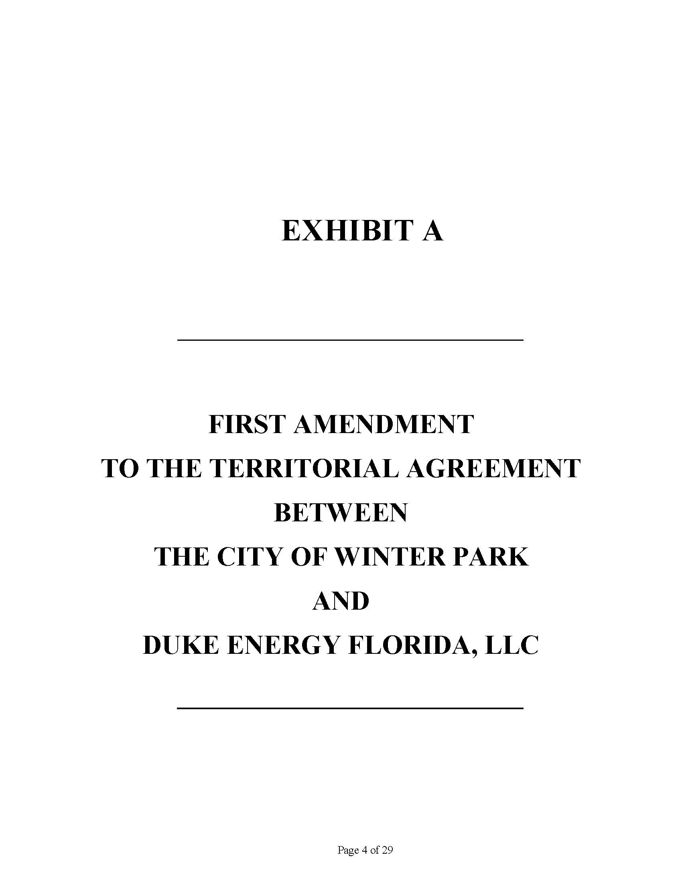

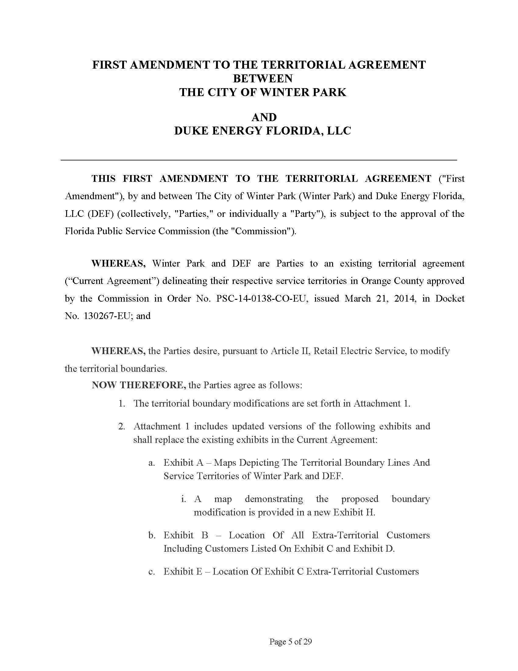

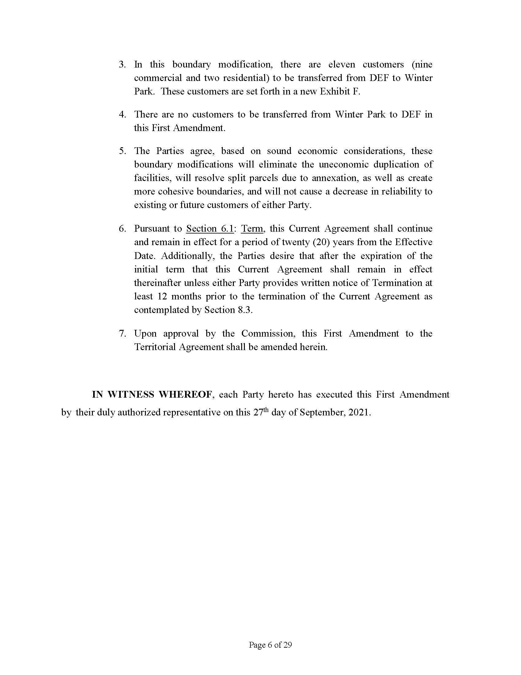

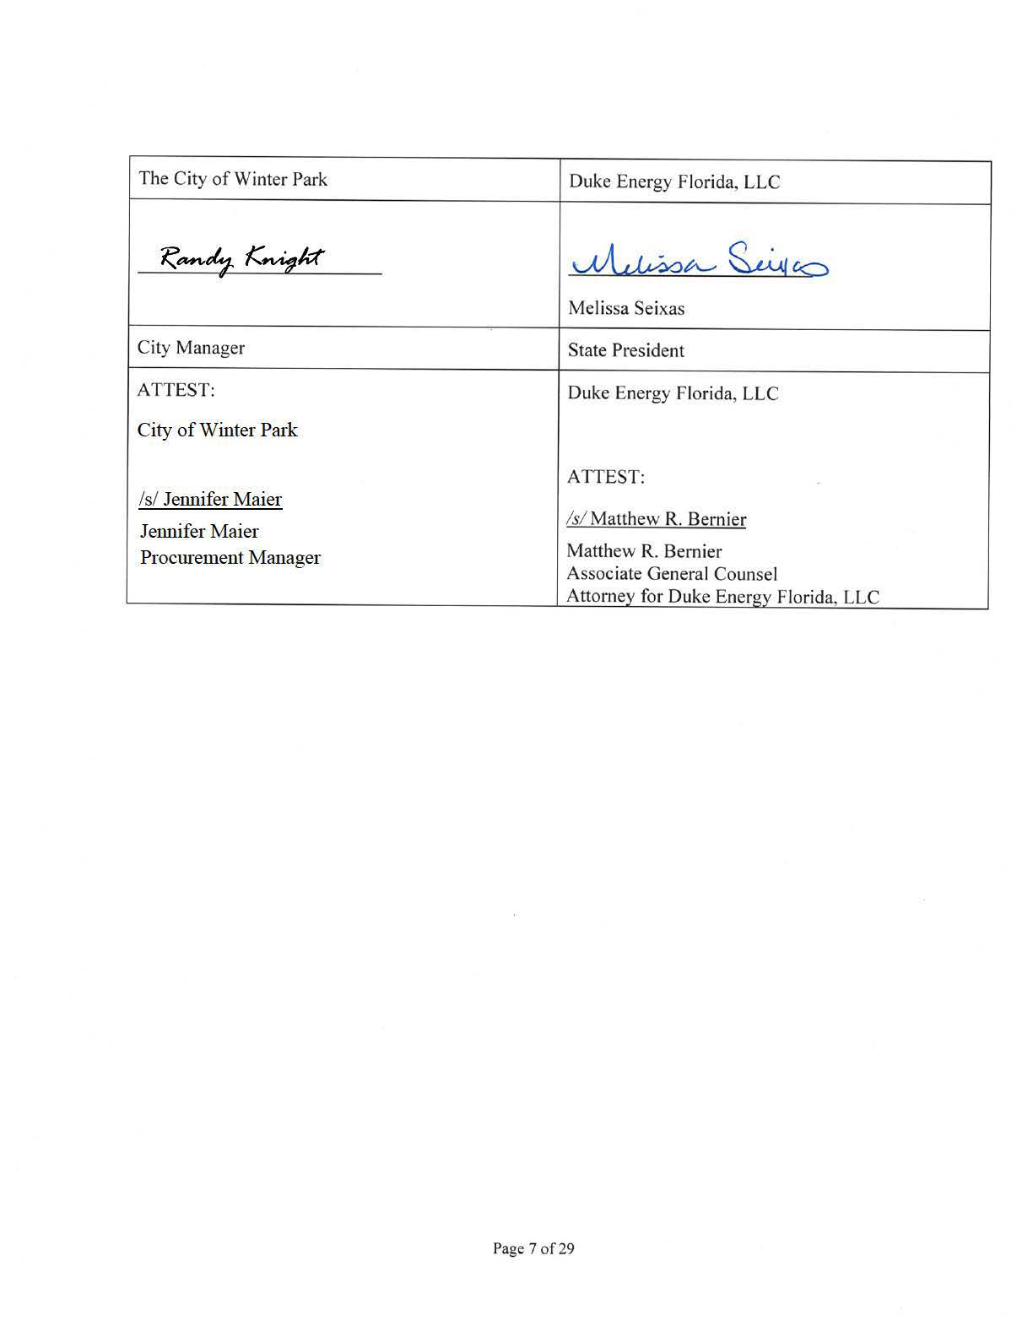

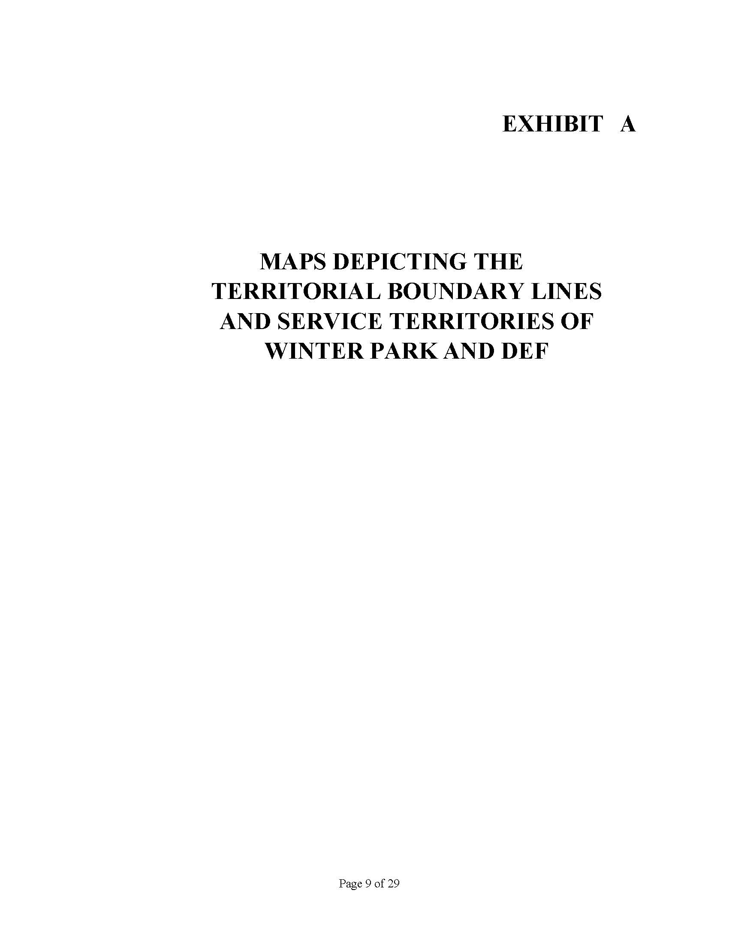

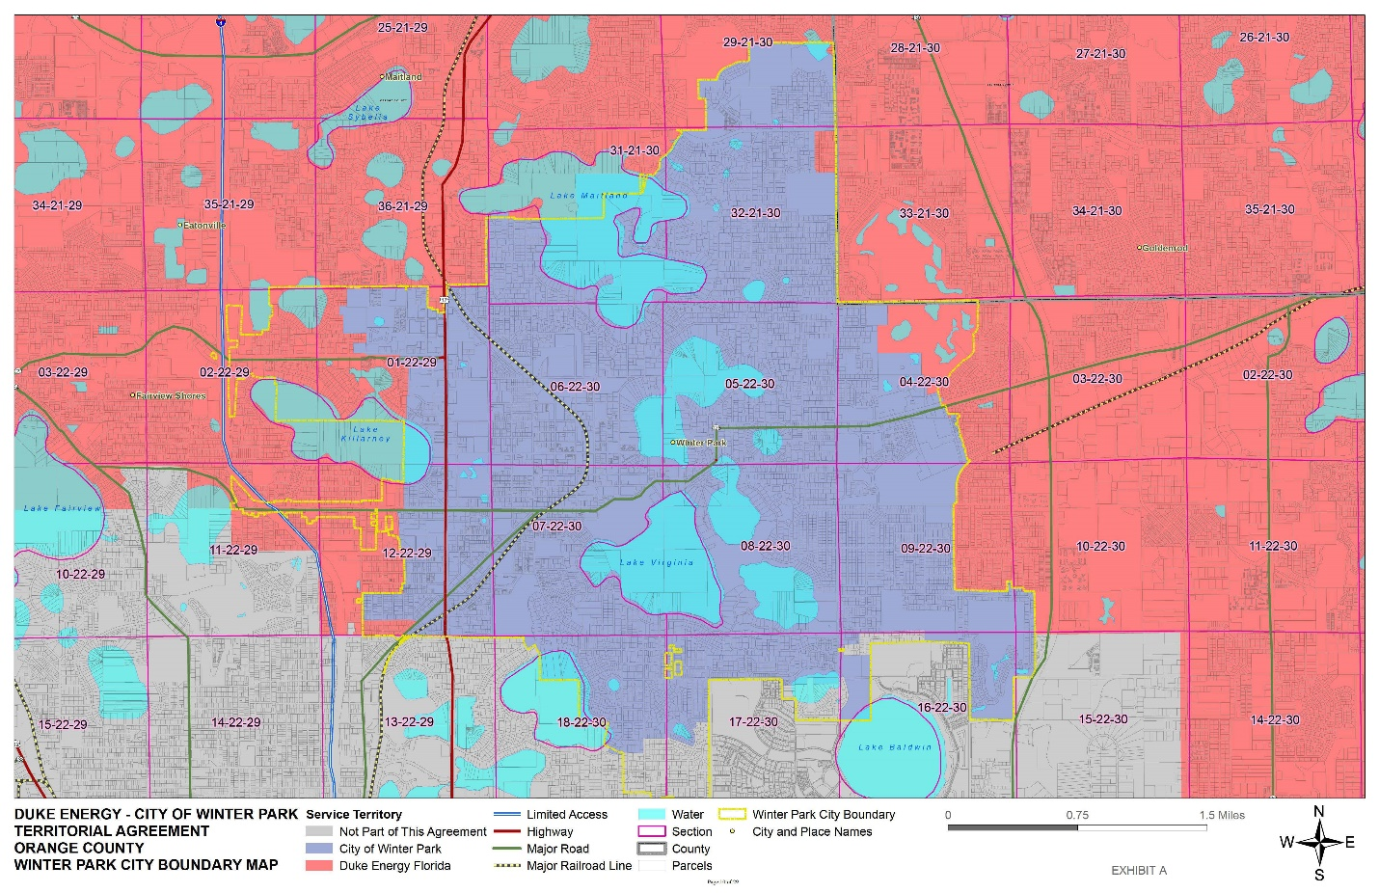

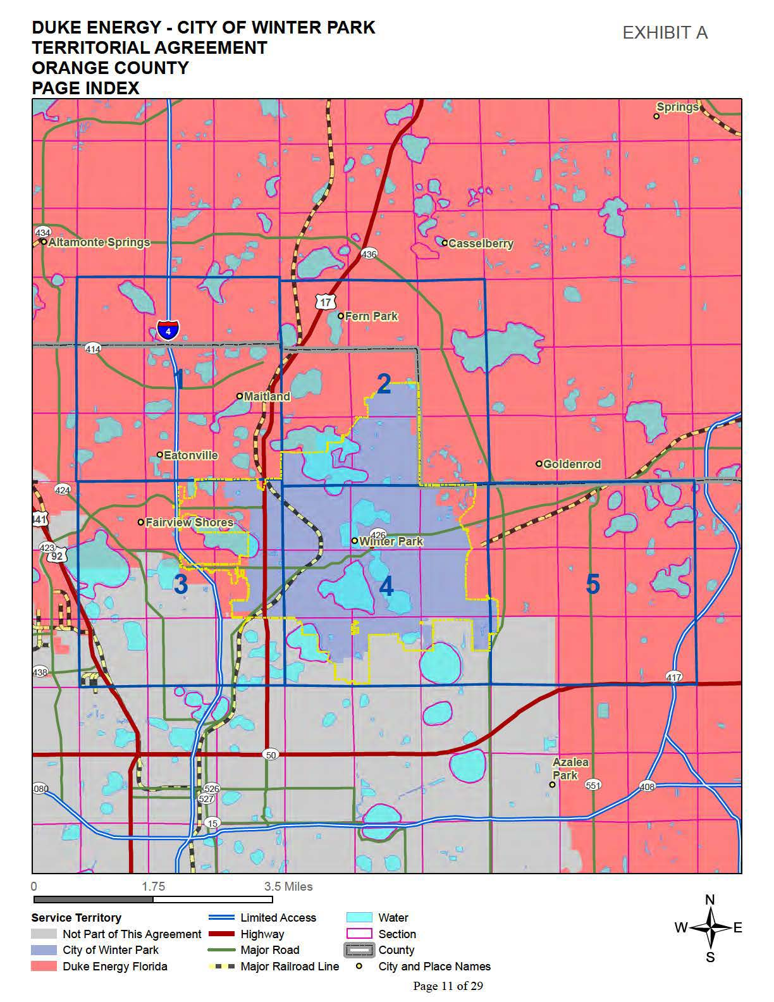

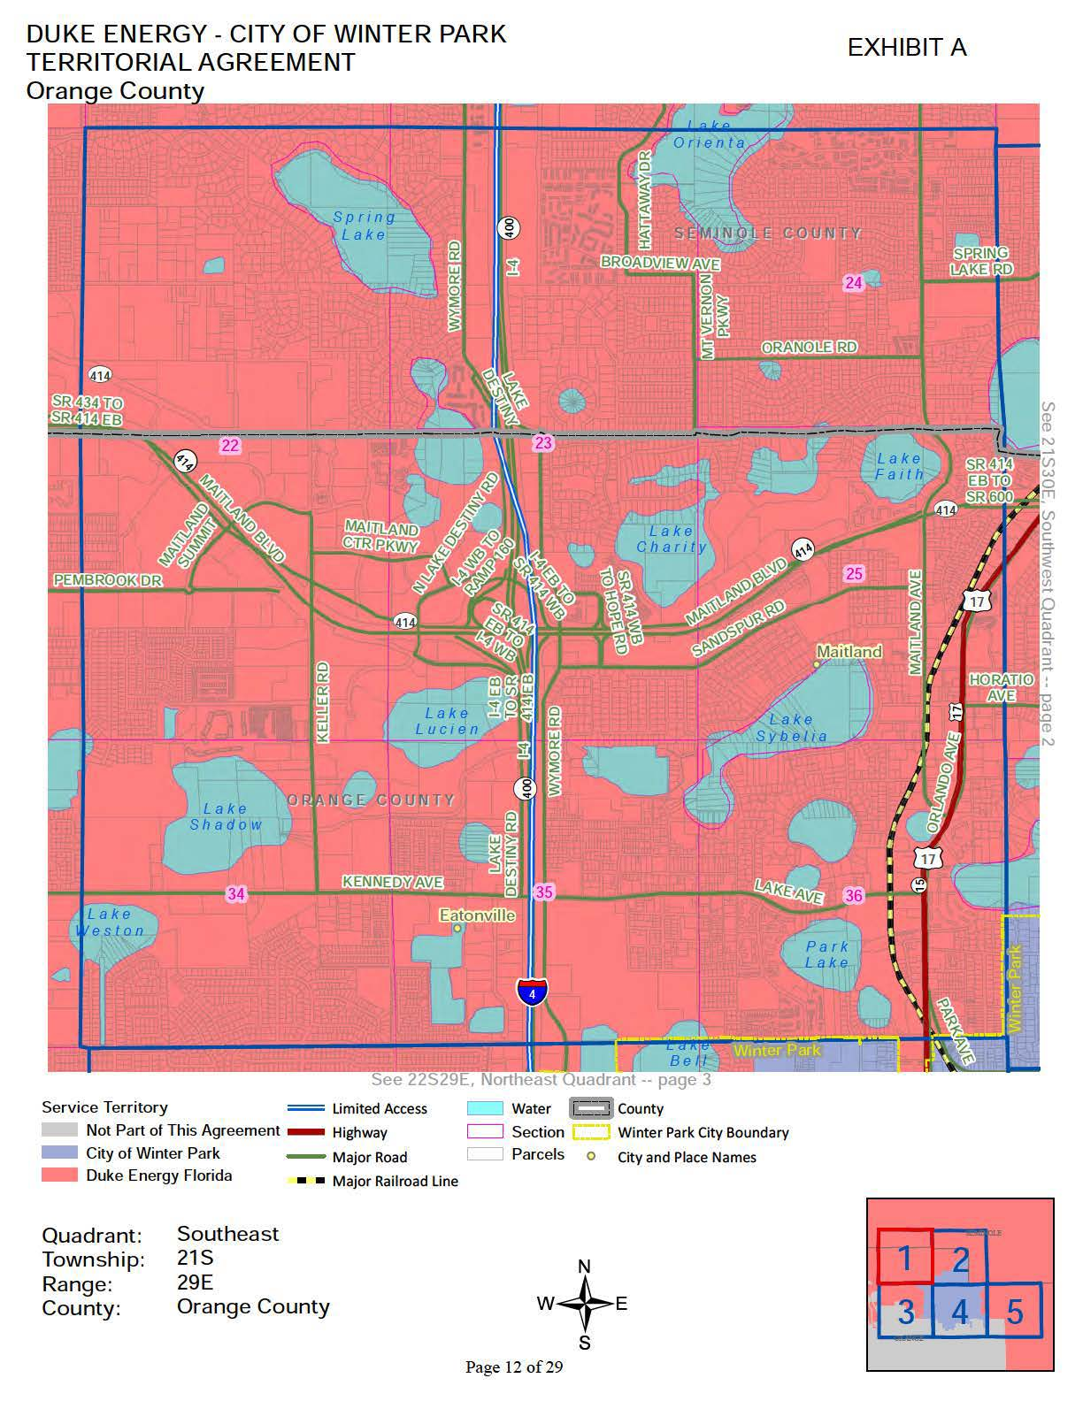

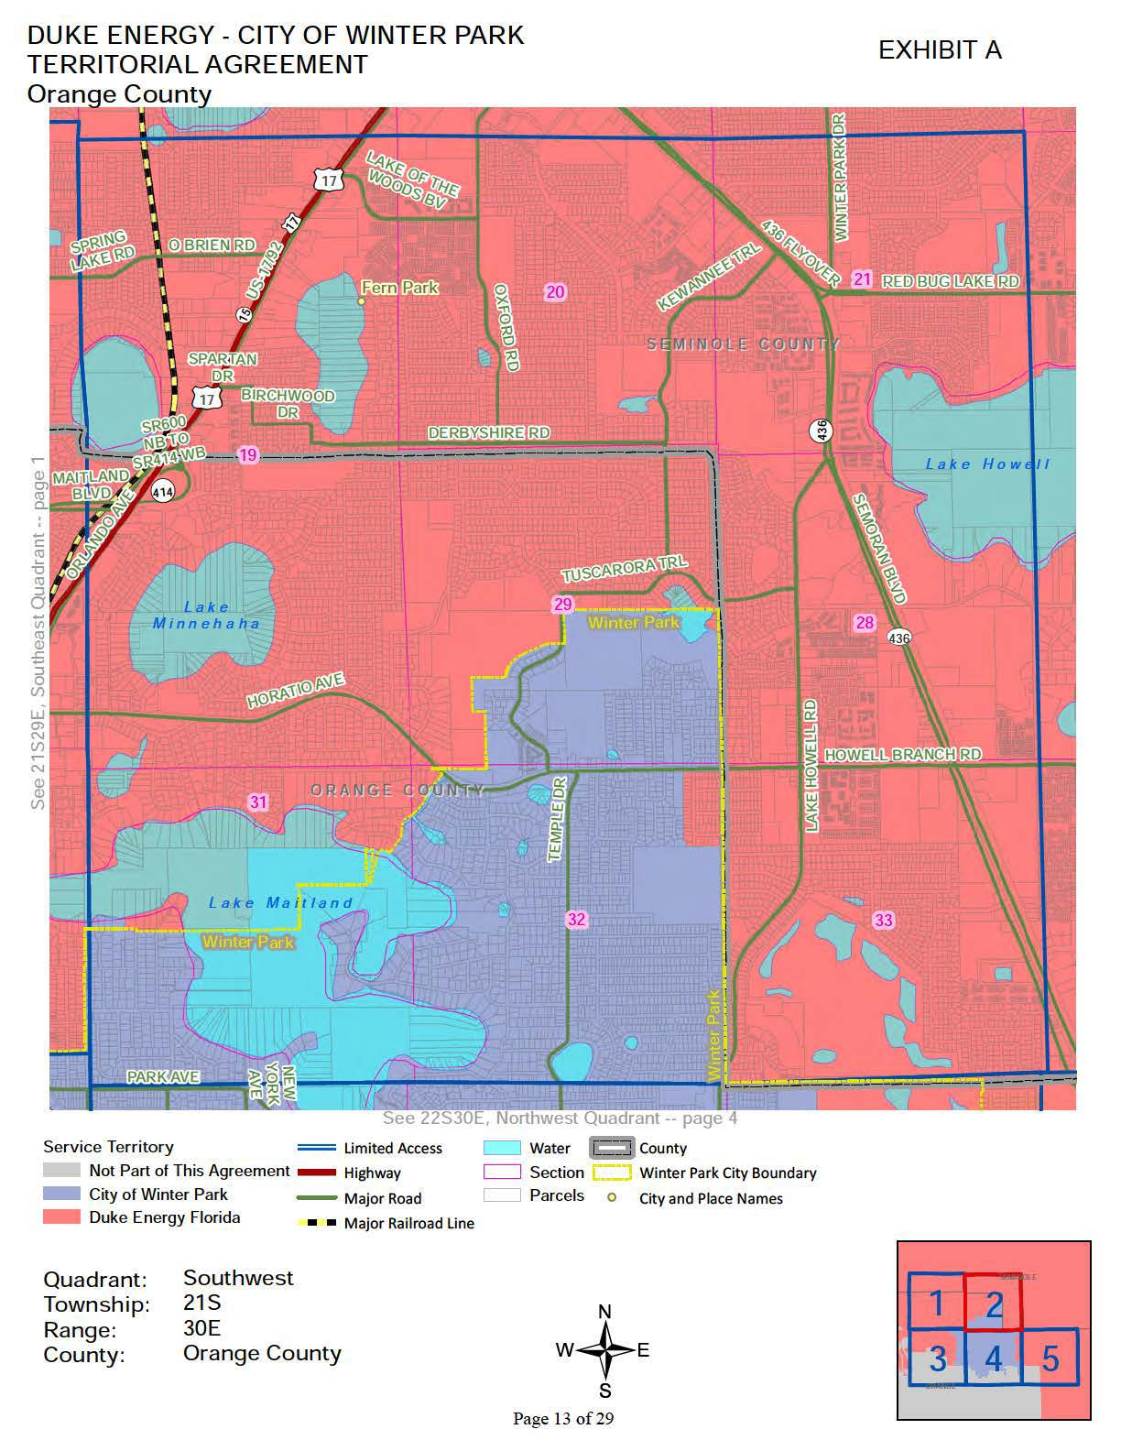

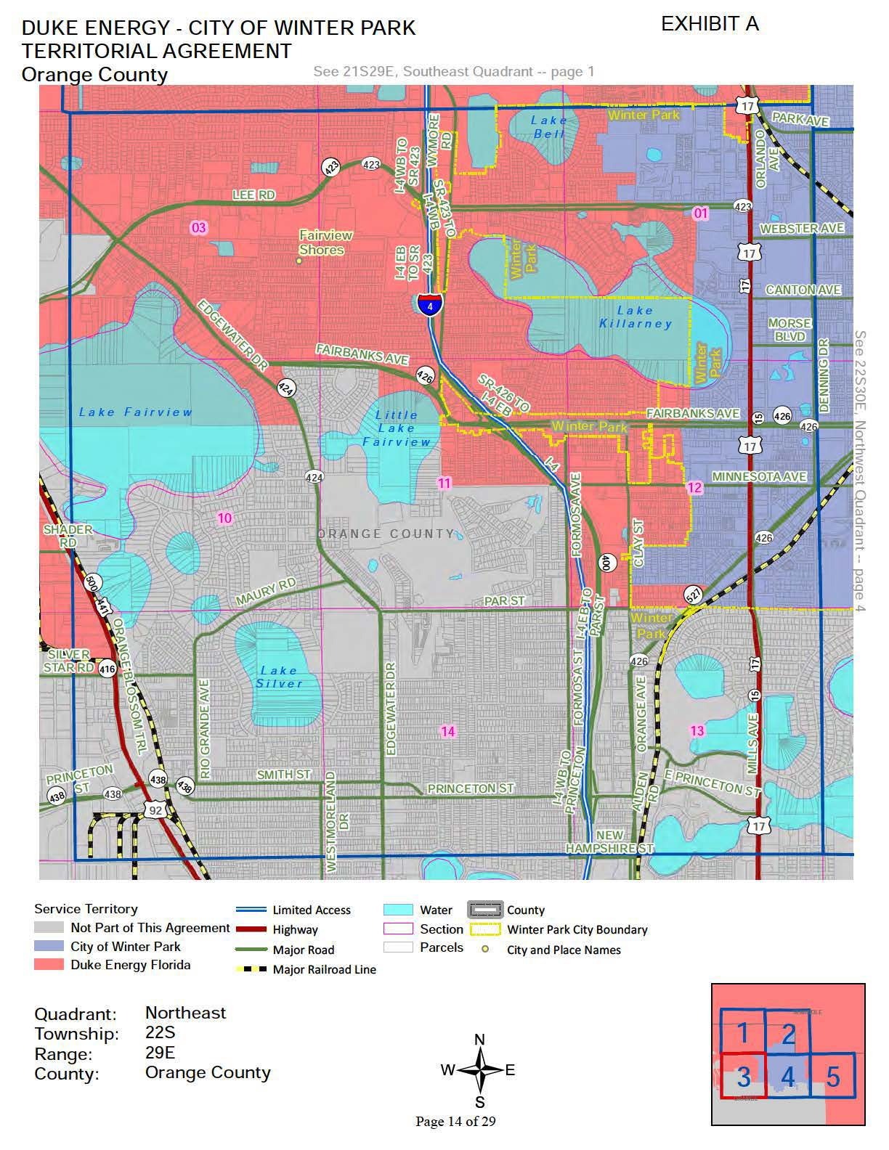

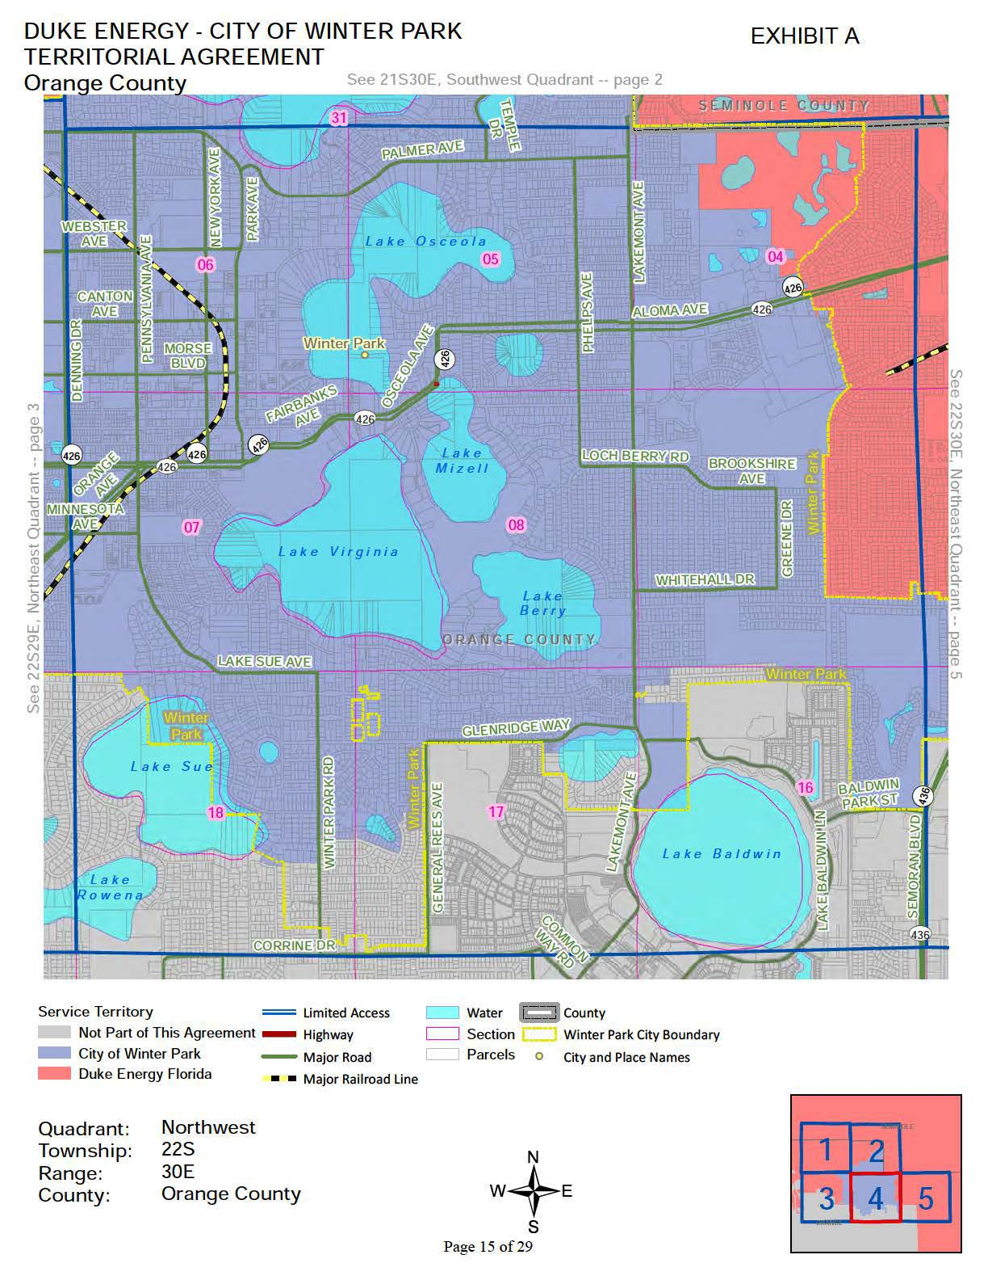

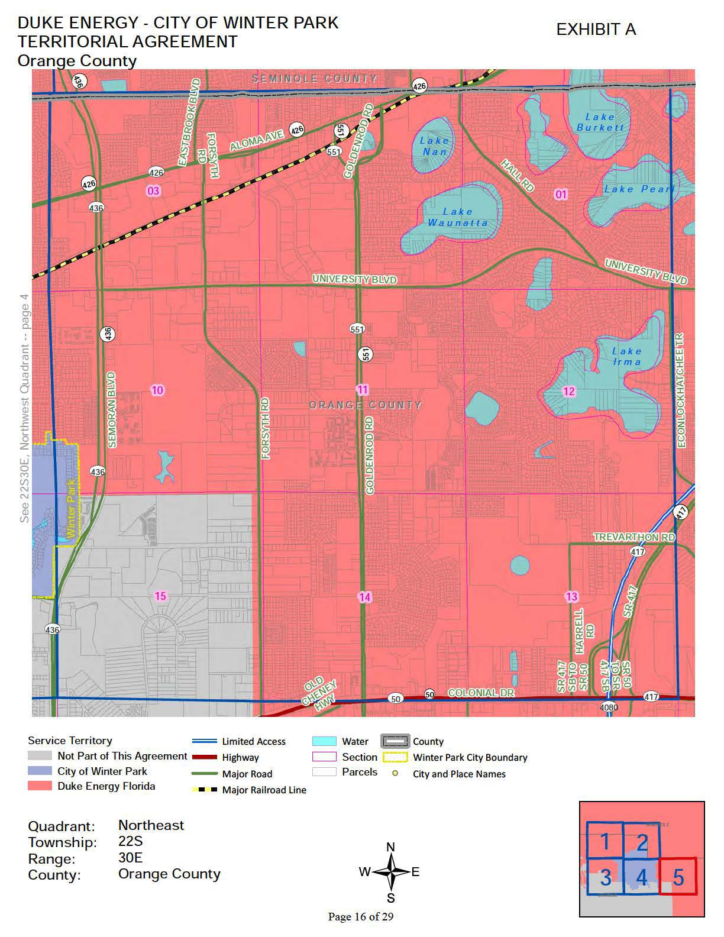

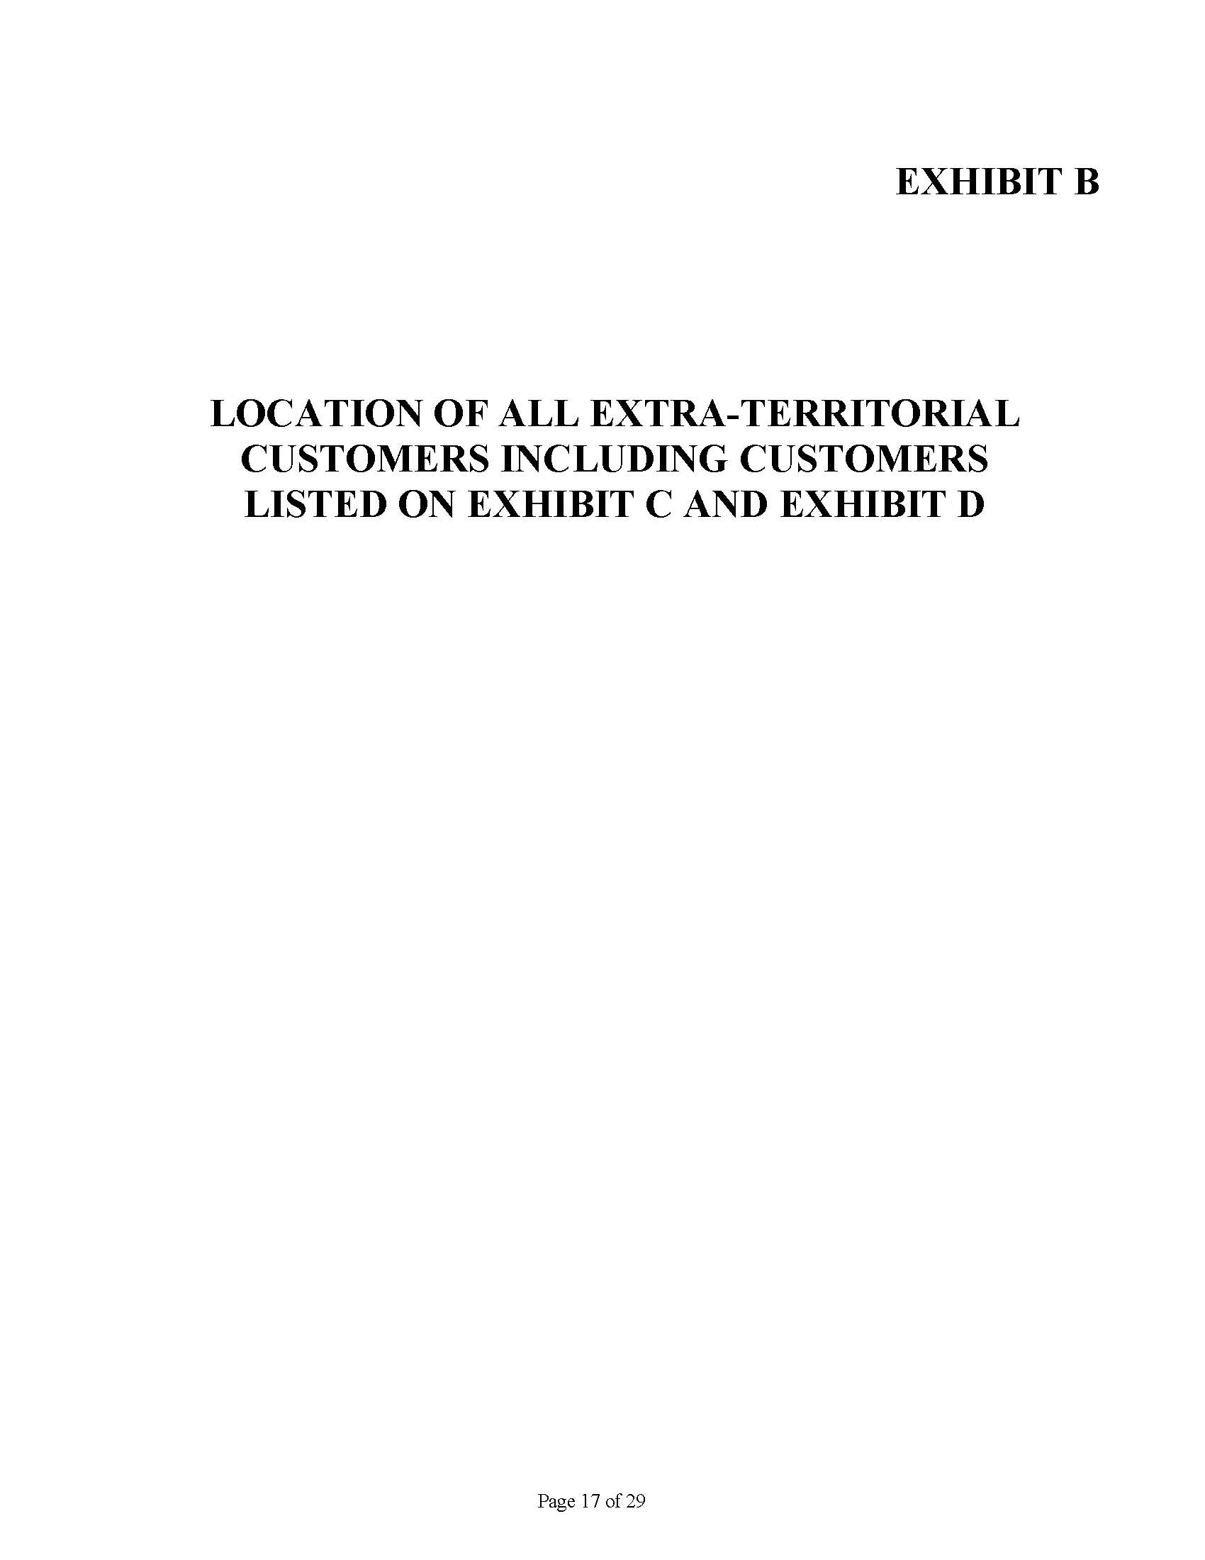

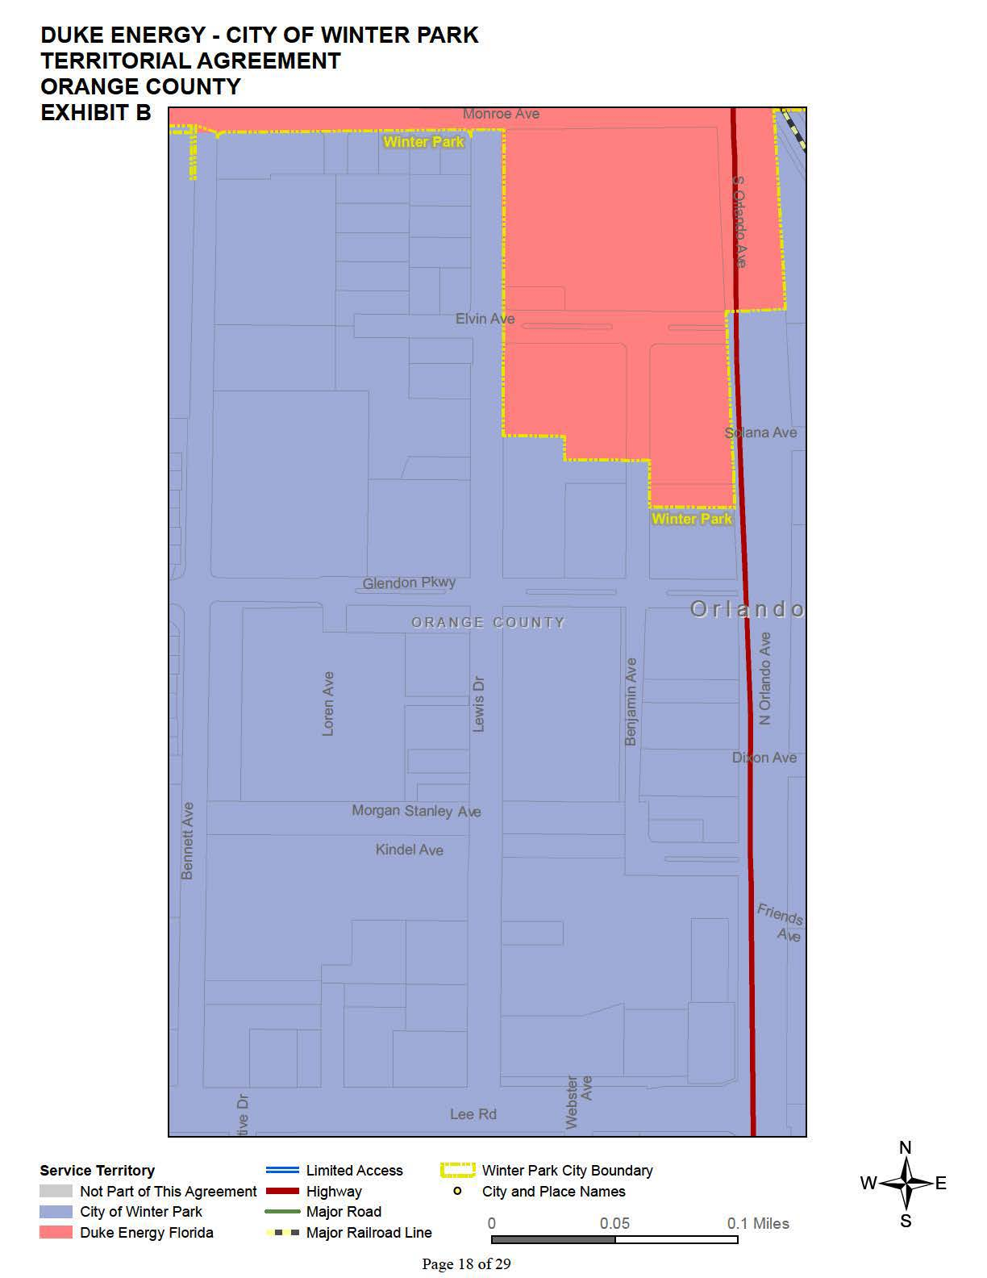

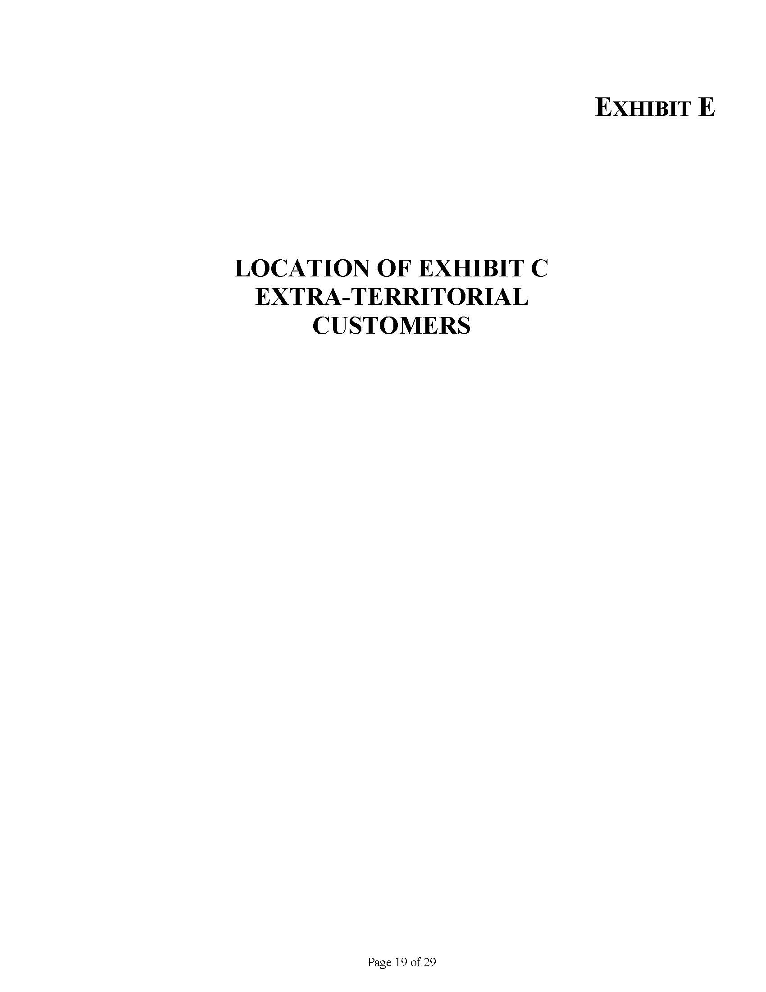

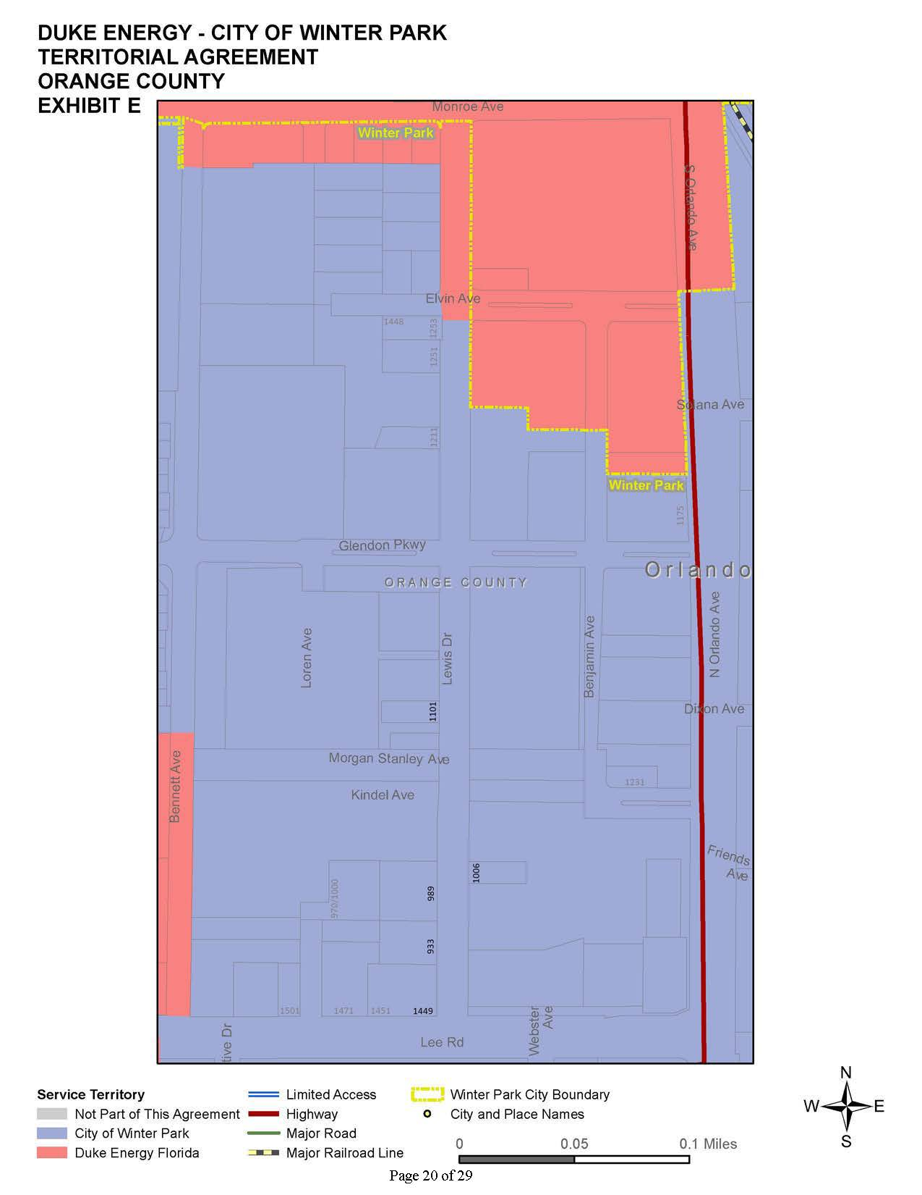

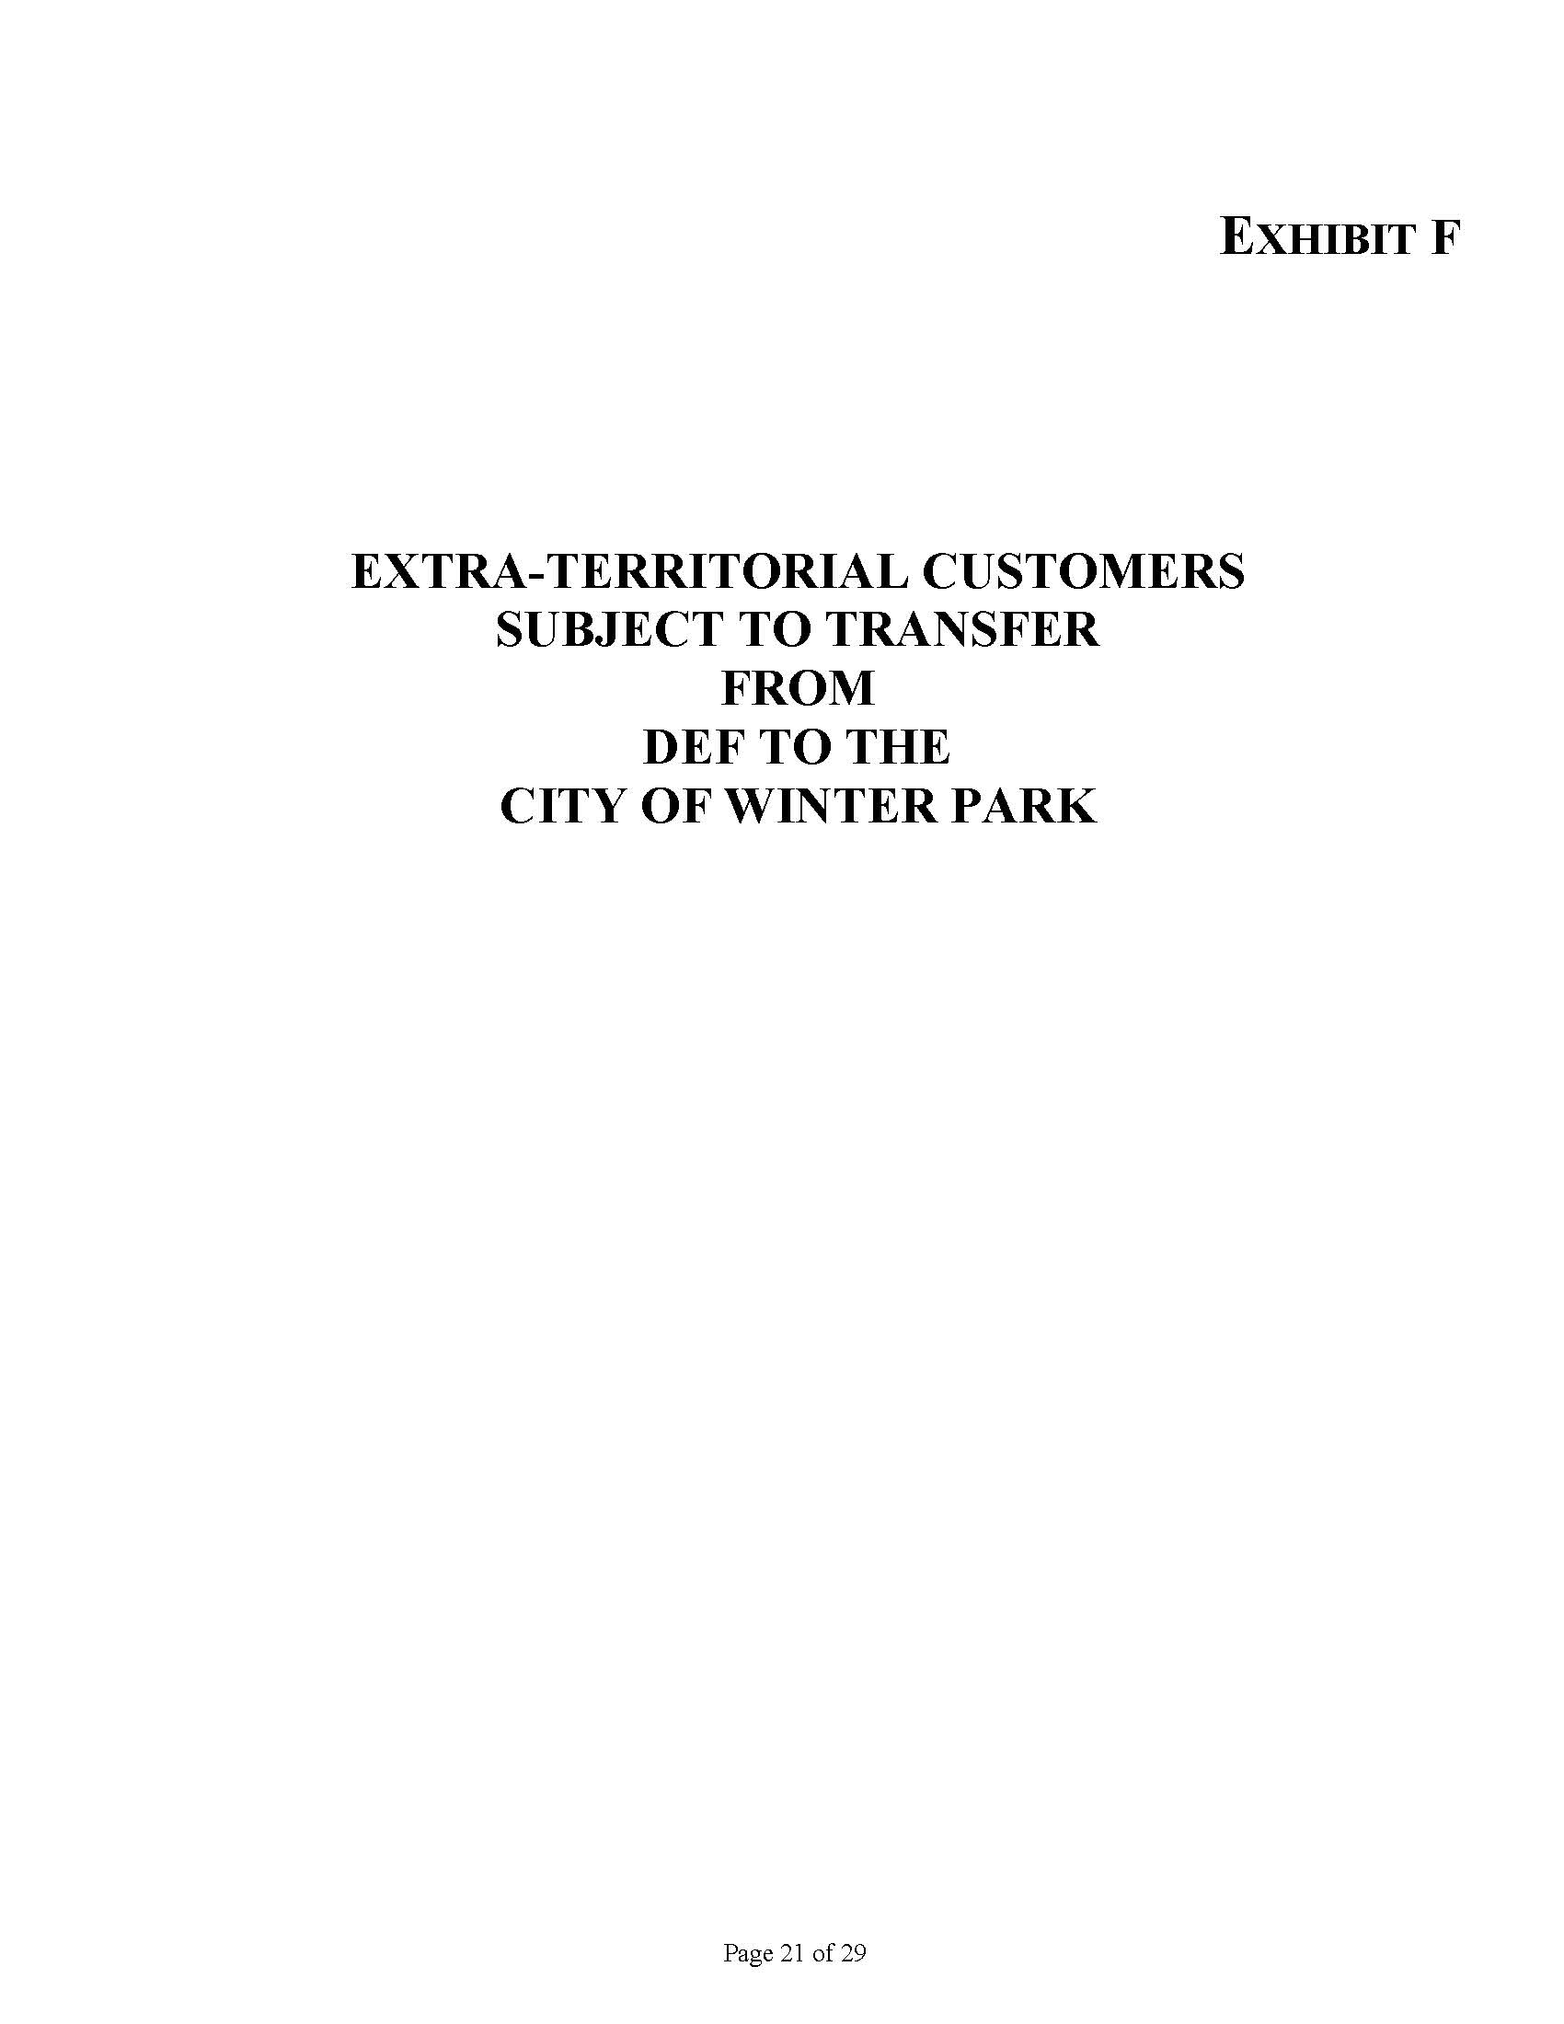

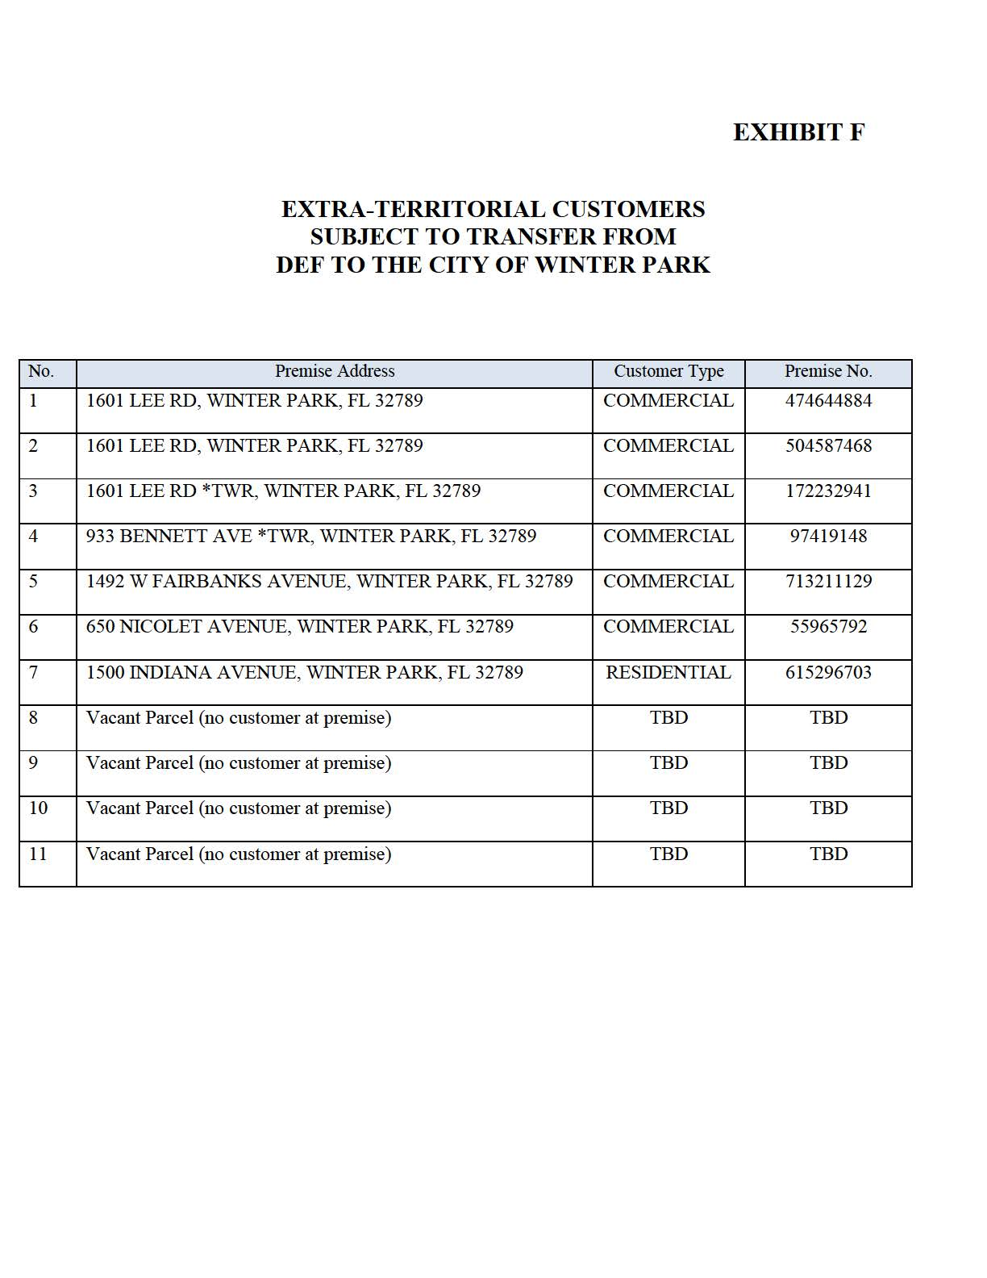

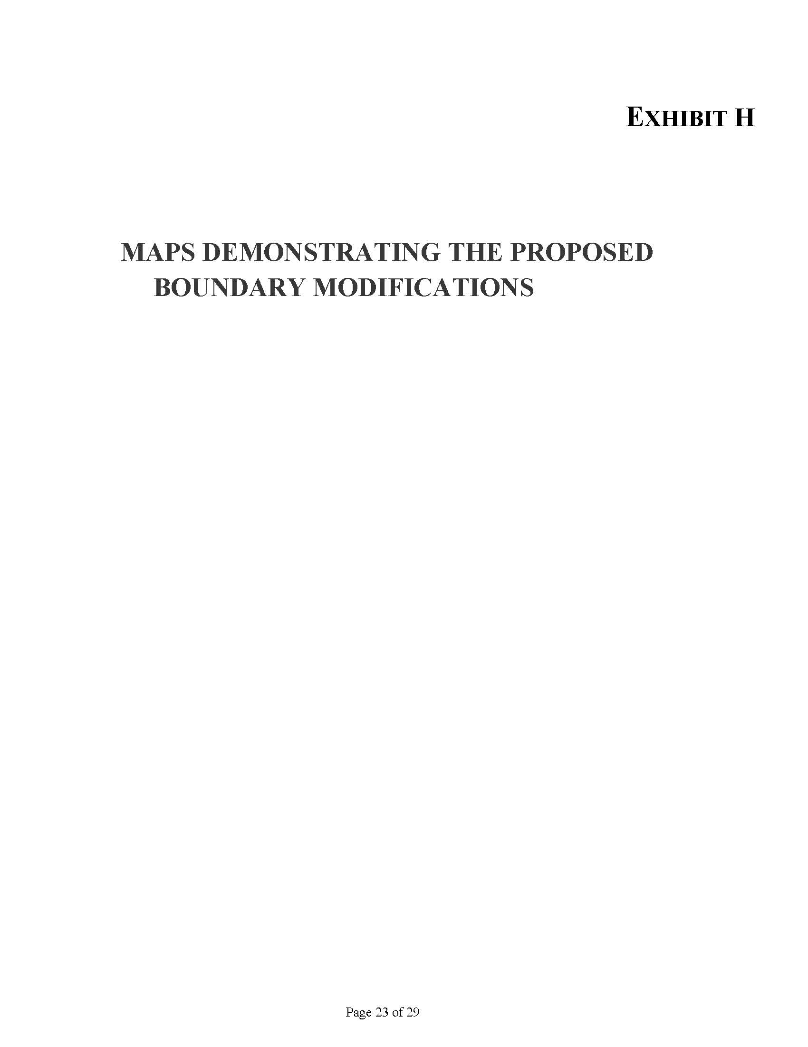

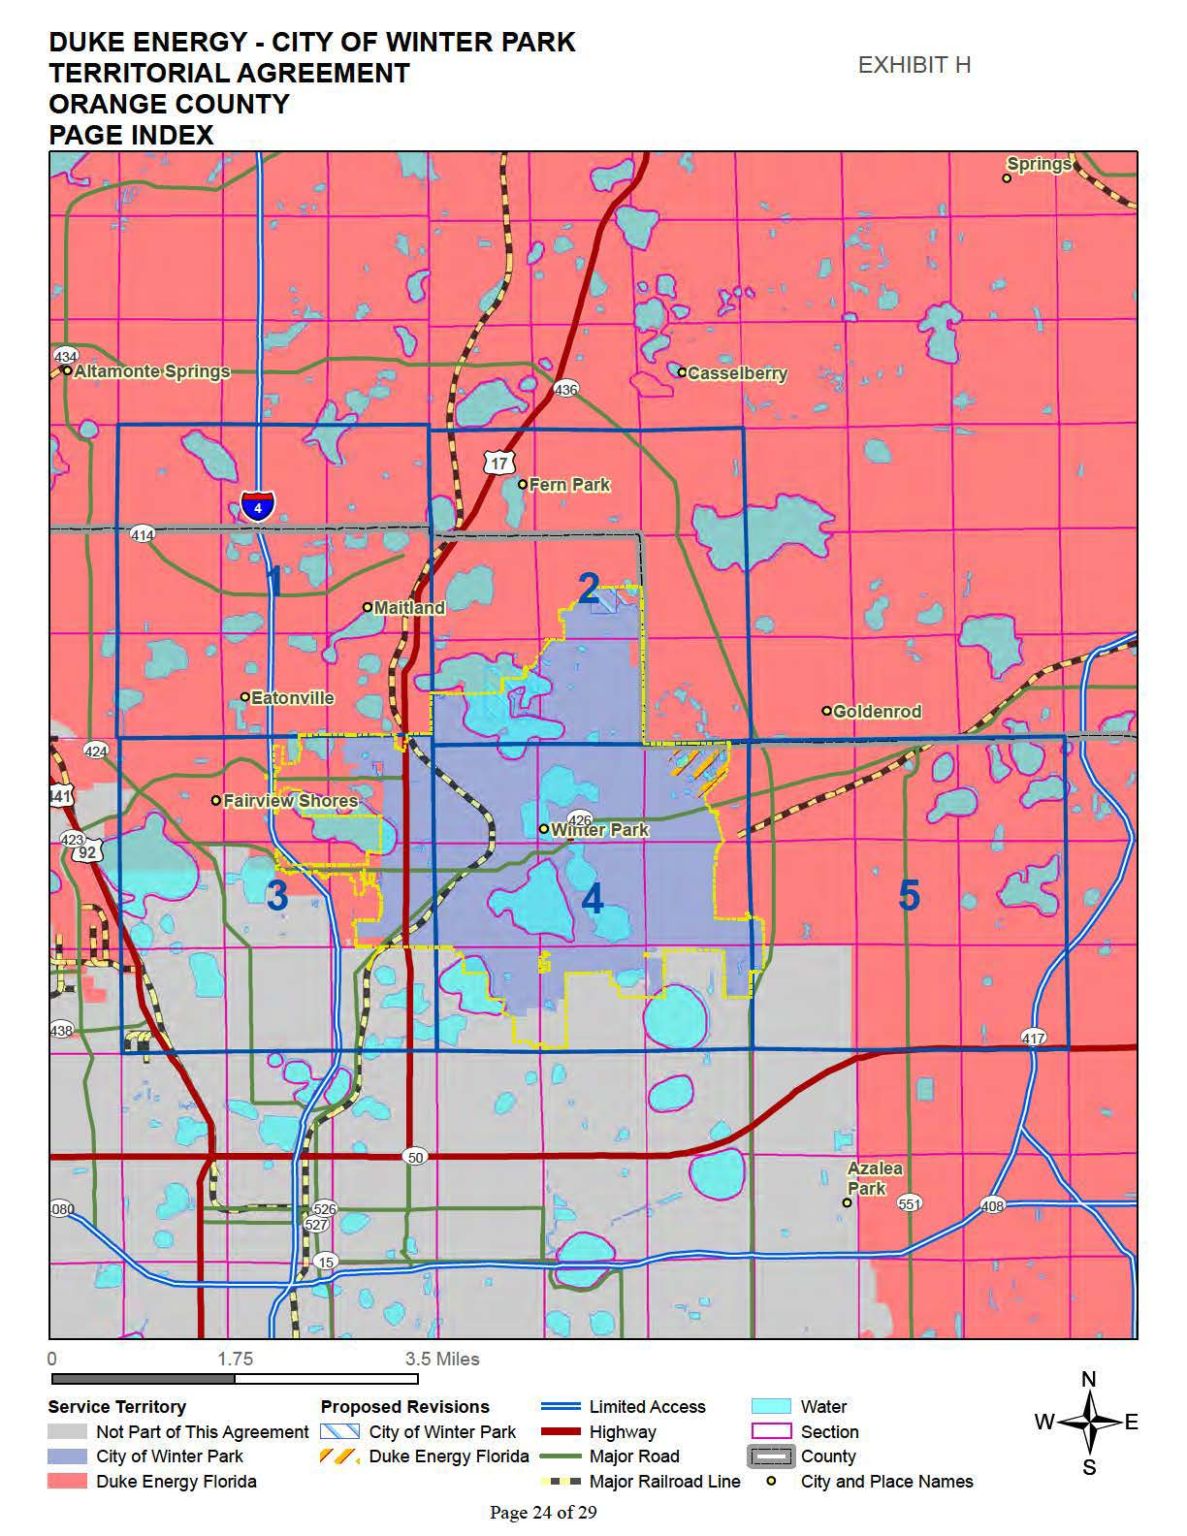

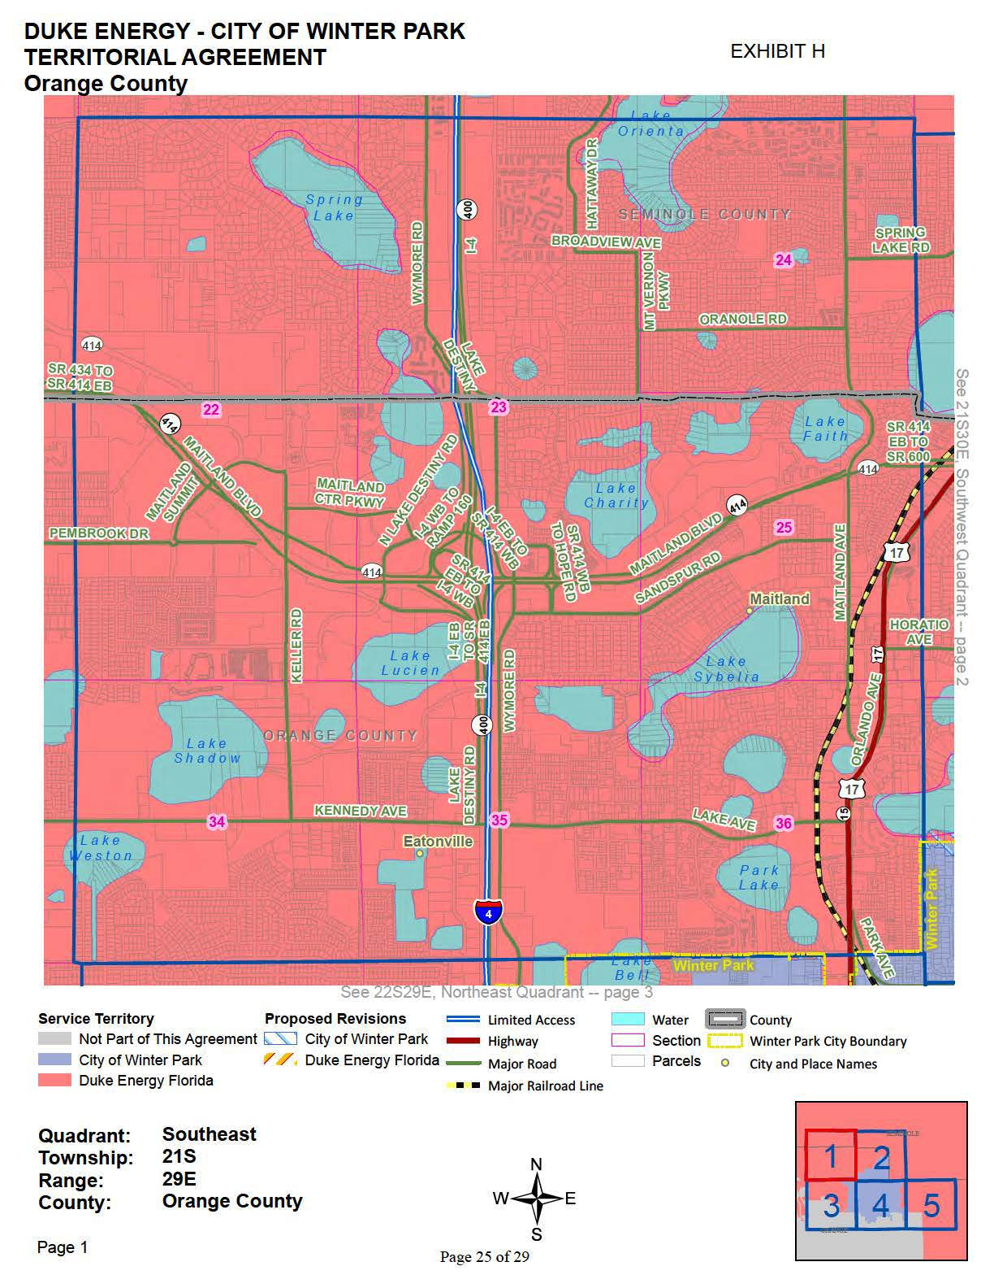

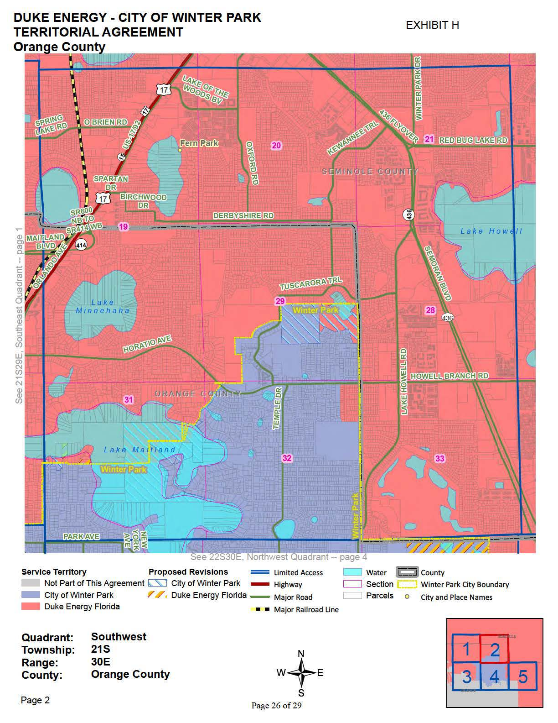

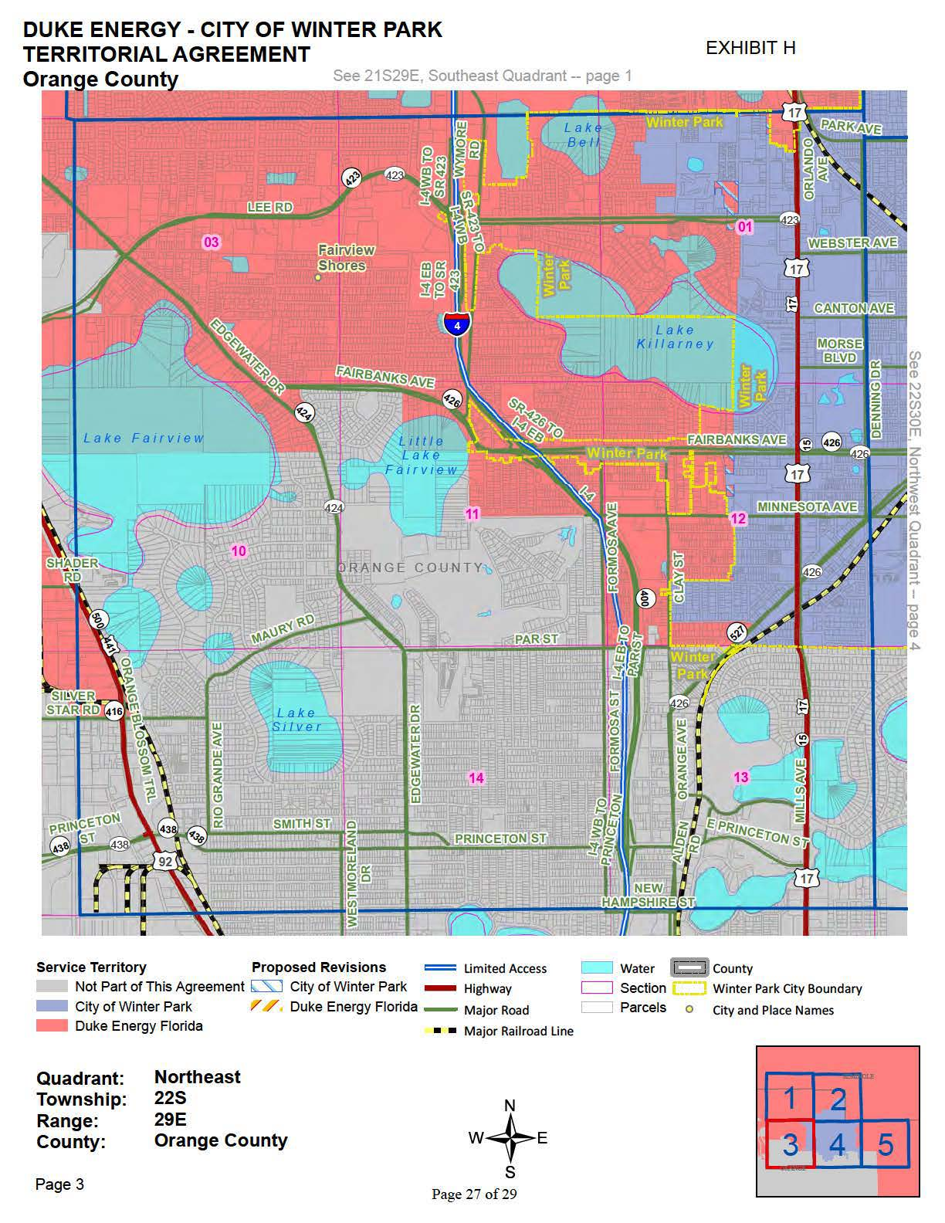

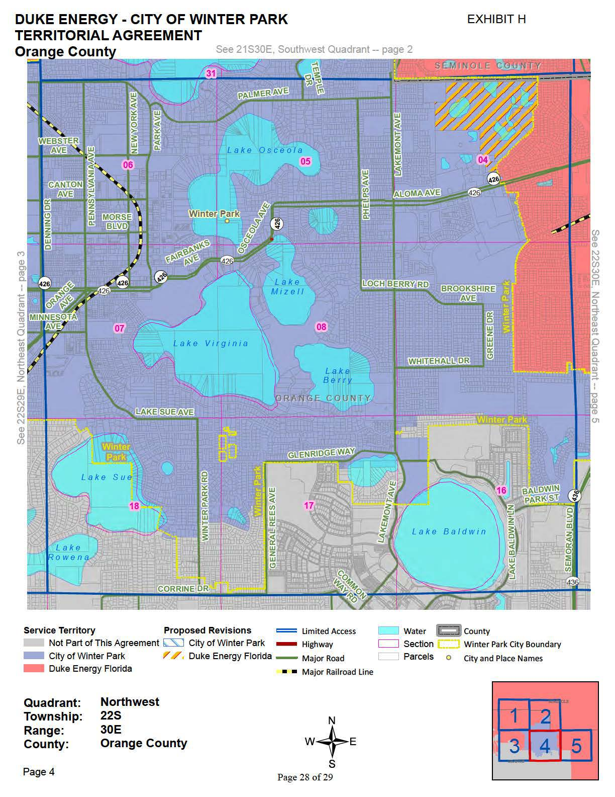

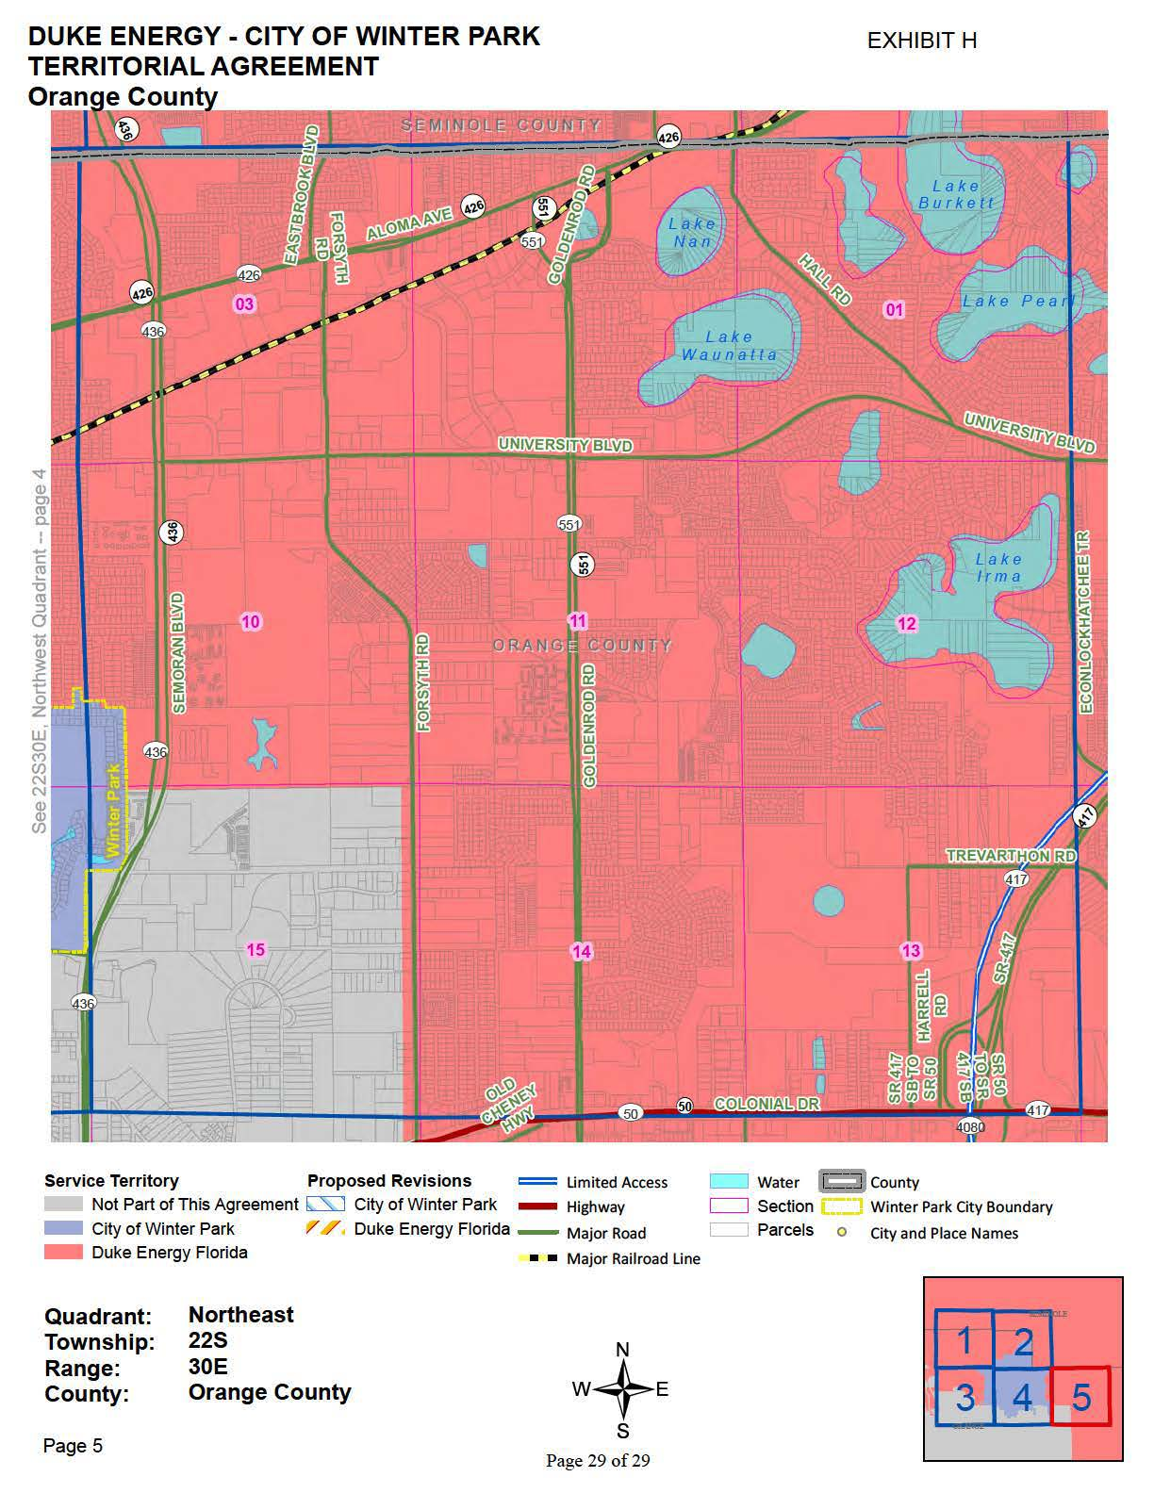

Order No. PSC-05-0453-PAA-EI, issued April 28, 2005, in Docket No. 20050117-EI, In re: Petition to relieve Progress Energy Florida, Inc. of the statutory obligation to provide electrical service to certain customers within the City of Winter Park, pursuant to Section 366.03 and 366.04, F.S.
Order No. PSC-14-0108-PAA-EU, issued February 24, 2014, in Docket No. 20130267-EU, In re: Joint petition for approval of territorial agreement in Orange County by the City of Winter Park and Duke Energy Florida, Inc.
Document No. 12808-2021.
Utilities Commission of the City of New Smyrna Beach v. Florida Public Service Commission, 469 So. 2d 731 (Fla. 1985).
Document No. 12593-2021, Response 1 and Revised Exhibit F to Staff’s Second Data Request.
In August 2021, DEF’s residential rate for 1,000 kWh was $132.21 and commercial rate for 1,500 kWh was $207.72. For the same month, Winter Park residential rate for 1,000 kWh was $115.30 and commercial rate for 1,500 kWh was $183.57.
Document No. 12404-2021, Response 2 in Staff’s First Data Request.
Document No. 12404-2021, Response 2 and Attachment A to Staff’s First Data Request.

