BEFORE THE FLORIDA PUBLIC SERVICE COMMISSION

In re: Joint motion requesting Commission approval of settlement agreement by the Office of Public Counsel and Black Bear Waterworks, Inc. | DOCKET NO. 20210174-WU  ORDER NO. PSC-2021-0461-PAA-WU  ISSUED: December 15, 2021

The following Commissioners participated in the disposition of this matter:

GARY F. CLARK, Chairman
ART GRAHAM
ANDREW GILES FAY
MIKE LA ROSA
GABRIELLA PASSIDOMO

NOTICE OF PROPOSED AGENCY ACTION
ORDER APPROVING SETTLEMENT ADDRESSING POTENTIAL OVEREARNINGS

BY THE COMMISSION:

NOTICE is hereby given by the Florida Public Service Commission that the action discussed herein is preliminary in nature and will become final unless a person whose interests are substantially affected files a petition for a formal proceeding, pursuant to Rule 25-22.029, Florida Administrative Code (F.A.C.).

Background
Black Bear Waterworks, Inc. (Black Bear or Utility) is a Class C utility serving approximately 331 water customers in Lake County. Black Bear was previously identified as potentially overearning in 2017, and agreed to refund 10.44 percent of water revenues billed for 2017, as a result of a Commission-approved Settlement Agreement in that case. Based on its review of Black Bear’s 2020 Annual Report, Commission staff identified potential 2021 overearnings. By letter dated August 5, 2021, Black Bear acknowledged our jurisdiction over revenues in excess of the maximum of the allowed Return on Equity (ROE) for 2021. On October 15, 2021 and October 27, 2021, informal meetings were held between Black Bear and the Office of Public Counsel (OPC) (collectively referred to as Parties) to discuss the disposition of potential 2021 overearnings. On November 5, 2021, Black Bear and OPC filed a Joint Motion requesting our approval of a Settlement Agreement to resolve potential 2021 overearnings.
The Joint Motion and Settlement Agreement have been attached as Attachment A to this order. We have jurisdiction pursuant to Sections 367.081, 367.082, and 367.121, Florida Statutes.

Decision
As stated in the background, as part of its ongoing surveillance activities, Commission staff identified possible overearnings based upon its review of Black Bear’s 2020 Annual Report. On November 5, 2021, the Parties filed a Joint Motion requesting our approval of a Settlement Agreement to resolve the disposition of 2021 overearnings, and address possible overearnings for 2022. With respect to 2021 overearnings, the Settlement Agreement provides that Black Bear should refund, via bill credits, 16.57 percent of water revenues billed for the calendar year 2021. The bill credits are anticipated to total approximately $32,500, and are expected to be issued during the first quarter of 2022. The refunds will be made in accordance with Rule 25-30.360, F.A.C.
In its letter dated August 5, 2021, the Utility indicated that it intends to consolidate Black Bear, as well as nine other subsidiary systems that are located within the same geographic vicinity, into a new corporation. This merger is intended to recognize efficiencies and resolve the historical difficulties in earnings for these systems. Many of the systems included in the planned consolidation have habitually earned below the bottom of their authorized rate of return on equity, while others have occasionally overearned while having relatively low rates.
The Settlement Agreement also provides protections for customers for possible overearnings of Black Bear in 2022. Black Bear has agreed to hold subject to refund all revenues received during calendar year 2022 that are above its authorized ROE range until a final review of its 2022 Annual Report is made.
In keeping with our long-standing policy and practice of encouraging parties to settle issues whenever possible, we hereby approve the Joint Motion and Settlement Agreement by the Parties. The proposed Settlement Agreement adequately addresses the potential overearnings Commission staff identified during its ongoing earnings surveillance activities, and provides protections for Black Bear’s customer for possible overearnings in 2022.
Based on the foregoing, it is

ORDERED by the Florida Public Service Commission that the proposed Settlement Agreement, attached hereto, is approved. As outlined in the Settlement Agreement, Black Bear shall refund 16.57 percent of water revenues billed for the calendar year 2021. It is further

ORDERED that the provisions of this Order, issued as proposed agency action, shall become final and effective upon the issuance of a Consummating Order unless an appropriate petition, in the form provided by Rule 28-106.201, Florida Administrative Code, is received by the Commission Clerk, 2540 Shumard Oak Boulevard, Tallahassee, Florida 32399-0850, by the close of business on the date set forth in the “Notice of Further Proceedings” attached hereto. It is further

ORDERED that this docket shall remain open to allow Commission staff to verify completion of the refunds approved herein. Once staff has verified that the refunds have been made in accordance with Rule 25-30.360, F.A.C., the docket shall be closed administratively.

By ORDER of the Florida Public Service Commission this 15th day of December, 2021.

/s/ Adam J. Teitzman
ADAM J. TEITZMAN
Commission Clerk
Florida Public Service Commission
2540 Shumard Oak Boulevard
Tallahassee, Florida 32399
(850) 413-6770
www.floridapsc.com

Copies furnished: A copy of this document is provided to the parties of record at the time of issuance and, if applicable, interested persons.

JSC

NOTICE OF FURTHER PROCEEDINGS OR JUDICIAL REVIEW

The Florida Public Service Commission is required by Section 120.569(1), Florida Statutes, to notify parties of any administrative hearing that is available under Section 120.57, Florida Statutes, as well as the procedures and time limits that apply. This notice should not be construed to mean all requests for an administrative hearing will be granted or result in the relief sought.

Mediation may be available on a case-by-case basis. If mediation is conducted, it does not affect a substantially interested person's right to a hearing.

The action proposed herein is preliminary in nature. Any person whose substantial interests are affected by the action proposed by this order may file a petition for a formal proceeding, in the form provided by Rule 28-106.201, Florida Administrative Code. This petition must be received by the Office of Commission Clerk, 2540 Shumard Oak Boulevard, Tallahassee, Florida 32399-0850, by the close of business on January 5, 2022.

In the absence of such a petition, this order shall become final and effective upon the issuance of a Consummating Order.

Any objection or protest filed in this/these docket(s) before the issuance date of this order is considered abandoned unless it satisfies the foregoing conditions and is renewed within the specified protest period.

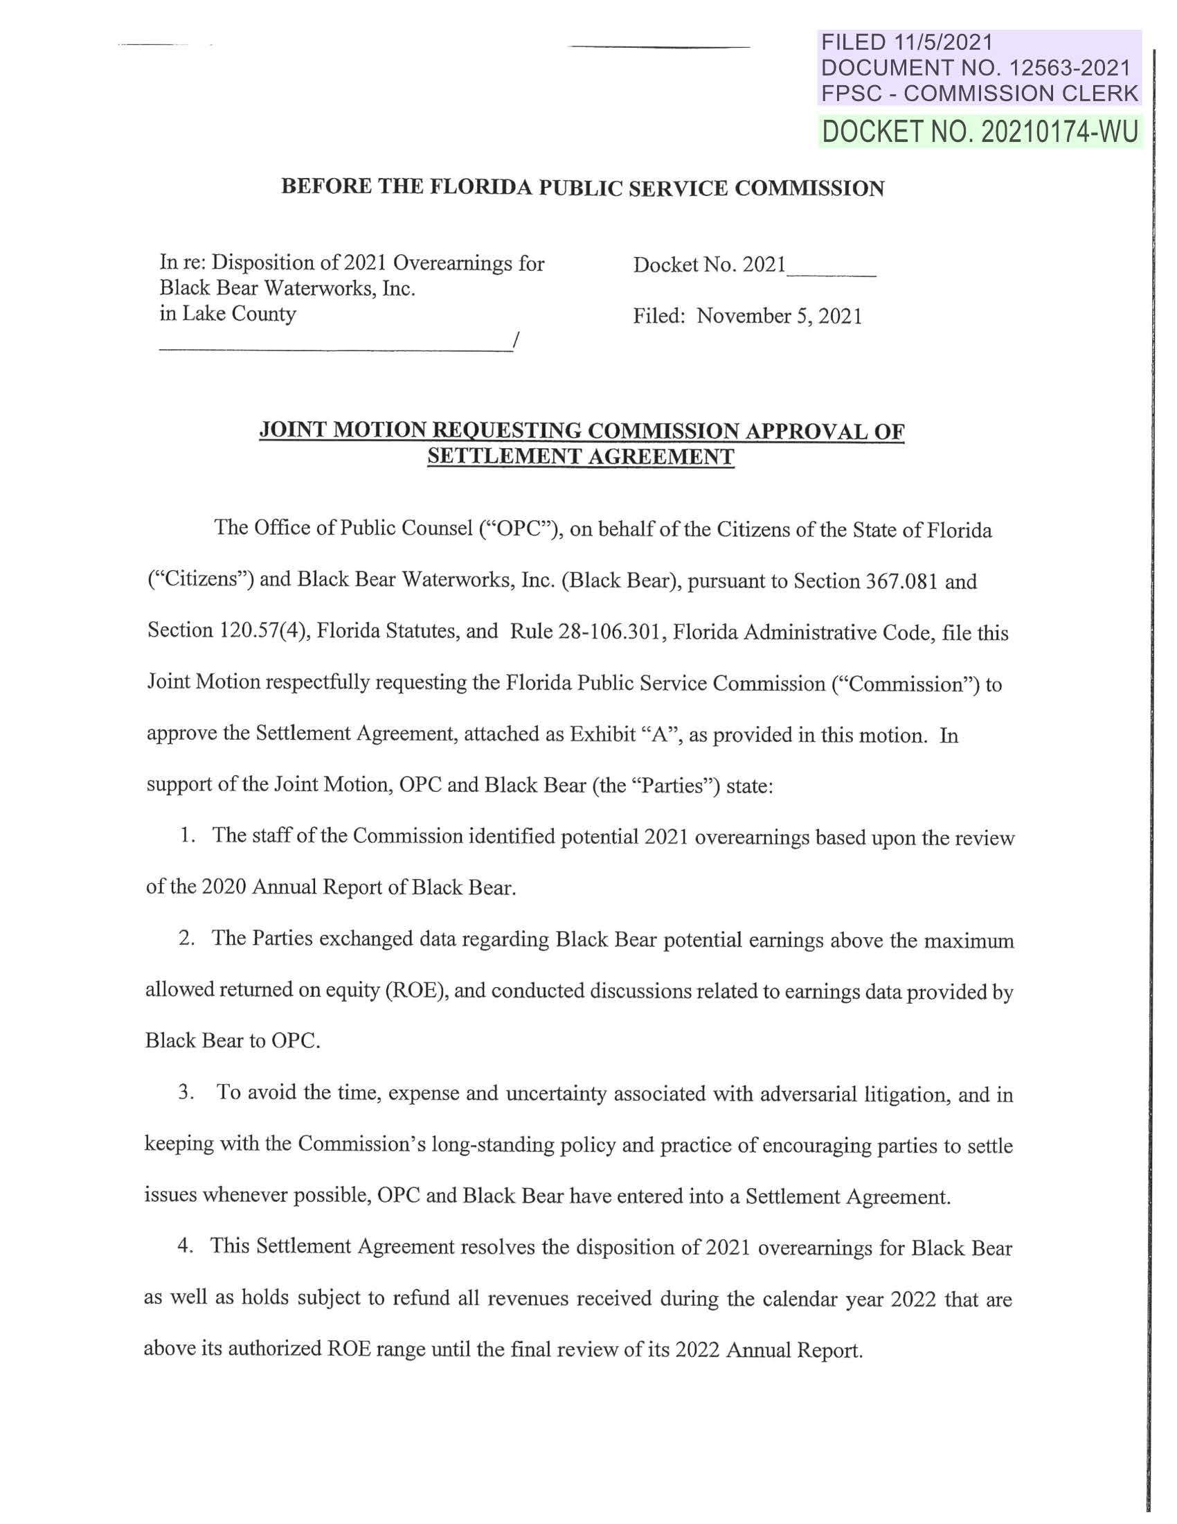

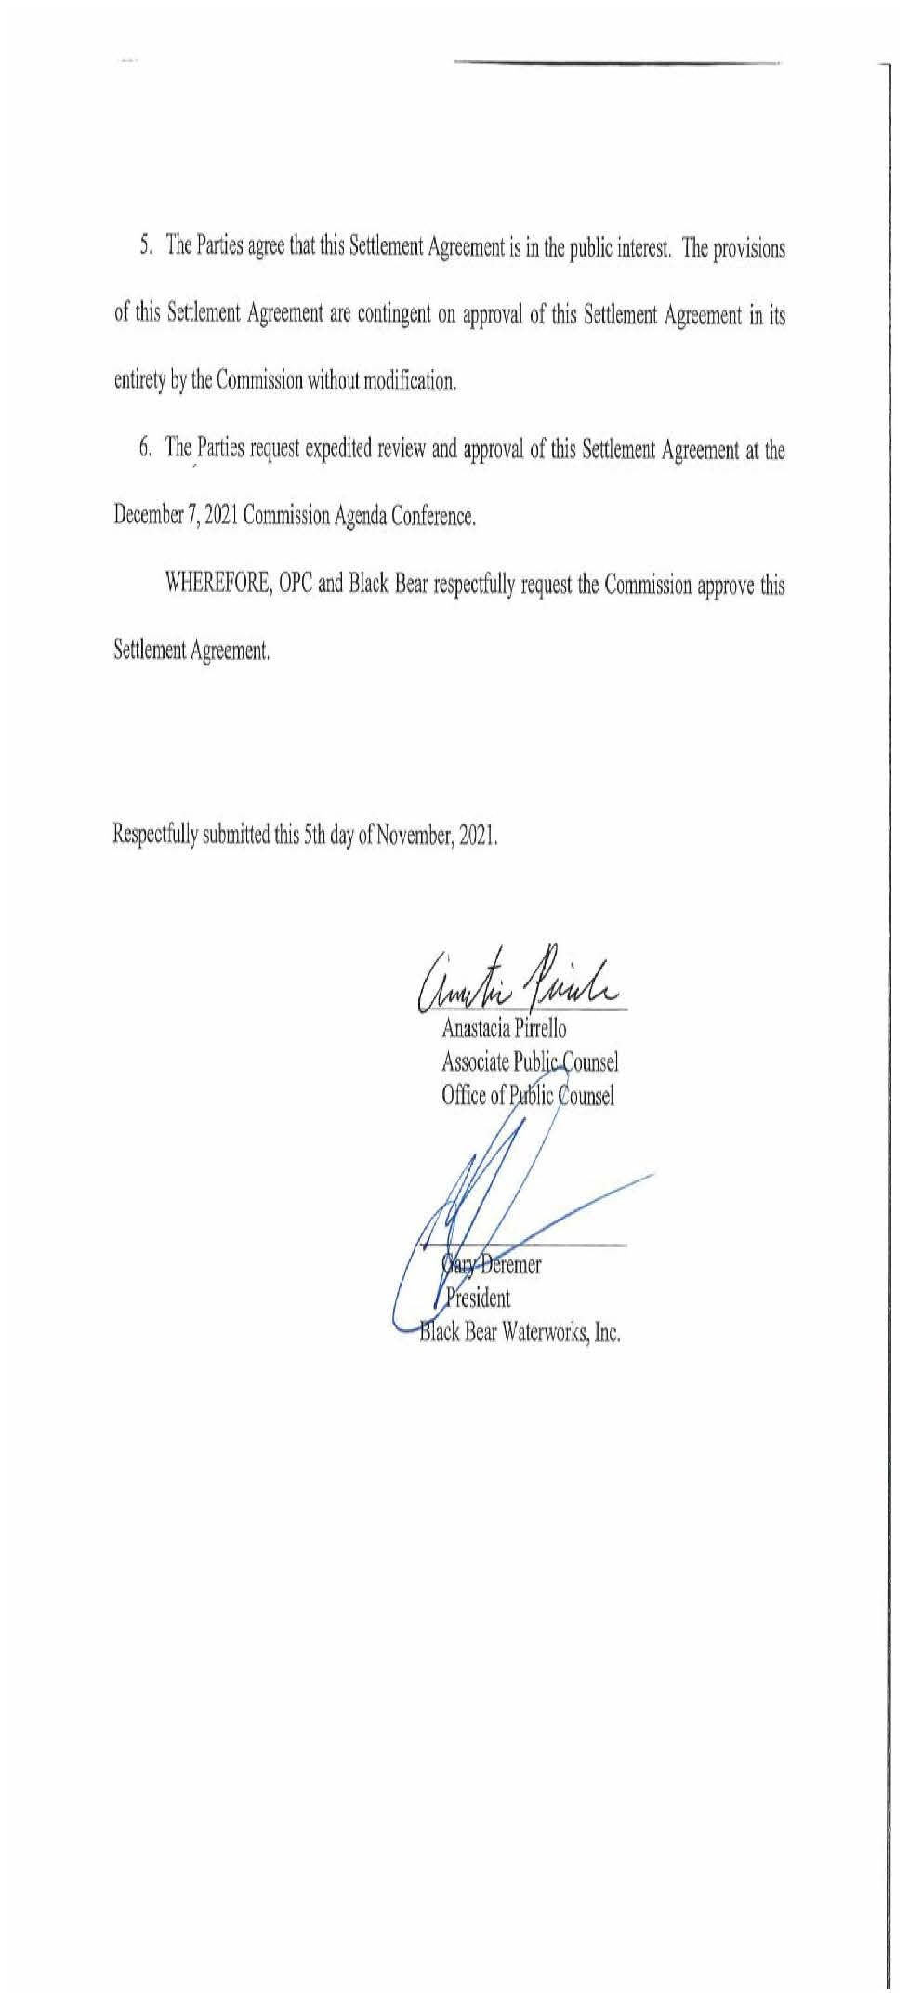
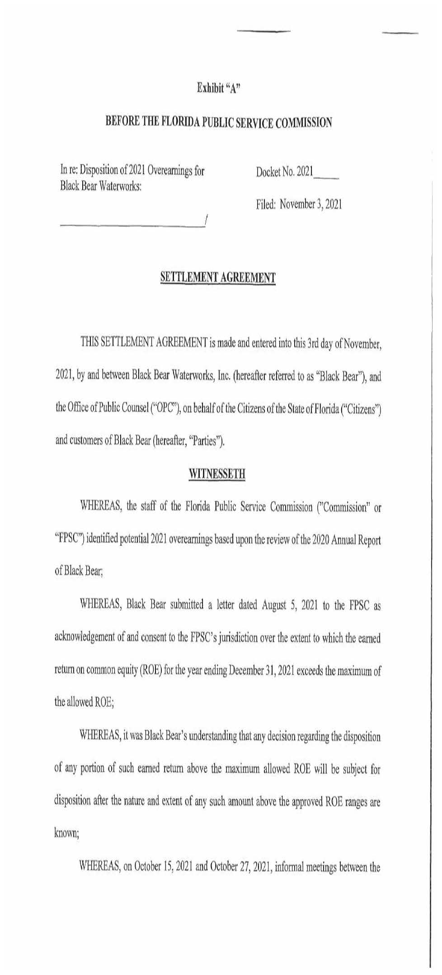

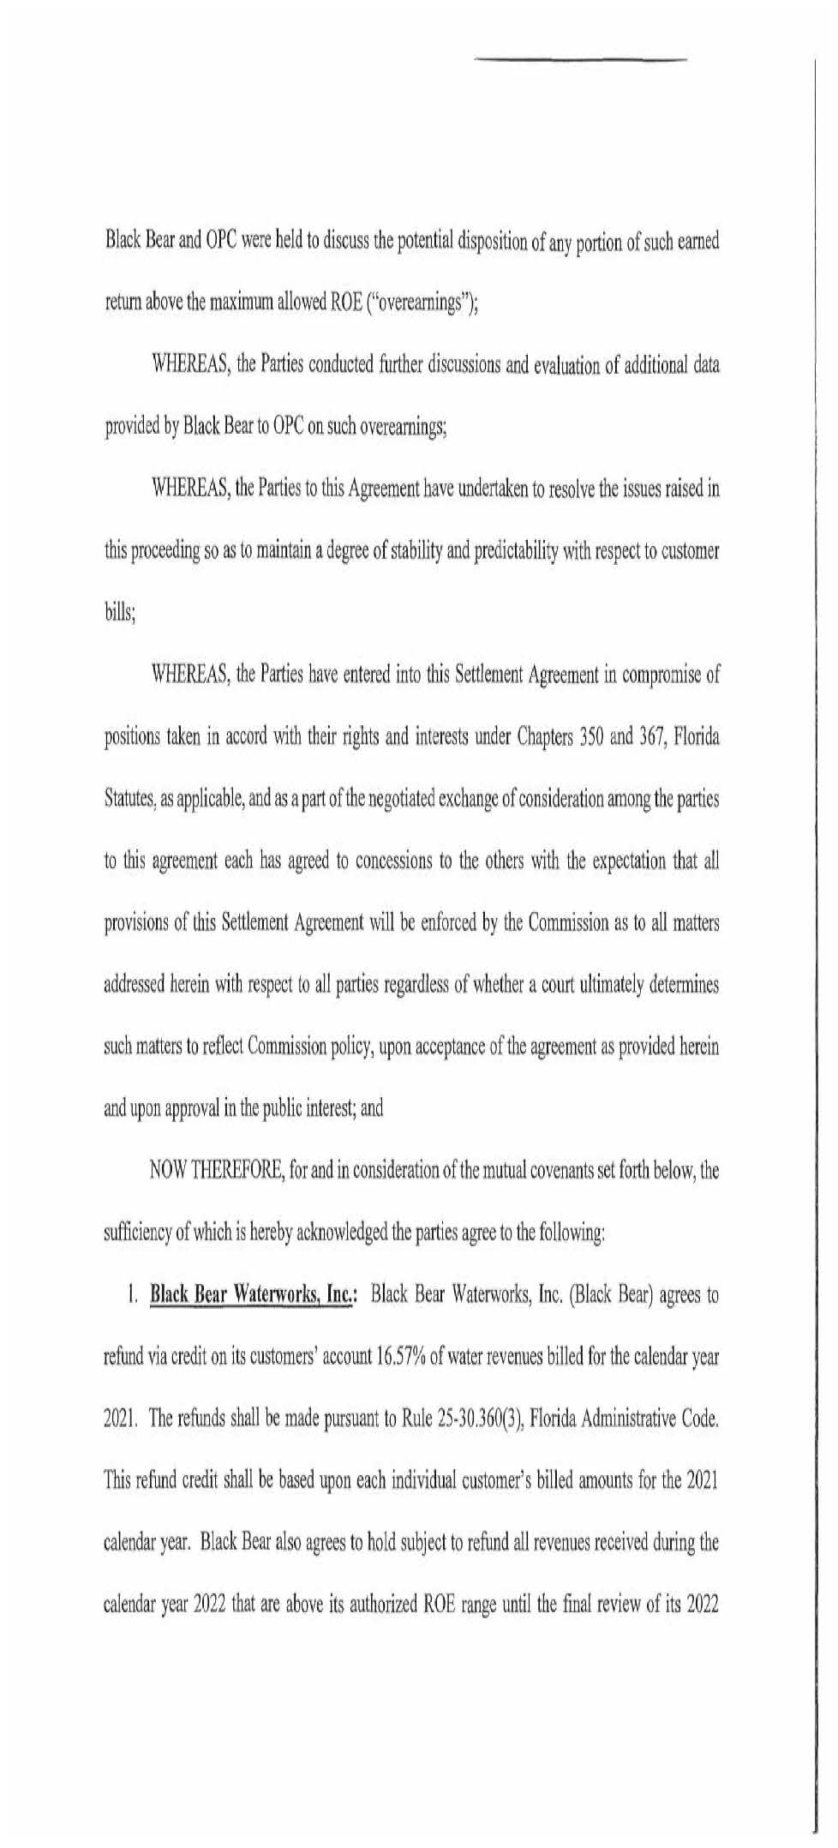

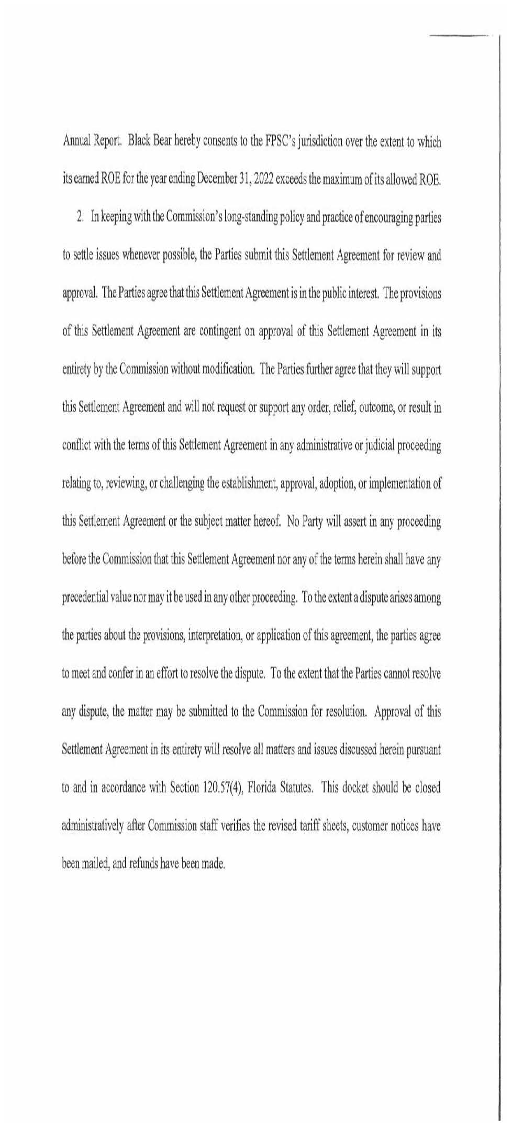
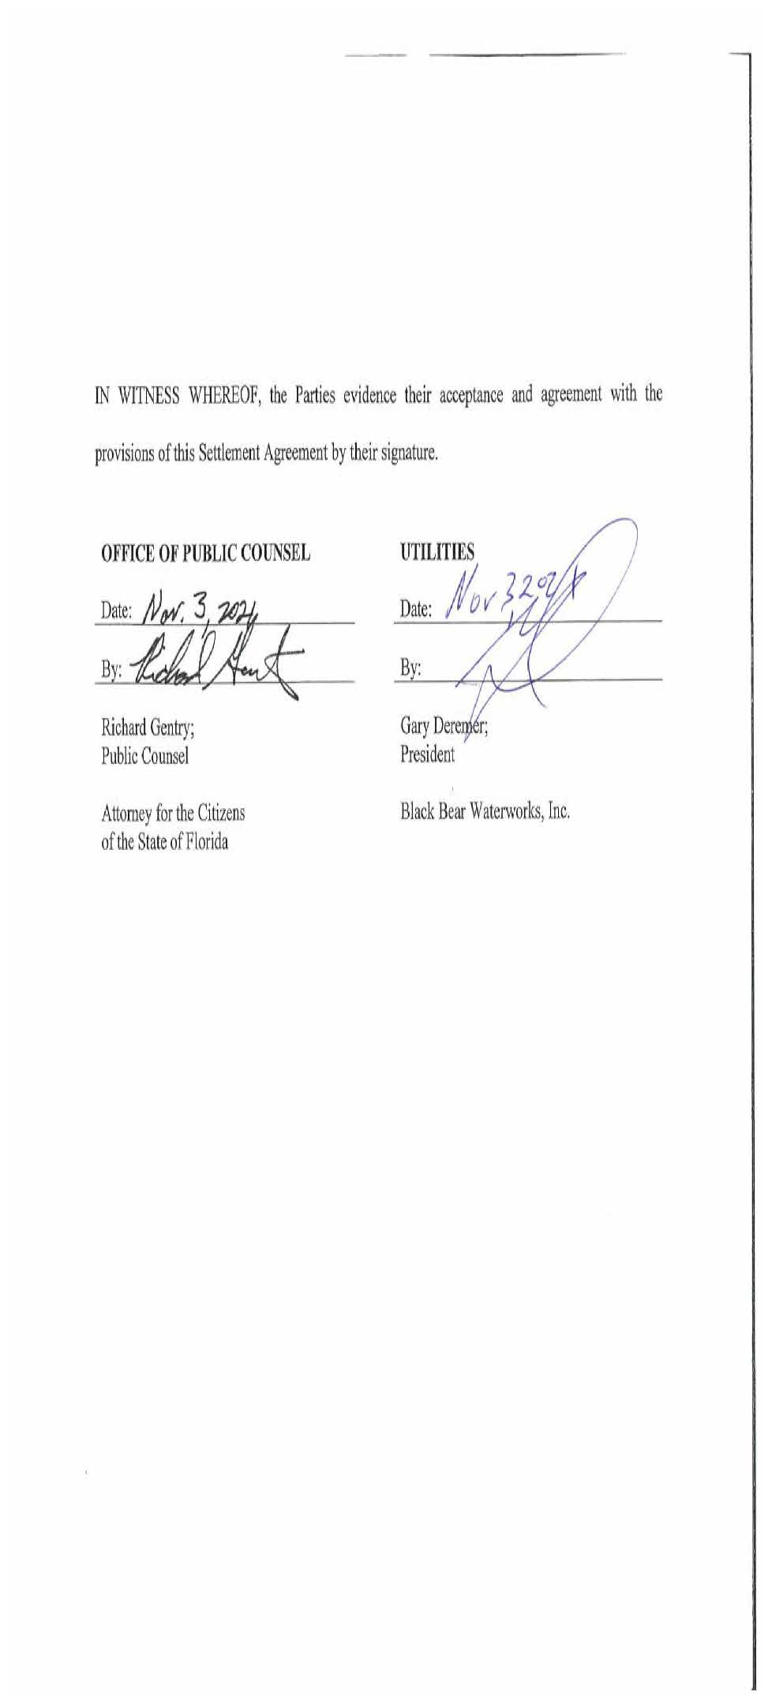

Order No. PSC-2017-0481-PAA-WU, issued December 21, 2017, in Docket 20170247-WU, In re: Joint Motion requesting Commission approval of settlement agreement by the Office of Public Counsel, Black Bear Waterworks, Inc., Brendenwood Waterworks, Inc., Brevard Waterworks, Inc., Country Walk Utilities, Inc., Harbor Waterworks, Inc., Lake Idlewild Utility Company, Raintree Waterworks, Inc., and Sunny Hills Utility Company.

