BEFORE THE FLORIDA PUBLIC SERVICE COMMISSION

|  |  |
| --- | --- |
| In re: Petition for approval of amended standard offer contract (Schedule COG-2), by Duke Energy Florida, LLC. | DOCKET NO. 20250054-EQ  ORDER NO. PSC-2025-0211-PAA-EQ  ISSUED: June 18, 2025 |

The following Commissioners participated in the disposition of this matter:

MIKE LA ROSA, Chairman

ART GRAHAM

GARY F. CLARK

ANDREW GILES FAY

GABRIELLA PASSIDOMO SMITH

NOTICE OF PROPOSED AGENCY ACTION

ORDER APPROVING DUKE ENERGY FLORIDA, LLC’S

AMENDED STANDARD OFFER CONTRACT AND RATE SCHEDULE (COG-2)

BY THE COMMISSION:

NOTICE is hereby given by the Florida Public Service Commission that the action discussed herein is preliminary in nature and will become final unless a person whose interests are substantially affected files a petition for a formal proceeding, pursuant to Rule 25-22.029, Florida Administrative Code (F.A.C.).

Case Background

Section 366.91(3), Florida Statutes (F.S.), requires each investor-owned utility (IOU) to continuously offer to purchase capacity and energy from renewable generating facilities (RF) and small qualifying facilities (QF). Rules 25-17.200 through 25-17.310, F.A.C., implement the statute and require each IOU to file with the Commission, by April 1 of each year, a revised standard offer contract based on the next avoidable fossil-fueled generating unit of each technology type identified in the utility’s current Ten-Year Site Plan (TYSP). On April 1, 2025, Duke Energy Florida, LLC (DEF) filed a petition for approval of its amended standard offer contract and rate schedule COG-2 based on its 2025 TYSP. We have jurisdiction over this amended standard offer contract, pursuant to Sections 366.04, 366.041, 366.05, 366.055, 366.06, and 366.91, F.S.

Analysis

Section 366.91(3), F.S., and Rule 25-17.250, F.A.C., require that an IOU continuously make available a standard offer contract for the purchase of firm capacity and energy from RFs and QFs with design capacities of 100 kilowatts (kW) or less. Pursuant to Rules 25-17.250(1) and (3), F.A.C., the standard offer contract must provide a term of at least 10 years, the payment terms must be based on the utility’s next avoidable fossil-fueled generating unit identified in its most recent TYSP or, if no avoided unit is identified, its next avoidable planned purchase. In its 2025 Ten-Year Site Plan, DEF has identified a 245 megawatt (MW) natural gas-fueled combustion turbine as the next avoidable planned generating unit. This unit has a projected in-service date of June 1, 2033, with planned construction beginning in January 2029.

Under DEF’s amended standard offer contract, the RF/QF operator commits to certain minimum performance requirements, based on the identified avoided unit, such as being operational and delivering an agreed upon amount of capacity by the in-service date of the avoided unit. In this way, the RF/QF thereby becomes eligible for capacity payments in addition to payments received for energy. The standard offer contract may also serve as a starting point for negotiation of contract terms by providing payment information to an RF/QF operator in a situation where one or both parties desire particular contract terms other than those established in the standard offer.

In order to promote renewable generation, we require each IOU to offer multiple options for capacity payments, including the options to receive early or levelized payments. If the RF/QF operator elects to receive capacity payments under the normal or levelized contract options, it will receive as-available energy payments only until the in-service date of the avoided unit (in this case June 1, 2033). Thereafter, they begin receiving capacity payments in addition to firm energy payments. If either the early or early levelized option is selected, then the operator will begin receiving capacity payments earlier than the in-service date of the avoided unit. However, payments made under the early capacity payment options tend to be lower in the later years of the contract term, because the net present value (NPV) of the total payments must remain equal for all contract payment options.

Table 1 contains DEF’s estimates of the annual payments for the normal and levelized capacity payment options available under the amended standard offer contract to an operator with a 50 MW facility operating at a capacity factor of 95 percent, which is the minimum capacity factor required under the contract to qualify for full capacity payments. Normal and levelized capacity payments begin with the projected in-service date of the avoided unit (June 1, 2033), and continue for 10 years, while early and early levelized capacity payments begin two (2) years prior to the in-service date, or January 2031 in this case.

(*This area intentionally left blank.*)

Table 1

Estimated Annual Payments to a 50 MW Renewable Facility

(95% Capacity Factor)

|  |  |  |  |  |  |
| --- | --- | --- | --- | --- | --- |
| Year | Energy Payments | Capacity Payment | | | |
| Normal | Levelized | Early | Early Levelized |
| $(000) | $(000) | $(000) | $(000) | $(000) |
| 2026 | 13,585 | - | - | - | - |
| 2027 | 13,799 | - | - | - | - |
| 2028 | 13,538 | - | - | - | - |
| 2029 | 12,569 | - | - | - | - |
| 2030 | 12,141 | - | - | - | - |
| 2031 | 12,905 | - | - | 7,679 | 8,441 |
| 2032 | 14,327 | - | - | 7,807 | 8,444 |
| 2033 | 15,628 | 5,952 | 6,493 | 7,938 | 8,447 |
| 2034 | 16,721 | 10,374 | 11,135 | 8,071 | 8,450 |
| 2035 | 18,488 | 10,547 | 11,140 | 8,206 | 8,454 |
| 2036 | 19,381 | 10,724 | 11,144 | 8,344 | 8,457 |
| 2037 | 20,071 | 10,904 | 11,149 | 8,484 | 8,461 |
| 2038 | 19,203 | 11,087 | 11,153 | 8,626 | 8,464 |
| 2039 | 19,829 | 11,272 | 11,158 | 8,770 | 8,468 |
| 2040 | 21,259 | 11,461 | 11,163 | 8,917 | 8,472 |
| 2041 | 21,474 | 11,653 | 11,168 | 9,067 | 8,476 |
| 2042 | 20,957 | 11,849 | 11,173 | 9,219 | 8,480 |
| 2043 | 21,180 | 12,047 | 11,178 | 9,374 | 8,484 |
| 2044 | 20,761 | 12,249 | 11,184 | 9,531 | 8,488 |
| 2045 | 21,124 | 12,455 | 11,189 | 9,691 | 8,492 |
| Total | 348,940 | 142,575 | 140,427 | 129,723 | 126,975 |
| Total (NPV) | 172,068 | 54,425 | 54,425 | 54,425 | 54,425 |

Source: DEF’s Response to Staff’s First Data Request.[1]

DEF’s amended standard offer contract, in type-and-strike format, is included as Attachment A to this Order. The changes made to DEF’s tariff sheets are consistent with the updated avoided unit. Revisions include updates to calendar dates and payment information, which reflect the current economic and financial assumptions for the avoided unit.

Decision

We find that the provisions of DEF’s amended standard offer contract and the associated rate schedule COG-2 conform to the requirements of Rules 25-17.200 through 25-17.310, F.A.C. The amended standard offer contract offers multiple payment options so that a developer of renewable generation may select the payment stream best suited to its financial needs. Therefore, we will approve this amended standard offer contract and rate schedule COG-2.

Based on the foregoing, it is

ORDERED by the Florida Public Service Commission that Duke Energy Florida, LLC’s petition for approval of amended standard offer contract and the associated rate schedule COG-2 is granted. The amended standard offer contract and the associated rate schedule COG-2, attached hereto as Attachment A, are approved as filed. The standard offer contract and the associated rate schedule COG-2 conform to the requirements of Rules 25-17.200 through 25-17.310, Florida Administrative Code. Further, the amended standard offer contract offers multiple payment options so that a developer of renewable energy may select the payment stream best suited to its financial needs. It is further

ORDERED that the provisions of this Order, issued as a proposed agency action, shall become final and effective upon the issuance of a Consummating Order unless an appropriate petition, in the form provided by Rule 28-106.201, Florida Administrative Code, is received by the Commission Clerk, 2540 Shumard Oak Boulevard, Tallahassee, Florida 32399-0850, by the close of business on the date set forth in the “Notice of Further Proceedings” attached hereto. Potential signatories are hereby made aware that, if a timely protest is filed, Duke Energy Florida, LLC’s standard offer contract may subsequently be revised. It is further

ORDERED that in the event this Order becomes final, this docket shall be closed.

By ORDER of the Florida Public Service Commission this 18th day of June, 2025.

|  |  |
| --- | --- |
|  | /s/ Adam J. Teitzman |
|  | ADAM J. TEITZMAN  Commission Clerk |

Florida Public Service Commission

2540 Shumard Oak Boulevard

Tallahassee, Florida 32399

(850) 413‑6770

www.floridapsc.com

Copies furnished: A copy of this document is provided to the parties of record at the time of issuance and, if applicable, interested persons.

JLA

NOTICE OF FURTHER PROCEEDINGS OR JUDICIAL REVIEW

The Florida Public Service Commission is required by Section 120.569(1), Florida Statutes, to notify parties of any administrative hearing that is available under Section 120.57, Florida Statutes, as well as the procedures and time limits that apply. This notice should not be construed to mean all requests for an administrative hearing will be granted or result in the relief sought.

Mediation may be available on a case-by-case basis. If mediation is conducted, it does not affect a substantially interested person's right to a hearing.

The action proposed herein is preliminary in nature. Any person whose substantial interests are affected by the action proposed by this order may file a petition for a formal proceeding, in the form provided by Rule 28-106.201, Florida Administrative Code. This petition must be received by the Office of Commission Clerk, 2540 Shumard Oak Boulevard, Tallahassee, Florida 32399-0850, by the close of business on July 9, 2025.

In the absence of such a petition, this order shall become final and effective upon the issuance of a Consummating Order.

Any objection or protest filed in this/these docket(s) before the issuance date of this order is considered abandoned unless it satisfies the foregoing conditions and is renewed within the specified protest period.

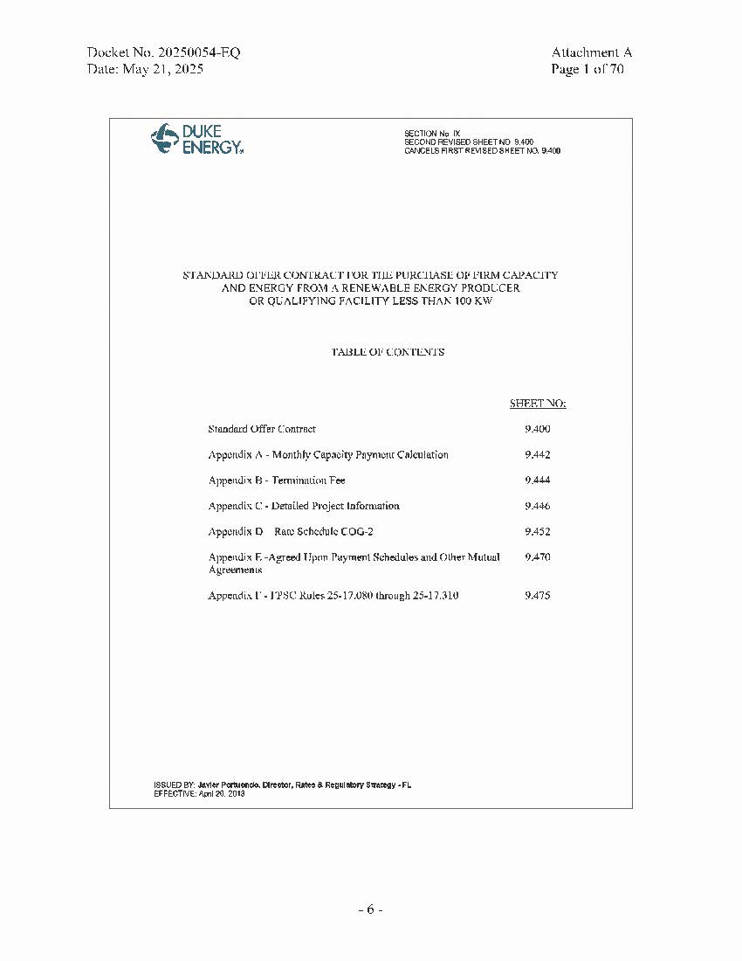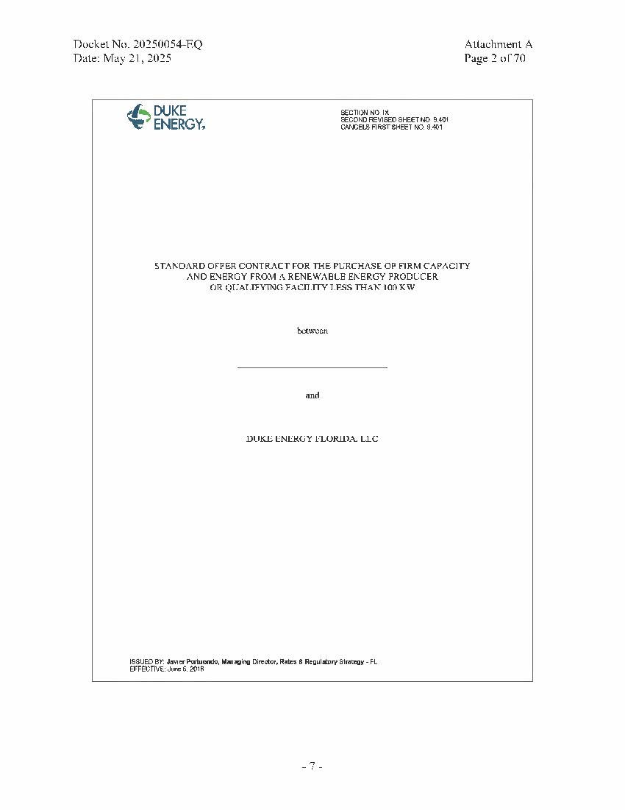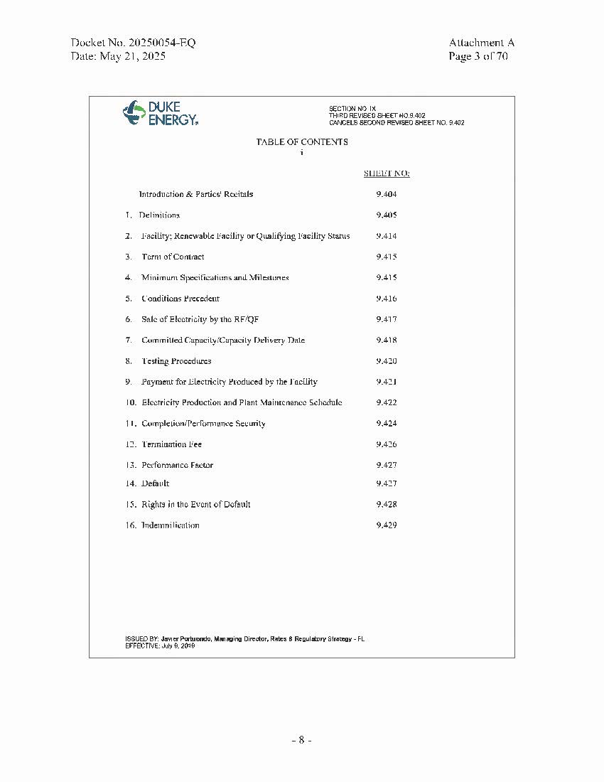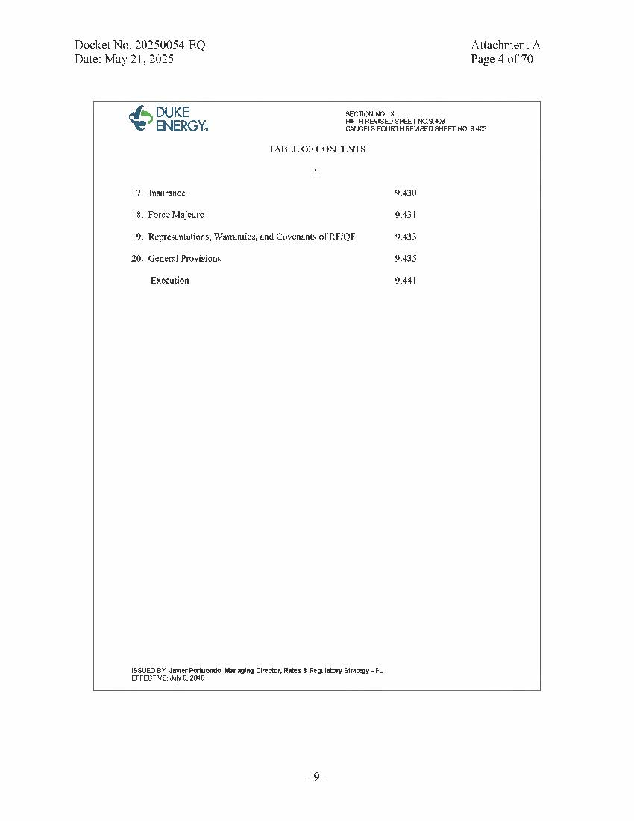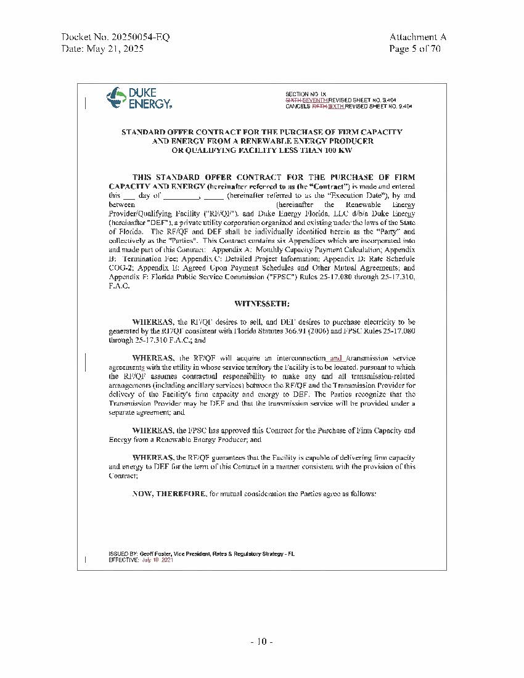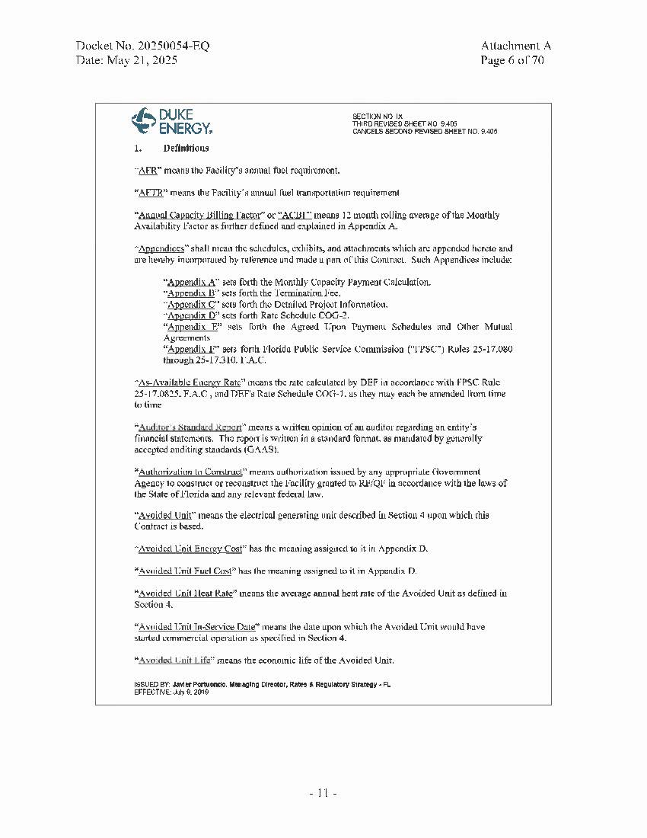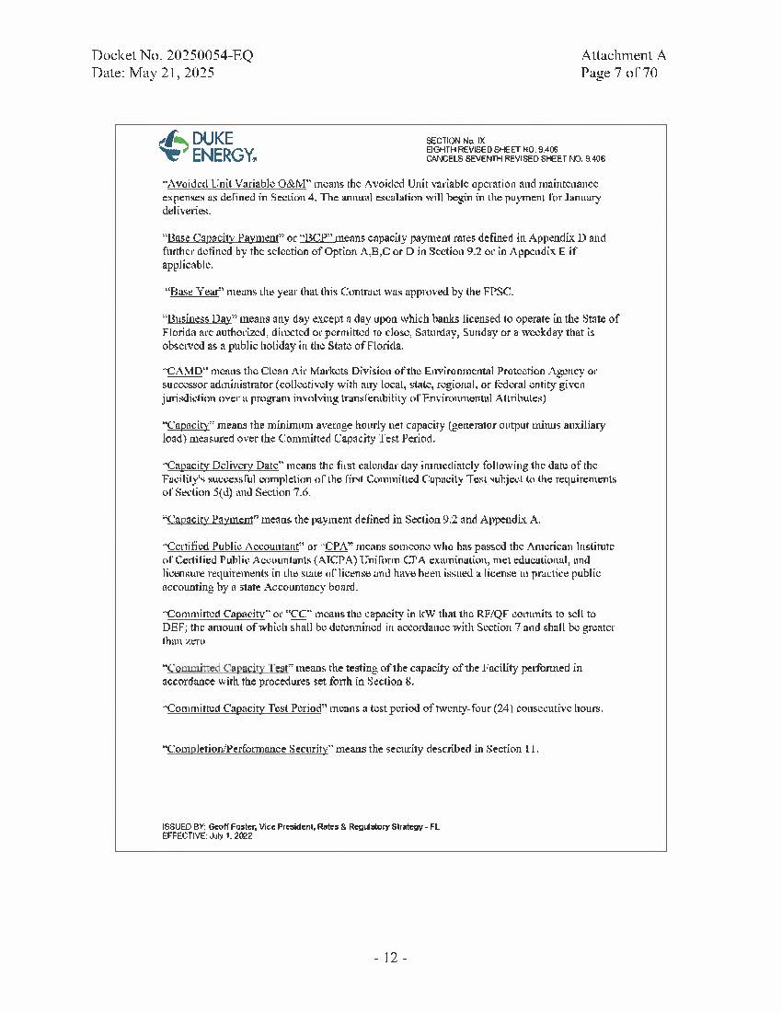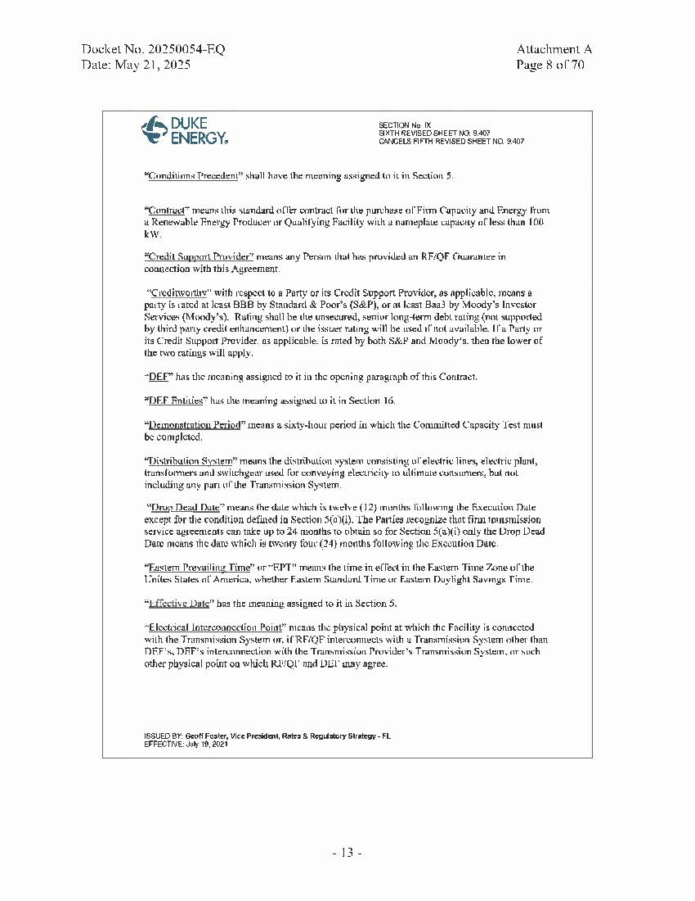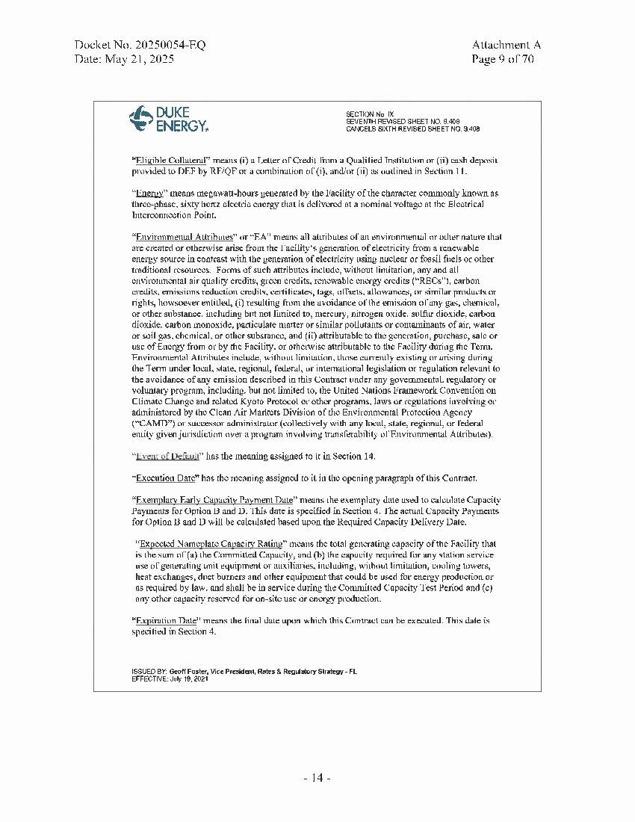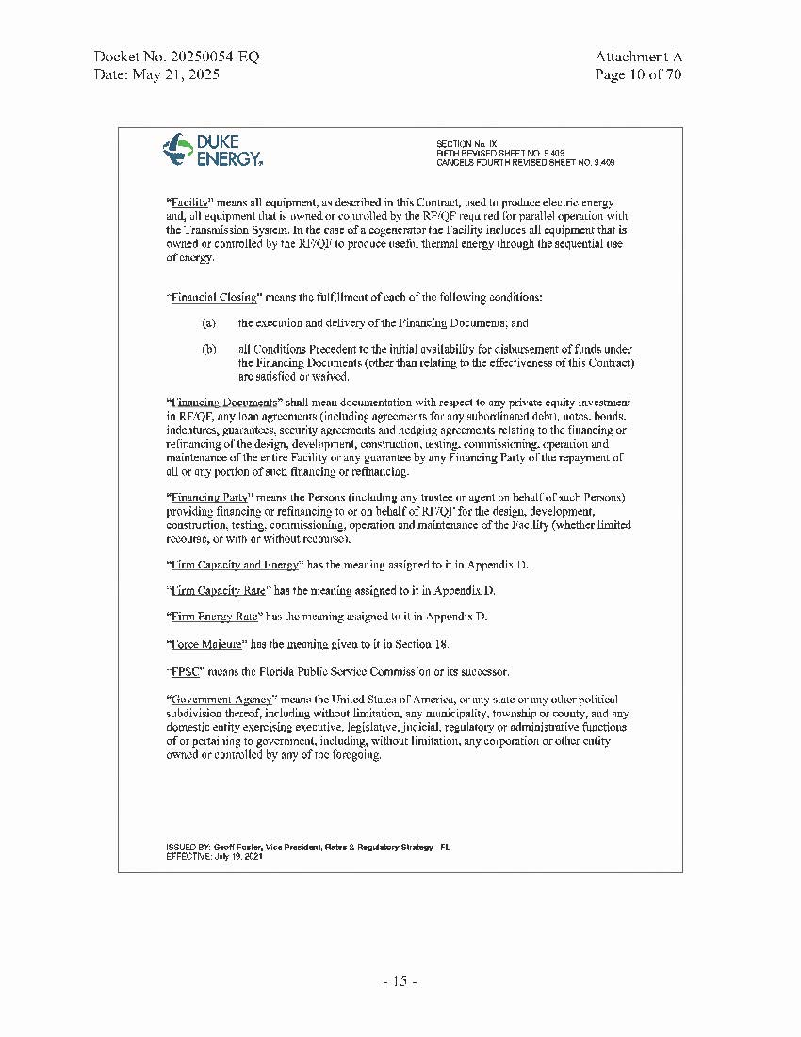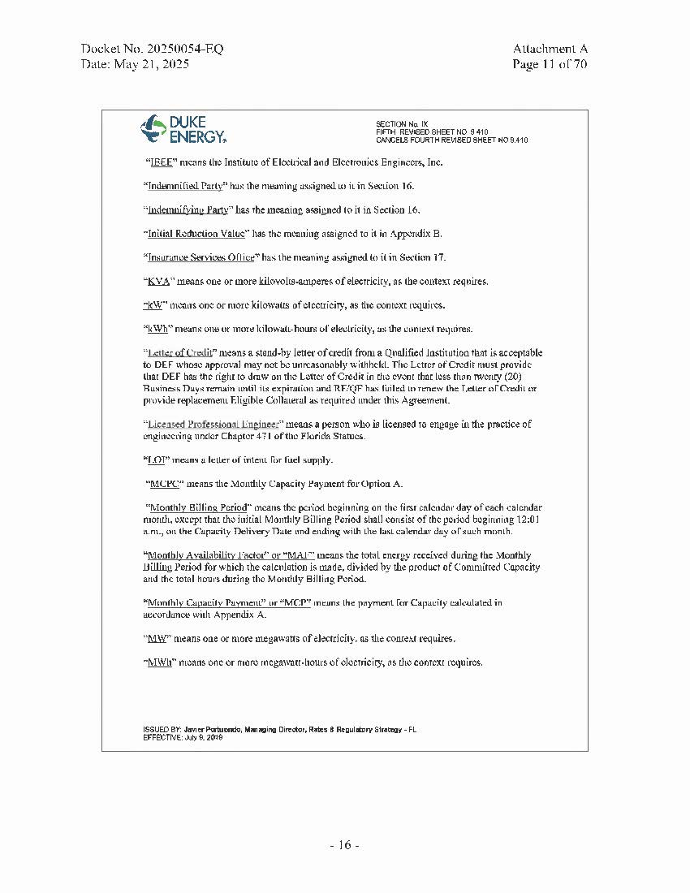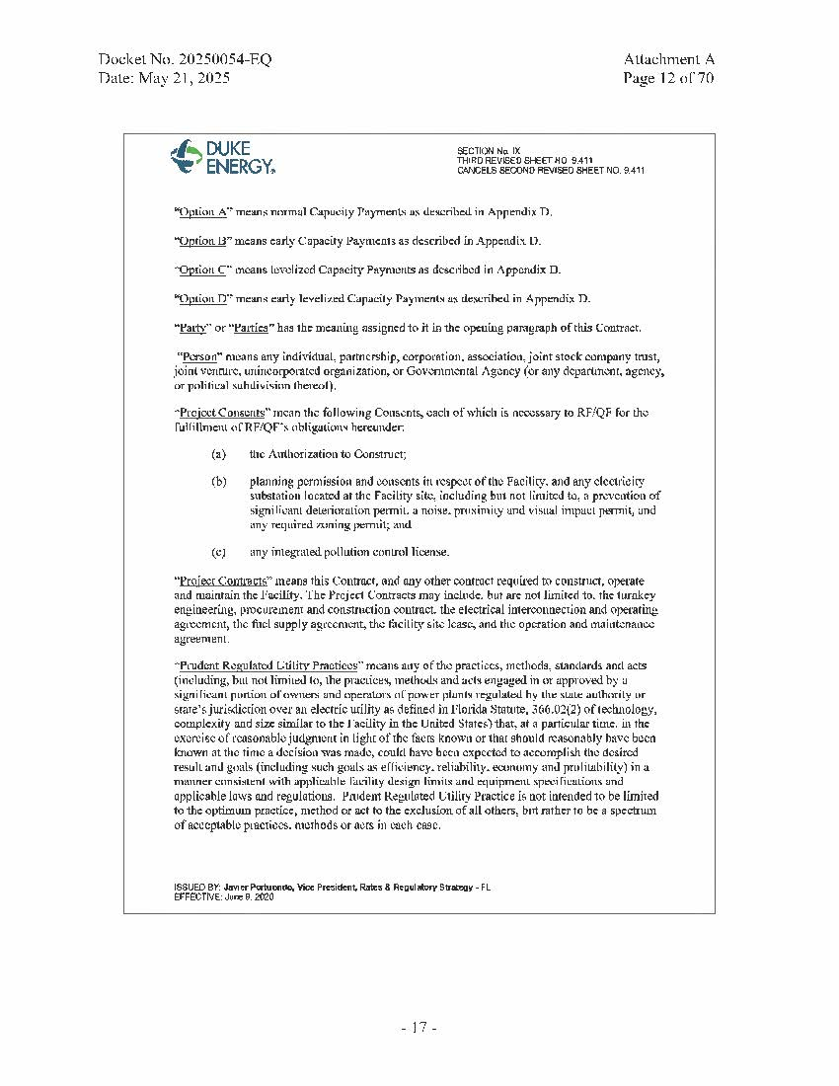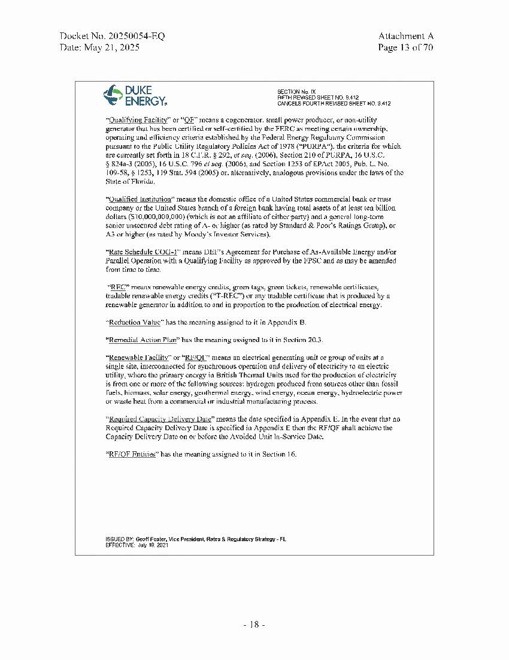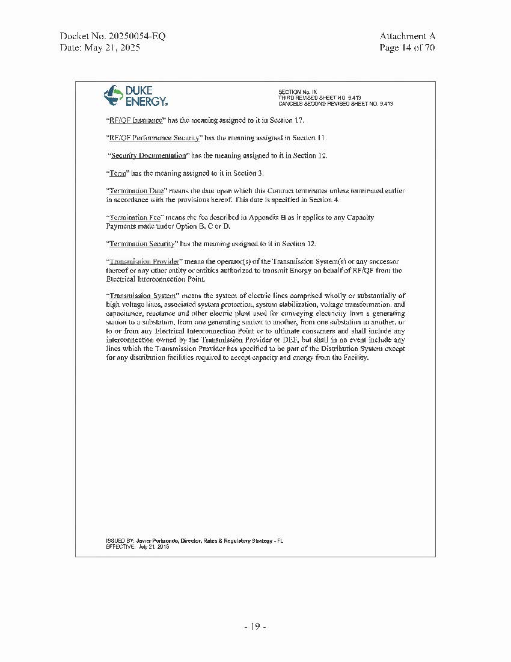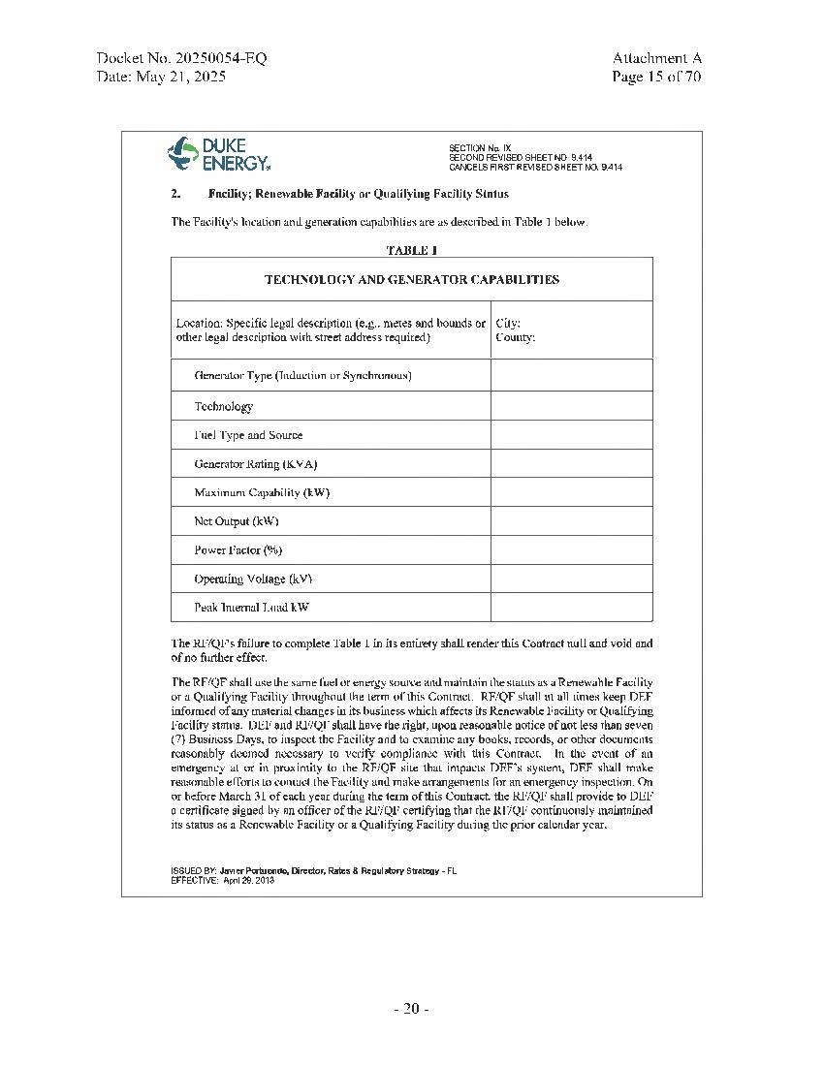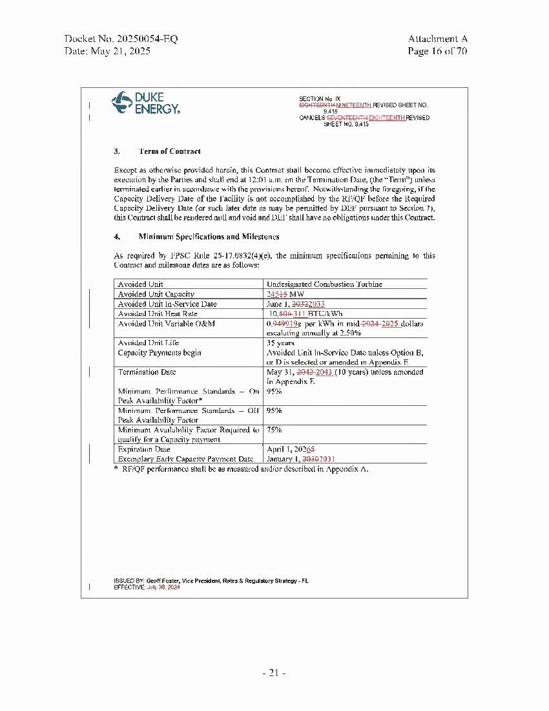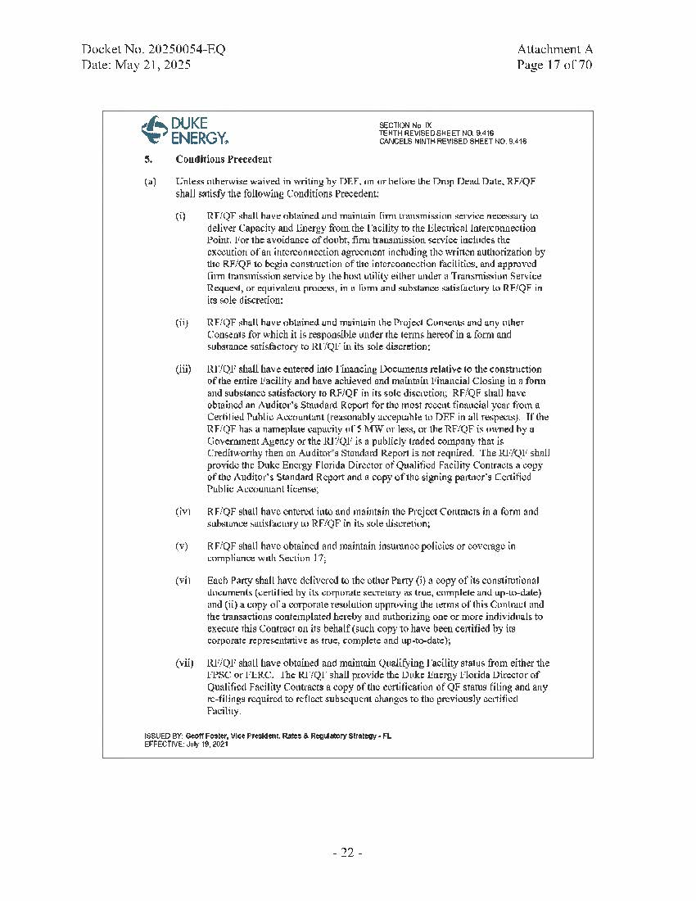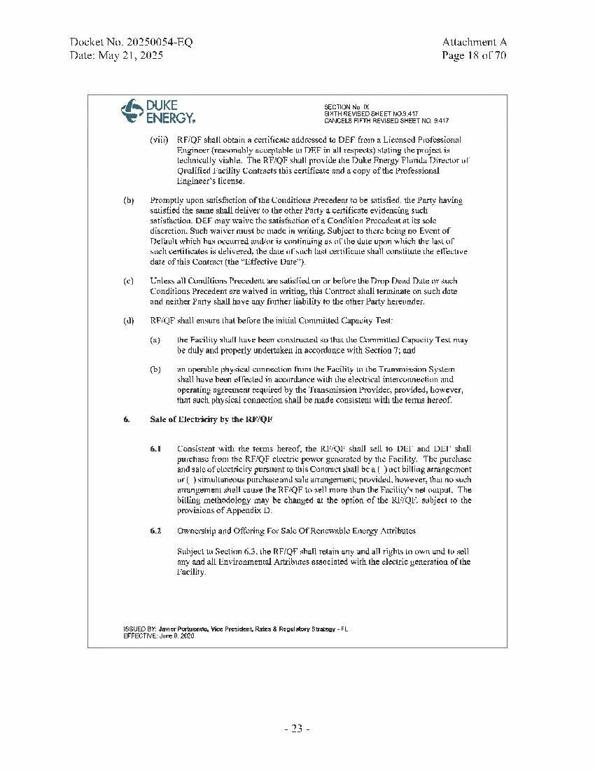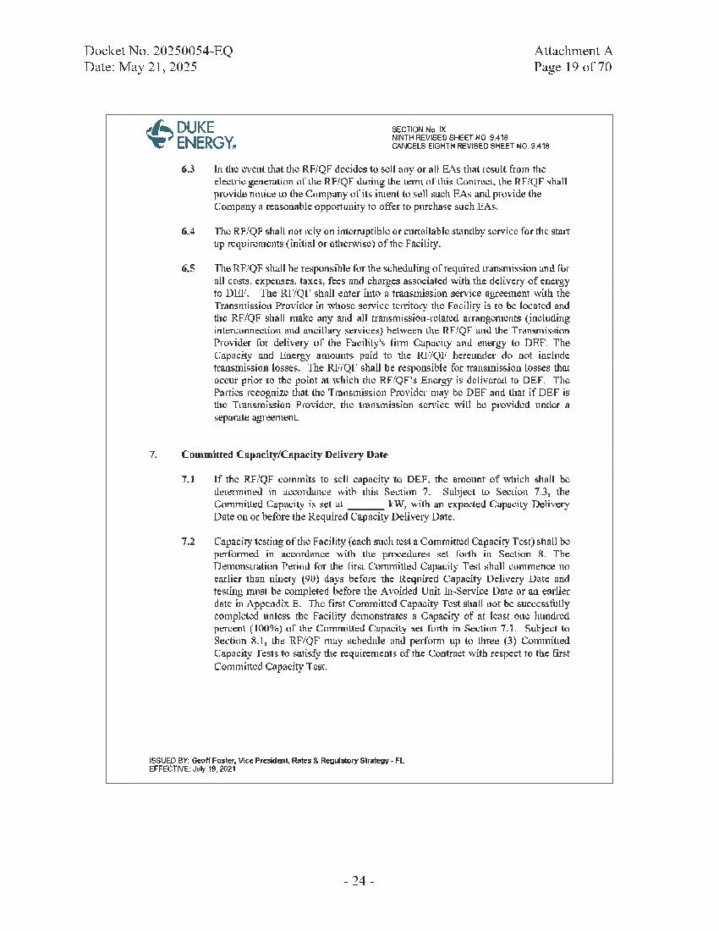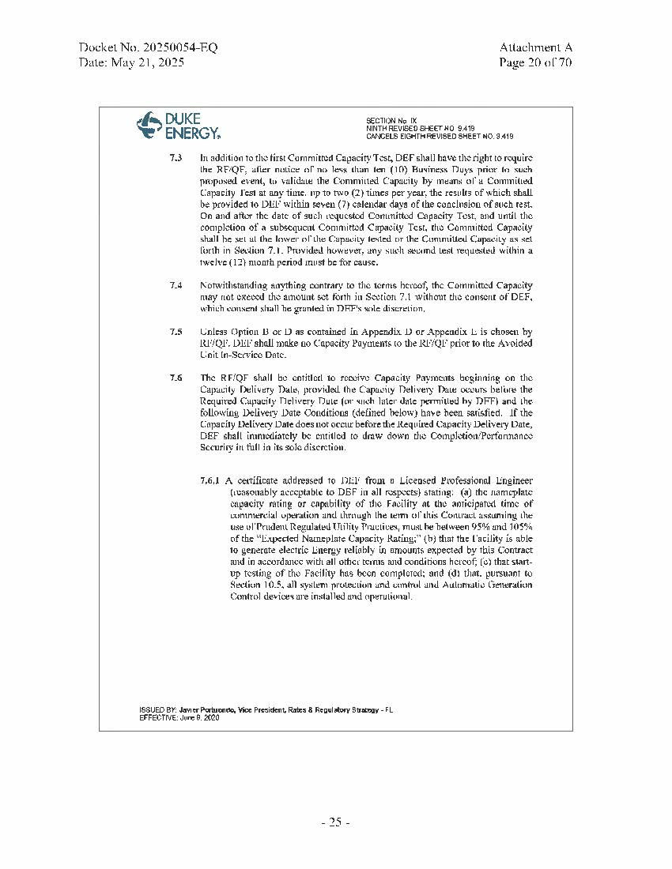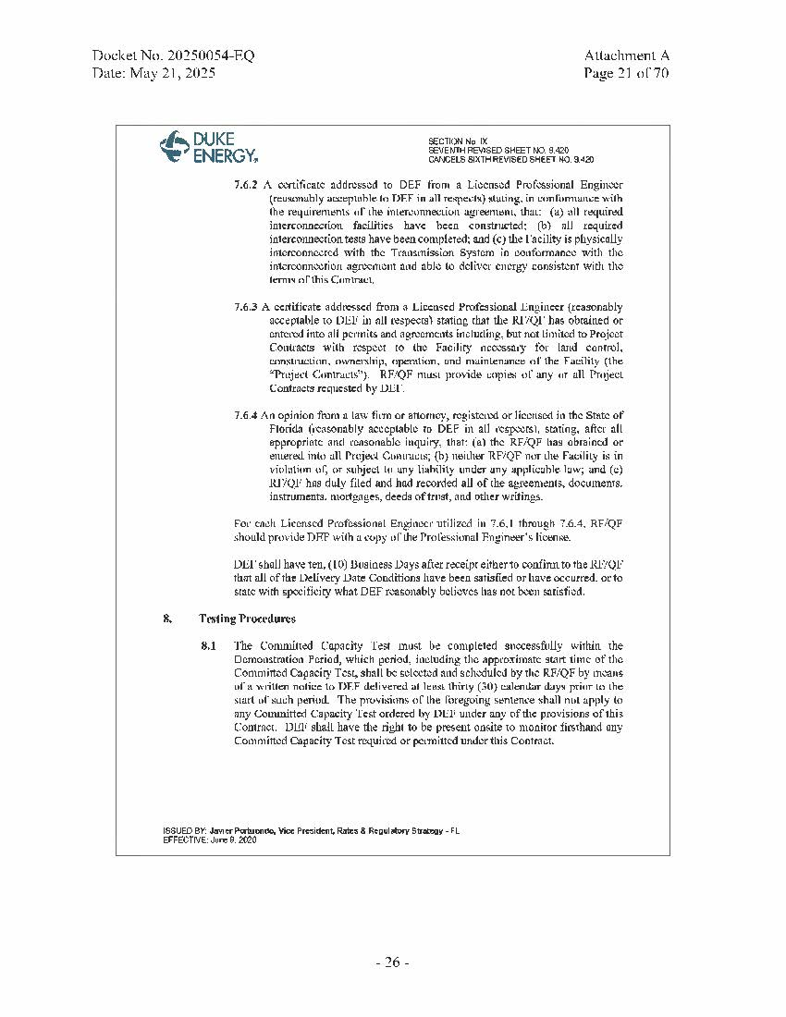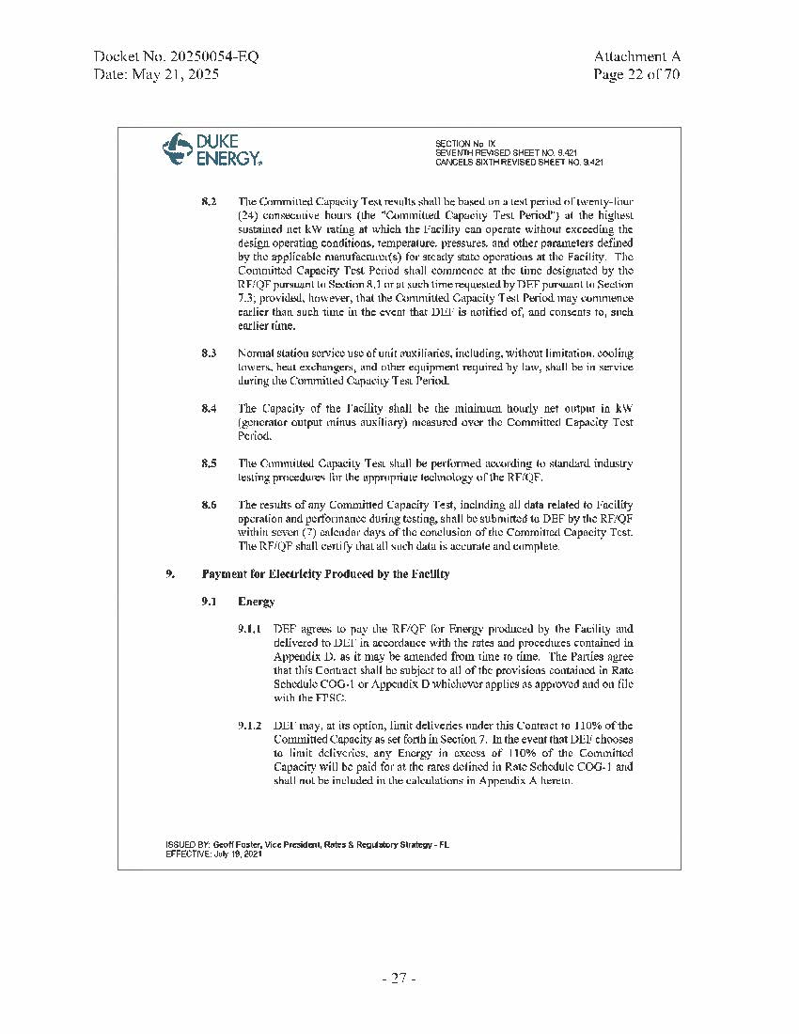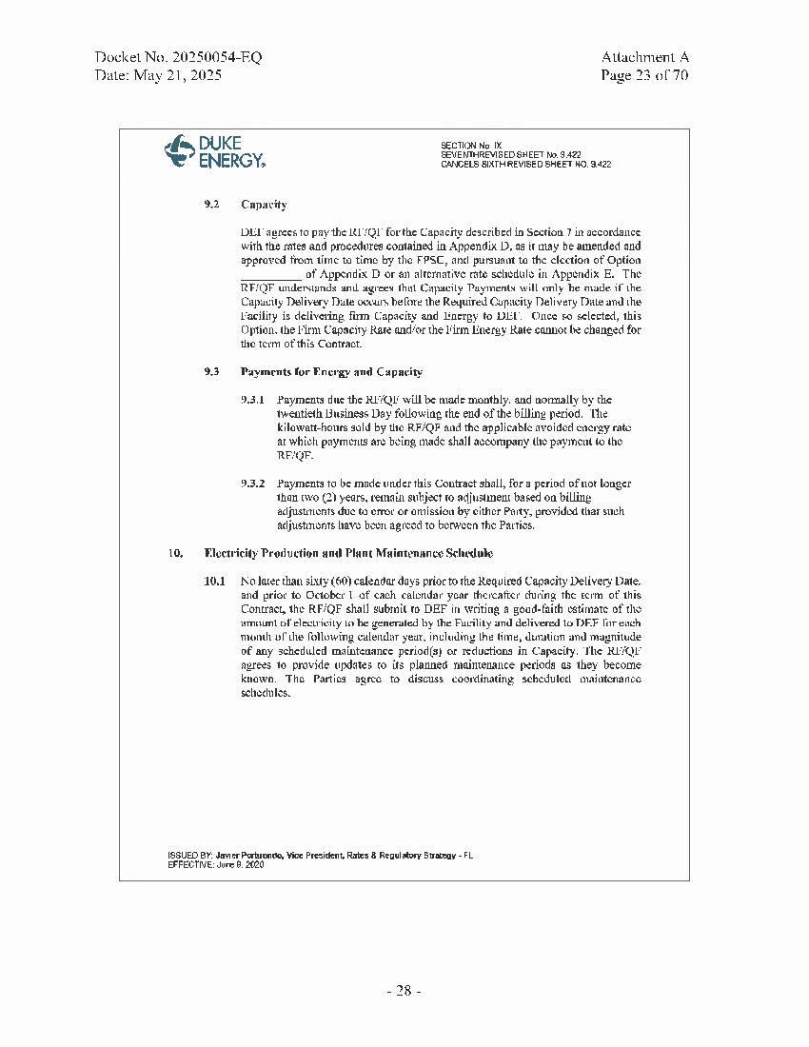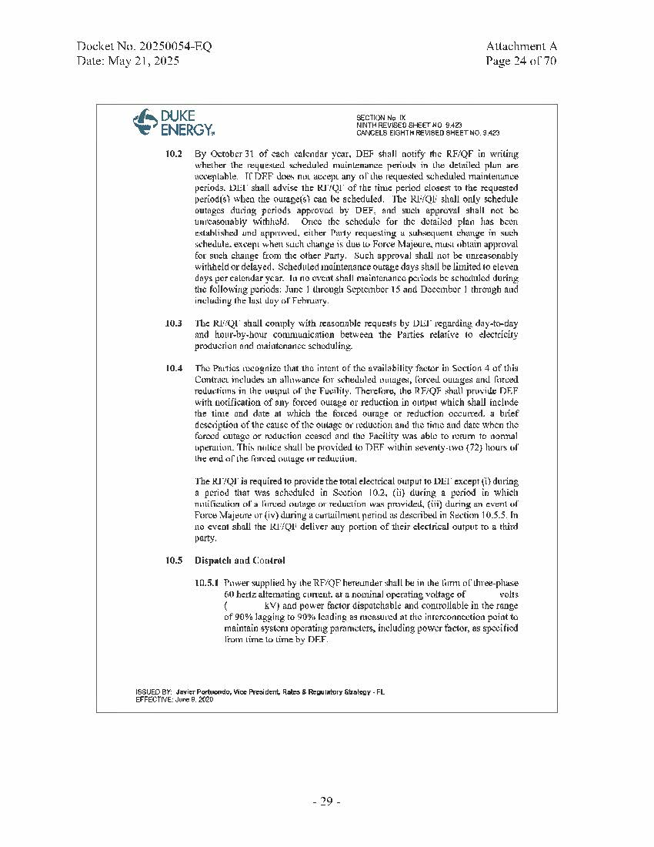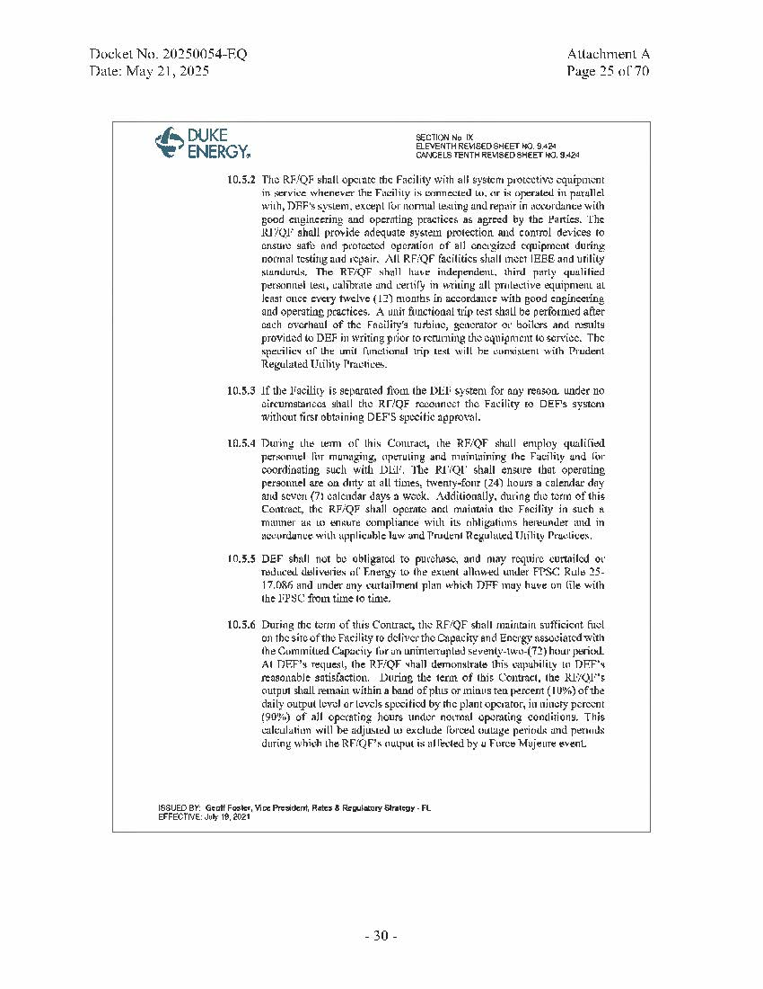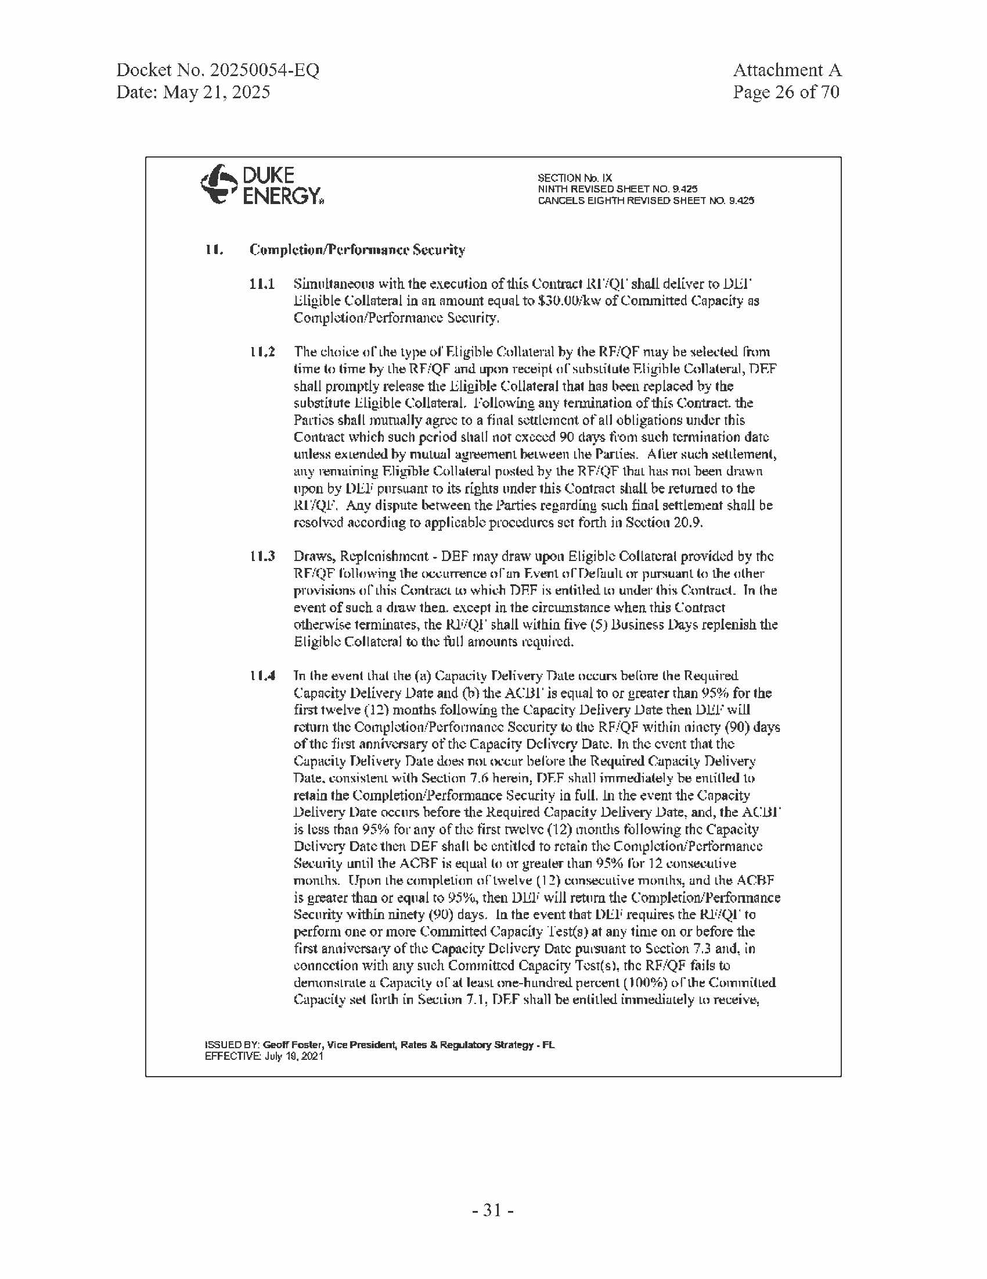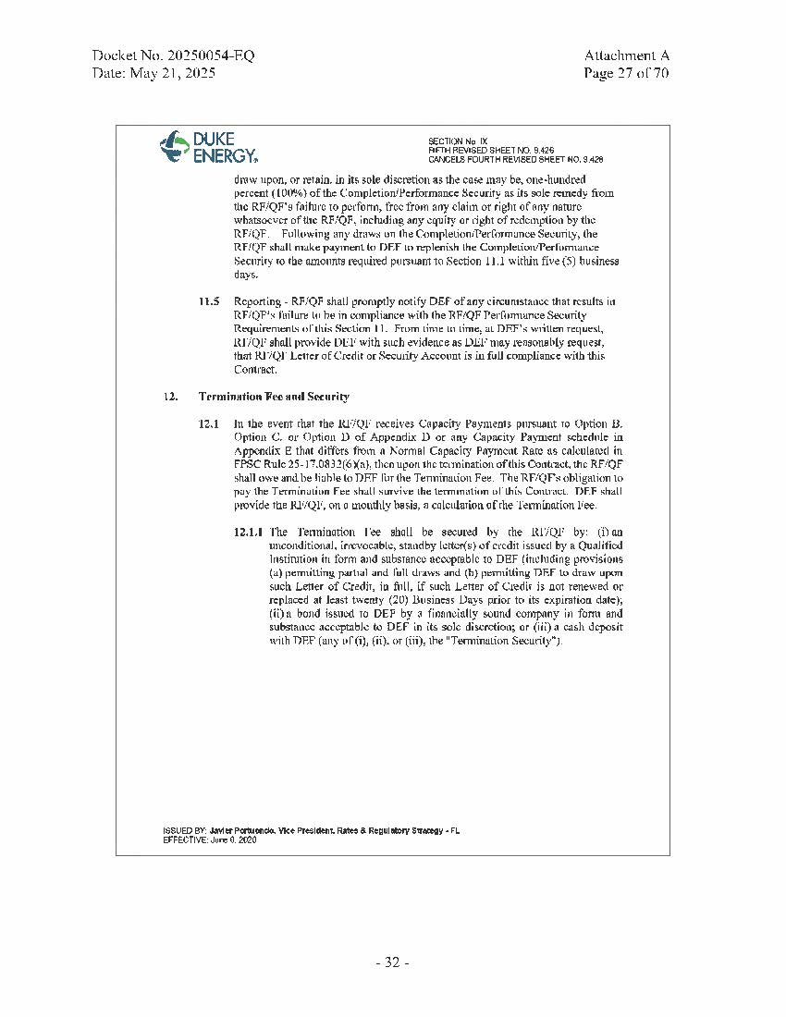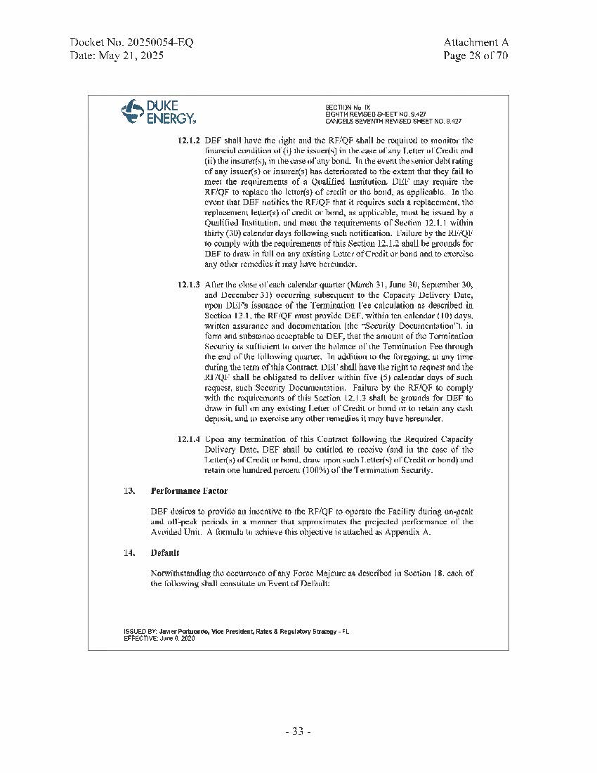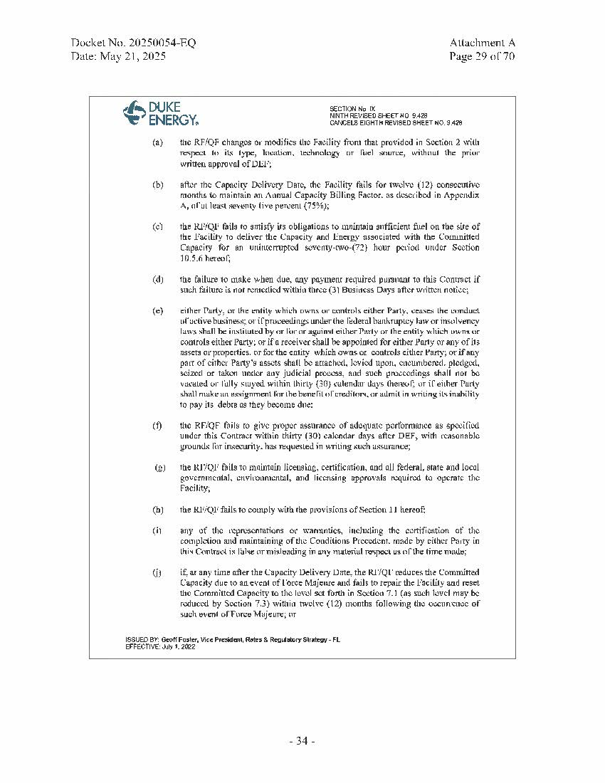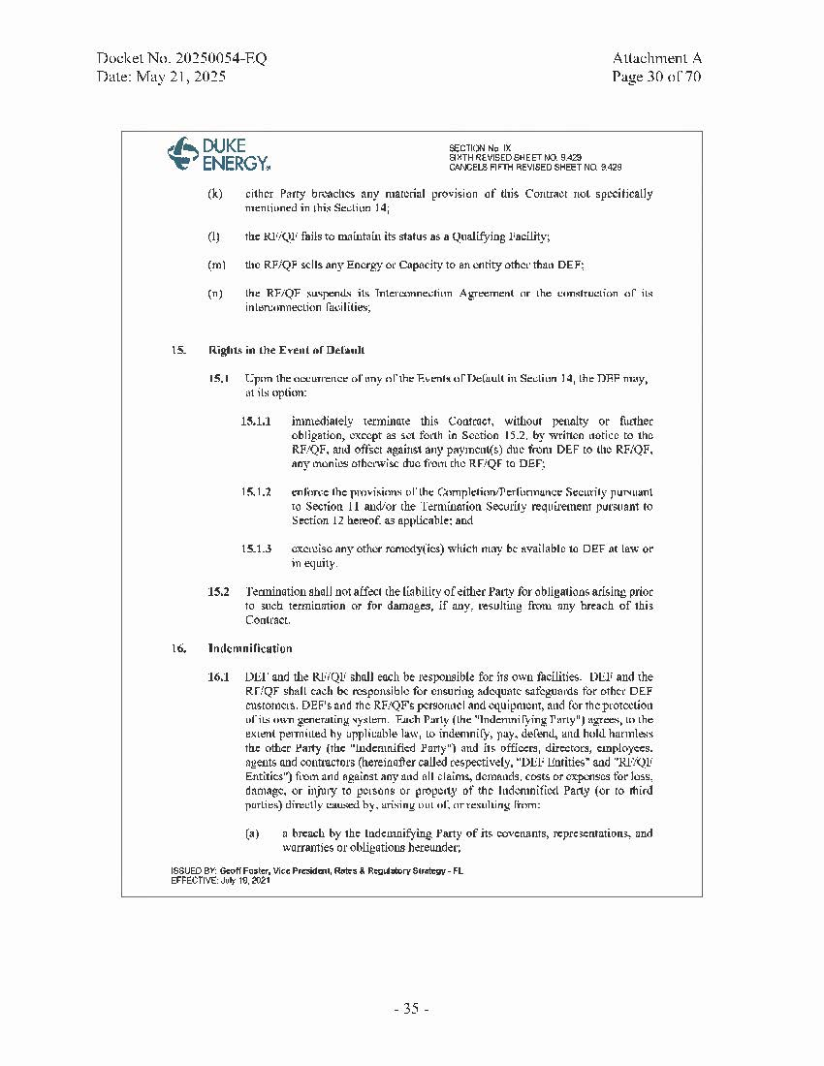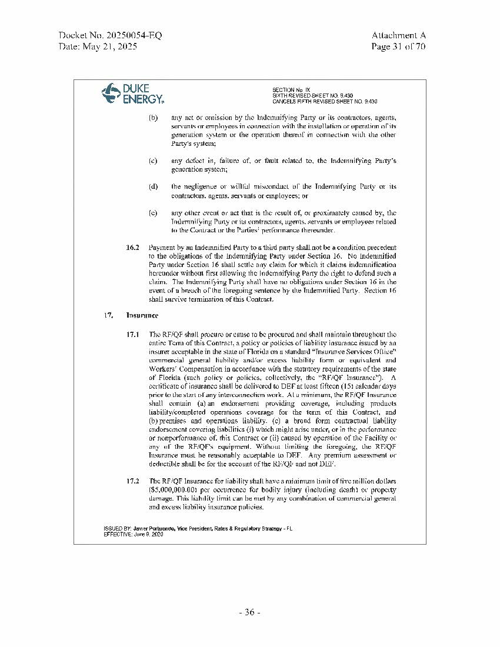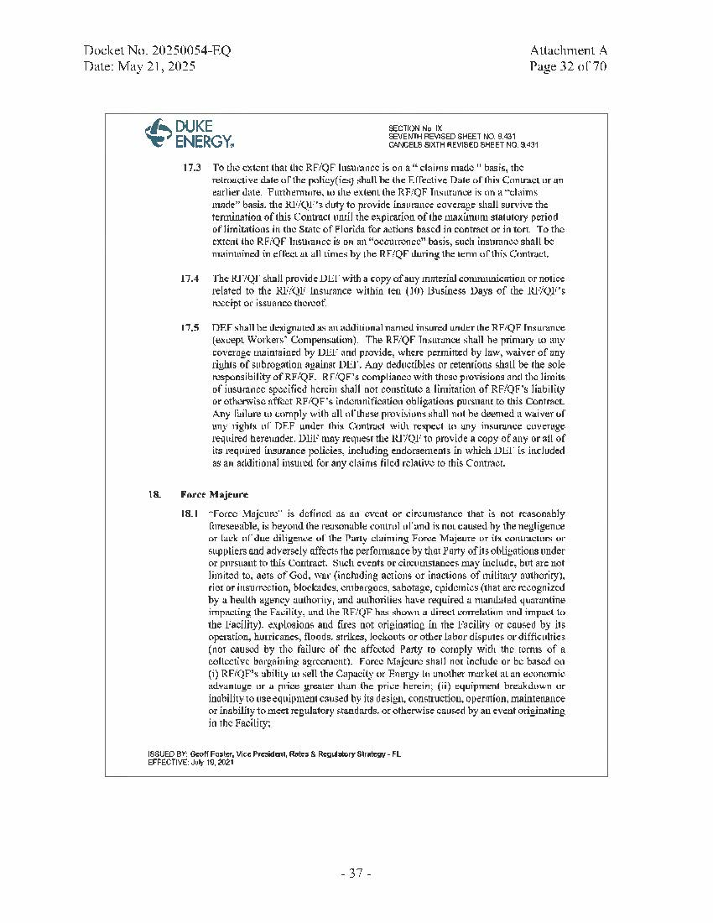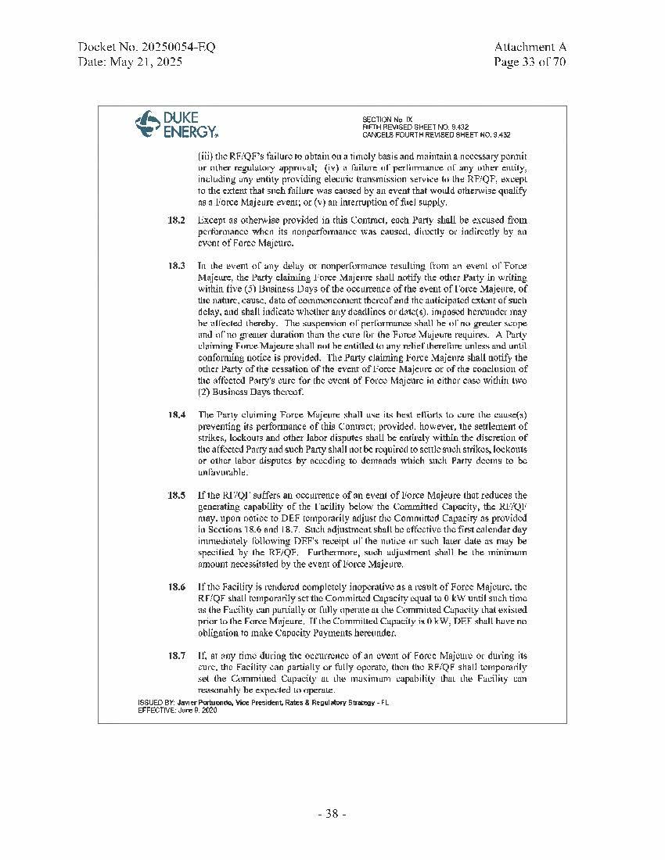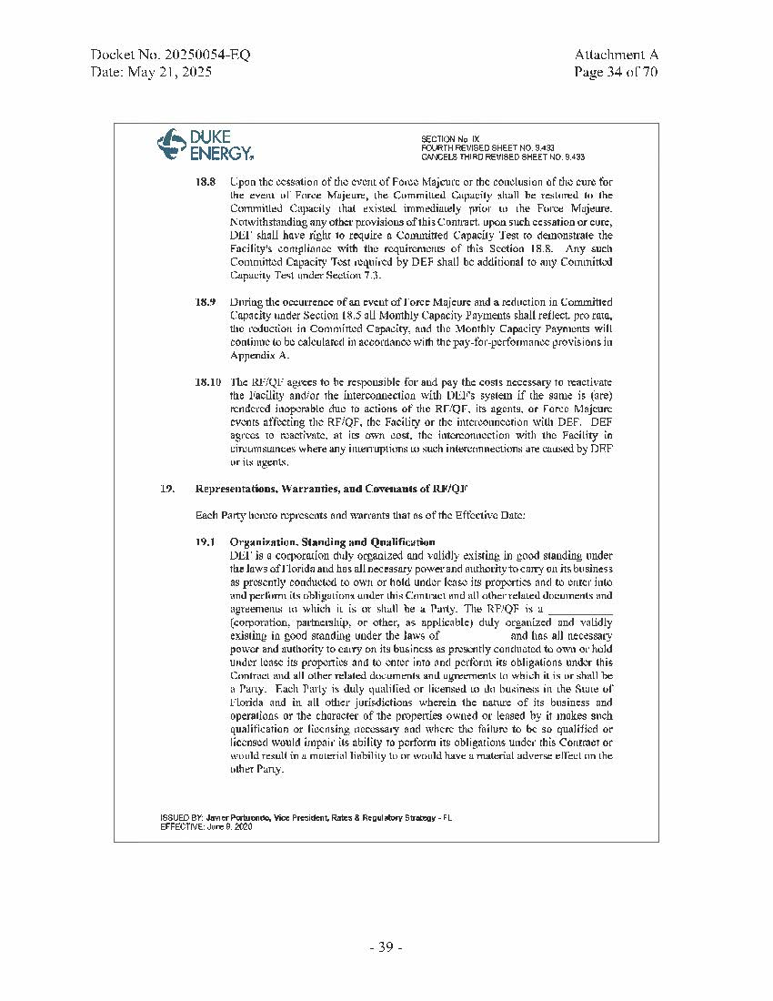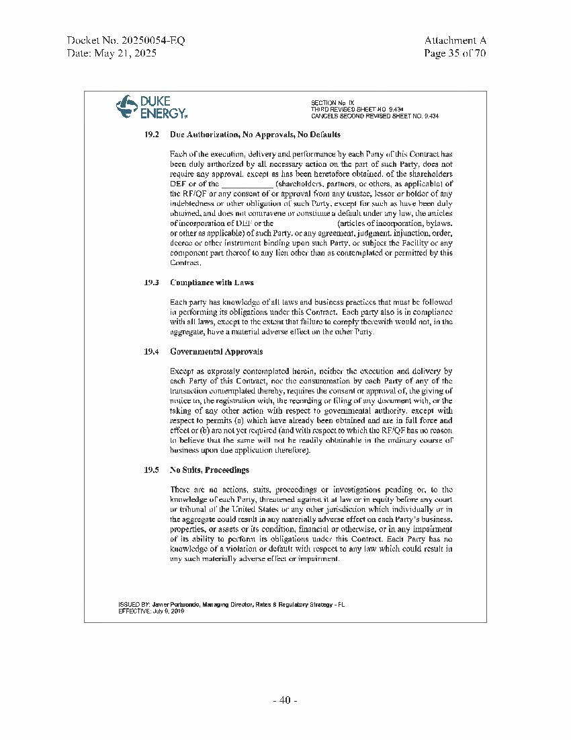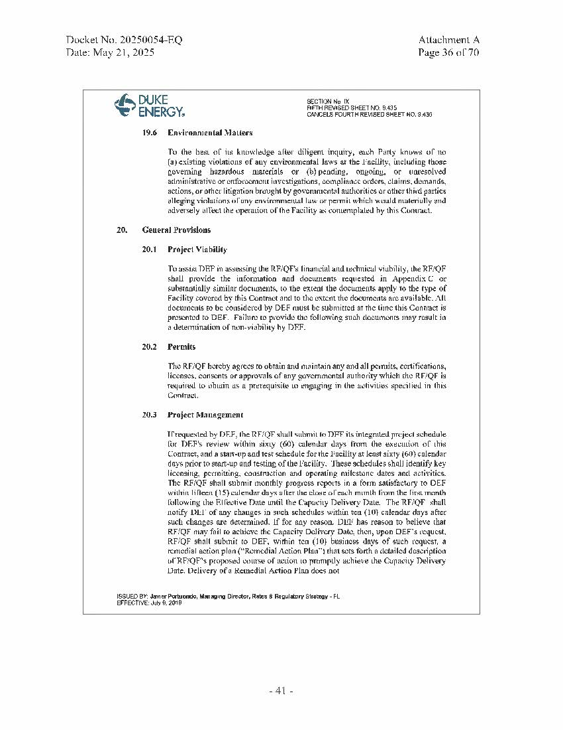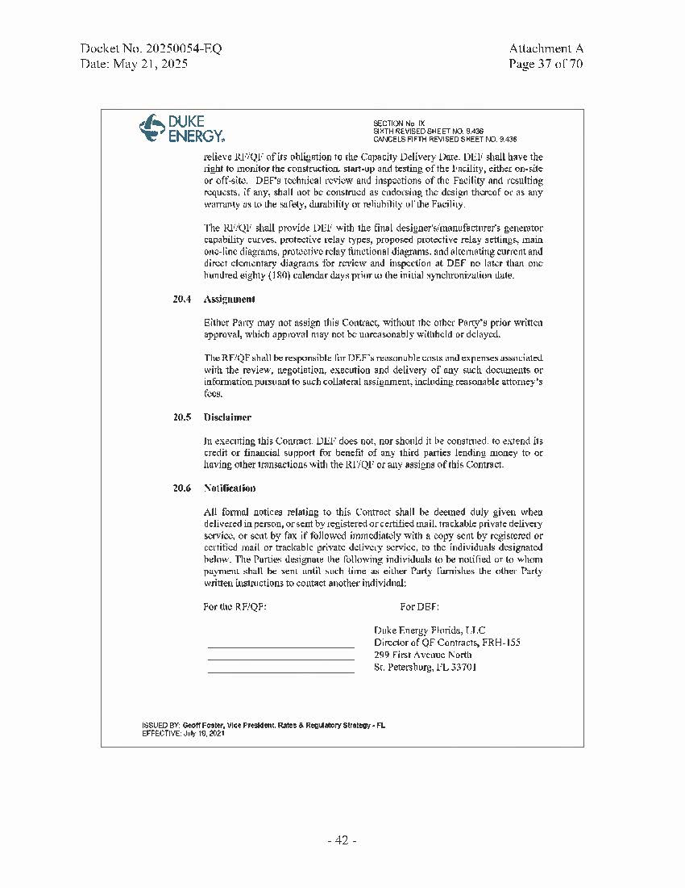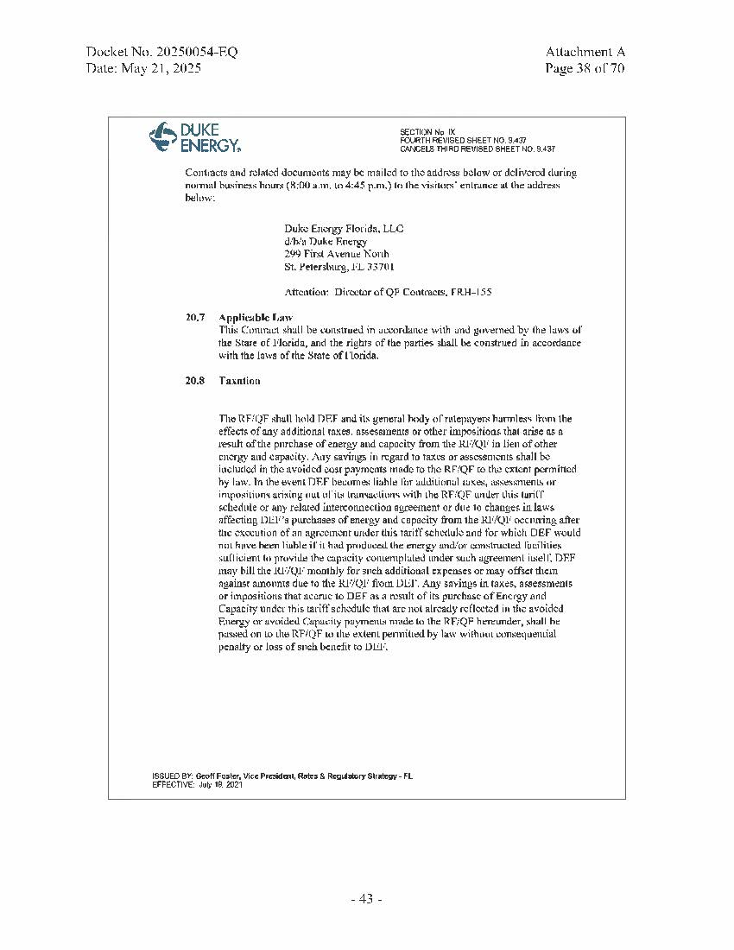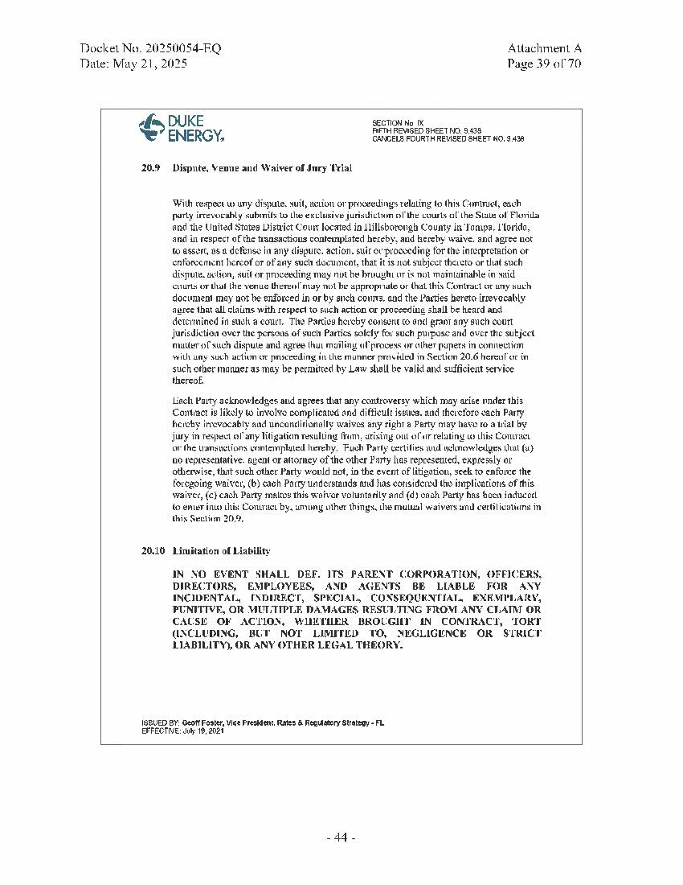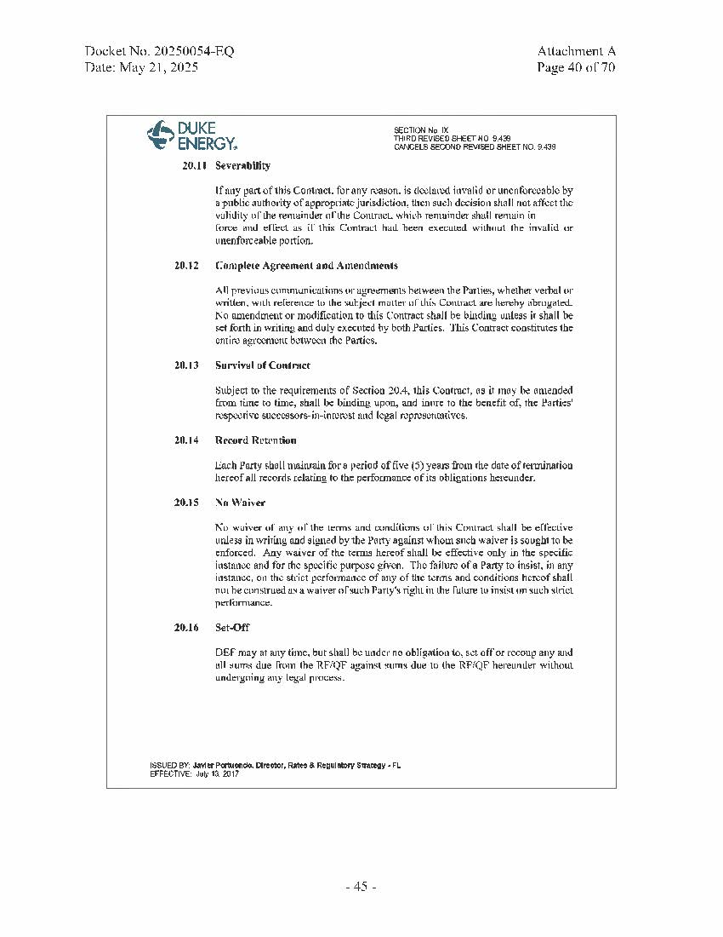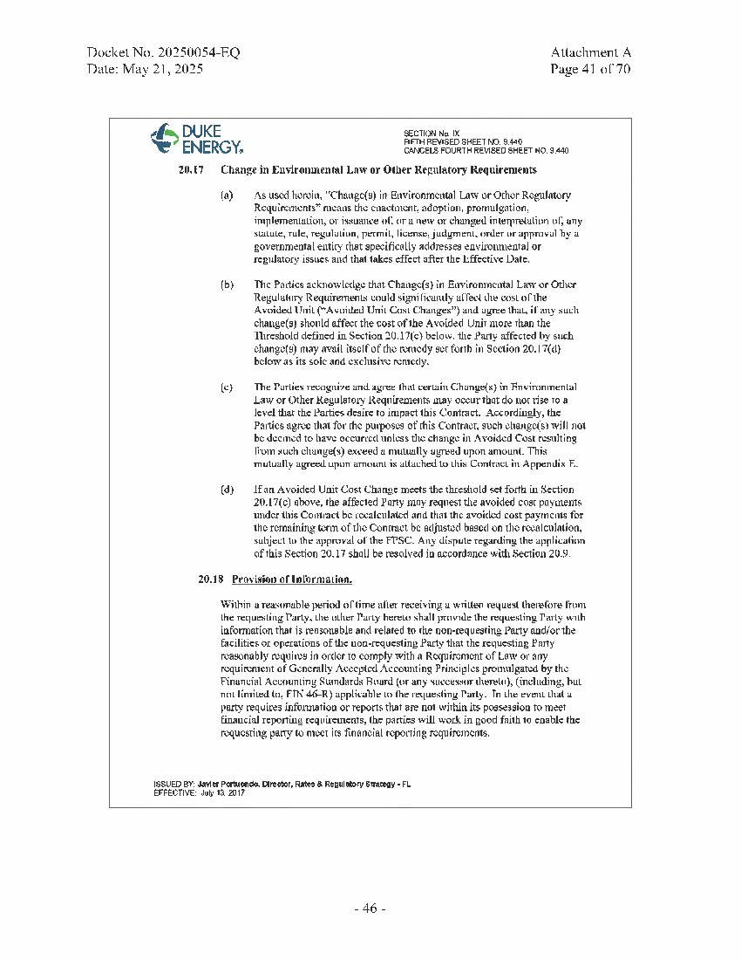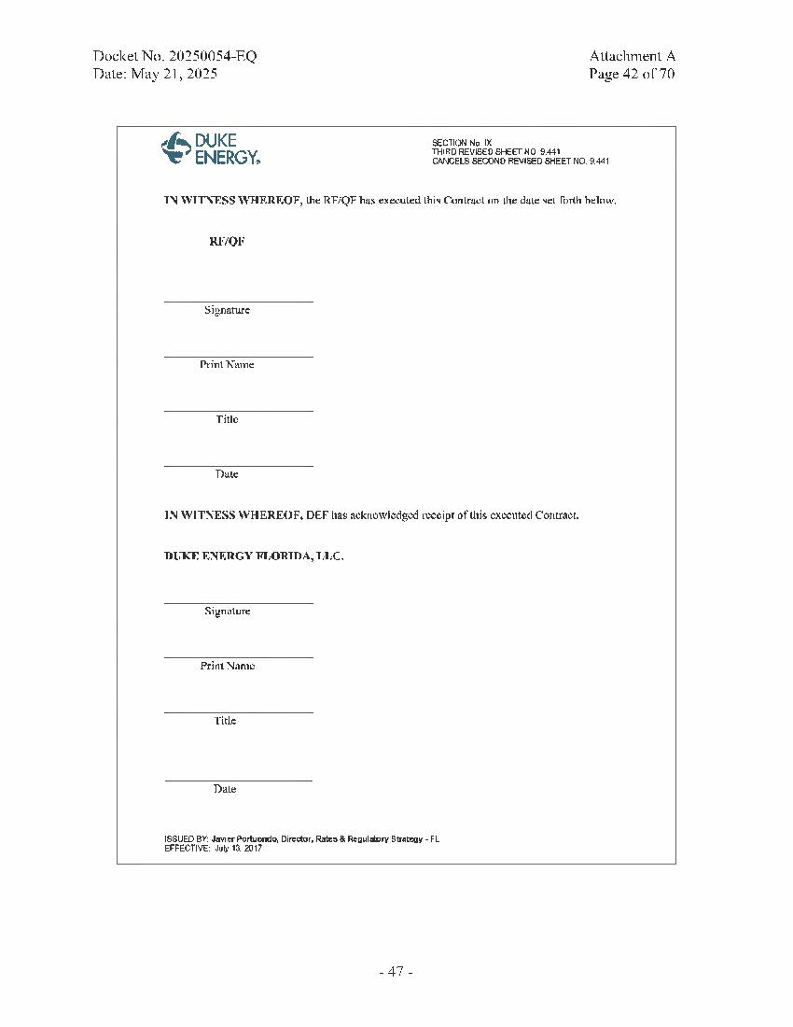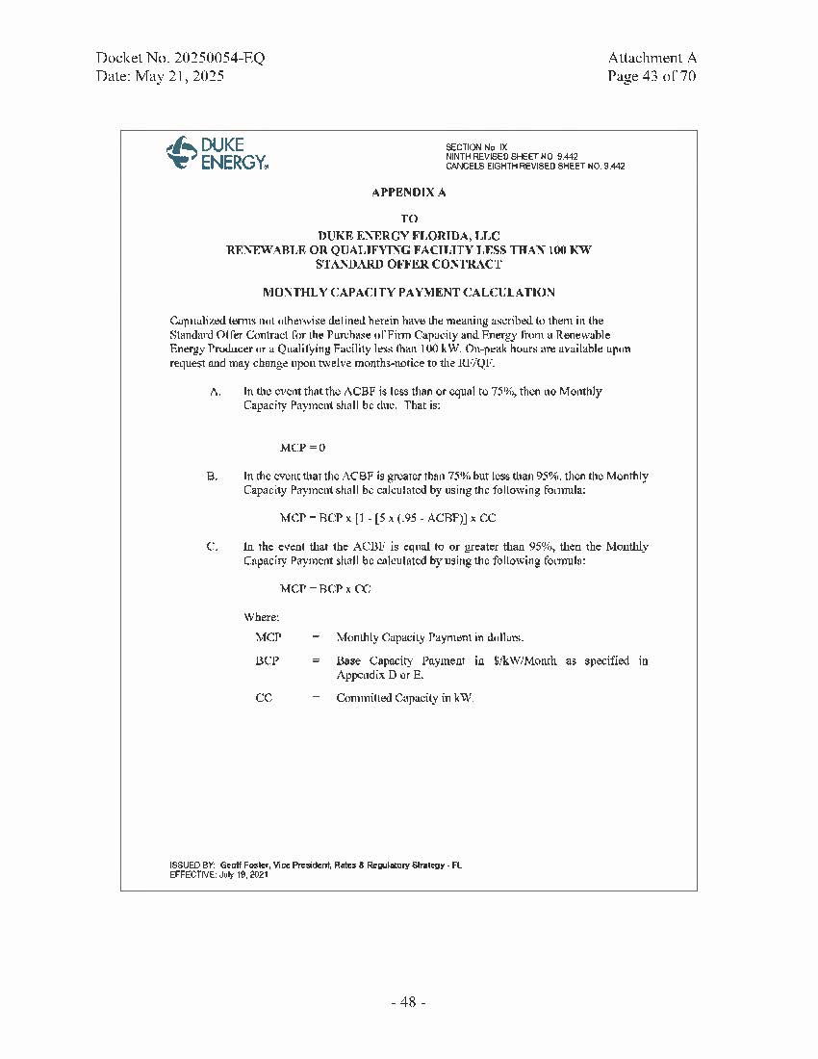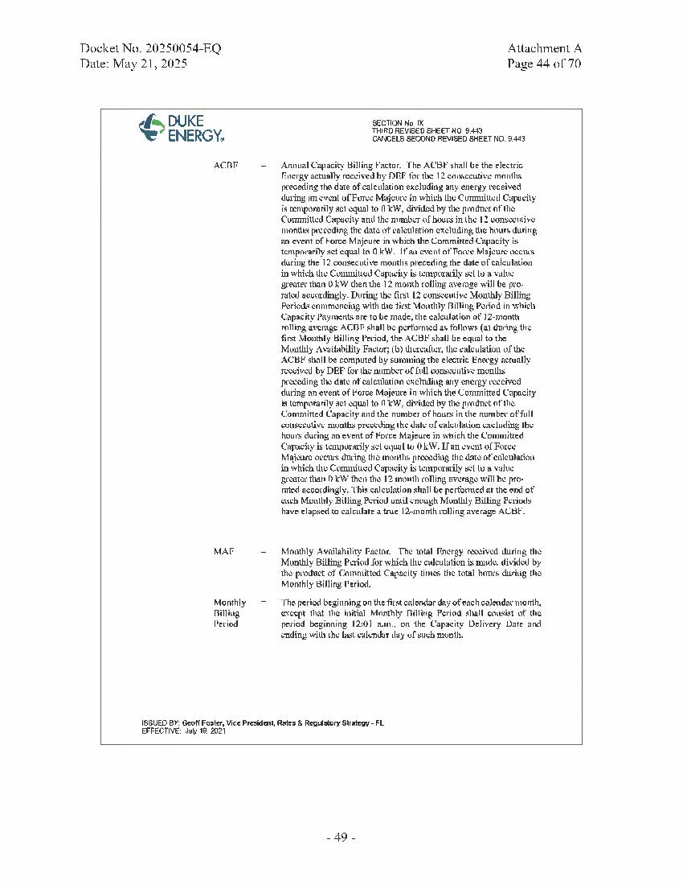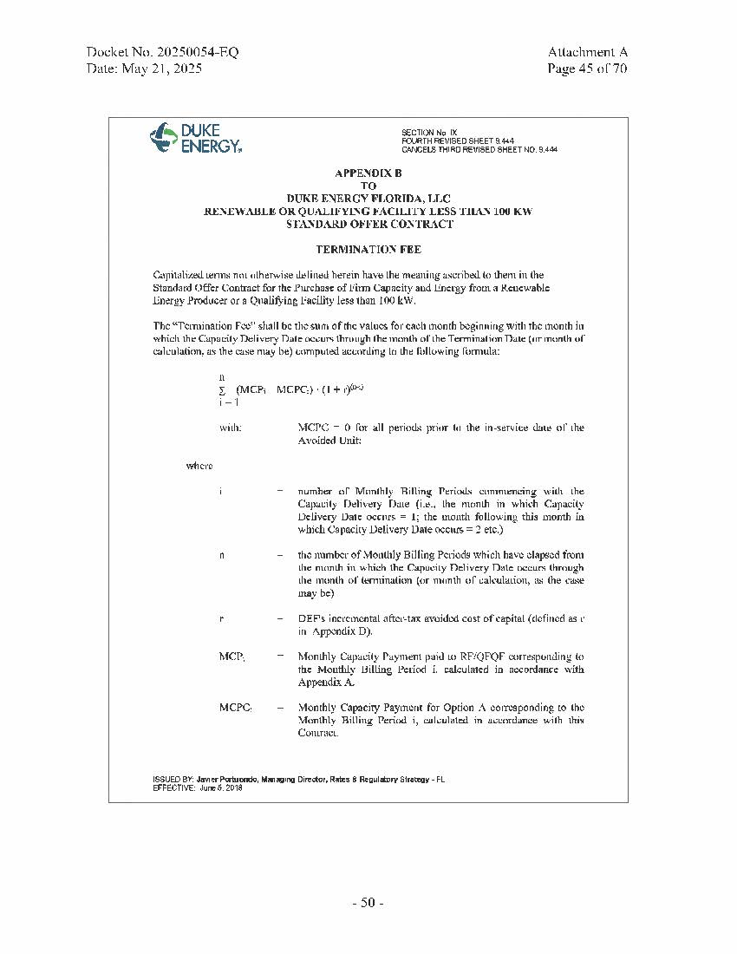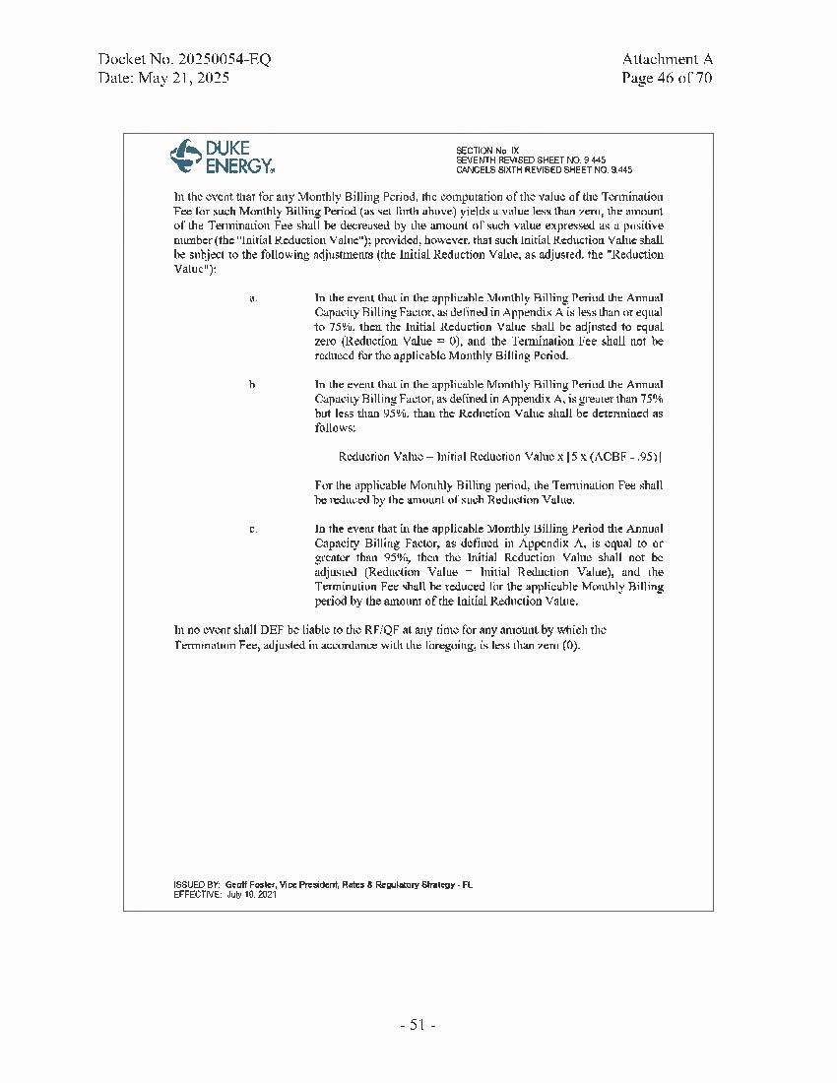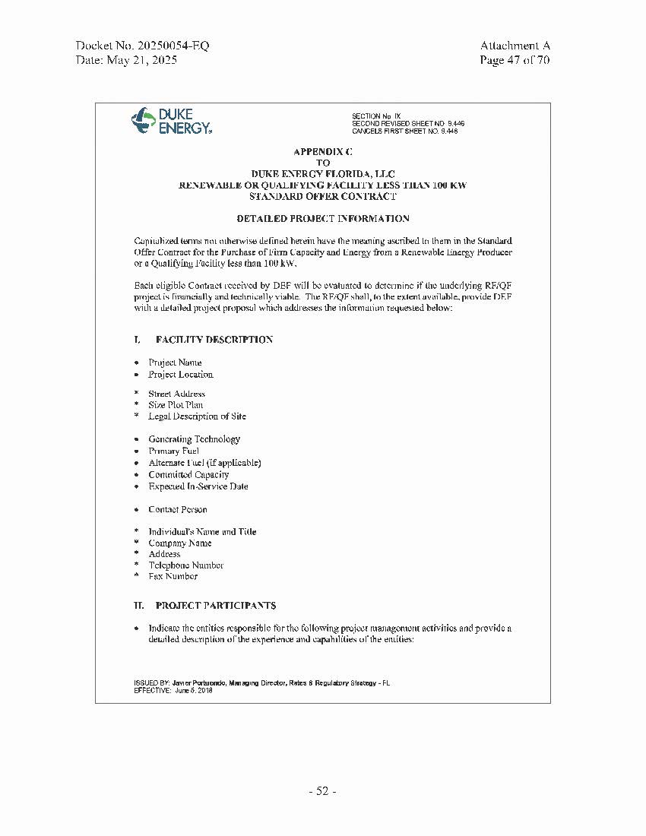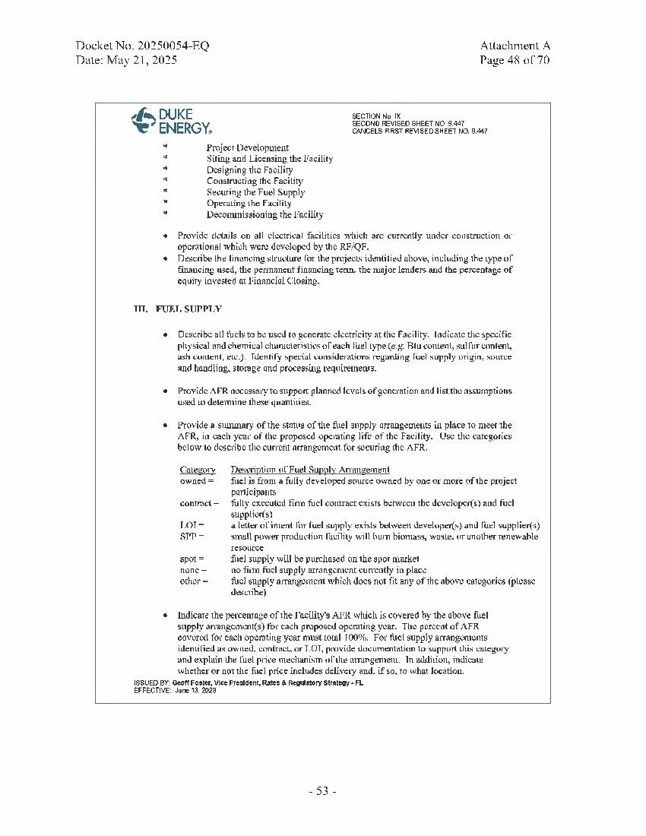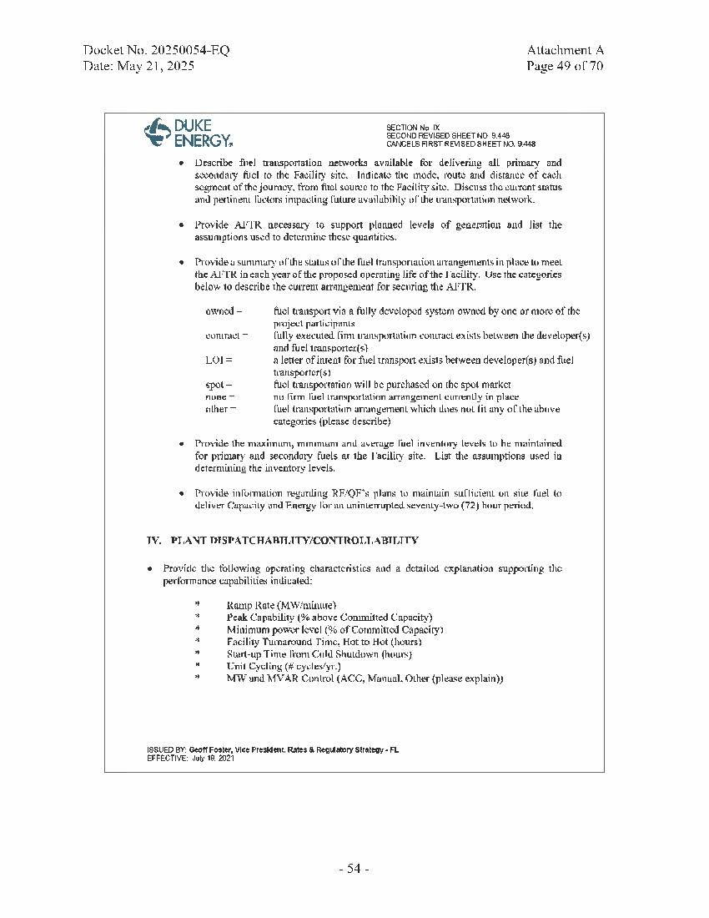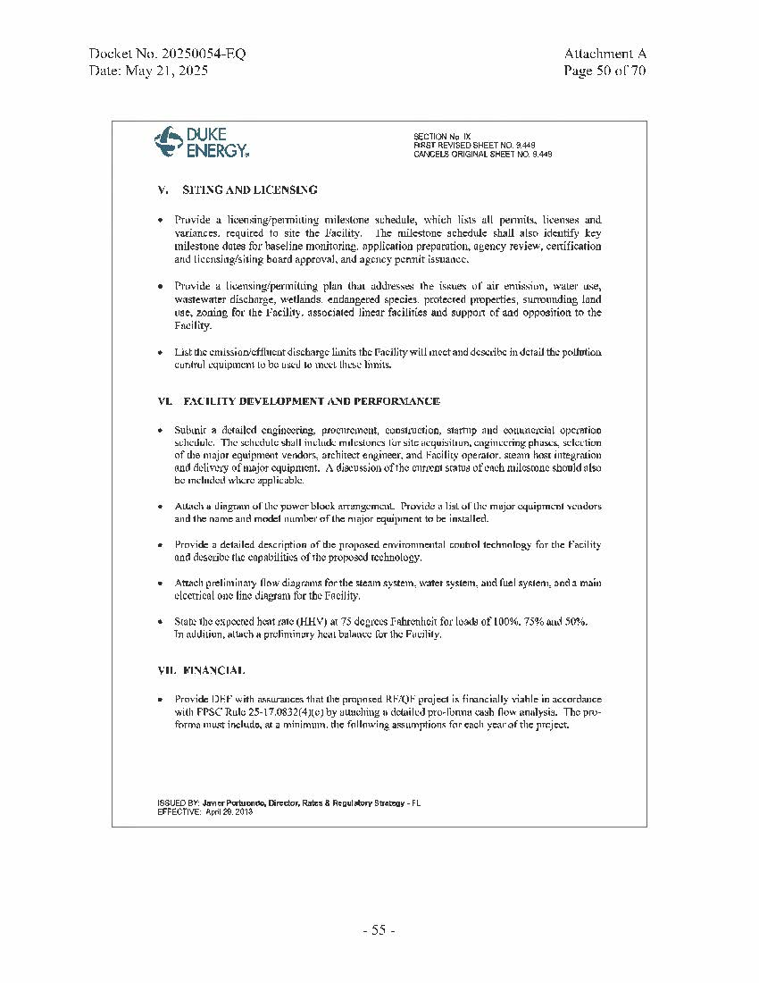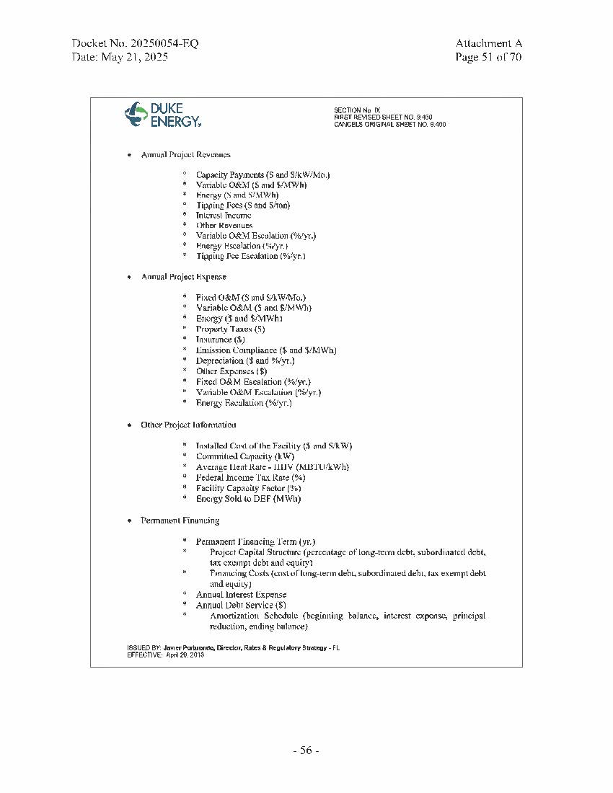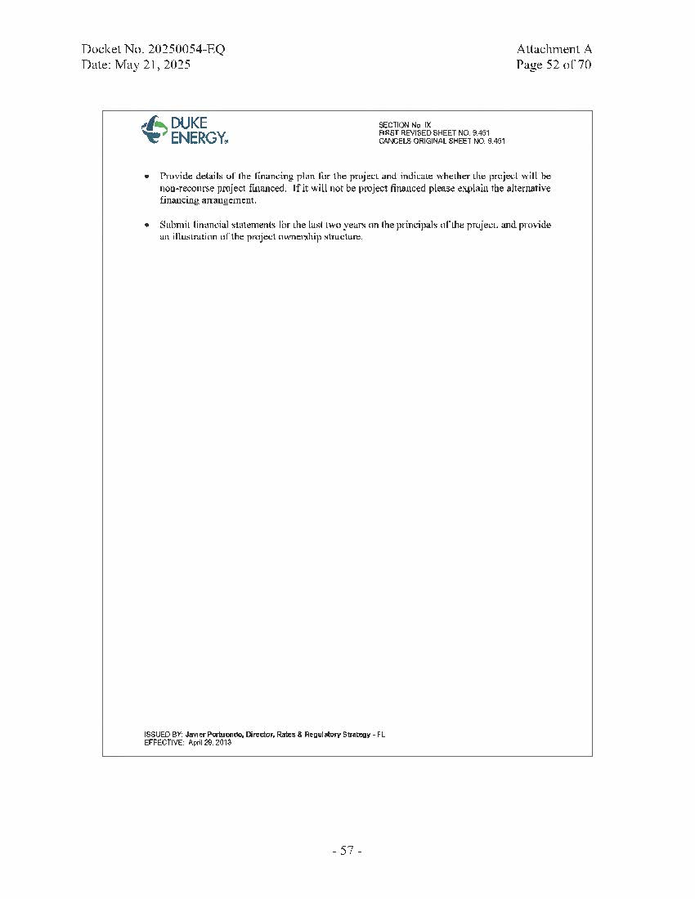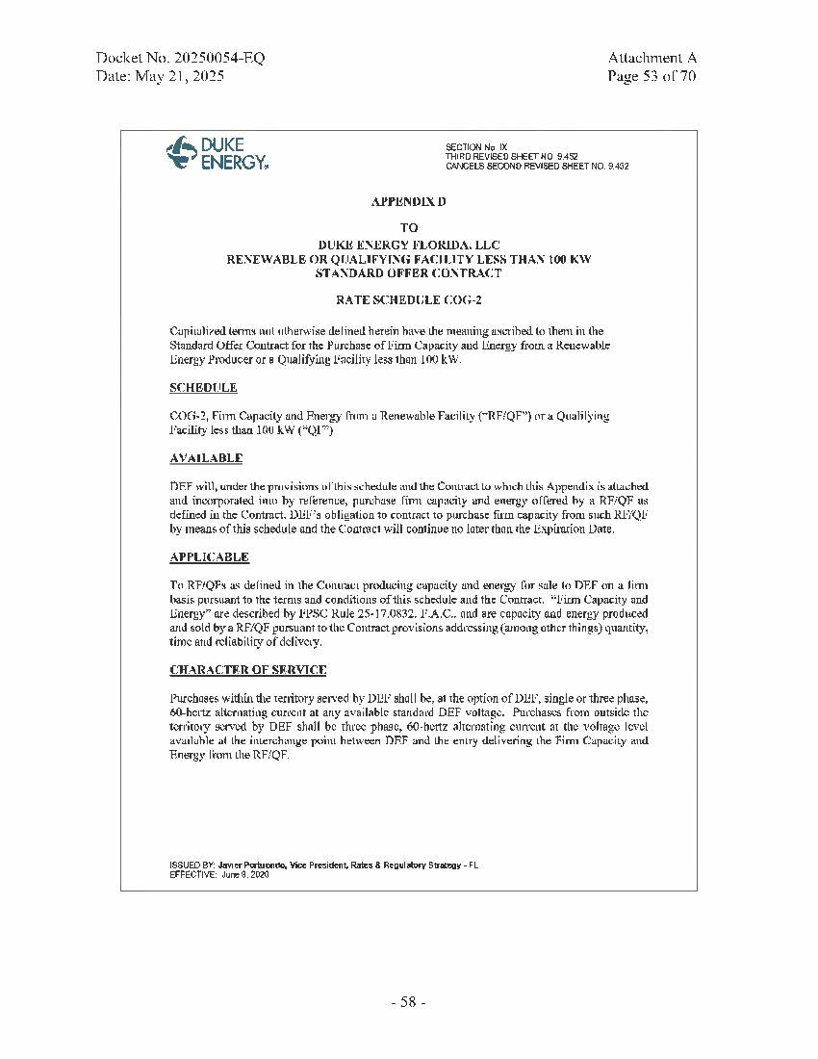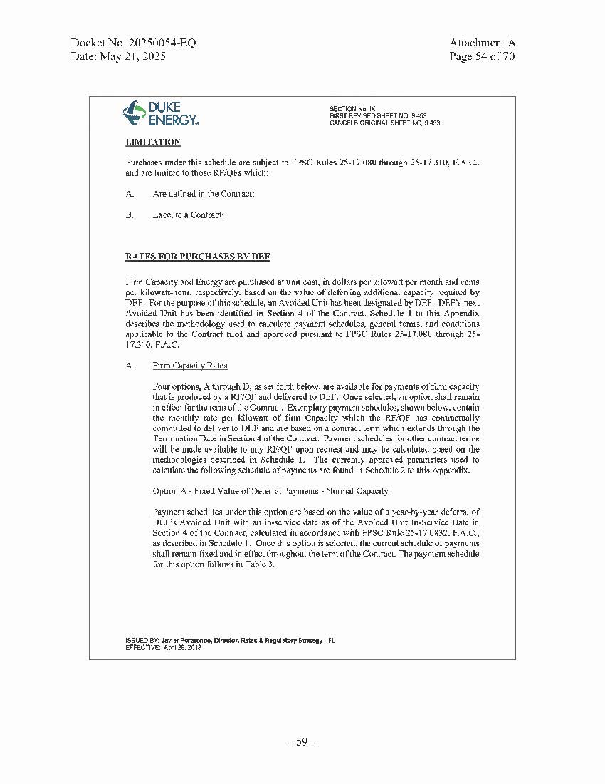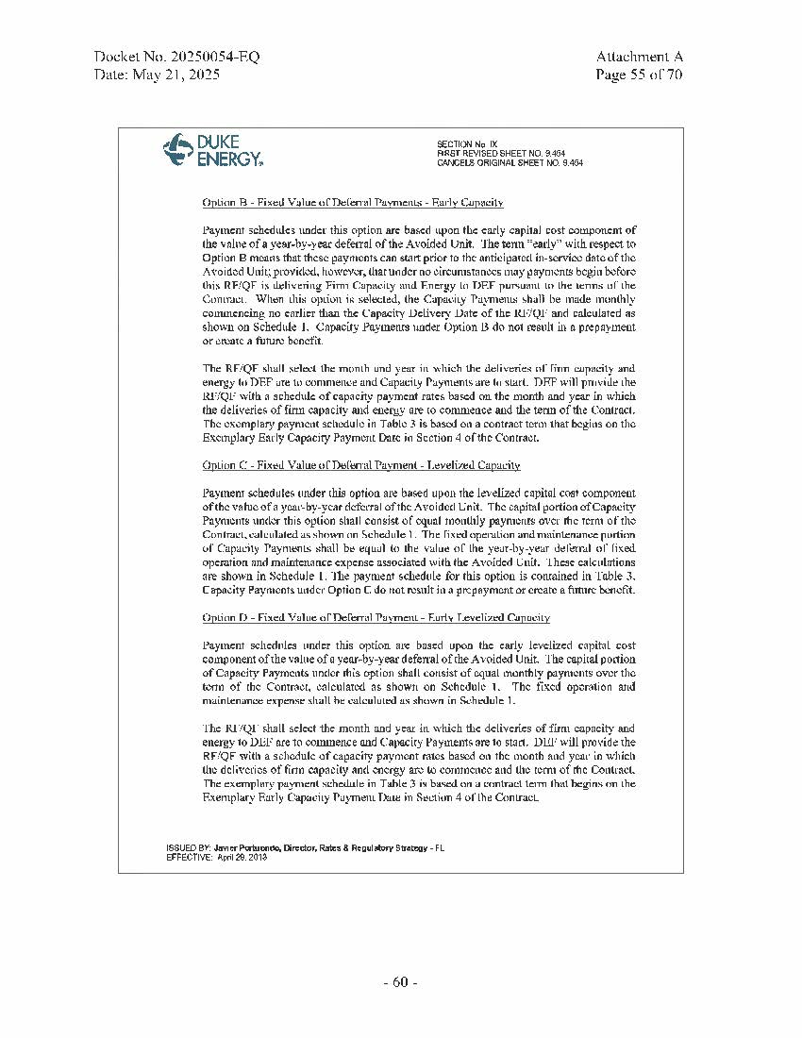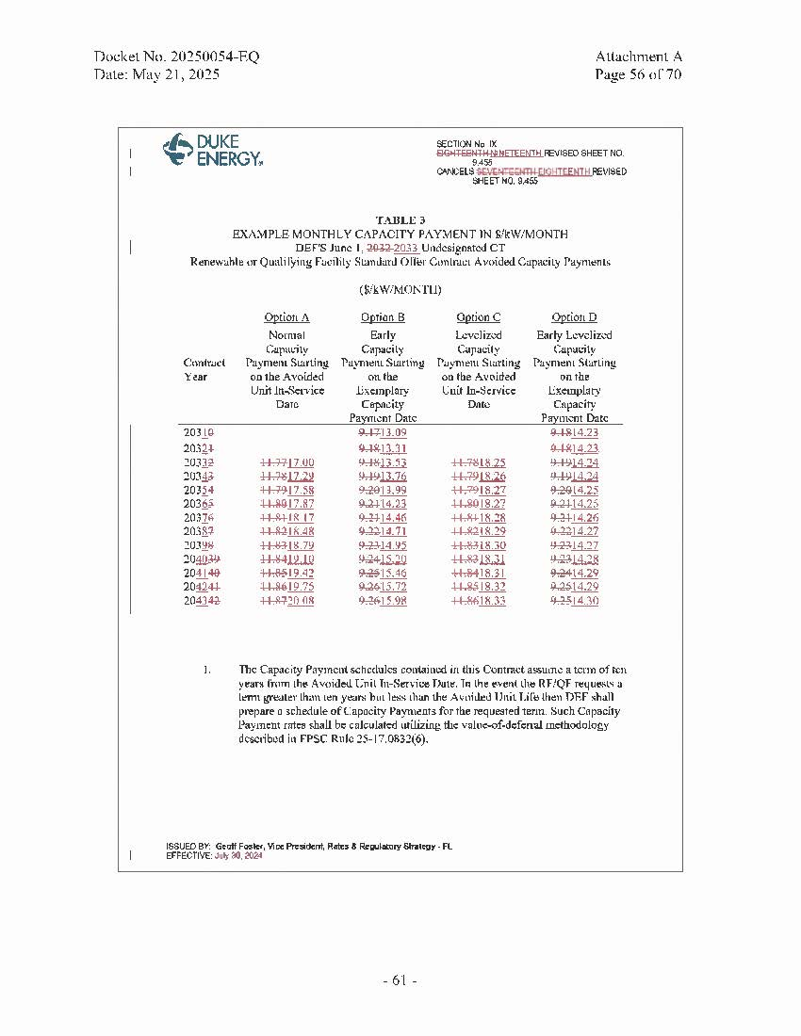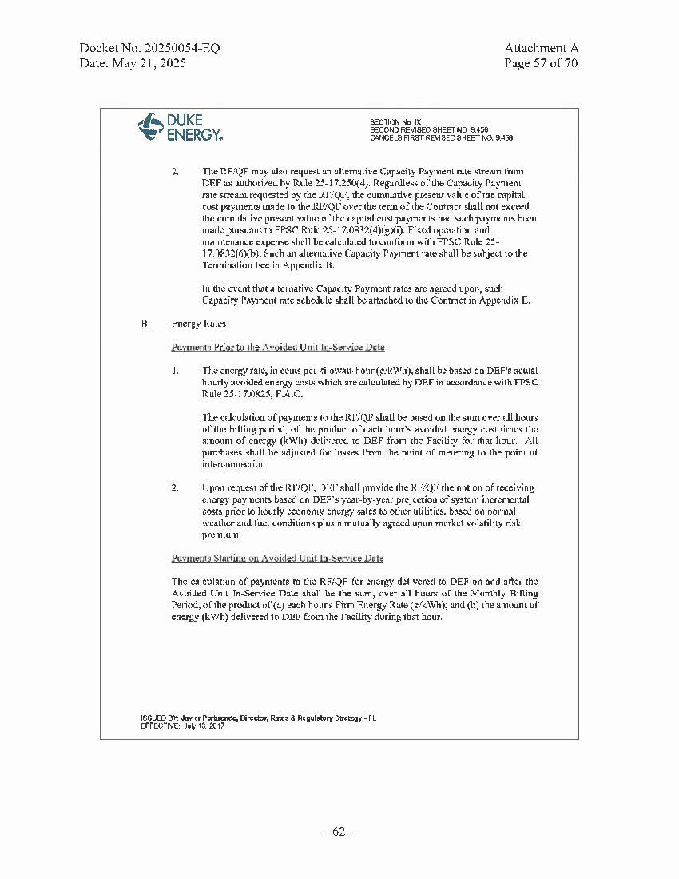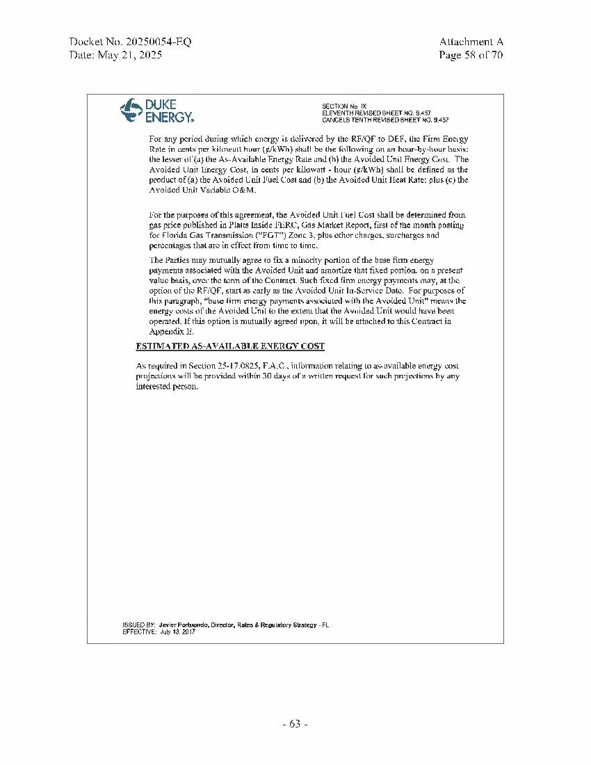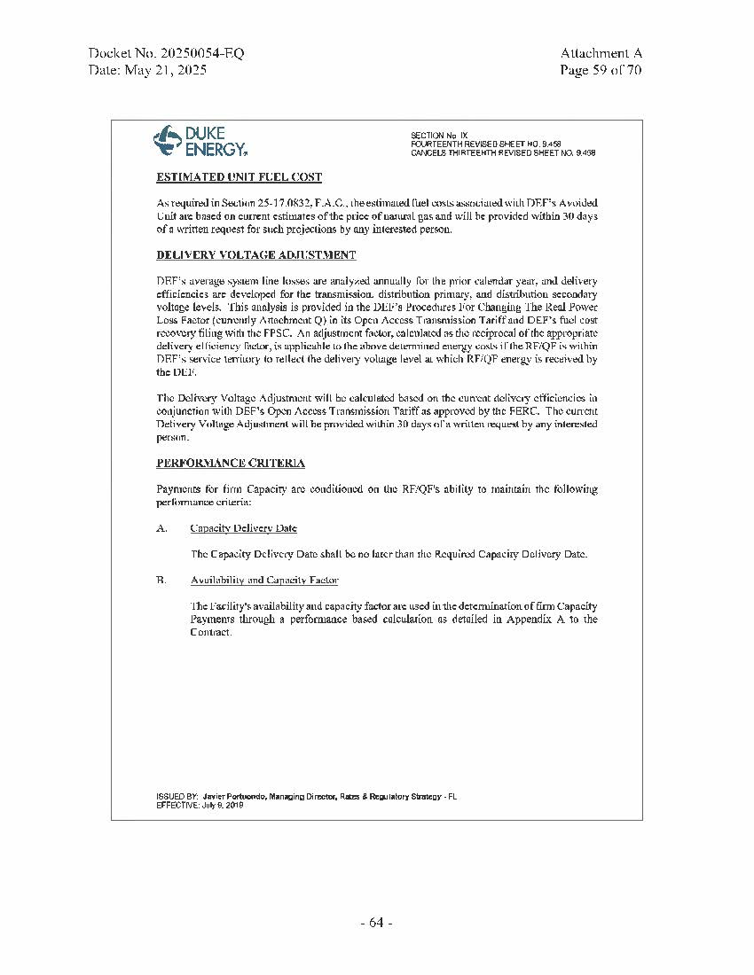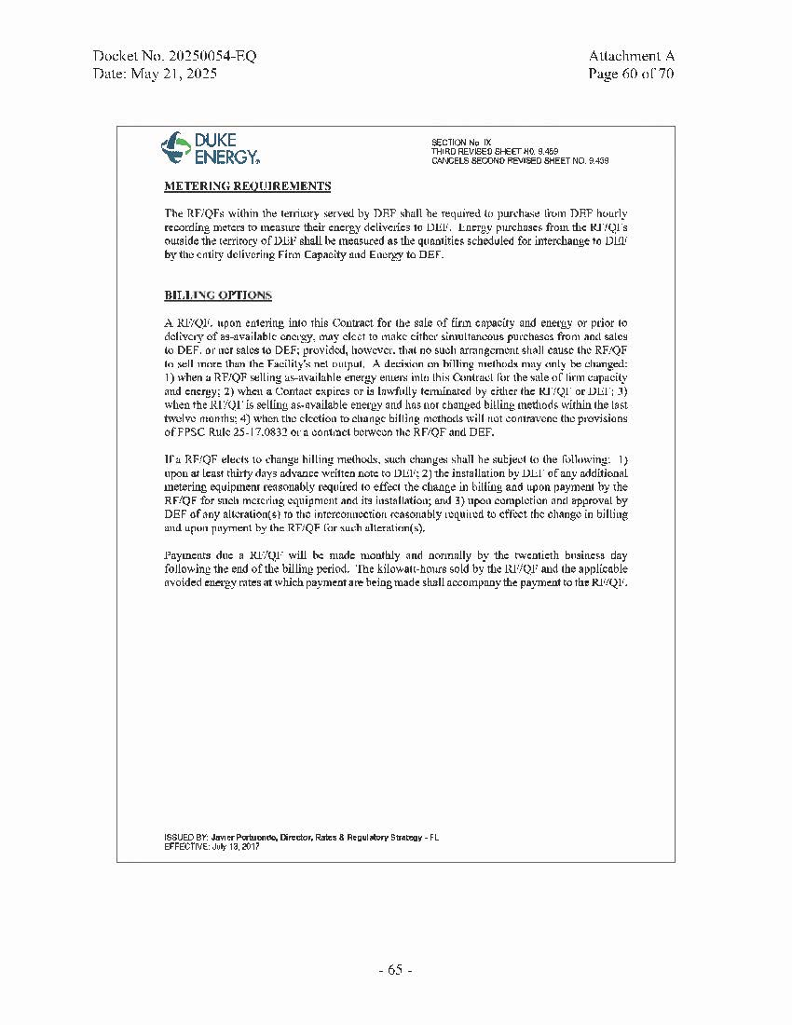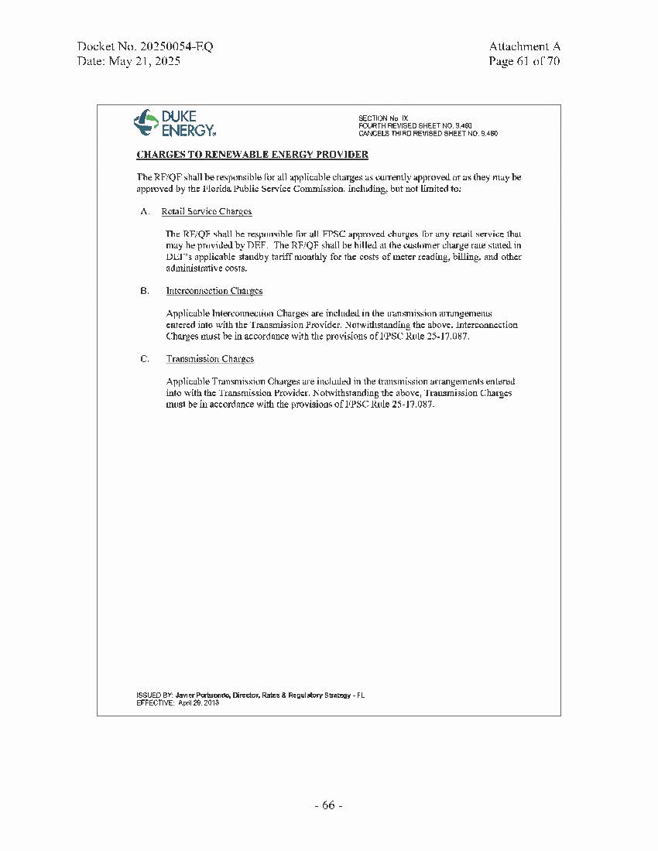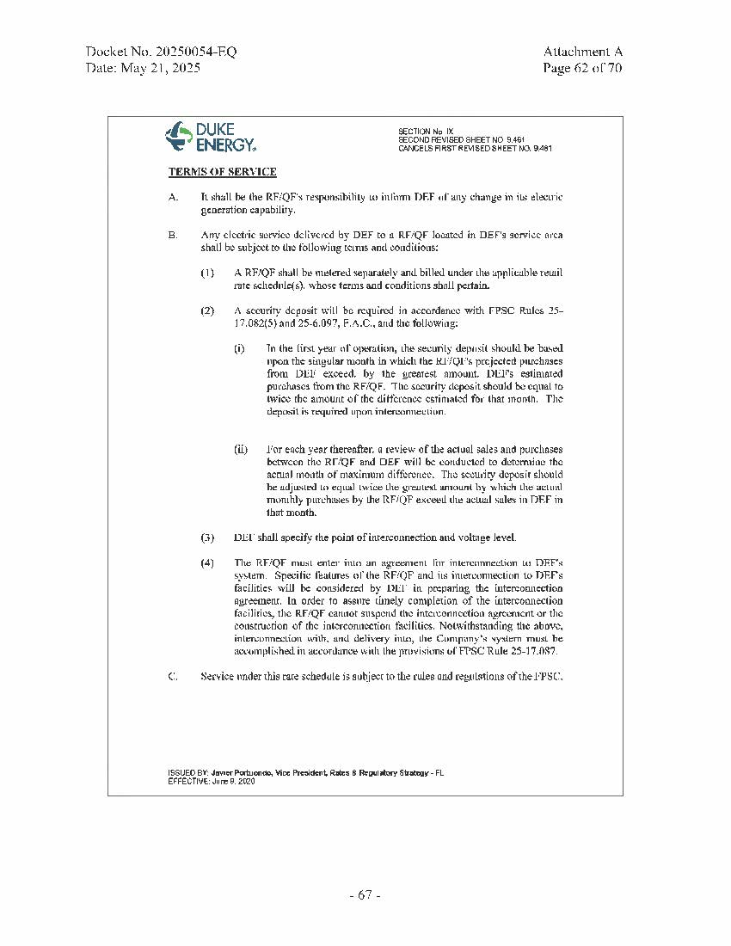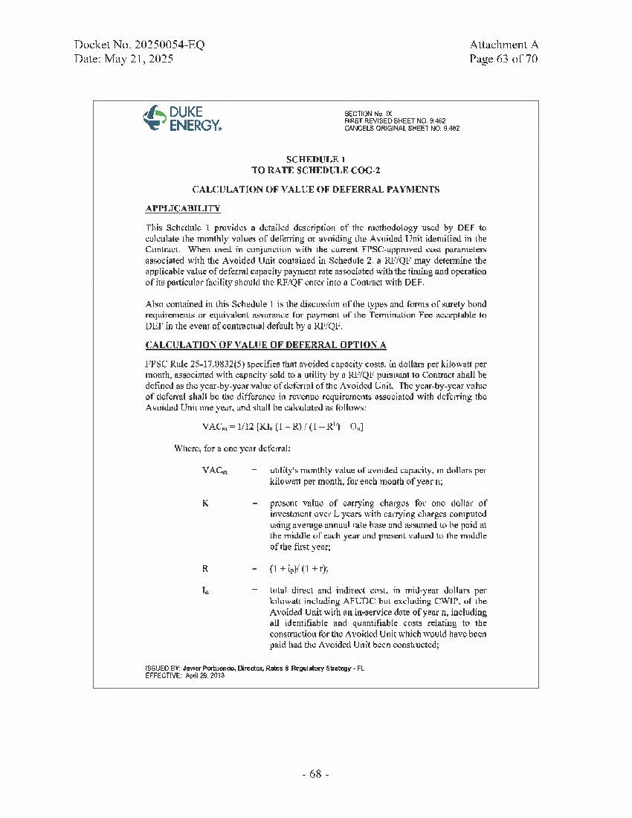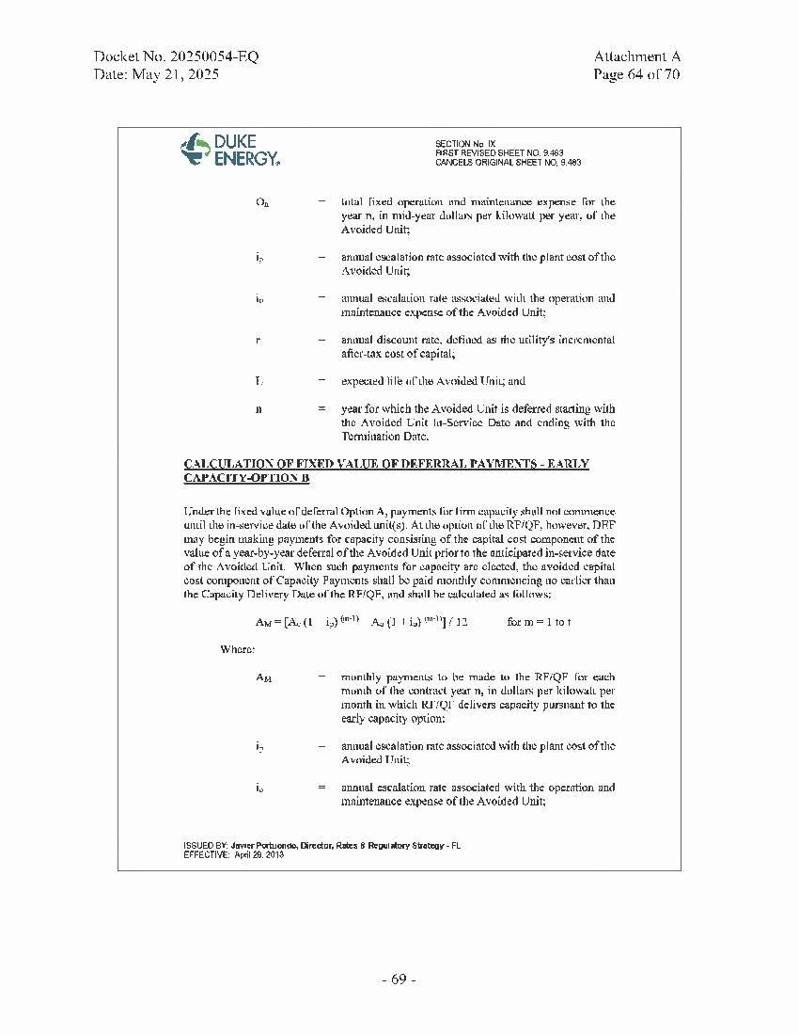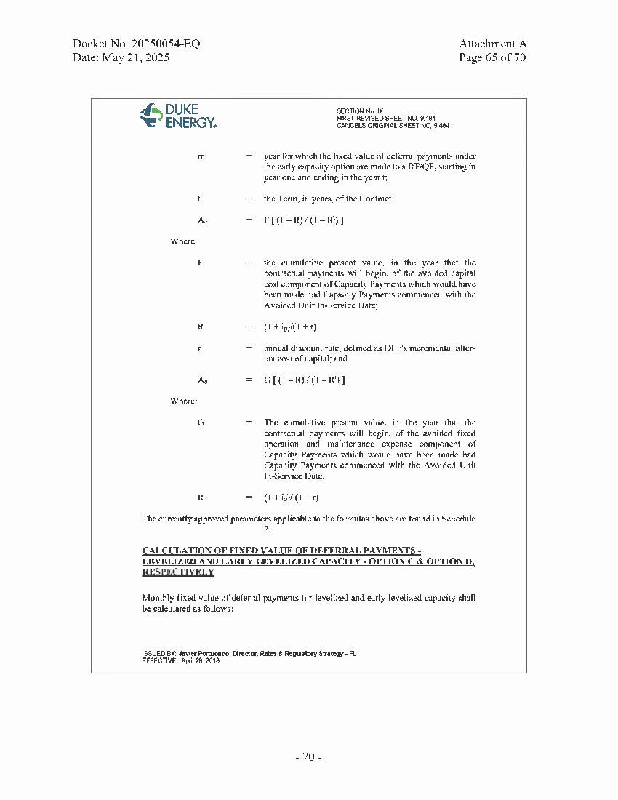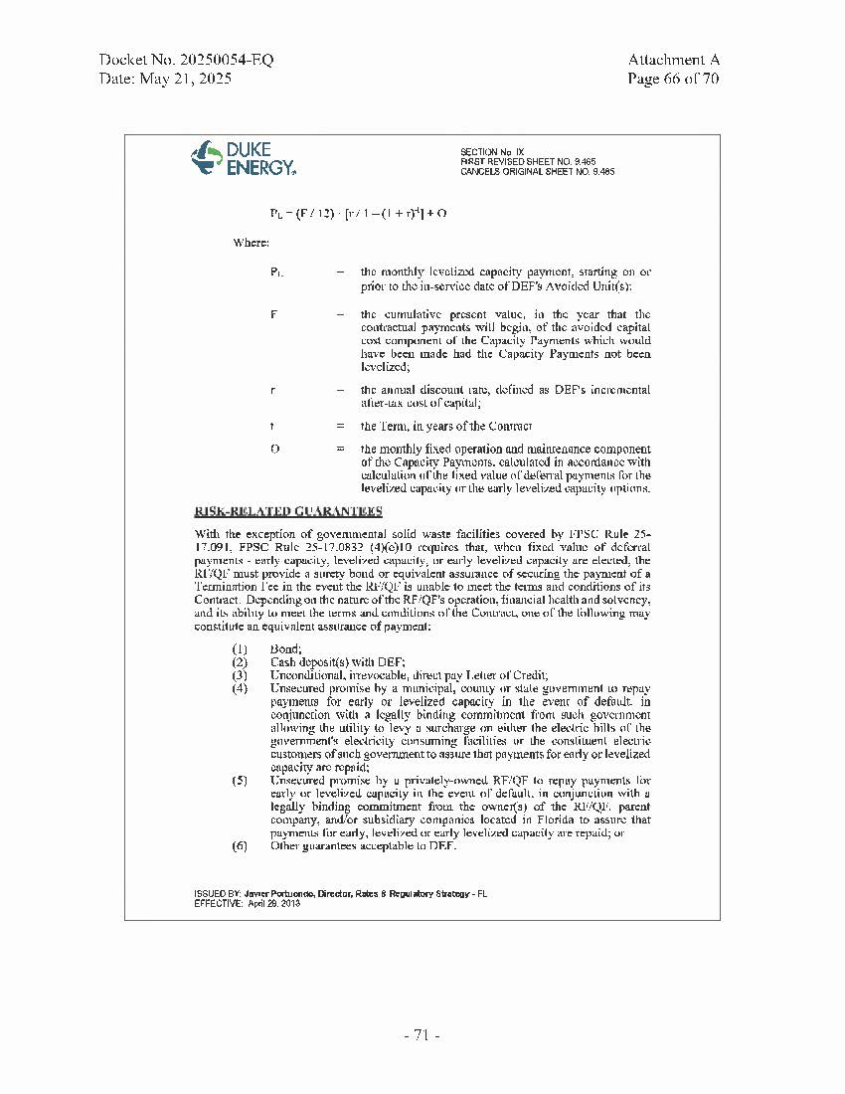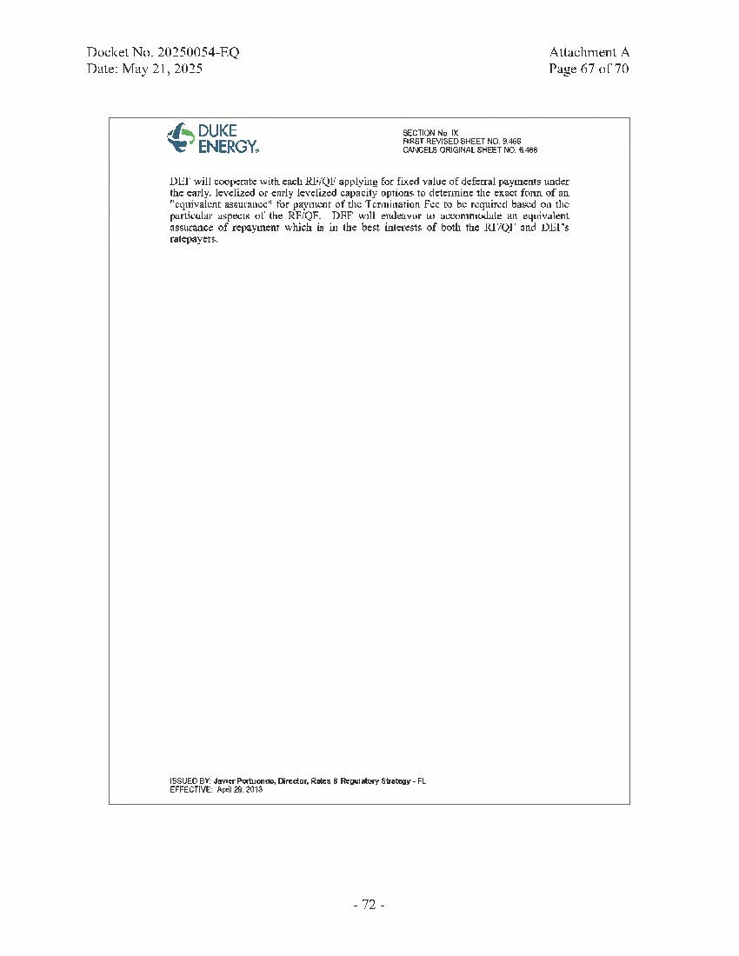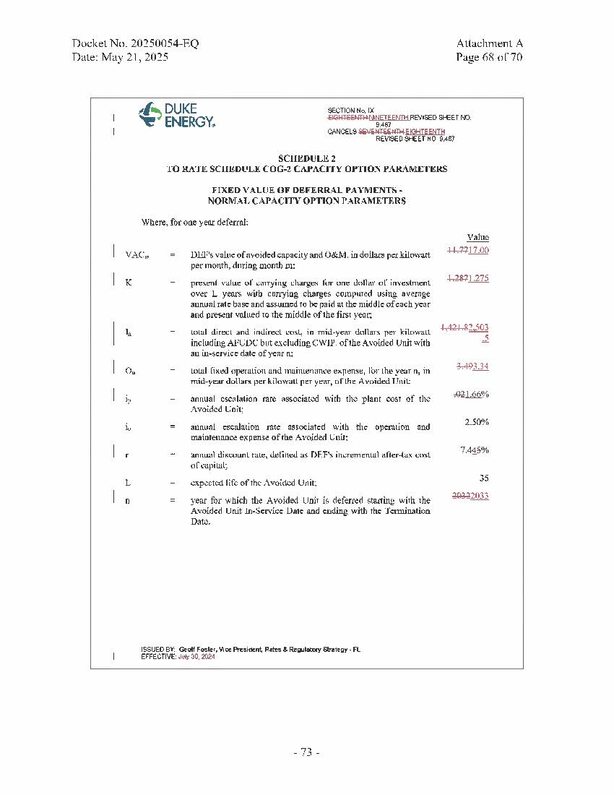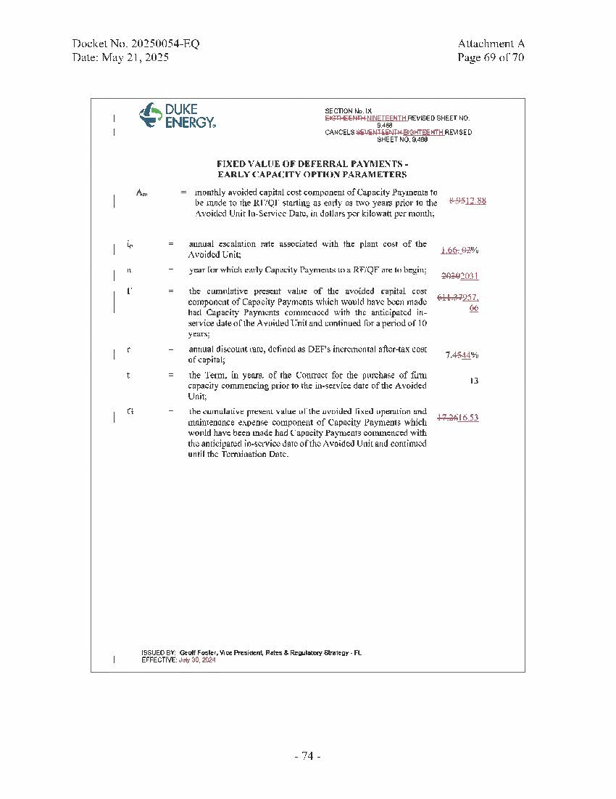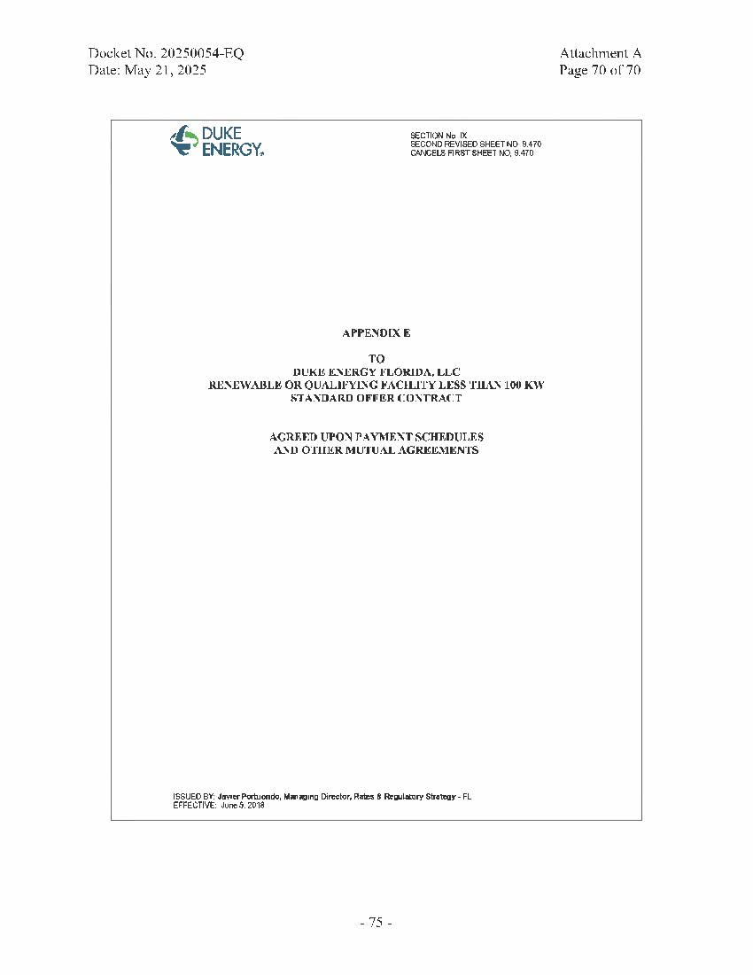

1. Document No. 02948-2025, filed Apr. 17, 2025, in Docket No. 20250054-EQ, *In re: Petition for approval of amended standard offer contract (Schedule COG-2), by Duke Energy Florida, LLC.*