|  |  |  |  |
| --- | --- | --- | --- |
| State of Florida  pscSEAL | | Public Service Commission  Capital Circle Office Center ● 2540 Shumard Oak Boulevard Tallahassee, Florida 32399-0850  -M-E-M-O-R-A-N-D-U-M- | |
| DATE: | June 19, 2025 | | |
| TO: | Office of Commission Clerk (Teitzman) | | |
| FROM: | Division of Economics (Ward)  Office of the General Counsel (Sandy) | | |
| RE: | Docket No. 20250080-GU – Petition for approval of tariff changes to implement a temporary surcharge to recovery regulatory asset, by St. Joe Natural Gas Company, Inc. | | |
| AGENDA: | 07/01/25 – Regular Agenda – Tariff Filing – Interested Persons May Participate | | |
| COMMISSIONERS ASSIGNED: | | | All Commissioners |
| PREHEARING OFFICER: | | | Administrative |
| CRITICAL DATES: | | | 07/19/25 (60-Day Suspension Date) |
| SPECIAL INSTRUCTIONS: | | | None |

Case Background

On May 20, 2025, St. Joe Natural Gas Company, Inc. (St. Joe or the utility) filed a petition for approval of tariff changes to implement a temporary surcharge that will enable it to collect $77,761 associated with a regulatory asset established in accordance with the settlement (2021 settlement) approved by Order No. PSC-2021-0196-AS-GU.[1] Paragraph one of the 2021 settlement provided that St. Joe should be allowed to recover $330,115 in storm costs through a storm surcharge through December 2024.[2]

Paragraph two of the 2021 settlement provided that, “The Parties agree that it is appropriate for [St. Joe] to record $77,761 associated with the remaining life value of lost capital assets in a regulatory asset and recover said amount over a period of 10 years through an increase to the Company’s base rates (“Base Rates”).”[3] Furthermore, paragraph three of the 2021 settlement stated:

The increase to Base Rates contemplated by Paragraph 2 will be implemented after the Storm Surcharge terminates. As such it is anticipated that the increase to Base Rates will be implemented January 1, 2025. [St. Joe] will file revised tariffs in 2024 to reflect this increase.

In its 2024 rate case proceeding, St. Joe did not include the $77,761 in base rates that went into effect January 7, 2025.[4] In its petition, the utility states that given the minimal increase and the ease of terminating a surcharge, it is asking that it be allowed to implement recovery of the $77,761 through the surcharges reflected in proposed Tariff Sheet No. 83, rather than implement recovery through base rates. Proposed Tariff Sheet No. 83 is attached to this recommendation as Attachment A.

During the evaluation of the petition, staff issued a data request for which responses were received on June 9, 2025. The Commission has jurisdiction over this matter pursuant to Sections 366.03, 366.04, 366.05, and 366.06, Florida Statutes (F.S.).

Discussion of Issues

Issue :

 Should the Commission approve St. Joe's request to implement a temporary 10-year surcharge to recover $77,761 associated with a regulatory asset established by the 2021 settlement?

Recommendation:

 Yes. The Commission should approve St. Joe’s request to implement a temporary surcharge to recover $77,761 associated with a regulatory asset established by the 2021 settlement. The surcharge as shown on proposed Tariff Sheet No. 83 should become effective on the day of the Commission’s vote. (Ward)

Staff Analysis:

 The 2021 settlement provided that St. Joe recover $77,761 associated with a regulatory asset through base rates over a period of ten years. As stated in the case background, the utility did not include the regulatory asset in its 2024 base rate proceeding. In its petition, the utility stated that given the minimal increase and ease of terminating a surcharge at the end of ten years, it is asking to implement recovery of the $77,761 through a surcharge. If the proposed surcharge is approved, an RS-2 customer using 20 therms a month will see a bill increase of $0.30.

In response to staff’s first data request, the utility stated that there was no interest included in the calculation of the surcharge.[5] St. Joe also provided work papers to demonstrate the methodology used to calculate the surcharge rates.[6] Staff has reviewed the provided work papers and found that the utility appropriately divided the increase amongst the customer classes as a percent of the classes’ total base rate revenue. Using projected billing determinants for January to December 2025, St. Joe then calculated the surcharge for each customer class by dividing the increase by the class’s therm sales and adjusting for taxes.

Staff believes that St. Joe’s request to implement a surcharge to recover the $77,761 associated with a regulatory asset established by the 2021 settlement instead of recovering the $77,761 through base rates is reasonable. The surcharge as shown on proposed Tariff Sheet No. 83 should become effective on the date of the Commission’s vote.

Issue 2:

 Should this docket be closed?

Recommendation:

 Yes. If Issue 1 is approved and a protest is filed within 21 days of the issuance of the order, the tariff should remain in effect, with any revenues held subject to refund, pending resolution of the protest. If no timely protest is filed, this docket should be closed upon the issuance of a consummating order. (Sandy)

Staff Analysis:

 Yes. If Issue 1 is approved and a protest is filed within 21 days of the issuance of the order, the tariff should remain in effect, with any revenues held subject to refund, pending resolution of the protest. If no timely protest is filed, this docket should be closed upon the issuance of a consummating order.

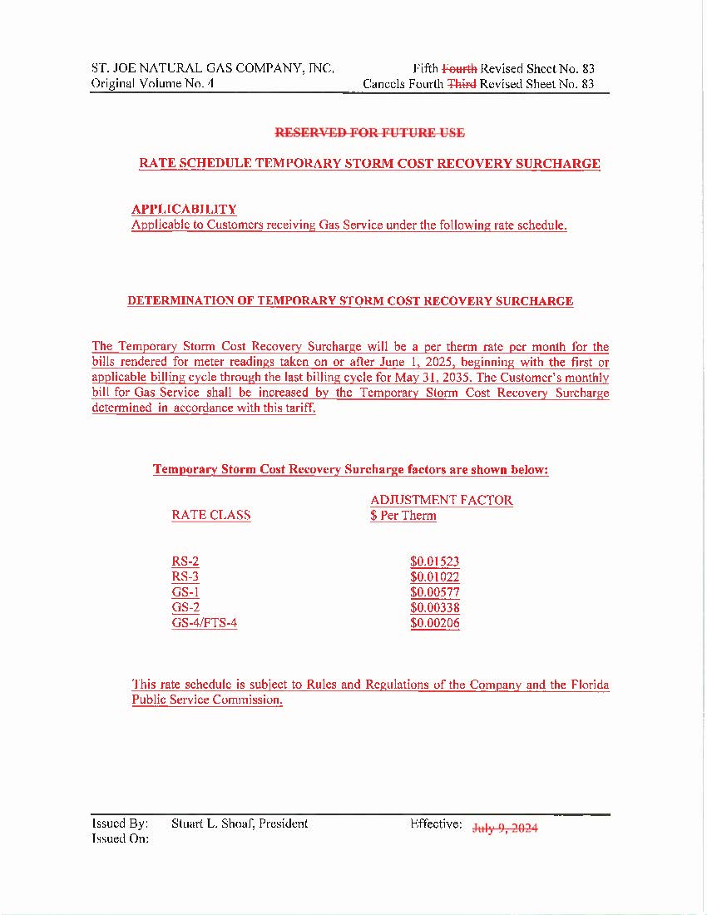

1. Order No. PSC-2021-0196-AS-GU, issued June 3, 2021, in Docket No. 20200039-GU, *In re: Petition for approval to implement a temporary storm cost recovery surcharge, by St. Joe Natural Gas Company.*
2. Order No. PSC-2021-0196-AS-GU, page 12.
3. Order No. PSC-2021-0196-AS-GU, page 12.
4. Order No. PSC-2025-0035-PAA-GU, issued January 30, 2025, in Docket No. 20250046-GU, *In re: Petition for rate increase by St. Joe Natural Gas Company, Inc.*
5. Response to Staff’s First Data Request, Response No. 2.
6. Response to Staff’s First Data Request, Response No. 1.