BEFORE THE FLORIDA PUBLIC SERVICE COMMISSION

|  |  |
| --- | --- |
| In re: Review of 2026-2035 Storm Protection Plan, pursuant to Rule 25-6.030, F.A.C., Florida Power & Light Company. | DOCKET NO. 20250014-EI  ORDER NO. PSC-2025-0218-FOF-EI  ISSUED: June 19, 2025 |

The following Commissioners participated in the disposition of this matter:

MIKE LA ROSA, Chairman

ART GRAHAM

GARY F. CLARK

ANDREW GILES FAY

GABRIELLA PASSIDOMO SMITH

FINAL ORDER APPROVING, WITH MODIFICATIONS,

FLORIDA POWER & LIGHT COMPANY’S

STORM PROTECTION PLAN

APPEARANCES:

CHRISTOPHER T. WRIGHT, ESQUIRE, 700 Universe Boulevard, Juno Beach, Florida 33408-0420

On behalf of Florida Power & Light Company (FPL).

WALT TRIERWEILER, PATRICIA A. CHRISTENSEN, OCTAVIO SIMOES-PONCE, CHARLES REHWINKEL, MARY A. WESSLING, and AUSTIN A. WATROUS, ESQUIRES, 111 West Madison Street, Room 812, Tallahassee, Florida 32399-1400

On behalf of Office of Public Counsel (OPC).

JACOB IMIG, TIMOTHY SPARKS, JENNIFER AUGSPURGER, CARLOS MARQUEZ, SAAD FAROOQI, and ADRIA HARPER, ESQUIRES, Florida Public Service Commission, 2540 Shumard Oak Boulevard, Tallahassee, Florida 32399-0850

On behalf of the Florida Public Service Commission (Staff).

MARY ANNE HELTON, ESQUIRE, Interim General Counsel, Florida Public Service Commission, 2540 Shumard Oak Boulevard, Tallahassee, Florida 32399-0850

Advisor to the Florida Public Service Commission.

Background

Section 366.96(3), Florida Statutes (F.S.), requires each public utility to file a transmission and distribution storm protection plan (SPP) that covers the immediate 10-year planning period, and explains the systematic approach the utility will follow to achieve the objectives of reducing restoration costs and outage times associated with extreme weather events and enhancing reliability. Pursuant to Section 366.96(4)-(6), F.S., at least every three years we are required to determine whether it is in the public interest to approve, approve with modification, or deny each utility’s transmission and distribution storm protection plan filed in accordance with Commission Rule 25-6.030, F.A.C.

On January 15, 2025, Florida Power & Light (FPL or Utility) filed a Petition for Approval of Storm Protection Plan. On January 21, 2025, the Office of Public Counsel (OPC), representing the utility customers, intervened in this docket by filing its Notice of Intervention, with a subsequent Order Acknowledging Intervention being filed on January 24, 2025. On April 25, 2025, FPL and OPC filed joint stipulations and proposed resolutions to all issues present in the 20250014-EI docket. A hearing was held on May 20, 2025 in Tallahassee, Florida.

FPL’s proposed 2026-2035 SPP includes the following eight programs, which are each discussed in greater detail *infra*:

* + Distribution Inspection Program;
  + Transmission Inspection Program;
  + Distribution Feeder Hardening Program;
  + Distribution Lateral Hardening Program;
  + Transmission Hardening Program;
  + Distribution Vegetation Management Program;
  + Transmission Vegetation Management Program;
  + Substation Storm Surge/Flood Mitigation Program.

Legal Standard

When reviewing each transmission and distribution SPP filed pursuant to Section 366.96, F.S., we must consider the following factors in order to make a public interest determination:

1. The extent to which the plan is expected to reduce restoration costs and outage times associated with extreme weather events and enhance reliability, including whether the plan prioritizes areas of lower reliability performance;
2. The extent to which storm protection of transmission and distribution infrastructure is feasible, reasonable, or practical in certain areas of the utility’s service territory, including, but not limited to, flood zones and rural areas;
3. The estimated costs and benefits to the utility and its customers of making the improvements proposed in the plan; and
4. The estimated annual rate impact resulting from implementation of the plan during the first 3 years addressed in the plan.[1]

Utility storm protection or hardening is an activity that goes above and beyond the basic standard of service to strengthen a utility’s existing infrastructure to withstand the potential for extreme weather. Rule 25-6.030, F.A.C., implements the statute, provides definitions (such as what an SPP is comprised of), and requires the utilities to provide certain information to support their SPPs.

Decision

**I.** Should the Commission approve, approve with modification, or deny FPL’s Storm Protection Plan?

**Stipulation:** The Commission should approve FPL’s 2026 SPP as modified by Attachment 1 to the Stipulations jointly filed by FPL and OPC on April 25, 2025.

1. Analysis

The agreed upon stipulations are the result of a robust discovery process. The stipulations, if approved, will result in a modification to the proposed SPP that FPL filed. As such, what is left for us to analyze in this proceeding are the eight programs that comprise the proposed SPP:

**Distribution Inspection Program -** Inspections are conducted on an eight-year pole inspection cycle using methods such as visual and sound and bore. Replacement poles are based on the National Electrical Safety Code’s Grade B construction standard.[2]

**Transmission Inspection Program -**The program includes visual inspection each year of FPL’s transmission structures and substations. Climbing and bucket truck inspections on wood structures are on a six-year cycle and steel and concrete structures are on a ten-year cycle.[3]

**Distribution Feeder Hardening Program -** Feeders are hardened as a result of FPL’s Priority Feeder Initiative which is a reliability program that targets feeders experiencing the highest number of interruptions and/or customers interrupted. This includes FPL’s initiative of design and construction practices to meet the NESC extreme wind loading (EWL) criteria.[4]

**Distribution Lateral Hardening Program -** FPL originally started this Program as a pilot program in 2018 and has continued the Program as part of its SPP. This Program targets certain overhead laterals, which were impacted by recent storms and have a history of vegetation-related outages and other reliability issues, for conversion from overhead to underground. FPL has also established and incorporated protocols for determining when a lateral may be overhead hardened as opposed to being placed underground.[5]

**Transmission Hardening Program -** This Program replaces all wood transmission structures with steel or concrete structures. The criteria for the replacements include proximity to high winds areas, system importance, customer counts, and opportunities to perform work on multiple transmission line sections within the same transmission corridor.[6]

**Distribution Vegetation Management Program -** This Program includes a three-year trim cycle for feeders, mid-year targeted trim maintenance cycle for certain feeders, six-year trim cycle for laterals, and continued customer education through FPL’s Right Tree, Right Place initiative.[7]

**Transmission Vegetation Management Program -** This Program includes inspecting the rights-of-way of transmission infrastructure, documenting vegetation inspection results and findings, and prescribing and executing a work plan. The North American Electric Reliability Corporation’s (NERC) vegetation management standards/requirements serve as the basis for FPL’s transmission vegetation management program, which requires annual inspection requirements, executing 100 percent of a utility’s annual vegetation work plan, and prevent any encroachment into established minimum vegetation clearance distances.[8]

**Substation Storm Surge/Flood Mitigation Program -** Damage to substations that are susceptible to storm surge and flooding during extreme weather events can be eliminated by raising the equipment at certain substations above flood level and constructing flood protection walls around other substations. FPL has identified certain substations located in areas throughout its service area that are susceptible to storm surge or flooding during extreme weather events.[9]

These programs are continuations of programs we previously approved in FPL’s last SPP.[10] We are nonetheless charged with evaluating and making a determination that the proposed SPP meets the statutory criteria set forth in Section 366.96, F.S. The evidentiary record before us, comprised of the testimonies of FPL witness Jarro and OPC witness Mara, as well as Exhibit Nos. 1, 2, 10–13, 27–35, 37-47, and 70, permit our informed review of the proposed SPP consistent with the parties’ stipulations, including the implementation timeframes and costs. As explained below, we accept the stipulations in Attachment 1 because we find they are supported by evidence and lead to a reasonable outcome consistent with the requirements of Section 366.96, F.S., and Rule 25-6.030, F.A.C. Specifically, the testimony and exhibits establish that the eight programs are expected to result in reduced restoration costs and outage times, prioritize areas of lower reliability performance, are feasible, reasonable, and practical, have explained costs and benefits, demonstrate rate impact on customers, and are in the public interest.

1. The FPL SPP is expected to result in reduced restoration costs and outage times associated with extreme weather events and enhance reliability as well as prioritize areas of lower reliability performance.

Section 366.96(4)(a), F.S., states that when reviewing a utility’s transmission and distribution SPP, we shall consider “[t]he extent to which the plan is expected to reduce restoration costs and outage times associated with extreme weather events and enhance reliability.” FPL presented testimony that despite the variability and subjectivity required to forecast estimated benefits of future SPP programs over a ten-year period, the performance of its system during historical extreme weather events demonstrates that continuing its existing SPP programs will reduce restoration costs and customer outage times associated with extreme weather events.[11]

For example, Witness Jarro testified that a prior analysis of Hurricanes Matthew and Irma indicated the restoration construction man-hours (“CMH”), days to restore, and storm restoration costs for these storms would have been significantly higher without FPL’s existing storm hardening programs.[12] The witness also provided a table that demonstrates the reductions of restoration costs and outages from hurricanes that impacted FPL’s service territory ranging from 2005 to 2023.[13] This table shows that a category 3 storm in 2005 impacting 21 counties caused FPL to replace 12,400 distribution poles and required 18 days to restore power to 100% of customers.[14] In 2023, another category 3 storm impacted 37 counties and required FPL to replace 171 distribution poles, and power was restored to 100% of customers in two days.[15]

The data provided by FPL in its 2026 SPP indicates a reduction in outage time and restoration costs. Because there was testimony and evidence from FPL supporting that the SPP is expected to reduce restoration costs and outage times associated with extreme weather events and enhance reliability, we find the SPP meets the statutory criteria of Section 366.96(4)(a), F.S.

1. FPL’ SPP is feasible, reasonable, or practical within the Utility’s service territory

Section 366.96(4)(b), F.S., requires us to consider the extent to which storm protection of transmission and distribution infrastructure is feasible, reasonable, or practical in certain areas of the utility’s service territory, including, but not limited to flood zones and rural areas.

FPL offered evidence that it “has not identified any portions of its service territory where continuing its existing SPP programs would not be feasible, reasonable, or practical.[16] According to FPL, all of its SPP programs are system-wide initiatives, but annual activities are prioritized on certain factors, including last inspection date, last vegetation maintenance date, reliability performance, impacts of recent extreme weather events, and efficient resource utilization.[17] For example, with its Transmission Hardening Program, FPL offered evidence that its annual prioritization/selection criteria for the wood structures to be replaced includes proximity to high wind areas, system importance, customer counts, and coordination with other storm initiatives (*e.g.*, distribution feeder hardening).[18] FPL offered evidence that other economic efficiencies, such as opportunities to perform work on multiple transmission line sections within the same transmission corridor, were also considered, and FPL could not identify any areas where the replacement of the remaining wood transmission structures would not be feasible, reasonable, or practical under the Transmission Hardening Program.[19]

Because there was testimony and evidence from FPL demonstrating that the SPP is feasible, reasonable, and practical in the Utility’s service territory (including in its flood zones and rural areas), we find that the SPP meets the statutory criteria in Section 366.96(4)(b), F.S.

1. The estimated costs and benefits of FPL’s SPP programs.

Section 366.96(4)(c), F.S., requires us to also consider the estimated costs and benefits to the utility and its customers from making the improvements proposed in the SPP. Rule 25-6.030(3)(d)(4.), F.A.C., requires a utility to provide a comparison of the estimated program costs, including capital and operating expenses, and the benefits. Notably, at the planning stage, utilities provide their best estimates of program costs. These costs must be reasonable and supported by the evidence. Estimates of costs and expenses are reviewed and trued-up later in the annual Storm Protection Plan Cost Recovery Clause (SPPCRC) proceeding.

FPL presented testimony and evidence regarding the myriad of benefits that the proposed SPP will generate. FPL witness Jarro testified that “SPP programs have and will continue to provide increased transmission and distribution (“T&D”) infrastructure resiliency, reduced restoration time, and reduced restoration costs when FPL’s system is impacted by severe weather events.”[20] For Hurricane Michael, witness Jarro presented testimony that FPL estimated that without hardening, restoration would have taken an additional two days, a 50% increase, and an additional $105 million, a 36% increase, in restoration costs.[21] For Irma, it would have taken an additional four days (40% longer) and an additional $496 million (40% higher) in restoration costs.[22]

For each of the eight SPP programs, FPL provided the estimated capital costs and operating expenses for 2026 through 2035, years 2026-2028 are summarized below in Table 1. The total cost is approximately $1.38 billion in 2026, $1.34 billion in 2027, and $1.27 billion in 2028.

**Table 1**

**FPL’s 2026-2028 SPP Program Cost Estimate**

|  |  |  |  |
| --- | --- | --- | --- |
| Program | 2026  (millions) | 2027  (millions) | 2028  (millions) |
| Distribution Inspection Program | $92.1 | $94.1 | $96.1 |
| Transmission Inspection Program | $61.7 | $63.6 | $65.5 |
| Distribution Feeder Hardening Program | $311.8 | $207.8 | $180.8 |
| Distribution Lateral Hardening Program | $744.0 | $777.5 | $733.1 |
| Transmission Hardening Program | $29.3 | $47.3 | $48.1 |
| Distribution Vegetation Management Program | $118.3 | $121.1 | $122.5 |
| Transmission Vegetation Management Program | $16.8 | $17.4 | $17.7 |
| Substation Storm Surge/Flood Mitigation Program | $8.5 | $8.5 | $8.5 |
| Total | $1,382.5 | $1,337.5 | $1,272.4 |

FPL provided adequate descriptions of the benefits that will result from implementing these SPP programs. The Utility also provided estimated program costs, including capital and operating expenses, required by our rule.

At the hearing, FPL stated that the stipulations are expected to reduce the estimated total ten-year plan cost by about $809 million over the ten-year period.[23] The stipulation set forth in Attachment 1 will be annual targets and not hard caps, and reasons for any variances will be addressed in FPL’s annual Storm Protection Plan Cost Recovery Clause (“SPPCRC”) filings. Because the estimated costs and description of benefits to FPL customers are supported by the evidence, we find that the SPP meets the statutory criteria in Section 366.96(4)(c), F.S.

iv. The estimated annual rate impact resulting from implementation of the FPL SPP for the first three years.

Section 366.96(4)(d), F.S., requires us to consider the estimated annual rate impact resulting from implementation of the plan during the first three years addressed in the plan. Notably, these rate impacts are estimates. The actual costs will be trued up in the SPPCRC. That said, the statute requires the utilities to provide their best cost estimates of their SPPs so that we can consider it during the planning stage and SPP determination.

FPL originally estimated SPP rate impacts per 1,000 kWh for residential customers of $9.92 in 2026, $11.21 in 2027, and $12.29 in 2028. These rate impacts are likely to be reduced following the approval of the stipulations. Because FPL addresses changes to rate impact in its 2026 SPP, we find it meets the statutory requirement.

v. The FPL SPP in the public interest.

Finally, Section 366.96(5)–(6), F.S., requires us to determine whether it is in the public interest to approve, approve with modification, or deny a proposed SPP within 180 days of filing. In reaching this decision we are guided by the factors in Section 366.96(4), the Florida Legislature’s intent, and Rule 25-6.030, F.A.C.

FPL and OPC stipulate that a modified SPP is in the public interest and should be approved by us. We agree that the joint proposal leads to a reasonable outcome consistent with law and supported by evidence. Based on the foregoing analysis and record support that the statutory criteria was met, we find that approving FPL’s SPP with the stipulated modifications is in the public interest.

1. Conclusion

Based on the above discussion, we approve FPL’s proposed SPP with modifications because it is in the public interest and meets the statutory criteria set forth in Section 366.96, F.S. Therefore, the modifications outlined in Attachment 1 shall be implemented.

`

Based on the foregoing, it is

ORDERED by the Florida Public Service Commission that the stipulations, findings, and rulings herein are hereby approved. It is further

ORDERED that Florida Power & Light Company’s Storm Protection Plan is approved with modifications as set forth herein and described in Attachment 1 of this Order. It is further

ORDERED that the modifications set forth on page 5 of Attachment 1 will be annual targets and not hard caps, and reasons for any variances will be addressed in Florida Power & Light Company’s annual Storm Protection Plan Cost Recovery Clause proceeding. It is further

ORDERED that Florida Power & Light Company shall file a modified Storm Protection Plan reflecting our ordered modifications within thirty (30) days of the issuance of this Order for administrative approval by Commission staff. It is further

ORDERED that this docket shall remain open for Commission staff’s verification that the modified Storm Protection Plan was filed and fully complies with our Order. Once these actions are complete, this docket shall be closed administratively.

By ORDER of the Florida Public Service Commission this 19th day of June, 2025.

|  |  |
| --- | --- |
|  | /s/ Adam J. Teitzman |
|  | ADAM J. TEITZMAN  Commission Clerk |

Florida Public Service Commission

2540 Shumard Oak Boulevard

Tallahassee, Florida 32399

(850) 413‑6770

www.floridapsc.com

Copies furnished: A copy of this document is provided to the parties of record at the time of issuance and, if applicable, interested persons.

JDI

NOTICE OF FURTHER PROCEEDINGS OR JUDICIAL REVIEW

The Florida Public Service Commission is required by Section 120.569(1), Florida Statutes, to notify parties of any administrative hearing or judicial review of Commission orders that is available under Sections 120.57 or 120.68, Florida Statutes, as well as the procedures and time limits that apply. This notice should not be construed to mean all requests for an administrative hearing or judicial review will be granted or result in the relief sought.

Any party adversely affected by the Commission's final action in this matter may request: 1) reconsideration of the decision by filing a motion for reconsideration with the Office of Commission Clerk, 2540 Shumard Oak Boulevard, Tallahassee, Florida 32399-0850, within fifteen (15) days of the issuance of this order in the form prescribed by Rule 25-22.060, Florida Administrative Code; or 2) judicial review by the Florida Supreme Court in the case of an electric, gas or telephone utility or the First District Court of Appeal in the case of a water and/or wastewater utility by filing a notice of appeal with the Office of Commission Clerk, and filing a copy of the notice of appeal and the filing fee with the appropriate court. This filing must be completed within thirty (30) days after the issuance of this order, pursuant to Rule 9.110, Florida Rules of Appellate Procedure. The notice of appeal must be in the form specified in Rule 9.900(a), Florida Rules of Appellate Procedure.

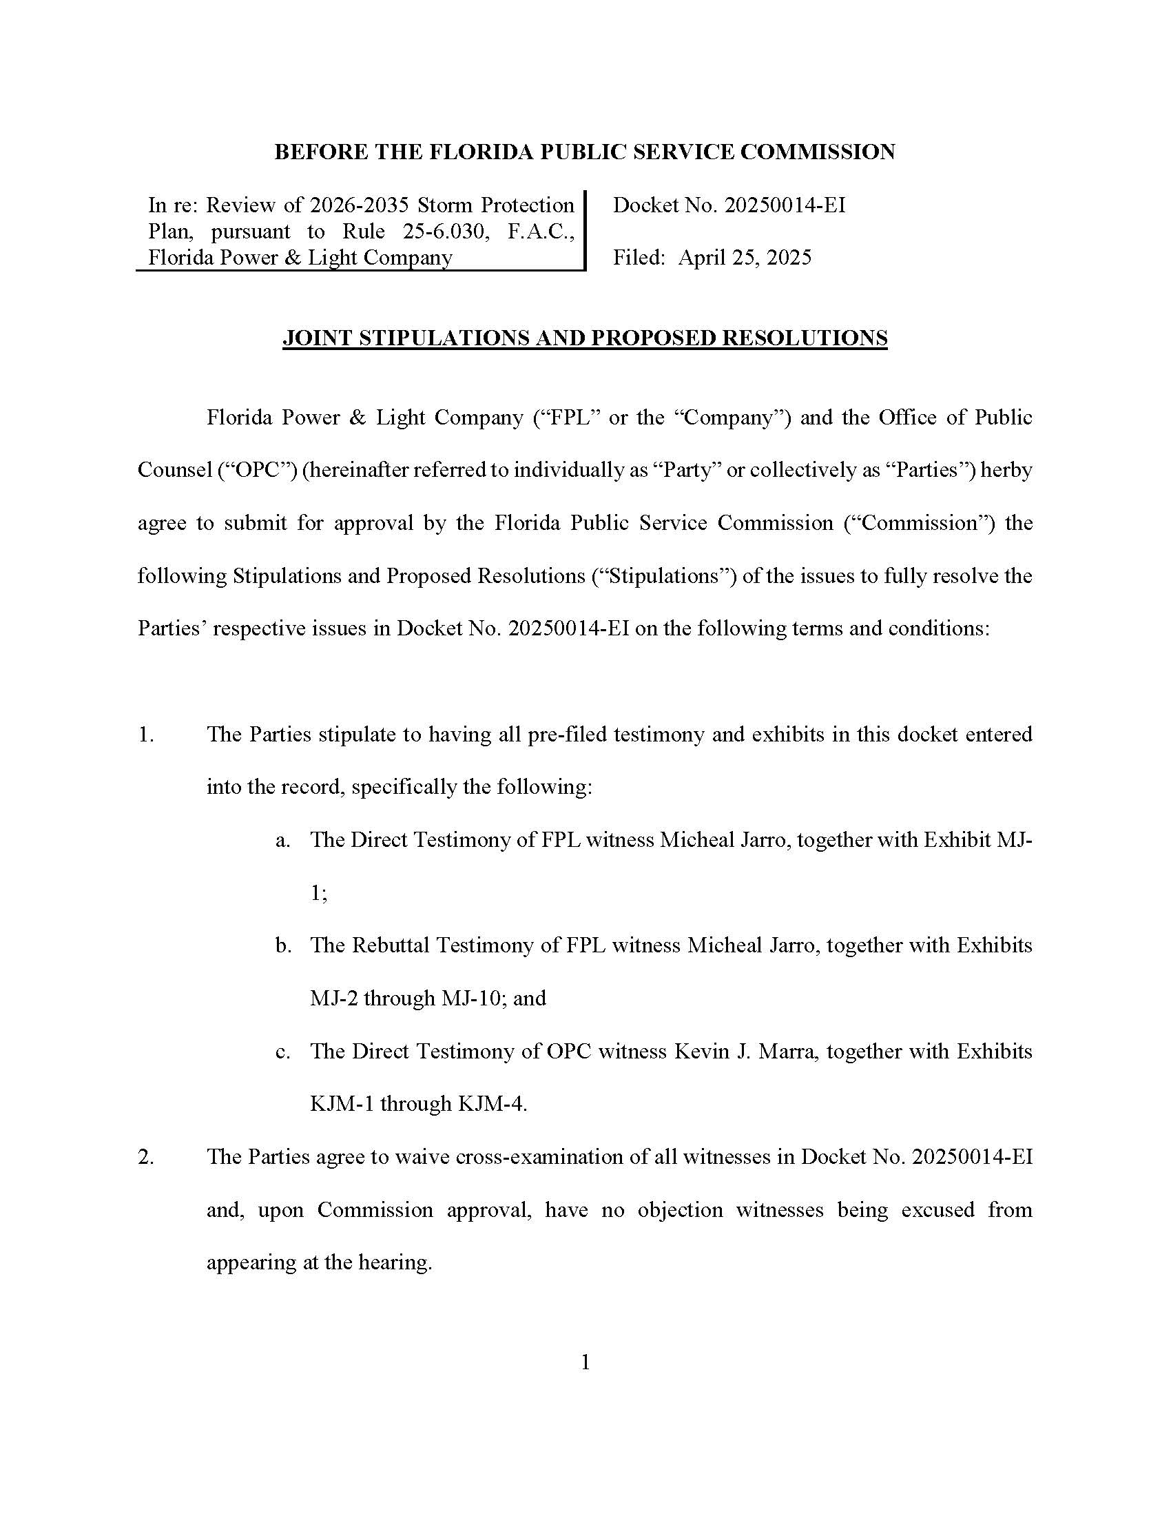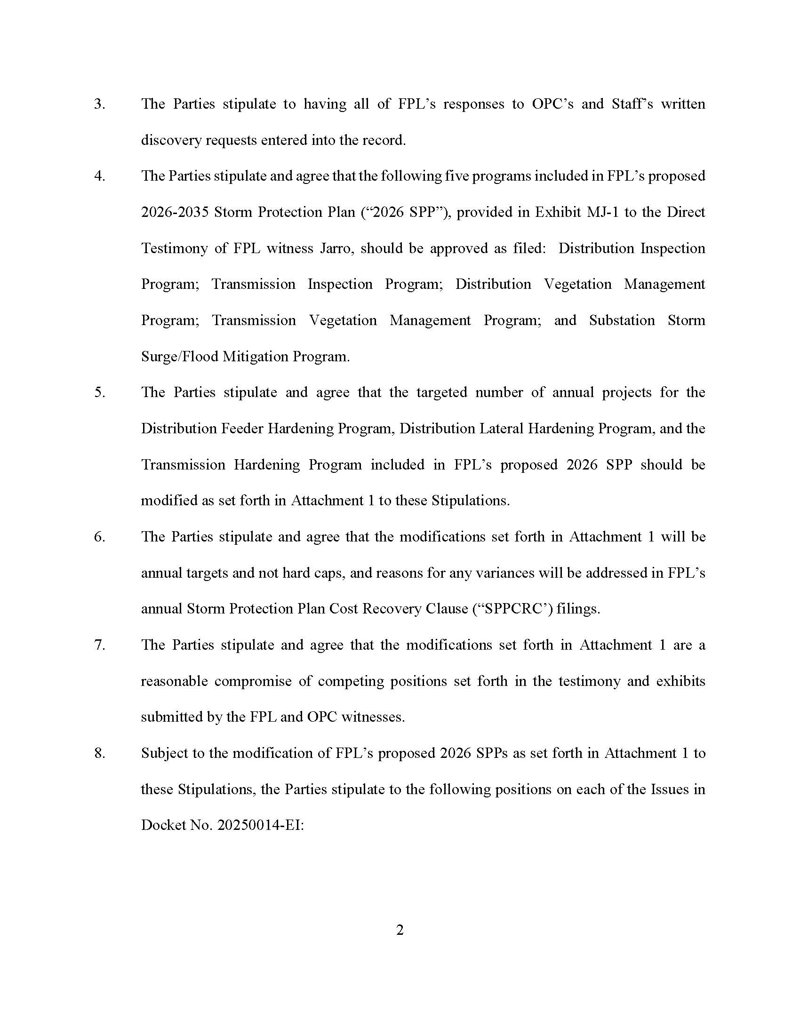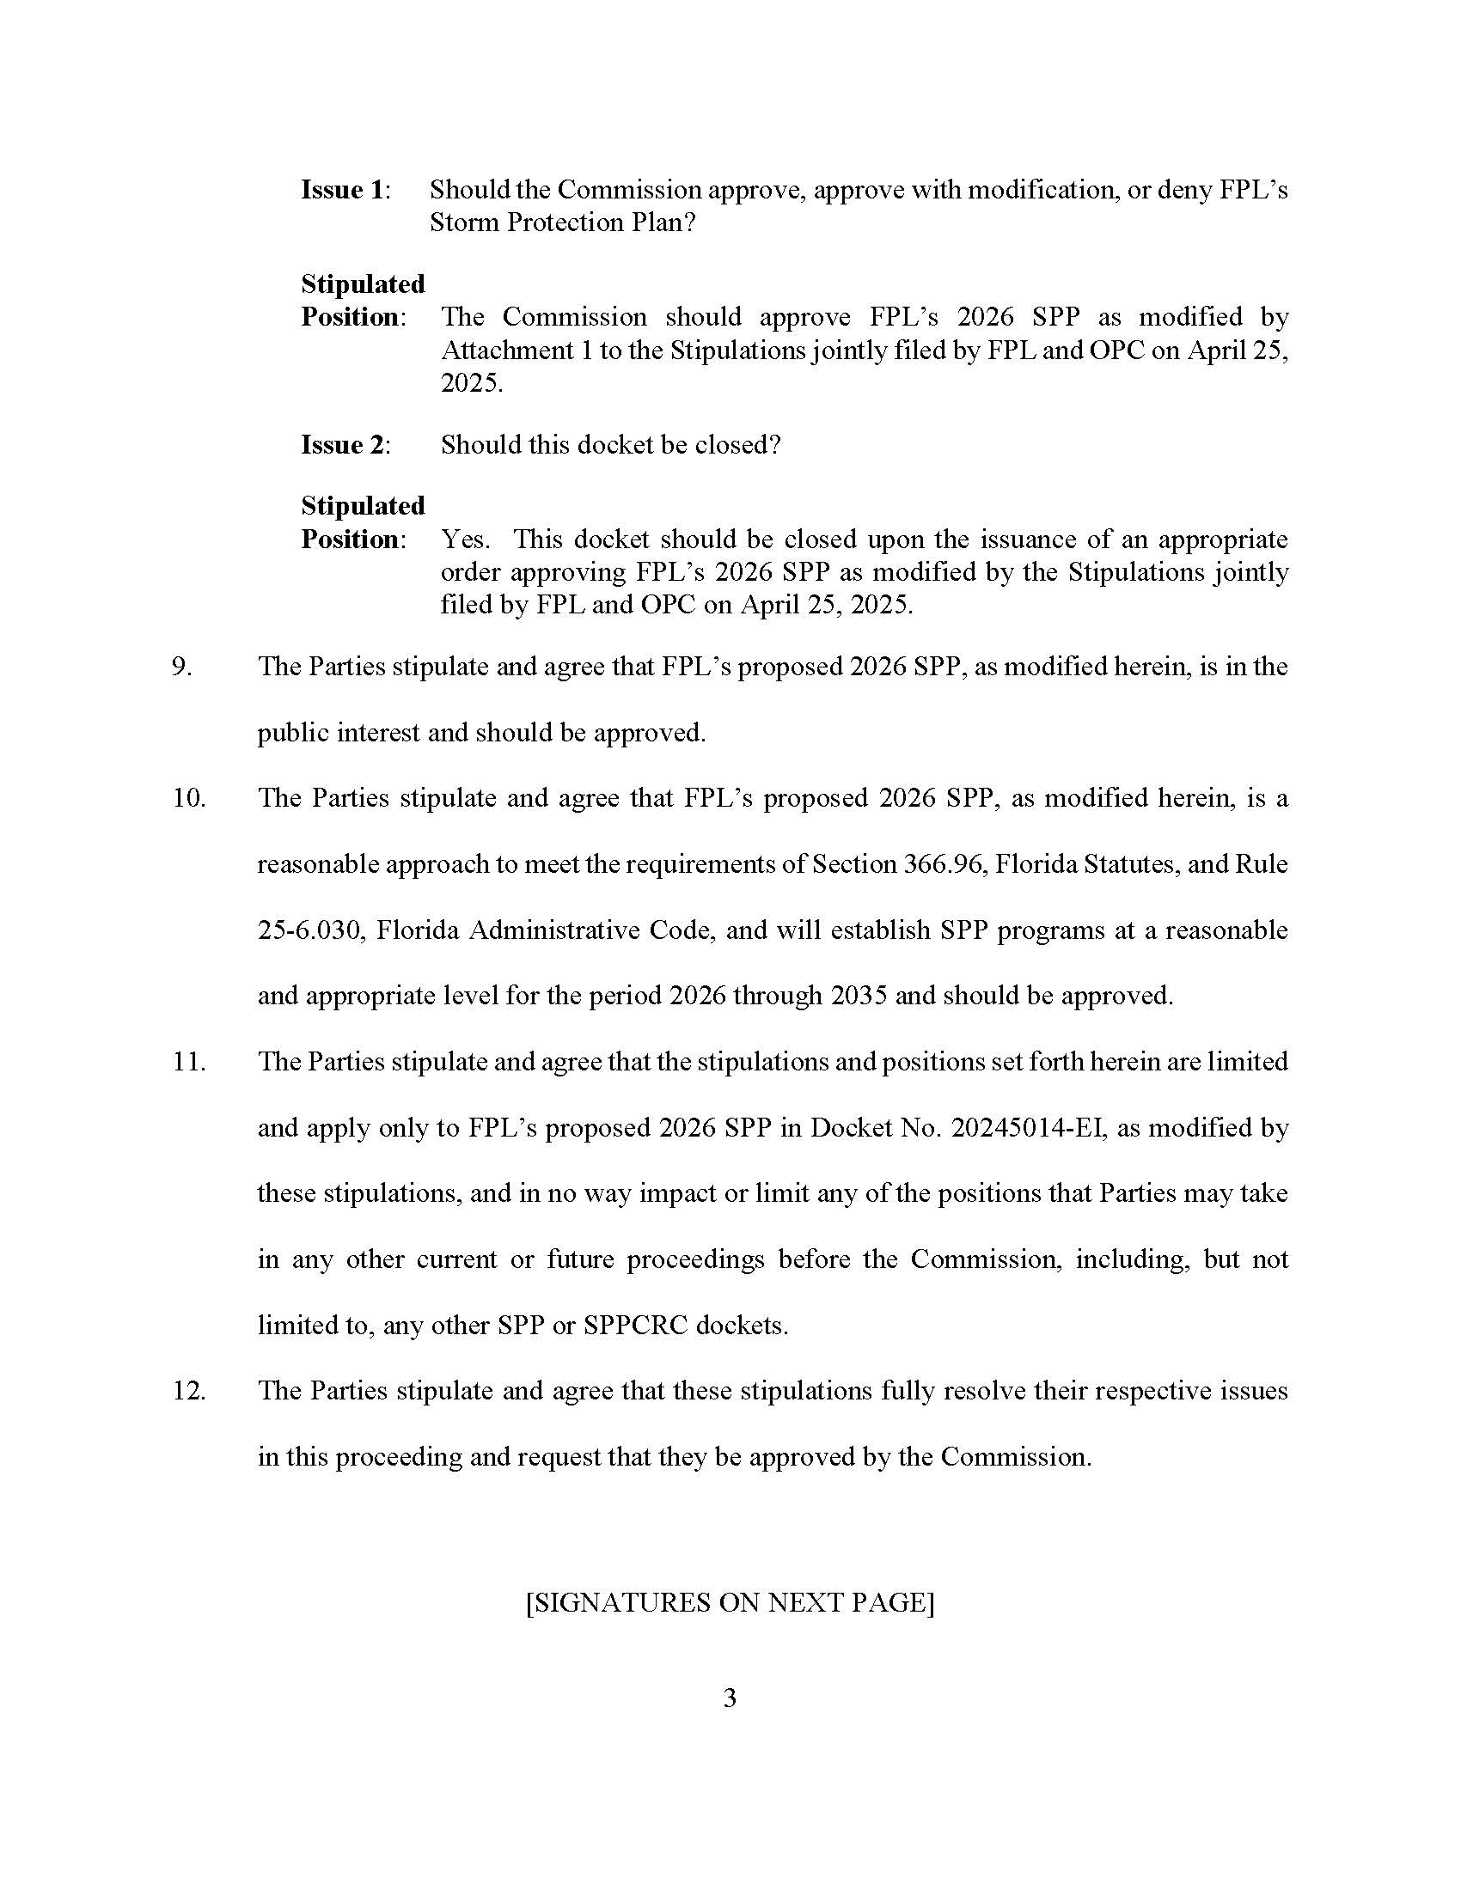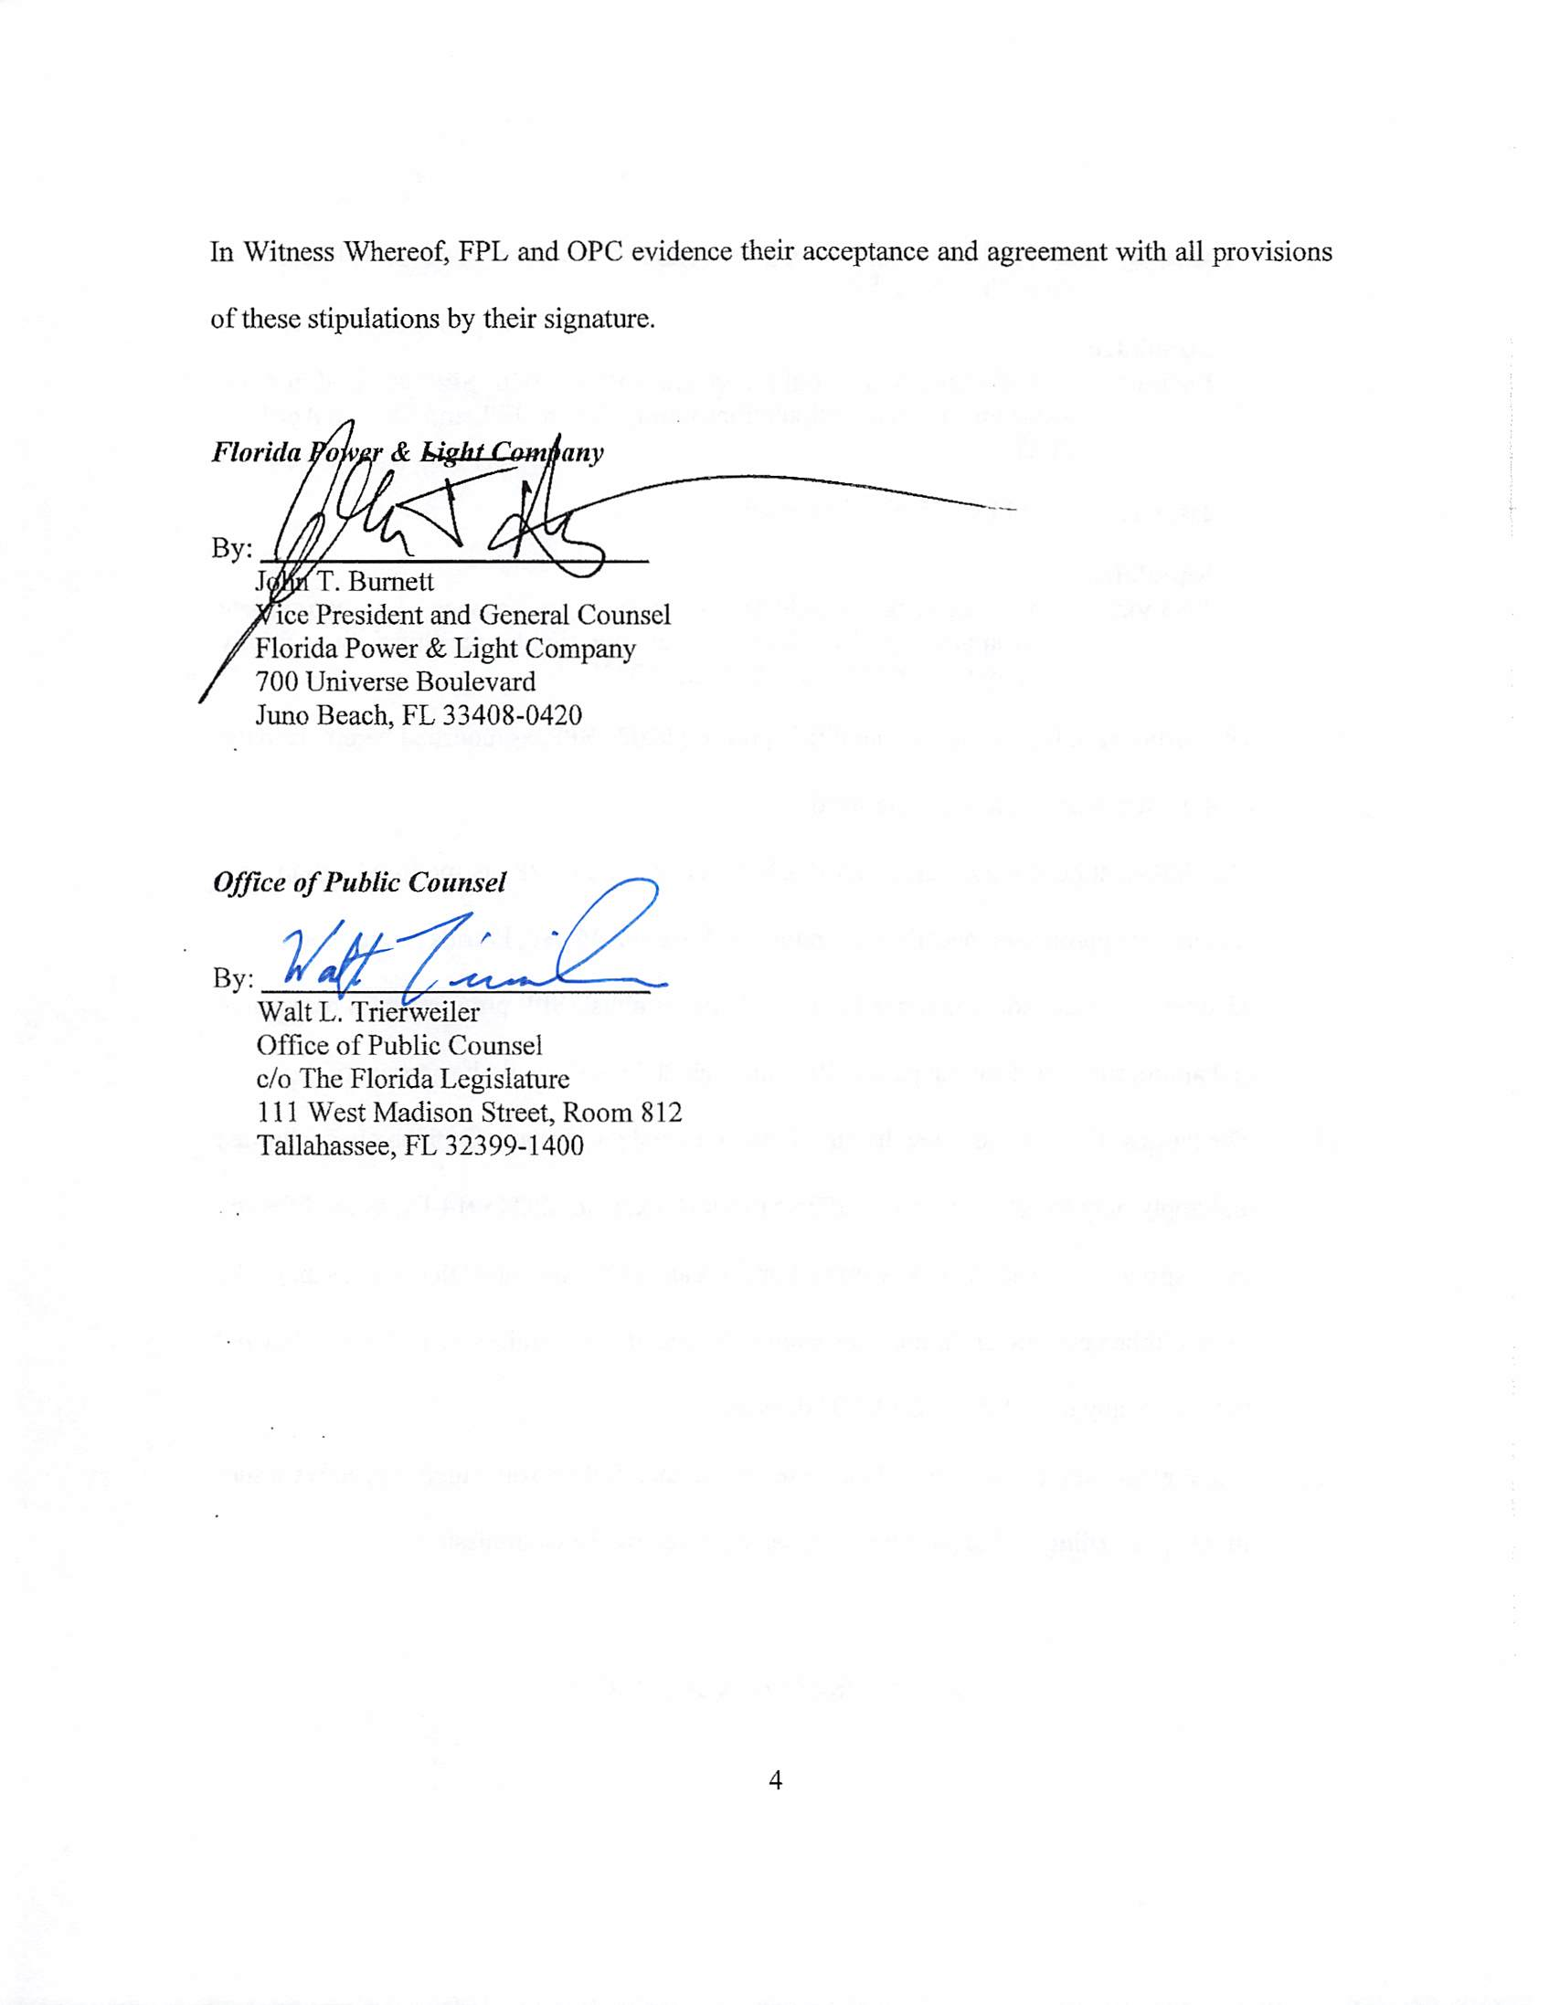

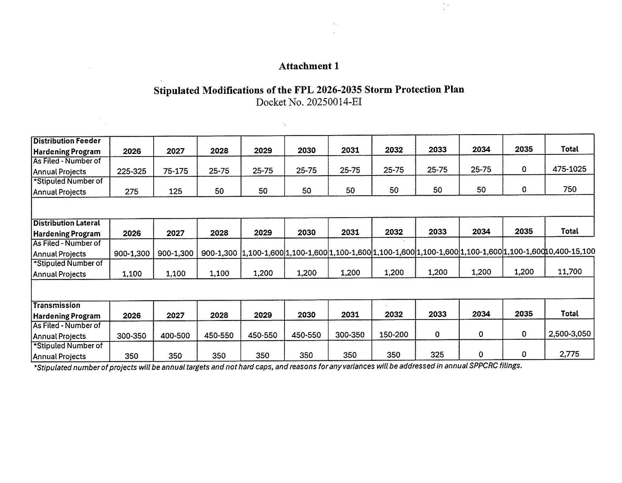

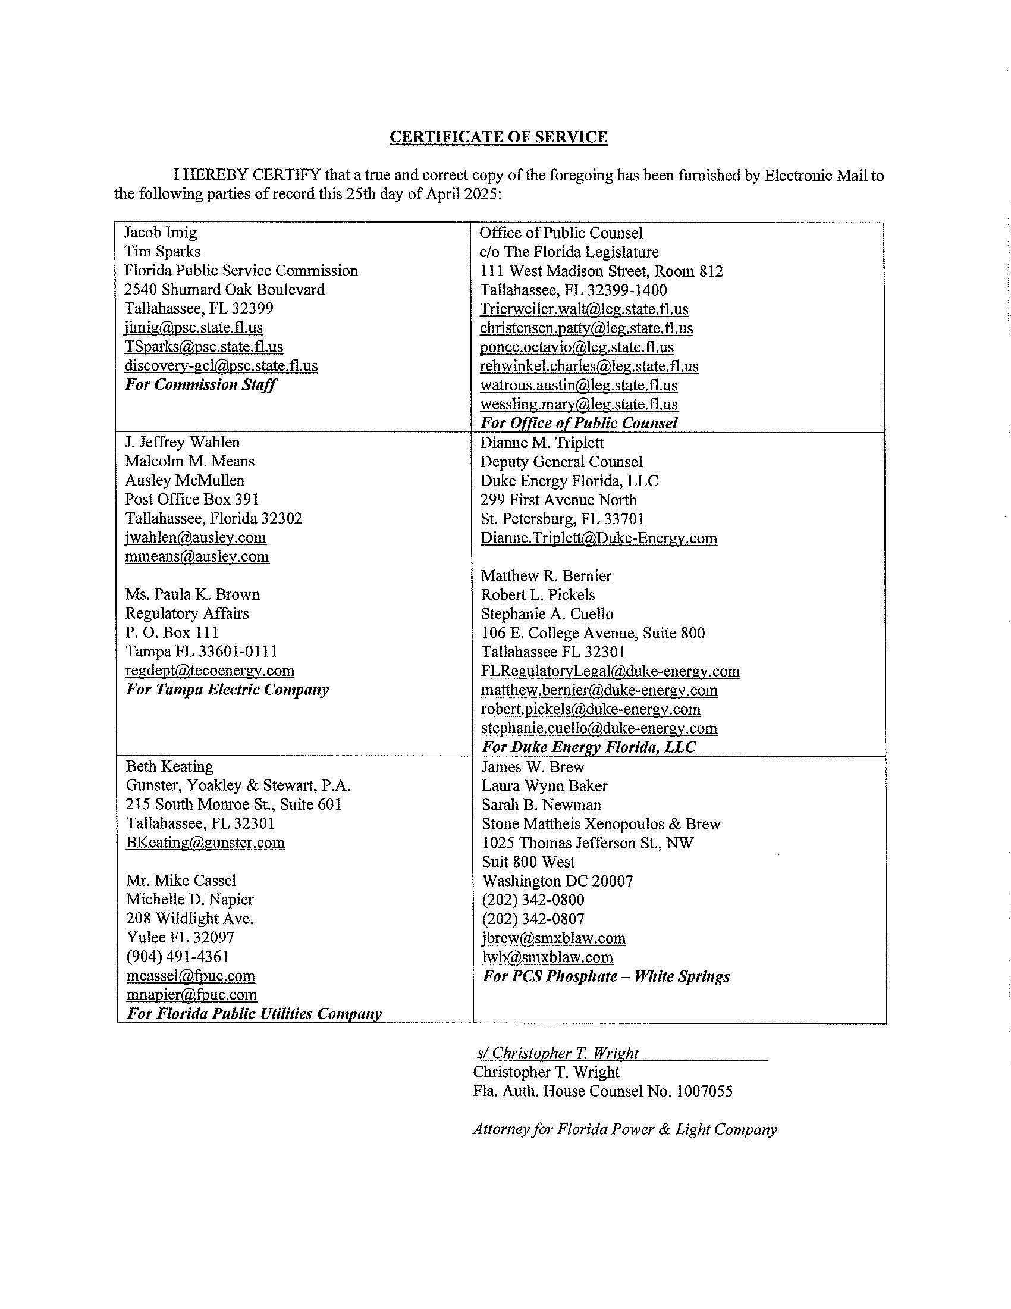

1. Section 366.96(4)–(5), F.S.
2. EXH MJ-1 pages 10-14.
3. EXH MJ-1 pages 15-18.
4. EXH MJ-1 pages 19-24.
5. EXH MJ-1 pages 24-30.
6. EXH MJ-1 pages 31-34.
7. EXH MJ-1 pages 34-38.
8. EXH MJ-1 pages 39-43.
9. EXH MJ-1 pages 43-47.
10. Order No. PSC-2022-0389-FOF-EI.
11. EXH MJ-1 page 7.
12. Id.
13. EXH MJ-1 page 8.
14. Id.
15. Id.
16. EXH MJ-1 pg. 9.
17. EXH MJ-1 pg. 10.
18. EXH MJ-1 pg. 34.
19. Id.
20. TR pg. 44 ln 6-9.
21. Id.
22. Id.
23. TR pg. 11 ln 16-19.