BEFORE THE FLORIDA PUBLIC SERVICE COMMISSION

|  |  |
| --- | --- |
| In re: Review of 2026-2035 Storm Protection Plan, pursuant to Rule 25-6.030, F.A.C., Tampa Electric Company. | DOCKET NO. 20250016-EI  ORDER NO. PSC-2025-0219-FOF-EI  ISSUED: June 19, 2025 |

The following Commissioners participated in the disposition of this matter:

MIKE LA ROSA, Chairman

ART GRAHAM

GARY F. CLARK

ANDREW GILES FAY

GABRIELLA PASSIDOMO SMITH

FINAL ORDER APPROVING, WITH MODIFICATIONS,

TAMPA ELECTRIC COMPANY’S

STORM PROTECTION PLAN

APPEARANCES:

J. JEFFREY WAHLEN, MALCOLM N. MEANS, and VIRGINIA PONDER, ESQUIRES, Post Office Box 391, Tallahassee, Florida 32302

On behalf of Tampa Electric Company (TECO).

WALT TRIERWEILER, PATRICIA A. CHRISTENSEN, OCTAVIO SIMOES-PONCE, CHARLES REHWINKEL, MARY A. WESSLING, and AUSTIN A. WATROUS, ESQUIRES, 111 West Madison Street, Room 812, Tallahassee, Florida 32399-1400

On behalf of Office of Public Counsel (OPC).

JACOB IMIG, TIMOTHY SPARKS, JENNIFER AUGSPURGER, CARLOS MARQUEZ, SAAD FAROOQI, and ADRIA HARPER, ESQUIRES, Florida Public Service Commission, 2540 Shumard Oak Boulevard, Tallahassee, Florida 32399-0850

On behalf of the Florida Public Service Commission (Staff).

MARY ANNE HELTON, ESQUIRE, Interim General Counsel, Florida Public Service Commission, 2540 Shumard Oak Boulevard, Tallahassee, Florida 32399-0850

Advisor to the Florida Public Service Commission.

BY THE COMMISSION:

Background

Section 366.96(3), Florida Statutes (F.S.), requires each public utility[1] to file a transmission and distribution storm protection plan (SPP) that covers the immediate 10-year planning period, and explains the systematic approach the utility will follow to achieve the objectives of reducing restoration costs and outage times associated with extreme weather events and enhancing reliability. Pursuant to Section 366.96(4)–(6), F.S., at least every three years we are required to determine whether it is in the public interest to approve, approve with modification, or deny each utility’s transmission and distribution SPP filed in accordance with Commission Rule 25-6.030, Florida Administrative Code (F.A.C.). Our decision must be made no later than 180 days from the utility’s filing date.

On January 15, 2025, Tampa Electric Company (TECO or Utility) filed its Petition for Approval of Storm Protection Plan. Shortly thereafter, the Office of Public Counsel (OPC), representing the utility customers, intervened in this docket. TECO’s proposed SPP included the following nine programs:

* Distribution Lateral Undergrounding;
* Vegetation Management;
* Transmission Asset Upgrades;
* Substation Extreme Weather Hardening;
* Distribution Overhead Feeder Hardening;
* Infrastructure Inspections;
* Legacy Storm Hardening Initiatives;
* Transmission Switch Hardening; and
* Distribution Storm Surge Hardening.

All of these programs, except for the Transmission Switch Hardening and Distribution Storm Surge Hardening programs, are programs that were approved in the prior SPP.[2] A hearing to fully address the petition was scheduled to begin on May 20, 2025.[3] However, on May 15, 2025, TECO and OPC filed a joint motion for approval of stipulations.[4] Those stipulations are reflected in Attachment A to this Order. We have jurisdiction over this matter pursuant to Section 366.96, F.S., and Chapter 120, F.S.

Legal Standard

When reviewing each transmission and distribution SPP filed pursuant to Section 366.96, F.S., we must consider the following factors in order to make a public interest determination:

1. The extent to which the plan is expected to reduce restoration costs and outage times associated with extreme weather events and enhance reliability, including whether the plan prioritizes areas of lower reliability performance;
2. The extent to which storm protection of transmission and distribution infrastructure is feasible, reasonable, or practical in certain areas of the utility’s service territory, including, but not limited to, flood zones and rural areas;
3. The estimated costs and benefits to the utility and its customers of making the improvements proposed in the plan; and
4. The estimated annual rate impact resulting from implementation of the plan during the first 3 years addressed in the plan.[5]

Utility storm protection or hardening is an activity that goes above and beyond the basic standard of service to strengthen a utility’s existing infrastructure to withstand the potential for extreme weather. Rule 25-6.030, F.A.C., implements the statute, provides definitions (such as what an SPP is comprised of), and requires the utilities to provide certain information to support their SPPs.

Decision

1. Should the proposed Distribution Storm Surge Hardening Program be included in TECO’s proposed 2026–2035 Storm Protection Plan?

**Stipulation**: Yes. It is in the public interest for the Commission to approve Tampa Electric’s Distribution Storm Surge Hardening Program as a component of the company’s 2026-2034 Storm Protection Plan (“SPP”).

1. Analysis and Conclusion

TECO and OPC stipulate that we should include the Distribution Storm Surge Hardening Program as part of TECO’s approved 2026-2035 Storm Protection Plan. The Distribution Storm Surge Hardening Program will upgrade live front distribution switchgears in flood zones A, B, and C into a submersible/water-resistant units and replace the secondary bushings on pad-mounted transformers with an insulated water-resistant units. Witness Palladino testified that this program will make vital equipment more resistant to water intrusion, which will mitigate the need for complete and more costly replacement of these units which, in turn, will reduce restoration costs and reduce outage time.[6]

Witness Palladino also testified that TECO analyzed and prioritized this program internally.[7] The Distribution Storm Surge Hardening Program grouped projects at the circuit level and prioritized projects based on evacuation zone, with evacuation zone A given highest priority.[8] The record evidence reflects that TECO’s costs for this project are projected to be $200,000 in 2026, $15.5 million in 2027, and $17.4 million in 2028.[9]

We accept this stipulation for the reasons discussed above and for further reasons discussed below, and find that the Distribution Storm Surge Hardening Program shall be included in TECO’s proposed 2026-2035 SPP because it is in the public interest and meets the statutory criteria set forth in Section 366.96, F.S.

1. Should the proposed Transmission Switch Hardening Program be included in TECO’s proposed 2026-2035 Storm Protection Plan?

**Stipulation**: Yes. The record supports a Commission finding that it is in the public interest for the Commission to approve Tampa Electric’s Transmission Switch Hardening Program, and a finding that Tampa Electric proceeding to implement the program in 2026, 2027, and 2028 is not evidence of imprudence. Such approval does not constitute a final determination that the Transmission Switch Hardening Program should ultimately remain in the company’s future SPP when it is next reviewed by the Commission pursuant to section 366.96(6), Florida Statutes. Accordingly, any approval of this program shall not be cited for precedent that the facts and circumstances of the Commission approval of Tampa Electric’s Transmission Switch Hardening Program supports inclusion of a similar program in any company’s SPP.

1. Analysis and Conclusion

TECO and OPC stipulate that we should include the Transmission Switch Hardening Program as part of TECO’s approved 2026-2035 Storm Protection Plan. The Transmission Switch Hardening Program is a four-year initiative to upgrade 250 transmission switch locations with modern switches enabled with Supervisory Control and Data Acquisition (SCADA) communication and remote-control capabilities. Operating these switches from a control center and avoiding sending technicians to the switch sites will allow for faster isolation of trouble spots on the transmission system and more rapid restoration following line faults, thereby increasing the resiliency of the transmission system.[10]

Witness Palladino also testified that TECO analyzed and prioritized this program internally.[11] The Transmission Switch Hardening Program grouped projects at the circuit level and prioritized projects based on the system voltage, with prioritization beginning with the 69kV system due to the volume of targeted switches being at this voltage.[12] The record evidence reflects that TECO is not expecting to incur costs for this project until 2028, with expected costs of $300,000 during that year.[13]

We accept this stipulation for the reasons discussed above and for further reasons discussed below, and find that the Transmission Switch Hardening Program shall be included in TECO’s proposed 2026-2035 SPP because it is in the public interest and meets the statutory criteria set forth in Section 366.96, F.S.

1. Should we approve, approve with modification, or deny TECO’s proposed 2026-2035 Storm Protection Plan?

**Stipulation**: The Parties stipulate and agree that it is in the public interest for the Commission to approve Tampa Electric’s 2026-2035 SPP with a modification to the company’s proposed Distribution Lateral Undergrounding Program and with the approval of the language resolving Issue 2.

The Parties acknowledge that Tampa Electric’s 2022-2031 SPP targeted conversion of 75-100 miles per year to underground. The Parties also acknowledge that Tampa Electric voluntarily reduced this target to 65-85 miles per year in its 2026-2035 SPP. The Parties agree that this modification will be an annual mileage target and not a hard cap.

1. Analysis

The agreed upon stipulations are the result of a robust discovery process. The stipulations will result in a modification to the proposed SPP that TECO filed. As such, what is left for us to analyze in this proceeding are the remaining seven programs that comprise TECO’s proposed SPP:

* **Distribution Lateral Undergrounding** – This program is meant to continue to strategically underground existing overhead lateral primary, lateral secondary, and service lines.[14]
* **Vegetation Management** – This program is comprised of five initiatives, including Distribution Vegetation Management Four-Year Cycle, Reactive Vegetation Management, Transmission Vegetation Management, Supplemental Distribution Circuit Vegetation Management, and Mid-Cycle Distribution Vegetation Management. There are only modifications to the latter two initiatives since the previous review of TECO’s SPP.[15]
* **Transmission Asset Upgrades** – This program systematically and proactively replaces all of TECO’s remaining transmission wood poles with non-wood material. TECO has approximately 25,000 transmission poles and structures with approximately 1,350 circuit miles of transmission facilities. Of these transmission structures, approximately 9.7% are supported with wood poles. TECO intends to complete this conversion during the timeframe of the proposed 2026-2035 SPP.[16]
* **Substation Extreme Weather Hardening** – This program is designed to harden existing substations to minimize outages, reduce restoration times and enhance emergency response during extreme weather events.[17]
* **Distribution Overhead Feeder Hardening** – This program will strengthen TECO’s distribution system to withstand increased wind-loading and harsh environmental conditions associated with extreme weather events.[18]
* **Infrastructure Inspections** – This program will continue the comprehensive inspection program including Wood Pole Inspections, Transmission Structure Inspections, and the Joint Use Pole Attachment Audit.[19]
* **Legacy Storm Hardening Initiatives** – This program consists of the legacy Storm Hardening Plan Initiatives for which TECO does not propose any specific projects at this time. TECO will be continuing these activities as they offer the storm resiliency benefits identified by the Commission in Order No. PSC-06-0351-PAA-EI.[20]
* **Transmission Switch Hardening** – This program is a four-year initiative to upgrade 250 transmission switch locations with modern switches enabled with Supervisory Control and Data Acquisition (SCADA) communication and remote-control capabilities. Operating these switches from a control center and avoiding sending technicians to the switch sites will allow for faster isolation of trouble spots on the transmission system and more rapid restoration following line faults, thereby increasing the resiliency of the transmission system.[21]
* **Distribution Storm Surge Hardening** – This program will upgrade the live front distribution switchgear in flood zones A, B, and C to a submersible/water-resistant units and replace the secondary bushings on pad-mounted transformers with insulated water-resistant units. This work will make this vital equipment more resistant to water intrusion, which will mitigate the need for complete and more costly replacement of these units which, in turn, will reduce restoration costs and reduce outage time.[22]

We note that seven of these programs are continuations of programs we previously approved in TECO’s last SPP.[23] We are nonetheless charged with evaluating and making a determination that the proposed SPP meets the statutory criteria set forth in Section 366.96, F.S. The evidentiary record before us—comprised of the testimonies of TECO witnesses Palladino, Lewis, and De Stigter and OPC witness Mara as well as Exhibit Nos. 1, 6-8, 19–21, 55–60, and 72—permit our informed review of the proposed SPP consistent with the parties’ stipulations, including implementation timeframes and costs. As explained, we accept the stipulations in Attachment A because we find they are supported by evidence and lead to a reasonable outcome consistent with the requirements of Section 366.96, F.S., and Rule 25-6.030, F.A.C. Specifically, the testimony and exhibits establish that the nine programs are expected to result in reduced restoration costs and outage times, prioritize areas of lower reliability performance, are feasible, reasonable, and practical, have explained costs and benefits, demonstrate rate impact on customers, and are in the public interest.

1. TECO’s SPP is expected to result in reduced restoration costs and outage times associated with extreme weather events and enhance reliability as well as prioritize areas of lower reliability performance

Section 366.96(4)(a), F.S., states that when reviewing a utility’s transmission and distribution SPP, we shall consider “[t]he extent to which the plan is expected to reduce restoration costs and outage times associated with extreme weather events and enhance reliability.” TECO presented testimony that its Distribution Lateral Undergrounding program, Transmission Asset Upgrades program, Distribution Overhead Feeder Hardening program, and the Substation Extreme Weather program would reduce outages and avoid restoration costs.

Witness De Stigter provided a summary of expected TECO customer benefits through reduced utility restoration costs and impacts to customers.[24] Based on the results of 1898 & Co.’s Storm Resilience Model, Witness De Stigter concluded that TECO’s SPP is expected to decrease restoration costs by approximately $130 million to $450 million.[25] Further, he testified that the customer outage benefits of the plan are projected to consist of an approximated 10% decrease in the storm “Customer Minutes Interrupted” (CMI) over the next 50 years.[26]

Witness De Stigter testified that TECO’s projects were evaluated and prioritized using the same criteria, and then are ranked based on their benefit cost ratio using each program’s life-cycle 50-year net present value (NPV) gross benefit value.[27]

Because there was testimony and evidence from TECO supporting that the SPP is expected to reduce restoration costs and outage times associated with extreme weather events and enhance reliability, we find that it meets the statutory criteria of Section 366.96(4)(a), F.S.

1. TECO’s SPP is feasible, reasonable, or practical within the Utility’s service territory

Section 366.96(4)(b), F.S., requires us to consider the extent to which storm protection of transmission and distribution infrastructure is feasible, reasonable, or practical in certain areas of the utility’s service territory, including, but not limited to flood zones and rural areas. TECO offered evidence from witness Palladino who testified regarding the feasibility and practicality of the SPP. Witness Palladino testified all components of its transmission and distribution systems can be hardened to achieve resiliency benefits.[28] He testified further that TECO believes that all customers should benefit from the storm protection investments, and that TECO has prioritized hardening those system components that offer the greatest projected benefits for the associated cost.[29] In addition, there is evidence before us that the nine SPP programs continue to be reasonable at this time for TECO’s service territory.

Because there was testimony and evidence from TECO demonstrating that the SPP is feasible, reasonable, and practical in the Utility’s service territory (including in its flood zones and rural areas), we find that the SPP meets the statutory criteria in Section 366.96(4)(b), F.S.

1. The estimated costs and benefits of TECO’s SPP programs

Section 366.96(4)(c), F.S., requires us to also consider the estimated costs and benefits to the utility and its customers from making the improvements proposed in the SPP. Rule 25-6.030(3)(d)(4.), F.A.C., requires a utility to provide a comparison of the estimated program costs, including capital and operating expenses, and the benefits. Notably, at the planning stage, utilities provide their best estimates of program costs. These costs must be reasonable and supported by the evidence. Estimates of costs and expenses are reviewed and trued-up later in the annual Storm Protection Plan Cost Recovery Clause (SPPCRC) proceeding.

TECO presented testimony and evidence regarding expected benefits through quantitative analysis of the Distribution Lateral Undergrounding program, Transmission Asset Upgrades program, Distribution Overhead Feeder Hardening program, and the Substation Extreme Weather program.[30] These anticipated benefits include avoided restoration costs, avoided customer outages, and monetization of avoided customer outages.[31]

Regarding the Vegetation Management Program, TECO worked with Accenture to analyze and compare full and partial circuit vegetation management activities based on their expected cost and benefit during extreme weather events, as well as overall service reliability.[32] For the two new programs, TECO analyzed them internally and prioritized projects based on the system voltage.[33] Finally, when considering prioritization of all the SPP programs, TECO considered other factors like execution constraints, ease of construction, start-up and ramp-up rates, and customer bill impacts.[34]

For each of the nine SPP programs, TECO provided projected capital and O&M costs for 2026 through 2035.[35] The total cost is approximately $220.95 million in 2026, $237.63 million in 2027, and $240.84 million in 2028.[36]

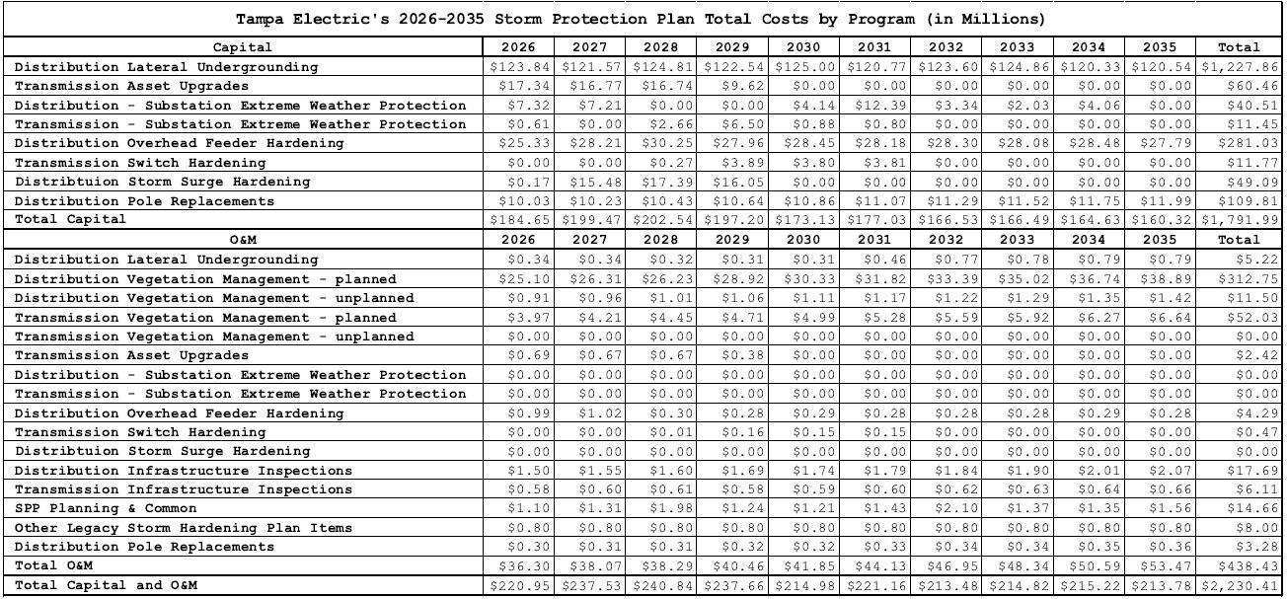

TECO provided adequate descriptions of the benefits that will result from implementing these SPP programs. The Utility also provided estimated program costs, including capital and operating expenses, required by our rule. Because the estimated costs and description of benefits to TECO customers are supported by the evidence, we find that the SPP meets the statutory criteria in Section 366.96(4)(c), F.S.

1. The estimated annual rate impact resulting from implementation of TECO’s SPP for the first three years

Section 366.96(4)(d), F.S., requires us to consider the estimated annual rate impact resulting from implementation of the plan during the first three years addressed in the plan. Notably, these rate impacts are estimates. The actual costs will be trued up in the SPPCRC. That said, the statute requires the utilities to provide their best cost estimates on their SPPs so that we can consider that information.

TECO originally estimated SPP rate impacts per 1,000 kwh for residential customers of $8.48 in 2026, $10.12 in 2027, and $11.45 in 2028.[37] However, TECO estimates that the stipulations will reduce the SPP rate impact on customers due to the reduction in the targeted range of miles to be undergrounded in TECO’s Distribution Lateral Undergrounding Program. While the new targeted range of miles is not a hard cap, the modification was entered to mitigate customer bill impacts and help maintain affordable rates for TECO customers.[38] Thus, the stipulation is expected to result in a reduced SPP rate impact on customers.

1. Is TECO’s SPP in the public interest?

Finally, Section 366.96(5)–(6), F.S., requires us to determine whether it is in the public interest to approve, approve with modification, or deny a proposed SPP within 180 days of filing. In reaching this decision we are guided by the factors in Section 366.96(4), the Florida Legislature’s intent, and Rule 25-6.030, F.A.C.

TECO and OPC stipulate that a modified SPP is in the public interest and should be approved by us. We agree that the joint proposal leads to a reasonable outcome consistent with law and supported by evidence. Based on the foregoing analysis and record support that the statutory criteria was met, we find that approving an SPP with the stipulated modifications is in the public interest.

1. Conclusion

Based on the above discussion, we approve the proposed SPP with modifications because it is in the public interest and meets the statutory criteria set forth in Section 366.96, F.S. Therefore, TECO’s SPP shall be approved with the modifications outlined in Attachment A.

Based on the foregoing, it is

ORDERED by the Florida Public Service Commission that the stipulations, findings, and rulings herein are hereby approved. It is further

ORDERED that Tampa Electric Company’s Storm Protection Plan is approved with modifications as set forth herein and described in Attachment A to this Order. It is further

ORDERED that Tampa Electric Company shall file a modified Storm Protection Plan reflecting our ordered modifications within thirty (30) days of the issuance of this Order for administrative approval by Commission staff. It is further

ORDERED that this docket shall remain open for Commission staff’s verification that the modified Storm Protection Plan was filed and fully complies with our Order. Once these actions are complete, this docket shall be closed administratively.

By ORDER of the Florida Public Service Commission this 19th day of June, 2025.

|  |  |
| --- | --- |
|  | /s/ Adam J. Teitzman |
|  | ADAM J. TEITZMAN  Commission Clerk |

Florida Public Service Commission

2540 Shumard Oak Boulevard

Tallahassee, Florida 32399

(850) 413‑6770

www.floridapsc.com

Copies furnished: A copy of this document is provided to the parties of record at the time of issuance and, if applicable, interested persons.

SF

NOTICE OF FURTHER PROCEEDINGS OR JUDICIAL REVIEW

The Florida Public Service Commission is required by Section 120.569(1), Florida Statutes, to notify parties of any administrative hearing or judicial review of Commission orders that is available under Sections 120.57 or 120.68, Florida Statutes, as well as the procedures and time limits that apply. This notice should not be construed to mean all requests for an administrative hearing or judicial review will be granted or result in the relief sought.

Any party adversely affected by the Commission's final action in this matter may request: 1) reconsideration of the decision by filing a motion for reconsideration with the Office of Commission Clerk, 2540 Shumard Oak Boulevard, Tallahassee, Florida 32399-0850, within fifteen (15) days of the issuance of this order in the form prescribed by Rule 25-22.060, Florida Administrative Code; or 2) judicial review by the Florida Supreme Court in the case of an electric, gas or telephone utility or the First District Court of Appeal in the case of a water and/or wastewater utility by filing a notice of appeal with the Office of Commission Clerk, and filing a copy of the notice of appeal and the filing fee with the appropriate court. This filing must be completed within thirty (30) days after the issuance of this order, pursuant to Rule 9.110, Florida Rules of Appellate Procedure. The notice of appeal must be in the form specified in Rule 9.900(a), Florida Rules of Appellate Procedure.

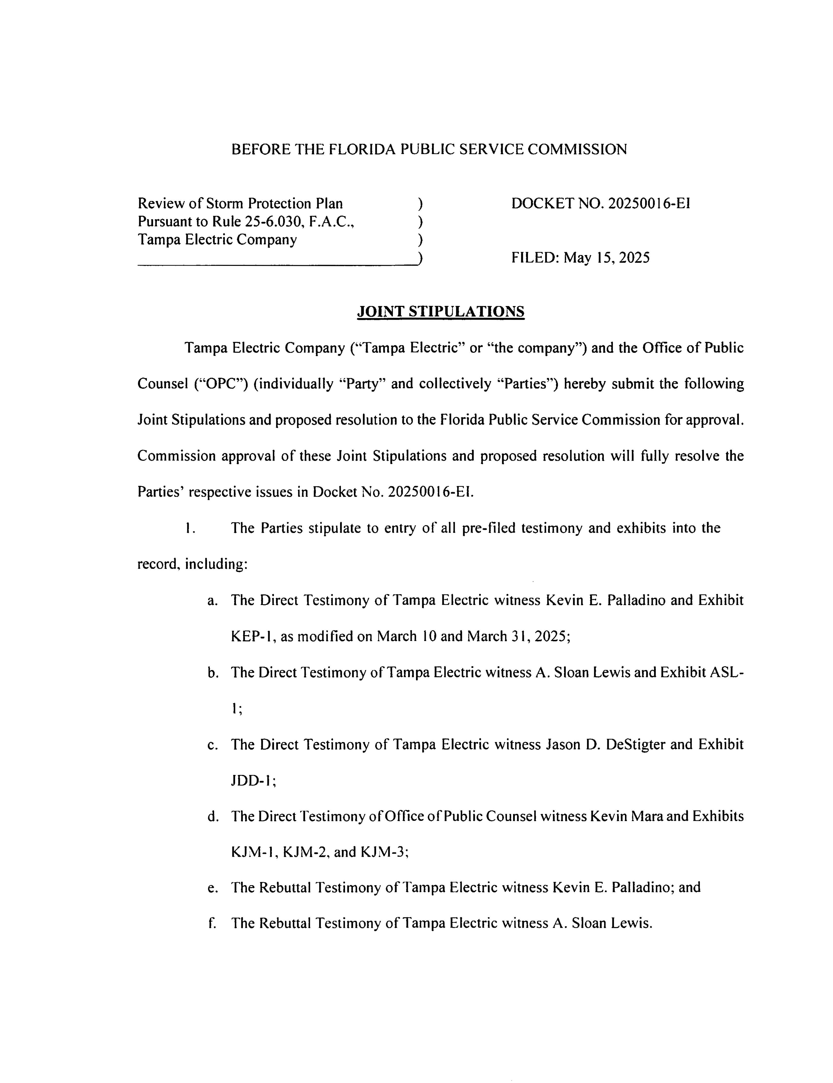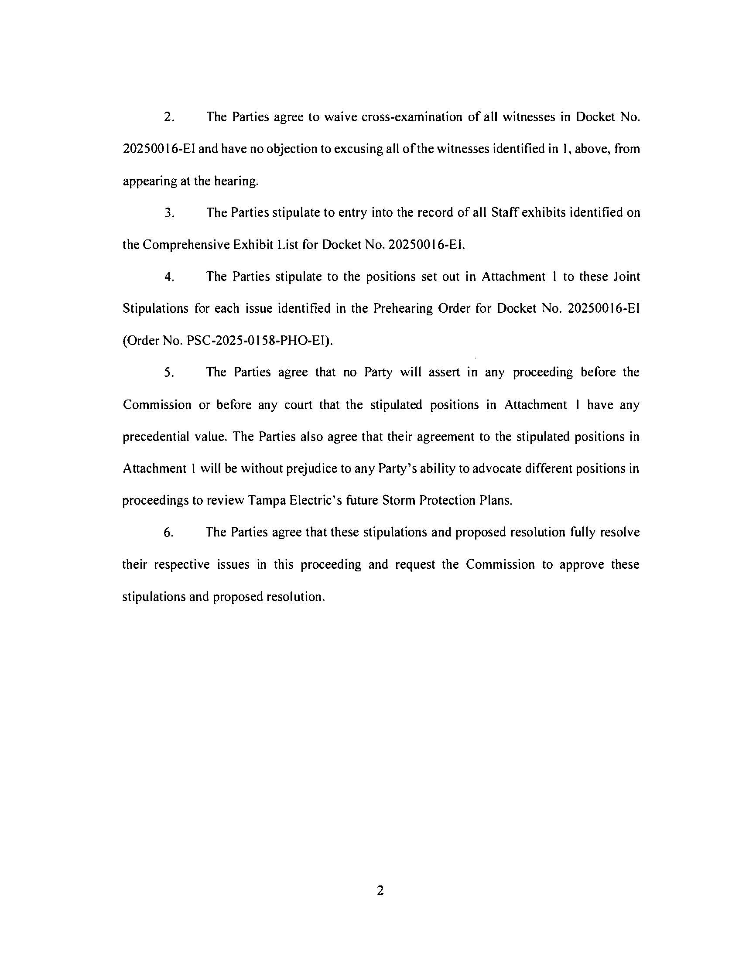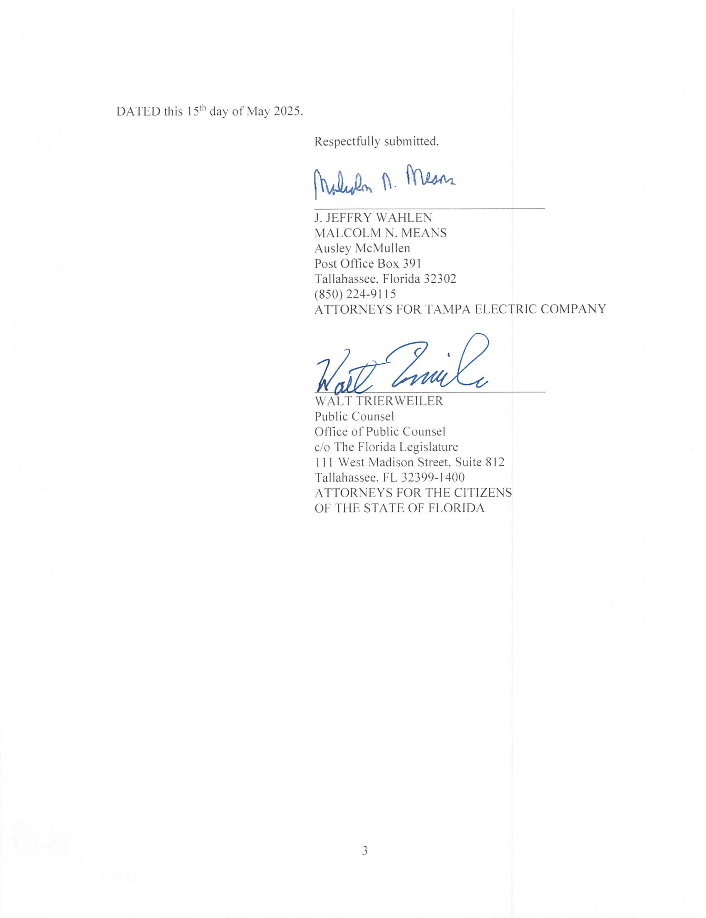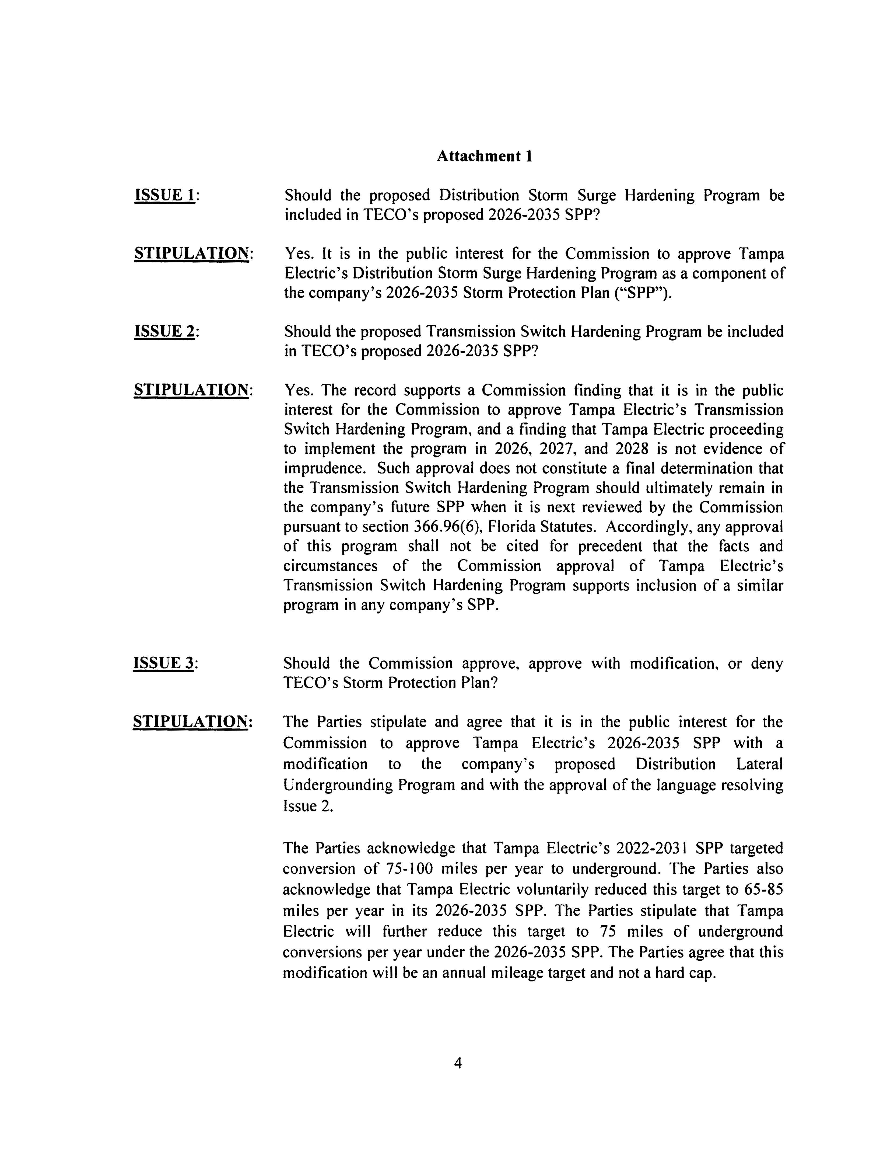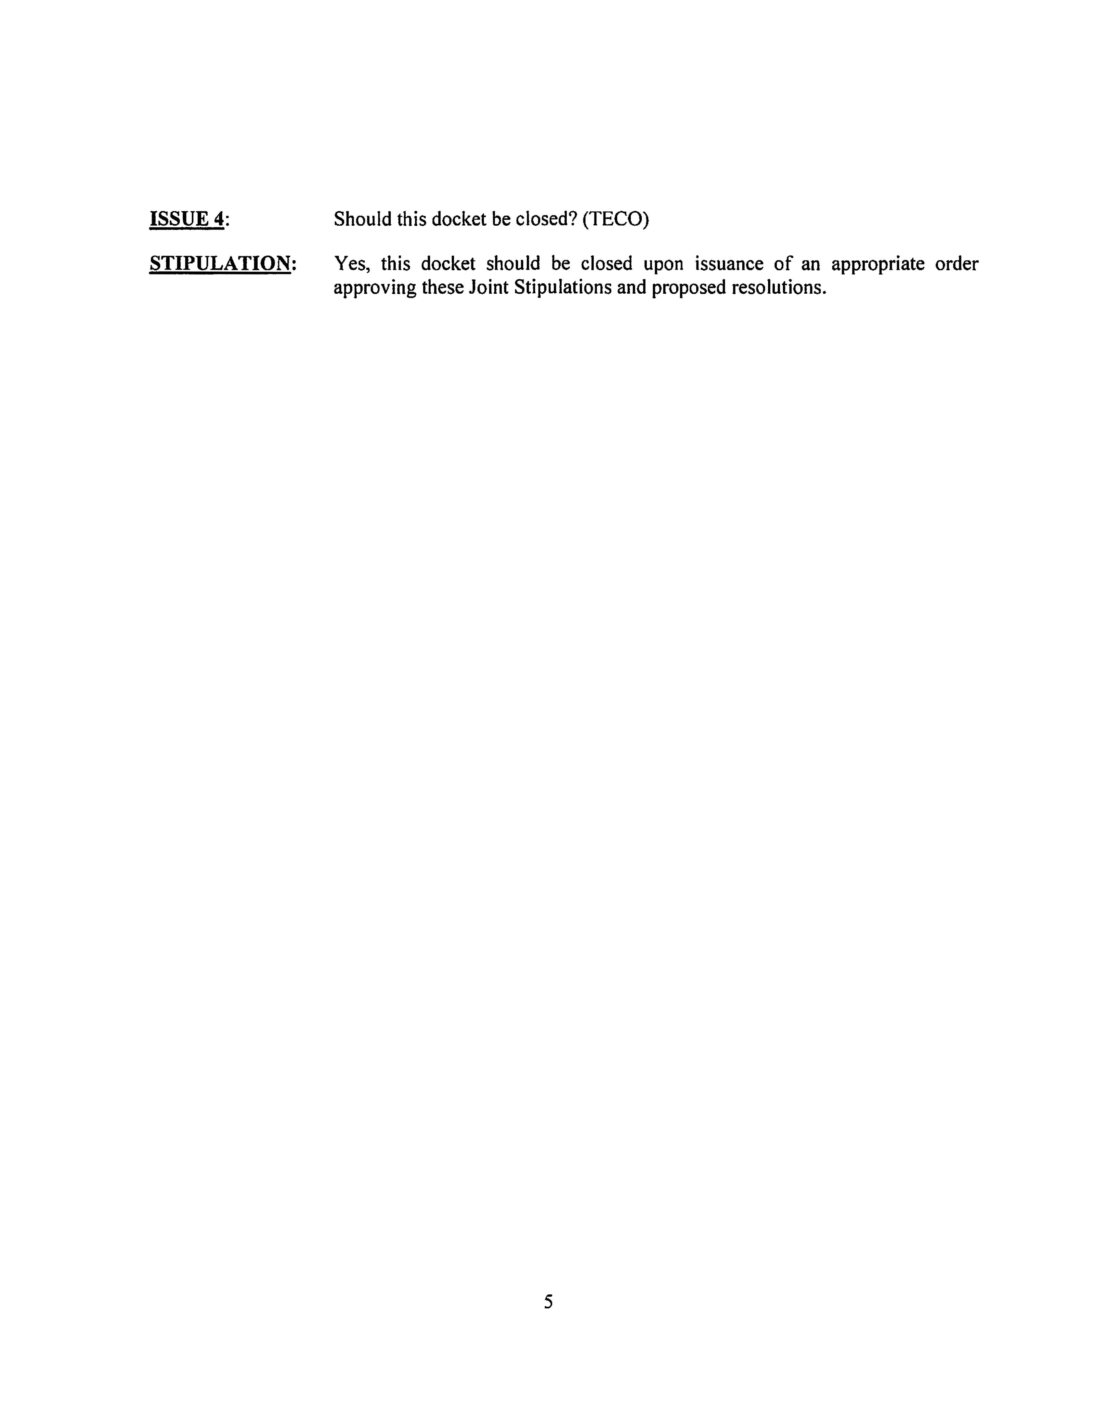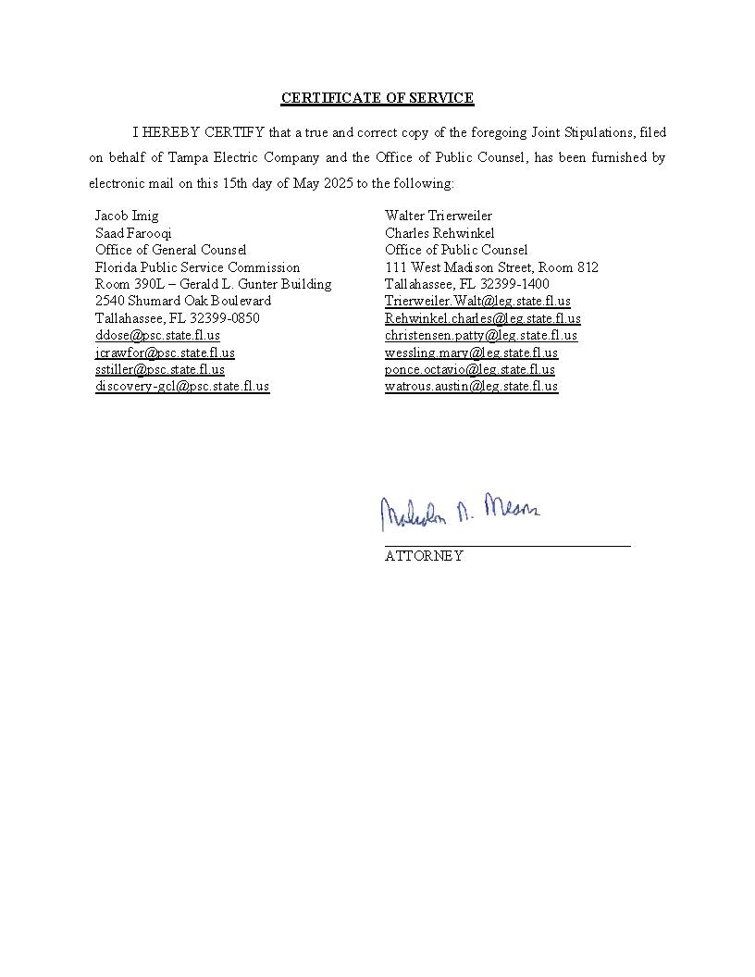

1. In a storm protection plan proceeding, the term “public utility” has the same meaning as set forth in Section 366.02(8), F.S., except that it does not include gas utilities. Section 366.96(2)(a), F.S.
2. *See* Order No. PSC-2022-0386-FOF-EI, issued November 10, 2022, in Docket No. 20220048-EI, *In re: Review of Storm Protection Plan, pursuant to Rule 25-6.030, F.A.C., Tampa Electric Company*.
3. Docket Nos. 20250014-EI, 20250015-EI, 20250016-EI, and 20250017-EI were consolidated for purpose of the hearing by Order No. PSC-2025-0029-PCO-EI.
4. Document No. 03643-2025, filed May 15, 2025, in Docket No. 20250016-EI, *Joint Stipulations.*
5. Section 366.96(4)–(5), F.S.
6. TR C7-352, l. 3-13.
7. TR C7-353, l. 16-17.
8. *Id*. at l. 21-25.
9. Exh. 6 – KEP-1 (Rev.), p. 51.
10. TR C7-362, l. 8-13.
11. TR C7-353, l. 16-17.
12. *Id*. at l. 17-21.
13. Exh. 6 – KEP-1 (Rev.), p. 43.
14. *Id*. at p. 32.
15. *Id*. at p. 35.
16. *Id*. at p. 41.
17. *Id*. at p. 43.
18. *Id*. at p. 45-46.
19. *Id*. at p. 51.
20. *Id*. at p. 59; *see* Order No. PSC-06-0351-PAA-EI, issued April 25, 2006, in Docket No. 060198-EI, *In re: Requirement for investor-owned electric utilities to file ongoing storm preparedness plans and implementation cost estimates.*
21. Exh. 6 – KEP-1 (Rev.), p. 42.
22. *Id*. at p. 49.
23. Order No. PSC-2022-0386-FOF-EI, issued November 10, 2022, in Docket No. 20220048-EI, *In re: Review of Storm Protection Plan, pursuant to Rule 25-6.030, F.A.C., Tampa Electric Company.*
24. TR C5-284, l. 13-15.
25. TR C5-314, l. 23-24.
26. TR C5-315, l. 5-7.
27. TR C5-311, l. 19-25.
28. TR C7-358, l. 5-8.
29. *Id*. at l. 8-12.
30. TR C7-352, l. 18-25.
31. *Id*.
32. TR C7-353, l. 7-11.
33. *Id*. at l. 16-25.
34. TR C7-354, l. 1-4.
35. Exh. 6 – KEP-1 (Rev.), p. 69.
36. *Id*.
37. TR C6-338, l. 2-10..
38. Hearing Transcript, p. 26, l. 9-16.