BEFORE THE FLORIDA PUBLIC SERVICE COMMISSION

|  |  |
| --- | --- |
| In re: Joint petition for approval of amendments to transportation service agreements between Peninsula Pipeline Company, Inc. and Florida City Gas. | DOCKET NO. 20250099-GU  ORDER NO. PSC-2025-0391-PAA-GU  ISSUED: October 22, 2025 |

The following Commissioners participated in the disposition of this matter:

MIKE LA ROSA, Chairman

GARY F. CLARK

ANDREW GILES FAY

GABRIELLA PASSIDOMO SMITH

NOTICE OF PROPOSED AGENCY ACTION

ORDER APPROVING AMENDMENTS TO

TRANSPORTATION SERVICE AGREEMENT

BY THE COMMISSION:

NOTICE is hereby given by the Florida Public Service Commission that the action discussed herein is preliminary in nature and will become final unless a person whose interests are substantially affected files a petition for a formal proceeding, pursuant to Rule 25-22.029, Florida Administrative Code (F.A.C.).

Background

On August 7, 2025, Peninsula Pipeline Company, Inc. (Peninsula) and Florida City Gas (FCG), collectively the Parties, filed a joint petition seeking approval of amendments to three separate Firm Transportation Service Agreements (FTSAs) that had been previously approved by us. The proposed amendments to the FTSAs are included as attachments to this order.

By Order No. PSC-2024-0271-PAA-GU (2024 Order), we approved three FTSAs between Peninsula and FCG.[1] FCG had entered into commodity purchase agreements with three third party Renewable Natural Gas (RNG) producers. Pursuant to the 2024 FTSAs, Peninsula would construct, own, and operate new gas pipelines allowing for the delivery of the natural gas purchased by FCG from the third party producers. To support the 2024 FTSAs, the parties had stated that this would diversify and introduce additional gas supply sources, enhance transmission access, and increase system resiliency. The three RNG projects are located in Brevard, Indian River, and Miami Dade Counties. The FTSAs contain monthly reservation charges, payable from FCG to Peninsula, that reflect Peninsula’s construction costs.

The Parties state the amendments to the FTSAs pertain to the interconnection agreements (ICAs) between FCG and the RNG producers which were referenced in the 2024 Order. The interconnection agreements (ICA) between FCG and the RNG producers were entered into before FCG was acquired by Chesapeake and not subject to our approval. The ICAs address the construction of pipeline facilities and establishment of an interconnection point connecting the RNG facilities to FCG. In the response to our staff’s fourth data request in Docket No. 20240039-GU, the Parties stated that upon acquisition of FCG by Chesapeake, it was determined that the interconnection projects would be a better fit as a Peninsula project.[2] In the same responses, the Parties explain that it would be best to use Peninsula to tie the RNG producers into the rest of the FCG distribution system because the project is more in line with the transmission activity projects that Peninsula has expertise in facilitating and building. The instant petition amends the FTSAs to reflect a subcontracting of the ICA work to Peninsula.

Peninsula and FCG are both wholly owned subsidiaries of Chesapeake Utilities Corporation (Chesapeake). We note that FCG became a subsidiary of Chesapeake on December 1, 2023. Peninsula operates as an intrastate natural gas transmission company as defined by Section 368.103(4), Florida Statutes (F.S.).[3] FCG operates as a local distribution company subject to our regulatory jurisdiction pursuant to Chapter 366, F.S.

By Order No. PSC-07-1012-TRF-GP, Peninsula received approval of an intrastate gas pipeline tariff that allows it to construct and operate intrastate pipeline facilities and to actively pursue agreements with natural gas customers.[4] The Parties are subsidiaries of Chesapeake, and agreements between affiliated companies must be approved by us pursuant to Section 368.105, F.S.

During the evaluation of the petition, our staff issued one data request to the Parties for which responses were received on September 5, 2025.[5] Our staff also had a phone call with the Parties on September 19, 2025, after which the Parties filed supplemental responses on September 23, 2025.[6] We have jurisdiction over this matter pursuant to Sections 368.104, and 368.105, F.S.

Decision

As described in paragraph 10 of the instant petition and in response to our staff’s data requests in Docket No. 20240039-GU, the Parties had contemplated that the interconnection work may also be done by Peninsula. Therefore, the Parties now propose for the FTSAs approved in the 2024 Order to be amended to add monthly reservation charges associated with the cost to construct, own, operate and maintain the interconnection facilities used to connect the RNG producers to FCG.

On page 6 of the instant petition, the Parties state the facilities previously approved in the FTSAs and the facilities mentioned in the ICAs are “inter-reliant.” Additionally, the Parties explain that it is most efficient for Peninsula to construct the pipeline facilities contemplated in the 2024 Order from each RNG site to the interconnection point with FCG, as well as the interconnection facilities addressed in the ICA. Peninsula will also construct the necessary regulator stations, pressure regulation and measuring equipment, valving, filters, and communications equipment necessary. Peninsula also agrees to install gas quality monitoring equipment and monitor at the interconnect to ensure that the natural gas meets required gas quality levels. FCG retains ownership of the meter and its agreement with each RNG producer. Furthermore, in response to our staff’s first data request, the Parties state that it would not be efficient to have two different entities doing the planning, engineering, permitting work, and operation and maintenance on facilities constructed for the same projects.[7]

With the proposed amendments, a fixed, monthly reservation charge, payable from FCG to Peninsula, will be added to the existing FTSAs. This charge is equal to the monthly service charge that the RNG producer will pay to FCG under the terms of the ICA once in-service. FCG will then credit the payment from the RNG producer to its Purchased Gas Adjustment Clause costs. Further discussion of this payment structure was provided in Peninsula and FCG’s supplemental response.[8] All of the amended FTSAs include monthly reservation charges that vary depending on the year of the agreement. Peninsula and FCG stated that this is because of negotiating charges reflective of the development of a project over time.[9] The Parties also mention this could be used as front-loaded recovery in the first few years with reductions over time.

Peninsula and FCG assert that the rates in the amended FTSAs meet the requirements of Section 368.105(3), F.S., and are consistent with Order Nos. PSC-2006-0023-DS-GP and PSC-2007-1012-TRF-GP and with Peninsula's tariff on file with us. We have reviewed the amended FTSAs and agree that the monthly reservation charges associated with the ICAs are identical to the monthly reservation charges that were included in the agreements between FCG and the RNG producers, which were entered prior to FCG becoming an affiliate to Peninsula.

The Parties assert, in response No. 2 of the Parties’ supplemental response, that the costs of these projects include a metering and regulation site with regulators, remote monitoring communication and control configurations, and meters. The Parties also state the costs of these projects are comparable to those of a standard interconnect. However, the company states there is equipment specific to the RNG that other interconnects do not require. These components average approximately $550,000 per project, which the Parties state is a small portion of the cost.

In the Parties’ supplemental response, the Parties state that the interconnect facilities for the Brevard project are currently anticipated to be completed in October 2025. The interconnect facilities related to the Indian River project are constructed and in service. Finally, the interconnect facilities related to the Miami Dade project are estimated to be completed in early 2026.

Conclusion

Based on the petition and the Parties’ responses to our staff’s data requests, we approve the proposed amendments to the FTSAs dated July 23, 2025, between Peninsula and FCG, attached to this order. The proposed amendments to the agreements are reasonable and meet the requirements of Section 368.105 F.S.

Based on the foregoing, it is

ORDERED by the Florida Public Service Commission that the proposed Amendments to the Firm Transportation Service Agreements dated July 13, 2025, between Peninsula Pipeline Company, Inc. and Florida City Gas are approved. The proposed amendments to the agreements are reasonable and meet the requirements of Section 368.105, F.S. It is further

ORDERED that the provisions of this Order, issued as proposed agency action, shall become final and effective upon the issuance of a Consummating Order unless an appropriate petition, in the form provided by Rule 28-106.201, Florida Administrative Code, is received by the Commission Clerk, 2540 Shumard Oak Boulevard, Tallahassee, Florida 32399-0850, by the close of business on the date set forth in the “Notice of Further Proceedings” attached hereto. It is further

ORDERED that in the event this Order becomes final, this docket shall be closed.

By ORDER of the Florida Public Service Commission this 22nd day of October, 2025.

|  |  |
| --- | --- |
|  | /s/ Adam J. Teitzman |
|  | ADAM J. TEITZMAN  Commission Clerk |

Florida Public Service Commission

2540 Shumard Oak Boulevard

Tallahassee, Florida 32399

(850) 413‑6770

www.floridapsc.com

Copies furnished: A copy of this document is provided to the parties of record at the time of issuance and, if applicable, interested persons.

DD

NOTICE OF FURTHER PROCEEDINGS OR JUDICIAL REVIEW

The Florida Public Service Commission is required by Section 120.569(1), Florida Statutes, to notify parties of any administrative hearing that is available under Section 120.57, Florida Statutes, as well as the procedures and time limits that apply. This notice should not be construed to mean all requests for an administrative hearing will be granted or result in the relief sought.

Mediation may be available on a case-by-case basis. If mediation is conducted, it does not affect a substantially interested person's right to a hearing.

The action proposed herein is preliminary in nature. Any person whose substantial interests are affected by the action proposed by this order may file a petition for a formal proceeding, in the form provided by Rule 28-106.201, Florida Administrative Code. This petition must be received by the Office of Commission Clerk, 2540 Shumard Oak Boulevard, Tallahassee, Florida 32399-0850, by the close of business on November 12, 2025.

In the absence of such a petition, this order shall become final and effective upon the issuance of a Consummating Order.

Any objection or protest filed in this/these docket(s) before the issuance date of this order is considered abandoned unless it satisfies the foregoing conditions and is renewed within the specified protest period.

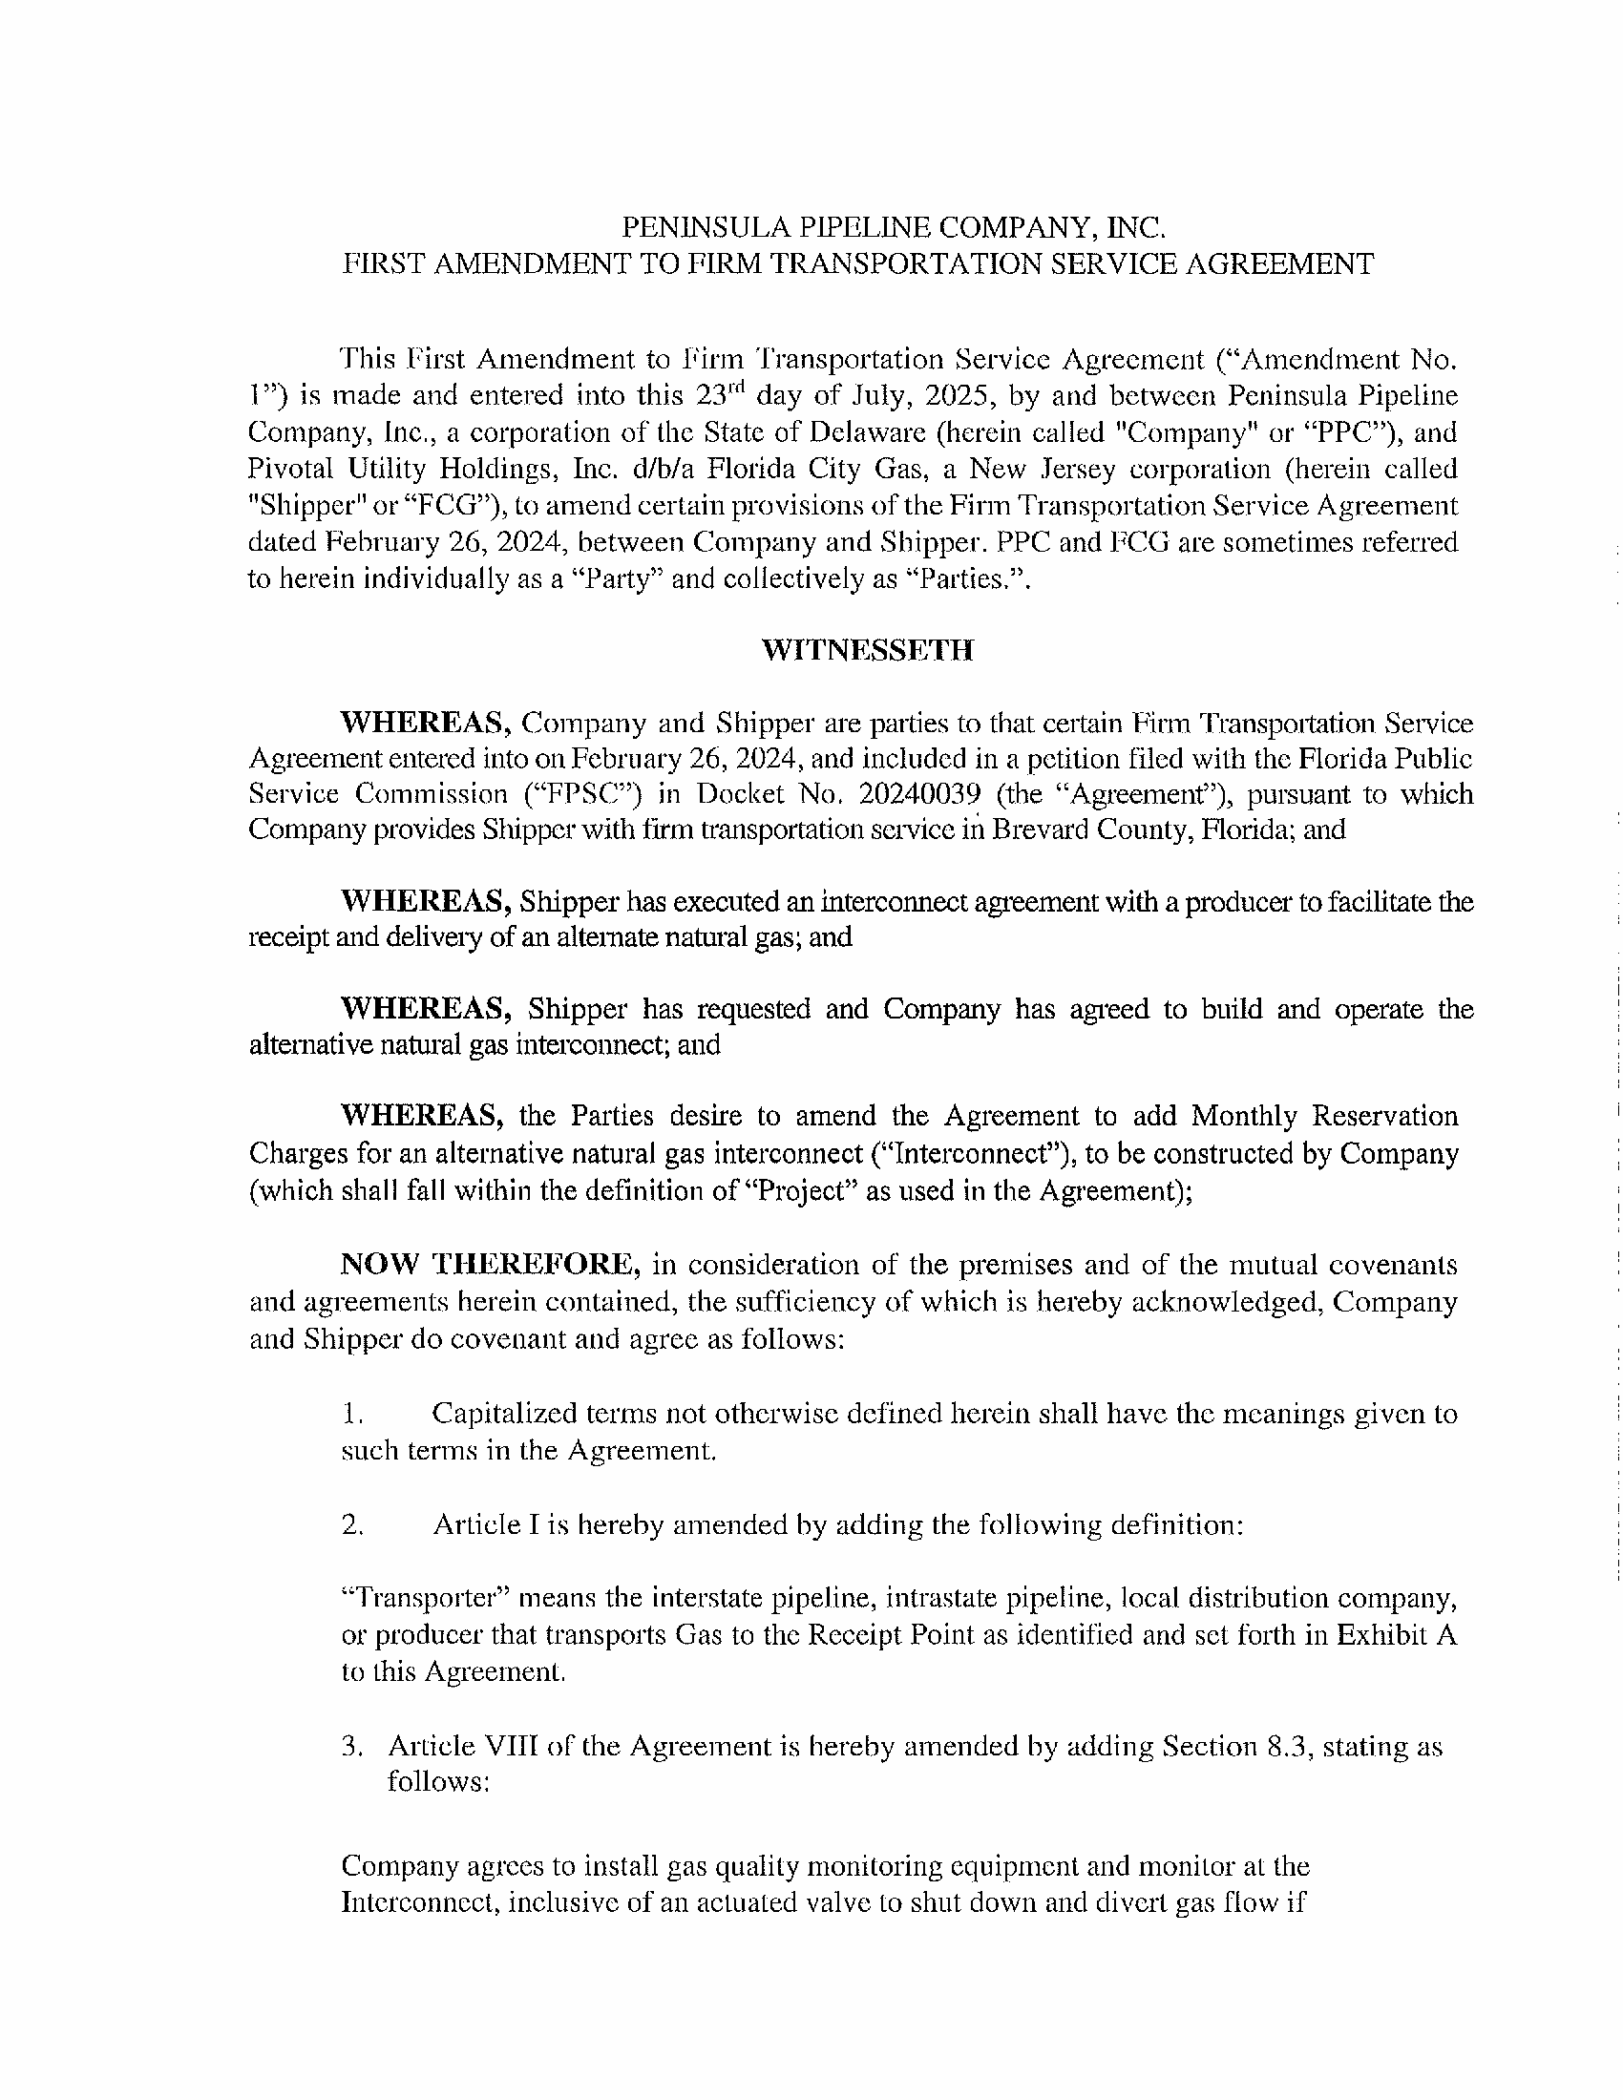

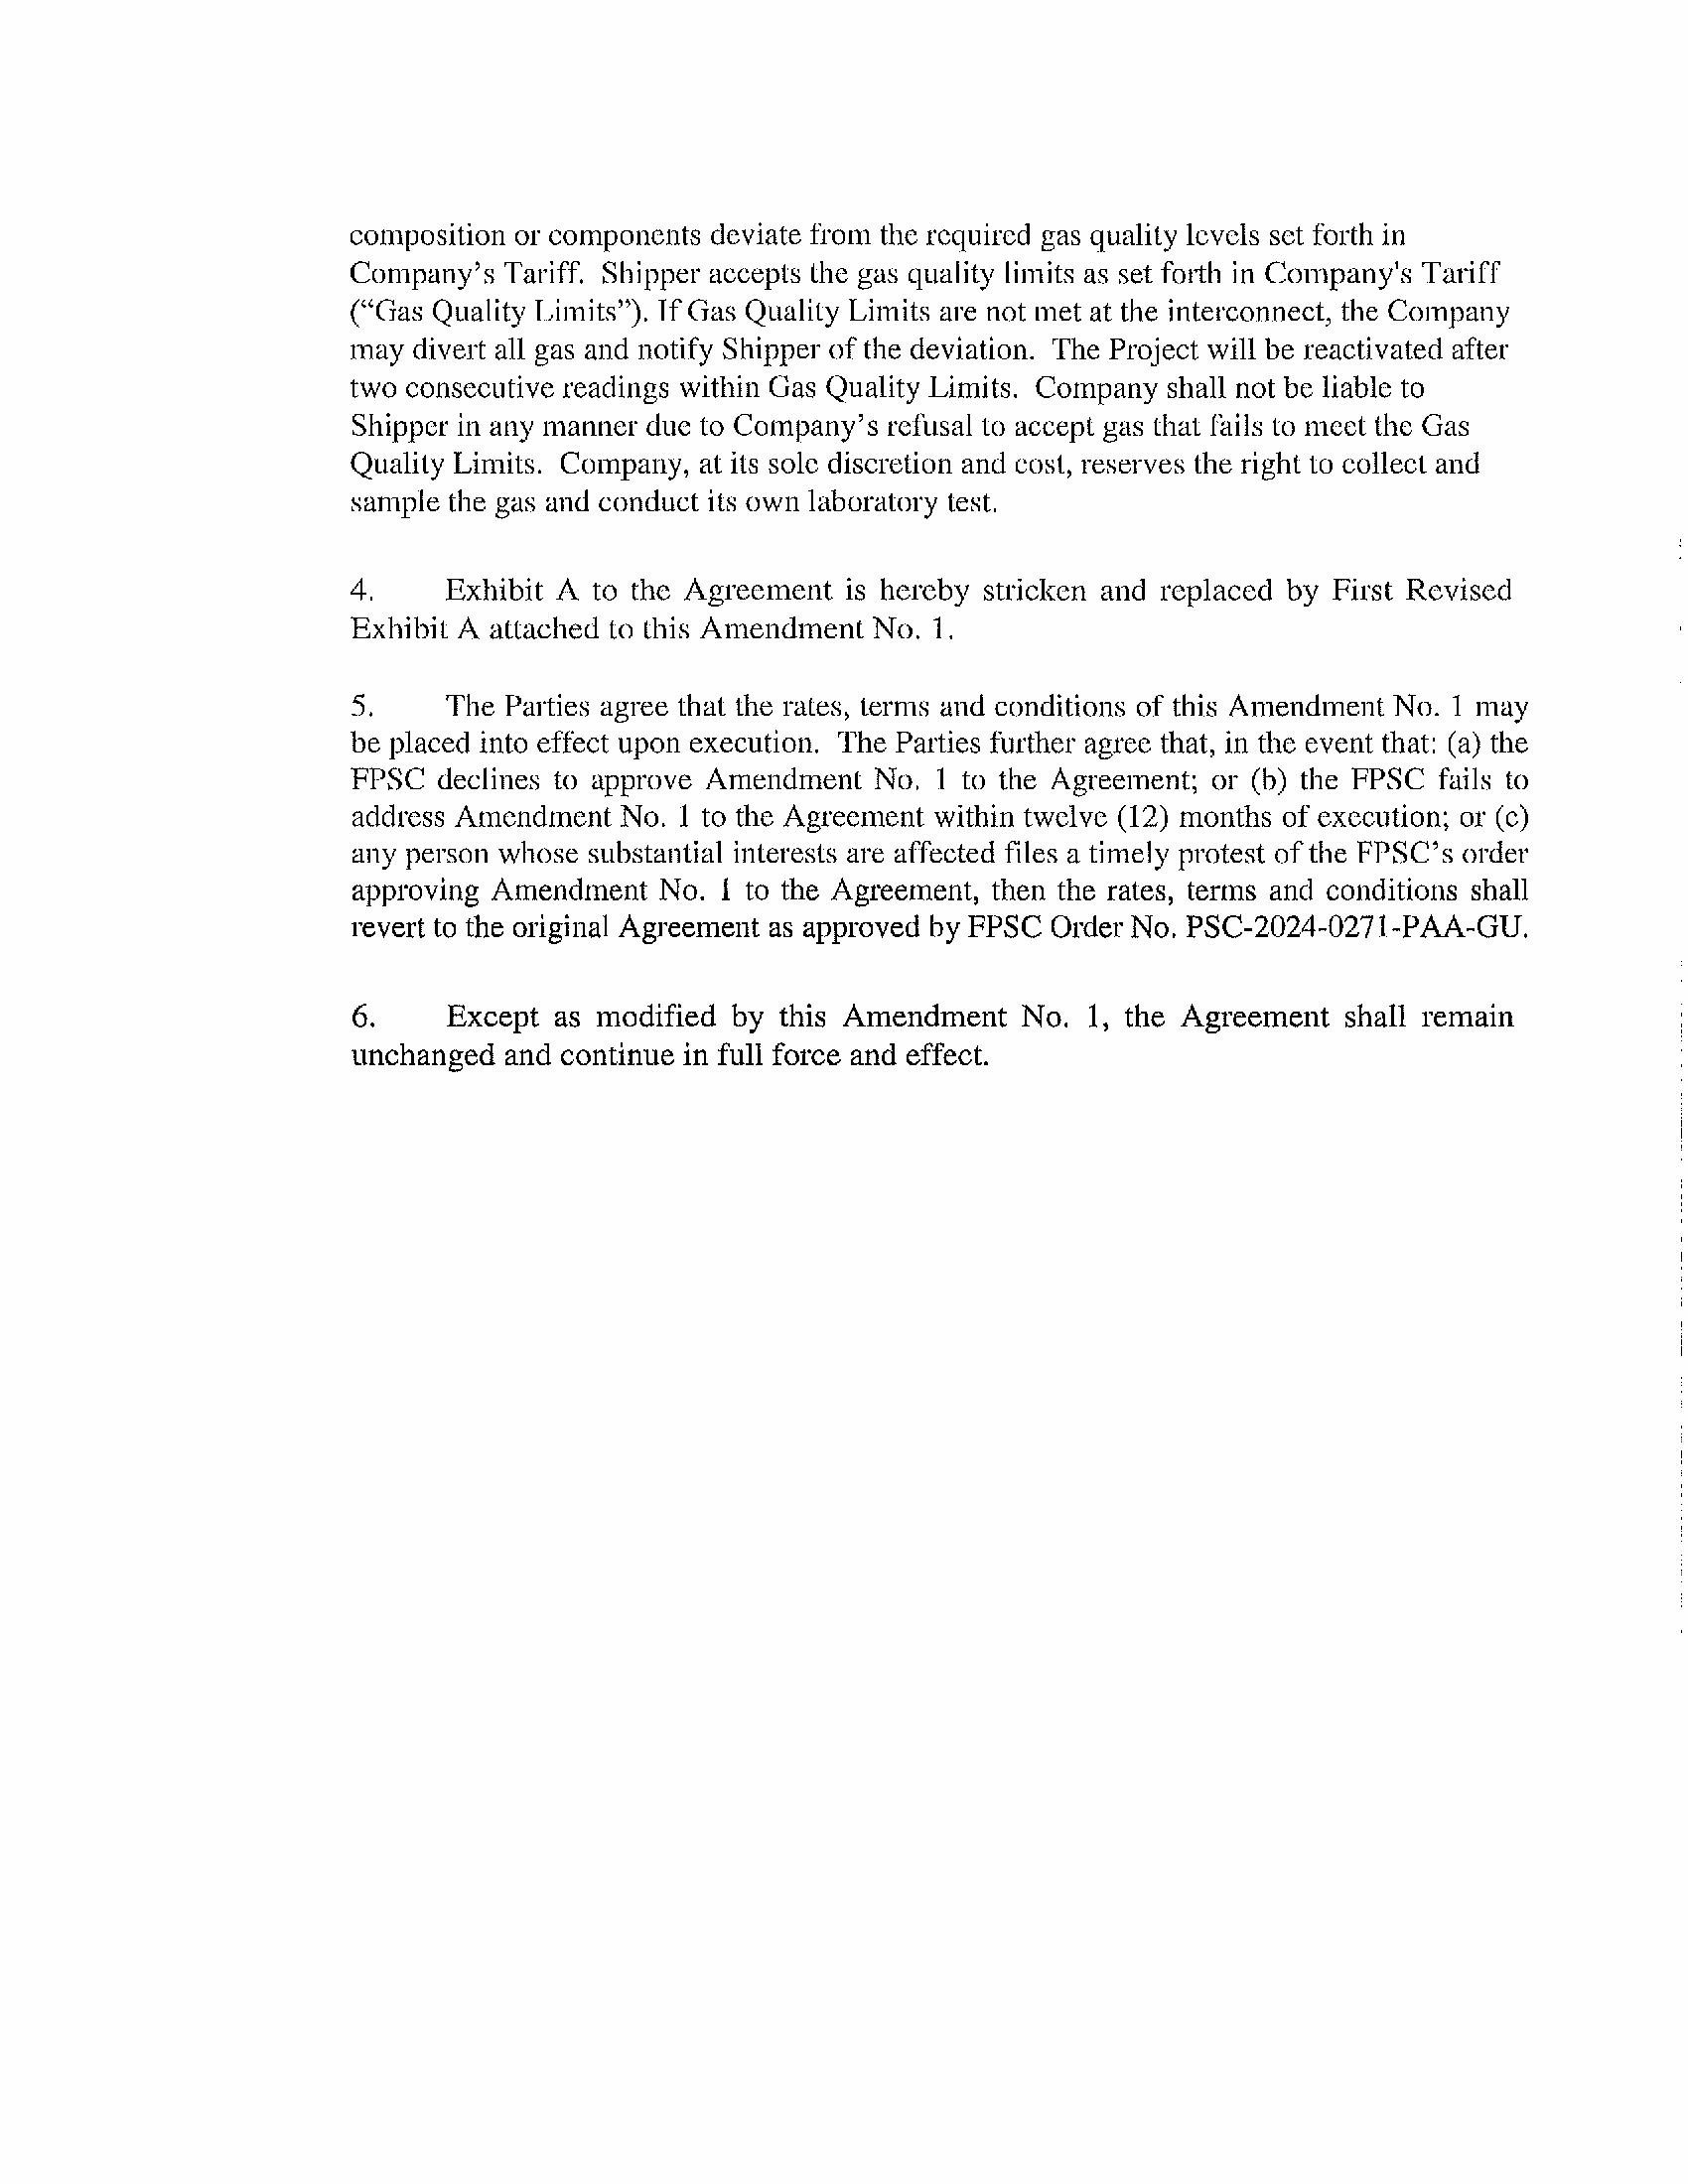

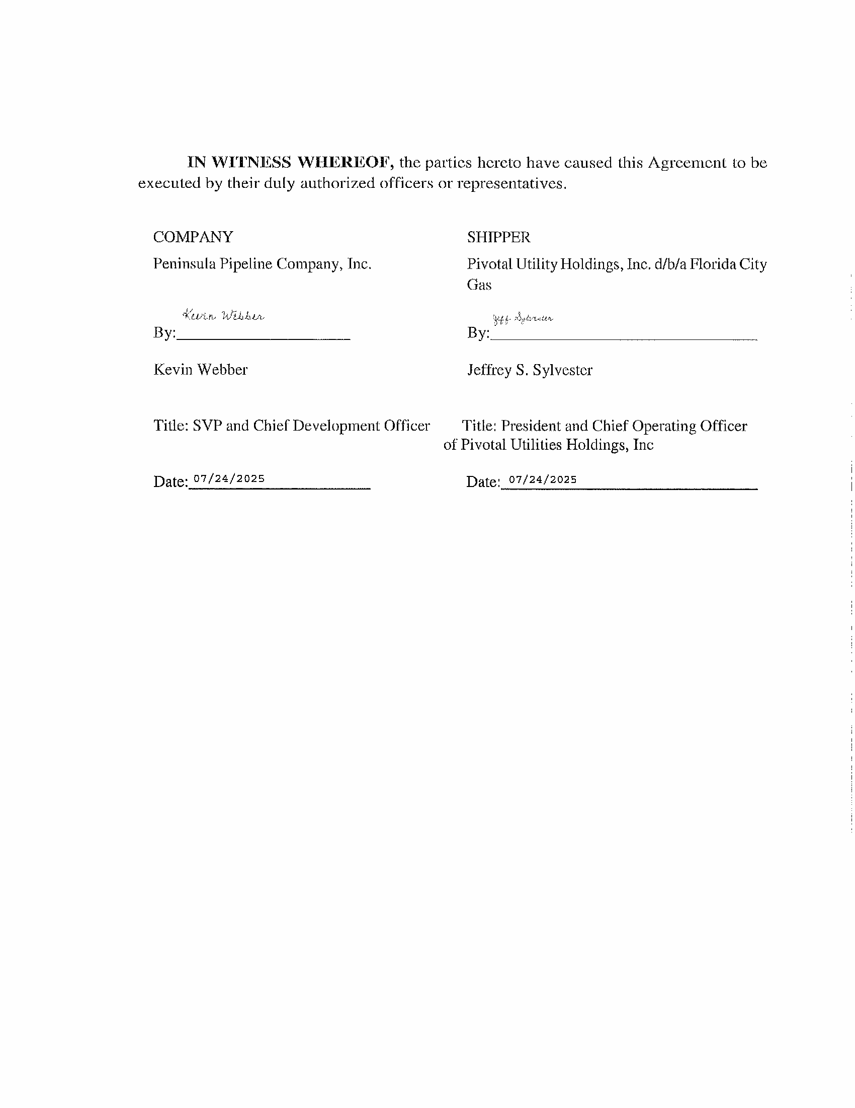

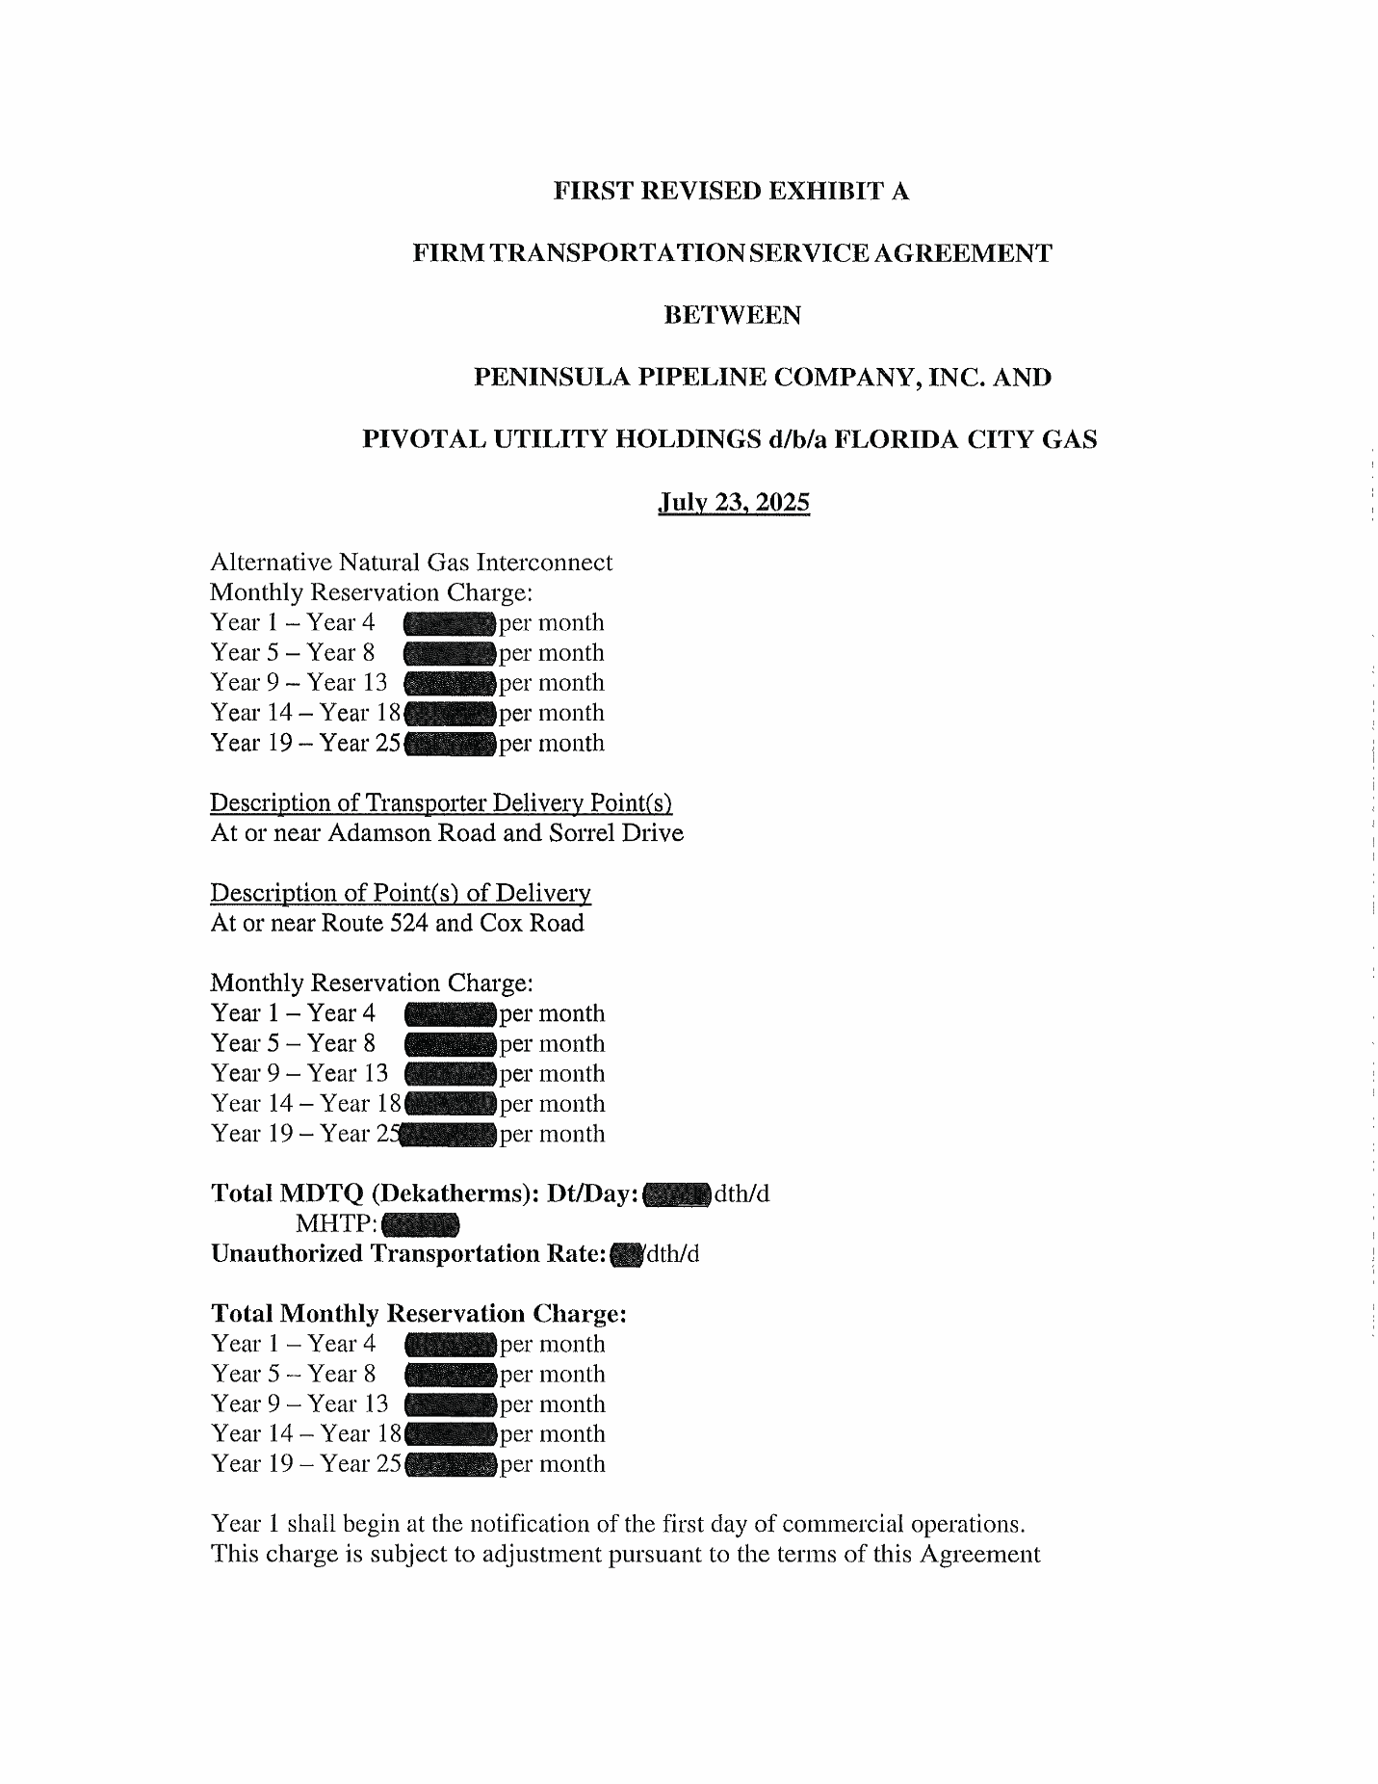

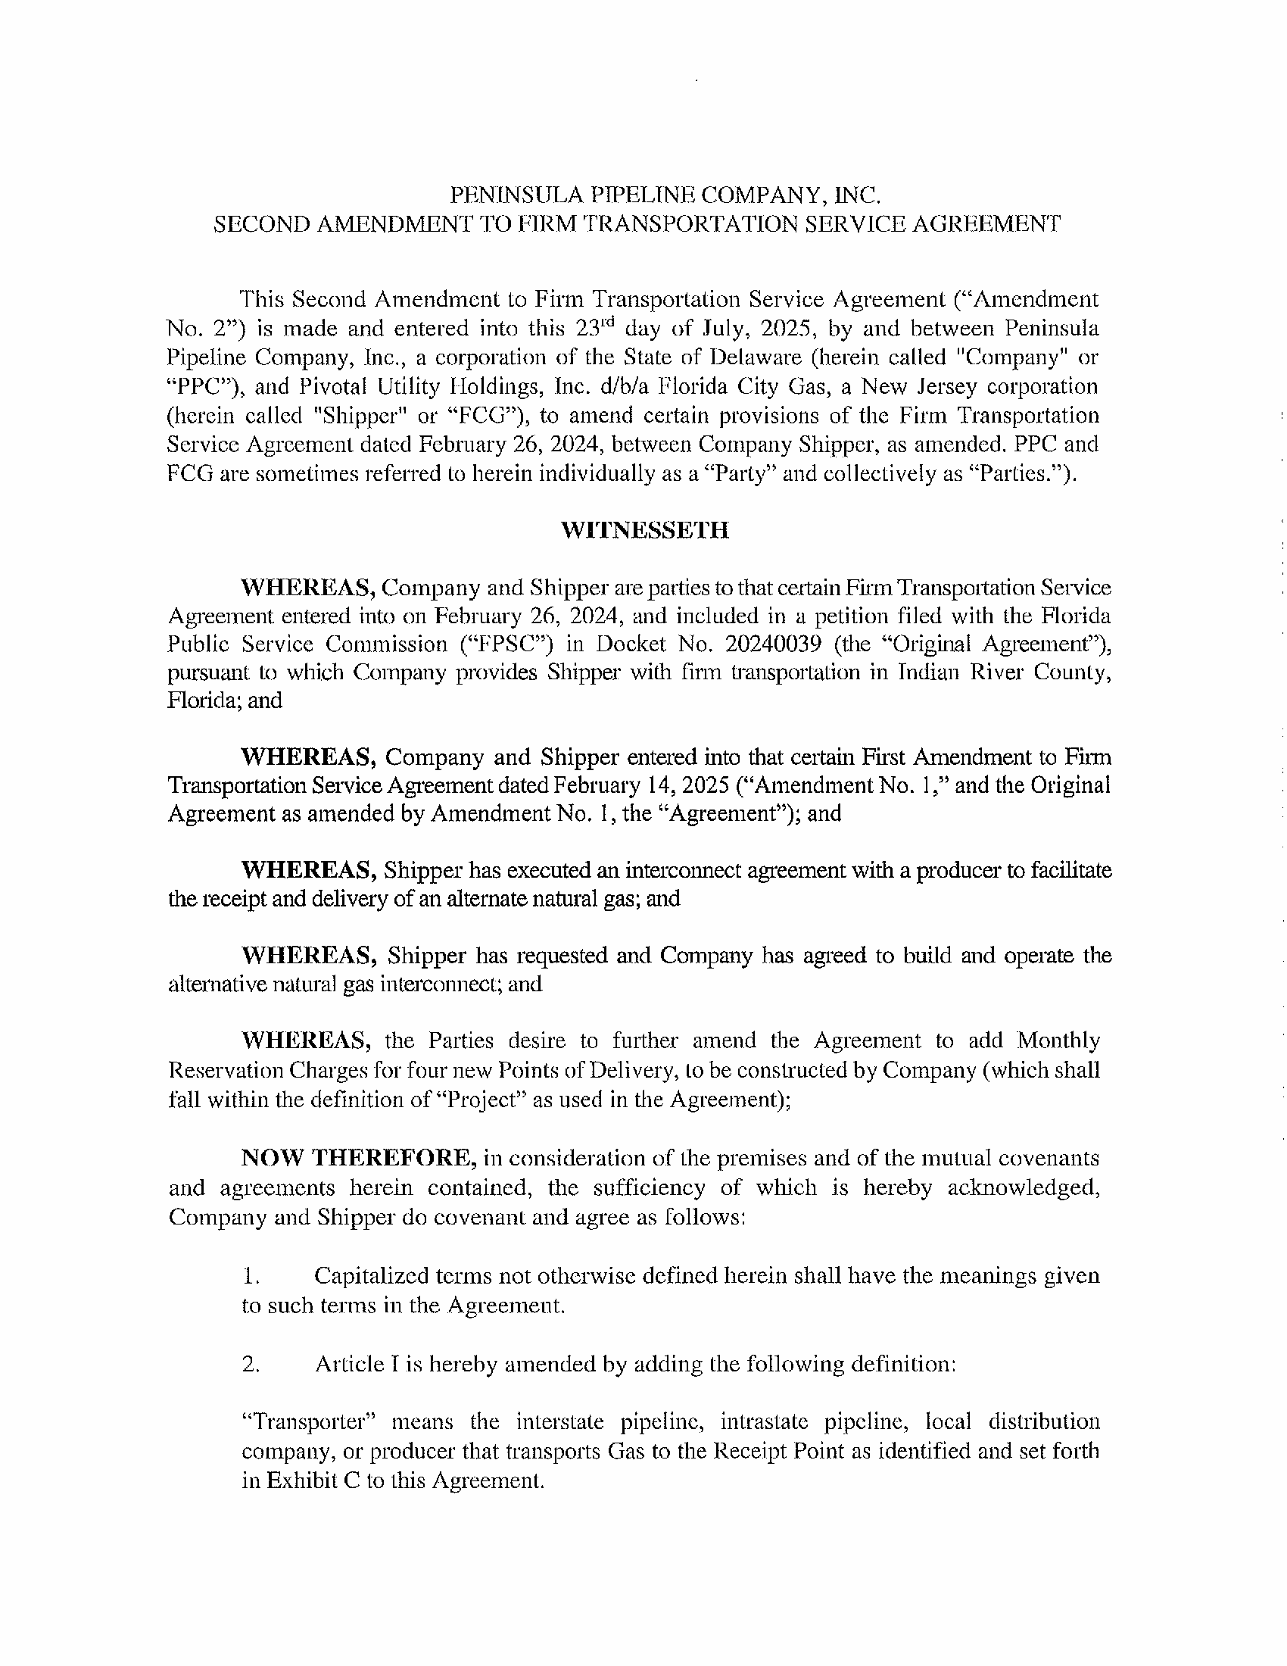

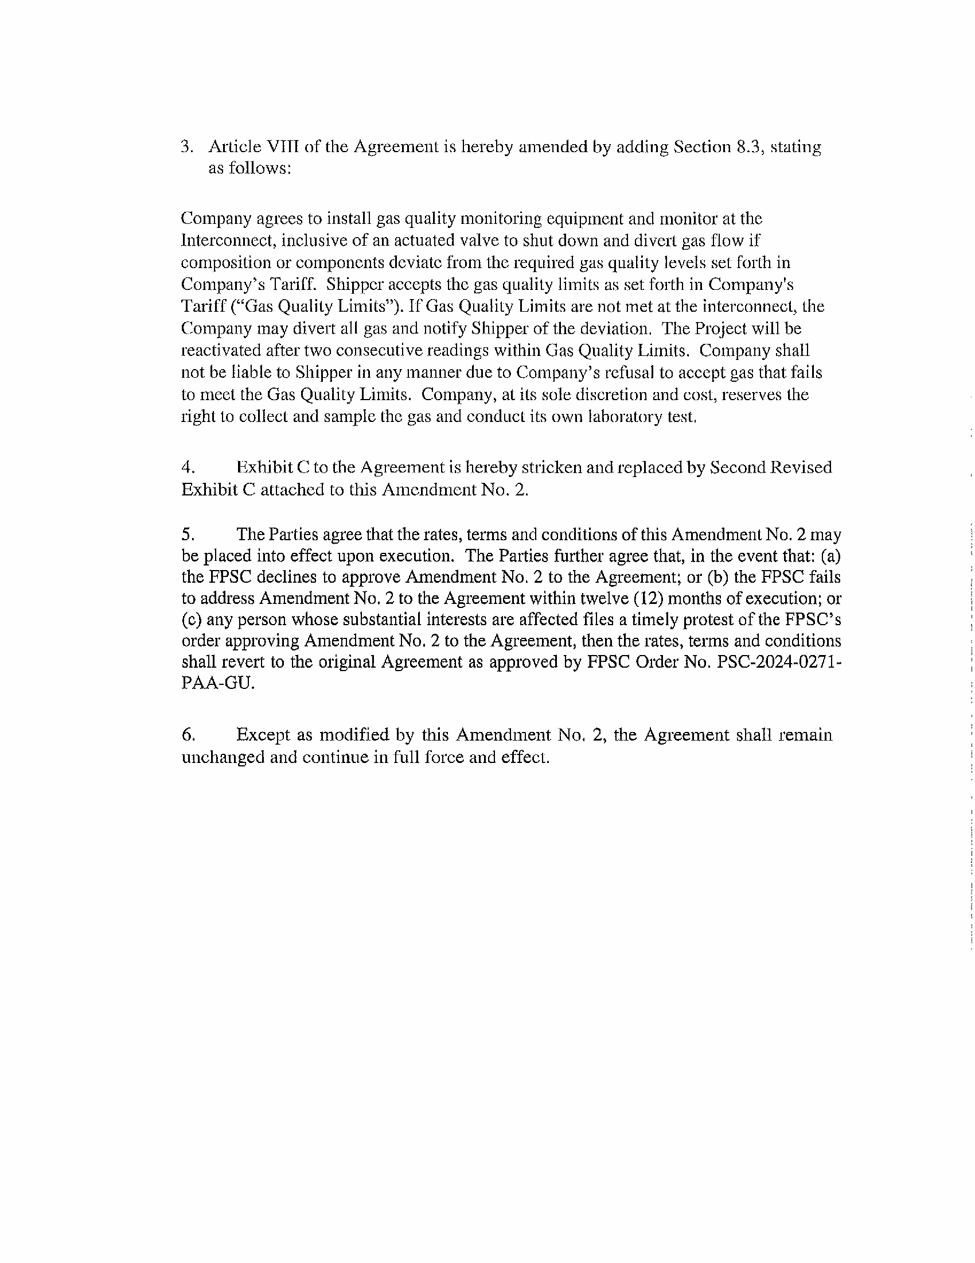

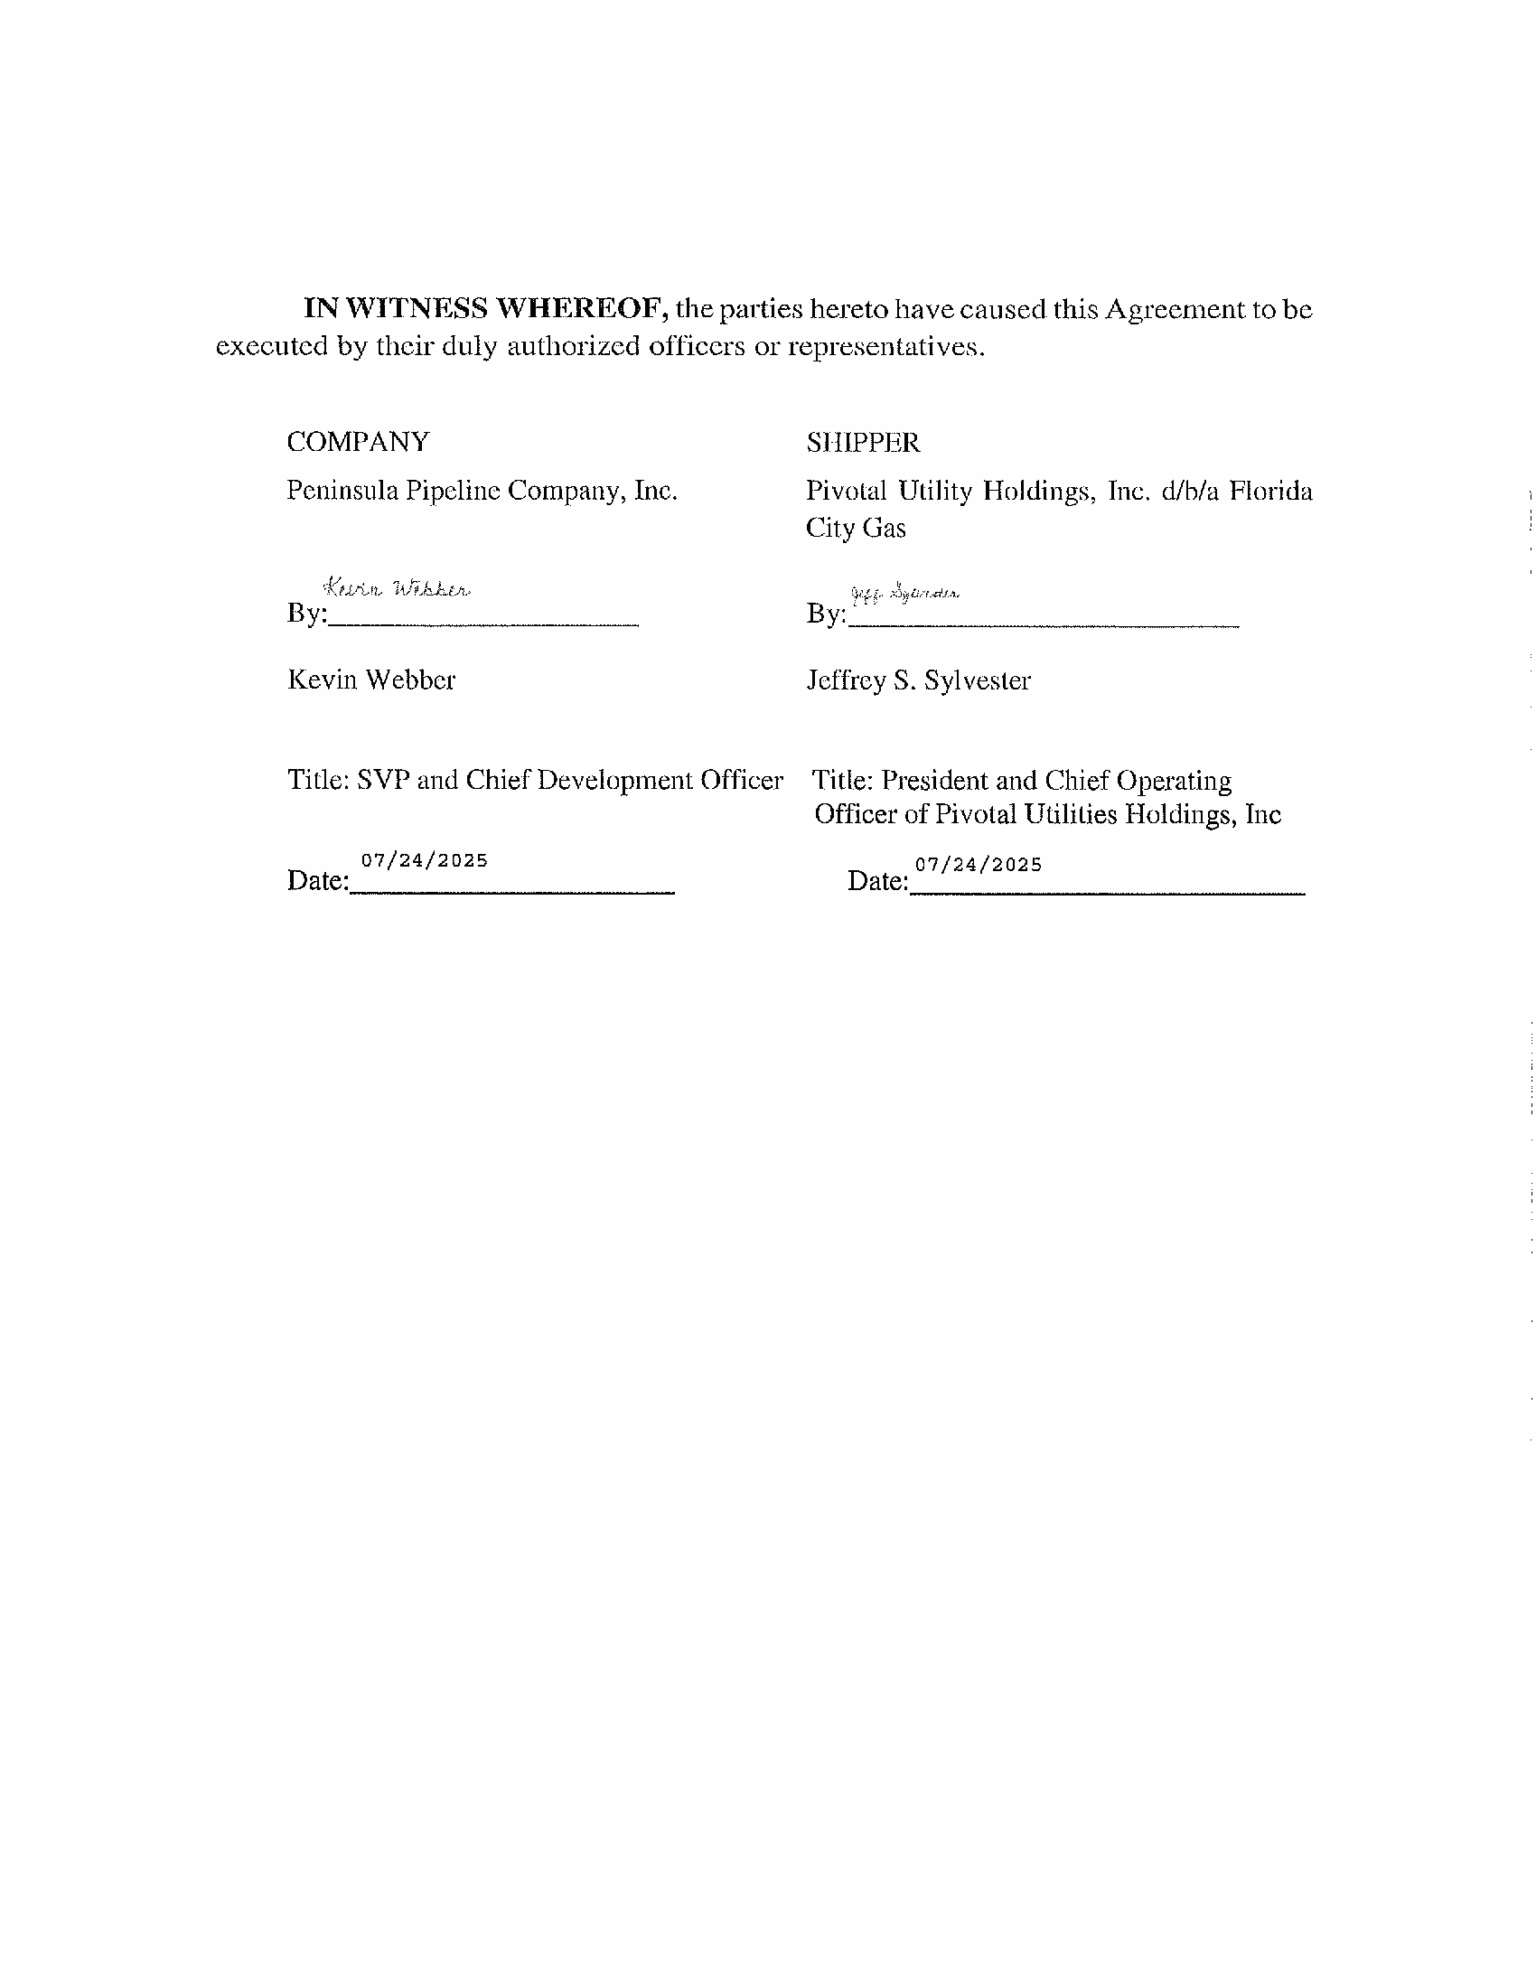

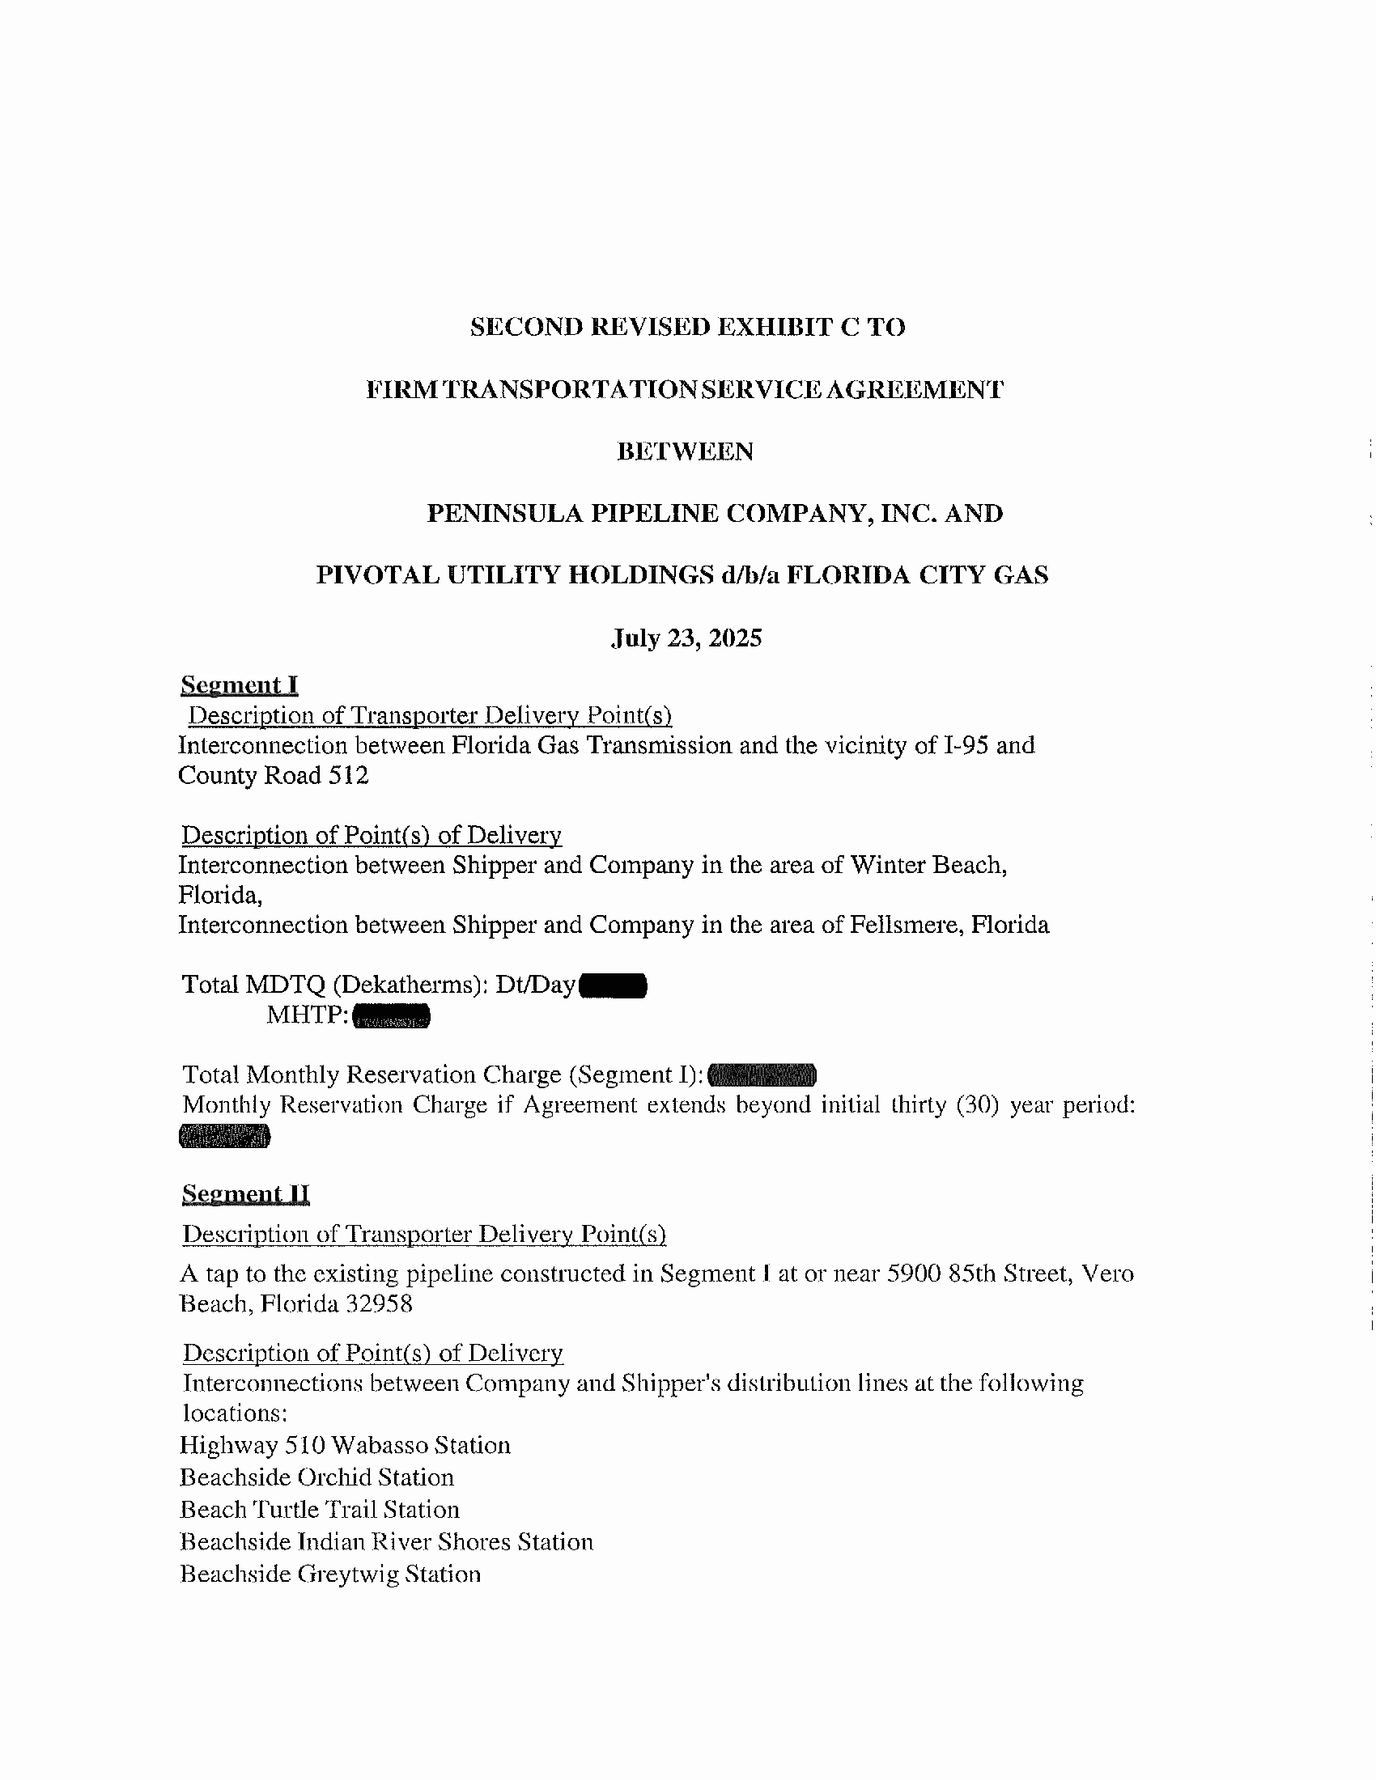

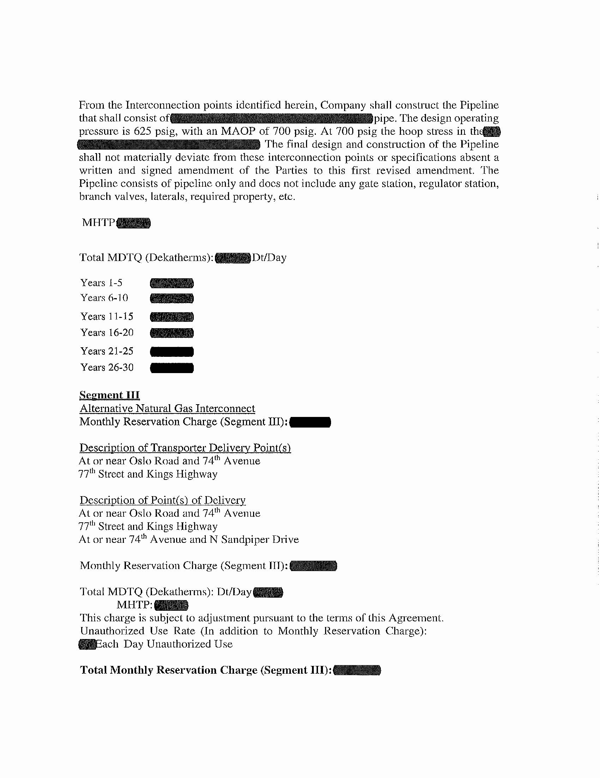



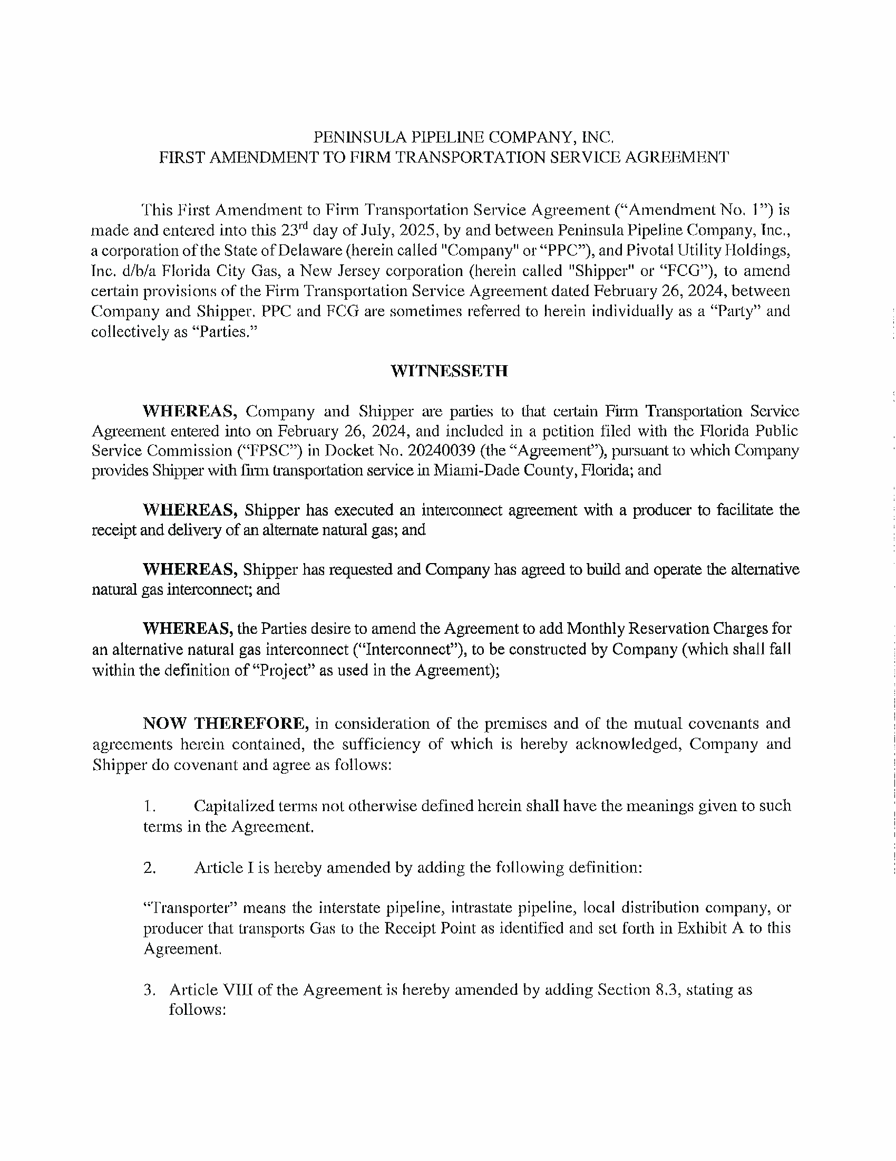

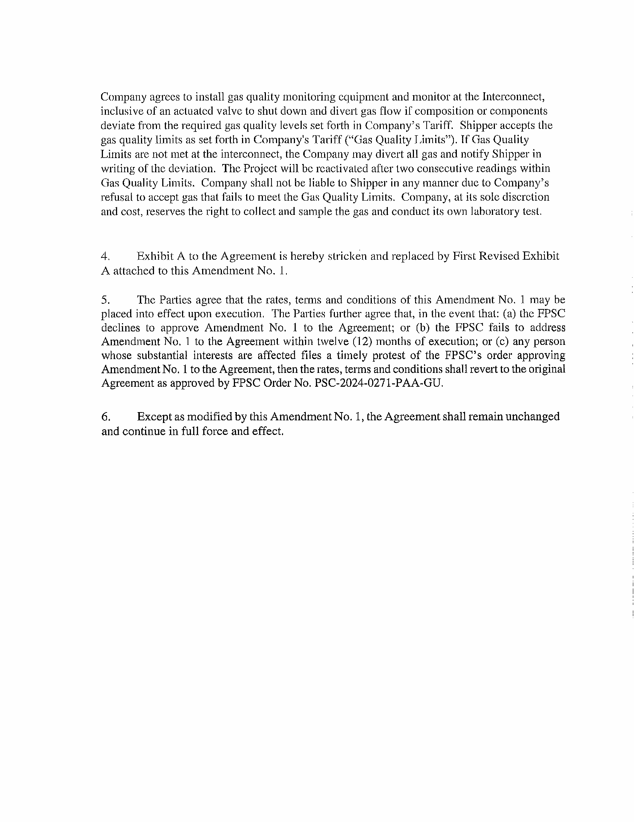

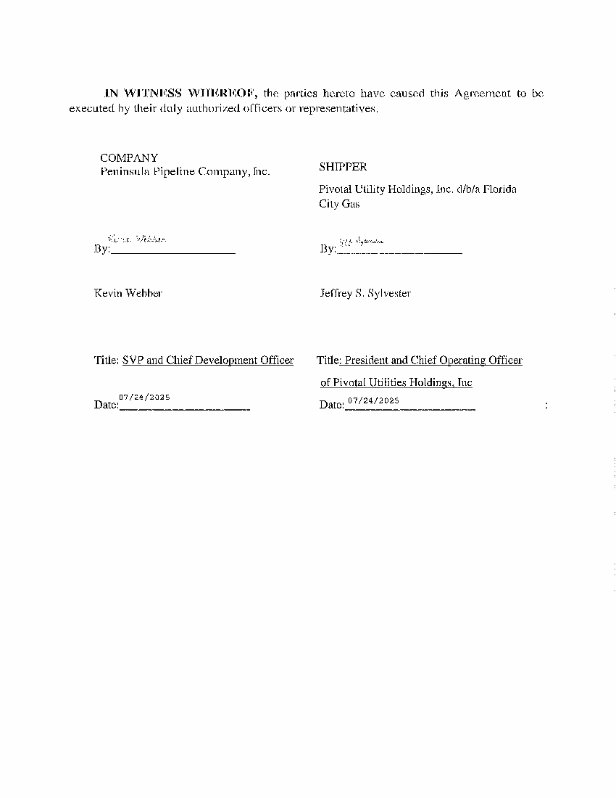

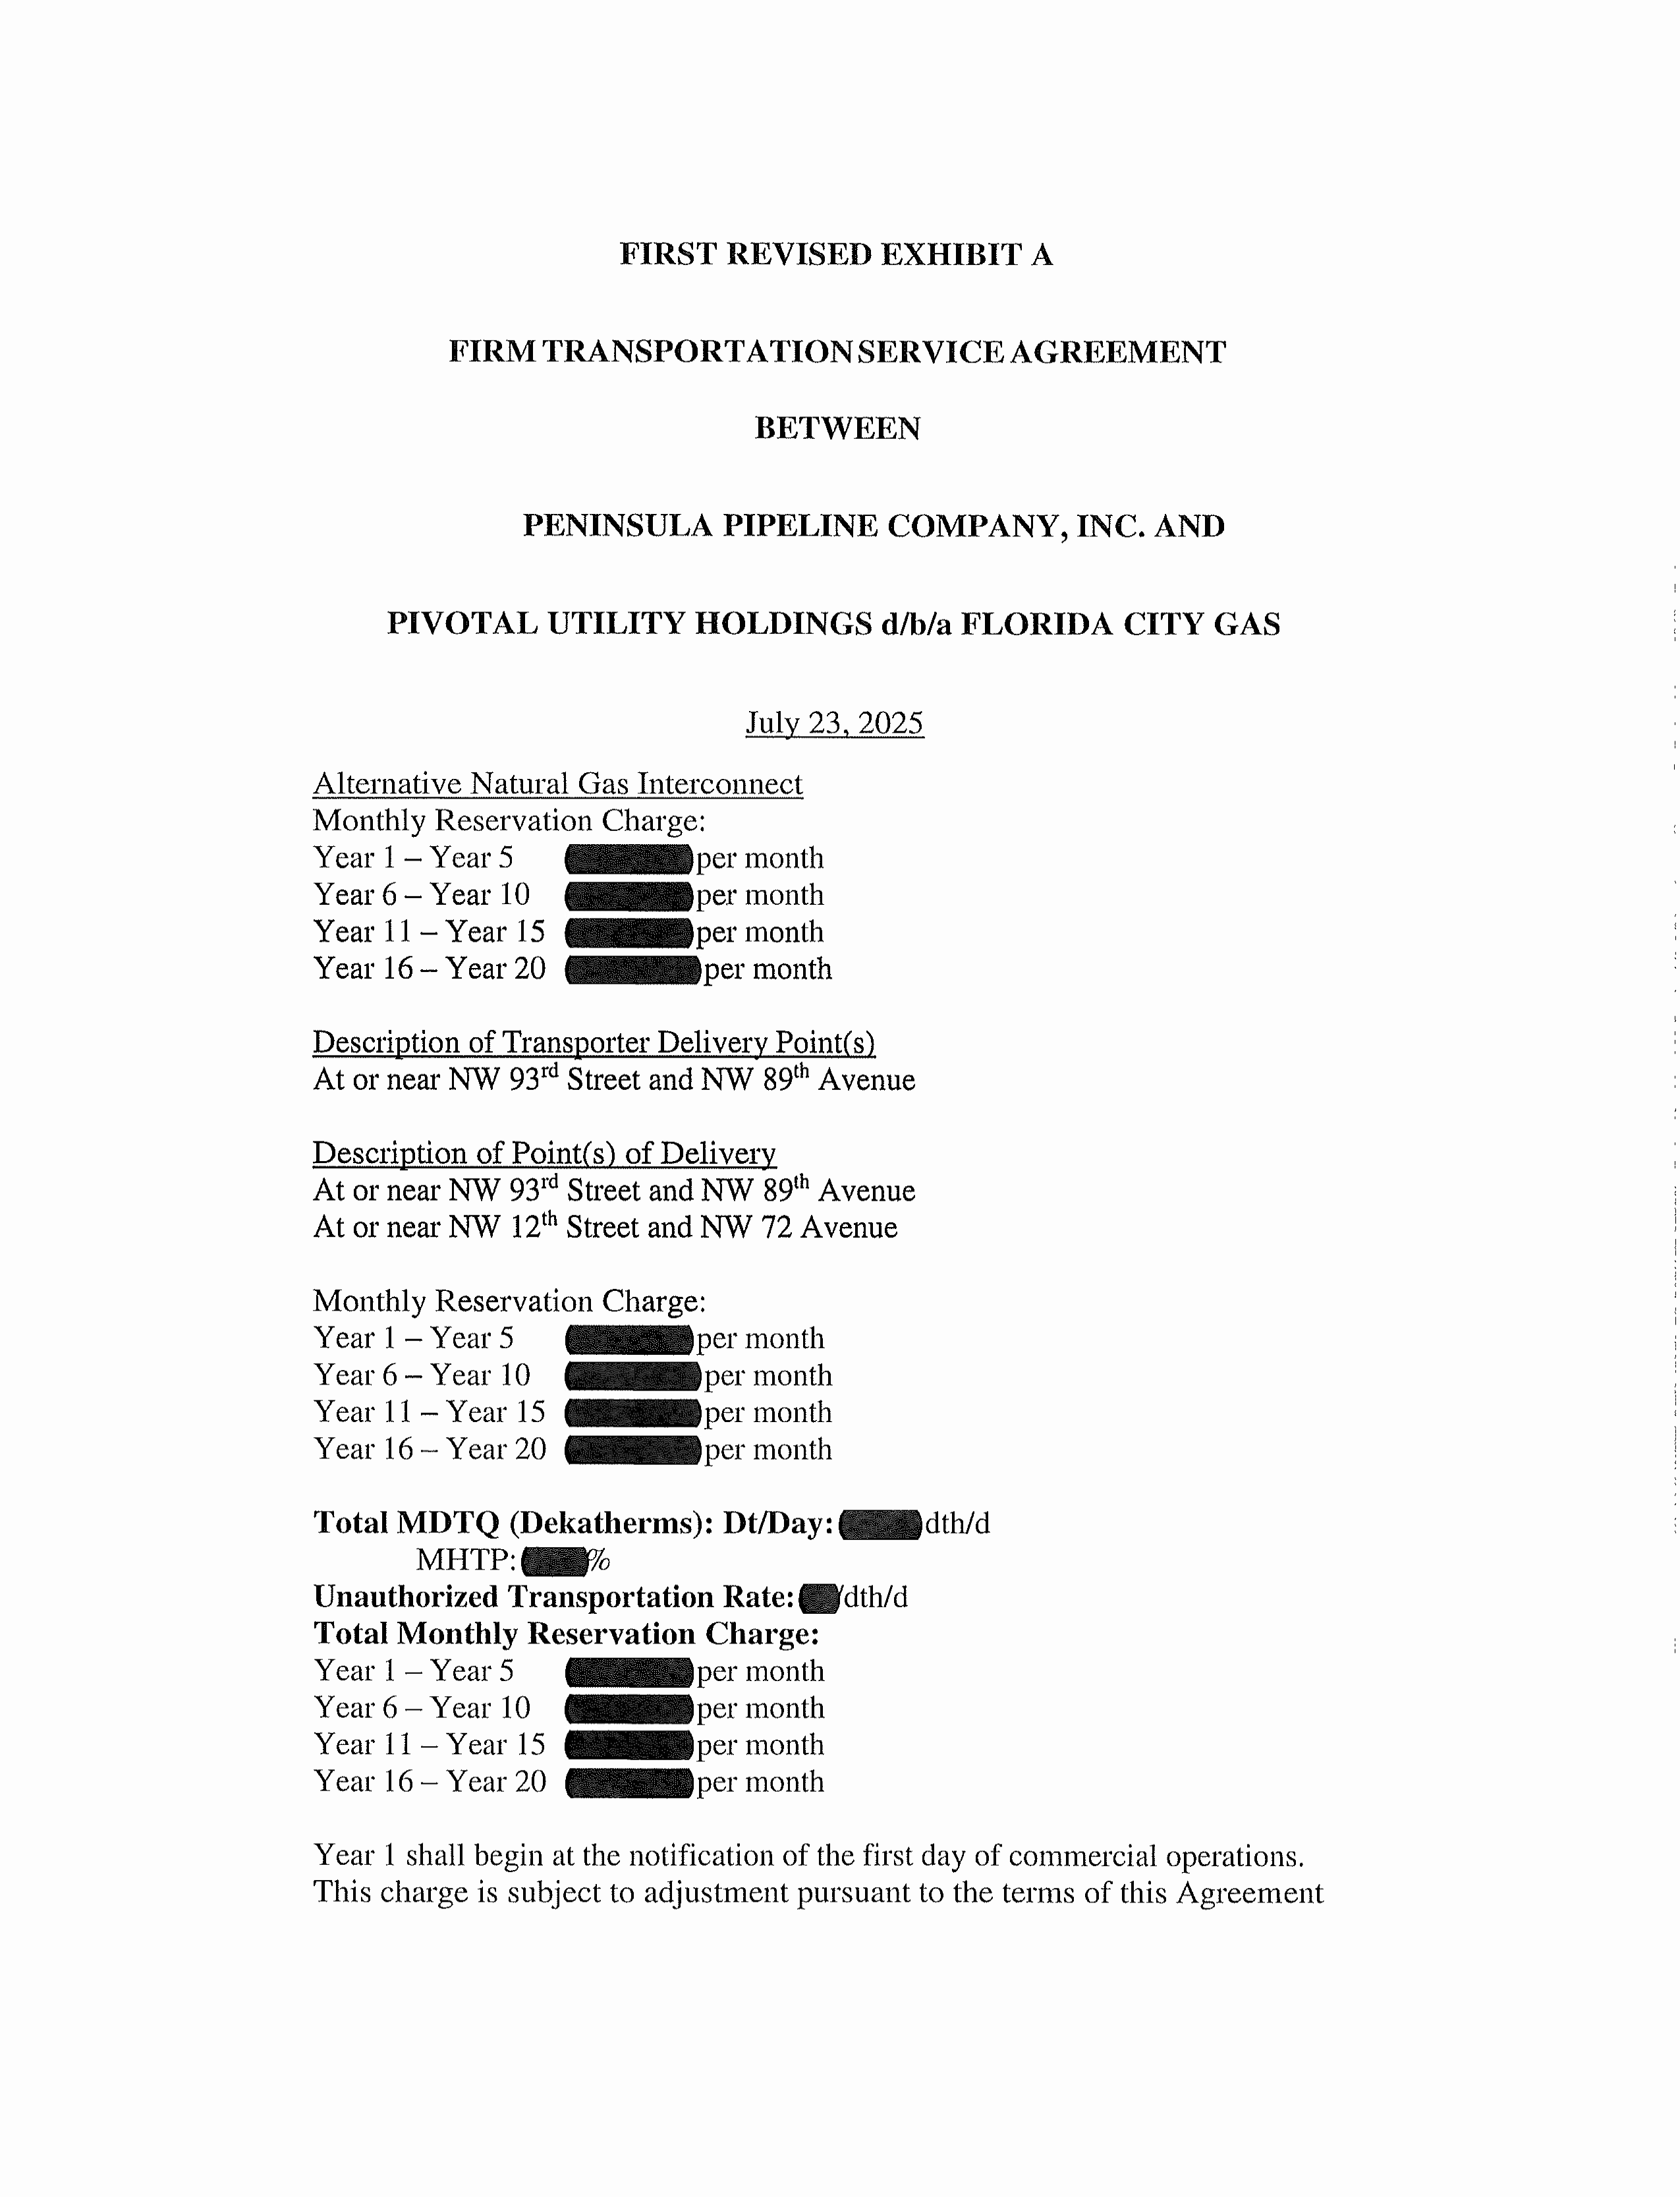

1. Order No. PSC-2024-0271-PAA-GU, issued July 26, 2024, in Docket No. 20240039-GU, *In re: Petition for approval of transportation service agreements between Peninsula Pipeline Company, Inc. and Pivotal Utility Holdings, Inc. d/b/a Florida City Gas.*
2. Document No. 05188-2024, filed June 10, 2024.
3. Order No. PSC-06-0023-DS-GP, issued January 9, 2006, in Docket No. 050584-GP, *In re: Petition for declaratory statement by Peninsula Pipeline Company, Inc. concerning recognition as a natural gas transmission company under Section 368.101, F.S., et seq.*
4. Order No. PSC-07-1012-TRF-GP, issued December 21, 2007, in Docket No. 20070570-GP, *In re: Petition for approval of natural gas transmission pipeline tariff by Peninsula Pipeline Company, Inc.*
5. Document No. 09213-2025, filed September 5, 2025.
6. Document No. 13843-2025, filed September 23, 2025.
7. Document No. 09213-2025, filed September 5, 2025.
8. Attachment A in the Parties’ Supplemental Response, Document No. 13843-2025, filed September 23, 2025.
9. Response No. 11 in Staff’s First Data Request, Document No. 09213-2025, filed September 5, 2025.