Commissioners:  Andrew G. Fay, Chairman  Art Graham  Gary F. Clark  Mike La Rosa  Gabriella A. Passidomo | State of Florida   | Division of  Accounting and Finance  Andrew L. Maurey  Director  (850) 413-6900
Public Service Commission
April 18, 2023

CERTIFIED MAIL: 70201290000072792736

Travis Staats, Manager
Camachee Cove Yacht Harbor Utility
3070 Harbor Drive
St. Augustine, Florida 32084

RE: Delinquent 2022 Annual Report for Camachee Cove Yacht Harbor Utility (WU992)

Dear Utility Contact:

According to our records, Camachee Cove Yacht Harbor Utility failed to timely file its 2022 Annual Report by March 31, 2023 . Rule 25-30.110(6), Florida Administrative Code, sets penalties for noncompliance with the annual report requirement. The applicable penalty for a Class C utility is $3.00 per day and is based on the number of calendar days elapsed from the due date until the date of filing. Therefore, it is imperative that the utility promptly file the 2022 annual report as well as a check made payable to the Florida Public Service Commission for the amount of the penalty. The payment of the penalty should be mailed to: Division of Administrative and IT Services, Fiscal Services Section, Florida Public Service Commission, 2540 Shumard Oak Boulevard, Tallahassee, Florida 32399-0850, ATTN: Katisha Mobley.

Continued failure to comply with these requirements may result in show cause proceedings and possibly additional fines. If you have any questions concerning this matter please contact Amber Norris at 850-413-6984 as soon as possible.

Sincerely,
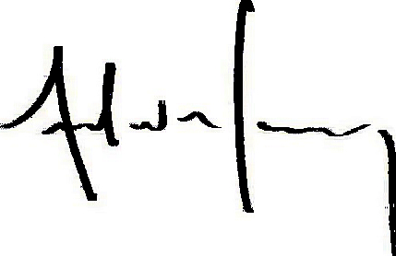
Andrew L. Maurey
Director

ALM/AN:sh
CC: Fiscal Services Section

